Original Research Article

First Record of a Crab Spider (Araneae: Thomisidae) Species of Genus Strigoplus Simon, 1886 in Chhattisgarh State, India

Abstract
The current research article indicates the new record of a crab spider species Strigoplus netravati Tikader, 1963 in the state of Chhattisgarh. This species belongs to the family Thomisidae which has been recorded in five states of India. It has been recorded for the first time in the state of Chhattisgarh. Chhattisgarh is the sixth state where this species has been recorded again. This is the first species at the generic and species level to be documented in the state. It was collected by hand picking method from the forest region of Gariaband district of Chhattisgarh. The record of this species adds another crab spider species to the state which will be very helpful in exploring the spider diversity of this state.
Keywords: Chhattisgarh, crab spider, Gariaband, species, record, Strigoplus netravati, Thomisidae
Introduction
Strigoplus Simon, 1886 is a crab spider genus in the family Thomisidae, found throughout the world. There are five species under this genus, out of which three species are found in India. The first species of this genus was Strigoplus netravati Tikader, 1963, which was recorded in India in 1963, later two more species were documented in India (WSC, 2016).
Chhattisgarh is a very important state from the point of view of spider biodiversity, where the credit for studying spiders first goes to Gajbe who recorded 49 species in Chhattisgarh which belonged to 27 genus and 10 families (Gajbe, 2003). Recently a big survey related to spiders was conducted in Chhattisgarh state in which 32 species were described under the family Thomisidae which represent 11 genus, in this maximum 14 species of genus Thomisus have been documented. Both new and old records have been mentioned in this study (Choudhury et al., 2024). Two major studies have been conducted especially in the Gariaband district of the state, first in Deobhog region in which four species representing three genera were recorded under the family Thomisidae (Nichat et al., 2024) and second in the North East region of Gariaband in which three species and two genus were recorded (Nichat et al., 2025a). Recently, several spider species have been recorded from Gariaband district, which is the first time in the state (Nayak et al., 2025a; 2025b; 2025c; 2025d; 2026).
The genus Strigoplus has not yet been recorded, despite studies in various regions of the state. The present study fills this research gap and explores the new distribution of this spider species.

Material and Methods
The Crab spider species Strigoplus netravati Tikader, 1963 has been collected randomly through hand picking methods from forest regions of Gariaband districts of Chhattisgarh (Fig. 1). The collected specimens were preserved in 70% ethanol. These specimens have been deposited in the Department of Zoology, Govt. D. B. Girls College, Raipur. These specimens are identified based on their morphological characteristics such as structure of epigyne, eye arrangement, leg configuration, body coloration, pattern on abdomen and carapace. All parts of this specimen like legs, sternum, carapace, eye arrangement and abdominal pattern have been thoroughly examined. Legs and spinnerets were examined under a compound microscope. Live photographs of this spider species were taken using Infinix Smart HD Camera and Canon HD DSLR Camera. The elevation and coordination of the collection sites of this spider species has been taken with the help of Google Earth software.
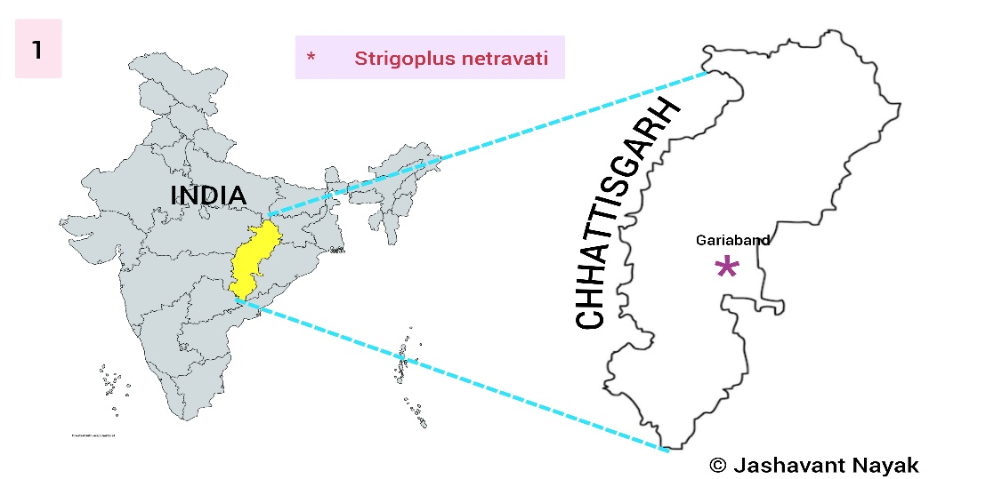
Figure 1: The map represents the new distribution of Strigoplus netravati in Chhattisgarh.

Result and Discussion
In this study, a special crab spider species under the family Thomisidae was collected from the Forest region of Gariaband district in Chhattisgarh. After carefully studying the morphology of the collected specimen, it was found to be the Strigoplus netravati spider species, which has been recorded for the first time in the state of Chhattisgarh. Below is complete information about this spider, including its morphological characteristics, examination techniques, location, and distribution in this Indian state.

Taxonomy
Thomisidae Sundevall, 1833
Genus Strigoplus Simon, 1886
Strigoplus netravati Tikader, 1963
(Fig. 2-7)

Material Examination
Strigoplus netravati Tikader, 1963: 1 female specimen was collected from forest region of Gariaband in Chhattisgarh state, coordinate 20°35'39"N 82°05'02"E, elevation 383.26m, Date 16.ii.2026, 03:53 PM (GMT +05:30) (Fig. 1) Collected by Jashavant Nayak and Hitesh Kumar Warte by hand picking method on the branch of Shorea robusta tree. The species have been preserved in 70% alcohol and are safely deposited in the Department of Zoology at Govt. D. B. Girls Post Graduate College, Raipur, Chhattisgarh, India.

Morphological characteristics
The cephalothorax is brown, rectangular and much smaller than the abdomen. The chelicerae are black, broad, and short, with the fangs being quite small. The eyes are arranged in front of the cephalothorax. The sternum is triangular with zigzag margins.
The abdomen is of brown colored round shape which is conical shaped in the posterior area. It is dorsoventrally flattened. Spinnerets are located in the ventral terminal end of the abdomen (Fig. 2-7). The first and second legs are very strong, dark brown, and project forward. Both legs are similar to each other. The coxa is small, wide and has become inveginated. The trochanter is short, cylindrical and wide. The femur is thick, straight, wide, strong, long and hairy. The patella is small and wide. The tibia is strong, cylindrical, slightly curved and hairy (Fig. 8-12). Third and fourth pairs of legs are small and brown in color except femur. The femur is long, strong and cylindrical, it is transparent white in colour. The epigyne, attached to the epigynum plate, is roughly conical in shape, with a thick, hairy, and broad outer portion. The Spermatheca are small and bean-like in shape. The fertilization duct is very short and spike-like, located in the center (Fig 14-15).
Diagnosis Characteristics
The round shaped abdomen, curved shaped white line on the anterior part of the abdomen and zigzag white, yellow and brown lines on the dorsal part of abdomen. Dorsum of opisthosoma with five sigillae White line on both lateral regions of the ventral part, female genitalia is short and upwardly directed, ocular area with no any depression. See (Tikader, 1963; Dhali et al., 2016)
Global Distribution: India (endemic species) (Singh et al., 2023).

Indian Distribution: Goa (Bastawade & Borkar, 2008; Pandit & Dharwadkar, 2020), Karnataka (Tikader, 1963, 1971; Sundararaj, 2008; Bhat et al., 2013), Kerala (Sunil Jose et al., 2008; Dhali et al., 2016; Asima et al., 2020), Maharashtra (Bastawade & Sharma, 2002), Tamil Nadu (Sen et al., 2022).

Habitat:
Strigoplus netravati Tikader, 1963 is a species that lives in trees and shrubs in forest regions, their bodies are adapted to camouflage themselves in the bark of trees and shrubs. These are diurnal spider species that are very active during the day and search for or hunt their food.

Table 1-Data of all recorded species of Genus Strigoplus in Indian states.
Family: Thomisidae Sundevall, 1833
Genus Strigoplus Simon, 1886 | Strigoplus bilobus | Saha & Raychaudhuri, 2004 | West Bengal | Singh et al., 2023
Genus Strigoplus Simon, 1886 | Strigoplus moluri | Patel, 2003 | Kerala and Maharashtra | Singh et al., 2023
Genus Strigoplus Simon, 1886 | Strigoplus netravati | Tikader, 1963 | Goa, Karnataka, Kerala, Maharashtra, Tamilnadu, currently in Chhattisgarh. | Singh et al., 2023

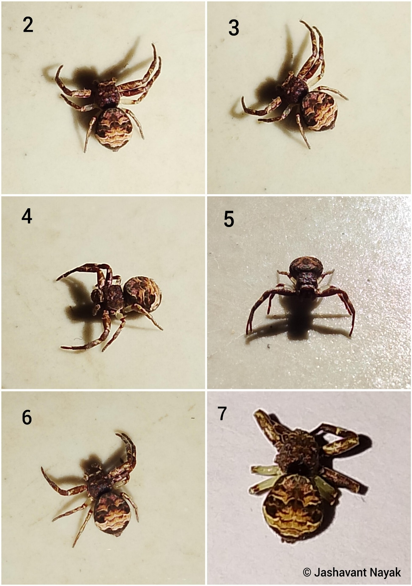
Figure 2-7--Habitus: Strigoplus netravati Tikader, 1963 (Adult female); 2. Dorsal view; 3&4 Anterolateral view; 4. Front view; 6&7 Dorsal view.

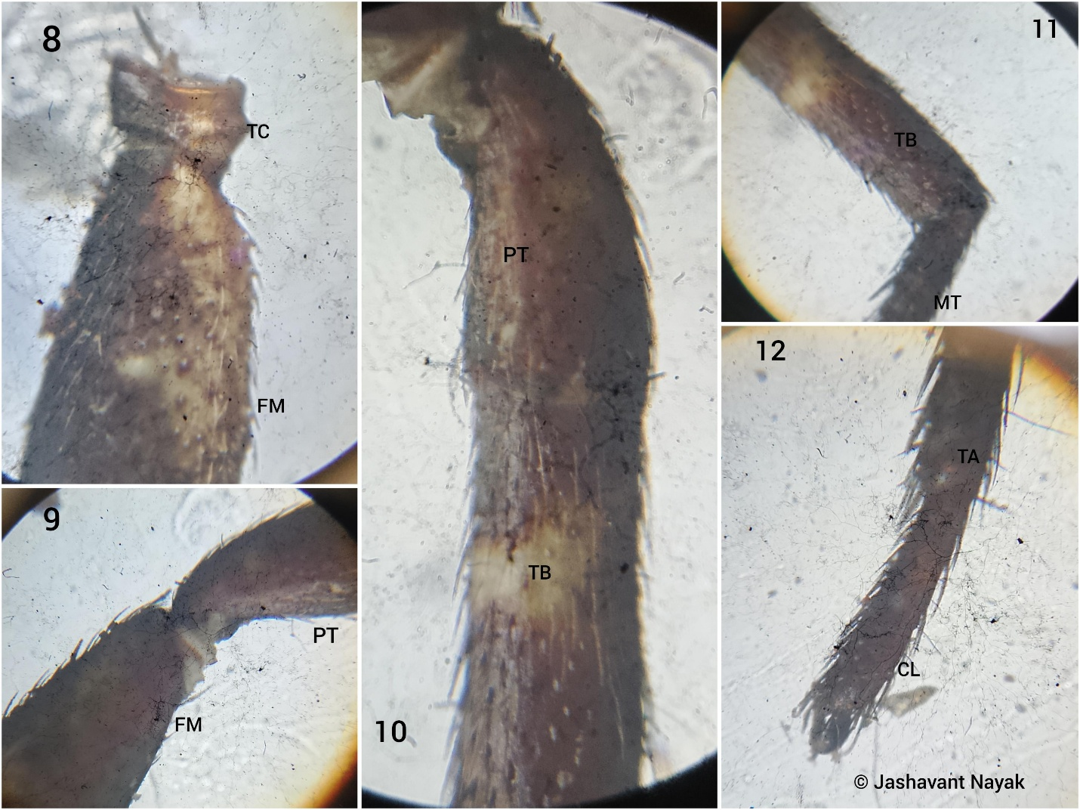
Figure: (8-12) microscopic pictures of first paired leg of Strigoplus netravati (Adult female), Abbreviations: TC- Trochanter, FM- Femur, PT- Patella, TB- Tibia, MT- Metatarsus, TA- Tarsus, CL- Claw.

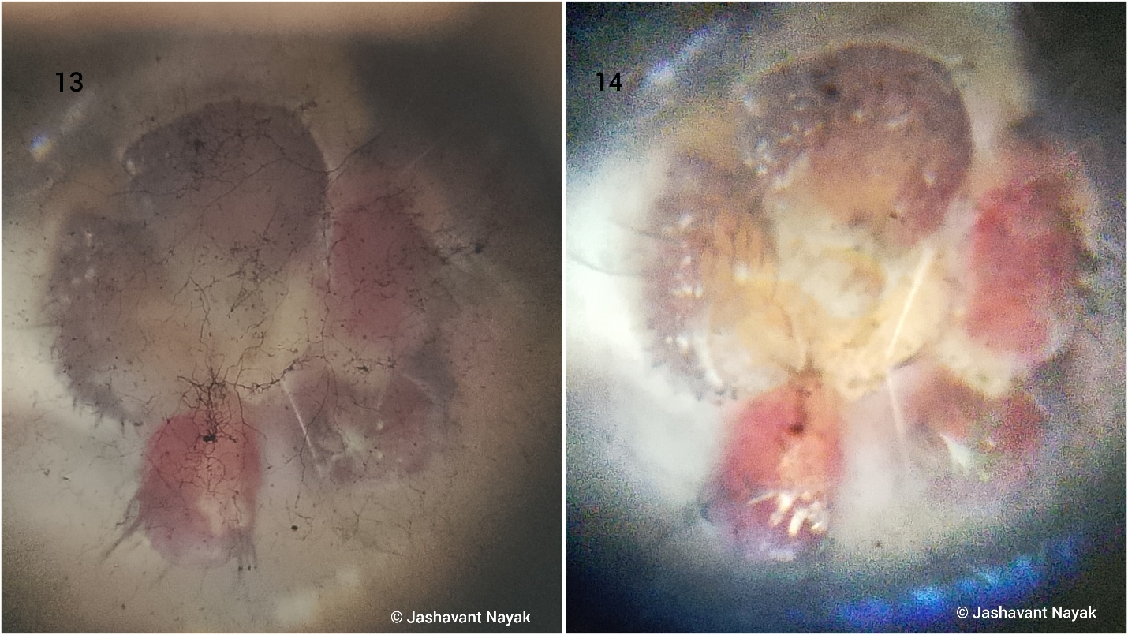
Figure (13-14): Strigoplus netravati Tikader, 1963 (Adult female) spinnerets of the species.

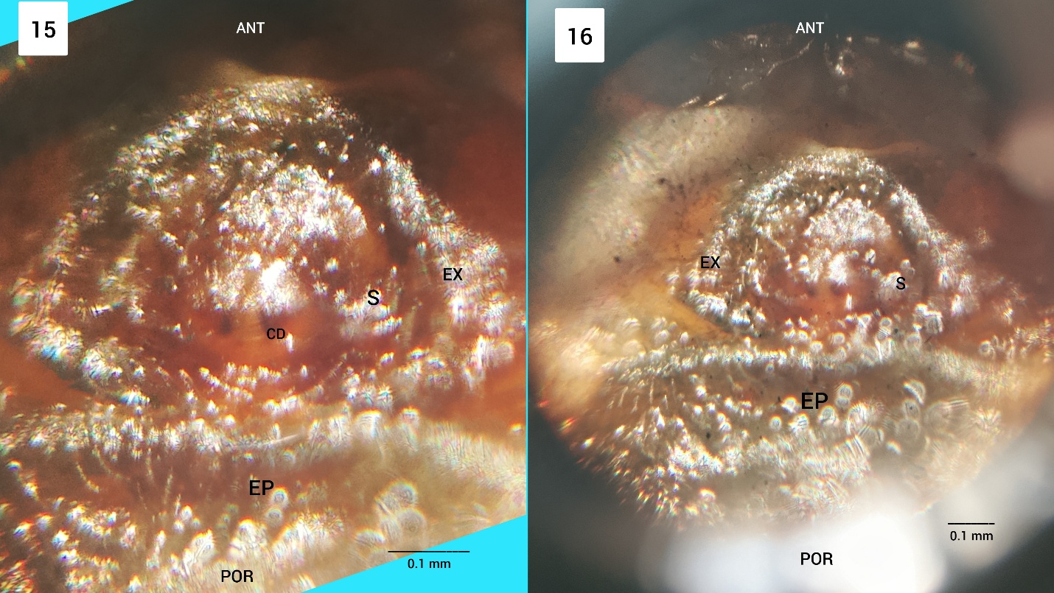
Figure (15-16): Strigoplus netravati female (adult) epigyne (ANT- Anterior, CD- Fertilization duct, EP- Epigyne Plate, EX- External margin, S- Spermatheca, POR- Posterior).

The genus Strigoplus Simon, 1886 is a less recorded species, its distributional details in India are very limited. Only three species of this genus have been documented in India, which have been recorded only in some particular states. Chhattisgarh state is the sixth state where this genus Strigoplus has been recorded. Strigoplus bilobus Saha & Raychaudhuri, 2004 is recorded only in West Bengal, Strigoplus moluri Patel, 2003 is recorded only in Kerala and Maharashtra states, whereas after this study Strigoplus netravati Tikader, 1963 has been recorded only in six states of India. These three species are endemic in India, that is, they are not found in any other country except India. There is very limited information about the species of spiders especially crab spiders in Chhattisgarh state because very few studies related to spiders have been done in this region, due to which their records and distribution in this state are very limited.

Conclusion
The present study explores the new distribution of a crab spider species, Strigoplus netravati Tikader, 1963, in the state of Chhattisgarh. This genus and species have been recorded for the first time in the state of Chhattisgarh. This study adds another crab spider species to the spider fauna list of Chhattisgarh, which will help future researchers to identify it by making morphological comparisons with other species of this genus and will also help in understanding the distribution of this species.

Disclaimer (Artificial intelligence)

Author(s) hereby declare that NO generative AI technologies such as Large Language Models (ChatGPT, COPILOT, etc.) and text-to-image generators have been used during the writing or editing of this manuscript.

References
Asima, A., Prasad, G. & Sudhikumar, A.V. (2020). Spider diversity of Kerala University Campus, Thiruvananthapuram, Kerala, India. Entomon, 45(3): 209-218.
Bastawade, D.B. & Borkar, M. (2008). Arachnida (orders Scorpiones, Uropygi, Amblypygi, Araneae and Phalangida). In: Fauna of Goa, State Fauna Series. Zoological Survey of India, Kolkata, 16, pp. 211-242.
Bastawade, D. B. & Sharma, R. M. (2002). New record of spider Strigoplus netravati from Maharashtra with additional morphological descriptions (Araneae: Thomisidae). Bionotes 4(4): 91.
Benjamin, S. P. (2017). Distributional and taxonomic notes on the crab spider genus Epidius with descriptions of five new species (Araneae: Thomisidae). Journal of Natural History, 51(9-10), 469-485.
Bhat, P.S., Srikumar, K.K., Raviprasad, T.N. (2013). Seasonal diversity and status of spiders (Arachnida: Araneae) in cashew ecosystem. World Applied Sciences Journal, 22(6):763-770.
Choudhury, S. R., Nirmalkar, Y., Singh, A. K., & Anand, A. (2024). Spider fauna of Chhattisgarh: An updated checklist of spiders of Chhattisgarh, India with new additions. Serket, 20(3), 311–334.
Dhali, D. C., Raychaudhuri, D. & Sureshan, P. M. (2016). Description of the unknown male of Strigoplus netravati Tikader, 1963 (Araneae: Thomisidae), with a key to the Indian species of the genus. Arachnida: Rivista Aracnologica Italiana 10: 26-33.
Evans, T. A. (1997). Distribution of social crab spiders in eucalypt forests. Australian Journal of Ecology, 22(1), 107-111.
Gajbe P. (2003). Checklist of Spiders (Arachnida : Araneae) of Madhya Pradesh andChhattisgarh. Zooss’ Print Journal 18 (10), 1223- 1226.
Nayak J., Sori P., Sahu L., Bharti D. (2025a). A new observational record of jumping spider (Aranae: Salticidae: Aelurillini: Aelurillina) Stenaelurillus metallicus Caleb & Mathai, 2016 in Chhattisgarh, India . International Journal of Biology Research 10(1) 19-21.https://www.biologyjournal.in/assets/archives/2025/vol10issue1/10007-1740555118544.pdf
Nayak J., Sori. P., Bharti D. (2025b). Description of a New Spider Meotipa sahyadri Kulkarni, Vartak, Deshpande & Halali, 2017 (Aranae: Theridiidae) in Chhattisgarh, India. International Journal of Research Publication and Reviews 6(2) 4518-4521. https://doi.org/10.55248/gengpi.6.0225.1026
Nayak, J., Warte, H. K., Sahu, L., & Rajanikant. (2025c). First description of a crab spider species Stiphropus sangayus Barrion & Litsinger, 1995 (Araneae: Araneomorphae: Thomisidae) in Odisha, India. International Journal of Zoology, Environment, and Life Sciences, 2(3), 7–10. https://doi.org/10.70604/ijzels.v2i3.73
Nayak, J., Chaure, M., Warte, H. K., Majumdar, M., Harris, K. K., & Nichat, A. R.(2025d). A new distribution of the spider genus Storenomorpha Simon, 1884 (Araneae: Zodariidae) in Chhattisgarh State, India. Asian Journal of Research in Zoology, 8(4), 127–133. https://doi.org/10.9734/ajriz/2025/v8i4224
Nayak, J., Warte, H. K., Sahu, L., & Singh, L. (2026). New distribution of two cobweb (Araneae: Theridiidae Sundevall, 1833) spiders in Chhattisgarh State, India. Asian Journal of Research in Zoology, 9(1), 1–9. https://doi.org/10.9734/ajriz/2026/v9i1235
Nichat A. R., Warte HK., Nayak J., (2024). Spider diversity (Arachnida:Aranae) in Deobhog region Gariyaband Chhattisgarh India : International Journal of Innovation and Science and Engineering : 11 (8) : 39 – 45 https://ijiset.com/vol11/v11s8/IJISET_V11_I08_03.pdf
Nichat A. R., Warte HK., Shaffi SA. & Nayak J., (2024). A study of biodiversity of spider species (arachnida : aranae : araneomorphae) in kokasara region, Kala-handi, Odisha, India : African Journal of Biological Sciences : 6 (15) : 9550- 9560. https://doi.org/10.48047/AFJBS.6.15.2024.9550-9560
Nichat A. R., Harris KK., Warte HK., Dubey M., Sori P. & Nayak J. (2025a). Spiders Diversity in North East Gariaband Forest Regions of Chhattisgarh, India. Uttar Pradesh Journal of Zoology, 46(4):119-127. DOI:https://doi.org/10.56557/upjoz/2025/v46i44808
Nichat, A. R., Nayak, J., Sori, P., & Warte, H. K. (2025b). Description of new jumping spider species Epocilla aura (Aranae: Salticidae: Chrysillini) from Gariaband district,Chhattisgarh State, India. International Research Journal of Biological Sciences, 14(2), 1–4.. http://www.isca.in
Nichat, A. R., Harris, K. K., Nayak, J., Kashyap, L., & Pawar, V. (2026a). Cyrtophora moluccensis Doleschall, 1857 (Arachnida: Araneae: Araneidae): First report in Chhattisgarh state of India. BIONATURE, 46(1), 55–63. https://doi.org/10.56557/bn/2026/v46i12091
Nichat, A. R., , Harris, K. K., Nayak, J., Majumdar, M., Warte, H. K., Sona, V., & Kumar, R. (2026b). First record of two Argyrodes Simon, 1864 (Araneae: Theridiidae) species from Chhattisgarh, India. Journal of Applied Life Sciences International, 29(1), 159–165. https://doi.org/10.9734/jalsi/2026/v29i1758
Pandit, R. & Dharwadkar, M. (2020). Preliminary checklist of spider fauna (Araneae: Arachnida) of Chandranath Hill, Goa, India. Journal of Threatened Taxa, 12(11): 16597–16606. doi: 10.11609/jott.6096.12.11.16597-16606
Patel, B. H. (2003). Fauna of protected areas-2: A preliminary list of spiders with descriptions of three new species from Parambikulam Wildlife Sanctuary, Kerala. Zoo's Print Journal 18: 1207-1212.
Saha, S. & Raychaudhuri, D. (2004c). Hitherto unknown genera of spiders, Ordgarius keyserling, Pasilobus Simon (Araneidae) and Strigoplus Simon (Thomisidae) from eastern India. Journal of the Bombay Natural History Society 101: 425-428.
Sen, S., Sudhin, P.P., Bera, C., Jwala, R., Subramanian, K.A. & Sureshan, P.M. (2022). Spiders (Arachnida: Araneae) of Kanyakumari Wildlife Sanctuary,Tamil Nadu, India. Records of Zoological Survey of India, 122(2):187–197. doi:10.26515/rzsi/v122/i2/2022/170243
Simon, E. (1886). Matériaux pour servir à la faune arachnologiques de l'Asie méridionale. III. Arachnides recueillis en 1884 dans la presqu'île de Malacca, par M. J. Morgan. IV. Arachnides recueillis à Collegal, district de Coimbatoore, par M. A. Theobald G. R. Bulletin de la Société Zoologique de France 10(4-6, 1885): 436-462, pl. 10.
Sundararaj, R. (2008). Distribution of predatory arthropod communities in selected sandal provenances of south India. Journal of Biopesticides, 1: 86-91.
Sundevall, C. J. (1833b). Conspectus Arachnidum. C. F. Berling, Londini Gothorum [= Lund], pp. 1-39.
Sunil Jose, K., Sudhikumar, A.V., Davis, S. & Sebastian, P.A. (2008). Preliminary studies on the diversity of spider fauna (Araneae: Arachnida) in Parambikulam Wildlife Sanctuary in Western Ghats, Kerala, India. Journal of the Bombay Natural History Society, 105(3): 264-273.
Tikader, B. K. (1963). Studies on interesting south Indian crab-spiders (Family: Thomisidae). Proceedings of the Indian Academy of Science 58(B): 249-262.
Tikader, B. K. (1971). Revision of Indian crab spiders (Araneae: Thomisidae). Memoirs of the Zoological Survey of India 15(8): 1-90.
Tikader, B. K. (1980). Thomisidae (Crab-spiders). Fauna India (Araneae) 1: 1-247.
World Spider Catalog (2026). World Spider Catalog. Version 27. Natural History Museum Bern, online at http://wsc.nmbe.ch, accessed on {20/02/2026}. doi: 10.24436/2

