Explore the Effects of Different Salinity Regimes in Fenugreek Accessions Using the Salt Tolerance Index

Abstract
Salinity is the major abiotic constrain of the crop production in arid and semi-arid regions of the world. The experiment was conducted at College of Horticulture and Forestry, Jhalawar during 2022-23 to estimate the effect of various salinity regimes on germination and seedling growth. Fourteen accessions of fenugreek were evaluated in RBD with three replications at three salinity regimes (0.00%, 0.50% and 0.75 % NaCl). Pooled analysis of variance was indicated significant differences among the accessions, salinity and accession × salinity for the seed vigour traits. Seed vigour traits were showed significant positive correlation with each other. Based on Salt tolerance indices and principal component analysis, RMt-305, RMt-351, AFg-2, RMt-303 and GM-2 were noticed tolerant among the accessions. These accessions can be utilized in breeding programmes for developing climate resilience varieties with better germination and seedling growth.
Keywords: Germination, fenugreek, seedling, seed vigour, NaCl
Introduction
Salinity is the major abiotic constrain of the crop production in arid and semi-arid regions of the world, primarily impairing germination and seedling growth. Soil salinity is a condition in which the soluble salt content reaches a harmful level to crops through reduced osmotic potential of the soil solution and the toxicity of specific ions (Zhao et al., 2007). Fenugreek (Trigonella foenum-graecum L.) is a self-pollinated, small seeded, annual which belongs to family Fabaceae. It has chromosome number 2n = 2x = 16. Generally, most of the plants cannot survive under high salinity conditions its leads to weak growth and development resulting in drastic loss in yield and quality (Atak et al., 2006; Kaya et al., 2006).
The morphological, physiological and biochemical activities of plant are affected by salt concentrations resulting reduction in germination, shoot and root length, alterations in the integrity of cell membranes, changes in different enzymatic activities and photosynthesis. It also affects metabolic activities by reducing the ability of plants to take up water that reduces plant growth. Seed germination is a complicated process and is sensitive to salt stress (Khalid et al., 2001). Salinity influence seed germination by reducing the osmotic potential and toxicity of specific ions such as sodium and chlorine, as well as reducing essential nutrients such as calcium and potassium. Both, phase of germination and seedling growth is most critical stage for determine the crop yield.
Due to increasing the salinity problems in the world day by day. Therefore, there is a basic need to develop genetically stress-tolerant varieties for farmers communities to sustainable crop production. The screening of salt-tolerant accessions from germplasm is the starting point of crop improvement (Dulai et al., 2011). Identification and selection of salt tolerant accessions of a species have immense value for agriculture. However, it is difficult to say that the breeders have efficient selection criteria and tools for improvement of salt tolerant varieties. Germination, seedling vigour and salt tolerance index are the most viable criteria used for selecting salt tolerance in crop plants (Jamil and Rha, 2004; Kumawat et al., 2022). Percentage and rate of germination, seedling growth and salt tolerance index are important growth parameters to be studied for accession selection (Khodarahmpour et al., 2011). Germination and seedling growth of germinated seeds at a particular time varies considerably among species and accessions. Salt tolerance index (STI) of the accessions, expressed as the ratio of dry matter yield produced under the salinity regimes and it was found a reliable criterion of ranking accession for salinity tolerance. Hence, this study aimed to determine the effects of salinity on germination and establishment of seedling growth in fenugreek.
Material and Method
The experiment was laid out in Laboratory of Plant Breeding, College of Horticulture and Forestry, Jhalawar during October,2022. Fourteen accessions of fenugreek viz, AFG-2, Hisar Suvarna, Pant Ragini, Nagaur Local, RMt-351, Jhunjhunu Local, RMt-305, AFG-4, Jhalawar Local, AFG-3, GM-2, CO-2, RMt-303 and Karnataka Local were evaluated in randomized block design with three replications under three salinity regimes. The salinity regimes were 0.0%, 0.50% and 0.75% NaCl, created by adding 2.5 g and 3.75 g NaCl in 500 ml of double distilled water, respectively. Thus, the NaCl salt solutions were ready for experiment. The volumetric flasks were priorly marked by permanent marker for identification. Prior to germination, the uniform seeds of fourteen accessions were surface sterilized with 0.1% mercuric chloride for 1 minute and washed 3 times under running tap water followed by washing with double distilled water. Petri dishes are sterilized at 165℃ for 4 hours in hot air oven and germination papers were autoclaved at 15 psi and 121 ℃ for 20 minutes. These petri dishes were prepared for each accession and replicated thrice. Hundred seeds of each accession were germinated in two petri dishes containing fifty seeds each with germination papers and then moistened with test solutions daily after removing previous day solution. The temperature and humidity maintained in germinator was 25±5 ℃ and 90±5 ℃, respectively. The experiment was terminated on the 8th day (ISTA, 2009) and observation were recorded for different traits viz., germination (%), shoot and root length (cm), fresh and dry weight of shoot and root (mg), seedling length (cm), fresh and dry weight of seedling (mg), seed vigour index-I & II and stress tolerance index (STI). The data on dry weight of shoot and root were recorded after drying them in hot air oven at 65 ℃ for 48 hours.
The methods used for recording observations for different traits are described below:
Germination (%): Germination (%) was recorded at the final day count and it was calculated by the use of following formula (Aniat et al. 2010) and seed was considered as germinated at the emergence of both root and shoot up to 2 mm length (Chartzoulakis et al., 2000).
Number of germinated seeds
Germination (%) = ---------------------------------------- ×100
Total number of seeds sown
Shoot and Root Length (cm): At the final day count of germination, randomly five germinated seedlings were selected from each accession and each replication. The seedling was divided into two parts viz., shoot and root. The hypocotyl length included in shoot length. The shoot and root length of seedlings was recorded using scale in centimetres and averaged. The seedling length was calculated by adding the length of shoot and root.
Shoot and Root Fresh Weight (mg): The fresh weight of shoot and root from the five seedlings which were selected already from each replication and in each accession was measured in milligram by using a sensitive electronic balance and averaged. The total fresh weight of seedling was calculated by adding fresh weight of shoot and root.
Shoot and Root Dry Weight (mg): The fresh shoot and root which were taken for weight were kept into paper bags. The name of accessions, replication and regimes of salinity were written on paper bags by pencil for further identification. After taking fresh weight, these were kept in oven at 65℃ for 48 hours for drying. After drying, the dried shoots and roots were weighed by sensitive electronic balance in milligram and average was calculated. The total dry weight of seedling was calculated by adding dry weight of shoot and root.
Seed Vigor Index-I (SVI-I) and Seed Vigor Index-II (SVI-II): SVI-I and SVI-II were calculated according to the method suggested by Abdul-Baki & Anderson (1973) using the following formulae.
SVI-I = Germination (%) × Seedling length (cm)
SVI-II = Germination (%) × Seedling dry weight (mg)
Salt Tolerance Index (STI): STI of already selected five seedlings was calculated by the following formula (Kokten et al., 2010).
Seedling dry weight (mg) of one of the salinity regimes
STI = -------------------------------------------------------------------- × 100
Seedling dry weight (mg) of control regimes

Statistical Analysis
The recorded data of the seed vigour traits were subjected to analysis of variance suggested formula by Gomez & Gomez, 1984. The Pearson correlation coefficient between seed vigour traits was estimated using GRAPES (Gopinath et al., 2020). To screening of better accession, principal component analysis (PCA) and GGE biplot were performed for stress tolerance index (STI) and seed vigour traits using GRAPES (Gopinath et al., 2020).

RESULT AND DISCUSSION
Analysis of Variance
Pooled analysis of variance were exhibited significant differences among salinity regimes (S), accessions (A), and A × S interaction for the traits viz., germination (%), shoot length (cm), root length (cm), seedling length (cm), fresh weight of shoot (mg), fresh weight of root (mg), fresh weight of seedlings (mg), dry weight of shoot (mg), dry weight of root (mg), dry weight of seedling (mg), seed vigour index-I and seed vigour index-II, indicated differential response of accessions to salinity regimes and presence of sufficient genetic variability in the accession. These findings were earlier reported by Asaadi, 2009 and Ratnakar & Rai, 2013 in fenugreek.
Effect of Salinity on Mean Performance
The mean values at different salinity regimes for various accessions and traits are presented in Table (2a,2b&2c). A wide range of variability was observed for all the studied traits. Perusal of table revealed that the mean values of all the traits varied along the salinity gradient. The value was maximum in the control (0.00%) that is in absence of salt stress and was minimum at the highest salinity level (0.75%) for majority of traits.
Germination (%): The magnitude of germination (%) decreased with increase in salt concentration. It was highest in S₀ (90.00) then decreased progressively in S₁ (81.00%) and S₂ (71.00) (Figure-1). It ranged from 85.00 (CO-2) to 94.00 (AFg-2) in S₀, 74.00 (Karnataka Local) to 89.00 (RMt-351) in S₁ and 62.00 (Pant Ragini) to 84.00 (RMt-303) in S₂ salinity regimes. The range was wider in S₂ as compared to S₁ salinity regimes indicted that higher salinity adversely affected to germination. The similar findings were earlier reported by Ghorbanpour et al., 2011, Ashagre et al., 2013, Kapoor & Pandey, 2015 and Kumawat et al., 2022.
Shoot length (cm): The shoot length was also decreased with increasing of salinity regimes. It was highest in S₀ (6.72) then decreased progressively in S₁ (5.48) and S₂ (4.94). It ranged from 5.55(Jhalawar Local) to 8.75(RMt-305) in S₀, 3.93 (Pant Ragini) to 7.85(GM-2) in S₁ and 3.21 (Jhalawar Local) to 7.81 (RMt-351) in S₂ salinity regimes.
Root length (cm): The root length was highest in S₀ (5.57) and it was decreased with increasing of salinity regimes as following in S₁ (5.05) and S₂ (4.28). It ranged from 4.20 (Hisar Suvarna) to 7.95 (RMt-303) in S₀, 3.22 (Karnataka Local) to 7.85 (RMt-351) in S₁ and 2.60 (CO-2) to 7.20 (AFg-2) in S₂ salinity regimes.
Shoot fresh weight (mg): In case of shoot fresh weight also decreased with increasing of salt concentrations. The magnitude of this parameter was highest in S₀ (183.67) followed by S₁ (141.11) and S₂ (129.78). It ranged from 164.23(Karnataka Local) to 194.62 (RMt-351) in S₀, 115.58 (CO-2) to 174.54 (GM-2) in S₁ and 106.91(Jhalawar Local) to 157.87(RMt-351) in S₂ in salinity regimes.
Root fresh weight (mg): It was found maximum in S₀ (59.01), then decrease progressively in S₁(47.26) and S₂ (44.42). It ranged from 46.56 (Jhalawar Local) to 70.16 (RMt-351) in S₀, 34.97 (CO-2) to 63.48 (RMt-303) in S₁ and 31.64(Karnataka Local) to 58.85 (RMt-351) in S₂ salinity regimes.
Shoot dry weight (mg): In case of shoot dry weight also decreased with increasing of salinity regimes. The magnitude of this parameter was highest in S₀ (10.34), then decreased in S₁ (8.63) and S₃ (7.79). It ranged from 9.40 (Karnataka Local) to 11.64 (RMt-351) in S₀, 7.21(CO-2) to 10.68 (RMt-305) in S₁ and 6.21 (Pant Ragini) to 10.06 (RMt-351) in S₂ salinity regimes. The stimulatory less effect of salinity has been previously reported by Kumawat et al. (2022).
Root dry weight (mg): Root dry weight was highest in S₀ (1.67) and lowest in S₂ (1.32). It ranged from 1.49 (Jhalawar Local) to 1.91(AFg-2) in S₀, 1.16 (Jhalawar Local) to 1.83(RMt-351) in S₁ and 1.01 (Karnataka Local) to 1.76 (RMt-305) in S₂ salinity regimes.
Seedling length (cm): The seedling length was highest in S₀ (12.30) and it was decreased with increasing salinity levels as following in S₁ (10.53) and S₂ (9.22). It ranged from 10.17(Jhalawar Local) to 15.46 (AFg-2) in S₀, 7.78(CO-2) to 14.39 (AFg-2) in S₁ and 6.13(CO-2) to 14.35 (RMt-351) in S₂ salinity regimes. Variation in seedling traits at different salinity regimes was earlier reported by Ratnakar & Rai, 2013, Soughir et al., 2013 and Kumawat et al., 2022.
Seedling fresh weight (mg): There was also a decreasing trend with increasing of salinity regimes. It was found maximum in S₀ (242.68) and decreased in S₁ (188.37) and S₂ (174.20). It ranged from 214.06 (Karnataka Local) to 264.78 (RMt-351) in S₀, 150.55 (CO-2) to 227.54 (GM-2) in S₁ and 141.67(Jhalawar Local) to 216.72 (RMt-351) in S₂ salinity regimes.
Seedling dry weight (mg): It was maximum in S₀ (12.00) then decreased in S₁ (10.06) and S₂ (9.11). It ranged from 10.96 (Karnataka Local) to 13.45 (RMt-351) in S₀, 8.44 (CO-2) to 12.23(RMt-305) in S₁ and 7.36 (Pant Ragini) to 11.56 (RMt-351) in S₂ salinity regimes. It has been reported previously by Asaadi, 2009 and Kumawat et al., 2022.
Seed vigour index (SVI)-I: The SVI-I weight also decreased with increasing of salinity regimes. It was highest in S₀ (1112.36) then decreased in S₁ (860.17) and S₂ (675.23). It ranged from 871.09 (CO-2) to 1458.67 (AFg-2) in S₀, 585.64 (CO-2) to 1266.72 (AFg-2) in S₁ and 386.05 (Jhalawar Local) to 1142.93 (RMt-351) in S₂ salinity regimes.
Seed vigour index (SVI)-II: It was higher in S₀ (1083.10) then decreased in S₁ (817.40) and S₂ (658.40). It ranged from 945.90 (Karnataka Local) to 1264.00 (RMt-351) in S₀, 635.40 (CO-2) to 1047.00 (RMt-351) in S₁ and 456.50 (Pant Ragini) to 921.20 (RMt-351) in S₂ salinity regimes.
The reduction in mean value was more in shoot length, root length, fresh weight of shoot and root, dry weight of shoot and root and seedling vigour index. The reduction was less in 0.5% NaCl and was found more in 0.75% NaCl. Seed vigour traits decreased under saline regimes was noticed by Abdelmoumen & EL-Idrissi, 2009. The effect of salinity on traits was not similar; some traits were influenced maximum while other minimum. Reduction in per se performance was due to salts of different nature and concentration because increased water potential, restricted the movement of water towards the seed surface (Houimli et al., 2008; Kumawat et al., 2022).
Correlation Coefficient Analysis
Seed vigour index (I & II) was showed significant positive correlation with germination, shoot length, root length, fresh weight of shoot, fresh weight of root, dry weight of shoot, dry weight of root, seedling length, seedling fresh weight and seedling dry weight, and also showed significantly positive correlation with each other at different salinity regimes (Table 3). Seed vigour index, root length and shoot length are major components of germination which can be taken into consideration to improve plant population through increasing germination per cent, ultimately resulting in higher seed yield under salinity regimes. Yadav et al. (2011) in barley and Manjeet et al. (2020) in sesame were reported similar findings.
Salt tolerant index (STI) (%): Many earlier studied were reported that STI is used for screening of salt tolerance index rather than other indices (Ali et al., 2007; Shahzad et al., 2012). The averages of STI were recorded highest (100) under S₀ and decreased with increasing of salinity regimes (Table 4 and Fig. 1&2). It was decreased in S₁ (83.65) and S₂ (75.54). The magnitude of STI was maximum for accession RMt-351 (87.16;85.99), AFg-2 (86.23;85.68), RMt-305 (98.18;84.80), RMt-303(85.58;83.02) and GM-2 (85.15;80.24) under S₁ and S₂ salinity regimes. A wide range of variation were noticed and varied from 74.57 to 98.18 in S₁ and 63.08 to 85.99 in S₂. Kumawat et al. (2022) was noticed similar result in fenugreek.
Screening of superior accessions based on principle component analysis (PCA)
The PCA revealed that the first one PCA of STI under S₁ and S₂ regimes and SVI explained 93.60 % of the total variation (Table 5 and Figure 3). Accession should have invariably higher STI and SVI in the salinity regimes. The superior accession is graphically defined by the longest vector in PC1 and without projections in PC2 (Costa De Mattos et al., 2013). RMt-305, RMt-351, AFG-2, RMt-303 and GM-2 accessions and SVI were located between PC1 concentric circles (Figure 4) and these accessions may be considered desirable for standard germination and better seedling establishment in S₁ and S₂ regimes. The similar findings were reported by Singh & Rajpoot, 2022 and Singh et al., 2025 in fenugreek.
Conclusion:
The seed vigour traits of accessions showed significantly variation at salinity regimes. Various salt tolerance indices were used for estimation of stress level and screening of elite accession. Many studies proposed the use of STI in screening of salt tolerance rather than other indices. The accessions viz., RMt-305, RMt-351, AFG-2, RMt-303 and GM-2 were found to be most tolerant salinity regimes using STI and seed vigour traits. These accessions could be used as a source for salt-responsive candidate genes in crop improvement and as a viable option to ensure food security under this climate change era.
Disclaimer (Artificial Intelligence)
Authors hereby declare that no generative AI technologies such as Large Language Models (ChatGPT, COPILOT, and Gemini, etc.) and text to-image generators not used during the writing or editing of this manuscript.
References
Abdelmoumen, H., & EL-Idrissi, M. M. (2009). Germination, growth and nodulation of fenugreek under salt stress. African Journal of Biotechnology, 8(11):2489-2496.
Abdul-Baki, A. A., & Anderson, J. D. (1973). Vigor determination in soybean seed by multiple criteria 1. Crop Science, 13: 630-633.
Ali, Z., Salam, A., Azhar, F. M., & Khan, I. A. (2007). Genotypic variation in salinity tolerance among spring and winter wheat (Triticum aestivum) accessions. South African Journal of Botany, 73:70-75.
Aniat-ul-Haq, Vamil, R., & Agnihotri, R. K. (2010). Effect of osmotic stress (PEG) on germination and seedling survival of lentil (Lens culinaris M.). Research Journal of Agricultural Science, 1(3):201-204.
Asaadi, A. M. (2009). Investigation of salinity stress on seed germination of Trigonella foenum-graecum. Research Journal of Biological Sciences, 4:1152-1155.
Ashagre, H., Hamza, I. A., Fasika, E., & Temesgen, F. (2013). Effect of salinity stress on germination and seedling vigour of chickpea (Cicer arietinum L.) cultivars. Academia Journal of Agricultural Research,1(9):161-166.
Atak, M., Kaya, M. D., Kaya, G., Cikili, Y., & Ciftci, C. Y. (2006). Effects of NaCl on the germination, seedling growth and water uptake of triticale. Turkey Journal of Agriculture and Forestry, 30: 39-47.
Chartzoulakis, K. S., & Klapaki, G. (2000). Response of two greenhouse pepper hybrids to NaCl salinity during different growth stages. Scientia Horticulture,86(1):247-260.
Costa De, M. P. H., Augusto De, O. R., Bespalhok Filho, J. K., Daros, E., & Verissimo, M. A. A. (2013). Evaluation of sugarcane genotypes and production environments in Parana by GGE biplot and AMMI analysis. Crop Breeding and Applied Biotechnology, 13: 83-90.
Dulai, S., Molnár, I., Molnár-Láng, M. (2011). Changes of photosynthetic parameters in wheat/barley introgression lines during salt stress. Acta Biologica Szegediensis, 55(1):73-75.
Ghorbanpour, A., Mami, Y., Ashournezhad, M., Abri, F., & Amani, M. (2011). Effect of salinity and drought stress on germination of fenugreek. African Journal of Agricultural Research, 6(24):5529-5532.
Gomez, K.A., & Gomez, A.A. (1984) Statistical Procedures for Agricultural Research. 2nd Edition, John Wiley and Sons, New York, 680 p.
Gopinath, P. P., Prasad, R., Joseph, B., & Adarsh, V. S. (2020). GRAPES: General R shiny based analysis platform empowered by statistics. https://www.kaugrapes.com/home. Version 1.0.0.DOI:10.5281/zenodo.4923220.
Houimli, S. I. M., Denden, M., & Hadj, S. B. E. (2008). Induction of salt tolerance in pepper (Capsicum annuum) by 24-epibrassinolide. European and Asian Journal of Biological Science, 2:83-90.
ISTA (2009). International rules for seed testing. Seed Science and Technology, 27: 1-334.
Jamil, M., & Rha, E. S. (2004). The Effect of Salinity (NaCI) on the germination and seedling of Sugar Beet (Beta vulgaris L.) and Cabbage (Brassica oleracea L.). Plant Resources, 7, 226-232.
Kapoor, N., & Pandey, V. (2015). Effect of salt stress on growth parameters, moisture content, relative water content and photosynthetic pigments of fenugreek variety RMt-1. Journal of Plant Sciences, 10(6):210-221.
Kaya, M. D., Okcu, G., Atak, M., Cikili, Y., & Kolsarici, O. (2006). Seed treatments to overcome salt and drought stress during germination in sunflower (Helianthus annuus L.). European Journal of Agronomy, 24: 291-295.
Khalid, N. M., Iqbal, F. H., Tahir, A., & Ahmad, N. A. (2001). Germination potential of chickpeas (Cicer arietinum L.) under saline conditions. Pakistan Journal of Biological Science,4:395-396.
Khodarahmpour, Z., Ifar, M., & Motamedi, M. (2012). Effects of NaCl salinity on maize (Zea mays L.) at germination and early seedling stage. African Journal of Biotechnology, 11(2):298-304.
Kokten, K., Karakoy, T., Bakoglu, A., & Akcura, M. (2010). Determination of salinity tolerance of some lentil (Lens culinaris M.) varieties. Journal of Food, Agriculture & Environment, 8(1):140-143.
Kumawat, S., Kumawat, R., Kumawat, K. R., Gothwal, D. K. & Yadav, S. (2022). Explore salt tolerant fenugreek genotypes seedlings using salt tolerance index, The Pharma Innovation Journal, SP-11(4): 1925-1931.
Manjeet, Mahavir, Anu, Singh, V. K., & Verma, P. K. (2020). Character association and path analysis for seed vigour traits in sesame (Sesamum indicum L.) Journal of Experimental Biology and Agricultural Sciences, DOI: http://dx.doi.org/10.18006/2020.8(2).
Ratnakar, A., & Rai, A. (2013). Effect of sodium chloride salinity on seed germination and early seedling growth of Trigonella foenum-graecum L. variety Peb. Octa Journal of Environmental Research, 1(4):304-309.
Shahzad, A., Ahmad, M., Iqbal, M., Ahmed, I., & Ali, G. M. (2012). Evaluation of wheat landrace genotypes for salinity tolerance at vegetative stage by using morphological and molecular markers. Genetic and Molecular Research,11:679-692.
Singh, B., & Rajpoot, V. (2022). Evaluation of drought tolerance indices for selection of high yielding fenugreek genotypes under moisture regimes. Indian Journal of Ecology, 49(2): 470-476. https://doi.org/10.55362/IJE/2022/3547
Singh, B., Rajpoot, V., Kumar, R., Kumari, V., Nagar, B., & Singh, K. (2025). Salinity tolerance benchmarking in fenugreek (Trigonella foenum-graecum L.) accessions for sustainable crop productivity. Advances in Research, 26 (6):368-381. DOI: https://doi.org/10.9734/air/2025/v26i61556
Soughir, M., Elouaer, M. A., & Hannachi, C. (2013). The effect of NaCl priming on emergence, growth and yield of fenugreek under saline conditions. Cercetari Agronomice in Moldova, 2(154):73-83.
Yadav, I., Soni, S. K., Jain, R., Vimal, S. C., Yadav, V. K. (2011). Character association and path analysis of vigour index with some important seed vigour contributing traits in Barley (H. vulgare L.). Environment and Ecology, 29: 1866-1870.
Zhao, J., Ren, W., Zhi, D., Wang, L., & Xia, G. (2007). Arabidopsis DREB1A/CBF3 bestowed transgenic tall fescue increased tolerance to drought stress. Plant Cell Reports, 26:1521-1528. https://doi.org/10.1007/s00299-007-0362-3

Table 1: The Pooled ANOVA for various traits under different salinity regimes.
S. No. | Traits | Source of variation (S.V.) with degree of freedom (d. f.)
S. No. | Traits | Salinity (S) (2) | Reps/Salinity (6) | Accession (A) (13) | A × S  (26) | Error (78)
1. | Germination (%) | 3705.579** | 6.635 | 226.952** | 19.434** | 5.849
2. | Shoot length (cm) | 35.129** | 0.004 | 9.842** | 1.135** | 0.022
3. | Root length (cm) | 17.867** | 0.011 | 13.330** | 1.019** | 0.015
4. | Shoot fresh weight (mg) | 33904.560** | 1.507 | 1603.946** | 155.283** | 7.433
5. | Root fresh weight (mg) | 2514.346** | 1.417 | 643.547** | 10.066** | 1.741
6. | Shoot dry weight (mg) | 70.758** | 0.012 | 6.746** | 0.562** | 0.008
7. | Root dry weight (mg) | 1.330** | 4.520 | 0.226** | 0.029** | 0.0003
8. | Seedling length (cm) | 100.211** | 0.026 | 44.187** | 2.461** | 0.031
9. | Seedling fresh weight(mg) | 54882.457** | 3.778 | 4229.489** | 193.744** | 10.380
10. | Seedling dry weight (mg) | 91.493** | 0.013 | 9.361** | 0.636** | 0.008
11. | Seed Vigour Index-1 | 2022227.50** | 593.243 | 470652.44** | 15530.221** | 798.666
12. | Seed Vigour Index-2 | 1933525.6** | 946.200 | 153776.10** | 6567.80** | 651.90
* and ** represent significant at 5% and 1% level of significance, respectively.

Table 2a: The mean values of accessions for different traits over different salinity regimes.
Accessions | Germination (%) |  |  | Shoot length (cm) |  |  | Root length (cm) |  |  | Shoot fresh weight (mg)
Accessions | S₀ | S₁ | S₂ | S₀ | S₁ | S₂ | S₀ | S₁ | S₂ | S₀ | S₁ | S₂
AFG-2 | 94 | 88 | 82 | 8.14 | 7.21 | 5.87 | 7.32 | 7.18 | 7.20 | 190.90 | 166.13 | 151.79
Hisar Suvarna | 90 | 79 | 70 | 6.69 | 5.33 | 4.53 | 4.20 | 4.81 | 3.74 | 183.91 | 135.62 | 125.15
Pant Ragini | 89 | 77 | 62 | 5.97 | 3.93 | 3.74 | 4.74 | 4.13 | 3.08 | 182.96 | 132.23 | 120.23
Nagaur Local | 90 | 79 | 67 | 6.68 | 5.32 | 4.46 | 5.35 | 4.75 | 3.66 | 183.00 | 134.15 | 123.95
RMt-351 | 94 | 89 | 80 | 7.07 | 5.90 | 7.81 | 6.24 | 7.85 | 6.54 | 194.62 | 153.21 | 157.87
Jhunjhunu Local | 88 | 77 | 67 | 5.97 | 4.60 | 3.70 | 4.66 | 3.98 | 3.02 | 179.85 | 129.54 | 117.54
RMt-305 | 92 | 85 | 78 | 8.75 | 6.08 | 6.02 | 6.04 | 5.87 | 5.33 | 190.71 | 154.55 | 145.88
AFG-4 | 91 | 81 | 74 | 6.77 | 5.46 | 4.92 | 5.56 | 5.02 | 4.26 | 186.07 | 138.83 | 127.16
Jhalawar Local | 86 | 76 | 62 | 5.55 | 4.56 | 3.21 | 4.62 | 3.80 | 2.99 | 175.35 | 124.95 | 106.91
AFG-3 | 90 | 80 | 68 | 6.76 | 5.40 | 4.63 | 5.55 | 4.94 | 3.86 | 184.40 | 137.51 | 125.84
GM-2 | 92 | 84 | 76 | 6.96 | 7.85 | 7.10 | 5.92 | 5.63 | 5.18 | 190.52 | 174.54 | 136.54
CO-2 | 85 | 75 | 64 | 5.78 | 4.27 | 3.53 | 4.47 | 3.51 | 2.60 | 172.42 | 115.58 | 112.28
RMt-303 | 93 | 87 | 84 | 7.09 | 6.14 | 6.04 | 7.95 | 6.09 | 5.56 | 192.40 | 157.22 | 151.22
Karnataka Local | 86 | 74 | 66 | 5.97 | 4.63 | 3.66 | 5.41 | 3.22 | 2.87 | 164.23 | 121.51 | 114.51
Mean | 90 | 81 | 71 | 6.72 | 5.48 | 4.94 | 5.57 | 5.05 | 4.28 | 183.67 | 141.11 | 129.78
CD at 5% level | 4.16 | 4.76 | 3.06 | 0.19 | 0.29 | 0.26 | 0.31 | 0.14 | 0.13 | 3.81 | 5.70 | 3.97

Table 2b: The mean values of accessions for different traits over different salinity regimes.
Accessions | Root fresh weight (mg) |  |  | Shoot dry weight (mg) |  |  | Root dry weight (mg) |  |  | Seedling length (cm)
Accessions | S₀ | S₁ | S₂ | S₀ | S₁ | S₂ | S₀ | S₁ | S₂ | S₀ | S₁ | S₂
AFG-2 | 66.44 | 54.98 | 56.38 | 10.85 | 9.55 | 9.32 | 1.91 | 1.45 | 1.61 | 15.46 | 14.39 | 13.07
Hisar Suvarna | 58.20 | 44.40 | 41.85 | 10.25 | 8.43 | 7.52 | 1.65 | 1.40 | 1.26 | 10.89 | 10.14 | 8.27
Pant Ragini | 55.11 | 41.70 | 38.70 | 10.06 | 8.16 | 6.21 | 1.61 | 1.35 | 1.16 | 10.71 | 8.06 | 6.82
Nagaur Local | 57.30 | 43.85 | 41.40 | 10.16 | 8.26 | 7.24 | 1.63 | 1.37 | 1.21 | 12.03 | 10.07 | 8.12
RMt-351 | 70.16 | 56.61 | 58.85 | 11.64 | 9.89 | 10.06 | 1.80 | 1.83 | 1.50 | 13.31 | 11.77 | 14.35
Jhunjhunu Local | 54.01 | 40.61 | 37.83 | 9.96 | 8.00 | 6.84 | 1.59 | 1.33 | 1.13 | 10.62 | 7.81 | 6.72
RMt-305 | 68.55 | 60.28 | 53.31 | 10.72 | 10.68 | 8.81 | 1.74 | 1.55 | 1.76 | 14.79 | 13.93 | 11.35
AFG-4 | 60.19 | 47.45 | 44.79 | 10.35 | 8.64 | 7.97 | 1.67 | 1.44 | 1.35 | 12.33 | 10.48 | 9.18
Jhalawar Local | 46.56 | 37.95 | 34.75 | 9.80 | 7.86 | 6.59 | 1.49 | 1.16 | 1.07 | 10.17 | 8.36 | 6.19
AFG-3 | 58.68 | 45.44 | 43.44 | 10.32 | 8.57 | 7.70 | 1.66 | 1.42 | 1.30 | 12.31 | 10.34 | 8.49
GM-2 | 64.10 | 53.01 | 49.34 | 10.40 | 8.70 | 8.34 | 1.77 | 1.66 | 1.42 | 12.88 | 13.48 | 12.28
CO-2 | 48.90 | 34.97 | 33.62 | 9.75 | 7.21 | 6.49 | 1.56 | 1.23 | 1.09 | 10.26 | 7.78 | 6.13
RMt-303 | 68.12 | 63.48 | 55.94 | 11.06 | 9.31 | 9.02 | 1.68 | 1.59 | 1.56 | 15.04 | 12.23 | 11.59
Karnataka Local | 49.83 | 36.88 | 31.64 | 9.40 | 7.54 | 6.96 | 1.55 | 1.29 | 1.01 | 11.38 | 8.61 | 6.53
Mean | 59.01 | 47.26 | 44.42 | 10.34 | 8.63 | 7.79 | 1.67 | 1.43 | 1.32 | 12.30 | 10.53 | 9.22
CD at 5% level | 2.86 | 1.89 | 1.73 | 0.13 | 0.10 | 0.19 | 0.03 | 0.03 | 0.03 | 0.30 | 0.29 | 0.30

Table 2c: The mean values of accessions for different traits over different salinity regimes.
Accessions | Seedling fresh weight (cm) |  |  | Seedling dry weight (mg) |  |  | Seed Vigour Index-1 |  |  | Seed Vigour Index-2
Accessions | S₀ | S₁ | S₂ | S₀ | S₁ | S₂ | S₀ | S₁ | S₂ | S₀ | S₁ | S₂
AFG-2 | 257.34 | 221.10 | 208.18 | 12.76 | 11.00 | 10.93 | 1458.67 | 1266.72 | 1067.41 | 1203.4 | 968.0 | 892.6
Hisar Suvarna | 242.12 | 180.02 | 167.00 | 11.89 | 9.83 | 8.78 | 979.71 | 804.45 | 578.60 | 1070.3 | 779.7 | 614.8
Pant Ragini | 238.07 | 173.93 | 158.93 | 11.67 | 9.51 | 7.36 | 954.39 | 616.97 | 422.82 | 1038.8 | 729.2 | 456.5
Nagaur Local | 240.30 | 178.00 | 165.35 | 11.79 | 9.63 | 8.44 | 1079.07 | 792.19 | 547.13 | 1057.6 | 757.3 | 568.5
RMt-351 | 264.78 | 209.82 | 216.72 | 13.45 | 11.72 | 11.56 | 1251.16 | 1051.10 | 1142.93 | 1264.0 | 1047.0 | 921.2
Jhunjhunu Local | 233.86 | 170.16 | 155.37 | 11.55 | 9.32 | 7.97 | 934.88 | 604.18 | 447.85 | 1016.4 | 720.9 | 531.1
RMt-305 | 259.26 | 214.83 | 199.19 | 12.46 | 12.23 | 10.57 | 1365.68 | 1184.00 | 881.45 | 1150.6 | 1039.9 | 820.7
AFG-4 | 246.26 | 186.28 | 171.95 | 12.02 | 10.08 | 9.32 | 1125.87 | 852.71 | 678.89 | 1097.7 | 819.6 | 689.9
Jhalawar Local | 221.91 | 162.90 | 141.67 | 11.29 | 9.02 | 7.66 | 873.79 | 632.48 | 386.05 | 970.9 | 682.6 | 477.4
AFG-3 | 243.09 | 182.95 | 169.29 | 11.98 | 9.99 | 9.00 | 1112.29 | 827.07 | 577.27 | 1082.2 | 799.2 | 612.0
GM-2 | 254.62 | 227.54 | 185.88 | 12.16 | 10.36 | 9.76 | 1180.26 | 1127.82 | 929.50 | 1115.0 | 866.5 | 738.5
CO-2 | 221.32 | 150.55 | 145.90 | 11.31 | 8.44 | 7.58 | 871.09 | 585.64 | 390.78 | 961.7 | 635.4 | 482.6
RMt-303 | 260.52 | 220.70 | 207.16 | 12.74 | 10.90 | 10.58 | 1403.76 | 1060.18 | 973.87 | 1189.0 | 945.0 | 888.4
Karnataka Local | 214.06 | 158.39 | 146.15 | 10.96 | 8.83 | 7.97 | 982.47 | 636.90 | 428.69 | 945.9 | 653.4 | 523.6
Mean | 242.68 | 188.37 | 174.20 | 12.00 | 10.06 | 9.11 | 1112.36 | 860.17 | 675.23 | 1083.1 | 817.4 | 658.4
CD at 5% level | 4.93 | 6.76 | 4.21 | 0.14 | 0.10 | 0.20 | 54.58 | 50.31 | 35.19 | 48.99 | 46.02 | 31.49

Table 3: Correlation between studied traits under different salinity regimes
 | Salinity | C1 | C2 | C3 | C4 | C5 | C6 | C7 | C8 | C9 | C10 | C11 | C12
C1 | S₀ | - | 0.803** | 0.755** | 0.939** | 0.966** | 0.910** | 0.902** | 0.852** | 0.972** | 0.934** | 0.890** | 0.970**
C1 | S₁ | - | 0.797** | 0.977** | 0.889** | 0.942** | 0.886** | 0.864** | 0.886** | 0.935** | 0.912** | 0.930** | 0.962**
C1 | S₂ | - | 0.864** | 0.927** | 0.945** | 0.937** | 0.947** | 0.897** | 0.923** | 0.945** | 0.956** | 0.954** | 0.983**
C2 | S₀ |  | - | 0.659* | 0.725** | 0.853** | 0.684** | 0.827** | 0.893** | 0.803** | 0.727** | 0.894** | 0.770**
C2 | S₁ |  | - | 0.742** | 0.941** | 0.752** | 0.639* | 0.694** | 0.925** | 0.903** | 0.669** | 0.912** | 0.718**
C2 | S₂ |  | - | 0.883** | 0.912** | 0.912** | 0.922** | 0.814** | 0.970** | 0.915** | 0.920** | 0.952** | 0.903**
C3 | S₀ |  |  | - | 0.619* | 0.763** | 0.703** | 0.688** | 0.927** | 0.702** | 0.722** | 0.920** | 0.757**
C3 | S₁ |  |  | - | 0.829** | 0.863** | 0.857** | 0.856** | 0.831** | 0.866** | 0.885** | 0.882** | 0.939**
C3 | S₂ |  |  | - | 0.956** | 0.960** | 0.955** | 0.886** | 0.971** | 0.961** | 0.960** | 0.978** | 0.962**
C4 | S₀ |  |  |  | - | 0.917** | 0.908** | 0.803** | 0.731** | 0.981** | 0.915** | 0.777** | 0.929**
C4 | S₁ |  |  |  | - | 0.870** | 0.767** | 0.797** | 0.929** | 0.985** | 0.797** | 0.935** | 0.834**
C4 | S₂ |  |  |  | - | 0.983** | 0.959** | 0.912** | 0.962** | 0.998** | 0.968** | 0.973** | 0.973**
C5 | S₀ |  |  |  |  | - | 0.921** | 0.874** | 0.882** | 0.977** | 0.939** | 0.910** | 0.963**
C5 | S₁ |  |  |  |  | - | 0.915** | 0.831** | 0.882** | 0.942** | 0.931** | 0.910** | 0.948**
C5 | S₂ |  |  |  |  | - | 0.952** | 0.934** | 0.965** | 0.993** | 0.966** | 0.972** | 0.968**
C6 | S₀ |  |  |  |  |  | - | 0.789** | 0.761** | 0.934** | 0.995** | 0.802** | 0.980**
C6 | S₁ |  |  |  |  |  | - | 0.764** | 0.851** | 0.842** | 0.995** | 0.875** | 0.975**
C6 | S₂ |  |  |  |  |  | - | 0.873** | 0.967** | 0.961** | 0.997** | 0.976** | 0.987**
C7 | S₀ |  |  |  |  |  |  | - | 0.824** | 0.854** | 0.846** | 0.853** | 0.879**
C7 | S₁ |  |  |  |  |  |  | - | 0.724** | 0.833** | 0.828** | 0.763** | 0.859**
C7 | S₂ |  |  |  |  |  |  | - | 0.876** | 0.924** | 0.909** | 0.888** | 0.912**
C8 | S₀ |  |  |  |  |  |  |  | - | 0.820** | 0.794** | 0.997** | 0.837**
C8 | S₁ |  |  |  |  |  |  |  | - | 0.941** | 0.858** | 0.994** | 0.879**
C8 | S₂ |  |  |  |  |  |  |  | - | 0.967** | 0.969** | 0.995** | 0.961**
C9 | S₀ |  |  |  |  |  |  |  |  | - | 0.947** | 0.858** | 0.965**
C9 | S₁ |  |  |  |  |  |  |  |  | - | 0.868** | 0.955** | 0.900**
C9 | S₂ |  |  |  |  |  |  |  |  | - | 0.971** | 0.977** | 0.975**
C10 | S₀ |  |  |  |  |  |  |  |  |  | - | 0.834** | 0.992**
C10 | S₁ |  |  |  |  |  |  |  |  |  | - | 0.886** | 0.988**
C10 | S₂ |  |  |  |  |  |  |  |  |  | - | 0.978** | 0.992**
C11 | S₀ |  |  |  |  |  |  |  |  |  |  | - | 0.876**
C11 | S₁ |  |  |  |  |  |  |  |  |  |  | - | 0.915**
C11 | S₂ |  |  |  |  |  |  |  |  |  |  | - | 0.981**
C12 | S₀ |  |  |  |  |  |  |  |  |  |  |  | -
C12 | S₁ |  |  |  |  |  |  |  |  |  |  |  | -
C12 | S₂ |  |  |  |  |  |  |  |  |  |  |  | -
* and ** represent significant at 5% and 1% level of significance, respectively.
Characters details:C1: Germination(%), C2: Shoot length(cm), C3: Root length(cm), C4: Shoot fresh weight(mg), C5: Root fresh weight(mg), C6: Shoot dry weight(mg), C7: Root dry weight(mg), C8: Seedling length(cm), C9: Seedling fresh weight(mg), C10: Seedling dry weight(mg), C11: Seed Vigour Index-1 andC:12 Seed Vigour Index-2
Table 4: Ranking of accessions based upon salt tolerance index (STI)
Accessions | Salinity regimes and rank of accessions
Accessions | S₀ | S₁ |  | S₂ |  | Rank total | Over all rank
Accessions | STI | STI | Rank | STI | Rank | Rank total | Over all rank
AFG-2 | 100.00 | 86.23 | 3 | 85.68 | 2 | 5 | 3
Hisar Suvarna | 100.00 | 82.62 | 8 | 73.82 | 8 | 16 | 8
Pant Ragini | 100.00 | 81.47 | 10 | 63.08 | 14 | 24 | 12
Nagaur Local | 100.00 | 81.63 | 9 | 71.59 | 10 | 19 | 9
RMT-351 | 100.00 | 87.16 | 2 | 85.99 | 1 | 3 | 1
Jhunjhunu Local | 100.00 | 80.72 | 11 | 68.98 | 11 | 22 | 11
RMT-305 | 100.00 | 98.18 | 1 | 84.80 | 3 | 4 | 2
AFG-4 | 100.00 | 83.83 | 6 | 77.57 | 6 | 12 | 6
Jhalawar Local | 100.00 | 79.92 | 13 | 67.85 | 12 | 25 | 13
AFG-3 | 100.00 | 83.39 | 7 | 75.13 | 7 | 14 | 7
GM-2 | 100.00 | 85.15 | 5 | 80.24 | 5 | 10 | 5
CO-2 | 100.00 | 74.57 | 14 | 67.00 | 13 | 27 | 14
RMt-303 | 100.00 | 85.58 | 4 | 83.02 | 4 | 8 | 4
Karnataka Local | 100.00 | 80.59 | 12 | 72.77 | 9 | 21 | 10
Mean | 100.00 | 83.65 | - | 75.54 | - | - | -

Table 5: Principal component analysis showing the contribution of salt tolerance index (STI) and seed vigour traits to the total variation among the fenugreek accessions.
Communality | PC1 | PC2 | PC3 | PC4 | PC5 | PC6 | PC7 | PC8 | PC9 | PC10
Germination (%) | -0.271 | -0.214 | 0.098 | -0.164 | -0.108 | 0.554 | -0.078 | 0.431 | 0.49 | -0.288
Shoot length (cm) | -0.266 | -0.079 | -0.343 | 0.393 | 0.512 | -0.081 | 0.151 | -0.185 | 0.393 | -0.077
Root length (cm) | -0.267 | -0.092 | -0.302 | -0.092 | -0.643 | -0.268 | -0.115 | -0.04 | -0.11 | -0.283
Shoot fresh weight (cm) | -0.269 | -0.166 | 0.195 | 0.414 | -0.024 | 0.023 | 0.387 | 0.338 | -0.418 | -0.048
Root fresh weight (cm) | -0.272 | -0.009 | 0.317 | 0.058 | -0.149 | 0.353 | -0.167 | -0.737 | 0.029 | 0.065
Shoot dry weight (cm) | -0.270 | 0.080 | 0.250 | -0.368 | 0.133 | -0.336 | 0.275 | -0.082 | 0.083 | -0.186
Root dry weight (cm) | -0.273 | 0.016 | 0.164 | 0.173 | 0.269 | -0.201 | -0.811 | 0.206 | -0.186 | -0.061
Seedling length (cm) | -0.272 | -0.088 | -0.328 | 0.135 | -0.112 | -0.185 | 0.01 | -0.109 | 0.124 | -0.188
Seedling dry weight (cm) | -0.272 | -0.106 | 0.244 | 0.278 | -0.073 | 0.152 | 0.174 | -0.079 | -0.246 | -0.004
Seed vigour index-1 | -0.272 | 0.07 | 0.239 | -0.285 | 0.155 | -0.316 | 0.105 | -0.041 | 0.039 | -0.161
Seed vigour index-2 | -0.273 | -0.122 | -0.247 | 0.049 | -0.196 | -0.089 | -0.022 | 0.069 | 0.136 | 0.675
Salt tolerant index under S₁ | -0.273 | -0.043 | 0.216 | -0.26 | 0.02 | -0.095 | 0.04 | 0.163 | 0.122 | 0.519
Salt tolerant index under S₂ | -0.223 | 0.93 | -0.073 | 0.142 | -0.117 | 0.147 | 0.053 | 0.136 | 0.054 | 0.015
Eigen value | 13.102 | 0.398 | 0.191 | 0.168 | 0.092 | 0.030 | 0.012 | 0.006 | 0.002 | 0.000
Percentage of variance | 93.584 | 2.84 | 1.363 | 1.202 | 0.656 | 0.211 | 0.085 | 0.04 | 0.017 | 0.002
Cumulative % of variance | 93.584 | 96.424 | 97.786 | 98.989 | 99.645 | 99.856 | 99.941 | 99.981 | 99.997 | 100

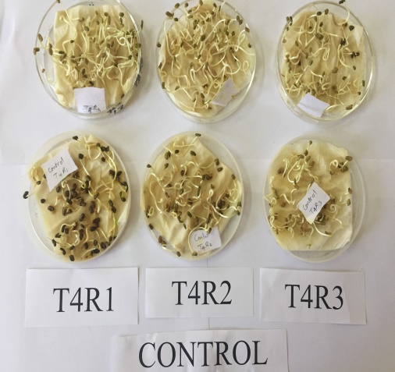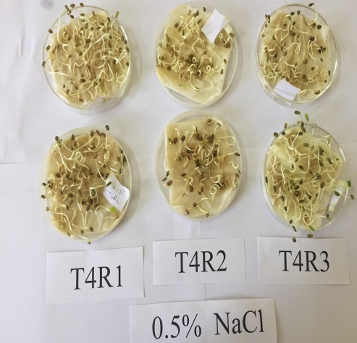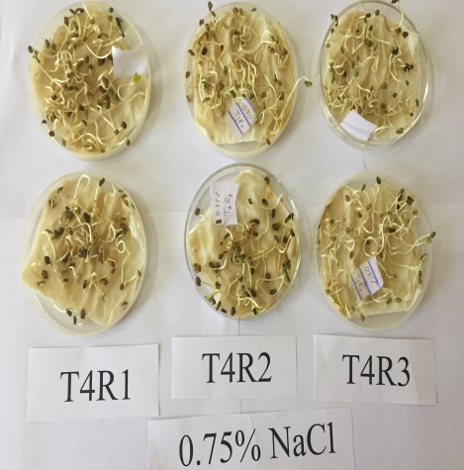
Fig. 5: Germination (%) at 8th days of Accession RMt-305 at different salinity regimes.

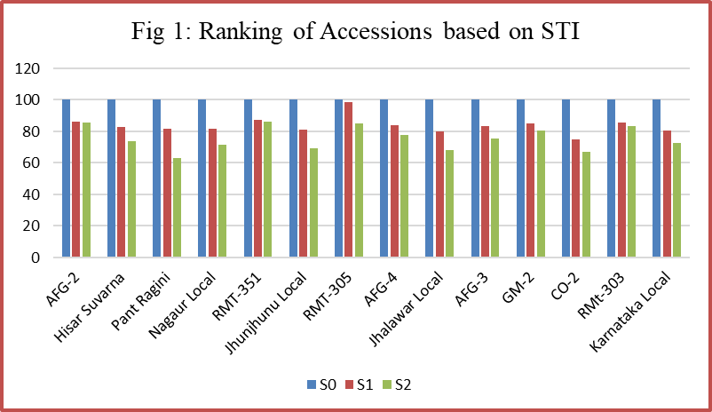

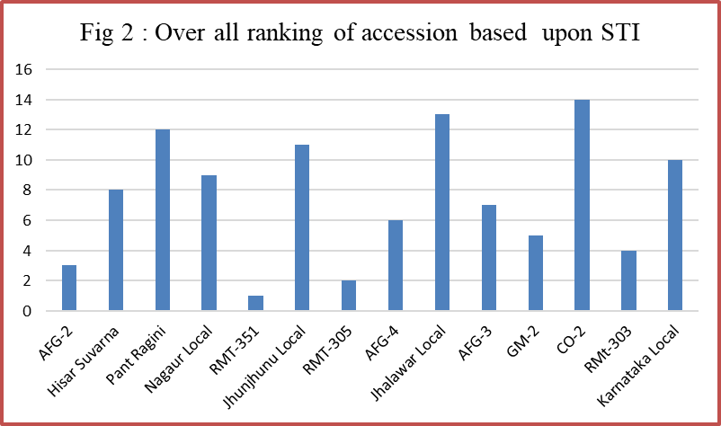

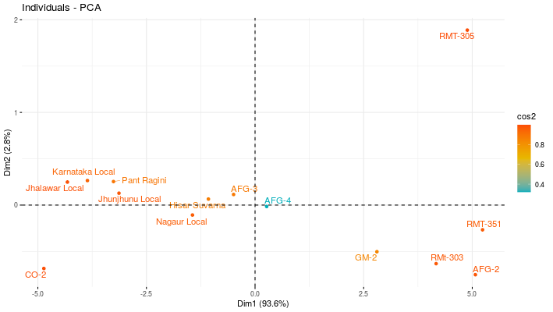

Fig 3: Distribution of cultivar across PC1, PC 2

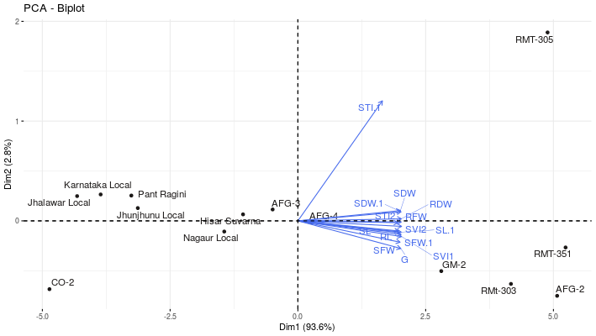

Fig 4. Biplot graph of the first two principal component axes for seed vigour traits and salt tolerant index.

