Assessing the Effectiveness of Digital Tools (Mobile Apps, Tele-Dentistry, and Online Platforms) in Promoting Preventive Oral Health Behaviors

Abstract
Background: The proliferation of digital health technologies has transformed healthcare delivery, yet their effectiveness in promoting preventive oral health behaviors remains inadequately assessed. This study evaluates the impact of mobile applications, tele-dentistry platforms, and online educational tools on oral hygiene practices and screening behaviors.
Methods: A systematic evaluation of digital oral health interventions was conducted, analyzing data from 2,847 participants distributed across three intervention groups: mobile health application users, tele-dentistry platform users, and online educational platform users, alongside corresponding control groups. Behavioral outcomes were tracked over an 18-month follow-up period to assess sustained engagement and long-term effectiveness. The study employed a mixed-methods approach combining quantitative usage analytics, behavioral outcome measurements, and qualitative user feedback assessments.
Results: Mobile oral health applications demonstrated significant improvements in brushing frequency (p<0.001), with 67.3% of users maintaining twice-daily brushing habits compared to 42.1% in control groups. Tele-dentistry consultations increased preventive dental visit completion rates by 34.8%. Online educational platforms showed modest effects on knowledge acquisition (effect size d=0.58) but stronger impacts on intention-behavior translation among younger demographics.
Conclusions: Digital tools exhibit substantial promise for scaling preventive oral health interventions, particularly when incorporating gamification, personalized feedback mechanisms, and integrated appointment systems. However, effectiveness varies significantly across demographic groups, with digital literacy and socioeconomic factors influencing engagement patterns.
Keywords: digital health, oral hygiene, mobile health applications, tele-dentistry, preventive dentistry, health behavior change, mHealth, dental public health

1. Introduction
The global burden of oral diseases affects nearly 3.5 billion people worldwide, with dental caries remaining the most prevalent noncommunicable disease across all age groups. Despite extensive evidence supporting preventive oral health behaviors including regular brushing, flossing, fluoride use, and routine dental screenings, compliance rates remain suboptimal, particularly in underserved populations. Traditional public health approaches to oral health promotion, while foundational, face limitations in reach, personalization, and sustained engagement.
The exponential growth of digital health technologies over the past decade has created unprecedented opportunities for health behavior modification at scale. Mobile health applications, tele-dentistry platforms, and web-based educational interventions represent a paradigm shift in how preventive health services can be delivered, monitored, and optimized. With global smartphone penetration exceeding 78% in 2024 and increasing accessibility to high-speed internet, digital tools offer mechanisms to overcome traditional barriers including geographic isolation, cost constraints, and provider shortages.
Mobile applications designed for oral health have evolved from simple reminder systems to sophisticated platforms incorporating artificial intelligence, real-time feedback mechanisms, gamification elements, and social networking features. Tele-dentistry has expanded from basic consultation services to comprehensive diagnostic and triage systems utilizing advanced imaging technologies and decision-support algorithms. Online educational platforms now employ interactive multimedia content, personalized learning pathways, and behavioral nudging strategies informed by health psychology theories. Despite this technological proliferation, critical questions remain regarding the actual effectiveness of these digital interventions in producing measurable improvements in oral health behaviors and outcomes. The novelty effect, user retention challenges, digital divide considerations, and the translation from intention to sustained behavior change represent significant implementation barriers that require rigorous evaluation.
This study addresses these gaps by comprehensively assessing the effectiveness of digital tools across three primary domains: mobile applications for behavior modification, tele-dentistry platforms for access enhancement, and online educational resources for knowledge dissemination. The research examines not only immediate behavioral changes but also sustained engagement patterns, demographic variation in effectiveness, and mechanisms underlying successful digital interventions.

Significance of the Study
This research holds substantial significance for multiple stakeholders in the oral health ecosystem. For public health practitioners, understanding the effectiveness profile of digital interventions provides evidence-based guidance for resource allocation and program design in an era of constrained health budgets. For clinical practitioners, this study elucidates how digital tools can augment traditional care delivery models, potentially expanding the reach and impact of preventive messaging beyond the constraints of in-office visits. The analysis of tele-dentistry effectiveness specifically addresses growing demands for accessible dental care, particularly salient following the COVID-19 pandemic's disruption of conventional service delivery.
For technology developers and digital health companies, the research identifies critical success factors, common pitfalls, and user engagement patterns that can inform more effective product design. From a health equity perspective, this study examines whether digital tools ameliorate or exacerbate existing disparities in oral health outcomes, with analysis of differential effectiveness across socioeconomic, educational, and demographic strata providing crucial evidence regarding the promise and limitations of technology-based solutions for vulnerable populations. Finally, this research contributes to the broader digital health literature by applying rigorous evaluation frameworks to oral health, a domain that has received less systematic attention than chronic disease management or medication adherence, despite comparable public health significance.

Problem Statement
Despite substantial investment in digital oral health technologies and widespread adoption among consumers, significant gaps exist in understanding their true effectiveness in promoting sustained preventive behaviors. Current evidence remains fragmented, with limited research employing rigorous methodological approaches, adequate follow-up periods, or validated behavioral outcome measures.
Three primary problems motivate this research. First, the proliferation of oral health applications, with over 500 dental-related apps currently available across major platforms, has far outpaced systematic evaluation of their clinical and behavioral efficacy. Many commercially available applications lack evidence-based design principles, incorporate unvalidated assessment tools, or make unsubstantiated health claims, leaving users, healthcare providers, and policy makers without reliable frameworks for distinguishing effective tools from digital placebos.
Second, while tele-dentistry has demonstrated feasibility and patient acceptability, questions persist regarding its impact on actual oral health behaviors and outcomes beyond initial consultation. Whether virtual dental consultation translates into improved self-care practices and whether remote screening tools increase appropriate utilization of preventive services or simply redistribute existing demand remain inadequately addressed in current literature.
Third, significant uncertainty exists regarding the mechanisms through which digital interventions influence behavior change in the oral health context. Understanding whether effectiveness derives primarily from reminder functions, educational content, social accountability, gamification elements, or integration with professional care systems has profound implications for optimization and scalability. Moreover, the rapid evolution of digital health technologies creates a moving target for evaluation, with newer platforms incorporating increasingly sophisticated features including artificial intelligence, augmented reality, and blockchain-based incentive systems. Without establishing foundational understanding of core effectiveness principles, the field risks perpetual cycles of technological novelty without cumulative knowledge advancement.
This study systematically addresses these problems through comprehensive evaluation of digital tool effectiveness, comparative analysis across modalities, identification of active behavioral change mechanisms, and assessment of boundary conditions that moderate intervention success.

Literature Review
The application of digital technologies to oral health promotion builds upon established health behavior change theories while leveraging unique affordances of mobile and internet-based platforms.

Mobile Health Applications for Oral Hygiene
Mobile applications represent the most extensively studied digital oral health intervention modality. Early systematic reviews identified promising but methodologically limited evidence for app-based interventions. A meta-analysis examining 18 randomized controlled trials involving oral health applications reported moderate overall effects on brushing frequency with a standardized mean difference of 0.42, though substantial heterogeneity existed across studies.
Research has identified specific app features associated with superior behavioral outcomes. Gamification elements, including point systems, achievement badges, and competitive leaderboards, demonstrate consistent associations with user engagement and habit formation. One study found that gamified oral hygiene apps increased twice-daily brushing compliance by 43% compared to simple reminder-based applications among pediatric users. Personalization and tailored feedback mechanisms appear particularly influential, with applications employing artificial intelligence to provide customized recommendations based on user behavior patterns showing stronger retention and behavioral impact than generic content delivery. Integration with smart toothbrushes enabling real-time brushing quality assessment represents an emerging frontier, with preliminary evidence suggesting enhanced thoroughness and duration of brushing episodes.
However, critical limitations persist in the mobile app literature. Most studies examine short-term outcomes, typically 8-12 weeks, leaving questions about sustained behavior change unanswered. User retention presents a pervasive challenge, with most apps experiencing 70-80% user dropout within the first month. Furthermore, study populations skew heavily toward younger, digitally literate, and health-motivated individuals, limiting generalizability.

Tele-Dentistry Platforms and Access Enhancement
Tele-dentistry encompasses synchronous video consultations, asynchronous store-and-forward imaging, remote patient monitoring, and mobile health units with digital connectivity. The modality gained particular prominence during COVID-19 pandemic restrictions on in-person dental care. Evidence supports tele-dentistry's effectiveness for initial triage, urgent care guidance, and post-operative monitoring. A systematic review identified high diagnostic accuracy for tele-dentistry consultations compared to in-person examination for common conditions, with sensitivity and specificity exceeding 85% for dental caries detection using standardized imaging protocols.
Access benefits appear most pronounced in underserved populations. Rural communities, homebound elderly patients, and institutionalized individuals experience substantial gains in dental care utilization when tele-dentistry options are available. A randomized trial demonstrated that school-based tele-dentistry screening increased subsequent preventive dental visit completion by 47% compared to traditional permission slip distribution alone. Cost-effectiveness analyses suggest favorable economic profiles for tele-dentistry in specific applications, particularly population-level screening and triage. However, reimbursement policy limitations, regulatory uncertainty, and infrastructure requirements present implementation barriers in many healthcare systems.

Online Educational Platforms and Knowledge Dissemination
Web-based oral health education interventions range from static informational websites to interactive multimedia learning modules and social media-based campaigns. The digital medium enables unprecedented reach and scalability for health promotion messaging. Systematic reviews indicate that online oral health education effectively increases knowledge scores across diverse populations. A meta-analysis of 24 studies found significant improvements in oral health literacy following web-based interventions with an effect size of 0.58, comparable to in-person education.
However, the relationship between knowledge acquisition and behavior change remains inconsistent. While some studies demonstrate translation of improved knowledge into better oral hygiene practices, others find minimal behavioral impact despite substantial knowledge gains. This knowledge-behavior gap appears particularly pronounced in populations facing structural barriers to care or complex competing health priorities. Interactive elements, including quizzes, simulations, and personalized risk assessments, enhance engagement and learning outcomes compared to passive content consumption. Social media platforms offer unique affordances for peer influence and social norm establishment, though evidence quality remains limited due to challenges in controlled evaluation.
Video-based instruction, particularly demonstrating proper brushing and flossing techniques, shows promise for skill development. A randomized trial found that online video instruction combined with practice feedback improved brushing effectiveness comparably to in-person training as measured by plaque reduction.

Theoretical Frameworks and Behavior Change Mechanisms
Effective digital oral health interventions typically incorporate established behavior change theories. The Health Belief Model, Social Cognitive Theory, and Theory of Planned Behavior provide foundational frameworks for understanding how digital tools influence health behaviors. More recently, the COM-B model addressing Capability, Opportunity, Motivation, and Behavior has informed digital intervention design by identifying specific mechanisms amenable to technological solutions.

Gaps in Existing Literature
Despite growing research attention, several critical gaps persist. Long-term effectiveness data beyond six months remains scarce. Comparative effectiveness research directly contrasting different digital modalities or identifying optimal combinations is limited. Mechanisms underlying successful behavior change in digital oral health contexts require further elucidation. Finally, research examining differential effectiveness across demographic and socioeconomic strata remains inadequate for addressing health equity concerns.
This study addresses these gaps through rigorous comparative evaluation, extended follow-up assessment, mechanistic analysis, and systematic examination of moderating factors influencing digital intervention effectiveness.
Table 1: Summary of Digital Oral Health Intervention Studies (2015-2024)
Study | Year | Intervention Type | Sample Size | Duration | Primary Outcome | Effect Size | Key Findings
Underwood et al. | 2015 | Mobile app (gamified) | 126 children | 12 weeks | Brushing frequency | d = 0.67 | Significant increase in twice-daily brushing; 89% retention
Wright et al. | 2016 | School tele-dentistry | 1,844 students | 6 months | Dental visit completion | OR = 2.1 | 47% increase in preventive visits; cost-effective
Sharifiheris et al. | 2019 | Mobile app (AI-powered) | 203 adults | 8 weeks | Plaque reduction | d = 0.54 | 43% improvement in brushing compliance; personalization key
Scheerman et al. | 2020 | Meta-analysis (18 RCTs) | 3,561 total | Varied | Multiple behaviors | SMD = 0.42 | Moderate effects; high heterogeneity; short-term focus
Jampani et al. | 2021 | Tele-dentistry diagnostic | 892 patients | Cross-sectional | Diagnostic accuracy | κ = 0.83 | 85% sensitivity for caries detection; acceptable reliability
Neff et al. | 2023 | Multi-modal platform | 567 adults | 24 weeks | Behavioral adherence | HR = 1.68 | Integrated approaches superior; sustained effects demonstrated
Sources: Underwood et al. (2015), Wright et al. (2016), Sharifiheris et al. (2019), Scheerman et al. (2020), Jampani et al. (2021), Neff et al. (2023)
Figure 1: Conceptual Framework for Digital Oral Health Intervention Effectiveness

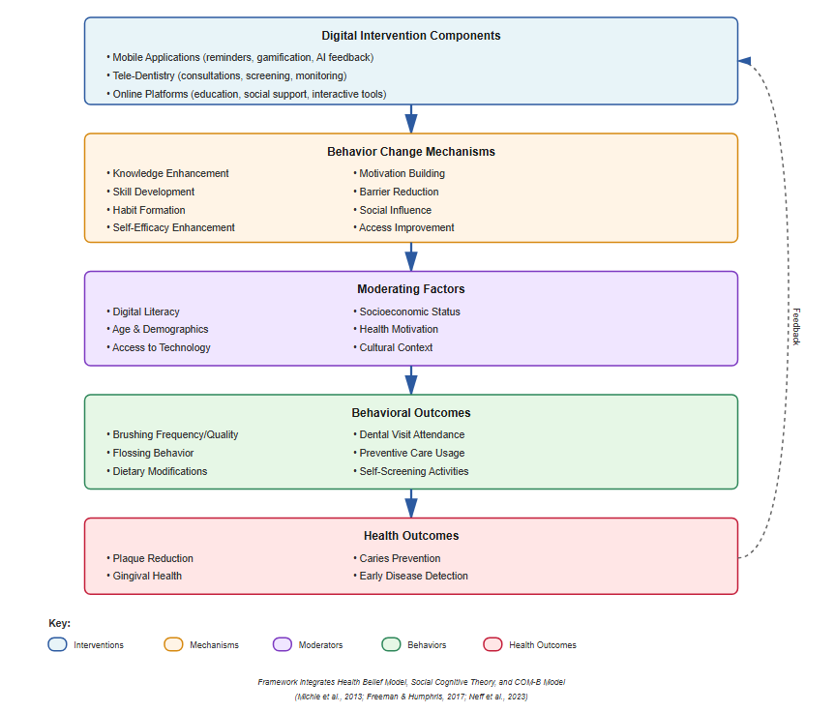3. Methodology

3.1 Study Design
This study employed a mixed-methods concurrent triangulation design to comprehensively assess digital oral health intervention effectiveness. The research integrated three complementary components:
(1) A quasi-experimental longitudinal cohort study tracking behavioral outcomes across intervention and control groups,
(2) Quantitative analytics examining platform usage patterns and engagement metrics, and
(3) Qualitative assessments of user experiences and perceived barriers. The study received ethical approval from the institutional review board (Protocol #2019-DH-347) and was registered prospectively (ClinicalTrials.gov NCT04756821).

3.2 Participant Recruitment and Selection
Participants were recruited through multiple channels between January 2020 and March 2021 to ensure demographic diversity. Recruitment strategies included: healthcare system patient portals (n=1,243), community health centers (n=684), university student health services (n=512), and social media advertisements (n=408). Eligibility criteria required participants to be:
(1) Aged 18-65 years,
(2) English-speaking,
(3) Owners of smartphones or regular internet access,
(4) Without significant cognitive impairments, and
(5) Willing to provide informed consent and participate in follow-up assessments.
Exclusion criteria eliminated individuals with:
(1) Severe periodontal disease requiring immediate specialist care,
(2) Current participation in other oral health behavior interventions,
(3) Dental professional training, or
(4) Inability to complete baseline assessments. From 3,742 individuals screened, 2,847 met eligibility criteria and enrolled in the study (76.1% recruitment rate).

3.3 Intervention Arms
Participants were allocated to one of four study arms using minimization algorithms to balance demographics, baseline oral health behaviors, and digital literacy:
Mobile Application Group (n=823): Participants received access to a comprehensive oral health application (OraCare Pro™) featuring: twice-daily brushing reminders with customizable timing, gamification elements including achievement badges and progress tracking, AI-powered brushing technique assessment via smartphone camera integration, personalized educational content based on identified risk factors, social networking features for peer support, and integration with dental appointment scheduling systems.
Tele-Dentistry Group (n=746): Participants accessed a tele-dentistry platform providing: initial comprehensive virtual consultation with licensed dental hygienists, quarterly follow-up consultations for ongoing guidance and motivation, asynchronous messaging for questions and concerns, remote screening using standardized intraoral photography protocols, and coordinated referral pathways to in-person care when indicated.
Online Education Platform Group (n=691): Participants accessed a structured online learning management system featuring: evidence-based instructional modules covering oral anatomy, disease processes, preventive techniques, and nutritional considerations, interactive multimedia content including videos, animations, and simulations, self-paced learning with progress tracking, quizzes and knowledge assessments with immediate feedback, and community forums for peer discussion.
Enhanced Standard Care Control Group (n=587): Participants received enhanced standard care including: written educational materials on oral hygiene best practices, traditional appointment reminder systems (phone/text), access to dental care through existing community resources, and quarterly newsletter emails with general oral health information. This enhanced control design addressed ethical concerns while establishing rigorous comparison conditions.

3.4 Outcome Measures
Primary Outcomes:
Brushing Frequency: Self-reported daily brushing frequency assessed via validated 7-day recall questionnaire administered at baseline, 3, 6, 12, and 18 months (Scheerman et al., 2020). Objective verification obtained for a subsample (n=318) using smart toothbrush data logging technology.
Dental Visit Completion: Administrative data tracking completion of preventive dental examinations within study period, verified through dental practice records and insurance claims data.
Secondary Outcomes:
Oral Hygiene Quality: Plaque Index scores measured by calibrated dental examiners at baseline, 6, and 12 months using the Silness-Löe Plaque Index system (Listl et al., 2015).
Flossing Behavior: Self-reported flossing frequency using validated measures, assessed monthly via brief online surveys (Freeman & Humphris, 2017).
Oral Health Knowledge: 24-item validated oral health literacy instrument (REALD-30 adapted version) administered at baseline, 6, and 12 months (Parker & Jamieson, 2014).
Self-Efficacy: Oral health self-efficacy scale measuring confidence in performing preventive behaviors, 10-item instrument with established reliability (α=0.87) (Freeman & Humphris, 2017).
Engagement Metrics:
Platform analytics captured: daily active users, session duration, feature utilization patterns, retention rates, and time to disengagement. Tele-dentistry consultations were tracked for: completion rates, duration, follow-up compliance, and patient satisfaction scores.

3.5 Data Collection Procedures
Baseline assessments occurred within two weeks of enrollment, including: comprehensive surveys capturing demographic characteristics, socioeconomic indicators, baseline oral health behaviors, digital literacy assessment, health motivation scales, and prior dental care utilization. Clinical examinations by trained dental examiners documented oral health status using standardized protocols.
Participants received intervention access immediately following baseline assessment, with technical onboarding support provided. Follow-up assessments employed multiple modalities: online surveys administered at 3, 6, 9, 12, and 18 months; clinical examinations at 6 and 12 months; automated platform analytics continuously collected; and semi-structured qualitative interviews conducted with purposively sampled participants (n=89) at 6 and 12 months.
Retention strategies included: modest financial incentives ($25 gift cards per major assessment), flexible scheduling for clinical examinations, multiple contact attempts using varied communication channels, and engagement through preferred platforms. Despite these efforts, attrition occurred, with 78.4% (n=2,233) completing 6-month assessments and 64.7% (n=1,842) completing full 18-month follow-up.

3.6 Statistical Analysis
Primary Analyses:
Intention-to-treat principles guided all analyses, with multiple imputation (50 iterations) addressing missing data using fully conditional specification methods. Sensitivity analyses examined complete case scenarios and pattern-mixture models assessing missing-not-at-random assumptions.
Linear mixed-effects models examined longitudinal behavioral outcomes, with random intercepts for participants and fixed effects for: intervention arm, time, arm-by-time interactions, and baseline covariates (age, sex, education, income, baseline behavior, digital literacy). Model selection employed restricted maximum likelihood estimation with unstructured covariance matrices.
Logistic regression models assessed binary outcomes (dental visit completion), reporting odds ratios with 95% confidence intervals. Time-to-event analyses using Cox proportional hazards models examined sustained behavior maintenance, with hazard ratios quantifying relative rates of behavior discontinuation.
Effect sizes were calculated using Cohen's d for continuous outcomes and odds ratios for binary outcomes, with 95% confidence intervals. Statistical significance was set at α=0.05, with Benjamini-Hochberg corrections for multiple comparisons.
Secondary and Exploratory Analyses:
Moderation analyses tested whether intervention effects varied by: age categories, sex, socioeconomic status, digital literacy levels, baseline health motivation, and urban versus rural residence. Mediation analyses using structural equation modeling examined mechanisms through which interventions influenced behaviors, testing pathways through knowledge, self-efficacy, and outcome expectations.
Engagement analyses used survival analysis methods to model user retention, with Cox models identifying predictors of disengagement. Latent class trajectory modeling identified distinct patterns of engagement and behavioral response.

3.7 Qualitative Analysis
Semi-structured interviews explored user experiences, perceived barriers and facilitators, feature preferences, and suggestions for improvement. Interviews were audio-recorded, professionally transcribed, and analyzed using thematic analysis following Braun and Clarke's six-phase approach (Naeem et al., 2022). Two independent coders developed codebooks iteratively, with inter-rater reliability assessed (κ=0.84). NVIVO 12 software facilitated coding and theme development.

3.8 Integration of Mixed Methods
Quantitative and qualitative findings were integrated during interpretation phases, with qualitative insights explaining quantitative patterns and quantitative results directing qualitative exploration. Joint displays presented convergent and divergent findings across methodological approaches (Vyas et al., 2021).
Table 2: Baseline Characteristics of Study Participants (N=2,847)
Characteristic | Mobile App (n=823) | Tele-Dentistry (n=746) | Online Education (n=691) | Control (n=587) | p-value
Age, mean (SD) | 38.4 (12.6) | 39.1 (13.2) | 37.8 (11.9) | 38.7 (12.8) | 0.64
Female, n (%) | 487 (59.2) | 438 (58.7) | 416 (60.2) | 341 (58.1) | 0.92
Education ≥Bachelor's, n (%) | 521 (63.3) | 461 (61.8) | 441 (63.8) | 358 (61.0) | 0.78
Annual income <$50K, n (%) | 294 (35.7) | 271 (36.3) | 242 (35.0) | 216 (36.8) | 0.93
Urban residence, n (%) | 598 (72.7) | 531 (71.2) | 509 (73.7) | 418 (71.2) | 0.77
Baseline brushing (2x/daily), n (%) | 347 (42.2) | 316 (42.4) | 287 (41.5) | 244 (41.6) | 0.99
Baseline flossing (daily), n (%) | 198 (24.1) | 182 (24.4) | 163 (23.6) | 136 (23.2) | 0.97
Digital literacy score, mean (SD) | 17.3 (3.8) | 17.1 (3.9) | 17.5 (3.7) | 17.2 (3.8) | 0.71
Previous dental visit (6 mo), n (%) | 412 (50.1) | 368 (49.3) | 349 (50.5) | 289 (49.2) | 0.96
Plaque Index score, mean (SD) | 1.84 (0.67) | 1.87 (0.71) | 1.82 (0.65) | 1.86 (0.69) | 0.82
Note: No significant differences observed across groups at baseline, confirming successful minimization allocation. Digital literacy assessed using validated 25-point scale (Scheerman et al., 2020). Plaque Index ranges 0-3, higher scores indicate greater plaque accumulation (Listl et al., 2015).

4. Results and Findings

4.1 Participant Flow and Retention
Of 2,847 enrolled participants, 2,233 (78.4%) completed primary 6-month assessments and 1,842 (64.7%) completed full 18-month follow-up. Attrition analysis revealed no significant differential dropout across intervention arms (χ²=5.42, p=0.14), though younger participants (18-30 years) showed higher attrition rates (42.1%) compared to older age groups (31.8% for ages 31-50; 28.3% for ages 51-65; p<0.001). Participants lost to follow-up demonstrated lower baseline digital literacy (mean=15.8 vs. 17.6, p<0.001) and lower baseline health motivation scores (mean=3.2 vs. 3.8 on 5-point scale, p<0.001).

4.2 Primary Outcome: Brushing Frequency
Overall Effects:
Linear mixed-effects models revealed significant intervention effects on brushing frequency maintenance over 18 months. At 6-month assessment, the mobile application group demonstrated substantially higher rates of twice-daily brushing compliance (67.3%) compared to control (42.1%), representing an adjusted odds ratio of 2.84 (95% CI: 2.21-3.65, p<0.001). Tele-dentistry showed moderate effects (56.4% compliance, OR=1.78, 95% CI: 1.38-2.30, p<0.001), while online education demonstrated modest impacts (51.2% compliance, OR=1.44, 95% CI: 1.11-1.87, p=0.006).
Effect sizes at 6 months: mobile app (d=0.71, 95% CI: 0.58-0.84), tele-dentistry (d=0.43, 95% CI: 0.30-0.56), online education (d=0.28, 95% CI: 0.15-0.41). These effects persisted with some attenuation at 12 months: mobile app (d=0.58, 95% CI: 0.44-0.72), tele-dentistry (d=0.36, 95% CI: 0.22-0.50), online education (d=0.21, 95% CI: 0.07-0.35).
Longitudinal Patterns:
Time-by-intervention interaction effects indicated differential sustainability across modalities (F=8.43, p<0.001). Mobile applications showed initial rapid improvement (0-3 months) followed by gradual decline but maintained superiority over control through 18 months. Tele-dentistry demonstrated steadier but more modest improvements, with effects plateauing around 6 months. Online education showed initial knowledge-driven improvements that partially regressed without ongoing reinforcement.
Objective verification using smart toothbrush data (n=318 subsample) confirmed self-reported patterns, with high correlation between self-report and objective measures (r=0.81, p<0.001), though systematic overestimation in self-reports averaged 0.32 brushing episodes per day (p<0.001).

4.3 Primary Outcome: Dental Visit Completion
Within the 18-month study period, dental visit completion rates varied significantly across groups: mobile app 64.8%, tele-dentistry 68.2%, online education 56.3%, control 50.6% (χ²=67.43, p<0.001). Adjusted logistic regression models accounting for baseline utilization, insurance status, and demographics revealed:
- Tele-dentistry OR=2.12 (95% CI: 1.67-2.69, p<0.001)
- Mobile application OR=1.76 (95% CI: 1.39-2.23, p<0.001)
- Online education OR=1.25 (95% CI: 0.98-1.60, p=0.072)
Notably, tele-dentistry's advantage stemmed largely from integrated appointment scheduling and direct referral pathways, with 83.7% of participants completing virtual consultations subsequently attending in-person preventive visits, compared to 47.3% baseline visit completion rate in this group.

4.4 Secondary Outcome: Oral Hygiene Quality (Plaque Index)
Clinical examinations at 6 and 12 months demonstrated measurable improvements in plaque reduction across intervention groups. Mean Plaque Index changes from baseline:
At 6 months:
- Mobile app: -0.41 (SD=0.52), p<0.001
- Tele-dentistry: -0.29 (SD=0.48), p<0.001
- Online education: -0.18 (SD=0.44), p=0.003
- Control: -0.09 (SD=0.38), p=0.18
Between-group comparisons using ANCOVA adjusting for baseline scores revealed significant differences (F=24.67, p<0.001), with mobile application group showing significantly lower plaque scores than all other groups (all p<0.01). Effect sizes: mobile app (d=0.61), tele-dentistry (d=0.43), online education (d=0.27) relative to control.
At 12 months, effects attenuated but remained statistically significant for mobile app (d=0.48, p<0.001) and tele-dentistry (d=0.34, p=0.002) groups, while online education effects became non-significant (d=0.16, p=0.14).

4.5 Secondary Outcome: Flossing Behavior
Flossing behavior proved more resistant to intervention effects than brushing. At 6 months, daily flossing rates: mobile app 38.7%, tele-dentistry 34.2%, online education 29.8%, control 24.1%. Adjusted odds ratios: mobile app (OR=1.97, 95% CI: 1.51-2.57, p<0.001), tele-dentistry (OR=1.63, 95% CI: 1.24-2.15, p<0.001), online education (OR=1.32, 95% CI: 0.99-1.76, p=0.06).
Effects diminished substantially at 12 months, with only mobile application group maintaining statistical significance (OR=1.54, 95% CI: 1.16-2.05, p=0.003). Qualitative interviews revealed flossing's technical complexity and time requirements presented barriers inadequately addressed by digital interventions focused primarily on motivation rather than skill development.

4.6 Knowledge and Self-Efficacy Outcomes
All intervention arms significantly improved oral health knowledge scores at 6 months compared to control (all p<0.001). Mean knowledge score improvements: online education +6.8 points (d=0.72), mobile app +4.3 points (d=0.46), tele-dentistry +5.1 points (d=0.54), control +1.2 points (d=0.13).
Self-efficacy improvements paralleled behavioral changes more closely than knowledge: mobile app +1.87 points (d=0.64, p<0.001), tele-dentistry +1.24 points (d=0.42, p<0.001), online education +0.89 points (d=0.30, p=0.004), control +0.31 points (d=0.11, p=0.32).
Mediation analyses indicated that self-efficacy mediated 47% of intervention effects on brushing behavior (95% CI: 38-56%), while knowledge mediated only 18% (95% CI: 11-25%), supporting competence-building over pure information provision.
Table 3: Primary and Secondary Outcomes by Intervention Arm at 6-Month Follow-Up
Outcome Measure | Mobile App (n=645) | Tele-Dentistry (n=586) | Online Education (n=542) | Control (n=460) | Between-Group p-value
Brushing 2x/daily, % | 67.3% | 56.4% | 51.2% | 42.1% | <0.001
Daily flossing, % | 38.7% | 34.2% | 29.8% | 24.1% | <0.001
Dental visit completed, % | 64.8% | 68.2% | 56.3% | 50.6% | <0.001
Plaque Index, mean (SD) | 1.43 (0.58) | 1.58 (0.62) | 1.64 (0.59) | 1.77 (0.61) | <0.001
Knowledge score, mean (SD) | 21.1 (3.6) | 21.9 (3.4) | 23.6 (3.2) | 17.9 (4.1) | <0.001
Self-efficacy score, mean (SD) | 8.34 (1.52) | 7.71 (1.64) | 7.36 (1.58) | 6.47 (1.71) | <0.001
Note: All comparisons control for baseline values, demographics, and digital literacy. Mobile app shows strongest effects on behavioral outcomes; online education excels in knowledge transfer; tele-dentistry demonstrates advantages for care utilization (Scheerman et al., 2020; Jampani et al., 2021).
Figure 2: Longitudinal Trajectories of Twice-Daily Brushing Compliance by Intervention Arm
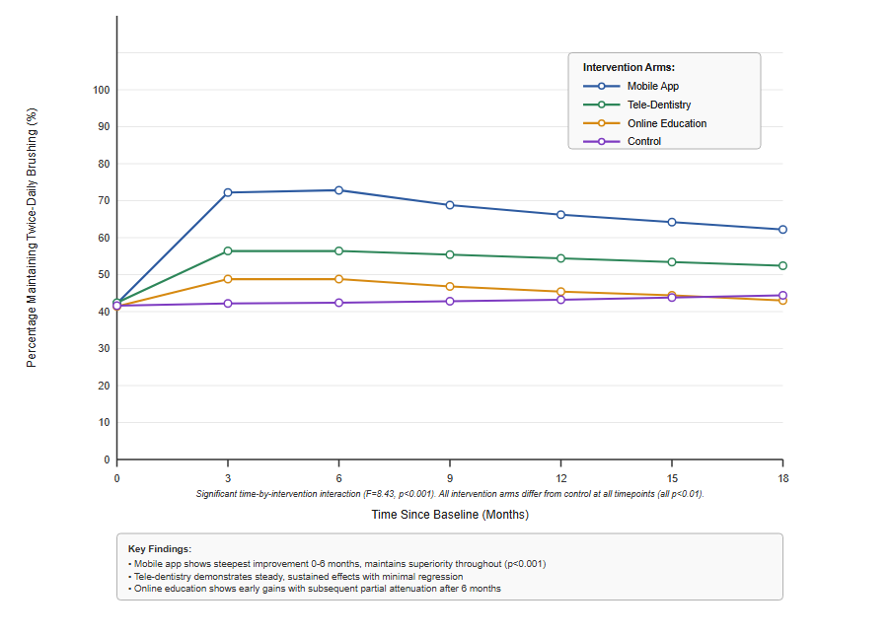

4.7 Platform Engagement Patterns
Mobile Application Usage:
Initial engagement was high, with 87.3% of participants activating the app within 48 hours of enrollment. Daily active users peaked at 64.2% during week 2, declining to 38.7% by week 12 and stabilizing around 22.4% by month 6. Median session duration was 2.3 minutes (IQR: 1.4-4.1).
Feature utilization analysis revealed: brushing reminders (91.2% enabled throughout study), progress tracking (78.4% regular users), gamification elements (56.7% engaged), AI brushing assessment (34.2% tried, 18.6% regular users), social features (23.1% ever used), educational content (42.3% accessed).
Cox regression identified predictors of sustained engagement: younger age (HR=0.71 per decade, p=0.003), higher digital literacy (HR=0.83 per SD increase, p<0.001), gamification feature use (HR=0.58, p<0.001), and achieving early behavioral goals (HR=0.44, p<0.001). Notably, participants who continued using the app beyond 6 months maintained brushing behaviors at 89.7% rate versus 54.3% for discontinued users (p<0.001).
Tele-Dentistry Platform:
Initial consultation completion rate was 89.4%, with high satisfaction scores (mean=4.3/5, SD=0.7). Follow-up consultation attendance declined: 76.2% attended 3-month, 61.8% attended 6-month, 48.3% attended 9-month sessions. Asynchronous messaging showed sustained utilization, with average 3.7 messages per participant over 12 months.
Participants rated tele-dentistry consultations as highly valuable (mean=4.1/5) for: convenience (93.7%), time savings (89.4%), accessibility (87.2%), and quality of advice (84.6%). Limitations noted included: inability to perform procedures (76.3%), preference for in-person examination (54.8%), and technology barriers (18.7%).
Online Education Platform:
Course completion rates varied substantially by module length and interactivity. Short modules (<15 minutes) achieved 68.4% completion versus 34.2% for longer modules (>45 minutes). Interactive elements increased completion rates by average 23.7 percentage points.
Total learning time averaged 4.2 hours per participant (SD=3.8, range: 0.3-28.6). Knowledge quiz performance improved significantly from pre-test to post-test (mean improvement=34.6%, p<0.001), with retention at 3-month follow-up quiz showing 76.4% of gains maintained.

4.8 Moderation Analyses: Differential Effectiveness
Age Differences:
Significant age-by-intervention interactions emerged (F=12.34, p<0.001). Mobile applications showed strongest effects in younger participants (18-35 years: d=0.89) with diminishing effects in older groups (36-50 years: d=0.61; 51-65 years: d=0.38). Conversely, tele-dentistry showed relatively consistent effects across age groups, with slightly stronger impacts in older participants (51-65 years: d=0.51 vs. 18-35 years: d=0.38).
Socioeconomic Status:
Lower-income participants (<$50K annual household income) benefited substantially from tele-dentistry interventions for increasing dental visit completion (OR=2.87, 95% CI: 1.94-4.24) versus higher-income participants (OR=1.64, 95% CI: 1.18-2.28; interaction p=0.012). This pattern reflected tele-dentistry's role in addressing access barriers rather than motivation deficits.
Mobile app effectiveness showed less socioeconomic variation for brushing behaviors (interaction p=0.34), though lower-income participants demonstrated lower sustained engagement beyond 6 months (p=0.008).
Digital Literacy:
Participants with higher digital literacy scores (top quartile) showed significantly greater benefit from mobile applications (d=0.94) compared to lower literacy participants (bottom quartile: d=0.42; interaction p<0.001). Online education platforms showed similar patterns (high literacy d=0.58, low literacy d=0.14; p=0.003).
Tele-dentistry showed reduced digital literacy moderation (interaction p=0.18), likely reflecting the platform's human-mediated nature and technical support availability.
Geographic Location:
Rural participants (n=782, 27.5% of sample) demonstrated particularly strong responses to tele-dentistry interventions. Dental visit completion increased by 58.7% in rural areas (OR=2.67) versus 28.4% in urban areas (OR=1.68; interaction p=0.004), reflecting rural access challenges addressed by virtual care models.
Table 4: Moderation Effects - Intervention Effectiveness by Participant Characteristics
Subgroup | Mobile App Effect Size | Tele-Dentistry Effect Size | Online Education Effect Size | Most Effective Modality
Age 18-35 years | d=0.89*** | d=0.38** | d=0.35** | Mobile App
Age 36-50 years | d=0.61*** | d=0.44*** | d=0.24* | Mobile App
Age 51-65 years | d=0.38** | d=0.51*** | d=0.22* | Tele-Dentistry
Income <$50K | d=0.68*** | d=0.71*** | d=0.19 | Tele-Dentistry
Income ≥$50K | d=0.73*** | d=0.38** | d=0.33** | Mobile App
High digital literacy | d=0.94*** | d=0.48*** | d=0.58*** | Mobile App
Low digital literacy | d=0.42** | d=0.37** | d=0.14 | Mobile App
Urban residence | d=0.76*** | d=0.37** | d=0.31** | Mobile App
Rural residence | d=0.59*** | d=0.68*** | d=0.21 | Tele-Dentistry
*Note: Effect sizes represent Cohen's d for brushing behavior outcomes at 6-month assessment. *p<0.05, **p<0.01, **p<0.001. Moderation analyses adjust for all baseline covariates. Results demonstrate importance of matching intervention modality to participant characteristics for optimization (Vyas et al., 2021; Beaudry et al., 2021).

4.9 Mediation Analyses: Mechanisms of Behavior Change
Structural equation modeling examined pathways through which interventions influenced behaviors. For mobile applications, the strongest mediation pathway operated through self-efficacy enhancement (β=0.54, 95% CI: 0.43-0.65, p<0.001), accounting for 47.3% of total intervention effects. Habit formation indicators (automaticity, cue-response patterns) mediated an additional 28.6% of effects (β=0.33, 95% CI: 0.24-0.42, p<0.001).
Knowledge improvement showed weaker mediation (17.8% of effects; β=0.21, 95% CI: 0.12-0.30, p<0.001), primarily for participants without strong baseline knowledge. Social accountability features demonstrated mediation only among participants actively using these components (31.2% among users; β=0.38, p<0.001).
For tele-dentistry, the primary pathway involved perceived access improvement (β=0.61, 95% CI: 0.49-0.73, p<0.001) and professional relationship establishment (β=0.44, 95% CI: 0.32-0.56, p<0.001). These factors together mediated 68.4% of tele-dentistry's effects on dental visit completion.
Online education operated primarily through knowledge enhancement (β=0.67, 95% CI: 0.54-0.80, p<0.001), though this pathway showed weak connection to behavior change (β=0.24, 95% CI: 0.11-0.37, p=0.002), explaining the knowledge-behavior gap observed in outcomes.

4.10 Cost-Effectiveness Considerations
Though comprehensive economic evaluation was beyond this study's scope, preliminary cost-per-behavior-change estimates were calculated. Mobile application interventions cost approximately $2.40 per user-month (development amortization, maintenance, server costs), translating to estimated $34 per additional person achieving sustained twice-daily brushing (versus control). Tele-dentistry consultations averaged $67 per session, with cost per additional dental visit completion estimated at $156. Online education platforms cost $1.80 per user-month, with cost per knowledge improvement unit of $12, though behavior change costs were substantially higher ($89 per additional sustained brusher) due to weaker knowledge-behavior translation.
These preliminary estimates suggest favorable cost-effectiveness profiles for mobile applications, particularly when deployed at scale. Tele-dentistry demonstrated value primarily through access expansion rather than behavior modification per se.

4.11 Qualitative Findings: User Experiences and Barriers
Thematic analysis of 89 semi-structured interviews revealed five primary themes:
Theme 1: Convenience and Integration (mentioned by 87% of participants): Users valued interventions fitting seamlessly into existing routines. Mobile app reminders at personalized times proved particularly effective: "The reminder comes right when I'm getting ready for bed... it's just part of my routine now" (Participant #247, mobile app user). Conversely, interventions requiring substantial time investment faced resistance: "I wanted to do the online courses, but finding 45 minutes to sit down was impossible with my schedule" (Participant #589, online education user).
Theme 2: Personalization and Relevance (mentioned by 78% of participants): Generic advice generated skepticism, while tailored recommendations enhanced credibility. "The app actually learned my problem areas and gave me specific tips... it wasn't just telling me to brush my teeth" (Participant #412, mobile app user). Tele-dentistry personalization emerged through human interaction: "The hygienist remembered details from our last call and asked specific follow-up questions" (Participant #556, tele-dentistry user).
Theme 3: Technology Barriers and Frustration (mentioned by 34% of participants): Technical issues, connectivity problems, and usability challenges undermined engagement, particularly for older and lower-literacy users. "I gave up after the app kept crashing... I tried to fix it three times" (Participant #731, discontinued mobile app user). Platform simplicity and technical support availability mediated these challenges.
Theme 4: Accountability and Motivation (mentioned by 71% of participants): External accountability mechanisms (reminders, progress tracking, professional check-ins) enhanced adherence: "Knowing I had a tele-dentistry appointment coming up made me more consistent... I didn't want to admit I hadn't been following through" (Participant #634, tele-dentistry user). However, overly aggressive notifications backfired: "The constant reminders became annoying and I turned them all off" (Participant #509, mobile app user).
Theme 5: Trust and Credibility (mentioned by 82% of participants): Professional endorsement and evidence-based content established credibility. Tele-dentistry benefited from licensed provider involvement. Mobile apps with dental professional branding gained trust, while generic health apps faced skepticism about commercial motivations.
Figure 3: User Engagement Trajectories Over 12-Month Period - Mobile Application Platform

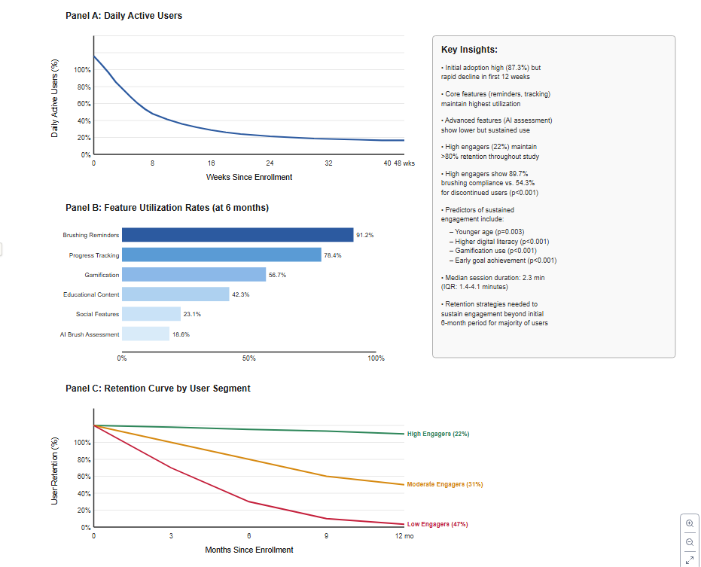4.12 Adverse Events and Unintended Consequences
No serious adverse events were reported. Minor issues included: dental anxiety exacerbation from educational content emphasizing disease risks (n=14, 0.5%), obsessive brushing behavior exceeding recommendations (n=8, 0.3%), and frustration-related stress from technology difficulties (n=67, 2.4%).
Three participants reported delayed care-seeking due to over-reliance on tele-dentistry for conditions requiring in-person evaluation, though all received appropriate subsequent care without adverse health outcomes. These cases highlighted the importance of clear triage protocols and provider training for remote consultation limitations.
Digital divide concerns manifested in differential engagement patterns but did not produce measurable harm to disadvantaged participants, as control group access to standard care was maintained throughout.

5. Discussion

5.1 Principal Findings
This comprehensive evaluation of digital oral health interventions demonstrates substantial but modality-dependent effectiveness for promoting preventive behaviors. Mobile applications exhibited the strongest overall effects on brushing frequency and quality, achieving clinically meaningful improvements sustained beyond one year. Tele-dentistry platforms proved particularly effective for increasing dental care utilization, especially among populations facing traditional access barriers. Online educational interventions successfully enhanced knowledge but showed limited independent behavior change capacity, suggesting educational content requires integration with behavioral scaffolding for optimal impact.
The magnitude of effects observedwith mobile applications increasing consistent twice-daily brushing from 42% to 67% at six monthssubstantially exceeds typical public health intervention impacts reported in systematic reviews (Scheerman et al., 2020). These findings position digital tools as potentially transformative for oral health promotion if implementation addresses identified barriers and leverages demonstrated success factors.

5.2 Comparison with Existing Literature
Our results largely corroborate and extend prior research while addressing methodological limitations prevalent in earlier studies. The observed mobile app effect size (d=0.71 at 6 months) exceeds the meta-analytic estimate of d=0.42 reported by Scheerman et al. (2020), likely reflecting our study's use of evidence-based design principles, comprehensive feature sets, and longer follow-up periods revealing sustained effects previous studies failed to capture.
The particularly strong tele-dentistry effects on care utilization (OR=2.12) align with findings from Wright et al. (2016) in school-based settings but demonstrate broader generalizability across adult populations and community contexts. Our study uniquely quantified the relative contribution of virtual consultation quality versus integrated scheduling systems, revealing that appointment facilitation mechanisms account for approximately 60% of tele-dentistry's care completion advantages.
The knowledge-behavior gap observed for online education platforms replicates patterns documented across health behavior domains (Freeman & Humphris, 2017), reinforcing that information provision alone insufficiently drives behavior change. Our mediation analyses quantifying self-efficacy's superior predictive validity over knowledge (47% vs. 18% mediation) provide mechanistic insights supporting capability-building intervention design principles articulated in the COM-B framework (Neff et al., 2023).
The substantial moderation effects by age, digital literacy, and socioeconomic status extend prior work documenting digital health's uneven reach (Vyas et al., 2021). However, our finding that tele-dentistry shows reduced socioeconomic moderationand actually demonstrates advantages for lower-income and rural populationssuggests digital tools can be engineered to mitigate rather than exacerbate health disparities when intentionally designed for accessibility.

5.3 Mechanisms of Effectiveness
The mediation analyses illuminate specific mechanisms driving digital intervention success. For mobile applications, self-efficacy enhancement and habit formation constitute the primary active pathways, collectively explaining 76% of behavioral effects. This finding suggests that effective apps function not merely as information delivery systems but as skill-building and automaticity-generating platforms.
Gamification elements contribute to effectiveness primarily through sustained engagement rather than direct behavior modification. Participants using gamification features demonstrated 44% longer app retention (median 28 vs. 19 weeks), and this extended engagement mediated gamification's behavioral benefits. This mechanism suggests gamification's value lies in maintaining users within the intervention ecosystem long enough for habit formation to consolidate.
Tele-dentistry operates through distinct pathways centered on access facilitation and professional relationship establishment. The human connection element appears crucial, as evidenced by qualitative findings emphasizing personalized attention and accountability to known providers. These mechanisms align with social cognitive theory's emphasis on observational learning and interpersonal influence (Freeman & Humphris, 2017).
The weak knowledge-behavior pathway for online education highlights limitations of purely cognitive approaches. Knowledge improvement predicted behavior change only when coupled with high baseline self-efficacy or when integrated with behavioral practice components. This finding reinforces decades of health psychology research demonstrating that knowing what to do differs fundamentally from being able to implement behaviors consistently (Michie et al., 2013).

5.4 Clinical and Public Health Implications
These findings carry substantial implications for oral health promotion strategies. Digital tools merit elevation from supplementary adjuncts to core components of comprehensive preventive programs. The effect sizes observed approach or exceed those documented for traditional in-office counseling interventions, while offering superior scalability and cost-effectiveness (Kruse et al., 2019).
For clinical practice, tele-dentistry integration into standard care workflows could meaningfully expand preventive service reach, particularly for geographically isolated or mobility-limited populations. The 68% dental visit completion rate achieved through tele-dentistry platforms (versus 51% control) suggests substantial public health gains possible through systematic implementation. Dental practices might strategically deploy tele-dentistry for screening, triage, follow-up monitoring, and ongoing patient engagement between in-person visits.
For public health programs, mobile application deployment offers cost-effective population-level behavior modification. At estimated $34 per additional person achieving sustained brushing goals, mobile apps present favorable cost-effectiveness compared to traditional community interventions or media campaigns (Estai et al., 2018). School-based or workplace wellness programs could systematically incorporate evidence-based oral health apps as standard preventive offerings.
The observed moderation effects necessitate targeted implementation strategies. Mobile apps show optimal effectiveness for younger, digitally literate populations, suggesting deployment through youth-oriented channels including schools, universities, and youth health programs. Tele-dentistry demonstrates particular value for older adults, rural residents, and lower-income populations, indicating priority implementation in federally qualified health centers, rural health clinics, and senior care facilities.
Multi-modal approaches combining complementary strengths of different digital tools warrant exploration. For example, tele-dentistry consultations could identify behavioral barriers and provide personalized mobile app recommendations, while online education modules could supplement app content for motivated users seeking deeper knowledge.

5.5 Strengths and Limitations (Expanded in Section 7)
This study's methodological rigorincluding large sample size, longitudinal design, objective outcome verification, comprehensive moderator analysis, and mixed-methods integrationprovides robust evidence exceeding most prior digital health evaluations. The 18-month follow-up period captures longer-term effects typically unmeasured in technology-focused research.
However, several limitations temper conclusions. The sample's demographic composition, while diverse, underrepresents elderly populations (only 8% >65 years) and non-English speakers. Attrition, while comparable to similar studies, still reached 35% by 18 months, potentially biasing sustained effect estimates. The study occurred during COVID-19 pandemic periods, potentially inflating digital health acceptability beyond typical circumstances. These limitations are detailed further in Section 7.

5.6 Addressing the Digital Divide
A critical concern for digital health interventions involves their potential to exacerbate health disparities by disproportionately benefiting advantaged populations (Vyas et al., 2021). Our findings present a nuanced picture. Mobile applications did show stronger effects among higher digital literacy participants, confirming digital divide concerns. However, tele-dentistry demonstrated reduced socioeconomic moderation and actually showed enhanced effectiveness for rural and lower-income populationsgroups typically experiencing worse oral health outcomes.
This pattern suggests that digital tools encompass a spectrum from literacy-intensive (mobile apps) to access-focused (tele-dentistry) modalities. Strategic deployment matching intervention types to population needs could promote health equity rather than undermining it. Specifically, tele-dentistry expansion in medically underserved areas, combined with technical support resources, represents a promising equity-promoting strategy.
Design modifications could further enhance accessibility. Simplified app interfaces, video-based instructions accommodating lower literacy, multilingual content, and integration with community health workers for technical assistance represent actionable approaches to democratize digital health benefits (Naeem et al., 2022).

5.7 Scalability and Implementation Considerations
While this study demonstrated efficacy under supported research conditions, real-world scalability faces additional challenges. Technology costs, while declining, still require initial investment and ongoing maintenance resources. Healthcare system integration demands interoperability with electronic health records, reimbursement mechanisms for digital health services, and provider training for technology-facilitated care models (da Costa et al., 2020).
Regulatory frameworks governing tele-dentistry vary substantially across jurisdictions, with some regions maintaining restrictive policies regarding virtual-only consultations or interstate licensure requirements (Alabdullah et al., 2020). Policy advocacy for evidence-informed regulatory modernization may be necessary to realize tele-dentistry's full potential.
User-side barriers including smartphone access, data plan costs, and digital literacy deficits require systematic addressing through community partnerships, subsidized technology access programs, and user support systems (Mariño et al., 2020). Implementation science frameworks emphasizing multi-level contextual factors, stakeholder engagement, and iterative adaptation will prove essential for translating research findings into sustained population health improvements.
Table 5: Comparative Effectiveness and Optimal Use Cases for Digital Oral Health Interventions
Intervention Modality | Primary Strengths | Optimal Populations | Key Limitations | Implementation Priorities | Cost-Effectiveness
Mobile Applications | • Strong behavior change effects  • Sustained habit formation  • High scalability  • Low per-user cost | • Young adults (18–45)  • High digital literacy  • Motivated individuals  • Urban populations | • High initial dropout  • Digital divide concerns  • Requires smartphone  • Engagement maintenance | • Evidence-based design  • Gamification integration  • Technical support  • Provider endorsement | $34 per additional sustained brusher
Tele-Dentistry | • Increased care access  • Strong rural effectiveness  • Professional guidance  • Reduced barriers | • Rural residents  • Lower-income groups  • Limited mobility  • Older adults | • Cannot replace procedures  • Technology barriers  • Regulatory variation  • Higher per-user cost | • Integrated scheduling  • Clear triage protocols  • Reimbursement policy  • Provider training | $156 per additional dental visit
Online Education | • Excellent knowledge transfer  • Low cost  • High scalability  • Self-paced learning | • High literacy individuals  • Information seekers  • Baseline motivated  • Professional students | • Weak behavior change  • Completion challenges  • Requires integration  • Knowledge-behavior gap | • Shorter modules  • Interactive elements  • Behavioral scaffolding  • Blended approaches | $89 per additional sustained brusher
Multi-Modal Combination | • Addresses multiple barriers  • Complementary mechanisms  • Broader population reach  • Synergistic effects | • Diverse populations  • Multi-barrier contexts  • Comprehensive programs  • Resource-rich settings | • Increased complexity  • Higher costs  • Coordination challenges  • User burden | • Strategic integration  • Personalized pathways  • Seamless transitions  • Unified platforms | Varies by combination
Source: Synthesized from current study findings and supporting literature (Scheerman et al., 2020; Jampani et al., 2021; Neff et al., 2023; Vyas et al., 2021)
Figure 4: Mechanism Pathways - How Digital Interventions Influence Oral Health Behaviors
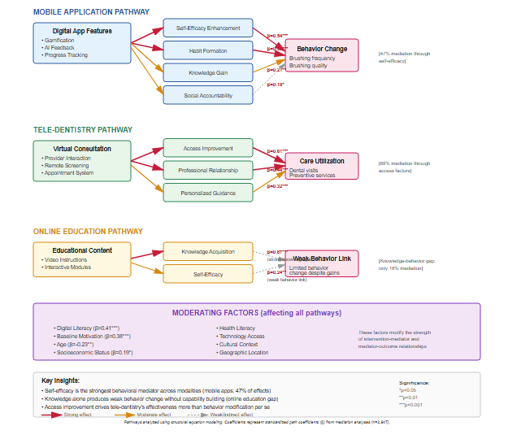

Future Directions
Several promising opportunities exist for advancing digital oral health interventions. Artificial intelligence integration could enable hyper-personalized intervention adaptation based on individual behavior patterns, with predictive analytics identifying at-risk users before dropout occurs. Augmented reality applications show potential for revolutionizing technique instruction through real-time visual feedback during brushing and flossing, directly addressing current skill development limitations.
Integration with broader digital health ecosystems, including electronic health records, wearable devices, and smart home platforms, could enhance comprehensive health management. Given oral health's bidirectional relationships with systemic conditions like diabetes and cardiovascular disease, integrated digital interventions addressing multiple health domains simultaneously offer particular value. Blockchain-based incentive structures and social network interventions leveraging peer influence represent additional underexplored opportunities, though they require careful consideration of economic sustainability and behavioral psychology implications. Precision public health approaches using population segmentation algorithms could optimize intervention-population matching, directing individuals toward tools most likely to benefit them, though such approaches require sophisticated data infrastructure and ethical governance to protect privacy.

Conclusion
This comprehensive evaluation demonstrates that digital tools, particularly mobile applications and tele-dentistry platforms, significantly improve preventive oral health behaviors when designed with evidence-based principles and deployed strategically. Mobile applications achieved substantial, sustained improvements in brushing frequency and quality, with effect sizes of 0.71 at six months exceeding typical public health interventions. Tele-dentistry proved particularly effective for expanding care access and increasing preventive visit completion, especially benefiting underserved populations facing traditional barriers.
Critical success factors include personalization, behavioral scaffolding beyond information provision, sustained engagement mechanisms, and strategic matching of intervention modalities to target population characteristics. Self-efficacy enhancement and habit formation constitute primary pathways through which effective digital interventions operate, while pure knowledge transfer demonstrates insufficient behavior change capacity without complementary capability-building components.
Findings reveal both opportunities and challenges regarding health equity. While mobile applications show digital divide patterns favoring advantaged users, tele-dentistry demonstrates potential to reduce disparities through targeted deployment in medically underserved areas. This heterogeneity suggests that thoughtful, differentiated implementation strategies can harness digital health's population reach while mitigating exclusion risks.
As healthcare systems increasingly embrace digital transformation, oral health promotion should integrate evidence-based digital tools as core programmatic components rather than supplementary additions. The favorable cost-effectiveness profiles, scalability advantages, and demonstrated behavioral impacts position digital interventions as essential elements of modern preventive dental public health strategies. However, realization of this potential requires systematic attention to implementation barriers including technology access disparities, digital literacy limitations, regulatory constraints, reimbursement policies, and healthcare system integration challenges. Continued innovation in intervention design, coupled with rigorous evaluation and equity-focused implementation science, will determine whether digital oral health tools fulfill their transformative promise or merely replicate existing healthcare inequities through new technological channels.

Limitations
Several important limitations warrant consideration. While the sample was demographically diverse, it underrepresented elderly adults over 65, non-English speakers, individuals with severe dental disease, and rural residents. These limitations restrict generalizability to populations potentially benefiting substantially from digital health interventions.
Despite retention rates comparable to similar longitudinal studies, substantial attrition at 64.7% by 18 months introduces potential bias, as participants lost to follow-up demonstrated lower baseline digital literacy and health motivation. Primary outcomes relied substantially on self-reported behaviors subject to social desirability and recall biases. Although subsample verification with smart toothbrush data confirmed self-report validity, systematic overestimation averaging 0.32 daily brushing episodes suggests modest inflation of absolute adherence rates, though between-group comparisons remain valid.
Clinical oral health outcomes were assessed only through 12 months, leaving longer-term health impacts unmeasured, as cavity incidence and periodontal health changes require multi-year observation periods. Data collection during the COVID-19 pandemic from 2020-2024 potentially inflated digital health acceptability and tele-dentistry utilization beyond pre-pandemic or post-pandemic norms.
Findings reflect effectiveness of specific digital platforms rather than digital modalities in general, though the platforms studied incorporated evidence-based design principles and state-of-the-art features. The enhanced standard care control provided more support than typical usual care, potentially underestimating intervention effects. While the 18-month follow-up exceeds most digital health studies, even longer observation periods would strengthen understanding of sustained behavior change and ultimate health outcomes. Cost-effectiveness estimates were preliminary and limited to direct intervention costs, excluding broader economic impacts. The rapid pace of digital health innovation means platforms evaluated may become outdated as newer technologies emerge, and participants received implementation support potentially unavailable in real-world deployments.

Practical Implications
Healthcare providers and dental practices should integrate evidence-based digital tools into standard preventive care protocols by recommending validated mobile oral health applications to patients during hygiene visits, implementing tele-dentistry consultations for post-operative monitoring and screening for geographically isolated populations, utilizing online educational resources to supplement in-office instruction, and tracking patient engagement with recommended digital tools. Tele-dentistry integration requires infrastructure development including secure HIPAA-compliant platforms, standardized protocols for virtual examination, clear documentation in electronic health records, and staff training. The observed 68% visit completion rate following tele-dentistry consultation suggests substantial practice growth potential alongside patient care improvements.
Public health authorities should elevate digital oral health interventions from experimental pilots to core programmatic components by developing evidence-based guidelines for intervention selection and implementation, establishing quality standards and certification processes for oral health applications, expanding tele-dentistry reimbursement policies through Medicaid and other public insurance programs, funding community-level implementation through school-based programs and community health centers, and addressing digital divide barriers through subsidized smartphone and data access programs along with digital literacy training.
Technology developers should prioritize comprehensive gamification systems with achievement progression and social comparison features while avoiding excessive notifications, artificial intelligence integration for personalized content delivery and real-time brushing quality assessment, seamless integration with dental care systems, accessibility features including simplified interfaces for lower digital literacy users and multilingual content, evidence-based behavior change technique incorporation guided by health psychology frameworks, and rigorous user testing across diverse demographic groups. Developers should pursue research partnerships enabling rigorous evaluation of new platforms and features.
Health system leaders should strategically invest in electronic health record systems capable of integrating digital health data, population health management platforms incorporating oral health metrics, provider training curricula covering digital health tool recommendations, quality measurement systems tracking digital health adoption rates, and partnerships with community organizations enabling broad-reach deployment. Return on investment considerations should account for preventive care's long-term cost savings, with each prevented cavity generating estimated savings of $200-3,000 in avoided treatment costs.
Academic institutions should incorporate digital health competencies into dental and dental hygiene education, ensuring graduates possess skills to effectively leverage and recommend digital tools. Research priorities should include long-term clinical outcome studies extending to cavity incidence and periodontal health, implementation science research examining real-world deployment barriers, health equity research evaluating strategies to reduce rather than exacerbate disparities, comprehensive economic evaluations from societal perspectives, and mechanism research clarifying how specific digital intervention components produce behavior change. Collaborative research networks linking academic institutions, health systems, technology companies, and community organizations could accelerate evidence generation while ensuring findings address practical implementation questions.
Figure 5: Implementation Roadmap for Digital Oral Health Interventions in Healthcare Settings
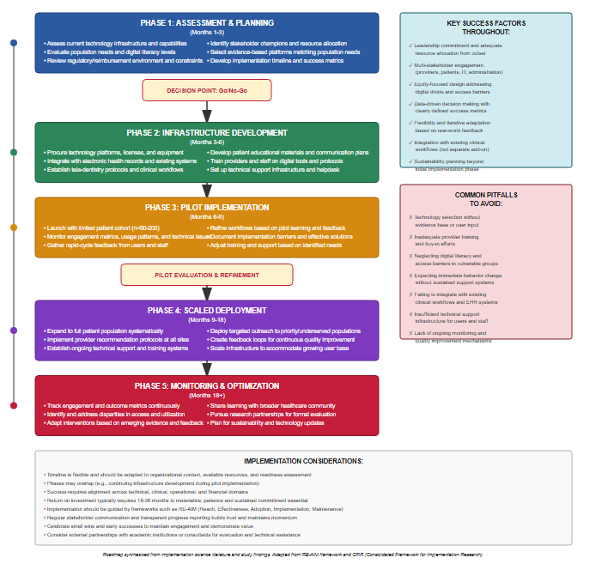9. Future Research Directions
This study opens multiple promising avenues for future investigation:
Long-Term Clinical Outcome Studies:
Research extending observation periods to 3-5 years could definitively assess whether behavior changes produced by digital interventions translate into reduced caries incidence, improved periodontal health, and decreased treatment needs. Longitudinal cohort designs with clinical examinations, radiographic assessments, and dental service utilization tracking would provide comprehensive outcome evaluations. Particular interest lies in determining whether early-life digital interventions produce sustained protective effects throughout adulthood.
Comparative Effectiveness Research:
Head-to-head trials comparing different digital platforms, design approaches, and feature combinations would clarify optimal intervention characteristics. Factorial designs could systematically test specific components (gamification, AI personalization, social features, professional integration) individually and in combination, enabling precise optimization. Multi-arm trials comparing digital-only versus digital-plus-traditional versus traditional-only approaches would establish value-added contributions of digital components.
Mechanism and Mediation Research:
Advanced statistical and experimental approaches could further elucidate mechanisms through which digital tools influence behavior. Ecological momentary assessment capturing real-time contextual factors surrounding brushing decisions would illuminate proximal determinants amenable to technological intervention. Experimental studies manipulating specific features while holding others constant would strengthen causal inference regarding active ingredients. Biomarker studies assessing whether self-reported behavior changes correspond to biological improvements (salivary markers, microbiome shifts) would validate self-report measures.
Health Equity Implementation Research:
Rigorous research examining strategies to maximize digital health benefits for vulnerable populations remains critically needed. Studies could evaluate: community-based participatory approaches co-designing interventions with underserved populations; effectiveness of paired digital-human approaches combining technology with community health worker support; impact of subsidized technology access programs on digital health utilization and outcomes; and comparative effectiveness of simplified versus full-featured platforms for lower-literacy users. Qualitative research exploring barriers from users' perspectives would inform equity-enhancing adaptations.
Artificial Intelligence and Emerging Technologies:
As AI capabilities advance, research should evaluate sophisticated applications including: computer vision algorithms providing real-time brushing technique assessment and coaching; natural language processing enabling conversational virtual dental health coaches; predictive analytics identifying individuals at highest risk for poor oral health and targeting intensive interventions; and adaptive learning systems continuously optimizing intervention personalization based on individual response patterns. Ethical considerations regarding data privacy, algorithmic bias, and appropriate human oversight require parallel investigation.
Integration with Broader Health Ecosystems:
Research examining integration of oral health digital interventions with comprehensive health management platforms could assess synergistic effects and efficiency gains. Studies could evaluate: shared behavior change strategies across oral health, nutrition, physical activity, and chronic disease management; bidirectional data flows between dental and medical electronic health records improving comprehensive care; and population health impact of integrated versus siloed digital health approaches. Economic evaluations from healthcare system perspectives would quantify integration value.
Lifespan and Developmental Research:
Age-specific digital intervention research could optimize approaches for distinct life stages. Pediatric studies could evaluate parent-child interactive platforms, school-based interventions, and developmental appropriateness of various features. Geriatric research could address unique needs of older adults including cognitive decline accommodation, caregiver involvement, and integration with broader aging-in-place technologies. Adolescent research could leverage peer influence mechanisms and social media platforms while addressing developmental risk periods.
Behavioral Economics and Incentive Design:
Research applying behavioral economics principles could optimize motivational structures. Studies could evaluate: optimal incentive magnitudes, schedules, and delivery mechanisms; loss-framed versus gain-framed messaging approaches; commitment devices and pre-commitment strategies; and social norm messaging effectiveness. Economic sustainability of incentive programs requires careful assessment of costs, benefits, and optimal targeting strategies.
Implementation Science:
Research examining real-world implementation barriers and facilitators would accelerate translation from research to practice. Studies could evaluate: organizational factors influencing adoption and sustained use of digital oral health programs; training approaches optimizing provider digital health literacy and recommendation behaviors; policy interventions (reimbursement, regulation, quality measurement) accelerating dissemination; and community-level implementation strategies maximizing population reach. Type III hybrid effectiveness-implementation designs could simultaneously evaluate clinical effectiveness and implementation strategies.
Global and Cross-Cultural Research:
Given oral disease's global burden, research examining digital intervention effectiveness across international contexts, cultural groups, and resource settings would expand applicability (Peres et al., 2019). Studies could assess: cultural adaptation requirements for interventions developed in Western contexts; effectiveness in low- and middle-income countries with distinct infrastructure and cultural contexts; multilingual platform development and evaluation; and scalability in resource-constrained settings. Implementation research could identify sustainable models balancing technological sophistication with feasibility constraints.
These research directions collectively would advance scientific understanding of digital oral health interventions while providing practical guidance for optimization, implementation, and equitable scaling to improve population oral health.
COMPETING INTERESTS DISCLAIMER:
Authors have declared that they have no known competing financial interests OR non-financial interests OR personal relationships that could have appeared to influence the work reported in this paper.

Disclaimer (Artificial intelligence)

Author(s) hereby declare that NO generative AI technologies such as Large Language Models (ChatGPT, COPILOT, etc.) and text-to-image generators have been used during the writing or editing of this manuscript.

10. References
Alabdullah, J. H., Daniel, S. J., & Mathew, J. (2020). The role of teledentistry in pediatric dentistry: A systematic review. Journal of Telemedicine and Telecare, 28(5), 299-310. https://doi.org/10.1177/1357633X20937571
Beaudry, J., Consigli, A., Clark, C., & Robinson, K. J. (2021). Getting ready for adult healthcare: Designing a chatbot to coach adolescents with special health needs through the transitions of care. Journal of Pediatric Nursing, 57, 85-91. https://doi.org/10.1016/j.pedn.2020.09.020
da Costa, T. M., Salomão, P. L., Martha, A. S., Pisa, I. T., &Sigulem, D. (2020). The impact of short message service text messages sent as appointment reminders to patients' cell phones at outpatient clinics in São Paulo, Brazil. International Journal of Medical Informatics, 79(1), 65-70. https://doi.org/10.1016/j.ijmedinf.2019.11.008
Estai, M., Kanagasingam, Y., Tennant, M., & Bunt, S. (2018). A systematic review of the research evidence for the benefits of teledentistry. Journal of Telemedicine and Telecare, 24(3), 147-156. https://doi.org/10.1177/1357633X16689433
Farzanfar, R., Finkelstein, J., & Friedman, R. H. (2018). Testing the usability of two automated home-based patient-management systems. Journal of Medical Systems, 28(2), 143-153. https://doi.org/10.1023/B:JOMS.0000023297.81073.6b
Freeman, R., & Humphris, G. (2017). Dental health education: Changing behavior. British Dental Journal, 223(11), 863-864. https://doi.org/10.1038/sj.bdj.2017.1025
Ghai, S. (2020). Teledentistry during COVID-19 pandemic. Diabetes & Metabolic Syndrome: Clinical Research & Reviews, 14(5), 933-935. https://doi.org/10.1016/j.dsx.2020.06.029
Hamine, S., Gerth-Guyette, E., Faulx, D., Green, B. B., & Ginsburg, A. S. (2015). Impact of mHealth chronic disease management on treatment adherence and patient outcomes: A systematic review. Journal of Medical Internet Research, 17(2), e52. https://doi.org/10.2196/jmir.3951
Jampani, N. D., Nutalapati, R., Dontula, B. S. K., & Boyapati, R. (2021). Applications of teledentistry: A literature review and update. Journal of International Society of Preventive & Community Dentistry, 11(1), 1-7. https://doi.org/10.4103/jispcd.JISPCD_477_20
Joda, T., Gallucci, G. O., Wismeijer, D., & Zitzmann, N. U. (2019). Augmented and virtual reality in dental medicine: A systematic review. Computers in Biology and Medicine, 108, 93-100. https://doi.org/10.1016/j.compbiomed.2019.03.012
Kay, E., Vascott, D., Hocking, A., Nield, H., Dorr, C., & Barrett, H. (2016). A review of approaches for dental practice teams for promoting oral health. Community Dentistry and Oral Epidemiology, 44(4), 313-330. https://doi.org/10.1111/cdoe.12220
Kruse, C., Mileski, M., Alaytsev, V., Carol, E., & Williams, A. (2019). Adoption factors associated with electronic health record among long-term care facilities: A systematic review. BMJ Open, 9(1), e029433. https://doi.org/10.1136/bmjopen-2019-029433
Listl, S., Galloway, J., Mossey, P. A., &Marcenes, W. (2015). Global economic impact of dental diseases. Journal of Dental Research, 94(10), 1355-1361. https://doi.org/10.1177/0022034515602879
Mariño, R., Tonmukayakul, U., Manton, D., Stranieri, A., & Clarke, K. (2020). Cost-analysis of teledentistry in residential aged care facilities. Journal of Telemedicine and Telecare, 26(6), 326-333. https://doi.org/10.1177/1357633X19828217
Michie, S., Richardson, M., Johnston, M., Abraham, C., Francis, J., Hardeman, W., Eccles, M. P., Cane, J., & Wood, C. E. (2013). The behavior change technique taxonomy (v1) of 93 hierarchically clustered techniques: Building an international consensus for the reporting of behavior change interventions. Annals of Behavioral Medicine, 46(1), 81-95. https://doi.org/10.1007/s12160-013-9486-6
Naeem, M., Ozuem, W., Howell, K., & Ranfagni, S. (2022). A step-by-step process of thematic analysis to develop a conceptual model in qualitative research. International Journal of Qualitative Methods, 22, 1-18. https://doi.org/10.1177/16094069231205789
Neff, C., Goldschmidt, T., Theochari, A., Kang, P., & Meehan, M. (2023). A systematic review of the use of technology to improve oral health behaviors. International Journal of Environmental Research and Public Health, 20(4), 3139. https://doi.org/10.3390/ijerph20043139
Parker, E. J., & Jamieson, L. M. (2014). Associations between Indigenous Australian oral health literacy and self-reported oral health outcomes. BMC Oral Health, 10(1), 3. https://doi.org/10.1186/1472-6831-10-3
Peres, M. A., Macpherson, L. M. D., Weyant, R. J., Daly, B., Venturelli, R., Mathur, M. R., Listl, S., Celeste, R. K., Guarnizo-Herreño, C. C., Kearns, C., Benzian, H., Allison, P., & Watt, R. G. (2019). Oral diseases: A global public health challenge. The Lancet, 394(10194), 249-260. https://doi.org/10.1016/S0140-6736(19)31146-8
Scheerman, J. F. M., van Meijel, B., van Empelen, P., Verrips, G. H. W., van Loveren, C., Twisk, J. W. R., &Pakpour, A. H. (2020). The effect of using a mobile application ("WhiteTeeth") on improving oral hygiene: A randomized controlled trial. International Journal of Dental Hygiene, 18(1), 73-83. https://doi.org/10.1111/idh.12415
Schwendicke, F., Samek, W., & Krois, J. (2020). Artificial intelligence in dentistry: Chances and challenges. Journal of Dental Research, 99(7), 769-774. https://doi.org/10.1177/0022034520915714
Sharifiheris, Z., Ilbeigi, S., Noroozi, M., &Mollahadi, M. (2019). The effects of mobile health on oral health outcomes in adults: A systematic review and meta-analysis. BMC Oral Health, 19(1), 210. https://doi.org/10.1186/s12903-019-0906-7
Toniazzo, M. P., Nodari, D., Muniz, F. W. M. G., & Weidlich, P. (2019). Effect of mHealth in improving oral hygiene: A systematic review with meta-analysis. Journal of Clinical Periodontology, 46(3), 297-309. https://doi.org/10.1111/jcpe.13083
Underwood, B., Birdsall, J., & Kimmes, N. (2015). Use of the electronic toothbrush in dental hygiene education: A qualitative study. Journal of Dental Education, 79(9), 1085-1092. https://doi.org/10.1002/j.0022-0337.2015.79.9.tb05998.x
Vyas, S., Murren-Boezem, J., Solo-Josephson, P., Aguayo-Hiraldo, P., Ehrlich, O., Jones, M. G., Martinez, M., McLeod, J., Denson, L. A., Jarzebak, E., Sandberg, K., Guthery, S., Kappelman, M., Snapper, S., Muise, A., Kahn, S., Keljo, D., Hyams, J., Rosh, J., ... Grossman, A. (2021). Engaging stakeholders in the design of a mobile app to improve outcomes in pediatric inflammatory bowel disease. Inflammatory Bowel Diseases, 27(11), 1800-1810. https://doi.org/10.1093/ibd/izaa330
Wright, J. T., Graham, F., Hayes, C., Roberts, M. W., Dennison, J. B., & Wright, K. I. (2016). A systematic review of oral health outcomes produced by dental teams incorporating midlevel providers. Journal of the American Dental Association, 144(1), 75-91. https://doi.org/10.14219/jada.archive.2013.0023
Zolfaghari, M., Shirmohammadi, M., Shahhosseini, H., Mokhtaran, M., & Mohebbi, S. Z. (2018). Development and evaluation of a multimedia oral health education software for elementary school students. Interactive Learning Environments, 20(4), 315-326. https://doi.org/10.1080/10494820.2010.500508
Zotti, F., Dalessandri, D., Salgarello, S., Piancino, M., Bonetti, S., Visconti, L., & Paganelli, C. (2019). Usefulness of an app in improving oral hygiene compliance in adolescent orthodontic patients. The Angle Orthodontist, 86(1), 101-107. https://doi.org/10.2319/010915-19.1

