Review Article
HEPATO-PROTECTIVE EFFECTS OF SOME MEDICINAL PLANTS OF UGANDA

ABSTRACT
Introduction: Hepatic diseases have become common, difficult to treat, and a big health challenge in Ugandan communities. Possibly these hepatic diseases are being caused by much alcohol consumption which is prevalent in our society, by poison consumption, pathogenic microbes e.g. hepatitis B which is a viral disease and chemotherapeutic agents e.g. thioacetamide, fluconazole, acetaminophen, diclofenac, rifampin and Isoniazid; which cause destruction and inflammation of the liver especially on prolonged use. Protecting the liver from damage is important because the liver has major metabolic functions in the body. Though prescription medications are available for their hepatoprotective effects, these often come with many other side effects. This puts our attention on medicinal plants which are available, reliable and cheap to get; as better alternative for hepatic therapy than the existing and expensive drugs. This paper is a literature review of existing information on medicinal plants around Uganda with hepatoprotective effects. Their chemical components, uses and local names according to the regions they are found in were also highlighted.
Methods: Literature search was carried out, especially on articles of pharmacognosy and pharmacology; about hepato protective effects of some medicinal plants, not only in our country but also worldwide as available in different databases. This was done using mostly Google scholar and Pub Med. The Uganda clinical guideline 2023 was used to relate the diseases.
Results: While specific studies on the hepatoprotective effects of Ugandan plants are limited especially by the cost of research and paucity of funding, several species used in Ugandan traditional medicine were reported to have shown potential liver-protective properties. These include; Allium cepa, Terminalia macroptera, Phyllanthus amarus, Kalanchoe pinnata, Curcuma longa, Boerhavia diffusa, Silybum marianum, Woodfordia fruticosa, Solanum nigrum, Phyllanthus muellarianus, Capsicum annuum and Moringa oleifera.
Discussion/Conclusion: Scientific validation of these hepatoprotective herbs should be encouraged by the government to investigate their comparative efficacy and toxicity with the imported drugs. Where they are found to be better alternatives to the imported medicines, these herbs can be approved legally to be inculcated in the mainstream health setting. Local pharmaceutical companies should also be encouraged to identify the extracts from these herbs as possible drug candidates and use them in local drug manufacture not only for internal consumption but also for export.
Key words: Hepatotoxicity, Hepatoprotective, Medicinal plants and chemotherapeutic drugs.

INTRODUCTION
Hepatoprotectivity refers to prevention of damage to the liver and support to its recovery from injury. Antiviral drugs like lamivudine and dolutegravir are used to treat hepatitis and have hepatoprotective effect (1, 2). Though some synthetic drugs have been discovered to have protective effects on the liver or treat liver diseases, these to some extent cause serious adverse effects after a prolonged use and are also more expensive than the traditional herbs. Hepatoprotective medications, while designed to support liver health, can cause systemic side effects such as nausea, vomiting, somnolence, pruritus, erythema, and fatigue. In patients with renal impairment, severe acidosis may occur (3). Hence this makes it hard for patients to acquire these drugs in a financially unstable population like Uganda’s. Hepatoprotective effect of medicinal plants can work through various mechanisms such as antioxidant activity (reducing oxidative stress), anti-inflammatory effect, enhancing liver cell regeneration and modulating detoxification enzymes (4). Medicinal plants refer to plants that contain bioactive compounds used to prevent, alleviate or cure diseases in humans. Plant parts like leaves, roots, bark, seeds, flowers used as extracts, powder and oils contain active phytochemicals such as alkaloids, flavonoids, tannins, glycosides and terpenoids which have a therapeutic effect on health.
The liver is a most crucial and indispensable organ in the body with multifunctional capabilities. It is involved in metabolism of nutrients such as lipids, proteins and carbohydrates and also exclusion of metabolites. Furthermore, the liver is the first destination of toxins from the intestinal tract and therefore can be involved in the breakdown and elimination of toxins from the body. The liver serves as a storage compartment for glycogen, vitamin, minerals and ions. It breaks down glycogen into glucose when blood glucose levels are low, detoxifies drugs, alcohol and chemicals. Hepatic diseases have become the leading health issue in our communities. These diseases include hepatitis, Acute or chronic liver inflammation, Cirrhosis and poisoning. All these can cause liver diseases due to the destruction and incapacitation of the liver cells (4).
Medicinal plants have been known as a common source of therapeutic agents for prevention and treatment of liver diseases. Nature has bestowed Uganda with an enormous wealth of medicinal herbs. Our communities, more especially those in rural areas still use the so called ancient medicines from plants for liver diseases (5). Herbs have been used to cure liver diseases since decades and this has drawn attention of researchers to investigate their hepato protective effects and increase interest of use by people of our country Uganda (5). We reviewed existing literature on the hepatoprotective effects of medicinal plants indigenous to Uganda. Knowledge of this will guide their usage and inclusion in allopathic medicine.
METHODS
Literature search was carried out between the months of February and may 2025, more especially on articles of pharmacognosy and pharmacology; about hepato protective effects of some medicinal plants, not only in our country but also worldwide as available in different databases. This was done using mostly Google scholar and Pub Med. We also used the Uganda clinical guidelines 2023 to relate the diseases (6).
RESULT
In Uganda, traditional medicine plays a significant role in healthcare, with numerous medicinal plants utilized for their therapeutic properties, including hepatoprotection capabilities. While specific studies on the hepatoprotective effects of Ugandan plants are limited especially by the cost of research and paucity of funding, several species used in Ugandan traditional medicine have shown potential liver-protective properties. These include the following; -
1. Allium cepa (katungulu)
It belongs to kingdom plantae, phylum tracheophyta, class lillopsida, order asparagales, family amaryllidaceae and species Allium cepa. It is also known as common onion (katungulu in runyankole and Rukiiga) and grown in Kabale, Kasese, Sironko and Mbarara. Allium cepa is widely cultivated in other parts of Uganda as a nutrient-rich, biennial bulbous herb for its edible underground, layered bulb. It is utilized globally for culinary purposes, characterized by a sharp flavor due to sulfur compounds, and is used medicinally to aid cardiovascular health and respiratory ailments. Allium cepa has a high dietary fiber and sugar content with about 90 percent water. A diet rich in vegetables has been identified as providing a number of health benefits to preventing two of the more prevalent and relevant diseases nowadays (7). Allium cepa contains a number of vitamins (B2, C, and B1), selenium, and potassium. Allium cepa has been claimed to cure diabetes mellitus, cardio vascular diseases, and stomach cancer. Onion peel reveals biological effective hypertrophic scar and keloid prevention. Studies demonstrate that onion extract is capable of removing hypertrophic wounds too (8). Regular intake of onions lowers the risk of colorectal, lung, liver, brain, stomach, ovarian, prostate, and breast cancer (9). Aqueous extracts of Allium cepa bulb has essential antioxidant and hepatoprotective function against ethanol induced hepatotoxicity (10). Pharmacological evaluation of Allium cepa extracts show hepatoprotective potential in albino rat (11).

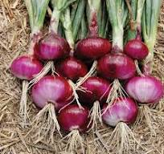
Picture 1: Allium cepa bulbs

2. Terminalia macroptera (embee)
This plant is traditionally used in Uganda, to treat hepatitis. It is commonly grown in Buganda and called embee by the Baganda. It belongs to kingdom plantae, phylum magnoliophyte, class magnoliopsida, order myrtales, family combretacecae and species Terminalia macroptera. Extracts from the plant can reduce liver damage caused by toxins and infections. It demonstrates anti-inflammatory, analgesic, and antipyretic properties. These findings support its use in traditional medicine for treating liver- related disorders (12).
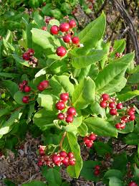
Picture 2: Terminalia macroptera

3. Phyllanthus amarus (iru)
Phyllanthus amarus also known as Iru by the Banyoro belongs to kingdom plantae, phylum magnoliophyta, class magnoliopsida, order malpighiales, family phyllanthacecae and species phyllanthus amarus. Phyllanthus amarus is a well-documented herbal medicine with significant hepatoprotective effects, providing defense against chemical, toxic, and alcohol-induced liver damage (13). It acts by reducing oxidative stress through potent antioxidant activity, enhancing liver enzymes (SOD, CAT, GPx), and lowering lipid peroxidation markers like TBARS. Key compounds, including lignans like phyllanthin and hypophyllanthin, help restore liver function and promote tissue repair. It exhibits hepatoprotective effects due to its ability to reduce oxidative stress, protect liver cells and improve liver function. Extracts from phyllanthus amarus can protect against various types of liver damage, including that induced by aflatoxin B1, carbon tetrachloride and ethanol (13). Phyllanthus amarus contains various classes of organic compounds including alkaloids, flavonoids, hydrolysable tannins, lignans, and phenolic acids (14).

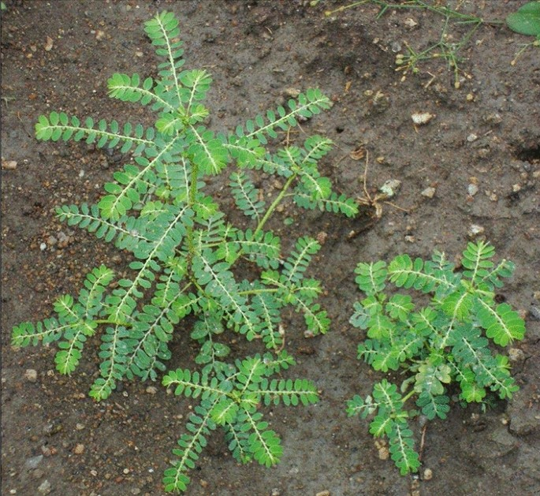
Picture 3: Phyllanthus amarus

4. Kalanchoe pinnata( Eyondo)
This belongs to the kingdom plantae, phylum tracheophyta, class magnoliopsida, order saxifrages, family crassulaceae and species Kalanchoe pinnata. It is called eyondo in Bunyoro and Ankole. Grown in parts of Hoima and Mbarara, and is commonly known for treating jaundice and hepatotoxicity by poisons (15). The extract from Kalanchoe pinnata contains phenolic acid and flavonoids which are antioxidants and aid in removing of ethanol, scavenge free radicals such as peroxides and superoxides which cause oxidative stress (16, 17).
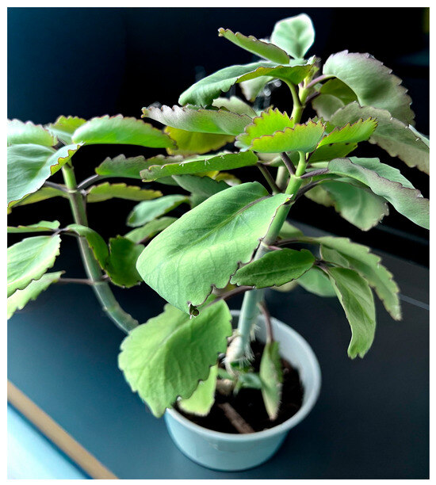
Picture 4: Kalanchoe pinnata

5. Curcuma longa (Turmeric)
Curcuma longa, commonly known as turmeric belongs to kingdom plantae, order zingiberales, family zingiberacecae, genus Curcuma and species Curcuma longa. It is a rhizomatous herbaceous perennial plant and has underground stems called rhizomes (18). The main constituents of Curcuma longa are the flavonoid curcumin, and various volatile oils including tumerone, atlantone and zingiberene (19). Curcuma longa exhibits a hepatoprotective effect primarily through its potent antioxidant and anti-inflammatory properties mediated by the active compound flavonoid curcumin. Curcumin protects the liver by scavenging free radicals such as superoxide, peroxides which can damage liver cells and cause inflammation thus reducing oxidative stress and inhibiting lipid peroxidation (19).
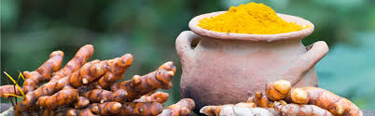
Pictures 5: Turmeric.

6. Boerhavia diffusa (kibira)
Boerhavia diffusa; commonly known as kibira by the Baganda or spreading hogweed belongs to kingdom plantae, phylum Tracheophyta order caryophyllales, family nyctaginaceae, genus Boerhavia, and species Boerhavia diffusa. It contains phytochemicals such as flavonoids and alkaloids that have the ability to scavenge the free radicals thus reducing oxidative stress and potentially modulating liver enzyme activity (20). The aqueous form of the drug administration has more hepatoprotective activity than the powder form and this is probably due to the better absorption of the liquid form through the gastro intestinal tract (21).
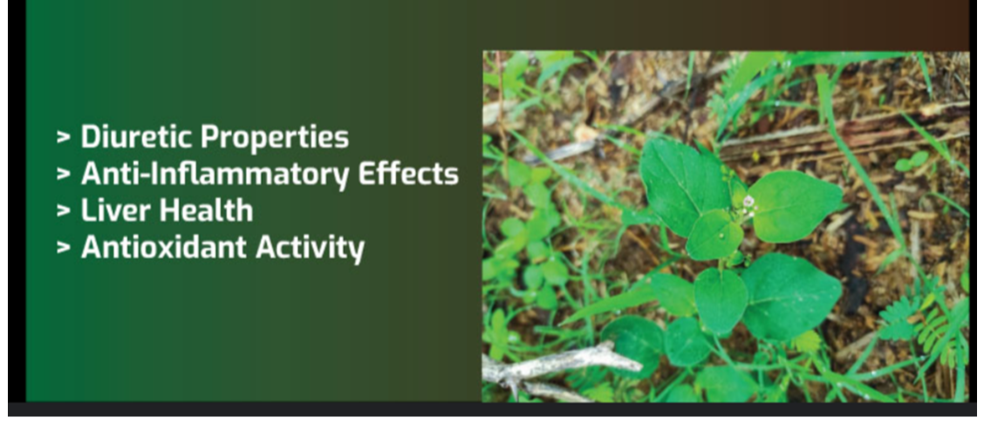
Picture 6: Boerhavia diffusa and its benefits

7. Silybum marianum (kyawooli)
Silybum marianum (kyawooli) is found in western Uganda around Albertine shore of lake Albert. This is a medicinal plant with a long therapeutic history in Uganda. It is called milk thistle and belongs to kingdom Plantae, phylum Magnoliophyta, class Magnoliopsida, order Asterales, family Asteraceae, species Silybum marianum and is used as a hepatoprotective medication to treat jaundice and enlarged liver (22). Silybum marianum, particularly its active compound silymarin, exhibits strong hepatoprotective effects, supported by evidence showing protection against liver damage induced by toxins like CCl4. It is widely recognized for improving various hepatic conditions due to antioxidant, anti-inflammatory, and membrane-stabilizing properties (23). Silymarin is an active ingredient extracted from seeds of milk thistle and it is a mixture of flavonolignans such as silybin, polyphenolic compounds such as taxifolin. Silymarin has antioxidant properties while flavonoids have the ability to scavenge free radicals thus preventing oxidative stress and preventing damage of liver cells. The seeds of this plant contain many compounds such as silybin, silibinin A and B, silicristin, silidianin, apigenin, dehydrosilybin, deoxysilyn cristin, among other phytochemicals. Extract of dried seed of this plant contains up to 4% Silymarin (24). Silymarin protects the liver against toxicities resulting from various toxins such as carbon tetra chloride, acetaminophen, and tetrachlorometane. It has been reported that Silymarin provides the Hepatoprotective effect by different mechanism including Antioxidant activity and scavenging free radicals, stimulation of DNA polymerase and stability of Hepatocellular membrane (25).
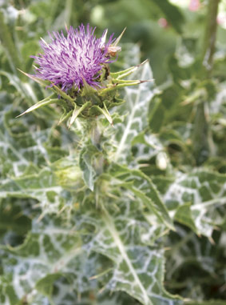
Pictures 7: Image of Milk Thistle

8. Woodfordia fruticosa (omutobotobo)
Woodfordia fruticosa is also known as omutobotobo in western regions of Uganda; to be more specific by the Banyoro in bunyoro, parts of Hoima. It belongs to family plantae, phylum magnoliophyta, class magnoliopsida, order myrtales, family lythraceae, and species Woodfordia fruticosa. Woodfordia fruticosa demonstrates significant hepatoprotective effects, particularly its methanol and aqueous extracts. Studies show that the aqueous extract (WF4) is the most potent, offering strong protection against carbon tetrachloride- and acetaminophen-induced liver damage (26). These findings validate the traditional use of the plant in treating liver disorders and highlight its potential as a natural therapeutic agent. The protective mechanisms may involve antioxidant activity and reduction of oxidative stress markers. The petroleum ether, alcohol, chloroform and aqueous extract of the flower of Woodfordia fruticosa is protective against Phenytoin induced damage of liver and carbon tetrachloride induced Hepatotoxicity (27).

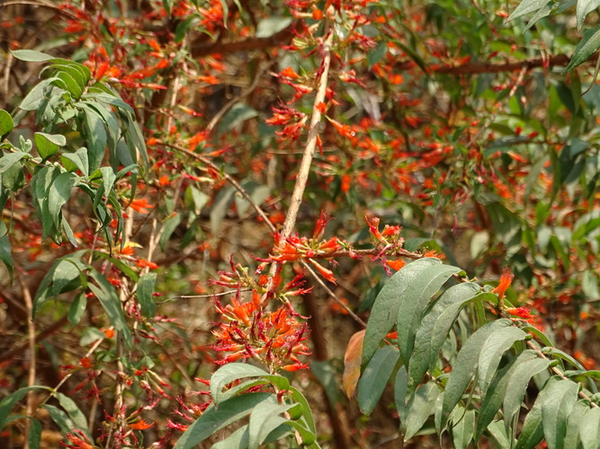
Picture 8: Woodfordia fruticosa (omutobotobo)

9. Solanum nigrum (ekimuli kyentebero)
There are two types of Solanum nigrum found; one has black colour fruits and second has reddish roots, which are all used for their medicinal value. Solanum nigrum belongs to kingdom plantae, phylum spermatophyte, class dicotyledonae, order solanales, family solanaceae, genus Solanum and species Solanum nigrum. Mostly common also in western areas of Uganda for example in Hoima, it is used for liver fibrosis. Solanum nigrum exhibits significant hepatoprotective effects, as demonstrated in multiple studies. Extracts from the plant reduce liver damage caused by ethanol and carbon tetrachloride, improving liver histopathology by decreasing cellular swelling, inflammation, and preserving hepatocyte integrity. These protective effects are attributed to antioxidant, anti-inflammatory, and free radical-scavenging properties of bioactive compounds in the plant. Both in vitro and in vivo models support its therapeutic potential for liver injury prevention and repair. Solanum nigrum aqueous and methanolic extracts were studied for hepatoprotective activity in rats injected with 0.2 ml kg of carbon tetrachloride for 10 consecutive days. It was found to be hepatoprotective against CC14- induced liver damage (28). The ethanol extract showed remarkable hepatoprotective activity. Ethanol extracts of Solanum nigrum Linn was investigated for the hepatoprotective activity against CC14- induced hepatic damage in rats (29). Salanum nigrum possesses numerous compounds that are responsible for its pharmacological activities. Whole plant extract was reported to contain alkaloids, flavonoids, tannins, saponins, glycosides, proteins carbohydrates, coumarins and phytosterols (30).
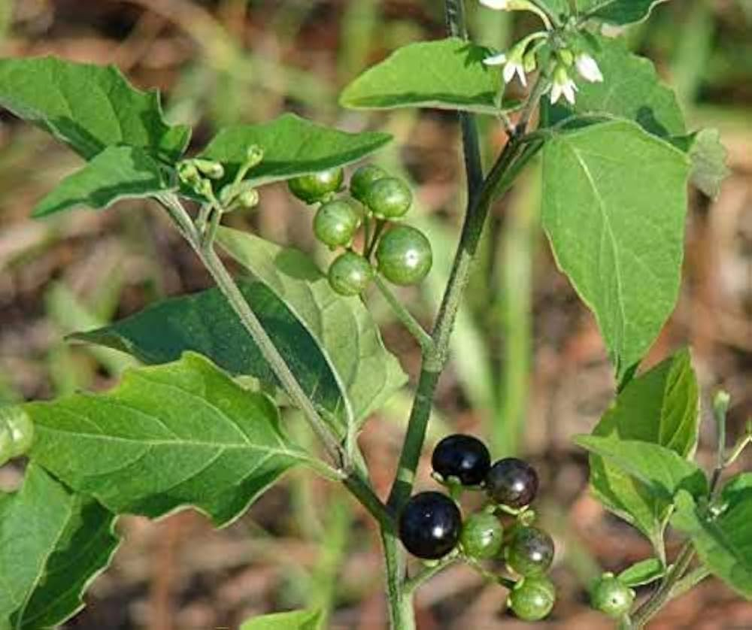
Picture 9: Solanum nigrum (ekimuli kyentebero)

10. Phyllanthus muellarianus (muko wewumbeko)
Phyllanthus muellerianus is a small, scrambling shrub or tree native to tropical Africa, typically growing in wet tropical biomes. It exhibits a straggling or climbing habit with numerous stems and can form canopy-like foliage. The plant produces copious panicles of small red fruits and may be deciduous or evergreen, depending on environmental conditions (31). Though its exact distribution and ecological role require further study, it thrives in seasonal tropical environments. This is also used in Uganda more especially the leaves to treat hepatic diseases. It belongs to kingdom plantae, order malpighiales, family phyllanthacecae, genus phyllanthus and species Phyllanthus muellarianus. It contains phytochemicals e.g. furosin, nitidine and galic acid which protect the liver from damage (32). The aqueous and methanolic extracts of phyllanthus muellarianus can mitigate liver injury induced by substances like acetaminophen, a common pain reliever. These extracts have shown the ability to reduce biomarkers of liver damage and oxidative stress, indicating their potential as protective agents against liver injury (32).

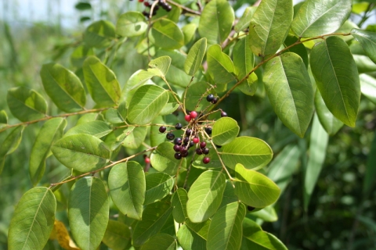
Picture 10: Phyllanthus muellarianus

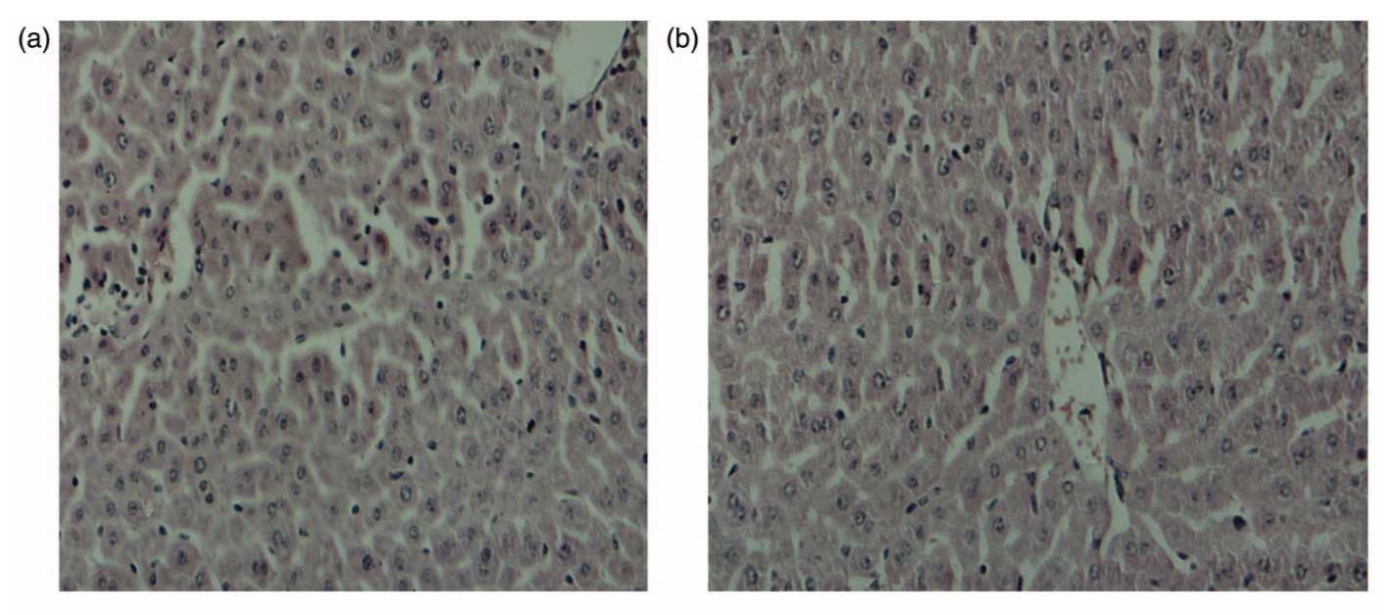
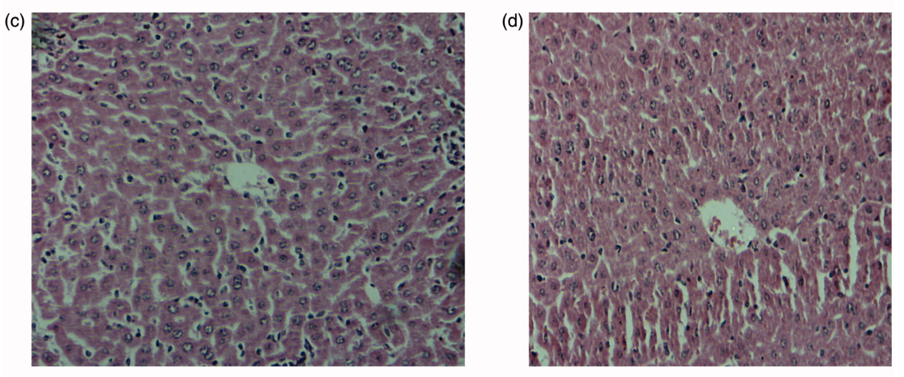
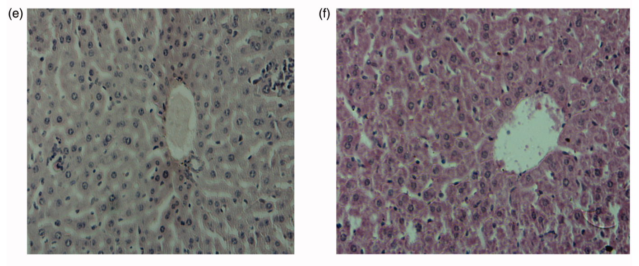
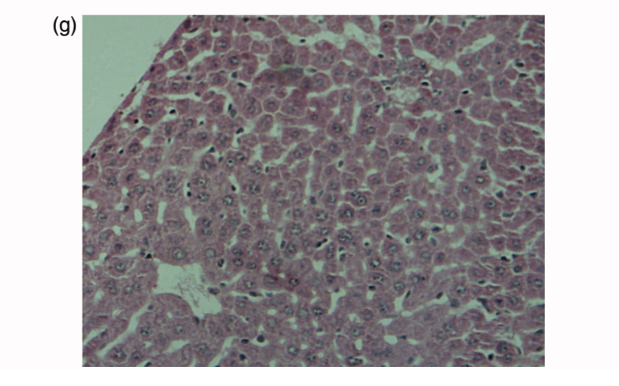
Picture 11: Histoartictecture of the liver of acetaminophen treated mice following oral administration of Phyllanthus muellarianus aqueous leaf extract. (A) control, (B) acetaminophen (c) 400 mg/kg b.w extract (d) 100 mg/kg b.w extract + acetaminophen (e) 200 mg/kg b.w extract + acetaminophen (f) 400 mg/kg b.w extract + acetaminophen (g) 200 mg/kg b.w sylimarin + acetaminophen (32).

11. Capsicum annuum (kamurali)
Capsicum annuum, which is also commonly known as chili peppers and kamurali in Runyankole. it is used in treating poisoning and belongs to kingdom plantae, phylum tracheophyta, class magnoliopsida, order solanales, family solanaceae, genus capsicum and species Capsicum annuum. The active compound in capsicum annuum is capsaicin which has a hepatoprotective effect. Capsaicin activates autophagy in the liver, a process that helps recycle damaged cells and potentially reduces lipid accumulation. Capsaicin also helps reduce oxidative stress, inflammation and apoptosis. Capsicum annuum, particularly its aqueous and ethanolic extracts, demonstrates hepatoprotective effects against liver damage induced by ethanol and paracetamol in animal models (33). Studies indicate that green and red varieties of C. annuum can mitigate oxidative stress and inflammation in the liver, preserving hepatic function. The protective mechanisms may involve antioxidant properties due to capsaicin and other bioactive compounds (34).
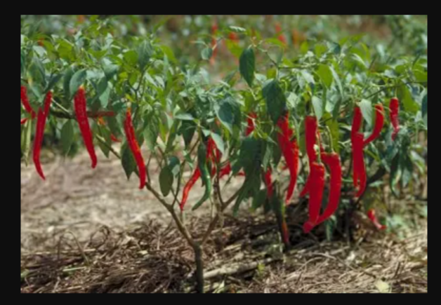
Picture 12: Capsicum annuum (kamurali)
Moringa oleifera (Molinga)
It is grown commonly in the western areas of Uganda where it is called molinga in the Buganda region of Uganda. Moringa oleifera which can also be called drumstick tree belongs to kingdom plantae, phylum tracheophyta, class magnoliopsida, order brassicales, family moringaceae, genus Moringa and species Moringa oleifera. Moringa is a herb with numerous medicinal potential (35, 36).
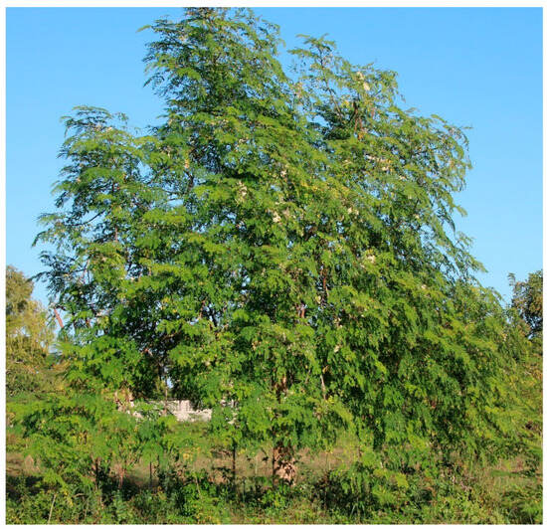
Picture 13: Moringa oleifera (molinga)

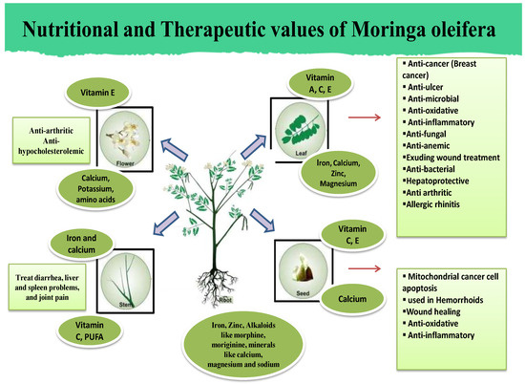
Picture 14: Nutritional and therapeutic values of Moringa oleifera whole plant (37).
Moringa is rich in antioxidants like flavonoids quercetin and kaempferol which help neutralize harmful free radicals and prevent oxidative stress that can damage the liver cells. Moringa also helps reduce or decrease the levels of liver enzymes AST, ALP, and ALT which are indicators of liver damage (38). Moringa oleifera exhibits significant hepatoprotective effects, as demonstrated in studies involving lead acetate and paracetamol-induced liver injury. Extracts from its leaves improved body weight and reduced serum markers like SGPT, SGOT, and ALP, indicating reduced liver damage (39). The protective mechanism is attributed to antioxidant compounds such as flavonoids and phenolics that mitigate oxidative stress. While liver weight recovery was not statistically significant, overall hepatic function showed marked improvement. These findings suggest Moringa oleifera as a promising natural agent for supporting liver health. Moringa oleifera, often called the 'tree of life' or 'miracle tree,' is renowned for its nutritional richness and ethnomedicinal applications in managing various health conditions across tropical and subtropical regions. Research highlights its potential in treating oxidative stress, inflammation, and metabolic disorders, supported by numerous scientific studies (40).
DISCUSSION
In this review we researched some plant species endogenous to Uganda, which have both hepato protective and other therapeutic effects for example:
- Allium cepa (katungulu) also known as onion exhibits an antidiabetic effect;-onion is reputed to help lower blood sugar levels and improve insulin sensitivity (40). Aqueous extracts of Allium cepa bulb has essential antioxidant and hepatoprotective function against ethanol induced hepatotoxicity (10, 42) and pharmacological evaluation of Allium cepa extracts show hepatoprotective potential in albino rat (11).
- Terminalia macroptera (Kibimba) not only has a hepatoprotective effect but also used in treating infectious diseases, tuberculosis and dysentery (12).
- Extracts from Phyllanthus amarus can protect against various types of liver damage, including that induced by aflatoxin B1, carbon tetrachloride and ethanol (13).
- The extract from Kalanchoe pinnata contains phenolic acid and flavonoids which are antioxidants and aid in removing of ethanol, scavenge free radicals such as peroxides and superoxides which cause oxidative stress (16, 17).
- Curcumin from Curcuma longa protects the liver by scavenging free radicals such as superoxide, peroxides which can damage liver cells and cause inflammation thus reducing oxidative stress and inhibiting lipid peroxidation (19).
- Boerhavia diffusa contains phytochemicals such as flavonoids and alkaloids that have the ability to scavenge the free radicals thus reducing oxidative stress and positively modulating liver enzyme activity (20).
- Silymarin from Silybum marianum provides the Hepatoprotective effect by different mechanism including Antioxidant activity and scavenging free radicals, stimulation of DNA polymerase and stable of Hepatocellular membrane (25).
- Woodfordia fruticosa is protective against Phenytoin induced damage of liver and carbon tetrachloride induced Hepatotoxicity (27).
- Solanum nigrum aqueous and methanolic extracts were studied for hepatoprotective activity in rats injected with 0.2 ml kg of carbon tetrachloride for 10 consecutive days. It was found to be hepatoprotective against CC14- induced liver damage (28).
- The aqueous and methanolic extracts of phyllanthus muellarianus have shown the ability to reduce biomarkers of liver damage and oxidative stress, indicating their potential as protective agents against liver injury (32).
- Capsicum annuum demonstrates hepatoprotective effects against liver damage induced by ethanol and paracetamol in animal models (33) and can mitigate oxidative stress and inflammation in the liver, preserving hepatic function (34).
- Moringa oleifera exhibits significant hepatoprotective effects, as demonstrated in studies involving lead acetate and paracetamol-induced liver injury. Extracts from its leaves improved body weight and reduced serum markers like SGPT, SGOT, and ALP, indicating reduced liver damage (39).
All the named plant species have one thing in common which is a hepatoprotective effect, and this hepatoprotective effect is achieved by majorly the antioxidant effect and the anti-inflammatory effect in the plant extracts. Hepatoprotective herbs are rich in flavonoids, polyphenols and other antioxidants that scavenge free radicals, prevent lipid peroxidation in liver cell membrane and reduce oxidative stress (19). These herbs often reduce liver inflammation by inhibiting pro-inflammatory cytokines for example Curcuma longa also called turmeric contains curcumin which inhibits COX-2 and NF-k B pathways (19). Many hepatoprotective herbs contain certain compounds that stimulate protein synthesis and promote hepatocyte regeneration for example Silymarin in Silybum marianum stimulates RNA polymerase I activity, promoting protein synthesis and liver regeneration (41). The need to protect the liver exists since it is a most important organ in the body, and liver diseases have become a common and difficult health challenge in Uganda (43). Liver damage in Uganda often arises due to the excessive alcohol consumption, polypharmacy and drug abuse (44). Therefore, protecting the hepatic system from damage caused by the factors above is very necessary (45). The use of herbal medicines to provide protection to liver is becoming a better alternative rather than the imported drugs that have; presented with many side effects, are quiet expensive and less reliable to our Ugandan population in addition to being cheaper and more affordable.

CONCLUSION
Uganda has been blessed with many medicinal plants with hepato protective activity. Scientific validation of these herbs should be encouraged by the government to investigate their comparative efficacy and toxicity with the imported drugs. Where they are found to be better alternatives to the imported medicines, these medicinal herbs can be approved legally to be used in the mainstream health setting. Large scale production of these herbs can also be promoted for it to reach the demand market for people of Uganda. Local pharmaceutical companies should also be encouraged to identify the extracts from these herbs as possible drug candidates and use them in local drug manufacture.
Institutional review board statement: Not applicable.
Informed consent statement: Not applicable
Disclaimer (Artificial intelligence)
Option 1:
Author(s) hereby declare that NO generative AI technologies such as Large Language Models (ChatGPT, COPILOT, etc.) and text-to-image generators have been used during the writing or editing of this manuscript.

REFERENCES
- Qin F, Jiang J, Qin C, Huang Y, Liang B, Xu Y, et al. Liver damage in patients living with HIV on antiretroviral treatment with normal baseline liver function and without HBV/HCV infection: An 11-year retrospective cohort study in Guangxi, China. BMJ Open. 2019;9(4):e023140.
- Bola Odegbemi O, Folaranmi Olaniyan M, Abidemi Muhibi M. Impact of tenofovir, lamivudine, and dolutegravir on liver function in HIV-positive individuals in Southern Nigeria. jcbr 2024; 8 (2) :28-33 URL: http://jcbr.goums.ac.ir/article-1-453-en.html
- Zhou, Y., Wang, J., Zhang, D., Liu, J., Wu, Q., Chen, J., Tan, P., Xing, B., Han, Y., Zhang, P., Xiao, X., & Pei, J. (2021). Mechanism of drug-induced liver injury and hepatoprotective effects of natural drugs. Chinese medicine, 16(1), 135. https://doi.org/10.1186/s13020-021-00543-x
- Okaiyeto K, Nwodo UU, Mabinya lv, Okoh Al, a review on some medicinal plants with hepato protective effects. Phcog Rev 2018:12:186-99
- Abhilash G, Maheswari YJ, Gopal A, Chanda D. Review on some medicinal plants with hepato‑protective activities. Res Rev J Pharmacogn Phytochem 2014; 22:33M
- Ministry of Health (2023) Uganda Clinical Guidelines: National Guidelines on the Management of Common Conditions. https://health.go.ug/sites/default/files/Uganda%20Clinical%20Guidelines%202023_FINAL.pdf
- Teshika J. D., Zakariyyah A. M., Zaynab T., et al. Traditional and modern uses of onion bulb (Allium cepaL.): a systematic review. Critical Reviews in Food Science and Nutrition . 2019;59(sup1):S39–S70. doi: 10.1080/10408398.2018.1499074
- Foo C. W., Tristani-Firouzi P. Topical modalities for treatment and prevention of postsurgical hypertrophic scars. Facial Plastic Surgery Clinics of North America . 2011;19(3):551–557. doi: 10.1016/j.fsc.2011.06.008
- Marefati N., Ghorani V., Shakeri F., et al. A review of anti-inflammatory, antioxidant, and immunomodulatory effects of Allium cepa and its main constituents. Pharmaceutical Biology . 2021;59(1):287–302. doi: 10.1080/13880209.2021.1874028
- Maurya, H. (2018). Pharmacological evaluation of Allium cepa extract as hepatoprotective potential in albino rat. International Journal of Health and Clinical Research, 1(2), 7–13.
- Ozougwu, J. C., & Eyo, J. E. (2014). Hepatoprotective effects of Allium cepa (onion) extracts against paracetamol-induced liver damage in rats. African Journal of Biotechnology , 13(26), 2679-2688.
- Kola-Mustapha A.T., Suleiman Olubusayomi Taiwo, Abimbola Rofiat Isiaka, Sherifat Omowunmi Amao, Ismail O. Ishola, Yusuf Oluwagbenga Ghazali, Sukurat O. Usman,Evaluation of Terminalia macroptera (Combretaceae) Guill. & Perr stem bark extract incorporated into an emulgel for the potential management of rheumatoid arthritis,Scientific African, Volume 19, 2023,e01557,ISSN 2468-2276,https://doi.org/10.1016/j.sciaf.2023.e01557.
- Farah Naaz, Saleem Javed, M.Z. Abdin, Hepatoprotective effect of ethanolic extract of Phyllanthus amarus Schum. et Thonn. on aflatoxin B1-induced liver damage in mice, Journal of Ethnopharmacology, Volume 113, Issue 3, 2007, 503-509, ISSN 0378-8741, https://doi.org/10.1016/j.jep.2007.07.017.
- Yakubu, Ojochenemi Ejeh, Otitoju, Oluwale, Isaac, John Umaru, Atanu, Francis Onakpa, Bando Christopher David, & Auwal, Hafiza. (2022). Hepatoprotective Effects of Phyllanthus Amarus Ethanolic Extract On CCL4-Induced Hepatotoxicity in Wistar Rats. International Journal of Scientific Research and Innovative Studies, 1(2), 50–55. Retrieved from https://www.ijsrisjournal.com/index.php/ojsfiles/article/view/50
- Yadav N.P, V.K Dixit,Hepatoprotective activity of leaves of Kalanchoe pinnata Pers.,Journal of Ethnopharmacology,Volume 86, Issues 2–3,2003,197-202,ISSN 0378-8741, https://doi.org/10.1016/S0378-8741(03)00074-6.
- Saeed K, Chughtai MFJ, Ahsan S, Mehmood T, Khalid MZ, Khaliq A, Zuhair M, Khalid W, Alsulami T, Law D, Mukonzo EL. Hepatoprotective Effect of a Kalanchoe pinnata-Based Beverage Against Carbon Tetrachloride- and Gentamicin-Induced Hepatotoxicity in Wistar Rats. J Am Nutr Assoc. 2025 Jul;44(5):405-421. doi: 10.1080/27697061.2024.2442615. Epub 2025 Feb 12. PMID: 39937610.
- Omoruyi, F., Tatina, L., Rios, L., Stennett, D., & Sparks, J. (2025). Insights into the Therapeutic Use of Kalanchoe pinnata Supplement in Diabetes Mellitus. Pharmaceuticals, 18(10), 1518. https://doi.org/10.3390/ph18101518
- Riani NWA, Utama IMS, Winaya IBO. The Hepatoprotective Effect of Curcuma longa Extract on Dengue Virus Serotype-2 infected BALB/c Mice. Open Access Maced J Med Sci. 2023 Jan 02; 11(A):111-116.https://doi.org/10.3889/oamjms.2023.8993
- Salama, S.M., Abdulla, M.A., AlRashdi, A.S. et al. Hepatoprotective effect of ethanolic extract of Curcuma longa on thioacetamide induced liver cirrhosis in rats. BMC Complement Altern Med 13, 56 (2013). https://doi.org/10.1186/1472-6882-13-56
- Beedimani, R. S., & Jeevangi, S. K. (2017). Evaluation of hepatoprotective activity of Boerhaavia diffusa against carbon tetrachloride induced liver toxicity in albino rats. International Journal of Basic & Clinical Pharmacology, 4(1), 153–158. Retrieved from https://www.ijbcp.com/index.php/ijbcp/article/view/882
- DU, S., R, M., S, V., R, S. N., MS, M. (2020). Hepatoprotective activity of Boerhaavia diffusa L. IP Journal of Nutrition, Metabolism and Health Science, 3(4), 109-113. https://doi.org/10.18231/j.ijnmhs.2020.022
- Ali Noory Fajer and Meaad Nasser Hussein: Hepatoprotective Effects of Silybum Marianum Extraction Against Acetamiprid-Induced Stress Oxidative in Male Rats: Potential Anticancer Application. Asian Pac J Cancer Biol, 9 (4), 503-508. DOI:10.31557/APJCB.2024.9.4.503
- Kamali, M., Mostafaei, A.S. Hepatoprotective effect of Silybum marianum on experimental hepatotoxicity in broilers. Comp Clin Pathol 23, 967–973 (2014). https://doi.org/10.1007/s00580-013-1726-4
- Sharma, P., Asediya, V., Kalra, G., Sultana, S., Purohit, N., Kibitlewska, K., Kozera, W., Czarnik, U., Karpiesiuk, K., Lecewicz, M., Wysocki, P., Lepczyński, A., Ożgo, M., Marynowska, M., Herosimczyk, A., Redlarska, E., Ślaska, B., Kowal, K., Tkaczyk-Wlizło, A., ... Pierzchała, M. (2025). Hepatoprotective Effect of Silymarin Herb in Prevention of Liver Dysfunction Using Pig as Animal Model. Nutrients, 17(20), 3278. https://doi.org/10.3390/nu17203278
- Vargas-Mendoza, N., Madrigal-Santillán, E., Morales-González, A., Esquivel-Soto, J., Esquivel-Chirino, C., García-Luna Y González-Rubio, M., Gayosso-de-Lucio, J. A., & Morales-González, J. A. (2014). Hepatoprotective effect of silymarin. World journal of hepatology, 6(3), 144–149. https://doi.org/10.4254/wjh.v6.i3.144
- Baravalia, Y., & Chanda, S. (2011). Protective effect of Woodfordia fruticosa flowers against acetaminophen-induced hepatic toxicity in rats. Pharmaceutical Biology, 49(8), 826–832. https://doi.org/10.3109/13880209.2010.550057
- Chandan B.K., A.K. Saxena, Sangeeta Shukla, N. Sharma, D.K. Gupta, K. Singh, Jyotsna Suri, M. Bhadauria, G.N. Qazi. Hepatoprotective activity of Woodfordia fruticosa Kurz flowers against carbon tetrachloride induced hepatotoxicity / Journal of Ethnopharmacology 119 (2008) 218–224
- Lin HM, Tseng HC, Wang CJ, Lin JJ, Lo CW, Chou FP. Hepatoprotective effects of Solanum nigrum Linn extract against CCl(4)-induced oxidative damage in rats. Chem Biol Interact. 2008 Feb 15;171(3):283-93. doi: 10.1016/j.cbi.2007.08.008. Epub 2007 Aug 19. PMID: 18045581.
- Krithika, R. and Verma, R.J. Solanum nigrum confers protection against CCl4-induced experimental hepatotoxicity by increasing hepatic protein synthesis and regulation of energy metabolism. Clin Phytosci 5, 1 (2019). https://doi.org/10.1186/s40816-018-0096-5.
- Fang-Ping Liu, Xin Ma, Min-Min Li, Zhi Li, Qing Han, Rui Li, Chang-Wen Li, Yi-Cong Chang, Chang-Wei Zhao, Yue-Xia Lin, Hepatoprotective effects of Solanum nigrum against ethanol-induced injury in primary hepatocytes and mice with analysis of glutathione S-transferase A1, Journal of the Chinese Medical Association,Volume 79, Issue 2,2016,Pages 65-71,ISSN 1726-4901,https://doi.org/10.1016/j.jcma.2015.08.013
- Martha Nneoma Ofokansi, Peter Achunike Akah, Juliet Ogochukwu Omewu (2023) Phyllanthus Muellerianus, (Kuntze) Eccell.: Review of the Ethnomedical Uses, Phytochemistry and Pharmacological Activities. J Med Plant Herbs 2: 1-12
- Ajiboye, T. O., Ahmad, F. M., Daisi, A. O., Yahaya, A. A., Ibitoye, O. B., Muritala, H. F., & Sunmonu, T. O. (2017). Hepatoprotective potential of Phyllanthus muellarianus leaf extract: studies on hepatic, oxidative stress and inflammatory biomarkers. Pharmaceutical Biology, 55(1), 1662–1670. https://doi.org/10.1080/13880209.2017.1317819
- Priya AS, Anitha A. In Vivo Hepatoprotective Effect of Ethanolic Extract of Capsicum Annuum L. Red Variety Against Paracetamol Induced Hepatotoxicity in Male Wistar Albino Rats. Eur J Biomed Pharma Sci. 2017;4(10):326-32.
- Moumita Das, Subhashree Basu, Bhaswati Banerjee, Anurupa Sen, Kuladip Jana, Gouriprosad Datta, Hepatoprotective effects of green Capsicum annum against ethanol induced oxidative stress,inflammation and apoptosis in rats,Journal of Ethnopharmacology,Volume 227,2018,69-81,ISSN 0378-8741, https://doi.org/10.1016/j.jep.2018.08.019.
- Ma Z.F. , J. Ahmad, H. Zhang, I. Khan, S. Muhammad,Evaluation of phytochemical and medicinal properties of Moringa (Moringa oleifera) as a potential functional food,South African Journal of Botany,Volume 129,2020,Pages 40-46, ISSN 0254-6299, https://doi.org/10.1016/j.sajb.2018.12.002,
- Ghasi, S., Nwobodo, E., & Ofili, J. O. (2000). Hypocholesterolemic effects of crude extract of leaf of Moringa oleifera Lam in high-fat diet fed wistar rats. Journal of Ethnopharmacology, 69, 21-25.
- Divya, S., Pandey, V. K., Dixit, R., Rustagi, S., Suthar, T., Atuahene, D., Nagy, V., Ungai, D., Ahmed, A. E. M., Kovács, B., & Shaikh, A. M. (2024). Exploring the Phytochemical, Pharmacological and Nutritional Properties of Moringa oleifera: A Comprehensive Review. Nutrients, 16(19), 3423. https://doi.org/10.3390/nu16193423
- Al-Sultan M. R. and Al-Sowayan, N. (2024) The Protective Effect of Moringa oleifera Leaves Extract on Paracetamol Hepatotoxicity in Male Rats. Journal of Biomedical Science and Engineering, 17, 72-82. doi: 10.4236/jbise.2024.173006
- Islam, R., Alam, M. J., Shanta, S. B., Rahman, M. H., Mahmud, S., & Khan, A. S. (2019). Evaluation of Liver Protective Activity of Moringa oleifera Bark Extract in Paracetamol Induced Hepatotoxicity in Rats. Journal of Pharmaceutical Research International, 25(4), 1–9. https://doi.org/10.9734/jpri/2018/v25i430108
- Aly, O., Abouelfadl, D.M., Shaker, O.G. et al. Hepatoprotective effect of Moringa oleifera extract on TNF-α and TGF-β expression in acetaminophen-induced liver fibrosis in rats. Egypt J Med Hum Genet 21, 69 (2020). https://doi.org/10.1186/s43042-020-00106-z
- Chakraborty, A. J., Uddin, T. M., Matin Zidan, B. M. R., Mitra, S., Das, R., Nainu, F., Dhama, K., Roy, A., Hossain, M. J., Khusro, A., & Emran, T. B. (2022). Allium cepa: A Treasure of Bioactive Phytochemicals with Prospective Health Benefits. Evidence-based complementary and alternative medicine: eCAM, 2022, 4586318. https://doi.org/10.1155/2022/4586318.
- Ige, Serah & Akhigbe, Roland & O, Edeogho & Folasade, Ajao & O.Q, Owolabi & Oyekunle, Olubunmi & Ajayi, Ayodeji. (2011). Hepatoprotective activities of Allium cepa in cadmium-treated rats. International Journal of Pharmacy and Pharmaceutical Sciences. 3. 60-63.
- Kagimu, M., Opio, K., Seremba, E., Ocama, P., & Apica, B. (2013). Decompensated cirrhosis-related admissions in a large urban hospital in Uganda: prevalence, clinical and laboratory features and implications for planning patient management. African Health Sciences, 13(4), 927–932. https://doi.org/10.4314/ahs.v13i4.10
- Opio, C. K., Seremba, E., Ocama, P., Lalitha, R., Kagimu, M., & Lee, W. M. (2013). Diagnosis of alcohol misuse and alcoholic liver disease among patients in the medical emergency admission service of a large urban hospital in Sub-Saharan Africa; a cross sectional study. The Pan African medical journal, 15, 23. https://doi.org/10.11604/pamj.2013.15.23.2040
- Thilagavathi, R., Begum, S. S., Varatharaj, S. D., Balasubramaniam, A. K., George, J. S., & Selvam, C. (2023). Recent insights into the hepatoprotective potential of medicinal plants and plant‐derived compounds. Phytotherapy Research, 37(5), 2102-2118.

