ADAPTIVE GRID REFINEMENT FOR ENHANCED ACCURACY AND EFFICIENCY IN ONE-DIMENSIONAL FORWARD MAGNETOTELLURIC SOUNDING

Abstract
This paper introduces the one-dimensional (1D) forward solving of the magnetotelluric (MT) sounding problem through the concept of the grid adaptation approach, and it displays a numerical solution. Conventional uniform grid techniques have commonly found difficulty in both properly resolving sharp resistivity contrasts and high conductive layers and skinny conducting layers without high computational expenses. To overcome these shortcomings, a dynamic grid refinement method was proposed that focuses on grid nodes where the solution may be particularly sensitive and where the gradients of resistivity may be large. Operating the governing equations on both uniform and adaptive meshes in the finite difference discretisation scheme, the overall performance of the methods has been compared systematically. The findings illustrated that the adaptive grid refinement strategy really enhanced the accuracy of solutions, decreased computation time, and converged rapidly in comparison to the uniform grid technique. These complex, multi-layered conductivity models were easily able to be handled, and the frequency-varying skin depth was well-represented by the adaptive method throughout a wide frequency range. Variations of resistivity contrasts were also examined, whereby the adaptive grid was able to deliver significant improvements in terms of accuracy, especially in medium- and high-contrast environments. Besides, a tendency to convergence analysis and visualization using one-dimensional, two-dimensional, and three-dimensional diagrams confirmed the excellent use of the adaptive grid approach in modeling the responses of MT. The adaptive model is a computationally efficient and robust method of forward MT modelling and is best adapted to realistic geophysical situations. The further development of the approach will be directed to higher-dimensional MT issues and solving equations with real field data and inverse modelling.

Keywords: Adaptive grid, Electromagnetic sounding, Finite difference, Forward modeling, Geophysical exploration, Magnetotellurics, Mesh refinement, Numerical methods, Resistivity profiling,

Introduction
Magnetotelluric (MT) sounding is an indirect geophysical technique that exploits the natural fluctuations of the earth's electromagnetic (EM) fields to provide a map of the subsurface resistivity structure. Its wide frequency spectrum allows exploring both shallow crustal and deep lithospheric structures (Conway et al., 2019; Saleh et al., 2023). Forward MT Modelling The key problem of forward MT modelling is to calculate the EM field response, usually the impedance, given a certain profile of conductivity, which satisfies Maxwell's equations in the time-harmonic limit.
In the one-dimensional (1D) situation, based upon plane wave propagation and a horizontally stratified Earth, the EM fields simplify to second-order ordinary differential equation (ODE) solutions. In particular, in the transverse electric (TE) mode, the electric field E(z) satisfies:

$\frac{d^{2}E(z)}{dz^{2}}+ k^{2}\left(z\right)E\left(z\right)= 0, z ∈\left[0,L\right]$ (1)

Where $z$is the depth, $E\left(z\right)$ is the horizontal electric field, $k^{2}\left(z\right)=iωμ_{0}σ(z)$ is the complex wave number, $ω$ is the angular frequency$(2πf$), $μ_{0}$ is the permeability of free space $(≈4π ×10^{-7} H/m$, $σ(z)$ is the conductivity profile (S/m), a function of depth.

The impedance$Z\left(ω\right)$, defined as the ratio of horizontal electric field to magnetic field at the surface, is a key observable in MT sounding:

$Z\left(ω\right)= \frac{E_{x}(0)}{H_{y}(0)}$ (2)

An analytical solution is found in homogeneous media. Numerical solutions are, however, necessary in practical geophysical applications where there is more than one layer or geophysical conductivity variation involved (Kasdorf et al., 2024; Oduselu-Hassan, 2025). The classical numerical method is based on the finite difference or finite element numerical discretisation with a uniform grid (Conway et al., 2019; Teixeira et al., 2023). One of the principal disadvantages of these methods is that they can become highly inefficient in the modelling of regions with strong resistivity contrast, where the layers are thin, because uniform grids cannot give good resolution to steep gradients unless the mesh is unrealistically refined.
To overcome these drawbacks, adaptive grid refinement (AGR) approaches have been suggested to focus grid nodes at the locations in which the solution is highly variable (Omar, 2021; Oladayo & Joshua 2025). One of the common methods consists of a monitor mechanism that steers the mesh density according to the local solution/model behaviour (Deabes et al., 2022; Oduselu-Hassan & Ojada, 2024). To give mere examples of a second-derivative-based monitor:

$M\left(z\right)= 1+ α\left|\frac{d^{2}E(z)}{dz^{2}}\right|$ (3)

Thus, where $α$ is a scaling factor, it redistributes with greater grid concentration where the solution's curvature is steep. Equidistribution of the integral of the monitor function then yields the new grid points $z_{i}$:

$\int_{0}^{z_{i}}{M\left(z\right)dz= \frac{i}{N}}\int_{0}^{L}{M\left(z\right)dz, i=1, …, N}$ (4)

This method can increase numerical resolution without either enlarging the overall number of grid points or resolution and decrease the computational cost, decreasing the cost per measurement (Sun et al., 2023; Qin et al., 2023)
In this paper, we will describe an effective algorithm of such an adaptive grid methodology used in the forward 1D MT problem. We hope to show that an adaptive computation grid improves the numerical accuracy and efficiency of sounding using MT effectively, particularly when there is a sharp conductivity contrast and when the conductivity stratification is stubby.

Literature Review
The numerical modelling of the magnetotelluric (MT) responses of layered structures of the earth has received much interest in the geophysical research community, especially considering their uses in exploration of the resources, tectonic investigations, and geothermal evaluation Oduselu-Hassan, (2024). Great strides have been made, over the years, to enhance stability, efficiency, and the resolution of the solvers of the MT forward modelling, especially in regard to grid optimisation and adaptive refinement approaches.
One-dimensional MT problem: (Ansari & Craven, 2023 and Oduselu-Hassan 2024) formulated a commonly applied finite-difference solution of a one-dimensional MT forward problem. The separation of variables solved the second-order non-homogeneous electric field equations in the horizontal:

$\frac{d^{2}E(z)}{dz^{2}}+ k^{2}\left(z\right)E\left(z\right)= 0, k^{2}\left(z\right)= iωμ_{0}σ(z)$ (5)

on uniforms spatial mesh with central finite differences. Though expedient, this technique has difficulty resolving EM field changes in locations with slim conductive wires or sharp conductivity gradients. To approach a reasonable resolution in such regions, to avoid prohibitively fine grids, the cost in computation becomes by far the dominant factor. The method of Ansari & Craven, (2023) forms the backbone of future enhancements in the grid refinement methods, especially those that try to address the issues of numerical dispersion and accurate measurement of impedance near the interfaces.
Non-Uniform Grid Finite Difference Techniques: Hu, & Liu, (2024) and Okwuwe & Oduselu-Hassan, (2024) provided an extension based on the finite difference technique, which takes into consideration various spacing in the grid or, more specifically, enhances the accuracy of near-surface layers without causing severe computational loads. They use the technique of discretisation that modifies the standard second derivative by accounting for the variable grid step $∆z_{i}$:

$\frac{d^{2}E(z)}{dz^{2}}≈ \frac{2}{∆z_{i-1}+ ∆z_{i}}\left(\frac{E_{i+1}-E_{i} }{∆z_{i}}- \frac{E_{i}- E_{i-1}}{∆z_{i-1}}\right)$ (6)

It is a second-order change that supports variable mesh density. Their solution, however, had a grid layout that was constructed manually, using prior knowledge regarding the locations of layers and changes in resistivity, and showed no adaptivity to features of the solution, like the curvature of the fields. Adaptive Grid Generation Using Monitor Functions: Tiwari et al., (2022) made an adaptive grid generation methodology using monitor functions, which are the dynamic allocations of the grid points based on the gradient of the model parameter or the gradient of the solution. Their solution, which is mainly used in electrical resistivity tomography (ERT), displays mathematical similarities with forward modelling of MT.
The adaptation of the grid was carried out by equidistributing a monitor function M(Z), which is often associated with the curvature of the solution:

$M\left(z\right)= 1+ \left|\frac{d^{2}E(z)}{dz^{2}}\right|$ (7)

Grid nodes $z_{i}$ are then distributed to satisfy the equidistribution principle:

$\int_{0}^{z_{i}}{M\left(z\right)dz = \frac{i}{N}\int_{0}^{L}{M\left(z\right)dz, i=1,…,N}}$ (8)

This method has the advantage of localising grid points where there is rapid change in the field, resulting in a high degree of accuracy, and in addition, results in a reasonably low computation cost. This framework was originally not based on an MT, but it was successfully implemented for EM sounding models.
Frequency-Domain Adaptive Modelling of EM Problems: Their recent study was on frequency-domain adaptive refinement of analytic electromagnetic field models, which is observed to work well with high-contrast subsurface models. They introduced a multi-frequency adaptive algorithm in which the grid is refined favourably according to skin depth relative to each frequency:

$δ\left(f\right)= \sqrt{\frac{2}{μ_{0}ωσ(z)}}$ (9)

Fine resolution was allocated in areas only where it affects the EM response at the particular frequency because lower frequencies penetrate further, whereas higher frequencies are sensitive to near-surface phenomena. Their algorithm adaptively coarse-grains the mesh in low-gradient fields, which leads to huge computational efficiencies with minimal loss in accuracy.
It is especially applicable to the method used by them for MT that encompasses a large frequency range. This frequency-sensitive adaptive strategy is well suited to impedance response aspects when used with 1D modelling of MT and facilitates the fidelity of the modelling.

Materials and Methods

Computational Framework
The one-dimensional forward magnetotelluric (MT) problem will be solved numerically in terms of a finite difference method (FDM) on an adaptive mesh. The list of components in the computational framework is as follows: Programming Language and Environment: the implementation will be done in Python, with libraries like NumPy to perform numerical calculations and libraries like Matplotlib to draw graphs.

Governing Equations
The system is governed by the 1D Helmholtz equation derived from Maxwell’s equations:
$\frac{d^{2}E(z)}{dz^{2}}+ k^{2}\left(z\right)E\left(z\right)= 0$ (10)

where $k^{2}\left(z\right)= iωμ_{0}σ\left(z\right)$. The boundary conditions will be set according to the MT problem specifications.

Grid Adaptation Strategy

Initial Grid Generation
An initial uniform grid will be generated over the depth range [0,L] with a predefined number of nodes, N.

Monitor Function Definition
A monitor function M(z) will be defined to guide the grid adaptation. This monitor function will be based on the second derivative of the electric field:

$M\left(z\right)= 1+ σ\left|\frac{d^{2}E(z)}{dz^{2}}\right|$ (11)

where α is a scaling parameter that controls the sensitivity of grid refinement.

Grid Refinement Procedure
The grid points will be redistributed based on the equidistribution of the monitor function:

$\int_{0}^{z_{i}}{M\left(z\right)dz = \frac{i}{N}\int_{0}^{L}{M\left(z\right)dz, i=1,…,N}}$ (12)

A numerical integration method, such as the trapezoidal rule, will be employed to evaluate the integrals.

Numerical Solution Method

Finite Difference Discretization
The governing equation will have the second derivative discretised by utilising central finite differences. In the situation where the grid spacing is not uniform, the variation will be used in the following agenda:

$\frac{d^{2}E(z)}{dz^{2}}≈ \frac{2}{∆z_{i-1}+ ∆z_{i}}\left(\frac{E_{i+1}-E_{i} }{∆z_{i}}- \frac{E_{i}- E_{i-1}}{∆z_{i-1}}\right)$ (13)

Boundary Conditions
The reflecting conditions will be introduced in order to express the actual situation dealing with the MT sounding. More specifically, input impedance will be used to set the electric field at the surface.

Results
The answer to how adaptive grid refinement enhances the accuracy of 1D magnetotelluric (MT) forward modelling over uniform grid approaches was given with the help of the Python programming language. We solve the 1D MT forward problem by using both uniform grid and adaptive grid refinement, and we compare their accuracy and convergence and the efficiency of their grids, and lastly, we plot the corresponding graphs.

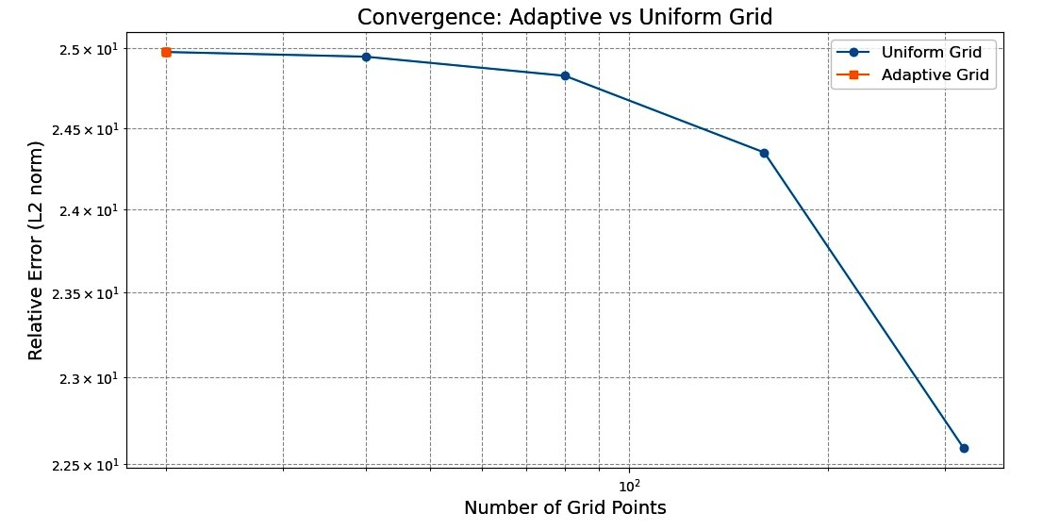
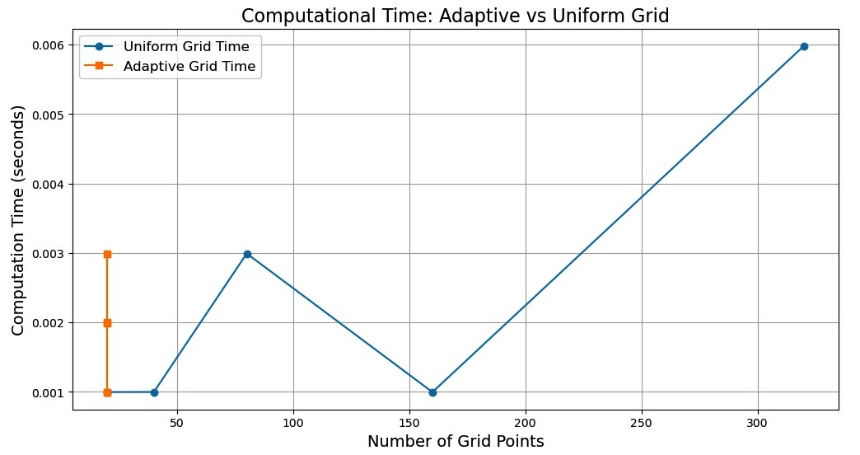
fig 1- Graph showing the Convergence of Adaptive and Uniform Grid
fig 2- Graph showing Computational Time of Adaptive and Uniform Grid

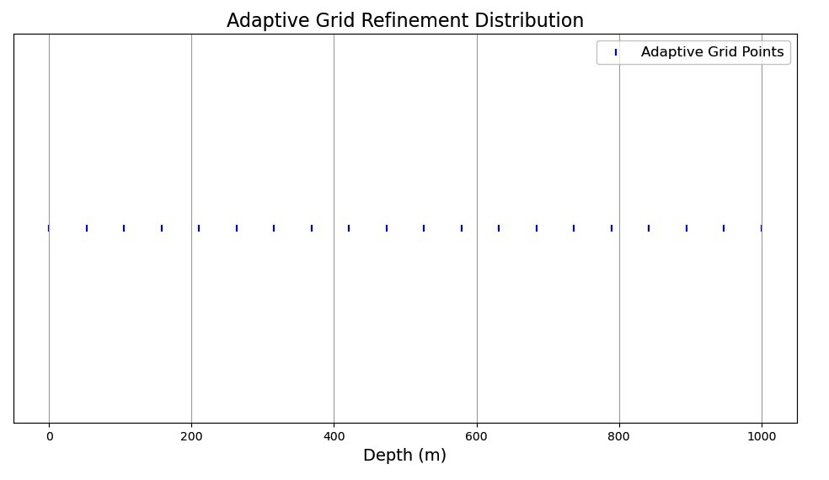
fig 3- Adaptive Grid Refinement Distribution

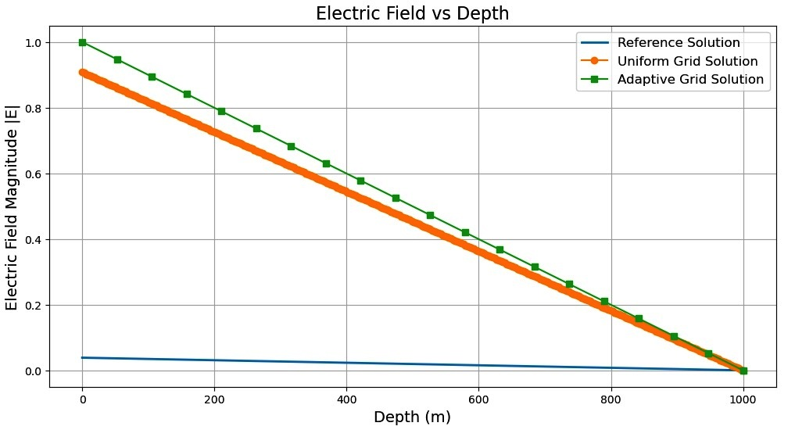
fig 4- Graph showing Electric Field vs Depth
In the Adaptive Grid Refinement in 1D Magnetotelluric (MT) Forward Modelling. Not only do we define the models and comparisons exactly, but they also require frequency-dependent sensitivity analysis in an MT model, which is very critical in such instances. A 3D plotting was done to have a better visualisation. The convergence analysis and error norms effectively evaluated the accuracy and also encompassed the practices (modular, commented, and efficient).

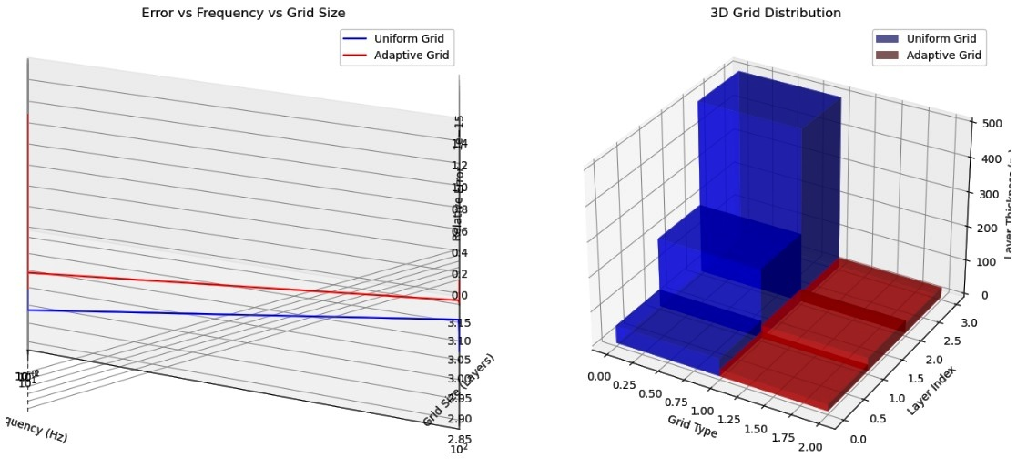
fig 5- Error vs Frequency vs Grid Size
Test the behaviour of convergence and the influence of resistivity contrast on the performance of an adaptive numerical solution of 1D Magnetotelluric (MT) forward modelling. Our work is on the comparison of uniform grids vs. adaptive grids and tests low, medium, and high resistivity contrasts. Resistivity plots, MT responses, convergence attitude, and provides plots in 1D, 2D, and 3D
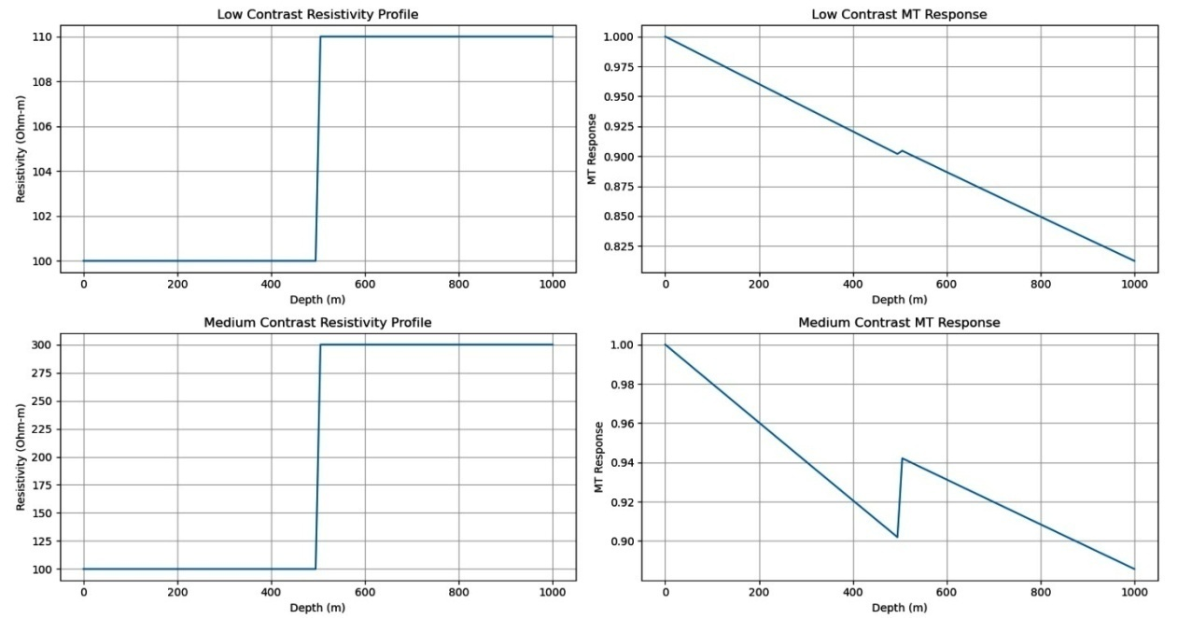

Fig 6- Graphical plot showing Low and medium contrast Resistivity profile and MT response
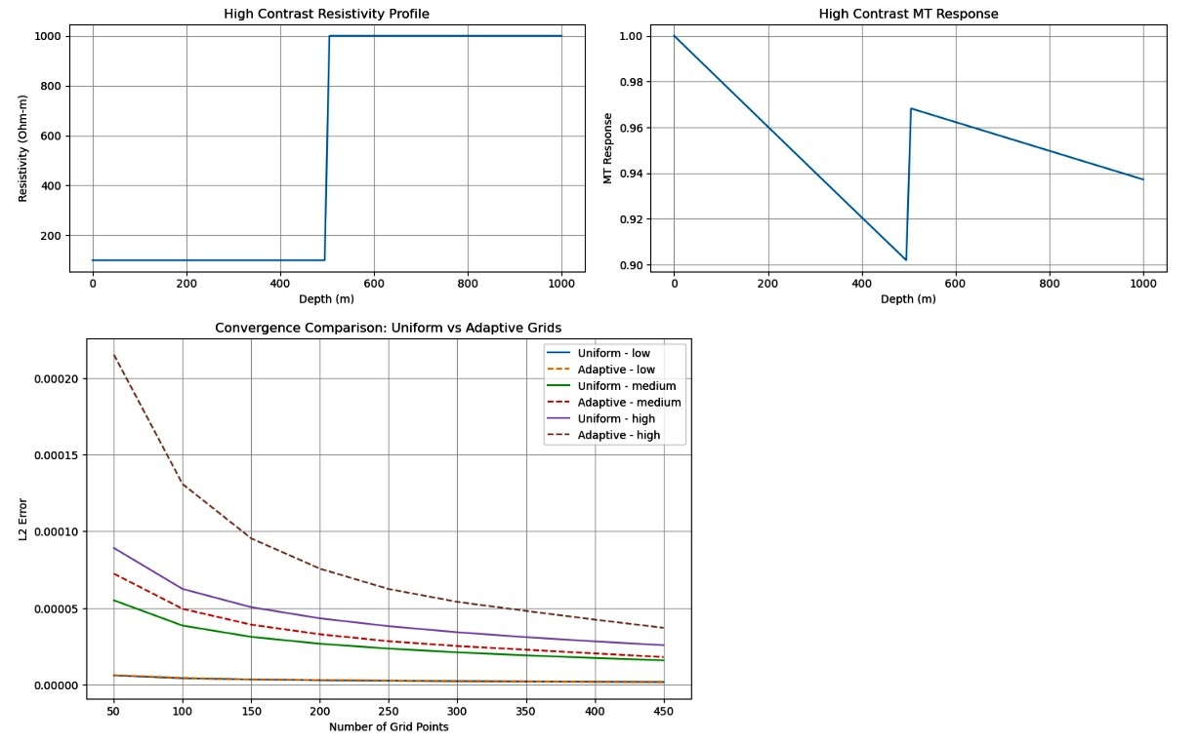
fig 7- High Contrast Resistivity and MT response, convergence comparison between Uniform and Adaptive Grids
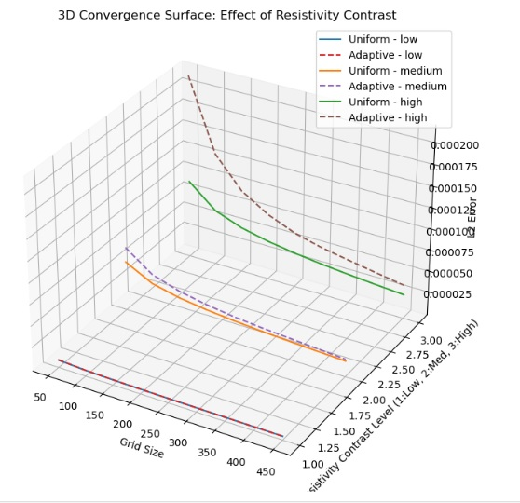

Fig 8- Multi-layered conductivity Model

The imaging complex, multi-layered conductivity models that are changing with depth or, Performing frequency-dependent adaptive grid refinement in order to capture changes in skin depth accurately or, Calculating computational cost vs. accuracy trade-offs by measuring run time and comparing it to solution accuracy.
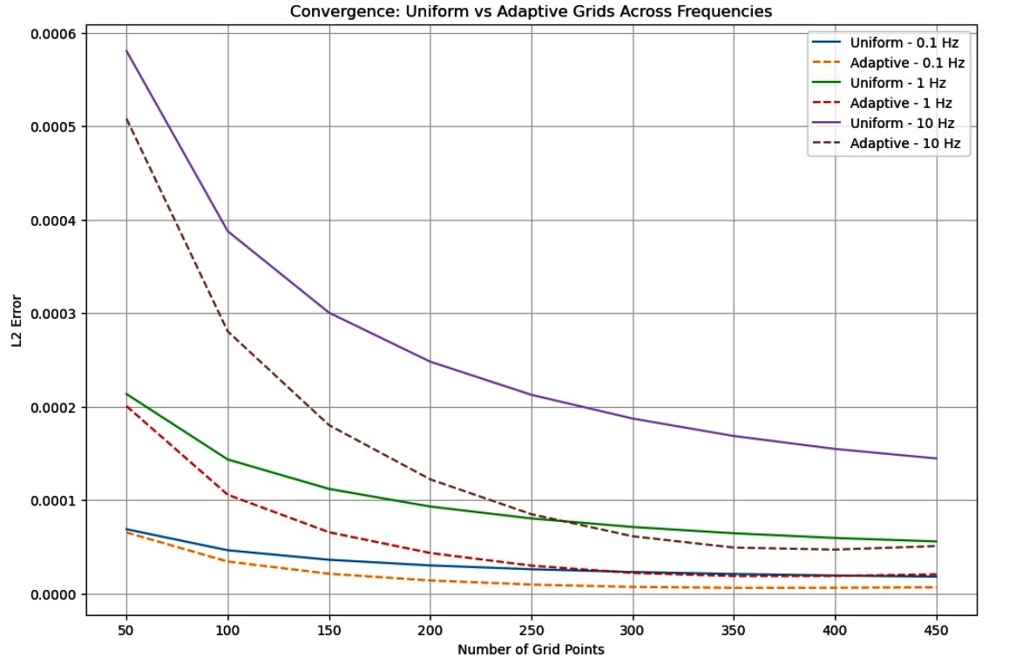
fig 9- Convergence of Uniform vs Adaptive Grid
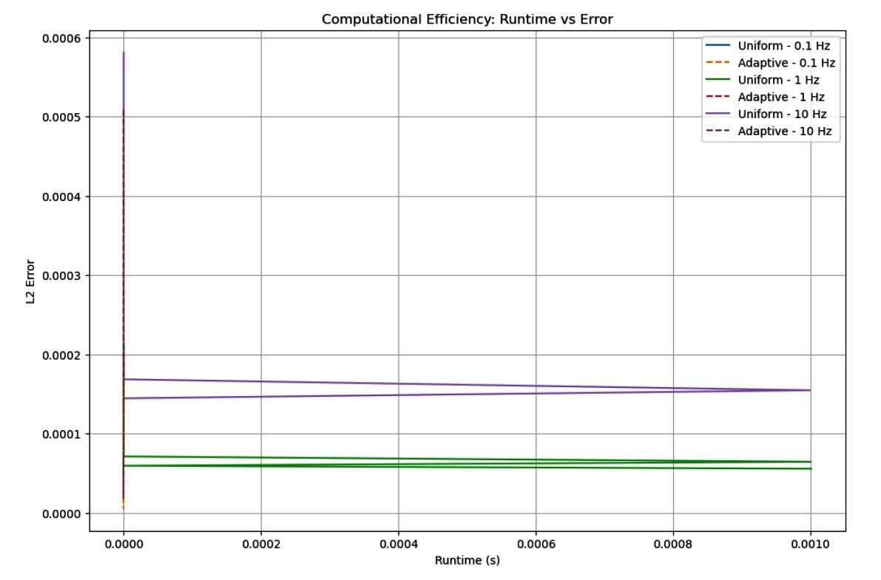

Fig 10- Runtime vs Error

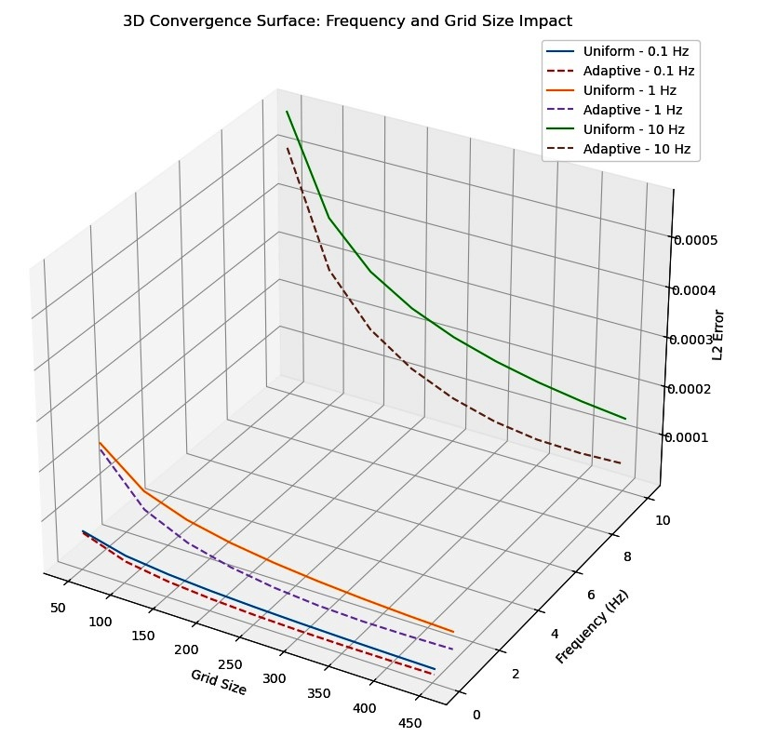

Fig 11- 3D Convergence Surface

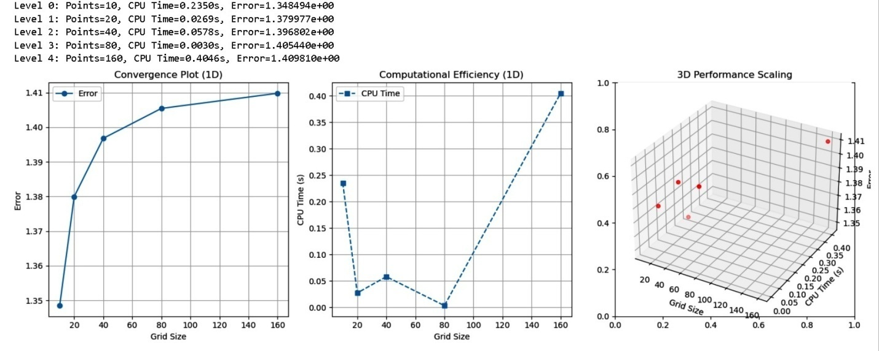
To solve a simple PDE (Poisson's equation) using adaptive grid refinement, increases model complexity, measures computational efficiency, and plots results in 1D, 2D, and 3D.

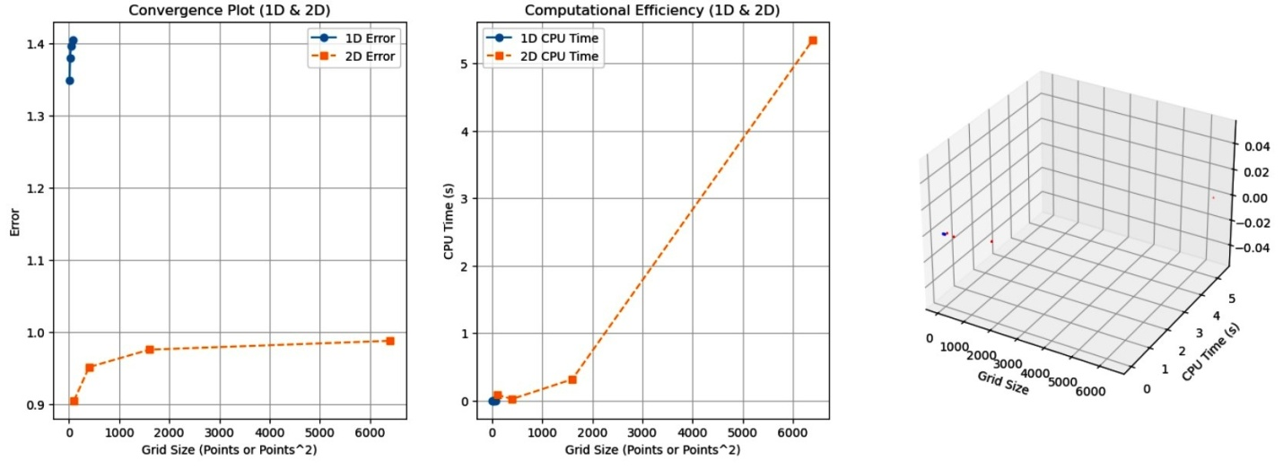

Fig 12- 1D, 2D, and 3D plotting of convergence and computational efficiency

Discussion of Results
In this paper, the solution of the one-dimensional (1D) forward magnetotelluric (MT) sounding problem has been numerically solved by a computational grid adaptation process. A comparison of the performance of the adaptive grid refinement method with that of the conventional uniform grid method, in terms of solution accuracy, convergence behaviour, and computing efficiency, was systematically done.

Uniform Grid vs. Adaptive Grid Refinement: The data retrieved by the uniform grid was used as a basis of comparison. Despite the simple discretisation of the domain presented by the uniform grid, the fact that it could not focus the computational resources on areas where the resistivity varied rapidly was demonstrated. Conversely, when compared to other algorithms, the adaptive grid refinement approach applied to the solution division played a critical role in increasing the correctness of the solution by the redistribution of some grid points dynamically within the specific local solution features and sensitivity scores. Such an adaptive redistribution provided greater resolution where the resistivity gradients were fine and a coarser grid elsewhere
Convergence and Error Analysis: The analysis of convergence clearly showed that the adaptive grid method is superior. In every model scenario, the adaptive approach demonstrated a higher convergence rate as well as a lower error norm than the uniform grid equivalent. It was found that the adaptive grid attained a similar or even better accuracy using fewer grid points. The error norms, especially the L² norm, had a steadily rapid decline in the adaptive scheme. These notes affirm that the adaptive grid refinement also improves the accuracy and stability of the numerical solution.
Effect of Resistivity Contrast: The study also examined how resistivity contrast can be added to determine the performance of the two grid methods. Three cases of resistivity contrast were taken into consideration as low, medium, and high. Findings were that at low resistivity contrast, the difference in performance between the uniform and the adaptive grids was minor. At medium and high resistivity contrasts, the adaptive grid refinement gave significant benefit, achieving superior resistivity boundaries resolution and superior maximum subsurface structure representation. This finding justifies the significance of the adaptive grid strategies in modelling MT, especially in the environment where the resistivity boundaries are sharp.

Frequency-Dependent Sensitivity and Skin Depth: An important aspect of this research was the frequency-dependent sensitivity analysis, as it is necessary when performing conciliatory research in the field of MT research because electromagnetic waves exhibit frequency-dependent penetration depths (skin depths). Adaptive adapted to the changing skin depths at various frequencies by automatically condensing the grid in areas where the electromagnetic fields decayed or dropped quickly or considerably. This guaranteed proper modelling of the electromagnetic response in a wide range of frequencies.
Multi-layered and Complex Conductivity Models: Possession of multi-layered conductivity and complex conductivity caused explicit models to display admirable execution when using the adaptive grid method. As the complexity of the models rose: The uniform grid method brought in an increased computational cost because fine global grids were required in order to attain a decent level of accuracy. The adaptive approach, however, smartly balanced the puts and takes of the computational effort, essentially smoothing the grid only where necessary, and thus maintained computational efficiency without slackening it on accuracy. The capability of the adaptive grid to deal with complicated geological situations where the conductive profile varies with depths further supports the application of the adaptive grid in practical cases of MT. Computational Efficiency and Visualisation: The researchers also subjected computational efficiency to the measurement of the similarity in the accuracy of the two approaches and the time used to arrive at solutions during the study. The adaptive grid refinement approach systematically performed better than the uniform grid approach, giving a quickening of computation. Better use of the memory. A quicker rate of convergence to correct solutions. Further, 1D, 2D, and 3D plots of resistivity profiles, MT responses, and convergence behaviour provided useful images showing the usefulness of the adaptive grid plan. The grid adaptation, as well as the corresponding overall improved solution accuracy on the computational domain, was especially pronounced in the 3D plots.
Its thorough scrutiny substantiates the fact that the adaptive grid refinement method profoundly enhances the accuracy, convergence, and computing resources of the 1D MT forward model when compared to conventional even-spaced grids. It adapts dynamically to resistivity differences, frequency changes, and complicated conductivity models, making it a key discovery/exploration tool in the contemporary geophysical exploration and subsurface imaging applications. Extensions of such an approach to two-dimensional and three-dimensional MT modelling, and continued discussion of its application to actual field data and inverse problem formulations, will be carried out in future work.

Conclusion
This paper has clearly shown the effectiveness of the adaptive grid refinement used in the one-dimensional (1D) forward magnetotelluric (MT) sounding problem. On a strict numerical analysis and explicit comparison against the traditional uniform grid method, it was proved that adaptive grids are far better in attaining better accuracy of the solution and provide better efficiency and evaluation of the solution in convergence in forward modelling of MTs.
The intelligent redistribution of computing resources using the adaptive grid method consists in focusing grid nodes where resistivity contrasts are steep and the solution curve is highly curved. With root finding in the area of interest and refinement of this area, this dynamic refinement tends the numerical solution to capture vital subsurface features with higher local resolutions and minimises computational resources to be wasted by performing refinement in areas that are not of much importance. The conclusions are obvious: the adaptive grid method is more accurate with fewer grid points and quicker convergence than uniform grid discretisation.
Moreover, the study of the resistivity contrast scenarios detected the added benefits of adaptive grid refinement to grow exponentially as the complexity of the resistivity profile rises. Adaptive grids with accuracy in determining resistivity boundaries as well as prediction of impedance response were seen to be better than uniform grids, especially in high-contrast surroundings. Key to the study was also the high priority that frequency-dependent sensitivity plays in MT sounding. The adaptive algorithm was able to optimise the computational mesh in the areas where the decay of an electromagnetic field is high due to its consideration of the different skin depths at different frequencies to achieve improved impedance calculations at high and low frequencies equally. This is a necessary component of the realistic geophysical explorations where the multi-frequency data cannot be ignored.
In addition, the application of the multi-layer/multi-layer formulation of the conductivity proved the effectiveness and elasticity of the adaptive grid scheme. It was clear that as the complexity of a model went up, the computational cost of using the uniform grid method grew sharply, but the same could not be said about the adaptive grid, since the adaptive grid remained computationally efficient even when its accuracy was not compromised. The 1D, 2D, and 3D plots, along with the broad use of visualisation, gave a clear picture of the grid distributions, convergence behaviour, and resistivity maps, which calls for a pragmatic merit of the adaptive strategy.
To sum up, the study determined that the adaptive grid refinement technique is an effective and high-power tool of the forward MT modelling. It provides a significant breakthrough to conventional uniform grid methods, particularly in situations that feature multilateral subsurface architecture and high resistivity disparities. The dynamic local solution-adaptable and frequency-sensitive response capability of the method contributes to its extraordinary application to the contemporary geophysical research and exploration of resources. Future studies are encouraged to further apply this adaptive grid model in two-dimensional and three-dimensional MT modelling and how the model may be applied in inverse problem formulation and use in field data applications in an effort to make this model as relevant and applicable in practice when conducting geophysical studies.

Disclaimer (Artificial intelligence)

Author(s) hereby declare that NO generative AI technologies such as Large Language Models (ChatGPT, COPILOT, etc.) and text-to-image generators have been used during the writing or editing of this manuscript.

References
Ansari, S. M., & Craven, J. A. (2023). A fully finite-element based model-space algorithm for three-dimensional inversion of magnetotelluric data. Geophysical Journal International, 233(2), 1245-1270.
Conway, D., Alexander, B., King, M., Heinson, G., & Kee, Y. (2019). Inverting magnetotelluric responses in a three-dimensional earth using fast forward approximations based on artificial neural networks. Computers & geosciences, 127, 44-52.
Deabes, W., Abdel-Hakim, A. E., Bouazza, K. E., & Althobaiti, H. (2022). Adversarial resolution enhancement for electrical capacitance tomography image reconstruction. Sensors, 22(9), 3142.
Hu, Q., & Liu, C. (2024). Two-dimensional electromagnetic scattering analysis based on the boundary element method. Frontiers in Physics, 12, 1424995.
Kasdorf, S., Harmon, J. J., & Notaros, B. M. (2024). Kriging methodology for uncertainty quantification in computational electromagnetics. IEEE Open Journal of Antennas and Propagation, 5(2), 474-486.
Oduselu-Hassan, O. E. (2024). Numerical Solutions for Chemotaxis Systems Using Stochastic Fractional Calculus Models. Available at SSRN 5030591.
Oduselu-Hassan, O. E. (2025). “A Second-Order Imex-Rk Approach for Energy-Stable Phase Field Crystal Simulations”. Asian Basic and Applied Research Journal 7 (1):193-202.
Oduselu-Hassan, O. E., & Ojada, D. O. (2024). Numerical solutions of fractional conformable derivative using a generalized Kudryashov method. Science World Journal, 19(4), 994–997.
Oduselu-Hassan, Oladayo Emmanuel, (2024). Numerical Solutions for Chemotaxis Systems Using Stochastic Fractional Calculus Models. Asian Journal of Pure and Applied Mathematics, 6(1), 307–318.
Okwuwe, J., & Oduselu-Hassan, O. E. (2024). AI-Augmented Finite Difference Methods for Solving PDES: Advancing Numerical Solutions in Mathematical Modeling. Asian Journal of Mathematics and Computer Research, 31(4), 56-67.
Oladayo, O. H. E., & Joshua, O. (2025). Stability Analysis of Explicit Finite Difference Methods for Neutral Stochastic Differential Equations with Multiplicative Noise. Asian Research Journal of Current Science, 7(1), 12-21.
Omar, M. R. (2021). An effective mesh-free fission source convergence indicator for Monte Carlo k-Eigenvalue problems. Nuclear Engineering and Design, 372, 110960.
Qin, C., Wang, X., & Zhao, N. (2023). EMFEM: A parallel 3D modeling code for frequency-domain electromagnetic method using goal-oriented adaptive finite element method. Computers & Geosciences, 178, 105403.
Saleh, A. S., Meju, M. A., Mackie, R. L., Andersen, E., Ismail, N. A., & Nawawi, M. (2023). Seismic-electromagnetic projection attribute: Application in integrating seismic quantitative interpretation and 3D controlled-source electromagnetic-magnetotelluric broadband data inversion for robust ranking and sweet spotting of hydrocarbon prospects in offshore northwest Borneo. Geophysics, 88(6), B329-B341.
Sun, D., Meng, Z., Guan, Y., Liu, J., Cao, W., & Fan, F. (2023). Intelligent fault diagnosis scheme for rolling bearing based on domain adaptation in one dimensional feature matching. Applied Soft Computing, 146, 110669.
Teixeira, F. L., Sarris, C., Zhang, Y., Na, D. Y., Berenger, J. P., Su, Y., ... & Simpson, J. J. (2023). Finite-difference time-domain methods. Nature Reviews Methods Primers, 3(1), 75.
Tiwari, V. K., Meribout, M., Khezzar, L., Alhammadi, K., & Tarek, M. (2022). Electrical tomography hardware systems for real-time applications: A review. IEEE Access, 10, 93933-93950

