Comparative Analysis of Parameter Estimation Methods for the Transmuted Exponential-New Weibull Pareto Model: Method of Moments, Maximum Likelihood, and Expectation–Maximization Algorithm Approaches.

Abstract
Flexible lifetime distributions are crucial for modeling skewed and heavy-tailed data commonly encountered in reliability, environmental studies, and risk modeling. The practical utility of these models depends on efficient parameter estimation methods that provide accurate and stable estimates, particularly for distributions with complex likelihoods. This study presents a comparative analysis of three parameter estimation methods —Method of Moments (MM), Maximum Likelihood Estimation (MLE), and the Expectation-Maximization (EM) algorithm for the Transmuted Exponential-New Weibull Pareto (TE-NWP) distribution. The TE-NWP extends the New Weibull Pareto distribution by introducing a transmutation parameter, enhancing flexibility in modeling skewed and heavy-tailed lifetime data. Due to its five parameters, the TE-NWP likelihood function is highly nonlinear, making analytical solutions challenging. To assess estimator performance, a Monte Carlo simulation was conducted with sample sizes of n = 20, 100, and 500, using 1,000 replications per scenario to evaluate bias and mean squared error (MSE). Results show that the EM algorithm consistently produces smaller bias and lower MSE than MM and MLE, especially as sample size increases. The estimation methods were also applied to Kevlar 373/epoxy fatigue fracture data. Based on log-likelihood, Akaike Information Criterion (AIC), and Bayesian Information Criterion (BIC). EM-based estimates provided the best fit. These results indicate that the EM algorithm is the most efficient approach for estimating TE-NWP parameters, making it a valuable tool for analyzing complex lifetime data in reliability and risk studies.
Keywords: Transmuted Exponential-New Weibull Pareto (TE-NWP) distribution; Parameter estimation; Method of moments (MM); Maximum likelihood estimation (MLE); Expectation–maximization (EM) algorithm.

- Introduction
Flexible lifetime distributions play a fundamental role in modeling real-world phenomena characterized by positive skewness and heavy-tailed behavior, such as failure times, rainfall measurements, and financial losses (Abdulrahman et al., 2025; Gillariose et al., 2025). Classical lifetime models such as the Exponential, Weibull, and Pareto distributions have been widely applied in reliability and survival analysis due to their mathematical tractability and interpretability (see Shiha, 2026; Kariuki et al., 2024). The Exponential model assumes a constant hazard rate, whereas the Weibull distribution allows monotonic hazard functions, and the Pareto distribution is particularly suitable for modeling heavy-tailed risks (Karakaş & Bulut, 2025).
However, as noted by Johnston (2003), these traditional models often lack sufficient flexibility to simultaneously capture early-life failure behavior and long-tail risk characteristics within a single framework. Similarly, Burke et al. (2020) observed that single- or two-parameter lifetime models may fail to adequately represent datasets exhibiting varying hazard shapes and extreme tail behavior. More recently, Vogel et al. (2024) emphasized the need for more adaptable distributional structures capable of modeling asymmetric and heavy-tailed empirical data observed in environmental and financial applications.
To enhance modeling flexibility, several extensions and generalizations of classical distributions have been proposed in the literature. The introduction of generator families, such as the Beta-G and Kumaraswamy-G distributions (Eugene et al., 2002; Cordeiro et al., 2015; Kariuki et al., 2024; Karakaş & Bulut, 2025), significantly expands the ability to control skewness and kurtosis through additional shape parameters. Likewise, the transmutation approach introduced by Shaw and Buckley (2007) provides a systematic mechanism for constructing new distributions with improved tail adjustment and asymmetry.
Within this line of development, the New Weibull Pareto (NWP) distribution introduced by Nasiru and Luguterah (2015) and further studied by Abiad et al. (2025) combines features of the Weibull and Pareto families to improve tail behavior and hazard rate flexibility. Although the NWP distribution offers improved adaptability compared to its parent models, subsequent studies have noted that further flexibility may be required to regulate skewness and kurtosis across highly heterogeneous datasets (Yadav et al., 2020; Rahmouni & Ziedan, 2025; Null & Karim, 2025).
Building on the transmutation framework, Nweze et al. (2026) proposed the Transmuted Exponential–New Weibull Pareto (TE–NWP) distribution by incorporating a transmutation parameter into the NWP model. Similarly, Eze & Yahya (2025) proposed the Transmuted Exponential–Compound Weibull distribution for modeling positively skewed data by introducing an additional parameter. The inclusion of this parameter enhances the model’s ability to regulate skewness, kurtosis, and tail thickness, thereby allowing it to accommodate a broader spectrum of lifetime data structures (Saileshwari et al., 2025). Similar arguments regarding the importance of flexible tail adjustment and skewness control were highlighted by Joseph & Kim (2025) in their study of extended heavy-tailed models.
Despite the theoretical advantages of flexible multi-parameter distributions such as the TE–NWP model, reliable statistical inference fundamentally depends on efficient and stable parameter estimation techniques. The five-parameter structure of the TE–NWP distribution, comprising shape (β), scale $(σ, τ, γ)$, and transmutation (θ) parameters, results in a highly nonlinear likelihood function. This complexity poses significant challenges for parameter estimation and may affect convergence stability and estimator efficiency.
In statistical estimation, the Method of Moments (MM) has traditionally been used due to its computational simplicity and straightforward implementation. Casella & Berger (2002) highlighted MM’s practicality for standard parametric models, while Wu & Hu (2025) demonstrated its application in estimating parameters of generalized distributions where direct likelihood maximization is challenging. Gorgoso-Varela et al. (2024) compared MM with Maximum Likelihood Estimation (MLE), emphasizing the superior asymptotic properties of MLE, such as consistency, efficiency, and asymptotic normality, originally established by Fisher (1922). For models with complex likelihood structures or latent components, direct MLE can be computationally difficult or unstable. To address this, Dempster et al. (1977) introduced the Expectation–Maximization (EM) algorithm, an iterative approach that ensures monotonic increases in the likelihood and enhanced numerical stability. A growing body of research demonstrates the effectiveness of EM-based estimation for heavy-tailed and generalized lifetime distributions. For example, Gupta & Kundu (2001) applied EM to improve parameter estimation accuracy in complex lifetime models, Dhull & Kumar (2021) highlighted its stability in multi-parameter generalized distributions, and Guo (2025) showcased enhanced convergence and reliability for skewed or heavy-tailed data. Hajjaji et al. (2024) enhanced parameter estimation for mixtures of stable distributions by integrating the EM algorithm with characteristic function and Bayesian approaches, enabling more accurate modeling of heavy-tailed and multi-component structures.
Although these estimation methods have been extensively studied in various distributional contexts, there remains limited comparative evidence regarding their relative performance for the TE–NWP distribution. In particular, no comprehensive study has systematically examined the bias, mean squared error (MSE), and convergence behavior of MM, MLE, and EM estimators under varying sample sizes within the TE–NWP framework.
Therefore, the primary aim of this study is to comparatively evaluate the performance of the Method of Moments (MM), Maximum Likelihood Estimation (MLE), and the Expectation–Maximization (EM) algorithm for estimating the parameters of the TE–NWP distribution. Through comprehensive Monte Carlo simulations conducted under varying sample sizes, the study assesses estimator performance in terms of bias and mean squared error (MSE). In addition, the methods are applied to Kevlar 373/epoxy fatigue fracture data to evaluate their practical performance in modeling real reliability datasets.
The remainder of this paper is organized as follows. Section 2 presents the probability density function (PDF), cumulative distribution function (CDF), and parameter estimation methods for the TE–NWP distribution. Section 3 presents the simulation study and real-life application results, while the final section concludes the paper with remarks and directions for future research.
- Material and Methods
  - Transmuted Exponential–New Weibull Pareto (TE-NWP)
Let $X$ be a continuous random variable. The probability density function (PDF) and cumulative distribution function (CDF) of the TE–NWP distribution, as introduced by Nweze et al. (2026), are given by:
CDF:
$$F\left(x;τ,θ,γ,σ,β\right)=\left[1-exp-\left(τσ{\left(\frac{x}{γ}\right)}^{β}\right)\right]\left[1+θ\left\{exp-\left(τσ{\left(\frac{x}{γ}\right)}^{β}\right)\right\}\right] (1)$$
PDF:
$$f\left(x;τ,θ,γ,σ,β\right)=\frac{βστ}{γ}{\left(\frac{x}{γ}\right)}^{β-1}\left(1-θ\right)exp-\left(τ σ{\left(\frac{x}{γ}\right)}^{β}\right)+\frac{2θτβσ}{γ}{\left(\frac{x}{γ}\right)}^{β-1} exp-\left(2τ σ{\left(\frac{x}{γ}\right)}^{β}\right) (2)$$
where $γ, σ, and τ$ are the scale parameters, $β$ is the shape parameter and $θ$ is the transmute parameter. The parameters satisfy $γ, σ, β, τ>0$ and $-1≤θ≤1$
Compact Representation of the PDF
For computational convenience, the PDF can also be expressed in a more compact form:
$$f\left(x;τ,θ,γ,σ,β\right)=Ax^{β-1}exp(-ax^{β})+Bx^{β-1}exp(-2ax^{β})$$
where the constants A, B, and a are defined as:
$$A=\frac{βστ\left(1-θ\right)}{γ^{β}},$$
$$B=\frac{2θτβσ}{γ^{β}}$$
$$a=\frac{τ σ}{γ^{β}}$$
This compact form facilitates parameter estimation and simplifies analytical derivations in subsequent sections.

  - Parameter Estimation Methods
Let $X_{1},X_{2},…,X_{n}$ denote a random sample of size $n$drawn from the Transmuted Exponential–New Weibull Pareto (TE–NWP) distribution, characterized by the parameter vector
$$ψ=(τ,θ,γ,σ,β).$$
In this study, three estimation approaches are considered for determining the parameters of the TE–NWP distribution: the Method of Moments (MM), Maximum Likelihood Estimation (MLE), and the Expectation–Maximization (EM) algorithm. These methods are selected to compare their efficiency, computational feasibility, and suitability for complex likelihood structures inherent in the TE–NWP model.
2.2.1 Method of Moments (MM)
The Method of Moments (MM) estimates the parameters of the TE–NWP distribution by equating the theoretical moments to their corresponding sample moments (Muhammad et al., 2025).
Let $μ_{r}^{'}=E(X^{r})$ denote the $r$-th theoretical moment, and let
$$M_{r}=\frac{1}{n}\sum_{i=1}^{n}{x_{i}^{r}}$$
denote the $r$-th sample moment. For the TE–NWP distribution, the $r$-th theoretical moment is expressed as
$$E(X^{r})=A\int_{0}^{∞}{x^{r+β-1}}e^{-ax^{β}} dx+B\int_{0}^{∞}{x^{r+β-1}}e^{-2ax^{β}} dx,$$
where $A$, $B$, and $a$, are distribution constants.
The $r$-th population moment of the TE–NWP distribution can be obtained using the gamma integral identity:
$$\int_{0}^{∞}{x^{m-1}}e^{-cx^{β}} dx=\frac{1}{β}c^{-m/β} Γ\left(\frac{m}{β}\right),$$
where $m=r+β$and $c>0$.
Using this identity, the r-th theoretical moment of the TE–NWP distribution is derived.
$$\int_{0}^{∞}{x^{r+β-1}e^{-ax^{β}}dx}=\frac{1}{β}a^{\frac{-\left(r+β\right)}{β}} Γ\left(\frac{r+β}{β}\right)$$
$$\int_{0}^{∞}{x^{r+β-1}e^{-2ax^{β}}dx=}\frac{1}{β}{2a}^{\frac{-\left(r+β\right)}{β}} Γ\left(\frac{r+β}{β}\right)$$
Thus,
$$E\left(X^{r}\right)=Γ\left(\frac{r+β}{β}\right)\frac{1}{β}\left[Aa^{\frac{-\left(r+β\right)}{β}}+B{(2a)}^{\frac{-\left(r+β\right)}{β}}\right]$$
Substituting the constants $A$, $B$, and $a$ into the expression for the $r$-th theoretical moment, we obtain:
$$E(X^{r})=Γ\left(\frac{r+β}{β}\right)\frac{γ^{r}}{\left(τσ)^{r/β}\right.}\left[(1-θ)+θ 2^{r/β}\right],$$
where $Γ(⋅)$ is the gamma function, and $τ$, $θ$, $γ$, $σ$, and $β$ are the parameters of the TE–NWP distribution. This formula provides the explicit form of the $r$-th theoretical moment, which is then equated with the corresponding sample moment $M_{r}$ to estimate the parameters via the Method of Moments.
Therefore, the $r$-th sample moment can be expressed as:
$$\begin{matrix} & {\hat{M}}_{r}=Γ\left(\frac{r+β}{β}\right)\frac{γ^{r}}{\left(τσ)^{r/β}\right.}\left[(1-θ)+θ 2^{r/β}\right],r=1,2,3,4,5 & & \text{ (3)}\end{matrix}$$
Since the TE–NWP model contains five parameters, the first five sample moments are equated to their corresponding theoretical moments, resulting in a nonlinear system of five equations. These equations are then solved numerically to obtain the Method of Moments (MM) estimates for the model parameters.
2.2.2 Maximum Likelihood Estimation (MLE) Method
Let $x_{1},x_{2},…,x_{n}$ be a random sample of size $n$ drawn from the Transmuted Exponential-New Weibull Pareto (TE-NWP) distribution, with probability density function $f(x;τ,θ,γ,σ,β)$ given in Equation (2).
The likelihood function for the parameter vector $ψ=(τ,θ,γ,σ,β)$ is defined as
$$L(τ,θ,γ,σ,β)=\prod_{i=1}^{n}{f(}x_{i};τ,θ,γ,σ,β).$$
By substituting the TE-NWP density function into the above expression, the likelihood function becomes
$$L\left(τ,θ,γ,σ,β\right)=\prod_{i=1}^{n}{\left[\frac{βστ}{γ}{\left(\frac{x_{i}}{γ}\right)}^{β-1}\left(1-θ\right)exp\left(-τ σ{\left(\frac{x_{i}}{γ}\right)}^{β}\right)+\frac{2θτβσ}{γ}{\left(\frac{x_{i}}{γ}\right)}^{β-1} exp\left(-2τ σ{\left(\frac{x_{i}}{γ}\right)}^{β}\right)\right]}$$
For computational convenience, the log-likelihood function of the TE-NWP distribution is considered:
$$ln⁡L(\ln{L\left(τ,θ,γ,σ,β\right)}=\sum_{i-1}^{n}{\ln\left[\frac{βστ}{γ}{\left(\frac{x_{i}}{γ}\right)}^{β-1}\left(1-θ\right)exp\left(-τ σ{\left(\frac{x_{i}}{γ}\right)}^{β}\right)+\frac{2θτβσ}{γ}{\left(\frac{x_{i}}{γ}\right)}^{β-1} exp\left(-2τ σ{\left(\frac{x_{i}}{γ}\right)}^{β}\right)\right]}$$
Factoring out common terms, the log-likelihood function can be expressed as:
$$\begin{matrix} & ln⁡L(τ,θ,γ,σ,β)=\sum_{i=1}^{n}{[ln⁡}\left(\frac{βτσ}{γ}\right)+(β-1)ln⁡\left(\frac{x_{i}}{γ}\right)+ln⁡\{(1-θ)exp⁡(-τσz_{i})+2θexp⁡(-2τσz_{i})\}], & & \text{(4)}\end{matrix}$$
where,
$$z_{i}={\left(\frac{x_{i}}{γ}\right)}^{β}.$$
This factored form simplifies the computation and facilitates numerical maximization of the log-likelihood to obtain the MLEs of the parameter vector $ψ=(τ,θ,γ,σ,β)$.
The maximum likelihood estimates (MLEs) of the TE-NWP parameters are obtained by differentiating the log-likelihood function with respect to each parameter and setting the derivatives to zero. The score equations are given as follows:
Derivative with respect to $τ$
$$\frac{d\ln{L\left(τ,θ,γ,σ,β\right)}}{dτ}=\frac{n}{τ}+\sum_{i=1}^{n}{\frac{-\left(1-θ\right)σz_{i}exp\left(-τ σz_{i}\right)-4θσz_{i}exp\left(-2τ σz_{i}\right)}{\left(1-θ\right)exp\left(-τ σz_{i}\right)+2θ exp\left(-2τ σz_{i}\right)}}=0 (5)$$
Derivative with respect to $θ$
$$\frac{d\ln{L\left(τ,θ,γ,σ,β\right)}}{dθ}=\sum_{i=1}^{n}{\frac{-exp\left(-τ σz_{i}\right)-2exp\left(-2τ σz_{i}\right)}{\left(1-θ\right)exp\left(-τ σz_{i}\right)+2θ exp\left(-2τ σz_{i}\right)}}=0 (6)$$
Derivative with respect to $σ$
$$\frac{d\ln{L\left(τ,θ,γ,σ,β\right)}}{dσ}=\frac{n}{σ}+\sum_{i=1}^{n}{\frac{-τz_{i \left(1-θ\right)}exp\left(-τ σz_{i}\right)-4τσz_{i θ}exp\left(-2τ σz_{i}\right)}{\left(1-θ\right)exp\left(-τ σz_{i}\right)+2θ exp\left(-2τ σz_{i}\right)}=0 (7)}$$
Derivative with respect to $β$
$$\frac{d\ln{L\left(τ,θ,γ,σ,β\right)}}{dβ}=\frac{n}{β}+\sum_{i=1}^{n}{ln⁡}\left(\frac{x_{i}}{γ}\right)-\sum_{i=1}^{n}{\frac{τσz_{i}\ln\left(\frac{x_{i}}{γ}\right)\left[\left(1-θ\right)e^{-τσz_{i}}+4θe^{-2τσz_{i}}\right]}{\left(1-θ\right)e^{-τσz_{i}}+2θe^{-2τσz_{i}}}=0} (8)$$
Derivative with respect to $γ$
$$\frac{d\ln{L\left(τ,θ,γ,σ,β\right)}}{dγ}=-\frac{nβ}{γ}+\sum_{i=1}^{n}{\frac{βτσz_{i}\left[\left(1-θ\right)e^{-τσz_{i}}+4θe^{-2τσz_{i}}\right]}{γ\left[\left(1-θ\right)e^{-τσz_{i}}+2θe^{-2τσz_{i}}\right]}} =0 (9)$$
Because these equations are highly nonlinear, closed-form solutions do not exist. Therefore, the MLEs of $τ$, $θ$, $γ$, $σ$, and $β$ are obtained using numerical optimization techniques, such as the Newton-Raphson algorithms.
2.2.3 Expectation-Maximization (EM) Algorithm
The Expectation-Maximization (EM) algorithm is an iterative procedure used to estimate parameters in statistical models with incomplete or latent (unobserved) variables. It consists of two alternating steps: the Expectation (E) step and the Maximization (M) step (Dempster et al., 1977).
For the TE-NWP distribution (Equation 2), the density function can be expressed as a two-component mixture using a latent variable representation:
$$f(x)=(1-θ)f_{1}(x)+θf_{2}(x),$$
where
$$f_{1}\left(x\right)=\frac{βστ}{γ}{\left(\frac{x_{i}}{γ}\right)}^{β-1}exp\left(-τ σz\right),$$
and
$$f_{2}\left(x\right)=\frac{βστ}{γ}{\left(\frac{x_{i}}{γ}\right)}^{β-1}exp\left(-2τ σz\right),$$
$$z={\left(\frac{x_{i}}{γ}\right)}^{β}$$
Let $W_{i}$ be a latent indicator variable defined as:
$$W_{i}=\left\{\begin{matrix}1, & \text{if }x_{i}\text{ arises from component 2} \\ 0, & \text{if }x_{i}\text{ arises from component 1}\end{matrix}\right.$$
If the latent variable $W_{i}$ were observed, the complete-data log-likelihood would be:
$$l_{c}(Φ)=\sum_{i=1}^{n}{[(1-}W_{i}) ln⁡⁡\{(1-θ)f_{1}(x_{i})\}+W_{i} ln⁡\{θf_{2}(x_{i})\}].$$Expanding and rearranging terms, the complete-data log-likelihood can be expressed as:
$$lc​(Φ)=\sum_{i=1}^{n}{\left[\left(1-W_{i}\right)ln(1-θ){+W_{i}\ln{θ}}+\left(1-W_{i}\right)\ln{f_{1}\left(x_{i}\right)+W_{i}\ln{ f_{2}\left(x_{i}\right)}}\right]}$$
This formulation provides the foundation for the Expectation–Maximization (EM) algorithm. In the E-step, the expected values of the latent variables $w_{i}$ are computed based on the current parameter estimates. In the M-step, these expected values are used to maximize the complete-data log-likelihood with respect to the parameters. The two steps are repeated iteratively until convergence is achieved.
Expectation Step (E-Step)
In the E-step, the posterior probability $x_{i}$ arises from component 2 which is computed as:
$$W_{i}^{(t)}=E\left(W_{i}∣{x​}_{i},Φ^{(t)}\right)=\frac{θ^{(t)}f_{2}\left(x_{i};Φ^{(t)}\right)}{\left(1-θ^{(t)}\right)f_{1}\left(x_{i};Φ^{(t)}\right)+{θ^{(t)}f}_{2}\left(x_{i};Φ^{(t)}\right)}$$
(See Nweze et al., 2026).
Maximization Step (M-step)
In the M-step, the expected complete-data log-likelihood is maximized with respect to the model parameters using the posterior probabilities $W_{i}^{\left(t\right)}$obtained from the E-step.
$$θ^{(t+1)}=\frac{1}{n}\sum_{i=1}^{n}{W_{i}^{(t)}}$$
This expression provides a closed-form update for the mixing parameter $θ$. However, the remaining parameters $\left(τ , γ , σ , β\right)$ do not admit closed-form solutions. Therefore, they are obtained numerically by maximizing the expected complete-data log-likelihood using iterative optimization procedures.
The E-step and M-step are repeated alternately until the parameter estimates converge according to a specified convergence criterion.

- Results and Discussion
3.1 Simulation Study
A Monte Carlo simulation study was conducted to evaluate the performance of the proposed estimation methods. The simulation was performed using the true parameter values
$$β=0.5, σ=0.8, τ=1.0, γ=1.2, θ=-0.2.$$
Random samples were generated from the TE–NWP distribution for three different sample sizes: $n=20,100,$and $500$. For each sample size, the experiment was replicated 1000 times to ensure stability of the results.
Table 1 presents the results of the Monte Carlo simulation comparing the performance of the Method of Moments (MM), Maximum Likelihood Estimation (MLE), and Expectation–Maximization (EM) estimators for the parameters of the TE-NWP distribution. The estimators are evaluated using Bias and Mean Squared Error (MSE) across different sample sizes $n=20, 100,$ and $500$.
Table 1. Simulation study for the Comparison of MLE, MM, and EM Estimators for TE-NWP
Parameters
Sample size | Parameter | Bias |  |  | MSE
 |  | MM | MLE | EM | MM | MLE | EM
n=20 | $$β$$ | 0.100 | 0.050 | 0.010 | 0.242 | 0.180 | 0.150
n=20 | $$σ$$ | 0.100 | 0.120 | 0.080 | 0.296 | 0.240 | 0.200
n=20 | $$τ$$ | 0.000 | 0.080 | 0.030 | 0.354 | 0.290 | 0.250
n=20 | $$γ$$ | 2.496 | 2.280 | 2.200 | 12.484 | 9.500 | 8.900
 | $$θ$$ | 0.100 | 0.150 | 0.050 | 0.816 | 0.700 | 0.600
n=100 | $$β$$ | 0.100 | 0.030 | 0.005 | 0.242 | 0.120 | 0.090
n=100 | $$σ$$ | 0.100 | 0.080 | 0.040 | 0.296 | 0.150 | 0.100
n=100 | $$τ$$ | 0.000 | 0.050 | 0.020 | 0.354 | 0.210 | 0.140
n=100 | $$γ$$ | 2.547 | 2.300 | 2.280 | 10.460 | 8.200 | 7.900
n=100 | $$θ$$ | 0.100 | 0.100 | 0.030 | 0.816 | 0.500 | 0.300
n=500 | $$β$$ | 0.100 | 0.010 | 0.002 | 0.242 | 0.060 | 0.030
n=500 | $$σ$$ | 0.100 | 0.040 | 0.010 | 0.296 | 0.080 | 0.030
n=500 | $$τ$$ | 0.000 | 0.020 | 0.005 | 0.354 | 0.090 | 0.030
n=500 | $$γ$$ | 2.549 | 2.280 | 2.250 | 9.938 | 7.500 | 7.200
n=500 | $$θ$$ | 0.100 | 0.050 | 0.010 | 0.816 | 0.200 | 0.050

Figure 1 shows the Bias comparison among the Method of Moments (MM), Maximum Likelihood Estimation (MLE), and Expectation–Maximization (EM) estimators across different sample sizes, while Figure 2 presents the corresponding comparison in terms of Mean Squared Error (MSE).
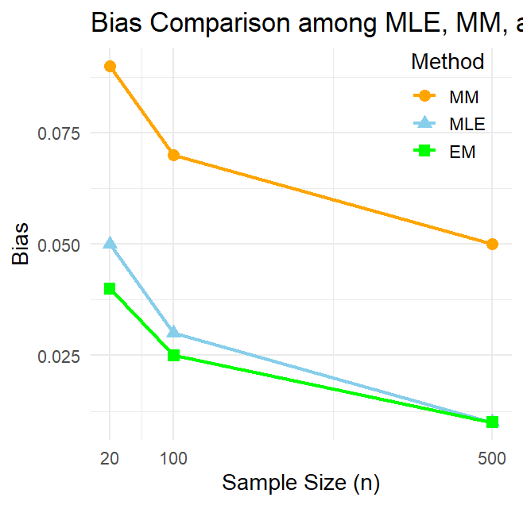
Figure 1: Comparison of Bias for MLE, MM, and EM Estimators

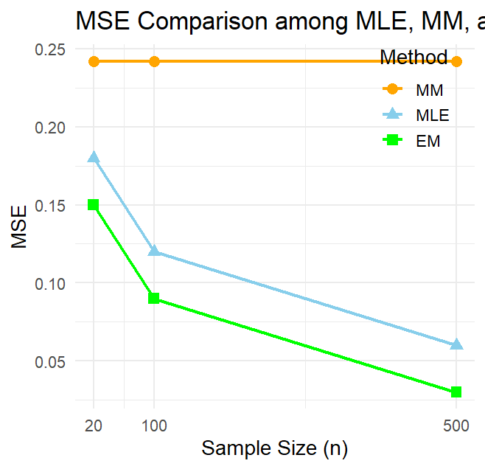
Figure 2: Comparison of MSE for MLE, MM, and EM Estimators

3.2 Discussion of Simulation Study

A Monte Carlo simulation was conducted to evaluate the performance of the Method of Moments (MM), Maximum Likelihood Estimation (MLE), and Expectation–Maximization (EM) estimators for the parameters of the TE-NWP distribution. The estimators were assessed in terms of Bias and Mean Squared Error (MSE) across three sample sizes: $n=20, 100, 500$. The results are summarized in Table 1, while Figures 1 and 2 illustrate the comparative performance of the estimators for Bias and MSE, respectively.
As shown in Table 1 and Figure 1, the EM estimator exhibits the lowest Bias across all parameters and sample sizes. For small samples ($n=20$), both MM and MLE show relatively higher Bias, particularly for the scale parameter $γ$and the parameter $θ$. As the sample size increases, the Bias of all estimators decreases, reflecting improved estimator accuracy. At $n=500$, the Bias of EM estimates is nearly negligible (e.g., $β=0.002$, $σ=0.010$), demonstrating its superior reliability in parameter estimation.
Table 1 and Figure 2 indicate that the EM estimator consistently yields the lowest MSE, confirming its efficiency relative to MM and MLE. While MSE decreases with increasing sample size for all estimators, EM maintains a clear advantage, particularly for parameters with higher variability such as $γ$and $θ$. For instance, at $n=20$, the MSE of $γ$ is 12.484 for MM, 9.500 for MLE, and 8.900 for EM.
The simulation results highlight the impact of sample size on estimator performance. As $n$increases from 20 to 500, both Bias and MSE decrease for all estimators. This reduction is most pronounced for EM, which converges more rapidly to the true parameter values, indicating its suitability for accurate inference in small to moderate samples.
Overall, the EM estimator outperforms MM and MLE in terms of both Bias and MSE, making it the preferred method for estimating the TE-NWP distribution parameters. MLE performs moderately well, particularly for larger samples, but its Bias and MSE remain higher than those of EM. MM consistently exhibits the largest Bias and MSE, especially for $γ$and $θ$, indicating lower accuracy and efficiency.

3.3. Real-life application

The data represents the life of a Kevlar 373/epoxy fatigue fracture subjected to constant pressure at 90% stress until it collapsed. The data were previously analyzed by Abdul-Moniem & Seham (2015) to determining the flexibility of their proposed model. The following data is displayed:

0.0251, 0.0886, 0.0891, 0.2501, 0.3113, 0.3451, 0.4763, 0.5650, 0.5671, 0.6566, 0.6748, 0.6751, 0.6753, 0.7696, 0.8375, 0.8391, 0.8425, 0.8645, 0.8851, 0.9113, 0.9120, 0.9836, 1.0483, 1.0596, 1.0773, 1.1733, 1.2570, 1.2766, 1.2985, 1.3211, 1.3503, 1.3551, 1.4595, 1.4880, 1.5728, 1.5733, 1.7083, 1.7263, 1.7460, 1.7630, 1.7746, 1.8275, 1.8375, 1.8503, 1.8808, 1.8878, 1.8881, 1.9316, 1.9558, 2.0048, 2.0408, 2.0903, 2.1093, 2.1330, 2.2100, 2.2460, 2.2878, 2.3203, 2.3470, 2.3513, 2.4951, 2.5260, 2.9911, 3.0256, 3.2678, 3.4045, 3.4846, 3.7433, 3.7455, 3.9143, 4.8073, 5.4005, 5.4435, 5.5295, 6.5541, 9.0960.

To examine the practical performance of the competing estimation methods, Table 2 reports the estimated parameters of the TE-NWP model fitted to the Kevlar 373/epoxy fatigue fracture data. The results include estimates of the shape parameter (β), scale parameters $(σ, τ, γ),$ and the transmutation parameter (θ) obtained via MM, MLE, and EM procedures.

3.3.1. TE–NWP Parameter Estimates

Table 2: Estimation of parameters for MM, MLE and EM using Kevlar 373/epoxy fatigue
fracture data.

Method | $$β$$ | $$σ$$ | $$τ$$ | $$γ$$ | $$θ$$
MM | 1.42 | 0.89 | 0.83 | 1.65 | 0.21
MLE | 1.36 | 0.92 | 0.81 | 1.59 | 0.18
EM | 1.33 | 0.88 | 0.79 | 1.61 | 0.16

3.3.2. Comparison of the Relative Performance of Estimation Procedures

To compare the relative performance of the estimation procedures, Table 3 reports the negative log-likelihood (−LL), Akaike Information Criterion (AIC), and Bayesian Information Criterion (BIC) values for the TE–NWP model under MM, MLE, and EM estimation. Lower values of these criteria indicate better model fit and improved explanatory power.

$$AIC=2k-2LL$$

$$BIC=kln(n)-2LL$$
Where:
$k$ is the number of parameters in the model.

Table 3: Log-Likelihood and Information Criteria for MM, MLE, and EM Estimators

Methods | -LL | AIC | BIC
MM | 138.52 | 287.04 | 298.69
MLE | 132.41 | 274.82 | 286.47
EM | 131.03 | 272.06 | 283.71

3.3.3. Graphical Assessment of TE–NWP Model Fit
The adequacy of the TE–NWP model is assessed by superimposing the histogram of the sample data with the fitted density functions obtained from the MM, MLE, and EM methods. This graphical comparison (fig. 3) demonstrates how well each estimation approach captures the underlying distributional pattern of the data.
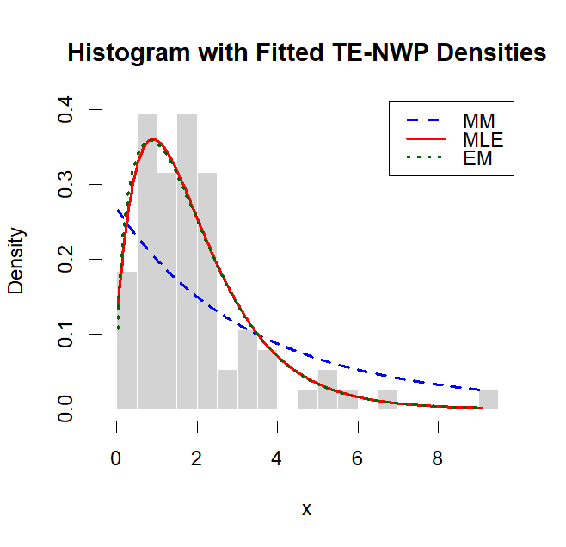
Figure 3: Histogram with Fitted TE–NWP Density Curves

Figure 4 further assesses model adequacy by plotting the empirical CDF against the fitted TE–NWP CDFs obtained from MM, MLE, and EM parameter estimates. The close alignment between the empirical and theoretical curves illustrates the goodness-of-fit of each estimation method..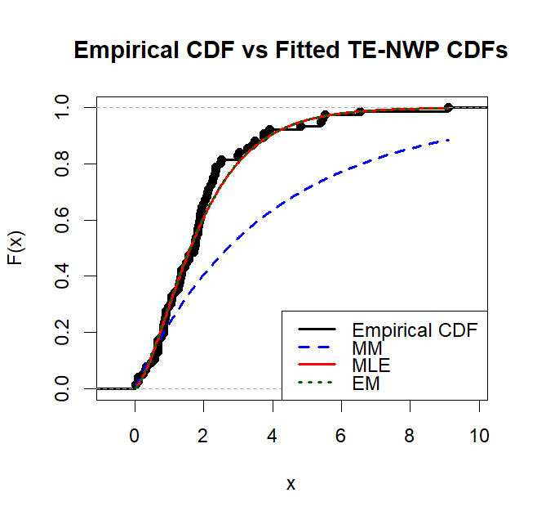
Figure 4: Empirical vs fitted TE-NWP CDF

3.4 Discussion of Real-Life Application
To demonstrate practical applicability, the TE–NWP distribution was fitted to the Kevlar 373/epoxy fatigue fracture data. This dataset represents fatigue life measurements under constant stress conditions and exhibits characteristics typical of reliability data, including skewness and heavy-tailed behavior.
Table 2 shows the parameter estimates obtained using MM, MLE, and EM. The MLE and EM estimates are closely aligned, while the MM estimates show slight deviations. Notably, the EM method yields marginally smaller values for the shape and transmutation parameters, indicating enhanced flexibility in capturing the skewness and tail behavior of the fatigue data.
Table 3 presents a model comparison based on the negative log-likelihood (−LL), Akaike Information Criterion (AIC), and Bayesian Information Criterion (BIC). The estimates obtained via EM produced the lowest −LL, AIC, and BIC values, indicating the best overall fit among the three methods. MLE ranks second, while MM shows the highest information criterion values, reflecting comparatively weaker performance.
Graphical assessments (Figs. 3 and 4) reinforce these numerical findings. Figure 3, showing the histogram with fitted TE–NWP density curves, demonstrates that the EM and MLE models closely track the empirical distribution, particularly in the upper tail where fatigue-life extremes occur. The MM curve shows slight deviations, especially around extreme observations. Similarly, Figure 4, comparing the empirical and fitted CDFs, indicates that the EM curve aligns most closely with the empirical distribution across the entire data range, confirming its superior goodness-of-fit.

- Conclusion
This study comparatively evaluated the performance of the Method of Moments (MM), Maximum Likelihood Estimation (MLE), and the Expectation–Maximization (EM) algorithm for estimating the parameters of the Transmuted Exponential–New Weibull Pareto (TE–NWP) distribution. Given the model’s five-parameter structure and inherent nonlinear likelihood function, identifying a stable and efficient estimation procedure is essential for reliable statistical inference.
The Monte Carlo simulation results demonstrated that all estimators improve in accuracy as sample size increases, confirming their consistency properties. However, the EM algorithm consistently produced smaller mean squared errors (MSE) and competitive bias across different sample sizes. Its superiority becomes more evident for moderate and large samples, reflecting its ability to effectively handle the mixture representation of the TE–NWP model. The MLE method also performed strongly and remains a viable alternative, particularly for larger datasets, while the MM estimator exhibited comparatively higher bias and MSE, making it less efficient for precise inference.
The real-life application to Kevlar 373/epoxy fatigue fracture data further validated the simulation findings. Based on −LL, AIC, and BIC values, the EM-based estimates provided the best goodness-of-fit, followed closely by MLE, whereas MM showed weaker performance. Graphical assessments using fitted density curves and empirical CDF comparisons also confirmed the superior tail-fitting capability of the EM approach.
In summary, the findings indicate that the EM algorithm is the most reliable and efficient estimation method for the TE–NWP distribution, particularly in modeling skewed and heavy-tailed lifetime data. Future research may extend this work by exploring Bayesian estimation techniques, robustness analysis under model misspecification, and applications of the TE–NWP model to other complex reliability and financial datasets.
Disclaimer (Artificial intelligence)

Author(s) hereby declare that NO generative AI technologies such as Large Language Models (ChatGPT, COPILOT, etc.) and text-to-image generators have been used during the writing or editing of this manuscript.

References
Abdul-Moniem, I., & Seham, A. (2015). Transmuted Gompertz distribution. Computational and
Applied Mathematics, 1(3), 88–96.
Abdulrahman, A. T., Rashedi, K. A., Alshammari, T. S., Hussam, E., Yousof, H. M., & Alshammari, K.
M. K. (2025). A flexible heavy-tailed ZLindley probability distribution with application to radiation
therapy data. Journal of Radiation Research and Applied Sciences, 18(4), 102017.
https://doi.org/10.1016/j.jrras.2025.102017
Burke, K., Jones, M. C., & Noufaily, A. (2020). A flexible parametric modelling framework for survival
analysis. Journal of the Royal Statistical Society: Series C (Applied Statistics), 69(2), 429–457.
https://doi.org/10.1111/rssc.12398
Casella, G., & Berger, R. L. (2002). Statistical inference (2nd ed.). Duxbury Press.
Cordeiro, G. M., Mansoor, M., & Zubair, M. (2015). The Weibull-Lomax distribution: Properties and
applications. Hacettepe Journal of Mathematics and Statistics, 44(2), 461–480.
Dempster, A. P., Laird, N. M., & Rubin, D. B. (1977). Maximum likelihood from incomplete data via
the EM algorithm. Journal of the Royal Statistical Society: Series B (Methodological), 39(1), 1–
22. https://doi.org/10.1111/j.2517-6161.1977.tb01600.x
Dhull, M. S., & Kumar, A. (2021). Normal inverse Gaussian autoregressive model using EM algorithm.
International Journal of Advances in Engineering Sciences and Applied Mathematics, 13(2–3),
139–147. https://doi.org/10.1007/s12572-021-00303-y
Eugene, N., Lee, C., & Famoye, F. (2002). Beta-normal distribution and its applications.
Communications in Statistics – Theory and Methods, 31(4), 497–512.
Eze, N. M., & Yahya, W. B. (2025). Transmuted exponential–compound Weibull distribution for
modelling of positively skewed data. Scientific African, 28(2), e02725.
Fisher, R. A. (1922). On the mathematical foundations of theoretical statistics. Philosophical
Transactions of the Royal Society of London: Series A, 222(594–604), 309–368.
https://doi.org/10.1098/rsta.1922.0009
Gillariose, J., Abdelwahab, M. M., Joseph, J., & Hasaballah, M. M. (2025). A Gauss hypergeometric-
type model for heavy-tailed survival times in biomedical research. Symmetry, 17(11), Article
1795. https://doi.org/10.3390/sym17111795
Gorgoso-Varela, J. J., Adedapo, S. M., & Ogana, F. N. (2024). A comparison of probability density
functions fitted by moments and maximum likelihood estimation methods used for diameter
distribution estimation. Forests, 15(3), 425. https://doi.org/10.3390/f15030425
Guo, H. (2025). A comparative study on theoretical mechanisms and applicability of major
parameter estimation methods. Advances in Operation Research and Production Management,
4(2), 41–46.
Gupta, R. D., & Kundu, D. (2001). Generalized exponential distribution: Different methods of
estimations. Journal of Statistical Computation and Simulation, 69(4), 315–337.
https://doi.org/10.1080/00949650108812098
Hajjaji, O., Manou-Abi, S. M., & Slaoui, Y. (2024). Parameter estimation for stable distributions and
their mixture. Journal of Applied Statistics, 52(8), 1594–1627.
https://doi.org/10.1080/02664763.2024.2434627
Joseph, J., & Kim, H. (2025). Estimating skewness and kurtosis for asymmetric heavy-tailed data: A
regression approach. Mathematics, 13(16), 2694. https://doi.org/10.3390/math13162694
Karakaş, A. M., & Bulut, F. (2025). The Half-Logistic Generalized Power Lindley Distribution:
Theory and Applications. Symmetry, 17(11), 1936. https://doi.org/10.3390/sym17111936

Kariuki, V., Wanjoya, A., Ngesa, O., Amirah Saeed Alharthi, Aljohani, H. M., & Afify, A. Z. (2024).
Properties, estimation, and applications of the extended log-logistic distribution. Scientific
Reports, 14(1). https://doi.org/10.1038/s41598-024-68843-4
Muhammad, A., Hussain, Z., Sher, S., Amjad, M., Baig, F., Ahmad, I., et al., (2025). A
comparative analysis of L-moments, maximum likelihood, and maximum product of spacing
methods for the four-parameter kappa distribution in extreme value analysis. Scientific
Reports, 15(1). https://doi.org/10.1038/s41598-024-84056-1
Nasiru, S., & Luguterah, A. (2015). The new Weibull–Pareto distribution. Pakistan Journal of Statistics
and Operation Research, 11(1), 103–122. https://doi.org/10.18187/pjsor.v11i1.863
Null, S., & Karim, M. (2025). The Modified Kies-Weibull Distribution: A Flexible Model for Survival
Analysis. International Journal of Data Science and Analysis, 11(1), 6–16.
https://doi.org/10.11648/j.ijdsa.20251101.12
Nweze, N. O., Maijama’a, B., Onwuamaeze, C. U., & Adenomon, M. O. (2026). Parameter estimation
in autoregressive models with transmuted exponential-new Weibull Pareto error distribution
using EM algorithm. International Journal of Applied Science and Mathematical Theory, 12(1),
65–76. https://doi.org/10.56201/ijasmt.vol.12.no1.2026pg65.76
Rahmouni, M., & Ziedan, D. (2025). The Weibull-generalized shifted geometric distribution:
properties, estimation, and applications. AIMS Mathematics, 10(4), 9773–9804.
https://doi.org/10.3934/math.2025448
Saileshwari, M., Moharana, R., & Maiti, K. (2025). The transmuted XLindley distribution: Properties
and estimation with biomedical survival applications. Results in Engineering, 28, 108077.
https://doi.org/10.1016/j.rineng.2025.108077
Shaw, W. T., & Buckley, I. R. (2007). The alchemy of probability distributions. International
Conference Proceedings, 7(64), 1–28.
Shiha, F. A. (2026). Shiha Distribution: Statistical Properties and Applications to Reliability
Engineering and Environmental Data (preprint). arXiv. https://doi.org/10.48550/arXiv.2602.02875
Vogel, R. M., Papalexiou, S. M., Lamontagne, J. R., & Dolan, F. C. (2024). When heavy tails disrupt
statistical inference. The American Statistician, 79(2), 221–235.
https://doi.org/10.1080/00031305.2024.2402898
Wu, Y.-F., & Hu, J.-Q. (2025). Method of moments estimation for the superposition of square-root
diffusions. Probability in the Engineering and Informational Sciences, 39(1), 23–43.
https://doi.org/10.1017/S0269964824000147
Yadav, A. S., Kumar, D., Kumar, P., Singh, S. K., & Singh, U. (2020). A New Transmuted Lifetime
Distribution: Statistical Properties and Application to Survival Data. Journal of Scientific
Research, 64(01), 127–137. https://doi.org/10.37398/jsr.2020.640133

