Analytical Study of Convective Heat and Mass Transfer in MHD Nanofluid Flow over a Stretching Sheet with Thermal and Concentration Effects.

Abstract
The study of convective heat and mass transfer in nanofluid flow over a stretching sheet, particularly under the combined influence of thermal and concentration gradients presents meaningful structures in the field of nanofluid dynamics. This research focuses on two-dimensional magnetohydrodynamics boundary layer flow of a nanofluid over a stretching sheet in the presence of concentration-based internal heat, chemical reaction, Brownian motion and thermophoresis. The governing partial differential equation were transformed to dimensionless form using nondimensional variables and the resulting equations were solved using homotopy perturbation method. The effect of various physical parameters on velocity, temperature and nanoparticles concentration are discussed with the aid of graphs. It is observed that the increase in the Brownian motion parameter and concentration based internal heat increases the temperature distribution throughout the boundary layer. Increasing the chemical reaction significantly decreases the concentration level while increase in the magnetic field significantly reduces the fluid velocity. The results are compared with the existing literatures on various special cases to check the accuracy of the present study and are found to be in excellent agreement.

Nomenclature
B - magnetic induction [Wbm-2]
C - nanoparticle concentration [–]
$C_{w}$ - nanoparticle concentration at stretching surface [–]
$C_{∞}$ - ambient nanoparticle concentration as y tends to infinity[–]
$C^{'}$ - dimensionless concentration [–]
$ρc$ - specific heat capacity [J kg-1 K-1]
$D_{B}$ - brownian diffusion coefficient [–]
$D_{T}$ - thermophoresis diffusion coefficient [–]vc
D- stretching constant [–]
g - acceleration due to gravity [ms-2]
k - thermal conductivity [Wm-1K-1]
κ - Boltzmann constant, 1.3805×10−23 JK−1
κ* - mean absorption coefficient [–]
Le - Lewis number [–]
M - Magnetic field parameter [–]
$N_{b}$ - Brownian motion parameter [–]
$N_{t}$ - Thermophoresis parameter [–]
P - fluid pressure [Pa]
Pr - Prandtl number [–]
$Q^{'}$- Heat source parameter [–]
${Q_{1}}^{'}$- Heat absorption coeffiecient [-]
T - fluid temperature [K]
$T_{w}$ - temperature at the stretching
Surface [K]
${T^{'}}_{∞}$- ambient temperature as y tends to infinity [K]
$T^{'}$ - dimensionless temperature [–]
u,v - velocity components along x and y axes respectively [ms-1]
$V^{'}$- dimensionless velocity components [–]
x, y - Cartesian coordinates measured along stretching surface [m]
Greek Symbols
υ - kinematic viscosity of the fluid [m2s-1]
${\left(ρ_{c}\right)}_{p}$- effective heat capacity of the nanoparticle [J m-3K-1]
${\left(ρc\right)}_{f}$- heat capacity of the fluid [J m-3K-1]
σ - Stefan-Boltzmann constant,
$ρ_{p}$ - nanoparticle mass density [kgm-3]
$ρ_{f}$ - fluid density [kgm-3]
τ - dimensionless time [–]

Keywords: MHD, Convective, Heat and Mass Transfer, Nanofluid, Stretching Sheet, Thermal and Concentration gradients
1.1 Introduction
Nanofluids have demonstrated remarkable enhancements in heat transfer compared to conventional fluids, attributable to their heightened thermal conductivity and convective heat transfer characteristics. This attribute has spurred interest in their application across a spectrum of thermal systems, including heat exchangers, refrigeration, electronics cooling, and solar energy devices. Despite significant strides in nanofluid research, certain knowledge gaps persist. A comprehensive grasp of the underlying mechanisms governing nanofluid heat transfer and any potential limitations is imperative. This research endeavors to fill these gaps by conducting a systematic and thorough investigation into the thermal performance of nanofluids. By addressing these knowledge deficits, the study aims to provide valuable insights that can inform the optimization of nanofluid applications in advanced thermal systems. The exploration of nanofluids represents a compelling frontier in thermal engineering, holding immense potential for enhancing heat transfer efficiency across diverse applications. In the light of this, Uka et al [1] the significance of nanofluids, which have garnered interdisciplinary interest across various fields, including mathematics, mechanical and chemical engineering, civil engineering, physics, and earth and natural sciences. Their applications in industrial and technological sectors enhance control over heat conduction and diffusion, while also improving thermal transport through convection, radiation, and conduction. Specifically, the research examines the hydromagnetic flow of nanofluids past an inclined heated surface, considering temperature-dependent, non-uniform heat source/sink effects along with thermal radiation within the framework of heat and mass transfer. Reddy and Chamkha [2] investigated a numerical approach that addressed the overarching challenge of magnetohydrodynamic (MHD) flow, along with heat and mass transfer of viscous, incompressible nanofluid over a uniformly stretching sheet through porous media. This scenario encompassed various complexities, including heat generation/absorption, thermal radiation, chemical reaction, thermo-diffusion, and diffusion-thermo effects. Kumar and Sonawane [3] showed that augmenting the concentration of nanoparticles improves the thermal conductivity of nanofluids, while the size of the particles influences the enhancement of convective heat transfer. Amos et al [4] investigated the free convection boundary layer flow of a rotating magnetohydrodynamic (MHD) fluid past a vertical porous plate with thermal radiation effects. The dimensionless coupled governing boundary layer partial differential equations are transformed into ordinary differential equations using the perturbation technique, based on the Boussinesq and Rosseland approximations. Analytical solutions are derived for the momentum, energy, and concentration equations, with graphical analyses presented to illustrate the variations in fluid velocity, temperature, and concentration. Esfahani et al. [5] investigated the ideal concentration of graphene oxide is the point at which both the particle size and viscosity of graphene oxide nanofluids demonstrate notable improvement in thermal conductivity. Beyond this optimal concentration, further increases in concentration do not yield significant enhancements in thermal conductivity.
Weli et al [6] investigated the fluid flow and transport within a vertical channel featuring exponentially decaying suction and a mobile wall. The governing equations are derived under the assumptions of incompressible flow, incorporating buoyancy forces and viscous dissipation. A finite-difference scheme is developed and implemented for numerical analysis. The graphical representation of the results indicates that increases in the Brinkman number, suction parameter, and Prandtl number lead to elevated temperature distributions, while higher Thermal Grashof numbers, Mass Grashof numbers, and suction parameters enhance flow velocity. Narayana and Babu [7] studied the transient motion of a non-Newtonian Casson nanofluid concerning its thermal conduction and entropy, exploring the effects of slip conditions and solar thermal transport on convection in the flow of Casson nanofluid. Marhatha et al. [8] investigated the flow of a viscous, incompressible, and electrically conducting nanofluid over a stretching sheet, considering the influence of a transverse magnetic field, by incorporating the effects of nonlinear thermal radiation, Newtonian heating, and partial velocity slip. Sreedevi et al. [9] investigated the unsteady magneto-hydrodynamic heat and mass transfer phenomena in hybrid nanofluid flow over a stretching surface, incorporating factors such as chemical reactions, suction, slip effects, and thermal radiation. The hybrid nanoparticles used in this research consisted of a combination of carbon nanotubes and silver nanoparticles, with water serving as the base fluid. Mahanta et al. [10] investigated the heat and mass transfer characteristics of an electrically conductive and incompressible Casson nanofluid flowing over an accelerated stretching plate under the influence of a magnetic field. The study accounted for the nanofluid's properties, including the effects of Brownian motion and thermophoresis. Furthermore, we consider convective boundary conditions, slip parameters, as well as Soret and Dufour effects.
Freidoonimehr et al. [11] discussed the analytical study using the homotopy analysis method (HAM) to analyze the heat and mass transfer phenomena in magnetohydrodynamic Oldroyd-B nanofluid flow over a stretching sheet with a convective boundary condition. The governing continuity, momentum, energy, and nanoparticle transport are transformed into ordinary differential equations (ODEs) through similarity transformations. Sandeep and Kumar [12] investigated the heat and mass transfer magnetohydrodynamic (MHD) nanofluid flow containing conducting dust particles past an inclined permeable stretching sheet, considering radiation, non-uniform heat source/sink, volume fractions of nanoparticles and dust particles, and chemical reaction effects. Specifically, we focused on Cu-water nanofluid incorporating conducting dust particles. The partial differential equations governing the flow were transformed into nonlinear ordinary differential equations using similarity transformations and solved numerically employing the Runge-Kutta-based shooting technique. The study investigated the impact of non-dimensional governing parameters on velocity, temperature, and concentration profiles, supported by graphical representations. Additionally, skin friction coefficient, Nusselt, and Sherwood numbers are analyzed and presented in tables. Comparisons with existing results under specific conditions show good agreement. Furthermore, an increase in the fluid nanoparticle interaction parameter is found to enhance the heat transfer rate, while an increase in the chemical reaction parameter enhances the mass transfer rate of the dusty nanofluid. Sudarsana and Sreedevi [13] conducted a study on the heat and mass transfer characteristics of steady and unsteady nanofluid flow over a stretched surface within a porous medium, taking into account various factors including chemical reactions, thermal radiation, magnetic fields, thermal stratification, and solutal stratification. Nagasantoshi et al. [14] investigated the heat and mass transfer properties of both constant and varying nanofluid flows over a stretched surface within a porous medium, taking into account factors such as chemical reactions, thermal radiation, magnetic fields, and thermal and solutal stratification. By employing the similarity variable method, the complex partial differential equations governing boundary layer flow, heat, and mass transfer were simplified into manageable ordinary differential equations. Reddy and Goud [15] investigated the magnetohydrodynamic (MHD) stagnation point flow of a nanofluid over a stretched cylinder, considering the effects of radiation. Both radiation and convective boundary conditions were analyzed, and the influences of Brownian motion and thermophoresis were incorporated into the nanofluid model. Ali et al. [16] presented a systematic review of carbon-based nanofluids, specifically emphasizing carbon nanotubes, graphene, and nanodiamonds and their applications in energy-related thermal systems. The review commenced with an overview of synthesis techniques for carbon-based feedstock, followed by an examination of nanofluid fabrication methods. Notably, it focused on dispersion stability, detailing measurement techniques, enhancement strategies, and their influence on thermophysical properties. Furthermore, the study highlighted recent advancements in correlations developed to predict these properties. Tlili [17] developed a mathematical model to compare the flow characteristics of nanofluid and hybrid nanofluid between two eccentric pipes. The investigation of nanofluids has advanced significantly over recent years. Building on this foundation, the researcher aimed to elevate the study by introducing hybrid nanofluids, which were modeled using various nanoparticles in either composite or mixed forms. Amos and Uka [18] studied the hydromagnetic flow of nanofluids in the presence of radiation and non-uniform heat generation/absorption past an exponentially stretching sheet. Utilizing similarity transformations, the flow equations are converted into nonlinear coupled differential equations. These equations are subsequently solved using the method of asymptotic series. Saeed et al. [19] investigated electromagnetic hydrodynamics (EMHD), viscous dissipation, Joule heating, and heat absorption within the coupled stress model. They formulated the hybrid nanofluid by suspending single-walled carbon nanotubes (SWCNTs) and multi-walled carbon nanotubes (MWCNTs) in pure human blood, rendering the model relevant for biomedical applications, including drug delivery through the circulatory system. Expanding upon the research conducted by Abbas et al. [20], it is evident that energy conversion and utilization are continuous and progressively critical processes that underpin both sustainability and economic development. The urgency to adopt clean energy sources has never been greater, as it plays a crucial role in addressing pressing environmental challenges while simultaneously promoting resource conservation. This imperative reflects the necessity for a transition towards sustainable energy practices to ensure a viable future for subsequent generations. Ghasemi et al, [21] examined the effects of solar radiation on the two-dimensional stagnation-point flow of a nanofluid over a stretching sheet. In these studies, the influence of an externally applied magnetic field was incorporated, while thermal radiation was modeled using the nonlinear Rosseland diffusion approximation. The governing boundary layer equations were reduced to a set of coupled nonlinear ordinary differential equations through appropriate similarity transformations and were subsequently solved numerically using the Differential Quadrature Method (DQM). The numerical scheme demonstrated excellent accuracy, rapid convergence, and reduced computational cost. The results indicated that both the temperature distribution and the thermal boundary layer thickness increased with increasing values of the Biot number. Furthermore, it was observed that an increase in the Brownian motion parameter significantly elevated the temperature field and resulted in a thicker thermal boundary layer, highlighting the important role of nanoparticle diffusion in enhancing thermal transport characteristics within the boundary layer flow. Waqas et al, [22] investigated the influence of thermal radiation and heat source–sink effects on hybrid nanofluid flow over a stretching surface. In this analysis, ethylene glycol was employed as the base fluid, while copper (Cu), aluminum oxide (Al₂O₃), and graphene oxide (GO) nanoparticles were dispersed to form the hybrid nanofluid. The governing partial differential equations describing the flow, heat, and mass transfer phenomena were transformed into a system of nonlinear ordinary differential equations using appropriate similarity transformations. These equations were solved numerically using the bvp4c solver in MATLAB to obtain approximate solutions to the flow problem. The effects of various physical parameters were examined through graphical and numerical analysis. The results indicated that the velocity profile increased with increasing values of the Deborah number but decreased with higher magnetic parameter values. Furthermore, the temperature distribution increased with increasing Biot number and thermal radiation parameter, while it decreased with increasing Deborah number. Preethi et al, [23] the Darcy–Forchheimer flow of a hyperbolic tangent hybrid nanofluid over a stretching sheet in the presence of linear and quadratic thermal radiation. In these investigations, the flow was subjected to a transverse magnetic field and viscous dissipation within a Darcy–Forchheimer porous medium. The analysis emphasized the importance of thermal radiation in high-temperature systems, noting its critical role in the design and operation of engineering applications such as nuclear power plants, internal combustion engines, rockets, satellites, and spacecraft propulsion systems. The hybrid nanofluid considered consisted of molybdenum disulfide (MoS₂) and silver (Ag) nanoparticles suspended in an equal percentage for ethylene glycol and water mixture. The governing partial differential equations describing the flow and heat transfer processes were transformed into ordinary differential equations using appropriate similarity transformations. The resulting system of equations was then solved numerically using the Runge–Kutta–Fehlberg fourth–fifth order (RKF-45) method. The effects of various physical parameters were presented through graphical illustrations. The results revealed a significant reduction in the velocity profile of the hyperbolic tangent fluid with increasing values of the Weissenberg number and the power-law index. Tamanna and Ahmmed (2025) investigated the flow of a non-Newtonian viscoelastic fluid over a stretching sheet embedded in a porous medium, while accounting for the influences of magnetic forces, thermophoresis, thermal radiation, heat and mass transfer, Brownian motion, and chemical reactions. The unsteady governing equations describing the flow were formulated using boundary layer approximations and subsequently transformed into a dimensionless system of equations. The resulting equations were solved numerically using an explicit finite difference scheme while appropriate stability and convergence criteria were established to ensure the reliability and accuracy of the numerical solutions. The effects of the governing physical parameters on the flow characteristics were presented through both graphical and tabular representations, and streamline as well as isotherm visualizations were employed to illustrate variations in the momentum and thermal boundary layer thicknesses. The results indicated that an increase in the elastic parameter enhanced the velocity distribution, as the improved elasticity of the fluid enabled it to store and release energy more effectively, thereby accelerating the flow. It was further observed that increasing the elastic parameter $\left(γ\right)$increased the fluid’s resistance to deformation and consequently enhanced the skin friction at the surface. In addition, the findings provided further insight into the behavior of the thermophoresis parameter $\left(N_{t}\right)$, revealing that the complex rheological characteristics of viscoelastic fluids, such as elasticity and shear-thinning effects, tended to suppress heat transfer, resulting in a comparatively lower Nusselt number than that observed in Newtonian fluids.
The novelty of this analytical investigation of the combined effects of thermal and concentration gradients on magnetohydrodynamic (MHD) nanofluid flow over a stretching sheet, incorporating coupled heat and mass transfer phenomena. Unlike prior studies that relied mainly on numerical methods. A Homotopy Perturbation Method (HPM) was employed to develop the Heat and Mass diffusion model in equations (21) and (22) above, providing approximate analytical solutions for unsteady transport in fluids. This framework offers both industrial and engineering applications such as polymer extrusion, chemical reactor design, cooling systems, metal forming, biomedical flows, environmental pollutant transport, and nanofluid-based thermal management.
1.2 Mathematical Formulation
We examine the characteristics of convective heat and mass transfer flow of a nanofluid over a laminar boundary layer flow occurring over a vertical sheet. The fluid involved is viscous, incompressible and electrically conducting. Our investigation incorporates the effect of concentration based internal heat, chemical reaction, Brownian motion and thermophoresis. The schematic diagram is shown in figure 1 and is described using a Cartesian coordinate system which defines the $x-$axis along the vertical direction of the stretching sheet while the $y-$axis is normal to it. The stretching sheet is maintained at temperature $T_{w}$ and concentration $C_{w}$; while $T_{∞}$ and $C_{∞}$ are the ambient temperature and concentration respectively. The magnetic Rynolds number is assumed to be small so that the induced magnetic field is neglected and we therefore apply a uniform magnetic field of strength $B_{0}$. The Boussinesq approximation is valid. we also impose a no-slip boundary condition at the domain boundaries. Consequently, following Khan et al, [21], the governing equation and boundary conditions are given below.
The continuity equation:
$\frac{{∂u}^{'}}{{∂x}^{'}}+\frac{{∂v}^{'}}{{∂y}^{'}}=0$ (1)
Note that the continuity equation expresses the principle of conservation of mass in a fluid flow.
The Momentum equation:
$\frac{{∂u}^{'}}{{∂t}^{'}}+u^{'}\frac{{∂u}^{'}}{{∂x}^{'}}+v^{'}\frac{{∂u}^{'}}{{∂y}^{'}}=\frac{∂}{{∂y}^{'}}\left(\frac{{∂u}^{'}}{{∂y}^{'}}\right)+gβ\left(T^{'}-T_{∞}\right)+gβ\left(C^{'}-C_{∞}\right)-\frac{{σB}_{0}^{2}u^{'}}{ρ}$ (2)
The Energy equation:
$\frac{{∂T}^{'}}{{∂t}^{'}}+u^{'}\frac{{∂T}^{'}}{{∂x}^{'}}+v^{'}\frac{{∂T}^{'}}{{∂y}^{'}}=\frac{∂}{{∂y}^{'}}\left(α\frac{{∂T}^{'}}{{∂y}^{'}}\right)+\frac{Q_{0}}{{ρc}_{p}}\left(T^{'}-T_{∞}\right)+τ\left[D_{B}\left(\frac{{∂T}^{'}}{∂y^{'}}\frac{{∂C}^{'}}{∂y^{'}}\right)+\frac{D_{T}}{T_{∞}}{\left(\frac{{∂T}^{'}}{{∂y}^{'}}\right)}^{2}\right]+\frac{Q^{'}}{{ρc}_{p}}\left(C^{'}-C_{∞}\right)$ (3)
The Concentration equation:
$\frac{{∂C}^{'}}{{∂t}^{'}}+u^{'}\frac{{∂C}^{'}}{{∂x}^{'}}+v^{'}\frac{{∂C}^{'}}{{∂y}^{'}}=D_{B}\frac{∂^{2}C^{'}}{{{∂y}^{'}}^{2}}+\frac{D_{T}}{T_{∞}}\frac{∂^{2}C^{'}}{{{∂y}^{'}}^{2}}+K_{r}^{'}\left(C^{'}-C_{∞}\right)$ (4)
Subject to the following initial and boundary conditions
$t^{'}=0$, $u^{'}=Dx$, $v^{'}=0$, $T^{'} =T_{∞}$, $C^{'}=C_{∞}$ everywhere.
$t^{'}≥0$, $u^{'}=0$, $v^{'}=0$, $T^{'} =T_{∞}$, $C^{'}=C_{∞}$ at $x^{'}=0$.
$u^{'}=Dx$, $v^{'}=0$, $T^{'} =T_{∞}$, $C^{'}=C_{∞}$ at $y^{'}=0$.
$u^{'}=0$, $v^{'}=0$, $T^{'} =T_{w}$, $C^{'}=C_{w}$ as $y^{'}→∞$. (5)

In equations (1) – (5), primes represent dimensional variables. The above system of equations represents the coupled behavior of velocity, temperature, and nanoparticle concentration fields in the presence of magnetic field effects, buoyancy forces, Brownian motion, thermophoresis, and chemical reaction.

We introduce the following nondimensinal variables
$x^{'}=\frac{xU_{0}}{v}$, $y^{'}=\frac{yU_{0}}{v}$, $u^{'}=\frac{u}{U_{0}}$, $v^{'}=\frac{v}{U_{0}}$, $t^{'}=\frac{tU_{0}^{2}}{v}$, $θ=\frac{T^{'}-T_{∞}}{T_{w}-T_{∞}}$, $ϕ=\frac{C^{'}-C_{∞}}{C_{w}-C_{∞}}$, $K_{r}^{'}=\frac{K_{r}v}{U_{0}^{2}}$
$M=\frac{σB_{0}^{2}}{ρU_{0}^{2}},$ $G_{r}=\frac{gβ\left(T_{w}-T_{∞}\right)v}{U_{0}^{3}}$, $G_{m}=\frac{gβ\left(C_{w}-C_{∞}\right)v}{U_{0}^{3}}$, $Q=\frac{Q_{0}}{{ρC}_{p}}\left(\frac{v}{U_{0}^{2}}\right)$, $Q_{1}=\frac{Q^{'}}{{ρC}_{p}}\left(\frac{v}{U_{0}^{2}}\right)$, $Pr=\frac{v}{α}$ ,
$Le=\frac{v}{D_{B}}$, $N_{b}=\frac{{\left(ρc\right)}_{p}D_{B\left(C_{w}-C_{∞}\right)}}{{\left(ρc\right)}_{f}v}$ , $N_{t}=\frac{{\left(ρc\right)}_{p}D_{T\left(T_{w}-T_{∞}\right)}}{{\left(ρc\right)}_{f}T_{∞}v}$. (6)
Applying the nondimensional variables in the expressions in (6) into equations (1) - (5) and obtain the following partial differential equations with their corresponding initial and boundary conditions.
$\frac{∂u}{∂x}+\frac{∂v}{∂y}=0$ (7)
$\frac{∂u}{∂t}+u\frac{∂u}{∂x}+v\frac{∂u}{∂y}=\frac{∂^{2}u}{{∂y}^{2}}+G_{r}θ+G_{m}ϕ-Mu$ (8)
$\frac{∂θ}{∂t}+u\frac{∂θ}{∂x}+v\frac{∂θ}{∂y}=\frac{1}{Pr}\frac{∂^{2}θ}{{∂y}^{2}}+Qθ+N_{b}\frac{∂θ}{∂y}\frac{∂ϕ}{∂y}+N_{t}{\left(\frac{∂θ}{∂y}\right)}^{2}+Q_{1}ϕ$ (9)
$\frac{∂ϕ}{∂t}+u\frac{∂ϕ}{∂x}+v\frac{∂ϕ}{∂y}=\frac{1}{L_{e}}\left[\frac{∂^{2}ϕ}{{∂y}^{2}}+\frac{N_{t}}{N_{b}}\frac{∂^{2}θ}{{∂y}^{2}}\right]+K_{r}ϕ$ (10)
$t≤0$,$u=0$, $v=0$, $θ=0$, $ϕ=0$ everywhere.
$t≥0$, $u=0$, $v=0$, $θ=0$, $ϕ=0$ at $x=0$
$u=1$, $v=0$, $θ=1$, $ϕ=1$ at $y=0$
$u=0$, $v=0$, $θ=0$, $ϕ=0$ at $y→∞$ (11)
where the parameter $M$ represents the magnetic parameter, which quantifies the influence of the applied magnetic field on the fluid motion. The term $G_{r}$ denotes the thermal Grashof number, accounting for the buoyancy force generated due to temperature differences within the fluid. Similarly, $G_{m}$ corresponds to the solutal Grashof number, which represents the buoyancy effects arising from concentration gradients. The parameter $Q$ signifies the heat source parameter, describing the internal heat generation within the fluid, while $Q_{1}$ represents the heat absorption coefficient, which accounts for heat absorption effects in the system. Furthermore, $Pr$ denotes the Prandtl number, expressing the ratio of momentum diffusivity to thermal diffusivity. The parameter $Le$ is the Lewis number, defined as the ratio of thermal diffusivity to mass diffusivity. In addition, $N_{b}$ represents the Brownian motion parameter, which characterizes nanoparticle diffusion due to random motion, whereas $N_{t}$ denotes the thermophoresis parameter, describing the migration of nanoparticles induced by temperature gradients.
1.3 Method of Solution
We adopted the Homotopy Perturbation (HPM) technique to obtain the approximate solution of the above dimensionless coupled partial differential equations (8) – (11) by constructing a homotopy that is suitable for this model. The partial differential equations are divided into two parts of $L$ (linear part) and $N$ (nonlinear part) in the equation such as;
$H\left(Ω,p\right)=\left(1-p\right)L+pN=0$ (12)
The series solution of the homotopy perturbation (HPM) for the momentum $u$ equation, the energy$θ$ equation and the concentration $ϕ$ equation in terms of $pϵ[0,1]$ is outlined respectively by;
$u$=$u_{0}+{pu}_{1}+p^{2}u_{2}+…$ (13)
$θ$=$θ_{0}+pθ_{1}+p^{2}θ_{2}+…$ (14)
$ϕ$=$ϕ_{0}+pϕ_{1}+p^{2}ϕ_{2}+…$ (15)
$V$=$V_{0}+pV_{1}+p^{2}V_{2}+…$ (16)
We constructed a suitable Homotopy perturbation to uncouple the highly coupled nonlinear partial differential equations for momentum, energy and concentration.
Momentum Equations:
H ($u,p$) = ($1-p$)$( \frac{∂u}{∂t}-\frac{∂^{2}u}{{∂y}^{2}} )$+$p\left(\frac{∂u}{∂t}+u\frac{∂u}{∂x}+v\frac{∂u}{∂y}-\frac{∂^{2}u}{{∂y}^{2}}-G_{r}θ-G_{m}ϕ+Mu\right)=0$ (17)
Energy Equation:
H ($θ,p$) = ($1-p$)$( \frac{∂θ}{∂t}-\frac{1}{p_{r}}\frac{∂^{2}θ}{{∂y}^{2}} )$+$p\left(\frac{∂θ}{∂t}+u\frac{∂θ}{∂x}+v\frac{∂θ}{∂y}-\frac{1}{p_{r}}\frac{∂^{2}θ}{{∂y}^{2}}-Qθ-N_{b}\frac{∂θ}{∂y}\frac{∂ϕ}{∂y}-N_{t} ( \frac{∂θ}{∂y} )^{2}-Q_{1}ϕ\right)=0$ (18)
Concentration Equation:
$H(ϕ,p$)= ($1-p$)$( \frac{∂ϕ}{∂t}-\frac{1}{L_{e}}\frac{∂^{2}ϕ}{{∂y}^{2}} )$+$p\left(\frac{∂ϕ}{∂t}+u\frac{∂ϕ}{∂x}+v\frac{∂ϕ}{∂y}-\frac{1}{L_{e}}\frac{∂^{2}ϕ}{{∂y}^{2}}-\frac{1}{L_{e}}\frac{N_{t}}{N_{b}}\frac{∂^{2}θ}{{∂y}^{2}}-K_{r}ϕ\right)$=0 (19)
We obtain the following equations by substituting equations (13)-(16) into equations (17), (18) and (19) respectively. By comparing the power coefficient analysis of the expanded Homotopy perturbation constructed from equations (17)-(19) to obtain an accurate approximate solution;
$\frac{{∂u}_{0}}{∂t}=\frac{∂^{2}u_{0}}{{∂y}^{2}}$ (20)
$\frac{{∂θ}_{0}}{∂t}=\frac{1}{Pr}\frac{∂^{2}θ_{0}}{{∂y}^{2}}$ (21)
$\frac{{∂ϕ}_{0}}{∂t}=\frac{1}{L_{e}}\frac{∂^{2}ϕ_{0}}{{∂y}^{2}}$ (22)
with their initial and boundary condition.
$t≤0$; $u_{0}=0$, $V_{0}=0$, $θ_{0}=0$, $ϕ_{0}=0$ everywhere
$t≥0$ ;
$u_{0}=0$, $V_{0}=0$, $θ_{0}=0$, $ϕ_{0}=0$ at $x=0$
$u_{0}=1$, $V_{0}=1$, $θ_{0}=1$, $ϕ_{0}=1$ at $y=0$
$u_{0}=0$, $V_{0}=0$, $θ_{0}=0$, $ϕ_{0}=0$ as $y→∞$ (23)
$\frac{{∂u}_{1}}{∂t}-\frac{∂^{2}u_{1}}{{∂y}^{2}}+u_{0}\frac{{∂u}_{0}}{∂x}+V_{0}\frac{{∂u}_{0}}{∂y}-G_{r}θ_{0}-G_{m}ϕ_{0}+Mu_{0}=0$ (24)
$\frac{{∂θ}_{1}}{∂t}-\frac{1}{Pr}\frac{∂^{2}θ_{1}}{{∂y}^{2}}-Qθ_{0}-N_{b}\frac{{∂θ}_{0}}{∂y}\frac{{∂ϕ}_{0}}{∂y}-N_{t}{\left(\frac{{∂θ}_{0}}{∂y}\right)}^{2}-Q_{1}ϕ_{0}=0$ (25)
$\frac{{∂ϕ}_{1}}{∂t}-\frac{1}{L_{e}}\frac{∂^{2}ϕ_{1}}{{∂y}^{2}}-\frac{N_{t}}{{N_{b}L}_{e}}\frac{∂^{2}ϕ_{0}}{{∂y}^{2}}-K_{r}ϕ_{0}=0$ (26)
$t≤0$; $u_{1}=0$, $V_{1}=0$, $θ_{1}=0$, $ϕ_{1}=0$ everywhere
$t≥0$;
$u_{1}=0$, $V_{1}=0$, $θ_{1}=0$, $ϕ_{1}=0$ at $x=0$
$u_{1}=1$, $V_{1}=1$, $θ_{1}=1$, $ϕ_{1}=1$ at $y=0$
$u_{1}=0$, $V_{1}=0$, $θ_{1}=0$, $ϕ_{1}=0$ as $y→∞$ (27)
To solve the homotopy perturbed equations outlined between (20) and (27), we utilize the regular perturbation technique, which enables the linearization of each equation. This method allows for the analytical treatment of the variables $u_{0}$, $θ_{0}$, and $ϕ_{0}$ as functions of time. The formulation was extended to first and second order approximation, expressed as follows;
$u_{0}=Eu_{00}e^{-nt}$ $θ_{0}=Eθ_{00}e^{-nt}$ $ϕ_{0}=Eϕ_{00}e^{-nt}$ (28)
$u_{1}=Eu_{01}e^{-nt}$ $θ_{1}=Eθ_{01}e^{-nt}$ $ϕ_{1}=Eϕ_{01}e^{-nt}$ (29)
This regular perturbation technique method transforms the partial differential equation to second order ordinary differential equation and solved using the method of undetermined coefficient.
Hence, we obtained the following Homotopy solution as shown below:
$u=\frac{1}{Esin\sqrt{n}h}sin\sqrt{n}y+p\left(\left(\frac{G_{r}}{\left(n-nPr\right)sin\sqrt{n}h}+\frac{G_{m}}{\left(n-nLe\right)sin\sqrt{n}h}-\frac{M}{nsin\sqrt{n}h}+\frac{1}{sin\sqrt{n}h}\right)sin\sqrt{n}y-\frac{G_{r}}{\left(n-nPr\right)sin\sqrt{nPr}h}sin\sqrt{nPr}y-\frac{G_{m}}{\left(n-nLe\right)sin\sqrt{nLe}h}sin\sqrt{nLe}y-\frac{M}{nsin\sqrt{n}h}sin\sqrt{n}y\right)$ (30)
$θ=\frac{1}{sin\sqrt{nPr}h}sin\sqrt{nPr}y +p\left(\left(\frac{PrN_{b}\sqrt{nPr\sqrt{nLe}}}{2\left(nPr-{\left(\sqrt{nPr}+\sqrt{nLe}\right)}^{2}\right)sin\sqrt{nPr}hsin\sqrt{nLe}h}+\frac{PrN_{b}\sqrt{nPr\sqrt{nLe}}}{2\left(nPr-{\left(\sqrt{nPr}-\sqrt{nLe}\right)}^{2}\right)sin\sqrt{nPr}hsin\sqrt{nLe}h}+\frac{PrN_{t}}{2\sin^{2}\sqrt{nPr}h}-\frac{PrN_{t}}{5nPr\sin^{2}\sqrt{nPr}h}\right)cos\sqrt{nPr}y+\left(\left( -\frac{PrN_{b}\sqrt{nPr\sqrt{nLe}}}{2\left(nPr-{\left(\sqrt{nPr}+\sqrt{nLe}\right)}^{2}\right)sin\sqrt{nPr}hsin\sqrt{nLe}hsin\sqrt{nPr}h}-\frac{PrN_{b}\sqrt{nPr\sqrt{nLe}}}{2\left(nPr-{\left(\sqrt{nPr}-\sqrt{nLe}\right)}^{2}\right)\sin^{2}\sqrt{nPr}hsin\sqrt{nLe}h}-\frac{PrN_{t}}{2\sin^{3}\sqrt{nPr}h}-\frac{PrN_{t}}{5nPr\sin^{3}\sqrt{nPr}h}\right)cos\sqrt{nPr}h+\frac{1}{\sin^{2}\sqrt{nPr}h}+\frac{Q}{nsin\sqrt{nPr}h}+\frac{PrN_{b}\sqrt{nPr\sqrt{nLe}}cos\left(\sqrt{nPr}+\sqrt{nLe}\right)h}{2\left(nPr-{\left(\sqrt{nPr}+\sqrt{nLe}\right)}^{2}\right)\sin^{2}\sqrt{nPr}hsin\sqrt{nLe}h}+\frac{PrN_{b}\sqrt{nPr\sqrt{nLe}}cos\left(\sqrt{nPr}-\sqrt{nLe}\right)h}{2\left(nPr-{\left(\sqrt{nPr}-\sqrt{nLe}\right)}^{2}\right)\sin^{2}\sqrt{nPr}hsin\sqrt{nLe}h}+\frac{PrN_{t}}{2\sin^{3}\sqrt{nPr}h}+\frac{PrN_{t}cos2\sqrt{nPr}h}{5nPr\sin^{3}\sqrt{nPr}h}+\frac{PrQ_{1}}{\left(nPr-nLe\right)sin\sqrt{nPr}h}+\frac{1}{sin\sqrt{nPr}h} \right)sin\sqrt{nPr}y-\left(\frac{1}{\sin^{2}\sqrt{nPr}h}+\frac{Q}{nsin\sqrt{nPr}h}\right)sin\sqrt{nPr}y-\frac{PrN_{b}\sqrt{nPr\sqrt{nLe}}}{2\left(nPr-{\left(\sqrt{nPr}+\sqrt{nLe}\right)}^{2}\right)sin\sqrt{nPr}hsin\sqrt{nLe}h}cos\left(\sqrt{nPr}+\sqrt{nLe}\right)y-\frac{PrN_{b}\sqrt{nPr\sqrt{nLe}}}{2\left(nPr-{\left(\sqrt{nPr}-\sqrt{nLe}\right)}^{2}\right)sin\sqrt{nPr}hsin\sqrt{nLe}h}cos\left(\sqrt{nPr}-\sqrt{nLe}\right)y-\left(\frac{PrN_{t}}{2\sin^{2}\sqrt{nPr}h}-\frac{PrN_{t}}{5nPr\sin^{2}\sqrt{nPr}h}\right)cos2\sqrt{nPr}y-\left(\frac{1}{\sin^{2}\sqrt{nPr}h}+\frac{Q}{nsin\sqrt{nPr}h}\right)sin\sqrt{nLe}y\right)$ (31)
$ϕ=\frac{1}{sin\sqrt{nLe}h}sin\sqrt{nLe}y+p\left(\left(-\frac{N_{t}nPr}{N_{b}E\sin^{2}\sqrt{nPr}h\left(nLe-nPr\right)sin\sqrt{nLe}h}sin\sqrt{nPr}h+\frac{ Kr}{nsin\sqrt{nLe}h}+\frac{1}{sin\sqrt{nLe}h}\right)sin\sqrt{nLe}y+\frac{N_{t}nPr}{{N_{b}Esin}^{2}\sqrt{nPr}h\left(nLe-nPr\right)}sin\sqrt{nPr}y-\frac{ Kr}{nsin\sqrt{nLe}h}sin\sqrt{nLe}y\right)$ (32)

1.4 Results
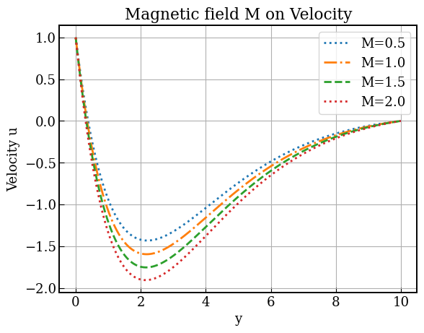
Figure 1: Effect of magnetic field $M$ on velocity of some parameter values $M=2.0$, $G_{r}=2.0$, $G_{m}=2.0$, $K_{r}=1.0$, $Le=1.5$, $N_{b}=N_{t}=1.0,$ $Pr=3.0$, $Q=Q_{1}=1.5$, $t=1.0$, $p=1.0$

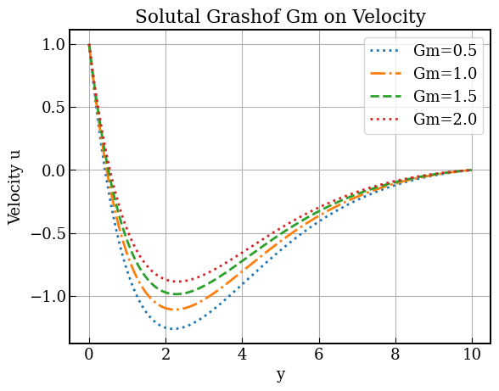

Figure 2: Effect of solutal bouyancy forcce $Gm$ on the velocity of some parameter values for $M=2.0$, $G_{r}=2.0$, $G_{m}=2.0$, $K_{r}=1.0$, $Le=1.5$, $N_{b}=N_{t}=1.0,$ $Pr=3.0$, $Q=Q_{1}=1.5$, $t=1.0$, $p=1.0$
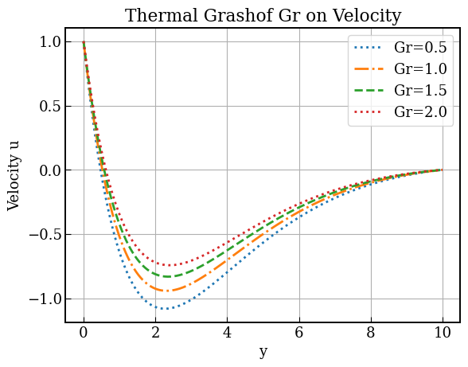
Figure 3: Effect of Thermal grassof Number $Gr$ the velocity of some parameter values for $M=2.0$, $G_{r}=2.0$, $G_{m}=2.0$, $K_{r}=1.0$, $Le=1.5$, $N_{b}=N_{t}=1.0,$ $Pr=3.0$, $Q=Q_{1}=1.5$, $t=1.0$, $p=1.0$
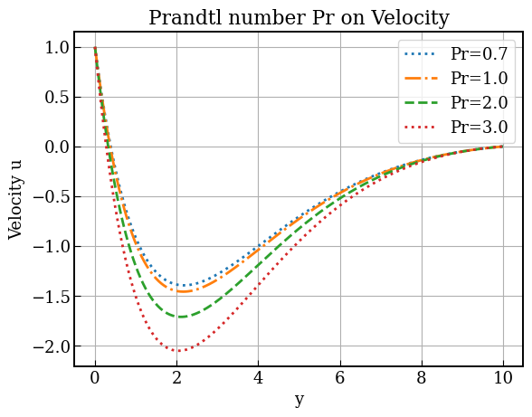
Figure 4: Effect of Prantl Number $Pr$ on the velocity of some parameter values for $M=2.0$, $G_{r}=2.0$, $G_{m}=2.0$, $K_{r}=1.0$, $Le=1.5$, $N_{b}=N_{t}=1.0,$ $Pr=3.0$, $Q=Q_{1}=1.5$, $t=1.0$, $p=1.0$
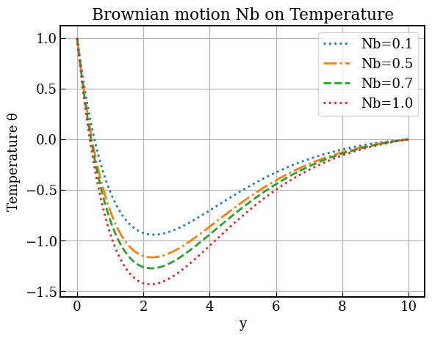
Figure 5: Effect of Brownian Motion $Nb$ on the Temperature $θ$ of some parameter values for $M=2.0$, $G_{r}=2.0$, $G_{m}=2.0$, $K_{r}=1.0$, $Le=1.5$, $N_{b}=N_{t}=1.0,$ $Pr=3.0$, $Q=Q_{1}=1.5$, $t=1.0$, $p=1.0$.
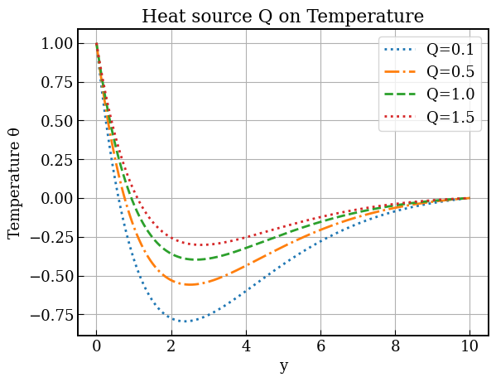
Figure 6: Effect Heat Source $Q$ on temperature of some parameter values for $M=2.0$, $G_{r}=2.0$, $G_{m}=2.0$, $K_{r}=1.0$, $Le=1.5$, $N_{b}=N_{t}=1.0,$ $Pr=3.0$, $Q=Q_{1}=1.5$, $t=1.0$, $p=1.0$.
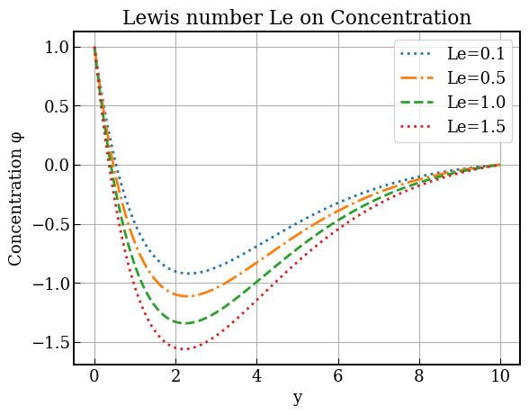
Figure 7: Effect of Lewis number on concentration of some parameter values for $M=2.0$, $G_{r}=2.0$, $G_{m}=2.0$, $K_{r}=1.0$, $Le=1.5$, $N_{b}=N_{t}=1.0,$ $Pr=3.0$, $Q=Q_{1}=1.5$, $t=1.0$, $p=1.0$.
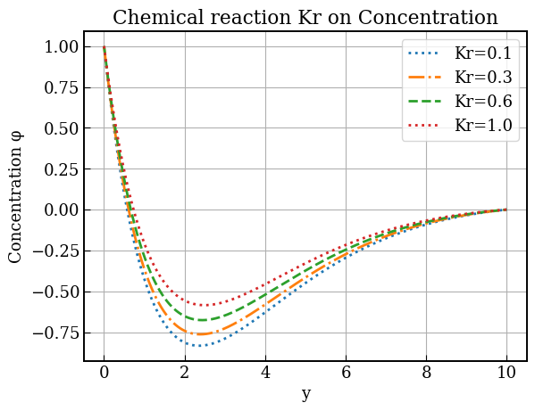
Figure 8: Effect chemical reaction on the concentration of some parameter values for $M=2.0$, $G_{r}=2.0$, $G_{m}=2.0$, $K_{r}=1.0$, $Le=1.5$, $N_{b}=N_{t}=1.0,$ $Pr=3.0$, $Q=Q_{1}=1.5$, $t=1.0$, $p=1.0$.
1.5 Discussion of Results
Figures 1–4 illustrate the influence of major hydrodynamic parameters on the velocity distribution within the boundary layer. Increasing the magnetic field parameter $M$significantly reduces fluid velocity because the imposed transverse magnetic field generates a Lorentz force that opposes the flow direction. This resistive force suppresses motion and decreases the momentum boundary layer thickness. Conversely, increasing the solutal Grashof number $G_{m}$ enhances the velocity profile, as stronger concentration-induced buoyancy forces accelerate the fluid and expand the velocity boundary layer.
A similar accelerating effect is observed for the thermal Grashof number $G_{r}$. Higher values of $G_{r}$ represent stronger buoyancy forces due to temperature differences between the surface and the ambient fluid, which increases fluid motion and thickens the momentum boundary layer. However, the Prandtl number $Pr$ produces an opposing trend: increasing $Pr$ reduces the velocity profile. This occurs because larger $Pr$ values correspond to higher momentum diffusivity relative to thermal diffusivity, implying greater viscous resistance that slows the flow and reduces boundary layer thickness.
Figures 5 and 6 focus on the temperature field. The temperature profile increases with the Brownian motion parameter $N_{b}$, since intensified random movement of nanoparticles enhances thermal energy transport within the fluid, thereby thickening the thermal boundary layer. Similarly, increasing the heat source parameter $Q$ raises the temperature distribution throughout the flow region because additional internal heat generation supplies energy to the system, resulting in higher fluid temperatures.
Figures 7 and 8 present the behavior of the concentration field. An increase in the Lewis number $Le$ reduces the concentration profile because larger $Le$ values indicate weaker mass diffusivity, which restricts species transport and leads to a thinner concentration boundary layer. Additionally, increasing the chemical reaction parameter $K_{r}$ significantly decreases concentration levels, as stronger reactions consume the diffusing species more rapidly within the boundary layer. Consequently, the concentration boundary layer thickness diminishes with increasing $K_{r}$.
1.6 Conclusion
This study provided a novel analytical investigation of the combined effects of thermal and concentration gradients on magnetohydrodynamic (MHD) nanofluid flow over a stretching sheet, incorporating coupled heat and mass transfer phenomena. The Homotopy Perturbation Method (HPM) was employed to develop the Heat and Mass Diffusion model, yielding approximate analytical solutions for unsteady transport in fluids. Results showed that increased Brownian motion and concentration-based internal heat enhanced temperature distribution, while higher chemical reaction rates reduced concentration and the magnetic field suppressed fluid velocity, with excellent agreement observed against existing literature. This analytical framework advances the theoretical understanding of nanofluid dynamics and supports a wide range of industrial and engineering applications, including polymer extrusion, chemical reactors, cooling systems, metal forming, biomedical flows, and nanofluid-based thermal management.
Disclaimer (Artificial intelligence)
Author(s) hereby declare that NO generative AI technologies such as Large Language Models (ChatGPT, COPILOT, etc.) and text-to-image generators have been used during the writing or editing of this manuscript.

Reference
[1] Uka, U. A., Agbo, O. A., Omamoke, E., Amos, E., & Edwin, D. K. (2022). Analysis and simulation of hydromagnetic nano-fluid flow passing an inclined heated sheet. International Journal of Heat and Technology, 40(6), 1386-1396. DOI: 10.18280/ijht.400605.
[2] Reddy, P. S., & Chamkha, A. J. (2016). Soret and Dufour effects on MHD convective flow of Al2O3–water and TiO2–water nanofluids past a stretching sheet in porous media with heat generation/absorption. Advanced Powder Technology, 27(4), 1207-1218. DOI: 10.1016/j.apt.2016.03.004.
[3] Kumar, N., & Sonawane, S. S. (2016). Experimental study of thermal conductivity and convective heat transfer enhancement using CuO and TiO2 nanoparticles. International Communications in Heat and Mass Transfer, 76, 98-107. DOI: 10.1016/j.icheatmasstransfer.2016.05.003.
[4] Amos, E., Amadi. C.P., & Nwaigwe, C. (2019). Free Convection Boundary Layer Flow of a Rotating MHD Fluid past a Vertical Porous Medium with Thermal Radiation. International Journal of Applied Science and Mathematical Theory, 5(2).
[5] Esfahani, M. R., Languri, E. M., & Nunna, M. R. (2016). Effect of particle size and viscosity on thermal conductivity enhancement of graphene oxide nanofluid. International Communications in Heat and Mass Transfer, 76, 308-315. DOI: 10.1016/j.icheatmasstransfer.2016.06.010.
[6] Weli, A., Amadi, C. P., & Nwaigwe, C. (2019). Numerical investigation of transport in a Couette flow with unsteady suction. IOSR Journal of Mathematics, 15(6), 74-83. DOI: 10.9790/5728-1506067483.
[7] Narayana, P. S., & Babu, D. H. (2016). Numerical study of MHD heat and mass transfer of a Jeffrey fluid over a stretching sheet with chemical reaction and thermal radiation. Journal of the Taiwan Institute of Chemical Engineers, 59, 18-25. DOI: 10.1016/j.jtice.2015.10.011.
[8] Mahatha, B. K., Nandkeolyar, R., Nagaraju, G., & Das, M. (2015). MHD stagnation point flow of a nanofluid with velocity slip, non-linear radiation and Newtonian heating. Procedia Engineering, 127, 1010-1017. DOI: 10.1016/j.proeng.2015.11.383.
[9] Sreedevi, P., P. Sudarsana Reddy, and Ali Chamkha. "Heat and mass transfer analysis of unsteady hybrid nanofluid flow over a stretching sheet with thermal radiation." SN Applied Sciences 2, no. 7 (2020): 1222. 10.1142/S1793524517500085.
[10] Mahanta, G., Das, M., Shaw, S., & Mahanta, K. L. (2019). Heat and mass transfer of Casson nanofluid flow over a stretching sheet in the presence of magnetic field with Brownian and thermophoretic effects. Journal of Engineering Science & Technology, 14(5), 3046-3061. DOI:
[11] Freidoonimehr, N., Rashidi, M. M., Momenpour, M. H., & Rashidi, S. (2017). Analytical approximation of heat and mass transfer in MHD non-Newtonian nanofluid flow over a stretching sheet with convective surface boundary conditions. International Journal of Biomathematics, 10(01), 1750008. DOI: 10.18869/acadpub.jafm.68.236.24381.
[12] Sandeep, N., & Kumar, J. (2016). Heat and mass transfer in nanofluid flow over an inclined stretching sheet with volume fraction of dust and nanoparticles. Journal of Applied Fluid Mechanics, 9(5), 2205-2215. DOI: 10.1080/01430750.2020.1730952.
[13] Sudarsana Reddy, P., & Sreedevi, P. (2022). Impact of chemical reaction and double stratification on heat and mass transfer characteristics of nanofluid flow over porous stretching sheet with thermal radiation. International Journal of Ambient Energy, 43(1), 1626-1636. DOI: 10.1080/01430750.2020.1730952.
[14] Nagasantoshi, P., Reddy, G. V., Reddy, M. G., & Padma, P. (2018). Heat and mass transfer of Non-Newtonian Nanofluid flow over a stretching sheet with non-uniform heat source and Variable viscosity. Journal of nanofluids, 7(5), 821-832. DOI: 10.1166/jon.2018.1488.
[15] Reddy, Y. D., & Goud, B. S. (2022). MHD heat and mass transfer stagnation point nanofluid flow along a stretching sheet influenced by thermal radiation. Journal of Thermal Analysis and Calorimetry, 147(21), 11991-12003. DOI: 10.1007/s10973-021-11170-7.
[16] Ali, N., Bahman, A. M., Aljuwayhel, N. F., Ebrahim, S. A., Mukherjee, S., & Alsayegh, A. (2021). Carbon-based nanofluids and their advances towards heat transfer applications—a review. Nanomaterials, 11(6), 1628. DOI: 10.3390/nano11061628.
[17] Tlili, I. (2024). Impact of thermal conductivity on the thermophysical properties and rheological behavior of nanofluid and hybrid nanofluid. Mathematical Sciences, 18(4), 493-501. DOI: 10.1007/s40096-024-00546-3.
[18] Amos, E., & Uka, U. A. (2022). Hydromagnetic nanofluid flow over an exponentially stretching sheet in the presence of radiation and nonuniform heat generation. IOSR Journal of Mathematics, 18(1), 31-43. DOI: 10.970/5728-1801023143.
[19] Saeed, A., Alsubie, A., Kumam, P., Nasir, S., Gul, T., & Kumam, W. (2021). Blood based hybrid nanofluid flow together with electromagnetic field and couple stresses. Scientific reports, 11(1), 12865. DOI: 10.1038/s41598-021-92311-4.
[20] Abbas, S., Nisa, Z. U., Nazar, M., Amjad, M., Ali, H., & Jan, A. Z. (2024). Application of heatand mass transfer to convective flow of Casson fluids in a microchannel with Caputo–Fabrizio derivative approach. Arabian Journal for Science and Engineering, 49(1), 1275-1286. DOI: 10.1007/s13369-023-08262-8.
[21] Ghasemi, S. E., & Hatami, M. (2021). Solar radiation effects on MHD stagnation point flow and heat transfer of a nanofluid over a stretching sheet. Case Studies in Thermal Engineering, 25, 100898. DOI: 10.1016/j.csite.2021.100898.
[22] Waqas, H., Farooq, U., Liu, D., Abid, M., Imran, M., & Muhammad, T. (2022). Heat transfer analysis of hybrid nanofluid flow with thermal radiation through a stretching sheet: A comparative study. International Communications in Heat and Mass Transfer, 138, 106303. DOI: 10.1016/j.icheatmasstransfer.2022.106303.
[23] Preethi, K., Hanumagowda, B. N., Pavithra, K. M., Varma, S. V. K., Mann, V. S., Singh, R., & Kattimani, P. (2025). Thermal scrutinization of MHD Darcy–Forchheimer flow of hybrid nanofluid over a stretching sheet with Richardson number and quadratic thermal radiation: hyperbolic tangent model. Multiscale and Multidisciplinary Modeling, Experiments and Design, 8(3), 171. DOI: 10.1007/s41939-024-00340-7.
[24] Tamanna, T., & Ahmmed, S. F. (2025). A Computational Study of MHD Radiative Viscoelastic Nanofluid Over a Stretching Sheet With Thermophoresis and Chemical Reaction. Engineering Reports, 7(12), e70532. DOI: 10.1002/eng2.70532.
[25] Khan, M. S., Wahiduzzaman, M., Sazad, M. A. K., & Uddin, M. S. (2012). Finite difference solution of MHD free convection heat and mass transfer flow of a nanofluid along a Stretching sheet with Heat generation effects. Indian J. Theor. Physics, 60(4), 285-306.

Biography of the Author’s
Chukwuemeka Paul Amadi received his B.Sc. degree in Mathematics and Computer Science from Rivers State University of Science and Technology, Nigeria, and his M.Sc. degree in Applied Mathematics from Rivers State University, Port Harcourt, Nigeria. He is currently a Lecturer I in the Department of Mathematics at Rivers State University. His research interests include fluid dynamics, magnetohydrodynamics, nanofluid modeling, and numerical simulations. He is a registered member of the Mathematical Association of Nigeria (MAN) and the Nigerian Mathematical Society (NMS). He has published several research articles in reputable local and international journals, contributing to the advancement of applied mathematics research.
Emeka Amos obtained his B.Sc. degree in Pure and Applied Mathematics from Rivers State University of Science and Technology, Nigeria. He later earned an M.Sc. degree in Radiation Physics from Rivers State University of Science and Technology, Port Harcourt, Nigeria. In addition, he obtained another M.Sc. degree in Applied and Industrial Mathematics from Federal University of Technology Owerri, Imo State, Nigeria. He holds a Ph.D. in Applied Mathematics from Rivers State University of Science and Technology, Port Harcourt, Nigeria.
Professor Amos previously served as the Head of the Department of Mathematics at Rivers State University. He is currently the Associate Dean of the Faculty of Science at the same institution. He is also a Professor in the Department of Mathematics at Rivers State University, Nigeria
His research interests include fluid dynamics, blood flow modeling, magnetohydrodynamics, nanofluid modeling, and numerical simulations. He is a registered member of the Mathematical Association of Nigeria (MAN) and the Nigerian Mathematical Society (NMS). Professor Amos has published numerous research articles in reputable local and international journals, contributing significantly to the advancement of applied mathematics research. He has supervised and graduated several M.Sc. and Ph.D. students in Applied Mathematics and also serves as an external examiner for universities both within Nigeria and internationally.

