Case Report

Multiple Drugs Interaction with Warfarin in a Single Patient: The Role of Rifampicin and Trimethoprim-Sulfamethoxazole (TMP-SMX)

.
ABSTRACT

Introduction: Warfarin is the only anticoagulant proven for use after mechanical heart valve surgery. Rifampicin has been reported to increase the warfarin requirement, while the use of Trimethoprim–Sulfamethoxazole (TMP-SMX) may increase the risk of bleeding when used together with warfarin. Due to its narrow therapeutic index and numerous interactions with drugs and foods, it is crucial to closely monitor INR levels in patients taking warfarin with both rifampicin and TMP-SMX.
Case presentation: We reported a case of a 58-year-old gentleman with severe aortic stenosis who underwent mechanical aortic valve surgery. The patient was discharged with a stable dose of warfarin (5mg daily) and INR levels. However, due to poor hygiene, limited ambulation, and poorly controlled diabetes, he was readmitted with an infected sacral sore, requiring the initiation of both rifampicin and TMP-SMX alongside warfarin.
Results: The commencement of both TMP-SMX and rifampicin in the patient caused a sudden increase in INR levels to 6 on day 4 of antibiotics, necessitating transfusion of fresh frozen plasma (FFP). Subsequently, the INR level became sub-therapeutic, requiring escalation of the warfarin dose to three times the baseline (15mg compared with the usual 5mg daily). The patient required treatment with TMP-SMX and rifampicin for a prolonged period of three weeks. However, the enzyme induction effect of rifampicin on warfarin metabolism persisted for up to three months after its discontinuation with the final warfarin dose being 7mg daily.
Conclusion: This case highlights the critical need for awareness of drug interactions with warfarin. The opposing effects of TMP-SMX and rifampicin on warfarin make it crucial to closely monitor INR levels to prevent both bleeding and thromboembolic events in patients after mechanical valve surgery.

Keywords: Warfarin , Rifampicin , Trimethoprim-Sulfamethoxazole (TMP-SMX)

1. INTRODUCTION

Vitamin K antagonist (VKA) or Warfarin remains the only oral anticoagulant with established efficacy and safety for thromboprophylaxis following mechanical heart valve replacement. Latest ESC 2025 guideline recommended lifelong treatment with a VKA guided by the international normalized ratio (INR).¹ Furthermore, bridging therapy with unfractionated heparin (UFH) or low-molecular-weight heparin(LMWH) and Warfarin should be initiated within 24 hours after mechanical valve implantation and stopped when INR reaches the target for two consecutive days.¹

Warfarin is known to have a narrow therapeutic index and numerous drug–drug and drug–food interactions. Therefore, patients on warfarin need to restrict foods with high vitamin K content such as broccoli, Brussels sprouts etc.² Furthermore, medications that can increase or decrease warfarin metabolism need to be carefully prescribe to the patients. Rifampicin has been shown to significantly increase warfarin dose requirements through hepatic enzyme induction, whereas trimethoprim–sulfamethoxazole (TMP-SMX) potentiates warfarin’s anticoagulant effect by inhibiting its metabolism, thereby increasing the risk of bleeding.³,⁴,⁵ Drug-drug interaction between warfarin and rifampicin can occur as high as 86%.¹⁴ Meanwhile, the bleeding risk increases almost 4-fold when a patient on long-term warfarin taking concurrent TMP-SMX.¹⁵ Therefore, close and frequent monitoring of the INR is essential when warfarin is co-administered with rifampicin and TMP-SMX.

2. CASE PRESENTATION

A 58-year-old man suffered from severe aortic stenosis (aortic valve area 0.5 cm²) with a poor ejection fraction of 30%. He underwent urgent mechanical aortic valve replacement surgery. Postoperative, he experienced multiple complications that necessitated a prolonged stay in the intensive care unit and an extended hospital stay. Due to his prolonged immobility and bedridden state, he developed a sacral sore and was discharged after more than two weeks of hospitalization for outpatient management. However, he was readmitted two months post-surgery for an infected sacral sore and new inguinal abscesses, likely due to his poor hygiene and uncontrolled diabetes.

The culture and sensitivity of his sacral sore swab returned positive for Methicillin-resistant Staphylococcus aureus, which was sensitive to rifampicin , TMP-SMX and vancomycin. To reduce the risk of rifampicin resistance when used as a single agent, multidisciplinary teams decided to combine rifampicin with TMP-SMX while managing the wound with local dressings. Vancomycin was not used in the case because lack of an oral form to manage the patient as an outpatient.

The patient's stable dose of warfarin prior to starting rifampicin and TMP-SMX was 5 to 5.5 mg, achieving a target INR between 2-3 for his mechanical aortic valve. The combination of rifampicin and TMP-SMX with warfarin led to a sudden increase in INR levels to 6 on day four of antibiotic treatment, necessitating a fresh frozen plasma(FFP) transfusion. We withheld warfarin for two days and restarted it at a lower dose of 3mg. By day 6 of antibiotic treatment, the warfarin requirement increased to three times the baseline dose but still failed to achieve the target INR, prompting the addition of LMWH. The patient required two weeks of TMP-SMX and three weeks of rifampicin along with local dressing for the sacral sore, as illustrated in Figure 1.

The interaction between TMP-SMX, rifampicin and warfarin persisted even weeks after rifampicin was discontinued, even though patient has normal liver and renal functions. In this case, the INR reached therapeutic levels one week after stopping rifampicin. However, the required warfarin dose remained significantly higher than the baseline dose even two months after the discontinuation of rifampicin, as illustrated in Figure 2.

3. discussion

Warfarin is a vitamin K antagonist that exerts its anticoagulant effect by inhibiting the hepatic synthesis of vitamin K–dependent clotting factors II, VII, IX, and X, as well as the endogenous anticoagulant proteins C and S.²,⁶,⁷ Through inhibition of the vitamin K epoxide reductase complex (VKORC1), warfarin reduces the regeneration of active vitamin K, thereby impairing the γ-carboxylation of clotting factors essential for coagulation. It is primarily metabolized in the liver via the cytochrome P450 (CYP450) enzyme system, predominantly through CYP2C9, with lesser contributions from CYP1A2 and CYP3A4.⁶,⁷ Due to this metabolic pathway and its narrow therapeutic index, warfarin is particularly vulnerable to clinically significant drug–drug interactions mediated by CYP enzyme inhibition or induction. Even minor alterations in hepatic enzyme activity can result in substantial fluctuations in the INR, exposing patients to either bleeding or thromboembolic complications.
TMP-SMX is a well-recognized potent inhibitor of CYP2C9. By competitively inhibiting this enzyme, TMP-SMX significantly reduces the metabolic clearance of the more active S-enantiomer of warfarin, thereby potentiating its anticoagulant effect.⁷,⁹ In our patient, the INR increased dramatically to 6 within four days of initiating TMP-SMX therapy, necessitating FFP transfusion to reduce the risk of major bleeding. The rapidity and magnitude of INR elevation observed in this case are consistent with previously reported literature demonstrating a strong and predictable interaction between warfarin and TMP-SMX.⁶,⁹ In addition to CYP2C9 inhibition, TMP-SMX may also displace warfarin from plasma protein binding sites, further increasing free circulating drug levels and enhancing anticoagulant activity.
Conversely, rifampicin is a potent inducer of multiple hepatic CYP enzymes, including CYP2C9, CYP3A4, and CYP1A2. It activates the pregnane X receptor (PXR), leading to increased transcription and synthesis of drug-metabolizing enzymes.⁵ This induction accelerates warfarin metabolism, thereby reducing its anti-coagulation effect and resulting in sub-therapeutic INR levels. Patients receiving rifampicin often require substantial increases in warfarin dosage, sometimes exceeding 50–200% of baseline to maintain therapeutic anticoagulation.⁵,⁸ In our case, the INR remained persistently subtherapeutic throughout the three-week course of rifampicin therapy, prompting the initiation of subcutaneous LMWH as bridging anticoagulation to mitigate the heightened risk of thromboembolic events, particularly given the presence of a mechanical heart valve.
The sequential exposure to both a potent CYP inhibitor and a strong inducer created a highly dynamic and unstable anticoagulation profile in our patient. This case highlights the complexity of managing warfarin therapy when opposing pharmacokinetic mechanisms occur within a short clinical time frame. Notably, while rifampicin’s enzyme-inducing effects typically persist for approximately 5 to 7 days after discontinuation,⁵ our patient exhibited a prolonged requirement for increased warfarin dosing for more than two months. Because rifampicin induces enzyme synthesis rather than directly activating enzymes, its effects persist until newly synthesized enzymes undergo degradation.⁵ Individualize variability in hepatic enzyme turnover, as well as potential genetic polymorphisms in CYP2C9 or VKORC1, may have contributed to the unusually prolonged sub-therapeutic INR observed in this case.
FFP contains coagulation factors, including factors II, VII, IX, and X, which counteract the effects of warfarin and help lower the INR to prevent major bleeding. However, the effect of FFP in reversing warfarin may be delayed, with correction taking up to 24–48 hours.¹⁰,¹¹ Four-factor prothrombin complex concentrate (4FPCC), which contains factors II, VII, IX, and X, produces a faster reduction in INR and achieves the target INR more rapidly compared to three-factor PCC (3F-PCC).¹⁰ The effect of PCC is much faster than that of FFP, typically occurring within 15 to 30 minutes, making it more suitable for patients with active bleeding.¹³ Although the latest guidelines on warfarin reversal favour PCC over FFP,¹⁰,¹² FFP was used in this case due to its lower cost compared with PCC. Despite the patient’s INR being 6, he did not exhibit any signs of bleeding that required urgent reversal of warfarin.
Patients with mechanical heart valves represent a particularly high-risk population in whom maintaining a stable therapeutic INR is critical. Sub-therapeutic anticoagulation increases the risk of prosthetic valve thrombosis(PVT) and systemic embolism, whereas supra-therapeutic INR levels predispose to major bleeding, including intracranial hemorrhage. The narrow therapeutic window of warfarin necessitates close INR monitoring, especially when initiating or discontinuing medications known to interact with its metabolism. In clinical practice, empirical warfarin dose adjustment and early INR reassessment within 48 to 72 hours after starting interacting agents may help reduce complications.
Other medications known to inhibit warfarin metabolism include metronidazole and ciprofloxacin, whereas agents such as phenytoin act as CYP inducers and may reduce warfarin efficacy.³ Recognition of these interactions is essential for proactive anticoagulation management. This case underscores the importance of interdisciplinary collaboration, anticipatory dose modification, and intensified INR surveillance when prescribing CYP-modulating agents in patients requiring lifelong warfarin therapy.

4. Conclusion

This case underscores the critical importance of recognizing clinically significant drug–drug interactions in patients receiving warfarin therapy, particularly those with mechanical heart valves who are at heightened risk for both thromboembolic and bleeding complications. The sequential exposure to a potent CYP inducer (rifampicin) followed by a strong CYP inhibitor (TMP-SMX) resulted in marked instability of anticoagulation control, making INR stabilization particularly challenging. The opposing pharmacokinetic mechanisms, enzyme induction accelerating warfarin metabolism and enzyme inhibition reducing its clearance produced substantial fluctuations in anticoagulant effect over a short clinical time frame.
Such closely timed opposing interactions are rarely described in mechanical valve patients, in whom maintaining a stable therapeutic INR is crucial to prevent PVT, systemic embolism, or major hemorrhage. This case highlights the need for anticipatory warfarin dose modification, frequent and timely INR monitoring, and careful reassessment following both initiation and discontinuation of interacting medications.
Furthermore, it emphasizes the importance of interdisciplinary coordination among cardiology, cardiothoracic surgery, infectious disease, and pharmacy teams to ensure safe anticoagulant management. Proactive strategies and heightened vigilance are essential to minimize preventable complications in patients requiring lifelong warfarin therapy after mechanical valve replacement.

Limitations and Future Research
Limitations: This report describes a single patient, limiting generalizability and preventing causal quantification of each drug’s contribution. Several potential confounders (dietary vitamin K consistency, adherence, intercurrent illness severity, and complete co-medication changes) were not fully measured, and pharmacogenetic testing (VKORC1/CYP2C9/CYP4F2) and warfarin plasma levels were unavailable. The indication for reversal and bleeding risk assessment could be reported more systematically. Future research should include prospective cohorts and PK/PD modeling of concurrent inhibitor–inducer exposures, stratified by genotype and rifampicin duration, to define monitoring frequency, bridging thresholds, and evidence-based dose adjustment algorithms for high-risk mechanical-valve patients.

CONSENT

Author declare that written informed consent was obtained from patient for publication of this case report. A copy of the written consent is available for review by the Editorial office/Chief Editor/Editorial Board members of this journal.

ETHICAL APPROVAL

Ethical approval was not required for this case report in accordance with institutional guidelines. Written informed consent was obtained from the patient for publication of this case report.

COMPETING INTERESTS DISCLAMER

Author have declared that they have no known competing financial interests OR non-financial interests OR personal relationships that could have appeared to influence the work reported in this paper.

DISCLAMER (ARTIFICIAL INTELLIGENCE)

Author hereby declare that NO generative AI technologies such as Large Language Models (ChatGPT, COPILOT, etc.) and text-to-image generators have been used during the writing or editing of this manuscript.

References

- 2025 ESC/EACTS Guidelines for the management of valvular heart disease [Internet]. Escardio.org. 2025. Available from: https://www.escardio.org/guidelines/clinical-practice-guidelines/all-esc-practice-guidelines/valvular-heart-disease/
- Patel S, Preuss CV, Bhutani J, Patel N. Warfarin [Internet]. Nih.gov. StatPearls Publishing; 2024. Available from: https://www.ncbi.nlm.nih.gov/books/NBK470313/
- Crader MF, Johns T, Arnold JK. Warfarin Drug Interactions [Internet]. Nih.gov. StatPearls Publishing; 2023. Available from: https://www.ncbi.nlm.nih.gov/books/NBK441964
- The Mechanism for Trimethoprim/Sulfamethoxazole’s (Bactrim; Bactrim DS; Septra) Inhibition of Warfarin (Coumadin; Jantoven) [Internet]. Ebmconsult.com. 2015. Available from: https://www.ebmconsult.com/articles/tmp-smx-bactrim-septra-warfarin-coumadin-interaction-mechanims
- Mito A, Hirono K, Ide H, Ozawa S, Ichida F, Taguchi M. Effects of Concomitant Administration of PXR Ligand Drugs on the Anticoagulant Effects of Warfarin. Biological and Pharmaceutical Bulletin [Internet]. 2022 Jun 1 [cited 2026 Feb 15];45(6):703–8. Available from: https://www.jstage.jst.go.jp/article/bpb/45/6/45_b21-00853/_html/-char/en
- Rishavy MA, Hallgren KW, Wilson L, Singh S, Runge KW, Berkner KL. Warfarin alters vitamin K metabolism: a surprising mechanism of VKORC1 uncoupling necessitates an additional reductase. Blood. 2018 Jun 21;131(25):2826-2835. doi: 10.1182/blood-2017-09-804666. Epub 2018 Mar 28. PMID: 29592891; PMCID: PMC6014353.
- Wu S, Chen X, Jin DY, Stafford DW, Pedersen LG, Tie JK. Warfarin and vitamin K epoxide reductase: a molecular accounting for observed inhibition. Blood [Internet]. 2018 Aug 9;132(6):647–57. Available from: https://www.ncbi.nlm.nih.gov/pmc/articles/PMC6085993/
- Romankiewicz JA, Ehrman M. Rifampin and warfarin: a drug interaction. Annals of Internal Medicine [Internet]. 1975 Feb 1;82(2):224–5. Available from: https://pubmed.ncbi.nlm.nih.gov/1115445/
- Vega AJ, Smith C, Matejowsky HG, Thornhill KJ, Borne GE, Mosieri CN, et al. Warfarin and Antibiotics: Drug Interactions and Clinical Considerations. Life [Internet]. 2023 Aug 1;13(8):1661. Available from: https://www.mdpi.com/2075-1729/13/8/1661
- Robinson D, McFadyen J, Merriman E, Wee TC, Baker R, Tran H. Updated recommendations for warfarin reversal in the setting of four‐factor prothrombin complex concentrate. Medical Journal of Australia [Internet]. 2024 Nov 25;222(1):49–51. Available from: https://www.mja.com.au/journal/2025/222/1/updated-recommendations-warfarin-reversal-setting-four-factor-prothrombin
- Hanley JP. Warfarin reversal. Journal of Clinical Pathology [Internet]. 2004 Nov 1;57(11):1132–9. Available from: https://jcp.bmj.com/content/57/11/1132.short
- Prothrombin Complex Concentrate Versus Fresh Frozen Plasma for Warfarin Reversal [Internet]. Ashpublications.org. 2021. Available from: https://ashpublications.org/ashclinicalnews/news/2770/Prothrombin-Complex-Concentrate-Versus-Fresh
- Franchini M, Lippi G. Prothrombin complex concentrates: an update. Blood Transfusion [Internet]. 2010 Jul 1;8(3):149–54. Available from: https://www.ncbi.nlm.nih.gov/pmc/articles/PMC2906185/
- Naseralallah L, Nasrallah D, Koraysh S, Al-Qudimat AR. Real-World Evaluation of the Interaction Between Rifampicin and Warfarin: A Retrospective Observational Study. Adv Pharmacol Pharm Sci. 2025 Jul 29;2025:5607280. doi: 10.1155/adpp/5607280. PMID: 40766050; PMCID: PMC12324922.
- Fischer HD, Juurlink DN, Mamdani MM, Kopp A, Laupacis A. Hemorrhage during warfarin therapy associated with cotrimoxazole and other urinary tract anti-infective agents: a population-based study. Arch Intern Med. 2010 Apr 12;170(7):617-21. doi: 10.1001/archinternmed.2010.37. PMID: 20386005.

figures

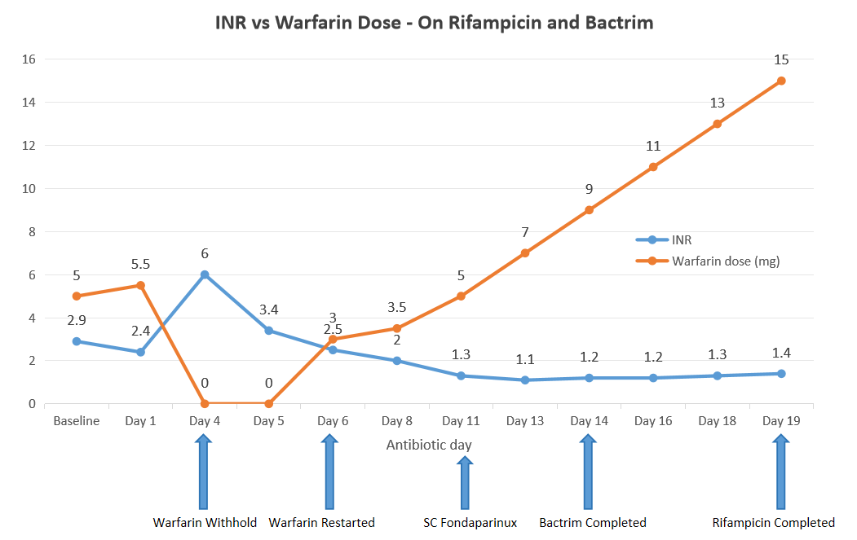

Figure 1 : This figure illustrates that on day 4 of antibiotic treatment, the INR level spiked to 6, necessitating temporary discontinuation of warfarin for two days and transfusion of three units of FFP. Warfarin was restarted on day 6 of antibiotic therapy. This was followed by persistently sub-therapeutic INR levels despite increasing the warfarin dose to three times the baseline requirement. LMWH was initiated on day 11, as the INR failed to reach the therapeutic target despite high-dose warfarin.
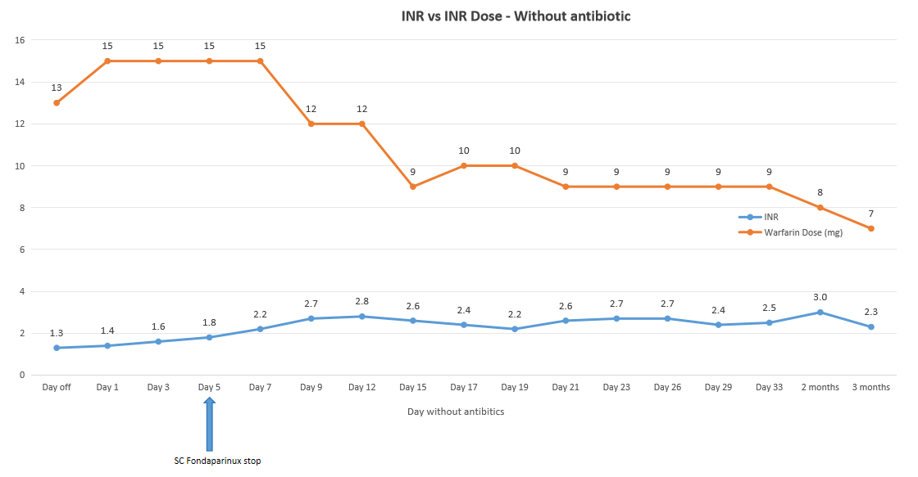

Figure 2 : The patient’s baseline warfarin dose was 5 mg daily. The figure demonstrates that the warfarin requirement remained elevated even after completion of rifampicin therapy. Low-molecular-weight heparin (LMWH) was discontinued five days after rifampicin cessation when the INR reached the target level of 1.8. The warfarin dose gradually decreased over a three-month period following discontinuation of rifampicin

