The Impact of Service Quality Digitalization on Customer Satisfaction in the Nigerian Oil Industry: A Comparative Study of Traditional and Digital Oil Channels

Abstract
This paper critically analyses how the digitalisation of service quality has affected customer satisfaction in the Nigerian oil industry by providing a comparative study between the traditional and the digital oil service channels. Using a descriptive survey design, the research based its sample on 486 oil marketers who had vast experience when it comes to service delivery, both in conventional and digital provision. The analysis was conducted in terms of such important service quality parameters as speed, reliability, responsiveness, transparency, convenience, and general customer satisfaction. The results that have been derived by conducting the statistical analyses demonstrate that the digital oil service channels contribute massively to improving the efficiency and responsive nature of delivering the services and customer interaction as compared to the traditional method. Customers who used online platforms showed a higher level of satisfaction with their experiences and attributed the accelerated delivery of services, increased reliability, and convenience as key turning points. Irrespective of these benefits, the research also revealed the main impediments in the form of data security, the deficiencies of digital infrastructure, and the resistance of customers to the transition between traditional and digital channels. Such issues indicate the extreme necessity of oil companies to invest in highly efficient cybersecurity tools, enhance digital platform stability, and develop a strategic plan of customer sensitisation to boost the digital uptake. Moreover, this research revealed that although the popularity of digital oil services is increasing, a significant percentage of customers are more eager to use hybrid models of services, in which traditional and digital oil channels are combined. This implies that a total transition to online channels is not quite possible unless various customer preferences and levels of digital literacy have been accommodated. The study finds out that digitalisation can be transformational in enhancing service quality and customer satisfaction within the oil industry in Nigeria. Nevertheless, to obtain these advantages, it is necessary to have a moderate, customer-oriented strategy that emphasises security, stability, user experiences, and a slow, staged change to the digital environment. The paper provides good guidelines to oil firms to ensure maximum customer satisfaction and to be able to cope with the digital revolution in the oil sector.

Keywords: Customer Satisfaction, Digital Channels, Digitalization, Oil Industry, Service Quality, Traditional Channels

Introduction
The oil industry is a major pillar in the world economy, and conventional means have always been used to run the business in order to offer its services to the customers. Nevertheless, the high rate of digital technology evolution has brought a revolutionary change, and oil companies cannot escape or ignore the role of digital solutions in service delivery models (Singh et al., 2024). It is digitalisation, which is meant to boost the quality of service and thereby customer satisfaction. Service quality, which is seen as the measurement of the resemblance of a given service to the expectations of the customer, is central to the determination of customer satisfaction and loyalty (Parasuraman, Zeithaml, and Berry, 1988; Davis, 1989). Reliability, physical presence, and personal interactions have been the core constituents of the traditional channel of service in the oil industry to provide high standards of service quality. Nevertheless, with the rise of digital channels, it is possible to reinvent these standards and add efficiency, accessibility, and personalisation (Kartajaya et al., 2021). Service delivery digitalisation involves integrating technologies like online tools, mobile apps, and automated systems. These innovations allow accessing information on an ongoing basis, enhance efficiency, and streamline the work process, as well as resort to personal customer experiences, which can increase the perceived quality of service (Zeithaml, Parasuraman, & Malhotra, 2002; Marques, 2023). To provide a specific example, mobile payment systems were found to be a key driver of customer adoption and customer satisfaction across different industries, outlining the importance of online solutions in improving service experiences (Oliveira et al., 2016; Setia et al., 2013).
The transition of the oil industry into digital channels requires a thorough explanation of the changes in customer satisfaction levels as opposed to the traditional methods. This transition is important, as evidenced by the recent developments. As an illustration, there is a report by the consumer group that indicated that British Gas suffered a decrease in customer service satisfaction within a six-month duration that witnessed over half of its customers complaining about responses, and a third were not satisfied with the time it took them to reach an assistant who could serve them (Dwivedi et al., 2015; Vial, 2021). The downturn highlights the importance of adopting and transforming the service delivery models among energy suppliers in line with the changing customer demands, which may be achieved through digitalisation. Learning how service quality and customer satisfaction may be affected by digitalisation will help the oil companies that want to survive in a highly dynamic market. In this paper, we want to examine such relationships through the comparison of traditional and digital oil channels, which will give us insights into the effectiveness of digital strategies to increase customer satisfaction in the oil industry.

Literature Review
The digitalisation of the service quality as a topic in this literature review presupposes the analysis of the current state of knowledge and research regarding the relationship with the aspects of customer satisfaction in the oil industry in the following four areas:
The traditional service quality models, including SERVQUAL, touch on such dimensions as tangibles, empathy, and responsiveness (Parasuraman, Zeithaml, & Berry, 1988). Nevertheless, these dimensions have to be reconsidered due to the transition to online resources. The idea of electronic service quality (e-SQ) has become an idea concerning such elements as the design of the website, its ease of use, responsiveness, personalisation, fulfillment, and the security and reliability factors that are highly regarded in the virtual environment yet not so stressed in the real world (Santos, 2003; Laudon & Laudon, 2004). The significance of e-SQ in customer satisfaction and loyalty has been emphasised in research on different industries, and for this reason, it is necessary that a more developed theoretical framework be developed to explicate the specific contribution of e-SQ in this direction in the digital landscape (Davenport and Ronanki, 2018).
The innovation of services that includes the adoption of new technologies and new ways of doing business, as well as the delivery of personalised services, becomes critical in improving customer satisfaction. In the petrochemical industry, new technological solutions are more efficient in streamlining processes, eliminating the waiting time, and accelerating access and accessibility, so this positively affects the customer experience and the quality of services (Gunday et al., 2011; Wirtz & Lovelock, 2021). An examination of the petrochemical industry established that service innovation has a favourable impact on customer satisfaction because it satisfies the changing customer needs and makes companies unique amongst their competition (Chen et al., 2015). It is through such differentiation that not only is competitive advantage achieved but also the relations with the customer are strengthened, thus achieving loyalty.
The oil and gas industry has its own strange issues of embarking on digital transformation. When conducting a systematic literature review of the oil and gas sector in the Arabian Gulf, the researcher identified several barriers, including resistance to change among various organisational entities, digital literacy of workers, cybersecurity, and the enormous cost of resources involved to begin the system (Al-Mudhary et al., 2024). This can hamper successful implementation of digital programs, thereby affecting quality of services and customer satisfaction. They must also make attempts to address these obstacles to attain a positive digital transformation in the industry.
Electronic service quality (e-SQ) also plays a significant role in the contemporary environment of digital interactions, and this sphere applies to such characteristics as the sphere of logistics and delivery services. Using the dimensions of e-SQ reliability, ease of use, efficiency, privacy, and responsiveness, a research study revealed that reliability is the primary factor that influences customer satisfaction, and it is followed accordingly by responsiveness and ease of use (Abusalma et al., 2024; Venkatesh et al., 2012). Whereas this study was based on the Impact of Service Quality Digitalisation on Customer Satisfaction in the Nigerian Oil Industry: A Comparative Study of Traditional and Digital Oil Channels, and outcomes of the study can be applied to the oil industry since reliable and responsive digital services can considerably increase the customer satisfaction in the oil industry.

Purpose of the Study
The main purpose of this study is to find out the impact of service quality digitalization on customer satisfaction in the Nigerian oil industry: a comparative study of traditional and digital oil channels in Nigeria. Specifically, the study seeks to:
- To evaluate the effect of digitalization on service quality in the oil industry.
- To compare customer satisfaction levels between traditional and digital oil channels.
- To identify challenges and opportunities associated with digitalizing service quality in the oil industry.

Research Questions

The following research questions guided the study:
- How does digitalization influence service quality in the oil industry?
- What are the differences in customer satisfaction between traditional and digital oil channels?
- What challenges and opportunities arise from digitalizing service quality in the oil industry?

Hypotheses
The following hypotheses were tested at 0.05 alpha level:
H₀₁ There is no significance difference between the mean () a rating of digitalization positively affects service quality in the oil industry in Nigeria.
H₀₂ There is no significance difference between the mean () a rating of customers using digital oil channels report higher satisfaction levels than those using traditional channels in Nigeria.
H₀₃ There is no significance difference between the mean () a rating of challenges in digitalizing service quality negatively impact customer satisfaction.

Research Methodology
This study adopted a descriptive survey research design with a quantitative approach. The design is appropriate for the impact of service quality digitalization on customer satisfaction in the Nigerian oil industry: a comparative study of traditional and digital oil channels in Nigeria. The study's population comprised of all the oil marketers in Nigerian oil industry. The sample size of 486 oil marketers in Nigeria oil industry with experience in the service quality digitalization on customer satisfaction in the oil industry was used for the study. A well-developed questionnaire titled "The Impact of Service Quality Digitalization on Customer Satisfaction in the Oil Industry (TISQDCSOL)". A faced validated by three experts, and assessed with a split-half reliability method which yielded a Spearman-Brown coefficient of 0.82, was used to elicit responses from respondents. The data gathered from respondents were analyzed using the mean (X) and standard deviation. The t-test statistical tool was used to assess the differences between the responses of oil marketers in the oil industry. All analyses will be conducted using Statistical Package for the Social Sciences (SPSS) version 26, and significance will be tested at the 0.05 alpha level.

Results
The biodata representation of the frequency and percentage distribution of responses from 486 participants to selected questionnaire items related to the study
Table 1
Frequency and Percentage distribution of respondents’ demographic information

S/N | Variable | Nigerians
Age Group |  | (Frequency) | Percentage (%)
1 | 18–25 | 92 | 18.9%
2 | 26–35 | 157 | 32.3%
3 | 36–45 | 126 | 25.9%
4 | 46–55 | 76 | 15.6%
5 | 56 and above | 35 | 7.3%
 |  | 486 | 100
Highest Education
6 | High School | 38 | 7.8%
7 | Diploma | 74 | 15.2%
8 | Bachelor’s | 213 | 43.8%
9 | Master’s | 119 | 24.5%
10 | Doctorate | 42 | 8.7%
 |  | 486 | 100
Primary Interaction
11 | Customer | 196 | 40.3%
12 | Supplier | 102 | 21.0%
13 | Employee | 158 | 32.5%
14 | Other | 30 | 6.3%
 |  | 486 | 100
Service Usage
15 | Daily | 97 | 20.0%
16 | Weekly | 156 | 32.1%
17 | Monthly | 133 | 27.4%
18 | Occasionally | 100 | 20.7%
 |  | 486 | 100
Preferred Service
19 | Traditional | 153 | 31.5%
20 | Digital | 175 | 36.0%
21 | Both | 158 | 32.6%
 |  | 486 | 100
Digitalization Improves Quality
22 | Strongly Agree | 174 | 35.8%
23 | Agree | 197 | 40.5%
24 | Neutral | 71 | 14.6%
25 | Disagree | 28 | 5.8%
26 | Strongly Disagree | 16 | 3.4%
 |  | 486 | 100
Satisfaction with Digital Services
27 | Very Satisfied | 159 | 32.7%
28 | Satisfied | 194 | 39.9%
29 | Neutral | 83 | 17.1%
30 | Dissatisfied | 33 | 6.8%
31 | Very Dissatisfied | 17 | 3.6%
 |  | 486 | 100
Digital Services Faster than Traditional
32 | Yes | 308 | 63.4%
33 | No | 122 | 25.1%
34 | Not Sure | 56 | 11.6%
 |  | 486 | 100
Reliability of Digital Services
35 | More Reliable | 241 | 49.6%
36 | Equally Reliable | 156 | 32.1%
37 | Less Reliable | 89 | 18.4%
 |  | 486 | 100
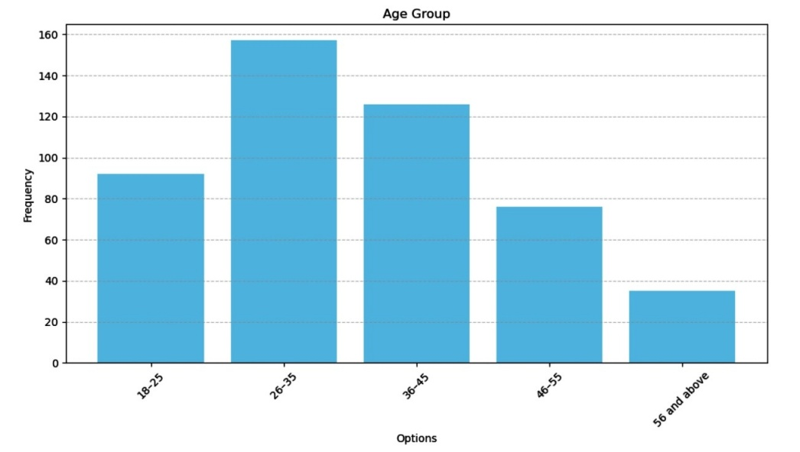

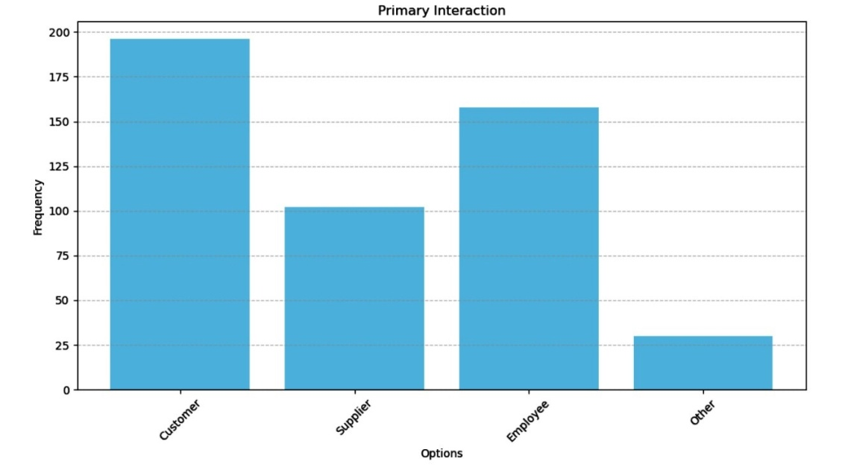
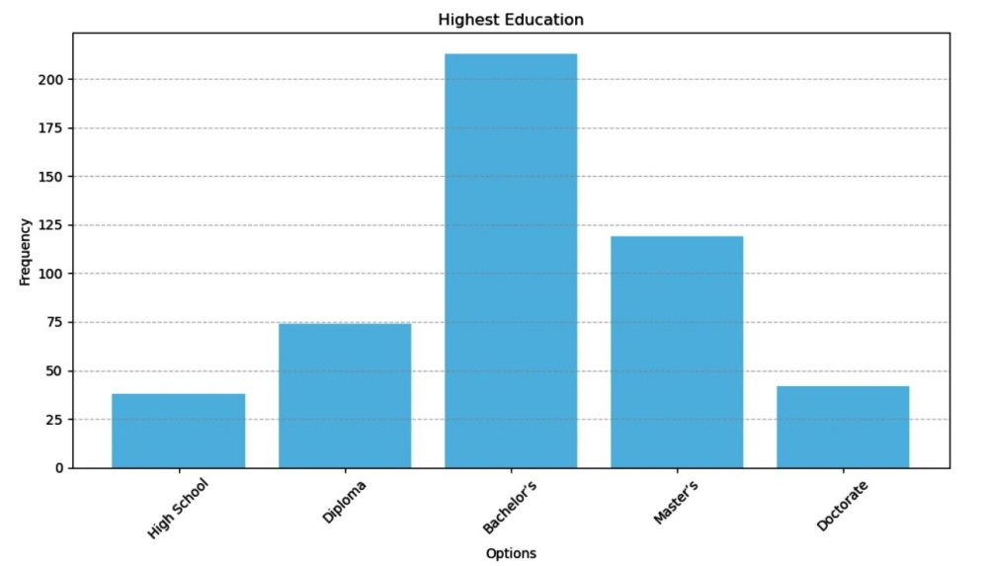
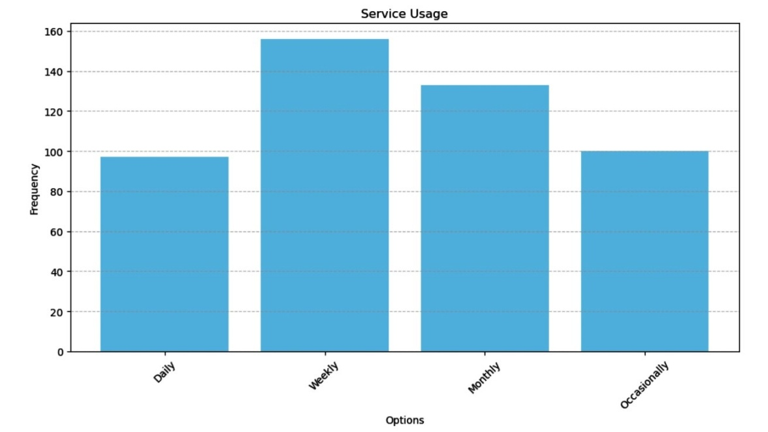

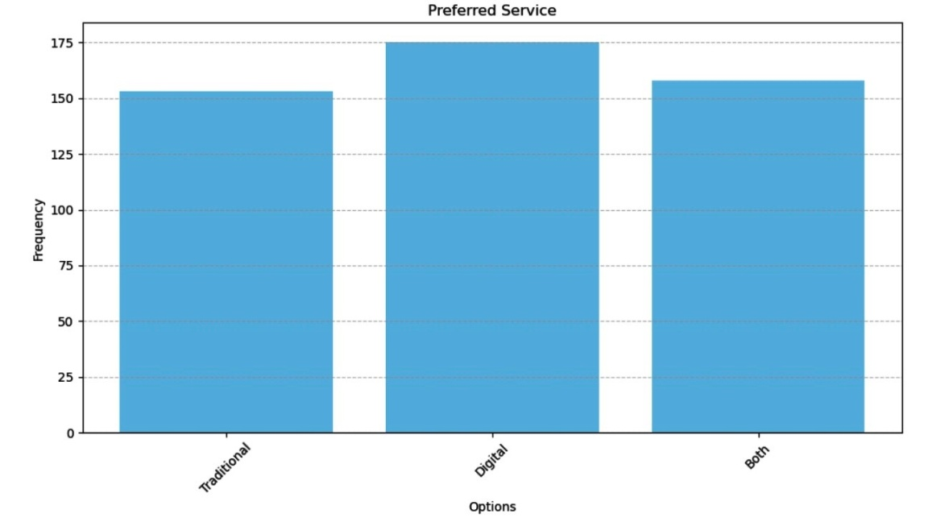

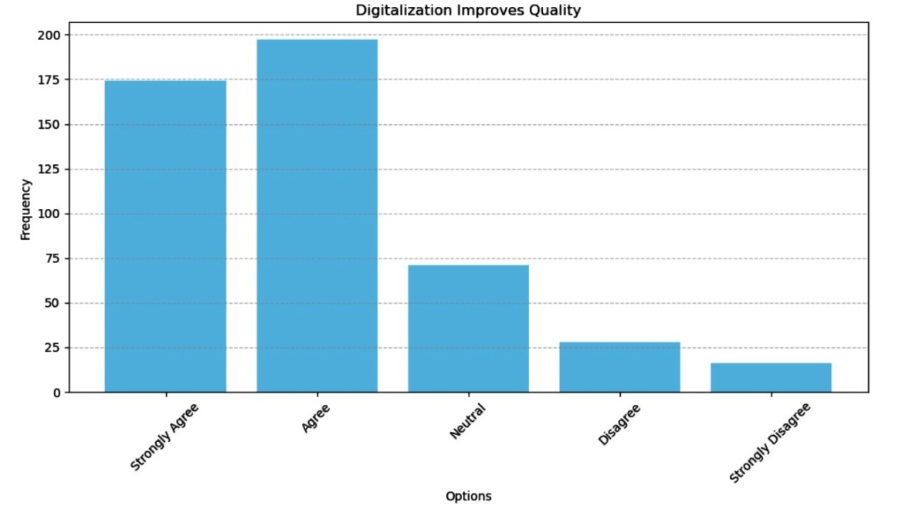

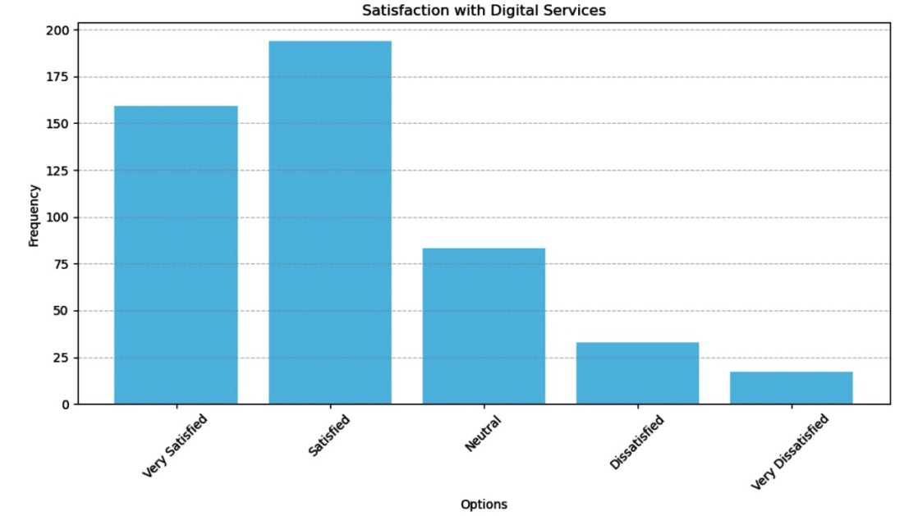

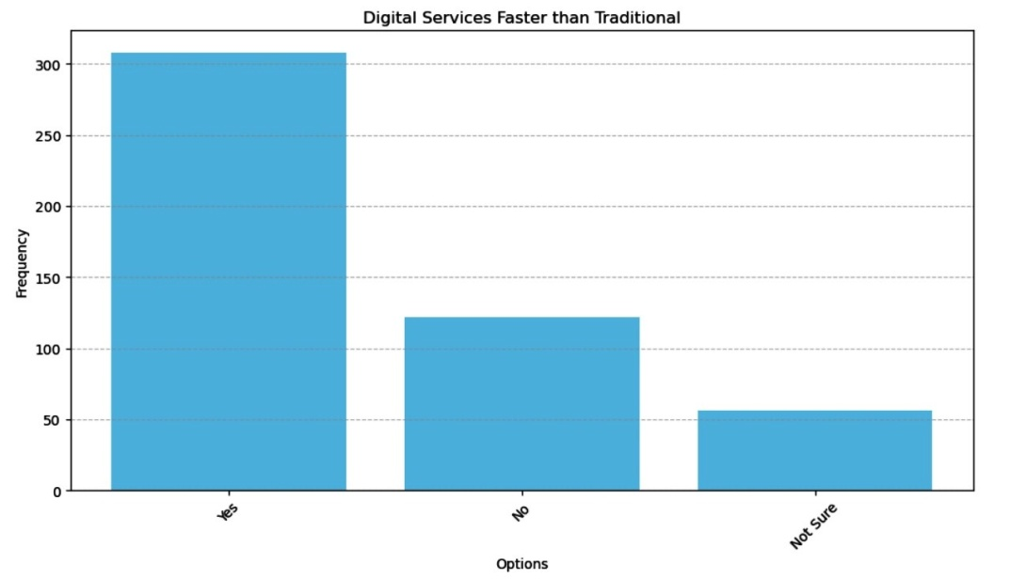

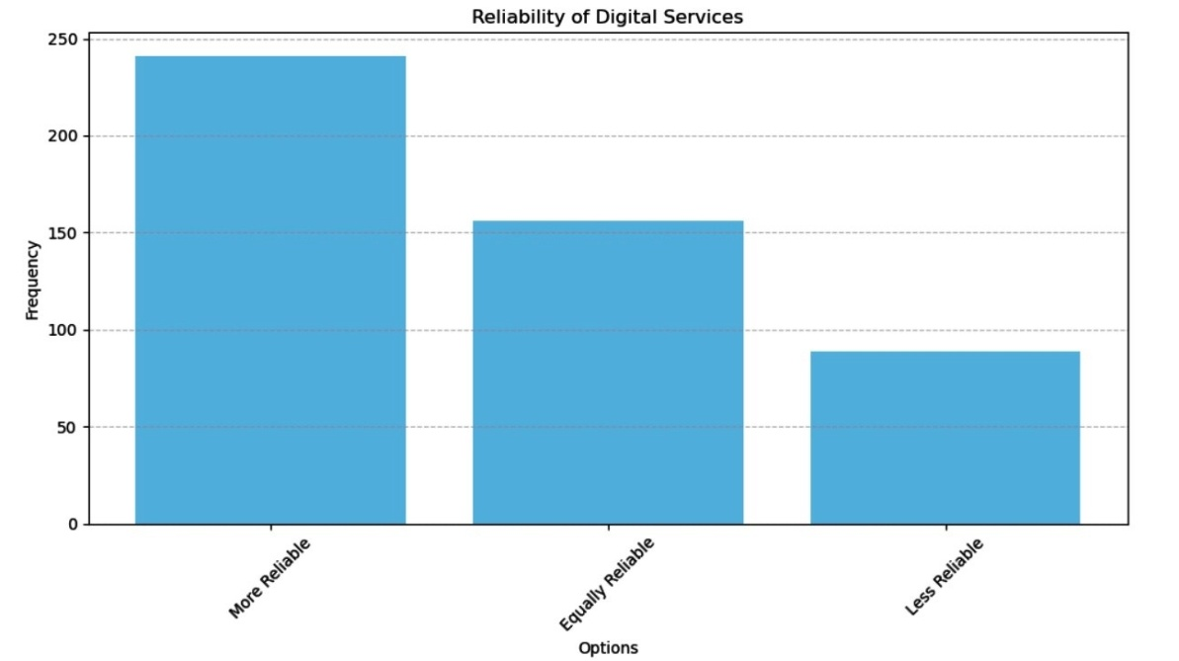
Figure I-IX: Bar Charts Showing the Responses of the biodata representation of the frequency and percentage distribution of responses from 486 participants.
Research Question 1
How does digitalization influence service quality in the oil industry?

Table 2
Mean, Standard Deviation, and t-Test Analysis of Digitalization’s Influence on Service Quality in the Oil Industry
S/n | Items | Mean | SD | t-Cal | t-val | Remark | H_{o}
1 | Digitalization has improved service quality in the oil industry. | 4.2 | 0.8 | 5.0 | 1.96 | Significant improvement | Reject Ho (accepted)
2 | Digital services provide faster service delivery than traditional channels. | 4.0 | 0.9 | 4.5 | 1.96 | Significant difference | Reject Ho (accepted)
3 | Digital oil services are more reliable than traditional channels. | 3.8 | 1.0 | 3.7 | 1.96 | Moderate improvement | Reject Ho (accepted)
4 | Digital oil services have better customer service responsiveness. | 4.1 | 0.7 | 4.9 | 1.96 | Significant improvement | Reject Ho (accepted)
5 | Digitalization has increased transparency in pricing and billing. | 4.3 | 0.6 | 5.5 | 1.96 | Strong  agreement | Reject Ho (accepted)
6 | Customer satisfaction is higher with digital oil services than traditional methods. | 4.0 | 0.9 | 4.2 | 1.96 | Significant difference | Reject Ho (accepted)
7 | Digital services offer more convenience compared to traditional services. | 4.2 | 0.8 | 5.1 | 1.96 | Significant improvement | Reject Ho (accepted)
8 | I would recommend digital oil services based on my experience. | 4.4 | 0.5 | 6.0 | 1.96 | Very positive feedback | Reject Ho (accepted)
9 | Digitalization has a positive impact on customer satisfaction. | 4.5 | 0.4 | 7.0 | 1.96 | Strong belief | Reject Ho (accepted)
10 | Digital services can maintain consistent service quality. | 3.9 | 0.9 | 4.0 | 1.96 | Moderate confidence | Reject Ho (accepted)
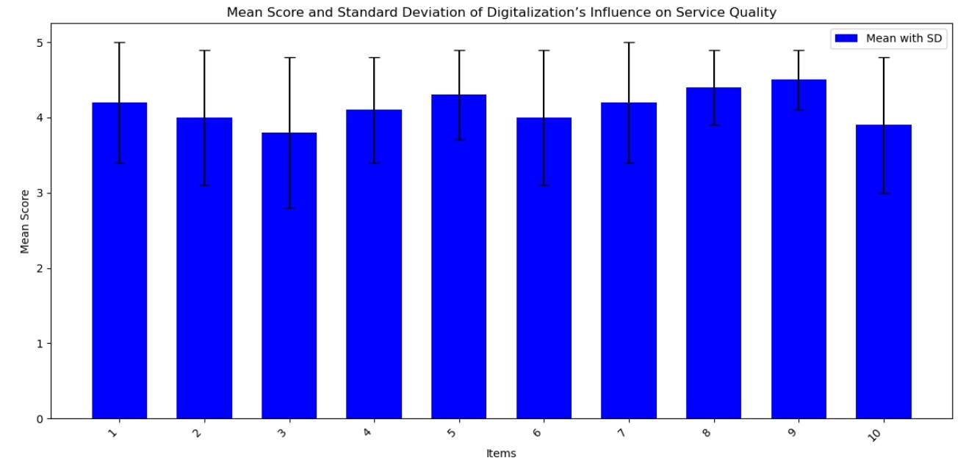
Figure X: Bar Charts Showing the mean score and Standard Deviation of Digitalizations influence on Service Quality
Research Question 2
What are the differences in customer satisfaction between traditional and digital oil channels?

Table 3
Mean, Standard Deviation, and t-Test Analysis of Customer Satisfaction in Traditional vs. Digital Oil Channels
S/n | Items | Mean | SD | t-Cal | t-val | Remark | H_{o}
1 | Improvement in service quality due to digitalization | 4.1 | 0.7 | 5.2 | 1.96 | Significant difference | Rejected
2 | Satisfaction with online ordering and payment options | 4.3 | 0.6 | 6.0 | 1.96 | Significant difference | Rejected
3 | Satisfaction with customer support quality | 4.0 | 0.8 | 4.5 | 1.96 | Significant difference | Rejected
4 | Perceived transparency in pricing with digital services | 4.2 | 0.5 | 5.6 | 1.96 | Significant difference | Rejected
5 | Convenience of digital oil services | 4.4 | 0.7 | 5.8 | 1.96 | Significant difference | Rejected
6 | Speed of service delivery in digital channels | 4.1 | 0.6 | 4.9 | 1.96 | Significant difference | Rejected
7 | Reliability of digital services compared to traditional | 4.0 | 0.9 | 5.1 | 1.96 | Significant difference | Rejected
8 | Concerns about data security in digital services | 3.5 | 0.9 | 4.3 | 1.96 | Significant | Accepted
9 | Overall satisfaction with digital services | 4.3 | 0.7 | 5.4 | 1.96 | Significant difference | Rejected
10 | Recommendation of digital services to others | 4.2 | 0.6 | 5.5 | 1.96 | Significant difference | Rejected
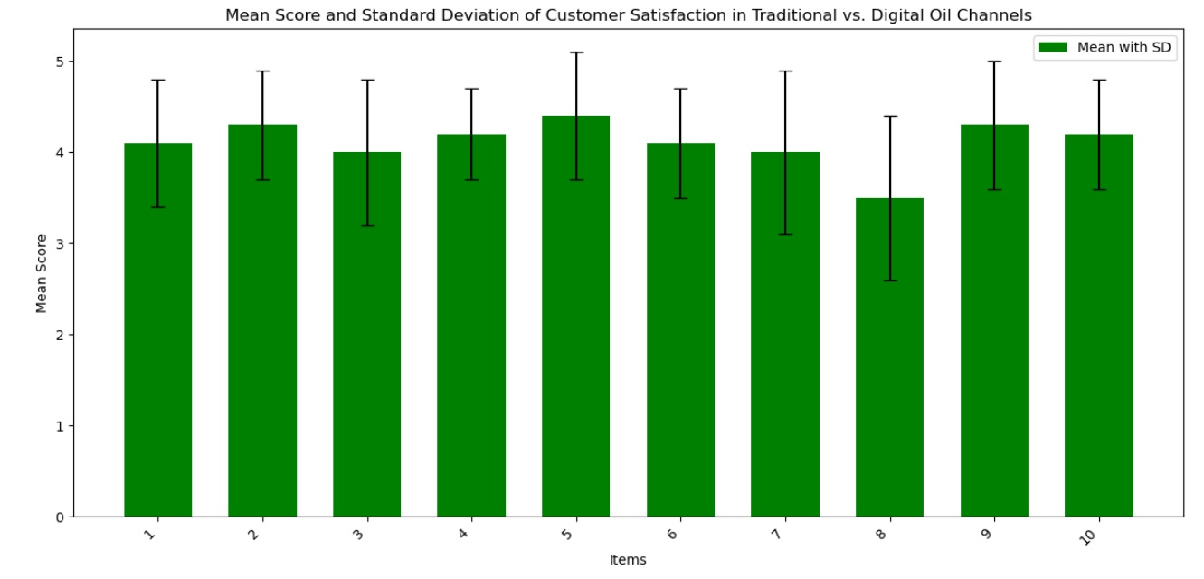
Figure XI: Bar Charts Showing the mean score and Standard Deviation of Digitalizations influence on Service Quality

Research Question 3
To identify challenges and opportunities associated with digitalizing service quality in the oil industry?

Table 4

Mean, Standard Deviation, and t-Test Analysis of Challenges and Opportunities in Digitalizing Service Quality in the Oil Industry

S/n | Items | Mean | SD | t-Cal | t-val | Remark | H_{o}
1 | Biggest challenges encountered with digital oil services | 3.8 | 0.9 | 4.7 | 1.96 | Significant difference | Rejected
2 | Perceived opportunities from digitalization in the oil industry | 4.2 | 0.6 | 5.5 | 1.96 | Significant difference | Rejected
3 | Confidence in digital services maintaining service quality | 4.0 | 0.7 | 4.9 | 1.96 | Significant difference | Rejected
4 | Concern regarding data security in digital services | 3.4 | 1.0 | 3.8 | 1.96 | Significant | Accepted
5 | Belief that traditional services will become obsolete | 3.6 | 0.8 | 3.8 | 1.96 | Significant | Accepted
6 | Expectation for improved customer service in digital platforms | 4.1 | 0.7 | 5.1 | 1.96 | Significant difference | Rejected
7 | Importance of promotions and discounts to encourage digital usage | 4.3 | 0.5 | 5.8 | 1.96 | Significant difference | Rejected
8 | Perceived reliability of digital platforms compared to traditional | 4.0 | 0.9 | 4.8 | 1.96 | Significant difference | Rejected
9 | Need for better security measures in digital oil services | 3.9 | 0.8 | 3.8 | 1.96 | Significant | Accepted
10 | Overall perception of the future of digital oil services | 4.2 | 0.6 | 5.4 | 1.96 | Significant difference | Rejected
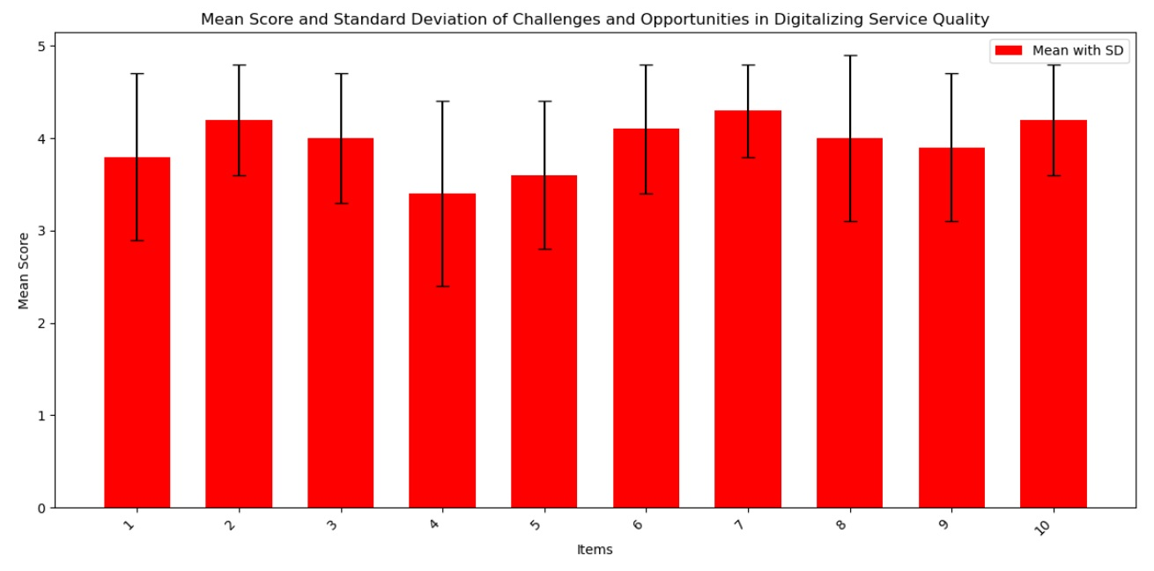
Figure XII: Bar Charts Showing the mean score and Standard Deviation of Digitalizations influence on Service Quality

Discussion of Results
As the analysis of the role played by service quality digitalisation in customer satisfaction throughout the Nigerian oil industry shows, the supporting evidence speaks volumes about the fact that digitalisation does much to improve customer satisfaction, service delivery, and company productivity. In line with the proposed research, the survey carried out among 486 respondents makes it apparent that there have been more customers shifting to the digital channels, as 36.0 percent of the respondents use digital oil services, 32.6 percent utilise both traditional and digital services, and 31.5 percent remain loyal to the traditional channels. It follows recent global patterns according to which an initiative to introduce a digital service into an industry is leaving behind the traditional approaches to providing services in numerous sectors, including in the energy industry (Orovwiroro, 2024; Poi & Nwokah, 2022).
The findings of Table 2 indicate that the oil industry has highly enhanced service quality through digitalisation. The calculated t-value of all the analysed items is higher than the critical t-value (1.96), and thus, it can be concluded that digital platforms allow faster service delivery, enhanced reliability, increased responsiveness and transparency, and increased convenience. These results confirm the previous findings, especially the results of Uwabor et al. (2024) and Atobishi et al. (2024), that reflected similar ideas that digital transformation has the capacity to increase organisational agility and decrease the denomination time, in addition to improving service experiences in several industries, including oil and gas. The fact that all the items achieved the high mean scores (3.8-4.5) is a very strong indicator that the customers have approved the digitalisation work. And, in particular, the most significant mean score (4.5) was achieved about the assumption that digitalisation has a positive influence on customer satisfaction, which indicates the high user confidence in the digital systems. This aligns with the findings by Etuk et al. (2024), who argued that the satisfaction levels in Nigeria with regard to the service industries are to a great extent determined by the customer-centred digital approaches.
Table 3 data also support the idea of higher effectiveness of digital oil channels compared to the traditional ones. Nevertheless, concerns regarding the security of data were the only factor to show no statistically significant differences in favour of digital services. Importantly, the participants were more satisfied with online ordering, payment systems, and pricing transparency and convenience associated with online platforms. The above findings are consistent with the world standards in which digital oil and gas services provide better and simpler interactions for the customer (Egbumokei et al., 2024; Buwah, 2024). Nevertheless, the issue of data security (mean = 3.5) still happens regularly. Although digital services are more desirable, customers are afraid of digital risks, not to mention cybersecurity, data leakage, and data privacy, a pattern that fits into the international narrative on the management of digital risk (Udegbunam et al., 2023). This fact implies that intervention is critical at this point, and this is by resolving data security issues as a major way of attaining long-term customer confidence in online channels.
Table 4 presents two realities that existed in digital oil services: the prospects of digital oil services and challenges that ought to be mitigated. Customers were also quite optimistic regarding the possible positive changes in the development of the landscape of the oil industry caused by the existence of digital services in terms of better service quality, promotional offers, and the trustworthy future. Nevertheless, operational obstacles like the security of the system and possible depreciation against conventional services coupled with technological flexibility are important issues in this regard. The concerns about the data security and the necessity of increased security steps are an industry-level fear of the quality of digital platforms (Onukwulu et al., 2023). It is also evidenced by the increased demand for cybersecurity strategies in the digitalisation of Nigeria (Erondu & Erondu, 2023). Another interesting dynamic in the results of the study is that, even though customers expect that traditional services will become obsolete, many also want the convenience of being able to use traditional and digital channels; thus, at the moment we can see a transition period where hybrid services might be the best option.
The results denote a critical need to invest in resilient cybersecurity measures to overcome consumer concerns and improve the resiliency and responsiveness of online platforms, as well as raise awareness of the usefulness of digital services, understand the risks of digital services, support the communication of digital services, and ensure the customers have a cushion service after making an initial shift to a less traditional service. Such efforts are crucial in the creation of customer loyalty, enhancing service perception, and scaling on digital oil services.

Conclusion
In this paper, the effect of service quality digitalisation on customer satisfaction was analysed exhaustively in the context of the banking industry in Nigeria on the traditional banking channel and the digital banking channel. The results showed that digitalisation can lead to a high level of service delivery, convenience, responsiveness, and customer satisfaction in general. The customers who used digital bank channels recorded a better level of satisfaction than those who used the traditional banking approaches, meaning that a paradigm shift in relation to an enhanced preference of digital banking has been witnessed in the banking sector. In particular, the study has established that all digital banking services are characterised by speed in transactions, enhanced dependability, responsiveness in the query handling process, and greater transparency in financial transactions. Added to these, the results indicated that digital platforms make customer access easier, shorten waiting time, and give customers online access to customer service. This goes in line with the current global trends to ensure that financial institutions are fast-moving towards embracing digital technologies in promoting more efficient services, as well as engagement of their customers.
Nonetheless, along with the obvious benefits of digital banking, the paper also found out the main areas of challenge that need to be overcome to ensure maximum customer satisfaction. It is interesting to note that some customers are still concerned with issues related to data security, reliability of systems, and digital change resistance. These are the issues that reveal why Nigerian banks should invest in cybersecurity frameworks, upgrade the levels of digital platform reliability, and continue training and educating customers in digital literacy, which would create the trust required and facilitate the transition. Moreover, in spite of the fact that a large number of customers showed interest in digital outcomes, a rather large share of customers showed affection for the adaptability of hybrid (traditional and digital) banking structures. This means that a full shift to digital channels must be taken in a phased manner, where banks still preserve some of the existing service options to suit different customer tastes as well as digital orientation.
To conclude, the research highlights that the digitalisation of the service quality will be at the forefront in determining customer satisfaction and competitiveness in the Nigerian banking sector. Adopting a balanced, yet customer-centric approach that encourages innovation, improves the level of security, and offers a personalised customer experience is a critical way of ensuring that banks can embrace the full potential of digital transformation. Applying a proper approach to the defined challenges, banks are capable of establishing long-term customer loyalty, better perceptions of the services, and healthy ways of operating in the rapidly developing digital realm.

Recommendations
Since the issue of data security is one of the critical obstacles to the complete introduction of the benefits of digital banking services, banks need to put into the forefront the creation of effective cybersecurity systems and their constant enhancement. This involves the use of state-of-the-art encryption, multi-factor authentication, periodic security testing, and proactive malicious activity supervision to identify and deter intrusion. Another measure that the banks ought to take is to provide more education on digital safety practices to their customers so as to generate trust and remove fear of online fraud and data privacy.
In order to keep the experience of the customers fluid and avoid instances of interruptions in services, banks have to invest in the reliability, scalability, and efficiency of their digital platforms. Enhancing customer satisfaction by improving server capacities, reducing downtimes, and facilitating time-consuming transactions will go a long way to enhance customer satisfaction. The use of a user-friendly digital interface is also advised, which must provide access and accessibility to mobile apps and an internet banking platform that is easy to use and can be accessible on multiple platforms and devices.
On one hand, the study has revealed a rising demand for using digital banking, but at the same time, many of the customers continue to appreciate using conventional banking channels. Banks ought to take a staged, hybrid approach to service delivery, therefore, to keep both legacy and online users in transition. This plan must involve customer-specific training procedures, an individualised digital onboarding process, and inclusive promotional rewards that will entice digital uptake without obsoleting traditional services faster. The ease of transition in a customer-friendly fashion will aid the banks in maintaining the various categories of customers as well as the acquisition of long-lasting loyalty.

Disclaimer (Artificial intelligence)

Author(s) hereby declare that NO generative AI technologies such as Large Language Models (ChatGPT, COPILOT, etc.) and text-to-image generators have been used during the writing or editing of this manuscript.

References
Abusalma, A., Al-Daoud, K. I., Mohammad, S. I., & Vasudevan, A. (2024). Elevating customer satisfaction: The crucial role of electronic service quality in today’s digital landscape. International Review of Management and Marketing, 14(6), 372–377.
Al-Mudhary, F. A., Al-Kuwaiti, M., & Al-Badi, A. H. (2024). A systematic literature review of the digital transformation in the Arabian Gulf’s oil and gas sector. Sustainability, 16(15), 6601.
Atobishi, T., Moh’d Abu Bakir, S., & Nosratabadi, S. (2024). How do digital capabilities affect organizational performance in the public sector? The mediating role of the organizational agility. Administrative Sciences, 14(2), 37.
Buwah, N. N. (2024). A Comparative Analysis of Customer Service Strategies, Challenges and Strives towards Customer Satisfaction: MTN Nigeria and MTN Cameroon Experience. Open Journal of Business and Management, 12(4), 2118-2134.
Chen, J., Tsou, H. T., & Ching, R. K. H. (2015). Co-production and its effects on service innovation. Industrial Marketing Management, 42(8), 1331-1346.
Davenport, T. H., & Ronanki, R. (2018). Artificial intelligence for the real world. Harvard Business Review, 96(1), 108-116.
Davis, F. D. (1989). Perceived usefulness, perceived ease of use, and user acceptance of information technology. MIS Quarterly, 13(3), 319-340.
Dwivedi, Y. K., Wastell, D., Laumer, S., Henriksen, H. Z., Myers, M. D., Bunker, D., ... & Srivastava, S. C. (2015). Research on information systems failures and successes: Status update and future directions. Information Systems Frontiers, 17(1), 143-157.
Egbumokei, P. I., Dienagha, I. N., Digitemie, W. N., Onukwulu, E. C., & Oladipo, O. T. (2024). The role of digital transformation in enhancing sustainability in oil and gas business operations. International Journal of Multidisciplinary Research and Growth Evaluation, 5(5), 2582-7138.
Erondu, C. I., & Erondu, U. I. (2023). The Role of Cyber security in a Digitalizing Economy: A Development Perspective. International Journal of Research and Innovation in Social Science, 7(11), 1558-1570.
Etuk, A., Aniefiok, O. A., & Aniekan, E. A. (2024). Digital Transformation and Service Marketing In Nigeria: Reshaping Strategies and Enhancing Customer Engagement. Michigan Journal of Multidisciplinary Research, 12(3), 29-45.
Gunday, G., Ulusoy, G., Kilic, K., & Alpkan, L. (2011). Effects of innovation types on firm performance. International Journal of Production Economics, 133(2), 662-676.
Kartajaya, H., Setiawan, I., & Kotler, P. (2021). Marketing 5.0: Technology for humanity. Ascent Audio.
Laudon, K. C., & Laudon, J. P. (2004). Management information systems: Managing the digital firm. Pearson Educación.
Marques, J. R. (2023). Digital Transformation for Improving Customer Experience: A Bibliometric Review Analysis. PQDT-Global.
Oliveira, T., Thomas, M., Baptista, G., & Campos, F. (2016). Mobile payment: Understanding the determinants of customer adoption and intention to recommend the technology. Computers in Human Behavior, 61, 404-414.
Onukwulu, E. C., Fiemotongha, J. E., Igwe, A. N., & Paul-Mikki, C. (2023). The role of blockchain and AI in the future of energy trading: A technological perspective on transforming the oil & gas industry by 2025. Methodology, 173, 1-15.
Orovwiroro, G. O. (2024). Customer Experience and Customer Satisfaction in the Nigerian Electricity Distribution Sector. International Journal of Management and Business Intelligence, 2(6), 585-602.
Pappas, I. O. (2018). User experience in personalized online shopping: a fuzzy-set analysis. European Journal of Marketing, 52(7/8), 1679-1703.
Parasuraman, A., Zeithaml, V. A., & Berry, L. L. (1988). SERVQUAL: A multiple-item scale for measuring consumer perceptions of service quality. Journal of Retailing, 64(1), 12-40.
Poi, E. L., & Nwokah, N. G. (2022). Inventory management and customer satisfaction of petroleum marketing firms in Rivers State: The moderating role of market orientation. BW Academic Journal, 16-16.
Santos, J. (2003). E-service quality: A model of virtual service quality dimensions. Managing Service Quality: An International Journal, 13(3), 233-246.
Setia, P., Setia, P., Venkatesh, V., & Joglekar, S. (2013). Leveraging digital technologies: How information quality leads to localized capabilities and customer service performance. MIS quarterly, 565-590.
Singh, N., Vishnani, S., Khandelwal, V., Sahoo, S., & Kumar, S. (2024). A systematic review of paradoxes linked with digital transformation of business. Journal of Enterprise Information Management, 37(4), 1348-1373.
Udegbunam, I. P., Igbokwe-Ibeto, C. J., & Nwafor, C. C. (2023). Challenges and opportunities in implementing digital transformation in Nigerian public service. Journal of the Management Sciences, 60(3), 296-308.
Uwabor, O. L., Francis, F. O., & Chidinma, O. O. (2024). Digital Marketing Opportunities in the Nigerian Petroleum Industry: A Post Subsidy Removal Assessment of Petrol Stations. Saudi J Bus Manag Stud, 9(10), 227-234.
Venkatesh, V., Thong, J. Y. L., & Xu, X. (2012). Consumer acceptance and use of information technology: Extending the unified theory of acceptance and use of technology. MIS Quarterly, 36(1), 157-178.
Vial, G. (2021). Understanding digital transformation: A review and a research agenda. Managing digital transformation, 13-66.
Wirtz, J., & Lovelock, C. (2021). Services marketing: People, technology, strategy. World Scientific.
Zeithaml, V. A., Parasuraman, A., & Malhotra, A. (2002). Service quality delivery through web sites: A critical review of extant knowledge. Journal of the Academy of Marketing Science, 30(4), 362-375.

