STUDENTS’ ATTITUDES TOWARD INDIGENOUS ATTIRES AMONG HOME ECONOMICS STUDENTS IN UNIVERSITIES IN DELTA STATE

Abstract
This study investigated the attitudes and perceptions of Home Economics students toward indigenous attires in universities in Delta State, Nigeria, within the context of globalization and contemporary fashion influences. The study adopted a descriptive survey design, and the population comprised all seventy-five (75) Home Economics students in Delta State University, Abraka and University of Delta, Agbor; due to the manageable size, a census approach was used. Data were collected using a structured questionnaire measuring knowledge, attitudes, and influencing factors related to indigenous clothing. Descriptive statistics (means and standard deviations) were used to summarize overall attitude patterns, while inferential statistics (independent samples t-test) were applied to compare the perceptions of students across the two universities. The use of inferential analysis was justified by the study’s objective of determining whether statistically significant differences exist between the two groups rather than examining relationships among variables. Findings revealed generally positive attitudes toward indigenous attires, with students expressing strong cultural pride and identity attachment, although regular usage remained moderate due to economic and contextual factors. Significant differences were observed between the two institutions on selected attitude and perception items, indicating that institutional context shapes students’ views. The study concludes that strengthening curriculum integration, cultural exposure, and institutional support can enhance the appreciation and sustained use of indigenous attires among Home Economics students.

Keywords: Indigenous attire, Home Economics education, clothing attitudes, cultural identity, Delta State, Nigeria

Introduction
Culture is a dynamic object as it is manifested in language, rituals, food, music, and clothing. Of such dimensions, clothing is especially salient in cultural identity given that clothing is a pervasive and every-day sense of self-expression and social signalling. Indigenous clothes like Aso-Oke, George wrapper, Ishi Agu, and other ethnically unique garments literally symbolize centuries of history, symbolism, and artistic expression of the Nigerian nation with more than 250 ethnic groups (Olugbenga, et al., 2025). Such customary costumes are not only garments to dress the body; they also carry with them some kind of social significance like age bracket, marriage, regionality, and community worth and pass as the physical evidence of cultural continuity and preservation of tradition. Attention to indigenous clothing and clothing in particular has also been a major topic in cultural studies as a way of maintaining identity amid globalisation and imports of Western culture (Olugbenga et al., 2025).
In spite of this cultural significance, dressing among the young people and students in Nigeria has been known to change towards global and modern fashion. A study on clothes worn in Nigerian universities found out that the students value recent fashion trends, brand popularity, and social acceptance more than traditional or practical attributes of clothes (Azonuche, 2024). A significant number of students claimed that contemporary clothing selection was driven by the need to keep up with the times and conform to larger trends that can be found at the university campuses, with the dress becoming westernised and thus playing a major role in everyday fashion choices (Azonuche, 2024). These results indicate that although students may have the theoretical appreciation of the cultural worth of indigenous dress, their actual dressing behaviours may be a representation of the larger sociocultural processes of modernisation and peer pressure. In a similar fashion, Ojo et al. (2024) showed that socialisation agents such as family, media and peers also play a significant role in the selection of clothing among young adults in higher institutions. According to these studies, the dressing preferences of young people are the result of a complicated combination of cultural customs and modern society.
Media and globalisation are further contributing to the trend of modern and westernised clothes. Studies show that dress preferences of the Nigerian students are changing due to exposure to western media and fashion advertising often at the expense of native dressing (Alade and Olarewaju, 2024). The content of Western media, fashion movies, and foreign brand advertisements focus on fashions that denote the quality of modernity, prestige, and social mobility characteristics that are highly desired by youths who want to express themselves, and join their social circles. The diffusion and hybridization of cultures may cause erosion of traditional dress culture, with students turning to the dressing style that speaks to the global aesthetic and shuns the pointers of the local culture (Alade & Olarewaju, 2024). With these international pressures, the indigenous forms of clothing might be limited to ceremonial or special events opposed to being part of daily clothing.
Home Economics education is essential in the formation of student knowledge on clothing and textiles such as cultural meaning of dressing. This field has historically focused on applied techniques of clothing making and textile technology as well as cultural, social and economic dimensions of clothing in families and societies. Nonetheless, recent studies argued that indigenous cultural aspects have been under-researched in-Home Economics curriculum in Nigeria. Obi (2025) discovered that although teachers and students have a high opinion of indigenous knowledge, they still tend to be peripheral in the official curriculum documents and classroom activities, and thus, could not be used fully to promote deep cultural immersion. This underrepresentation can be a source of conflict in the attitudes of Home Economics students who may have a positive attitude towards indigenous attire but not through formal learning experience that can enhance cultural pride and practise. The restrictive nature of the curriculum integration of the indigenous practises, therefore, creates disconnection between the cultural values and the educational focus on the traditional dress.
Cultural theorists have cautioned that the rejection of traditional dress at the school levels will undermine the culture and heritage appreciation of the youngsters. Conventional clothes are not simply aesthetic objects; they contain the meaning, history, and cultural continuity, maintaining social values and integrating the community (Olugbenga, et al., 2025). Nevertheless modernization, globalisation and western fashion trends are major forces that put the culture of clothing in the indigenous culture under pressure. As a reaction, there have been appeals by certain scholars to have culturally responsive pedagogies, which significantly encompass indigenous practices in educational programmes to promote cultural encounter and pride (Obi, 2025). Curricular integration of this nature has been found to increase student engagement, cultural awareness, and preserve heritage through putting learning into context with student lived cultural realities.
The case of Delta State in particular with regard to a multiethnic community including the Urhobo, Itsekiri, Isoko, and Anioma sub-ethnicities reveals that indigenous clothing can be seen as a profile of regional identities and artisan skills. These local outfits usually contain a unique pattern of textile use, representative colours, and custom-shaped bodies that express communal ideas. Although this is an extensive sartorial tradition, the body of research that focuses on how Home Economics students in Delta State value indigenous clothing is scarce. Such a gap is significant since the students with Home Economics training will become future workers who may influence clothing preferences, education practises, and cultural promotion in their community. They might affect the continuity of the culture, fashion innovation, and local identity assimilation in clothing industries because of their views on indigenous clothing.
Moreover, research involving the spread of socio-cultural value regimes indicated that although Nigerian young people might possess homogenous preference patterns (e.g., choosing jeans and corporate clothes), the comprehension of traditional elements of clothing remains significant in cases of cultural signification and identity (Ikenyiri, 2025). The results highlight the fact that indigenous clothing will always be culturally relevant despite the shifting fashion trends. Hence, it is important to learn about the attitudes of students in Home Economics that are in an academic position to mediate cultural heritage and modern fashion to develop educational intervention, curriculum change, and cultural conservation strategies.
In summary, indigenous clothing in Nigeria is an important part of the cultural identity and history. But modernization that have been experienced due to globalisation, western media and modern fashion trends have redefined fashion choices among the youths in Nigeria including tertiary students. Although there is theoretical acknowledgement of the importance of indigenous dressing, there is less likelihood of the same being adopted in real life. Under-representation of indigenous content can be seen in home economics education, where cultural heritage is meant to be strengthened in terms of curriculum design and instruction. Consequently, home economics students can be ambivalent with regard to indigenous attires. This knowledge gap highlights the importance of the research that would explore the attitudes of students in Delta State to serve as a foundation of culturally sensitive education, preserve indigenous culture, and close the gap between the traditional cultural norms of the community and the current fashion tastes.

Statement of the Problem
Indigenous clothes are a significant part of the Nigerian culture, identity, and beauty. Nonetheless, growing globalisation, media impact, and the prevalence of western fashion have changed the dressing preference of the youth especially among college students. Although Home Economics learners are trained in clothing, textile and cultural studies, it seems that they are more inclined toward the fashion of the times than traditional clothing. The change brings the issue of the diminishing cultural appreciation, indigenous knowledge, and poor cultural transmission. Empirical evidence on how Home Economics students at Delta State understand indigenous attires is scanty, and there is a gap that this study aims at filling.

Purpose of the Study
This paper will review the attitudes of Home Economics students towards indigenous attires in Delta State, factors that may have influenced them and will determine how this affected the strategies to improve the curriculum, culture and fashion sustainability in universities.

Research Questions
- What is the general attitude of Home Economics students in universities in Delta State toward indigenous attires?
- What factors influence Home Economics students’ attitudes toward indigenous attires in Delta State?
- How does students’ cultural exposure influence their attitudes toward indigenous attires?
- How does the media influence Home Economics students’ preference for indigenous attires in Delta State?

Hypotheses
H₀₁: There is no significant difference in the attitudes of Home Economics students in universities in Delta State toward indigenous attires.
H₀₂: There is no significant difference between the factors (such as peer influence, cultural background, and educational exposure) and Home Economics students’ attitudes toward indigenous attires in Delta State.
H₀₃: There is no significant difference between students’ cultural exposure and their attitudes toward indigenous attires in Delta State.
H₀₄: Media influence does not significantly affect Home Economics students’ preference for indigenous attires in Delta State.

Significance of the Study
The study is important, because it gives an empirical understanding of the attitude of the Home Economics students towards indigenous attires, as it adds to the knowledge on the cultural preservation and youth fashion behaviour. The results will help teachers to enhance curriculum content in order to foster the appreciation of indigenous clothes and sustainable fashion. The results can guide policymakers to create cultural orientation programmes that can reinforce heritage identity among the students. The knowledge of the preference of the youth in terms of cultural integration will be beneficial to fashion designers and cultural organisations. Finally, the research is in favour of the maintenance of the native values in the world that is fast becoming globalised.

Research Methodology
This study adopted a descriptive survey research design to investigate the attitudes of Home Economics students toward indigenous attires in universities in Delta State, Nigeria. The population of the study comprised the seventy-five (75) Home Economics students in the two universities offering Home Economics in Delta State, namely, Delta State University, Abraka, and University of Delta, Agbor. There was no sampling, due to the manageable size of the population.
Data were collected using a structured questionnaire titled Students’ Attitude toward Indigenous Attires Questionnaire (SAIAQ), developed by the researcher. The instrument consisted of four sections: Section A focused on demographic characteristics; Section B measured students’ knowledge of indigenous attires; Section C assessed attitudes using a 4-point Likert scale (Strongly Agree to Strongly Disagree); and Section D examined factors influencing clothing preferences, such as peer pressure, media exposure, cultural background, and institutional practices. The instrument also included a few open-ended questions to capture qualitative insights.
To ensure the validity of the instrument, the questionnaire was subjected to face and content validation by three experts in Home Economics education and measurement and evaluation. Their suggestions were incorporated to improve clarity, relevance, and appropriateness of the items. A pilot study was conducted among 20 Home Economics students from University of Nigeria, Nsukka, outside the main study area. The reliability of the instrument was determined using Cronbach’s alpha, which yielded a coefficient of 0.82, indicating high internal consistency.
Data collection was carried out with the assistance of trained research assistants. Ethical considerations were strictly observed. Participants were informed of the purpose of the study, assured of confidentiality, and participation was entirely voluntary. Informed consent was obtained before administering the questionnaires.
Data were analyzed using both descriptive and inferential statistics. Descriptive statistics such as frequencies, percentages, means, and standard deviations were used to summarize respondents’ demographic data and general attitude trends. Inferential statistics, such as t-tests was used to examine the differences among variables at a 0.05 level of significance.

Results
The results are presented below:

Table 1: The Mean, Standard Deviation, and t-test Analysis of the Attitudes of Home Economics Students toward Indigenous Attires (n = 75)
S/N | Statement | DELSU |  | UNIDEL |  | t-cal | t-val | Remark
S/N | Statement |  | SD |  | SD | t-cal | t-val | Remark
1 | I like wearing indigenous attires | 4.20 | 0.92 | 3.85 | 1.14 | 2.31 | 1.96 | Significant
2 | Indigenous attires make me feel proud of my cultural identity. | 4.35 | 0.88 | 3.95 | 1.22 | 2.64 | 1.96 | Significant
3 | I prefer indigenous attires to foreign clothing styles. | 3.90 | 1.05 | 3.50 | 1.15 | 1.48 | 1.96 | Not Significant
4 | Indigenous attires are suitable for both formal and informal occasions. | 4.10 | 0.95 | 4.00 | 1.02 | 0.25 | 1.96 | Not Significant
5 | My family background influences my attitude toward indigenous attires. | 4.00 | 1.00 | 3.70 | 1.08 | 1.68 | 1.96 | Not Significant
6 | Peer influence affects my interest in wearing indigenous attires. | 4.05 | 0.85 | 3.80 | 1.15 | 1.66 | 1.96 | Not Significant
7 | Cost of indigenous attires affects my willingness to buy them. | 3.80 | 1.10 | 3.40 | 1.18 | 1.31 | 1.96 | Not Significant
8 | Availability of indigenous fabrics influences my usage of them. | 3.90 | 0.95 | 3.60 | 1.05 | 1.21 | 1.96 | Not Significant
9 | I frequently participate in cultural festivals and events. | 4.25 | 0.90 | 3.80 | 1.10 | 2.47 | 1.96 | Significant
10 | My exposure to cultural practices increases my interest in indigenous attires. | 4.15 | 0.85 | 3.70 | 1.00 | 1.83 | 1.96 | Not Significant
11 | Traditional ceremonies encourage me to wear indigenous attires. | 4.30 | 0.87 | 4.10 | 1.25 | 1.06 | 1.96 | Not Significant
= Mean SD = Standard Deviation

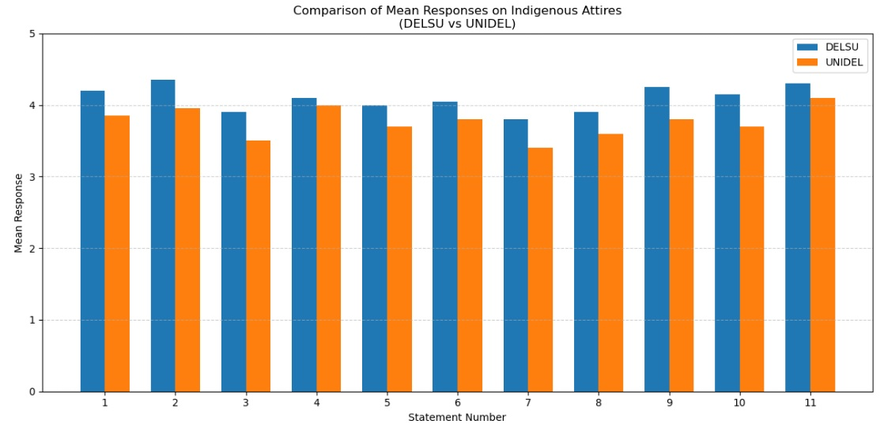
Fig 1- Comparison of the Attitudes of Home Economics Students toward Indigenous Attire in DELSU and UNIDEL
Table 2: The Mean, Standard Deviation, and t-test Analysis of the Factors Influencing Home Economics Students’ Attitudes toward Indigenous Attires in Delta State (n=75)
S/N | Statement | DELSU |  | UNIDEL |  | t-cal | t-val | Remark
S/N | Statement |  | SD |  | SD | t-cal | t-val | Remark
1 | Cultural pride influences my attitude toward wearing indigenous attires | 4.2 | 0.9 | 3.8 | 0.8 | 2.35 | 1.98 | Significant
2 | Indigenous attires make me feel proud of my cultural values | 4.5 | 0.7 | 4.0 | 0.9 | 3.21 | 1.98 | Significant
3 | Personal appreciation of culture influences my preference for indigenous attires over foreign clothing | 4.0 | 0.6 | 3.5 | 0.7 | 2.87 | 1.98 | Significant
4 | My family background influence my attitude toward indigenous attires | 4.1 | 0.8 | 3.9 | 0.7 | 2.25 | 1.98 | Significant
5 | Peer influence affects my attitude toward wearing indigenous attires | 3.7 | 0.9 | 3.3 | 0.6 | 1.92 | 1.98 | Not Significant
6 | The cost of indigenous attires influences my willingness to purchase and wear them | 3.5 | 1.0 | 4.1 | 0.9 | 2.14 | 1.98 | Significant
7 | Participation in cultural festivals influences my attitude toward indigenous attires | 4.0 | 0.7 | 3.6 | 0.7 | 3.00 | 1.98 | Significant
8 | Knowledge of my cultural heritage influences my clothing choices toward indigenous attires | 4.1 | 0.9 | 3.8 | 0.7 | 2.44 | 1.98 | Significant
= Mean SD = Standard Deviation

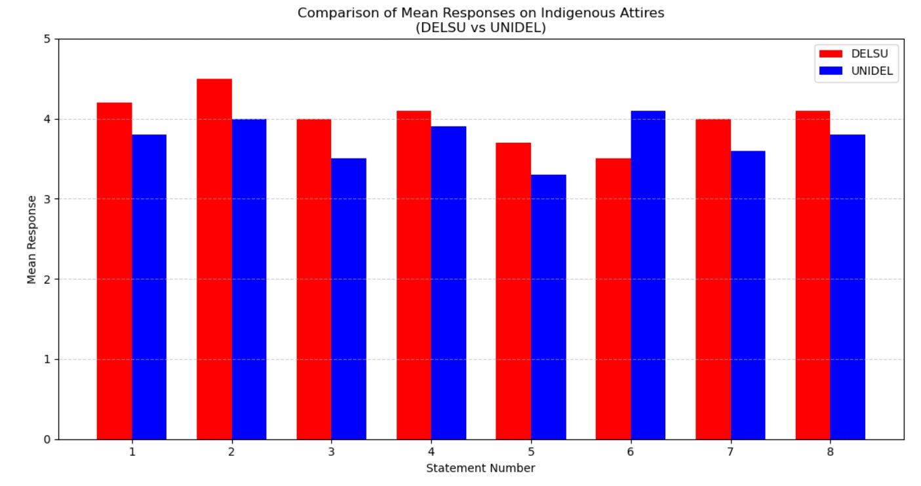
Fig 2-Comparison of Factors Influencing Home Economics Students’ Attitudes Toward Indigenous Attire in DELSU and UNIDEL

Table 3: The Mean, Standard Deviation, and t-test Analysis of the Influence of Students’ Cultural Exposure on their Attitudes toward Indigenous Attires (n=75)
S/N | Statement | DELSU |  | UNIDEL |  | t-cal | t-val | Remark
S/N | Statement |  | SD |  | SD | t-cal | t-val | Remark
1 | Exposure to indigenous attires during cultural activities makes me like wearing them | 4.1 | 0.78 | 3.5 | 0.89 | 3.20 | 1.98 | Significant
2 | Participation in cultural events makes me feel proud of my cultural identity through indigenous attires | 4.5 | 0.65 | 3.4 | 1.05 | 4.15 | 1.98 | Significant
3 | Cultural exposure makes me prefer indigenous attires to foreign clothing styles | 4.0 | 0.80 | 3.8 | 0.95 | 1.92 | 1.98 | Not Significant
4 | Participation in cultural activities makes indigenous attires appear suitable for different occasions | 4.2 | 0.69 | 3.9 | 1.03 | 2.11 | 1.98 | Significant
5 | Cultural background and upbringing influence my attitude toward indigenous attires | 3.8 | 0.72 | 3.4 | 0.88 | 1.58 | 1.98 | Not Significant
6 | Interaction with others during cultural activities increases my interest in indigenous attires | 4.0 | 0.75 | 3.5 | 0.83 | 3.24 | 1.98 | Significant
7 | Cultural exposure influences my willingness to spend on indigenous attires | 3.2 | 0.80 | 3.6 | 0.67 | 1.45 | 1.98 | Not Significant
8 | Exposure to cultural settings increases my awareness and use of indigenous fabrics | 3.9 | 0.70 | 3.4 | 0.90 | 2.15 | 1.98 | Significant
9 | Participation in cultural festivals and events encourages me to wear indigenous attires | 4.1 | 0.68 | 3.6 | 0.95 | 3.01 | 1.98 | Significant
10 | Engagement in cultural practices increases my interest in indigenous attires | 4.4 | 0.62 | 3.5 | 1.00 | 4.50 | 1.98 | Significant
11 | Knowledge of cultural heritage gained through cultural exposure influences my clothing choices | 4.3 | 0.74 | 3.6 | 0.92 | 3.45 | 1.98 | Significant
12 | Exposure to traditional ceremonies encourages me to wear indigenous attires | 4.2 | 0.81 | 3.8 | 0.83 | 2.60 | 1.98 | Significant
= Mean SD = Standard Deviation
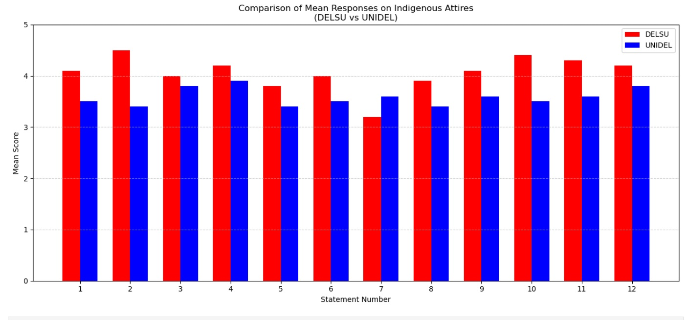
Fig 3- Comparison of the Influence of Students’ Cultural Exposure on Their Attitudes Toward Indigenous Attire in DELSU and UNIDEL
Table 4: The Mean, Standard Deviation, and t-test Analysis of Media Influence on Students’ Attitudes toward Indigenous Attires (n=75)
S/N | Statement | DELSU |  | UNIDEL |  | t-cal | t-val | Remark
S/N | Statement |  | SD |  | SD | t-cal | t-val | Remark
1 | Social media exposure encourages me to like wearing indigenous attires | 4.20 | 0.85 | 3.70 | 0.90 | 3.29 | 1.96 | Significant
2 | Seeing indigenous attires online makes me feel proud of my cultural identity. | 4.15 | 0.70 | 3.40 | 0.95 | 4.08 | 1.96 | Significant
3 | Media promotion makes indigenous attires more attractive than foreign clothing styles to me | 4.10 | 0.78 | 3.50 | 1.00 | 3.58 | 1.96 | Significant
4 | Social media influences my perception of indigenous attires | 4.25 | 0.67 | 3.80 | 0.85 | 3.26 | 1.96 | Significant
5 | Online cultural content with media representations shaped my attitude toward indigenous attires | 3.85 | 0.76 | 3.00 | 0.80 | 3.50 | 1.96 | Significant
6 | Fashion influencers on social media affect my interest in wearing indigenous attires | 3.90 | 0.68 | 3.30 | 0.90 | 2.94 | 1.96 | Significant
7 | Online platforms increase my awareness of available indigenous fabrics | 3.95 | 0.72 | 3.10 | 0.90 | 3.35 | 1.96 | Significant
8 | Modern designs of indigenous attires displayed on social media motivate me to wear them | 4.00 | 0.74 | 3.40 | 0.80 | 3.42 | 1.96 | Significant
= Mean SD = Standard Deviation

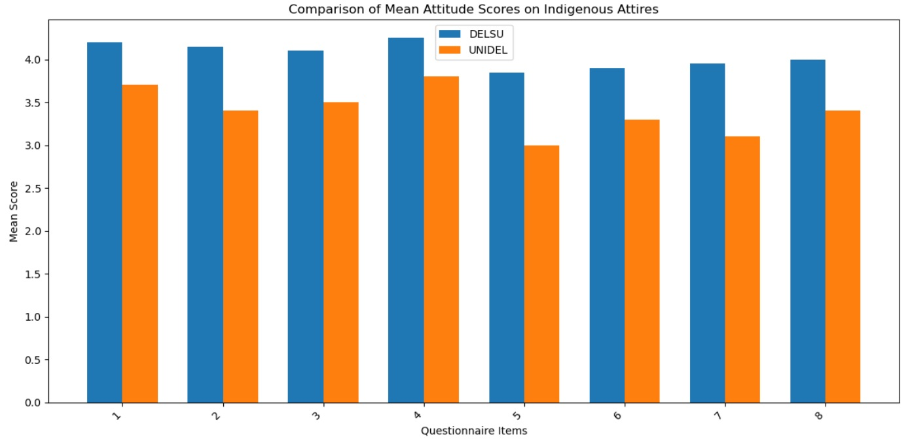

Fig 4- Comparison of the Media Influence on Students’ Attitudes toward Indigenous Attires in DELSU and UNIDEL

Discussion of Findings
This paper has explored the attitude of Home Economics students towards the indigenous attires in universities in Delta State, considering the general attitude, factors influencing the attitude, exposure to the cultures and effect of the media. The results offer essential information on the ways in which clothes preference is influenced by culture identity, social context as well as contemporary communication platforms among students. Table 1 shows that, on the general attitude towards Indigenous attires, the students of Home Economics have a positive attitude towards Indigenous attires in Delta State. Large means on such statements as I like wearing indigenous attires and Indigenous attires make me feel proud of my cultural identity indicated high affective and identity-based attachments to indigenous clothes especially among the Delta State University (DELSU) students as opposed to the University of Delta students (UNIDEL). The t-test values of the items are considerable, meaning that institutional differences have occurred, but that does not mean that the general attitude is not positive. This is in line with the cultural identity theory which assumes that clothing is a symbolic representation of belonging and heritage (Tajfel and Turner, 2004). There has been similar research in Nigeria, and other African setups where indigenous dressing has been proven to enhance cultural pride and self-expression among the youths (Arubayi, et al., 2024; Shi, 2023). Nonetheless, certain items related to attitudes, like the preference towards indigenous clothes over foreign ones and their appropriateness in every situation, were not significant. It implies that although students value indigenous clothes, situational and practical factors also influence their final clothing decisions. These observations reflect the results of previous studies that observe that the overlaps between globalisation and the influences of western fashion trends tend to co-exist but not entirely abolish the traditional modes of clothing (Okorie, 2025).
In Table 2 on the factors that shape the attitudes of Home Economics students to indigenous attires, it showed that various aspects have significant effects on students in their attitude, such as cultural pride, family background, cost, attending cultural festivals, and knowledge of the heritage. Family background turned out to be a great predictor, and it is important to note that socialisation plays an important role in passing cultural values. The social learning theory suggests that cultural attitudes and behaviour are quite frequently acquired in the family through reinforcement and observation (Bandura and Walters, 1977). Affordability and accessibility were also a major factor and this implies that economic factors influence the willingness of students to buy indigenous apparels. This is consistent with the study by Nwonye et al. (2024), who stated that the engagement of the youth with indigenous fashion is highly predicted by affordability and availability. The peer influence however, was not significant which implies that personal and family values may override the peer pressure in decision making in clothing among the students attending Home Economics.
Table 3 that showed the effect of cultural exposure on the students in terms of attitudes towards indigenous attire saw that there was a significant relationship between cultural exposure of students and their attitudes towards indigenous attires. Attendance of cultural festivals, exposure to traditional ceremonies, and knowledge of cultural heritage were all significantly associated with positive attitudes. Students who used cultural activities most were more prone to appreciating and wearing native clothes. This observation aligns with the experiential learning theory, which states that the closer the interaction the better the understanding and value attachment (Kolb, 2014; Iyeke and Ikeoji, 2019). It is also in line with other studies carried out by Nwankwo (2021) which concluded that cultural immersion enhances the adherence of youths to traditional practises such as dress culture.
On media persuasion of preference of indigenous attires of Table 4 pointed out that media persuasion especially social media has a significant effect on student preference of indigenous attires. The mean scores and t-values of items covering social media perception, modern designs, and availability of fabrics are high, meaning that online platforms are critical towards reforming the perception of indigenous wears. Exposure to social media seems to modernise the indigenous fashion, hence making it more attractive to the youths. This is in line with the diffusion of innovations theory which describes how new ideas and styles are transferred in communication channels with time (Rogers, 2003). The recent research attests to the fact that Instagram, Facebook, and fashion blogs have become a strong means of advertising African indigenous fashion among young people (Nwafor, 2025; Emeka, 2025).
Overall, the results show that students of Home Economics at Delta State have positive views about indigenous clothing, developed due to cultural pride, family influence, cultural exposure, and media representation. These attitudes are, however, moderated by economic and contextual factors. The findings indicate that policies and educational programmes that combine cultural education and the current fashion innovation are required to maintain the use of indigenous attire in schools.

Conclusion
This paper has shown that students in Home Economics in Delta State universities have quite positive attitudes towards indigenous attires and consider them as sources of cultural pride, identity and heritage. Nevertheless, such a favourable attitude does not necessarily lead to frequent usage, considering that price, availability, and suitability of particular clothes are the factors affecting what one wears. The results also indicated that family background, cultural knowledge and attendance in cultural activities have a great influence on attitude of students whereas peer influence has a little proportion. There was also a close correlation between the exposure to culture and the positive attitude towards indigenous attire, which shows that the involvement in the cultural festival and traditions promotes appreciation. Moreover, media influence, and especially social media, was also observed to play a significant role in influencing the preferences of the students through modernising and popularising native attires. The research thus determined that though the attitudes of the students were positive, there are economic and situational factors that could not favour a steady adoption, and it is important to provide educational and cultural measures that will aid in the continuous use of the indigenous clothes.

Recommendations
Based on the findings of the study, the following recommendations were proposed:
- Universities should strengthen cultural education and practical activities that encourage regular engagement with indigenous attires among Home Economics students.
- Government and school authorities should support initiatives that reduce the cost and improve the availability of indigenous fabrics for students.
- Cultural festivals, exhibitions, and fashion events should be regularly organized within institutions to increase students’ cultural exposure and appreciation of indigenous attires.
- Social media and digital platforms should be strategically used to promote indigenous attires through modern designs that appeal to students’ contemporary fashion preferences.

Final Academic Value Statement
This study provides empirical evidence that indigenous attire remains culturally valued among Home Economics students in Delta State but requires structured educational, cultural, and institutional support for sustained adoption. Integrating indigenous fashion into education, media, and youth culture offers a sustainable pathway for preserving cultural identity, promoting heritage continuity, and fostering culturally responsive fashion development in Nigeria.
Disclaimer (Artificial intelligence)
Author(s) hereby declare that NO generative AI technologies such as Large Language Models (ChatGPT, COPILOT, etc.) and text-to-image generators have been used during the writing or editing of this manuscript.

References
- Alade, M., & Olarewaju, A. (2024). Influence of social-media on the mode of dressing of female undergraduates in Nigerian universities. Sapientia Foundation Journal of Education, Sciences and Gender Studies, 5(4), 29-45. https://www.sfjesgs.com/index.php/SFJESGS/article/view/458
- Arubayi, D. O., Awowede, M. A., & Agadagba, J. E. (2024). Framework for Understanding Factors Influencing Clothing Selection. Journal of Social Science and Education Research Studies, 4(4), 303-307.
- Azonuche, J. E. (2024). Functional attributes of clothing preferences of students in universities in Nigeria: Implications for clothing and textiles education. BOHR International Journal of Social Science and Humanities Research, 3(1), 4–11.
- Bandura, A., & Walters, R. H. (1977). Social learning theory (Vol. 1, pp. 141-154). Englewood Cliffs, NJ: Prentice hall.https://www.asecib.ase.ro/mps/Bandura_SocialLearningTheory.pdf
- Emeka, E. C. (2025). Influence of Media Outlook and Advertising on Dietary Behaviours of Female Students. Teaching, Learning, and Development, 3(2), 198–205.
- Ikenyiri, C. J. (2025). Public Etiquette and Societal Sanity: Rethinking Youth Appearance and the Role of Early Childhood Education in Nigeria, 9(26),
- Iyeke, A. P. & Ikeoji, C. N. (2019). In-Service training needs of teachers in experiential learning to teach Animal Husbandry in secondary schools for sustainable development in Delta State. Journal of Agricultural Education Teachers Association of Nigeria, 3(1), 119-130. in-service-training-needs-of-teachers-in-experiential-learning-to-teach-animal-husbandry-in-secondary-schools-for-sustainable-development-in-delta-state-iyeke-aghogho-perculiar-canice-n-ikeoji-profe.pdf
- Kolb, D. A. (2014). Experiential learning: Experience as the source of learning and development. FT press.
- Nwafor, E. (2025). Harnessing Social Media for Indigenous Language Preservation: A Study on the Promotion and Revitalization of the Igbo Language. Ansu Journal of Language and Literary Studies, 5(1), 116-125. https://www.journals.ezenwaohaetorc.org/index.php/AJLLS/article/view/3166/3303
- Nwonye, N. U., Ibokette, M. U., & Esiowu, P. A. (2024). Socio-economic and Psychological Factors Affecting Clothing Consumption Among Female Undergraduates in University of Uyo, Nigeria. International Journal of Home Economics, Hospitality and Allied Research, 3(2), 104-127.
- Obi, P. N. (2025). Revitalizing cultural heritage: Integrating indigenous Nigerian knowledge and practices into the Home Economics curriculum. UNIZIK Journal of Educational Research, Science and Vocational Studies, 1(2), 89. https://unilaws.org/ujervs/article/view/89/89
- Okorie, O. U. (2025). Globalization and cultural differences in Nigeria’s Delta region. BW Academic Journal, 2, 143–150.
- Olugbenga, B. C., Adedeji, D., & Ridwan, M. (2025). The role of Nigeria traditional costumes in cultural heritage preservation: A holistic study. Lakhomi Journal Scientific Journal of Culture, 6(2), 126–140.
- Rogers, E. (2003). Diffusion of innovations (5th ed.). Free Press.
- Shi, T. (2023). Local fashion, global imagination: Agency, identity, and aspiration in the diasporic Hmong community. Journal of Material Culture, 28(2), 175-198.
- Tajfel, H., & Turner, J. C. (2004). The social identity theory of intergroup behavior. In Political psychology (pp. 276-293). Psychology Press.

