Original Research Article

Genetic Variability and Divergence for Yield and yield contributing traits in black gram [Vigna mungo (L.) Hepper] Genotypes

ABSTRACT
Background/Aim : The genetic study was carried out during the summer season of 2025 to evaluate variability and divergence present among sixteen black gram (Vigna mungo L. Hepper) genotypes for yield attributes.
methode: The experiment was laid out in a Randomized Block Design (RBD) with three replications and data were recorded on ten yield attributes.
result: Significant differences were observed among the genotypes, indicating broad genetic variability. High heritability coupled with high genetic advance was recorded for number of branches per plant, number of clusters per plant, number of pods per cluster, number of pods per plant and number of seeds per pod suggesting the predominance of additive gene action. The genetic divergence has analyzed using Mahalanobis’ D² and genotypes were grouped into seven distinct clusters, with a maximum inter-cluster distance observed between Clusters II and VI, implying scope for the exploitation of heterosis. Cluster mean analysis revealed trait-specific superiority, with T 912 excelling in number of pods per plant, pod length, seed weight and single plant yield, while ADT 3 and VBN 8 and VBN 5 were also promising. Contribution towards genetic divergence identified that number of seeds per pod and single plant yield as the major contributors.
Conclusion: On overview the study reveals that there is a presence of considerable genetic variability and divergence among black gram genotypes particularly the genotypes viz., T 912, ADT 3, VBN 8 and VBN 5 could produce superior genotypes, while focusing on yield attributes such as number of seeds per pod, pod length and single plant yield would enhance breeding efficiency.
Keywords: Black gram, divergence, cluster, variability, yield attributes.
- INTRODUCTION
Black gram (Vigna mungo L. Hepper), commonly known as Urd bean, is a significant grain legume that was domesticated from its wild progenitor, Vigna mungo var. silvestris (Lukoki et al., 1980; Jayashree et al., 2019). India holds the distinction of being the world's largest producer as well as consumer of black gram (Sushmitharaj et al., 2018). According to the 2nd advance estimates for 2023-24 black gram production in India is estimated at 2.05 million tonnes from an area of around 4 million hectares, with an average productivity of approximately 598 kg/ha. This marks a slight decrease from the 2.63 million tonnes recorded in 2022-23 (Prasanna et al., 2024). Black gram is a day-neutral, warm-season crop adaptable to semi-arid to lowland and subtropical regions (Jamil et al., 2022). Understanding the genetic potential of crop genotypes is essential for crop improvement and this potential can be effectively measured through variability parameters. (Sathya et al.,2021). Genetic diversity, defined as the variation in genes and traits both within and between plant species, is an indispensable for successful plant breeding. It represents the raw material from which breeders can develop new and improved cultivars possessing desirable characteristics, such as higher yields, enhanced disease resistance and improved tolerance to various environmental stresses. D² analysis, a powerful multivariate statistical technique, classifies genotypes into relatively homogeneous groups.
The objective of this classification is to minimize intra-cluster diversity while maximizing
inter-cluster diversity (Kumar et al.,2014). Cluster analysis, based on D² values, serves as a measure of generalized distance between closely associated genotypes (Rao, 1952). The presence of broad genetic diversity creates a favourable environment for the potential screening of genotypes based on their cluster mean performance, which, in turn, provides precious selection of parental lines for hybridization programs. Keeping these crucial points in consideration, the present investigation is precisely carried out to evaluate the mean performance, genetic variability and genetic divergence of the black gram genotypes.
- MATERIAL AND METHODS
The experiment was conducted at Nalanda College of Agriculture, Tiruchirappalli during the Zaid season of 2025 to assess genetic variability and divergence among sixteen black gram genotypes for yield attributes. The trial was laid out in a Randomized Block Design (RBD) with three replications, each genotype sown in two rows of 2 meter with a spacing of 45 × 10 cm. Two seeds per hill were dibbled, thinned to one plant before 15 days after sowing. Standard irrigation practices were followed, including life-saving irrigation on the third day after sowing and subsequent need-based flooding. Observations on ten yield attributes viz., days to 50 percent flowering, plant height, number of branches per plant, number of clusters per plant, number of pods per cluster, number of pods per plant, pod length, number of seeds per pod, seed test weight and single plant yield were recorded from five randomly selected plants in each replication. Observed data were analyzed using standard statistical methods suggested by Panse and Sukhatme, 1967; Snedecor, 1946; Lush, 1940; Burton, 1952; Sivasubramanian and Menon, 1973; Johnson et al., 1955. Genetic divergence was estimated through Mahalanobis’ D² analysis (1936) and genotypes were ranked by the method suggested by Singh and Chaudhary (1977).
- RESULTS AND DISCUSSION
Sixteen black gram genotypes showed a significant variation for all ten yield attributes (Table 1), indicating abundant genetic variability. Days to 50 percent flowering ranged from 31.33 days (ADT 5) to 42.67 days (VBN 3), while plant height varied between 37.33 cm (ADT 3) and 48.66 cm (VBN 12). Yield attributes such as number of branches per plant, number of clusters per plant, number of pods per plant, pod length, number of seeds per pod and seed test weight also showed broad variation. The highest single plant yield was recorded in ADT 5 (6.45 g), followed by VBN 8, VBN 12, ADT 3, VBN 5 and T 912. A comparative ranking of genotypes based on score values and relative yield is presented in Table 2. The score chart further facilitated the identification of superior genotypes by integrating multiple yield attributes and relative yield values.

Table 1: Mean performance of yield attributes
S. No. | Genotypes | DFF | PHT (cm) | NBP | NCP | NPC | NPP | PL (cm) | NSP | STW (g) | SPY(g)
 | ADT - 5 | 31.33 | 43.73 | 10.66* | 10.00* | 6.00 | 19.33* | 6.00 | 7.00* | 4.80 | 6.45*
 | ADT - 6 | 38.00 | 44.33 | 8.00 | 6.33 | 6.33 | 17.00* | 4.80 | 6.00 | 4.20 | 4.29
 | KKM 1 | 39.33* | 47.16* | 8.00 | 5.33 | 4.00 | 11.66 | 4.46 | 3.33 | 4.33 | 4.65
 | VBN - 6 | 35.66 | 45.00 | 6.00 | 9.66* | 6.00 | 13.33 | 6.33* | 4.00 | 5.00* | 4.68
 | VBN - 8 | 37.00 | 46.50* | 10.33* | 10.66* | 8.00* | 12.66 | 5.50 | 4.00 | 4.80 | 5.98*
 | VBN -10 | 33.33 | 46.00 | 7.66 | 6.33 | 4.00 | 16.00 | 5.70 | 5.33 | 3.83 | 4.95
 | VBN -11 | 38.33* | 47.50* | 10.66* | 7.33 | 6.00 | 17.00* | 5.53 | 6.66* | 4.83 | 5.41
 | VBN -12 | 36.00 | 48.66* | 11.33* | 10.00* | 7.33* | 17.33* | 6.53* | 7.33* | 5.56* | 6.37*
 | ADT-3 | 35.67 | 37.33 | 10.67* | 10.00* | 6.00 | 8.00 | 6.00* | 7.00* | 4.80 | 6.09*
 | CO7 | 38.00 | 43.00 | 8.00 | 6.33 | 6.33 | 12.66 | 4.80 | 6.00 | 4.20 | 4.96
 | VBN-2 | 36.00 | 46.67* | 9.00 | 5.33 | 3.33 | 10.33 | 4.47 | 3.33 | 4.43 | 4.99
 | VBN-3 | 42.67* | 45.00 | 5.00 | 9.67* | 3.67 | 9.33 | 6.33* | 4.00 | 4.63 | 4.69
 | VBN-5 | 37.33 | 46.50* | 6.67 | 10.67* | 11.33* | 18.67* | 5.57 | 4.00 | 4.80 | 5.98*
 | VBN-9 | 38.00 | 46.00 | 6.67 | 6.33 | 4.00 | 18.00* | 5.70 | 7.00* | 3.83 | 5.29
 | KM-2 | 40.00* | 47.50* | 7.00 | 8.33 | 6.33 | 17.00* | 5.53 | 6.67* | 4.73 | 5.36
 | T-912 | 36.00 | 37.83 | 8.00 | 11.33* | 9.00* | 20.00* | 6.53* | 7.00* | 5.57* | 6.37*
Grand mean |  | 37.05 | 44.93 | 8.35 | 8.35 | 6.10 | 14.90 | 5.62 | 5.55 | 4.65 | 5.41
SE |  | 1.28 | 1.34 | 0.74 | 0.89 | 0.94 | 1.45 | 0.29 | 0.62 | 0.22 | 0.27
CD at 5 percent |  | 3.72 | 3.87 | 2.12 | 2.54 | 2.70 | 4.16 | 0.83 | 1.80 | 0.62 | 0.78
*Significant at 5 % and the bold values indicate maximum and minimum values.

Table 2: Score chart for mean performance of genotypes for yield attributes
Genotype | DFF | PHT (cm) | NBP | NCP | NPC | NPP | PL (cm) | NSP | STW (g) | SPY (g) | Total score |  | RY (percent)
ADT - 5 | 0 | 0 | 1 | 1 | 0 | 1 | 0 | 1 | 0 | 1 | 5 | 100.00
ADT - 6 | 0 | 0 | 0 | 0 | 0 | 1 | 0 | 0 | 0 | 0 | 1 | 66.51
KKM 1 | 1 | 1 | 0 | 0 | 0 | 0 | 0 | 0 | 0 | 0 | 2 | 72.09
VBN - 6 | 0 | 0 | 0 | 1 | 0 | 0 | 1 | 0 | 1 | 0 | 3 | 72.56
VBN - 8 | 0 | 1 | 1 | 1 | 1 | 0 | 0 | 0 | 0 | 1 | 5 | 92.71
VBN -10 | 0 | 0 | 0 | 0 | 0 | 0 | 0 | 0 | 0 | 0 | 0 | 76.74
VBN -11 | 1 | 1 | 1 | 0 | 0 | 1 | 0 | 1 | 0 | 0 | 5 | 83.88
VBN -12 | 0 | 1 | 1 | 1 | 1 | 1 | 1 | 1 | 1 | 1 | 9 | 98.76
ADT-3 | 0 | 0 | 1 | 1 | 0 | 0 | 1 | 1 | 0 | 1 | 5 | 94.42
CO7 | 0 | 0 | 0 | 0 | 0 | 0 | 0 | 0 | 0 | 0 | 0 | 76.90
VBN-2 | 0 | 1 | 0 | 0 | 0 | 0 | 0 | 0 | 0 | 0 | 1 | 77.36
VBN-3 | 1 | 0 | 0 | 1 | 0 | 0 | 1 | 0 | 0 | 0 | 3 | 72.71
VBN-5 | 0 | 1 | 0 | 1 | 1 | 1 | 0 | 0 | 0 | 1 | 5 | 92.71
VBN-9 | 0 | 0 | 0 | 0 | 0 | 1 | 0 | 1 | 0 | 0 | 2 | 82.02
KM-2 | 1 | 1 | 0 | 0 | 0 | 1 | 0 | 1 | 0 | 0 | 4 | 83.10
T-912 | 0 | 0 | 0 | 1 | 1 | 1 | 1 | 1 | 1 | 1 | 7 | 98.76
DFF - Days to 50% flowering, PHT - Plant height(cm), NBP - No. of branches/plant, NCP - No. of clusters per plant NPC - No. of pods per cluster, NPP - No. of pods per plant, PL - Pod length (cm), NSP - No. of seeds per pod, STW - Seed Test weight(g), and SPY-Single Plant yield(g).
Estimates of variability (Table 3; Figure 1) revealed higher PCV than GCV for all traits, highlighting there is an influence of environmental factors. The estimate on High heritability coupled with high genetic advance was observed for number of branches per plant, number of clusters per plant, number of pods per cluster, number of pods per plant and number of seeds per pod, suggesting prevalence of additive gene action and the selection of these traits will be effective.

Table 3: Genetic Variability parameters for yield attributes
Character | DFF | PHT (cm) | NBP | NCP | NPC | NPP | PL (cm) | NSP | STW (g) | SPY(g)
Range | 31.33-42.67 | 37.33-47.50 | 5.00-11.33 | 5.33-11.33 | 3.33-11.33 | 8.00-20.00 | 4.46-6.53 | 3.33-7.33 | 3.83-5.57 | 4.29 - 6.45
Mean | 37.05 | 44.93 | 8.35 | 8.35 | 6.10 | 14.90 | 5.62 | 5.55 | 4.65 | 5.41
Phenotypic variance (PV) | 10.22 | 13.99 | 4.73 | 6.01 | 6.27 | 18.30 | 0.63 | 3.04 | 0.35 | 0.65
Genotypic variance (GV) | 5.24 | 8.60 | 3.09 | 3.67 | 3.66 | 12.07 | 0.39 | 1.88 | 0.21 | 0.43
Phenotypic coefficient of variation  (PCV) in percent | 8.63 | 8.33 | 26.01 | 29.34 | 41.04 | 28.71 | 14.18 | 31.45 | 12.71 | 14.91
Genotypic coefficient of variation  (GCV) in percent | 6.18 | 6.53 | 21.06 | 22.95 | 31.32 | 23.32 | 11.06 | 24.74 | 9.80 | 12.10
Heritability in broad sense  (h²) in percent | 51.31 | 61.48 | 65.55 | 61.16 | 58.24 | 65.97 | 60.88 | 61.90 | 59.56 | 65.93
Genetic advance (GA) | 3.38 | 4.74 | 2.93 | 3.09 | 3.00 | 5.81 | 1.00 | 2.22 | 0.72 | 1.09
GA as percent of Mean | 9.12 | 10.55 | 35.12 | 36.96 | 49.24 | 39.02 | 17.79 | 40.09 | 15.59 | 20.24
DFF - Days to 50% flowering, PHT - Plant height(cm), NBP - No. of branches/plant, NCP - No. of clusters per plant NPC - No. of pods per cluster, NPP - No. of pods per plant, PL - Pod length (cm), NSP - No. of seeds per pod, STW - Seed Test weight(g), and SPY-Single Plant yield(g).
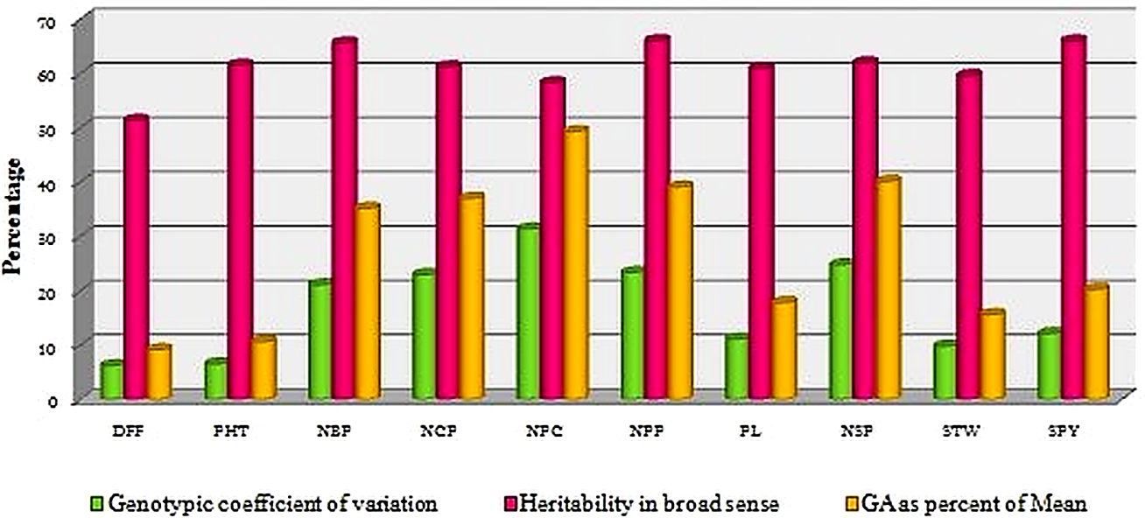
Figure 1: Genotypic Coefficient of Variation % (GCV) , Heritability in broad sense % (H²), and Genetic Advance as percent of Mean % (GAM).
DFF - Days to 50% flowering, PHT - Plant height(cm), NBP - No. of branches/plant, NCP - No. of clusters per plant NPC - No. of pods per cluster, NPP - No. of pods per plant, PL - Pod length (cm), NSP - No. of seeds per pod, STW - Seed Test weight(g), and SPY-Single Plant yield(g).
The genotypes were grouped based on Mahalanobis’ D² analysis into seven distinct clusters (Table 4; Figure 2 and Figure 3), confirming presence of broad genetic divergence. Cluster III was the largest (4 genotypes), while Clusters VI (ADT 3) and VII (T 912) were solitary, indicating their distinct genetic identity. Maximum inter-cluster distance was observed between Clusters II and VI, suggesting potential heterotic combinations (Table 5).
Table 4: Clustering pattern of Sixteen genotypes
Cluster number | Total number of genotypes | Genotypes | Source
1 | 3 | KKM 1 | Tamil Nadu Agricultural University, Coimbatore
1 | 3 | VBN-2 | National Pulse Research Centre, Vamban
1 | 3 | CO7 | Tamil Nadu Agricultural University, Coimbatore
2 | 3 | VBN -10 | National Pulse Research Centre, Vamban
2 | 3 | VBN-9 | National Pulse Research Centre, Vamban
2 | 3 | ADT - 6 | Tamil Nadu Rice Research Station, Aduthurai
3 | 4 | VBN -11 | National Pulse Research Centre, Vamban
3 | 4 | KM-2 | STAMIN, Kudumiyanmalai
3 | 4 | VBN -12 | National Pulse Research Centre, Vamban
3 | 4 | ADT - 5 | Tamil Nadu Rice Research Station, Aduthurai
4 | 2 | VBN - 6 | National Pulse Research Centre, Vamban
4 | 2 | VBN-3 | National Pulse Research Centre, Vamban
5 | 2 | VBN - 8 | National Pulse Research Centre, Vamban
5 | 2 | VBN-5 | National Pulse Research Centre, Vamban
6 | 1 | ADT-3 | Tamil Nadu Rice Research Station, Aduthurai
7 | 1 | T-912 | STAMIN, Kudumiyanmalai
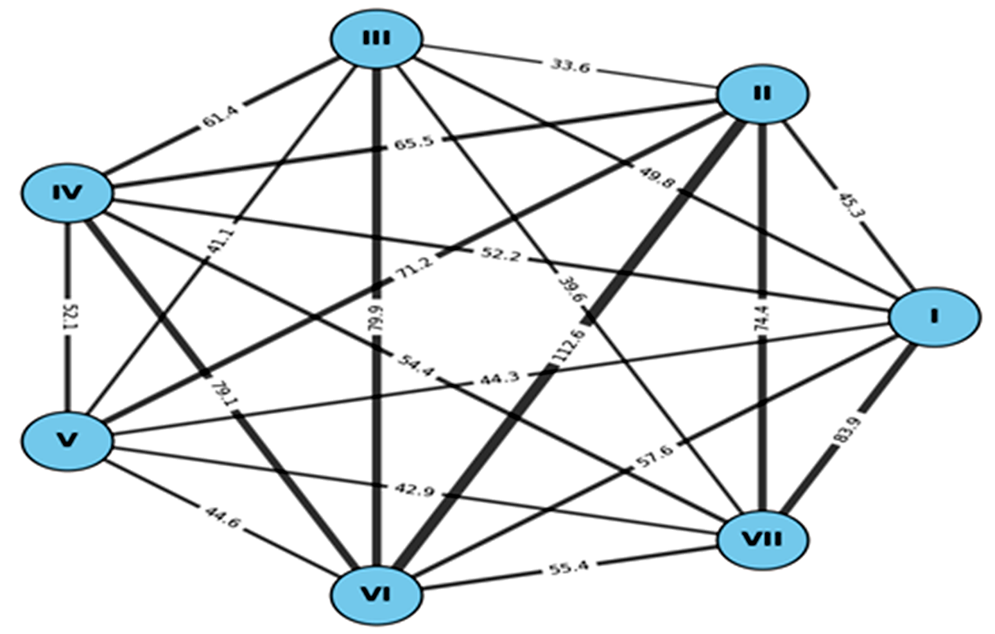
Figure 2: Network diagram depicting inter-cluster genetic divergence among seven clusters based on Mahalanobis D² statistics.
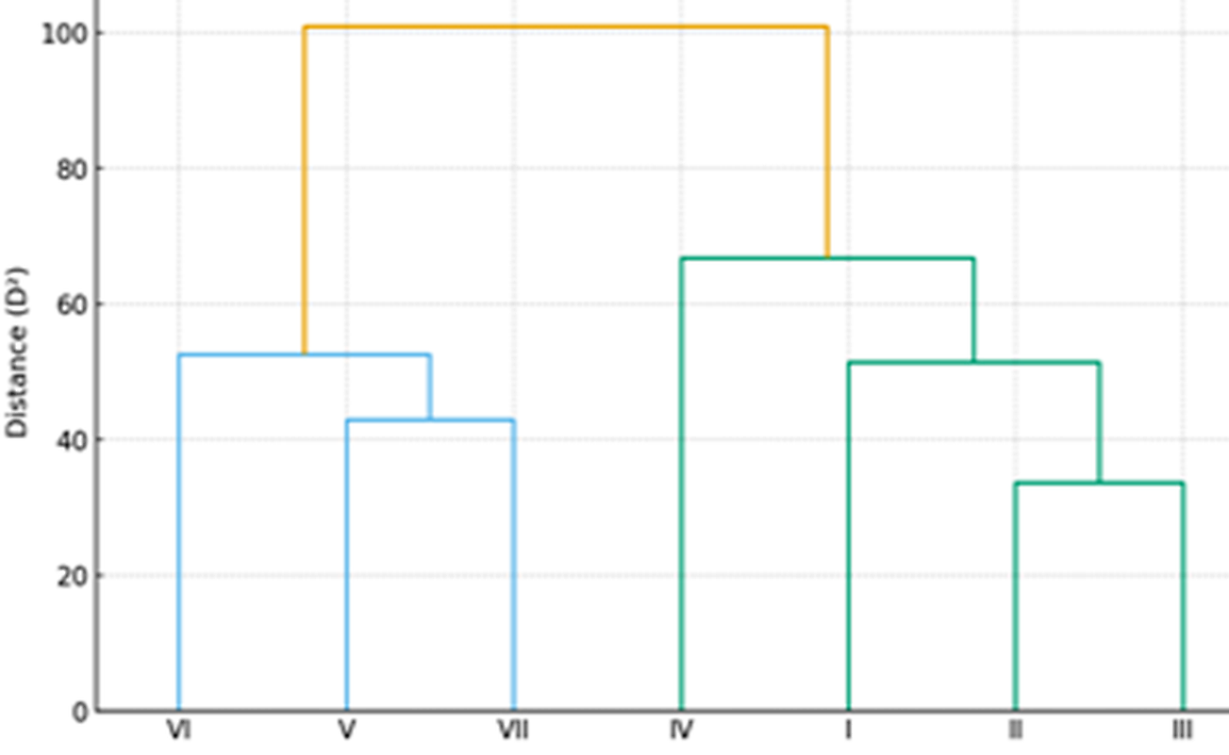
Figure 3: Dendrogram illustrating genetic divergence among seven clusters based on Mahalanobis D² statistics.
Table 5: Average intra and inter cluster D² and D values
Clusters | I | II | III | IV | V | VI | VII
I | 15.856  (3.981) | 45.263  (6.727) | 49.821  (7.058) | 52.237  (7.227) | 44.295  (6.655) | 57.580  (7.588) | 83.889  (9.159)
II |  | 17.006  (4.123) | 33.618  (5.798) | 65.483  (8.092) | 71.232  (8.439) | 112.586  (10.610) | 74.357  (8.623)
III |  |  | 19.322  (4.395) | 61.431  (7.837) | 41.055  (6.407) | 79.885  (8.937) | 39.565  (6.290)
IV |  |  |  | 18.690  (4.323) | 52.106  (7.218) | 79.082  (8.892) | 54.411  (7.376)
V |  |  |  |  | 23.300  (4.827) | 44.592  (6.677) | 42.933  (6.552)
VI |  |  |  |  |  | 0 | 55.380  (7.441)
VII |  |  |  |  |  |  | 0
Values in parenthesis are the D values and bold values indicate intra cluster distances
Cluster mean analysis (Table 6) indicated trait-specific superiority. Cluster VI was shows an earlier days to 50 percent flowering and had the highest number of branches per plant, Cluster V excelled in number of clusters per plant and number of pods per cluster, while Cluster VII (T 912) recorded maximum number of pods per plant, pod length, seed test weight and single plant yield.
Table 6: Cluster mean values for ten yield attributes
Cluster  Character | I | II | III | IV | V | VI | VII
Days to 50 % flowering (DFF) | 37.778 | 36.444 | 36.417 | 39.167 | 37.167 | 35.667 | 36.000
Plant height (PHT) | 45.611 | 45.444 | 46.850 | 45.000 | 46.500 | 37.333 | 37.833
Number of branches per plant (NBP) | 8.333 | 7.445 | 9.917 | 5.500 | 8.500 | 10.667 | 8.000
Number of clusters per plant (NCP) | 5.666 | 6.333 | 8.917 | 9.667 | 10.667 | 10.000 | 11.333
Number of pods per cluster(NPC) | 4.555 | 4.778 | 6.417 | 4.834 | 9.667 | 6.000 | 9.000
Number of pods per plant (NPP) | 11.556 | 17.000 | 17.667 | 11.333 | 15.667 | 8.000 | 20.000
Pod length (PL) | 4.578 | 5.400 | 5.900 | 6.333 | 5.534 | 6.000 | 6.533
Number of seeds per pod(NSP) | 4.222 | 6.111 | 6.917 | 4.000 | 4.000 | 7.000 | 7.000
Seed Test weight (STW) | 4.322 | 3.955 | 4.983 | 4.817 | 4.800 | 4.800 | 5.567
Single Plant yield(SPY) | 4.867 | 4.843 | 5.899 | 4.687 | 5.983 | 6.087 | 6.370
Underlined bold figures indicate maximum cluster mean values and only bold figures indicate minimum cluster mean values.
Contribution towards genetic divergence (Table 7; Figure 3) showed number of seeds per pod (25 percent) and single plant yield (20 percent) as major contributors to divergence, followed by pod length and number of pods per plant. Similar results were reported in earlier studies (Meena et al., 2020; Bhanuprasad et al., 2022; Pavithra et al., 2024).Overall, the results highlight the presence of substantial variability and divergence among the genotypes. Genotypes from divergent clusters, particularly Cluster VII (T 912), Cluster VI (ADT 3) and Cluster V (VBN 8, VBN 5), are promising parents for hybridization to generate superior genotypes. Emphasis on number of seeds per pod, pod length and single plant yield would improve breeding efficiency for yield improvement in black gram.
Table 7: Contribution of yield related characters towards genetic divergence
S. No | Character | Number of times ranked first | Contribution (percentage)
 | Days to 50 % flowering (DFF) | 6 | 5.00
 | Plant height (PHT) | 7 | 5.84
 | Number of branches per plant (NBP) | 10 | 8.33
 | Number of clusters per plant (NCP) | 6 | 5.00
 | Number of pods per cluster(NPC) | 4 | 3.33
 | Number of pods per plant (NPP) | 10 | 8.33
 | Pod length (PL) | 17 | 14.17
 | Number of seeds per pod(NSP) | 30 | 25.00
 | Seed Test weight (STW) | 6 | 5.00
 | Single Plant yield(SPY) | 24 | 20.00
Total |  | 120 | 100
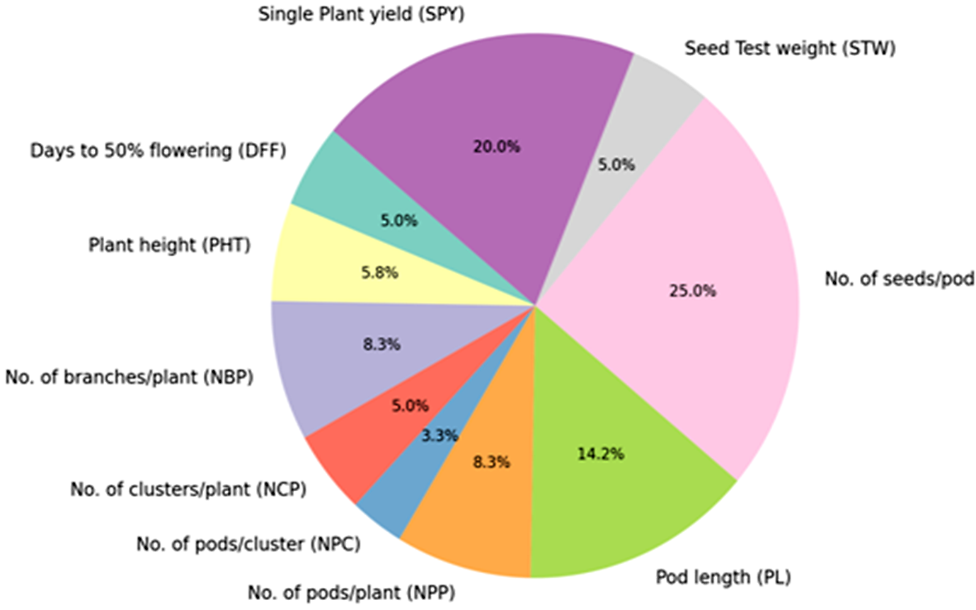
Figure 4: Percentage contribution of different traits towards genetic divergence based on Mahalanobis D² analysis.
- Conclusion
The present investigation demonstrated considerable genetic variability and divergence among the sixteen black gram genotypes evaluated for yield and its associated traits. Substantial variation in mean performance across genotypes indicated the availability of exploitable genetic variability for yield improvement. Higher phenotypic coefficient of variation compared with genotypic coefficient of variation for all traits suggested the influence of environmental factors on trait expression. However, moderate to high heritability coupled with high genetic advance was observed for number of branches per plant, number of clusters per plant, number of pods per cluster, number of pods per plant and number of seeds per pod, indicating the predominance of additive gene action and the potential effectiveness of direct phenotypic selection for these traits.
Multivariate analysis based on Mahalanobis D² statistics revealed the presence of substantial genetic divergence among the genotypes, grouping them into seven distinct clusters. The occurrence of solitary clusters (VI and VII) highlighted the presence of genetically unique genotypes, while the maximum inter-cluster distance observed between clusters II and VI indicated the possibility of obtaining superior recombinants through hybridization between these genetically divergent groups. Cluster mean analysis further revealed that Cluster VII (T-912) possessed superior values for key yield attributes such as number of pods per plant, pod length, seed test weight and single plant yield, whereas Cluster VI (ADT-3) exhibited early flowering and higher branching ability.
Trait contribution analysis indicated that number of seeds per pod, single plant yield and pod length were the major contributors to total genetic divergence, emphasizing their importance in determining yield variability among genotypes. The integration of variability parameters, cluster analysis and trait contribution clearly identified Cluster VII (T-912), Cluster VI (ADT-3) and Cluster V (VBN-8 and VBN-5) as promising parental lines for future breeding programmes. Hybridization among these genetically divergent genotypes, followed by selection for key yield attributes, particularly number of seeds per pod, pod length and single plant yield, could facilitate the development of high-yielding black gram cultivars. Overall, the findings provide valuable insights into the genetic architecture of yield-related traits and offer a strong foundation for designing effective breeding strategies aimed at enhancing productivity in black gram.
REFERENCES
Bhanuprasad, P., Lavanya, G.R., Reddy, B.M. and Ramesh, B. (2022). Genetic Parameters and Diversity Analysis in Black gram (Vigna mungo L. Hepper) for Seed Yield Characters. International Journal of Plant and Soil Science, 4(24), 340-347. https://doi.org/10.9734/ijpss/2022/v34i242648
Burton, G. W. (1952). Quantitative inheritance in grasses. Proceedings of 6th International Grassland Congress, 1: 277-283.
Jamil, S., Ilyas, M., Khan, M. Z., Awan, S. I., Rehman, S., Shafique. S., Hafeez, S.,
Riaz, M., Ahmad, H. M., Tamkeen, A., Ghaffar, M. A., and Khan, M. M. (2022). Heritability, genetic gain and path coefficient analyses in black gram at Poonch Rawalakot, Azad Jammu and Kashmir. SABRAO Journal of Breeding and Genetics, 54(3), 537–548. https://doi.org/10.54910/sabrao2022.54.3.7
Jayashree, V., Muthuswamy, A., Jayamani, P., and Kumar, K. K. (2019). Genetic divergence studies in Black gram (Vigna mungo (L.) Hepper). Electronic Journal of Plant Breeding, 10(2), 742–747. https://doi.org/10.5958/0975-928x.2019.00097.8
Jeeva, G., and Saravanan, K. (2017). Genetic divergence of Green gram (Vigna radiata (L.) Wilckzek) grown in coastal saline lowland of Tamil Nadu, India. Plant Archives, 17(2), 1617-1620.
Johnson, H.W., Robinson, H. F., and Comstock, R. E. (1955). Estimation of genetic and environmental variability in soyabean. Agronomy Journal, 47, 314-318. https://doi.org/10.2134/agronj1955.00021962004700070009x
Joshi, D.P., Parmar, L.D., Meena, R.K. and Chaudhary, G.K. (2022). Estimation of genetic diversity in mungbean (Vigna radiata (L.) Wilczek) genotypes grown in Gujarat. Legume Research -An International Journal, 45(7), 828-833. https://doi.org/10.18805/lr-4836
Katiyar, P. K., Dixit, G. P., Singh, B. B., Ali, H., and Dubey, M. K. (2009). Non-hierarchical Euclidean cluster analysis for genetic divergence in mung bean cultivars. Journal of Food Legumes, 22, 34-36.
Kumar, A., Sharma, N. K., Kumar, R., Chandel, D., and Yadav, M. K. (2022). Genetic divergence studies in mungbean germplasm under arid environment. The Pharma Innovation Journal, 11(2), 2415-241.
Kumar, M., and Singh, P. S. (2014). Screening of Black gram genotypes against major insect pests. Indian Journal of Entomology,76(1), 84-86.
Lukoki L, Marechal R. and Otoul E. 1980. The wild ancestors of the cultivated beans Vigna radiata (L.) Wilezek and V. mungo (L.) Hepper. Bulletin du Jardin Botanique National de Belgique, 50(3/4), 385-391. https://doi.org/10.2307/3667837
Lush, J.L. 1940. Intra-sire correlation and regression of offspring on rams as a method of estimating heritability of characters. Proceedings of American Society of Animal Production., 33, 293-301. https://doi.org/10.2527/jas1940.19401293x
Mahalanobis, P.C. 1936. On the generalised distance in statistics. Proceedings of National Institute of Sciences. India, 2, 49-55.
Mahalingam, A., Manivannan, N., Ragul, S. and Narayanan, L. (2018). Genetic divergence among Green gram (Vigna radiata (L.) Wilczek) germplasm collections. Electronic Journal of Plant Breeding, 9(1), 350-354. https://doi.org/10.5958/0975-928x.2018.00045.5
Meena, P. L., Yadav, R. S., and Singh, R. K. (2020). Genetic variability and correlation studies for yield and yield-contributing traits in black gram. Journal of Pharmacognosy and Phytochemistry, 9(3), 1578–1582.
Mehandi, S., Singh, I.P., Bohra, A. and Singh, C.M. (2015). Multivariate analysis in green gram (Vigna radiata (L.) Wilczek). Legume Research, 38(6), 758-762. https://doi.org/10.18805/lr.v38i6.6720
Mohan, S., Sheeba, A., Murugan, E., Ibrahim, S. M. (2021). Screening of Mungbean Germplasm for Resistance to Mungbean Yellow Mosaic Virus under Natural Condition. Indian Journal of Science and Technology, 7(7), 891–896. https://doi.org/10.17485/ijst/2014/v7i7.1
Panse, V.G. and Sukhatme, P.V. (1967). Statistical method for agricultural workers. ICAR. New Delhi.
Pavithra N, Jayalalitha K, Jyothi, N. L., Sujatha, T., Harisatyanarayana, N., and Roja V. (2024). Genetic diversity analysis for physiological, reproductive, biochemical and yield traits of Black gram (Vigna mungo L.) genotypes under high temperature stress. Electronic Journal of Plant Breeding, 15(1), 155–163. https://doi.org/10.37992/2024.1501.025
Prasanna, M. H, Manivannan, N., Kumaresan, D., Saminathan, V. R., and
Senthilraja, G. (2024). Variability, association and cluster analysis of backcross derived lines in black gram (Vigna mungo (L.) Hepper). Plant Science Today, 11(4), 01-06. https://doi.org/10.14719/pst.5345
Priya, L, Pillai, A. M., Shoba, D., Merina, P. K. S., and Aananthi, N. (2018). Genetic variability and correlation studies in black gram (Vigna mungo (L.) Hepper). Electronic Journal of Plant Breeding, 9(4), 1583–1587. https://doi.org/10.5958/0975-928x.2018.00197.7
Rao, C. R. (1952). Advanced statistical methods in biometrical research. John Wiley and Sons, Incorporated, New York.
Reddy, S. K., Rao, K. S., and Reddy, Y. T. N. (2018). Genetic variability and heritability for yield and its components in black gram [Vigna mungo (L.) Hepper]. Legume Research, 41(5), 743–748.
Sathya, P., Manivannan, N., Viswanathan, P. L., Ganapathy, N., and Karthikeyan, G. (2021). Genetic variability, association and path coefficient analyses in segregating populations of black gram (Vigna mungo (L.) Hepper). Madras Agricultural Journal, 108(1-3), 1–7.
Sheena, T. and Hemalatha, G. (2021). Genetic variability studies in blackgram (Vigna mungo (L.) Hepper). Electronic Journal of Plant Breeding, 10(7), 757-762.
Singh, A., Sharma, A., and Kumar, V. (2021). Assessment of genetic variability, heritability and genetic advance for yield attributes in black gram. Legume Research, 44(6), 1012–1018.
Singh, R.K. and Chaudhary, B.D. (1977). Biometrical methods in quantitative genetic analysis. Kalyani Publishers, New Delhi.
Sivasubramanian, S. and Menon, P.M. (1973). Genotypic and phenotypic variability in rice. Madras Agriculture Journal, 60 (9-12), 1093 – 1096.
Snedcor, G.W. (1946). Statistical methods. The Iowa state university press, Ames, Lowa, U.S.A.
Sushmitharaj, D. V., Shoba, D., and Pillai M. A. (2018). Genetic variability and correlation studies in black gram (Vigna mungo [L.] Hepper) with reference to YMV resistance. International Journal of Current Microbiology and Applied Sciences, Special Issue 6, 2849–2856.

