Diversity and Phytochemical screening of Invasive Plant Species in Bhubaneswar Municipality,Odisha

Abstract
Invasive plant species reduce the physiological ability of normal native plants by growing as invasive on them and as result become threat for the native phyto-diversity. The current study on Invasive plant species demonstrate the diversity and biochemical analysis conducted by utilizing data collected from field exploration and laboratory work.72 different species belonging to 39 familiesof alien plants were recorded in the locality of Bhubaneswar. Out of these, 80 % are herb species followed by 15 % shrub, 2 % trees and 3 % climbers. Asteraceae was the dominant family with Chromolaena odorata most widely reported species followed by Cleome viscosa and Parthenium hysterophorus. It was marked that nearly 70 % of the expansive alien species are native to American nativity and 30 % belong to other continents such as Africa and Asian origin. In terms of habitat of invasive plants, wastelands ranked highest (69%), followed by road sides (13%), agricultural lands (10%), aquatic (2 %) and others (6 %).The phytochemical analysis of the selected common occurring alien plants stem and leaf samples from different parts of Bhubaneswar, showed falvonoid and tannins were mostly present in all most all the plants sample. Alkaloid was observed in the all plants sample except Cleome viscosa. Saponin was seen in samples of Chromolaena odorata, Lantana camara and Parthenium hysterophorus.
Keywords: Invasive plant species, Biodiversity, Phytochemicals, Bhubaneswar.
Introduction:
The welfare of human civilization is an important aspect of biodiversity that is directly as well as indirectly linked with the ecosystem (Aerts et al., 2018; Stone et al., 2018; Jones, 2019; Kannan et al., 2016; Jones and McDermott, 2018). For the fulfillment of our daily dietary requirements human mostly depend on plants, for these reason wide varieties of plants intentionally or unintentionally were established to new habits by introduction. These new plants varieties introduced were treated as alien species (Mallick et al. 2019). Invasive Plant Species (IPS) are those foreign varieties of plants that were introduced by various ways to a new ecosystem, knowingly for cultivation and economical gain or unintentionally while travelling from one region of the world to other for trading or tourism.
In the past several decades, invasive species of plants have posed serious threats to the biodiversity,environmental quality and ecosystem services of different native environment (Ricciardi et al. 2017;Kueffer, 2017; Jones and McDermott, 2018; Bartz and Kowarik, 2019) as well as caused different health issues in human (Stone et al., 2018;Jones and McDermott, 2018; Jones, 2019). Disturbances caused by the alien species results in adverse effects on the habitats they invade, which includes loss of indigenous of native species diversity, soil nutrient, loss of productivity of ecosystems, and many more (Rai and Singh ., 2020).Native plants contribute significantly to carbon sequestration and act as sink for air pollutants (Pejchar and Mooney, 2009; Shackleton et al., 2019). India is a developing country which shows increase in economic status by national and international trading. This result in introduction of more and more alien species into the ecosystem of India. In a study conducted by Khuroo et al., in 2012, it was observed that nearly 1600 Invasive flora species were found in India with three dominating families (Asteraceae, Fabaceae and Poaceae) and three genera (Eucalyptus, Ipomoea and Senna). A floristic survey carried out by Mandal et al. (2020) in Odisha revealed that 209 invasive species are enumerated belonging to 162 genera and 62 families. Similar studies were also conducted by many researchers (Nayak and Satapathy 2015; Panda et al. 2018; Das et al. 2019; Mallick et al., 2019). Odisha is one of the East Costal States of India. It is located between the 17.49'N and 22.34'N latitudes and 81.27'E and 87.29'E longitudes.
Phytochemical analysis of the different invasive plant extracts revealed almost all the major phytoconstituents including Alkaloids, Phytosterols, Diterpenes, Flavonoids, Saponins, Tannins, Phenols etc (James et al., 2018).Gul et al.(2020) showed that study noted that the leaf sample of Lantana camara contains phytochemicals such as tannins, flavonoids, saponins, phenolic compounds etc. while Murugesan et al.(2018) marked that the methanol extract of Cleome viscosa contain abundant amount phenol and flavonoid.
Materials and methods:
- Study Area:
Bhubaneswar, the Smart city and capital of Odisha is located between 85° 44' E and 85° 55' E longitude, and 20° 12' N and 20° 25' N latitude in Khurda district of Odisha. It is situated in the eastern coastal plains, along the axis of the Eastern Ghats mountains. The city has an average altitude of 45 m (148 ft) above sea level.
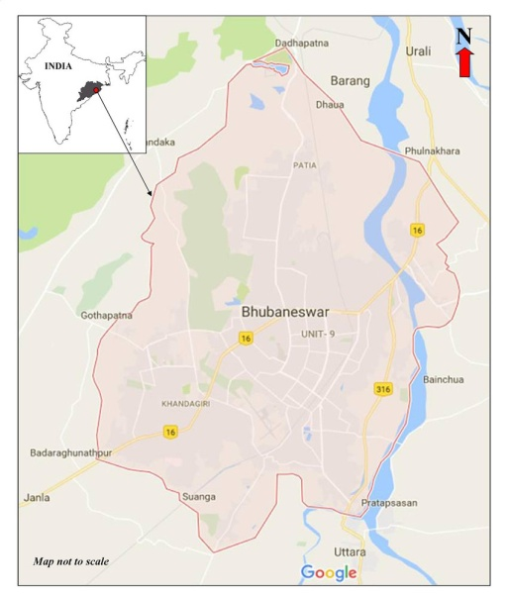
Picture:1 Map showing location of study area(Source-Google)
ii.Field Sampling:
Data and samples of invasive plant species were collected through direct field observation by the method implemented by Mohanta. et al. (2022), from 50 randomly localized quadrates of 50 × 20 m size, within disturbed areas of Bhubaneswar. Regular field trips to the study sites were conducted in 2021-2023. The collected plant species identification was done with the help of regional floras (Haines, 1925; Gamble and Fischer, 1915-1935; Saxena and Brahmam, 1996).
iii. Taxonomical Study:
Completely intact plant samples of invasive species from different regions of Bhubaneswar were collected by regular visit. Collection of plant species and herbarium collection was prepared by taking the samples of most abundantly found invasive species following the procedure described by Seshagirirao et. al. (2016) and Jain & Rao (1977).
iv.Phytochemical Screening:
The standard phytochemical screening methods described by Rashmi & Rajkumar (2011); Das & Devkota (2018) were followed for qualitative phytochemical screening of plant extracts(distilled water and methanol extract).

Results:
i.Invasive Plant Diversity
From the study sites, 72 different species belonging to 39 families of alien plants were recorded in the locality of Bhubaneswar.(Table:1), some are presented in Fig.1. Out of these, 80 % are herb species followed by 15 % shrub, 2 % trees and 3 % climbers. Asteraceae was the dominant family with Chromolaena odorata most widely reported species followed by Cleome viscosa and Parthenium hysterophorus (Table- 1). It was marked that nearly 75 % of the expansive alien species are native to American and 25 % belong to other continents such as African and Asian. Among study of commonly occurring IAS in Bhubaneswar area, it was noticed about 20 plant species are found every study sites. (Table: 2). In terms of habitat of commonly occurring IAS, wastelands ranked highest (69 %), followed by agricultural lands (10%), road sides (13 %), aquatic (2 %) and others (6 %) (Fig.2).
Table.1. List of Invasive Plant species collected from Bhubaneswar Municipality area, Odisha
Sl.  No. | Name of the Species | Family | Habit | Nativity
1. | Abutilon indicum (L.) Sweet | Malvaceae | Herb | Africa
2. | Acanthospermum hispidium DC. | Asteraceae | Herb | Brazil
3. | Ageratum conyzoides L. | Asteraceae | Herb | Tropical America
4. | Alternanthera paronychioides St. Hil | Amaranthaceae | Herb | Tropical America
5. | Aloe barbadensis Mill. | Liliaceae | Herb | Mediterranean
6. | Amaranthus viridis | Amaranthaceae | Herb | Asia Pacific
7. | Antigonum leptopus Hook & Arn. | Polygonaceae | Climber | Tropical America
8. | Argemone maxicana L. | Papaveraceae | Herb | Tropical Central &  South America
9. | Azolla pinnata R.Br. | Azollaceae | Herb | Asia, Africa
10. | Blumea lacera (Burm.f.) DC. | Asteraceae | Herb | Tropical America
11. | Borassus flabellifer L. | Arecaceae | Tree | Tropical Africa
12. | Calotropis gigantea R.Br. | Asclepiadaceae | Shrub | Tropical Africa
13. | Calotropis procera (Ait.) R.Br. | Asclepiadaceae | Shrub | Tropical Africa
14. | Cassia alata L. | Caesalpiniaceae | Tree | West Indies
15. | Cassia hirsuta L. | Caesalpiniaceae | Shrub | Tropical America
16. | Cassia occidentalis L. | Caesalpiniaceae | Herb | Tropical South  America
17. | Cassia tora L. | Caesalpiniaceae | Herb | Tropical South America
18. | Celosia argentea L. | Amaranthaceae | Herb | Tropical Africa
19. | Euphorbia hirta | Euphorbiaceae | Herb | Tropical America
20. | Chloris barbata Sw. | Poaceae | Herb | Tropical America
21. | Chromolaena odorata | Asteraceae | Herb | Tropical America
22. | Cleome rutidosperma DC | Capparaceae | Herb | Tropical America
23. | Cleome viscosa L. | Capparaceae | Herb | Tropical America
24. | Corchorus aestuans L. | Tiliaceae | Herb | Tropical America
25. | Crotalaria pallida Ait. | Fabaceae | Herb | Tropical America
26. | Croton bonplandianus Baill | Euphorbiaceae | Herb | Temperate South America
27. | Cryptostegia grandiflora R.Br. | Periplocaceae | Shrub | Madagascar
28. | Cuscuta reflexa Roxb. | Cuscutaceae | Climber | Mediterranean
29. | Cyperus difformis L. | Cyperaceae | Herb | Tropical America
30. | Datura metel L. | Solanaceae | Herb | Tropical America
31. | Eclipta prostrata (L.) L. Mant. | Asteraceae | Herb | Tropical America
32. | Eichhornia crassipes (Mart.) Solms-Laub. | Pontederiaceae | Aquatic  Herb | Tropical America
33. | Evolvulus nummularius (L.) L. | Verbenaceae | Herb | Tropical America
34. | Gnaphalium polycaulon Pers. | Asteraceae | Herb | Tropical America
35. | Grangea maderaspatana (L.) Poir. | Asteraceae | Herb | Tropical South America
36. | Hyptis suaveolens (L.) Poit. | Lamiaceae | Herb | Tropical America
37. | Impatiens balsamina L. | Balsaminaceae | Herb | Tropical America
38. | Indigofera linaei Ali | Fabaceae | Herb | Tropical Africa
39. | Ipomea carnea Jacq. | Convolvulaceae | Shrub | Tropical America
40. | Ipomea pes-tigridis L. | Convolvulaceae | Climber | Tropical Africa
41. | Ipomea quamoclit L. | Convolvulaceae | Climber | Tropical America
42. | Lantana camara L. | Verbenaceae | Shrub | Tropical America
43. | Leonotis nepetifolia (L.) R.Br. | Lamiaceae | Herb | Tropical Africa
44. | Ludwigia perennis L. | Onagraceae | Herb | Tropical America
45. | Macroptilium atropurpureum (DC.) Urb. | Fabaceae | Climber | Tropical Africa
46. | Martynia annua L. | Martyniaceae | Herb | Tropical America
47. | Mikania micrantha Kunth. | Asteraceae | Climber | Tropical America
48. | Mimosa pudica L. | Mimosaceae | Herb | Brazil
49. | Mirabilis jalapa L. | Nyctanginaceae | Herb | Peru
50. | Ocimum canum Sims. | Lamiaceae | Herb | Tropical America
51. | Opuntia stricta (Haw.) Haw. | Cactaceae | Shrub | Tropical America
52. | Oxalis corniculata L. | Oxalidaceae | Herb | Europe
53. | Parthenium hysterophorus L. | Asteraceae | Herb | Tropical North America
54. | Passiflora foetida L. | Passifloraceae | Herb | Tropical South America
55. | Pistia stratiotes L. | Araceae | Herb | Tropical America
56. | Portulaca oleracea L. var. oleracea | Portulacaceae | Herb | Tropical South America
57. | Portulaca quadrifida L. | Portulaceae | Herb | Tropical America
58. | Rhoeo discolor Hance. | Commelinaceae | Herb | Central America
59. | Ruellia tuberosa L. | Acanthaceae | Herb | Tropical America
60. | Saccarum spontaneum L. | Poaceae | Herb | Tropical West Asia
61 | Salvinia molesta D.S. Mitch. | Salviniaceae | Herb | Brazil
62 | Sida acuta Brum.f. | Malvaceae | Herb | Tropical America
63 | Solanum nigrum | Solanaceae | Shrub | Tropical America
64 | Spathodea campanulata Beauv. | Bignoniaceae | Tree | Trop. Africa
65 | Spermacoce hispida L. | Rubiaceae | Herb | Tropical America
66 | Spilanthes radicans Jacq. | Asteraceae | Herb | Tropical South America
67 | Stachytarpheta jamaicensis (L.)  Vahl. | Verbenaceae | Herb | Tropical America
68 | Synedrella nodiflora (L.) Gaertn. | Asteraceae | Herb | West Indies
68 | Tridax procumbens L. | Asteraceae | Herb | Tropical Central America
70 | Trianthema portulacastrum | Aizoaceae | Herb | Africa and America
71 | Triumfetta rhomboidea | Tiliaceae | Herb | Tropical America
72 | Vernonia cinerea | Asteraceae | Herb | South America
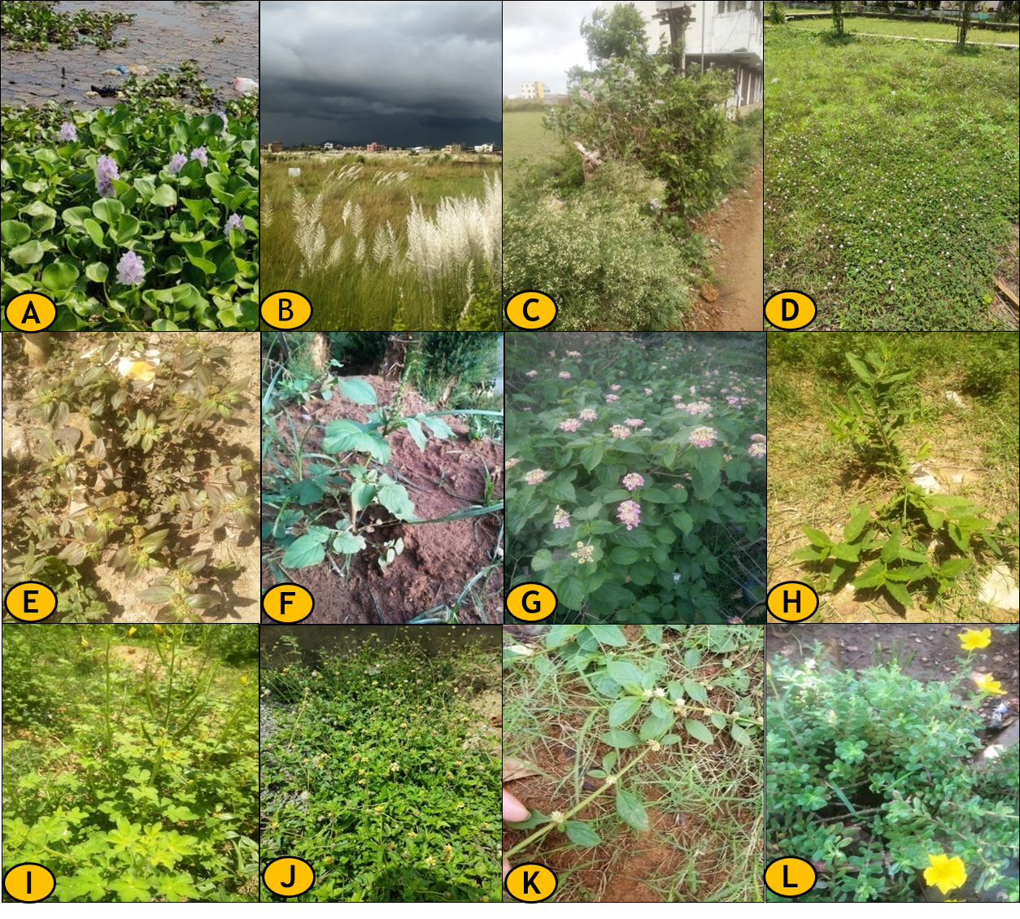
Fig.1. List of common Invasive plant species studied from different habitats of Bhubaneswar.
A.Eichhornia crassipes, B.Saccarum spontaneum. C.Parthenium hysterophorus,D.Mimosa pudica, E.Euphorbia hirta, F.Amaranthus viridis,G. Lantana camara, H.Sida acuta, I.Cleome viscosa, J.Tridax procumbens,K. Alternanthera paronychioides,L.Portulaca oleracea

Table 2: List of most commonly observed invasive species recorded in different habitats of Bhubaneswar.
Sl. No. | Plant  code | Name of the Species | Family | Habit | Location
1 | P1 | Alternanthera paronychioides | Amaranthaceae | Herb | Wasteland, backyard of houses
2 | P2 | Amaranthus viridis | Amaranthaceae | Herb | Roadside, Wasteland
3 | P3 | Argemone maxicana L. | Papaveraceae | Herb | Wasteland, backyard of houses, college campus
4 | P4 | Calotropis gigantea R.Br. | Asclepiadaceae | Shrub | Wasteland, backyard of houses, college campus
5 | P5 | Cassia alata L. | Caesalpiniaceae | Tree | Roadside, Wasteland
6 | P6 | Cassia occidentalis L. | Caesalpiniaceae | Herb | Roadside, Wasteland
7 | P7 | Chloris barbata Sw. | Poaceae | Herb | Roadside, Wasteland, Agriculture land, backyard of house
8 | P8 | Chromolaena odorata | Asteraceae | Shrub | Roadside, Wasteland
9 | P9 | Euphorbia hirta | Euphorbiaceae | Herb | Roadside, Wasteland, Agriculture land, backyard of house
10 | P10 | Cleome viscose L. | Capparaceae | Herb | Roadside, Wasteland, Agriculture land, backyard of house, college campus
11 | P11 | Eichhornia crassipes | Pontederiaceae | Herb | Local pond
12 | P12 | Lantana camara L. | Verbenaceae | Shrub | Roadside, Wasteland
13 | P13 | Mikania micrantha | Asteraceae | Climber | Roadside, Wasteland
14 | P14 | Mimosa pudica L. | Mimosaceae | Herb | Wasteland, backyard of house, college campus
15 | P15 | Parthenium hysterophorus L. | Asteraceae | Herb | Roadside, Wasteland, backyard of house, college campus
16 | P16 | Saccarum spontaneum L. | Poaceae | Herb | Agriculture land
17 | P17 | Solanum nigrum | Solanaceae | Shrub | Backyard of house, college campus
18 | P18 | Sida acuta | Malvaceae | Herb | Roadside, Wasteland, backyard of house, college campus
19 | P19 | Tridax procumbens L. | Asteraceae | Herb | Roadside, Wasteland, Agriculture land, backyard of house, college campus
20 | P20 | Trianthema portulacastrum | Aizoaceae | Herb | Roadside, Wasteland

Fig.2. Habitat wise Distribution of Invasive Plant species in study area
From , the habit wise study , it was found herbs (80%) are the dominating plant groups from the total invasive plants found in the study area followed by shrubs(15%) . The climbers (3%) and trees (2%) take part the next position respectively. (Fig.3.)

Fig.3. Habit wise diversity of Invasive Plant Species in Bhubaneswar.
The species of predominance family Asteraceae shows the high impact in this region. Most of the invasive species were migrated to this region by transport from other regions as Bhubaneswar has reputed education institutions, employment organization, government institutions, etc. The windy weather conditions of the region become suitable for their growth and dispersion. Due to the dominant nature and high propagation ability few among these invasive species (Parthenium hysterophorus and Chromolaena odorata) were widely spread in the locality. It was marked that the dominant natures of alien varieties make it very difficult for local or native local Indian herb and shrub species to survive. Heliotropium indicum and Acalypha indica are few among the native Indian species which can grow along with the invasive species.

Fig.4: The population density of the commonly observed invasive species mentioned in table 1 that were recorded in 50 random location of area 50 m X 20 m all around Bhubaneswar.
ii.Secondary metabolites:
- Stem Aqueous extract: Flavonoid was detected in most of the aqueous extracts of plant stem sample except Calotropis gigantea and Mimosa pudica (Table 3). Alkaloid was observed in the plants sample of Calotropis gigantea, Lantana camara and Mimosa pudica. Terpenoids was seen in samples of Eichhornia crassipes and Mimosa pudica.
Table 3: Phytochemical screening of aqueous extract collected from the stem sample of selected invasive plant species.
Plant | Alkaloid | Flavonoids | Saponin | Tannins | Terpenoids
Calotropis gigantean | + | - | - | + | -
Chromolaena odorata | - | + | + | + | -
Cleome viscosa | - | + | - | + | -
Eichhornia crassipes | - | + | - | + | +
Lantana camara | + | + | + | + | -
Mimosa pudica | + | - | - | - | +
Partheniumhysterophorus | - | + | - | - | -
b. Leaf Aqueous extract:
From the study it was resulted that , Flavonoid was detected in most of the aqueous extracts of plant leaf sample except Calotropis gigantea (Table 4). Alkaloid was observed in the all plants sample except Cleome viscosa. Saponin was seen in samples of Chromolaena odorata, Lantana camara and Parthenium hysterophorus.
Table 4:Phytochemical screening of aqueous extract collected from the leaf sample of different invasive plant species.
Plant | Alkaloid | Flavonoids | Saponin | Tannins | Terpenoids
Calotropis gigantea | + | - | - | + | -
Chromolaena odorata | + | + | + | + | -
Cleome viscosa | - | + | - | + | +
Eichhornia crassipes | + | + | - | + | +
Lantana camara | + | + | + | + | -
Mimosa pudica | + | + | - | - | +
Parthenium hysterophorus | + | + | + | - | +
c.Stem Methanol extract: The biochemical test showed Flavonoid was detected in most of the methnol extracts of plant stem sample except Calotropis gigantea (Table 5). Alkaloid was observed in the plants sample of Calotropis gigantea, Lantana camara, Mimosa pudica and Parthenium hysterophorus whereas Tannins were seen in most of samples except Parthenium hysterophorus.

Table 5: Qualitative analysis of secondary metabolites present in methanol extract collected from the stem sample of different invasive plant species.
Plant | Alkaloid | Flavonoids | Saponin | Tannins | Terpenoids
Calotropis gigantean | + | - | - | + | -
Chromolaenaodorata | - | + | + | + | -
Cleome viscosa | - | + | - | + | -
Eichhorniacrassipes | - | + | - | + | +
Lantana camara | + | + | + | + | -
Mimosa pudica | + | + | - | + | +
Partheniumhysterophorus | + | + | + | - | +
d. Leaf Methanol extract: Tannin was seen in all the methanol extract collected from the leaf sample of different invasive plant species (Table 6). Saponin was seen in samples of Chromolaena odorata, Lantana camara and Parthenium hysterophorus.
Table 6: Qualitative analysis of secondary metabolites present in methanol extract collected from the leaf sample of different invasive plant species.
Plant | Alkaloid | Flavonoids | Saponin | Tannins | Terpenoids
Calotropis gigantea | + | - | - | + | +
Chromolaena odorata | - | + | + | + | -
Cleome viscosa | - | + | - | + | -
Eichhornia crassipes | - | + | - | + | -
Lantana camara | + | + | + | + | -
Mimosa pudica | + | + | - | + | +
Parthenium hysterophorus | + | + | + | + | +

Discussion:
Urbanization can be considered as one of the most saviour factors that drastically affect the biodiversity as a result of which native species tends to decline in urban areas (Miles et al. 2019; Kondratyeva et al. 2020). Urbanization also leads to homogenization of the environment that will ultimately promote the invasion of non-native species (Ruas et al. 2022). Bhubaneswar smart city is one of the developing cities of India where urbanization is rapidly increasing. People from different parts of Odisha as well as India are coming to Bhubaneswar for job or education purpose which creates a greater need for shelter and better transportation paths. Due to the increase in construction of new shelter places and highways the free space for growth of plants is reducing day by day. And in that limited area it was observed that the invasive plants are more dominant in comparison to native species.
In the current study it was observed that Falvonoid and Tannins were mostly present in the entire plants sample (aqueous and methanol extract). Alkaloid was observed in the all plants sample except Cleome viscosa. Saponin was seen in samples of Chromolaena odorata, Lantana camara and Parthenium hysterophorus.Terpenoid was also detected in few plants.
Secondary metabolites such as terpenoids, flavonoids, alkanoid where reported in the aqueous extract of Eichhornia crassipes by Tony Lmunyolsebe (2016).Srorang et al. (2012) observed phenolics, flavonoids and tannins compounds in the methanol extract of Eichhornia crassipes. Gul et al.(2020) in his experimental study noted that the leaf sample of Lantana camara contains phytochemicals such as tannins, flavonoids, saponins, phenolic compounds etc.In phytochemical study conducted by Murugesan et al.(2018) it was mark that the methanol extract of Cleome viscosa contain abundant amount phenol and flavonoid. Pratap et al.(2018) reported alkaloid in both methanol and water extract of Mimosa pudica. They also observed that flavonoid, phenol and tannins were detected in the methanol extract but in the water extract.
In the latex extract of Calotropis gigantea, Ishnava et al.(2011) observed the presence of alkaloid and phenolic compound. Rashmi and Rajkumar (2011) observed the presence of saponins, flavonoids and tannins in the leaf sample of Chromolaena odorata. Muhammad et al.(2012) in his experimental study reported presence of flavonoid, alkanoid and saponins in the extract collected from Parthenium hysterophorus.

Phenols present in plants as secondary metabolites that assistance to get ease torment or bothering in or around your mouth, whose items are utilized as a momentary treatment in pharyngitis. Flavonoids have various therapeutic advantages, including anticancer, cancer prevention agent, calming, and antiviral properties which have neuroprotective and cardio-defensive impacts. The presence of saponins in plants can possibly diminish blood lipids, lower blood glucose and lower disease chances, reaction as well as helps in the restraint of dental caries and platelet conglomeration, as a counteractant against intense lead harming whenever taken in diet. These financially savvy therapeutic parts have huge organic exercises, and their viability has been demonstrated for various infections.

Conclusion
The presence of invasive species, one of the significant reason for modification of any environment species lavishness, is a significant risk to the local plant varieties. The attack by the exotic plant species as invasion spreaded intentionally or unexpectedly makes a danger the local vegetation in future. The invasive species can be valuable assuming they have explicit compound properties that are applicable in the utilization to serve human wellbeing. invasive plants can be utilized as a feasible and free stock of phytochemicals having cell reinforcement, antibacterial, antifungal, and anticancer properties, among others .Hence, information on invasive plants should infer an administration plan for these plants, which should incorporate something like three unmistakable stages: counteraction, early identification and fast reaction, and the executives (control, destruction or potentially use). As depicted all through the review work the presence of the few normal phytochemical compound extravagance like tanins, flavonoids, saponins which potentiate helpful dynamic standards in the avoidance or treatment of a few clinical circumstances.

Reference:
- Aerts, R., O.Honnay and A.V.Nieuwenhuys. 2018. Biodiversity and human health: mechanisms and evidence of the positive health effects of diversity in nature and green spaces. Br. Med. Bull. 127:5–22.
- Bartz, R. andI.Kowarik. 2019. Assessing the environmental impacts of invasive alien plants: a review of assessment approaches. NeoBiota. 43:69–99.
- Das, R.K. and A.Devkota. 2018. Antifungal activities and phytochemical screening of two invasive alien species of Nepal. Studies in Fungi. 3(1): 293–301.
- Das, S.K., A.Subudhi,S. Naik, S.R.Pradhan andS.S.Bisoi. 2019. Origin, diversity and uses of invasive alien plant species in Utkal University campus, Bhubaneswar, Odisha. International Journal of life sciences. 7 (3): 509-517.
- Gamble, J.S. andC.E.C Fischer. 1915-1935. Flora of the Presidency Madras, Calcutta: Botanical Survey of India. Vol: 1–3.
- Gul, H., et al. 2020. An evaluation of phytochemical screening of Lantana camara Linn. (An invasive plant species of Pakistan). Pure Appl. Biol. 9(3): 1856-1863.
- Ishnava, K.B., J.B.Chauhan,A.A. Garg andA.M.Thakkar. 2012. Antibacterial and phytochemical studies on Calotropisgigantia (L.) R. Br. latex against selected cariogenic bacteria.Saudi Journal of Biological Sciences. 19(1): 87-91.
- Jain SK, Rao, RR 1967. A handbook for field and herbarium methods , Today and Tomorrow’s printers & Publishers, New Delhi.
- James, J.M., C.U.Geethumol, A.Anilkumar andG.Selvaraj. 2018. Phytochemical screening, antibacterial and allelopathic effects of few invasive plants of Kerala. Plant Science Today. 5(4): 175-181.
- JohnlyAlfredsRorong, et al. 2012. Phytochemical analysis of water hyacinth (Eichhorniacrassipes) of agricultural waste as biosensitizer for ferriphotoreduction. Agrivita. 34(2): 152-160.
- Jones, B.A. 2019. Tree shade, temperature, and human health: evidence from invasive species-induced deforestation. Ecol. Econ. 156:12–23.
- Jones, B.A. andS.M.McDermott. 2018. Health impacts of invasive species through an altered natural environment: assessing air pollution sinks as a causal pathway. Environ. Resour. Econ. 71(1):23–43.
- Kannan, R., C.M.Shackleton, S.Krishnan and R.U.Shaanker. 2016. Can local use assist in controlling invasive alien species in tropical forests? The case of Lantana camara in southern India. For. Ecol. Manage. 376:166–173.
- Khuroo, A.A., Z.A. Reshi, A.H. Malik, E.Weber, I.Rashid and G.H. Dar. 2012. Alien flora of India: taxonomic composition, invasion status and biogeographic affiliations. Biol Invasions. 14:99–113. DOI 10.1007/s10530-011-9981-2.
- Kondratyeva, A., S.Knapp, W.Durka, I.Kühn, J.Vallet, N.Machon, G.Martin, E.Motard, P.Grandcolas andS.Pavoine. 2020. Urbanization Effects on Biodiversity Revealed by a Two-Scale Analysis of Species Functional Uniqueness vs. Redundancy. Front. Ecol. Evol. 8:73. doi: 10.3389/fevo.2020.00073
- Kueffer, C. 2017. Plant invasions in the Anthropocene. 358 (6364): 724–725.
- Mallick, S.N., N.X. Ekka, S.Kumar and S.C.Sahu. 2019. Invasive Alien Flora in and around an Urban Area of India In Diversity and Ecology of Invasive Plants. Intech Open.
- Mandal, U., M.Panda andG.Mahalik. 2020. Overview on nativity, diversity and uses of invasive alien plant species in Odisha, India. In: Dr. Susanta Kumar Biswal and Dr. Sanjeet Kumar (eds) Medico-Biowealth of Odisha. APRF Publishers. Vol. II, pp 22-39.
- Miles, L.S., S.T. Breitbart, H.H. Wagner and M.T.J. Johnson. 2019. Urbanization Shapes the Ecology and Evolution of Plant-Arthropod Herbivore Interactions. Front. Ecol. Evol. 7:310. doi: 10.3389/fevo.2019.00310
- Mohanta, M.R., Y. Rout, B. Pradhan, D. Bhoi, P.K. Chand and S.C. Sahu. 2022. Anthropogenic interventions regulate forest structure and carbon stock in transitional dry forests of Similipal Biosphere Reserve, India. Écoscience. https://doi.org/10.1080/11956860.2022.2030130
- Muhammad, B., R. Khan,Y. Arshad andR.A. Khan. 2012. Phytochemical and cytotoxic analysis of Phartheniumhysterophosis selected from District Bannu, Pakistan. African Journal of Biotechnology. 11(55): 11857-11860.
- Murugesan, K., G.Lakshmanan, C.Sivaraj, A.Sathiyaseelan, P.T. and Kalaichelvan. 2018. Phytochemical analysis and in vitro antioxidant activities of Cleome viscosa L. European Journal of Biomedical and Pharmaceutical Sciences. 5(1): 609-616.
- Nayak, S. K. andK.B. Satapathy. 2015. Diversity, uses and origin of invasive alien plants in Dhenkanal district of Odisha, India. International Research Journal of Biological Sciences. 4(2): 21-27.
- Panda, T., N.Mishra, B.K.Pradhan andR.B.Mohanty. 2018. Expansive alien flora of Odisha, India. Journal of Agriculture and Environment for International Development (JAEID). 112(1): 43-64.
- Pejchar, L. andH.A.Mooney. 2009. Invasive species, ecosystem services and human well-being. Trends in Ecology and Evolution. 24(9):497- 504.
- Pratap,C.R., V.Deepak, Sai Krishna, S.Fathima, A.Thaha andJ.Raj. 2018. Analysis of Phytochemical Constituents and Anthelmintic Activity of Leaf Extracts of Mimosa pudica L. Asian Journal of Biomedical and Pharmaceutical Sciences. 8(65): 1-5.
- Rai, P.K. and J.S. Singh. 2020. Invasive alien plant species: Their impact on environment, ecosystem services and human health. Ecological Indicators. 111:106020. https://doi.org/10.1016/j.ecolind.2019.106020
- Ruas, R.B., L.M.S.Costa andF.Bered. 2022. Urbanization driving changes in plant species and communities – A global view. Global Ecology and Conservation. 38:e02243 https://doi.org/10.1016/j.gecco.2022.e02243
- Rashmi, S. and H.G. Rajkumar. 2011. Preliminary Phytochemical Analysis and in Vitro Evaluation of Antifungal Activity of Five Invasive Plant Species against Macrophomina phaseolina (Tassi) Goid. International Journal of Plant Research. 1(1): 11-15.
- Ricciardi, A., R.J.Neves andJ.B.Rasmussen. 1998. Impending extinction of North American fresh water mussels (Unionoida) following the zebra mussel (Dreissenapolymorpha) invasion. Journal of Animal Ecology. 67: 613-619.
- Saxena, H.O andM.Brahmam. 1996. The Flora of Orissa, Vol I-IV. Orissa Forest Development Corporation Ltd, Bhubaneswar, India. 2918pp.
- Seshagirirao, K., et. al. 2016. Preparation of herbarium specimen for plant identification and voucher number. Roxburghia. 6(1-4): 111-119.
- Shackleton, R.T., C.M.Shackleton andC.A.Kull. 2019. The role of invasive alien species in shaping local livelihoods and human well-being: a review. J. Environ. Manage. 229:145–157. http://dx.doi.org/10.1016/j.jenvman.2018.05.007
- Stone, C.M., et al. 2018. Would the control of invasive alien plants reduce malaria transmission? A review. Parasites Vectors. 11:76.
- Tony, I. 2016. Phytochemical Composition and Antibacterial Activity Of Eichhornia crassipes In Lake Victoria, Kisumu. International journal of scientific & technology research. 5(09): 45-52.

