Osmoprotective Action of Nutrient Salt Sprays in Mitigating Terminal Heat Stress and Improving Wheat Yield in the Gangetic Plains

Abstract
A field experiment was conducted during the rabi season of 2022-23 to evaluate the effects of foliar applications of various nutrient salts on the growth, development, and yield of wheat (Triticum aestivum L.) variety -UP-262 under the lower Gangetic alluvial soils of West Bengal. The experiment was laid out in a randomized block design with 3 replications and 10 foliar treatments. The foliar treatments were water spray, NaCl @0.5%, K₂SO₄ @0.5%, KCl @0.5%, CaCl₂ @0.5%, Boron @0.2% and 0.1%, Zinc @0.1%, a combined spray of zinc and boron, and a mixture of NaCl and KCl each at 0.25%. These nutrients were sprayed at 50% flowering of the crop. The results showed that all the foliar applications had significant positive effects on yield and yield contributing characters of wheat compared to the control. Foliar application of NaCl @ 0.5% significantly increased filled grains spike⁻¹, ear length, and 1000-grain weight, thus the highest grain yield (2810.53kg/ha) was obtained with this treatment followed closely by K₂SO₄ @0.5%. However, the combined spray of zinc and boron increased grain yield and therefore improves micronutrient supplementation. This finding implies that foliar application of targeted nutrients at key development stages might improve wheat productivity through the remedying of nutrient deficiencies.
Key words: Foliar treatments, Micronutrient, Nutrient salts, Osmo protective, Terminal heat stress, Yield
Introduction

Wheat (Triticum aestivum L.) is the second most important cereal crop worldwide and is grown in a wide range of agro-climatic conditions in India. Wheat is cultivated over about 31.82 million hectares in the country, producing nearly 112.74 million tonnes, with an average yield of 3543 kg per hectare (ICAR-IIWBR, 2022). In West Bengal, wheat occupies a relatively small proportion of the total cropped area. The crop is grown on about 0.4 million hectares, and the state records an annual production of approximately 0.9 million tonnes (Government of India, 2024; ICAR-IIWBR, 2024). Although wheat is not a dominant cereal in the region, it still contributes meaningfully to the state's agricultural production, especially in districts with suitable winter conditions. The state, though not traditionally associated with wheat cultivation, has significant potential to improve its productivity through better agronomic practices.
The role of macro and micronutrients is crucial in crop nutrition for achieving higher yields. Macronutrients and micronutrients are very important for plant growth, however, their availability in the soil depends on several factors such as leaching, fixation, and volatilization, especially during crucial growth stages (Shrivastav et al., 2020). In addition, high fertilization cost necessitates the adoption of effective fertilizer application technologies to ensure their use becomes economically viable. Foliar fertilization can serve as an alternative approach, wherein nutrients are delivered directly to the leaves of the plant for its essential elements during crucial growth stages (Niu et al., 2021).
Deficiencies of micronutrients such as boron and zinc are increasingly reported in several places, including in West Bengal, where boron plays a vital role in improving inflorescence development and yield attributes of wheat (Misu, 2021). Foliar application of nutrients has been recognized as a highly effective method to enhance nutrient availability, particularly during flowering and grain-filling stages. This method enhances nutrient uptake and promotes the movement of vital compounds and hence reduces eventual nutrient shortages that may occur during crucial developmental stages of crops.
Considering all these aspects, a field experiment was conducted to evaluate the impact of foliar sprays of macro and micronutrients like NaCl, K₂SO₄, KCl, CaCl₂, boron, and zinc on yield parameters of wheat in the lower Gangetic alluvial soils of West Bengal. This study aims to explore the potential of foliar fertilization in maximizing wheat productivity and improving nutrient use efficiency in non-traditional wheat-growing regions.

Materials and methods
A field experiment on the effect of foliar treatments on wheat (variety: UP-262) using different macro and micronutrient salt solutions conducted at Experimental Farm of Calcutta University, Baruipur, South 24 Parganas, West Bengal (88°26′ E, 22°22′ N). There were ten treatments combination in the experiment: water spray, NaCl @ 0.5%, K₂SO₄ @ 0.5%, KCl @ 0.5%, CaCl₂ @ 0.5%, boron @ 0.2%, Zn + boron @ 0.1%, zinc @ 0.1%, and a combined spray of zinc and boron, and a mixture of NaCl and KCl each at 0.25. These treatments were laid out in a randomized block design with three replications. The experimental field comes under the new Gangetic alluvial region with organic carbon content of 0.72%, available nitrogen of 210 kgha⁻¹, available zinc at 0.14 mgkg⁻¹ and boron at 0.41 mgkg⁻¹. Foliar nutrient solutions were applied at a rate of 800lha⁻¹, with solution concentrations adjusted to 0.5% (5 g/L), 0.25% (2.5 g/L), 0.1% (1 g/L), and 0.2% (2 g/L) as required. The wheat variety 'UP 262' was sown during the first week of December at a seed rate of 100 kgha⁻¹, with rows spaced 25 cm apart and seeds placed at a depth of 5–6 cm in well-prepared soil. A basal application of fertilizers included 100 kg N, 50 kg P₂O₅, and 50 kg K₂O ha⁻¹. Half of the nitrogen, along with the full dose of phosphorus and potassium, was incorporated during the final land preparation prior to sowing, and the remaining nitrogen was top-dressed at the tillering stage. Light irrigation was provided immediately post-sowing to ensure uniform germination, followed by additional irrigation at crown initiation and grain filling stages. Weed control through hoeing was performed at three and five weeks after sowing.
Foliar application of nutrient solutions was carried out using a micro-jet sprayer after 50% flowering of the wheat crop. Harvesting was done in the second week of March in both study years. Data collected were analyzed statistically following the procedure outlined by Gomez and Gomez (1984).
Results and discussion
The statistical analysis of one-year experimental data on the length of panicle (cm), number of filled grains ear head⁻¹, and test weight of grains (g) revealed significant variation due to foliar application of macro and micro-nutrient salt solutions in wheat. The experimental results indicate that NaCl @0.5% foliar application is found to perform better in enhancing yield attributes compared with other treatments. Among the foliar spray treatments, NaCl@0.5% markedly improved the filled grains ear head⁻¹ to 41.43. It was superior to all the other foliar applications regarding the grain filling and contributed to a higher grain yield. Foliar spray treatments also altered ear head length. Ear head length was the maximum (11.60cm) with NaCl at 0.5%. However, the control (water spray) gave the shortest ear head (9.80cm), indicating a positive effect of NaCl on ear head development. The highest test weight (39.70gm) was exhibited from the foliar application of NaCl@ 0.5%. Test weight was superior to all other treatments, including the water spray control. It indicates that NaCl not only facilitates in better yield component, but also improves seed quality by an increased test weight. All the foliar spray treatments significantly affected the grain yields of wheat. NaCl@ 0.5% gave the highest yield (2879.90 kg/ha) among all treatments, which was followed by K₂SO₄@0.5% (2820.92 kg/ha).
Yield increase due to NaCl may be attributed to the enhancement of several yield component contributory parameters such as a greater number of filled grains, ear head length and test weight. The higher yield due to NaCl application may also be linked to the water stress effect induced by the salt solution during the late grain filling period (Evans and Rowson., 1970), although the exact mechanism remains unclear. It is possible that NaCl's effect on water stress and ion dynamics (Na⁺, Cl⁻) during grain filling contributed to the translocation of stored carbohydrates to the developing grains, as similar effects have been reported in previous studies under water stress conditions. The beneficial effect of foliar nutrient treatments might be due to they acted as Osmo protectants under environmental stress (terminal heat stress) and water stress (intermittent drought condition) (Chowdhury et al., 2020).
In addition to NaCl, the beneficial effect of foliar potassium on carbon fixation and the translocation of carbon compounds during the late grain filling stage was also evident.
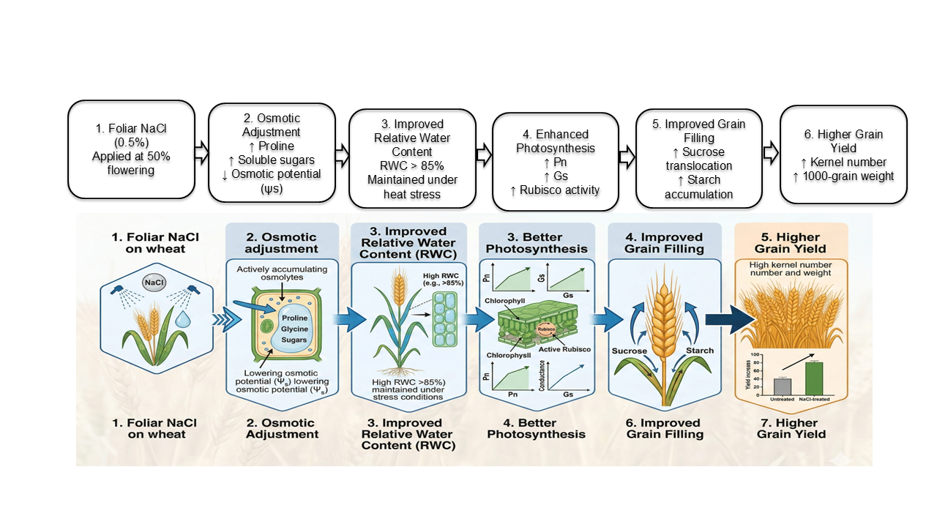
Foliar application of 0.5% NaCl treatment recorded higher yield attributes and seed yield. Probable reason behind it may be that in addition to its function as a functional nutrient it also controlled the fungal and bacterial infection which remained as hidden in our open eyes. In the month of February, during the time of flowering and seed filling of wheat, the temperature started to rise and not remained as cooler as it was required. Due to this, there was a chance of force maturity of the crop which might have reduced the seed filling period resulting in low yield of wheat, this could be mitigated by spraying of foliar nutrients which acted as Osmo-protectants (Bouranis & Chorianopoulou, 2023). Again, at the time of flowering and seed filling stage heavy rains occurred twice and cloudy weather continued for few days (in month of February 2016) which might have caused favorable weather for increasing the fungal and bacterial disease infestation and this was perhaps prevented or controlled by NaCl and other nutrients having Cl.
Fig 1. Proposed Mechanism of Foliar NaCl in Mitigating Terminal Heat Stress in Wheat
Khalid et al. (2006) also mentioned that adequate K results in superior of water use efficiency and mention a normal balance between carbohydrates and protein results in stronger wheat straw and assist in grain filling. Foliar nutrients having Potassium nutrient recorded better result that might be due to potassium played an important part in regulating the water economy in plant tissues so it might confer resistant to intermittent drought. Potassium is known to play a crucial role in carbohydrate translocation, which likely contributed to the increased grain yield observed with the foliar spray of K₂SO₄.
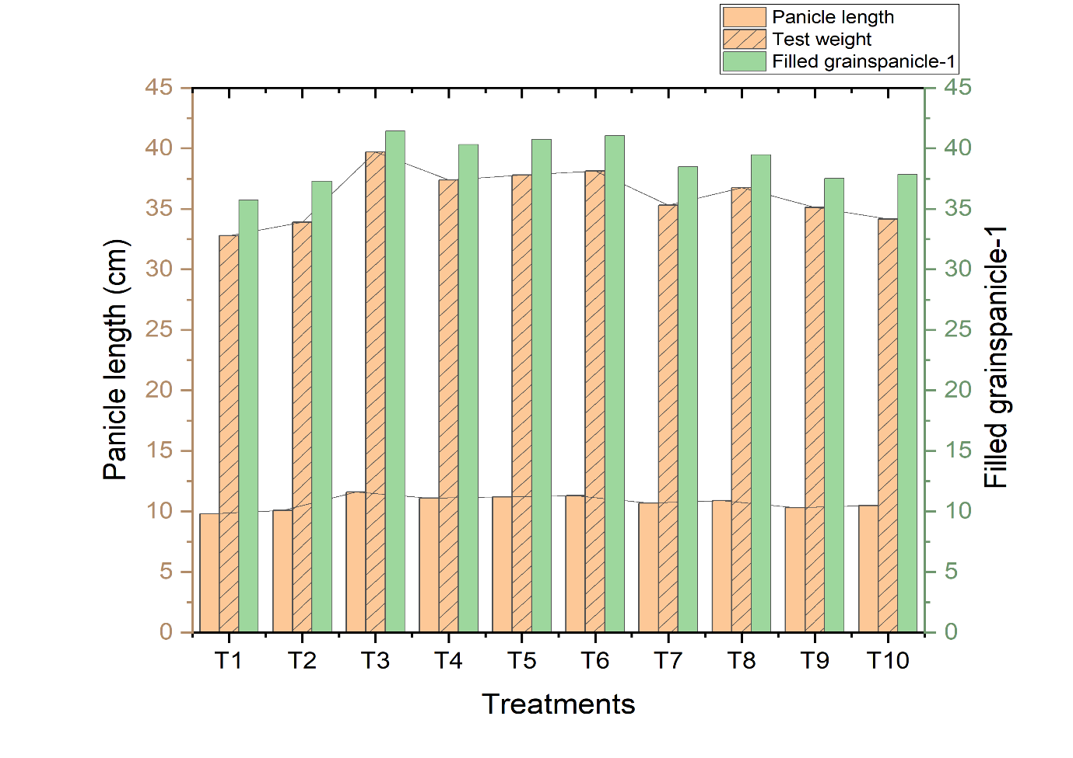
Fig2: Effects of treatments on Panicle length(cm), Filled grains panicle⁻¹, Test weight(g) of wheat.
Conclusion
The application of NaCl as a foliar spray at 0.5% proved to be an effective and cost-efficient method for enhancing wheat yield. This treatment significantly improved key yield components, including the number of filled grains, ear head length, test weight, and overall grain yield. The findings suggest that NaCl, through its interaction with water stress during the late grain filling period, can play a pivotal role in increasing wheat productivity. Further research is needed to fully understand the mechanisms through which NaCl influences wheat growth and yield, especially with regard to its effects on water stress and ion dynamics.
References

Bouranis, D. L., & Chorianopoulou, S. N. (2023). Foliar application of sulfur-containing compounds—Pros and cons. Plants, 12(22), 3794. https://doi.org/10.3390/plants12223794
Chowdhury, A. R., Ghosh, M., Lal, M., Pal, A., Hazra, K. K., Acharya, S., & Pathak, S. K. (2020). Foliar spray of synthetic osmolytes alleviates terminal heat stress in late-sown wheat. International Journal of Plant Production, 14(2), 321–333. https://doi.org/10.1007/s42106-020-00091-2
Evans, L. T., & Rowson, H. N. (1970). Photosynthesis and respiration by the flag leaf and components during grain development in wheat. Australian Journal of Biological Sciences, 23(2), 245–254. https://doi.org/10.1071/BI9700245
Gomez, K. A., & Gomez, A. A. (1984). Statistical procedures for agricultural research (2nd ed.). John Wiley & Sons.
Government of India. (2024). Agricultural statistics at a glance 2023. Directorate of Economics and Statistics, Ministry of Agriculture & Farmers Welfare. https://eands.dacnet.nic.in
ICAR–Indian Institute of Wheat and Barley Research. (2022). Progress report of AICRP on wheat and barley 2022–23 (Social Science). ICAR-IIWBR.
ICAR–Indian Institute of Wheat and Barley Research. (2024). Director’s report of AICRP on wheat and barley 2022–23. ICAR-IIWBR. http://www.aicrpwheatbarleyicar.in
Khalid, R., Khan, S. A., & Ahmad, S. (2006). Role of potassium in improving water use efficiency and grain filling in wheat. Journal of Agronomy and Crop Science, 192(6), 426–432. https://doi.org/10.1111/j.1439-037X.2006.00216.x
Misu, U. M. (2021). Influence of boron application methods on morpho-physiological attributes and yield of wheat (Triticum aestivum L.) (Doctoral dissertation, Sher-e-Bangla Agricultural University, Dhaka, Bangladesh).
Niu, J., Liu, C., Huang, M., Liu, K., & Yan, D. (2021). Effects of foliar fertilization: A review of current status and future perspectives. Journal of Soil Science and Plant Nutrition, 21(1), 104–118. https://doi.org/10.1007/s42729-020-00346-3
Shrivastav, P., Prasad, M., Singh, T. B., Yadav, A., Goyal, D., Ali, A., & Dantu, P. K. (2020). Role of nutrients in plant growth and development. In M. Naeem et al. (Eds.), Contaminants in agriculture: Sources, impacts and management (pp. 43–59). Springer. https://doi.org/10.1007/978-3-030-41552-5_2

Table1: Effects of treatments on growth and yield parameters of wheat.
Treatments | Panicle length  (cm) | Filled grainspanicle⁻¹ | Test weight  (g) | Seed yield  (Kgha⁻¹)
Water spray | 9.80 | 35.73 | 32.78 | 2396.30
KCl@0.5% | 10.08 | 37.28 | 33.91 | 2259.63
NaCl@0.5% | 11.60 | 41.43 | 39.70 | 2879.90
CaCl₂@0.5% | 11.10 | 40.31 | 37.38 | 2765.35
NaCl+KCl@0.25% | 11.20 | 40.74 | 37.78 | 2798.20
K₂SO₄@0.5%+@0.1% | 11.30 | 41.06 | 38.12 | 2820.92
Boron@0.1% | 10.70 | 38.49 | 35.29 | 2710.80
Boron@0.2% | 10.90 | 39.46 | 36.75 | 2745.25
Zn@0.1% | 10.30 | 37.52 | 35.13 | 2595.91
Zn+ Boron@0.1%+@0.1% | 10.50 | 37.84 | 34.16 | 2610.20
CD(P=0.05) | 0.63 | 2.087 | 2.071 | 62.114

