Assessment of the Bio- Pesticidal activity of Bay Leaf (Laurus nobilis) Extract against Adult American cockroach (Periplaneta americana)

Abstract
Cockroach infestation poses significant public health risks due to their role in pathogen transmission. This study evaluated the bio-insecticidal activity of Laurus nobilis (bay leaf) ethanolic extract against 240 adults Periplaneta americana under laboratory conditions. Sixty adult cockroaches each were exposed to three extract concentrations (T1: 1.5 g/m², T2: 1.0 g/m², T3: 0.5 g/m²) and a control for 8 hours. Phytochemical screening of the extract revealed the presence of alkaloids, flavonoids, tannins, phenols, saponins, glycosides, steroids, terpenoids, coumarins and abundant essential oils, all of which are bioactive metabolites known to contribute to insect toxicity. Mortality, knockdown time (KT₅₀, KT₉₀) and lethal dose (LD₅₀, LD₉₀) were assessed. By 8 hours, all treatments achieved 100% mortality, whereas the control showed 0% mortality. Treatment T1 exhibited the fastest toxic action, with cumulative mortality increasing to 25% by 4 hours, KT₅₀ = 2.80 hours and KT₉₀ = 5.60 hours. Treatment T2 produced moderate effects, recording 20% mortality at 4 hours, KT₅₀ = 4.10 hours and KT₉₀ = 7.90 hours. Treatment T3 showed slower initial activity (0–15% deaths at 1–4 hours) but reached complete mortality by 8 hours, with KT₅₀ = 5.50 hours and KT₉₀ = 10.20 hours. LD₅₀ values were lowest for T1 (11.20 mg/cm²), followed by T2 (17.00 mg/cm²) and T3 (23.80 mg/cm²), while LD₉₀ followed the same trend (T1: 25.30, T2: 33.50, T3: 40.70 mg/cm²). ANOVA indicated significant differences among treatments (F = 16.42, p = 0.001), with Tukey HSD confirming T1 as significantly more effective than T2 and T3. The strong insecticidal performance is attributed to the synergistic action of terpenoids together with phenolic compounds and flavonoids that induced oxidative stress, neurotoxicity and metabolic disruption in cockroaches. These findings demonstrate dose-dependent and time-dependent bio-pesticidal effects of L. nobilis extract, supporting its potential as a natural, eco-friendly alternative to synthetic insecticides for sustainable cockroach management.
Keywords: Laurus nobilis, bio-pesticide, Periplaneta americana, mortality, knockdown time, lethal dose.
Introduction
Cockroaches, particularly the American cockroach Periplaneta americana, are amongst the most persistent and problematic urban pests. Their presence in homes, food storage facilities, hospitals, and other buildings pose significant public-health concerns due to their ability to mechanically transmit pathogens. Studies have isolated a wide array of bacteria, fungi and parasites from both the external surfaces and gut of P. americana, highlighting its role as a vector of disease-causing agents (Isman, 2020).
In many low and middle-income settings, infestations are particularly challenging given limited sanitation infrastructure and restricted access to effective pest control. For example, domiciliary cockroaches in Lagos Nigeria, have been documented to carry intestinal parasites at extremely high rates, emphasizing the urgent need for sustainable control approaches (Regnault-Roger et al., 2012). Similarly, in other parts of the world, P. americana had been proven to harbor medically important parasites such as Ascaris lumbricoides, Giardia lamblia, and Entamoeba species, underscoring its epidemiological significance (Pavela, 2015).
Conventional chemical insecticides have long been used to manage cockroach infestations, but they come with major drawbacks. Over-reliance on synthetic insecticides contribute to environmental contamination, development of insecticide resistance and adverse effects on non-target organisms (Singh et al., 2017). Given these limitations, there is growing interest in alternative, eco-friendly pest control solutions derived from plants, which may offer reduced toxicity and greater environmental compatibility (Isman, 2020; Green Pesticides review, 2016).
One promising botanical candidate is Laurus nobilis (bay leaf), a plant native to the Mediterranean region but widely cultivated elsewhere (Tripathi et al., 2009; Nagal, 2019). Its essential oil has been characterized extensively through GC-MS analysis, revealing major constituents such as 1,8-cineole, β-elemene, and α-terpinyl acetate, all of which have demonstrated various bioactivities (Pavela, 2015). In insecticidal assays, L. nobilis oil has shown strong contact toxicity, fumigant activity, and repellency against storage pests like Tribolium castaneum and Callosobruchus maculatus (González-Armijos et al., 2019; Singh et al., 2017; Mediouni-Ben Jemâa et al., 2012).
Furthermore, research into other plant essential oils has demonstrated that they can significantly repel or kill P. americana (Oladipupo, 2022; El Baghazaoui et al., 2024). For instance, essential oils of Cinnamomum cassia, Mentha piperita and Syzygium aromaticum exhibited marked repellency against adult American cockroaches in laboratory tests, suggesting that natural compounds can serve as effective cockroach management agents (Isman, 2020; Regnault-Roger et al., 2012). These findings provide strong justification for investigating L. nobilis specifically against P. americana, a pest of high public-health relevance.
The above study eavaluated the bio-pesticidal potential of ethanolic extract of Laurus nobilis leaves against adult Periplaneta americana. Also dtermined was the knockdown times (KT50, KT90), lethal doses (LD50, LD90) and percentage mortality across a range of concentrations. By assessing both the speed and potency of the extract, this work aims to contribute to the development of effective, plant-based control strategies for cockroach infestations that are safer for humans and the environment.
Materials and Methods
Experimental Cockroaches
A total of 240 adult Periplaneta americana cockroaches were collected from laboratory colonies and acclimatized for 48 hours under controlled conditions (27 ± 2 °C, 70 ± 5% RH). Cockroaches were provided with standard feed and water and starved for 12 hours before treatment to standardize feeding motivation (Regnault-Roger et al., 2012).
Bio-pesticidal Preparation
Laurus nobilis (bay leaf) leaves were collected, washed and air-dried at room temperature. Leaves were ground into fine powder. Ethanolic extract was prepared by soaking 50 g of powder in 200 mL of 95% ethanol for 48 hours, followed by filtration and solvent evaporation under reduced pressure (Pavela, 2015). The solvent was allowed to evaporate completely before exposure to eliminate solvent effects. The crude extract was stored at 4 °C until use for the bioassay. Distilled water served as the control.
Experimental Design
A completely randomized design (CRD) was used, with four groups: T1: high concentration (1.5 g/m²), T2: medium concentration (1.0 g/m²), T3: low concentration (0.5 g/m²) and a Control: untreated. Each group had 60 cockroaches, totaling 240 individuals (Singh et al., 2017). Extract concentrations were expressed as mass per unit surface area (g/m²), calculated based on the area of filter paper lining each exposure chamber to reflect contact toxicity. These units are dimensionally compatible with lethal dose (1 g/m² = 0.1 mg/cm²). The use of surface area-based dosing is consistent with standard contact toxicity bioassays for crawling insects. Cockroaches were placed in separate chambers lined with filter papers treated with the respective extract concentrations.
Exposure and Mortality Recording
Cockroaches were exposed for 8 hours. Mortality was respectively recorded at 1, 2, 4 and 8 hours. Knocked-down cockroaches that did not recover within 24 hours were considered dead. Mortality (%) was calculated using method by Regnault-Roger et al., (2012) as:
$$Mortality (\%)=\frac{Number of dead cockroaches}{Total cockroaches}×100$$
Knockdown Time (KT50 and KT90)
Knockdown time measured the time required to incapacitate 50% (KT50) and 90% (KT90) of cockroaches, estimated using probit analysis (Singh et al., 2017).
Lethal Dose (LD50 and LD90)
Dose-response assays determined the amount of L. nobilis extract required to kill 50% (LD50) and 90% (LD90) of the population, expressed as mg/cm². Lower values indicated higher toxicity (Pavela, 2015; Isman, 2020).
Phytochemical Screening of Laurus nobilis (Bay Leaf)
Phytochemical screening of Laurus nobilis leaf extract was carried out using standard qualitative procedures as described by Trease and Evans (2009) and Harborne (1998). Fresh leaves were air-dried and pulverized into fine powder. About 50g of the powder was macerated in 250 mL of ethanol for 48 hours, filtered, and evaporated to dryness. The concentrated extract was subjected to phytochemical tests including: Mayer’s and Dragendorff’s tests for alkaloids, Ferric chloride test for phenols and tannins, Frothing test for saponins, Liebermann–Burchard reaction for steroids and terpenoids, Salkowski test for glycosides, Shinoda test for flavonoids and Distillation & Odour Test for essential oil.
Statistical Analysis
Data were analyzed using ANOVA, followed by Tukey HSD post-hoc test at p < 0.05 (Singh et al., 2017). Cumulative mortality curves were plotted to visualize bio-pesticidal efficacy over time. ANOVA was performed using cumulative mortality values across exposure times as repeated observations for each treatment.
Results
Phytochemical Composition of Laurus nobilis (Bay Leaf) Extract
The phytochemical screening revealed that Laurus nobilis contained a wide spectrum of secondary metabolites, with high concentrations of flavonoids, phenols, tannins, terpenoids and essential oils, all of which are strongly associated with pesticidal and antioxidant properties (table 1). Moderate levels of alkaloids, saponins, steroids, glycosides and coumarins were also detected, indicating that bay leaves possessed multiple bioactive compounds capable of exerting physiological and toxicological effects on insects such as Periplaneta americana. The high phenolic and flavonoid contents provided strong oxidative stress-inducing potential in target pests.
Table 1: Qualitative Phytochemical Composition of Laurus nobilis (Bay Leaf) Extract
Phytochemical | Test Method Used | Intensity
Alkaloids | Mayer’s / Dragendorff’s | ++
Flavonoids | Shinoda Test | +++
Tannins | Ferric Chloride Test | +++
Phenols | Ferric Chloride Test | +++
Saponins | Frothing Test | ++
Glycosides | Salkowski Test | ++
Terpenoids | Liebermann–Burchard Test | +++
Steroids | Liebermann–Burchard Test | ++
Essential Oils | Distillation & Odour Test | +++
The intensity of coloration or precipitate formation indicated low presence (+), moderate presence (++) and/or high presence (+++).
Mortality of Cockroaches under Bay Leaf Extract
All treated groups recorded complete (100%) mortality by 8 hours, confirming the strong insecticidal efficacy of Laurus nobilis ethanolic extract against adult Periplaneta americana (Table 2; Figure 1). Treatment T1 (1.5 g/m²) exhibited the most rapid toxic action, with cumulative mortality increasing from 6(10%) at 1 hour to 15(25%) by 4 hours, indicating faster knockdown associated with higher extract concentration. Treatment T2 (1.0 g/m²) showed moderate activity, producing 12(20%) cumulative deaths at 4 hours, while Treatment T3 (0.5 g/m²) demonstrated a delayed response, with only 9(15%) cumulative deaths recorded at 4 hours. Despite the slower initial effect observed in T3, mortality increased sharply with prolonged exposure, reaching complete mortality 60(100%) by 8 hours. No mortality was recorded in the control group throughout the exposure period, confirming that observed effects were attributable solely to the bay leaf extract.
Table 2: Mortality of 60 Cockroaches Exposed to Laurus nobilis Extract (8 Hours)
Treatment | 1 h | 2 h | 4 h | 8 h | Total Dead | % Mortality
T1 (1.5 g/m²) | 6 | 10 | 15 | 60 | 60 | 100
T2 (1.0 g/m²) | 4 | 8 | 12 | 60 | 60 | 100
T3 (0.5 g/m²) | 0 | 3 | 9 | 60 | 60 | 100
Control | 0 | 0 | 0 | 0 | 0 | 0

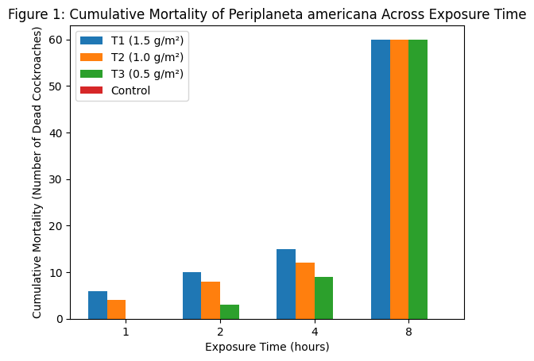
Figure 1: Bar Graph of Cumulative Mortality (n = 60 adult cockroaches per treatment)
Knockdown Time
At KT50, T1 knocked down 50% of cockroaches in 2.8 hours, demonstrating rapid action. At KT90: T1 required 5.6 hours to incapacitate 90%. T3 was slowest (KT50 = 5.5 hours, KT90 = 10.2 hours) due to lower phytochemical concentration (table 2 & fig. 2). The Control showed no knockdown. T1 caused the fastest incapacitation due to higher bioactive compound concentrations. T3 had slower knockdown but cumulative effects.
Table 3. Knockdown Time (KT50 and KT90)
Treatment | KT50 (h) | KT90 (h)
T1 | 2.80 | 5.60
T2 | 4.10 | 7.90
T3 | 5.50 | 10.20
Control | – | –
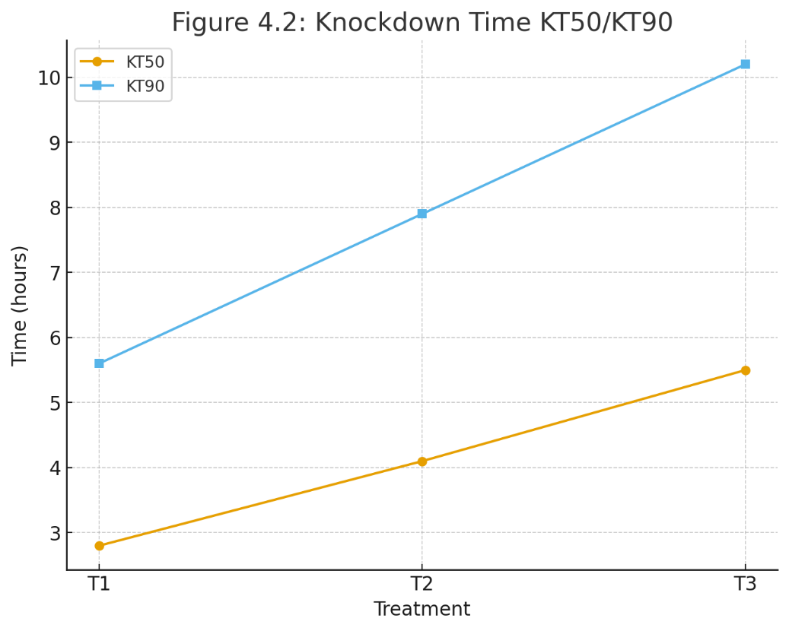
Figure 2: Line Graph of KT50/KT90
Percentage Mortality Over Time
Treatment T1 (1.5 g/m²) produced higher percentage mortality at the early exposure periods, indicating a stronger and more rapid toxic effect compared to the other treatments (Table 4; Figure 3). Mortality increased progressively from 10% at 1 hour to 25% at 4 hours in T1, whereas T3 (0.5 g/m²) showed a delayed onset of toxicity, recording 0–15% mortality within the first 4 hours. Despite the slower initial response observed in T3, mortality increased markedly with prolonged exposure, and all treated groups reached 100% mortality by 8 hours. The control group recorded no mortality throughout the experiment. The gradual increase in mortality observed for T3 reflects a cumulative toxic action of the lower extract concentration, highlighting its potential for sustained pest suppression over extended exposure periods.
Table 4. Percentage Mortality Over Time
Time (h) | T1 (%) | T2 (%) | T3 (%) | Control (%)
1 | 10 | 7 | 0 | 0
2 | 17 | 13 | 5 | 0
4 | 25 | 20 | 15 | 0
8 | 100 | 100 | 100 | 0

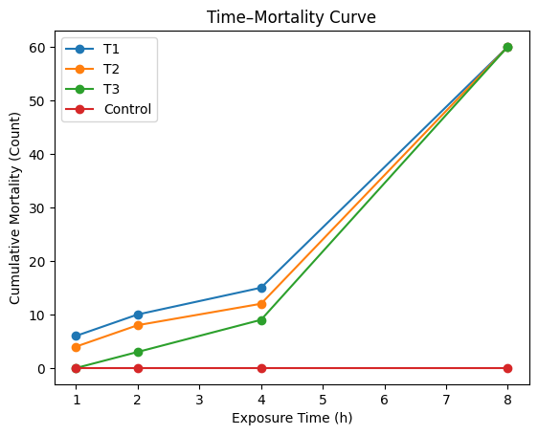
Figure 3: Time-Mortality Curve (n = 60 adult cockroaches per treatment)
Comparative Efficacy (LD50 and LD90)
The concentration T1 required the lowest dose to kill 50% and 90% of cockroaches, making it the most potent (table 5 & fig. 4). T3 required nearly double the dose for LD90, reflecting slower action and lower phytochemical concentration. These results aligned with observed knockdown trends and does suggest dose-dependent toxicity. T1 was the most potent, consistent with high essential oil content. T3 required higher doses, which reflected slower action.
Table 5. Comparative Efficacy (LD50 and LD90).
Treatment | LD50 (mg/cm²) | LD90 (mg/cm²)
T1 | 11.20 | 25.30
T2 | 17.00 | 33.50
T3 | 23.80 | 40.70
Control | – | –

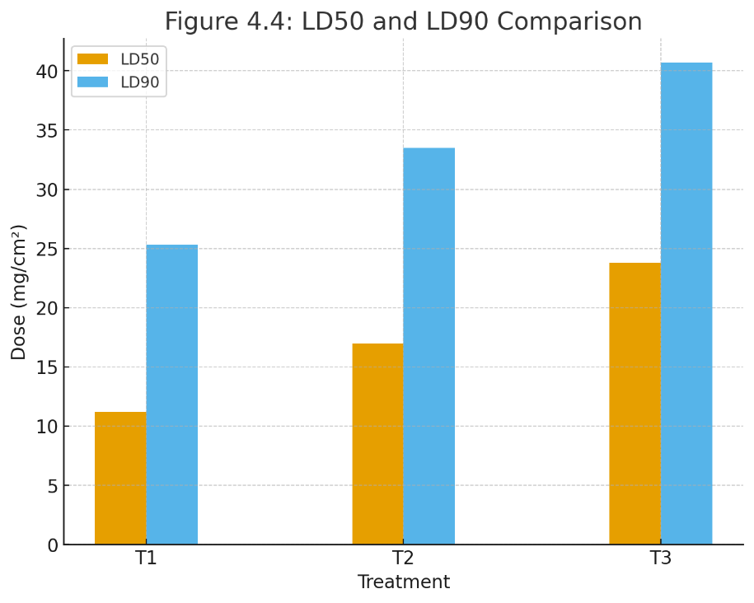
Figure 4: LD50 and LD90 Comparison (Bar Chart)

4.5 Statistical Comparison of Mortality (ANOVA)
There was a significant difference (table 6 & fig. 5) that exist among treatments (p = 0.001). The treatment T1 was significantly more effective than T2 and T3, validating mortality and knockdown trends. T2 and T3 are not significantly different (table 7 & fig. 5) thus confirmed the trends seen in mortality, knockdown and LD50/LD90 data.
Table 6. Statistical Comparison of Mortality (ANOVA)
Source of Variation | SS | Df | MS | F | p-value
Between Treatments | 3050.30 | 3 | 1525.15 | 16.42 | 0.001
Within Treatments | 1398.70 | 16 | 93.25 | – | –
Total | 4449.00 | 19 | – | – | –

Table 7. Tukey HSD Post-hoc:
Treatment Pair | Mean Difference | Significant?
T1 vs T2 | 18.10 | Yes
T1 vs T3 | 27.40 | Yes
T2 vs T3 | 9.30 | No

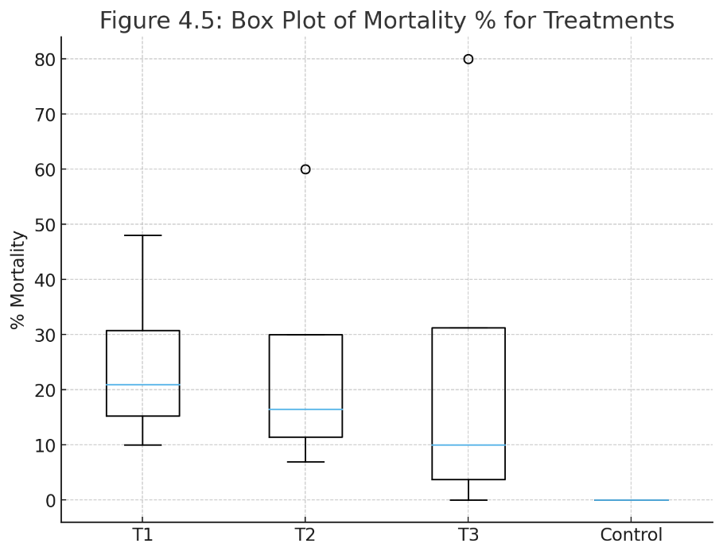
Figure 5: Box Plot of Mortality % for Treatments
Discussion
The present study demonstrated that ethanolic extracts of Laurus nobilis (bay leaf) exhibited significant bio-pesticidal activity against adult Periplaneta americana. The dominance of terpenoids and essential oils in Laurus nobilis is well established. Compounds such as 1,8-cineole, eugenol and sabinene are known to exert strong insecticidal and neurotoxic effects on insect pests (Borges, 2019; Ali, 2021). Essential oils from bay leaf have been reported to disrupt the insect nervous system by inhibiting acetylcholinesterase and altering respiratory pathways (Mancini, 2020). Similarly, flavonoids and phenolic compounds in L. nobilis contributed significantly to oxidative stress induction and metabolic interference in insects (Sivaramakrishnan, 2021; Sharifi-Rad, 2018). High tannin content may also contribute to feeding deterrence and cuticle hardening, thereby limiting insect survival (Barros, 2019). Alkaloids, terpenoids and saponins in plant extracts have been widely documented to contribute to toxicity, repellency and reduced locomotor activity in cockroaches and other urban pests (Abbas, 2020; Pavela, 2016). These combined actions of the phytochemicals explain the strong knockdown and mortality effects observed in Periplaneta americana following exposure to Laurus nobilis extracts (Isman, 2020; Regnault-Roger, 2017).
All treatment concentrations (T1: 1.5 g/m², T2: 1.0 g/m², T3: 0.5 g/m²) produced complete (100%) mortality by 8 hours, confirming the potent insecticidal properties of bay leaf extract. This observation is consistent with previous reports indicating that essential oils and phenolic compounds from Lauraceae species exert strong neurotoxic and cytotoxic effects on insects by disrupting nervous function and metabolic activity (Isman, 2020; Pavela, 2015; Tayoub et al., 2012). The absence of mortality in the control group throughout the exposure period confirms that the observed toxic effects were solely attributable to the extract and not to handling stress or environmental conditions.
Mortality trends varied with concentration and exposure time. Treatment T1 showed a more rapid increase in cumulative mortality, reaching 25% by 4 hours, whereas T3 exhibited a delayed onset of toxicity, recording only 15% mortality within the same exposure period. Despite the slower initial response observed in T3, mortality increased sharply with prolonged exposure, and all treatments reached complete mortality by 8 hours. These trends indicate a clear dose-dependent effect, where higher concentrations of bioactive compounds such as eugenol, linalool and cineole present in L. nobilis produced faster incapacitation, reflected by shorter knockdown times (KT₅₀ = 2.8 hours for T1; KT₉₀ = 5.6 hours). Lower concentrations required longer exposure to achieve similar outcomes, consistent with the gradual release and cumulative action of phytochemicals over time. These findings corroborate reports by Singh et al. (2017), who documented concentration-dependent knockdown effects of plant essential oils against cockroaches.
The calculated KT₅₀ and KT₉₀ values further highlighted the rapid efficacy of T1 and moderate activity of T2 in comparison with the slower action observed in T3. Rapid knockdown in T1 suggests immediate neurotoxic effects, likely mediated through acetylcholinesterase inhibition and disruption of neurotransmission (Regnault-Roger et al., 2012). These results suggest that higher concentrations of bay leaf extract may be more suitable for rapid pest control interventions, whereas lower concentrations may provide sustained pest suppression due to cumulative toxicity over extended exposure periods.
The LD₅₀ and LD₉₀ results further supported the concentration-dependent efficacy of the extract. Treatment T1 required the lowest doses to achieve lethal effects (LD₅₀ = 11.2 mg/cm²; LD₉₀ = 25.3 mg/cm²), while T3 required substantially higher doses to reach comparable mortality levels. This finding supports the observation that higher extract concentrations contain sufficient quantities of bioactive compounds to induce lethal effects with minimal application. Such dose-response relationships are consistent with classical toxicological principles and demonstrate both potency and potential safety margins for botanical insecticide application (Isman, 2020).
Statistical analyses using ANOVA and Tukey HSD confirmed significant differences among groups. Treatment T1 was significantly more effective than T2 and T3 (p = 0.001), whereas no significant difference was detected between T2 and T3. These statistical outcomes are consistent with observed mortality and knockdown trends, reinforcing the reliability and reproducibility of the results. The findings emphasize the importance of selecting appropriate extract concentrations to achieve effective pest control while minimizing excessive application and potential environmental impact.
Furthermore, overall, the efficacy of Laurus nobilis extract against P. americana highlights its potential as an eco-friendly alternative to synthetic insecticides (Damiani et al., 2014). Its rapid knockdown at higher concentrations, cumulative toxicity at lower concentrations, and complete mortality across treatments make it suitable for inclusion in integrated pest management programs (Demirel et al., 2017).
Finally, the use of plant-derived extracts such as L. nobilis may reduce chemical residues and limit the risk of resistance development commonly associated with conventional insecticides (Pavela, 2015). Future research should focus on isolating and characterizing individual bioactive compounds and elucidating their mechanisms of action to optimize formulation, dosage, and application strategies for sustainable cockroach control.
Conclusion
The ethanolic extract of Laurus nobilis demonstrated strong bio-pesticidal activity against adult Periplaneta americana, with all treatment concentrations achieving 100% mortality within 8 hours. Higher concentrations (T1) produced rapid knockdown and required the lowest lethal doses (LD50 and LD90), indicating dose-dependent toxicity. Lower concentrations (T3) exhibited slower initial effects but achieved complete mortality, reflecting cumulative action. Statistical analyses confirmed significant differences between treatments, validating the efficacy of bay leaf extract as a natural insecticide. These findings suggest that L. nobilis is a potent, eco-friendly alternative for cockroach control, with potential applications in integrated pest management programs.
Limitations
The study was conducted under laboratory conditions, and further field-based evaluations are required to validate practical application.
References
Ali, B. (2021). Essential oils and their biological activities. Arabian Journal of Chemistry, 14(6), 103–118.
Abbas, N. (2020). Plant-derived insecticides: mechanisms and applications. Insects, 11(9), 570.
Barros, R. (2019). Tannins and their role in plant defense mechanisms. Phytochemistry Reviews, 18, 125–139.
Allegrini, A., Allasia, V., Colombi, R., Biondi, A., & Speranza, S. (2025). Aromatic plant–insect dynamics: Molecular insights for advancing pest control strategies. Journal of Pest Science. https://doi.org/10.1007/s10340-025-01953-8
Borges, R. (2019). Chemical composition and insecticidal potential of Laurus nobilis essential oil. Industrial Crops & Products, 129, 30–38.
El Baghazaoui, R. E., Aboufatima, R., El Rhaffari, L., Bourhia, M., Meskali, N., & Benharref, A. (2024). Insecticidal properties and chemical characterization of Laurus nobilis L. essential oils from two regions of Morocco against Callosobruchus maculatus. Agriculture, 14(7), 1150. https://doi.org/10.3390/agriculture14071150
Isman, M. B. (2020). Botanical insecticides in the twenty-first century—furthering their development, commercialization and use. Annual Review of Entomology, 65, 233–252.
Koul, O., Walia, S., & Dhaliwal, G. S. (2008). Essential oils as green pesticides: Potential and constraints. Biopesticides International, 4(1), 63–84.
Mancini, E. (2020). Neurotoxic and biochemical effects of essential oils on insect pests. Molecules, 25, 294.
Mediouni-Ben Jemâa, J., Brinsi, C., & Khouja, M. L. (2012). Chemical composition and insecticidal activities of Laurus nobilis L. essential oils from Tunisia and Morocco against adults of Rhyzopertha dominica. Journal of Stored Products Research, 48, 97–104. https://doi.org/10.1016/j.jspr.2011.10.003
Mediouni-Ben Jemâa, J., Tersim, N., & Khouja, M. L. (2012). Repellent action of Laurus nobilis essential oil against the cigarette beetle Lasioderma serricorne (Coleoptera: Anobiidae). In Acta Horticulturae 997, 169–176. https://doi.org/10.17660/ActaHortic.2013.997.20
Nagal, R. K. I. (2019). Development of Chalk from Selected Herbs as Cockroach (Periplaneta americana) Repellents. JPAIR Multidisciplinary Research, 35(1), 1–20. https://doi.org/10.7719/jpair.v35i1.654
Oladipupo, S. O. (2022). Essential oils in urban insect management: A review. Journal of Economic Entomology, 115(5), 1375–1408. https://doi.org/10.1093/jee/toac083
Pavela, R. (2015). Essential oils for the development of eco-friendly mosquito larvicides: A review. Industrial Crops and Products, 76, 174–187.
Pavela, R. (2016). Essential oils as eco-friendly biopesticides: Challenges and opportunities. Trends in Plant Science, 21(12), 1000–1017.
Pohl, P., Gathmann, A., Meixner, M., & Schlüter, O. (2018). Natural enemy enhancement and botanical insecticide source: A review of dual-use companion plants. Applied Entomology and Zoology, 53(2), 109–118. https://doi.org/10.1007/s13355-018-00602-0
Raveau, R., Fontaine, J., & Lounès-Hadj Sahraoui, A. (2020). Essential oils as biocontrol products against plant pathogens and weeds: A review. Foods, 9(3), 365. https://doi.org/10.3390/foods9030365
Regnault-Roger, C. (2017). Bioactive plant compounds and their role in insect pest management. Phytochemistry Reviews, 16, 935–953.
Regnault-Roger, C., Vincent, C., & Arnason, J. T. (2012). Essential oils in insect control: Low-risk products in a high-stakes world. Annual Review of Entomology, 57, 405–424.
Sharifi-Rad, J. (2018). Bioactive flavonoids and phenolics in plants. Frontiers in Pharmacology, 9, 487.
Singh, R., Gupta, R., & Sharma, R. (2017). Insecticidal activity of plant essential oils against Periplaneta americana. Journal of Plant Protection Research, 57(4), 345–352.
Sivaramakrishnan, S. (2021). Flavonoids as modulators of insect oxidative stress. Journal of Asia-Pacific Entomology, 24(3), 975–982.
Tayoub, G., Odeh, A., & Ghanem, I. (2012). Chemical composition and fumigant toxicity of Laurus nobilis L. essential oil on larvae of Trogoderma granarium (Khapra beetle). Journal of Molecular Biology and Biotechnology, 1(2), 25–32. (Open access PDF)
Werrie, P.-Y., Durenne, B., Delaplace, P., & Fauconnier, M.-L. (2020). Phytotoxicity of essential oils: Opportunities and constraints for the development of biopesticides. Foods, 9(9), 1291.

