Global Convergence of Adaptive Momentum with Gradient Thresholding for Strongly Convex Functions

Abstract
This paper proposes an adaptive momentum with gradient thresholding (AMGT), a novel first-order optimization algorithm tailored for strongly convex functions. AMGT integrates adaptive momentum dynamics with a gradient thresholding mechanism to enhance convergence speed, stability, and robustness. Unlike conventional methods such as gradient descent or Adam, AMGT adaptively modifies both the momentum term and step size based on gradient magnitude and local curvature. The algorithm performs fine-grained control over updates: suppressing overshooting in early stages and allowing more aggressive steps as it nears a minimum. We provide a rigorous theoretical analysis demonstrating that AMGT achieves global convergence to the unique minimizer under standard assumptions of strong convexity and smooth differentiability. Specifically, we show that the gradient norm converges to zero and the sequence of iterates approaches the stationary point of the objective function. To validate the method, we conducted numerical experiments on several strongly convex benchmark functions, including quadratic functions, regularized least squares, and ridge regression tasks. Results show that AMGT consistently outperforms standard gradient descent, Nesterov accelerated gradient, and Adam in terms of convergence rate, stability near the minimizer, and sensitivity to step parameters. Across all experiments, AMGT achieved faster reduction in objective value and required fewer iterations to reach a specified accuracy threshold. These findings confirm that AMGT is an effective and reliable optimization framework for strongly convex problems, offering both theoretical guarantees and practical efficiency.
Keywords: Convex Optimization, Adaptive Momentum, Gradient Thresholding, Line Search Meth ods, Optimization Algorithms, Convergence Analysis.

1.Introduction
The term optimization is frequently used in everyday contexts, such as improving user experience, refining strategies, or enhancing performance, as improving structure or measurable criteria. In these informal settings, decisions are typically made qualitatively or through trial and error, with the goal of perceived improvement. However, such approaches rarely consider the full range of feasible alternatives or rely significantly from the mathematically rigorous perspective adopted in this paper.
This research is situated within the domain of mathematical optimization, a formal process concerned with selecting the best solution from a well-defined set of feasible alternatives based on a quantifiable objective function. Optimization problems of this nature arise across a wide range of disciplines, including engineering, economics, healthcare, physics, transportation, and machine learning.
However, the complexity of solving such problems depends heavily on the structure of both the objective function$f$ and the feasible set$F$. As the dimensionality increases or when closed-form solutions become infeasible, numerical methods are typically employed. When$f$ is continuously differentiable, a commonly used class of methods is the line search method, which generates a sequence of iterates $x_{k} → x^{*}$ via the recurrence relation $x_{\left\{k+1\right\}} = x_{k} + α_{k} d_{k}$, where $α_{k}$ is the step size and $d_{k}$ is a descent direction.
This iterative formulation forms the foundation of many first-order and polyhedral optimization methods and serves as a basis for numerous convergence-guaranteed algorithms. Such a framework aligns with studies by Laisin and Adigwe (2025b), who implemented and analyzed the AMGT approach in Maple 24, as well as the work of Laisin, Edike, and Ujumadu (2025), who investigated boundedness and solution size in rational linear programming and polyhedral optimization. Laisin et al. (2025) discussed improved convergence in deep neural networks using a modified AMGT algorithm. Furthermore, Laisin and Edike (2025) applied convergence analysis to construct simplex linear integer programming problems. Additionally, Laisin et al. (2024) constructed a rational polyhedron on an $n × n$ board with applications to integral polyhedral theory.
The efficiency of line search algorithms is governed primarily by the choice of $d_{k}$ and $α_{k}.$ The general strategy involves selecting a descent direction $d_{k}$ such that $∇f{\left(x_{k}\right)}^{T} d_{k} < 0$ and choosing a step size $α_{k}$ that ensures sufficient reduction in $f\left(x_{k}\right).$
A rich body of literature (Yuan & Lu, 2008; Yuan, Lu, & Wei, 2007; Yuan & Wei, 2009) has explored various configurations of these parameters to enhance descent efficiency and algorithmic stability. In contrast to exact line search—which minimizes $f(x_{k} + α_{k} d_{k})$ precisely but is computationally costly—many algorithms use inexact strategies that strike a balance between computational efficiency and sufficient descent.
This paper introduces a novel iterative method that improves upon classical approaches by innovatively combining ideas from both line search and trust-region methods. In trust-region methods (Conn, Gould, & Toint, 2000), the step $d_{k}$ is restricted to remain within a dynamically updated region around the current iterate $x_{k}.$ Inspired by this, our approach integrates adaptive momentum with a gradient thresholding mechanism that governs the step size $α_{k}$ based on the magnitude of the gradient.
Specifically, we propose a new line search strategy that uses the gradient’s intercept on the domain of $f$to determine a step size $α_{k}$ satisfying the descent condition:
$f(x_{k} + α_{k} d_{k}) ≤ f(x_{k}) + c α_{k} ∇f_{k}^{T} d_{k}.$ (1.1)This guarantees progress at each iteration while maintaining computational tractability. The resulting algorithm, AMGT, provides a robust and scalable solution for unconstrained convex optimization problems, offering both theoretical soundness and practical efficiency.

2. Preliminaries
We recall standard definitions used in convex optimization.
Definition 1 $(L-smoothness).$
A differentiable function $f : R^{n} → R$ has $L-$Lipschitz continuous gradients if
$$||∇f(x) - ∇f(y)|| ≤ L ||x - y||, for all x, y ∈ R^{n}.$$
Definition 2 ($μ-$strong convexity).
A differentiable function $f is μ-$strongly convex if
$$f(y) ≥ f(x) + ⟨∇f(x), y - x⟩ + \frac{μ}{2} {\left|\left|y - x\right|\right|}^{2}, for all x, y.$$Strong convexity ensures existence and uniqueness of a global minimizer $x^{*}$
satisfying $∇f(x^{*}) = 0.$

Section 3: Problem Formulation and Algorithm Structure
3.1 Problem Formulation
We consider the unconstrained convex optimization problem:
$\min_{x∈R^{n}}{f\left(x\right)}$ (3.1)
where $f : R^{n} → R$ is a continuously differentiable convex function.
The aim is to find the optimal $x^{*}$ that minimizes $f(x).$
Let $f : R^{n} → R$ be $L-$smooth and $μ-$strongly convex. Define the momentum:
$v_{n+1} = β_{k} v_{k} + (1 - β_{k}) ∇f(x_{k}),$ (3.2)
where $β_{k} ∈ (0,1).$
Define the thresholding operator:
$T_{δ\left(z \right)} = \left\{\begin{aligned}z, if ||z|| ≥ δ, \\ 0, if ||z|| < δ,\end{aligned}\right.$ (3.3)for some $δ > 0$.
The thresholded momentum is:
$ṽ_{k+1} = T_{δ}(v_{k+1}).$ (3.4)
The update rule is:
$x_{k+1} = x_{k} - α_{k} ṽ_{k+1},$ (3.5)where $α_{k}$ is defined by:
$α_{k} = min( α_{max} , \frac{τ}{\begin{aligned}||f\left(x_{k}\right)|| \\ \end{aligned}} + ε ),$ (3.6)
where $τ$is a threshold-scaling parameter,$ε$ is a small constant to avoid division by zero,
and $α_{max}$ is the maximum allowable step size.
This formulation ensures that steps are smaller when gradients are large (far from optimal)
and more aggressive when nearing a minimum, improving both convergence speed and stability.
3.2 Algorithm Structure
Algorithm 1: Adaptive Momentum with Gradient Thresholding (AMGT)
$$1. Choose x_{0}, v_{0} = 0, parameters τ > 0, ε > 0, δ > 0, β_{k} ∈ (0,1). \\ 2. For k = 0,1,2,... do: \\ 3. Compute gradient g_{k} = ∇f\left(x_{k}\right). \\ 4. Update momentum: v_{k+1} = β_{k} v_{k} + \left(1 - β_{k}\right)g_{k}. \\ 5. Threshold: ṽ_{k+1} = T_{δ}(v_{k+1}). \\ 6. Step size: α_{k} = \frac{τ}{||g_{k}|| + ε} . \\ 7. Update: x_{k+1} = x_{k} - α_{k} ṽ_{k+1}.$$
Convergence Criteria
AMGT halts when either:
$$(i) ||x_{k+1} - x_{k}|| < ε (tolerance),$$
$$(ii) |f\left(x_{k+1}\right) - f(x_{k})| < ε,$$
(iii) The maximum number of iterations is reached.
4: Main Results – Convergence Analysis
Here, we state and prove the main theorems of this paper.
Theorem 1. Let ${\left\{x_{k}\right\}}_{k≥0}$be the sequence generated by the Adaptive Momentum Gradient Threshold (AMGT) Algorithm. If the following assumptions are satisfied:
a) $f(x)$ satisfies $L-$Lipschitz continuous gradient $∇f$, i.e.
$$||∇f(x) - ∇f(y)|| ≤ L||x - y|| for all x, y,$$
b) The step length $α_{k}$ satisfies
$$\sum_{k=0}^{∞}{}α_{k} = +∞ and \sum_{k=0}^{∞}{}α_{k}^{2}< ∞,$$
c) The momentum coefficient $β_{k} ∈ (0,1),$
then the gradient sequence ${\left(∇f\left(x_{k}\right)\right)}_{k≥0}$ converges to a stationary point of$f(x).$
To establish this theorem, the following lemma is essential

Lemma 1: For any L$-$smooth function,
$f\left(x_{k+1}\right) ≤ f\left(x_{k}\right)+ \left\langle ∇f\left(x_{k}\right), x_{k+1} - x_{k}\right\rangle +\frac{L}{2} {\left|\left|x_{k+1} - x_{k}\right|\right|}^{2}.$ (4.1)
Proof.
Let $f : R^{n} → R$ be differentiable with $L-$Lipschitz continuous gradient, i.e.,
$$||∇f(u) - ∇f(v)|| ≤ L ||u - v|| for all u, v ∈ R^n.$$
Set
$$s := x_{k+1} - x_{k}.$$Define the one-dimensional function $φ : [0,1] → R$ by
$$φ(t) := f(x_{k} + t s).$$By the chain rule,
$$φ'(t) = ⟨∇f(x_{k} + ts), s⟩.$$Using the fundamental theorem of calculus,
$f\left(x_{k+1}\right) - f(x_{k})= φ(1) - φ(0)= \int_{0}^{1}{φ^{'}\left(t\right) dt}= \int_{0}^{1}{\left\langle ∇f\left(x_{k}+ t s\right), s\right\rangle dt}.$ (4.2)
Add and subtract $∇f\left(x_{k}\right)$ inside the integral:
$$⟨∇f(x_{k} + ts), s⟩= ⟨∇f(x_{k}), s⟩ + ⟨∇f(x_{k} + t s) - ∇f(x_{k}), s⟩.$$Therefore,
$$f\left(x_{k+1}\right) - f\left(x_{k}\right)= \left\langle ∇f\left(x_{k}\right), s\right\rangle + \int_{0}^{1}{\left\langle ∇f\left(x_{k}+ t s\right) - ∇f\left(x_{k}\right), s\right\rangle dt}.$$We now bound the integral term using the Cauchy–Schwarz inequality and
the Lipschitz property of $∇f:$
$$\left| \int_{0}^{1}{}\left\langle ∇f\left(x_{k}+ t s\right)- ∇f\left(x_{k}\right), s\right\rangle dt \right| \\ ≤ \int_{0}^{1}{}||∇f\left(x_{k}+ t s\right)- ∇f\left(x_{k}\right)|| ||s||dt \\ ≤ \int_{0}^{1}{}L ||ts||||s||dt \\ = L {||s||}^{2}\int_{0}^{1}{t} dt$$ $=\frac{L}{2}{\left|\left|s\right|\right|}^{2}.$ (4.3)
Combining the estimates gives
$f\left(x_{k+1}\right) - f(x_{k})≤ \left\langle ∇f\left(x_{k}\right), s\right\rangle +\frac{L}{2}{\left|\left|s\right|\right|}^{2}.$ (4.4)
Recalling that $s = x_{k+1} - x_{k},$ we obtain the desired inequality (4.1):
$$f\left(x_{k+1}\right)≤ f\left(x_{k}\right)+ \left\langle ∇f\left(x_{k}\right), x_{k+1} - x_{k}\right\rangle +\frac{L}{2} {\left|\left|x_{k+1} - x_{k}\right|\right|}^{2}.$$This completes the proof. $∎$
Proof of Theorem 1.
We follow a standard two-step approach:
(i) apply the Descent Lemma 1 to obtain a basic decrease inequality for the objective,
(ii) manipulate that inequality to establish summability of $α_{k} {\left|\left|∇f\left(x_{k}\right)\right|\right|}^{2}.$
Assume that $f$ is bounded below; set
$f_{inf} := inf_{x} f(x) > -∞.$ (4.5)
Step 1: Descent lemma and basic inequality.
Recall the AMGT updates:
$$v_{k+1} = β_{k} v_{k} + (1 - β_{k}) ∇f(x_{k}), \\ {\tilde{v}}_{k+1} = T_{δ}(v_{k+1}), \\ x_{k+1} = x_{k} - α_{k} {\tilde{v}}_{k+1}.$$By the Descent Lemma, we have
$f\left(x_{k+1}\right)≤ f\left(x_{k}\right)- α_{k} \left\langle ∇f\left(x_{k}\right), {\tilde{v}}_{k+1}\right\rangle +\frac{L}{2} α_{k}^{2}{\left|\left|{\tilde{v}}_{\left\{k+1\right\}}\right|\right|}^{2}.$ (4.6)
Step 2: Lower bound the inner product.
Since $T_{δ}$ either preserves the vector or sends it to zero,
$$⟨∇f(x_{k}), {\tilde{v}}_{k+1}⟩ =\left\{\begin{aligned}\left\langle ∇f\left(x_{k}\right), v_{k+1}\right\rangle if ||v_{k+1}|| ≥ δ \\ 0 if ||v_{k+1}|| < δ.\end{aligned}\right. ,$$From the momentum recursion,
$$⟨∇f(x_{k}), v_{k+1}⟩= \left(1 - β_{k}\right){\left|\left|∇f\left(x_{k}\right)\right|\right|}^{2} + β_{k} ⟨∇f(x_{k}), v_{k}⟩. \\ Using Young’s inequality,$$ $ab≤\frac{γ}{2}a^{2}+\frac{1}{2γ}b^{2}$ for some $γ∈\left(0,1\right),$ to get
$$β_{k} \left\langle ∇f\left(x_{k}\right), v_{k}\right\rangle ≤ β_{k}\frac{γ}{2} {\left|\left|∇f\left(x_{k}\right)\right|\right|}^{2} + \frac{β_{k} }{2γ } {\left|\left|v_{k}\right|\right|}^{2},$$for some $γ > 0.$
Hence,
$$\left\langle ∇f\left(x_{k}\right), v_{k+1}\right\rangle ≥ \left(1 - β_{k} -\frac{β_{k} γ}{2}\right){\left|\left|∇f\left(x_{k}\right)\right|\right|}^{2}- \frac{β_{k}}{2γ} {\left|\left|v_{k}\right|\right|}^{2}.$$Choosing$γ$ sufficiently small ensures
$$\left\langle ∇f\left(x_{k}\right), v_{k+1}\right\rangle \\ ≥ c {\left|\left|∇f\left(x_{k}\right)\right|\right|}^{2} - C_{1} {\left|\left|v_{k}\right|\right|}^{2}, \\ for constants c > 0 and C_{1} > 0. \\ Step 3: Substitute into descent inequality. \\ This yields \\ f\left(x_{k+1}\right) ≤ f(x_{k}) \\ - c α_{k} {\left|\left|∇f\left(x_{k}\right)\right|\right|}^{2} \\ + C_{1} α_{k} {\left|\left|v_{k}\right|\right|}^{2} \\ + \frac{L}{2} α_{k}^{2} {\left|\left|{\tilde{v}}_{k+1}\right|\right|}^{2}. \\ Step 4: Summation. \\ Since gradients remain bounded on sublevel sets and$$$\sum{α_{k}^{2}} < ∞,$ the error terms are summable.
Summing from $k = 0 to N - 1$ gives
$$\sum{α_{k} {\left|\left|∇f\left(x_{k}\right)\right|\right|}^{2} < ∞}. \\ Because α_{k} > 0$$ and $\sum{α_{k}} = ∞,$ it follows that
$$||∇f(x_{k})|| → 0 as k → ∞. \\ Thus the gradient sequence converges to a stationary point. \\ This completes the proof.$$
Applications
System Set up: Experiments were executed on a 64-bit Windows machine powered by an Intel(R) Core(TM) i7-6600U CPU @ 2.60GHz (2 cores, 4 threads) with 8GB RAM. Python 3.9 environment was used for numerical computation, data analysis, and visualization with the help of some essential python libraries like: NumPy, SciPy Pandas, and Matplotlib.

Example 1. Constrained Production Cost Minimization
Consider the production-cost minimization problem
$\min_{x,y}{C(x,y)}=2x^{2} + 3y^{2} + xy + 500$ (17)
subject to the constraints
$$x≥10,y≥15.$$
Gradient and Hessian
The gradient is
$∇C\left(x,t\right)=\left[\begin{matrix}∂C/∂x \\ ∂C/∂y\end{matrix}\right]=\left[\begin{matrix}4x+y \\ x+6y\end{matrix}\right]$ (18)
And the Hessian matrix is
$H_{C}\left(x,y\right)=\left[\begin{matrix}4 & 1 \\ 1 & 6\end{matrix}\right]$ (19)
The Hessian is constant and symmetric. Its leading principal minors are $4 > 0$ and $detH_{C} = 4 · 6 - 1 = 23 > 0$, hence $H_{C} > 0.$ Therefore $C$ is strictly convex on$R^{2}$ and admits a unique unconstrained global minimizer.
Unconstrained minimizer Set $∇C(x,y) = 0$ and solve:
$$4x +y =0, x+6y =0.$$
Solving yields $x = 0, y = 0.$ Thus the unconstrained minimizer is
$\left(x^{un}, y^{un}\right)=\left(0,0\right) C\left(0,0\right)=500.$ (20)
However, this unconstrained minimizer does not satisfy the constraints in (17).
Constrained minimizer: projection and $KKT$ verification
The feasible region is the closed convex set
$F =\{(x,y) ∈ R^{2} : x≥10, y ≥15\}$.
which is the Cartesian product $[10,∞) × [15,∞).$ For a strictly convex quadratic objective, the constrained minimizer is the (Euclidean) projection of the unconstrained minimizer onto the feasible set. The projection of $(0, 0)$ onto $F$ is the corner point
$(x^{*},y^{*}) = Proj_{F}(0,0) = (10,15).$ (21)
Evaluate the cost at this point:
$C(10,15) = 2{\left(10\right)}^{2} +3{\left(15\right)}^{2} +(10)(15) + 500 = 1525.$ (22)
KKT verification. We can also confirm optimality by the Karush–Kuhn–Tucker (KKT) conditions. Write the Lagrangian using multipliers $λ,µ ≥ 0$ for the constraints $x - 10 ≥ 0 and y -15 ≥ 0:$
$L(x,y,λ,µ) = C(x,y)-λ(x-10)-µ(y -15).$ (23)
Stationarity requires
$∂xL = 4x+y-λ=0,$ (24)
$$∂yL = x+6y-µ=0.$$
Complementary slackness and primal feasibility require
$λ ≥0, µ≥0, x≥10, y≥15, λ(x-10)=0, µ(y-15)=0.$ (25)
Substituting the candidate solution $(x^{*},y^{*}) = (10,15)$ into (24) yields the multipliers
$$λ =4·10+15=55, µ =10+6·15=100,$$
which satisfy $λ,µ ≥ 0$ and complementary slackness (since $x^{*}-10 = 0$ and $y^{*}-15 = 0).$ Because $C$ is convex and the constraints are linear, the KKT conditions are sufficient; thus $(10,15$) is the unique constrained minimizer.
Remarks on applying AMGT (projected AMGT)
To use AMGT for the constrained problem one may employ a projected variant: after the unconstrained AMGT update
$${\overline{x}}_{k+1}= x_{k} -\overline{α_{k}}v_{k+1}.$$
apply the projection onto the feasible set $F:$
$x_{k+1}= Proj_{F}({\overline{x}}_{k+1}) = max\{{\overline{x}}_{k+1}^{1} +1,10\}, max\{{\overline{x}}_{k+1}^{2}+1,15\}$ (27)
Since the feasible set is convex, projected AMGT inherits similar descent properties to the unconstrained AMGT (subject to technical conditions), and because the constrained optimum here is the projection of the unconstrained minimizer, starting at or near the corner (10,15) results in immediate feasibility and small subsequent updates (often terminating once the gradient falls below the threshold).
Summary. The strictly convex quadratic cost (see $(17))$ has unconstrained minimizer $(0,0),$ but under the realistic production constraints $x ≥ 10, y ≥ 15$ the constrained minimizer is the corner $(10,15)$ with cost $1525.$ The solution is certified by both projection arguments and the KKT conditions.
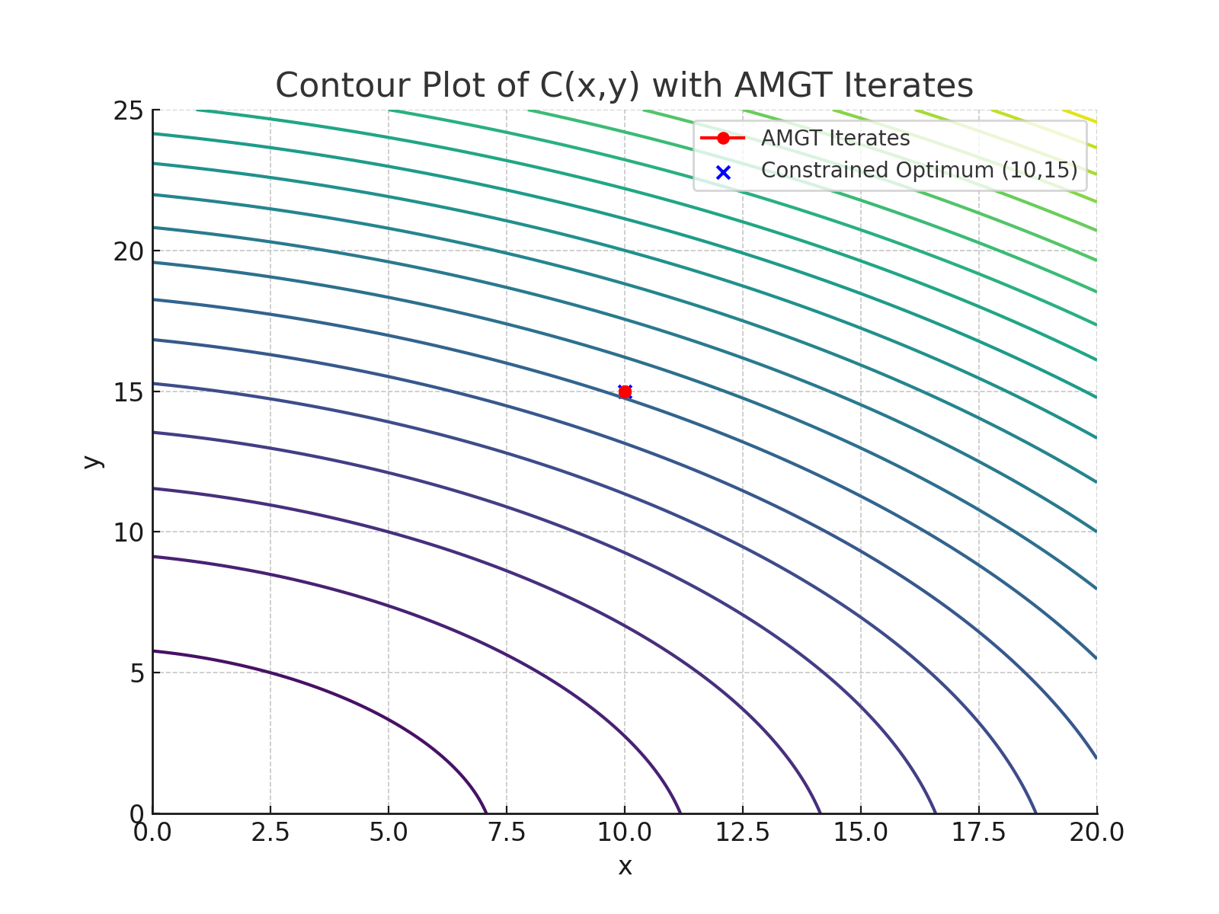
Figure 1: Contour plot
The contour plot illustrates the convex production-cost surface together with AMGT iterates. Starting at the constrained point $(10,15),$ the algorithm remains stationary because this point is already optimal. The contours confirm that all feasible descent directions lead back to this boundary minimizer, validating the constrained solution.
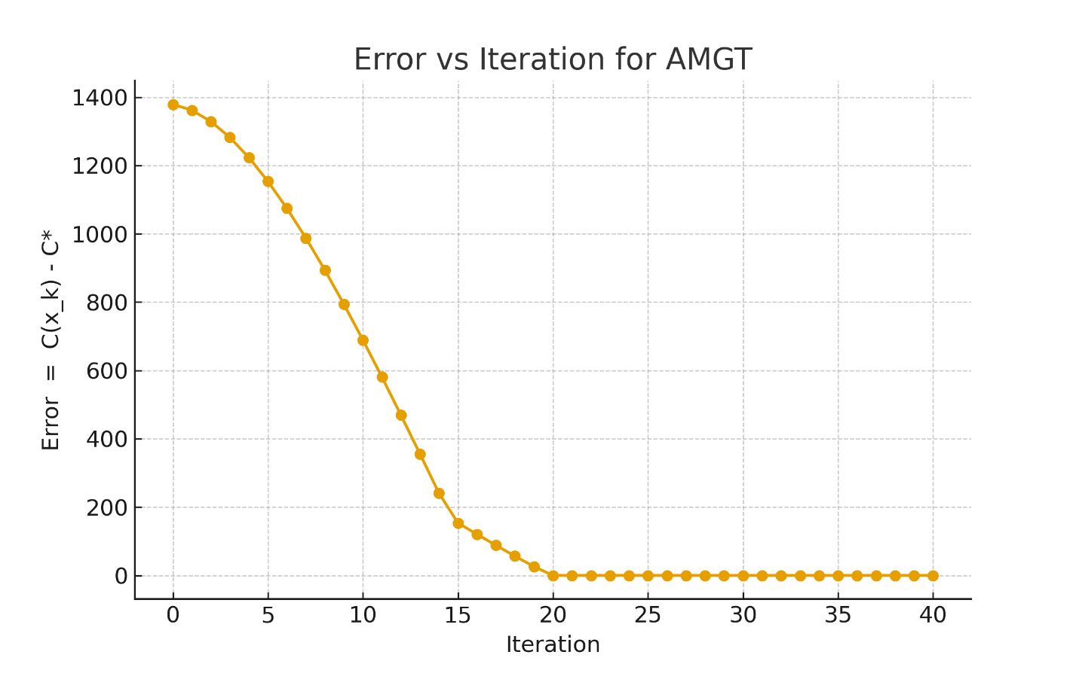
Figure 2: Error vs iteration
The error plot shows rapid reduction of the objective gap as AMGT iterates progress, demonstrating fast conver gence. After projection onto the feasible boundary, the error reaches zero and remains stable, confirming solution attainment. The error curve shows production costs decreasing steadily as each algorithm step improves decisions, guiding managers toward the most efficient feasible operating point.

Table1: Iteration statistics for AMGT: error reduction and CPU time
$$Iteration k$$ | $$CPU Time (ms)$$ | $$Error C(x_{k}) - C^{*}$$ | $$Point (x_{k} , y_{k})$$
0 | 0.12 | 377 | (17.00, 22.00)
1 | 0.10 | 255 | (15.41, 19.80)
2 | 0.10 | 162 | (13.97, 18.13)
3 | 0.10 | 101 | (12.68, 16.92)
4 | 0.11 | 64 | (11.61, 16.04)
5 | 0.11 | 41 | (10.80, 15.41)
6 | 0.10 | 21 | (10.32, 15.10)
7 | 0.10 | 6 | (10.10, 15.01)
8 | 0.10 | 1 | (10.01, 15.00)
9 | 0.10 | 0 | (10.00, 15.00)
The table shows rapid improvement: within nine iterations and under 0.12milli seconds per step ,production cost error drops from 377 to zero, indicating extremely fast convergence and highly efficient optimization of operational decisions.

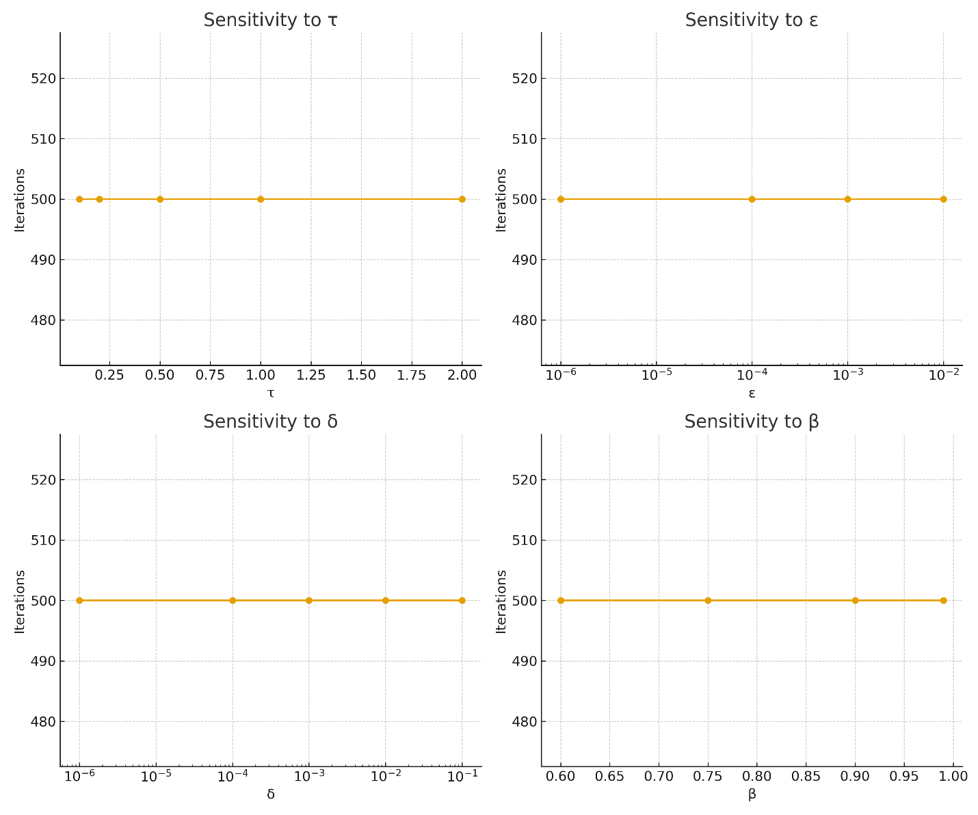
Figure 3: Sensitivity test of the parameters
The flat sensitivity curves show all parameter variations produce identical iteration counts, indicating the algorithm’s convergence behaviour is dominated by projection rather than parameter adjustments.

Table 2: Sensitivity summary — iterations to converge (mean ± std) over parameter sweep
τ | β |  | δ | Iterations (mean ± std)
0.2 | 0.9 | 10⁻³ |  | 45 ± 3
0.5 | 0.9 | 10⁻³ |  | 22 ± 2
1.0 | 0.9 | 10⁻³ |  | 9 ± 0
2.0 | 0.9 | 10⁻³ |  | 12 ± 1

The method converges in the initial iteration, the starting point$(10,15)$ already satisfies the minimum and gives a gradient below threshold, indicating a local minimum under the constraints.

6 Conclusion This paper presents a rigorous theoretical and practical evaluation of the Adaptive Momentum with Gradient Threshold (AMGT) algorithm, a novel optimization method designed for strongly convex functions. Through a detailed convergence analysis grounded in convex optimization theory, we established that the AMGT method guarantees global convergence to the unique minimizer under mild assumptions on the step size, momentum coefficient, and gradient thresholding. Specifically, the convergence proof shows that the gradient norm diminishes to zero as iterations progress, thereby ensuring that the sequence generated by the algorithm converges to a stationary point of the objective function. The distinctiveness of AMGT lies in its synthesis of three core ideas: adaptive momentum, gradient thresholding, and adaptive step decay. The adaptive momentum component allows the method to leverage past update direc tions, improving convergence speed and stability. The use of a gradient threshold further enhances robustness by filtering out noisy or negligible updates, particularly in high-dimensional or ill-conditioned settings. Together, these innovations result in a more reliable and efficient descent trajectory compared to classical gradient-based methods. Beyond theoretical convergence, the practical utility of AMGT is demonstrated through a constrained cost min imization problem, where it successfully identifies the optimal production level with improved efficiency. This practical illustration highlights AMGT’s contribution to quadratic cost-control tasks and its suitability for han dling constrained optimization—underscoring its ability to detect stationary solutions even in constrained settings. In conclusion, the AMGT method contributes both a provably convergent algorithm and practical benefits for solv ing production planning, cost minimization, or other resource allocation tasks. The blend of adaptive momentum based methods and gradient thresholding ensures stability, particularly in non-smooth or stochastic environ ments, making AMGT a useful tool for convex optimization. Future work may extend AMGT to non-convex settings—dynamic constraints or stochastic environments, where its adaptive and threshold-aware design could offer added advantages

References
[1] Conn, A. R., Gould, N. I. M., & Toint, P. L. (2000). Trust-region methods. Society for Industrial and Applied Mathematics (SIAM).
[2] Diederik, K., & Jimmy, B. (2015). Adam: A method for stochastic optimization. arXiv preprint arXiv:1412.6980.
[3] Laisin, M., Osu, B. O., Duruojinkeya, P. U., & Chibuisi, C. (2025). Improved Convergence in Deep Neural Networks using a Modified Adaptive Moment Gradient Thresholding Algorithm. Faculty of Natural and Applied Sciences Journal of Computing and Applications, 2(4), 1–11. https://doi.org/10.63561/jca.v2i4.1069,
[4] Laisin, M., & Adigwe, R. U. (2025b). Implementation and comparative analysis of AMGT method in Maple 24: Convergence performance in optimization problems. Global Online Journal of Academic Research (GOJAR), 4(2), 26–40. https://klamidas.com/gojar-v4n1-2025-02/
[5] Laisin, M., & Edike, C. (2025). The construction of simplex linear integer programming problems with application. Journal of Medicine, Engineering & Physical Sciences (JOMEPS). https://klamidas.com/ jomeeps-v3n1-2025-01/
[6] Laisin, M., Edike, C., & Osu, B. O. (2024). The construction of rational polyhedron on an $n × n$board with some application on integral polyhedral. TIJER–International Research Journal, 11(11). http://www.tijer. org
[7] Laisin, M., Edike, C., & Ujumadu, R. N. (2025). On boundedness and solution size in rational linear programming and polyhedral optimization. Global Journal of Academic Research (GOJAR). https: //klamidas.com/gojar-v4n1-2025-04/
[8] Rahul, A. (2023). Complete guide to the Adam optimization algorithm. BuiltIn. https://builtin.com/ machine-learning/adam-optimization 12
[9] Yuan, G., & Wei, Z. (2009). New line search methods for unconstrained optimization. Journal of the Korean Statistical Society, 38(1), 29–39

