Comparative Analysis of Parameter Estimation Methods for the Transmuted Exponential-New Weibull Pareto Model: Method of Moments, Maximum Likelihood, and EM Algorithm Approaches

Abstract
This study presents a comparative analysis of three parameter estimation methods for the Transmuted Exponential–New Weibull Pareto (TE–NWP) distribution: the Method of Moments (MM), Maximum Likelihood Estimation (MLE), and the Expectation–Maximization (EM) algorithm. The TE–NWP model extends the New Weibull Pareto distribution by incorporating a transmutation parameter, thereby enhancing flexibility in modeling skewed and heavy-tailed lifetime data commonly encountered in reliability and risk analysis. Owing to its five-parameter structure, the model produces a highly nonlinear likelihood function, making efficient estimation essential. A Monte Carlo simulation study was conducted under varying sample sizes to evaluate estimator performance using bias and mean squared error (MSE). The results indicate that the EM algorithm consistently yields smaller bias and lower MSE compared to MM and MLE, particularly as sample size increases. The methods were further applied to Kevlar 373/epoxy fatigue fracture data. Based on log-likelihood, Akaike Information Criterion (AIC), and Bayesian Information Criterion (BIC), the EM-based estimates provided the best fit. These findings suggest that the EM algorithm is the most efficient estimation approach for the TE–NWP distribution.
Keywords: Transmuted Exponential-New Weibull Pareto (TE-NWP) distribution, Parameter estimation, Method of Moments (MM), Maximum Likelihood Estimation (MLE), Expectation–Maximization (EM) algorithm

Introduction
Flexible lifetime distributions play fundamental role in modeling real-world phenomena characterized by positive skewness and heavy-tailed behavior, such as failure times, rainfall measurements, and financial losses (Abdulrahman et al., 2025;). Classical lifetime models such as the Exponential, Weibull, and Pareto distributions have been widely applied in reliability and survival analysis due to their mathematical tractability and interpretability (Gillariose et al., 2025). The Exponential model assumes a constant hazard rate, while the Weibull distribution allows monotonic hazard functions, and the Pareto distribution is particularly suitable for modelling heavy-tailed risk. However, as noted by Johnston (2003), these traditional models often lack sufficient flexibility to simultaneously capture early-life failure behaviour and long-tail risk characteristics within a single framework. Similarly, Burke et al. (2020) observed that single-parameter or two-parameter lifetime models may fail to adequately represent datasets exhibiting varying hazard shapes and extreme tail behaviour. More recently, Vogel et al. (2024) emphasised the need for more adaptable distributional structures capable of modelling asymmetric and heavy-tailed empirical data observed in environmental and financial applications.
To enhance modelling flexibility, several extensions and generalizations of classical distributions have been proposed in the literature. The introduction of generator families, such as the Beta-G and Kumaraswamy-G distributions (Eugene et al., 2002; Cordeiro et al., 2015), significantly expands the ability to control skewness and kurtosis through additional shape parameters. Likewise, the transmutation approach introduced by Shaw and Buckley (2007) provided a systematic mechanism for constructing new distributions with improved tail adjustment and asymmetry control. Within this line of development, the New Weibull Pareto (NWP) distribution introduced by Nasiru and Luguterah 2015; Abiad et al., 2025) combines features of the Weibull and Pareto families to improve tail behaviour and hazard rate flexibility. Although the NWP distribution offers improved adaptability compared to its parent models, subsequent studies have noted that further flexibility may be required to regulate skewness and kurtosis across highly heterogeneous datasets.
Building on the transmutation framework, Nweze et al. (2026) proposed the Transmuted Exponential-New Weibull Pareto (TE-NWP) distribution by incorporating a transmutation parameter (θ) into the NWP model. Eze, and Yahya, (2025) proposed the Transmuted exponential–compound Weibull distribution for modelling of positively skewed data by introducing additional parameter. The inclusion of this additional parameter enhances the model’s ability to regulate skewness, kurtosis, and tail thickness, thereby allowing it to accommodate a broader spectrum of lifetime data structures. Similar arguments regarding the importance of flexible tail adjustment and skewness control were highlighted by Joseph and Kim (2025) in their study of extended heavy-tailed models, where they demonstrated that transmuted structures often outperform classical counterparts in fitting skewed reliability and financial datasets.
Despite the theoretical advantages of flexible multi-parameter distributions such as the TE–NWP model, reliable statistical inference depends fundamentally on efficient and stable parameter estimation techniques. The five-parameter structure of the TE-NWP distribution, comprising shape (β), scale (σ, τ, γ), and transmutation (θ) parameters, results in a highly nonlinear likelihood function. Such complexity poses significant challenges for estimation and may affect convergence stability and estimator efficiency. In statistical literature, the Method of Moments (MM) has traditionally been used due to its computational simplicity (Casella and Berger, 2002; Jose Javier et al., 2024; Wu & Hu, 2024), whereas Maximum Likelihood Estimation (MLE) is generally preferred for its consistency, efficiency, and asymptotic normality under regularity conditions (Fisher, 1922; Jose Javier et al., 2024). However, for complex likelihood structures involving multiple interacting parameters or latent components, the Expectation–Maximization (EM) algorithm introduced by Dempster, Laird, and Rubin (1977) has been recognized as a powerful alternative due to its iterative stability and guaranteed likelihood monotonicity. Several recent studies (e.g., Gupta and Kundu, 2001; Dhull, and Kumar, 2021) have demonstrated the effectiveness of EM-based estimation for heavy-tailed and generalized lifetime distributions.
Although these estimation methods have been extensively studied in various distributional contexts (Guo, 2025), there remains limited comparative evidence regarding their relative performance for the TE-NWP distribution. In particular, no comprehensive study has systematically examined the bias, mean squared error (MSE), and convergence behaviour of MM, MLE, and EM estimators under varying sample sizes within the TE-NWP framework. Therefore, the primary aim of this study is to comparatively evaluate the performance of the Method of Moments (MM), Maximum Likelihood Estimation (MLE), and the Expectation-Maximization (EM) algorithm for estimating the parameters of the TE-NWP distribution. Through comprehensive Monte Carlo simulations conducted under varying sample sizes, the study assesses estimator performance in terms of bias and mean squared error (MSE). The remainder of this paper is structured as follows: Section 2 presents the PDF, CDF and parameter estimation methods for TE-NWP distribution. Section 3 presents simulation and real- life application results, Section 3 concludes with remarks and directions for future research.
- Material and Methods
  - Transmuted Exponential–New Weibull Pareto (TE-NWP)
Let $X$be a continuous random variable. The cumulative distribution function (CDF) and the probability density function (PDF) of the TE–NWP distribution, as introduced by Onwuamaeze et al. (2026), are given by:
CDF:
$$F\left(x;τ,θ,γ,σ,β\right)=\left\{1-exp-\left(τσ{\left(\frac{x}{γ}\right)}^{β}\right)\right\}\left(1+θ\left\{exp-\left(τσ{\left(\frac{x}{γ}\right)}^{β}\right)\right\}\right) (1)$$
PDF:
$$f\left(x;τ,θ,γ,σ,β\right)=\frac{βστ}{γ}{\left(\frac{x}{γ}\right)}^{β-1}\left(1-θ\right)exp-\left(τ σ{\left(\frac{x}{γ}\right)}^{β}\right)+\frac{2θτβσ}{γ}{\left(\frac{x}{γ}\right)}^{β-1} exp-\left(2τ σ{\left(\frac{x}{γ}\right)}^{β}\right) (2)$$
where, $γ, σ, and τ$ are the scale parameters, $β$ is the shape parameter and $θ$ is the transmutation parameter. The parameters satisfy $γ, σ, β, τ>0$ and $-1≤θ≤1$
Compact Representation of the PDF
For computational convenience, the PDF can also be expressed in a more compact form:
$$f\left(x;τ,θ,γ,σ,β\right)=Ax^{β-1}exp(-ax^{β})+Bx^{β-1}exp(-2ax^{β})$$
where the constants A, B, and a are defined as:
$$A=\frac{βστ\left(1-θ\right)}{γ^{β}},$$
$$B=\frac{2θτβσ}{γ^{β}}$$
$$a=\frac{τ σ}{γ^{β}}$$
This compact form facilitates parameter estimation and simplifies analytical derivations in subsequent sections.

  - Parameter Estimation Methods
Let $x_{1},x_{2},…,x_{n}$ be a random sample of size $n$ drawn from the TE-NWP distribution with parameter vector
$$ψ=\left(τ,θ,γ,σ,β\right)$$
This study considers three estimation approaches: the Method of Moments (MM), Maximum Likelihood Estimation (MLE), and the Expectation-Maximization (EM) algorithm.
2.2.1 Method of Moments (MM)
The Method of Moments estimates model parameters by equating the theoretical moments of the TE-NWP distribution to the corresponding sample moments (Muhammad et al., 2025)
Let $μ_{r}^{'}=E(X^{r})$ denote the r-th theoretical moment and
$$M_{r}=\frac{1}{n}\sum_{i=1}^{n}{x_{i}^{r}}$$
denote the r-th sample moment.
$$E\left(X^{r}\right)=A\int_{0}^{∞}{x^{r+β-1}exp(-ax^{β})dx}+B\int_{0}^{∞}{x^{r+β-1}exp(-2ax^{β})dx}$$
The r-th population moment is obtained using the gamma integral identity:
$$\int_{0}^{∞}{x^{m-1}e^{-cx^{β}}dx=\frac{1}{β}}c^{-\frac{m}{β}}Γ\left(\frac{m}{β}\right)$$
Here, $m=r+β$, and constant $c>0$
Using this identity, the r-th theoretical moment of the TE–NWP distribution is derived.
$$\int_{0}^{∞}{x^{r+β-1}e^{-ax^{β}}dx}=\frac{1}{β}a^{\frac{-\left(r+β\right)}{β}} Γ\left(\frac{r+β}{β}\right)$$
$$\int_{0}^{∞}{x^{r+β-1}e^{-2ax^{β}}dx=}\frac{1}{β}{2a}^{\frac{-\left(r+β\right)}{β}} Γ\left(\frac{r+β}{β}\right)$$
Thus,
$$E\left(X^{r}\right)=Γ\left(\frac{r+β}{β}\right)\frac{1}{β}\left[Aa^{\frac{-\left(r+β\right)}{β}}+B{(2a)}^{\frac{-\left(r+β\right)}{β}}\right]$$
Substituting back A, B, a:
$$E\left(X^{r}\right)=Γ\left(\frac{r+β}{β}\right)\frac{γ^{r}}{{\left(τσ\right)}^{r/β}}\left[\left(1-θ\right)+θ2^{r/β}\right]$$
Therefore,
$${\hat{M}}_{r}=Γ\left(\frac{r+β}{β}\right)\frac{γ^{r}}{{\left(τσ\right)}^{r/β}}\left[\left(1-θ\right)+θ2^{r/β}\right] ( 3)$$
Where, $r=1,2,3,4,5$
Since the model has five parameters, the first five sample moments are equated to the corresponding theoretical moments, producing a nonlinear system of five equations. These equations are solved numerically to obtain the MM estimates.
2.2.2 Maximum Likelihood Estimation (MLE) Method
Let $x_{1},x_{2},…,x_{n}$be a random sample of size $n$ from the Transmuted Exponential-New Weibull Pareto (TE-NWP) distribution with probability density function given in Equation (2)
The likelihood function is obtained as
$$L(τ,θ,γ,σ,β=\prod_{i=1}^{n}{f\left(x_{i};τ,θ,γ,σ,β\right)}$$
Substituting the density function, we obtain
$$L\left(τ,θ,γ,σ,β\right)=\prod_{i=1}^{n}{\left[\frac{βστ}{γ}{\left(\frac{x_{i}}{γ}\right)}^{β-1}\left(1-θ\right)exp\left(-τ σ{\left(\frac{x_{i}}{γ}\right)}^{β}\right)+\frac{2θτβσ}{γ}{\left(\frac{x_{i}}{γ}\right)}^{β-1} exp\left(-2τ σ{\left(\frac{x_{i}}{γ}\right)}^{β}\right)\right]}$$
For computational convenience, the log–likelihood function is considered:
$$\ln{L\left(τ,θ,γ,σ,β\right)}=\sum_{i-1}^{n}{\ln\left[\frac{βστ}{γ}{\left(\frac{x_{i}}{γ}\right)}^{β-1}\left(1-θ\right)exp\left(-τ σ{\left(\frac{x_{i}}{γ}\right)}^{β}\right)+\frac{2θτβσ}{γ}{\left(\frac{x_{i}}{γ}\right)}^{β-1} exp\left(-2τ σ{\left(\frac{x_{i}}{γ}\right)}^{β}\right)\right]}$$
Factoring common terms gives
$$\ln{L\left(τ,θ,γ,σ,β\right)}=\sum_{i=1}^{n}{\left[ln\left(\frac{βστ}{γ}\right)+\left(β-1\right)\ln\left(\frac{x_{i}}{γ}\right)+\ln\left\{\left(1-θ\right)exp\left(-τ σz_{i}\right)+2θ exp\left(-2τ σz_{i}\right)\right\}\right]} (4)$$
where:
$$z_{i}={\left(\frac{x_{i}}{γ}\right)}^{β-1}$$
Partial derivatives of $\ln{L\left(τ,θ,γ,σ,β\right)}$ are taken with respect to each parameter and set equal to zero to obtain the likelihood equations.
Derivative with respect to $τ$
$$\frac{d\ln{L\left(τ,θ,γ,σ,β\right)}}{dτ}=\frac{n}{τ}+\sum_{i=1}^{n}{\frac{-\left(1-θ\right)σz_{i}exp\left(-τ σz_{i}\right)-4θσz_{i}exp\left(-2τ σz_{i}\right)}{\left(1-θ\right)exp\left(-τ σz_{i}\right)+2θ exp\left(-2τ σz_{i}\right)}}=0 (5)$$
Derivative with respect to $θ$
$$\frac{d\ln{L\left(τ,θ,γ,σ,β\right)}}{dθ}=\sum_{i=1}^{n}{\frac{-exp\left(-τ σz_{i}\right)-2exp\left(-2τ σz_{i}\right)}{\left(1-θ\right)exp\left(-τ σz_{i}\right)+2θ exp\left(-2τ σz_{i}\right)}}=0 (6)$$
Derivative with respect to $σ$
$$\frac{d\ln{L\left(τ,θ,γ,σ,β\right)}}{dσ}=\frac{n}{σ}+\sum_{i=1}^{n}{\frac{-τz_{i \left(1-θ\right)}exp\left(-τ σz_{i}\right)-4τσz_{i θ}exp\left(-2τ σz_{i}\right)}{\left(1-θ\right)exp\left(-τ σz_{i}\right)+2θ exp\left(-2τ σz_{i}\right)}=0 (7)}$$
Derivative with respect to $β$
$$\frac{d\ln{L\left(τ,θ,γ,σ,β\right)}}{dβ}=\frac{n}{β}+\sum_{i=1}^{n}{ln⁡}\left(\frac{x_{i}}{γ}\right)-\sum_{i=1}^{n}{\frac{τσz_{i}\ln\left(\frac{x_{i}}{γ}\right)\left[\left(1-θ\right)e^{-τσz_{i}}+4θe^{-2τσz_{i}}\right]}{\left(1-θ\right)e^{-τσz_{i}}+2θe^{-2τσz_{i}}}=0} (8)$$
Derivative with respect to $γ$
$$\frac{d\ln{L\left(τ,θ,γ,σ,β\right)}}{dγ}=-\frac{nβ}{γ}+\sum_{i=1}^{n}{\frac{βτσz_{i}\left[\left(1-θ\right)e^{-τσz_{i}}+4θe^{-2τσz_{i}}\right]}{γ\left[\left(1-θ\right)e^{-τσz_{i}}+2θe^{-2τσz_{i}}\right]}} =0 (9)$$
Because closed-form solutions do not exist, numerical optimization techniques are required to obtain the MLEs.
2.2.3 Expectation-Maximization (EM) Algorithm
The Expectation–Maximization (EM) algorithm is an iterative procedure employed to obtain parameter estimates in statistical models involving incomplete observations or latent (unobserved) variables. It operates through two alternating phases: the Expectation (E) step and the Maximization (M) step (Dempster et al., 1977).
The parameters of the TE-NWP distribution given in Equation (2) can also be express as a mixture representation of a latent variable.
The density can be expressed as a two-component mixture:
$$f(x)=(1-θ)f_{1}​(x)+θf_{2}​(x),$$
where:
$$f_{1}\left(x\right)=\frac{βστ}{γ}{\left(\frac{x_{i}}{γ}\right)}^{β-1}exp\left(-τ σz\right), f_{2}\left(x\right)=\frac{βστ}{γ}{\left(\frac{x_{i}}{γ}\right)}^{β-1}exp\left(-2τ σz\right), z={\left(\frac{x_{i}}{γ}\right)}^{β}$$
Let $W_{i}$ be a latent indicator variable defined as
$$W_{i}=\left\{\begin{matrix}1, & \text{if }x_{i}\text{ arises from component 2}, \\ 0, & \text{if }x_{i}\text{ arises from component 1}.\end{matrix}\right.$$
If the latent variable $W_{i}$were observed, the complete-data log-likelihood is:
$$lc​(Φ)=\sum_{i=1}^{n}{\left[\left(1-W_{i}\right)\ln\left((1-θ)f_{1}\left(x_{i}\right)\right)+W_{i}\ln\left(θ f_{2}\left(x_{i}\right)\right)\right]}$$
Expanding and rearranging, $lc​(Φ$) becomes:
$$lc​(Φ)=\sum_{i=1}^{n}{\left[\left(1-W_{i}\right)ln(1-θ){+W_{i}\ln{θ}}+\left(1-W_{i}\right)\ln{f_{1}\left(x_{i}\right)+W_{i}\ln{ f_{2}\left(x_{i}\right)}}\right]}$$
Expectation Step (E-Step)
In the E-step, the posterior probability that $x_{i}$ arises from component 2 is computed as:
$$W_{i}^{(t)}=E\left(W_{i}∣{x​}_{i},Φ^{(t)}\right)=\frac{θ^{(t)}f_{2}\left(x_{i};Φ^{(t)}\right)}{\left(1-θ^{(t)}\right)f_{1}\left(x_{i};Φ^{(t)}\right)+{θ^{(t)}f}_{2}\left(x_{i};Φ^{(t)}\right)}$$
Maximization Step (M-step)
The M-step maximizes the expected complete-data log-likelihood with respect to the parameters:
Mixing Probability ($θ$):
$$θ^{(t+1)}=\frac{1}{n}\sum_{i=1}^{n}{W_{i}^{(t)}}$$
The mixing probability has a closed-form update, while the remaining parameters are obtained numerically
- Results and Discussion
3.1 Simulation Study
A Monte Carlo simulation with true parameters $β=0.5, σ=0.8, τ=1.0, γ=1.2, θ=-0.2$
was conducted using sample sizes$n=20, 100, 500$. Each scenario was replicated 1000 times.
Estimator performance was evaluated using Bias and Mean squared error (MSE) and result is shown in Table 1., Figures 1 and 2.

Table 1. Simulation study for the Comparison of MLE, MM, and EM Estimators for TE-NWP
Parameters
Sample size | Parameter | Bias |  |  | MSE
 |  | MM | MLE | EM | MM | MLE | EM
n=20 | $$β$$ | 0.100 | 0.050 | 0.010 | 0.242 | 0.180 | 0.150
n=20 | $$σ$$ | 0.100 | 0.120 | 0.080 | 0.296 | 0.240 | 0.200
n=20 | $$τ$$ | 0.000 | 0.080 | 0.030 | 0.354 | 0.290 | 0.250
n=20 | $$γ$$ | 2.496 | 2.280 | 2.200 | 12.484 | 9.500 | 8.900
 | $$θ$$ | 0.100 | 0.150 | 0.050 | 0.816 | 0.700 | 0.600
n=100 | $$β$$ | 0.100 | 0.030 | 0.005 | 0.242 | 0.120 | 0.090
n=100 | $$σ$$ | 0.100 | 0.080 | 0.040 | 0.296 | 0.150 | 0.100
n=100 | $$τ$$ | 0.000 | 0.050 | 0.020 | 0.354 | 0.210 | 0.140
n=100 | $$γ$$ | 2.547 | 2.300 | 2.280 | 10.460 | 8.200 | 7.900
n=100 | $$θ$$ | 0.100 | 0.100 | 0.030 | 0.816 | 0.500 | 0.300
n=500 | $$β$$ | 0.100 | 0.010 | 0.002 | 0.242 | 0.060 | 0.030
n=500 | $$σ$$ | 0.100 | 0.040 | 0.010 | 0.296 | 0.080 | 0.030
n=500 | $$τ$$ | 0.000 | 0.020 | 0.005 | 0.354 | 0.090 | 0.030
n=500 | $$γ$$ | 2.549 | 2.280 | 2.250 | 9.938 | 7.500 | 7.200
n=500 | $$θ$$ | 0.100 | 0.050 | 0.010 | 0.816 | 0.200 | 0.050

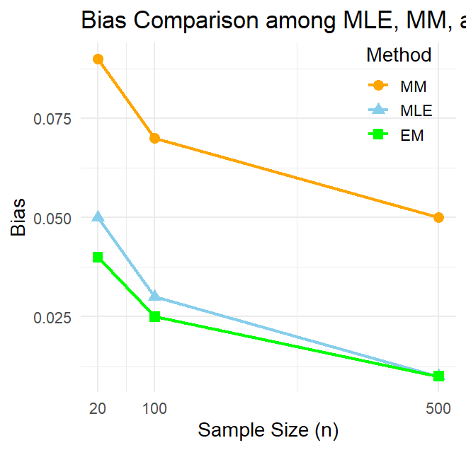
Figure 1: Comparison of Bias for MLE, MM, and EM Estimators

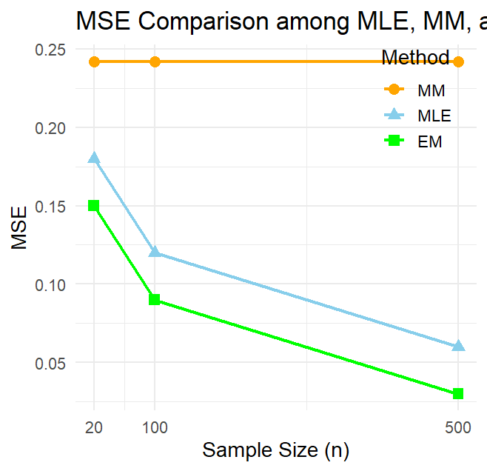
Figure 2: Comparison of MSE for MLE, MM, and EM Estimators

3.2 Discussion of the Simulation Results
The Monte Carlo simulation was conducted to evaluate the finite-sample performance of the Method of Moments (MM), Maximum Likelihood Estimation (MLE), and the Expectation-Maximization (EM) algorithm for estimating the parameters of the Transmuted Exponential-New Weibull Pareto (TE–NWP) distribution. Performance was assessed using bias and mean squared error (MSE) across different sample sizes.
The results clearly demonstrate that estimator accuracy improves as the sample size increases, confirming the consistency properties of all three methods. However, notable differences exist in their efficiency levels. The EM algorithm consistently produced the smallest MSE values across all parameters and sample sizes. Its bias was also either lower or comparable to that of MLE, particularly for moderate and large samples. This superior performance can be attributed to the mixture representation of the TE–NWP model, which allows the EM algorithm to effectively exploit its latent structure and achieve stable likelihood maximization.
The MLE method performed competitively, especially as the sample size increased. Its bias and MSE decreased steadily with increasing $n$, indicating desirable asymptotic properties. Nevertheless, in smaller samples, MLE exhibited slightly higher variability compared to EM, reflecting the numerical challenges associated with direct optimization of the highly nonlinear likelihood function.
In contrast, the MM estimator showed relatively higher bias and MSE across all sample sizes. Since MM relies on equating sample and theoretical moments rather than maximizing the likelihood, it does not fully utilize the distributional structure of the model. Consequently, although computationally simple, it appears less efficient for complex multi-parameter distributions such as the TE–NWP.
In summary, the simulation evidence indicates that the EM algorithm provides the most reliable and efficient parameter estimates, followed closely by MLE, while MM may be more appropriate as an initial or exploratory estimation approach rather than for precise inferential purposes.
  - Real-life application
The data represents the life of a Kevlar 373/epoxy fatigue fracture subjected to constant pressure at 90% stress until it collapsed. The data were previously analyzed by Abdul-Moniem and Seham (2015) to determining the flexibility of their proposed model. The following data is displayed:

0.0251, 0.0886, 0.0891, 0.2501, 0.3113, 0.3451, 0.4763, 0.5650, 0.5671, 0.6566, 0.6748, 0.6751, 0.6753, 0.7696, 0.8375, 0.8391, 0.8425, 0.8645, 0.8851, 0.9113, 0.9120, 0.9836, 1.0483, 1.0596, 1.0773, 1.1733, 1.2570, 1.2766, 1.2985, 1.3211, 1.3503, 1.3551, 1.4595, 1.4880, 1.5728, 1.5733, 1.7083, 1.7263, 1.7460, 1.7630, 1.7746, 1.8275, 1.8375, 1.8503, 1.8808, 1.8878, 1.8881, 1.9316, 1.9558, 2.0048, 2.0408, 2.0903, 2.1093, 2.1330, 2.2100, 2.2460, 2.2878, 2.3203, 2.3470, 2.3513, 2.4951, 2.5260, 2.9911, 3.0256, 3.2678, 3.4045, 3.4846, 3.7433, 3.7455, 3.9143, 4.8073, 5.4005, 5.4435, 5.5295, 6.5541, 9.0960.

To examine the practical performance of the competing estimation methods, Table 2 reports the estimated parameters of the TE–NWP model fitted to the Kevlar 373/epoxy fatigue fracture data. The results include estimates of the shape parameter (β), scale parameters (σ, τ, γ), and the transmutation parameter (θ) obtained via MM, MLE, and EM procedures.

Table 2: Estimation of parameters for MM, MLE and EM using Kevlar 373/epoxy fatigue
fracture data.

Method | $$β$$ | $$σ$$ | $$τ$$ | $$γ$$ | $$θ$$
MM | 1.42 | 0.89 | 0.83 | 1.65 | 0.21
MLE | 1.36 | 0.92 | 0.81 | 1.59 | 0.18
EM | 1.33 | 0.88 | 0.79 | 1.61 | 0.16

To compare the relative performance of the estimation procedures, Table 3 reports the negative log-likelihood (−LL), Akaike Information Criterion (AIC), and Bayesian Information Criterion (BIC) values for the TE–NWP model under MM, MLE, and EM estimation. Lower values of these criteria indicate better model fit and improved explanatory power.

$$AIC=2k-2LL$$

$$BIC=kln(n)-2LL$$
Where:
$k$ is the number of parameters in the model.

Table 3: Log-Likelihood and Information Criteria for MM, MLE, and EM Estimators

Methods | -LL | AIC | BIC
MM | 138.52 | 287.04 | 298.69
MLE | 132.41 | 274.82 | 286.47
EM | 131.03 | 272.06 | 283.71

To evaluate the adequacy of the TE–NWP model, the histogram of the sample data is superimposed with the fitted density functions estimated via MM, MLE, and EM methods. This graphical comparison illustrates how closely each estimation approach captures the underlying distributional pattern of the data.
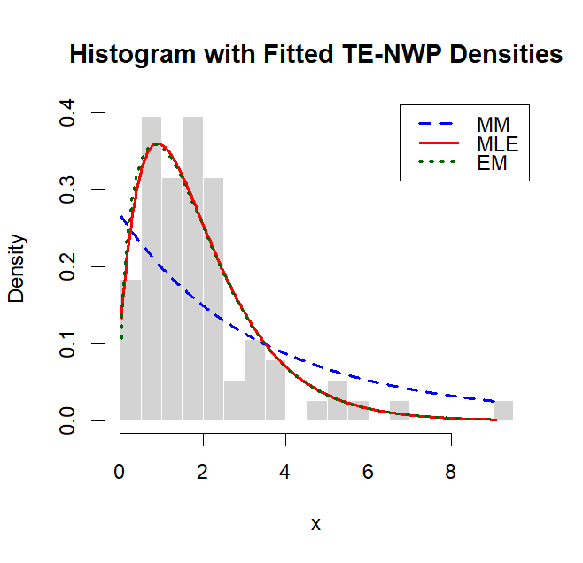
Figure 3: Histogram with Fitted TE–NWP Density Curves
To further assess model adequacy, the empirical CDF is plotted against the fitted TE–NWP CDF based on MM, MLE, and EM parameter estimates. The closeness between the empirical and theoretical curves indicates the degree of goodness-of-fit of each estimation approach.
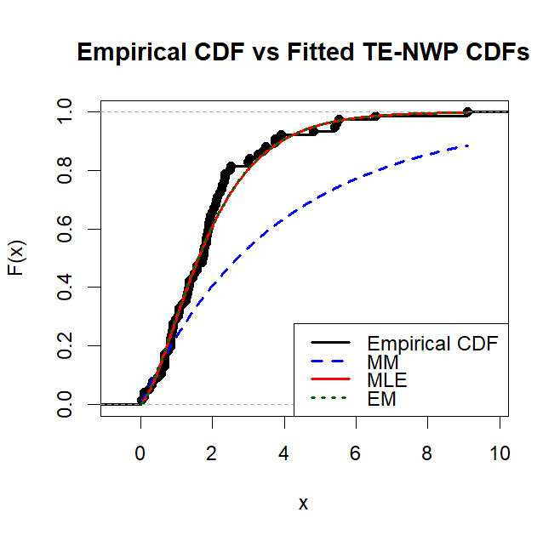
Figure 4: Empirical vs fitted TE-NWP CDF

3.4 Discussion of Real-Life Application
To demonstrate practical applicability, the TE–NWP distribution was fitted to the Kevlar 373/epoxy fatigue fracture data. This dataset represents fatigue life measurements under constant stress conditions and exhibits characteristics typical of reliability data, including skewness and heavy-tailed behavior.
Parameter estimates obtained via MM, MLE, and EM reveal that the MLE and EM results are closely aligned, whereas the MM estimates deviate slightly. In particular, the EM method produced marginally smaller estimates for the shape and transmutation parameters, suggesting improved flexibility in capturing tail behaviour and skewness in the fatigue data.
Model comparison using the negative log-likelihood (−LL), Akaike Information Criterion (AIC), and Bayesian Information Criterion (BIC) provides further insight. The EM-based estimates yielded the smallest −LL, AIC, and BIC values, indicating the best overall fit among the competing methods. MLE ranked second, while MM recorded the highest information criteria values, reflecting comparatively weaker performance.
Graphical assessments reinforce these numerical findings. The histogram with fitted TE–NWP density curves shows that the EM and MLE models closely track the empirical distribution, particularly in the upper tail region where fatigue-life extremes occur. The MM curve displays slight deviations, especially around extreme observations. Similarly, the empirical versus fitted CDF comparison indicates that the EM curve adheres most closely to the empirical distribution across the entire support of the data, confirming its superior goodness-of-fit.
Taken together, the empirical results corroborate the simulation findings: the EM algorithm provides the most stable parameter estimates and achieves the best model fit for real heavy-tailed reliability data. The TE–NWP distribution, when estimated via EM, proves to be a flexible and effective tool for modeling fatigue life data characterized by skewness and long-tail behaviour.

- Conclusion
This study comparatively evaluated the performance of the Method of Moments (MM), Maximum Likelihood Estimation (MLE), and the Expectation–Maximization (EM) algorithm for estimating the parameters of the Transmuted Exponential–New Weibull Pareto (TE–NWP) distribution. Given the model’s five-parameter structure and inherent nonlinear likelihood function, identifying a stable and efficient estimation procedure is essential for reliable statistical inference.
The Monte Carlo simulation results demonstrated that all estimators improve in accuracy as sample size increases, confirming their consistency properties. However, the EM algorithm consistently produced smaller mean squared errors (MSE) and competitive bias across different sample sizes. Its superiority becomes more evident for moderate and large samples, reflecting its ability to effectively handle the mixture representation of the TE–NWP model. The MLE method also performed strongly and remains a viable alternative, particularly for larger datasets, while the MM estimator exhibited comparatively higher bias and MSE, making it less efficient for precise inference.
The real-life application to Kevlar 373/epoxy fatigue fracture data further validated the simulation findings. Based on −LL, AIC, and BIC values, the EM-based estimates provided the best goodness-of-fit, followed closely by MLE, whereas MM showed weaker performance. Graphical assessments using fitted density curves and empirical CDF comparisons also confirmed the superior tail-fitting capability of the EM approach.
Overall, the findings indicate that the EM algorithm is the most reliable and efficient estimation method for the TE–NWP distribution, particularly in modeling skewed and heavy-tailed lifetime data. Future research may extend this work by exploring Bayesian estimation techniques, robustness analysis under model misspecification, and applications of the TE–NWP model to other complex reliability and financial datasets.

References
Abdul-Moniem, I., & Seham, A. (2015). Transmuted Gompertz distribution. Computational and
Applied Mathematics, 1(3), 88–96.
Abdulrahman, A. T., Rashedi, K. A., Alshammari, T. S., Hussam, E., Yousof, H. M., & Alshammari, K.
M. K. (2025). A flexible heavy-tailed ZLindley probability distribution with application to radiation
therapy data. Journal of Radiation Research and Applied Sciences, 18(4), 102017.
https://doi.org/10.1016/j.jrras.2025.102017
Burke, K., Jones, M. C., & Noufaily, A. (2020). A flexible parametric modelling framework for survival
analysis. Journal of the Royal Statistical Society: Series C (Applied Statistics), 69(2), 429–457.
https://doi.org/10.1111/rssc.12398
Casella, G., & Berger, R. L. (2002). Statistical inference (2nd ed.). Duxbury Press.
Cordeiro, G. M., Mansoor, M., & Zubair, M. (2015). The Weibull-Lomax distribution: Properties and
applications. Hacettepe Journal of Mathematics and Statistics, 44(2), 461–480.
Dempster, A. P., Laird, N. M., & Rubin, D. B. (1977). Maximum likelihood from incomplete data via
the EM algorithm. Journal of the Royal Statistical Society: Series B (Methodological), 39(1), 1–
22. https://doi.org/10.1111/j.2517-6161.1977.tb01600.x
Dhull, M. S., & Kumar, A. (2021). Normal inverse Gaussian autoregressive model using EM algorithm.
International Journal of Advances in Engineering Sciences and Applied Mathematics, 13(2–3),
139–147. https://doi.org/10.1007/s12572-021-00303-y
Eugene, N., Lee, C., & Famoye, F. (2002). Beta-normal distribution and its applications.
Communications in Statistics – Theory and Methods, 31(4), 497–512.
Eze, N. M., & Yahya, W. B. (2025). Transmuted exponential–compound Weibull distribution for
modelling of positively skewed data. Scientific African, 28(2), e02725.
Fisher, R. A. (1922). On the mathematical foundations of theoretical statistics. Philosophical
Transactions of the Royal Society of London: Series A, 222(594–604), 309–368.
https://doi.org/10.1098/rsta.1922.0009
Gillariose, J., Abdelwahab, M. M., Joseph, J., & Hasaballah, M. M. (2025). A Gauss hypergeometric-
type model for heavy-tailed survival times in biomedical research. Symmetry, 17(11), Article
1795. https://doi.org/10.3390/sym17111795
Gorgoso-Varela, J. J., Adedapo, S. M., & Ogana, F. N. (2024). A comparison of probability density
functions fitted by moments and maximum likelihood estimation methods used for diameter
distribution estimation. Forests, 15(3), 425. https://doi.org/10.3390/f15030425
Guo, H. (2025). A comparative study on theoretical mechanisms and applicability of major
parameter estimation methods. Advances in Operation Research and Production Management,
4(2), 41–46.
Gupta, R. D., & Kundu, D. (2001). Generalized exponential distribution: Different methods of
estimations. Journal of Statistical Computation and Simulation, 69(4), 315–337.
https://doi.org/10.1080/00949650108812098
Joseph, J., & Kim, H. (2025). Estimating skewness and kurtosis for asymmetric heavy-tailed data: A
regression approach. Mathematics, 13(16), 2694. https://doi.org/10.3390/math13162694
Muhammad, A., Hussain, Z., Sher, S., Amjad, M., Baig, F., Ahmad, I., et al., (2025). A
comparative analysis of L-moments, maximum likelihood, and maximum product of spacing
methods for the four-parameter kappa distribution in extreme value analysis. Scientific
Reports, 15(1). https://doi.org/10.1038/s41598-024-84056-1
Nasiru, S., & Luguterah, A. (2015). The new Weibull–Pareto distribution. Pakistan Journal of Statistics
and Operation Research, 11(1), 103–122. https://doi.org/10.18187/pjsor.v11i1.863
Nweze, N. O., Maijama’a, B., Onwuamaeze, C. U., & Adenomon, M. O. (2026). Parameter estimation
in autoregressive models with transmuted exponential–new Weibull Pareto error distribution
using EM algorithm. International Journal of Applied Science and Mathematical Theory, 12(1),
65–76. https://doi.org/10.56201/ijasmt.vol.12.no1.2026pg65.76
Shaw, W. T., & Buckley, I. R. (2007). The alchemy of probability distributions. International
Conference Proceedings, 7(64), 1–28.
Vogel, R. M., Papalexiou, S. M., Lamontagne, J. R., & Dolan, F. C. (2024). When heavy tails disrupt
statistical inference. The American Statistician, 79(2), 221–235.
https://doi.org/10.1080/00031305.2024.2402898
Wu, Y.-F., & Hu, J.-Q. (2025). Method of moments estimation for the superposition of square-root
diffusions. Probability in the Engineering and Informational Sciences, 39(1), 23–43.
https://doi.org/10.1017/S0269964824000147

