Convective Heat and Mass Transfer in MHD Nanofluid Flow over a Stretching Sheet with Thermal and Concentration Effects

Abstract
The study of convective heat and mass transfer in nanofluids flowing over a stretching sheet, particularly under the combined influence of thermal and concentration gradients present a complex and under-ranging problems within the field of nanofluid dynamics. This work develops a mathematical model based on the governing equations of fluid dynamics without ignoring the generalized features of nanofluids including variable thermal conductivity, and enhanced heat transfer coefficients. Our flow in this study is characterized by a stretching mechanism which imposes heat capacity that influence the velocity, temperature and concentration profiles within the fluid. Without loss of generality, the resulting PDE’s are transformed into a set of ODE’s which were non-dimensionalized for analytical and numerical treatments. The effects of nanoparticle volume fractions, stretching rate, wall temperature and concentration on the heat and mass transfer rates were systematically analyzed. Results indicate that increasing the nanoparticle concentration enhances thermal conductivity leading to improved heat transfer efficiency. The interplay between thermal and concentration gradients significantly affected the flow behavior with implications for heat transfer augmentation and concentration stratification.

Keywords: MHD, Convective, Heat and Mass Transfer, Nanofluid, Stretching Sheet, Thermal and Concentration gradients
1.1 Introduction
Nanofluids have demonstrated remarkable enhancements in heat transfer compared to conventional fluids, attributable to their heightened thermal conductivity and convective heat transfer characteristics. This attribute has spurred interest in their application across a spectrum of thermal systems, including heat exchangers, refrigeration, electronics cooling, and solar energy devices. Despite significant strides in nanofluid research, certain knowledge gaps persist. A comprehensive grasp of the underlying mechanisms governing nanofluid heat transfer and any potential limitations is imperative. This research endeavors to fill these gaps by conducting a systematic and thorough investigation into the thermal performance of nanofluids. By addressing these knowledge deficits, the study aims to provide valuable insights that can inform the optimization of nanofluid applications in advanced thermal systems. The exploration of nanofluids represents a compelling frontier in thermal engineering, holding immense potential for enhancing heat transfer efficiency across diverse applications. In the light of this, Uka et al [1] the significance of nanofluids, which have garnered interdisciplinary interest across various fields, including mathematics, mechanical and chemical engineering, civil engineering, physics, and earth and natural sciences. Their applications in industrial and technological sectors enhance control over heat conduction and diffusion, while also improving thermal transport through convection, radiation, and conduction. Specifically, the research examines the hydromagnetic flow of nanofluids past an inclined heated surface, considering temperature-dependent, non-uniform heat source/sink effects along with thermal radiation within the framework of heat and mass transfer. Reddy and Chamkha [2] investigated a numerical approach that addressed the overarching challenge of magnetohydrodynamic (MHD) flow, along with heat and mass transfer of viscous, incompressible nanofluid over a uniformly stretching sheet through porous media. This scenario encompassed various complexities, including heat generation/absorption, thermal radiation, chemical reaction, thermo-diffusion, and diffusion-thermo effects. Kumar and Sonawane [3] showed that augmenting the concentration of nanoparticles improves the thermal conductivity of nanofluids, while the size of the particles influences the enhancement of convective heat transfer. Amos et al [4] investigated the free convection boundary layer flow of a rotating magnetohydrodynamic (MHD) fluid past a vertical porous plate with thermal radiation effects. The dimensionless coupled governing boundary layer partial differential equations are transformed into ordinary differential equations using the perturbation technique, based on the Boussinesq and Rosseland approximations. Analytical solutions are derived for the momentum, energy, and concentration equations, with graphical analyses presented to illustrate the variations in fluid velocity, temperature, and concentration. Esfahani et al. [5] investigated the ideal concentration of graphene oxide is the point at which both the particle size and viscosity of graphene oxide nanofluids demonstrate notable improvement in thermal conductivity. Beyond this optimal concentration, further increases in concentration do not yield significant enhancements in thermal conductivity.
Weli et al [6] investigated the fluid flow and transport within a vertical channel featuring exponentially decaying suction and a mobile wall. The governing equations are derived under the assumptions of incompressible flow, incorporating buoyancy forces and viscous dissipation. A finite-difference scheme is developed and implemented for numerical analysis. The graphical representation of the results indicates that increases in the Brinkman number, suction parameter, and Prandtl number lead to elevated temperature distributions, while higher Thermal Grashof numbers, Mass Grashof numbers, and suction parameters enhance flow velocity. Narayana and Babu [7] studied the transient motion of a non-Newtonian Casson nanofluid concerning its thermal conduction and entropy, exploring the effects of slip conditions and solar thermal transport on convection in the flow of Casson nanofluid. Marhatha et al. [8] investigated the flow of a viscous, incompressible, and electrically conducting nanofluid over a stretching sheet, considering the influence of a transverse magnetic field, by incorporating the effects of nonlinear thermal radiation, Newtonian heating, and partial velocity slip. Sreedevi et al. [9] investigated the unsteady magneto-hydrodynamic heat and mass transfer phenomena in hybrid nanofluid flow over a stretching surface, incorporating factors such as chemical reactions, suction, slip effects, and thermal radiation. The hybrid nanoparticles used in this research consisted of a combination of carbon nanotubes and silver nanoparticles, with water serving as the base fluid. Mahanta et al. [10] investigated the heat and mass transfer characteristics of an electrically conductive and incompressible Casson nanofluid flowing over an accelerated stretching plate under the influence of a magnetic field. The study accounted for the nanofluid's properties, including the effects of Brownian motion and thermophoresis. Furthermore, we consider convective boundary conditions, slip parameters, as well as Soret and Dufour effects.
Freidoonimehr et al. [11] discussed the analytical study using the homotopy analysis method (HAM) to analyze the heat and mass transfer phenomena in magnetohydrodynamic Oldroyd-B nanofluid flow over a stretching sheet with a convective boundary condition. The governing continuity, momentum, energy, and nanoparticle transport are transformed into ordinary differential equations (ODEs) through similarity transformations. Sandeep and Kumar [12] investigated the heat and mass transfer magnetohydrodynamic (MHD) nanofluid flow containing conducting dust particles past an inclined permeable stretching sheet, considering radiation, non-uniform heat source/sink, volume fractions of nanoparticles and dust particles, and chemical reaction effects. Specifically, we focused on Cu-water nanofluid incorporating conducting dust particles. The partial differential equations governing the flow were transformed into nonlinear ordinary differential equations using similarity transformations and solved numerically employing the Runge-Kutta-based shooting technique. The study investigated the impact of non-dimensional governing parameters on velocity, temperature, and concentration profiles, supported by graphical representations. Additionally, skin friction coefficient, Nusselt, and Sherwood numbers are analyzed and presented in tables. Comparisons with existing results under specific conditions show good agreement. Furthermore, an increase in the fluid nanoparticle interaction parameter is found to enhance the heat transfer rate, while an increase in the chemical reaction parameter enhances the mass transfer rate of the dusty nanofluid. Sudarsana and Sreedevi [13] conducted a study on the heat and mass transfer characteristics of steady and unsteady nanofluid flow over a stretched surface within a porous medium, taking into account various factors including chemical reactions, thermal radiation, magnetic fields, thermal stratification, and solutal stratification. Nagasantoshi et al. [14] investigated the heat and mass transfer properties of both constant and varying nanofluid flows over a stretched surface within a porous medium, taking into account factors such as chemical reactions, thermal radiation, magnetic fields, and thermal and solutal stratification. By employing the similarity variable method, the complex partial differential equations governing boundary layer flow, heat, and mass transfer were simplified into manageable ordinary differential equations. Reddy and Goud [15] investigated the magnetohydrodynamic (MHD) stagnation point flow of a nanofluid over a stretched cylinder, considering the effects of radiation. Both radiation and convective boundary conditions were analyzed, and the influences of Brownian motion and thermophoresis were incorporated into the nanofluid model. Ali et al. [16] presented a systematic review of carbon-based nanofluids, specifically emphasizing carbon nanotubes, graphene, and nanodiamonds and their applications in energy-related thermal systems. The review commenced with an overview of synthesis techniques for carbon-based feedstock, followed by an examination of nanofluid fabrication methods. Notably, it focused on dispersion stability, detailing measurement techniques, enhancement strategies, and their influence on thermophysical properties. Furthermore, the study highlighted recent advancements in correlations developed to predict these properties. Tlili [17] developed a mathematical model to compare the flow characteristics of nanofluid and hybrid nanofluid between two eccentric pipes. The investigation of nanofluids has advanced significantly over recent years. Building on this foundation, the researcher aimed to elevate the study by introducing hybrid nanofluids, which were modeled using various nanoparticles in either composite or mixed forms. Amos and Uka [18] studied the hydromagnetic flow of nanofluids in the presence of radiation and non-uniform heat generation/absorption past an exponentially stretching sheet. Utilizing similarity transformations, the flow equations are converted into nonlinear coupled differential equations. These equations are subsequently solved using the method of asymptotic series. Saeed et al. [19] investigated electromagnetic hydrodynamics (EMHD), viscous dissipation, Joule heating, and heat absorption within the coupled stress model. They formulated the hybrid nanofluid by suspending single-walled carbon nanotubes (SWCNTs) and multi-walled carbon nanotubes (MWCNTs) in pure human blood, rendering the model relevant for biomedical applications, including drug delivery through the circulatory system. Expanding upon the research conducted by Abbas et al. [20], it is evident that energy conversion and utilization are continuous and progressively critical processes that underpin both sustainability and economic development. The urgency to adopt clean energy sources has never been greater, as it plays a crucial role in addressing pressing environmental challenges while simultaneously promoting resource conservation. This imperative reflects the necessity for a transition towards sustainable energy practices to ensure a viable future for subsequent generations.
1.2 Mathematical Formulation
We examine the characteristics of convective heat and mass transfer flow of a nanofluid over a laminar boundary layer flow occurring over a vertical stretching sheet. The fluid involved is a viscous, incompressible, and electrically conducting nanofluid. Our investigation incorporates the effects of heat generation and viscous dissipation. The schematic diagram of the system is described using a Cartesian coordinate which defines the $x$-axis to align with the vertical direction of the stretching sheet, while the $y$-axis corresponds to the normal direction to the sheet. To ensure the origin remains fixed, two opposing forces of equal magnitude are applied along the $x$-axis, facilitating the stretching process of the sheet. Time $t>0$, temperature of the plate and species concentration are raised to $T_{w}>T_{∞}$ and $C_{w}>C_{∞}$ respectively which are constant, where $T_{ w}$, $C_{w}$ are the nanoparticle temperature and concentration at the stretching surface and $T_{∞}$, $C_{∞}$ are the ambient temperature and concentration of the nanoparticles as $y→∞$. Magnetic field $B_{0}$ is applied in the $y-$direction, $c_{p}$ is the specific heat capacity of the nanoparticle, $D_{B}$ is the Brownian diffusion coefficient. Under these assumptions, the convective heat and mass transfer flow of a nanofluid over a stretching sheet with thermal and concentration heat effects are governed by the following equations. At the boundaries of the computational domain, Dirichlet boundary conditions are enforced, establishing $u_{0}$ as a fixed constant. This condition guarantees that the spatial gradient of $u_{0}$ in the $x$-direction is zero, mathematically expressed as $\frac{∂u_{0}}{∂x}=0$. We also impose no-slip boundary conditions at the domain boundaries, requiring that the fluid velocity at these boundaries matches the velocity of the boundary itself, which is set to zero. Consequently, this results in $V_{0}=0$, indicating the absence of flow in the $y$-direction at the boundaries.
The continuity equation:
$\frac{{∂u}^{'}}{{∂x}^{'}}+\frac{{∂v}^{'}}{{∂y}^{'}}=0$ (1)
This implies that $u^{'}$ and $v^{'}$ are the velocity components in the $x^{'}$ and $y^{'}$ directions respectively.
$\frac{{∂u}^{'}}{{∂x}^{'}}$ represents the rate of change of the $u^{'}$ component with respect to $x^{'}$ direction. This is only within a certain framework, like a coordinate transformation. Where $u^{'}$ and $v^{'}$ represents the transformed component of velocity.
Note that the continuity equation expresses the principle of conservation of mass in a fluid flow.
The Momentum equation:
$\frac{{∂u}^{'}}{{∂t}^{'}}+u^{'}\frac{{∂u}^{'}}{{∂x}^{'}}+v^{'}\frac{{∂u}^{'}}{{∂y}^{'}}=\frac{∂}{{∂y}^{'}}\left(\frac{{∂u}^{'}}{{∂y}^{'}}\right)+gβ\left(T-T_{∞}\right)+gβ\left(C-C_{∞}\right)-\frac{{σB}_{0}^{2}u^{'}}{ρ}$ (2)
The Energy equation:
$\frac{∂T}{{∂t}^{'}}+u^{'}\frac{∂T}{{∂x}^{'}}+v^{'}\frac{∂T}{{∂y}^{'}}=\frac{∂}{{∂y}^{'}}\left(α\frac{∂T}{{∂y}^{'}}\right)+\frac{Q_{0}}{{ρc}_{p}}\left(T-T_{∞}\right)+τ\left[D_{B}\left(\frac{∂T}{∂y^{'}}\frac{∂C}{∂y^{'}}\right)+\frac{D_{T}}{T_{∞}}{\left(\frac{∂T}{{∂y}^{'}}\right)}^{2}\right]+\frac{Q^{'}}{{ρc}_{p}}\left(C-C_{∞}\right)$ (3)
The Concentration equation:
$\frac{∂C}{{∂t}^{'}}+u^{'}\frac{∂C}{{∂x}^{'}}+v^{'}\frac{∂C}{{∂y}^{'}}=D_{B}\frac{∂^{2}C}{{∂y}^{2}}+\frac{D_{T}}{T_{∞}}\frac{∂^{2}C}{{∂y}^{2}}+K_{r}^{'}\left(C-C_{∞}\right)$ (4)
Subject to the following initial and boundary conditions
$t^{'}=0$, $u^{'}=Dx$, $v^{'}=0$, $T =T_{∞}$, $C=C_{∞}$ everywhere.
$t^{'}≥0$, $u^{'}=0$, $v^{'}=0$, $T =T_{∞}$, $C=C_{∞}$ at $x=0$.
$u^{'}=Dx$, $v^{'}=0$, $T =T_{∞}$, $C=C_{∞}$ at $y=0$.
$u^{'}=0$, $v^{'}=0$, $T =T_{w}$, $C=C_{w}$ as $y→∞$. (5)

Non-Dimensionless Variables
$x^{'}=\frac{xU_{0}}{v}$, $y^{'}=\frac{yU_{0}}{v}$, $u^{'}=\frac{u}{U_{0}}$, $v^{'}=\frac{v}{U_{0}}$, $t^{'}=\frac{tU_{0}^{2}}{v}$, $θ=\frac{T-T_{∞}}{T_{w}-T_{∞}}$, $ϕ=\frac{C-C_{∞}}{C_{w}-C_{∞}}$, $K_{r}^{'}=\frac{K_{r}v}{U_{0}^{2}}$
Non-Dimensionless Parameters
$M=\frac{σB_{0}^{2}}{ρU_{0}^{2}},$ $G_{r}=\frac{gβ\left(T_{w}-T_{∞}\right)v}{U_{0}^{3}}$, $G_{m}=\frac{gβ\left(C_{w}-C_{∞}\right)v}{U_{0}^{3}}$, $Q=\frac{Q_{0}}{{ρC}_{p}}\left(\frac{v}{U_{0}^{2}}\right)$, $Q_{1}=\frac{Q^{'}}{{ρC}_{p}}\left(\frac{v}{U_{0}^{2}}\right)$, $Pr=\frac{v}{α}$ ,
$Le=\frac{v}{D_{B}}$, $N_{b}=\frac{{\left(ρc\right)}_{p}D_{B\left(C_{w}-C_{∞}\right)}}{{\left(ρc\right)}_{f}v}$ , $N_{t}=\frac{{\left(ρc\right)}_{p}D_{T\left(T_{w}-T_{∞}\right)}}{{\left(ρc\right)}_{f}T_{∞}v}$.
We applied the dimensionless variables and parameters to the equation (1) - (5) and obtained the following dimensionless partial differential equations with their corresponding initial and boundary conditions respectively.
$\frac{∂u}{∂t}+u\frac{∂u}{∂x}+v\frac{∂u}{∂y}=\frac{∂^{2}u}{{∂y}^{2}}+G_{r}θ+G_{m}ϕ-Mu$ (6)
$\frac{∂θ}{∂t}+u\frac{∂θ}{∂x}+v\frac{∂θ}{∂y}=\frac{1}{Pr}\frac{∂^{2}θ}{{∂y}^{2}}+Qθ+N_{b}\frac{∂θ}{∂y}\frac{∂ϕ}{∂y}+N_{t}{\left(\frac{∂θ}{∂y}\right)}^{2}+Q_{1}ϕ$ (7)
$\frac{∂ϕ}{∂t}+u\frac{∂ϕ}{∂x}+v\frac{∂ϕ}{∂y}=\frac{1}{L_{e}}\left[\frac{∂^{2}ϕ}{{∂y}^{2}}+\frac{N_{t}}{N_{b}}\frac{∂^{2}θ}{{∂y}^{2}}\right]+K_{r}ϕ$ (8)
$t≤0$,$u=0$, $v=0$, $θ=0$, $ϕ=0$ everywhere.
$t≥0$, $u=0$, $v=0$, $θ=0$, $ϕ=0$ at $x=0$
$u=1$, $v=0$, $θ=1$, $ϕ=1$ at $y=0$
$u=0$, $v=0$, $θ=0$, $ϕ=0$ at $y→∞$ (9)
1.3 Method of Solution
We adopted the Homotopy Perturbation (HPM) technique to obtain the approximate solution of the above dimensionless coupled partial differential equations (6) – (9) by constructing a homotopy that is suitable for this model. The differential equations are divided into two parts of $L$ (linear part) and $N$ (nonlinear part) in the equation such as;
$H\left(Ω,p\right)=\left(1-p\right)L+pN=0$ (10)
The series solution of the homotopy perturbation (HPM) for the momentum $u$ equation, the energy$θ$ equation and the concentration $ϕ$ equation in terms of $pϵ[0,1]$ is outlined respectively by;
$u$=$u_{0}+{pu}_{1}+p^{2}u_{2}+…$ (11)
$θ$=$θ_{0}+pθ_{1}+p^{2}θ_{2}+…$ (12)
$ϕ$=$ϕ_{0}+pϕ_{1}+p^{2}ϕ_{2}+…$ (13)
$V$=$V_{0}+pV_{1}+p^{2}V_{2}+…$ (14)
We constructed a suitable Homotopy perturbation to uncouple the highly coupled nonlinear partial differential equations for momentum, energy and concentration. We obtain the following equations by substituting equations 11-14 into the constructed Homotopy perturbation and compare the power coefficient analysis to traditional perturbation theory. Each coefficient represents progressively more accurate approximations of the solution.
$\frac{{∂u}_{0}}{∂t}=\frac{∂^{2}u_{0}}{{∂y}^{2}}$ (15)
$\frac{{∂θ}_{0}}{∂t}=\frac{1}{Pr}\frac{∂^{2}θ_{0}}{{∂y}^{2}}$ (16)
$\frac{{∂ϕ}_{0}}{∂t}=\frac{1}{L_{e}}\frac{∂^{2}ϕ_{0}}{{∂y}^{2}}$ (17)
with their initial and boundary condition.
$t≤0$; $u_{0}=0$, $V_{0}=0$, $θ_{0}=0$, $ϕ_{0}=0$ everywhere
$t≥0$ ;
$u_{0}=0$, $V_{0}=0$, $θ_{0}=0$, $ϕ_{0}=0$ at $x=0$
$u_{0}=1$, $V_{0}=1$, $θ_{0}=1$, $ϕ_{0}=1$ at $y=0$
$u_{0}=0$, $V_{0}=0$, $θ_{0}=0$, $ϕ_{0}=0$ as $y→∞$ (18)
$\frac{{∂u}_{1}}{∂t}-\frac{∂^{2}u_{1}}{{∂y}^{2}}+u_{0}\frac{{∂u}_{0}}{∂x}+V_{0}\frac{{∂u}_{0}}{∂y}-G_{r}θ_{0}-G_{m}ϕ_{0}+Mu_{0}=0$ (19)
$\frac{{∂θ}_{1}}{∂t}-\frac{1}{Pr}\frac{∂^{2}θ_{1}}{{∂y}^{2}}-Qθ_{0}-N_{b}\frac{{∂θ}_{0}}{∂y}\frac{{∂ϕ}_{0}}{∂y}-N_{t}{\left(\frac{{∂θ}_{0}}{∂y}\right)}^{2}-Q_{1}ϕ_{0}=0$ (20)
$\frac{{∂ϕ}_{1}}{∂t}-\frac{1}{L_{e}}\frac{∂^{2}ϕ_{1}}{{∂y}^{2}}-\frac{N_{t}}{{N_{b}L}_{e}}\frac{∂^{2}ϕ_{0}}{{∂y}^{2}}-K_{r}ϕ_{0}=0$ (21)
$t≤0$; $u_{1}=0$, $V_{1}=0$, $θ_{1}=0$, $ϕ_{1}=0$ everywhere
$t≥0$;
$u_{1}=0$, $V_{1}=0$, $θ_{1}=0$, $ϕ_{1}=0$ at $x=0$
$u_{1}=1$, $V_{1}=1$, $θ_{1}=1$, $ϕ_{1}=1$ at $y=0$
$u_{1}=0$, $V_{1}=0$, $θ_{1}=0$, $ϕ_{1}=0$ as $y→∞$ (22)
To solve the homotopy perturbed equations outlined between (18) and (21), we utilize the regular perturbation technique, which enables the linearization of each equation. This method allows for the analytical treatment of the variables $u_{0}$, $θ_{0}$, and $ϕ_{0}$ as functions of time. The formulation was extended to first and second order approximation, expressed as follows;
$u_{0}=Eu_{00}e^{-nt}$ $θ_{0}=Eθ_{00}e^{-nt}$ $ϕ_{0}=Eϕ_{00}e^{-nt}$ (23)
$u_{1}=Eu_{01}e^{-nt}$ $θ_{1}=Eθ_{01}e^{-nt}$ $ϕ_{1}=Eϕ_{01}e^{-nt}$ (24)
This regular perturbation technique method transforms the partial differential equation to second order ordinary differential equation and solved using the method of undetermined coefficient.
Hence, we obtained the following Homotopy solution as shown below:
$u=\frac{1}{Esin\sqrt{n}h}sin\sqrt{n}y+p\left(\left(\frac{G_{r}}{\left(n-nPr\right)sin\sqrt{n}h}+\frac{G_{m}}{\left(n-nLe\right)sin\sqrt{n}h}-\frac{M}{nsin\sqrt{n}h}+\frac{1}{sin\sqrt{n}h}\right)sin\sqrt{n}y-\frac{G_{r}}{\left(n-nPr\right)sin\sqrt{nPr}h}sin\sqrt{nPr}y-\frac{G_{m}}{\left(n-nLe\right)sin\sqrt{nLe}h}sin\sqrt{nLe}y-\frac{M}{nsin\sqrt{n}h}sin\sqrt{n}y\right)$ (25)
$θ=\frac{1}{sin\sqrt{nPr}h}sin\sqrt{nPr}y +p\left(\left(\frac{PrN_{b}\sqrt{nPr\sqrt{nLe}}}{2\left(nPr-{\left(\sqrt{nPr}+\sqrt{nLe}\right)}^{2}\right)sin\sqrt{nPr}hsin\sqrt{nLe}h}+\frac{PrN_{b}\sqrt{nPr\sqrt{nLe}}}{2\left(nPr-{\left(\sqrt{nPr}-\sqrt{nLe}\right)}^{2}\right)sin\sqrt{nPr}hsin\sqrt{nLe}h}+\frac{PrN_{t}}{2\sin^{2}\sqrt{nPr}h}-\frac{PrN_{t}}{5nPr\sin^{2}\sqrt{nPr}h}\right)cos\sqrt{nPr}y+\left(\left( -\frac{PrN_{b}\sqrt{nPr\sqrt{nLe}}}{2\left(nPr-{\left(\sqrt{nPr}+\sqrt{nLe}\right)}^{2}\right)sin\sqrt{nPr}hsin\sqrt{nLe}hsin\sqrt{nPr}h}-\frac{PrN_{b}\sqrt{nPr\sqrt{nLe}}}{2\left(nPr-{\left(\sqrt{nPr}-\sqrt{nLe}\right)}^{2}\right)\sin^{2}\sqrt{nPr}hsin\sqrt{nLe}h}-\frac{PrN_{t}}{2\sin^{3}\sqrt{nPr}h}-\frac{PrN_{t}}{5nPr\sin^{3}\sqrt{nPr}h}\right)cos\sqrt{nPr}h+\frac{1}{\sin^{2}\sqrt{nPr}h}+\frac{Q}{nsin\sqrt{nPr}h}+\frac{PrN_{b}\sqrt{nPr\sqrt{nLe}}cos\left(\sqrt{nPr}+\sqrt{nLe}\right)h}{2\left(nPr-{\left(\sqrt{nPr}+\sqrt{nLe}\right)}^{2}\right)\sin^{2}\sqrt{nPr}hsin\sqrt{nLe}h}+\frac{PrN_{b}\sqrt{nPr\sqrt{nLe}}cos\left(\sqrt{nPr}-\sqrt{nLe}\right)h}{2\left(nPr-{\left(\sqrt{nPr}-\sqrt{nLe}\right)}^{2}\right)\sin^{2}\sqrt{nPr}hsin\sqrt{nLe}h}+\frac{PrN_{t}}{2\sin^{3}\sqrt{nPr}h}+\frac{PrN_{t}cos2\sqrt{nPr}h}{5nPr\sin^{3}\sqrt{nPr}h}+\frac{PrQ_{1}}{\left(nPr-nLe\right)sin\sqrt{nPr}h}+\frac{1}{sin\sqrt{nPr}h} \right)sin\sqrt{nPr}y-\left(\frac{1}{\sin^{2}\sqrt{nPr}h}+\frac{Q}{nsin\sqrt{nPr}h}\right)sin\sqrt{nPr}y-\frac{PrN_{b}\sqrt{nPr\sqrt{nLe}}}{2\left(nPr-{\left(\sqrt{nPr}+\sqrt{nLe}\right)}^{2}\right)sin\sqrt{nPr}hsin\sqrt{nLe}h}cos\left(\sqrt{nPr}+\sqrt{nLe}\right)y-\frac{PrN_{b}\sqrt{nPr\sqrt{nLe}}}{2\left(nPr-{\left(\sqrt{nPr}-\sqrt{nLe}\right)}^{2}\right)sin\sqrt{nPr}hsin\sqrt{nLe}h}cos\left(\sqrt{nPr}-\sqrt{nLe}\right)y-\left(\frac{PrN_{t}}{2\sin^{2}\sqrt{nPr}h}-\frac{PrN_{t}}{5nPr\sin^{2}\sqrt{nPr}h}\right)cos2\sqrt{nPr}y-\left(\frac{1}{\sin^{2}\sqrt{nPr}h}+\frac{Q}{nsin\sqrt{nPr}h}\right)sin\sqrt{nLe}y\right)$ (26)
$ϕ=\frac{1}{sin\sqrt{nLe}h}sin\sqrt{nLe}y+p\left(\left(-\frac{N_{t}nPr}{N_{b}E\sin^{2}\sqrt{nPr}h\left(nLe-nPr\right)sin\sqrt{nLe}h}sin\sqrt{nPr}h+\frac{ Kr}{nsin\sqrt{nLe}h}+\frac{1}{sin\sqrt{nLe}h}\right)sin\sqrt{nLe}y+\frac{N_{t}nPr}{{N_{b}Esin}^{2}\sqrt{nPr}h\left(nLe-nPr\right)}sin\sqrt{nPr}y-\frac{ Kr}{nsin\sqrt{nLe}h}sin\sqrt{nLe}y\right)$ (27)

1.4 Results
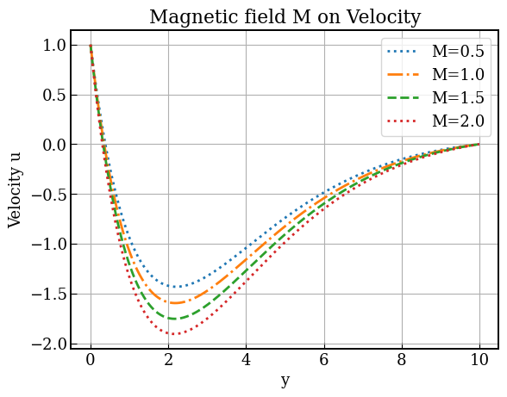
Figure 1: Effect of magnetic field $M$ on velocity of some parameter values $M=2.0$, $G_{r}=2.0$, $G_{m}=2.0$, $K_{r}=1.0$, $Le=1.5$, $N_{b}=N_{t}=1.0,$ $Pr=3.0$, $Q=Q_{1}=1.5$, $t=1.0$, $p=1.0$

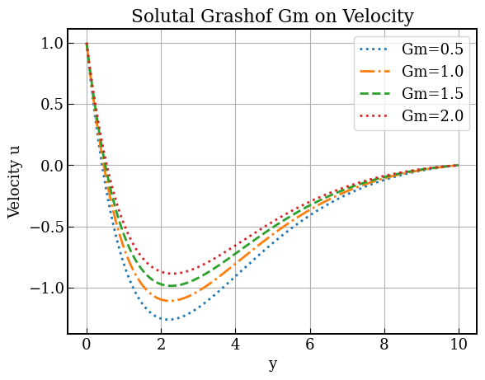

Figure 2: Effect of solutal bouyancy forcce $Gm$ on the velocity of some parameter values for $M=2.0$, $G_{r}=2.0$, $G_{m}=2.0$, $K_{r}=1.0$, $Le=1.5$, $N_{b}=N_{t}=1.0,$ $Pr=3.0$, $Q=Q_{1}=1.5$, $t=1.0$, $p=1.0$
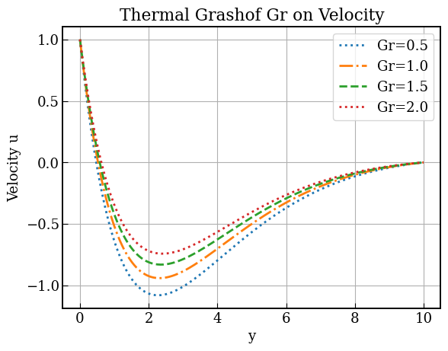
Figure 3: Effect of Thermal grassof Number $Gr$ the velocity of some parameter values for $M=2.0$, $G_{r}=2.0$, $G_{m}=2.0$, $K_{r}=1.0$, $Le=1.5$, $N_{b}=N_{t}=1.0,$ $Pr=3.0$, $Q=Q_{1}=1.5$, $t=1.0$, $p=1.0$
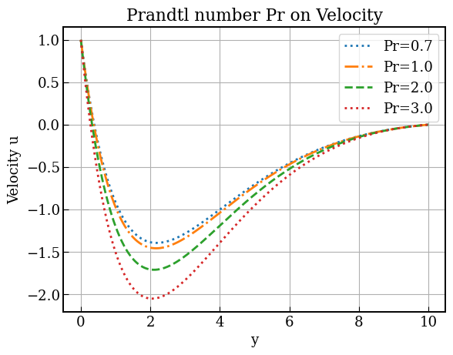
Figure 4: Effect of Prantl Number $Pr$ on the velocity of some parameter values for $M=2.0$, $G_{r}=2.0$, $G_{m}=2.0$, $K_{r}=1.0$, $Le=1.5$, $N_{b}=N_{t}=1.0,$ $Pr=3.0$, $Q=Q_{1}=1.5$, $t=1.0$, $p=1.0$
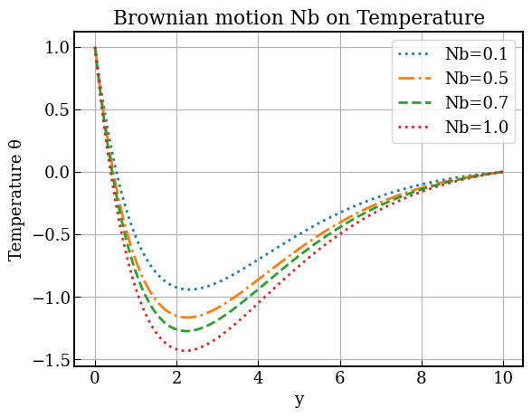
Figure 5: Effect of Brownian Motion $Nb$ on the Temperature $θ$ of some parameter values for $M=2.0$, $G_{r}=2.0$, $G_{m}=2.0$, $K_{r}=1.0$, $Le=1.5$, $N_{b}=N_{t}=1.0,$ $Pr=3.0$, $Q=Q_{1}=1.5$, $t=1.0$, $p=1.0$.
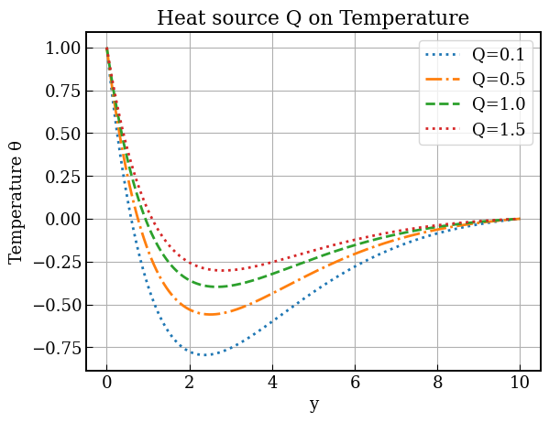
Figure 6: Effect Heat Source $Q$ on temperature of some parameter values for $M=2.0$, $G_{r}=2.0$, $G_{m}=2.0$, $K_{r}=1.0$, $Le=1.5$, $N_{b}=N_{t}=1.0,$ $Pr=3.0$, $Q=Q_{1}=1.5$, $t=1.0$, $p=1.0$.
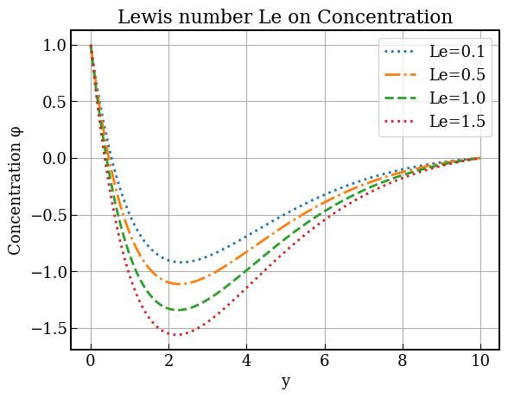
Figure 7: Effect of Lewis number on concentration of some parameter values for $M=2.0$, $G_{r}=2.0$, $G_{m}=2.0$, $K_{r}=1.0$, $Le=1.5$, $N_{b}=N_{t}=1.0,$ $Pr=3.0$, $Q=Q_{1}=1.5$, $t=1.0$, $p=1.0$.
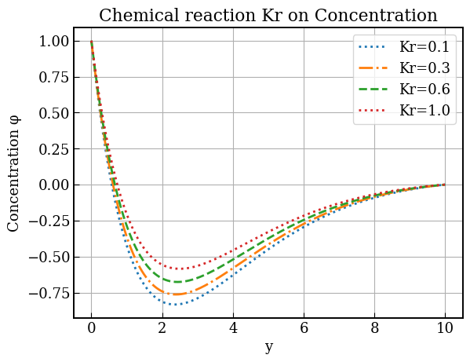
Figure 8: Effect chemical reaction on the concentration of some parameter values for $M=2.0$, $G_{r}=2.0$, $G_{m}=2.0$, $K_{r}=1.0$, $Le=1.5$, $N_{b}=N_{t}=1.0,$ $Pr=3.0$, $Q=Q_{1}=1.5$, $t=1.0$, $p=1.0$.
1.5 Discussion of Results
Figures 1–4 illustrate the influence of major hydrodynamic parameters on the velocity distribution within the boundary layer. Increasing the magnetic field parameter $M$significantly reduces fluid velocity because the imposed transverse magnetic field generates a Lorentz force that opposes the flow direction. This resistive force suppresses motion and decreases the momentum boundary layer thickness. Conversely, increasing the solutal Grashof number $G_{m}$ enhances the velocity profile, as stronger concentration-induced buoyancy forces accelerate the fluid and expand the velocity boundary layer.
A similar accelerating effect is observed for the thermal Grashof number $G_{r}$. Higher values of $G_{r}$represent stronger buoyancy forces due to temperature differences between the surface and the ambient fluid, which increases fluid motion and thickens the momentum boundary layer. However, the Prandtl number $Pr$ produces an opposing trend: increasing $Pr$ reduces the velocity profile. This occurs because larger $Pr$ values correspond to higher momentum diffusivity relative to thermal diffusivity, implying greater viscous resistance that slows the flow and reduces boundary layer thickness.
Figures 5 and 6 focus on the temperature field. The temperature profile increases with the Brownian motion parameter $N_{b}$, since intensified random movement of nanoparticles enhances thermal energy transport within the fluid, thereby thickening the thermal boundary layer. Similarly, increasing the heat source parameter $Q$ raises the temperature distribution throughout the flow region because additional internal heat generation supplies energy to the system, resulting in higher fluid temperatures.
Figures 7 and 8 present the behavior of the concentration field. An increase in the Lewis number $Le$ reduces the concentration profile because larger $Le$ values indicate weaker mass diffusivity, which restricts species transport and leads to a thinner concentration boundary layer. Additionally, increasing the chemical reaction parameter $K_{r}$ significantly decreases concentration levels, as stronger reactions consume the diffusing species more rapidly within the boundary layer. Consequently, the concentration boundary layer thickness diminishes with increasing $K_{r}$.
1.6 Conclusion
This work has thus far examined the convective heat and mass transfer in nanofluid flow over a stretching sheet, demonstrating that thermal and solutal buoyancy forces, internal heat generation and absorption, Prandtl and Lewis numbers, Brownian motion, and unsteady effects significantly govern the velocity, temperature, and concentration fields, with heat generation and buoyancy enhancing transport processes while heat absorption and higher diffusivity ratios overturns them.

Reference

[1] Uka, U. A., Agbo, O. A., Omamoke, E., Amos, E., & Edwin, D. K. (2022). Analysis and simulation of hydromagnetic nano-fluid flow passing an inclined heated sheet. International Journal of Heat and Technology, 40(6), 1386-1396.
[2] Reddy, P. S., & Chamkha, A. J. (2016). Soret and Dufour effects on MHD convective flow of Al2O3–water and TiO2–water nanofluids past a stretching sheet in porous media with heat generation/absorption. Advanced Powder Technology, 27(4), 1207-1218.
[3] Kumar, N., & Sonawane, S. S. (2016). Experimental study of thermal conductivity and convective heat transfer enhancement using CuO and TiO2 nanoparticles. International Communications in Heat and Mass Transfer, 76, 98-107.
[4] Amos, E., Amadi. C.P., & Nwaigwe, C. (2019). Free Convection Boundary Layer Flow of a Rotating MHD Fluid past a Vertical Porous Medium with Thermal Radiation. International Journal of Applied Science and Mathematical Theory, 5(2).
[5] Esfahani, M. R., Languri, E. M., & Nunna, M. R. (2016). Effect of particle size and viscosity on thermal conductivity enhancement of graphene oxide nanofluid. International Communications in Heat and Mass Transfer, 76, 308-315.
[6] Weli, A., Amadi, C. P., & Nwaigwe, C. (2019). Numerical investigation of transport in a Couette flow with unsteady suction. IOSR Journal of Mathematics, 15(6), 74-83.
[7] Narayana, P. S., & Babu, D. H. (2016). Numerical study of MHD heat and mass transfer of a Jeffrey fluid over a stretching sheet with chemical reaction and thermal radiation. Journal of the Taiwan Institute of Chemical Engineers, 59, 18-25.
[8] Mahatha, B. K., Nandkeolyar, R., Nagaraju, G., & Das, M. (2015). MHD stagnation point flow of a nanofluid with velocity slip, non-linear radiation and Newtonian heating. Procedia Engineering, 127, 1010-1017.
[9] Sreedevi, P., P. Sudarsana Reddy, and Ali Chamkha. "Heat and mass transfer analysis of unsteady hybrid nanofluid flow over a stretching sheet with thermal radiation." SN Applied Sciences 2, no. 7 (2020): 1222.
[10] Mahanta, G., Das, M., Shaw, S., & Mahanta, K. L. (2019). Heat and mass transfer of Casson nanofluid flow over a stretching sheet in the presence of magnetic field with Brownian and thermophoretic effects. Journal of Engineering Science & Technology, 14(5), 3046-3061.
[11] Freidoonimehr, N., Rashidi, M. M., Momenpour, M. H., & Rashidi, S. (2017). Analytical approximation of heat and mass transfer in MHD non-Newtonian nanofluid flow over a stretching sheet with convective surface boundary conditions. International Journal of Biomathematics, 10(01), 1750008.
[12] Sandeep, N., & Kumar, J. (2016). Heat and mass transfer in nanofluid flow over an inclined stretching sheet with volume fraction of dust and nanoparticles. Journal of Applied Fluid Mechanics, 9(5), 2205-2215.
[13] Sudarsana Reddy, P., & Sreedevi, P. (2022). Impact of chemical reaction and double stratification on heat and mass transfer characteristics of nanofluid flow over porous stretching sheet with thermal radiation. International Journal of Ambient Energy, 43(1), 1626-1636.
[14] Nagasantoshi, P., Reddy, G. V., Reddy, M. G., & Padma, P. (2018). Heat and mass transfer of Non-Newtonian Nanofluid flow over a stretching sheet with non-uniform heat source and Variable viscosity. Journal of nanofluids, 7(5), 821-832.
[15] Reddy, Y. D., & Goud, B. S. (2022). MHD heat and mass transfer stagnation point nanofluid flow along a stretching sheet influenced by thermal radiation. Journal of Thermal Analysis and Calorimetry, 147(21), 11991-12003.
[16] Ali, N., Bahman, A. M., Aljuwayhel, N. F., Ebrahim, S. A., Mukherjee, S., & Alsayegh, A. (2021). Carbon-based nanofluids and their advances towards heat transfer applications—a review. Nanomaterials, 11(6), 1628.
[17] Tlili, I. (2024). Impact of thermal conductivity on the thermophysical properties and rheological behavior of nanofluid and hybrid nanofluid. Mathematical Sciences, 18(4), 493-501.
[18] Amos, E., & Uka, U. A. (2022). Hydromagnetic nanofluid flow over an exponentially stretching sheet in the presence of radiation and nonuniform heat generation. IOSR Journal of Mathematics, 18(1), 31-43.
[19] Saeed, A., Alsubie, A., Kumam, P., Nasir, S., Gul, T., & Kumam, W. (2021). Blood based hybrid nanofluid flow together with electromagnetic field and couple stresses. Scientific reports, 11(1), 12865.
[20] Abbas, S., Nisa, Z. U., Nazar, M., Amjad, M., Ali, H., & Jan, A. Z. (2024). Application of heatand mass transfer to convective flow of Casson fluids in a microchannel with Caputo–Fabrizio derivative approach. Arabian Journal for Science and Engineering, 49(1), 1275-1286

