Original research article

New Distributional Record of Brettus cingulatus (Araneae: Salticidae: Spartaeinae) in Chhattisgarh Region, India

Abstract
The present study reports a new distributional record of the jumping spider species Brettus cingulatus Thorell, 1895 in Chhattisgarh state. This is a specific spider species belonging to the family Salticidae. This species was collected from three different sites Deobhog, Udanti Wildlife Sanctuary and Gariaband forest region in the Gariaband district of Chhattisgarh during field surveys using the hand-picking method. This is the first record of this species in the state, making it a new genus and species for Chhattisgarh. This study adds a new entry to the arachnofauna list of Chhattisgarh.
Keywords: Brettus cingulatus, Chhattisgarh, Gariaband, Genus, Salticidae, Species, Udanti Wildlife Sanctuary.

Introduction
Brettus Thorell, 1895 is a jumping spider genus in the family Salticidae found in Asia and Madagascar in Africa. Six species have been recorded so far, of which only three are found in India (WSC, 2026). Brettus cingulatus Thorell, 1895 is a medium-sized jumping spider species in the genus Brettus, found only in South and Southeast Asia. It has been recorded in eight countries including India (WSC, 2026). In India, this species was first recorded in Tamil Nadu (Simon, 1900) and has since been recorded in other states (Singh et al,. 2023). It was recently recorded again in the same state (Sen et al., 2022). Till now this species has been recorded in nine states of India. Recently, new distributions of some spiders were recorded in Chhattisgarh state but this species has not been recorded yet (Nayak et al., 2025a; 2025b; Nichat et al., 2024a; 2025a; 2025b).

Materials and Methods
Two specimens of jumping spider Brettus cingulatus Thorell, 1895 have been collected in Gariaband district of Chhattisgarh, one specimen was collected from Deobhog and the other from Udanti Wildlife Sanctuary. These were collected randomly through field visits by hand picking methods. Both the specimens are preserved by 70% ethanol and kept in the Department of Zoology of Govt. D. B. Girls Post Graduate College Raipur. Identification of this species has been done on the basis of its morphological features like eye arrangement, epigyne structure and body pattern. For its identification, help of published literature related to this spider has been taken. Its live photograph has been taken with a Canon HD camera and its epigyne and pedipalps have been examined with a stereozoom microscope.
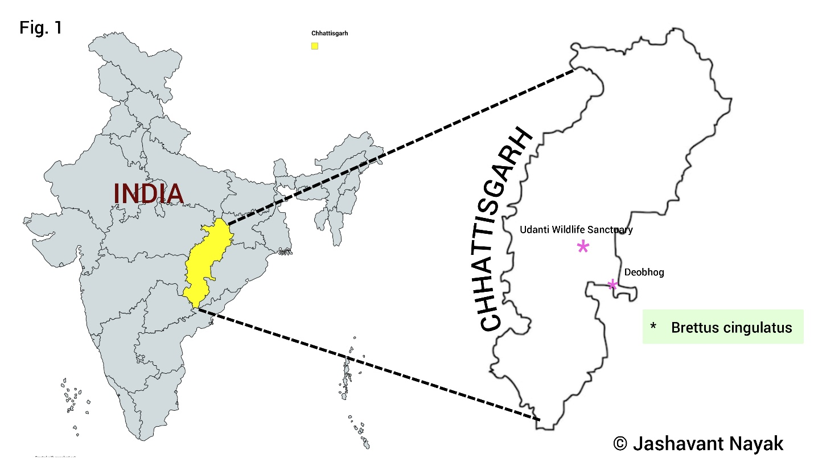
Figure 1: Map represents the location of Brettus cingulatus spider species in Chhattisgarh.

Result and Discussion
Two spider specimens were collected in the Gariaband district of Chhattisgarh. Morphological analysis of these specimens revealed them to be Brettus cingulatus, a jumping spider belonging to the family Salticidae. This is the first time this genus and species have been recorded in the state of Chhattisgarh. A full description of this species is provided below.

Taxonomy
Family: Salticidae Blackwall, 1841
Genus: Brettus Thorell, 1895
Brettus cingulatus Thorell, 1895

Specimen Details
Brettus cingulatus Thorell, 1895 (female): 2 specimens have been collected from Gariaband district. One specimen has been collected from Banyan tree in Deobhog region and the other specimen has been collected from Shorea robusta tree in Udanti Wildlife Sanctuary. Both these specimens have been preserved in 70% alcohol and deposited in the Department of Zoology of Govt. D. B. Girls Post Graduate College Raipur, Chhattisgarh. The collection of both these specimens has been collected by Jashavant Nayak using hand picking methods.
Table 1- Collection of Brettus cingulatus Thorell
Species | Location | Date/ Time of collection
Brettus cingulatus Thorell, 1895  (Female) | Deobhog, Gariaband  19°54'45"N 82°38'30"E/ 264.79 m | 07.xi.2025 / 01:22 PM (+05:30 GMT)
Brettus cingulatus Thorell, 1895  (Female) | Udanti Wildlife Sanctuary Gariaband  20°07'29"N 82°17'17"E/ 424.92 m | 22.i.2026 / 09:07 PM (+05:30 GMT)

Characteristics
The cephalothorax is oval in shape, the middle dorsal carapace is brown in colour with the anterior region being yellow and the posterior region being dark brown. The eyes are eight in number, the anterior median eyes being the largest, two pairs of eyes are located in the front and two pairs on the dorsal carapace. The small hairs of the carapace are projected in the forward direction. The pedipalps are hairy, whitish, and thin; this is the degenerated form. In female spiders, the pedipalps function to sense temperature and stimuli. The abdomen is about the same size as the cephalothorax but slightly longer. It is entirely brown in color. The posterior region of the abdomen has a whitish transverse band with a black stripe running along its front. The ventral region is pale whitish with a black line in a curved shape attached to the epigyne. The entire abdomen is covered by small hairs projecting backwards. Two oval-shaped rings are found on both sides of the dorsal region of the abdomen, which have a thin black stripe. The epigyne is located on the ventral side near the cephalothorax. It is a swollen part covered with small hairs. The internal margin of the epigyne is dark brown. Its anterior portion is wide and its posterior portion is narrow. The first do legs are quite big, thick, brown, strong and projected towards the front. trochanter and coxa are small and thick, femur is slightly flat, strong and brown in colour, trochanter and coxa are small and thin in third pairs of legs, femur and patella are strong, cylindrical and brown. The metatarsus, tarsus and claws are hairy, cylindrical. The fourth legs are quite long, the coxa and trochanter are small, and hairy. The femur and patella are long, cylindrical, brown and hairy. The metatarsus, tarsus and claws are cylindrical and hairy.

Diagnosis
White lateral stripes on the carapace, two rings on the abdomen present in the lateral region, white stripes on the posterior part and oval epigyne. Keep the third leg attached to the abdomen during resting time. See Thorell, 1895; Ahmed et al., 2017; Abhijith and Hill, 2019.

Global Distribution: India, Sri Lanka, China, Vietnam, Myanmar, Thailand, Malaysia, Indonesia (Sumatra) (WSC, 2026).

Indian Distribution: Assam (Chetia & Kalita, 2012; Gupta et al., 2015; Saha et al., 2015), Goa (Halarnkar & Pai, 2018; Pandit & Dharwadkar, 2020), Gujarat (Thumar, 2019), Karnataka (Bhat et al., 2013; Ahmed et al., 2017; Abhijith & Hill, 2019), Kerala (Strand, 1912; Malamel & Samson, 2014; Malamel & Sudhikumar, 2020), Maharashtra (More & Sawant, 2013; Ahmed et al., 2017; Patil & Uniyal, 2018), Rajasthan (Patil et al., 2016), Tamil Nadu (Simon, 1900; Sen et al., 2022), West Bengal (Dhali et al., 2017; Sen et al., 2015; Roy et al., 2016), present record in Chhattisgarh.

Brettus cingulatus Thorell, 1895 an Asian salticid found in India as well as eight other Asian countries. It has been recorded in nine states in India, in this study it has been recorded in Chhattisgarh state. Chhattisgarh is a very important state from the point of view of the biodiversity of spiders but due to limited information about spider fauna in this state, not much information is known about spiders, especially jumping spiders in this region. Brettus cingulatus Thorell, 1895 has been recorded only in one district Gariaband in the state, there is no description of it in the rest of the districts of the state. In the current study, only females were reported; males are not yet known. Future studies may also record males, but currently, sufficient information is available for males. The biggest problem in studying spiders is that they are everywhere but are not easily visible due to their small size. These salticids spend most of their time in the leaves of trees or spend their entire life in the canopy of the tree, due to which researchers face a lot of difficulty in finding them. These are found randomly, only then can they be identified and studied. Present study will help arachnologists in the future to understand its behavior, similar species and importance better.

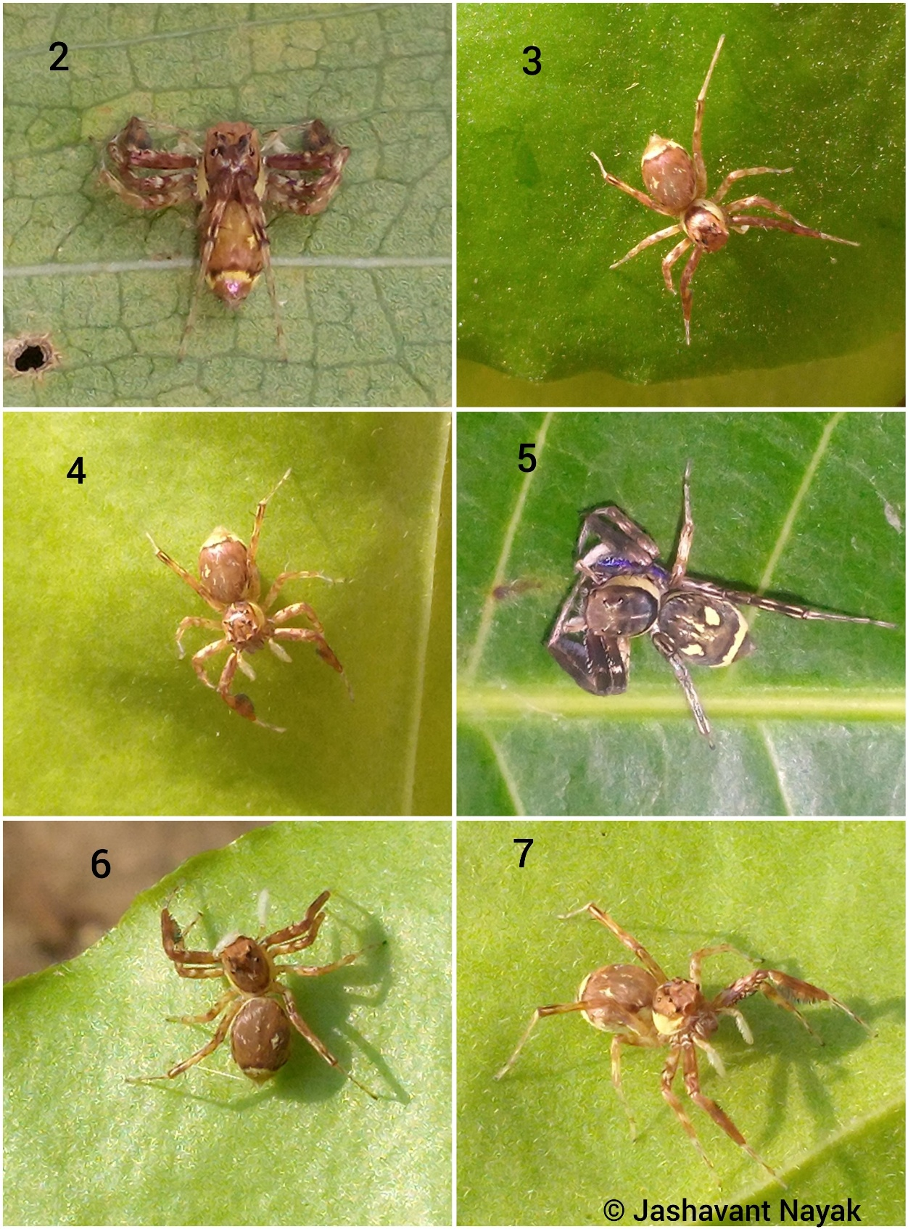
Habitus: Brettus cingulatus Thorell, 1895 (female); 2-6. Dorsal view, 7. Lateral view.

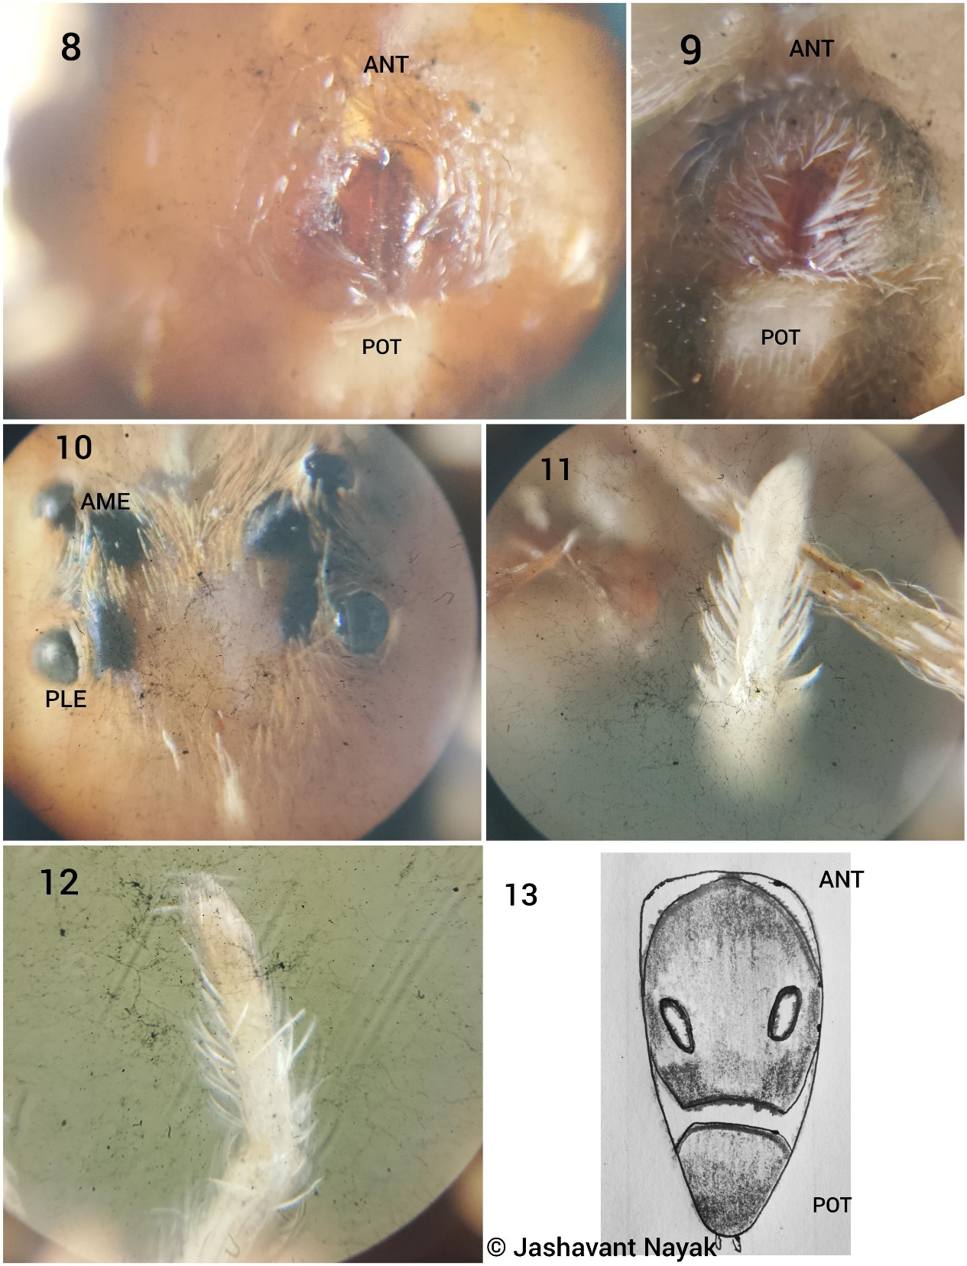
Figure 2: Brettus cingulatus Thorell, 1895 (female): 8&9. Epigyne, 10. Eye arrangement, 11&12. Degenerated padipal, 13. Morphological illustration of dorsal abdomen. Abbreviations ANT Anterior, POT Posterior, AME Anterior Median Eye, PLE Posterior Lateral Eye.

Conclusion
The summary of this study is that a jumping spider species, Brettus cingulatus, has been recorded for the first time in Chhattisgarh state, adding another salticid spider to the state's spider fauna list. This study represents the new distribution of this species.

Disclaimer (Artificial Intelligence)
Author(s) hereby declare that NO generative AI technologies such as Large Language Models (ChatGPT) and text-to-image generators have been used during writing or editing of this Manuscript.

Competing Interests
Authors have declared that no competing interests exist.

References
Abhijith A.P.C. & Hill, D.E. (2019). Notes on the jumping spider Brettus cingulatus in Karnataka (Araneae: Salticidae: Spartaeini). Peckhamia, 186.1: 1-14.
Ahmed, J., Khalap, R., Hill, D.E., Sumukha, J.N. & Mohan, K. (2017). First record of Brettus cingulatus from India, with a review of Brettus in South and Southeast Asia (Araneae: Salticidae: Spartaeinae). Peckhamia, 151.1: 1-13.
Bhat, P.S., Srikumar, K.K., Raviprasad, T.N. (2013). Seasonal diversity and status of spiders (Arachnida: Araneae) in cashew ecosystem. World Applied Sciences Journal, 22(6):763-770.
Blackwall, J. (1841). The difference in the number of eyes with which spiders are provided proposed as the basis of their distribution into tribes; with descriptions of newly discovered species and the characters of a new family and three new genera of spiders. Transactions of the Linnean Society of London 18(4): 601-670. doi: 10.1111/j.1095-8339.1838.tb00210.x
Chetia, P. & Kalita, D.K. (2012). Diversity and distribution of spiders from Gibbon Wildlife Sanctuary, Assam, India. Indian Journal of Arachnology, 1(1): 130-142.
Dhali, D.C., Saha, S. & Raychaudhuri, D. (2017). Litter and ground dwelling spiders (Araneae: Arachnida) of reserve forests of Dooars, West Bengal (Monograph). World Scientific News, 63: 1-242.
Gupta, R., Devi, O.S. & Islam, M. (2015). Common spiders from select protected areas of upper Assam. Assam State Biodiversity Board Rehabari, Guwahati, 186 pp.
Halarnkar, M.M. & Pai, I.K. (2018). Distribution, diversity and ecology of spider species at two different habitats. International Journal of Environmental Sciences & Natural Resources, 8(5): 162-167.
Malamel, J.J. & Samson, P.D. (2014). A pioneering study on the spider (Arachnida: Araneae) fauna of Kumarakom Bird Sanctuary. International Journal of Science, Environment and Technology, 3(3): 872-880.
Malamel, J.J. & Sudhikumar, A.V. (2020). An investigation of diversity and bioecology of araneofauna of Pathiramanal Island in Vembanad Lake, a Ramsar site, Kerala, India. Zoology and Ecology, 30(2): 126-137. doi:10.35513/21658005.2020.2.7
More, S. & Sawant, V. (2013). Spider fauna of Radhanagari Wildlife Sanctuary, Chandoli National Parkandkoyna Wildlife Sanctuary. Indian Journal of Arachnology, 2(1): 81-92.
Nayak J., Sori P., Sahu L., Bharti D. (2025). A new observational record of jumping spider (Aranae: Salticidae: Aelurillini: Aelurillina) Stenaelurillus metallicus Caleb & Mathai, 2016 in Chhattisgarh, India . International Journal of Biology Research 10(1) 19-21. https://www.biologyjournal.in/assets/archives/2025/vol10issue1/10007-1740555118544.pdf
Nayak J., Sori. P., Bharti D. (2025a). Description of a New Spider Meotipa sahyadri Kulkarni, Vartak, Deshpande & Halali, 2017 (Aranae: Theridiidae) in Chhattisgarh, India. International Journal of Research Publication and Reviews 6(2) 4518-4521. https://doi.org/10.55248/gengpi.6.0225.1026
Nayak, J., Chaure, M., Warte, H. K., Majumdar, M., Harris, K. K., & Nichat, A. R. (2025b). A new distribution of the spider genus Storenomorpha Simon, 1884 (Araneae: Zodariidae) in Chhattisgarh State, India. Asian Journal of Research in Zoology, 8(4), 127–133. https://doi.org/10.9734/ajriz/2025/v8i4224
Nayak J., Warte H.K., Sori P. & Sahu L. (2025c). Study on Jumping Spiders (Aranae: Araneomorphae: Salticidae) Diversity in Shraddha Public School Campus Gariaband, Chhattisgarh, India. International Journal of Latest Technology In Engineering, Management & Applied Science : 14 (3): 350- 353 DOI : https://doi.org/10.51583/IJLTEMAS.2025.140300037
Nayak, J., Warte, H. K., & Chaure, M. (2025d). A brief study of jumping spider (Arachnida: Araneae: Salticidae) diversity around Tandula Dam, Balod, Chhattisgarh, India. Journal of Science Research International, 11(8), 1–8. https://doi.org/10.5281/zenodo.17442064
Nayak, J. (2025). Stenaelurillus jagannathae Das, Malik & Vidhel, 2015: First Description in Chhattisgarh, India. Bioscience Discovery, 16(3):37-40. http://biosciencediscovery.com/Archive.html#
Nichat A. R., Warte H.K., Nayak J., (2024a). Spider diversity (Arachnida:Aranae) in Deobhog region Gariyaband Chhattisgarh India : International Journal of Innovation and Science and Engineering : 11 (8) : 39 – 45. https://ijiset.com/vol11/v11s8/IJISET_V11_I08_03.pdf
Nichat A. R., Warte H.K., Shaffi SA. & Nayak J., (2024b). A study of biodiversity of spider species (arachnida : aranae : araneomorphae) in kokasara region, Kala-handi, Odisha, India : African Journal of Biological Sciences : 6 (15) : 9550- 9560. https://doi.org/10.48047/AFJBS.6.15.2024.9550-9560
Nichat A. R., Harris K.K., Warte H.K., Dubey M., Sori P. & Nayak J. (2025a). Spiders Diversity in North East Gariaband Forest Regions of Chhattisgarh, India. Uttar Pradesh Journal of Zoology, 46(4):119-127. DOI: https://doi.org/10.56557/upjoz/2025/v46i44808
Nichat, A. R., Nayak, J., Sori, P., & Warte, H. K. (2025b). Description of new jumping spider species Epocilla aura (Aranae: Salticidae: Chrysillini) from Gariaband district, Chhattisgarh State, India. International Research Journal of Biological Sciences, 14(2), 1–4. http://www.isca.in
Pandit, R. & Dharwadkar, M. (2020). Preliminary checklist of spider fauna (Araneae: Arachnida) of Chandranath Hill, Goa, India. Journal of Threatened Taxa, 12(11): 16597–16606. doi: 10.11609/jott.6096.12.11.16597-16606
Patil, S.R., Roy, S. & Bano, R. (2016). A note on soil spiders (Arachnida: Araneae) from Jaisalmer district, Rajasthan. International Journal of Fauna and Biological Studies, 3(2): 22-23.
Patil, V.K. & Uniyal, V.P. (2018). Important notes on the spider Brettus cingulatus Thorell, 1895 (Araneae: Salticidae) from India. Advanced Agricultural Research & Technology Journal, 2(1): 104-107.
Roy, T.K., Saha, S. & Raychaudhuri, D. (2016). A treatise on the jumping spiders (Araneae: Salticidae) of tea ecosystem of Dooars, West Bengal, India. World Scientific News 53(1): 1-66.
Saha, S., Roy, T.K., Dhali, D.C. & Raychaudhuri, D. (2015). Spider faunal diversity of tea ecosystem of Assam, India. Romanian Journal of Biology Zoology, 60(1): 13–26.
Sen, S., Dhali, D.C., Saha, S. & Raychaudhuri, D. (2015). Spiders (Araneae: Arachnida) of Reserve Forests of Dooars: Gorumara National Park, Chapramari Wildlife Sanctuary and Mahananda Wildlife Sanctuary. World Scientific News, 20: 1-339.
Sen, S., Sudhin, P.P., Bera, C., Jwala, R., Subramanian, K.A. & Sureshan, P.M. (2022). Spiders (Arachnida: Araneae) of Kanyakumari Wildlife Sanctuary,Tamil Nadu, India. Records of Zoological Survey of India, 122(2):187–197. doi:10.26515/rzsi/v122/i2/2022/170243
Simon, E. (1900). Etudes arachnologiques.30e Mémoire. XLVII. Descriptions d’espèces nouvelles de la famille des Attidae. Annales de la Société Entomologique de France, 69: 27-61.
Singh R., Singh B B., & Singh G., (2023). Spider Fauna of India, Asian Biological Research Foundation, Prayagraj, India, Nature Light Publications, Pune ISBN- 978-81-959483-4-5
Strand, E. (1912). Über einige Spinnen aus Travancore in Indien. Archiv für Naturgeschichte 78(A8): 144-148.
Thorell, T. (1895). Descriptive catalogue of the spiders of Burma, based upon the collection made by Eugene W. Oates and preserved in the British Museum. London, 406 pp. doi: 10.5962/bhl.title.17492
Thumar, R.H. (2019). Biodiversity and taxonomic study of predacious spiders of some orchard plants in and around Navsari district Gujarat. Ph. D. thesis, Veer Narmad South Gujarat University, Surat, Gujarat, 261 pp. http://hdl.handle.net/10603/272366
World Spider Catalog 2026. World Spider Catalog. Version 26. Natural History Museum Bern, online at http://wsc.nmbe.ch, accessed on {02/01/2026}. doi: 10.24436/2

