Short communication

Micromorphology and Diversity of selected Xylariaceae from Mount Abu Wildlife Sanctuary in Mount Abu, Rajasthan, India

ABSTRACT
The fungal family Xylariaceae (Ascomycota) is one of the largest and most ecologically important groups of fungi worldwide. Its members include wood-decomposing saprobes, endophytes living inside plant tissues, and a few species that act as plant pathogens. Although many Xylariaceae species have been reported from India, detailed regional studies are still lacking in several biologically rich areas. This study explores the diversity and taxonomy of Xylariaceae in the Mount Abu Wildlife Sanctuary, Mt. Abu, Rajasthan — a humid forested region surrounded by an otherwise dry landscape. Fieldwork was carried out during the monsoon and winter seasons from July 2024 to February 2025 along forest trails and moist ravines at elevations between 1000 and 1400 m. Fungal stromata were collected from dead wood. Specimens were photographed in the field and examined in the laboratory using standard morphological and microscopic methods. Characters such as stromatal form, perithecial structure, asci, paraphyses, ascospore size and shape, amyloidity, and germ slit features were studied and compared with published descriptions for accurate identification. In total, five species of Xylariaceae belonging to three genera were recorded: Rosellinia (two species), Kretzschmaria (one species), and Xylaria (two species). Detailed descriptions are provided for Kretzschmaria mangiferae, Rosellinia macrospora, Rosellinia saccardii, Xylaria apiculata, and Xylaria minuta. Some of these taxa represent rarely reported records for the region, extending the known distribution of family Xylariaceae in Rajasthan. These findings show that Mount Abu supports a rich and distinctive xylariaceous fungal community and emphasize the importance of localized surveys for documenting fungal diversity. The study also provides a useful baseline for future taxonomic, ecological, and molecular research on wood-inhabiting fungi in semi-tropical forest ecosystem of Mt. Abu.
Keywords : Ascomycota, Xylariaceae, stromata, asci, ascospores
1.INTRODUCTION
The family Xylariaceae is considered one of the largest and most diverse groups within the Ascomycota, showing a worldwide distribution. Its presence across numerous regions and a wide range of ecological habitats has been well documented in various studies (Lee et al. 2002).Most of its members are wood-inhabiting fungi, with especially high diversity in tropical regions. Members of this group are predominantly saprophytes, although some species are known to act as plant pathogens (Proffer 1988; Hartman et al. 2008) or occur as endophytes. They have been reported from a variety of substrates, including decomposing wood, animal dung, leaf litter, and soil (Davis et al. 2003; Okane et al. 2008). While certain taxa exhibit host specificity, others are associated with a wide range of hosts, spanning multiple genera and fungal groups. Notably, several species have been documented in association with bamboo, palms (Suwannasai 2013), and even teak trees. Significant contributions to the understanding of Xylariaceae diversity in India have been made through the work of Thind and Waraitch (1969), Thind and Dargan (1975, 1978, 1979), as well as more recent studies by Rajulu et al. (2013). Delimiting genera and accurately identifying species within Xylariaceae has long been challenging, largely due to their wide morphological diversity and variability in key structural traits (Rogers 2000). Traditionally, generic classification within the family has relied primarily on stromatal morphology and colour, as well as ascospore shape and size. Xylaria is the largest genus within Xylariaceae. For instance, Koyani et al. (2016) identified 19 Xylariaceae taxa in Gujarat (western India), including 14 Xylaria species along with representatives of Daldinia and Hypoxylon. Similarly, Rosellinia, which has about 160 species worldwide, is also one of the largest genera in the Xylariales. Studies of Xylariaceae globally highlight their ecological roles as decomposers of wood and leaves, as well as endophytes and occasional plant pathogens.
Mount Abu (24.593°N, 72.718°E), the only hill station in Rajasthan, India, is located at approximately 1350 meters above sea level. It has a humid tropical climate during the monsoon season. Unlike the surrounding Thar Desert, Mount Abu receives significant rainfall during the monsoons and maintains high humidity, which supports lush forests of gymnosperms and angiosperms. As a result, its fungal diversity is unusually high for the state. Chouhan et al. (2021) noted that “the mushroom flora of Mount Abu is diverse” and includes many brightly coloured species that appear after the rain. Previous surveys of Mount Abu's fungi have identified numerous ascomycetes (Panwar & Kaur 1976, 1977). However, comprehensive studies on the diversity of Xylariaceae in Mount Abu are still limited. In this study, we present the findings from our field survey of Xylariaceae fungi from Mount Abu Wildlife sanctuary in Mount Abu. We report some xylariaceous taxa we encountered, which include Rosellinia, Kretzschmaria and Xylaria spp. We describe their stromatal and micromorphological features and discuss their diversity in relation to regional and global Xylariaceae. This study applies standard taxonomic methods and provides detailed accounts of Xylariaceae in the Mount Abu Wildlife sanctuary area. In this study, we aimed to record the diversity of the fungal family Xylariaceae, a group known for producing a wide range of biologically active secondary metabolites, largely because many of its members occur as endophytes (Hacioglu et al. 2011; Nilza 2013; Fan et al. 2014). In addition, species of Xylariaceae are important producers of lignocellulose-degrading enzymes, which are extensively utilized in industries such as pharmaceuticals, paper and pulp manufacturing, and textiles (Soto et al. 2015).

2.MATERIALS AND METHODS
2.1 Study site and sampling : Specimens were collected in the Mount Abu Wildlife Sanctuary and nearby forested areas during the monsoon to winter seasons (July,2024 to February,2025). The tropical semi-deciduous forests of Mount Abu, dominated by pines, were explored along trails and moist ravines at elevations between 1000 and 1400 meters. Fruiting bodies were carefully gathered from soil, wood, leaf litter, and plant debris into sterile paper bags labelled with the location, name of the host substrate and date of collection and carried to the laboratory. A portion of each sample was photographed in its natural setting by Apple 13 pro max.

2.2 Morphological examination : In the laboratory, the stromata were described based on size, shape, colour, and surface texture. Hand sections or thin slices of the stromata were mounted in 3–5% KOH on glass slides for microscopic study. Ascospore size and shape were measured using lactophenol cotton blue or Melzer’s reagent to test for amyloidity. Observations were conducted following standard mycological protocols. For identification, features of the perithecia, asci, paraphyses, and ascospores were compared with published descriptions and keys for Xylariales (Rogers 2000). Specifically, the apical apparatus and germ slit characteristics were examined: asci of Xylariaceae are typically unitunicate, eight-spored, and cylindrical with an amyloid apical ring, while ascospores are pigmented and possess germ slits or pores. The specimens were deposited in the mycological collection of Maulana Azad University, Jodhpur, Rajasthan.
2.3 Imaging and documentation : Field photographs were captured by Apple 13pro max and Photomicrographs were taken using a compound microscope equipped with an imaging camera. Measurements of 20–30 asci and ascospores were averaged for each collection. Habit and structure of stromata were documented using a macro lens. Morphological characteristics were evaluated and compared with taxonomic literature (e.g., Rogers 2000; Hyde et al.,2020) to confirm genus and species level identifications.
3. RESULT
3.1 Morphological and Taxonomic Description
Below, the observed Xylariaceae taxa are described, with emphasis on stromatal and micromorphological details. Standard taxonomic terminology (ascoma = stromata, ostiole, peridium, etc.) is used. All measurements are given in micrometers (μm) unless otherwise noted. The present study contributes 5 species of Xylariaceae belonging to three genera viz Rosellinia, (2 species), Kretzschmaria (1 species) and Xylaria (2 species).
The detail morphological characteristics are:
3.1.1 Rosellinia Cesati and de Notaris ; Giorno Botanica Italiano 1 : 334 : 1844.
The genus Rosellinia was erected by Cesati and de Notaris in 1844 with R. aquila Ces. and De Not. as the type species. The genus is characterized by the superficial stromata, often occurring in dense swarms upon a common blackish or brownish hyphal mat (subiculum), stromata has usually single ascomata ; Ascomata globose to subglobose, smooth, black, ostiole papillate ; Asci cylindrical, stipitate with well developed amyloid apical ring, paraphysate ; Ascospores brown to black, uniseriate, non - septate, often with minute colourless appendages or oil globules or longitudinal furrow.

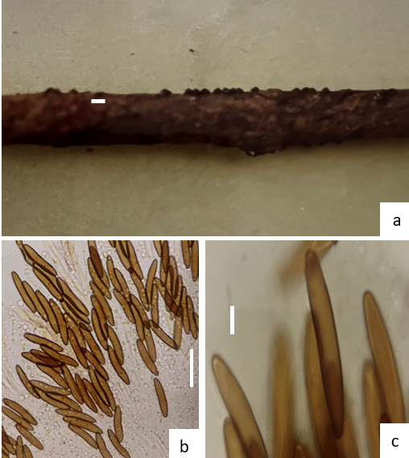

Fig. 1 Rosellinia macrospora. a. Stromata on dead wood, b. Asci with ascospores,
c. Ascospores. Scale bars: a = 0.5 mm. b = 25μm. c = 10μm.

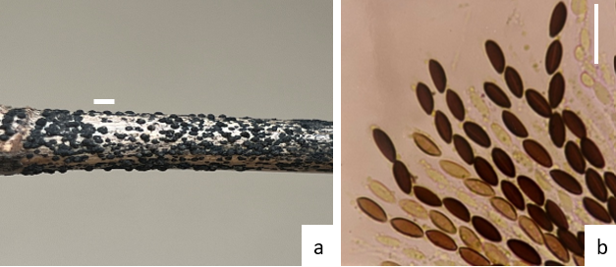

Fig. 2 Rosallina saccardii. a. Stromata on wood, b. Asci with Ascospores. Scale bars: a = 0.5 mm. b = 32 µm.

3.1.1.1 Rosellinia macrospora A. Pande and Mhaskar, Indian Phytopath. 26 (1) : 88 (1973) Fig. 1 a-b
Macroscopic Description - The stroma is black, smooth in texture, scattered, erumpent, carbonaceous, and partially embedded in the substrate. It is pyriform to ovate in shape and measures approximately 0.5–0.6 mm in size. Each stroma contains a single ascoma. The ascomata are globose with a short, slightly pointed beak and open through an ostiole, measuring about 690–800 × 570–650 µm.
Microscopic Description - The asci are abundant, cylindrical, unitunicate, and shortly stalked, with a rounded apical region. They dehisce through a long germ slit associated with a distinct apical pore, and measure approximately 147.5–175.0 × 20–25 µm. Each ascus bears eight ascospores. The ascospores are unicellular, fusoid to elliptic in outline, light brown, and thick-walled with rounded ends. A germ slit extends over nearly the full length of the spore. The spores are arranged in a single row and measure approximately 40.0–47.5 × 7.5 µm.

Habit - Dead twigs of Lantana camara L.
Distribution - Mount Abu Wildlife Sanctuary, Mount Abu, district Sirohi, Rajasthan
Material examined – INDIA, Rajasthan, District Sirohi, Mount Abu Wildlife Sanctuary, on dead twigs of Lantana camara, 24 November 2024, Hemlata 0120 (MAUJ).

Remark - The species differs from the type species primarily by the presence of comparatively larger asci and ascospores.

3.1.1.2 Rosellinia saccardii L. E. Petrini Fig. 2 a-b
Current Scientific Name : Rosellinia saccardoi L. E. Petrini (1992)

Macroscopic Description - The stromata measure approximately 1.0–1.6 mm in diameter and 0.7–1.3 mm in height. They are carbonaceous, gregarious, and semi-globose to cup-shaped, with a nearly flattened upper surface bearing fine papillae or pointed black ostioles. The basal region commonly narrows into a short, broad stipe that remains embedded in the subiculum. Typically, each stroma contains a single ascoma; however, adjacent stromata may fuse, giving the appearance of a stroma with multiple ascomata. The ectostroma is black and 75–125 µm thick. The endostroma is initially light brown, becoming darker with age, and is progressively reduced to the basal region during maturation.
Microscopic Description - The ascomata are globose, measuring about 750–950 µm in diameter and 750–825 µm in height. Asci are abundant, elongated, unitunicate, paraphysate, and stalked, with a distinct apical plug, and measure approximately 120.0–122.5 × 7.5–10.0 µm. Each ascus contains eight ascospores. The ascospores are unicellular, light to dark brown, ellipsoid to slightly asymmetrical in shape with subtly constricted ends. A straight germ slit runs almost the entire length of the spore. The spores are arranged in a single row and measure approximately 15 × 5–7.5 µm.
Habit - Dead branches of Bambusa vulgaris Schrad. Ex J. C. Wendl.
Distribution - Mount Abu Wildlife Sanctuary, Mount Abu, district Sirohi, Rajasthan
Material examined – INDIA, Rajasthan, District Sirohi, Mount Abu Wildlife Sanctuary, on Bambusa vulgaris, 15 December 2024, Hemlata 0127 (MAUJ).

3.1.2 Kretzschmaria Fr., Summ. Veg. Scan. 409 : 1849.
The genus Kretzschmaria was established by Fries in 1849 with the type species K. clavus Fr. The genus is characterized by indistinctly stipitate sub-globose or hemispherical, flattened stroma, forming flat-topped crusts ; Ascomata arranged in the periphery, opening by papillated ostioles.

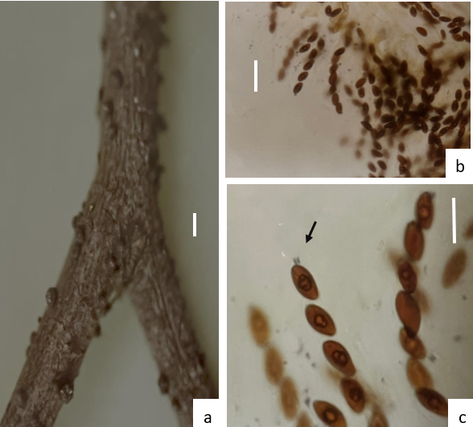
Fig. 3 Kretzschmaris mangiferae. a. Stromata on wood; b,c. Asci with Ascospores (arrow mark showing apical apparatus. Scale bars: a = 2 mm. b = 50 µm. c= 27

3.1.2.1 Kretzschmaria mangiferae Fig. 3 a-c
Type species - Kretzschmaria clavus (Fr.) Sacc., Syll. Fung. (Abellini) 2: XXIX (1883)
Basionym: Sphaeria clavus Fr. 1830
Index Fungorum: 168400
Macroscopic Description - The stromata are scattered, superficial, black, hard, and carbonaceous in texture. They are very shortly stipitate, hemispherical in shape with a slightly pointed apex, measuring approximately 2.0–2.5 mm in diameter and 0.75–1.75 mm in height. The stromatal surface is lobed and encloses about five to six ascomata. The ectostroma is brown and pseudoparenchymatous, while the endostroma consists of hyaline pseudoparenchymatous tissue.
Microscopic Description - The ascomata are flask-shaped and completely embedded within the stroma, opening to the exterior through ostioles. They measure about 350–500 × 380–405 µm. The peridium is 30–40 µm thick, with an outer layer 15–22 µm thick composed of light-brown, thin-walled pseudoparenchymatous cells arranged in three to five layers, and an inner layer 12–20 µm thick made up of three to six layers of elongated, hyaline, thin-walled cells. The rind is dark brown in colour. Asci are numerous, cylindrical, shortly stalked, and unitunicate, each containing eight spores. They possess a thickened amyloid apical apparatus and measure approximately 100–130 × 7–8.5 µm. Paraphyses are hyaline, simple, septate, about 2.0–2.5 µm thick, and extend up to 180 µm in length. The ascospores are arranged in a single row, elliptic in shape, unicellular, and dark brown, with one to two oil droplets or a longitudinal germ slit. Their ends are obtuse and they are enclosed within a thin, hyaline mucilaginous sheath. The spores measure approximately 11.2–13.5 × 5–6 µm.
Habit - Dead twigs of Mangifera indica L.
Distribution - Mount Abu Wildlife Sanctuary, Mount Abu, district Sirohi, Rajasthan
Material examined – INDIA, Rajasthan, District Sirohi, Mount Abu Wildlife Sanctuary, on dead twigs of Mangifera indica, 02 January 2025, Hemlata 0132 (MAUJ).
Remark – Though the molecular sequence analysis is not done by the authors, but considering the slight morphological deviations from described taxa, the present collection is best treated as Kretzschmaria sp. aff. K. clavus.

3.1.3 Xylaria Hill ex Greville; Flora Edinensis 355 : 1823.

Hill and Greville established this genus in 1823 with the type species X. hypoxylon (L.) Grev. This genus is characterized by erect, stalked stromata with dark or black, club-shaped, cylindrical or fusiform, sometimes forked head; Asci and ascospore typical xylaroid.

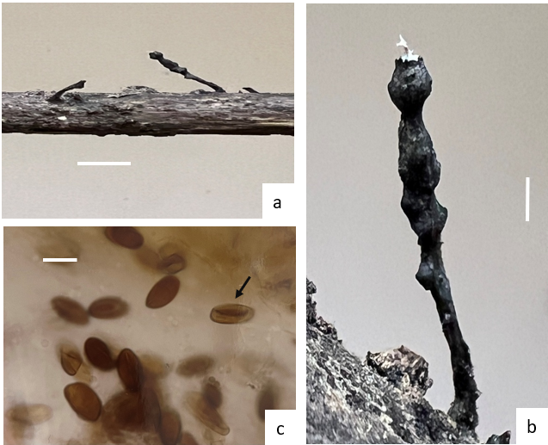

Fig. 4 Xylaria apiculata. Stromata on wood, b. Close view of stromata, c. Ascospores (arrow mark showing germ slit). Scale bars: a = 0.5 cm. b = 1mm. c= 10 µm

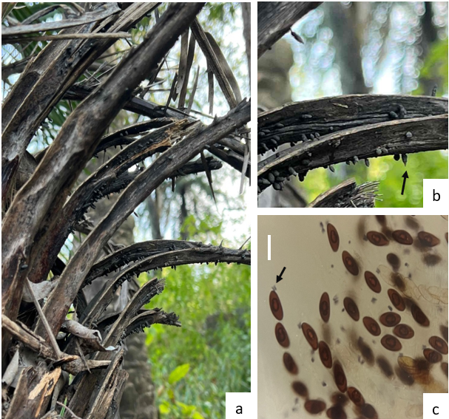
Fig. 5 Xylaria minuta. a. Stromata on dead leaf base of Phoenix, b. Close view showing pointed apex of stromata, c. Asci with Ascospores (arrow showing apical ring). bars: b = 0.5 c= 10 µm

3.1.3.1 Xylaria apiculata Cooke, Grevillea 8 46: 66 (1879) Fig. 4 a-b
Index Fungorum ID : 190405
Obligate synonym : Xylosphaera apiculata (Cooke) Dennis, Kew Bull. 13 (1): 102 (1958)

Macroscopic Description - The stromata are black, carbonaceous, and occur singly or in groups. They are erumpent, superficial, and distinctly stipitate, measuring about 1 cm in total length and 2–3 mm in width, with a tapering, pointed apex. The stipe itself is approximately 0.5–1 cm long. The ascomata are immersed within the stroma, globose to ovoid in shape, and open by means of an ostiole. They measure roughly 480–700 × 320–480 µm.

Microscopic Description - The asci are abundant, cylindrical, and possess a distinct apical plug, measuring about 142.5–162.5 × 8.7–9.2 µm. Each ascus contains eight ascospores. The ascospores are brown, unicellular, and inequilateral, surrounded by a thin hyaline sheath. A straight germ slit and an oil droplet are present. The spores are arranged in a single row and measure approximately 10–15 × 5.0–7.5 µm.
Habit - Dead twigs of unknown Angiosperm plant.
Distribution - Mount Abu Wildlife Sanctuary, Mount Abu, district Sirohi, Rajasthan
Material examined – INDIA, Rajasthan, District Sirohi, Mount Abu Wildlife Sanctuary, on Bambusa vulgaris, 06 February 2025, Hemlata 0141 (MAUJ).

3.1.3.2 Xylaria minuta Panwar, Indian Phytopathology 27 (1) : 110 (1974) Fig. 5 a-c
Macroscopic Description - The stromata are black, carbonaceous, scattered, erumpent, and superficial, clavate in form with a distinctly pointed apex. They measure approximately 3–7 mm in length and 1.0–1.5 mm in width, and possess a short stalk about 400–500 µm long. The ascomata are globose to sub -globose, measuring roughly 490–900 × 330–690 µm, with a papillate surface. The neck measures approximately 90–94 × 20 µm.
Microscopic Description - Asci are abundant, cylindrical, stipitate, and bear a distinct apical plug. Each ascus contains eight spores and measures about 55.5–80.2 × 7.5 µm. Paraphyses are filiform, septate, and extend up to 95 µm in length. The ascospores are elliptic and concavo-convex, ranging from light to dark brown in colour. They are arranged in a single row and contain one to two oil globules along with a distinct germ slit. Spore dimensions are approximately 8.5–11.5 × 4.5–5.5 µm.
Habit - Dead leaf bases and rachis of Phoenix sylvestris (L.) Roxb
Distribution - Mount Abu Wildlife Sanctuary, Mount Abu, district Sirohi, Rajasthan
Material examined – INDIA, Rajasthan, District Sirohi, Mount Abu Wildlife Sanctuary, on Dead leaf bases and rachis of Phoenix sylvestris, 06 February 2025, Hemlata 0142 (MAUJ).
Remark – The morphology of stromata is slightly differed from previous description. However, the measurement and micromorphology of ascospores and habit are enough to consider it a Xylaria minuta.
Key to the species of three Xylariaceae genera
1a. Stromata indistinctly stipitate sub-globose or hemispherical, flattened stroma, forming flat-topped crusts ………… Kretzschmaria mangiferae
1b. Stromata erect, stipitate, clavate, filiform, or discoid; not forming a widespread crust ………… 2
2a. Stromata small, superficial, globose to subglobose, often seated on a subiculum; not distinctly stipitate (genus Rosellinia) ………… 3
2b. Stromata upright, distinctly stipitate or club-shaped (genus Xylaria) ………… 4
3a. Ascospores large, more than 30 µm long, dark brown, ellipsoid with narrowly rounded ends; germ slit straight, spore-length; asci long-stipitate ………… Rosellinia macrospora
3b. Ascospores smaller, less than 25 µm long, ellipsoid to fusiform; germ slit shorter than spore length; asci comparatively shorter ………… Rosellinia saccardi
4a. Stromata very small, slender, hair-like to filiform, usually less than 1 cm tall; surface smooth to slightly roughened; ascospores minute ………… Xylaria minuta
4b. Stromata larger, clavate or cylindrical, usually more than 1 cm tall ………… 5
5a. Stromatal apex distinctly apiculate (with a pointed sterile tip); surface often minutely roughened; ascospores ellipsoid, dark brown, with straight germ slit nearly spore-length ………… Xylaria apiculata

4.DISCUSSION AND CONCLUSION
The family Xylariaceae forms one of the most species-rich and taxonomically complex groups among the Ascomycota, especially in tropical and subtropical regions (Thind KS, Dargan JS, 1975–1979; Rogers JD, 2000; Wijayawardene NN, Hyde KD, Rajeshkumar KC, et al., 2017 ; Kirk, PF, Cannon, PF, Minter, DW & Stalpers, JA.(2008).Although many studies have explored this family in parts of southern and northeastern India, information from northwestern India remains limited (Koyani RD,2017). Mount Abu Wildlife Sanctuary, with its locally humid forest environment surrounded by a generally dry landscape, provides suitable conditions for wood-inhabiting and endophytic fungi. Earlier fungal surveys from this region indicated the presence of dark-spored lignicolous fungi (Chouhan R., Panwar C., 2022), suggesting that xylariaceous taxa were likely to occur. The present study confirms that Mount Abu supports a notable diversity of Xylariaceae, mainly associated with dead twigs, fallen wood and forest litter.
Micromorphological features played a central role in species identification in this study. Characters such as ascospore size and shape, pigmentation, presence of oil droplets, germ slit features and wall structure were found to be particularly reliable for distinguishing species (Fournier J, Flessa F, Peršoh D, et al.,2011; Hsieh HM, Lin CR, Fang MJ, et al., 2010; Lee Y, Han SS, Jeong IS, 2002). In contrast, macroscopic stromatal characters showed greater variability and were influenced by environmental factors such as substrate type, moisture and developmental stage (Karun NC, Sridhar KR, 2015). This supports the view that reliance on external morphology alone can lead to misidentification, particularly within morphologically variable genera such as Xylaria. (Lee Y, Han SS, Jeong IS, 2002; Ma H, Song Z, Pan X, et al. ,2022; Sharathchandra K, Mahadevakumar S, et al.,2023). Detailed microscopic examination therefore remains essential for accurate species delimitation, especially in studies where molecular data are not yet available (Hsieh HM, Lin CR, Fang MJ, et al., 2010).
The taxa documented here were primarily lignicolous saprobes, reflecting the important role of Xylariaceae in the decomposition of woody material and nutrient recycling within forest ecosystems ( Hartman J, Beale J, Bachi P, 2008; Proffer TJ, 1988 ; Malik W.S., et.al, 2023). Their frequent occurrence on dead wood and plant debris is consistent with their ecological function as primary decomposers. At the same time, many members of this family are also known to exist as endophytes within living plant tissues and later shift to a saprobic lifestyle when the host tissues senesce (Davis EC, Franklin JB, Shaw AJ, Vilgalys R , 2003. Okane I, Srikitikulchai P, Toyama K, et al., 2008). This ecological flexibility likely enables xylariaceous fungi to persist across seasons and under varying environmental conditions, such as the strong humidity fluctuations observed in Mount Abu.
From a biogeographical perspective, Xylariaceae are known to be highly diverse in tropical regions, and new species and distribution records continue to emerge from Asia, Central America and India (Cedeño-Sanchez M, Wendt L, Stadler M, et al., 2020; Ma H, Song Z, Pan X, et al., 2022; Sharathchandra K, Mahadevakumar S, et al. 2023). The present findings extend the known range of several taxa into northwestern India and highlight the importance of forested refuges such as Mount Abu for conserving fungal diversity in otherwise dry regions (Suwannasai N, Phosri C, Sangvichien E, et al.,2013). These results reinforce the idea that fungal biodiversity remains incompletely documented, even in areas that appear climatically marginal for fungal growth ( Dutta G, Singh RK, 2023; Kshirsagar AS, Rhatwal SM, Gandhe RV, 2009).
In addition to their ecological significance, xylariaceous fungi are of growing applied interest due to their ability to produce a wide range of biologically active secondary metabolites with antimicrobial and other properties ( Fan NW, Chang HS, Cheng MJ, et al., 2014; Hacioglu N, Akata I, Dulger B, 2011; Ramesh V, Karunakaran C, Rajendran A, 2012). Because metabolite production can vary substantially between closely related species, accurate taxonomic identification is critical for applied and biotechnological research ( Okane I, Srikitikulchai P, Tabuchi Y, et al., 2012). The morphological framework developed in this study therefore provides a useful basis for future work on bioactive compounds and functional ecology of Xylariaceae from this region.
While micromorphology proved effective for species identification in this study, modern taxonomic research increasingly emphasizes the integration of morphological, ecological and molecular data. DNA-based approaches are particularly valuable for resolving cryptic species and clarifying relationships within species complexes (Himani S, Krishnappa M, 2020; Hsieh HM, Lin CR, Fang MJ, et al., 2010 ; Kim D.H., ei.al.,2025; Okane I, Srikitikulchai P, Toyama K, et al., 2008; Song, Ma. H., 2022 ; Suwannasai, N., 2023; Wenyu Zeng,2024; Zhu, A.-H.,2024). Future studies from Mount Abu would benefit from combining molecular phylogenetic analyses with detailed morphology and expanded seasonal sampling to obtain a more complete understanding of xylariaceous diversity ( Patil A, Patil MS, Dangat BT, 2012; Rajulu MBG, Nagamani T, Babuc AG, et al., 2013).
Overall, this study demonstrates that Mount Abu Wildlife Sanctuary harbours a taxonomically and ecologically important assemblage of Xylariaceae, despite its location within a predominantly semi-arid region. Careful micromorphological analysis, particularly of ascospore and ascus characters, was crucial for accurate species identification.
DISCLAIMER (ARTIFICIAL INTELLIGENCE)
Author(s) hereby declares that NO generative AI technologies such as Large Language Models (ChatGPT, COPILOT, etc.) and text-to-image generators have been used during the writing of this manuscript. For Grammar corrections ChatGPT 5.2 is used.
COMPETING INTERESTS
Authors have declared that they have no known competing financial interests OR non-financial interests OR personal relationships that could have appeared to influence the work reported in this paper.
REFERENCES
Cedeño-Sanchez, M., Wendt, L. & Stadler, M. et al. (2020). New species of Hypoxylon and Xylariaceae from Panama. Mycosphere, 11(1): 1457–1476. https://doi.org/10.5943/mycosphere/11/1/9
Chouhan, R. & Panwar, C. (2022). Coprophilous and lignicolous dark-spored macrofungi of Mount Abu, Rajasthan, India. Journal of Mycopathological Research, 60(4): 531–544. https://doi.org/10.57023/JMycR.60.4.2022.53
Dargan, J.S. (1976). Studies in Xylariaceae of North-Western Himalayas. Ph.D. Thesis, Panjab University, India.
Davis, E.C., Franklin, J.B., Shaw, A.J. & Vilgalys, R. (2003). Endophytic Xylaria among liverworts and angiosperms: Phylogenetics, evolution and symbiosis. American Journal of Botany, 90(11): 1661–1667.
Dutta, G. & Singh, R.K. (2023). Checklist of Hypoxylaceae and Xylariaceae of India. Kavaka, 59(3): 68–87. https://doi.org/10.36460/Kavaka/59/3/2023/68-87
Fan, N.-W., Chang, H.-S., Cheng, M.-J., Hsieh, S.-Y., Liu, T.-W. & Chen, I.-S. (2014). Secondary metabolites from the endophytic fungus Xylaria cubensis. Helvetica Chimica Acta, 97(12): 1689–1699.
Fournier, J., Flessa, F. & Peršoh, D. (2011). Three new Xylaria species from southwestern Europe. Mycological Progress.
Hacioglu, N., Akata, I. & Dulger, B. (2011). Antimicrobial potential of Xylaria polymorpha. African Journal of Microbiology Research, 5(6): 728–730.
Hartman, J., Beale, J. & Bachi, P. (2008). Root and collar rots of tree fruits. UK Cooperative Extension Service, Plant Pathology Fact Sheet (PPFS-FR-T-10), University of Kentucky.
Himani, S. & Krishnappa, M. (2020). Xylaria oxyacanthae, a new record from India. Studies in Fungi, 5(1): 485–490. https://doi.org/10.5943/sif/5/1/29
Hsieh, H.M., Lin, C.R., Fang, M.J. et al. (2010). Phylogenetic status of Xylaria subgenus Pseudoxylaria. Molecular Phylogenetics and Evolution, 54(3): 957–969.
Hyde, K.D., Dong, Y., Phookamsak, R., Jeewon, R., Bhat, D.J., Jones, E.B.G. et al. (2020). Fungal diversity notes 1151–1276. Fungal Diversity, 100(1): 5–277.
Kim DH, Kawg YN, Kim HS, Han SK, Kim CS, Lee JK. (2025). Morphological and Phylogenetic Characterization of Four Additional Xylaria-associated Species: Three New Species and One Newly Recognized Species in Korea. Mycobiology, 5;53(5):747-759. doi: 10.1080/12298093.2025.2551300. PMID: 40926781; PMCID: PMC12416027.
Karun, N.C. & Sridhar, K.R. (2015). Xylaria complex in south-western India. Plant Pathology & Quarantine, 5(2): 83–96. https://doi.org/10.5943/ppq/5/2/7
Kirk, P.F., Cannon, P.F., Minter, D.W. & Stalpers, J.A. (2008). Dictionary of the Fungi (10th ed.). CABI, UK.
Koyani, R.D., Patel, H.R., Vasava, A.M. & Rajput, K.S. (2016). Xylariaceae: Overview and addition to fungal diversity of Gujarat State. Studies in Fungi, 1(1): 69–79. https://doi.org/10.5943/sif/1/1/6
Kshirsagar, A.S., Rhatwal, S.M. & Gandhe, R.V. (2009). The genus Xylaria from Maharashtra, India. Indian Phytopathology, 62: 54–63.
Lee, Y., Han, S.S. & Jeong, I.S. (2002). Taxonomical characteristics of Xylaria spp. collected from Malaysia. Mycobiology, 30(4): 193–196.
Ma, H., Song, Z., Pan, X. et al. (2022). Four new pale-spored species of Xylaria. Biology, 11(6): 885. https://doi.org/10.3390/biology11060885
Malik WS, Nisa AU,Wani AH, Lone SA and Bhat MY (2023). Taxonomy and diversity of genus . d Xylaria J Mycol Pl Pathol from district Ramban, Jammu and Kashmir, India. 53 (1): 43-50

Nilza (2013). Screening of endophytic fungi Xylaria for antibacterial and antifungal activity. Ph.D. Dissertation, Thapar University, Patiala, India.
Okane, I., Srikitikulchai, P., Tabuchi, Y., Sivichai, S. & Nakagiri, A. (2012). Recognition and characterization of four Thai xylariaceous fungi inhabiting tropical foliages as endophytes by DNA sequences and host preference. Mycoscience, 53(2): 122–132. https://doi.org/10.1007/S10267-011-0149-9
Panwar, K.S. and S. Kaur, 1976. Ascomycetes of Mount Abu, Rajasthan II. Kavaka, 4: 77-82.
Panwar, K.S. and S. Kaur, 1977. Ascomycetes of Mount Abu, Rajasthan III. Kavaka, 5: 41-48.
Patil, A., Patil, M.S. & Dangat, B.T. (2012). Giant ascomycetes from Maharashtra, India. Mycosphere, 3: 353–356. https://doi.org/10.5943/mycosphere/3/3/8
Proffer, T.J. (1988). Xylaria root rot of urban trees caused by Xylaria polymorpha. Plant Disease, 72: 79. https://doi.org/10.1094/PD-72-0079A
Rajulu, M.B.G., Nagamani, T., Babu, A.G., Aggarwal, A., Suryanarayanan, T.S. & Sudhakara, M. (2013). Endophytic Xylariaceae from the forests of the Western Ghats, southern India: Distribution and biological activities. Mycology, 4(1): 29–37.
Ramesh, V., Karunakaran, C. & Rajendran, A. (2012). Antibacterial activity of Xylaria curta. Mycology, 3: 252–257.
Rogers, J.D. (2000). Thoughts and musings about tropical Xylariaceae. Mycological Research, 104: 1412–1420.
Sharathchandra, K., Mahadevakumar, S., Nuthan, B.R. & Satish, S. (2023). Xylaria sridharii sp. nov. from India. Phytotaxa, 625(2): 180–190. https://doi.org/10.11646/phytotaxa.625.2.4
Song, Ma. H., Pan, Z., Qu, X., Yang, Z., Li, Z., & Zhu, A. (2022). Four New Pale-Spored Species of Xylaria (Xylariaceae, Xylariales) with a Key to Worldwide Species on Fallen Fruits and Seeds. Biology, 11(6), 885. https://doi.org/10.3390/biology11060885
Soto, G.G., Medina-González, G.E., Treviño-Ramírez, J.E. & Hernández-Luna, C.E. (2015). Native macrofungi producing lignin-modifying enzymes with biotechnological potential. BioResources, 10(4): 6676–6689.
Suwannasai, N., Phosri, C., Sangvichien, E., Sihanonth, P., Ruchikachorn, N., Whalley, M.A., Yao, Y. & Whalley, A.J.S. (2013). Biogeography of selected Xylariaceae. Mycosystema, 32(3): 469–484.
Suwannasai, N., Sangvichien, E., Phosri, C. et al (2023). Exploring the Xylariaceae and its relatives. Bot Stud 64, 15. https://doi.org/10.1186/s40529-023-00389-6
Thind, K.S. & Dargan, J.S. (1975). Xylariaceae of India – II. Journal of the Indian Botanical Society, 54: 167–175.
Thind, K.S. & Dargan, J.S. (1978). Xylariaceae of India – VI. Indian Phytopathology, 31: 490–496.
Thind, K.S. & Dargan, J.S. (1979). Xylariaceae of India – V. Journal of the Indian Botanical Society, 58: 285–293.
Thind, K.S. & Waraitch, K.S. (1969). Xylariaceae of India – I. Proceedings of the Indian Academy of Sciences, 70B: 131–138.
Wenyu Zeng, Kamran Habib, Xin Zhou, Yulin Ren, Xiangchun Shen, Bei Wang, Yingqian Kang, Jichuan Kang, Qirui Li, Morphology and multigene phylogeny reveal four new Xylaria (Xylariales, Xylariaceae) species from karst region in China (2024). Mycokeys, 108 :169-196. https://doi.org/10.3897/mycokeys.108.130565
Wijayawardene, N.N., Hyde, K.D., Rajeshkumar, K.C. et al. (2017). Notes for genera: Ascomycota. Fungal Diversity, 86: 1–594. https://doi.org/10.1007/s13225-017-0386-0
Zhu, A.-H., Song, Z.-K., Wang, J.-F., Guan, H.-W., Qu, Z., & Ma, H.-X. (2024). Multi-Gene Phylogenetic Analyses Reveals Heteroxylaria Gen. Nov. and New Contributions to Xylariaceae (Ascomycota) from China. Journal of Fungi, 10(9), 645. https://doi.org/10.3390/jof10090645

