Original Research Article

Cyrtophora moluccensis Doleschall, 1857 (Arachnida: Araneae: Araneidae): First Report in Chhattisgarh State of India

Abstract
The present study has shown the new distribution of an orb weaver spider Cyrtophora moluccensis Doleschall, 1857 in Chhattisgarh state. Recently, Chaudhary and his associates have claimed to have recorded it in Surguja, but they have identified it wrongly. The species they have recorded is named Cyrtarachne inaequalis Thorell, 1895, and it comes under the Araneidae family. In this research article, Cyrtophora moluccensis Doleschall, 1857 has been described along with its valid live pictures. This spider species has been recorded from Mainpur block of Gariaband state in Chhattisgarh. This is the first time that this spider has been recorded in Chhattisgarh.
Keywords: Araneidae, Chhattisgarh, Cyrtarachne inaequalis, Cyrtophora moluccensis, Gariaband, Mainpur, Spider.

Introduction
The Cyrtophora genus is a spider genera in the family Araneidae, known as Communal tent web or tent web spiders (Singh et al., 2023). They live in large tent webs, either on trees or between trees. Their size is quite large compared to other spiders. Of all the species discovered, Cyrtophora citricola was the first to be discovered in 1775, and the most recently discovered species is Cyrtophora bituberculata, which was recorded in India in 2017 (WSC, 2026). There are 47 species of Cyrtophora Simon, 1864 found all over the world, out of which only 11 species are found in India (Singh et al., 2023; WSC, 2026). There is a lot of variation in the morphology of these spiders, some are small and some are large in size (Simon, 1864; 1895). They have eight eyes in their cephalothorax which are of similar size (McCook, 1894; Doleschall, 1857).
These species maintain forest ecosystems by controlling pests (Uniyal & Hore, 2009). They are used in scientific studies such as social behaviour, the evolution of web formation, and mutualistic behaviour with other animal species (Majumder and Talukdar, 2013; Lubin, 1974).
Chhattisgarh is a very poor state in terms of spider fauna, with very little information available about them. There are only a few sites in the state where spider studies have been conducted (Nayak et al., 2025d; 2025e; 2025f; 2025g). Currently, different groups of spiders are being recorded in Chhattisgarh state (Nayak et al., 2025a; 2025b; 2025c; Nichat et. al., 2025b) Only four species of Cyrtophora have been recorded so far: Cyrtophora bidenta Tikader, 1970 in Raigarh (Ekka & Kujur, 2015; Kujur & Ekka, 2016a), Cyrtophora cicatrosa Deobhog (Nichat et. al., 2024) and Chhura region of Gariaband District (Nichat et. al., 2025a), and Cyrtophora citricola (Nichat et al., 2025a), Cyrtophora jabalpurensis (Kujur & Ekka, 2012). All previous described Cyrtophora species are endemic in India.

Material and Methods
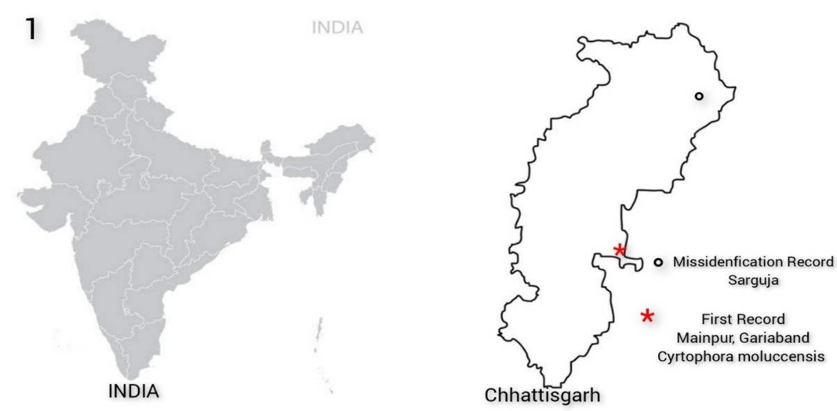
Cyrtophora moluccensis Doleschall, 1857 was spotted in a large Sal tree in Mainpur block (Deharguda) of Gariaband district of Chhattisgarh state. This region is situated at Latitude 20.324431° & Longitude 82. 245779° (Fig. 1). This is completely a forest region having large Saal, Char and Tendu trees. This spider was carefully collected by simple capturing method and preserved in 70% alcohol. Its live photographs were taken by INFINIX smart HD camera and Google map camera 1.4.13. Recent standard research articles have been used for its identification which have been published in standard journals till 2025 & some websites World Spider Catalogue, 2026..The previously recorded spider was compared with the new spider based on the photographs provided in the paper.

Figure: 1; Map represent the study area where spider species was misidentified and new record of spider Cyrtophora moluccensis Doleschall, 1857.

Results and Discussion
Taxonomy
Family Araneidae Clerck 1757
Cyrtophora Simon, 1864
Cyrtophora moluccensis Doleschall, 1857
(Fig. 2-10)
Synonyms
Epeira moluccensis Doleschall, 1857
Epeira margaritacea Doleschall, 1859
Argiope marxii McCook, 1894
Euetria moluccensis Thorell, 1890
Cyrtophora moluccensis Simon, 1895

Classification:
Phylum: Arthropoda
Class: Arachnida
Order: Aranae
Subclass: Araneomorphae
Family: Araneidae Clerck, 1757
Subfamily: Cyrtophorinae
Genus: Cyrtophora Simon, 1864
species: Cyrtophora moluccensis Doleschall, 1857

Specimen Examination : Cyrtophora moluccensis Doleschall, 1857 was spotted in a large Sal tree in Mainpur block (Deharguda) of Gariaband district of Chhattisgarh state. This region is situated at Latitude 20.324431° & Longitude 82. 245779° (Fig. 1). This is a completely forested region having large Saal, Char and Tendu trees. This spider was carefully collected by a simple capturing method and preserved in 70% alcohol. Its live photographs were taken by INFINIX smart HD camera and Google Maps camera 1.4.13. Recent standard research articles have been used for its identification, which have been published in standard journals till 2025 and on some websites, World Spider Catalogue, 2026.

Description:
The cephalothorax is oval and has a dorsoventrally flattened, dorsal carapace covered by white hairs. Three pairs of long furrows are present on the dorsal carapace, the sternum is oval, the chelicerae are small and weak with small hairs. Eyes are black and rounded. Eight eyes are arranged in the middle row and one pair in a lateral position (Fig.10). The abdomen is larger than the cephalothorax, elongated and conical shaped, with a pubescence pattern or yellow, black whitish pattern on the whole dorsal and lateral region. Anterior portion is more whitish, while the posterior region has dark black and yellow marks. Two large, black and round points are present on both lateral parts of the dorsal region (Fig.4). The abdomen is covered by small hairs. Legs are long, strong, black, cylindrical and covered by large setae and small hairs. Trochanter is large, short, strong, cylindrical and covered by whitish hairs. Coxa is small, thick and strong. The femur is long, strong, black and thick, covered by small hairs, ventral part is whitish brown with black dots. The patella is black and medium, thick, hairy and curved. Tibia is strong, long, hairy and black in colour. The metatarsus is long, cylindrical, black and thin. Tarsus is small, cylindrical and black. The claw is hairy, black and the end portion of the legs..
Diagnosis:
Cyrtophora moluccensis Doleschall, 1857 was identified by literatures, internet websites Inaturalist Spider Of India & Indian Biodiversity Portal. Literature Doleschall, 1857, Tikader, B. K. (1982a), Uniyal et al. 2011.

Global Distribution:
India to Japan, Indonesia, Papua New Guinea, Australia, Solomon Is., Palau, Micronesia, Fiji, Tonga, French Polynesia (WSC, 2026).

Indian Distribution:
Andaman & Nicobar (Tikader, 1977b), Assam (Pandit, 2019), Karnataka (Sharma & Ramakrishna, 2021), Kerala (Malamel & Sudhikumar, 2020), Madhya Pradesh (Tikader, 1982), Maharashtra (Maheshwari et al., 2018), Meghalaya (Gogoi & Ningthoujam, 2023), Puducherry (Sangeeta & Reddy, 2012), Rajasthan (Lawania & Trigunayat, 2015; Malhotra et al., 2019; Kashmeera et al., 2020), Sikkim (Saha et al., 2016), Tamil Nadu (Dharmaraj et al., 2018), Uttar Pradesh (Uniyal & Hore, 2009; Lawania & Mathur, 2014a), Uttarakhand (Quasin & Uniyal, 2011; Uniyal et al., 2011), West Bengal (Majumder & Talukdar, 2013; Raychaudhuri et al., 2016), Chhattisgarh (Present report).
Habitat
Cyrtophora moluccensis orb weaver spiders make large webs on the trees and live there. In these species, the size of the male is much smaller than that of the female.

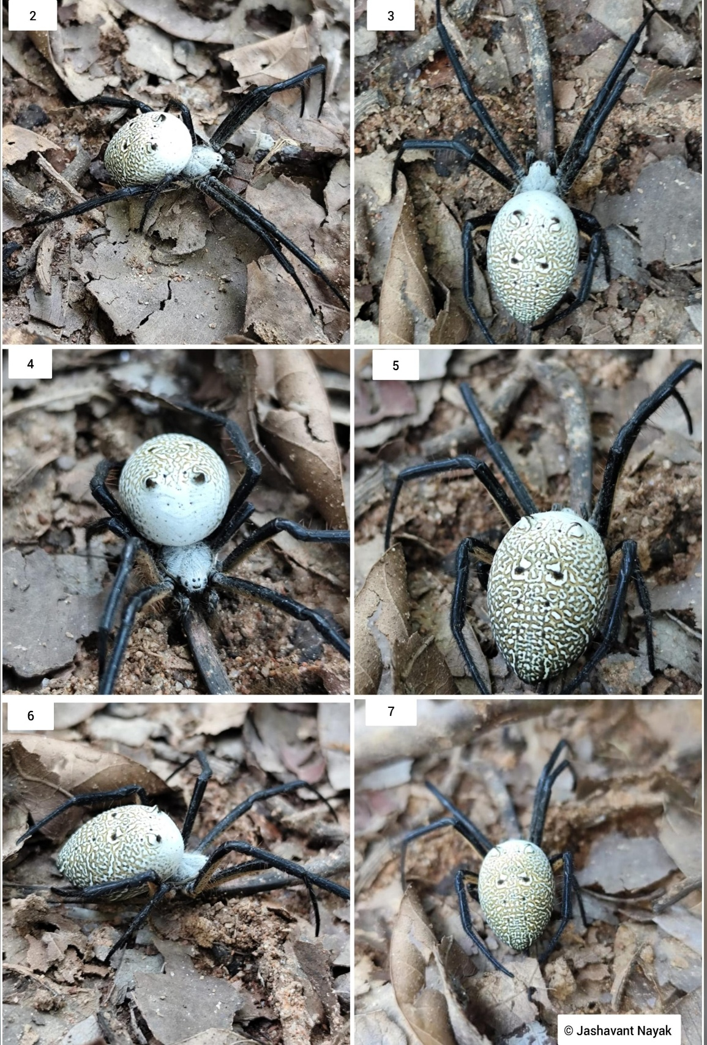
Figures:2-7; Habitus- Cyrtophora moluccensis Doleschall, 1857 female, 2. Dorsal view, 3. Dorsal view with legs and body morphology, 4. Anterior view, 5. Lateral view, 6. Posterodorsal view of spider.

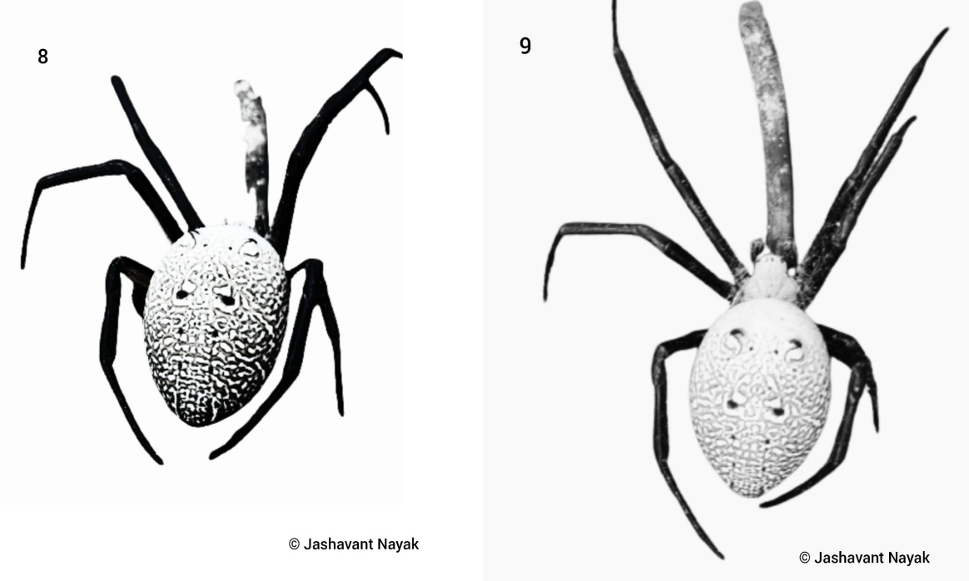
Figure: 8-9; Cyrtophora moluccensis Doleschall, 1857 female: Body pattern on dorsal opisthosoma of spider.
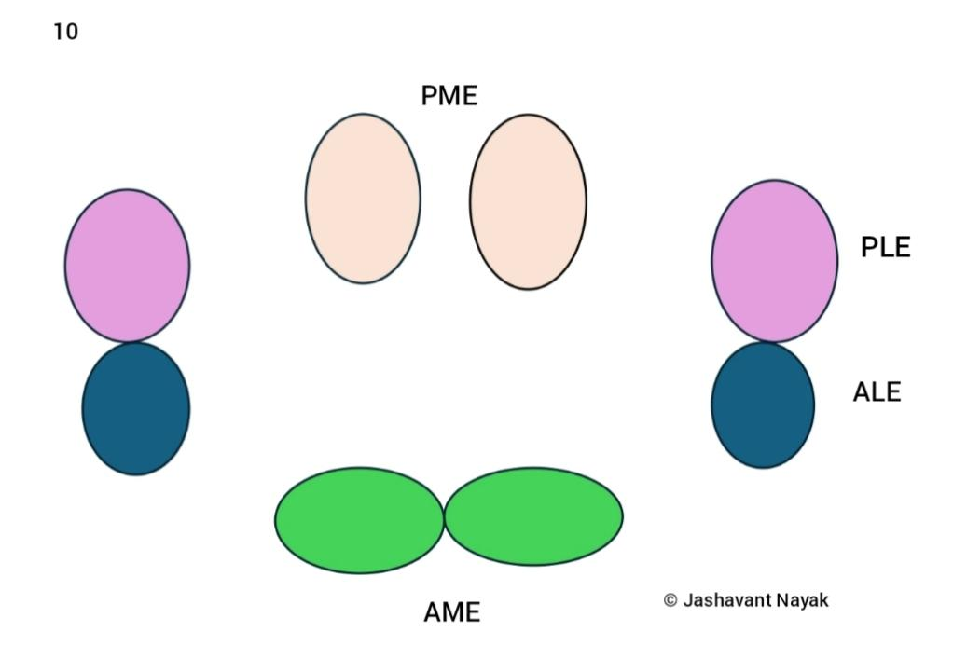

Figure: 10; Eye configuration of recorded spider species Cyrtophora moluccensis Doleschall, 1857 female:. (Abbreviations: PME-Posterior Median Eye, PLE-Posterior Lateral Eye, ALE- Anterior Lateral Eye, AME- Anterior Median Eye.

Cyrtarachne inaequalis: After analysing the previous research article, the characteristics of this species are as follows: the head is small and black in colour, the abdomen is very large, triangular-oval shaped, and whitish-brown in colour. The dorsal region of the abdomen is very convex, and there are conical, ring-like convex structures on both lateral sides of the abdomen.

For the first time, Cyrtophora moluccensis has been recorded in Chhattisgarh state. When the collected specimen was thoroughly examined, all its characteristics matched those of Cyrtophora moluccensis, confirming its identification as this species. This record adds another orb-web spider species to the list found in Chhattisgarh. While this species has been recorded in other Indian states, its documentation in a biodiversity-rich area like Chhattisgarh is significant. It was claimed that this species is found in Sarguja, Chhattisgarh, but when the documents related to this record were analysed, it was found that it is not Cyrtophora moluccensis. Chhattisgarh is a region covered by extensive forests and boasts high biodiversity. These spiders are found in dense, high-vegetation areas. This spider species spins large tent-like webs that trap numerous insects, contributing to pest control in the forest ecosystem and maintaining the food chain. These spiders are not found on the ground but rather build large webs high up in trees. This species was observed randomly during a forest visit on a Sal tree along the roadside and was subsequently examined properly. With this record, three species of Cyrtophora are now known to exist in Chhattisgarh: Cyrtophora citricola, Cyrtophora cicatrosa, and Cyrtophora moluccensis. This study will aid in the identification and understanding of other orb-web spiders.

Conclusion
An orb spider, Cyrtophora moluccensis Doleschall, 1857 (Female), has been identified for the first time in the forest area of Mainpur block of Gariaband district. However, the earlier identification of a spider from Sarguja by Choudhury et al., (2024) as Cyrtophora moluccensis Doleschall, 1857 was a faulty identification. Its correct identification is Cyrtarachne inaequalis Thorell, 1895. The correct identification and new record of Cyrtophora species adds another spider to Chhattisgarh, which helps in increasing the diversity of orb spiders in the state.
Disclaimer (Artificial Intelligence)
Author(s) hereby declare that no AI technologies have been used during the writing or editing of manuscripts. All photographs and manuscript is real without used of any AI tools.

References
Choudhury, S. R., Nirmalkar, Y., Singh, A. K., & Anand, A. (2024). Spider fauna of Chhattisgarh: An updated checklist of spiders of Chhattisgarh, India with new additions. Serket, 20(3), 311–334.
Clerck, C. (1757). Aranei Svecici. Svenska spindlar, uti sina hufvud-slågter indelte samt under några och sextio särskildte arter beskrefne och med illuminerade figurer uplyste. Laurentius Salvius, Stockholmiae, 154 pp. doi: 10.5962/bhl.title.119890
Dharmaraj, J., Gunasekaran, C. & Rajkumar, V. (2018). Diversity and plethora of Spider fauna at different habitats of the Nilgiris, Tamil Nadu South India. International Journal of Recent Scientific Research Research, 9(3A): 4634-24637.
Doleschall, L. (1857). Bijdrage tot de kennis der Arachniden van den Indischen Archipel. Natuurkundig Tijdschrift voor Nederlandsch-Indie 13: 399-434, pl. 1-2. Doi:10.5962/bhl.title.66068
Doleschall, L. (1859). Tweede Bijdrage tot de kennis der Arachniden van den Indischen Archipel. Acta Societatis Scientiarum Indo-Neerlandicae 5(5): 1-60, pl. 1-17.
Ekka, A. & Kujur, R. (2015). Spider diversity of Ram Jharna, Raigarh district, Chhattisgarh, India. Research Journal of Pharmacology & Technology, 8(7): 813-819.
Gogoi, J. & Ningthoujam, K. (2023). Arthropod biodiversity in agricultural, Horticultural and silvicultural ecosystems with special reference to spiders (Araneae) in mid-hills of Meghalaya, India. Journal of Agriculture and Horticulture Research, 6(2): 244-262.
Kashmeera, N.A., Drisya – Mohan, O.M. & Sudhikumar, A.V. (2020). Spiders of Rocky desert in Kailana, Rajasthan, India. Serket, 17(3): 201-206.
Kujur, R. & Ekka, A. (2016). Exploring the Spider fauna of Gomarda Wildlife Sanctuary, Chhattisgarh, India. International Research Journal of Biological Sciences, 5(6): 31-36.
Kujur, R. & Ekka, A. (2012). Inventorization of Spider fauna of IndraVihar Park, Raigarh, Chhattisgarh, India. IOSR Journal of Environmental Science, Toxicology and Food Technology, 1(2): 20-26.
Lawania, K.K. & Mathur, P. (2014a). Baseline studies on the spider fauna (Araneae) of Braj region (Braj-Bhoomi), India. International Journal of Basic and Applies Biology, 2(1); 137-141.
Lawania, K.K. & Trigunayat, M.M. (2015). A comparative study of the spider (Araneae) fauna in Keoladeo National Park (KNP), Nahargarh Wildlife Sanctuary (NWS) and Sur-sarovar Bird Sanctuary (SBS), India. International Journal on Agricultural Sciences, 6(1): 141-146.
Lubin, Y. D. (1974). Adaptive advantages and the evolution of colony formation in Cyrtophora (Araneae: Araneidae). Zoological Journal of the Linnean Society, 54(4), 321–339. https://doi.org/10.1111/j.1096-3642.1974.tb00806.x
Maheshwari, N.R., Patil, S.R. & Choda, M.Z. (2018). Spider fauna from north Maharashtra, India. Flora and Fauna, 24(1): 163-173.
Majumder, S.C. & Talukdar, S. (2013). Studies on taxonomy and diversity of Spiders from Darjeeling Hills with special reference to family Clubioneidae in Light of conservation. Records of the Zoological Survey of India, Occasional Paper No. 340, 96 pp.
Malhotra, G.S., Neera, K. & Saxena, M.M. (2019): Spider diversity and Abundance in different habitats of Upper-Northern Rajasthan. ESSENCE International Journal for Environmental Rehabilitation and Conservation, 10(1): 1-14.
Malamel, J.J. & Sudhikumar, A.V. (2020). An investigation of diversity and Bioecology of araneofauna of Pathiramanal Island in Vembanad Lake, a Ramsar site, Kerala, India. Zoology and Ecology, 30(2): 126-137. Doi:10.35513/21658005.2020.2.7
McCook, H. C. (1894). American spiders and their spinningwork. A natural history of the orbweaving spiders of the United States with special regard to their industry and habits. Vol. III. Philadelphia, 285 pp., 30 pls. doi: 10.5962/bhl.title.2681
Nayak J., Sori P., Sahu L., Bharti D. (2025a). A new observational record of jumping spider (Aranae: Salticidae: Aelurillini: Aelurillina) Stenaelurillus metallicus Caleb & Mathai, 2016 in Chhattisgarh, India . International Journal of Biology Research 10(1) 19-21. https://www.biologyjournal.in/assets/archives/2025/vol10issue1/10007- 1740555118544.pdf
Nayak J., Sori. P., Bharti D. (2025b). Description of a New Spider Meotipa sahyadri Kulkarni, Vartak, Deshpande & Halali, 2017 (Aranae: Theridiidae) in Chhattisgarh, India. International Journal of Research Publication and Reviews 6(2) 4518-4521. https://doi.org/10.55248/gengpi.6.0225.1026
Nayak J. & Sori P. (2025). Hamadruas hieroglyphica Thorell, 1887 (Aranae: Oxyopidae): First Description of a lynx Spider In Chhattisgarh, India. International Research Journal of Modernization in Engineering Technology and Science: 7(3): 632-634. DOI: https://www.doi.org/10.56726/IRJMETS68434
Nayak J., Warte H.K., Sori P. & Sahu L. (2025c). Study on Jumping Spiders (Aranae: Araneomorphae: Salticidae) Diversity in Shraddha Public School Campus Gariaband, Chhattisgarh, India. International Journal Of Latest Technology In Engineering, Management & Applied Science : 14 (3): 350- 353 DOI : https://doi.org/10.51583/IJLTEMAS.2025.140300037
Nayak, J. (2025). Stenaelurillus jagannathae Das, Malik & Vidhel, 2015: First Description in Chhattisgarh, India. Bioscience Discovery, 16(3):37-40. http://biosciencediscovery.com/Archive.html#
Nayak, J., Chaure, M., Majumdar, M., Nichat, A. R., & Harris, K. K. (2025d). Assessment of orb weaver spider (Araneidae Clerck, 1757) diversity in Gariaband forest region with a new endemic species in Chhattisgarh region, India. International Journal of Fauna and Biological Studies, 12(5), 61–67. https://doi.org/10.22271/23940522.2025.v12.i5a.1131
Nayak, J., Warte, H. K., Sahu, L., & Rajanikant. (2025e). First description of a crab spider species Stiphropus sangayus Barrion & Litsinger, 1995 (Araneae: Araneomorphae: Thomisidae) in Odisha, India. International Journal of Zoology, Environment, and Life Sciences, 2(3), 7–10. https://doi.org/10.70604/ijzels.v2i3.73
Nayak, J., Warte, H. K., & Chaure, M. (2025f). A brief study of jumping spider (Arachnida: Araneae: Salticidae) diversity around Tandula Dam, Balod, Chhattisgarh, India. Journal of Science Research International, 11(8), 1–8. https://doi.org/10.5281/zenodo.17442064
Nayak, J., Chaure, M., Warte, H. K., Majumdar, M., Harris, K. K., & Nichat, A. R. (2025g). A new distribution of the spider genus Storenomorpha Simon, 1884 (Araneae: Zodariidae) in Chhattisgarh State, India. Asian Journal of Research in Zoology, 8(4), 127–133. https://doi.org/10.9734/ajriz/2025/v8i4224
Nayak, J., Warte, H. K., Sahu, L., & Singh, L. (2026). New distribution of two cobweb (Araneae: Theridiidae Sundevall, 1833) spiders in Chhattisgarh State, India. Asian Journal of Research in Zoology, 9(1), 1–9. https://doi.org/10.9734/ajriz/2026/v9i1235
Nichat A. R., Warte HK., Nayak J., (2024). Spider diversity (Arachnida:Aranae) in Deobhog region Gariyaband Chhattisgarh India : International Journal of Innovation and Science and Engineering. : 11 (8) : 39 – 45 https://ijiset.com/vol11/v11s8/IJISET_V11_I08_03.pdf
Nichat A. R., Harris KK., Warte HK., Dubey M., Sori P. & Nayak J. (2025a). Spiders Diversity in North East Gariaband Forest Regions of Chhattisgarh, India. Uttar Pradesh Journal of Zoology, 46(4):119-127. DOI: https://doi.org/10.56557/upjoz/2025/v46i44808
Nichat, A. R., Nayak, J., Sori, P., & Warte, H. K. (2025b). Description of new jumping spider species Epocilla aura (Aranae: Salticidae: Chrysillini) from Gariaband district, Chhattisgarh State, India. International Research Journal of Biological Sciences, 14(2), 1–4. International Science Community Association. http://www.isca.in
Quasin, S. & Uniyal, V.P. (2011). Spider diversity along altitudinal gradient in Milam Valley, Nanda Devi Biosphere Reserve, Western Himalaya. Indian Forester, 137(10):1207-1211.
Pandit, A.K. (2019). Diversity of common garden and house spider in Tinsukia District. Journal of Entomology & Zoology Studies, 7(4): 1432-1439.
Raychaudhuri, D., Saha, S. & Roy, T. K. (2016). Spiders: a proficient candidate in Practising IPM for Darjeeling Tea. World Scientific News, 38: 1-62.
Saha, S., Roy, T.K. & Raychaudhuri, D. (2016). Survey on spider faunal diversity of darjeeling tea plantations. Munis Entomology & Zoology, 11(2): 622-635.
Sangeeta, S. & Reddy, M.V. (2012). Spider biodiversity response to habitat restoration at Puducherry on southeast coast, India. Continental Journal of Biological Sciences, 5(2): 12-23.
Sharma, S. & Ramakrishna, S. (2021). Study on diversity of spiders from Bangalore University Campus, Bengaluru, India. International Journal of Scientific Research, 10(3): 37-38. Doi:10.36106/ijsr
Simon, E. (1864). Histoire naturelle des Araignées (Aranéides). Roret, Paris, 540 pp. doi: 10.5962/bhl.title.47654
Simon, E. (1895). Histoire naturelle des araignées. Deuxième édition, tome premier. Roret, Paris, pp. 761-1084. Doi: 10.5962/bhl.title.51973
Singh, R., Verma, A. K., Singh, B. B., & Singh, G. (2023). Spider Fauna Of India. Asian Biological Research Foundation, Prayagraj, India Nature Light Publications, Pune . ISBN 978-81-959483-4-5
Thorell, T. (1890a). Studi sui ragni Malesi e Papuani. IV, 1. Annali del Museo Civico di Storia Naturale di Genova 28: 5-421.
Tikader, B.K. (1977b). Studies on spider fauna of Andaman and Nicobar islands, Indian Ocean. Records of the Zoological Survey of India, 72: 153-212.
Tikader, B.K. (1982). The Fauna of India, Spiders: Araneae, Part 1 Family Araneidae (= Argiopidae) Typical Orb-Weavers, pp. 1-293; Part 2 Family Gnaphosidae, Zoological Survey of India, Kolkata, pp. 295-536.
Tikader, B. K. (1982a). Part 1. Family Araneidae (= Argiopidae). Typical orb-weavers. In: The fauna of India. Spiders: Araneae. Vol. II. Zoological Survey of India, Calcutta, pp. 1-293.
Uniyal, V.P. & Hore, U. (2009). Effect of Management Practices on Spider Diversity in Terai Conservation Area (TCA). Final Project Report, Wild Life Institute of India. 222 pp.
Uniyal, V.P., Sivakumar, K. & Quasin, S. (2011). Diversity of spiders in Nanda Devi Biosphere Reserve. Wildlife Institute of India, Dehradun. (DST Project Completion Report), 199 pp.
World Spider Catalog (2026). World Spider Catalog. Version 26. Natural History Museum Bern, online at http://wsc.nmbe.ch, accessed on {01.01.2026}. Doi: 10.24436/2

