FORMULATION AND QUALITY ASSESSMENT OF HERBAL FUNCTIONAL FERMENTED BEVERAGE FROM ROSE (ROSA SPP.) AND KALMEGH (ANDROGRAPHIS PANICULATA).

Abstract
Fermented beverages have high expression in the market for beverages and many health benefits obtained from them. Commercially, fermented beverages are produced by the fermentation yeast which involves the conversion of sugar into alcohol and carbon dioxide. Under this study, “Studies on fermented beverages and storage behavior of rose petal and kalmegh” was made with the objectives of getting a high quality of nutrients. The physical and biochemical parameters of fresh beverage were determined. The total soluble solids of Rose petal and Kalmegh obtained were 4.25 ºBrix and 5.06 ºBrix. The fermented beverages of 12 treatments and 3 replication with different combination of Rose petal and Kalmegh: T1 (100g Rose), T2 (100g kalmegh), T3 (95g rose +5g kalmegh), T4 (90g Rose + 5g kalmegh), T5 (85g Rose + 5g kalmegh), T6 (80g Rose + 5g kalmegh), T7 (75g Rose + 5g kalmegh), T8 (95g Rose + 10 g kalmegh), T9 (90g Rose + 10g kalmegh), T10 (85g Rose + 10g Kalmegh), T11 (80g Rose + 10g kalmegh) and T12 (75g Rose + 10g kalmegh) . The 12 treatments combination were analysed for the Alcohol content, TSS, TS, RS, NRS, Titrable acidity, P^{H}, Anthocyanin, Ascorbic acid, and Phenol both in freshly and aged fermented beverage (6 months of storage). The result obtained showed that content of alcohol varied between (1.79% - 2.12%), TSS (5.80 ºBrix-5.87 ºBrix), TS (2.47%-3.39%), RS (1.51%-2.51%), NRS (1.05%-1.24%), Titrable acidity (1.11%-1.28%), P^{H} (3.97- 4.07) , Anthocyanin (0.29mg/100ml – 0.44mg/100ml), Ascorbic acid (8.28mg/100ml -8.72mg/100ml), Phenol (98.03mg/100ml – 111.49mg/100ml) in the freshly fermented beverages while after 6 month of storage the content of alcohol varied between (4.49% - 4.80%), TSS (4.07 ºBrix-4.67 ºBrix), TS (1.59%-2.68%), RS (1.32%-1.83%), NRS (0.46%-0.80%), Titrable acidity (0.90%-0.98%), P^{H} (4.16- 4.37) , Anthocyanin (0.29mg/100ml – 0.31mg/100ml), Ascorbic acid (7.02mg/100ml -8.16mg/100ml), Phenol (31.70mg/100ml – 34.15mg/100ml)
Based on the organoleptic score of the treatments, T6 scored the best with the value of 4.21 which were more acceptable by the panellist followed by T1 and T10 with 3.88 and 3.50 respectively.

Keyword: Dried rose petal, Kalmegh powder, Alcohol, Yeast.

Introduction
Fermented beverages have gained significant popularity in the global market due to their unique flavors, nutritional profiles, and potential health benefits. These beverages are typically produced through microbial fermentation, where yeasts convert sugars into alcohol and carbon dioxide, resulting in products that may offer probiotic effects, enhanced bioavailability of nutrients, and antioxidant properties. Traditional fermented drinks, such as kombucha or kefir, have been adapted to incorporate herbal ingredients for added therapeutic value. Rose petals (Rosa spp.) and kalmegh (Andrographis paniculata) are two such botanicals with established medicinal uses.Rose petals are rich in polyphenols, flavonoids, and vitamins, contributing to anti-inflammatory, antioxidant, and digestive health benefits. They have been used in fermented beverages to enhance flavor and provide skin health support, stress relief, and immune modulation. Kalmegh, known as the "king of bitters," possesses hepatoprotective, immunostimulant, and anti-inflammatory properties due to compounds like andrographolide. Its bitter taste aids digestion and liver function, making it a candidate for functional beverages. Combining these in fermented forms could yield nutrient-rich products with synergistic effects. Fermentation is a traditional biotechnological process used for preservation and value addition of foods. Alcoholic fermentation mediated by Saccharomyces cerevisiae converts sugars into ethanol and improves shelf life and sensory attributes (Ray and Joshi 2014; Şanlier et al. 2017). Fermented beverages are increasingly recognized for health-promoting properties due to bioactive metabolites and improved nutrient availability (Parvez et al. 2006).Rose petals are rich in phenolic compounds, flavonoids and anthocyanins (Baydar and Baydar 2013; Kumar et al. 2009; Kumari et al. 2018). Their antioxidant and antimicrobial properties have been documented extensively (Ozkan et al. 2004; Nowak et al. 2014; Abdel-Hameed et al. 2013). Rose volatiles contribute characteristic aroma compounds (Agarwal et al. 2005; Jalali-Heravi et al. 2008).Kalmegh (Andrographis paniculata) contains andrographolide and other diterpenoids with antioxidant and immunomodulatory activities (Niranjan et al. 2010; Rafat et al. 2009; Tandon et al. 2015). However, its bitterness limits direct consumption.

However, the stability of fermented herbal beverages during storage is critical, as changes in physicochemical parameters can affect quality, safety, and sensory appeal. This study aimed to develop fermented beverages from varying combinations of rose petals and kalmegh, evaluate their physical and biochemical parameters fresh and after 6 months of storage, and assess organoleptic acceptability. The objectives included optimizing nutrient quality and understanding storage-induced changes.

Materials and Methods
A. Physical parameters
- PHYSICAL PARAMETERS
- Rose and kalmegh.
The physical characteristics of rose flower and kalmegh were determined by using measuring scale (flower size, petal length) the shape of rose and kalmegh were determined visually and the color of the rose petals and kalmegh measured by RHS color charts.

Table 3.2 : Physical characteristics of rose and kalmegh
Sl. No. | Physical parameters | Methods used
1. | Flower size | By measuring scale
2. | Petal length | By measuring scale
3. | Petal color | By RHS color chart

1. Rose
- Average flower size

The average flower size of rose was measured by using a measuring scale.

- Petal length

The petal length was determined by using measuring scale and Digital vennier caliper.

- Petal color

Visuals and RHS charts determined the petal color.

2. Kalmegh

- Petal length

The petal length was determined by using measuring scale.

- Petal color

Visuals and RHS charts determined the petal color.

- Shape and Size

It was determined by Digital vennier caliper and measuring scale.

Table 3.3: Chemical parameters at fresh condition
Sl. No. | Chemical parameters | Methods used
1. | TSS (Degree Brix) | By Hand Refractometer
2. | Total sugar (%) | By Lane and Eynon (1923)
3. | Reducing sugar (%) | By Lane and Eynon (1923)
4. | Non reducing sugar (%) | By Lane and Eynon (1923
5. | Acidity (%) | By Standard Alkali solution
6. | Ascorbic acid (mg/100g) | Dye-2,6 Dichlorophenol Indophenol solution
7. | Anthocynin(mg/100g or ml) | By Ranganna, 2004
8. | Phenols content(%) | By Ranganna, 2004
9. | Alcohol % | By Alcoholometer, Alex 500

3.4 Standardization of beverages
Standardization of fermented beverages from dried rose petals and Kalmegh powder was evaluated with appropriate proportions of these two combinations made with 12 Treatments and 3 Replications are presented in the table 3.4 as follows:
Table 3.4: Standardization of ingredient for the fermented beverage
Treatments | Proportion of ingredients for 1.00 litre
T1 | Rose (100g)
T2 | Kalmegh (100g)
T3 | Rose + kalmegh (95+5g)
T4 | Rose + kalmegh (90+5g)
T5 | Rose + kalmegh (85+5g)
T6 | Rose + kalmegh (80+5g)
T7 | Rose + kalmegh (75+5g)
T8 | Rose + kalmegh (95+10g)
T9 | Rose + kalmegh (90+10g)
T10 | Rose + kalmegh (85+10g)
T11 | Rose + kalmegh (80+10g)
T₁₂ | Rose + kalmegh (75+10g)

Replication- 3
Design of treatment – completely randomized block design
Methodology used in fermentation of dried rose petals and Kalmegh powder

Flow chart 1: Technological flow sheet for fermentation process

SAMPLE(S)

CLEANING OF SAMPLES

CRUSHING (Mixer grinder)

FILLING UP TO THREE- FOURTH

ADDITION OF SUGAR (24% TSS)

ADJUSTMENT OF pH (3.5 to 4)

PASTEURISATION (for 15min)

KEEPING FOR AN HOUR

ADDITION OF WINE YEAST (20 ml/5lt sample)

FERMENTATION ( days)

RACKING (syphoning off clear liquid)

FINING AND FILTRATION

AGING (MATURATION) ( for 6 months)

PASTEURISATION AT 85°C (for 2 min.)

BOTTLING

CROWN CORKING

PASTEURISATION AT 82°C (for 20 min.)

COOLING

STORAGE

Dried rose petals were sorted out to remove inert materials. Amount required for preparation of sample were calculated as per the number of treatments, replication and proportions of the two components. Rose petals and Kalmegh were grinded with the help of grinder respectively. The ingredients were prepared according to the treatment maintaining TSS (24%), pH (3.5-4) which was adjusted by adding jaggery and critic acid respectively.
2 liter of samples were filled into sterilized bamboo containers with capacity of 2.5-3 liters and 5ml cultured yeast (saccharomyces cereviseae), after completion of fermentation, samples were siphoned off with muslin cloth and clear filtered fermented beverages were kept for aging (6 months) in a sterilized bottle. Flow chart of the method has been given in Flow chart: 1

Table 3.5: Inoculation of yeast and days taken for fermentation at ambient temperature
Treatments | 2024-2025 |  |  |  |  |  | Total days taken for full fermentation |  |  | Mean
Treatments | Inoculation date (DEC ^{TH}2024) |  |  | Full fermentation date (Jan^{th}2025) |  |  |  |  |  | Mean
Treatments | R1 | R2 | R3 | R1 | R2 | R3 | R1 | R2 | R3 | Mean
T1 | 17th | 17th | 17th | 7th | 7th | 7th | 20th | 20th | 20th | 20.0
T2 | 17th | 17th | 17th | 5th | 3th | 6th | 18th | 16th | 19th | 17.7
T3 | 18th | 18th | 18th | 10th | 8th | 7th | 22th | 20th | 19th | 20.3
T4 | 18th | 18th | 18th | 11th | 11th | 11th | 21th | 21th | 21th | 21.0
T5 | 18th | 18th | 18th | 12th | 12th | 15th | 22th | 22th | 25th | 23.0
T6 | 19th | 19th | 19th | 13th | 12th | 14th | 25th | 24th | 26th | 25.0
T7 | 19th | 19th | 19th | 15th | 14th | 13th | 27th | 26th | 23th | 25.3
T8 | 19th | 19th | 19th | 17th | 16th | 17th | 29th | 28th | 29th | 28.7
T9 | 19th | 19th | 19th | 15th | 16th | 17th | 27th | 28th | 26th | 27.0
T10 | 20th | 20th | 20th | 14th | 16th | 18th | 25th | 26th | 28th | 26.3
T11 | 20th | 20th | 20th | 16th | 19th | 12th | 28th | 29th | 23th | 26.7
T12 | 20th | 20th | 20th | 14th | 16th | 18th | 25th | 26th | 28th | 26.3

Storage
Fermented beverages were kept under storage for 6 months. The nutritional qualities of fermented beverages were assessed.
Bottling of fermented beverages
The completely fermented samples were strained and filled into sterilized bottles with airtight sealing. The sealed bottles were stored in dry and cool place for aging (6 months) fermented beverages of alcohol content were determined at initial months (freshly fermented) and aged (6 months).

Experiment no 2: Storage studies of standardized fermented beverages from rose and kalmegh

- Total soluble solids
Total soluble solids of dried rose petals and Kalmegh powder of freshly and aged fermented beverages were determined by Hand Refractometer. The mean value is expressed in ºBrix.

- Total sugar:
Total sugar was analyzed by Lane and Eynon (1923) method by using Fehling’s solution and methyl blue indicator with hydrolysis of HCI and neutralizing with NaOH pellets. it was estimated value expressed in percentage.
Total sugar (%) =20/titrate value.

- Reducing sugar:
Fehling’s was used to estimated the reducing sugar suggested by Lane and Eynon (1923) using methyl blue indicator and expressed as percent fresh weight/volume basis.
Reducing sugar % = 20/titrate value.

- Non reducing sugar : % = (Total sugar % - Reducing sugar%) × 0.95

- Titratable acidity:
Acidity of fermented beverages of dried rose petals and Kalmegh powder was assessed with titrate against standard alkali (N/10 NaOH) solution using phenolphthalein as indicator and was expressed as per cent in terms of citric acid (AOAC, 1984).

Titre value × Normality of NaOH (N/10) × Meq Wt. of acid 0.064 × Vol × 100
Acidity % =

Aliquot taken for estimation × Wt. of sample taken

- pH: is determined by Digital pH meter.

- Ascorbic acid:
Ascorbic acid of fermented beverages of dried rose petals and Kalmegh powder was determined by using metaphosphoric acid method with 2, 6 Dichlorophenol indophenols solution as described by Ranganna (2004). The end point was marked by appearance of pink color. It was expressed as mg of ascorbic acid present in 100g/100ml of samples.
0.5

Dye Factor (D.F) =
Titre value of standard ascorbic acid

Titre value x D.F x Volume made up x 100

Ascorbic Acid (mg/ 100 g or ml) =
- Anthocyanin:
Aliquot taken x wt. of the sample

The total amount of dried rose petals and Kalmegh powder and fermented beverage was determined by Ranganna (2004) method. Methanolic HCI was used as solvent and reading was taken in UV-Spectrophotometer at 535λnm against the blank. Value was measured in mg/100ml.

O.D × V ol × 100
Total O.D=
Wt. of sample

Total optical density

=
Anthocyanin (mg/100 ml or g)
98.2

- Phenol:
Phenol content of fermented beverage of dried rose petals and Kalmegh powder were described by Ranganna (2004). Fohlin-Ciocalteu’s phenol reagent, 80% ethanol and sodium carbonate were used. Reading was observed in UV-Spectrophotometer at 650λnm against blank. Value was measured in per cent or mg/100ml or g with the help of standard curve of phenol (catechol).
Y( concentration std curve) × Vol × 100

Total phenol (mg/100ml or g)=
Wt. of sample × 1000 × Aliquot taken

- Alcohol:
Alcohol content of fermented beverages was analyzed through alcoholmeter Alex-500 and value was expressed in per cent by v/v. it is digitally electric operated and results were generated automatically.

- Organoleptic quality of fermented beverages:
Initially and periodically the samples were distributed to a team of 15 panelist for overall acceptability that include the points like color, aroma or flavor and taste of the fermented beverage on a 5.00 Point Hedonic Scale (Amerine et al 1965) as mentioned below

Table 3.6 Organoleptic quality of fermented beverage
Organoleptic scale | Rating
5 | Liked extremely (LE)
4 | Liked moderately (LM)
3 | Neither liked nor disliked (NLND)
2 | Disliked moderately (DM)
1 | Disliked extremely (DM)

Samples receiving acceptability score of 3.00 and above were considered acceptable and palatable

- Statistical analysis:
Statistical analysis and test of significance were done following the method described by Panse and Sukhatme (1967) while the method described by Mahalanobis (1936) was followed for Completely Randomized Block design. The analysis of variance (Anova) of the data was carried out by the techniques as suggested by (Raghuramula et al, 1983).

√2 × MMS
Treat S.E. ± =
Replication

CD at 5%=SE × t value

Experiment no.3: Estimation of Benefit: cost ratio of standardized fermented beverages

The benefit cost ratio was calculated after estimation of total cost involved including the operational and 10% overhead charges incurred during the preparation of fermentation of beverages. The benefit: cost ratio was computed by the formula as given below:

Net income
Net income Benefit: Cost ratio (b/c)=
Total cost Involved

The gross income was estimated by average market price of similar products and total cost of production was estimated by addition of the fixed cost and variable cost with 10% overhead charges of fixed inputs.

Results and Discussion

Physicochemical and Biochemical Parameters
The fermented beverages exhibited variations in parameters across treatments, with ranges summarized in Tables 1 and 2 for fresh and stored samples

Physico-chemical characteristics of dried rose petals and kalmegh
4.1: Physical characteristics of dried Rose petals and kalmegh:
The data of physical parameters of dried rose petals and kalmeghobserved during the research period are presented in Table 1. The colour of rose petals was shownreddish pink colour by RHS chart as well as the visual observation. The diameter of flower and length measured as 5.51cm and 3.32cm respectively. A similar study was made by Shahrin et al. (2015) where most of the rose cultivars exhibited red to reddish colour like cultivars Taj Mahal, Red Baby, Star Fire and Printed moon. Some cultivars also exhibited pink to pinkish colour like Pinkey Smile, Sweet Love and Charming LadySweet Sakata exhibited Magenta colour. Regret berg cultivar was reported to be 5.17cm flower size by Tabassum et al (2002). Similarly, kalmegh was observed a Dark green in colour. The Flower size and length were observed as 1.21cm and 0.87cm respectively.

Table 1: Physical characteristics of dried rose and kalmegh
Sl. No | Parameters (colour) | Observations
1 | Rose Flower diameter | 5.51cm
2 | Rose Petal length | 3.32cm
3 | Rose Petal color | Reddish pink, 58A byRHS chart
4 | KalmeghFlower length | 1.21cm
5 | KalmeghPetal breadth | 0.87cm
6 | KalmeghPetal color | Greenish dark 146A,B by RHS chart

4.2. Biochemical characteristics of dried Rose petals

Table 2: Biochemical characteristics of dried rose petals
Sl. No. | Parameters | Value
1. | Total soluble solids (TSS) | 4.25 ºBrix
2. | Total sugar | 2.94 %
3. | Reducing sugar | 2.44 %
4. | Non reducing sugar | 0.62 %
5. | Titratable acidity | 0.26 %
6. | Ascorbic acid | 9.19 mg/100
7. | Anthocyanin | 2.43 mg/100
8. | Phenol | 289.71 mg/100
The biochemical composition of dried rose petals’ values is shown in Table 2 and the results of dried rose petals TSS was 4.25°Brix , total sugar (2.94%), reducing sugar (2.44%), non reducing sugar (0.62%), Titratable acidity (0.26%), Ascorbic acid (9.83mg/100), Anthocyanin (2.43mg/100g) and phenol content of 289.71mg/100g respectively. A similar line of work made by Chauhan (2018) showed a range of 1.91 to 2.11°Brix TSS, pH of fresh rose petals 5.09, ascorbic acid 6.94mg/100g in fresh rose petals and 2.48 to 6.45mg/100g ascorbic acid in dried rose petals. Prata et al. (2017) resulted that total sugar was found to vary between cultivars from 2.31 to 3.64mg/100g and reducing sugar to be highest in the cultivar Prima Donna containing 2.80 mg/100g whereasSaptariniet al. (2018) reported the dried rose petals possessed anthocyanin of 0.459 ± 0.003mg/L in maceration and 0.366 ± 0.005mg/L in percolation method. Similarly, Butcaruet al. (2018) reported the anthocyanin content in petals of “Falstaff” variety of rose to be 33.06 mg/100g. Ercisli (2007) was also reported that the pH value of Rosa canina fruit was 4.07 and Rosa willosawas 4.73. Samesh et al. (2018) was in agreement with the results of phenolic content of rose petals which was 25.13-52.01 mg gallic acid equivalents/g dry weight (DW). It was also supported the result by Kart et al. (2017) showed that dried rose petals contained 5.24-166.36 mg GAE/200 ml phenol.

4.3: Biochemical characteristics of kalmegh
The biochemical composition of dried kalmegh was analysed and data depicted from Table 3. The nutritional value of kalmegh powder was observed with TSS content of 5.60°Brix, total sugar (3.03%), reducing sugar (2.56%) and non reducing sugar (0.44%), acidity (0.17%), ascorbic acid (5.23mg/100g), phenol (0.77mg/100g) and Anthocyanin(42.86mg/100g) respectively. There was no such evidence found or mentioned anywhere yet.
Table 3: Biochemical characteristics of kalmegh
Sl. No. | Parameters | Value
1. | Total Soluble Solids (TSS) | 5.60 º Brix
2. | Total sugar | 3.03 %
3. | Reducing sugar | 2.56 %
4. | Non reducing sugar | 0.44 %
5. | Titratable acidity | 0.17 %
6. | Ascorbic acid | 5.23 mg/100g
7. | Phenol | 0.77 mg/100g
8. | Anthocyanin | 42.86 mg/100g
Standardization of fermented beverages from rose petals and kalmegh
4.4: Time taken for fermentation
The data depicted from Table 4 for the total days taken for fermentation showed variation in completion of fermentation period with different treatments. The total days taken for fermentation varied from 17.07 days to 28.07days with significant differences between the treatments. The maximum fermentation period of 28.07 days was observed in Treatment T₈, followed by T₉with a fermentation period of 27.02 days whereas, the least days taken for fermentation period were observed in T₂ (17.07 days) at ambient temperature. The variation of days for fermentation might be the effect of the yeast (Saccharomyces cerevisiae) population by different ingredient combinations.

Table 4: Total days taken for the completion of fermentation by yeast at ambient temperature
Treatment | Total days taken for  fermentation | Alcohol %of freshly  fermented | Alcohol % after  6 months
T1 | 20.10 | 0.67 | 4.05
T2 | 17.07 | 0.47 | 2.99
T3 | 20.31 | 0.45 | 2.03
T4 | 21.33 | 0.56 | 2.06
T5 | 23.21 | 0.58 | 2.18
T6 | 25.12 | 1.79 | 4.80
T7 | 25.37 | 0.42 | 1.23
T8 | 28.07 | 1.59 | 4.49
T9 | 27.02 | 1.52 | 3.64
T10 | 26.33 | 1.70 | 3.09
T11 | 26.07 | 1.75 | 2.67
T12 | 26.31 | 2.12 | 3.19
SEd ± | 1.276 | 0.025 | 0.106
CD(0.01) | 3.590 | 0.071 | 0.299
CV(%) | 6.53 | 2.79 | 4.29

4.5: Standardization of fermented beverage:
Based on the medicinal value and availability of raw materials of dried rose petals and kalmegh powder in different concentrations and proportions had been made for the standardization of the fermented beverage. The proportions of ingredients required for fermentedbeverage in each treatment are presented in Table 5. Periodical panel tests of fermented beverage were conducted at an interval of 0 month (freshly fermented) and 6 months (aged fermented beverage) by 15 panellists respectively. The acceptability of freshly and aged fermented beverages on the basis of overall 5.0 Point ratingscoreranged between 2.16 to 4.33 and 2.27 to 4.21 respectively.
Acceptability of the fermented beverage was significant (p≤0.01)among the treatment combinations in both conditions. Treatments T₆ (4.33) showed highest acceptability score which was followed by T₁ (3.30) and T₁₀ (3.25) in freshly fermented beverage while after 6 months storage of fermented beverage (aged) the highest score was obtained in treatment T₆ (4.21) fallowed by T₁ (3.80) and T₁₀ (3.50) by panellist members. Similarly, the lowest rated value was also noted in T₃ (2.69) and T₂ (2.16) in freshly fermented beverage whereas in aged fermented beverage least score was obtainedin T₅ (2.65) and T₂(2.27) respectively as shown in Fig. 1. The value of score point of fermented beverage was only accepted above 2.50 rated value for both. The
results of sensory evaluation of fermented beverage was in agreement with Many et al. (2014) who conducted a nutrient analysis of tomato wine for fresh and on 6 months aged wineand Patil et al. (2012) worked on the production of wine from jamun (Syzygiumcumini) showed dark purple color were preferred.

Table 5: Standardization of fermented beverages from rose petals and kalmegh
Treatment | Proportion of Ingredients  (Rose + Kalmegh) | Organoleptic Score (5.0 Hedonic Scale )
Treatment | Proportion of Ingredients  (Rose + Kalmegh) | Freshly fermented beverages | Aged fermented beverages (6month)
T1 | Rose (100g) | 3.30 | 3.88
T2 | Kalmegh (100g) | 2.16 | 2.27
T3 | Rose + kalmegh (95+5g) | 2.69 | 2.84
T4 | Rose + kalmegh (90+5g) | 2.76 | 2.94
T5 | Rose + kalmegh (85+5g) | 2.77 | 2.65
T6 | Rose + kalmegh (80+5g) | 4.33 | 4.21
T7 | Rose + kalmegh (75+5g) | 2.74 | 3.28
T8 | Rose + kalmegh (95+10g) | 2.73 | 3.15
T9 | Rose + kalmegh (90+10g) | 2.92 | 3.13
T10 | Rose + kalmegh (85+10g) | 3.25 | 3.50
T11 | Rose + kalmegh (80+10g) | 2.84 | 3.13
T12 | Rose + kalmegh (75+10g) | 2.78 | 3.42
 | SEd ± | 0.149 | 0.186
 | CD(0.01) | 0.421 | 0.524
 | CV(%) | 8.05 | 9.14

4.2. Experiment No.2: Study on quality assessment of standardized fermented beverages during storage
Changes in the quality of fermented beverages of rose petals with combination of kalmegh were observed during the research period. The changes occurred in quality of the fermented beverages during storage was recorded with different nutritional parameter values with the treatments and data are presented in Table 6 to 11 and illustrated in Fig. 1 to 11.

TSS:
The value of TSS of freshly and aged fermented beverages is presented in Table 6 and Fig. 2.A significant difference (p≤0.01) amongst the treatments was noticed in TSS content of freshly and aged fermented beverages. TSS of freshly fermented beverage was recorded highest in T₆ (5.87°Brix) which contains 80g dried rose petals and 5g of kalmegh, and lowest in T₇ (75g dried rose petals + 5g kalmegh) 4.07°Brix. There was a change in TSS over the period of storage of fermented beverages at ambient temperature. A decrease in TSS was found after 6 months (aged) of storage in all the treatments. The TSS content of aged fermented beverage was showed a decreasing in trend from fresh one. The highest TSS was in T₁₁ (4.67°Brix) and lowest in T₄ (3.03°Brix) respectively as shown in Fig. 2. The decrease of TSS might be conversion of invert sugar into alcohol during storage. A similar work done by Hyun-jeonget al. (2017) in kiwi fruit juice ('Jecy Sweet' and 'Jecy Gold')during fermentation TSS decreased after 120 days of aging. Gavimathet al. (2012) conducted a comparative study on different fruit wines namely Papaya, Banana, Orange and Lime 5th, 9th, 15th, 25th and 30th day respectively TSS was found to decrease in all the four wines from the initial day to 30th days.

Table.6: Changes in TSS and Total sugar content in fermented beverages from rose petals and kalmegh
Treatment | Tss (ºBrix) |  |  |  | Total sugar (%)
Treatment | Freshly fermented beverages | Aged fermented beverages  (6month) |  | Freshly feremented beverages |  | Aged  fermented beverages  (6month)
T1 | 4.97 | 4.00 |  | 2.47 |  | 1.12
T2 | 5.80 | 3.27 |  | 3.39 |  | 2.68
T3 | 5.13 | 3.53 |  | 1.82 |  | 1.59
T4 | 5.33 | 3.03 |  | 1.50 |  | 1.45
T5 | 4.13 | 4.07 |  | 2.01 |  | 1.14
T6 | 5.87 | 3.67 |  | 2.03 |  | 1.23
T7 | 4.07 | 3.73 |  | 1.86 |  | 1.21
T8 | 4.87 | 3.73 |  | 1.58 |  | 1.18
T9 | 4.60 | 3.60 |  | 1.52 |  | 1.25
T10 | 4.53 | 3.53 |  | 2.02 |  | 1.24
T11 | 4.73 | 4.67 |  | 1.94 |  | 1.19
T12 | 4.40 | 3.47 |  | 1.83 |  | 1.27
SEd ± | 0.163 | 0.090 |  | 0.116 |  | 0.056
CD (0.01) | 0.460 | 0.253 |  | 0.327 |  | 0.158
CV (%) | 4.12 | 2.99 |  | 7.14 |  | 4.99

Total Sugar:
The data of Total sugar content of fermented beverage is shownin Table 6 and Fig. 3 and showed a significant difference (p≤0.01) among the twelfth treatments in both conditions. Freshly fermented beverage rose petal and kalmegh of total sugar content was found highest in T₂ (3.39%) followed by T₁ (2.47%) and T₆ (2.03%) whereas, lowest was in T₉ (1.52%) followed by T₄ (1.50%). After 6 months of storage the reduction was found in the total sugar content. The highest reduction was observed in T₅ (1.14%) and T₁ (1.12%), reduction from the fresh to aged,The decreasing of total sugar content in aged fermented beverage might be due to conversion of sugar into invert sugar. A similar result was mentioned by Thapa et al. (2006) on microbial and physico-chemical changes of a traditional alcoholic beverage of Sikkim and Darjeeling hills known as Kodo Ko Jaanr, there was decrease in total sugar (85.9% to 28.7%) at the end of fermentation. Agarwal and Potphode (2015) studied on bioethanol production from flower of Quisqualis indica the initial sugar content (before fermentation) of Quisqualis indica flower was 13.2 % and was decreased after fermentation to 5.6 %.

Reducing sugar:
The value of reducing sugar content in freshly and aged fermented beverages of dried rose petals and kalmegh powder were found significantly different (p≤0.01) within the treatments as data depicted from Table 7 and illustrated in Fig. 4. Reducing sugar content in freshly fermented beverage was found highest in T₂ (2.51%) followed by T₆ (1.51%) and T₁₂ (1.37%) respectively whereas, least amount of reducing sugar in freshly fermented beverage was observed in T₅ (0.90%). Aged fermented beverage showed changes in reducing sugar content with a slight decreased in all the treatments. T₂obtained the highest value of reducing sugar (1.83%) followed by T₄ (1.32%) whereas, lowest was observed in T₁₁ (0.82%) and T₁₂ (0.79%) respectively. The reducing sugar content was also mentioned by Appe et al. (2018) on bioethanol production from Ixora coccinea and Quisqualis indica, there was a decrease in reducing sugar after fermentation. The initial reducing sugar content of I. coccinea was 1.350 mg/ml and decreased after the fermentation to 0.740 mg/ml while in Q. indica, the initial sugar content was 1.900 mg/ml and decreased to 0.570 mg/ml.

Non-reducing sugar:
The data of non-reducing sugar content of freshly and aged fermented beverages were found significantly different (p≤0.01) among the treatments and data are presented in Table 7 and illustrated in Fig.5. The non-reducing sugar content was found highest in T1 (1.24%) on par with T₅ (1.05%) and lowest was in T₈ (0.41%) and T₄ (0.36%) in freshly fermented beverage respectively. While, there was a change in non-reducing sugar content after 6 months of storage. The non-reducing sugar content in fermented beverage was observed in decreasing trend in aged fermented beverage whereas, the T₂ contained highest amount of non-reducing sugar (0.80%) and lowest was observed in T₄ (0.14%) after 6 months of storage. The non-reducing sugar result was agreement with Jamja,T. (2019) in fermentation of rose and cinnamon.

Table 7: Changes in Reducing sugar and Non-reducing sugar content in fermented beverages from rose petals and kalmegh
Treatment | Reducing  (%) |  | Non-reducing  (%)
Treatment | Fresh  fermented beverages | Aged fermented beverages (6month) | Freshly  fermented beverages | Aged fermented beverages (6month)
T1 | 1.17 | 0.90 | 1.24 | 0.21
T2 | 2.51 | 1.83 | 0.83 | 0.80
T3 | 1.34 | 1.23 | 0.46 | 0.34
T4 | 1.12 | 1.32 | 0.36 | 0.13
T5 | 0.90 | 0.83 | 1.05 | 0.29
T6 | 1.51 | 1.08 | 0.49 | 0.14
T7 | 1.23 | 1.01 | 0.60 | 0.18
T8 | 1.14 | 0.90 | 0.41 | 0.26
T9 | 1.02 | 0.82 | 0.47 | 0.41
T10 | 0.99 | 0.85 | 0.97 | 0.37
T11 | 1.28 | 0.82 | 0.62 | 0.35
T12 | 1.37 | 0.79 | 0.51 | 0.46
SEd ± | 0.082 | 0.050 | 0.056 | 0.033
CD (0.01) | 0.232 | 0.142 | 0.158 | 0.094
CV (%) | 7.80 | 6.03 | 10.32 | 12.56

Titratable acidity:
The Titratable acidity of freshly fermented beverage and aged fermented beverages value was statistically significant (p≤0.01) within the treatments and data depicted from Table 8and illustrated in Fig.6 the highest amount of acidity was found in T₆ (1.28%) on par with T₃ (0.94%) while lowest was observed in T₄ (0.64). Change in acidity of aged fermented beverage was found significant effect within the treatments after 6 months of storage whereas it was found a decreasing trend from the fresh one.The highest acidity in aged fermented beverage was analyzed in T₆ (0.98%) followed by T₁₁(0.90%), T₁(0.85%), T₇ and T₅( 0.81%), least in T₄ (0.55%) respectively. The value of acidity decreased after 6 month of storage which might be due to oxidized citric acid in presence of fermentation and storage. A similar result was found by Gavimathet al. (2012) who conducted a comparative study on different fruit wines namely Papaya, Banana, Orange and Lime 5th, 9th, 15th, 25th and 30th day respectively there was a decline in acidity of all four wines. Alobo et al. (2009) produced wine from roselle (Hibiscus sabdariffa) calyx extract their study showed that 0.69% titratable acidity.

pH:
The pH data depicted from Table 8 and Fig. 7 showed the value of pH of freshly fermented and aged. The highest value of pH was observed in T₂ (4.07) followed by T₆ (3.97) whereas, lowest value of pH was in T₁₂ (3.82) in freshly fermented. Slight changes in pH were noticed after 6 months storage of fermented beverage. The highest pH value was in T₂ (4.37) followed by T₆ (4.16) while lowest was in T₁₂ (3.82) in aged fermented beverage.

Table 8: Changes in Titratable acidity and pH content in fermented beverages from rose petals and kalmegh
Treatment | Acidity | (%)  % | pH
Treatment | Freshly fermented beverages | Aged fermented beverages  (6MONTH) | Freshly fermented beverages | Aged fermented beverages  (6MONTH)
T1 | 0.98 | 0.85 | 3.82 | 3.94
T2 | 0.81 | 0.73 | 4.07 | 4.37
T3 | 0.94 | 0.77 | 3.92 | 4.00
T4 | 0.64 | 0.55 | 3.91 | 4.12
T5 | 0.90 | 0.81 | 3.89 | 3.92
T6 | 1.28 | 0.98 | 3.97 | 4.16
T7 | 1.11 | 0.81 | 3.95 | 4.00
T8 | 0.81 | 0.64 | 3.92 | 3.96
T9 | 0.77 | 0.60 | 3.85 | 3.90
T10 | 1.11 | 0.77 | 3.86 | 3.98
T11 | 1.07 | 0.90 | 3.87 | 3.96
T12 | 0.90 | 0.77 | 3.80 | 3.82
SEd ± | 0.085 | 0.035 | 0.065 | 0.142
CD ( 0.01) | 0.241 | 0.099 | 0.183 | 0.399
CV (%) | 11.16 | 5.67 | 2.05 | 4.33

Anthocyanin:
The value of Anthocyanin content observed in fresh and aged fermented beverage was significantly different (p≤0.01) within the treatments and value are presented in Table 10 and Fig.10. The highest content of anthocyanin found highest in freshly fermented beverage was T₁ (0.44mg/100ml) on par with T₃ and T₄ (0.29mg/100ml) whereas least amount of anthocyanin was in T₂ (0.07mg/100ml) while there was decrease in anthocyanin content in aged fermented beverage since it is a water soluble nutrient there might have been oxidation reactions occurred within the beverage and reacted with other nutrients resulted in decrease amount of anthocyanin from fresh one. Hence, less amount of anthocyanin content in aged fermented beverage was in T₁ (0.31mg/100ml) and lowest in T₂(0.06mg/100ml). Alobo et al. (2009) mentioned a similar type of experiment on the production of wine from Roselle (Hibiscus sabdariffa) calyx extract, must and wine and found the Total Anthocyanins (abs/ml) were 28.43(extract), 28.30(must) and 22.65 (wine) respectively.

Ascorbic acid:
The Ascorbic acid content of freshly and aged fermented beverage showed significant (p≤0.01) within the treatments and data are presented in Table.9 and Fig. 8. Ascorbic acid in freshly fermented beverage was found highest in T₁ (8.72mg/100ml) on par with T₈ (8.28mg/100ml) while lowest was in T₂ (6.10mg/100ml). The results of ascorbic acid content declined after 6 month of storage of fermented beverage it was noticed that the highest amount of ascorbic acid was in T₁, (8.16mg/100ml) followed by T₈, (7.02mg/100ml) whereas lowest was in T₁₁ and T₂ (4.08mg/100ml) in aged fermented beverage. The declining of ascorbic acid might be due to oxidation and reduction inside the beverage. Results of ascorbic acid value was reported by Many et al. (2014) found a Vitamin C equivalent in fresh tomato wine of 0.057 and in 6 months old wine was 0.025. Another study mentioned by Alobo et al. (2009) experimented on the production of wine from Roselle (Hibiscus sabdariffa) calyx extract, must and wine and found ascorbic acid (mg/100 ml) were 1.12(extract), 1.06(must) and 0.6(wine) respectively

Table 9: Changes in Anthocyanin and Ascorbic acid content in fermented beverages from rose petals and kalmegh
Treatment | Anthocyanin (mg/100g) |  | Ascorbic acid (mg/100g)
Treatment | Freshly fermented beverages | Aged fermented beverages (6month) | Freshly fermented beverages | Aged fermented beverages (6month)
T1 | 0.44 | 0.31 | 8.72 | 8.16
T2 | 0.07 | 0.06 | 6.10 | 4.8
T3 | 0.29 | 0.29 | 6.98 | 5.76
T4 | 0.29 | 0.29 | 6.54 | 5.76
T5 | 0.25 | 0.25 | 7.41 | 6.24
T6 | 0.22 | 0.18 | 6.98 | 5.76
T7 | 0.21 | 0.21 | 6.54 | 5.28
T8 | 0.26 | 0.26 | 8.28 | 7.2
T9 | 0.22 | 0.22 | 6.98 | 5.76
T10 | 0.21 | 0.19 | 6.54 | 5.28
T11 | 0.21 | 0.21 | 6.54 | 4.8
T12 | 0.21 | 0.21 | 7.41 | 6.72
SEd ± | 0.018 | 0.025 | 0.108 | 0.138
CD (0.01) | 0.050 | 0.071 | 0.304 | 0.388
CV (%) | 9.21 | 12.99 | 1.87 | 0.388

Phenol:
The phenol content of fresh and aged fermented beverage was significantlydifferent (p≤0.01) within the treatments and data are presented in Table 10 and illustrated in Fig. 11. The highest amount of phenol content among the treatments of freshly fermented beverage was T₄ (90g+5g) rose and kalmegh, 111.49mg/100ml on par with T₈ (98.03 mg/100ml) whereas lowest was T₂ (41.50mg/100ml). There was decrease in phenol content during storage of fermented beverage for 6 months which showed highest value in T₁₂ (34.15 mg/100ml) on par with T₃ (31.21 mg/100ml) and lowest content was in T₁₀ (28.89 mg/100ml).
Table 10: Changes in Phenol content in fermented beverages from rose petals and kalmegh
Treatment | Phenols (mg/100g)
Treatment | Freshly fermented beverages | Aged fermented beverages (6month)
T1 | 71.51 | 29.98
T2 | 41.50 | 29.39
T3 | 62.58 | 31.21
T4 | 111.49 | 30.30
T5 | 83.93 | 29.39
T6 | 84.11 | 30.16
T7 | 89.23 | 30.07
T8 | 98.03 | 29.17
T9 | 92.45 | 28.94
T10 | 73.18 | 28.89
T11 | 44.85 | 31.70
T12 | 64.30 | 34.15
SEd ± | 7.607 | 0.853
CD (0.01) | 21.39 | 2.398
CV (%) | 12.19 | 3.45

Alcohol:
The amount of alcohol in fresh and aged fermented beverage was measured and found significant difference (p≤0.01) between the treatments and values presented in Table 11 and illustrated in Fig.12.showed that the highest alcohol content in freshly fermented beverage was (2.12%) in T₁₂ fallowed by T₆ (1.79%) whereas lowest alcohol content was observed in T₇ (0.42%). Increase in Alcohol content was observed during the storage period of fermented beverage which contained highest amount in T₆ (4.80%) on par with T₈ (4.49%) while the lowest alcohol content in aged fermented beverage was in T₇ (1.23%). The increase of alcohol content during storage might be due to slow fermentation by present carbohydrate, starch and sugar which converted into alcohol by action of present yeast in the beverage. The results was in agreement with Hyun-jeonget al. (2017) who reported alcohol in kiwi fruit juice ('Jecy Sweet' and 'Jecy Gold')during fermentation at 120 days aging there was increase in alcohol from the 4th day of fermentation and was highest (10.2%) in 'Jecy Sweet' fermented by S.bayanusLalvin, followed by 9.2% in 'Jecy Sweet' fermented by S. cerevisiae Fermivin and 9.4% in 'Jecy Gold' fermented by Lalvin and Fermivin on the 12th day of fermentation. Soni and Dey (2013) reported on value added fermented product of Madhucalatifolia flower where the alcohol content of the product increased from 8.0 to 9.0 %. Thapa et al. (2006) studied microbial and physico-chemical changes of a traditional alcoholic beverage of Sikkim and Darjeeling hills known as Kodo Ko Jaanr and alcohol content increased from 0.1% to 6.9%.

Table 11: Changes in Alcohol content in fermented beverages from rose petals and kalmegh
Treatment | Alcohol
Treatment | Freshly fermented beverage  (0month) |  | Aged fermented beverage  (6months
 | Alcohol (%) | Density (g/cm³⁾ | Alcohol (%) | Density (g/cm³⁾
T1 | 0.67 | 1.01 | 4.05 | 1.01
T2 | 0.47 | 1.05 | 2.99 | 1.01
T3 | 0.45 | 1.01 | 2.03 | 1.01
T4 | 0.56 | 1.01 | 2.06 | 1.00
T5 | 0.58 | 1.01 | 2.18 | 1.01
T6 | 1.79 | 1.01 | 4.80 | 1.01
T7 | 0.42 | 1.01 | 1.23 | 1.01
T8 | 1.59 | 1.01 | 4.49 | 1.01
T9 | 1.52 | 1.01 | 3.64 | 1.01
T10 | 1.70 | 1.01 | 3.09 | 1.01
T11 | 1.75 | 1.01 | 2.67 | 1.00
T12 | 2.12 | 1.01 | 3.19 | 1.01
SEd ± | 0.025 |  | 0.106
CD (0.01) | 0.071 |  | 0.299
CV (%) | 2.79 |  | 4.29

4.3. Experiment No. 3: Estimation of benefit/cost ratio of fermented beverages from rose petals and kalmegh
The cost of ingredients and other expenses incurred for making of fermented beverages were estimated based on market price and benefit: cost ratio was calculated accordingly. The calculated benefit: cost ratio values are shown in Table 12. The benefit:cost ratio of standardized beverages was calculated based on rated score by panellists and highest amount of alcohol present in treatment. The benefit: cost ratio expressed against one rupee investment for the fermented product.

Benefit cost ratio of fermented beverage:
The data depicted from table 12 showed that calculated value of Benefit: Cost ratio of standardized fermented beverages based on sensory score, percent of alcohol and phenol content found more marketable B/C ratio in T₆ (3.51) got first grade among twelfth treatment whereas second grade was T₁ (2.95) and third grade was T₁₀ (2.38) with the sensory score and alcohol percent 4.80, 4.05 and 3.09 respectively. While other treatment also benefitted but product was more considerable if the B/C ratio value was more than 2.00.The benefit cost ratio estimated by Jamja, T. (2019) in fermented product of rose and cinnamon B/C ratio T₉ (6.09) and T₁₂ (5.68).

Table12: Estimated Benefit: Cost ratio of the fermented beverages from rose and kalmegh
Treatment | Sensory Score 5 Points Hedoinc Scale | Alcohol (%V/V) | Phenol (mg/100ml) | B:C ratio | Grade
T1 | 3.88 | 4.05 | 29.98 | 2.95 | 2nd
T2 | 2.27 | 2.99 | 29.39 | 1.82 | 4th
T3 | 2.84 | 2.03 | 31.21 | 1.82 | 4th
T4 | 2.94 | 2.06 | 30.30 | 1.82 | 4th
T5 | 2.65 | 2.18 | 29.39 | 1.82 | 4th
T6 | 4.21 | 4.80 | 30.16 | 3.51 | 1st
T7 | 3.28 | 1.23 | 30.07 | 1.82 | 4th
T8 | 3.15 | 4.49 | 29.17 | 1.82 | 4th
T9 | 3.13 | 3.64 | 28.94 | 1.82 | 4th
T10 | 3.50 | 3.09 | 28.89 | 2.38 | 3rd
T11 | 3.13 | 2.67 | 31.70 | 1.82 | 4th
T12 | 3.42 | 3.19 | 34.15 | 1.82 | 4th

Fig 12. Estimated Benefit: Cost ratio of the fermented beverages from rose and kalmegh

Conclusion
This study demonstrates that fermented beverages from rose petals and kalmegh offer high nutrient quality, with T6 emerging as the optimal formulation based on organoleptic scores. Storage at 4°C for 6 months led to moderate declines in antioxidants and sugars but increased alcohol, highlighting the need for controlled conditions to maintain stability. These beverages hold potential as functional health drinks, combining the benefits of rose and kalmegh.

The future scopes of the research work entitled “Formulation and Quality Assessment of Herbal Functional Fermented Beverage from Rose (Rosa spp.) and Kalmegh (Andrographis paniculata)”are as follows:
- The fermented beverages of rose petal and kalmegh have been proven to cure the many disorder in human but stills need to improve the clinical supports.
- It may be very helpful for human against the covid -19 but its need to further work on the formulation status.
- The proportions of each components followed in this experiment can be modified to assess the quality attributes of beverages.
- The wider studies can be done to investigate the curative medicinal uses of these beverages to many chronic diseases as anti- diabetes, anti-diarrhoea, anti-cancer, anti-hypertension, antibacterial, anti-oxidants, and anti-pyretic.

Disclaimer (Artificial intelligence)

Author(s) hereby declare that NO generative AI technologies such as Large Language Models (ChatGPT, COPILOT, etc.) and text-to-image generators have been used during the writing or editing of this manuscript.

References
Agarwal, S. G., Gupta A., Kapahi, B. K., Meena, B., Thappa, R. K. and Suri, O. P. (2005). Chemical Composition of Rose Water Volatiles.Journalof Essential Oil Research. 17(3): 265-267.

Agriopoulou, S. and Stamatelopoulou, E.. (2017). Influence of Storage Conditions on the Quality Characteristics of Wines. EC Nutrition.8(3): 93-98.

Alam, N., Hossain, M., Khalil, M. I., Moniruzzaman, M., Sulaiman, S. A. and Gan, S. H. (2011). High catechin concentrations detected in Withaniasomnifera (ashwagandha) by high performance liquid chromatography analysis. Complementary and Alternative Medicine. 11(1):1-8.
Al-Garni, A. A., Rahimulddin, S. A., Al-Doghaither, H. A., Al-Harbi, H. A. and Omar, U. M. (2017) Evaluation of the antioxidant activities of aqueous extracts of fresh Madeni rose petals. International journal of science and nature. 8 (3): 461-468.
Alobo, A. P. and Offonry, S. U. (2009).Characteristics of Coloured Wine Produced from Roselle (Hibiscus sabdariffa) Calyx Extract. Journal of the Institute of Brewing.115(2): 91–94.
AOAC, 1984, Official Methods of the Association of Official Analytical Chemists., 14th edition., Arlington USA.
Appe, M., Margam, R. and Boddireddy, S. (2018). Bioethanol production from Ixora coccinea and Quisqualis indica flowers. International Journal of Pharmaceutical, Chemical and Biological Sciences.8(1): 161-164.
Basim, E. and Basim, H. (2003).Antibacterial activity of Rosa damascena essential oil.Fitoterapia. 74(4),394–396.
Baydar, N. G. and Baydar, H. (2013).Phenolic compounds, antiradical activity and antioxidant capacity of oil-bearing rose (Rosa damascena Mill.) extracts. Industrial Crops and Products. 41:375–380.
Biolley, J. P. and Jay, M. (1993). Anthocyanins in Modern Roses: Chemical and Colorimetric Features in Relation to the Colour Range. Journal of Experimental Botany. 44(268): 1725-1734.
Brandao, C. C., Asquieri, E. R., Attaran, S. and Damiani, C. (2014). Study of the aging of fermented of yacon (Smallanthussonchifolius) and sensory profile and acceptance. Food Science and Technology. 34(2), 324–331.
Butcaru, A. C.., Stanica, F. and Dobrin, A. (2018). Some results on nutritional properties of organic rose petals and related processed products. Scientific Papers, series B, Horticulture .12:197-202.
Cendrowski, A., Ucibisz, I., Mitek, M., Kieliszek, M. and Kolniak-Ostek, J. (2017). Profile of the Phenolic Compounds of Rosa rugosa Petals.Journal of Food Quality 2:1–10.

Chauhan, Y. K. (2018). Development of On-Farm Fluidized Bed Drying System for Rose Petals. Journal of food science.11:1-8
Chua, L.S. Yap K.C and Jaganath, I.B. (2013).comparison of total phenolic content, scavenging activity and HPLC-ESI-MS/MS profiles of both young and mature leaves and stems of andrographispaniculata. Natural product communication. 8 (12):1725-1729.
Deepak, S. Pawar, A. and Shinde, P. (2014). study of antioxidant and antimicrobial activities of Andrographis paniculata. Asian Journal of Plant Science and Research. 4(2): 31-41.
Garofulic, I. E., Karin, K. G., Galic, I., Dragovic-Uzelac, V. and Savic, Z. (2012). The Influence of Processing on Physico-chemical Parameters, Phenolics, Antioxidant Activity and Sensory Attributes of Elderberry (Sambucus nigra L.) fruit wine. Croatian Journal of Food Technology, Biotechnology and Nutrition. 7: 9-13.

Gavimath, C. C., Kalsekar, D. P., Raorane, C. J., Kulkarni, S. M., Gavade, B. G., Ravishankar, B. E. and Hooli, V. R.. (2012). Comparative Analysis of Wine from Different Fruits. International Journal of Advance0d Biotechnology and Research. 3(4): 810 -813.
Gherghina, E., Balan, D., Luta, G. and Israel-Roming, F. (2018).Variation of Some Antioxidants Content in Rosa Canina L. Fruit During Storage. Agriculture for Life, Life for Agriculture. 1(1): 523-528.
Guimaraes, R.., Barros, L., Carvalho, A. M., and Ferreira, I. C. F. R.. (2010). Studies on Chemical Constituents and Bioactivity of Rosa micrantha: An Alternative Antioxidants Source for Food, Pharmaceutical, or Cosmetic Applications. Journal of Agricultural and Food Chemistry. 58(10): 6277–6284.
Ifie, I., Marshall, L.J., Ho, P. and Williamson, G. (2016). Hibiscus sabdariffa (Roselle) extracts and wine: Phytochemical profile, physicochemical properties, and carbohydrase inhibition.. Journal of Agricultural Food and Chemistry. 64(24): 4921-4931.
Jalali-Heravi, M., Parastar, H. and Sereshti, H. (2008). Development of a method for analysis of Iranian damask rose oil: Combination of gas chromatography–mass spectrometry with Chemometric techniques. Analytica Chimica Acta. 62(3): 11–21.
Jamja, T. (2019). thesis submitted in the department of horticulture NEHU Tura campus, Meghalaya.
Jang, S. Y., Woo, S. M., Kim, O. M., Choi, I. W. and Jeong, Y. (2007). Optimum Alcohol Fermenting Conditions for Kiwi (Actinidia chinensis) Wine. Food Science and Biotechnology.16(4) 526 – 530.
Kamal, A. (2015) Ethanol production from Mahua flower (Madhucalatifolia) using yeast Saccharomyces cerevisiae. International Journal of Current Science and Technology. 3(11): 145-147.
Kart, D. and Cagindi, O. (2017). Determination of antioxidant properties of dry rose tea. International Journal of Secondary Metabolite. 4(3): 384-390.
Kumar, N., Bhandari, P., Singh, B. and Bari, S. S. (2009). Antioxidant activity and ultra-performance LC-electrospray ionization-quadrupole time-of-flight mass spectrometry for phenolics-based fingerprinting of Rose species: Rosa damascena, Rosa bourboniana and Rosa brunonii. Food and Chemical Toxicology. 47(2): 361–367.

Kumar,P.,Singh, R., Nazmi, A., Lakhanpal, D., Kataria, H. and Kaur, G. (2014).Glioprotective Effects of Ashwagandha Leaf Extract against Lead Induced Toxicity. Bio-Medical Research International. 5:1-15.
Kumar, R., Rai, J., Kajal, N. C. and Devi, P. (2018) Comparative study of effect of Withaniasomnifera as an adjuvant to DOTS in patients of newly diagnosed sputum smear positive pulmonary tuberculosis. Indian Journal of Tuberculosis. 65(3), 246–251.
Abdel-Hameed, E. S. S., Bazaid, S. A., & Salman, M. S.. (2013) Characterization of the Phytochemical Constituents of Taif Rose and Its Antioxidant and Anticancer Activities. BioMed Research International. 1-13.
Kumar, S., Nikhanj, P. and Kocher, G. S. (2017). Assessment of diverse substrates for quality wines production. International Journal of Current Microbiology and Applied Sciences.12(6):2676-2682.

Kumari, P., Raju, D. V. S., Singh, K. P., Prasad, K. V. and Panwar, S. (2018). Characterization of Phenolic Compounds in Petal Extracts of Rose. Indian Journal of Horticulture. 75(2) 349:351.
Lane, J. H. and Eynon, L. (1923). Determination of reducing sugar by means of Fehling’s solution with methylene blue indicator as internal indicator. Journal of the Society of Chemical Industry. 43: 32-36.
Lee, J. h., Lee, H. and Choung, M. (2011). Anthocyanin compositions and biological activity from red rose petals of Korean edible rose (Rosa hybrid cv. Noblered). Food Chemistry. 129(2): 272-278.
Liu, Y., Zhi, D., Wang, X., Fei, D., Zhang, Z.,Wu, Z., Li, Y., Chen, P and Li, H. (2018).Kushui Rose (R. Setate x R. Rugosa) decoction exerts antitumor effects in C. elegans by downregulating Ras/MAPK pathway and resisting oxidative stress. International Journal of Molecular Medicine. 42(3): 1411-1417.
Liu,Y., Lu,B., Xu, L., Yin, L., Wang, X., Peng, J. and Liu, K. (2010). The antioxidant activity and hypolipidemic activity of the total flavonoids from the fruit of Rosa laevigata Michx. Natural Science. 2(3): 175-183.
Makwana, M. and Hati, S. (2019). Fermented beverages. fermented beverages and their health benefits.Woodhead publishing.Journal of food science 5(1):1-29.
Mancas, V. and Amariei, S. (2017). Total phenolic content and antioxidant activity of syrups from peony (paeonia peregrina mill. var. romanica) and rose (rosa centifolia) petals. Food and Environment Safety Journal. 15(1).
Many, J. N., Radhika, B. and Ganesan, T. (2014). Nutrient Analysis of Tomato Wine. International Journal of Innovative Science, Engineering & Technology. 1(8): 278-283.
Marrero, S. C., Martínez-Rodríguez, A., Pérez, S. E. M. and Moya, S. P. (2019).Woodhead publishing. Fermented Beverages. New trends and application of fermented beverages.5(2):31-66.
Mohanty, S. K., Behera, S., Swain, M. R. and Ray, R. C. (2009). Bioethanol production from mahula (Madhucalatifolia L.) flowers by solid-state fermentation. Applied Energy. 86:640–644.
Nanda, S. and Das, P. K. (2015) Medicinal Efficacy of Rose Plant: A Mini Review. PharmaTutor. 3(10): 23-26.
Niranjan A. Tewari S.K and Lehri .A (2010). Biological activities of kalmegh and its active principles. Indian Journal of Natural Products and Resources 1(2):125-135.
Nowak, R., Olech, M., Pecio, L., Oleszek, W., Los, R., Malm, A. and Rzymowskad, J. (2014).Cytotoxic,antioxidant,antimicrobial properties and chemical composition of rose petals.Journal of Food science Agricultural. 94(3):560–567.

Oh, H. J. and Lim, S.B. (2017).Quality Changes in Kiwifruit Wines during Fermentation and Aging with Different Yeasts. Journal of the Korean Society of Food Science and Nutrition. 46(4):481-489.
Ozkan G., Sagdic O., Baydar, N. G and Baydar, H. (2004). Antioxidant and Antibacterial Activities of Rosa Damascena Flower Extracts. Food Science and Technology International. 10(4): 277–281.
Panse, V. G. and Sukhatme, P. V. (1967). Statistical Methods for Agricultural Workers., 2nd edition., Indian Council of Agricultural Research, New Delhi.
Park, H., Kim, H. S., Eom, S. J., Kim, K. T. and Paik, H. D. (2015). Antioxidative and anticanceric activities of Magnolia (Magnolia denudata) flower petal extract fermented by Pediococcusacidilactici KCCM 11614. Molecules. 20(7): 12154-12165.
Parvez, S., Malik, K.A., Kang, S. Ah and Kim, H.-Y.(2006). Probiotics and their fermented food products are beneficial for health. Journal of Applied Microbiology. 100(6): 1171-1185.
Patil, P. S., Tatke, P. A. and Gabhe, S. Y. (2015). In vitro Antioxidant and Free Radical Scavenging Activity of Extracts of Rosa damascena Flower Petals. American Journal of Phytomedicine and Clinical Therapeutics 3 (9):589-601.
Patil, S. S., Thorat, R. M. and Rajasekaran, P. (2012). Utilization of Jamun Fruit (Syzygiumcumini) for Production of Red Wine. Journal of Advanced Laboratory Research in Biology. 3(3): 200-203.

Pereira, A. L. F., Almeida, F. D. L., de Jesus, A. L. T., da Costa, J. M. C., & Rodrigues, S. (2012). Storage Stability and Acceptance of Probiotic Beverage from Cashew Apple Juice. Food and Bioprocess Technology.6(11): 3155–3165.
Pino, J. A., Márqueza, E. and Castrob, D. (2010).Changes in volatile compounds during the fermentation/aging of noni fruit (Morindacitrifolia L.) by the ancient traditional process. Acta Alimentaria. 39(3):337–342.

Pires, T. C .S. P., Dias, M. I., Barros, L. and Ferreira, I. C. F. R. (2017). Nutritional and chemical characterization of edible petals and corresponding infusions: Valorization as new food ingredients. Food Chemistry.220: 337–343.
Potphode, A. and Agarwaal, S. (2015). Bioethanol production from flowers of Quisqualis indica. International Journal of Science, Engineering and Technology Research.4(4): 842-845.
Prata, G. G. B, Souza, O., Lopes, M. M. A, Oliveira, L. S., Aragao, F. A. S., Alver, R. E. and Silva, S. M. (2017). Nutritional characterization, Bioactive Compounds and Antioxidant Activity of Brazilian Roses (Rosa spp.). Jpurnal of Agricultural Science Tecnology. 19(4): 929-941.
Quina, F. H. and Bastos, E. L. (2018). Chemistry Inspired by the Colors of Fruits, Flowers and Wine. Annals of the Brazilian Academy of Sciences.90(1): 681-695.
Rafat A. Philip K. and Muniandy S. (2009). Antioxidant potential and content of phenolic compounds in ethanolic extracts of selected parts of Andrographis paniculata. University of Malaya, Journal of Medicinal Plants Research.4(3) : 197-202 .
Raghuramula,H.,Madhavan,N.K.andSundaram,K.(1983).Amanualoflaboratory technology. National Institute of Nutrition, Indian Council of Medical Research,Hyderabad.
Rajani M. Shrivastava N. and Ravishankara M.N. (2000). A rapid method for isolation of Andrographolide from Andrographis paniculataNees (kalmegh). Pharmaceutical biology vol.38 : 204-209.
Ranganna, S. (2004). Handbook of Analysis and Quality Control for Fruit and Vegetable Products. 3rd edition., Tata McGraw Hill Publication Corporation Limited, New Delhi, India.
Rasheed, H. M., Khan, T., Wahid, F., Khan, R. and Shah, A. J. (2015). Chemical Composition and Vasorelaxant and Antispasmodic Effects of Essential Oil fromRosa indicaL. Petals. Evidence-Based Complementary and Alternative Medicine.5: 1–9.
Ray, C. and Joshi, V. K. (2014). Fermented Foods: Past, Present and Future. A Science Publishers book.
Reddy, L. V. A. and Reddy, O. V. S. (2005). Production and Characterization of mango fruit (Mangifera indica L). World Journal of Microbiology & Biotechnology. 21: 1345–1350.
Romero, C. N., Brenes, M., Garciaa, P., Garciaa, A. and Garrido, A. (2004). Polyphenol Changes during Fermentation of Naturally Black Olives. Journal of Agricultural and Food Chemistry. 52(7): 1973–1979.
Şanlier, N., Gökcen, B. B. and Sezgin, A. C. (2017). Health benefits of fermented foods. Critical Reviews in Food Science and Nutrition. 59(3): 506-527.

Saptarini, N. M., Hadisoebroto, G. and Herawati, I. E. (2018). Anthocyanin Content of Petal of Red Rose (Rosa Damascene Mill.) and Red China Rose (Hibiscus Rosa-Sinensis L.) from Maceration and Percolation Method JPSR3: 86-89.
Selahvarzian, A., Alizadeh, A., Baharvand, P. A., Eldahshan, O. A. and Rasoulian, B. (2018). Medicinal Properties of Rosa canina L. Herbal Medicines Journal.3(2):77-84.
Segum, K.Y.; Nielsen, D.S.; Karapinar, M.; Jakobsen, (2011). M. Identification of lactic acid bacteria isolated from Tarhana, a traditional Turkish fermented food. International Journal of Food Microbial. 135: 105–111
Shahrina, S., Ronia, M. Z. K., Taufique, T., Mehrajb, H. and Uddina, A. F. M. J. (2015). Study on flowering characteristics and categorization of rose cultivars for color, fragrance and usage. Journal of Bio-science Agricultural Reource. 4(1): 20-30.

Shameh, S., Hosseini, B., Alirezalu, A. and Maleki, R.(2018)Phytochemical Composition and Antioxidant Activity of Petals of Six Rosa Species from Iran. Journal of science International101(6):1788-1793.
Sharma, M. Sharma R.G. and Sharma, A. (2013). study of physic-chemical properties of drug and physiological variation in leaves of andrographispaniculata. Acta Chimica and Pharmaceutical Indica :3(1):52-64.
Singh, R., Shukla, B. K., Jain, N. K., Sharma, K. C., Kumar, S., Kant, K. and Ranjan, J. K. (2013) Fermentation process for alcoholic beverage production from Mahua (MadhucaindicaJ.F.Mel) flowers. African Journal of Biotechnology. 12(39): 5771-5777.
Tandon C., Mathur P. and Sen M. (2015) A Review on Its Antibacterial Activities and Phytocompounds. European Journal of Medicinal Plants8(1): 1-10.
Thoo, Y. Y. Ng, S. Y., Khoo, M. Z., Wan Aida, and W. M.(2013) A binary solvent extraction system for phenolic antioxidants and its application to the estimation of antioxidant capacity in Andrographis paniculata extracts. International Food Research Journal 20(3):1103-111.
Yassa, N., Masoomi, F., Rohani, R. S. E and Hadjiakhoondi, A. (2009). Chemical composition and antioxidant activity of the extract and essential oil of Rosa damascena from Iran, population of Guilan,.DARU Journal of Pharmaceutical Sciences.17(3):175–180
Y. H. Hui, L. Meunier-Goddik, J.Josephsen, W. Nip, Peggy S.Stanfield (2004).Handbook of Food and Beverages. Science of Food andBeverages. 3:45-
Youssef, H. M. K. E. and Mousa, R. M. A. (2012). Nutritional Assessment of Low-Calorie Baladi Rose Petals Jam. Food and Public Health. 2(6): 197-201.

Zhang, Y. (2010). Biochemical changes in low-salt solid-state fermented soy sauce. African Journal of Biotechnology.9(48):8215–8221.

Annexure

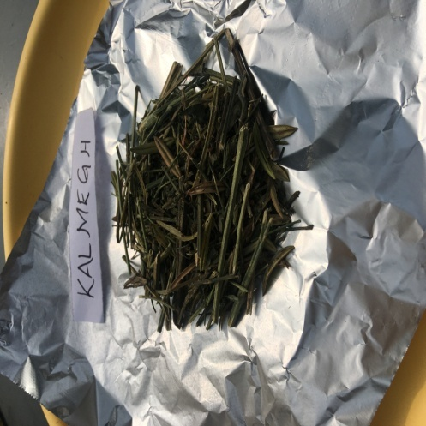
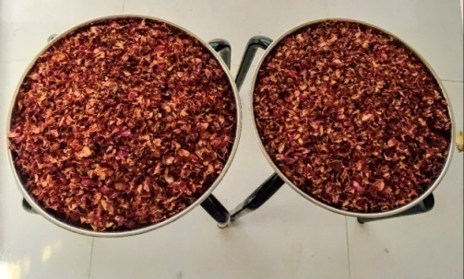

A. Dried rose petals

B. Dried kalmegh

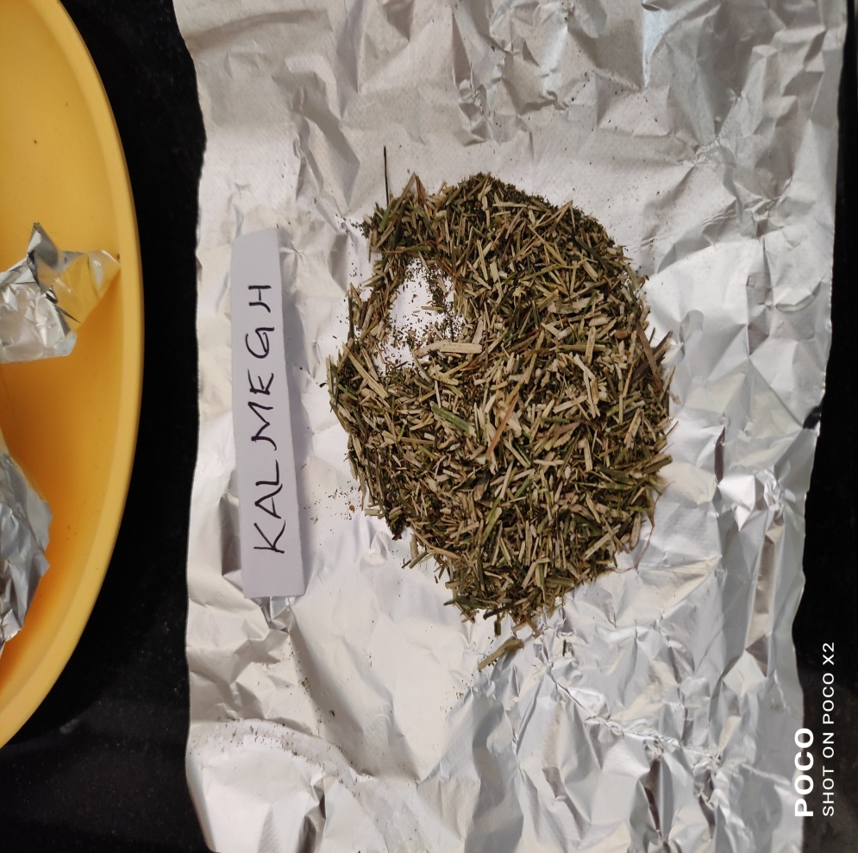
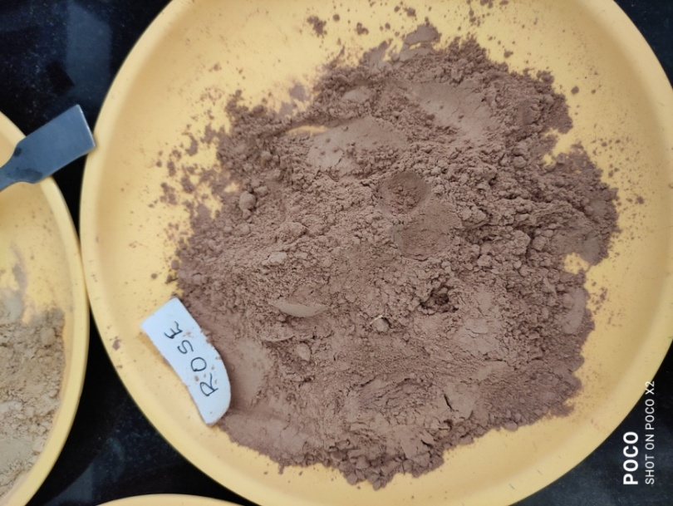
C. Fresh rose & kalmegh powder

Plate 1. Raw materials of Rose and kalmegh used for preparation of fermented beverage

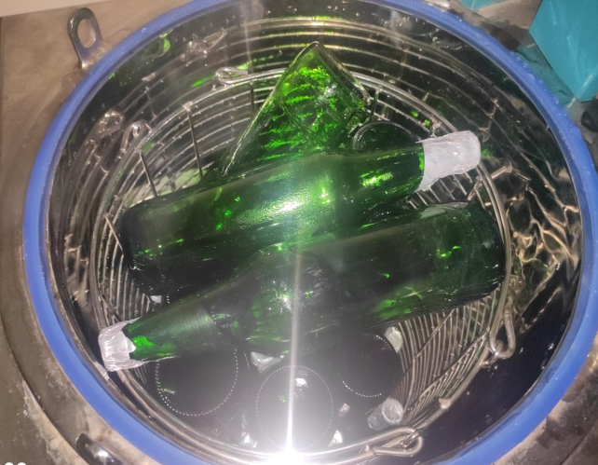

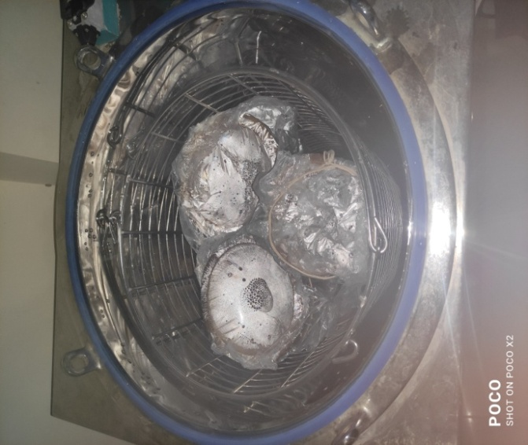
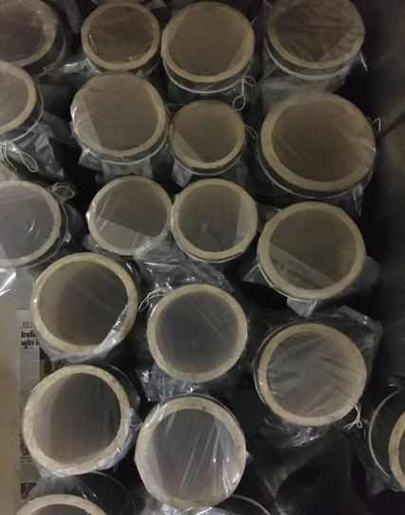
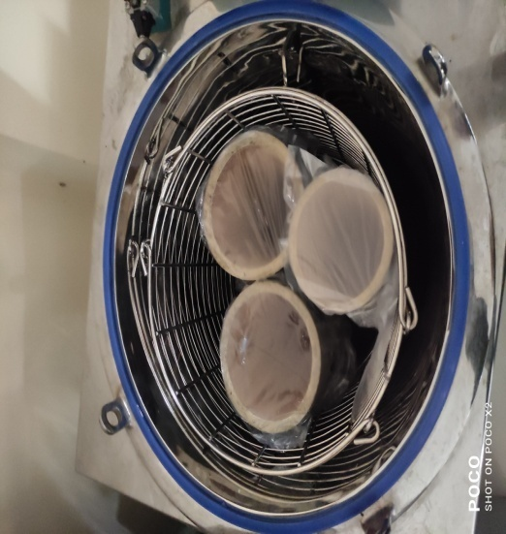
A.Ready for sterilization
B.Sterilization of bamboo and bottles
Plate 2. Sterilization of containers used for fermentation
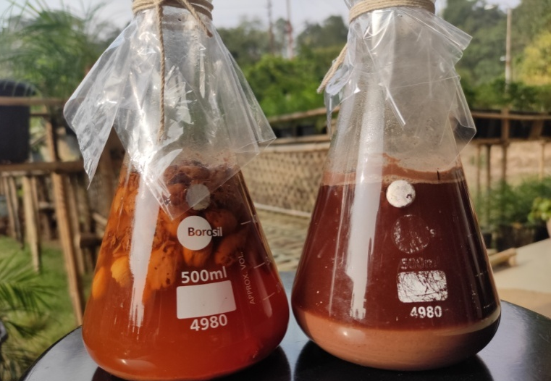
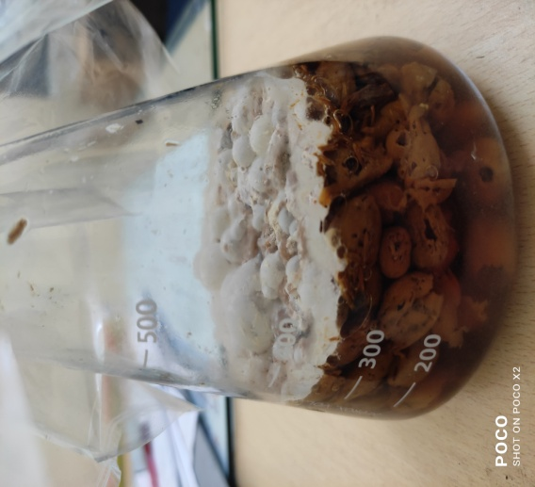

Plate 3. Prepared mother culture (fermenting yeast) for using of fermentation

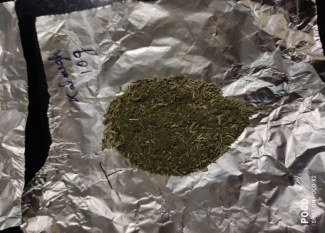
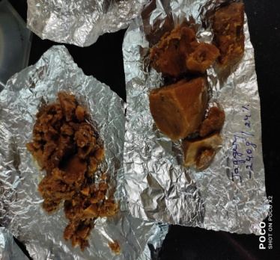
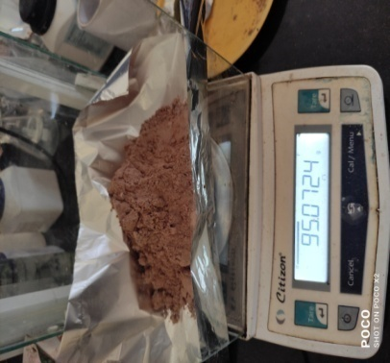
D. Jaggery proportion
C. Kalmegh proportion
B. weighing of rose powder
Plate 4. Addition of ingredients for preparing fermenting material into the bamboo container

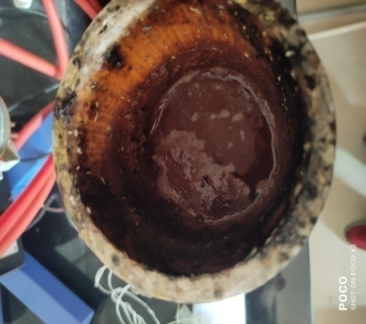
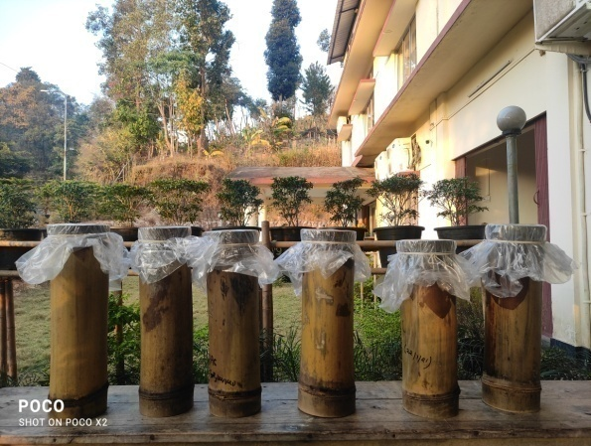
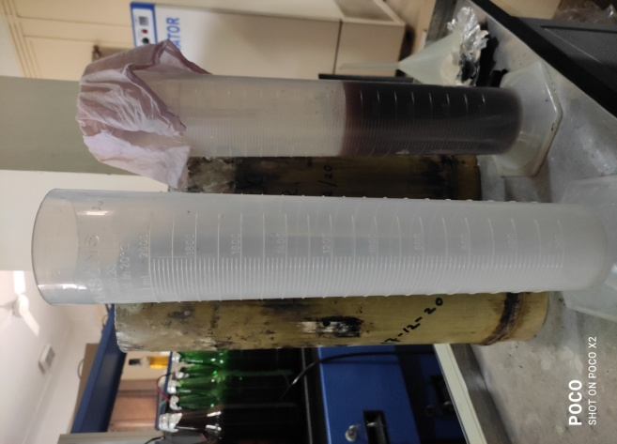
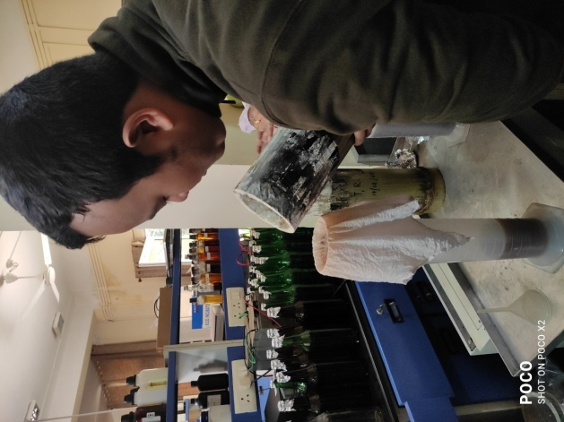
Plate 5. Fermentation of all treatment of rose, kalmegh and combined at ambient temperature, as well as filtration

C. Filtration of fermented beverages with help of muslin cloth
B. Ready for filtration
A.Storage of fermented beverages
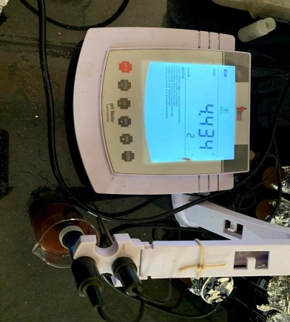
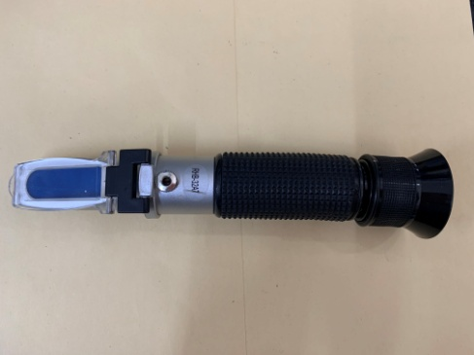

B. pH meter
A.Refractometer

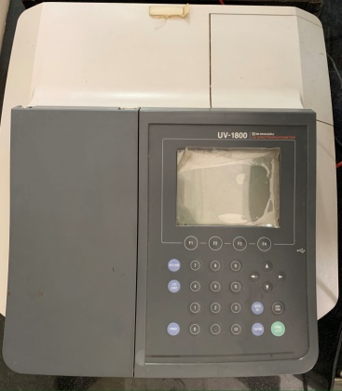
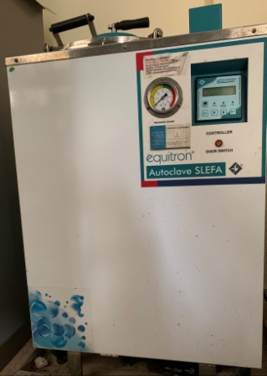
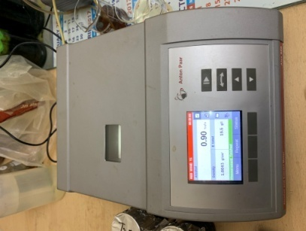

E. Alcoholmeter , (Alex-500)
D. Spectrophotometer
C. Autoclave

Plate 6. Equipment used for analysis of nutrient of fermented beverage

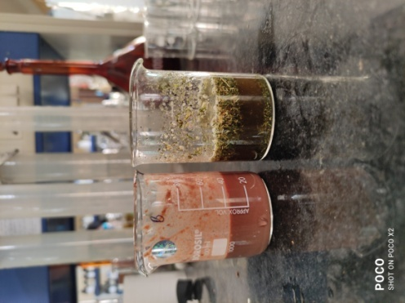
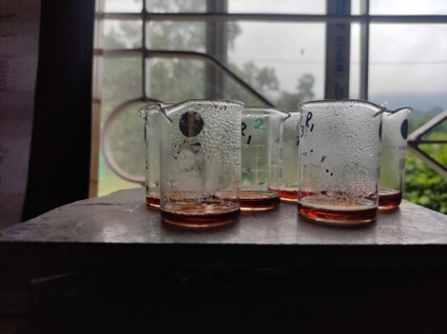

B. Total sugars
A.Fresh Rose & Kalmegh (Anlaysis)

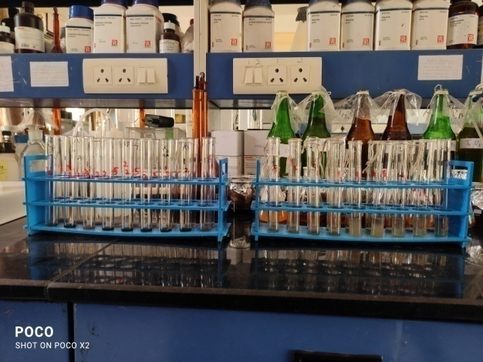
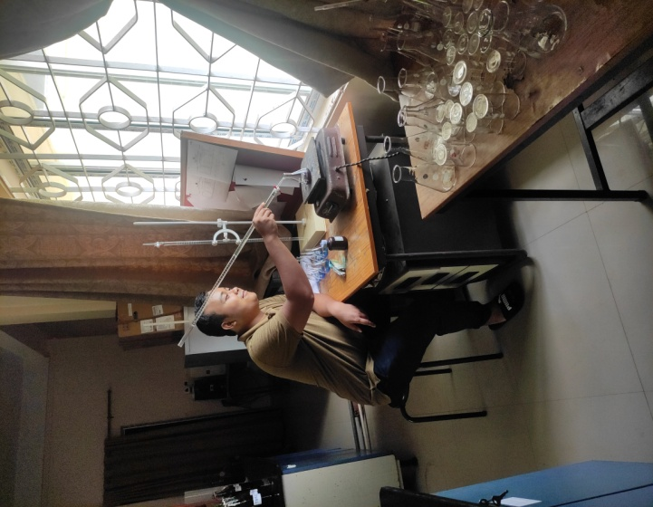

D. phenols
C.Titration of sugars

Plate 7. Biochemical analysis of fermented beverage at different stages

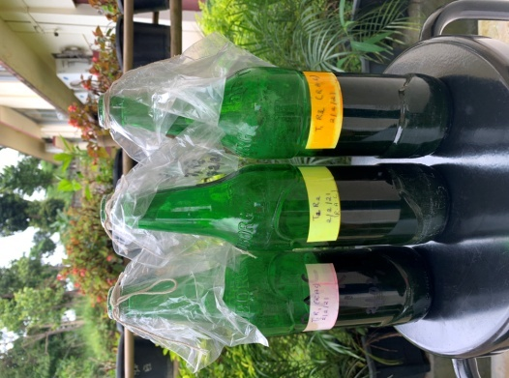
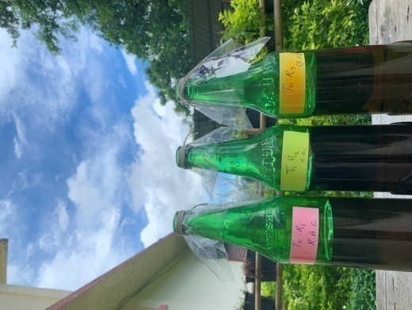
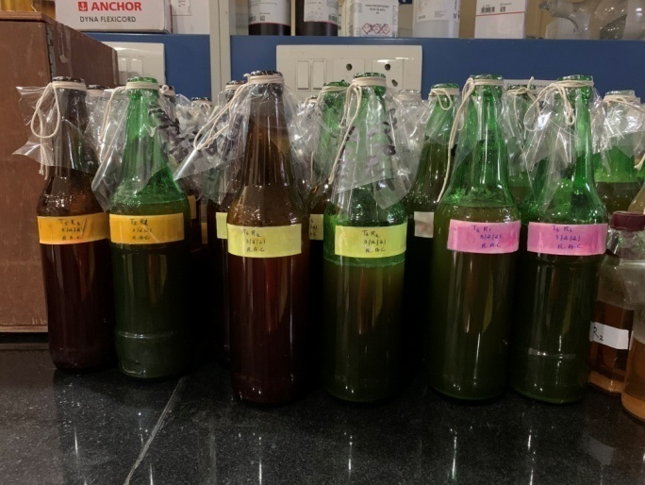
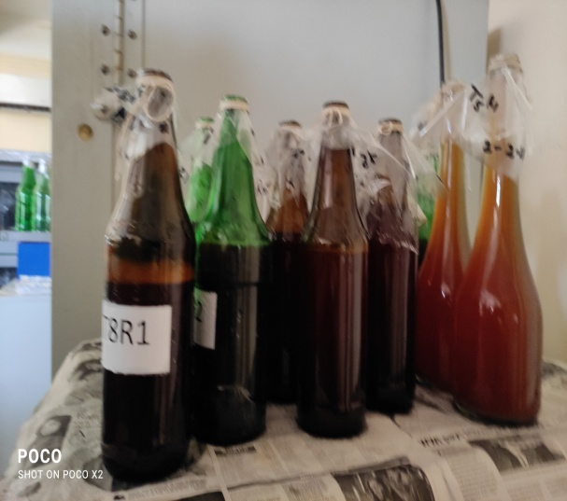
Plate 8. Stored fermented beverage

C. Aged fermented beverages
A.Storage of freshly fermeted beverages
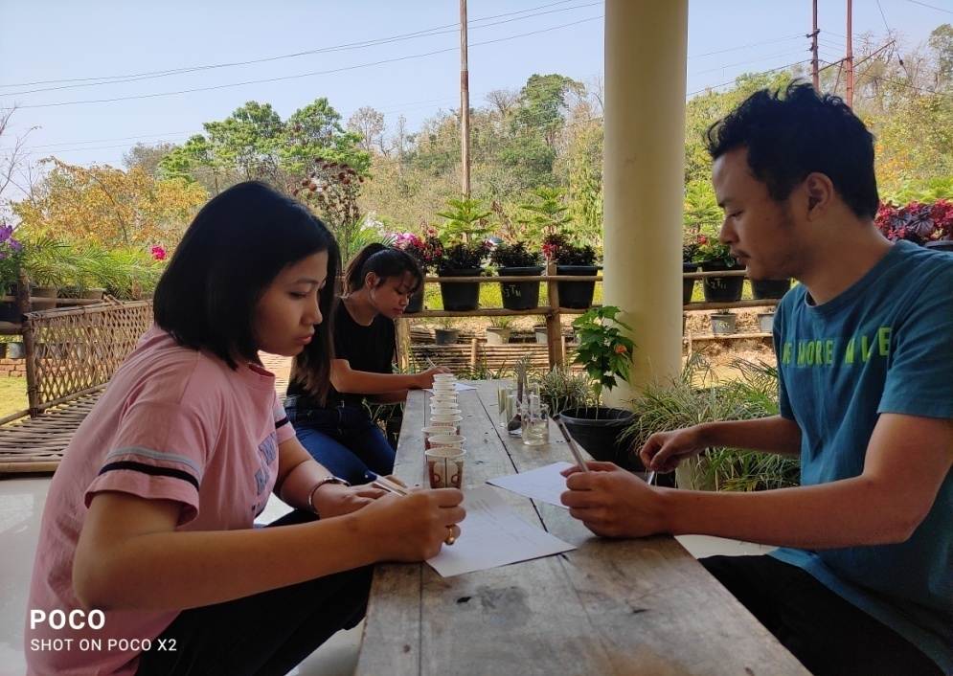

A.Organoleptic test freshly fermeted beverages

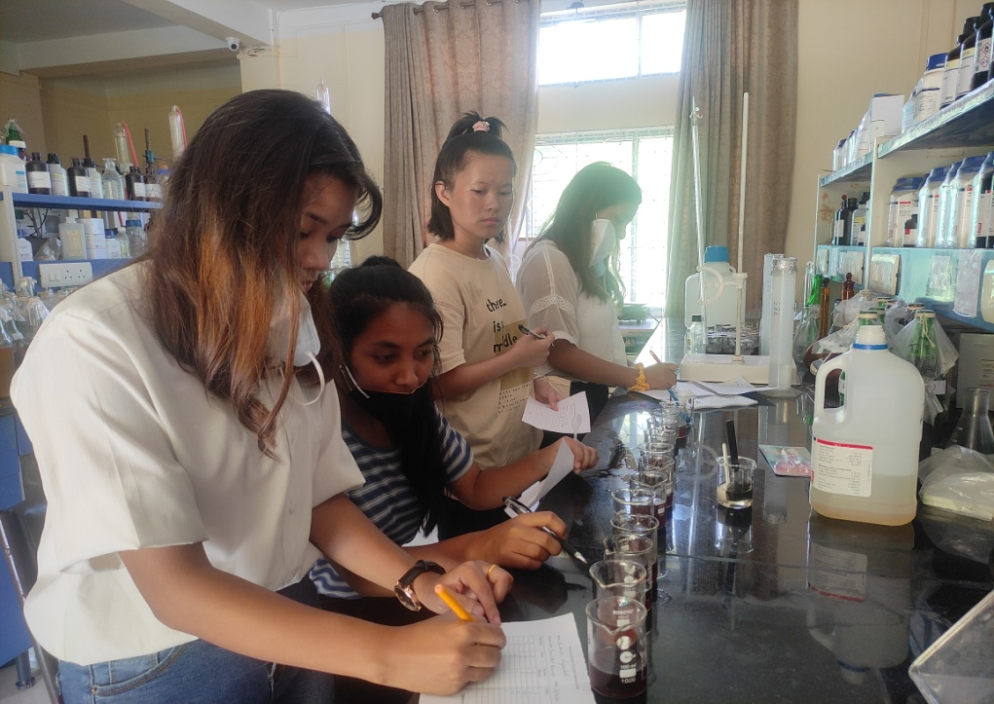

B.organoleptic test of Aged fermeted beverages
Plate 9. Standardization of fermented beverage (Rose and kalmegh) by panelists

