Original Research Article

Antibacterial Activity of Selected Medicinal Plant Extracts and Their Interactions with Antibiotics Against Serratia marcescens and Pseudomonas aeruginosa

Abstract- The emergence of antimicrobial resistance to Gram-negative isolates has rekindled interest in new approaches that would potentiate the activity of traditional antibiotics, such as plant extracts for medicinal purposes. Antibacterial activity of some selected medicinal plant extracts in tandem with standard antibiotics against Pseudomonas aeruginosa and Serratia marcescens was studied. The aqueous crude extracts of the plants (R.aculeata, C.bursa-pastoris, I.coccinea and P.olerecea) were screened individually as well as in combination with ampicillin, ciprofloxacin, erythromycin and amoxicillin in 1:1 proportions by agar-well diffusion technique. On Serratia marcescens, against which all the extracts exhibited moderate activity with inhibition zones of diameter of 12-18 mm, Randia aculeata and Ixora coccinea displayed significant potential among others, Portulaca oleracea was moderately active while Capsella bursa pastoris showed a negative result. Ciprofloxacin exhibited excellent antibacterial activity (28 mm), whereas the other antibiotics showed resistance. Synergistic effects of combinations were not identified and in some cases the inhibitory zones of some antibacterial agents were found to be decrease partners with antagonistic interactions. For P. aeruginosa, none of plant extracts had antibacterial activities and least effective against them were antibiotics (except ciprofloxacin with inhibition zone diameter = 24 mm). Its antibacterial activity decreased even more when combined with plant extracts. Such results indicate that the selected medicinal plant extracts had no synergistic effect on, and even inhibited, antibacterial activity of antibiotics (something like conventional antibiotic-potentiating effects) against Serratia marcescens and Pseudomonas aeruginosa. The study emphasises the need for systematic assessment of plant-antibiotic interaction and caution in concurrent use of plant extracts with antibiotics without prior determination of their interaction.

Keywords - Antimicrobial resistance; Medicinal plant extracts; Antibiotic interactions; Serratia marcescens; Pseudomonas aeruginosa

Introduction- AMR has become one of the most serious public health concerns globally of the twenty-first century, challenging the prevention and treatment of a growing number of infectious diseases. AMR has been recognized by the World Health Organization as a threat to global healthcare systems with growing numbers of reports on treatment failure, extended hospital stays and increased mortality [1]. The extensive and often indiscriminate use of antibiotics in clinical, agricultural, and veterinary settings has accelerated the selection and dissemination of resistant bacterial strains, thereby diminishing the effectiveness of conventional antimicrobial therapies [2]. Gram-negative bacteria present a particularly serious challenge due to their complex cell envelope structure, which includes an outer membrane that limits antibiotic penetration, as well as intrinsic and acquired resistance mechanisms such as efflux pumps, enzymatic drug inactivation, and target site modification [3]. Among these organisms, Serratia marcescens and Pseudomonas aeruginosa are clinically significant opportunistic pathogens frequently associated with nosocomial infections, including bloodstream infections, ventilator-associated pneumonia, urinary tract infections, and wound infections. Serratia marcescens has increasingly demonstrated resistance to multiple antibiotic classes, particularly β-lactams and macrolides, and is well known for its ability to persist in hospital environments [4]. Similarly, Pseudomonas aeruginosa is notorious for its intrinsic resistance to many antimicrobial agents, rapid acquisition of additional resistance determinants, and capacity to form biofilms, all of which complicate effective treatment [5]. The increasing resistance of these pathogens have underscored the need for alternative or adjunctive antimicrobial approaches. Plants used for medicinal purpose since old times in traditional medicinal systems enable the introduction of novel and gradually useful bioactive compounds. A variety of plant-originated secondary metabolites such as flavonoids, phenolic acids, alkaloids, tannins, triterpenoids and saponins have been found to possess antibacterial activity that is mediated through disruption of the bacteria cell membrane integrity, prevention of the enzymatic processes or nucleic acid synthesis or mediation Over the bacterial signaling systems [6]. In addition to their inherent antibacterial properties, medicinal plant extracts have also become the subject of interest as antibiotic activity modulators. The synergistic usage of plant phytochemicals with antibiotics has been suggested to be a route toward improving antimicrobial activity, circumventing resistance and lowering antibiotic concentration. This kind of combinations may have synergistic, additive, indifferent or antagonistic effect [7]. While synergistic effects are often emphasized in the literature, growing evidence indicates that plant–antibiotic combinations are not universally beneficial. In some cases, plant extracts may interfere with antibiotic action, leading to reduced antibacterial efficacy. Importantly, antagonistic and indifferent interactions remain underreported despite their clinical relevance [8].
Most existing studies on plant–antibiotic interactions focus on Gram-positive bacteria, whereas comparatively fewer investigations address highly resistant Gram-negative pathogens. In addition, many studies rely on crude plant extracts, which contain complex mixtures of bioactive constituents that may interact unpredictably with antibiotics [9]. The medicinal plants selected for the present study Randia aculeata, Capsella bursa-pastoris, Ixora coccinea, and Portulaca oleracea are traditionally used for various therapeutic purposes and have been reported to possess antimicrobial and antioxidant properties [10]. However, systematic evaluation of their antibacterial activity, particularly in combination with commonly used antibiotics against S. marcescens and P. aeruginosa, remains limited.
In this study, antibiotics representing different classes ampicillin, ciprofloxacin, erythromycin, and amoxicillin were selected to investigate potential interaction patterns with the chosen plant extracts. The agar well diffusion assay was employed as a preliminary screening method to evaluate antibacterial activity and to compare inhibition zones produced by individual and combined treatments [11]. The primary objective was to assess the antibacterial efficacy of selected plant extracts alone and in combination with antibiotics against Serratia marcescens and Pseudomonas aeruginosa. By documenting both effective and antagonistic interactions, this study aims to contribute to a more evidence-based and cautious approach toward the use of plant–antibiotic combinations in antimicrobial therapy.

Material and Methodology
Plant Material Collection and Extract Preparation- Four medicinal plants, Randia aculeata, Ixora coccinea, Capsella bursa-pastoris, and Portulaca oleracea, were collected from Thakur Complex, Kandivali East, Mumbai, Maharashtra, India. The collected plant materials were thoroughly washed with distilled water to remove adhering debris and air-dried under shade. The dried materials were cut into small pieces for aqueous extract preparation. Ten grams of each plant sample were boiled in 100 mL of sterile distilled water for 20 minutes. After cooling to room temperature, the extracts were clarified by centrifugation at 10,000 rpm for 10 minutes at 4 °C to remove debris and particulate matter. The clear supernatants were collected in sterile tubes and stored at 4 °C for use within 48 hours. No microfiltration was performed; however, sterility of the extracts was confirmed by plating aliquots on nutrient agar prior to antibacterial testing.
Antibiotic Selection and Preparation- Four commonly used antibiotics ampicillin, amoxicillin, erythromycin, and ciprofloxacin were utilized in this study. Stock solutions were prepared to achieve a final working concentration of 30 µg/mL for each antibiotic. These antibiotics were used as positive controls and in combination with plant extracts to evaluate potential interaction effects.
Bacterial Cultures and Inoculum Preparation- Representative Gram-negative bacteria were selected for antibacterial testing, including Serratia marcescens, Pseudomonas aeruginosa . Each bacterial strain was cultured overnight in nutrient broth, and turbidity was adjusted to match the 0.5 McFarland standard to ensure uniform inoculum density.
Agar Well Diffusion Assay and Combination Testing- The antibacterial activity of the plant extracts, antibiotics, and their combinations was evaluated using the agar well diffusion method. Mueller-Hinton agar plates were swabbed uniformly with each bacterial culture. For each organism, three treatments were applied per plate: (1) a well containing plant extract alone (control), (2) a well containing antibiotic alone at 30 µg/mL (control), and (3) a well containing a 1:1 mixture of plant extract and antibiotic (test sample). A total of 8 plates were prepared to cover all combinations of the four plant extracts with four antibiotics across the selected bacterial strains. The plates were incubated at 37 °C for 24 hours, after which zones of inhibition were measured in millimeters.
Data Recording and Interpretation- Zones of inhibition from individual and combined treatments were recorded and compared to determine interaction patterns, including synergistic, additive, indifferent, or antagonistic effects. All antibacterial assays were performed in triplicate, and zones of inhibition were recorded as mean values. All experiments were conducted under aseptic conditions, following standard laboratory safety protocols. The results provided insights into the ability of plant extracts to modulate the antibacterial activity of conventional antibiotics.
Observation

Table 1. Antibacterial activity of selected medicinal plant extracts and their combinations with antibiotics against Serratia marcescens, expressed as mean zone of inhibition ± standard deviation (mm) (n = 3)
Treatment | Organism - S. marcescns (Zone of Inhibition)  (mm, Mean ± SD)
Randia aculeata – Extract Alone | 12 ± 1
Ampicillin (AMP) (30 µg/mL) Alone | 0
Randia aculeata + Ampicillin (1:1) | 0
Capsella bursa-pastoris – Extract Alone | 0
Ciprofloxacin (CIP) (30 µg/mL) | 28 ± 2
Capsella bursa-pastoris + Ciprofloxacin (1:1) | 24
Ixora coccinea – Extract Alone | 18 ± 1
Erythromycin (ERY) (30 µg/mL) | 0
Ixora coccinea + Erythromycin (1:1) | 14
Portulaca oleracea – Extract Alone | 12 ± 1
Amoxicillin (AMOX) (30 µg/mL) | 0
Portulaca oleracea + Amoxicillin (1:1) | 0

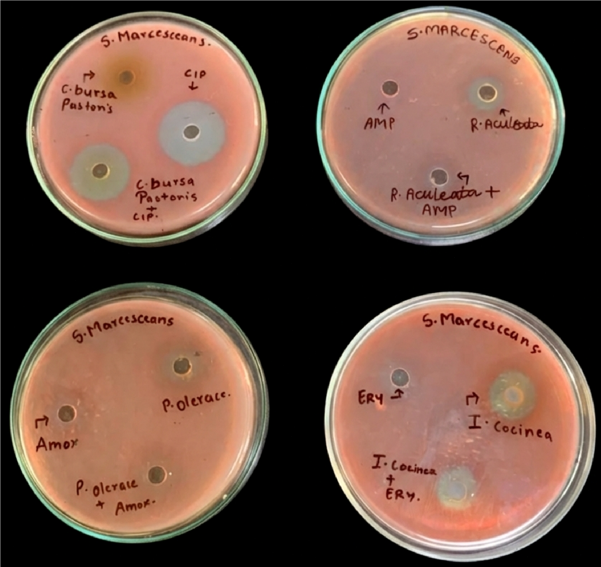

Figure 1: Antibacterial activity of plant extract and antibiotic against S. marcescens

Table 2. Antibacterial activity of selected medicinal plant extracts and their combinations with antibiotics against Pseudomonas aeruginosa, expressed as mean zone of inhibition ± standard deviation (mm) (n = 3).

Treatment | Organism - Pseudomonas aeruginosa (Zone of Inhibition) mm
Randia aculeata – Extract Alone | 0
Ampicillin (AMP) (30 µg/mL) Alone | 0
Randia aculeata + Ampicillin (1:1) | 0
Capsella bursa-pastoris – Extract Alone | 0
Ciprofloxacin (CIP) (30 µg/mL) | 24 ± 2
Capsella bursa-pastoris + Ciprofloxacin (1:1) | 16 ± 1
Ixora coccinea – Extract Alone | 0
Erythromycin (ERY) (30 µg/mL) | 0
Ixora coccinea + Erythromycin (1:1) | 0
Portulaca oleracea – Extract Alone | 0
Amoxicillin (AMOX) (30 µg/mL) | 0
Portulaca oleracea + Amoxicillin (1:1) | 0

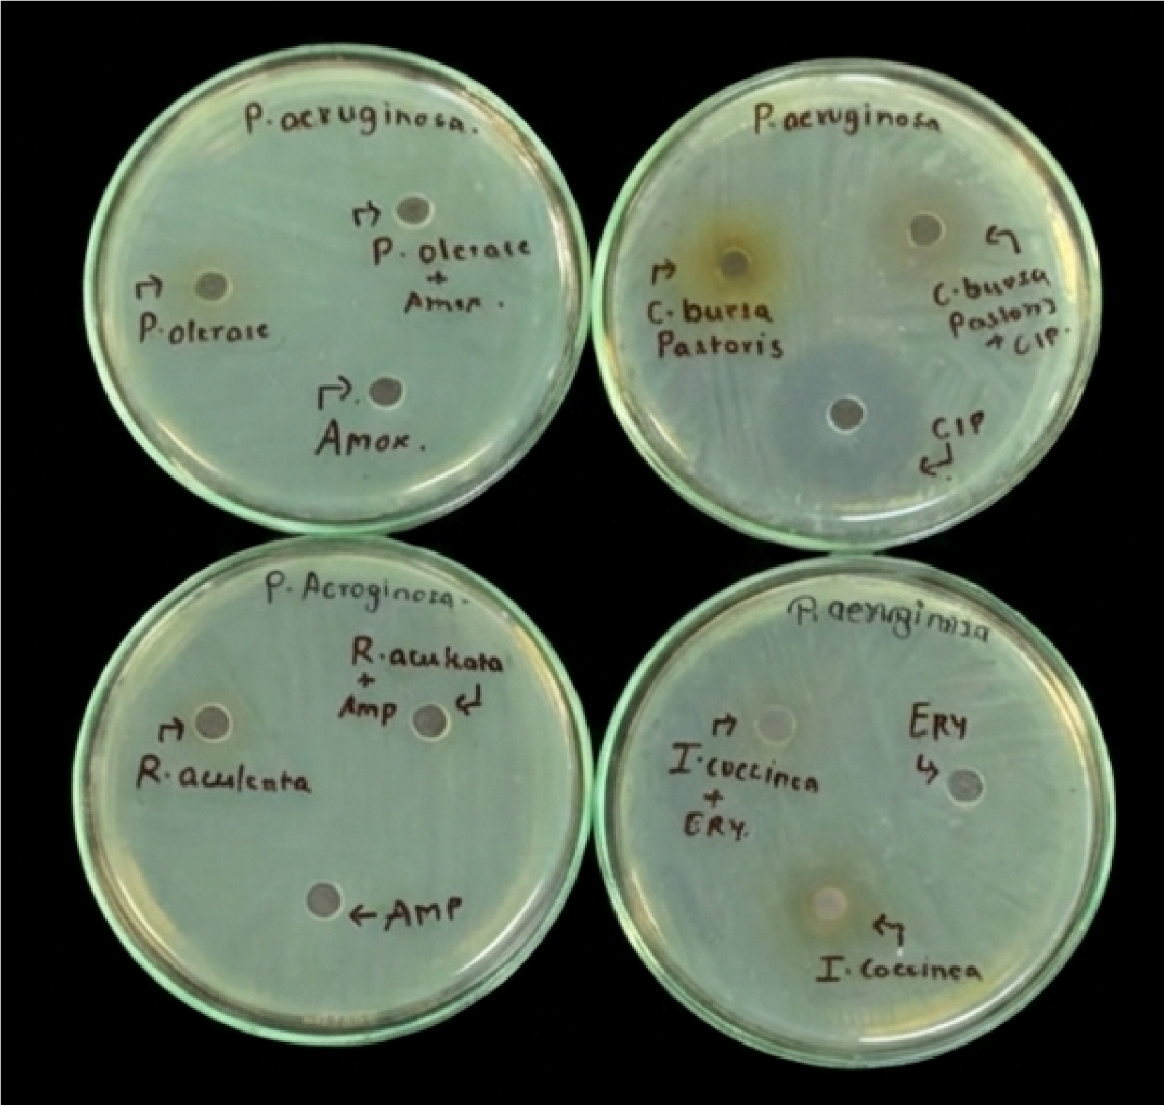

Figure 2: Antibacterial activity of plant extract and antibiotic against P. aeruginosa

Result- The antibacterial activity of four selected medicinal plant extracts (Randia aculeata, Capsella bursa-pastoris, Ixora coccinea, and Portulaca oleracea) was evaluated individually and in combination with standard antibiotics against Serratia marcescens and Pseudomonas aeruginosa using the agar well diffusion method. Zones of inhibition were measured to assess antibacterial efficacy and to interpret interaction patterns between plant extracts and antibiotics, including synergistic, additive, indifferent, or antagonistic effects. Against Serratia marcescens, three plant extracts Randia aculeata, Ixora coccinea, and Portulaca oleracea exhibited measurable intrinsic antibacterial activity, producing zones of inhibition of 12 mm, 18 mm, and 12 mm, respectively. In contrast, Capsella bursa-pastoris showed no detectable inhibitory effect. Among the antibiotics tested, ciprofloxacin demonstrated strong antibacterial activity (28 mm), whereas ampicillin, erythromycin, and amoxicillin showed complete resistance (0 mm). This resistance pattern is consistent with previous reports describing the multidrug-resistant nature of S. marcescens, particularly against β-lactam and macrolide antibiotics.
Importantly, none of the plant–antibiotic combinations resulted in enhanced antibacterial activity. Instead, several combinations produced reduced zones of inhibition compared to the most active individual agent, indicating antagonistic interactions. The combination of Capsella bursa-pastoris with ciprofloxacin showed a reduced inhibition zone (24 mm) relative to ciprofloxacin alone (28 mm). Similarly, the combination of Ixora coccinea with erythromycin resulted in a smaller inhibition zone (14 mm) compared to the extract alone (18 mm). These findings suggest that certain phytochemical constituents present in crude plant extracts may interfere with antibiotic activity rather than potentiate it. No antibacterial activity was observed for combinations involving ampicillin or amoxicillin, further supporting the absence of synergistic effects.
In the case of Pseudomonas aeruginosa, all plant extracts failed to exhibit antibacterial activity when tested individually, reflecting the organism’s high intrinsic resistance. Among the antibiotics evaluated, only ciprofloxacin showed antibacterial efficacy, producing a zone of inhibition of 24 mm. However, when ciprofloxacin was combined with Capsella bursa-pastoris, a marked reduction in antibacterial activity was observed (16 mm), indicating an antagonistic interaction. All other antibiotics and plant–antibiotic combinations showed no inhibitory activity against P. aeruginosa. Overall, interaction analysis revealed no synergistic or additive effects between the tested plant extracts and antibiotics. Most combinations were either indifferent or antagonistic, particularly against P. aeruginosa. The pronounced resistance observed in this organism may be attributed to its outer membrane barrier, efflux pump systems, and adaptive resistance mechanisms, which collectively limit the effectiveness of both antibiotics and plant-derived compounds. Additionally, the use of crude aqueous extracts may contribute to antagonistic outcomes due to complex phytochemical interactions that affect antibiotic diffusion or stability [12]. These findings underscore the importance of systematically evaluating plant–antibiotic combinations before proposing their therapeutic use. While medicinal plants remain valuable sources of bioactive compounds, their indiscriminate combination with antibiotics may reduce antibacterial efficacy rather than enhance it. The agar well diffusion assay used in this study serves as a preliminary screening tool; therefore, further quantitative analyses such as minimum inhibitory concentration (MIC) determination and fractional inhibitory concentration (FIC) index studies are required to confirm and mechanistically characterize the observed interaction patterns [13].
Conclusion - The present study evaluated the antibacterial activity of selected medicinal plant extracts, both individually and in combination with conventional antibiotics, against Serratia marcescens and Pseudomonas aeruginosa. The findings demonstrate that while certain plant extracts exhibited moderate intrinsic antibacterial activity against S. marcescens, none were effective against P. aeruginosa. Among the antibiotics tested, ciprofloxacin remained the most effective agent against both organisms. Importantly, the combination of plant extracts with antibiotics did not result in enhanced antibacterial efficacy. In several cases, a reduction in zones of inhibition was observed when plant extracts were combined with antibiotics, indicating antagonistic interactions [14]. These results suggest that the indiscriminate co-administration of medicinal plant extracts with antibiotics may compromise antibacterial activity rather than improve therapeutic outcomes. The study highlights the necessity of systematic and evidence-based evaluation of plant–antibiotic interactions before their consideration for clinical or adjunct therapeutic use. Although medicinal plants continue to represent valuable sources of bioactive compounds, their combined use with antibiotics requires careful assessment to avoid unintended antagonistic effects. Further research involving purified phytochemicals, quantitative assays such as minimum inhibitory concentration (MIC) determination, and detailed mechanistic investigations is recommended to clarify the nature of these interactions and to identify combinations with genuine therapeutic potential [15].
Future Scope- The findings of the present study indicate limited antibacterial enhancement when selected medicinal plant extracts are combined with conventional antibiotics, particularly against Pseudomonas aeruginosa. Future research should therefore focus on isolating and characterizing specific bioactive compounds within these plant extracts to determine whether purified constituents exhibit improved antibacterial efficacy compared to crude preparations [16]. Further investigations employing quantitative antimicrobial assays, such as minimum inhibitory concentration (MIC), minimum bactericidal concentration (MBC), and time–kill studies, are recommended to validate and extend the diffusion-based findings [17]. These methods would provide more precise insight into the nature of extract–antibiotic interactions and help distinguish true antagonistic effects from concentration-dependent responses. Mechanistic studies are warranted to elucidate the molecular basis of the observed antagonistic interactions, including potential interference with antibiotic uptake, modulation of efflux pump activity, or chemical incompatibility between phytochemicals and antibiotics [18]. In addition, evaluating different extract-to-antibiotic ratios may reveal interaction patterns not evident at a fixed 1:1 combination.Given the pronounced resistance observed in P. aeruginosa, future work should include testing against a broader panel of clinically relevant multidrug-resistant Gram-negative pathogens. Synergy screening using checkerboard assays and fractional inhibitory concentration (FIC) index analysis may further clarify interaction profiles. Finally, in vivo efficacy studies and cytotoxicity assessments are essential to establish the safety and therapeutic relevance of promising plant-derived compounds. Integrating phytochemical profiling with advanced antimicrobial screening approaches may ultimately contribute to the rational development of plant-based adjuncts or alternatives to existing antibacterial therapies [19].

Disclaimer (Artificial intelligence)

Author(s) hereby declare that NO generative AI technologies such as Large Language Models (ChatGPT, COPILOT, etc.) and text-to-image generators have been used during the writing or editing of this manuscript.

References
- Salam, M. A., Al-Amin, M. Y., Salam, M. T., Pawar, J. S., Akhter, N., Rabaan, A. A., & Alqumber, M. A. A.
(2023). Antimicrobial Resistance: A Growing Serious Threat for Global Public Health. Healthcare (Basel,
Switzerland), 11(13), 1946. https://doi.org/10.3390/healthcare11131946
- Caneschi, A., Bardhi, A., Barbarossa, A., & Zaghini, A. (2023). The Use of Antibiotics and Antimicrobial Resistance in Veterinary Medicine, a Complex Phenomenon: A Narrative Review. Antibiotics (Basel, Switzerland), 12(3), 487. https://doi.org/10.3390/antibiotics12030487
- Impey, R. E., Hawkins, D. A., Sutton, J. M., & Soares da Costa, T. P. (2020). Overcoming Intrinsic and Acquired Resistance Mechanisms Associated with the Cell Wall of Gram-Negative Bacteria. Antibiotics (Basel, Switzerland), 9(9), 623. https://doi.org/10.3390/antibiotics9090623
- Khanna, A., Khanna, M., & Aggarwal, A. (2013). Serratia marcescens- a rare opportunistic nosocomial pathogen and measures to limit its spread in hospitalized patients. Journal of clinical and diagnostic research : JCDR, 7(2), 243–246. https://doi.org/10.7860/JCDR/2013/5010.2737
5] Glen, K. A., & Lamont, I. L. (2021). β-lactam Resistance in Pseudomonas aeruginosa: Current Status, Future Prospects. Pathogens (Basel, Switzerland), 10(12), 1638. https://doi.org/10.3390/pathogens10121638
6] El-Saadony, M. T., Saad, A. M., Mohammed, D. M., Korma, S. A., Alshahrani, M. Y., Ahmed, A. E., Ibrahim, E. H., Salem, H. M., Alkafaas, S. S., Saif, A. M., Elkafas, S. S., Fahmy, M. A., Abd El-Mageed, T. A., Abady, M. M., Assal, H. Y., El-Tarabily, M. K., Mathew, B. T., AbuQamar, S. F., El-Tarabily, K. A., & Ibrahim, S. A. (2025). Medicinal plants: bioactive compounds, biological activities, combating multidrug-resistant microorganisms, and human health benefits - a comprehensive review. Frontiers in immunology, 16, 1491777.
https://doi.org/10.3389/fimmu.2025.1491777
7] Matei, A. T., & Visan, A. I. (2025). Mechanism, Efficacy, and Safety of Natural Antibiotics. Antibiotics (Basel,
Switzerland), 14(10), 981. https://doi.org/10.3390/antibiotics14100981
8] Cheesman, M. J., Ilanko, A., Blonk, B., & Cock, I. E. (2017). Developing New Antimicrobial Therapies: Are Synergistic Combinations of Plant Extracts/Compounds with Conventional Antibiotics the Solution?. Pharmacognosy reviews, 11(22), 57–72. https://doi.org/10.4103/phrev.phrev_21_17
9] Angane, M., Swift, S., Huang, K., Perera, J., Chen, X., Butts, C. A., & Quek, S. Y. (2023). Synergistic antimicrobial interaction of plant essential oils and extracts against foodborne pathogens. Food science & nutrition, 12(2), 1189–1206. https://doi.org/10.1002/fsn3.3834
10] Udaybhan A. Yadav, Bhanupratap Vishwakarma, Ashana Singh, Nidhi Yadav, Antima Yadav, Tanvi Yadav, and
Gauri Bhusate (2025). Phytochemical-Rich Plant Extracts as Natural Antibacterial Agents: A Comparative Study of Randia aculeata, Ixora coccinea, Capsella bursa-pastoris, and Portulaca oleraceaAgainst Clinically Relevant Pathogens. Microbiology Archives, an International Journal. DOI: https://doi.org/10.51470/MA.2025.7.2.95

11] Bubonja-Šonje, M., Knežević, S., & Abram, M. (2020). Challenges to antimicrobial susceptibility testing of plant-derived polyphenolic compounds. Arhiv za higijenu rada i toksikologiju, 71(4), 300–311. https://doi.org/10.2478/aiht-2020-71-3396
12] Gaurav, A., Bakht, P., Saini, M., Pandey, S., & Pathania, R. (2023). Role of bacterial efflux pumps in antibiotic resistance, virulence, and strategies to discover novel efflux pump inhibitors. Microbiology (Reading, England), 169(5), 001333. https://doi.org/10.1099/mic.0.001333
13] Hossain T. J. (2024). Methods for screening and evaluation of antimicrobial activity: A review of protocols, advantages, and limitations. European journal of microbiology & immunology, 14(2), 97–115. https://doi.org/10.1556/1886.2024.00035
14] Fadila Moussaoui, Tajelmolk Alaoui, Evaluation of antibacterial activity and synergistic effect between antibiotic and the essential oils of some medicinal plants, Asian Pacific Journal of Tropical Biomedicine, Volume 6, Issue 1, 2016, Pages 32-37, ISSN 2221-1691, https://doi.org/10.1016/j.apjtb.2015.09.024.
15] Nesru, Y., Ahmed, M., Mengistu, A., & Naimuddin, M. (2025). Phytochemical screening and inhibitory effects of Catha edulis Forsk extracts on oxidation, growth, biofilm and quorum sensing of selected pathogens. Journal, genetic engineering & biotechnology, 23(4), 100560. https://doi.org/10.1016/j.jgeb.2025.100560
16] Sasidharan, S., Chen, Y., Saravanan, D., Sundram, K. M., & Yoga Latha, L. (2011). Extraction, isolation and characterization of bioactive compounds from plants' extracts. African journal of traditional, complementary, and alternative medicines : AJTCAM, 8(1), 1–10.
17] Gajic, I., Kabic, J., Kekic, D., Jovicevic, M., Milenkovic, M., Mitic Culafic, D., Trudic, A., Ranin, L., & Opavski, N. (2022). Antimicrobial Susceptibility Testing: A Comprehensive Review of Currently Used Methods. Antibiotics (Basel, Switzerland), 11(4), 427. https://doi.org/10.3390/antibiotics11040427
18] Alikhani, M. S., Nazari, M., & Hatamkhani, S. (2025). Enhancing antibiotic therapy through comprehensive pharmacokinetic/pharmacodynamic principles. Frontiers in cellular and infection microbiology, 15, 1521091. https://doi.org/10.3389/fcimb.2025.1521091
[19]Hsieh, M. H., Yu, C. M., Yu, V. L., & Chow, J. W. (1993). Synergy assessed by checkerboard. A critical analysis. Diagnostic microbiology and infectious disease, 16(4), 343–349. https://doi.org/10.1016/0732-8893(93)90087-n

