Effects of Aqueous Garlic Extract on Cadmium-Induced Cardiac Damage in Wistar Rats

ABSTRACT
Cadmium (Cd), a common toxic metal present in the environment, poses a risk to organisms as it can accumulate in the food chain. Exposure to Cd leads to oxidative stress, DNA damage, and apoptosis. The study aimed to investigate the protective effects of aqueous extract of Allium sativum (garlic) on cadmium-induced cardiac damage in adult male Wistar rats as A.sativum has folkloric therapeutic use in the treatment of various cardiac disorders. A total of 32 rats were divided into four groups. The control group received tap water, Group II was orally administered CdCl₂ (5mg/kg body weight) daily for 30 days, Group III received the aqueous extract of A. sativum (200mg/kg body weight) for 30 days, and Group IV was pre-treated with the aqueous extract of A. sativum (200mg/kg body weight) 90 minutes prior to CdCl₂ treatment (5mg/kg body weight) for 30 days. At the end of the study, blood and heart tissue samples were collected for biochemical and histopathological analysis. The results showed that rats in Group II exhibited general weakness, decreased food and water intake, and significantly lower body weights (g) (15.5) compared to the other groups (Group I: 59.83, Group III; 31.62, and Group IV; 18.75). However, there was no significant difference in organ weights (g) across the groups. Cd exposure led to increased levels of lipid peroxidation (nMol of TBARS), indicating oxidative damage in the cardiac tissues in Group II (37.62±1.71) compared with Group I (10.30±0.43), Group III (11.76±1.41) and Group IV (14.92±3.77) at p<0.05. The activities of antioxidant enzymes, including superoxide dismutase, catalase, and glutathione peroxidase, were significantly decreased in Group II rats (7.28±1.52, 1.32±0.40, and 4.95±0.9 respectively) compared to other groups at p<0.05. Additionally, there was a significant increase in lactate dehydrogenase (LDH1) levels in the serum of Group II rats (11.45±0.39) at p<0.05. Furthermore, histological examination of the cardiac tissues revealed damage to the myofibers, vacuolization of cytoplasm, myocardial fibre necrosis, and irregularity and disarrangement of the myofibrils in the Cd-exposed group. However, these changes were significantly protected when rats were pre-treated with the aqueous extract of A. sativum.
In conclusion, administration of 5mg/kg body weight caused Cd-induced oxidative stress in adult male Wistar rats, while oral administration of aqueous extract of A.sativum may be beneficial in ameliorating Cd-induced oxidative damages in the rat heart through its modulations of antioxidative and heavy metal chelating activities.
Keywords: A.sativum. cadmium, antioxidants, oxidative stress, Wistar rats.

INTRODUCTION
“The heart is a contractile muscular organ that propels blood through the vascular system, ensuring systemic and pulmonary circulation. In rats, the heart exhibits a quadrangular pyramidal morphology, closely approximating the anatomical structure observed in the human heart” (Rehman & Rehman, 2023). “In vertebrates, it is located in the anterior portion of the thorax and is encircled by a thin, transparent pericardium” (Orheruata et al., 2018). “The heart is mesodermal in origin and develops from the splanchnopleuric mesoderm located anterior to the prechordal plate” (Ripa et al., 2023). “The mammalian four-chambered heart has double circulation located in the thorax while the rat heart comprises two distinct pumps; the right side and left side of which are housed in the same organ due to their shared evolutionary history. The physical examination of the heart of the Wistar rat revealed that it has a structure typical of a mammalian heart” (Orheruata et al., 2018), with a clearly defined atrioventricular (AV) groove separating the atria from the ventricles. “The chordae tendineae of the mitral valve are attached to the anterior and posterior papillary muscles of the left ventricle, which have relatively long, slender apical parts that protrude into the ventricular lumen” (Anderson et al., 2006). “The main sources of Cd poisoning in non-occupationally exposed populations are; food, drinking water, and cigarette smoking” (Olateju et al., 2024). “Occupational exposure to Cd happens during mining, working with Cd-containing ores, pigments, and paints, manufacturing of electronics and batteries, and burning of fossil fuels” (Tucker et al 2018). “Soluble Cd²⁺ salts accumulate and injure various tissues, including the heart, kidney, liver, brain, lung prostate, and adenohypophysis depending on the exposure, time, and dose” (Nazimabashir et al., 2015). “Studies on animals have shown that acute Cd exposure can cause cardiovascular problems by altering the antioxidant defense system” (Guo et al., 2020), resulting in the pathogenesis of hypertension, cardiotoxicity (Priya et al., 2017), atherosclerosis (Messner et al.,2009), and stroke (Tellez-plaza et al., 2013), myocardial infarction and peripheral arterial disease ((E. O. et al., 2024) but confirmatory information is sparse, and the mechanisms behind these interactions are still unknown (Messner et al., 2009). “Most of the Cd in the body is bound to metallothionein (MT), a part of cysteine-rich, low molecular weight and ubiquitous intracellular proteins with high affinity for metals” (Ferramola et al., 2012). “Cd forms a complex with metallothionein by durable combinations with the apoprotein thionein” (Nazimabashir et al., 2015). In doses as low as 0.1 μM, Cd may accumulate in the heart muscle and cause cardiotoxicity (Guo et al., 2020), Cd also affects cardiac function, changing the composition, shape, structure of the heart ((Lu et al., 2024)). “Several medicinal plant products rich in antioxidant phytoconstituents have been reported to be beneficial against Cd-induced oxidative stress-mediated damages in cardiac tissues” (Bhattacharjee et al., 2019), therefore, the present study was designed to evaluate the efficacy of aqueous A.sativum extract against Cd-induced oxidative stress-mediated damages in the heart of male Wistar rats.
“Garlic (Allium sativum) is an aromatic herbaceous plant and one of the oldest and most important herbs that is consumed worldwide as food and traditional medicine for different diseases” (Olateju et al., 2024). “Garlic has also been shown to improve vascular function (Bradley et al., 2016) and has been reported to possess several biological properties including anticarcinogenic, antioxidant, antidiabetic, anti-atherosclerotic, antibacterial, antifungal and antihypertensive activities in traditional medicines” (Lu et al., 2024).

MATERIALS AND METHODS
Thirty-two male Wistar rats (180g-250g) were divided into four groups. Group 1 (control) had tap water; Group II received CdCl2 (5mg/kg); Group III had A. sativum extract (200mg/kg); Group IV received co-treatment. Oral gavage was daily for 30 days.
Cadmium chloride from LOBA Chemical Laboratory, India, via Adfolak Chemical Shop, Ibadan, was used. Fresh A. sativum bulbs from Bodija Market, Ibadan, were washed, peeled, and 50g was ground into a paste. Distilled water (100ml) yielded the aqueous A. sativum extract (stock solution). Dosage was calculated as (numerator/cap Dose (mg/kg) x weight (kg))/ (concentration (mg/ml)). After overnight fasting, rats were euthanized, blood was collected for cardiac marker assays, and heart tissues were for biochemical evaluations and histopathological examination. Quantitative data (mean ± SD) underwent Analysis of Variance and Tukey’s multiple comparison post-hoc test using GraphPad Prism 8.4. Significance was set at p < 0.05.

RESULTS
The behavioral observations throughout the study revealed distinct patterns among the experimental groups. Rats in the control and A. sativum groups exhibited high activity levels, while those in the A. sativum + Cd group displayed mild activity. Notably, the Cd-treated group (Cd group II) exhibited sullen behavior compared to other groups. Furthermore, the Cd-treated rats displayed signs of general body weakness, and reduced food and water intake, leading to a decrease in weight gain. Gait abnormalities, such as hyperabduction of the head, external rotation of limbs, and hind limb hyperabduction, were observed in some Cd-treated animals, suggesting potential neurological impacts. (Table 1).
Table 1: Body weight (g) of rats

GROUP | INITIAL BODY WEIGHT (Day 1) MEAN±SD | FINAL BODY WEIGHT (Day 30) MEAN±SD | WEIGHT GAIN | %WEIGHT GAIN
CONTROL | 188.67±27-95 | 248.50±10.3 | 59.83 | 13.69
Cd | 207.38± 8.345 | 222.88 ±8.0 | 15.5ª | 3.6
A.sativum | 208.63±6.806 | 240.25± 6.8 | 31.62^{ab} | 7.04
A.sativum+Cd | 219.63± 11.03 | 238.38± 11.36 | 18.75^{b} | 4.09
Heart Weight
Figure 1: The differences in protein concentration across the experimental groups

The figure 1 illustrates the differences in protein concentration across the experimental groups: Control (Group I), Cadmium-treated (Group II), Allium sativum-treated (Group III), and Allium sativum + Cadmium co-treatment (Group IV). Data (n=5) are expressed as mean ± SD, with statistical significance set at P<0.05. No significant differences were observed in heart weights among the groups

##
xx
@
Figure 2: The difference in protein concentration among groups
The figure 2 shows the difference in protein concentration among groups. the control group I, Cd group II, A. sativum group III, and A. sativum + Cd group IV. Values (n=5) are presented as mean ± SD at P<0.05. Cadmium group vs control (**) p=0.0149, Allium sativum group vs Cadmium (@) p= 0.0064, and Allium sativum- cadmium group vs cadmium group (##) p= 0.0060.

*
#
@@
Figure 3: The activity of SOD level among groups
The figure 3 shows the activity of SOD level among the control group I, Cd group II, A. sativum group III, and A.sativum + Cd group IV. Values (n=5) are presented as mean ± SD at P<0.05. Cadmium group vs control (*) p=0.0297, Allium sativum group vs Cadmium group (@) p=0.0039, and Allium sativum- cadmium group vs cadmium group (#) p= 0.0121.

**
@
##

Figure 4: The mean GPx level among groups
The figure 4 shows the mean GPx level among the control group I, Cd group II, A. sativum group III, and A.sativum + Cd group IV. Values (n=5) are presented as mean ± SD at P<0.05. Cadmium group vs control (**) p= 0.0305, Allium sativum group vs cadmium (@) p= 0.0032 and Allium sativum- cadmium group vs cadmium group (##) p= 0.0032.

*
@
#

Figure 5: The difference in the activity of Catalase (CAT) among groups
The figure 5 shows the difference in the activity of Catalase (CAT) among the control group I, Cd group II, A. sativum group III, and A. sativum + Cd group IV. Values (n=5) are presented as mean ± SD at P<0.05. Cadmium group vs control (*) p= 0.0160, Allium sativum group vs cadmium group (@) p= 0.0278, Allium sativum- cadmium group vs cadmium group (#) p= 0.0453.

*****
###
@
Figure 6: The mean MDA level among groups
The figure 6 shows the mean MDA level among the control group I, Cd group II, A. sativum group III, and A. sativum + Cd group IV. Values (n=5) are presented as mean ± SD at P<0.05. Cadmium group vs control group (****) p<0.0001, Allium sativum group vs cadmium group (@) p=<0.0001, Allium sativum- cadmium group vs cadmium group (###) p= 0.0003.

@A
*

Figure 7: The mean LDH1 concentration among groups
The figure 7 shows the mean LDH1 concentration among the control group I, Cd group II, A. sativum group III, and A. sativum + Cd group IV. Values (n=5) are presented as mean ± SD at P<0.05. Cadmium group vs control (*) p=0.0166, Allium sativum group vs Cadmium group (@) p= 0.0455.

The mean and SD of heart weight of the Control group I (0.69±0.13), the Cd group II (0.76± 0.038), the A. sativum group III (0.66±0.02), and the A. sativum+ Cd group IV (0.63±0.01). However, further investigations into cardiac markers and biochemical parameters provided more insights. (Figure 1). Protein concentration in the Cd group II significantly increased compared to the control group I and other treated groups at p<0.05. In contrast, the A. sativum group III showed a significant decrease compared to the Cd group II. The A. sativum + Cd group IV also displayed reduced protein concentration compared to the Cd group II at P<0.05 (Figure 2). Superoxide dismutase (SOD) activity showed a significant reduction in the Cd group II compared to the control and other treated groups. Conversely, the A. sativum group III exhibited increased SOD activity compared to the control and Cd group II at P<0.05 (Figure 3). Glutathione peroxidase (GPx) activity decreased significantly in the Cd group II compared to the control and other treated groups. However, the A. sativum group III displayed elevated GPx activity compared to the Cd group II. Additionally, the A. sativum + Cd group IV showed increased GPx activity compared to Cd group II (Figure 4).
Catalase (CAT) activity significantly decreased in the Cd group II compared to the control and other treated groups. Both A. sativum groups (III and IV) displayed increased CAT activity compared to the Cd group II at P<0.05 (Figure 5). Malondialdehyde (MDA) levels significantly increased in the Cd group II compared to the control and other treated groups. Conversely, the A. sativum group III exhibited decreased MDA levels compared to the Cd group II. The A. sativum + Cd group IV also displayed reduced MDA levels compared to Cd group II at P<0.05 (Figure 6). Lactate dehydrogenase 1 (LDH1) concentration in the serum significantly increased in the Cd group II compared to the control and A. sativum group III. However, the A. sativum group III showed a significant decrease in LDH activity compared to the Cd group II at P<0.05 (Figure 7).

MICROSCOPIC ASSESSMENT OF THE LEFT VENTRICLE
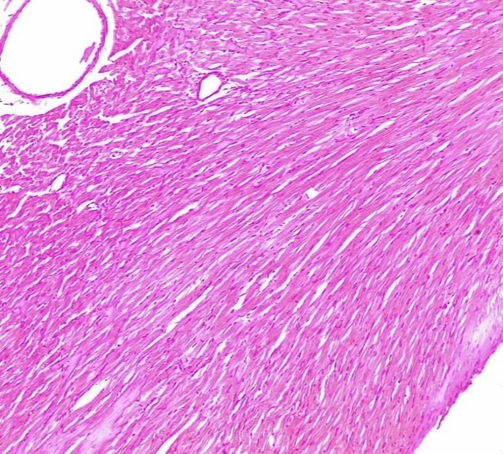
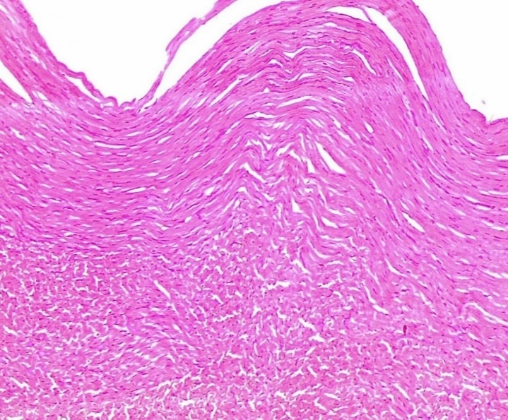
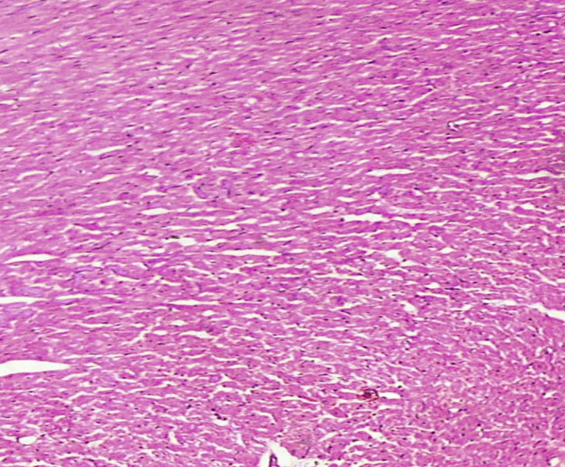
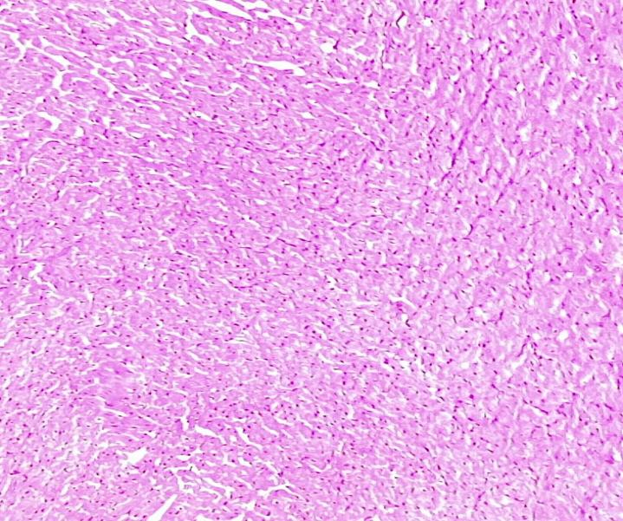
MF
CA
N
BV
N
MF
MF
A
B
D
C
MF
N

PLATE 1: Photomicrograph of longitudinal sections of the left ventricle of the heart of adult Wistar rats. H&E, X100.

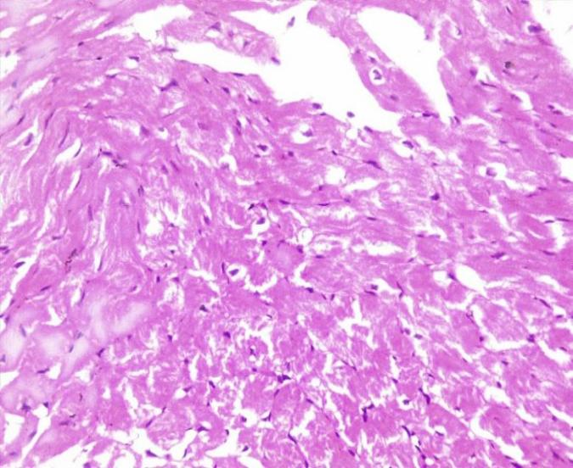
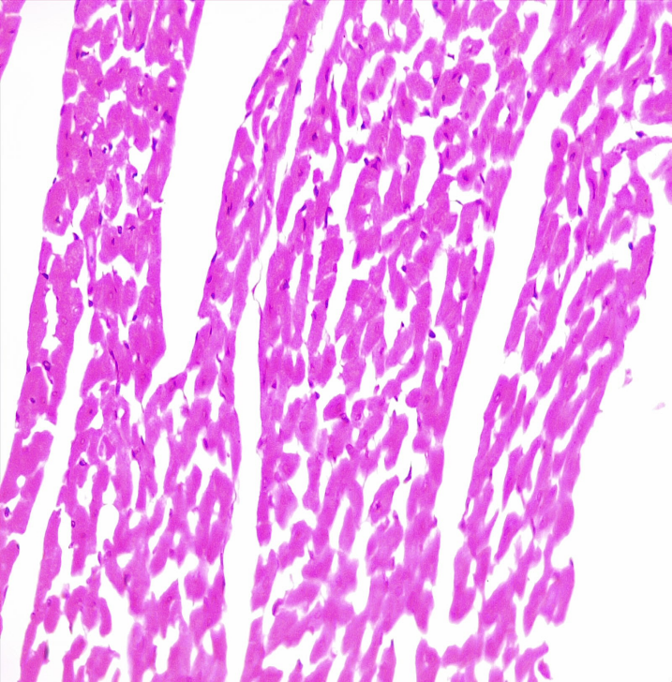
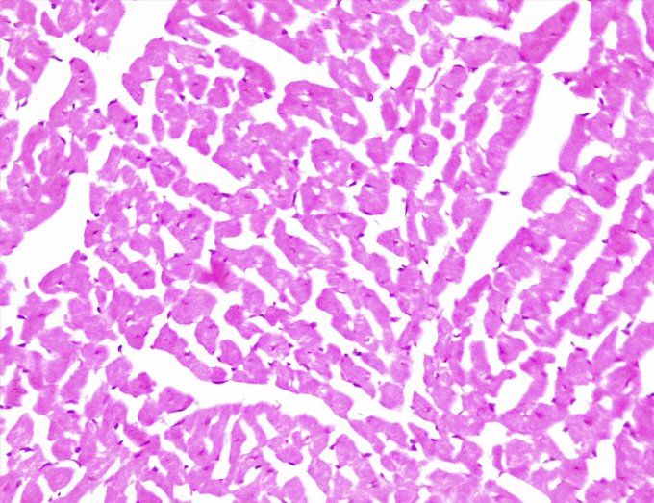
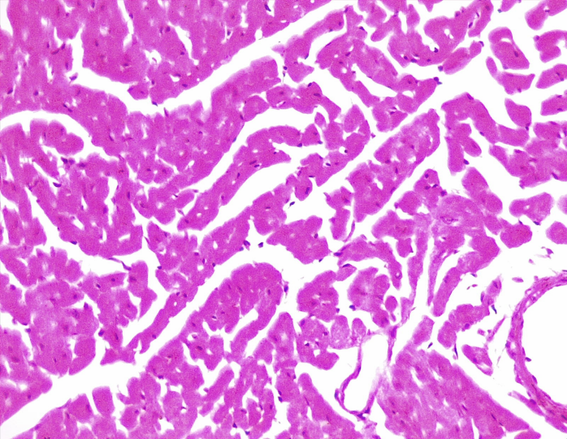
MF
B
N
MF
A
N
MF
CA
MF
BV
N
C
D
N

PLATE 2: Photomicrograph of transverse sections of the left ventricle of the heart of adult Wistar rats. H&E, X400.

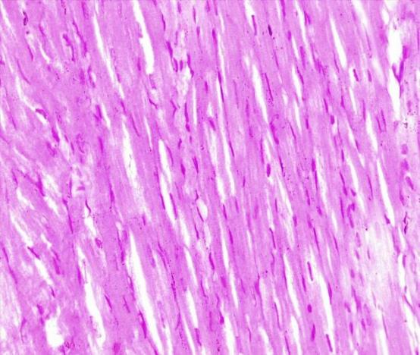
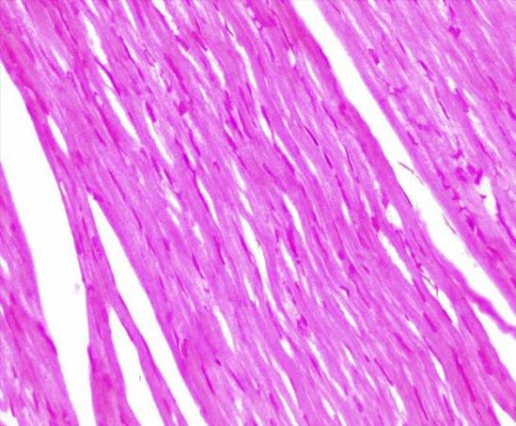
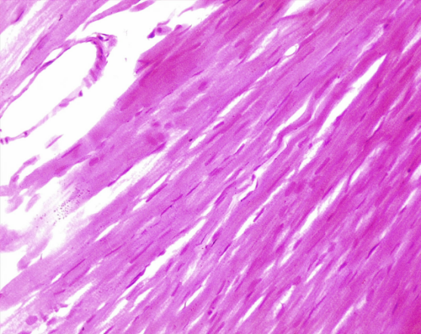
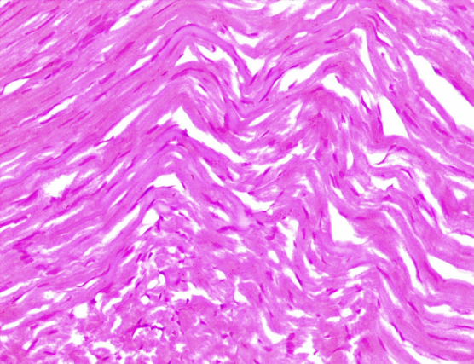
A
C
N
ID
ID
MF
N
ID
MF
N
BV
MF
D
N
MF
B

PLATE 3: Photomicrograph of longitudinal sections of the left ventricle of the heart of adult Wistar rats. H&E, X400
PLATE 1: Photomicrograph of longitudinal sections of the left ventricle of the heart of adult Wistar rats stained with H&E for X100. (A) Control group I displays a normal architecture of the left ventricle, with branched cardiac muscle fibers containing centrally placed nuclei. (B) Cd group II shows myocardial fibre waviness (blue arrow) and disorganization of cardiac muscle fibers. (C) A. sativum group III displays a normal architecture of the myocardium with a regular arrangement of muscle fibers, the presence of blood vessels, and centrally located nuclei. (D) A. sativum + Cd group IV shows some restoration of myocardial fibers with no vacuolated cytoplasm and the presence of capillaries among the muscle fibres. (N- Nucleus, MF- Cardiac muscle fibre, CA- Capillary)
PLATE 2: Photomicrograph of transverse sections of the left ventricle of the heart of adult Wistar rats stained with H&E for X400. (A) Control group I displays the normal architecture of the left ventricle with branching and anastomosing cardiac muscle fibers and central elongated nuclei. (B) Cd group II shows disarrangement of cardiac muscle fibers, hypertrophic muscle fibers (blue arrow), and cytoplasmic vacuolated cells (yellow arrow). (C) A. sativum group III displays the normal architecture of the myocardium with the regular alignment of muscle fibers and nuclei. (D) A. sativum + Cd group IV shows some restoration of myocardial fibers. (N- Nucleus, MF- Cardiac muscle fiber, CA- Capillary, BV- Blood vessel)
PLATE 3: Photomicrograph of longitudinal sections of the left ventricle of the heart of adult Wistar rats stained with H&E for X400. (A) Control group I displays the normal architecture of the left ventricle with a regular arrangement of muscle fibers, intercalated discs connecting the fibers, and intact cells. (B) Cd group II shows disorganization of cardiac muscle fibers, hypertrophic muscle fibers (blue arrow), and myocardial fiber waviness (yellow arrow). (C) A. sativum group III displays the normal architecture of the myocardium with a regular arrangement of muscle fibers and capillaries present among cardiac muscle fibers. (D) A. sativum + Cd group IV shows restoration of some myocardial fibers. (O- Nucleus, MF- Cardiac muscle fiber, ID- Intercalated disc, BV- Blood vessel, CA- Capillary).
DISCUSSION
It is well-proclaimed that Cd may accumulate in the heart, thereby causing an increase in the production of ROS such as superoxide anion, and hydrogen peroxide, thereby inducing oxidative stress (Bhattacharjee et al., 2019). In this study, toxicity of the Cd is associated with oxidative stress-mediated damages which may be associated with loss in the total body weight, distortion of the cellular antioxidant defense system, and increase in the serum level of LDH1. These changes observed in Cd-treated rats were attenuated with A. sativum aqueous extract (200mg/kg body weight) because it possesses antioxidant properties that inhibit ROS activity in the body. Findings in this study showed a significant reduction in the percentage weight gain of the Cd group II (15.5g) when compared to the control group I (59.83g) and A. sativum group III (31.62g). There was a slight increase in the percentage weight gain of the A. sativum+ Cd group IV (18.75g) compared to Cd group II, and alteration in body weight induced by Cd intoxication was slightly restored upon pre-administration of aqueous extract of A. sativum. The weight gain in the Control group I is the highest. Values (n=5) are presented as mean ± SD at P<0.05. This result agrees with (Nazimabashir et al., 2014) who suggested that Cd accumulation causes disturbances in the total body weight of rats and may be due to tissue damage and reduction in their functions. Changes in body weight serve as a marker that is used for checking the animal health status, and a reduction in body weight serves as an indicator of the deterioration in the health of the experimental rats during the experiment ((Emamat et al., 2020)). The decreased body weight recorded in the Cd-treated groups may be a result of a reduction in food and water intake following the administration of Cd. The retardation in growth may also be attributed to the direct effect of Cd on growth, as Cd-induced toxicity involves the induction of oxidative stress resulting in alterations in the antioxidant status, thereby leading to severe metabolic disorders and inability to gain weight (Poli et al., 2022). There was no statistically significant difference in the organ weight (g) of animals across the groups. Although, the Cd group II (0.76± 0.038) has a higher mean organ weight compared to other groups, this aligns with the report of Bhattacharjee et al., (2019), they reported that Cd administration elevates the weight of the heart tissues which may lead to organomegaly. The present dose of Cd (5 mg/kg body weight) resulted in three animal mortalities during the treatment period. In this study, there was a significant decrease in the level of SOD (µ/mg of protein) at P< 0.05 in the Cd group II (7.28±1.52). However, a statistically significant increase at P<0.05 was recorded in rats pre-treated with an aqueous extract of A. sativum (12.50±0.37), the levels were elevated near the control levels. Under normal physiological conditions, the mammalian body produces ROS that are generated inside the cells and are removed by endogenous antioxidants. An imbalance between the anti-oxidant defense and oxidants leads to oxidative stress (Priya et al., 2017). The reduced activity of SOD in the Cd-treated group II may be due to the replacement of Zn²⁺ ions by Cd. The direct binding of Cd ions to the active sites of this enzyme or utilization of more enzymes in scavenging the oxidants produced during Cd toxicity can be said to be another reason why there was loss of catalytic function of SOD (Priya et al., 2017). However, when the rats were pre-treated with an aqueous extract of A. sativum for 30 days, they demonstrated an increased level of activity of this enzyme up to control group I animals. This aligns with the result of the studies of Kilikdar et al., (2013), who reported that an aqueous extract of A. sativum can exert its antioxidant effect directly via free radical scavenging or indirectly by upregulating cellular antioxidant enzymes such as SOD. The SOD activity in the cardiac tissues of rats of the control group I and A. sativum group III exhibited no significant changes indicating not only that the extract has the potential to alleviate oxidative stress but also may be considered safe for consumption as a natural antioxidant. Catalase decomposes hydrogen peroxide and converts it to water and diatomic oxygen. In this study, a significant reduction in the activity of CAT (µM/min/mg protein) was recorded in the Cd group II (1.32±0.40; P < 0.05), and an increase in the CAT activity level when rats were pre-administered with A. sativum before Cd administration (4.64±0.31). The CAT activity in the cardiac tissues of rats of the control group I (5.37±0.34) and A. sativum group (4.98±1.54) exhibited no significant changes. This result aligns with the studies of Shaikh et al., (1999), who reported that Cd-induced alterations in the CAT activity in cardiac tissue can be described as an adaptive response to oxidative stress. Reduction in the activity of CAT in the cardiac tissues of rats in the Cd-treated group may be caused by the deprotonation of the nitrogen atom of the imidazole ring in His-74 due to Cd interaction (Wang et al., 2015). However, Cd-induced alterations on CAT enzyme activity were protected when the rats were pre-administered with an aqueous extract of A. sativum showing the potent antioxidant properties of A. sativum as reported by the studies of (Kilikdar et al., 2013), that A. sativum can exert its antioxidant effect directly via free radical scavenging or indirectly by upregulating cellular antioxidant enzymes such as CAT. This study further demonstrates that after Cd treatment, the levels of GPx decreased significantly in the rat cardiac tissue of Cd group II compared with the control group I and other experimental groups, there was a significant increase in the GPx activity level up to control levels when rat were pre-administered with A. sativum before Cd administration at P<0.05. A statistically significant increase in the activity of GPx was also noted in the rats treated with aqueous extract of A. sativum only when compared to the Control group I (Figure 4). This aligns with the studies of Mitra et al., 2012, who reported a decrease in the activity of the GPx enzyme of the Cd-treated group compared with the control group and other experimental groups. This shows that the glutathione metabolizing pathway is disturbed in Cd-treated rats (Mitra et al., 2015). GPx oxidizes GSH to GSSG by utilizing hydrogen peroxide as its substrate (Priya et al., 2017).
Lipid peroxidation is a potent indicator of oxidative damage (Weisberg et al., 2003), MDA is the breakdown product of the major chain reactions leading to the oxidation of polyunsaturated fatty acids and thus serves as a reliable marker of oxidative stress-mediated LPO in myocardial tissue (Sahma et al., 2003). Biochemical assays in this study show that MDA (nMol of TBARS) was increased in cardiac tissues of Cd group II (37.62±1.71) indicating accentuated oxidative damage. There was a significant decrease in the MDA levels of rats in A. sativum+ Cd group IV (14.92±3.77). There was no significant difference in the MDA level in the A. sativum group III (11.76±1.41) and control group I (10.30±0.43) at P<0.05. The result of this study correlates with Alpsoy et al., (2014); Priya et al., (2017), in their studies, they observed a significant increase in the cardiac content of MDA following Cd administration. Previous studies have reported that Cd-induced lipid peroxidation was diminished by plant extracts (Alpsoy et al., 2014). Pre-treatment with an aqueous extract of A. sativum successfully decreased the levels of lipid peroxidation possibly by scavenging the harmful effects of free radicals generated during Cd toxicity, thereby protecting the tissues from undergoing oxidative damage, this is consistent with Alpsoy et al., 2014, who reported on the heavy metal chelating activity of A. sativum. Results from this study prove that the rat hearts were susceptible to ROS-mediated damage, evident from the higher levels of MDA found in the cardiac tissues. Lactate dehydrogenase 1 is an enzyme that serves as an indicator of myocardial damage upon the loss of functional integrity of membrane architecture resulting in the leakage of this enzyme from the heart into the bloodstream (Priya et al., 2017). In this study, biochemical estimations of this marker enzyme showed a profound increase in the serum Cd-treated animals following Cd administration (11.45±0.39) at P<0.05, this is consistent with the result of Bhattacharjee et al., (2019). However, rats pre-treated with aqueous extract of A. sativum protected the cardiac tissues since the levels of LDH1 in their serum were significantly reduced (6.50±2.39, P<0.05). The antioxidant property of A. sativum might have strengthened the heart tissue membrane integrity, thereby preventing Cd-induced membrane damage indicating that this extract may have the capacity to protect the rat myocardial tissue (E. O. et al., 2024).
About histological alterations, Hematoxylin and eosin-heart tissue sections of Cd intoxicated rats revealed that the Cd administration with the present dose for the thirty consecutive days brought about significant alterations to the myocardium of the heart. These alterations include; loss of cardiac myofibers, vacuolization of cytoplasm, hypertrophy of muscle fibers, irregularity, and disarrangement of the myofibrils in cardiac tissues. Here again, the histological appearance of rats pre-treated with aqueous extract of A. sativum was found to be significantly improved (Plate 1-3). This result is consistent with a previous report by (Alpsoy et al., 2014), that cardiac tissue is susceptible to Cd-induced cardiotoxicity, reinforced by another research, Mitra et al., (2015) in their work, they revealed that the myocardium is highly susceptible to damages caused by Cd after Cd treatment every alternate day for 15 days. “The histoarchitecture of the control group I and A.sativum groups appeared normal with no damage to the tissue morphology proving that the extract not only can protect cardiac tissues against oxidative stress but also does not cause tissue damage, indicating again that the A. sativum may be considered safe for human consumption in future” (E. O. et al., 2024).
Based on this study, it can be presumed that A. sativum possibly exerted its cardio-preventive and protective effects in experimental rats via, at least, one of these mechanisms: (a) by acting as sacrificial antioxidants, thus sparing the consumption of endogenous antioxidants; (b) by stimulating the antioxidant defense system; and (c) possibly its metal-chelating properties.

CONCLUSION
The study highlights the diverse effects of Cd exposure and A. sativum treatment on behavior, biochemical parameters, and cardiac markers in rats. The observed alterations in oxidative stress markers and enzyme activities suggest potential cardioprotective effects of A. sativum against Cd-induced toxicity. The study emphasizes the importance of further research to elucidate the underlying mechanisms and clinical relevance of these findings as it may serve as a possible nutritional intervention and the extract itself or fractions that may be obtained from it may be used as a future nutritional supplement to fight oxidative stress-induced cardio-toxicity in persons exposed to Cd.

RECOMMENDATION
Further studies are required for adjudging the long-term effects of the A. sativum extract on animal study. It is worth elucidating the molecular mechanisms that go beyond A. sativum extract cardio-protection in Cd intoxication.

Disclaimer (Artificial intelligence)
Author(s) hereby declare that NO generative AI technologies such as Large Language Models (ChatGPT, COPILOT, etc.) and text-to-image generators have been used during the writing or editing of this manuscript.

Ethical Approval
Animal Ethic committee approval has been collected and preserved by the author(s)

REFERENCES
Alpsoy, S., Kanter, M., Aktas C., Erboga, M., Akyuz, A., Cayan, D., and Oran, M. 2014. Protective Effects of Onion Extract on Cd-Induced Oxidative Stress, Histological Damage, and Apoptosis in Rat Heart. Biol Trace Elem Res 159:297–303.
Anderson, P.G., Bishop S.P. and Peterson, J.T. 2006. Cardiovascular Research. The Laboratory Rat, 2nd Edition. Pg 773-802
Batiha, GE., Beshbishy A.M., Wasef, L.G., Elewa Y.H., Al-Sagan A.A., Taha, A.E., et al. 2020. Chemical constituents and pharmacological activities of garlic (Allium sativum L.): A review. Nutrients. 25:12(3):872
Bhattacharjee, B., Palash K.P., Arnab k.G., Sanatan M., Aindrila C., and Bandyopadhyay D. 2019. Aqueous bark extract of Terminalia arjuna protects against Cd-induced hepatic and cardiac injuries in male Wistar rats through antioxidative mechanisms. Food and Chemical Toxicology 124: 249–264
Bradley, J.M., Organ, C. L., and Lefer, D.J. 2016.Garlic-Derived Organic Polysulfides and Myocardial Protection. J Nutr. 146(2):403–409.
Emamat, H., Tangestani, H., Totmaj, A. S., Ghalandari, H., & Nasrollahzadeh, J. (2020). The effect of garlic on vascular function: A systematic review of randomized clinical trials. Clinical Nutrition, 39(12), 3563–3570. https://doi.org/10.1016/J.CLNU.2020.02.016

E. O., A., J. N., N., & N. E., U. (2024). Cadmium-induced Up-regulation of Nitric Oxide Synthase Activity in Rats’ Testes: Ameliorative Effect of PurXcel. Journal of Complementary and Alternative Medical Research, 25(8), 28–35. https://doi.org/10.9734/JOCAMR/2024/V25I8557

Ferramola M., Diaz M.F., Honroe S., Sanchez S., Anton R.I., and Anzulovich A.C. 2012. Cd-induced oxidative stress and histological damage in the myocardium. Effects of a soy. Toxicol Appl Pharmacol. 15; 265(3): 380-9
Guo, K., Ge, J., Zhang, C., Lv, M. W., Zhang, Q., Talukder, M., & Li, J. L. (2020). `Cadmium induced cardiac inflammation in chicken (Gallus gallus) via modulating cytochrome P450 systems and Nrf2 mediated antioxidant defense. Chemosphere, 249, 125858. https://doi.org/10.1016/J.CHEMOSPHERE.2020.125858

Kilikdar, D., Mukherjee D., Dutta.M.., Ghosh,A. K.., and Bandyopadhyay, D. 2013. Protective effect of aqueous A. sativum extract against lead-induced cardiac injury in rats. Journal of Cell and Tissue Research. 13(3) 3817-3828
Lu, M., Pan, J., Hu, Y., Ding, L., Li, Y., Cui, X., Zhang, M., Zhang, Z., & Li, C. (2024). Advances in the study of vascular related protective effect of garlic (Allium sativum) extract and compounds. The Journal of Nutritional Biochemistry, 124, 109531. https://doi.org/10.1016/J.JNUTBIO.2023.109531

Messner B., Bernhard, D., Knoflach M., Seubert A., Ritsch A., Pfaller K., Henderson B., Ying H.S., Zeller I., Willeit J. et al. 2009. Cd Is a Novel and Independent Risk Factor for Early Atherosclerosis Mechanisms and In Vivo Relevance. Arterioscler Thromb Vasc Biol. 29:1392-1398.
Mitra, E., Ghosh, A.K., Ghosh, D., Mukherjee, D., Chattopadhyay, W., Dutta, S., Pattar S.K., et al. 2015. Protective effect of aqueous Curry leaf (Murraya koenigii) extract against cadmium-induced oxidative stress in rat heart. Chmico-Biological Interactions 242:179-193.
Nazimabashir, V., Manoharan, S., and Selvaraj, M. P. 2014. Protective role of grape seed proanthocyanidins against Cd induced hepatic dysfunction in rats. Toxicol. Res 3:131.
Nazimabashir, Vaihundam M., and Selvaraj M. 2015. Cd induced cardiac oxidative stress in rats and its attenuation by GSP through the activation of Nrf2 signaling pathway. Chemico-Biological Interaction. 242:179-193.
Novelli E.L., Marques S.J., Almeida A. S., Diniz and Faine B. O. 2000. Toxic mechanism of Cd exposure on cardiac tissue. Toxic substance mechanism. 19:207–217

Olateju, B. S., Ige, S. F., Ridwanullahi, A., Samuel, O. A., Asegunloluwa, A. G., & Ibukunoluwa, A. M. (2024). Gender Differences in the Effects of Cadmium Exposure on Hematological Parameters in Wistar Rats. Asian Journal of Medicine and Health, 22(9), 65–79. https://doi.org/10.9734/AJMAH/2024/V22I91091

Orheruata, R.A., Om’iniaboh, F.A., and Ejeguo A. 2018. Comparative Studies on the Cardiovascular System in the Wistar Rat (Rattus norvegicus) and Agama Lizard (Agama agama) J. Appl. Sci. Environ. Manage 22(4)605 – 608.
Poli, V., Madduru, R., Apama, Y., Kandukuri, V., and Motireddy R.S. 2022. Amelioration of Cd-induced oxidative damage in wistar rats by vitamin c, zinc an N-acetylcysteine. Med Sci (Basel)10(1):7.
Priya L.B., Rathinasamy B., Elangovana P., Dhivyaa V., Chih-Yang HD., and Padmaa V. 2017. Tinospora cordifolia extract attenuates Cd-induced biochemical and histological alterations in the heart of male Wistar rats. Biomedicine & Pharmacotherapy. 87:280–287.
Rehman, I., & Rehman, A. (2023). Anatomy, Thorax, Heart. StatPearls. https://www.ncbi.nlm.nih.gov/books/NBK470256/
Ripa, R., George, T., Shumway, K. R., & Sattar, Y. (2023). Physiology, Cardiac Muscle. StatPearls. https://www.ncbi.nlm.nih.gov/books/NBK572070/

Sahma, E., Parlakpinar, H., Ozer M.K., Ozturk F., and Acet, A. 2003. Melatonin protects against myocardial doxorubicin toxicity in rats: role physiological concentrations. J Pineal Res 35:257–261.
Shaikh, Z.A., Vu, T.T., and Zaman, K. 1999. Oxidative stress as a mechanism of chronic Cd -induced hepatotoxicity and renal toxicity and protection by antioxidants. Toxicol. Appl. Pharmacol. 154:256 –263.
Singh, I.B., and Pal, G.P. 2007. Cardiovascular System. In: Human Embryology (8th Ed). McMilliam India Ltd. New Dehli, p. 192.
Tellez-Plaza M., Guallar E., Howard B.V., Umans J.G., Francesconi K.A, et al. 2013. Cd exposure and incident cardiovascular disease, Epidemiology 24(3): 421–429
Tucker, G.P., Curry, V.J., Doyle, J., M., Fowler, B.J., Gehle, K., Hall, L.S. and Hatcher, M. 2008. Agency for Toxic Substances and Disease Registry Case Studies in Environmental Medicine (CSEM) Cadmium Toxicity. 3-61. https://www.atsdr.cdc.gov/csem/cadmium/docs/cadmium.pdf Date assessed: 1st April, 2023. 3:25 am
Wang, J., Zhang, H.T., Zhang, R.Z., Liu, R., and Chen, Y. 2015. Molecular mechanism on Cd-induced activity changes of catalase and superoxide dismutase. Int. J. Biol. Macromol. 77:59–67.

