Case Report

Juvenile xanthogranuloma on the Eyelid: A case report

ABSTRACT
We present the case of a 4-year-old male with a painless, firm, smooth, yellow-orange, rounded papule approximately 6 mm in diameter located on his right upper eyelid. The lesion caused functional limitation in eye opening. Due to the risk of visual impairment, an ophthalmological evaluation was performed, followed by complete surgical excision.
The diagnosis was confirmed by histopathological examination, establishing the nature of juvenile xanthogranuloma, a non-Langerhans cell histiocytosis.
No recurrence was observed during follow-up. This case highlights the importance of recognizing eyelid presentations of this condition and promoting a multidisciplinary approach to prevent visual sequelae in the pediatric population.
Key words: Juvenile Xanthogranuloma, non-Langerhans cells, histopathology, Giant cells of Touton.
Introduction
Juvenile xanthogranuloma (JXG) is a rare benign condition and represents the most common variant within non-Langerhans cell histiocytoses¹. It manifests itself by orange-yellow papular or nodular lesions, located on the head and neck, whose development seems to be driven by an as-yet-unidentified stimulus ^{1,2}.
Although it is cutaneous, there are cases with extracutaneous involvement, being the ocular region with the greatest involvement. ²
This pathology, whose evolution is usually self-limiting, occurs more frequently during the first months of life, although it can also be observed in adults.³ It is called by a variety of names, including xanthoma multiple of infancy, juvenile xanthoma, neviform xanthoma and juvenile giant cell granuloma.⁴
Although its etiology remains unknown, recent studies suggest that it could correspond to a reactive process in response to certain factors that have not yet been specified.⁴
PRESENTATION OF CASE.
The study presents the case of a 4-year-old male preschooler. Product of first pregnancy, controlled pregnancy and simple eutocic delivery. No relevant personal or family history is reported.
The patient attended the dermatology service at the Dr. Enrique Tejera Hospital City, Valencia, Venezuela, accompanied by his mother, who reported the appearance, approximately five months ago, lesion on the left upper eyelid, presenting a progressive growth.
During dermatological evaluation, a dermatosis was observed on the left upper eyelid, characterized by a solitary yellow-orange papular lesion, rounded in shape, approximately 6 mm in diameter, with firm consistency, well-defined borders, and a smooth surface. The lesion had an evolution of five months, was painless, and was associated with difficulty in opening the eye (Figure 1).
Dermoscopic examination revealed a yellow-orange background, surrounded by an erythematous halo, with the presence of linear vessels, "sign in the setting sun" (Figure 2). Histopathological study of the skin is requested to confirm diagnosis.
In order to rule out ocular Involvement, ophthalmological evaluation was indicated. Complementary studies were also requested, including complete hematology, peripheral blood smears, and renal and liver function tests, aimed at ruling out possible extracutaneous or systemic manifestations.
Through the data obtained by clinical and dermoscopy, excision of the lesion is indicated in view of the limitation to the ocular opening, size and anatomical location

The laboratory results were within normal parameters. Evaluation by the Hematology service did not show alterations suggestive of hematological disease. On the other hand, ophthalmology concluded with the diagnosis of healthy eye.
The histopathological study showed preserved epidermis, proliferation in the dermis, composed of scattered Touton-type giant cells, accompanied by foamy histiocytes, confirming the diagnosis of juvenile xanthogranuloma (Figure 3). During 6 months of follow-up, no recurrence was evidenced.
Discussión
Historically, JXG was first described in 1905 by Adamson, who documented the case of a two-year-old boy with multiple congenital xanthomatous lesions.⁵ Subsequently, McDonagh reported five additional cases with similar characteristics.⁶
In 1950 Helwig and Hackney established the term JXG, after analyzing a series of 140 documented cases.⁷
JXG originates from a proliferation of dendritic cells, characterized by their positivity for factor XIIIa, considered a precursor element of various dendritic disorders within non-Langerhans cell histiocytosis (HCNL), this being the most frequent variant.⁸
The origin of histiocytosis, including Langerhans cell (LCH), has been debated between its inflammatory or neoplastic nature. Somatic mutations in genes of the MAPK signaling pathway, such as BRAF-V600E and MAP2K1, have been identified as being present in most cases of LCH, driving cell differentiation and systemic inflammation.⁹
The clinical manifestations of this disease are characterized by the appearance of papules or nodules of 2 mm -20 mm, with a well-defined, firm yellow-orange tone and a smooth surface that evolve progressively.¹⁰ In most cases (80%-90%), the lesions are solitary and usually asymptomatic, except in cases where they reach a considerable size or are located in sensitive areas. Less common variants have also been identified, such as subcutaneous, intramuscular, generalized, large (>2 cm), lichenoid, plaque-shaped, or ring-patterned lesions.¹⁰
JXG can occur in various areas of the body, although it is most common on the head, neck, and upper trunk.¹¹
Dermoscopy is a key tool for the diagnosis of this pathology, providing characteristic findings such as the "setting sun sign", defined by a yellow-orange background, an erythematous halo and linear vessels. Other dermatoscopic features include an erythematous border, a faint pigment network, and thin linear white streaks.^{12,13}
Histologically, JXG is characterized by a mixed dermal infiltrate composed of mononuclear cells, multinucleated giant cells, including Touton cells, and spindle cells. Lymphocytes, eosinophils, neutrophils, and mast cells can also be found.¹⁴ These histopathological findings are related to the case presented.
Immunohistochemistry can help differentiate juvenile xanthogranuloma from Langerhans cell histiocytosis. In juvenile xanthogranuloma, it is CD68 positive; factor XIIIa and, less frequently for CD4, lysozyme and the Ki-67 proliferation marker. In contrast, the S-100 protein is positive in langerhans cell histiocytosis, absent in juvenile xanthogranuloma.¹⁵
The treatment of JXG is usually conservative, with a self-limiting course and spontaneous regression. Although most cases do not leave sequelae, some larger injuries may require surgical intervention for cosmetic reasons. The use of steroids has been explored in specific cases, such as eye involvement, but it is not the standard treatment.¹⁶
The case presented has the typical clinical features of juvenile xanthogranuloma. Dermoscopy was a key tool for the initial diagnosis, as it evidenced specific structures compatible with this pathology. For definitive confirmation, a histopathological study was performed with hematoxylin-eosin staining, without immunohistochemistry due to economic limitations. From the clinical point of view, lesions such as chalazion, dermoid cyst, pyogenic granuloma, and langerhans cell histiocytosis were included in the differential diagnoses, and were ruled out by clinical findings, dermoscopy, and histopathology.
Given that systemic involvement has been reported in some cases with generalized presentation, complementary studies such as complete hematology, renal and liver function tests, and comprehensive ophthalmological evaluation were considered. The latter approach was fundamental in the case due to the location of the lesion and the functional impact on the ocular opening, with the potential risk on the visual axis. Through ophthalmological evaluation, profound complications (iris, retina, orbit and optic nerve) were ruled out.
Surgical excision was indicated due to the size and limitation of the lesion, achieving complete remission without recurrences, with improvement in the aesthetic appearance and quality of life of the patient.
Conclusion
JXG is condition whith well-defined clinicak features and a self- limiting course, characterizad by distinctive morphological findings.
Its diagnosis is based on dermoscopy and histopathological study. Management should be individualized according to the size and location of the lesion.
In cases close to the ocular apparatus, such as the one described, surgical excision and ophthalmological evaluation are essential to rule out extracutaneous involvement, this comprehensive evaluation being key to preserving critical functions and guiding appropriate follow-up

Disclaimer (Artificial intelligence)

Author(s) hereby declare that NO generative AI technologies such as Large Language Models (ChatGPT, COPILOT, etc.) and text-to-image generators have been used during the writing or editing of this manuscript.

references.
1. Dehner LP. Juvenile xanthogranuloma in the first two decades of life: a clinicopathologic study of 174 cases with cutaneous and extracutaneous manifestations. Am J Surg Pathol. 2003;27(5):579-93.
2. Luder CM, Nordemann TM, Ramelite E, Mühleisen B, Kerl K, Guenova E, et al. Histiocytosis: cutaneous manifestations of hematopoietic neoplasms and non- neoplastic histiocytic proliferations. J Eur Acad Dermatol Venereol. 2018;32 (6): 926-34. DOI: 10.1111/jdv.14794
3. Domínguez H, Briones MC, Garcés JC, Úraga E. Dermatoscopy in juvenile xanthogranuloma: report of 4 cases. Dr. Dermatology Center Úraga 2019;1(3):37- 42
4. López I, et al. Solitary juvenile xanthogranuloma. Dermatol Rev Mex.2007;51(3):37-42. https://doi.org/10.24245/dermatolrevmex.v69i3.10523
5. Adamson N. Congenital xanthoma multiplex in a child. Br J Dermatol.1905;17:222-3
6. McDonagh J. A contribution to our knowledge of the naevo-xantho-endothelioma. Br J Dermatol. 1912; 24:85.
7. Helwig E, Hackney V. Juvenile xanthogranuloma (nevoxanthoendothelioma). Am j Pathol.1954;30:365.
8. Hernández-San Martín MJ, Vargas-Mora P, Aranibar L. Juvenile xanthogranuloma: an entity with wide clinical spectrum. Actas Dermosyfiliogr. 2020; 111(9):725-33.
9. Seidel MG, Brcic L, Hoefler G, Hutter J, Minkov M, Steffen LS, et al. Concurrence of a kinase-dead BRAF and an oncogenic KRAS gain-of-function mutation in juvenile xanthogranuloma. Pediatr Blood Cancer. 2023; 70(4): e30060. DOI: 10.1002/pbc.30060
10. Haroche J, Abla O. Uncommon histiocytic disorders: Rosai-Dorfman, juvenile xanthogranuloma, and Erdheim-Chester disease. Hematology. 2015; 2015(1):571-8.
11. Janssen D, Harms D. Juvenile xanthogranuloma in childhood and adolescence: a clinicopathologic study of 129 patients from the Kiel pediatric tumor registry. Am J Surg Pathol. 2005;29(1): 21-8.
12. Pretel M, Irrazaval I, Lera M, Aguado L, Idoate MA. Dermoscopic ``setting sun`` pattern of juvenile xanthogranuloma. J Am Acad Dermatol.2015; 72: S73–5
13. Rubegni P, Mandato F, Fimiani M. Juvenile Xanthogranuloma: dermoscopic pattern. Dermatology 2009; 218:380.
14. Villarreal CD, Chávez Álvarez S, Ayala Cortés AS, Gómez Flores M, Ocampo Candiani J. Xanthogranuloma in adult simulating keratocantoma: case report and review of the literature. Dermatol cosm, Med y Qir. 2017; 15(4):252-4.
15. Zelger B, Cerio R, Orchard G, Wilson-Jones E. Juvenile and adult xanthogranuloma: a histological and immunohistochemical comparison. Am J Surg Pathol 1994;18(2):126-35.
16. Samara WA, Khoo CTL, Say EAT, Saktanasate J, Eagle RC, Shields JA, et al. Juvenile xanthogranuloma involving the eye and ocular adnexa: tumor control, visual outcomes, and globe salvage in 30 patients. Ophthalmology. 2015; 122:2130-8.

Page skin
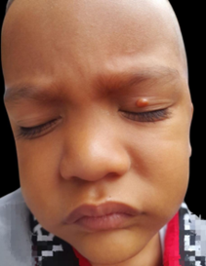
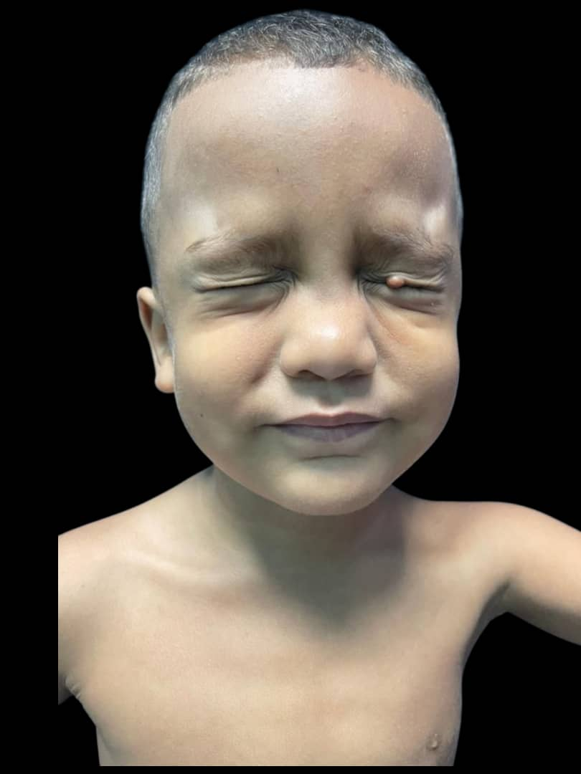
- Figure 1: 6 mm yellowish-orange papule

- Figure 2: Yellow-orange background, surrounded by an erythematous halo, with the presence of linear vessels, ''sign of the setting sun''

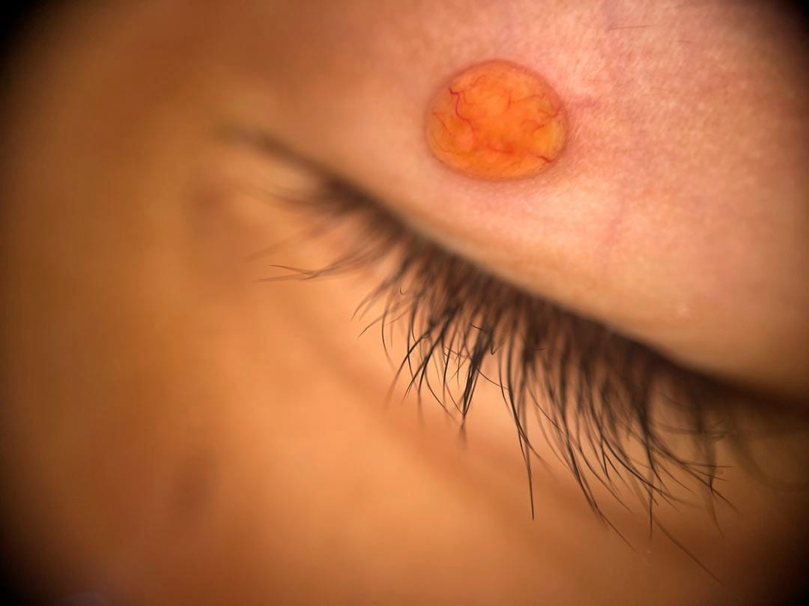

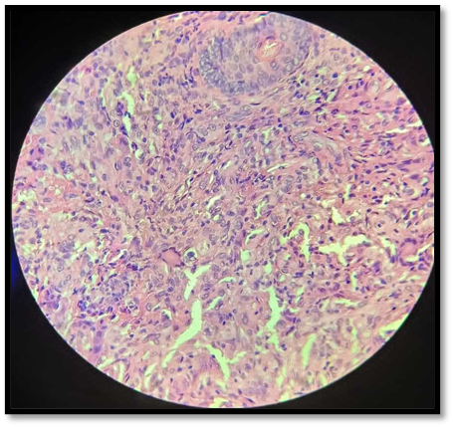
- Figure 3: Histological study stained with hematoxylin-eosin at 40X; Touton-type giant cells, foamy histiocytes are evident in the dermis.

