Case report

Unraveling the genetic signature behind a refractory vasculitis: A Adenosine deaminase 2 deficiency case report

.
ABSTRACT

Adenosine deaminase 2 deficiency (DADA2) is a rare genetic disorder that follows an autosomal recessive pattern, stemming from mutations in both copies of the ADA2 gene. This condition leads to reduced enzyme activity and can cause a wide range of issues related to blood vessels, inflammation, and the immune system. We present the case of a 19-year-old male from a family with a history of consanguinity, who has experienced recurrent fevers, mouth sores resembling aphthous ulcers, hives, joint pain due to inflammation, and neurological symptoms that appeared early in life. Imaging of the brain showed several small areas of damage from lack of blood flow. Lab tests indicated ongoing inflammation without signs of low blood cell counts or deficiencies in immunoglobulins, and tests for infections and immune responses came back negative. Because systemic inflammation can lead to early strokes, we suspected DADA2. Genetic testing confirmed he had a homozygous variant in the ADA2 gene (NM_001282225.2:c.1069G>A). After starting treatment with weekly etanercept, he quickly saw a reduction in fever, stability in his neurological condition, and normalization of inflammatory markers. This case underscores the importance of considering DADA2 in young patients who show signs of systemic vasculitis, unexplained fevers, or early strokes. Early diagnosis is vital, as prompt anti–TNF-α treatment can help prevent serious complications and greatly enhance patient outcomes.

Keywords: Adenosine deaminase 2 deficiency, DADA2,CECR1 mutations, Autoinflammatory disease, Vasculitis, ADA2 enzyme activity, Anti-TNF therapy, Gene sequencing, Genotype–phenotype correlation, Monogenic vasculitis, Early-onset vasculitis.

1. INTRODUCTION

Adenosine deaminase 2 deficiency (DADA2) is a rare genetic disorder that was first identified in 2014 [1], highlighting the intricate connections between immunity, inflammation, and vasculitis. This condition is a monogenic, autosomal recessive disease caused by biallelic mutations in the ADA2 gene (previously known as CECR1), which results in little to no ADA2 enzymatic activity [2].The clinical presentation of DADA2 is quite varied and includes a range of vascular issues, immune system irregularities, blood disorders, and autoinflammatory symptoms [3]. This wide array of symptoms can often lead to delays in diagnosis or even misdiagnosis. In this report, we share the case of a patient who exhibited systemic vasculitis along with early-onset neurological symptoms, and whose diagnosis of DADA2 was confirmed through genetic testing. Through this case study, we delve into the clinical, biological, genetic, and treatment aspects of this often-overlooked condition, emphasizing the importance of recognizing it due to its significant implications for prognosis and therapy.

2. CASE REPORT
The patient, E.S., a 19-year-old male born to first-degree consanguineous parents, was admitted to the Department of Internal Medicine. Since childhood, he had experienced recurrent unexplained fevers associated with cutaneous lesions resembling genital aphthosis and recurrent urticaria, along with neurological manifestations suggestive of early ischemic strokes confirmed by imaging, and inflammatory joint pain.
Clinical examination revealed hepatomegaly and splenomegaly without growth retardation. Laboratory tests showed a persistent inflammatory syndrome, without cytopenia or serum immunoglobulin deficiency. Immunological and infectious screenings were unremarkable. Brain imaging confirmed multiple lacunar infarcts.
Given this presentation of systemic vasculitis with early neurological involvement, ADA2 deficiency was suspected. Genetic analysis revealed a homozygous variant NM_001282225.2:c.1069G>A in the ADA2 gene (class 3), confirming the diagnosis of DADA2.
The patient was treated with an anti–TNF-α agent (etanercept 25 mg/week), leading to a favorable evolution: resolution of fever, neurological stabilization, and normalization of inflammatory markers.

3. discussion
ADA2 deficiency is a rare genetic condition that follows an autosomal recessive pattern, stemming from mutations in the ADA2 gene found on chromosome 22q11.1 [1,7]. This gene is responsible for producing an extracellular enzyme that plays a key role in purine metabolism, as well as in managing vascular immunity and inflammation [2,4]. The ADA2 protein is essential for striking a balance between pro-inflammatory and anti-inflammatory responses, ensuring the stability of endothelial cells, and guiding macrophages to adopt the anti-inflammatory M2 phenotype [8].
Without it, the body's innate immune system can go haywire, leading to an overproduction of inflammatory cytokines, especially TNF-α, and issues with blood vessel regulation. This explains the wide range of clinical symptoms [9]. The disease tends to show up more often in children from families with a history of intermarriage [10]. The clinical signs can vary quite a bit, typically falling into three main but often overlapping categories: autoinflammatory, vascular, and hematologic [1,3] (Figure 1).
Figure 1 - Genotype and functional correlates of disease phenotype in DADA2
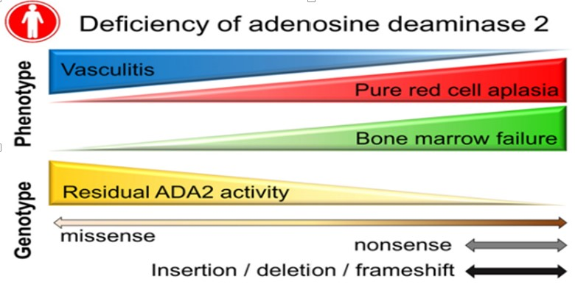
Diagnosing the condition relies on recognizing a suggestive clinical phenotype, checking for low or absent ADA2 enzymatic activity, and confirming it through ADA2 gene sequencing [5,9]. Sometimes, patients are mistakenly diagnosed with lupus, polyarteritis nodosa, or Behçet’s disease, which can delay the right treatment [4,9]; in our case, it took 17 years to get the correct diagnosis. Treatment strategies vary based on the phenotype: anti–TNF-α agents are currently the go-to therapy for vascular and inflammatory types [6,11], while severe hematologic cases might require allogeneic bone marrow transplantation [12]. For our patient, starting anti–TNF-α therapy led to significant clinical and biological improvement, highlighting the effectiveness of this targeted approach [6].

4. Conclusion
This case really emphasizes how crucial it is to think about ADA2 deficiency when diagnosing systemic vasculitis in children and young adults, especially in situations involving early-onset stroke, unexplained fevers, or signs of immunodeficiency. Catching it early allows for the right treatment, particularly with anti–TNF-α therapy, which can help avoid serious complications. The increasing awareness of this condition highlights the significant role that monogenic diseases play in unexplained inflammatory syndromes and showcases the importance of genetics in diagnosing autoinflammatory disorders.

Consent
All authors declare that ‘written informed consent was obtained from the patient (or other approved parties) for publication of this case report and accompanying images. A copy of the written consent is available for review by the Editorial office/Chief Editor/Editorial Board members of this journal.

References

- Meyts I, Aksentijevich I. Deficiency of Adenosine Deaminase 2 (DADA2): Updates on the Phenotype, Genetics, Pathogenesis, and Treatment. J Clin Immunol. 2018;38(5):569-578.
- Zhou Q, et al. Early-onset stroke and vasculopathy associated with ADA2 mutations. N Engl J Med. 2014;370(10):911-920.
- Navon Elkan P, et al. ADA2 deficiency: Clues to the pathogenesis of vasculitis and immunodeficiency. J Allergy Clin Immunol. 2014;134(3):605-612.
- Hashem H, et al. Deficiency of adenosine deaminase 2: A new autoinflammatory disease. J Pediatr Hematol Oncol. 2017;39(3):e123-e129.
- Ben-Ami T, et al. Genetic diagnosis of ADA2 deficiency in patients with systemic vasculitis. Rheumatology. 2020;59(10):2870-2878.
- Caorsi R, et al. ADA2 deficiency: Clinical spectrum and long-term treatment outcomes with anti-TNF therapy. Ann Rheum Dis. 2017;76(10):1728-1736.
- Zavialov AV, et al. Genetic and biochemical basis of ADA2 deficiency. Hum Mutat. 2018;39(3):324-331.
- Zhou Q, et al. Functional characterization of ADA2 in endothelial and macrophage regulation. Blood. 2019;133(9):1009-1019.
- Özen S, et al. Deficiency of adenosine deaminase 2 (DADA2): Clinical, immunologic, and genetic features. Front Immunol. 2022;13:811473.
- Barzaghi F, et al. Deficiency of ADA2 presenting with systemic inflammation and early-onset stroke in consanguineous families. J Clin Immunol. 2019;39(4):350-358.
- Nanthapisal S, et al. Anti-TNF therapy in ADA2 deficiency: A multicenter experience. J Allergy Clin Immunol Pract. 2020;8(3):919-928.e9.
- Hashem H, et al. Hematopoietic stem cell transplantation for ADA2 deficiency: Long-term outcome. Blood. 2017;130(10):1156-1163.

