Original Research Article

Strengthening Community Engagement in Mangrove Rehabilitation: Best Practice from IMPACT Program in East Kalimantan-Indonesia

.
ABSTRACT

Aims: This study aims to analyze the effectiveness of progressive community engagement methods applied in the IMPACT mangrove rehabilitation program initiated by PT Indika Energy Tbk in Paser Regency, East Kalimantan Province, particularly in strengthening community involvement and improving rehabilitation outcomes.

Study Design: This research employed a qualitative case study design.

Place and Duration of Study: The study was conducted in nine coastal villages in Paser Regency, East Kalimantan Province, Indonesia, within the implementation period of the IMPACT mangrove rehabilitation program up to the end of 2025.

Methodology: The study applied a progressive community engagement framework consisting of three stages: social investigation, social mapping, and building a common dream. Data were collected through program documentation, field observations, and stakeholder engagement processes involving community-based mangrove care groups participating in the rehabilitation activities.

Results: The results showed that the program successfully engaged nine village-based mangrove care groups. More than 191,000 mangrove seedlings were produced, and approximately 186,000 seedlings were planted, achieving a survival rate exceeding 86% by the end of 2025. In addition, the progressive community engagement approach significantly enhanced the community’s sense of ownership and commitment to the mangrove rehabilitation program.

Conclusion: This study concludes that a structured and collaborative community-based approach is a key factor in the success of coastal ecosystem rehabilitation. The findings provide important implications for the development of more inclusive, participatory, and sustainable natural resource management programs.

Keywords: mangrove rehabilitation, progressive community engagement, social investigation, social mapping, common dream

1. INTRODUCTION

Environmental damage and degradation in Indonesia’s coastal areas have attracted considerable attention from various stakeholders. Coastal biodiversity, which is predominantly dominated by mangrove ecosystems, is increasingly threatened by land-use conversion, pollution, and other illegal activities (Richards et al., 2020). These pressures result in ecological losses as well as significant direct economic impacts on local coastal communities (Sarker et al., 2019). One striking example is the uncontrolled conversion of land into aquaculture ponds, which has led to the loss of mangrove vegetation that plays a crucial role in sustaining coastal ecosystems (Begum et al., 2021). This reality highlights the urgent need for rehabilitation efforts in degraded areas. Mangroves not only function as natural protection against coastal erosion but also serve as a vital foundation for coastal habitats and biodiversity, as well as natural resources that support the livelihoods of surrounding communities (Moussa et al., 2024).

Best practices from the Sundarbans in India, the location of the largest mangrove ecosystem in the world, demonstrate that the success of mangrove rehabilitation is strongly influenced by management approaches that actively involve local communities. The implementation of ecosystem management policies with community participation has proven effective in maintaining and even enhancing biodiversity. This empirical evidence confirms that community-based approaches can generate positive and significant impacts on the sustainable conservation of mangrove ecosystems (Sarker et al., 2019). In Indonesia, Damastuti and de Groot (2019) report that participatory ecosystem mapping activities, in which communities are involved in determining protection and utilization zones for mangroves, have successfully increased community awareness and sense of ownership regarding the sustainability of rehabilitation projects.

Efforts to rehabilitate mangrove ecosystems by positioning local communities as key elements have been undertaken in various countries, including Indonesia. Nevertheless, many mangrove rehabilitation initiatives have failed due to the lack of active community involvement and the inability to implement effective and appropriate collaborative mechanisms (Cameron et al., 2021; Ounvichit & Yoddumnern-Attig, 2018).

The failure of several mangrove rehabilitation activities is often associated with a mismatch between the approaches applied and the social structure of local communities (Gatt et al., 2022). In some cases, limited community understanding of the importance of mangrove rehabilitation, as well as a lack of synergy between program objectives and community visions, have been identified as the main factors contributing to rehabilitation failure (Utami et al., 2024). Therefore, it is essential to align program components with local wisdom and social values in order to formulate a deep and effective collaborative model between local communities and program management.

In 2023, PT Indika Energy Tbk initiated the Indika Energy Mangrove Program in Action (IMPACT) as a mangrove rehabilitation program in Indonesia. This program mainstreams a distinctive and progressive social approach. According to the Oxford English Dictionary, progressive refers to moving forward, developing, or gradually improving toward a better condition. In the context of community engagement, a progressive approach entails the active, continuous, and increasingly in-depth involvement of communities in decision-making and program implementation processes.

A progressive approach to community engagement encourages communities not only to become objects of change but also subjects who play an active role in the transformation process (Wolff et al., 2021). In the context of this study, community engagement is realized through the establishment of mangrove stewardship groups (hereafter referred to as groups) in nine locus villages.

The IMPACT Program’s rehabilitation plan targets an area of 250 hectares by the end of 2025. To ensure the availability of seedlings, the IMPACT Program relies heavily on the groups through nursery and seedling cultivation activities. By the end of 2025, the groups had successfully propagated approximately 191,000 seedlings and planted around 186,000 seedlings across an area of 250,5 hectares. Monitoring results from the fourth semester indicate a survival rate of 86%.

This study aims to provide an in-depth examination of how the detailed processes and stages of community engagement in the IMPACT Program are implemented, with a particular focus on community engagement practices in Paser Regency, East Kalimantan Province. Through this approach, a coherent and comprehensive perspective on a progressive community engagement model is obtained. Furthermore, this study is expected to fill a gap in the existing literature regarding community engagement methods in mangrove rehabilitation activities. This research is also anticipated to offer policy recommendations that can be replicated in other regions facing similar challenges in mangrove rehabilitation.

2. material and methods
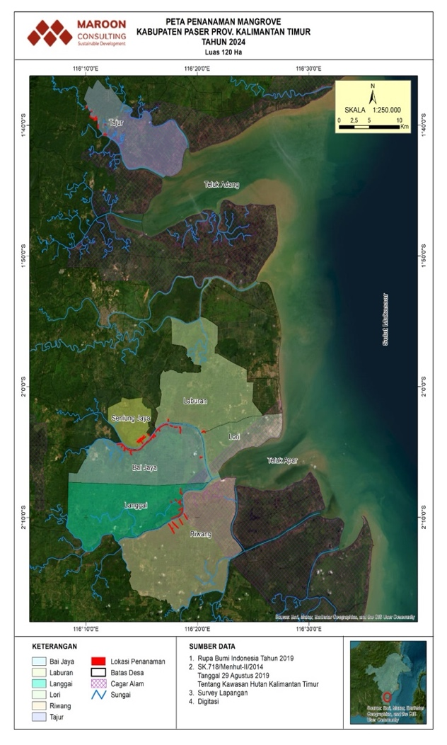
Figure 1. Locus IMPACT Program Map

MAP OF IMPACT PROGRAM
IN PASER REGENCY EAST KALIMANTAN 2025
This study adopts a qualitative research design using a case study approach. The case study method is appropriate because it allows for an in-depth and comprehensive examination of the processes and stages of progressive community engagement within the context of mangrove rehabilitation (Lhosupasirirat et al., 2023). By employing a case study approach, this research is able to explore comprehensively how the roles of social actors and the optimization of local wisdom influence implementation success, as well as the direction and dynamics of collaboration among stakeholders involved in mangrove rehabilitation programs.

The philosophical foundation of this study draws on patterns of social participation and collaboration that emphasize the importance of active community involvement in natural resource management, as applied to the context of coastal environments and mangrove ecosystem rehabilitation (Huxham & Vangen, 2013).

Approaches based on social participation, social collaboration, and empowerment are highly relevant for explaining the process of progressive community engagement. The social participation approach (Phadsri et al., 2021) identifies levels of community involvement in decision-making, underscoring the importance of active participation for achieving program success. Meanwhile, social collaboration (Listiana & Ariyanto, 2024) emphasizes the significance of cooperation and collaboration between implementers and community groups in achieving shared objectives. In addition, the community empowerment approach (Mandrysz, 2020) highlights the importance of community control over decisions that affect their lives. Taken together, these three approaches provide a logical foundation for progressive community engagement.

This study was conducted through longitudinal observation over the first and third years of program implementation, spanning a total of 36 months. The observation period began with the program kick-off in February 2023 and continued until January 2026. In the first year, the program was implemented in Lori Village and Sungai Langir Village, followed in the second year by the addition of seven villages: Tajur Village, Riwang Village, Bai Jaya Village, Laburan Village, Langgai Village, Suliliran Baru Village and Seniung Jaya Village. This study systematically and sequentially explains each stage of the progressive community engagement process that was developed throughout the program.

3. results and discussion

The values of inclusivity, collaboration, and a shared-welfare-oriented approach constitute the fundamental philosophical elements of this concept. This philosophy emphasizes that communities—whether defined by geographic boundaries, shared interests, or common goals—play a central role in identifying directions, setting priorities, and making decisions to address challenges that affect them. Within this process, community engagement functions not only as a problem-solving mechanism but also as a means to build communication and public trust, strengthen social relationships, and foster a sense of ownership over the outcomes achieved. The IMPACT Program seeks to ensure that all voices within the community are comprehensively heard. Accordingly, this concept places strong emphasis on the development of long-term, relational, multistakeholder mutualism.

The social participation approach underscores the importance of involving multiple elements of society in community engagement processes. This approach serves as a critical foundation to ensure that decision-making does not benefit only a single group but instead generates value for all stakeholders involved. Through this approach, organizations can achieve shared objectives while remaining aligned with broader social, environmental, and economic development demands. Consequently, this theoretical framework is highly important and particularly relevant to the IMPACT Program, as it supports the formulation of inclusive strategies—especially in an era where all aspects of implementation increasingly require transparency and accountability. The development of inclusive strategies necessitates careful consideration of the interests of diverse stakeholders, which is effective in preventing dominance by a single party and in promoting more equitable and balanced decision-making.
Similarly, the implementation of a social collaboration approach contributes to disentangling community dynamics by explaining how institutionalized norms, values, and rules influence individual behavior as well as organizational forms within society. In program development, institutions play a crucial role in unifying the community’s common dream.
The IMPACT Program formalizes community cohesion through the establishment of groups. These groups effectively implement frameworks that bring individuals together, build social expectations, and guide collective community actions. The groups have proven capable of effectively accommodating diverse interests of individual stakeholders, thereby enabling collaboration to improve resource management, facilitate information and knowledge sharing, and provide support for capacity development. This process is considered to significantly enhance the dignity of community members as active program actors. Based on the foundational explanation of these approaches, the IMPACT Program developed three major stages for conducting community engagement, namely (i) Social Investigation, (ii) Social Mapping (iii) Build Common Dream.
Figure 2. Stages of Progressive Community Engagement Implemented by the IMPACT Program

3.1 Social Investigation

Social investigation constitutes the initial stage developed by the IMPACT Program to capture the existing social structure as accurately and comprehensively as possible, reflecting actual conditions in the field. This method is essential for building trust and gathering preliminary information, which is expected to serve as critical guidance for investigators in identifying strategic informants to approach and assessing their level of influence within the social structure. Inaccurate identification of strategic informants may result in significant losses of time, effort, and resources, particularly when addressing issues related to local communities.

The outputs of social investigation activities include a comprehensive report that may even uncover the untold storiesbehind events experienced by the community. Based on these findings, it is expected that in-depth information regarding real community needs and original ideas can be obtained, which may serve as long-term solutions for the community. To adequately understand local culture and social practices, investigators are required to live and integrate with the community for a certain period of time. During this process, investigators become part of the community—working alongside residents, engaging in discussions about everyday issues, and even using local languages.

During the pre-program phase, the IMPACT Program deployed a team to conduct social investigations with the objective of obtaining sufficient insights into residents’ lifestyles and customary practices. The team coordinated with village heads and local champions, which ultimately led to the establishment of mangrove stewardship groups at the village level. Once this initial foundation was established, a shared understanding was developed between the program implementers and the Village Government (Pemerintah Desa). After all planning elements were fully prepared, subsequent stages were carried out by field officers.

The IMPACT Program assigns two field officers who are based in Tanah Grogot. These field officers serve as the frontline actors for program success and are responsible for all coordination activities as derivatives of the communication strategy with the Village Government (Pemerintah Desa) and community groups. They also play a key role in facilitating daily discussions and organizing capacity-building activities for the groups. During field orientation, field officers carry out a critical task, namely ensuring that mangrove planting activities are conducted in accordance with the planned quantities and designated locations.

The IMPACT Program places strong emphasis on the implementation of the Free, Prior, and Informed Consent (FPIC) process. FPIC aims to ensure that communities clearly understand their rights and that these rights are protected and fulfilled (Kemp & Owen, 2017). Most activities are deliberately conducted in an informal manner, except when formal reinforcement from the village head is required, such as during ceremonies, official inaugurations, or capacity-building sessions for Village Mangrove Stewardship Groups, in which case structured meetings are organized.

Based on field experience, informal approaches are considered more effective because they foster stronger social bonding. Compared to formal approaches such as focus group discussions (FGDs) and official meetings, not all individuals feel comfortable expressing their opinions in formal forums. Information shared in such settings is generally normative rather than personal or confidential. However, it is precisely this personal and confidential information that may be valuable for subsequent stages, particularly social mapping.

This informal approach can be carried out in the evening after Maghrib or Isha prayers, through relaxed conversations over coffee. Such informal discussions typically begin with introductions related to family background, daily occupations, hobbies, and the extent of social networks. Gradually, conversations then move toward the core information being sought. Humorous stories or light jokes may also be interspersed to create a relaxed atmosphere and maintain rapport. Rarely can information needs be fully met in a single visit; therefore, follow-up visits are often conducted at later times.

In contrast, focus group discussions (FGDs) present challenges, as it is often difficult to invite community members to reconvene if inaccuracies or gaps in the collected information are identified. Addressing this issue is essential to ensure that the data obtained are valid and reliable, which is achieved through the application of triangulation methods (Flick, 2004).

Snowball triangulation is a method used to enhance the credibility and validity of investigative findings (Yunindyawati et al., 2022). Credibility refers to the degree of trustworthiness of a finding, whereas validity relates to the extent to which a finding accurately reflects or evaluates the phenomenon under investigation in relation to the relevant theoretical framework. Triangulation, which involves integrating theories, methods, or observers within a study, helps ensure that fundamental biases arising from the use of a single method or a single observer can be mitigated. Snowball triangulation is a procedure that enables data validation and can be applied in both quantitative and qualitative research contexts (Cohen et al., 2002; Noble & Heale, 2019).

The IMPACT Program refers to this triangulation method as “follow the name.” Follow the name is an approach aimed at exploring, testing, and verifying information by tracing the individuals named by initial informants, conducted sequentially until information saturation is achieved. This method can only be effectively implemented through a non-formal approach.

3.2. Social Mapping

Social mapping is the subsequent method used to analyze social structures and to obtain direct information regarding socio-cultural positions within a specific area. The type and depth of information revealed through social mapping activities are highly dependent on the quality of the information-gathering process conducted during the preceding stage.

Social mapping is undertaken to obtain both general information and more specific, targeted data, with topics that may be broad or selectively focused (Gunawan et al., 2018). In general, the results of social mapping in coastal villages along Apar Bay and Adang Bay indicate that the population largely consists of migrants from South Sulawesi. The majority of residents belong to the Bugis ethnic group, practice Islam, and work primarily as brackish-water pond fishers, while those who do not own ponds are typically employed as laborers in aquaculture ponds. Within these ponds, residents cultivate milkfish (Chanos chanos) with a rearing period of up to six months. By the fourth month, shrimp post-larvae are introduced into the ponds, with the expectation that both shrimp and milkfish can be harvested simultaneously in the several specific aspects can be reported as outputs of this activity.

3.2.1 Identification of actors and actor relationship networks

A mandatory criterion in social mapping studies is the identification of key actors or local champions, along with the mapping of networks of relationships among these actors. The purpose of mapping actor relationship networks is to understand the dynamics of social interactions among actors who hold roles and influence within the community. These relationship networks encompass interactions between institutions and institutions, institutions and individuals, as well as individuals and individuals (Chen & Wu, 2021). The criteria for determining local champions at this stage are as follows:

- Recognized as a community leader, possessing influence and whose voice is respected and heard by the community. Such individuals are typically former village heads, traditional leaders, religious leaders, or prominent figures among religious, community, or youth groups.
- Possessing influence due to an official position, such as a definitive village head or the chairperson of the Village Representative Body.
- Possessing influence due to asset ownership, for example, owners of extensive rice fields, aquaculture ponds, or plantations, where many community members are employed.

At the beginning of the program, Muhammad Arafah, commonly known as Arfa, was appointed as the group coordinator in Lori Village. Arfa has close kinship ties with the village head. In Lori Village, Arfa is a prominent youth leader with broad influence and sufficient social capital. He was appointed to establish and coordinate the village youth group known as Mangrove Lestari in support of the IMPACT Program. By the end of the second year, the Mangrove Lestari Group had successfully conducted mangrove planting activities in Lori Village, Langgai Village, and Riwang Village, covering a total area of 50.6 hectares.

In Sungai Langir Village, Arie Saputra was appointed as the group coordinator. Arie is a respected youth figure who serves as a role model within the community. His legitimacy is further strengthened by his role as the Village Secretary of Sungai Langir Village. This dual legitimacy was considered advantageous in supporting the implementation of the IMPACT Program through the Tani Jaya Makmur Group, as both his formal position and social standing contributed positively to program execution. This group successfully propagated and planted approximately 12,700 mangrove seedlings across an area of 10 hectares.

Entering the second year of implementation, the Village Head of Bai Jaya appointed Pedi Fremedi as the coordinator of the Apar Jaya Group. Fremedi serves as the head of Neighborhood Unit (RT) 03 and is also a respected community figure in the village. He was the initiator of Bai Jaya Village’s designation as an ecotourism village. Fremedi possesses a strong and forward-looking vision that is well recognized by community members. In addition, he maintains good relationships with residents and demonstrates strong leadership skills. The Apar Jaya Group successfully conducted mangrove planting activities covering an area of 30 hectares.

In Seniung Jaya Village, the Village Head requested the IMPACT Team to coordinate with Ijak. Ijak is a highly respected community figure with considerable influence among local residents. Together with the Harapan Maju Group, Ijak successfully planted mangroves across an area of 9 hectares in Seniung Jaya Village and Laburan Village.

The fifth village collaborating with the IMPACT Program is Tajur. In Tajur Village, Abbas was selected as the local champion. Abbas is a community leader who works as a brackish-water aquaculture fisher and concurrently serves as the head of Neighborhood Unit (RT) 01. Under Abbas’s coordination, the Bumiki Hijau Group successfully propagated approximately 34,500 seedlings, which were planted across an area of 30 hectares.

3.2.1 Actor Classification

Actors identified through social mapping were classified into three major groups: those with positive influence, neutral influence, and negative influence. Actors with positive influence are those who, based on their capacity, demonstrate willingness to participate and actively encourage program implementation. Neutral actors are those who, despite having influence, have not yet taken a clear position. Actors with negative influence are those who possess the potential to obstruct, coerce, or even terminate the program. These findings support the study by Pirozzi (2023), which emphasizes the importance of deeply identifying priority actors to be approached, mobilized, and engaged as key drivers and supporters during the early stages of program implementation.

During both the preparation and implementation phases of the program, no actors with significant negative influence were identified. Several actors were found to be neutral, primarily because they had not yet fully understood the urgency of mangrove rehabilitation. Others expressed support, as they recalled periods when mangrove forests were still abundant and coastal yields were more productive. Consequently, they perceived mangrove rehabilitation efforts as a means to improve their livelihoods. In this context, the IMPACT Program further modified its approach by incorporating the identification of community forums used to discuss shared interests. Every community possesses various forms of communication forums that serve as platforms for consolidating ideas, information, and necessary changes within village dynamics. Therefore, it is crucial to identify the intensity, timing, and locations of village forums (Begum et al., 2021).

The communication forums commonly used by the groups follow a similar pattern. Group meetings generally focus on knowledge transfer and updates on mangrove rehabilitation practices. These meetings are facilitated by field officers and are typically conducted in the evening. Evening meetings are preferred because, during the daytime, group members are occupied with work to meet their household needs. Light refreshments and coffee are usually provided, funded through the group’s collective savings.

3.2.3. Identification of sustainable livelihoods

It is also essential to identify various sustainable livelihood potentials, which refer to the internal strengths of communities that can be utilized as capital to meet present needs without compromising the ability of future generations to meet their own needs (Lasso & Dahles, 2018). The results of this identification process serve as a highly influential reference in determining the operational cost allocations for group members in carrying out their activities.

3.3. Building Common Dream

After social mapping activities have been comprehensively completed, a subsequent engagement approach is undertaken with a slightly different mission and perspective. The direction of investigation evolves in line with updates from the findings of the social investigation. Once all existing local potentials have been identified, the next stage involves eliciting community opinions to define their future aspirations. At this stage, community members are invited to engage in collective imagination to envision and construct a shared future.

One of the core components of this progressive stakeholder engagement program is the pursuit of shared aspirations, or the development of a common dream, among local communities grounded in knowledge and local wisdom. This common dream represents a quantum that transcends individual aspirations and serves as a guiding vision toward a future desired by children, families, and the broader community. In this stage of building a common dream, the role of field officers is highly strategic.

A key principle emphasized is that field officers must be capable of building community self-confidence and enhancing community dignity, as rural communities generally lack references to successful experiences and often perceive themselves as inferior. This focus illustrates that the activity genuinely seeks to unify community aspirations through valid, reliable, and contextual information regarding local customs and cultural practices, relying on immersive and integrative methods. This process is often referred to as community defusing, which philosophically involves the organic diffusion of ideas or information through highly intensive and deeply personal interactions.

Developing community defusing represents a critical point within the sequence of approaches adopted by the IMPACT Program. Once field officers succeed in influencing community opinions, the majority of the “battlefield” has effectively been won. This approach is implemented entirely through informal and highly personal interactions. Informal communication implicitly fosters very strong social bonds.

These practices support findings by Feng et al. (2018) and Nie (2021), which indicate that, in the Indonesian context, informal communication is more effective in building social bonding due to its relaxed, open, and non-restrictive nature. Such communication enables individuals to share experiences, ideas, and feelings more freely without discomfort, thereby creating stronger interpersonal bonds, enhancing trust, and strengthening relationships. Within the framework of community empowerment, social capital theory reinforces this argument, emphasizing that strong social relationships—formed through informal interactions—play a crucial role in fostering solidarity and cooperation within communities.

The outputs of this process significantly influence program acceptance. The success of the IMPACT Program during its first year became widely discussed in neighboring villages. Beyond community-level discussions, the program was also discussed within WhatsApp group networks of village heads across Paser Regency. As a result, field officers received numerous communications from residents of other villages inquiring whether their villages could become partner villages of the IMPACT Program.

These requests were largely driven by horizontal information transfer among community members, which contributed to increasing public awareness of mangrove rehabilitation (Wang & Chen, 2023). During the program’s entry phase, consultation stages were conducted with local communities. Community members were approached for in-depth discussions, during which their input, suggestions, and critiques—particularly regarding local knowledge and customary practices—were carefully listened to and documented. Where feasible and not contradictory to scientific principles, such inputs were incorporated into the program agenda. Importantly, communities retained a meaningful role in decision-making.

The high level of community acceptance of the IMPACT Program reflects the success of progressive community engagement. This finding aligns with Ellison et al. (2020), who describe mangrove rehabilitation and restoration as forms of adaptive management and highlight the socio-ecological benefits of mangrove rehabilitation, such as increased fish catches and enhanced ecosystem services. Their study notes that local communities place high value on these benefits.

3.4. Performance of the IMPACT Program (2023–2025)
Over the course of its two-year implementation, the IMPACT Program successfully passed its critical program milestone by establishing nine village-based mangrove stewardship groups. A key value observed in the field related to the implementation of progressive community engagement proved effective in strengthening group governance and facilitating communication processes, enabling both parties to better understand each other’s conditions. The IMPACT Program emphasized the urgency of strengthening group capacity through knowledge development and transfer to ensure program sustainability. Similarly, the program promoted increased transparency and institutional accountability within village groups as an application of good governance principles.
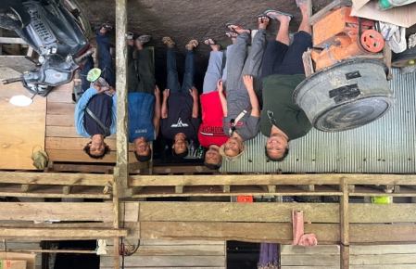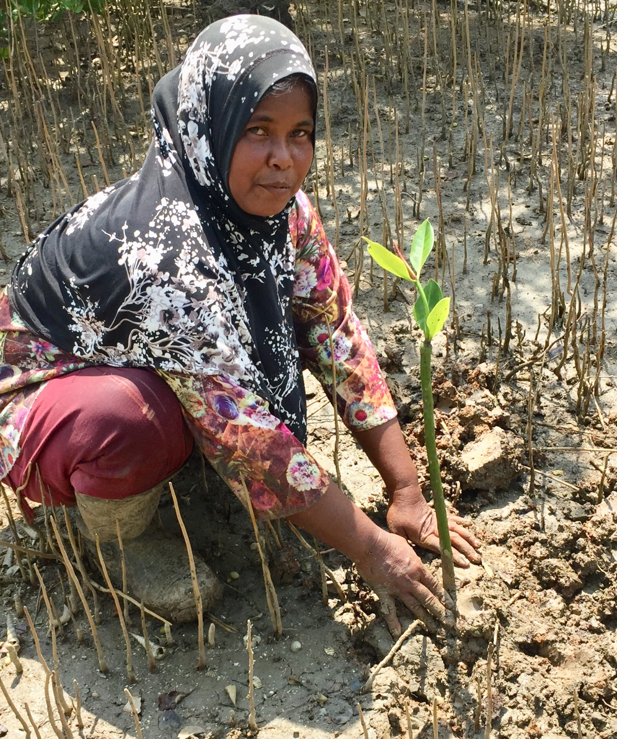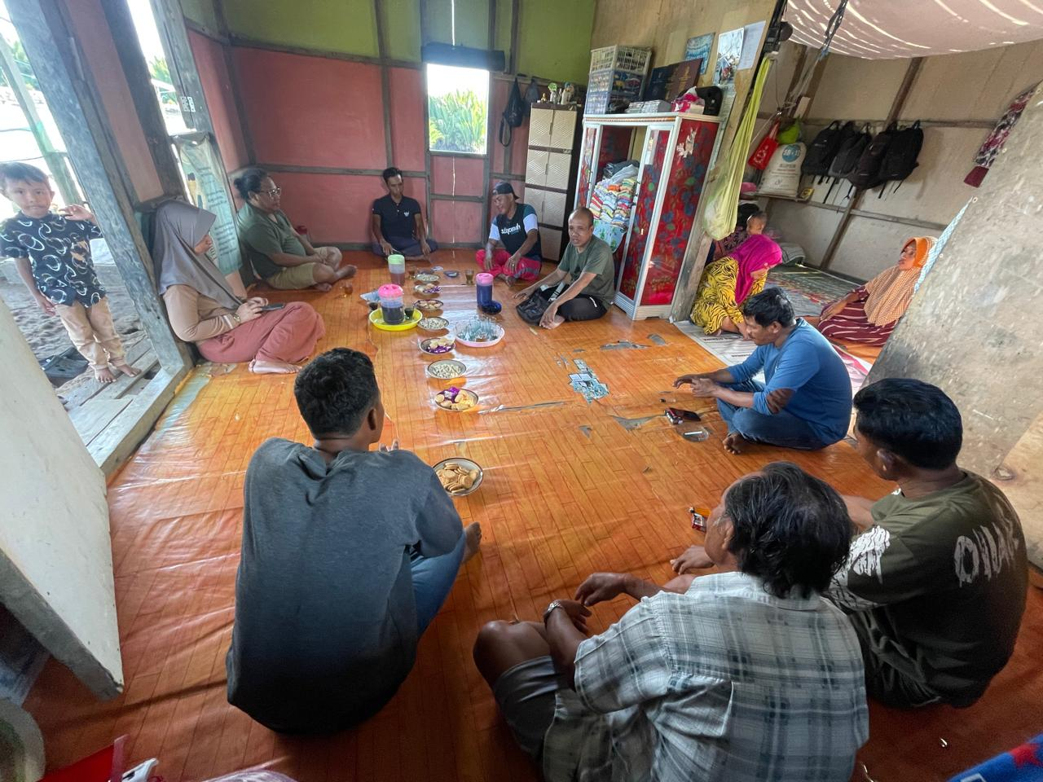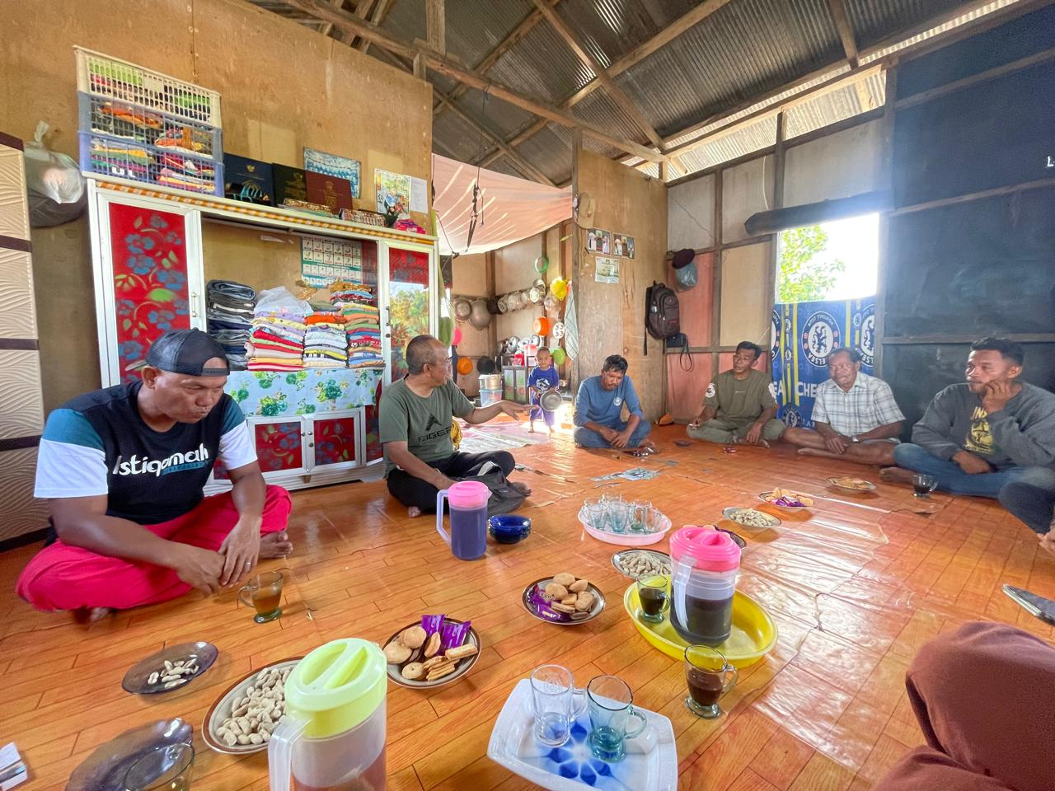
Figure 3. Interaction with the Community
The strengthening of group governance can be considered successful, as reflected in the increased level of community participation. In the first year of the program, the initiative involved only 18 participants from two villages. By the end of the third year, however, the IMPACT Program had successfully collaborated with village groups, comprising a total of 147 members. This governance strengthening is evidenced by the active involvement of group members across all stages of program planning, implementation, and decision-making related to mangrove rehabilitation management. In several villages, women’s groups were also involved in nursery-related activities. Even in Tajur Village, Seniung Jaya Village, Bai Jaya Village, and Suliliran Baru Village, women’s groups were also involved in nursery-related activities. It is recorded that more than 30 women had participated in this program up to 2025.

Beyond quantitative participation, improvements in community knowledge regarding the benefits of mangrove ecosystems and supportive attitudes toward rehabilitation represent important indicators of success. All group members developed a solid understanding of the ecological value and functional roles of mangroves. This outcome is reflected in the successful nursery practices that replicate the Kebun Bibit Rakyat (Community Nursery Garden) concept, in accordance with Ministry of Environment and Forestry Regulation No. 10 of 2021. Under this system, groups independently supported land rehabilitation programs by collecting propagules, cultivating them in nurseries, and conducting planting once the seedlings were ready. Such activities require substantial technical knowledge and skills.

One important intervention introduced by the IMPACT Program was an enhanced focus on strengthening field officers’ understanding of local wisdom. A common practical weakness frequently encountered in the field is the insufficient integration of community local wisdom into program development processes. This gap often creates vulnerabilities on both sides: communities may be unfamiliar with new approaches, while program implementers may lack understanding of the traditional knowledge embedded within local contexts. Such conditions can constitute significant barriers to program effectiveness (Siddiq, 2018). Overly technocratic approaches often devalue community knowledge. However, with the implementation of progressive community engagement, this issue was no longer observed.

As an illustrative example, there exists locally grounded knowledge rooted in community wisdom that has not been widely explored, namely knowledge related to calculating tidal cycles, specifically high tide periods (masa konda) and ebb–flow periods (masa sorong). The IMPACT Program examined and subsequently replicated this method, incorporating it into the formulation of group governance practices. The outcome was the determination of planting schedules and the delineation of planting boundary zones.

In practice, the outermost planting boundary is determined by the highest tidal level. Planting beyond this high-tide boundary would result in seedlings being submerged continuously for more than seven days during high tides, leading to seedling mortality. Conversely, when planting is conducted within this boundary, seedlings are able to grow and develop effectively. The implementation of this locally informed method has proven to assist groups efficiently in terms of planting timing and effectively in identifying suitable planting locations to ensure optimal seedling growth. This practice supports the social participation approach (Khan & Eversole, 2024).

4. Conclusion

The IMPACT Program, initiated by PT Indika Energy Tbk, successfully demonstrates that a progressive community engagement approach can serve as an effective strategy for mangrove rehabilitation. By engaging communities through the establishment of mangrove stewardship groups in nine villages in Paser Regency, East Kalimantan, the program achieved significant outcomes, with a survival is 86% by the end of 2025. The progressive approach—comprising social investigation, social mapping, and the development of a common dream—not only enhanced the technical success of mangrove rehabilitation but also fostered a sense of pride and ownership among community members. These findings indicate that structured community engagement grounded in local wisdom constitutes a critical element for the sustainability of coastal ecosystem rehabilitation programs.

From a theoretical perspective, this study contributes to the literature on social participation approaches in natural resource management, particularly in the context of mangrove rehabilitation. Progressive engagement that emphasizes inclusivity, social collaboration, and community empowerment enriches existing concepts of community participation within coastal rehabilitation frameworks. This study also reinforces the relevance of social investigation, social mapping, and the development of a common dream as instrumental methods for understanding social structures and ensuring alignment between program implementation and local needs. From a managerial standpoint, the findings offer practical guidance for rehabilitation program implementers to adopt more personal and non-formal community-based approaches. Strategies such as “follow the name” in data triangulation and informal trust-building approaches can be adapted by other organizations to enhance the effectiveness of community engagement in similar projects. Furthermore, the importance of collaboration with village governments and local champions emerges as a key lesson for fostering stakeholder synergy in support of long-term program sustainability.

DISCLAIMER
The authors hereby declare that no generative artificial intelligence technologies, including but not limited to large language models (such as Chatgpt, CoPilot, or similar tools) or text-to-image generation systems, were used at any stage of the writing, editing, or preparation of this manuscript.

COMPETING INTERESTS DISCLAIMER:
Authors have declared that they have no known competing financial interests OR non-financial interests OR personal relationships that could have appeared to influence the work reported in this paper.

References
Begum, F., Lobry de Bruyn, L., Kristiansen, P., & Islam, M. A. (2021). Institutionalising co-management activities for conservation of forest resources: Evidence from the Sundarban mangrove forest management of Bangladesh. Journal of Environmental Management, 298, 113504. https://doi.org/10.1016/J.JENVMAN.2021.113504
Cameron, C., Kennedy, B., Tuiwawa, S., Goldwater, N., Soapi, K., & Lovelock, C. E. (2021). High variance in community structure and ecosystem carbon stocks of Fijian mangroves driven by differences in geomorphology and climate. Environmental Research, 192, 110213. https://doi.org/10.1016/j.envres.2020.110213
Chen, Y. S., & Wu, S. T. (2021). An exploration of actor-network theory and social affordance for the development of a tourist attraction: A case study of a Jimmy-related theme park, Taiwan. Tourism Management, 82, 104206. https://doi.org/10.1016/J.TOURMAN.2020.104206
Cohen, L., Manion, L., & Morrison, K. (2002). Research Methods in Education. Routledge. https://doi.org/10.4324/9780203224342
Damastuti, E., & de Groot, R. (2019). Participatory ecosystem service mapping to enhance community-based mangrove rehabilitation and management in Demak, Indonesia. Regional Environmental Change, 19(1), 65–78. https://doi.org/10.1007/s10113-018-1378-7
Ellison, A. M., Felson, A. J., & Friess, D. A. (2020). Mangrove Rehabilitation and Restoration as Experimental Adaptive Management. Frontiers in Marine Science, 7. https://doi.org/10.3389/fmars.2020.00327
Feng, S., Hossain, L., & Paton, D. (2018). Harnessing informal education for community resilience. Disaster Prevention and Management, 27(1), 43–59. https://doi.org/10.1108/DPM-07-2017-0157
Flick, U. (2004). Triangulation in qualitative research. . In A companion to Qualitative Research (pp. 178–183).
Gatt, Y. M., Andradi-Brown, D. A., Ahmadia, G. N., Martin, P. A., Sutherland, W. J., Spalding, M. D., Donnison, A., & Worthington, T. A. (2022). Quantifying the Reporting, Coverage and Consistency of Key Indicators in Mangrove Restoration Projects. Frontiers in Forests and Global Change, 5. https://doi.org/10.3389/ffgc.2022.720394
Gunawan, Himma, F., Sekarningrum, B., Ginanjar, M., Denara, R., Sa’adiah, B. A., Muhammad, T., Yunita, D., Sukarna, A., & Sutrisno, B. (2018). Tahapan Pembangunan Masyarakat (W. Gunawan, Ed.; 1st ed., Vol. 1). Unpad Press.
Huxham, C., & Vangen, S. (2013). Managing to Collaborate. Routledge. https://doi.org/10.4324/9780203010167
Kemp, D., & Owen, J. R. (2017). Corporate Readiness and the Human Rights Risks of Applying FPIC in the Global Mining Industry. Business and Human Rights Journal, 2(1), 163–169. https://doi.org/10.1017/bhj.2016.28
Khan, S., & Eversole, R. (2024). Reproducing poverty through participation: examining the constraints of community development strategies in fostering empowerment and social change. Community Development Journal. https://doi.org/10.1093/cdj/bsae045
Lasso, A., & Dahles, H. (2018). Are tourism livelihoods sustainable ? Tourism development and economic transformation on Komodo Island , Indonesia transformation on Komodo Island , Indonesia. 23(5), 473–485. https://doi.org/10.1080/10941665.2018.1467939
Lhosupasirirat, P., Dahdouh‐Guebas, F., Hugé, J., Wodehouse, D., & Enright, J. (2023). Stakeholder perceptions on Community‐Based Ecological Mangrove Restoration (CBEMR): a case study in Thailand. Restoration Ecology, 31(5). https://doi.org/10.1111/rec.13894
Listiana, I., & Ariyanto, D. (2024). Enhancing coastal community participation in mangrove rehabilitation through structural equation modeling. Global Journal of Environmental Science and Management, 10(2), 873–890. https://doi.org/10.22035/gjesm.2024.02.28
Mandrysz, W. (2020). Community-Based Social Economy – Social Capital and Civic Participation in Social Entrepreneurship and Community Development. Management Dynamics in the Knowledge Economy, 8(1), 81–93. https://doi.org/10.2478/mdke-2020-0006
Moussa, L. G., Mohan, M., Burmeister, N., King, S. A. L., Burt, J. A., Rog, S. M., Watt, M. S., Udagedara, S., Sujud, L., Montenegro, J. F., Heng, J. E., Carvalho, S. A., Ali, T., Veettil, B. K., Arachchige, P. S. P., Albanai, J. A., Sidik, F., Shaban, A., Peñaranda, M. L. P., … Ewane, E. B. (2024). Mangrove Ecotourism along the Coasts of the Gulf Cooperation Council Countries: A Systematic Review. Land, 13(9), 1351. https://doi.org/10.3390/land13091351
Nie, X. (2021). Empowering informal settlements in Jakarta with urban agriculture: exploring a community-based approach. Urban Research & Practice, 14(3), 325–339. https://doi.org/10.1080/17535069.2021.1940029
Noble, H., & Heale, R. (2019). Triangulation in Research, with Examples. Evidence Based Nursing, 22(3), 67–68. https://doi.org/10.1136/ebnurs-2019-103145
Ounvichit, T., & Yoddumnern-Attig, B. (2018). Community dialogs on the probabilities of community-based mangrove institution. Kasetsart Journal of Social Sciences, 39(3), 365–373. https://doi.org/10.1016/j.kjss.2018.07.001
Oxford University Press. (2024). Oxford English Dictionary. https://www.oed.com
Phadsri, S., Shioji, R., Tanimura, A., Apichai, S., & Jaknissai, J. (2021). Proactive Community Occupational Therapy Service for Social Participation Development of Thai Adults with Depression: A Grounded Theory Study from Occupational Therapists’ Perspective. Occupational Therapy International, 2021, 1–11. https://doi.org/10.1155/2021/6695052
Pirozzi, M. (2023). Effectively managing negative and neutral stakeholders: a critical challenge. PM World Journal, XII(II), 1–15.
Richards, D. R., Thompson, B. S., & Wijedasa, L. (2020). Quantifying net loss of global mangrove carbon stocks from 20 years of land cover change. Nature Communications, 11(1). https://doi.org/10.1038/s41467-020-18118-z
Sarker, S. K., Matthiopoulos, J., Mitchell, S. N., Ahmed, Z. U., Mamun, Md. B. Al, & Reeve, R. (2019). 1980s–2010s: The world’s largest mangrove ecosystem is becoming homogeneous. Biological Conservation, 236, 79–91. https://doi.org/10.1016/j.biocon.2019.05.011
Siddiq, M. A. (2018). Dilema Komersialisasi Pengetahuan Tradisional Dalam Sistem Hukum Indonesia: Antara Perlindungan Dan Pembagian Manfaat. Jurnal Hukum & Pembangunan, 48(1), 164–180. https://doi.org/10.21143/jhp.vol.48.no.1.1600
Utami, W., Sugiyanto, C., & Rahardjo, N. (2024). Mangrove area degradation and management strategies in Indonesia: A review. In Journal of Degraded and Mining Lands Management (Vol. 11, Issue 3, pp. 6037–6047). Brawijaya University. https://doi.org/10.15243/jdmlm.2024.113.6037
Wang, T., & Chen, H.-M. (2023). Integration of building information modeling and project management in construction project life cycle. Automation in Construction, 150, 104832. https://doi.org/10.1016/j.autcon.2023.104832
Wolff, E., French, M., Ilhamsyah, N., Sawailau, M. J., & Ramírez-Lovering, D. (2021). Collaborating With Communities: Citizen Science Flood Monitoring in Urban Informal Settlements. Urban Planning, 6(4), 351–364. https://doi.org/10.17645/up.v6i4.4648
Yunindyawati, Agus Susanto, T., Lidya, E., Erlina, L., & Maulana. (2022). Pemetaan Aktor dan Jaringan Hubungan Antar Aktor dalam Pembangunan Pedesaan. Jurnal Penyuluhan, 18(02), 307–322. https://doi.org/10.25015/18202238766

