Comparative Study of Antibacterial Activity of Selected Plant Extracts and Their Combinations with Antibiotics Against Serratia marcescens and Pseudomonas aeruginosa

Abstract- The increasing prevalence of antimicrobial resistance among Gram-negative pathogens has driven the search for alternative strategies to improve the efficacy of existing antibiotics, with medicinal plant extracts gaining attention for their potential antibacterial properties and ability to modulate antibiotic activity. This study aimed to evaluate the antibacterial activity of selected plant extracts both alone and in combination with conventional antibiotics against Serratia marcescens and Pseudomonas aeruginosa. Crude extracts of Randia aculeata, Capsella bursa-pastoris, Ixora coccinea, and Portulaca oleracea were tested individually and in 1:1 combinations with ampicillin, ciprofloxacin, erythromycin, and amoxicillin. Antibacterial activity was assessed using the agar well diffusion method, and zones of inhibition were measured to determine interaction patterns. Against Serratia marcescens, Randia aculeata, Ixora coccinea, and Portulaca oleracea exhibited moderate antibacterial activity when tested alone, whereas Capsella bursa-pastoris showed no inhibitory effect. Ciprofloxacin demonstrated the highest antibacterial activity, while ampicillin, erythromycin, and amoxicillin showed resistance. Combination treatments did not enhance antibacterial activity; instead, reduced zones of inhibition were observed in several combinations, indicating antagonistic interactions. For Pseudomonas aeruginosa, all plant extracts and most antibiotics were ineffective, with ciprofloxacin being the only active agent, and its combination with plant extracts resulted in reduced antibacterial activity. These findings indicate that the tested plant extracts do not enhance the antibacterial efficacy of conventional antibiotics against Serratia marcescens and Pseudomonas aeruginosa, emphasizing the need for systematic evaluation of plant–antibiotic combinations before their consideration for therapeutic applications.

Keywords - Antimicrobial resistance, Medicinal plant extracts, Antibiotic interaction, Serratia marcescens, Pseudomonas aeruginosa.

Introduction- Antimicrobial resistance (AMR) has emerged as one of the most pressing global health concerns of the twenty-first century, threatening the effective prevention and treatment of a wide range of infectious diseases. The World Health Organization has identified AMR as a major risk to public health systems worldwide, with increasing reports of treatment failures, prolonged hospital stays, and elevated mortality rates [1]. The continuous and often indiscriminate use of antibiotics in clinical, agricultural, and veterinary settings has accelerated the selection and spread of resistant bacterial strains, thereby diminishing the efficacy of conventional antimicrobial therapies [2]. Gram-negative bacteria are particularly challenging to control due to their complex cell envelope structure, which includes an outer membrane that restricts antibiotic penetration, as well as intrinsic and acquired resistance mechanisms such as efflux pumps, enzymatic drug degradation, and target site modifications [3]. Among these organisms, Serratia marcescens and Pseudomonas aeruginosa are of significant clinical importance. Both species are opportunistic pathogens commonly associated with nosocomial infections, including bloodstream infections, ventilator-associated pneumonia, urinary tract infections, and wound infections. Serratia marcescens has gained attention due to its increasing resistance to multiple antibiotic classes, particularly β-lactams and macrolides [4]. It is frequently implicated in hospital outbreaks and is known for its ability to survive in disinfectants and moist environments, making infection control difficult. Similarly, Pseudomonas aeruginosa is recognized for its remarkable adaptability and resistance, often displaying intrinsic resistance to many antibiotics and rapidly acquiring additional resistance determinants. Its ability to form biofilms further complicates treatment, as biofilm-associated cells exhibit reduced susceptibility to antimicrobial agents. The escalating resistance observed in these pathogens has stimulated intense research into alternative antimicrobial strategies [5]. Medicinal plants have been used for centuries in traditional medicine systems and represent a rich reservoir of structurally diverse bioactive compounds. Numerous studies have demonstrated that plant-derived phytochemicals including flavonoids, phenolic acids, alkaloids, saponins, tannins, and terpenoids possess antibacterial properties. These compounds may exert their effects through various mechanisms, such as disruption of bacterial cell membranes, inhibition of enzyme activity, interference with nucleic acid synthesis, and modulation of quorum sensing pathways [6].
In addition to their intrinsic antibacterial activity, plant extracts have attracted interest as potential modulators of antibiotic efficacy. The combination of plant-derived compounds with antibiotics has been proposed as a promising approach to enhance antibacterial activity, overcome resistance, and reduce the effective dosage of antibiotics. Such combinations can result in different interaction patterns, including synergistic, additive, indifferent, or antagonistic effects [7]. Synergistic interactions, where the combined effect exceeds the sum of individual effects, are particularly desirable in the context of resistant infections. However, accumulating evidence suggests that not all combinations are beneficial and that certain plant extracts may interfere with antibiotic action, leading to reduced efficacy. Despite growing interest in plant–antibiotic combinations, most available studies focus on Gram-positive bacteria, while comparatively fewer investigations address highly resistant Gram-negative pathogens [8]. Furthermore, the majority of studies report synergy without adequately exploring antagonistic or indifferent interactions, which are equally important for guiding safe and effective therapeutic applications. The use of crude plant extracts adds another layer of complexity, as they contain multiple bioactive constituents that may interact with antibiotics in unpredictable ways [9]. The medicinal plants selected for the present study Randia aculeata, Capsella bursa-pastoris, Ixora coccinea, and Portulaca oleracea have been traditionally used for various therapeutic purposes and have been reported to possess antimicrobial, anti-inflammatory, or antioxidant properties [10]. However, systematic evaluation of their antibacterial activity, particularly in combination with commonly used antibiotics, remains limited. Moreover, their effects against clinically relevant Gram-negative pathogens such as S. marcescens and P. aeruginosa have not been extensively documented.
In this study, conventional antibiotics representing different classes ampicillin, ciprofloxacin, erythromycin, and amoxicillin were selected to evaluate potential interaction patterns with the chosen plant extracts. The agar well diffusion method was employed as a preliminary screening tool to assess antibacterial activity and to compare zones of inhibition produced by individual and combined treatments [11]. This approach enabled the classification of interactions as synergistic, additive, indifferent, or antagonistic based on comparative inhibition profiles. The primary objective of this research was to investigate the antibacterial efficacy of selected plant extracts alone and in combination with antibiotics against Serratia marcescens and Pseudomonas aeruginosa. By systematically analyzing both individual and combined effects, the study aims to provide insight into the potential benefits and limitations of plant–antibiotic combinations. The findings are expected to contribute to a more rational and evidence-based approach toward the development of alternative or adjunct antimicrobial strategies, while also highlighting the importance of cautious evaluation to avoid antagonistic interactions that may compromise antibiotic therapy.

Material and Methodology
Plant Material Collection and Extract Preparation- Four medicinal plants Randia aculeata, Ixora coccinea, Capsella bursa-pastoris, and Portulaca oleracea were collected, thoroughly washed with distilled water, and air-dried. The plant materials were cut into small pieces for aqueous extract preparation. Ten grams of each plant sample were boiled in 100 mL of sterile distilled water for 20 minutes. After cooling to room temperature, the extracts were clarified by centrifugation at 10,000 rpm for 10 minutes at 4 °C to remove debris and particulate matter. The clear supernatants were collected in sterile tubes and stored at 4 °C for use within 48 hours. No microfiltration was performed, but sterility was confirmed by plating aliquots of the extracts on nutrient agar prior to testing.
Antibiotic Selection and Preparation- Four commonly used antibiotics ampicillin, amoxicillin, erythromycin, and ciprofloxacin were utilized in this study. Stock solutions were prepared to achieve a final working concentration of 30 µg/mL for each antibiotic. These antibiotics were used as positive controls and in combination with plant extracts to evaluate potential interaction effects.
Bacterial Cultures and Inoculum Preparation- Representative Gram-negative bacteria were selected for antibacterial testing, including Serratia marcescens, Pseudomonas aeruginosa . Each bacterial strain was cultured overnight in nutrient broth, and turbidity was adjusted to match the 0.5 McFarland standard to ensure uniform inoculum density.
Agar Well Diffusion Assay and Combination Testing- The antibacterial activity of the plant extracts, antibiotics, and their combinations was evaluated using the agar well diffusion method. Mueller-Hinton agar plates were swabbed uniformly with each bacterial culture. For each organism, three treatments were applied per plate: (1) a well containing plant extract alone (control), (2) a well containing antibiotic alone at 30 µg/mL (control), and (3) a well containing a 1:1 mixture of plant extract and antibiotic (test sample). A total of 8 plates were prepared to cover all combinations of the four plant extracts with four antibiotics across the selected bacterial strains. The plates were incubated at 37 °C for 24 hours, after which zones of inhibition were measured in millimeters.
Data Recording and Interpretation- Zones of inhibition from individual and combined treatments were recorded and compared to determine interaction patterns synergistic, additive, indifferent, or antagonistic. All experiments were conducted under aseptic conditions, following standard laboratory safety protocols. The results provided insights into the potential of plant extracts to enhance or modulate the antibacterial activity of conventional antibiotics, highlighting combinations with promising therapeutic potential.

Observation
Treatment | Organism - S. marcescns (Zone of Inhibition) mm
Randia aculeata – Extract Alone | 12
Ampicillin (AMP) (30 µg/mL) Alone | 0
Randia aculeata + Ampicillin (1:1) | 0
Capsella bursa-pastoris – Extract Alone | 0
Ciprofloxacin (CIP) (30 µg/mL) | 28
Capsella bursa-pastoris + Ciprofloxacin (1:1) | 24
Ixora coccinea – Extract Alone | 18
Erythromycin (ERY) (30 µg/mL) | 0
Ixora coccinea + Erythromycin (1:1) | 14
Portulaca oleracea – Extract Alone | 12
Amoxicillin (AMOX) (30 µg/mL) | 0
Portulaca oleracea + Amoxicillin (1:1) | 0

Table 1: Antibacterial activity of selected plant extracts and their combinations with antibiotics against Serratia marcescens, expressed as zones of inhibition (mm).
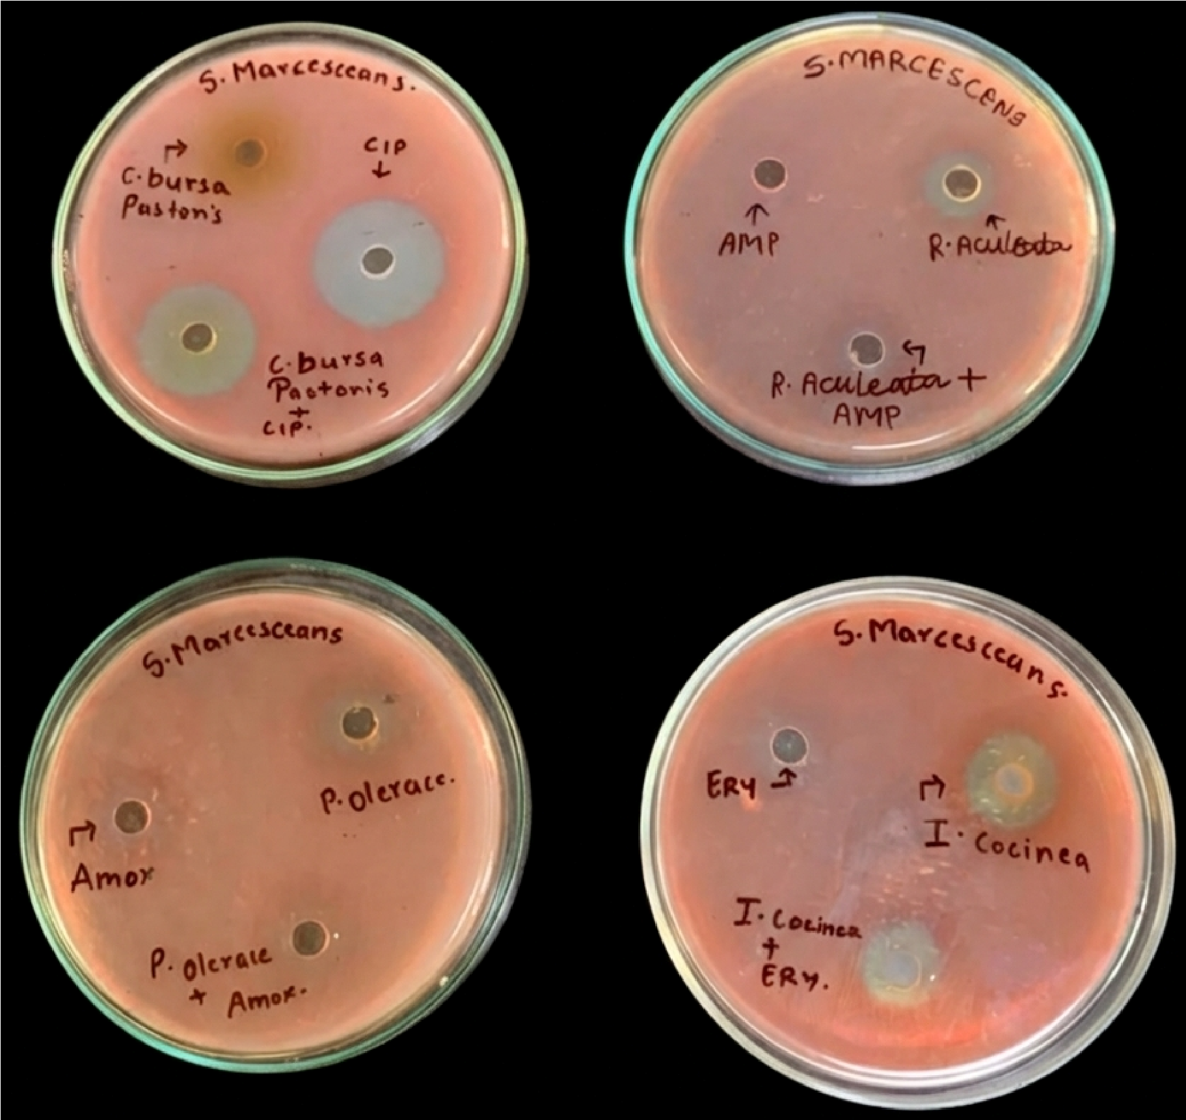

Figure 1: Antibacterial activity of plant extract and antibiotic against S. marcescens

Treatment | Organism - Pseudomonas aeruginosa (Zone of Inhibition) mm
Randia aculeata – Extract Alone | 0
Ampicillin (AMP) (30 µg/mL) Alone | 0
Randia aculeata + Ampicillin (1:1) | 0
Capsella bursa-pastoris – Extract Alone | 0
Ciprofloxacin (CIP) (30 µg/mL) | 24
Capsella bursa-pastoris + Ciprofloxacin (1:1) | 16
Ixora coccinea – Extract Alone | 0
Erythromycin (ERY) (30 µg/mL) | 0
Ixora coccinea + Erythromycin (1:1) | 0
Portulaca oleracea – Extract Alone | 0
Amoxicillin (AMOX) (30 µg/mL) | 0
Portulaca oleracea + Amoxicillin (1:1) | 0

Table 2: Antibacterial activity of selected plant extracts and their combinations with antibiotics against Pseudomonas aeruginosa, expressed as zones of inhibition (mm).

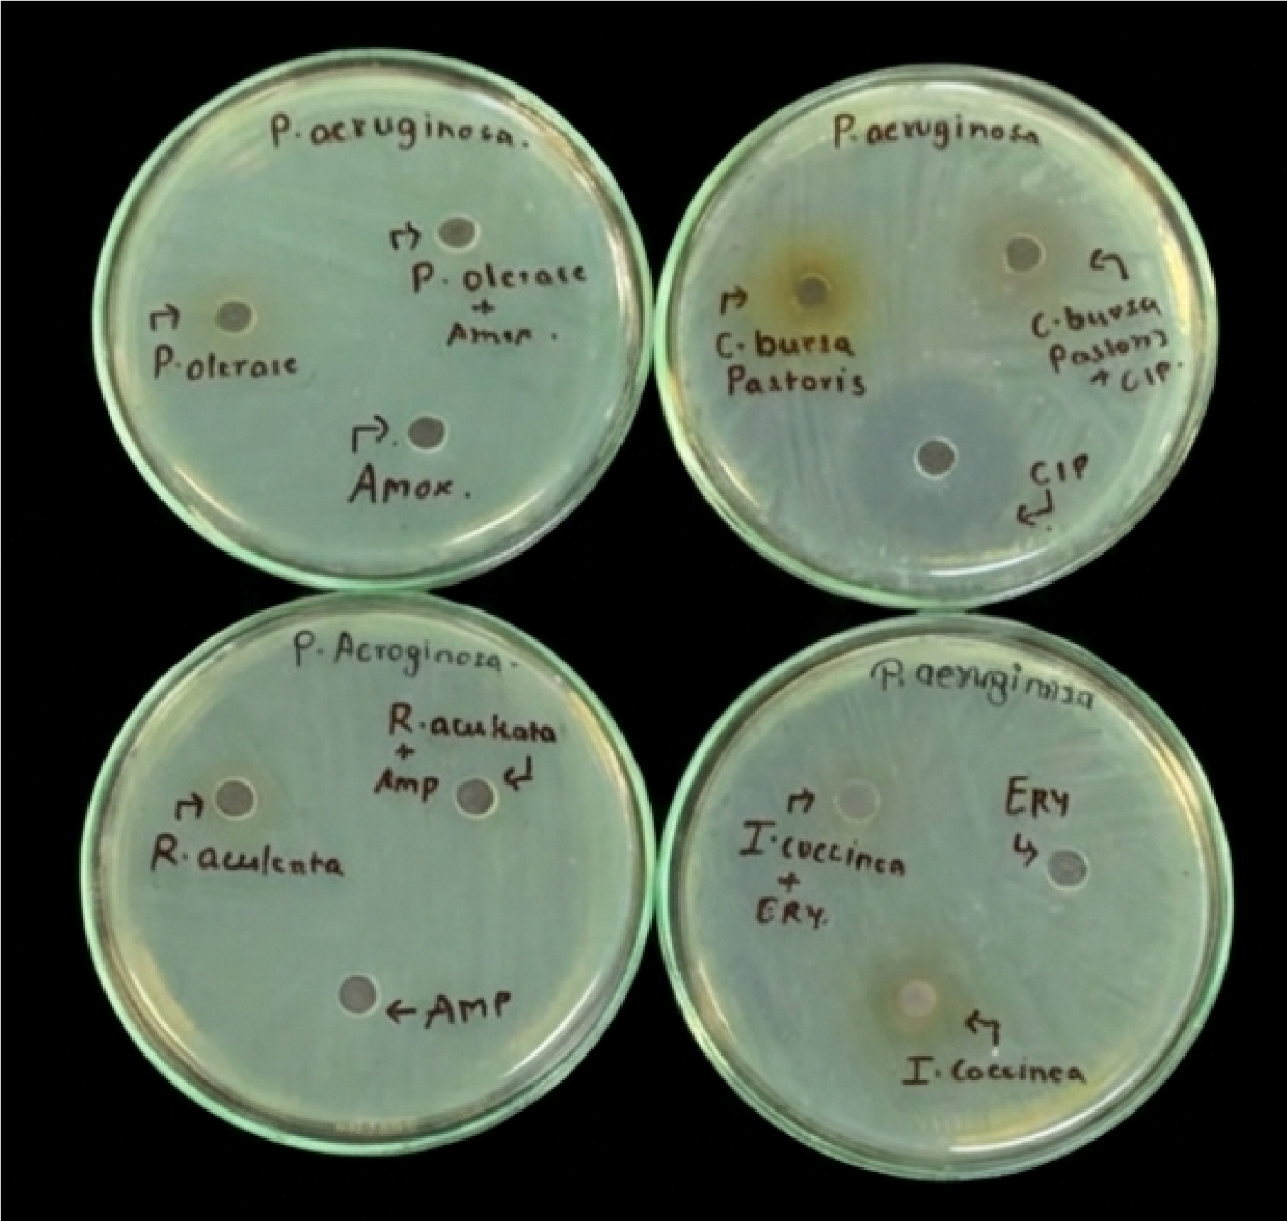

Figure 2: Antibacterial activity of plant extract and antibiotic against P. aeruginosa
Results And Discussion- The antibacterial activity of four selected plant extracts (Randia aculeata, Capsella bursa-pastoris, Ixora coccinea, and Portulaca oleracea) was evaluated individually and in combination with standard antibiotics against Serratia marcescens and Pseudomonas aeruginosa using the agar well diffusion method. Zones of inhibition were measured to assess antibacterial efficacy and to interpret interaction patterns between plant extracts and antibiotics. Among the tested plant extracts, Randia aculeata, Ixora coccinea, and Portulaca oleracea exhibited measurable antibacterial activity when tested alone, producing zones of inhibition of 12 mm, 18 mm, and 12 mm respectively. Capsella bursa-pastoris showed no inhibitory effect against S. marcescens. The antibiotics ampicillin, erythromycin, and amoxicillin demonstrated complete resistance (0 mm zone), whereas ciprofloxacin showed strong antibacterial activity with a zone of inhibition of 28 mm. Combination treatments did not result in synergistic enhancement. The combination of Capsella bursa-pastoris with ciprofloxacin resulted in a reduced zone of inhibition (24 mm) compared to ciprofloxacin alone, indicating an antagonistic interaction. Similarly, the combination of Ixora coccinea with erythromycin produced a reduced inhibitory zone (14 mm) compared to the extract alone (18 mm), suggesting interference rather than enhancement. No antibacterial activity was observed for the combinations involving ampicillin or amoxicillin.
All plant extracts failed to exhibit antibacterial activity against P. aeruginosa when tested individually, indicating a high level of intrinsic resistance. Among the antibiotics tested, only ciprofloxacin was effective, producing a zone of inhibition of 24 mm. When ciprofloxacin was combined with Capsella bursa-pastoris, a reduced zone of inhibition (16 mm) was observed, indicating an antagonistic interaction. All other antibiotics and extract–antibiotic combinations showed no inhibitory activity against P. aeruginosa. These interaction analysis revealed no synergistic or additive effects between the tested plant extracts and antibiotics. Most combinations were either indifferent or antagonistic, particularly against P. aeruginosa, highlighting the strong resistance profile of this organism.
Conclusion - The present study evaluated the antibacterial potential of selected medicinal plant extracts alone and in combination with conventional antibiotics against Serratia marcescens and Pseudomonas aeruginosa. The findings demonstrate that while certain plant extracts exhibited moderate antibacterial activity against S. marcescens, none were effective against P. aeruginosa. Ciprofloxacin remained the most effective antibiotic against both organisms. Importantly, the combination of plant extracts with antibiotics did not enhance antibacterial efficacy. In several cases, reduced zones of inhibition were observed, indicating antagonistic interactions. These results suggest that the indiscriminate combination of plant extracts with antibiotics may compromise antibacterial activity rather than improve it. The study highlights the necessity of systematic interaction studies before proposing plant–antibiotic combinations for therapeutic use. While medicinal plants continue to represent valuable sources of bioactive compounds, their combinational use with antibiotics requires careful evaluation to avoid adverse interactions. Further studies involving purified phytochemicals, minimum inhibitory concentration (MIC) assays, and mechanistic investigations are recommended to better understand the observed antagonistic effects.
Future Scope- The findings of the present study indicate limited antibacterial enhancement when selected plant extracts are combined with conventional antibiotics, particularly against Pseudomonas aeruginosa. Future research should therefore focus on isolating and characterizing the specific bioactive compounds within the plant extracts to determine whether purified constituents exhibit improved antibacterial efficacy compared to crude extracts. Further studies employing quantitative methods such as minimum inhibitory concentration (MIC), minimum bactericidal concentration (MBC), and time–kill assays are recommended to validate and expand upon the diffusion-based results. These approaches would provide more precise insights into the nature of extract–antibiotic interactions and help distinguish between true antagonism and concentration-dependent effects.
Mechanistic investigations are warranted to elucidate the molecular basis of the observed antagonistic interactions, including potential interference with antibiotic uptake, efflux pump modulation, or chemical incompatibility between phytochemicals and antibiotics. Additionally, evaluating different extract-to-antibiotic ratios may reveal interaction patterns not evident at a fixed 1:1 combination. Given the high resistance observed in P. aeruginosa, future work should include testing against a broader panel of clinically relevant multidrug-resistant Gram-negative pathogens and exploring synergistic screening using checkerboard or fractional inhibitory concentration (FIC) index methods. Finally, in vivo studies and cytotoxicity assessments are essential to establish the safety and therapeutic relevance of promising plant-derived compounds. Integrating phytochemical profiling with advanced antimicrobial screening may contribute to the rational development of plant-based adjuncts or alternatives to existing antibacterial therapies.

References
- Salam, M. A., Al-Amin, M. Y., Salam, M. T., Pawar, J. S., Akhter, N., Rabaan, A. A., & Alqumber, M. A. A.
(2023). Antimicrobial Resistance: A Growing Serious Threat for Global Public Health. Healthcare (Basel,
Switzerland), 11(13), 1946. https://doi.org/10.3390/healthcare11131946
- Caneschi, A., Bardhi, A., Barbarossa, A., & Zaghini, A. (2023). The Use of Antibiotics and Antimicrobial Resistance in Veterinary Medicine, a Complex Phenomenon: A Narrative Review. Antibiotics (Basel, Switzerland), 12(3), 487. https://doi.org/10.3390/antibiotics12030487
- Impey, R. E., Hawkins, D. A., Sutton, J. M., & Soares da Costa, T. P. (2020). Overcoming Intrinsic and Acquired Resistance Mechanisms Associated with the Cell Wall of Gram-Negative Bacteria. Antibiotics (Basel, Switzerland), 9(9), 623. https://doi.org/10.3390/antibiotics9090623
- Khanna, A., Khanna, M., & Aggarwal, A. (2013). Serratia marcescens- a rare opportunistic nosocomial pathogen and measures to limit its spread in hospitalized patients. Journal of clinical and diagnostic research : JCDR, 7(2), 243–246. https://doi.org/10.7860/JCDR/2013/5010.2737
5]Glen, K. A., & Lamont, I. L. (2021). β-lactam Resistance in Pseudomonas aeruginosa: Current Status, Future Prospects. Pathogens (Basel, Switzerland), 10(12), 1638. https://doi.org/10.3390/pathogens10121638
6]El-Saadony, M. T., Saad, A. M., Mohammed, D. M., Korma, S. A., Alshahrani, M. Y., Ahmed, A. E., Ibrahim, E. H., Salem, H. M., Alkafaas, S. S., Saif, A. M., Elkafas, S. S., Fahmy, M. A., Abd El-Mageed, T. A., Abady, M. M., Assal, H. Y., El-Tarabily, M. K., Mathew, B. T., AbuQamar, S. F., El-Tarabily, K. A., & Ibrahim, S. A. (2025). Medicinal plants: bioactive compounds, biological activities, combating multidrug-resistant microorganisms, and human health benefits - a comprehensive review. Frontiers in immunology, 16, 1491777.
https://doi.org/10.3389/fimmu.2025.1491777
7]Matei, A. T., & Visan, A. I. (2025). Mechanism, Efficacy, and Safety of Natural Antibiotics. Antibiotics (Basel,
Switzerland), 14(10), 981. https://doi.org/10.3390/antibiotics14100981
8]Cheesman, M. J., Ilanko, A., Blonk, B., & Cock, I. E. (2017). Developing New Antimicrobial Therapies: Are Synergistic Combinations of Plant Extracts/Compounds with Conventional Antibiotics the Solution?. Pharmacognosy reviews, 11(22), 57–72. https://doi.org/10.4103/phrev.phrev_21_17
9]Angane, M., Swift, S., Huang, K., Perera, J., Chen, X., Butts, C. A., & Quek, S. Y. (2023). Synergistic antimicrobial interaction of plant essential oils and extracts against foodborne pathogens. Food science & nutrition, 12(2), 1189–1206. https://doi.org/10.1002/fsn3.3834
10]Udaybhan A. Yadav, Bhanupratap Vishwakarma, Ashana Singh, Nidhi Yadav, Antima Yadav, Tanvi Yadav, and
Gauri Bhusate (2025). Phytochemical-Rich Plant Extracts as Natural Antibacterial Agents: A Comparative Study of Randia aculeata, Ixora coccinea, Capsella bursa-pastoris, and Portulaca oleraceaAgainst Clinically Relevant Pathogens. Microbiology Archives, an International Journal. DOI:
https://doi.org/10.51470/MA.2025.7.2.95
11]Bubonja-Šonje, M., Knežević, S., & Abram, M. (2020). Challenges to antimicrobial susceptibility testing of plant-derived polyphenolic compounds. Arhiv za higijenu rada i toksikologiju, 71(4), 300–311. https://doi.org/10.2478/aiht-2020-71-3396

