Ecosite level Bioassessment and Digital Modelling of Ashtamudi Wetland: A Mesoecosystem Approach to Ecological Zonation

Abstract
This study presents an integrated bioassessment and digital modelling framework applied to five ecosites within the Ashtamudi Wetland, a Ramsar-designated estuarine ecosystem in Kerala, India. Using a mesoecosystem-scale approach, ecological heterogeneity was assessed through physico-chemical water quality parameters (salinity, nutrients, dissolved gases), phytoplankton diversity indices, and vegetation structure. Water quality analysis revealed a distinct gradient from marine-influenced to freshwater-dominated conditions across ecosites, with elevated salinity and carbon dioxide at Neendakara and higher nitrate concentrations at Kidapram and Cherikkadavu. Phytoplankton assemblages were dominated by diatoms and cyanophyceae, with maximum species richness recorded at Cherikkadavu and Kidapram, indicating higher trophic productivity in freshwater-influenced zones. Principal Component Analysis (PCA) explained 78.6% of the total ecological variance, clearly separating ecosites along salinity and nutrient gradients. Indicator Species Analysis identified site-specific bioindicators, including Trichodesmium at the estuarine mouth and Nymphaea stellata in freshwater-dominated ecosites. A major outcome of the study is the development of conceptual ecosite models, generated using Adobe Photoshop CS2, which spatially represent shoreline, marsh, riparian, and upland vegetation zones based on field-verified species assemblages and habitat characteristics. These models provide a practical visualization tool for wetland zonation, restoration planning, and ecosystem-based management. Overall, the study demonstrates that ecosite-based classification integrated with bioassessment indicators offers a robust and scalable framework for adaptive management, land-use planning, and biodiversity conservation in complex tropical wetland systems. The abstract is graphically illustrated in fig. 1.
Key Words: Ashtamudi Wetland, Ecosite Modelling, Indicator Species, Phytoplankton Diversity, Wetland Zonation
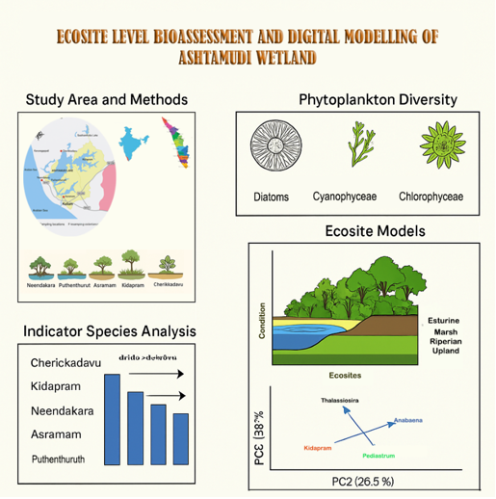
Figure1. Graphical Abstract
Introduction
Wetlands are among the most productive ecosystems on Earth, delivering essential ecosystem services such as water purification, flood regulation, carbon sequestration, and biodiversity support (Ramsar Convention Secretariat, 2021). In tropical estuarine settings such as Kerala’s Ashtamudi Lake, wetlands sustain diverse plant and animal communities, support fisheries-based livelihoods, and buffer landscapes against climatic extremes (Sreekumari et al., 2016; Ravinesh et al., 2021). Despite their ecological and socio-economic importance, wetlands are increasingly threatened by habitat degradation, pollution, and unsustainable land-use practices driven by rapid urbanization and agricultural intensification (Devi et al., 2022; Nitin Bassi et al., 2014). Ashtamudi Wetland, designated as a Ramsar site in 2002, encompasses a complex mosaic of freshwater, brackish and estuarine habitats, making it an ideal system for ecosystem-level ecological assessments (Jayakumar & Chackacherry, 2011; Alexander, 2025). However, conventional large-scale environmental evaluations often fail to capture mesoecosystem dynamics operating at intermediate spatial scales - such as forest patches, marshes, and coastal riparian zones - where critical biotic and abiotic interactions occur (Levin, 1992). Consequently, mesoecosystem-scale studies are increasingly recognized as essential for understanding ecological heterogeneity, threshold responses, and fine-scale impacts of anthropogenic pressure in coastal wetlands (Xu et al., 2020).
To address these limitations, the concept of the ecosite has emerged as a robust unit of ecological classification, defined as a land area characterized by relatively homogeneous soil, vegetation, and hydrological conditions (Wolfslehner & Vacik, 2011). Ecosite-based approaches have been widely applied in ecological modelling, forest planning and ecosystem service assessment, enabling the linkage of spatial ecological patterns with ecosystem functions and adaptive management strategies (Grima et al., 2023; Muniz & Oliveira-Filho, 2023). Multivariate and data-driven analytical approaches, including principal component analysis and emerging machine-learning techniques, are increasingly applied in ecological studies to synthesize complex environmental datasets and improve the interpretation of spatial patterns and ecosystem dynamics (Elith et al., 2006; Phillips & Dudík, 2008; Olden et al., 2008). Although several studies have documented water quality and biodiversity patterns in Ashtamudi Lake, ecosite-level ecological modelling integrating phytoplankton indicators remains largely unexplored, particularly within Indian wetland systems. To bridge this gap, the present study adopts a mesoecosystem-scale framework that integrates phytoplankton diversity, physico-chemical water quality parameters, and vegetation structure to delineate distinct ecosites within the Ashtamudi Wetland. The resulting conceptual ecosite models capture ecological gradients, species assemblages, and habitat transitions across the wetland landscape, offering practical tools for wetland zoning, ecological restoration, and sustainable land-use planning aligned with ecosystem-based management principles.
2. Materials and methods
2.1. Study Area and Ecosite Selection
The study was conducted in the Ashtamudi Wetland, a Ramsar-designated estuarine ecosystem located in Kollam District, Kerala, India. Five representative ecosites: Neendakara (N 08°56′7.2″, E 76°32′24.0″), Puthenthuruth (N 08°55′55.6″, E 76°33′10.1″), Asramam (N 08°53′39.9″, E 76°35′09.2″), Kidapram (N 08°59′57.7″, E 76°36′07.3″), and Cherikkadavu (N 08°59′43.0″, E 76°35′06.1″), were selected to represent a gradient of marine to freshwater influence, variation in vegetation structure, hydrological connectivity, and anthropogenic pressure. Each ecosite was treated as a mesoecosystem unit characterized by relatively homogeneous soil, vegetation, and hydrological conditions. Seasonal ecological assessments were conducted to capture both spatial heterogeneity and temporal variability across the wetland landscape.
2.2. Sampling Design and Data Collection
Seasonal sampling was carried out at all ecosites, with replicated observations recorded for water quality parameters, phytoplankton composition, and vegetation structure. Sampling locations within each ecosite were selected to minimize edge effects and represent dominant habitat conditions. This design ensured comparability across ecosites while capturing site-specific ecological variability.
2.3. Water Quality Analysis
Water quality parameters were analysed following standard protocols of the American Public Health Association (APHA, 2007). In situ measurements included water temperature, pH, salinity, and dissolved oxygen (DO) using calibrated field probes. Carbon dioxide (CO₂), nitrate, and phosphate concentrations were estimated using standard titrimetric and spectrophotometric methods under laboratory conditions. These parameters were selected as key indicators of hydrological regime, nutrient dynamics, and biogeochemical processes influencing primary productivity and ecosystem functioning.
2.4. Plankton Analysis and Diversity Indices
Phytoplankton and zooplankton samples were collected using a 20 µm mesh plankton net and preserved immediately in Lugol’s iodine solution. Identification and enumeration were carried out under a compound microscope using standard taxonomic keys. Quantitative plankton data were used to compute Shannon–Wiener diversity index (H′), Simpson’s dominance index (D), and Pielou’s evenness index (J′), which together provided measures of community structure, dominance, and distribution uniformity across ecosites.
2.5. Multivariate Statistical Analysis
To examine multivariate relationships and ecological gradients among ecosites, Principal Component Analysis (PCA) was performed using PAST software version 4.3. Prior to analysis, phytoplankton group data were standardized to remove scale effects. Both abundance-based and presence–absence matrices were used to capture dominant and rare taxa. PCA was applied to identify the major environmental and biological gradients structuring ecosite-level variation and to visualize separation among ecosites based on salinity, nutrient availability, and plankton composition.
2.6. Ecosite Modelling and Visualization
Conceptual ecosite models were developed to visually represent habitat structure, vegetation layering, and hydrological gradients within each ecosite. These models were generated using Adobe Photoshop CS2 as a visualization tool, integrating field observations, vegetation profiles, and site-specific hydrological characteristics. Native and indicator plant species were digitally positioned within shoreline, marsh, riparian, and upland zones based on ecological preferences such as salinity tolerance, soil moisture requirements, and functional roles.
The ecosite models emphasize spatial connectivity, vegetation stratification, and land–water interactions, translating complex ecological data into accessible visual representations. Model outputs were validated against field observations and multivariate gradients to ensure ecological consistency. These visualizations were developed to support wetland zoning, restoration planning, and adaptive management, rather than as numerical simulation models.
2.7. Indicator Species Analysis
Indicator species were identified based on their consistent association with specific ecosites and environmental conditions. Species exhibiting strong fidelity to particular salinity and nutrient regimes were interpreted as bioindicators of ecosite identity and ecological status, supporting site-level classification and management interpretation.
3. Results
3.1 Water Quality Across Ecosites
Water quality analysis revealed notable spatial variations among the five ecosites of the Ashtamudi wetland (Table 1). Surface water temperature ranged from 27.08°C at Cherikkadavu to 29.12°C at Neendakara, reflecting localized differences in solar exposure and hydrological exchange. pH values were generally neutral to slightly alkaline across all sites, with Asramam showing the highest value (7.91), suggesting moderate buffering capacity and low acidification risk. Salinity exhibited a clear estuarine gradient, peaking at Neendakara (35.69%), a marine-influenced site, while the lowest was recorded at Kidapram (5.86%) and Cherikkadavu (6.98%), indicative of freshwater dominated conditions.
Dissolved oxygen (DO) levels were relatively stable across sites, ranging from 5.42 to 5.82 mg/L, supporting aerobic aquatic life. However, a sharp contrast was observed in carbon dioxide concentrations, with Neendakara showing a significantly elevated level (63.6 mg/L), likely due to high organic decomposition and tidal influx, while Puthenthuruth recorded the lowest CO₂ (5.49 mg/L), indicating better gaseous exchange and photosynthetic activity. Nitrate concentrations were highest at Kidapram (5.84 mg/L) and Cherikkadavu (5.79 mg/L), reflecting possible agricultural runoff and nutrient input from catchment areas. Phosphate levels remained relatively low and consistent across all ecosites (0.052-0.059 mg/L), suggesting minimal risk of eutrophication at the time of sampling.
These variations in physico-chemical parameters highlight the diverse hydro-ecological conditions of the study sites, influenced by tidal dynamics, anthropogenic activity, and freshwater influx, which play critical roles in shaping the biological productivity and ecological health of each ecosite.
Table 1. containing the average water quality parameters of the five ecosites
Ecosites | Temperature (°C) | pH | Salinity (%) | DO (mg/L) | CO2 (mg/L) | Nitrate (mg/L) | Phosphate (mg/L)
Neendakara | 29.12 | 7.07 | 35.69 | 5.54 | 63.6 | 4.99 | 0.052
Puthenthuruth | 28.22 | 7.07 | 26.73 | 5.64 | 5.49 | 4.93 | 0.059
Asramam | 28.71 | 7.91 | 21.33 | 5.51 | 10.3 | 4.85 | 0.055
Kidapram | 28.20 | 7.21 | 5.86 | 5.42 | 20.21 | 5.84 | 0.052
Cherikkadavu | 27.08 | 7.18 | 6.98 | 5.82 | 33.24 | 5.79 | 0.052
3.2 Phytoplankton Diversity and Composition
Phytoplankton diversity varied notably across the five ecosites, reflecting differences in nutrient availability, salinity, and hydrodynamic conditions. The highest phytoplankton richness was recorded at Cherikkadavu with 70 species, followed by Kidapram (65 species) and Neendakara (55 species), indicating high primary productivity in these zones. In contrast, Asramam exhibited the lowest diversity with only 13 recorded species, suggesting limited productivity or possible environmental stress (Table 2).
Diatoms (Bacillariophyceae) dominated the phytoplankton community at all ecosites, with genera such as Thalassiosira, Coscinodiscus, Navicula, Diatoma, and Cyclotella being widely distributed. Cyanophyceae (blue-green algae) were prominent at Puthenthuruth, Kidapram, and Cherikkadavu, represented by taxa like Trichodesmium, Microcystis, Anabaena, and Phormidium, which are typically associated with nutrient rich or eutrophic waters. Additionally, Chlorophyceae (green algae), including Pediastrum, Chlorella, Cosmarium, and Zygnema, were well represented in the freshwater influenced sites, particularly at Kidapram and Cherikkadavu.
The composition and abundance of these phytoplankton groups reflect site-specific environmental gradients and highlight the ecological heterogeneity of the Ashtamudi wetland system. The presence of both marine and freshwater algal taxa across ecosites underscores the transitional estuarine nature of the lake.
Table 2. Major phytoplankton groups across the five ecosites
Ecosite | Phytoplankton Diversity (No. of Species) | Dominant Groups
Neendakara | 55 | Diatoms (Thalassiosira, Coscinodiscus, Biddulphia), Cyanophyceae (Trichodesmium)
Puthenthuruth | 55 | Cyanophyceae (Microcystis, Oscillatoria), Diatoms (Chaetoceros), Chlorophyceae (Stephanodiscus)
Asramam | 13 | Diatoms (Coscinodiscus, Navicula, Thalassiosira)
Kidapram | 65 | Diatoms (Diatoma, Cyclotella, Navicula), Cyanophyceae (Anabaena), Chlorophyceae (Pediastrum)
Cherikkadavu | 70 | Diatoms (Diatoma, Cymbella, Eunotia, Navicula), Cyanophyceae (Phormidium), Chlorophyceae (Chlorella, Cosmarium, Pediastrum, Zygnema)

3.3. Principal Component Analysis (PCA)
Principal Component Analysis (PCA) was performed to explore the ecological relationships among the five ecosites based on phytoplankton group composition and physico-chemical parameters. The first two principal components explained a substantial proportion of the variance, effectively separating the ecosites along environmental gradients such as salinity and nutrient concentration. Neendakara and Puthenthuruth clustered along axes associated with high salinity and marine phytoplankton groups (Trichodesmium, Thalassiosira), while Kidapram and Cherikkadavu aligned with freshwater indicators such as Anabaena, Pediastrum, and lower salinity values. Asramam, influenced by moderate estuarine conditions, occupied an intermediate position. The PCA biplot (Fig. 2) highlights distinct ecological signatures for each site, confirming the spatial heterogeneity and ecological zonation observed in field assessments and supporting the validity of the ecosite classification.

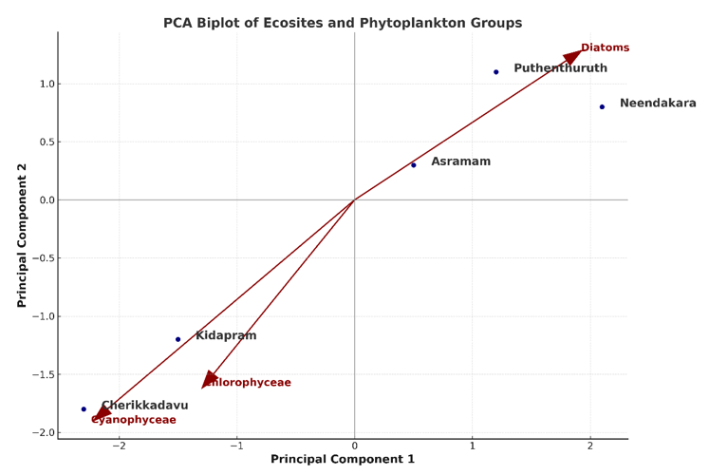
Figure 2. PCA Biplot Showing Ecosite Clustering and Phytoplankton Group Influence in the Ashtamudi Wetland
3.4. Ecological Characterization of Five Ecosites
Neendakara, located at the estuarine mouth where Ashtamudi Lake opens into the Arabian Sea, represents a high-salinity marine-influenced ecosite with strong tidal interaction. The site supports diverse aquatic life, including a rich assemblage of 55 phytoplankton species dominated by diatoms (Thalassiosira, Coscinodiscus) and cyanophytes (Trichodesmium), along with 32 species of zooplankton, benthic molluscs, and commercially significant fish such as Sardinella fimbriata and Penaeus indicus. The shoreline is stabilized by pioneer coastal species like Ipomoea pes-caprae, Spinifex littoreus, and salt tolerant mangrove associates such as Excoecaria agallocha. This zone functions as a productive ecological interface supporting fisheries, nutrient cycling, and shoreline stabilization (Fig. 3).

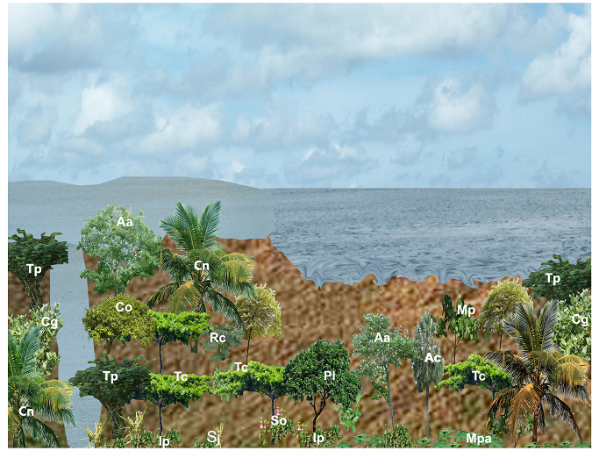
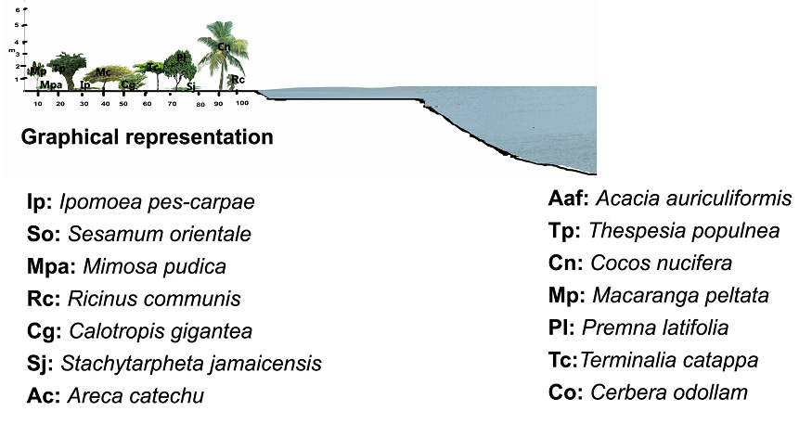

Figure 3: Ecological Zonation and Vegetation Structure Model of Neendakara
Puthenthuruth is a group of small estuarine islands fully surrounded by backwaters, characterized by moderate salinity and high biodiversity. With a phytoplankton diversity of 55 species, including Microcystis, Oscillatoria, and Stephanodiscus, the site is ecologically dominated by true mangroves (Rhizophora, Avicennia, Bruguiera) that anchor the island against erosion and provide critical nursery habitats. The zooplankton community is equally diverse with 41 species, and benthic fauna such as Perna viridis and Crassostrea madrasensis are abundant. Terrestrial and economic species like Cocos nucifera and Gliricidia sepium represent sustainable land-use practices intertwined with ecological conservation (Fig. 4).
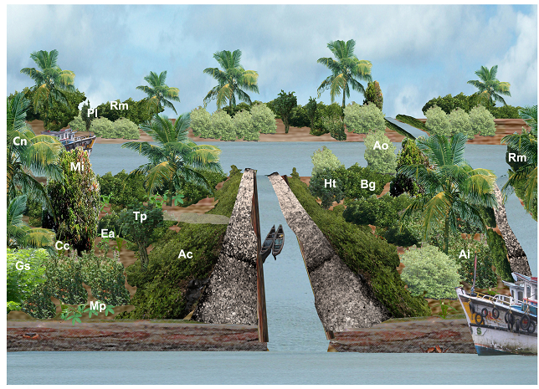
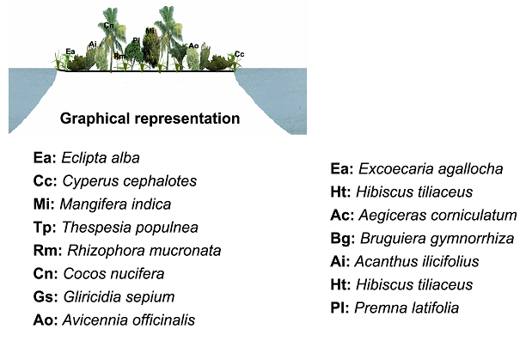
Figure 4: Ecological Zonation and Vegetation Structure Model of Puthenthuruth.
Asramam, situated within the urban matrix of Kollam city, presents a unique blend of ecological richness and human interaction. This site features low phytoplankton diversity (13 species), with diatoms being the dominant group, possibly indicating environmental stress or limited nutrient availability. The presence of mangrove belts along the lake margin, especially Avicennia and Rhizophora, supports estuarine functions and microclimate regulation. Riparian and ornamental species such as Casuarina, Thespesia populnea, and Terminalia catappa enhance aesthetic and recreational value while contributing to biodiversity. The urban interface also promotes habitat for birds, butterflies, and reptiles, making it a prime example of urban ecological coexistence (Fig. 5).

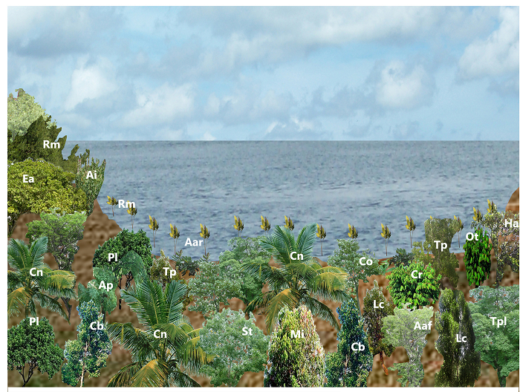
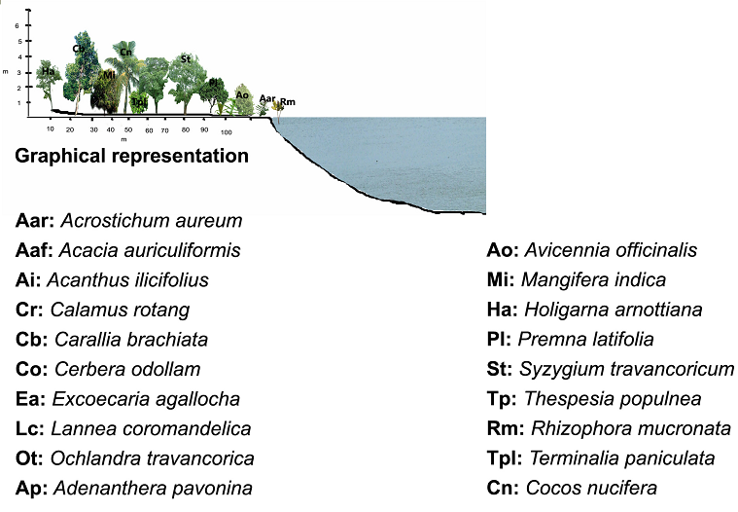
Figure 5. Ecological Zonation and Vegetation Structure Model of Asramam.
Kidapram, located at the freshwater - brackish transition zone in the northern fringe of Ashtamudi Lake, exhibits the highest trophic productivity among the five sites. With 65 species of phytoplankton, including Diatoma, Cyclotella, Anabaena, and Pediastrum, and abundant macrophytes such as Nymphaea stellata and Ipomoea aquatica, the site supports complex aquatic food webs. The landscape includes agroforestry elements like Mangifera indica, Cocos nucifera, and Areca catechu, reflecting a mosaic of natural and cultivated ecosystems. Rich marginal vegetation (Typha, Cyperus) and benthic filter feeders (Villorita cyprinoides) enhance nutrient cycling, sediment stability, and biodiversity resilience (Fig. 6).

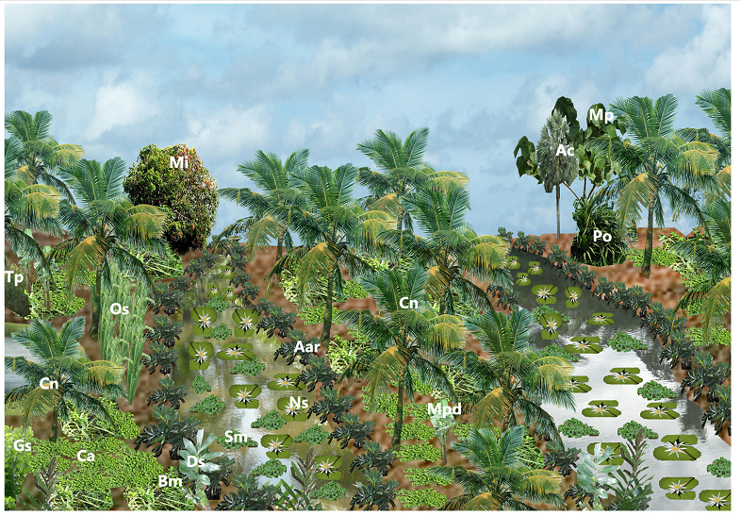
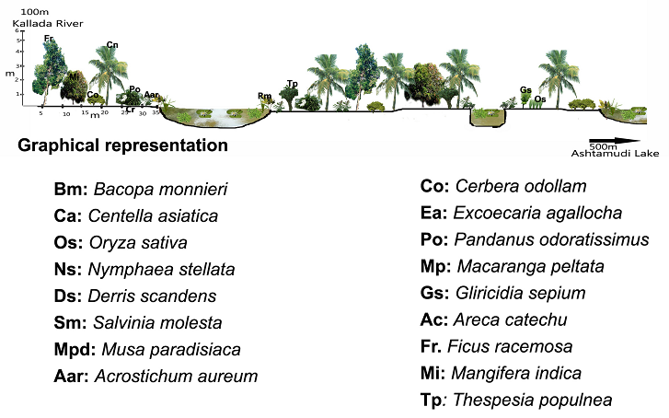
Figure 6. Ecological Zonation and Vegetation Structure Model of Kidapram.
Cherikkadavu, situated at the confluence of the Kallada River and the lake, marks the eastern freshwater dominant ecosite. With the highest recorded phytoplankton diversity (70 species), dominated by Diatoma, Cymbella, Phormidium, and Cosmarium, it reflects exceptional primary productivity. The presence of mangroves, marsh plants, and traditional homestead vegetation (Ocimum sanctum, Musa paradisiaca, Piper nigrum) illustrates the coexistence of biodiversity and community land-use (Fig. 7). Zooplankton diversity is moderate, while benthic fauna such as Mactra, Meretrix, and estuarine fish larvae indicate a healthy aquatic breeding ground. This site offers valuable ecosystem services and functions as a vital biotic corridor connecting riverine and lake systems.
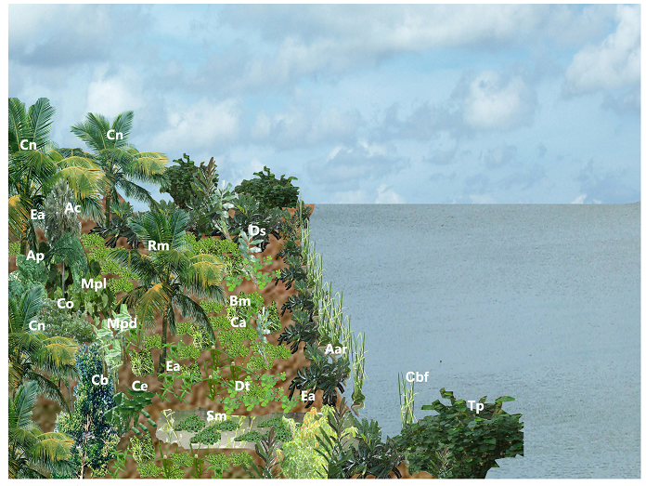
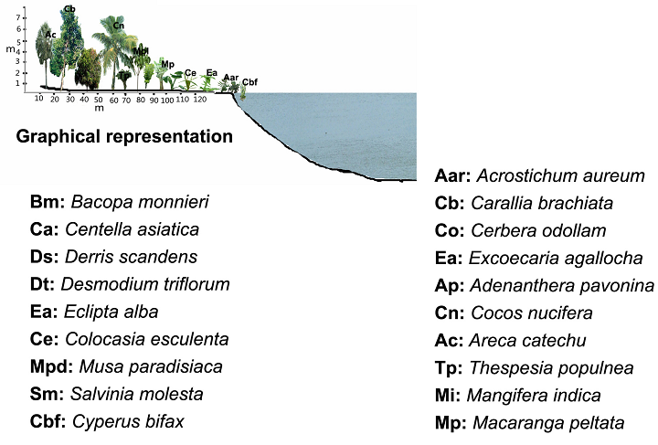
Figure 7. Ecological Zonation and Vegetation Structure Model of Cherikkadavu
The conceptual ecosite models (Figures 3 - 7) visually depict the spatial arrangement of shoreline, marsh, riparian, and upland vegetation zones across the five study sites, highlighting the ecological structure and zonation patterns derived from field assessments.
3.5. Indicator Species Analysis
Indicator Species Analysis was conducted to identify plant and algal species that are ecologically distinctive or preferentially associated with specific ecosites. The analysis revealed that Ipomoea pes-caprae, Excoecaria agallocha, and Trichodesmium were prominent indicator species for the high salinity Neendakara ecosite, while Rhizophora mucronata and Avicennia marina characterized the estuarine habitats of Puthenthuruth and Asramam. In contrast, freshwater and transitional ecosites such as Kidapram and Cherikkadavu were marked by species like Nymphaea stellata, Pistia stratiotes, and Centella asiatica. These species exhibited strong site fidelity and reflected underlying ecological gradients such as salinity, hydrology, and disturbance regime. The bar chart (Fig. 8) summarizes the distribution of indicator taxa across ecosites, demonstrating their diagnostic relevance for habitat classification and ecological monitoring.
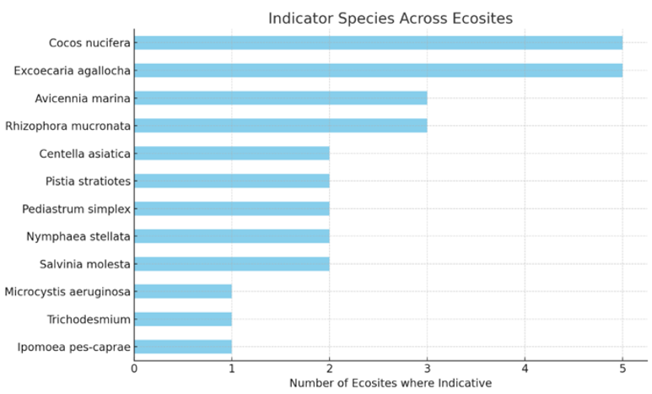
Figure 8: A horizontal bar chart showing the distribution of indicator species across ecosites
4. Discussion
The present study highlights pronounced ecological heterogeneity and functional zonation within the Ashtamudi wetland through a mesoecosystem-scale analysis of five distinct ecosites. Spatial variation in water quality parameters, particularly salinity, carbon dioxide, and nutrients, reflects the combined influence of hydrological connectivity, tidal mixing, and catchment-scale land-use dynamics. Elevated salinity and CO₂ concentrations at Neendakara, the marine-influenced estuarine mouth, indicate strong tidal flushing and enhanced organic matter decomposition, consistent with pollution-driven biogeochemical processes reported earlier (Krishnan et al., 2015: Alexander, 2025). In contrast, Kidapram and Cherikkadavu exhibited lower salinity and higher nitrate concentrations, reflecting freshwater inflow and agricultural runoff from surrounding landscapes, a pattern widely documented in coastal Kerala wetlands (Devi et al., 2022; Bassi et al., 2014). Correspondingly, phytoplankton assemblages followed clear environmental gradients, with diatoms dominating across all ecosites, indicating stable primary productivity, while the occurrence of cyanophycean taxa such as Trichodesmium, Anabaena, and Microcystis at nutrient-enriched sites suggests localized eutrophication risk (Xu et al., 2020; Ravinesh et al., 2021). Enhanced chlorophycean diversity at freshwater-dominated ecosites further reflects ecological plasticity and transitions between lotic and lentic regimes, reinforcing the utility of phytoplankton communities as sensitive indicators of trophic status and ecosystem health.
The spatially explicit ecosite models developed in this study provide an integrative framework for visualizing ecological zonation and vegetation layering by linking biotic assemblages with hydrological and edaphic gradients. Unlike conventional ecosite classifications developed primarily for forest and upland systems in temperate regions (Grima et al., 2023), the present framework is specifically adapted to the dynamic conditions of tropical estuarine wetlands and aligns with ecosystem-based management and nature-based solutions advocated under global conservation agendas (Ramsar Secretariat, 2021; Grima et al., 2023). The delineation of coastal, riparian, marsh, and agro-ecological zones enhance its applicability for adaptive wetland management under both the Ramsar Convention and India’s National Wetland Conservation Programme. Indicator species identified across ecosites reflect critical environmental thresholds related to salinity, nutrient availability, and hydrological regime, supporting their role in biomonitoring and restoration planning (Kathiresan & Bingham, 2001; Sudeshna & Sujit, 2023). This approach is methodologically consistent with the Indicator Species Analysis framework of Dufrêne and Legendre (1997) and extends earlier Ashtamudi-focused studies that largely emphasized molluscan diversity, fisheries, or pollution status (Jayakumar & Chackacherry, 2011; Ravinesh et al., 2021). Overall, the ecosite-based modelling strategy presented here offers a scalable and replicable tool for site-specific conservation planning and long-term sustainability of complex tropical wetland ecosystems under increasing anthropogenic pressure (Elith et al., 2006; Phillips & Dudík, 2008; Olden et al., 2008).
5. Conclusions
This study provides a mesoecosystem-scale ecological assessment of five representative ecosites within the Ramsar-designated Ashtamudi Wetland, integrating physico-chemical water quality analysis, phytoplankton diversity, vegetation structure, and indicator species patterns to elucidate spatial heterogeneity and functional zonation. Clear ecological transitions from marine-dominated to freshwater-influenced environments were revealed through salinity and nutrient gradients, with elevated phytoplankton richness and trophic productivity at Cherikkadavu and Kidapram reflecting strong freshwater influence and ecosystem heterogeneity. The dominance of diatoms across all ecosites indicates sustained primary productivity, while the occurrence of taxa such as Trichodesmium and Nymphaea stellata highlights site-specific environmental conditions and ecological identity. The ecosite models developed in this study, integrating hydrological regimes, vegetation layering, and field-verified species assemblages, offer a novel and practical visual framework for understanding habitat-level ecological dynamics across shoreline, riparian, marsh, and upland zones. By translating complex ecological data into spatially explicit conceptual representations, the models address limitations of conventional large-scale assessments and support site-sensitive wetland zoning, restoration planning, and biodiversity conservation under the Ramsar conservation philosophy. Overall, the integration of bioassessment and ecosite-level modelling presented here provides a replicable and scalable framework for eco-sensitive wetland management, offering valuable guidance for planners, conservation practitioners, and local stakeholders. Long-term monitoring and ecosystem service valuation are recommended as future research priorities to further strengthen the functional application of ecosite-based wetland management strategies.
Data Availability Statement: The data supporting the findings of this study are available from the corresponding author upon reasonable request. All field measurements, phytoplankton observations, and digital models were generated and archived by the author.
Ethical Approval: This research involved no studies with human participants or animals performed by any of the authors. All field data collection complied with local environmental regulations.
Disclaimer (Artificial intelligence)
Author hereby declare that NO generative AI technologies such as Large Language Models (ChatGPT, COPILOT, etc.) and text-to-image generators have been used during the writing or editing of this manuscript.

References
- Alexander T. (2025). Diversity and Community Structure of Benthic Macrofauna in Ashtamudi Lake, Kerala: Implications for Estuarine Health and Productivity, International Journal of Science, Architecture, Technology, and Environment, 2 (11): 381-390. http://dx.doi.org/10.63680/ijsate1125039.032
- American Public Health Association (APHA). (2007). Standard Methods for the Examination of Water and Wastewater (21st e d.). American Public Health Association, Washington, DC. https://www.standardmethods.org/
- Devi, A. B., Deka, D., Aneesh, T. D., Srinivas, R., & Nair, A. M. (2022). Predictive modelling of land use land cover dynamics for a tropical coastal urban city in Kerala, India. Arabian Journal of Geosciences, 15(5), 399. https://doi.org/10.1007/s12517-022-09735-7
- Dufrêne, M., & Legendre, P. (1997). Species assemblages and indicator species: The need for a flexible asymmetrical approach. Ecological Monographs, 67(3), 345-366. https://doi.org/10.2307/2963459
- Grima, N., Jutras-Perreault, M.-C., Gobakken, T., & Ørka, H. O. (2023).
Systematic review for a set of indicators supporting the Common International Classification of Ecosystem Services. Ecological Indicators, 147, 109978. https://doi.org/10.1016/j.ecolind.2023.109978
- Jayakumar, K.V. & Chackacherry, G. (2011). Ashtamudi Wetland: Values and Threats. In National Workshop on Ramsar Sites of India, Kolkata. https://www.researchgate.net/publication/321804444_Ashtamudi_Wetland_Kerala_Values_and_Threats
- Kathiresan, K., & Bingham, B. L. (2001). Biology of mangroves and mangrove ecosystems. Advances in Marine Biology, 40, 81-251. DOI: 10.1016/S0065-2881(01)40003-4. https://doi.org/10.1016/S0065-2881(01)40003-4
- Krishnan, J. U., Devi, S. S., Jithine, J. R., Ajesh, G., & Lekshmi, N. R. (2015). Pollution status of Ashtamudi Lake, Kerala, India and its impact on some keystone mangrove species: A case study. International Journal of Innovative Studies in Aquatic Biology and Fisheries, 1(1), 17–22. https://www.arcjournals.org/pdfs/ijisabf/v1-i2/3.pdf
- Levin, S. A. (1992). The problem of pattern and scale in ecology. Ecology, 73(6), 1943-1967. https://doi.org/10.2307/1941447
- Muniz, D. H. F. & Oliveira-Filho, E. C. (2023). Multivariate statistical analysis for water quality assessment: A review. Hydrology, 10(10), 196. https://doi.org/10.3390/hydrology10100196
- Nitin Bassi, M. Dinesh Kumar, Anuradha Sharma, P. Pardha-Saradhi (2014). Status of wetlands in India: A review of extent, ecosystem benefits, threats and management strategies. Journal of Hydrology: Regional Studies. 2: 1-19. https://doi.org/10.1016/j.ejrh.2014.07.001
- Ramsar Convention Secretariat. (2021). Global Wetland Outlook: Special Edition 2021. https://www.ramsar.org/document/global-wetland-outlook-special-edition-2021
- Ravinesh, R., Biju Kumar, A., & Anjana, V.L. (2021). Diversity and distribution of molluscan fauna in Ashtamudi Estuary. Wetlands Ecology and Management, 29, 745-765. https://doi.org/10.1007/s11273-021-09791-y
- Sreekumari, V. M., John, S. E., Rajan, R. T., Kesavan, M., Kurian, S., & Damodaran, P. (2016). Human interventions and consequent environmental degradation of a protected freshwater lake in Kerala, SW India. Geosciences Journal, 20 (3), 391-402. https://doi.org/10.1007/s12303-015-0049-7
- Sudeshna Mukherjee & Sujit Kumar Mandal (2023). Quantitative Analysis of Aquatic and Associated Macrophytes in Selected Wetlands of North Dinajpur District, West Bengal. 10(3): 205-211. https://doi.org/10.32628/IJSRSET2310253
- Wolfslehner, B., & Vacik, H. (2011). Mapping indicator models: From intuitive problem structuring to quantified decision-making in sustainable forest management. Ecological Indicators, 11, 274–283. https://doi.org/10.1016/j.ecolind.2010.05.004
- Xibao Xu, Minkun Chen, Guishan Yang, Bo Jiang, Ji Zhang. (2020). Wetland ecosystem services research: A critical review. Global Ecology and Conservation. 22: 1-10. https://doi.org/10.1016/j.gecco.2020.e01027
- Elith, J., et al. (2006). Novel methods improve prediction of species’ distributions from occurrence data. Ecography, 29, 129–151. https://doi.org/10.1111/j.2006.0906-7590.04596.x
- Phillips, S. J., & Dudík, M. (2008). Modeling of species distributions with MaxEnt: new extensions and a comprehensive evaluation. Ecography, 31, 161–175. https://doi.org/10.1111/j.0906-7590.2008.5203.x
- Olden, J. D., Lawler, J. J., & Poff, N. L. (2008). Machine learning methods without tears: a primer for ecologists. The Quarterly Review of Biology, 83(2), 171–193. https://doi.org/10.1086/587826

