Short Communication

Ecology and Ethnobotany of Osyris lanceolata Hochst. & Steud. (Santalaceae) in Odisha, India

Abstract
Osyris lanceolata Hochst. & Steud. (Santalaceae), commonly known as African sandalwood or Jangli chai, is an evergreen, hemiparasitic tree of high medicinal and economic importance. The species is widely distributed across tropical and subtropical regions of Africa and Asia, exhibiting a scattered and patchy population structure. The present study compiles and synthesises available information on the habit, habitat, morphology, host associations, distribution, and ethnomedicinal uses of O. lanceolata, with special reference to its occurrence in Odisha state, India. The study highlights its ecological adaptability, hemiparasitic behaviour, and ethnobotanical significance, while also identifying critical knowledge gaps related to population ecology, regeneration biology, conservation status, and sustainable utilisation. Addressing these gaps is essential for formulating effective conservation and management strategies for this increasingly threatened species.
Keywords: African sandalwood, Ethnobotany, Hemiparasitic plant, Odisha, Osyris lanceolata
Introduction
Osyris lanceolata Hochst. & Steud., commonly known as East African sandalwood, is a hemi-parasitic androdioecious multi-stemmed small tree or shrub. The great variation in leaf size and shape has elicited a considerable synonymy (Khayota et al., 2023). The genus Osyris L. comprises evergreen shrubs or small trees belonging to the family Santalaceae, most members of which exhibit a hemiparasitic habit by partially parasitising neighbouring plants. Species of Osyris are widely distributed across tropical and temperate regions of the world, and the genus is represented by more than 34 species globally (Xiang et al. 2003). The species grows in upland dry evergreen forest and mist forest, with associated bushland and grassland, extending down rivers and from there marginally into deciduous woodland; It is found in the altitudinal range (50–)900–2700 m (Polhill, 2005). These plants are ecologically distinctive due to their parasitic associations and are economically important for their aromatic wood and medicinal properties. Osyris lanceolata Hochst. & Steud. ex A. DC. is an evergreen, drought-tolerant, hemiparasitic small tree attaining a height of 1–10 m (Gathara et al. 2014). It is the only representative of the genus Osyris reported from the state of Odisha, India. The species is widely known by various vernacular names, including African sandalwood and East African sandalwood, while in India it is commonly referred to as Jangli Chai (Malik et al. 2023). The heartwood of O. lanceolata yields essential oils of considerable commercial value, extensively used in the perfumery industry (Mugula et al. 2021). Its utilisation increased notably in the early twentieth century following the decline in natural populations of Santalum album L., which led to a search for alternative sources of sandalwood oil (Adugnaw 2020). Many households utilise O. lanceolate Hochst. & Steud. for their subsistent livelihoods and as a medicinal source for human and ethno veterinary purposes (Moichwanetse 2020; Mwangi et al., 2021). Ecologically, O. lanceolata exhibits a broad host range and parasitises a variety of woody and shrubby plant species. In Tanzania, reported host plants include Rhus natalensis, Dodonaea viscosa, Tecomaria capensis, Catha edulis, Apodytes dimidiata, Brachystegia spiciformis, Maytenus acuminatus, Casuarina equisetifolia, and Aphloia theiformis (Mwang’ingo et al. 2010). Such host flexibility contributes to its ability to survive in diverse habitats, ranging from dry woodlands to montane ecosystems. Despite its wide geographic distribution and economic importance, detailed information on the ecology, host associations, and regional distribution of O. lanceolata in India, particularly in Odisha, remains limited and fragmented. The present study is therefore significant in consolidating available knowledge on the habit, habitat, and distribution of O. lanceolata, while providing region-specific insights from Odisha. Present documentation is essential for improving understanding of its ecological requirements and for supporting future conservation, management, and sustainable utilisation strategies for this increasingly threatened hemiparasitic tree.
Methodology
A comprehensive review of published literature was carried out to compile information on the taxonomy, morphology, distribution, host associations, and ethnomedicinal uses of Osyris lanceolata Hochst. & Steud. Relevant data were collected from floras, research articles, review papers, and ethnobotanical studies, including regional floristic works and peer-reviewed journals (Kumar, 2025). Special emphasis was given to literature documenting the occurrence and ecological attributes of the species in India and Odisha. Nomenclature and taxonomic details were verified using standard floristic references (Saxena and Brahmam 1995). Field surveys were conducted in different forested and hilly regions of Odisha, particularly in areas where Osyris lanceolata has been previously reported, including Deomali hills (Koraput district) and surrounding landscapes. Surveys were undertaken during the flowering and fruiting seasons to facilitate accurate identification. Habitat characteristics, growth form, associated vegetation, and host plant associations were recorded through direct field observations. Photographs of vegetative and reproductive parts were taken, and the distribution pattern of populations was noted. Identification of the species was confirmed using standard taxonomic keys and regional floras (Saxena and Brahmam 1995).
Morphology and Host Association
Field observations revealed that Osyris lanceolata is an evergreen, hemiparasitic small tree attaining a height of approximately 7–10 m, with a rounded to irregular canopy and a smooth grey bark (Figure 1). The species exhibits a highly branched growth form, with branches often drooping or pendant, a characteristic that may aid in light interception in open and semi-open habitats. Leaves are sparse, simple, and alternately arranged, displaying blue-green to yellow-green colouration. They are thick, coriaceous, slightly glaucous, and crowded along the stems, with shapes varying from obovate-oblong to elliptic-lanceolate or oblanceolate. The cuneate leaf base and mucronate apex observed in the present study are consistent with earlier descriptions by Saxena and Brahmam (1995) and Mwang’ingo et al. (2010), confirming the taxonomic identity of the species. The reproductive morphology is characterised by small, unisexual, yellow-green flowers borne in axillary clusters or short panicles of 2–3 flowers. Male flowers occur in axillary cymes, whereas female flowers are solitary, with all floral parts arranged in fours, indicating a tetramerous floral structure. The fruit is a globose, yellow drupe measuring 7–8 mm in diameter. These morphological traits are diagnostic for O. lanceolata and facilitate its distinction from closely related taxa within the genus. The consistency between field observations and earlier reports suggests limited morphological plasticity across its distribution range. The hemiparasitic nature of O. lanceolata was evident from its association with multiple host species in the field. In the present study, Pongamia pinnata, Wendlandia thyrsoidea, and Ageratina adenophora were recorded as host plants. The ability of O. lanceolata to parasitise both native tree species and invasive shrubs such as A. adenophora indicates a broad host range and ecological flexibility. Similar observations of wide host diversity have been reported from East Africa, where the species parasitises a range of woody taxa (Mwang’ingo et al. 2010). Such host generalism may enhance survival in heterogeneous habitats but may also influence growth performance, population structure, and regeneration dynamics. The results of the present study corroborate earlier reports indicating that O. lanceolata has a wide pantropical distribution across Africa, South Asia, Southeast Asia, China, and parts of southern Europe (Mwang’ingo et al. 2007).
Distribution
In India, the species occurs sporadically across the subtropical Himalayas, Northeast India, Central India, and Peninsular regions, including Odisha (Balakrishnan et al. 2012; Malik et al. 2023; Gusain et al. 2025). Within Odisha, populations were confirmed from the Deomali hills of Koraput district, supplementing earlier records from the Mahendragiri hills and Similipal Biosphere Reserve (Saxena and Brahmam 1995). The species exhibits a highly scattered and patchy distribution, typically restricted to rocky slopes, dry woodlands, and montane habitats up to 2,000 m elevation. Such fragmented occurrences may be attributed to specific habitat requirements, dependence on suitable host plants, and anthropogenic pressures. The observed pattern of isolated individuals or small clusters suggests limited natural regeneration, a phenomenon also reported from other parts of its range.
Ethnomedicinal Uses
The compilation of ethnomedicinal uses (Table 1) highlights the extensive traditional knowledge associated with O. lanceolata across Africa and South Asia. Different plant parts, including bark, leaves, roots, and heartwood, are used to treat a wide range of ailments such as fungal infections, gynaecological disorders, diarrhoea, neurological problems, respiratory ailments, sexually transmitted diseases, and bone fractures. Leaves are particularly valued in Nepal for their use as lactation stimulants, labour inducers, and treatments for sprains and muscle injuries (Osujih 1993; Shyaula 2012). The frequent use of bark, roots, and heartwood in medicinal preparations, especially in East Africa and Nepal, underscores the pharmacological potential of the species but also raises concerns regarding destructive harvesting practices. Removal of bark and roots can severely affect plant survival, especially in species with slow growth and poor regeneration. The broad spectrum of medicinal applications documented in different cultural contexts indicates the need for further phytochemical and pharmacological investigations, as well as the development of sustainable harvesting protocols. The combined results on morphology, host association, distribution, and ethnomedicinal use suggest that O. lanceolata is a highly adaptable yet vulnerable species. While its hemiparasitic habit and host generalism allow it to occupy diverse habitats, its scattered distribution, dependence on specific ecological conditions, and intensive use for medicinal and commercial purposes may pose significant threats to its long-term survival. The documentation of its occurrence in Odisha adds valuable regional data and emphasises the need for site-specific conservation measures. Integrating ecological studies with ethnobotanical knowledge can contribute to the formulation of effective conservation and management strategies for this economically and culturally important hemiparasitic tree.
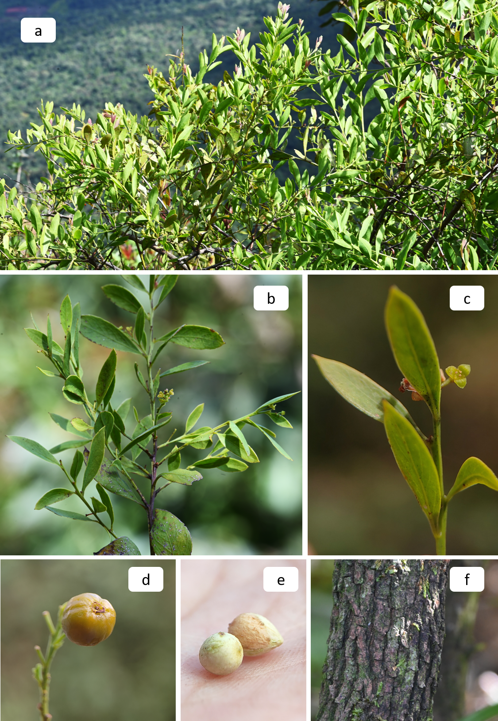
Figure 1: Vegetative parts of O. lanceolata; a) canopy, b & c) leaves with flower, d) fruit, e) seeds. F) bark
Table 1: Medicinal uses of Osyris lanceolata
Plant part | Ailment | Mode of use | Region/ Ethnic group | Reference
Bark | Candidiasis and fungal infections | Decoction of bark | East Africa | Masevhe et al. (2015)
Bark | Gynaecological disorders | Smoke directed to the vagina | South Africa | Mwangi et al. (2021)
Leaves | Lactation stimulant and labour induction | Dried leaves infused in hot water as herbal tea (“Nundhiki”) | Kavre district, Nepal (Tamang, Newar) | Osujih (1993)
Leaves | Sprains and muscle injuries | 2 kg leaves boiled in 10 L water- reduced, evaporated to viscous mass (“Nundhiki ko khoto”), mixed with butter/rapeseed oil, used externally to massage twice daily | Central Nepal | Shyaula (2012)
Leaves | Emetic and antiviral | Decoction or crude use | Asia, Africa | Mwangi et al. (2021)
Leaves | ENT (Ear, Nose, Throat) infections | Leaves are boiled and administered orally | East Africa | Malik et al. (2023)
Leaves | Bacterial infections | Leaf extract | Nepal | Paudel and Gyawali (2014)
Roots | Diarrhoea | Roots decoction in water, thrice daily (250 ml) | Kenya | Malik et al. (2023)
Roots | Neurological problems | Root-based preparations | Nepal | Acharya and Rokaya (2005)
Roots and bark | Postpartum bleeding and uterine contraction | Root bark boiled for 10 min, filtrate taken orally (10 tsp, three times daily) | Nepal | Shrestha and Joshi (1993)
Roots and bark | Anaemia, cough and malaria | Decoction of roots, bark and heartwood | Tanzania, Kenya | Shyaula (2012); Mwangi et al. (2021)
Roots and bark | Bone fracture, dislocation | 100 g bark boiled in 3 L water to a gelatinous mass, applied as plaster | Nepal | Mwangi et al. (2021)
Wood/ heartwood | Cough | Wood decoction | Tanzania | Shyaula (2012)

Conclusion
Osyris lanceolata Hochst. & Steud. is an ecologically distinctive and ethnobotanically significant hemiparasitic tree with a wide pantropical distribution. The present study consolidates information on its morphology, host associations, habitat preference, distribution, and traditional medicinal uses, with particular emphasis on its occurrence in Odisha, India. Field observations confirm that the species is morphologically consistent with earlier descriptions and exhibits broad host flexibility, enabling it to persist in diverse and often resource-limited habitats such as rocky slopes, dry woodlands, and montane regions. Despite its adaptability, O. lanceolata shows a highly scattered and patchy distribution, suggesting limited natural regeneration and potential vulnerability to habitat disturbance. The extensive use of its bark, roots, and heartwood in traditional medicine across Africa and South Asia highlights its high cultural and therapeutic value, but also raises concerns regarding unsustainable and destructive harvesting practices. The documentation of new locality records from Odisha contributes valuable baseline data for understanding the regional distribution of the species. Overall, the findings underscore the need for focused ecological studies on population dynamics, regeneration biology, and host specificity, alongside phytochemical validation of its medicinal properties. Conservation-oriented management strategies, including habitat protection, awareness among local communities, and promotion of sustainable utilisation practices, are essential to ensure the long-term survival of O. lanceolata in its natural habitats.

COMPETING INTERESTS DISCLAIMER:
Authors have declared that they have no known competing financial interests OR non-financial interests OR personal relationships that could have appeared to influence the work reported in this paper.

Disclaimer (Artificial intelligence)
Author(s) hereby declare that NO generative AI technologies such as Large Language Models (ChatGPT, COPILOT, etc.) and text-to-image generators have been used during the writing or editing of this manuscript.

References
Acharya KP and Rokaya MB. (2005). Ethnobotanical survey of medicinal plants traded in the streets of Kathmandu valley. Scientific World. 3(3): 44-48.
Adugnaw, A. (2020). Clonal Propagation of Osyris lanceolata Plant Through Air Layering at Bazawit Hill, Northern Ethiopia. An Endangered, Medicinal and sandal wood Plant in East Africa. European Journal of Experimental Biology, 10(6), 4-6. http://www.imedpub.com/european-journal-of-experimental-biology/
Balakrishnan, N. P., Chakrabarty, T., Sanjappa, M., Lakshminarasimhan, P., & Singh, P. (2012). Flora of India, Volume 23: Loranthaceae - Daphniphyllaceae. Botanical Survey of India. https://www.nhbs.com/flora-of-india-volume-23-loranthaceae-daphniphyllaceae-book
Bhattarai, N. K. (1990). Herbal Folk Medicines of Kabhrepalanchok District, Central Nepal. International Journal of Crude Drug Research, 28(3), 225–231. https://doi.org/10.3109/13880209009082728
Gathara, M., Makenzi, P., Kimondo, J., & Muturi, G. (2014). Prediction of Osyris lanceolata (Hochst. & Steud.) site suitability using indicator plant species and edaphic factors in humid highland and dry lowland forests in Kenya. Journal of Horticulture and Forestry, 6(11), 99-106. https://doi.org/10.5897/JHF2014.0365
Gusain, M., Rathore, M., & Namitha, N.K. (2025). Improving seed germination and seedling performance of Osyris lanceolata through fruit maturity indices, seed pretreatments, and substrate optimization. Annual Research & Review in Biology, 40(8), 216-233. https://doi.org/10.9734/arrb/2025/v40i82299
Kumar, S. (2025). Data collection from literature for biological sciences, medicinal plants research, ethnobotany, and pharmacology: a methodological overview. Journal of Biodiversity and Conservation, 9(2), 167-169. https://doi.org/10.5281/zenodo.15610715
Malik AH, Noor S, Hurra WA and Tewari LM. (2023). Evaluation of Antimicrobial Activity, Taxonomic characteristics and Ethnobotanical Uses of Osyris wightiana Wall. ex Wight. Biological Forum – An International Journal. 15(3): 880-885.
Masevhe, N. A., McGaw, L. J., & Eloff, J. N. (2015). The traditional use of plants to manage candidiasis and related infections in Venda, South Africa. Journal of Ethnopharmacology, 168, 364-372. https://doi.org/10.1016/j.jep.2015.03.046
Mugula, B. B., Kiboi, S. K., Kanya, J. I., Egeru, A., Okullo, P., Curto, M., & Meimberg, H. (2021). Knowledge Gaps in Taxonomy, Ecology, Population Distribution Drivers and Genetic Diversity of African Sandalwood (Osyris lanceolata Hochst. & Steud.): A Scoping Review for Conservation. Plants, 10(9), 1780. https://doi.org/10.3390/plants10091780
Mwangi, J. G., Njoka, J. T., & Spaling, H. (2021). The cultural beliefs, values and utilization of East Africa Sandalwood Osyris lanceolata Hochst. & Steud. (1832) in and around Chyulu Hills Ecosystem, Kenya. Ethnobotany Research & Applications, 22(12), 1-18. https://doi.org/10.32859/era.22.12.1-18
Mwang'ingo, P. L., Teklehaimanot, Z., Lulandala, L. L., & Mwihomeke, S. T. (2005). Host plants of Osyris lanceolata (African sandalwood) and their influence on its early growth performance in Tanzania. Southern African Forestry Journal, 203(1), 55–65. https://doi.org/10.2989/10295920509505219
Mwang'ingo PL, Teklehaimanot Z, Hall JB and Zilihona JE. (2007). Sex distribution, reproductive biology, and regeneration in the dioecious species Osyris lanceolata (African sandalwood). Tanzania. Tanzania Journal of Forestry and Nature Conservation 76:118- 133.
Osujih, M. (1993). Exploration of the frontiers of tradomedical practices: basis for development of alternative medical healthcare services in developing countries. Journal of the Royal Society of Health, 113(4), 190-194. https://doi.org/10.1177/146642409311300409
Paudel PN and Gyawali R. (2014). Phytochemical Screening and Antimicrobial Activity of Some Selected Medicinal Plants of Nepal. International Journal of Pharmaceutical and Biological Archives. 5(3):84-92.
Saxena HO and Brahmam M. (1995). The Flora of Orissa (Vol. 3). Regional Research Laboratory, Bhubaneswar and Orissa Forest Development Corporation Ltd., Bhubaneswar, Odisha, India.
Shrestha, I., & Joshi, N. (1993). Medicinal plants of the Lele village of Lalitpur district, Nepal. International Journal of Pharmacognosy, 31(2), 130-134. https://doi.org/10.3109/13880209309082929
Shyaula, S. L. (2012). A review on genus Osyris: Phytochemical constituents and traditional uses. Journal of Natural Pharmaceuticals, 3(2), 61-70. https://doi.org/10.4103/2229-5119.102747
Xiang, K. T., Nianhe, X., & Gilbert, M. G. (2003). In Flora of China Editorial Committee (Eds.), *Flora of China. Vol 5* (pp. 208-219). Science Press (Beijing) and Missouri Botanical Garden Press. https://www.efloras.org/florataxon.aspx?flora_id=2&vol_id=5
Polhill, P.M., 2005. Flora of Tropical East Africa: Santalaceae. Royal Botanic Gardens, Kew.
Khayota, B., Mwamodenyi, J., Lusweti, A. M., & Kyalo, S. (2023). Conservation and sustainable management of Osyris lanceolata for economic development in East Africa: Final report for Output 3.2: Conducting a detailed study on production, harvesting, processing, transport, trade, control and monitoring of Osyris lanceolata with a view of establishing a fair tracking/control system. Link: https://cites-tsp.org/sites/default/files/project_files/2023-03/CTSP_Kenya%20NDF%20Report_Final-min.pdf
Moichwanetse, B. I., Ndhlovu, P. T., Sedupane, G., & Aremu, A. O. (2020). Ethno-veterinary plants used for the treatment of retained placenta and associated diseases in cattle among Dinokana communities, North West Province, South Africa. South African Journal of Botany, 132, 108-116.

