Toxicity of Commonly Used Medicinal Plants in Uganda: A Review

ABSTRACT
Uganda is rich in biodiversity, with a vast array of medicinal plants that have been used for generations to generations to treat various ailments. Medicinal plant plays a significant role in Ugandan healthcare, particularly in rural and urban areas where access to modern medicine is limited. However, the widespread use of medicinal plants raises concerns about their safety and potential toxicity. Despite their widespread use, the safety and toxicity profiles of many of these plants remain inadequately studied, posing potential public health risks. This article evaluates the toxicity of commonly used medicinal plants in Uganda, including Vernonia amygdalina, Warburgia ugandensis (Uganda heart), Prunus africana (African Cherry), Abus precatorius, Agave sisalana Perrine, Azadirachta Indica (Neem), Illium sativum, Annona muricata, Moringa oleifera ( Moringa), Yam leaves (Mutene), Capsicum annum, Carica papaya and Citrus limonum Risso. These plants are frequently used to treat ailments such as malaria, gastrointestinal disorders, respiratory infections, and skin diseases. We explore the importance of evaluating the toxicity of these commonly used medicinal plants in Uganda, the methods used for assessment, and examples of plants with potential toxic effects. This review article emphasizes the importance of dosage and preparation methods, as toxicity often correlates with concentration and solvent type. We advocate for the integration of scientific validation into traditional medicine practices and highlight the urgent need for public health education on the safe use of herbal remedies to ensure the efficacy and safety of these plants.
Key words: Medicinal Plants , Uganda, Toxicity, Biodiversity, healthcare, medicine
Introduction:
“In Uganda, medicinal plants are widely used in rural and urban areas. Especially for the poor populations and it is on that ground that the Government of the Republic of Uganda has especially focused on the use of herbal medicine and is in the process of assimilating it into the main health care system” (Kamatenesi et al.2011). As a result, “the government of the Republic of Uganda enacted into law ‘The Indigenous and Complementary Medicine Bill 2015’ which is accented to by the president on 14th September 2020” (Mwaka et al. 2019). “In Some of the areas for example Rwenzori region in particular, 21% of the households are in the low-income bracket of UGX 338,527” (UBOS 2008; World Population Prospects, 2022) and “this limits them from the use of modern health services, resorting to traditional medicine considering that there is high medicinal plant diversity in this region” (Oryem-Origa et al.1995).This is essentially due to the rapidly increasing costs of pharmaceutical-based medicines as compared averagely to the low incomes statues of a major part of the population. In addition, the efficacies and effectiveness of many of medicinal plants that's proved, but the fact remains that certain plants used in medical treatments have toxic side effects. It is in this perspective that we investigated by bibliographic literature on the toxicity of medicinal plants used in treatment of communicable and non-communicable diseases. (Farzaei M. et al., 2020) It is crucial to gain knowledge on these plant-based medicines prepared and prescribed by practitioners, particularly in terms of toxicity, composition, specific efficacy of disease and to advise practitioners of this alternative medicine on the protection and security of patients.
The use of medicinal plants is one of the oldest methods used by human kind in life threatening conditions. In the evolution history to date it has been adopted to be part of human cultures. In Uganda for example, plants are used in medicines to treat different communicable and non-communicable diseases. “The use of medicinal plants has been commonly associated with severe side effects. In South Africa, for example, high rates of dehydration, vomiting, diarrhea, and altered mental status have been observed in patients who reported recent use of medicinal plants for medical attention” (Luyckx et al., 2004). Similarly, “traditional herbal treatment has been associated with dysfunctions of the liver and kidneys resulting in high patient mortality” (Luyckx et al., 2004). “Acute kidney failure is one of the most severe, but under-recognized, complications of medicinal plants use for medicine use and yet it forms an important aetiology of renal diseases in routine clinical practice” (Luyckx et al., 2004; Luyckx, 2012). “About 35% of all cases of acute renal failure in Africa have been associated with the use of herbal remedies. Moreover, this figure is thought to be an underestimate because of the secrecy surrounding traditional health practices and the use of traditional remedies” (Isnard Bagnis et al., 2004; Luyckx et al., 2004). “Contamination from ingestion of potentially toxic medicinal herbs, incorrect substitution of required medicine with toxic herbs, adulteration, herb-drug interactions, the use of suboptimal un-standardized herbal medicines and lack of regulations or their enforcement are some of the main challenges that plague the use of herbal medicines” (Ernst, 2002; Liwa and Jaka, 2016). It is also known that the source, composition, and preparation of herbal remedies vary with prevailing local healing practices and level of knowledge and skill of the herbalist (Jha and Rathi, 2008; Anywar et al., 2021). These treatments include body-washes, massages, ingestions, etc. Plants provide a wide variety of biochemical useful to Humans (Ugandans). Their uses include foods, agricultural chemicals and pharmaceuticals.
According to the World Health Organization (WHO), about 40–90% of people living in rural and urban areas of the country frequently use Medicinal plants. This situation is due to the limited access to modern health services and also researchers explained the high prevalence of medicinal plant use by massive rural-to-urban migration, the influence of cultural and social surroundings, and the belief that natural products pose no risk (van Andel and Carvalheiro, 2013, Lins Brandão et al., 2006, Bussmann et al., 2007, Oreagba et al., 2011). Though, “the use of medicinal plants can have deleterious effects on health as reported elsewhere” (fall et al., 2011). “Most plants contain toxic substances like some secondary metabolites” (Ishii et al., 1984). “Plants produce a variety of secondary metabolites that are subdivided by chemists into several classes based on their molecular structure. Among secondary metabolites are saponins, terpenoids, cyanogenic, tannins, toxic amino acids, glycosides, alkaloids” (Dai and Mumper, 2010). It has been shown that “the toxicity of a given plant depends on various factors, including the strength of secondary metabolites, the quantity/dosage taken by the patient or client and the time of exposure, different parts of the plant (root, oil, leaves, stem bark and seeds), individual body chemistry, climate and soil, and genetic differences within the species” (Tülay, 2012). This said it clearly appears that medicinal plants should be used with precautions and toxicology studies conducted to increase the knowledge on the plant or plants preparation given to populations.
For this purpose, “in-vitro and in-vivo models are available to study the toxicity of medicinal plants” (Philomena, 2011). “Regardless of the type of extract, the parts of plant used, the concentration of the extract, the mode of administration, and the organism under consideration the lethal dose 50 (LD50) which represents the dose that kill 50% of a tested population is used to appreciate the toxicity of the plant” (Amy et al., 2002).

METHODS FOR EVALUATING TOXICITY
1. Traditional Knowledge and Ethnobotanical Studies
Ethnobotanical surveys are often the starting point for identifying plants with potential toxicity concerns. Healers and herbalists who have used these plants for generations provided insight into safe usage practices, effective dosages, and known side effects. However, this knowledge is not always scientifically validated, and traditional use does not guarantee safety.
2. Phytochemical Screening
Phytochemical analysis involves identifying the active compounds present in the plant. While many phytochemicals have therapeutic benefits, some are known to be toxic. For example, alkaloids, saponins, and tannins are common in medicinal plants, but excessive consumption can lead to toxicity. Phytochemical screening helps identify these compounds and estimate potential risks (Hamidi et al.2014).
3. In Vitro Toxicity Testing
In vitro toxicity tests are conducted in controlled laboratory settings to evaluate the effects of plant extracts on cultured cells. These tests help to determine cytotoxicity, genotoxicity (DNA damage), and other harmful effects at the cellular level. By assessing the dose-dependent toxicity, researchers can establish safe concentration limits for plant extracts (Hamidi et al.2014).
4. In Vivo Toxicity Testing
In vivo tests involve studying the toxic effects of plant extracts on animals such as mice or rats. These studies assess acute and chronic toxicity, providing information on the lethal dose (LD50), organ damage, and overall systemic toxicity. Such experiments help to determine the long-term effects of consuming specific plants and their potential to cause organ-specific damage (e.g., hepatotoxicity, nephrotoxicity) (Hamidi et al.2014).
5. Clinical Trials and Human Studies
While animal studies provide valuable insights, human clinical trials are essential to fully assess the safety of medicinal plants. In these trials, controlled doses of plant extracts are administered to human participants under medical supervision. Adverse effects are monitored, and data on safe dosage ranges are collected. Such trials are rare in Uganda but essential for validating traditional medicinal use and ensuring safety.
6. Toxicogenomics and Bioinformatics
Advances in genomics and bioinformatics allow for a deeper understanding of how plant-derived compounds affect gene expression and biological pathways. Toxicogenomics involves studying the interaction between toxic compounds and genetic material, which can help predict potential long-term effects of medicinal plants and identify biomarkers for toxicity (Hamidi et al.2014).

EXAMPLES OF COMMONLY USED MEDICINAL PLANTS IN UGANDA AND THEIR TOXICITY
- Warburgia ugandensis (Ugandan Greenheart)
Warburgia ugandenis are traditionally used to treat a variety of illnesses including stomach ache, diarrhea, abdominal pain, oral thrush cold and coughs, malaria, and gastrointestinal disorders. The therapeutic properties of its medicinal values and toxicity are linked to the secondary metabolites.

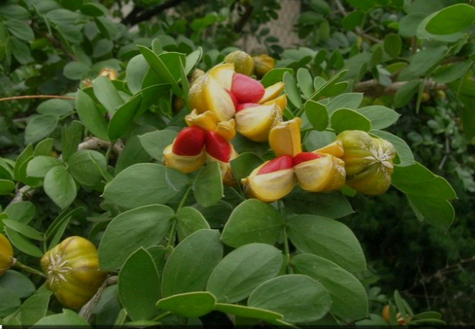
Figure 1. Warburgia ugandensis (Ugandan Greenheart)
Toxicity: High doses can cause gastrointestinal irritation, liver damage. Exceeding doses can lead to vomiting general body weakness and ulcers
- Vernonia amygdalina (Bitter Leaf)
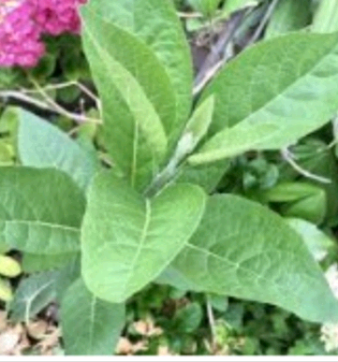
Figure 2.Vernonia amygdalina (Bitter Leaf)
Vernonia amygdalina extracts are used in traditional medicine for various purposes, including treatment of diabetes and fever. However, it's important to consider the potential for toxicity, mostly at high doses. Widely used for malaria and digestive issues.
Toxicity:
Some studies have indicated that high concentrations of Vernonia amygdalina extracts can have toxic effects on cell cultures, inducing cytotoxicity and apoptosis.
The aqueous extract of Vernonia amygdalina has shown a significant decreasing trend in hematological indices (red blood cells, hemoglobin, and packed cell volume) in fish (Clarias gariepenus) when exposed to increasing concentrations. Excessive consumption may lead to kidney and liver damage due to its high oxalate content.
- Prunus africana (African Cherry)
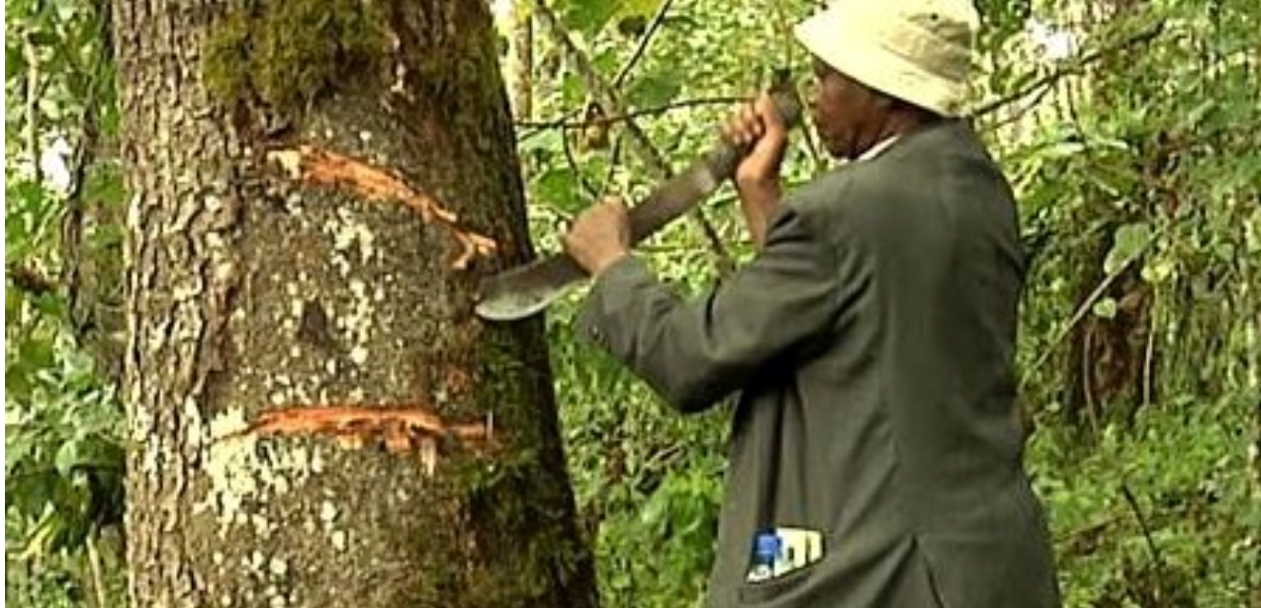
Figure 3. Harvesting Prunus Africana bark
Local names
Bamb-Babwisi of Bundibugyo district (Western Uganda) call it Kamulali
Banyankole of Western Uganda call it Eshendi/ kamulali
Uses
Water is added to pounded bark and the red liquid thus obtained is used as a remedy for stomach ache. Its bark is also used for the purpose of wound healing. Apart from the bark, its leaves infusion is used to treat various disorders such as: improving appetite, treatment of genital infection and hirusutism (a condition that is characterized by unwanted and male-pattern hair growth) in women. The bark of this tree is also an aphrodisiac for enhancing vitality and sexual power in males. “Its bark is highly valued for its medicinal properties. The dull gray to brown black bark is used for the treatment of BPH” (Keehn A, et al., July 2016). “It is particularly used as a treatment for benign prostatic hyperplasia and prostate gland hypertrophy that commonly affect the older men. The herb improves urinary symptoms associated with BPH which is marked by the enlargement of the prostate gland. It significantly reduces the urinary frequency and pain with urination in men who suffer from mild to moderate BPH symptoms. Prunus africana is primarily used to treat prostate disorders and inflammation” (Edgar, AD et al,.2007).
Toxicity
Prunus africana (African Cherry) can be toxic, especially its bark, leaves, and seeds, which contain cyanide-like compounds. While the fruits and flowers generally have low concentrations of toxins, excessive use can lead to poisoning. Symptoms of poisoning include weakness, dilated pupils, and respiratory failure. The bark and seeds are particularly dangerous, and caution should be taken when using or consuming any part of the plant. Over use can cause gastrointestinal discomfort and liver toxicity (Letoyah A. Y., 2017).
- Abrus precatorius.
Figure 4. Abrus precatorius (West African pharmacopeia)
Abrus precatorius (AP) is a folk medicine with a long-term medicinal history worldwide, which is extensively used to various ailments, such as bronchitis, jaundice, hepatitis, contraception, tumor, abortion, malaria. Bamba-Babwisi of Bundibugyo (Western Uganda) calls the fruits maaso gha Bhalogho. It is also known as Abrus seed, Crabs eye, Rosary pea, Love nut, Jequirity. Abrus precatorius is a poisonous plant which contains one of the most lethal toxin, Abrin, a toxalbumin that inhibits protein synthesis causing cell death. It grows better in tropical and sub-tropical areas of Uganda. The Parts used for medicinal purposes are usually the Roots leaves and stem.
Uses for Abrus precatorius
Some traditional uses include treating wounds, scratches, and other ailments, although these uses are not supported by scientific evidence. The root is used to sweeten medicines while leaves and stem are used for treatment of cough.
Modern pharmacological studies have demonstrated that Abrus Precatorius possesses wide-ranging biological activities, including antitumor, antimicrobial, insecticidal, antiprotozoal, antiparasitic, anti-inflammatory, antioxidant, immunomodulatory, antifertility, antidiabetic, and other pharmacological activities.
Toxicity
Ingestion of crushed seeds or injection of abrin can lead to severe poisoning and death, with no known antidote.
- Agave sisalana Perrine
Agave sisalana Perrine is commonly known as Sisal (Family Agavaceae). The Bamba-Babwisi of Bundibugyo (Western Uganda) calls it Kiikogha. It is a Perennial plant with short stem, numerous leaves (in rosette) which are thick, fleshy, thorny and which can reach 2 m in height and 15 cm in width; inflorescence in panicles at the apex of a hardy and long central stem of 3 to 8 m; greenish-yellow flowers which rarely develop into capsular fruits and into seeds, but produce a lot of plantlets that ensure the fast propagation. Sisal can be cultivated in the whole of tropical areas of Uganda. Part used leaf or leaf waste (sludge), stripped from the leaves during the removal of the fibers. Sisal waste Sludge is the juice of the leaf concentrate, which is allowed to ferment for several days, then steamed at high pressure to complete the hydrolysis and liberation of hecogenin, by filtration and drying.

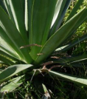
Figure 5. Sisal
Sisal extracts are effective in reducing inflammation, and some have shown anti-edematogenic effects and have been shown to have analgesic properties. Sisal is a source of hecogenin, which is used in the partial synthesis of the drug cortisone (Naveen J., et al. 2019).
Traditionally, sisal has been used as a folk remedy for dysentery, leprosy sores, and syphilis. Saponins, found in sisal, can disrupt erythrocytes and cause cell lysis due to their detergent action. Its fresh leaf contact with the body cause painful itching that may results in boils (Naveen J., et al. 2019).
- Azadirachta indica (Neem)
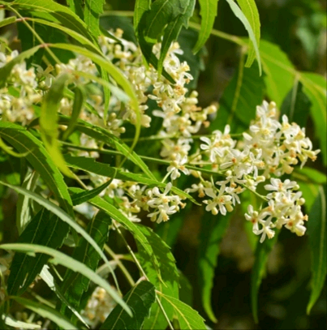
Figure 6. Azadirachta indica (Neem)
Azadirachta indica locally known by the Bamba-Babwisi of Bundibugyo (Western Uganda) as Nheem is used for leprosy, eye disorders, bloody nose, intestinal worms, stomach upset, loss of appetite, skin ulcers, diseases of the heart and blood vessels (cardiovascular disease), fever, diabetes, gum disease (gingivitis), and liver problems. The leaf is also used for birth control and to cause abortions. It’s also used for malaria, skin conditions, and as an insect repellent.
The bark is used for malaria, stomach and intestinal ulcers, skin diseases, pain, and fever. The flower is used for reducing bile, controlling phlegm, and treating intestinal worms. The fruit is used for hemorrhoids, intestinal worms, urinary tract disorders, bloody nose, phlegm, eye disorders, diabetes, wounds, and leprosy. Neem twigs are used for cough, asthma, hemorrhoids, intestinal worms, low sperm levels, urinary disorders, and diabetes. People in the Central regions of Uganda and some western parts sometimes chew neem twigs instead of using toothbrushes, but this can cause illness, neem twigs are often contaminated with fungi within two weeks of harvest and should be avoided.
Potential Side Effects
These include vomiting, diarrhea, drowsiness, blood disorders, seizures, loss of consciousness, coma, brain disorders, and even death.
Toxicity
Large doses or long-term use of neem oil or bark can potentially harm the kidneys and liver. Neem oil and bark are likely unsafe when taken orally during pregnancy. Prolonged use can cause liver and kidney damage, especially in children.
- Aloe vera
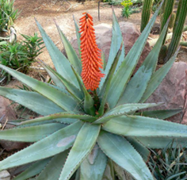
Figure 7. Aloe Vera
“Aloe vera is known for its thick, pointed, and fleshy green leaves, which may grow to about 12–19 inches (30–50 centimeters) in length. Each leaf contains a slimy tissue that stores water, making the leaves thick. This water-filled tissue is the “gel” that people associate with aloe vera products. Aloe vera is a medicinal plant with antioxidant and antibacterial properties. Aloe vera benefits include reducing dental plaque, accelerating wound healing, preventing wrinkles, and managing blood sugar” (Kamath NP, et al. (2020). “The gel contains most of the beneficial bioactive compounds in the plant, including vitamins, minerals, amino acids, and antioxidants. Antioxidants are important for health. Aloe vera gel contains trusted Source powerful antioxidants belonging to a large family of substances known as polyphenols. These polyphenols, along with several other compounds in aloe vera, help inhibit the growth of certain bacteria that can cause infections in humans. It stimulates wound healing and most people often use aloe vera as a topical medication, rubbing it onto the skin rather than consuming it” (Kaminaka C, et al. (2020). “It has a long history of use in treating sores, and particularly burns, including sunburn” (Hekmatpou D,et al., . 2019). “Aloe vera reduces dental plaque, tooth decay and diseases of the gum are very common health problems” (Kamath NP, et al. (2020).
Toxicity
Allergic reaction
Some people may be allergic to raw aloe vera, resulting in contact dermatitis symptoms including redness, hives, itching, and skin rash.
Skin Irritation
Increased skin sensitivity or irritation immediately after application
Dryness
Prolonged exposure to raw aloe vera gel on the face can lead to dryness.
Stinging or Burning
Application on dry or sensitive skin may cause temporary stinging or burning sensations.
Excessive consumption of aloe latex can cause diarrhea, kidney damage, and electrolyte imbalances (Pressman P. et al 2019).
- llium sativum
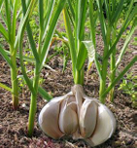
Figure 8. Garlic
Garlic is a common bulb vegetable that is used to flavor food. Western Uganda people call it Katunguluchumu/ katunguruichumu. Its herbaceous plant with coated bulb consisting of some ten pods enclosed in a common papery sheath; flat and smooth leaves, whitish or greenish umbellate flowers frequently replaced by bulblets. Garlic is indigenous to Uganda and is cultivated all over Uganda. The plant contains biologically active components that contribute to its pharmacological properties. Carbohydrates, protein, fat, minerals, water, and vitamins are all found in abundance in this plant. The plant also has a high medicinal value and is used to cure a variety of human diseases.
The part used is the bulbs. Garlic is used as Antimicrobial, dietetic, flavouring agent, anthelmintic, antihypertensive, colon cancer chemoprevention.
Toxicity and side effects
Digestive Issues
Excessive garlic consumption can lead to bad breath, nausea, vomiting, and abdominal pain.
Kidney Damage
Studies suggest that high doses of garlic may damage the kidneys.
Allergic Reactions
Some individuals may experience allergic reactions, including skin rashes, hives, and swelling.
Interactions with Medications
Garlic can interact with anticoagulants and other medications, potentially increasing the risk of bleeding (Bayan L. et al, 2014).
- Annona muricata
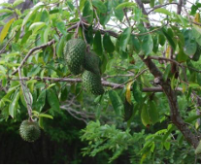
Figure 9. Soursop
Annona muricata is an evergreen plant growing in tropical and subtropical regions. It is commonly called prickly custard apple, soursop orGraviola. The Bamba-Babwisi of Western Uganda call it Kitafiili. Because of the rich amount of phytochemicals, it has ethnomedical importance. In western Uganda and other parts of the country, leaves are traditionally used to control fever, skin rashes, and convulsive seizures. It’s used to elevate mother milk after childbirth. It is an antioxidant agent also used to treat cancer and parasitic infection. The leaf extract is used to treat colon and Brest cancer and 12 other types of cancer and has potential anti-arthritic activity. Leaf extract with methanol shows potential antidiabetic and hypolipidemic properties. Its fruit extract is used for the treatment of depression. Oral administration of leaf extract suppresses abdominal expressions induced with acetic acid exhibit anti-inflammatory activity also shows antinociceptive activities.
Over eating, may lead to stomach discomfort, vomiting
- Moringa oleifera (Moringa)
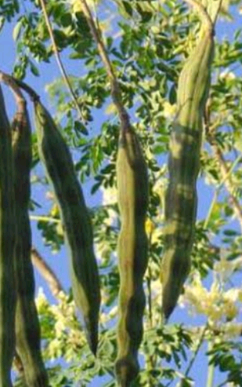
Figure 10. Moringa Oleifera figure captured by kakwangwa chance James.
Moringa oleifera is a fairly large tree native to all parts of the country that has been used in traditional herbal remedies for the recent Twenty years. It’s used for malnutrition, diabetes, and inflammation. Moringa oleifera, specifically its leaves, has been studied for its potential health benefits. Research indicates that it may have hypocholesterolemic effects, meaning it could help lower cholesterol levels. Studies involving both obese patients and rats fed high-fat diets have shown promising results. Furthermore, moringa leaves are also recognized for their potential to help with hypercholesterolemia and hypoglycemic effects (Ghasi, S. et al., 2000).
Toxicity
This can include alterations in liver and kidney function, miscarriage, changes in blood parameters, diarrhea, insomnia, and kidney stone formation due to the high alkaloid contents (T.P. Millard et al., 2003).
11.Capsicum annuum
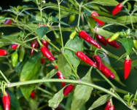
Figure 11: Capsicum annuum
Commonly known as red pepper but the Bamba-Babwisi of Bundibugyo western Uganda calls it Kamulali khee nonni. It is applied externally as a stimulant and counter irritant; internally, as a pungent stomachic, carminative and stimulant, to dispel flatulence and rouse the appetite. Toxicity includes stomach discomfort. It’s not well absorbed in the GI tract and it may be felt during defection if consumed in high doses
- Carica Papaya
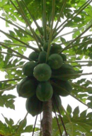
Figure 12. Carica Papaya
Commonly known as Pawpaw or Papaya but the Bamba-Babwisi of Bundibugyo and most western Uganda societies call it Kiipapaali. Odor of ripe fruit is faintly aromatic and has a sweet taste. Fruit, berry, oblong to oblong ovate in shape, dark green becoming yellowish orange on ripening with numerous seed on parietal placenta, epicarp is leathery, mesocarp is fleshy, orange-coloured. The milky juice of the unripe fruits used as cosmetic, anthelmintic, also has oxytocic properties. Ripe fresh fruits are stomachic, carminative, digestive and diuretic. It is not recommended to a patient of Ulcers. Excessive consumption/high doses may result in running stomach
- Citrus limonum Risso
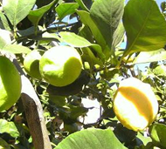
Figure 13. Picture taken by Mugaba Robert.
Commonly known as Lemon, Citron Citronnier or Limonier. Most societies in Uganda call it Muchungwa-Ndimawa. This is a short-boled shrub that sometimes branches off near the base, branches more or less wide spreading, and thorny; leaves, simple. Lemon is packed with vitamin c and other nutrients. It is known to cause stomach discomfort.
13. Psidium guajava (guava)
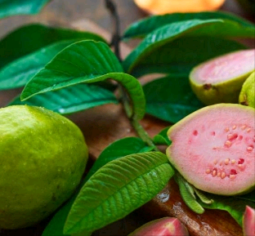
Figure 14. Guava
Locally Known as Maapela Babwisi of Bundibugyo District and in most societies in Uganda, guava is well known tropic tree which is abundantly grown for fruit. This plant finds applications for the treatment of diarrhea, dysentery, gastroenteritis, hypertension, diabetes, caries and pain relief and for improvement in locomotors coordination.
Its leaf’s extract is being used as a medicine in cough, diarrhea, and oral ulcers and in some swollen gums wound. Its fruit is rich in vitamins A, C, iron, phosphorus and calcium and minerals (Rahim N,et al. 2010). “Guava contains high content of organic and inorganic compounds like secondary metabolites e.g. antioxidants, polyphenols, antiviral compounds, anti-inflammatory compounds” (Rahim N,et al. 2010).
“The phenolic compounds in guava help to cure cancerous cells and prevent skin aging before time. The presence of terpenes, caryophyllene oxide and p-selinene produces relaxation effects. Guava leaves contain many compounds which act as fungistatic and bacteriostatic agents. Guava has a high content of important antioxidants and has radio-protective ability. Quercetin is considered as most active antioxidant in the guava leaves and is responsible for its spasmolytic activity. Its ethyl acetate extract can stop the germ infection and thymus production” (Jiminez-Escrig A, et al. 2001). Guava leaf extract may cause temporary nausea or stomach pain in some individuals.
14. Pumpkin (Cucurbita maxima, Cucurbita moschata and Cucurbita pepo)
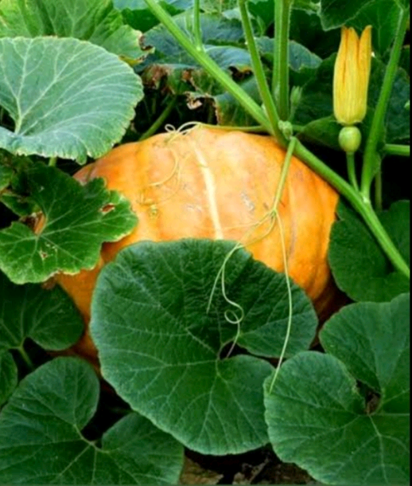
Figure 15. Pumpkin Leaves picture taken by Kakwangwa Chance James
Pumpkin leaf is a nutritious and exotic African leafy vegetables. Pumpkin leaves are rich in iron content which is vital to the proper function of haemoglobin, which reduces the chances of anaemia. Pumpkin leaves also have the ability to reduce incidences of non-communicable chronic diseases such as type 2 diabetes (Akwaowo E.U.A., 2000). The leaves are rich in vitamins and minerals such as Ca, P and Fe. The seed is also eaten as food. The oil obtained from the seed to possess antioxidant property. “The aqueous extract had a high cidentalis leaf contained a significantly high amount of vitamin C, free soluble polyphenols content in the leaf of the plant which was ity as typified by their higher reducing power and free radicals” (Akwaowo E.U.A., 2000).
Toxicity
Pumpkin leaves can contain compounds like tannins and phytates that can interfere with the absorption of minerals like iron and zinc. Root extracts of fluted pumpkin have been shown to contain toxic compounds, including alkaloids and saponins (Akwaowo E.U.A., 2000).
CONCLUSION
Medicinal plants are an integral part of Uganda’s healthcare system, offering affordable and accessible treatment options. Proper evaluation of toxicity is essential to ensure their safe and effective use. Phytochemical analysis, in vitro and in vivo studies, and clinical trials are some of the methods used to assess the toxicological profile of these plants. As the use of herbal medicine continues to grow, there is a need for stronger regulatory oversight and more scientific research to validate the safety of commonly used medicinal plants in Uganda. Ultimately, while medicinal plants hold great promise for treating various diseases, understanding their potential toxicity is key to maximizing their benefits and minimizing risks to public health. However, their potential toxicity cannot be ignored. Evaluating the safety of these plants through scientific research, public education, and regulatory oversight is essential to ensure their responsible use. By addressing the challenges and promoting safe practices, Uganda can harness the benefits of its rich biodiversity while protecting the health of its people. This review provides valuable ethnobotanical insights into commonly used medicinal plants in Uganda, highlighting their therapeutic applications alongside associated toxicities. By documenting traditional knowledge and aligning it with available scientific evidence, it bridges the gap between indigenous practices and modern toxicological evaluation. A detailed review of pharmacological properties and potential adverse effects serves as a critical resource for researchers, healthcare practitioners, and policymakers. Ultimately, it supports the safe integration of herbal remedies into public health systems while promoting further research into the standardization and regulation of traditional medicine.

Disclaimer (Artificial intelligence)
Author(s) hereby declare that NO generative AI technologies such as Large Language Models (ChatGPT, COPILOT, etc.) and text-to-image generators have been used during the writing or editing of this manuscript.

REFERENCES
Akwaowo E.U.A., Ndon B.A. and Etuk E.U. (2000) Minerals and antinutrients in fluted pumpkin (Telfairia occidentalis Hook f.). Food Chemistry 70(2), 235–240.
Anywar, G., Byamukama, R., Tumwebaze, M., & Lye, K. A. (2021). A review of ethnobotany, phytochemistry and pharmacology of Albizia coriaria. Journal of Ethnopharmacology, 269, 113689. https://doi.org/10.1016/j.jep.2020.113689.
Araya-Quintanilla F, et al. (2021). Effectiveness of aloe vera in patients with type 2 Diabetes Mellitus and pre-diabetes: An overview of systematic reviews.
https://www.sciencedirect.com/science/article/abs/pii/S187140212100312X?via%3Dihub
Bayan L., Koulivand P. H., Gorji A. Garlic: a review of potential therapeutic effects. Avicenna journal of phytomedicine. 2014;4(1):1–14
Bunalema, L., Obakiro, S. B., Tabuti, J. R. S., & Waako, P. (2014). Knowledge, attitudes and practices on the use of traditional medicine among communities in Uganda: A cross-sectional study. BMC Complementary and Alternative Medicine, 14(1), 333. https://doi.org/10.1186/1472-6882-14-333
Edgar, AD; Levin, R; Constantinou, CE; Denis, L (2007). "A critical review of the pharmacology of the plant extract of Pygeum africanum in the treatment of LUTS". Neurourology and Urodynamics. 26 (4): 458–63, discussion 464. doi:10.1002/nau.20136. PMID 17397059. S2CID 24774409.
Eisenberg, DM, Davis, RB, Ettner, SL, et al., JAMA 1998; 280:1569.
Ernst, E. J Intern Med 2002; 252:107.
Farzaei MH, Bayrami Z, Farzaei F, Aneva I, Das SK, Kumar Patra J, Das G, Abdollahi M. Poisoning by Medicinal Plants. Iran Med. 2020; 23:117–27.

Ghasi S, Nwobodo E, Ofili JO. Hypocholesterolemic effects of crude extract of leaf of Moringa oleifera Lam in high-fat diet fed wistar rats. J Ethnopharmacol. 2000 Jan;69(1):21-5. doi: 10.1016/s0378-8741(99)00106-3. PMID: 10661880.
Graham, RE, Ahn, AC, Davis, RB, et al. J Natl Med Assoc 2005; 97:535.
Hamidi, Mentor & Jovanova, Blagica & Kadifkova Panovska, Tatjana. (2014). Toxicological evaluation of the plant products using Brine Shrimp (Artemia salina L.) model. Macedonian Pharmaceutical Bulletin. 60. 9-18. 10.33320/maced.pharm.bull.2014.60.01.002.

Hekmatpou D, Mehrabi F, Rahzani K, Aminiyan A. The Effect of Aloe Vera Clinical Trials on Prevention and Healing of Skin Wound: A Systematic Review. Iran J Med Sci. 2019 Jan;44(1):1-9. PMID: 30666070; PMCID: PMC6330525.
Hekmatpou D, Mehrabi F, Rahzani K, Aminiyan A. The Effect of Aloe Vera Clinical Trials on Prevention and Healing of Skin Wound: A Systematic Review. Iran J Med Sci. 2019 Jan;44(1):1-9. PMID: 30666070; PMCID: PMC6330525
Huang, WF, Wen, KC, Hsiao, ML. J Clin Pharmacol 1997; 37:344.
Jiminez-Escrig A, Rincon M, Pulido R, Saura-Calixto F. Guava fruit (Psidium guajava L.) as a new source of antioxidant dietary fiber. J Agric Food Chem. 2001;49(11):5489–93.
Kaggwa, B., Kyeyune, H., Munanura, E. I., Anywar, G., Lutoti, S., Aber, J., ... & Ogwang, P. E. (2022). Safety and Efficacy of Medicinal Plants Used to Manufacture Herbal Products with Regulatory Approval in Uganda: A Cross‐Sectional Study. Evidence‐Based Complementary and Alternative Medicine, 2022(1), 1304839.
Kamath NP, et al. (2020). The effect of aloe vera and tea tree oil mouthwashes on the oral health of school children.
https://pubmed.ncbi.nlm.nih.gov/31111439/
Kaminaka C, et al. (2020). Effects of low‐dose Aloe sterol supplementation on skin moisture, collagen score and objective or subjective symptoms: 12‐week, double‐blind, randomized controlled trial.
https://pmc.ncbi.nlm.nih.gov/articles/PMC7496846/
Keehn A, Taylor J, Lowe FC (July 2016). "Phytotherapy for Benign Prostatic Hyperplasia". Curr Urol Rep. 17 (7): 53. doi:10.1007/s11934-016-0609-z. PMID 27180172. S2CID 25609876.).
Letoyah A. Y., Antiproliferative Activity. Phytochemical Composition and Toxicity Studies of Fagaropsis Angolensis and Prunus Africana Crude Extracts. University of Nairobi; 2017. Msc thesis.
Nabila VK, et al. (2020). The effect of Aloe vera ethanol extract on the growth inhibition of Candida albicans.
https://pubmed.ncbi.nlm.nih.gov/32662608/
Najafizade N, et al. (2024). Investigating the effect of Aloe vera on the prevention and treatment of radiotherapy-induced oral mucositis in patients with head-and-neck cancer.
https://pmc.ncbi.nlm.nih.gov/articles/PMC11132420/
Naveen J., Jawaid M., Amuthakkannan P., Chandrasekar M. 21—Mechanical and Physical Properties of Sisal and Hybrid Sisal Fiber-Reinforced Polymer Composites. In: Jawaid M., Thariq M., Saba N., editors. Mechanical and Physical Testing of Biocomposites, Fibre-Reinforced Composites and Hybrid Composites. Woodhead Publishing; Cambridge, UK: 2019. pp. 427–440. (Woodhead Publishing Series in Composites Science and Engineering
Ni, H, Simile, C, Hardy, AM. Med Care 2002; 40:353.
Pattnaik N, et al. (2021). Aloe vera mouthwashes can be a natural alternative to chemically formulated ones – A randomized-controlled trial.
https://pubmed.ncbi.nlm.nih.gov/35722228/
Philomena G. Concerns regarding the safety and toxicity of medicinal plants - An overview. J Appl Pharmaceut Sci 2011; 01(6): 40-44.
Pressman P, Clemens R, Hayes AW. Aloe vera at the frontier of glycobiology and integrative medicine: health implications of an ancient plant. SAGE Open Medicine. 2019; 7:2050312119875921.
Rahim N, Gomes DJ, Watanabe H, Rahman SR, Chomvarin C, Endtz HP, Alam M. Antibacterial activity of Psidium guajava leaf and bark against multidrug-resistant Vibrio cholerae. Jpn J Infect Dis. 2010; 63:271–4.
Sánchez M, et al. (2020). Pharmacological update properties of aloe vera and its major active constituents.
https://pmc.ncbi.nlm.nih.gov/articles/PMC7144722/
Saydah, SH, Eberhardt, J Altern Complement Med 2006; 12:805.
Seeff, LB, Lindsay, KL, Bacon, BR, et al. Hepatology 2001; 34:595.
Strader, DB, Bacon, BR, Lindsay, KL, et al. Am J Gastroenterol 2002; 97:2391.
T.P. Millard, Y.W. Wong, D.I. Orton. Erythrodermic cutaneous adverse drug reaction to oral pseudoephedrine confirmed on patch testing. Contact Dermatitis, 49 (2003), pp. 263-264 http://dx.doi.org/10.1111/j.0105-1873.2003.0225f.x | Medline
Tabuti, J. R., Kukunda, C. B., & Waako, P. J. (2010). Medicinal plants used by traditional medicine practitioners in the treatment of tuberculosis and related ailments in Uganda. Journal of ethnopharmacology, 127(1), 130-136.
Tabuti, J. R. S., Lye, K. A., & Dhillion, S. S. (2003). Traditional herbal drugs of Bulamogi, Uganda: Plants, use and administration. Journal of Ethnopharmacology, 88(1), 19–44. https://doi.org/10.1016/S0378-8741(03)00161-2
Uganda Bureau of Statistics, 2008.
WHO (World Health Organization). Traditional medicine strategy: (2014-2023). https://www.who.int/publications/i/item/9789241506096
WHO (2004). Guidelines on Safety Monitoring of Herbal Medicines in Pharmacovigilance Systems. World Health Organization. https://apps.who.int/iris/handle/10665/43034
World Population Prospects, 2022.

