ACUTE AND SUB-ACUTE TOXICITY EFFECT OF HYDRO-ETHANOLIC EXTRACT OF HERBAL PRODUCT COMPONENTS (Securidaca longipedunculata AND Spondia mombin) IN MALE WISTAR RATS

ABSTRACT
The management of diverse ailment have been treated with myriads of medicinal plants with the toxicological evaluation under estimated. This study evaluated the toxicity of a binary herbal mix containing Securidaca longipedunculata and Spondias mombin, widely used in Ogbomoso for managing benign prostatic hyperplasia. The powdered product was subjected to hydro-ethanol extraction obtaining Securidaca longipedunculata and Spondias mombin extract (SLSME) and analyzed using Gas Chromatography–Mass Spectrometry; identifying eighteen phytochemical compounds. Acute toxicity was investigated in four Wistar rats, while sub-acute effects were evaluated in twenty male rats (130 g average weight) administered 167, 250, and 500 mg/kg of SLSME daily for 14 days.
Biochemical, hematological and histological parameters were examined. No mortality occurred at 5000 mg/kg in acute testing. Sub-acute exposure significantly reduced ALP, AST, creatinine, urea, uric acid, LDL, TAG, and cholesterol, while elevating HDL and some hematological indices. Histology showed mild hepatic and renal alterations at higher doses but no marked damage at 167 mg/kg. Overall, SLSME exhibited low toxicity which support its traditional use.
In conclusion, this study has shown that the herbal product exerts no toxicity in the liver, kidney and blood of the experimental Wilstar rats.

Keywords: Securidaca longipedunculata, Spondias mombin, Binary Herbal Mix, SLSME and Gas Chromatography-Mass Spectrometry.

- Introduction
Traditional medicine has long played a vital role in healthcare systems, particularly in developing nations where access to conventional medicine is often limited (WHO, 2013). In Nigeria, herbal remedies are widely used for managing various ailments, including prostate enlargement, which is a condition that is predominant among aged men (Sofowora, 1996). Prostate enlargement, or benign prostatic hyperplasia (BPH), is identified by the non-malignant proliferation of the prostate gland, leading to urinary difficulties and other complications (Roehrborn, 2025). Many men resort to herbal treatments due to their perceived affordability, accessibility, and effectiveness. However, despite their widespread use, the safety profiles of many of these herbal remedies remain largely unverified.
The prevalent dependent use of herbal products in the management of prostate enlargement necessitates the strict scientific analysis of their toxicity profile (Ekor, 2014; Csikós et al., 2021) even though some of these products have bioactive compounds with therapeutic potential, they also harbor toxic elements that are likely to cause health problems when used chronically (Posadzki et al., 2013). Evaluating the acute and subacute toxicity of herbs is essential since it provides information about the potential negative effects of these medications, ensuring their safety. These researches contribute to establishing the deadly dosages, physiological alterations, and histopathological consequences of both short and long-term exposure of herb extracts (Jordan and Cunningham, 2010; Navarro et al., 2017).
In light of the mounting doubts over the efficacy of herbal remedies for prostate enlargement, the purpose of this study was to assess the acute and sub-acute toxicity effects of a well-known herbal product made from two distinct plants (Securidaca longipedunculata and Spondia mombin) which are traditionally utilized in Nigeria, particularly in Ogbomoso for the management of benign prostatic hyperplasia, amidst growing scepticism regarding the effectiveness of herbal remedies for prostate enlargement. Securidaca longipedulata is the so-called violet tree that is characterized by anti-inflammatory and antioxidant properties (Ogunmefun and Gbile, 2012; Mustapaha, 2013; Maroyi, 2013). Saponins, alkaloids, flavonoids, and the rest of the bioactive components of the plant can help improve its therapeutic efficacy by controlling oxidative stress and inflammatory processes (Dermane et al., 2024). These properties are especially necessary in reducing the symptoms associated with BPH and reducing the risk of prostate cancer (Roehrborn, 2008). However, the "hog plum," or Spondias mombin, has multiple pharmacological properties that could benefit prostate health, including as antioxidant activity, anti-inflammatory actions, and possible hormonal modulation (Ogunro et al., 2022; Igharo et al., 2024). In addition to this, its anti-proliferative and antibacterial properties could also increase its suitability as a component of binary herb powder-based therapies against prostate-related conditions. The study involved the safety of binary herbal powder mix of Securidaca longipedulata and Spondias mombin as applied to prostate health.

- Methodology

2.1 Plant Collection and Extraction
The herbal powder containing Securidata longipedunculata and Spondias mombin was purchased from a local herb seller at Ojagbo Ogbomoso, Oyo State, Nigeria. The plant sample was extracted using hydro-ethanol in accordance with Handa et al., (2008) methodology. Securidata longipedunculata and Spondias mombin extracted powder (SLSME) was obtained by freeze-drying the extract after it had been concentrated using a rotary evaporator.

2.2 Phytochemical analysis using Gas Chromatography-Mass Spectrometry (GC-MS)
The SLSME was subjected to GC-MS analysis using a combined 7890A gas chromatograph system (Agilent 19091-433HP, USA) and mass spectrophotometer. The system was fitted with a HP-5 MS fused silica column (5% phenyl methyl siloxane 30.0m × 250 μm, film thickness 0.25 μm), interfaced with 5675C Inert MSD with Triple-Axis detector. Helium gas was used as carrier gas and was adjusted to column velocity flow of 1.0 ml/min. The relative percent amount of each component was calculated by comparing its average peak area to total areas.

2.3. Experimental Animals
Twenty-four male Wistar rat with average weight of 130g were bought from the animal house at Ladoke Akintola University of Technology, Ogbomoso, Oyo State, Nigeria. Animals were kept in a room under natural light and dark cycle, with free access to rat chow and water and were acclimatized for two weeks before the study commenced.
2.4 Determination of LD₅₀
Four rats were used for to determine the LD₅₀ (2 female and 2 male). The up and down method was adopted (Bruce, 1985; OECD, 2013). The procedure entailed administering doses to the rats individually using a "staircase method" as a limit test, commencing with the lowest dose (2000 mg/kg) and increasing the dosage in the absence of death or behavioural alterations until reaching the maximum dose (5000 mg/kg). The animals were observed for 48 hours after being weighed and given the lowest dose possible, 2000 mg/kg. Subsequently, the dosage increased to the maximum level of 5000 mg/kg of the extract in the absence of mortality or behavioral alterations. Thereafter, the rats were observed for 72 hours following the administration of 5000 mg/kg of the extract.

2.5 Sub-acute Toxicity Test
Twenty rats were randomly grouped into four (4) groups, each consisting of five rats, to evaluate the sub-acute toxicity of the substance. They were administered orally for 14 days in the following ways:
Group 1: Rats served as normal control were fed with normal rat chow
Group 2: Rats administered with 167 mg/kg of the herbal extract daily.
Group 3: Rats administered with 250 mg/kg of the herbal extract daily.
Group 4: Rats administered with 500 mg/kg of the herbal extract daily.

2.6 Sacrifice and Tissue Collection
The rats undergone overnight fasting and were anaesthetized with diethyl ether. Blood samples were obtained by cardiac puncture into heparinized and plain tubes. Blood samples in heparinized tubes were used for haematological evaluation while those in the plain tubes were processed into serum to determine biochemical parameters. The liver and kidneys were harvested, rinsed and fixed in 10% formalin for histology.

2.7 Biochemical Parameters
The serum was analyzed for the activities of aspartate aminotransferase (Bergmeyer et al., 1985), alanine aminotransferase (Bergmeyer et al., 1985) and alkaline phosphatase (Peake et al., 1988). Albumin and total protein were analyzed according to the method of (Elvin-Lewis, 2001) while total bilirubin was analyzed using the method of (Ezeja et al., 2014). The serum was also analyzed for creatinine, urea uric acid (Wasan et al., 2001). Low-density lipoprotein (LDL), high-density lipoprotein (HDL), cholesterol and triacyl glyceride were analyzed using the method described by (Fossati and Principe, 1982).

2.8 Histopathological Examination
The harvested liver and kidneys were sectioned by a microtome into 5-μm thick slices and stained with hematoxylin and eosin (HandE) dye. The stained sections were viewed with Leica Optika B-192 microscope at power magnifications of 10 and 40, and photomicrographs were recorded (Martey et al., 2010).

2.9 Statistical Analysis
All the statistical analyses were carried out using GraphPad Prism software, version 9.0 (2022). Values of p < 0.05 were considered statistically significant. Data were expressed as the mean ± SEM, Statistical analysis was done by t-test analysis.

Results

3.1 LD₅₀ Determination of SLSME
Rats treated with 2000 and 5000 mg/kg of the SLSME showed no changes in behavior and no apparent toxicity symptoms after 72 hours post treatment. The rats survived the highest dose; hence, it was concluded that the LD₅₀ of the extracts was greater than 5000 mg/kg/body weight.

3.2 Gas Chromatography-Mass Spectrometry of SLSME
A total of 17 phytochemical compounds were identified from the GC-MS analysis of the extract. The chromatogram is presented in Figure 1 while the chemical constituents with their peak width, molecular weight and concentration (%) are represented in Table 1.

Table 1: Phytochemical Screening of Polyherbal Extract (Spondia mombin and Securidaca longipendunculata)
S/N Identified Compounds Peak Value Molecular Weight Retention Time Peak Area
1. Furan, 3-methyl- 0.183 82.042 3.705 1747150
2. Bicyclo[4.2.0]octa-1,3,5-triene 0.086 104.063 4.105 352077
3. Cyclohexene, 3-methyl- 0.086 96.094 4.55 840312
4. 2(5H)-Furanone, 3-methyl- 0.063 98.037 4.66 509248
5. Benzaldehyde 0.286 106.042 5.204 3990577
6. Phenol 0.097 94.042 5.507 1693716
7. Benzofuran 0.029 118.042 5.696 4509319
8. Benzene, 2-propenyl 0.092 118.078 6.102 341663
9. Acetophenone 0.206 120.058 6.692 4471283
10. Phthalan 0.126 120.058 6.938 298671
11. Undecane 0.074 156.188 7.178 255936
12. Benzofuran, 7-methyl- 0.086 132.058 7.241 1197653
13. Benzofuran, 2-methyl- 0.189 132.058 7.321 846524
14. Azulene 0.16 128.063 8.036 271325
15. Benzoic acid, ethyl ester 0.132 150.068 8.254 557548
16. Naphthalene, 2-ethenyl- 0.149 154.078 11.161 243066
17. 3-Phenyl-2-propyn-1-ol 0.166 132.058 11.647 312829

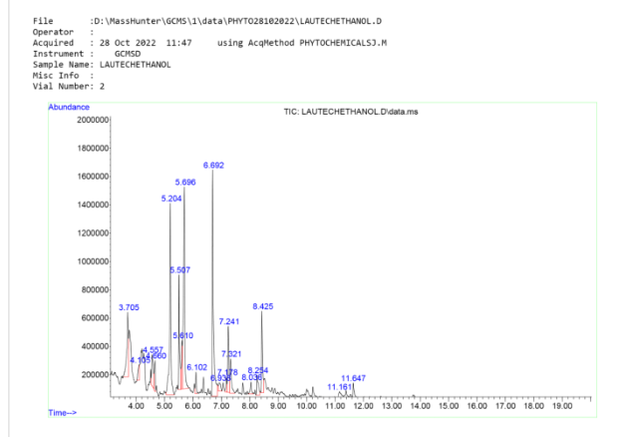

Figure 1: GC-MS chromatogram of hydro-ethanol extract of binary herbal powder mix

3.3 Effects of SLSME on Serum Lipid Profile
The extract was found to significantly (p<0.05) reduce the levels of low-density lipoprotein (LDL), Triglyceride (TAG) and Cholesterol at certain doses relative to control as shown in (Table 2). The level of high-density lipoprotein was however elevated by the extract relative to control.

Table 2: Effects of SLSME on Serum Lipid Profile
Treatment  (mg/kg bw) | LDL (mg/dl) | HDL (mg/dl) | TAG (mg/dl) | Cholesterol mg/dl)
500 | 8.29 ± 0.028* | 11.32 ± 0.023* | 75.21 ± 0.496* | 119.8 ± 0.012*
250 | 8.89 ± 0.024* | 11.86 ± 0.012* | 78.24 ± 0.014 | 120.5 ± 0.019*
167 | 9.45 ± 0.012 | 11.74 ± 0.013* | 76.41 ± 0.024* | 132.4 ± 0.029*
Control | 9.84 ± 0.007 | 9.43 ± 0.024 | 78.79 ± 0.017 | 130.4 ± 0.015
Value in Mean ± SD * significantly (p<0.05) lower than control (p<0.05)

LDL- Low Density Lipoprotein Cholesterol, HDL- High Density Lipoprotein, TAG- Low Density Lipoprotein

3.4 Effects of SLSME on Renal Function Markers
Table 3 showed that the tested doses of the extract significantly (p<0.05) reduced the levels of creatinine, urea and uric acid compared to the control (group A).

Table 3: Sub-acute Effect of SLSME on Serum Renal Function Indices
Treatment  (mg/kg bw) | Creatinine Conc (µmol/l) | Urea Conc (mg/dl) | Uric Acid Conc(mg/dl)
500 | 18.58 ± 0.0452* | 36.35 ± 0.0903* | 4.442 ± 0.0404*
250 | 20.44 ± 0.0604* | 37.38 ± 0.0479* | 4.528 ± 0.0347*
167 | 23.28 ± 0.0826* | 37.56 ± 0.0908* | 4.734 ± 0.0464*
Control | 22.54 ± 0.1023 | 40.40 ± 0.0450 | 5.538 ± 0.0439
Value in Mean ± SD * significantly (p<0.05) lower than control (p<0.05)

3.5 Effects of SLSME on Serum Liver Function Indices
In table 4, the lowest doses of the extract significantly (p<0.05) reduced the levels of ALP and AST while the high dose significantly (p<0.05) reduced ALT. However, the levels of albumin, total protein and total bilirubin were not significantly changed compared with the control.

Table 4: Effects of SLSME on Serum Liver Function Indices
Treatment  (mg/kg bw) | ALP Conc (µ/L) | AST Conc (µ/L) | ALT Conc  (µ/L) | Albumin Conc (g/dl) | Total Protein conc (g/dl) | Total Bilirubin  conc (µmol/l)
500 | 46.55 ± 0.5375* | 71.62 ± 0.4193* | 22.67 ± 0.653* | 2.535 ± 0.0598 | 6.281 ± 0.1301 | 43.52 ± 0.7478
250 | 46.11 ± 0.4787* | 70.24 ± 0.1442* | 25.85 ± 0.350 | 2.602 ± 0.0453 | 6.315 ± 0.0527 | 43.44 ± 1.111
167 | 49.06 ± 0.7400 | 84.91 ± 0.7724* | 28.43 ± 0.203 | 2.672 ± 0.0469 | 6.256 ± 0.0530 | 42.44 ± 0.9823
Control | 50.35 ± 0.9190 | 81.16 ± 0.7102 | 25.93 ± 1.383 | 2.661 ± 0.0612 | 6.198 ± 0.0468 | 44.61 ± 0.9024
Value in Mean ± SD * significantly (p<0.05) lower than control (p<0.05)

3.6 Effects of SLSME on Haematoligical Parameters
Table 5 show that the extract significantly elevated the values of white blood cell (WBC), lymphocyte, monocyte, haemoglobin (HB) and platelet at high doses relative to controls. However, the level of RBC had significantly reduced compared to control at low doses.

Table 5: Sub-acute Effects of Hydro-Ethanolic Herbal Extract on Haematological Markers of Experimental Rats
Treatment | WBC (x10⁹/L) | Lymphocyte (%) | Monocyte (%) | RBC (x10¹²/L) | HGB (g/dl) | PLT (x10⁹/L)
500 mg/kg b.w | 18.85 ±1.3# | 12.89 ± 0.10# | 0.76 ± 0.012# | 7.42 ± 0.066 | 156 ± 2.03# | 768.5 ± 9.27#
250 mg/kg b.w | 17.56 ± 0.69# | 11.71 ± 0.32# | 0.76 ± 0.008# | 6.15 ± 0.075* | 130 ± 1.86* | 736.9 ± 0.96#
167 mg/kg b.w | 15.93 ± 1.37# | 9.74 ± 0.41 | 0.61 ± 0.036 | 6.78 ± 0.039* | 147 ± 4.06 | 486.5 ± 22.42*
NRC | 8.19 ± 0.70 | 9.46 ± 0.37 | 0.59 ± 0.020 | 7.04 ± 0.088 | 144 ± 5.81 | 614.9 ± 15.00
Value in Mean ± SD * significantly (p<0.05) lower than control (p<0.05)
* (Significantly lower)
# (Significantly higher)
WBC- White Blood Cells, RBC- Red Blood Cells, HGB- Heamoglobin, PLT- Platelet.

3.7 Histopathology of Hepatic and Renal Tissue
Figure 1 shows the presence of congestion and infiltration in the hepatic parenchyma and sinusoids at 250 and 500 mg/kg of the extract during the subacute treatment. These features were not observed in the control. In Figure 2, the effect of the SLSME inflict a significant alteration that is characterized by hemorrhage, infiltration by red inflammatory cells, atrophy of the glomerulus (characterized by a wide capsular margin) and narrowed renal tubules at 250 and 500 mg/kg during the subacute treatment whereas these features were not observed in groups 167 mg/kg and control.

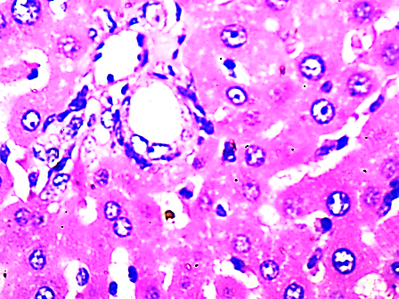
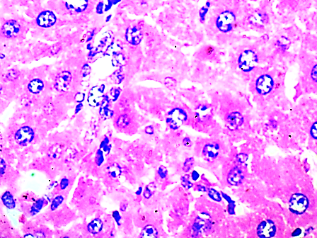
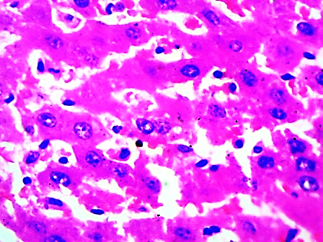
Portal triad
167 mg/kg
Control

Hepatocytes

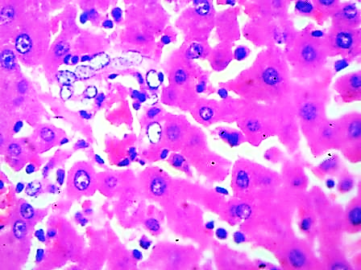
250 mg/kg
500 mg/kg
Kupffer cells

Sinusoid

Figure 2 Micrograph of liver of rats treated with hydro-ethanol extract of binary herbal powder mix (× 400)

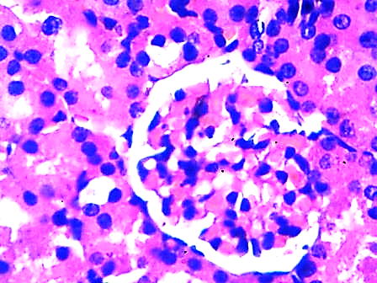
Control
Glomerulus
167 mg/kg
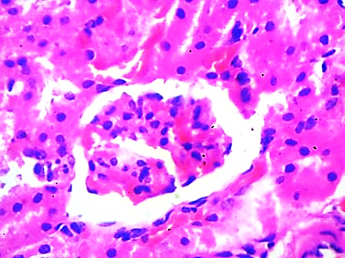
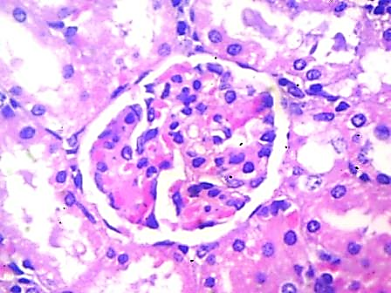
Maesangial clls

250 mg/kg
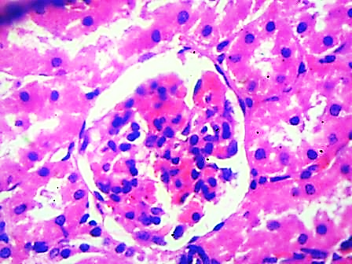
Renal tubules
500 mg/kg

Capsule

Figure 3 Micrograph of kidney of rats treated with hydro-ethanol extract of binary herbal powder mix (× 400)

DISCUSSION
The use of binary herbal powder mix formulations is growing across Africa, especially in managing chronic ailments such as benign prostatic hyperplasia (BPH). However, scientific evidence regarding their toxicological safety remains limited. Although many traditional herbal mixtures are based on anecdotal knowledge and cultural usage, there is a critical need to assess their safety in a controlled laboratory setting to prevent the risk of organ toxicity, systemic failure, or unintended pharmacological interactions (Ekor, 2014; Sharifi-Rad et al., 2022).
Seventeen chemical constituents identified in the hydro-ethanol extract of the binary herbal powder mix include azulene derivatives, benzofuran, benzoic acid esters, furan derivatives, and various volatile phenolics, all recognized for their extensive pharmacological potential, encompassing anti-inflammatory, antimicrobial, hepatoprotective, and antioxidant effects. Azulene, a significant compound in the extract, demonstrates protective effects by scavenging reactive oxygen species (ROS), regulating cytokines that cause inflammation (such as TNF-α and IL-6), and stabilizing cellular membranes, particularly in hepatic and renal tissues (Lee et al., 2023). Benzofurans are noted for their antimicrobial, anti-inflammatory and cytoprotective qualities (Chand et al., 2017). These bioactive phytochemicals existence in the plants supports the claims of the tradition use of herbal medicine in management of diseases (Ogbuagu et al., 2022; Lee et al., 2023).
The rats tested with doses up to 5000 mg/kg showed no signs of behavioral, physiological, or clinical harm, according to the extract's acute toxicity study. This implies that the LD₅₀ of the plants surpasses this dosage, categorizing the herbal formulation as virtually non-toxic based on the OECD's recommendations for acute oral toxicity (OECD, 2008). No fatalities or discernible adverse effects, such as lethargy, tremors, respiratory distress, or diarrhea, were observed during the 48-hour monitoring period. This result aligns with prior toxicological research on Spondias mombin, which also indicated a high LD₅₀ threshold of 5000 mg/kg in rodents (Maria et al., 2022). In contrast, Securidaca longipedunculata exhibited a more inconsistent safety profile, with certain studies reporting neurotoxicity and respiratory issues at doses exceeding 250–300 mg/kg, particularly with methanolic root extracts (Namadina et al., 2020).
Furthermore, the extract subacute toxicity evaluation was carried out to investigate the main lipid metabolism indices, such as total cholesterol, triglycerides, high-density lipoprotein, and low-density lipoprotein. This study revealed that the extract significantly reduced serum LDL, total cholesterol, and triglyceride levels, while elevating HDL levels across all treatment groups. These findings underscore the extract potential for cardiovascular protection. This action may be ascribed to phenolic and flavonoid compounds, including benzofurans and azulene, recognized for their role in modulating lipid metabolism and inhibiting cholesterol biosynthesis (Bakun et al., 2021). This observation aligns with findings indicating Spondias mombin leaf extracts may exhibit lipid-lowering properties at elevated doses, potentially through the inhibition of HMG-CoA reductase and the enhancement of lipoprotein lipase activity (Gomes et al., 2020). The antioxidant properties of azulene and quercetin-like flavonoids present in the extract may aid in stabilizing lipid profiles by diminishing lipid peroxidation and safeguarding LDL from oxidative alteration (Lee et al., 2023).
The elimination of metabolic waste products including urea and creatinine, blood pressure regulation, and electrolyte balance all depend on the kidneys. Evaluation of renal function using biochemical parameters including urea, creatinine, and uric acid is a crucial aspect of systemic toxicity research. This study found that serum creatinine levels considerably increased at 167 mg/kg but decreased at higher dosages, indicating that renal stress at lower doses was successfully alleviated at elevated doses. The levels of urea and uric acid were reduced in all treatment groups, suggesting that the extract does not impair renal excretory function and may enhance the clearance of nitrogenous waste at therapeutic doses. Nephrotoxicity has been documented with high dosages or extended exposure to Securidaca longipedunculata (Namadina et al., 2020). They also recorded elevated creatinine levels and histological evidence of tubular necrosis after prolonged treatment of its root extract. Nonetheless, these effects were absent in the current investigation, potentially attributable to the combination formulation with Spondias mombin, which is recognized for its renoprotective qualities (Ogunro et al., 2023). The renoprotective effect may result from the antioxidative and anti-inflammatory properties of S. mombin, which mitigate renal oxidative stress and glomerular dysfunction (Gomes et al., 2020; Ogunro et al., 2023).
The liver is pivotal in metabolism, detoxification, and homeostasis, rendering it a crucial focus in toxicological assessments. This study evaluated liver function by assessing serum concentrations of alanine aminotransferase (ALT), aspartate aminotransferase (AST), alkaline phosphatase (ALP), total bilirubin, albumin, and total protein. These biomarkers act as precise indications of hepatic injury, cholestasis, and the synthetic capacity of the liver. This study's data indicated that ALT levels were consistent across all doses, implying a lack of hepatocellular leakage or necrosis, which may reflect enhanced hepatic bile function and less hepatobiliary stress. The hydroethanolic extract of Securidaca longipedunculata and Spondias mombin is non-toxic and exhibits hepatoprotective properties. The extract did not compromise liver cellular integrity or metabolic activity at the given dosage. Cytosolic enzymes ALT and AST are typically released into the bloodstream when hepatocytes are injured or necrotic. Their stable levels in rats indicate the maintenance of hepatocyte membrane integrity and a low likelihood of hepatocellular damage (Veteläinen et al., 2007; Thapa and Walia, 2007). ALP is an enzyme that indicates hepatobiliary function, especially concerning bile duct obstruction or cholestasis. Its rise is commonly noted in disorders such as hepatitis, intrahepatic cholestasis, or infiltrative diseases, including granulomas and tumors. This investigation demonstrated that ALP levels remained below physiological limits across all treated groups, further indicating the absence of biliary or hepatobiliary disease (Poupon, 2015). The findings align with the hepatoprotective properties associated with antioxidant-rich phytochemicals, such as azulene and benzofuran derivatives found in the extract (Lee et al., 2023). The hepatoprotective properties of the hydro-ethanol extract from the binary herbal powder blend may be ascribed to its bioactive components, including azulene, flavonoids, and benzoic acid derivatives, which are recognized for their ability to inhibit lipid peroxidation, augment glutathione levels, and scavenge free radicals (Lee et al., 2023).
Haematological parameters offer critical insights into the physiological and pathological conditions of the circulatory and immune systems. These parameters are particularly susceptible to toxic shocks and frequently serve as the initial signs of systemic toxicity. Haematological parameters such as packed cell volume (PCV), haemoglobin concentration (Hb), red blood cell count (RBC), white blood cell count (WBC), and platelet count were evaluated in this study. The results revealed a significant elevation in WBC counts among all treatment groups, indicating heightened immunological activity or haematopoietic stimulation. Lymphocyte and monocyte counts were elevated at dosages of 250 and 500 mg/kg, indicating possible immunostimulant. A dose-dependent effect on erythropoiesis was evident as the red blood cell concentration increased at 500 mg/kg after decreasing at 167 and 250 mg/kg. RBC indices, such as hemoglobin and platelet counts, are commonly used to assess the blood capacity to carry oxygen and the erythrocytes functional integrity. The consistent values across these criteria indicate that the extract did not adversely affect bone marrow function or induce hemolysis. It also signifies sufficient erythropoietic stimulation and minimal disruption of erythrocyte shape or hemoglobin production. This discovery is significant as specific herbal components, particularly alkaloids and xanthones, may cause oxidative harm to red blood cells, resulting in haemolytic anaemia (Oduola et al., 2010). The absence of such effects indicates a protective or, at the very least, neutral function of the phytoconstituents in the extract.
This study's histological evaluation of liver and kidney tissues demonstrated alterations aligned with the dose-dependent biochemical and haematological patterns, especially in the low- and mid-dose groups. Hepatocellular pyknosis, periportal inflammation, and portal triad congestion were detected in the liver, correlating with the modest AST rise noted at a dosage of 167 mg/kg, indicating early-stage hepatic adaptation or stress. Correspondingly, the kidney tissue exhibited glomerular atrophy and tubular constriction at 167 mg/kg, correlating with the high creatinine level noted in the same cohort. The typical structural characteristics at 500 mg/kg corroborate the noted decrease in creatinine levels and enhancement of renal function. The data suggest that the extract may improve renal resilience at elevated doses, potentially attributable to the nephroprotective flavonoids present in S. mombin, as documented by (Akinmoladun et al. 2021).
In addition, this seeming contradiction between biochemical results and histopathologic alteration can be attributed to sensitivity and differences in the time frames of detection. Biochemical analyses detect the leakage of enzymes into the bloodstream in the body systemically, whereas histopathology investigations evaluate localized tissue responses. In this case, the micrographic evidence of inflammation or congestion can be present without the corresponding measurable elevation in enzymes (Ezeja et al., 2014). Moreover, the antioxidant phytochemicals in these medicinal plants can prevent the permeability alterations in the hepatorenal tissues; this ensures that the levels of serum enzymes are normal even in the face of slight remodeling or remodeling changes in the tissues (Lee et al., 2023). Similarly, the same trend was also detected in the case of plant extracts that activate xenobiotic and antioxidant systems simultaneously (Namadina et al., 2020; Siqueira et al., 2020).
The minor renal alterations seen at elevated dosages may be linked to osmotic or metabolic stressors, given that Securidaca longipedunculata contains chemical constituent saponins and alkaloids capable of significantly influencing tubular reabsorption. The co-occurrence of Spondia mombin, recognized for its renoprotective characteristics, presumably mitigated effects by functioning synergistically as antioxidants and anti-inflammatory agents (Ogunro et al., 2023). This mechanism would elucidate the reported normal or enhanced Glomerular Filtration Rate (GFR) indices despite the histological alterations.
Integrating the biochemical and histological data indicates that the hydro-ethanolic extract facilitated physiological adaptation without causing toxic damage. At low to moderate dosages, the extract maintained systemic homeostasis. However, at elevated doses, a transient stress response was observed, manifesting solely in histological assessments rather than biochemical analyses. The absence of necrosis, fibrosis, or enzyme leakage may be attributed to the activation of metabolic adaptation or detoxifying and antioxidant pathways by the phytochemicals (Ekor, 2014).

CONCLUSION
This study has shown that the hydro-ethanolic extract of Securidaca longipedunculata and Spondias mombin (SLSME) is quite safe, exhibiting no mortality at doses up to 5000 mg/kg and only moderate, reversible alterations in liver and kidney structure under severe sub-acute circumstances. The alterations noted in lipid metabolism included a reduction in LDL, triglycerides, and cholesterol, alongside an elevation in HDL, which can be partially ascribed to the presence of phenolic and flavonoid compounds recognized for their modulatory effects on lipid pathways and their protective role against oxidative damage. Similarly, the decrease in creatinine, urea, and uric acid, along with the renoprotective properties of S. mombin constituents, including benzofuran derivatives and azulene, is recognized for their ability to stabilize cell membranes, act as free radical scavengers, and alleviate glomerular stress.
The immunostimulatory impact, likely linked to the synergistic activity of benzofurans and other volatile bioactives included in the extract, is further evidenced by the enhanced hematologic indices, including elevated white blood cells, lymphocytes, and hemoglobin levels. These findings collectively provide mechanistic evidence supporting the traditional use of this herbal blend in treating benign prostatic hyperplasia, emphasizing its antioxidant, anti-inflammatory, and organ-protective properties. Despite the extract demonstrating a high safety level and various protective benefits at therapeutic levels, more chronic or sub-chronic studies may be conducted to ascertain the extract's safety and efficacy.
Ethical Approval
Animal Ethic committee approval has been collected and preserved by the author(s)
Disclaimer (Artificial intelligence)
Option 1:
Author(s) affirm that they did not utilize any generative AI tools such as ChatGPT, Copilot, or text-to-image generators during the composition or revision of this paper. If I had used any tools, Author(s) would list the name, version, model, source, and each prompt provided. In this instance, all of this is certainly their own work.

REFERENCES
- World Health Organization. (2018). WHO traditional medicine strategy 2014–2023. Geneva: WHO. https://apps.who.int/iris/handle/10665/92455
- Sofowora, A. (1996). Research on medicinal plants and traditional medicine in Africa. The Journal of Alternative and Complementary Medicine, 2(3), 365–372. https://doi.org/10.1089/acm.1996.2.365
- Roehrborn, C. G. (2005). Benign prostatic hyperplasia: An overview. Reviews in Urology, 7(Suppl 9), S3–S14. https://www.ncbi.nlm.nih.gov/pmc/articles/PMC1477638/
- Csikós, E., Horváth, A., Ács, K., Varga, E., & Lantos, T. (2021). Treatment of benign prostatic hyperplasia by natural drugs. Molecules, 26(23), 7141. https://doi.org/10.3390/molecules26237141
- Ekor, M. (2014). The growing use of herbal medicines: Issues relating to adverse reactions and challenges in monitoring safety. Frontiers in Pharmacology, 4, 177. https://doi.org/10.3389/fphar.2013.00177
- Posadzki, P., Watson, L., & Ernst, E. (2013). Herb–drug interactions: An overview of systematic reviews. British Journal of Clinical Pharmacology, 75(3), 603–618. https://doi.org/10.1111/j.1365-2125.2012.04350.x
- Jordan, S. A., Cunningham, D. G., & Marles, R. J. (2010). Assessment of herbal medicinal products: Challenges and opportunities to increase the knowledge base for safety assessment. Toxicology and Applied Pharmacology, 243(2), 198–216. https://doi.org/10.1016/j.taap.2009.12.005
- Navarro, V. J., Khan, I., Björnsson, E., Seeff, L. B., Serrano, J., & Hoofnagle, J. H. (2017). Liver injury from herbal and dietary supplements. Hepatology, 65(1), 363–373. https://doi.org/10.1002/hep.28813
- Ogunmefun, O. T., & Gbile, Z. O. (2012). An ethnobotanical study of anti-rheumatic plants in Southwestern States of Nigeria. Asian Journal of Science and Technology, 4(1), 63–66. https://www.journalajst.com/ethnobotanical-study-anti-rheumatic-plants-southwestern-states-nigeria
- Mustapha, A. A. (2013). Ethno-medico-botanical uses of Securidaca longipedunculata (Fresen) (Family Polygalaceae) from Keffi Local Government, Nasarawa State, Nigeria. Journal of Natural Remedies, 13(2), 133–137. https://www.academia.edu/download/32590884/38433-41095-1-PB.pdf
- Maroyi, A. (2013). Traditional use of medicinal plants in south-central Zimbabwe: Review and perspectives. Journal of Ethnobiology and Ethnomedicine, 9(1), 31. https://doi.org/10.1186/1746-4269-9-31
- Dermane, A., Kporvie, A. K., Kindji, K. P., Metowogo, K., & Eklu-Gadegbeku, K. (2024). Immunomodulatory and anti-inflammatory activities of hydro-ethanolic extract of Securidaca longipedunculata Fresen leaves. Journal of Herbmed Pharmacology, 13(2), 280–288. https://pdfs.semanticscholar.org/2736/79845995bff2775455c5b529ad60ffa74d4a.pdf
- Roehrborn, C. G. (2008). Pathology of benign prostatic hyperplasia. International Journal of Impotence Research, 20(3), S11–S18. https://doi.org/10.1038/ijir.2008.55
- Ogunro, O. B., Salawu, A. O., Alotaibi, S. S., Albogami, S. M., Batiha, G. E., & Waard, M. D. (2022). Quercetin-3-O-β-d-glucopyranoside-rich fraction from Spondias mombin leaves halted responses from oxidative stress, neuroinflammation, apoptosis, and lipid peroxidation in the brain of dichlorvos-treated Wistar rats. Toxics, 10(8), 477. https://doi.org/10.3390/toxics10080477
- Igharo, O. G., Adewole, K. E., Olayemi, M. A., Oke, O. S., Okoh, C. O. (2024). Synergistic effects of polyherbal extracts on prostatic hyperplasia. African Journal of Urology, 30(1), 19–28. https://doi.org/10.1186/s12301-024-00410-9
- Organisation for Economic Co-operation and Development. (2008). OECD guidelines for the testing of chemicals: Repeated dose 28-day oral toxicity study in rodents. Paris: OECD Publishing. https://doi.org/10.1787/9789264070684-en
- Bergmeyer, H. U., Horder, M., & Rej, R. (1986). International Federation of Clinical Chemistry (IFCC) Scientific Committee, Analytical Section: Approved recommendation (1985) on IFCC methods for the measurement of catalytic concentration of enzymes. Part 3. IFCC method for alanine aminotransferase. Journal of Clinical Chemistry and Clinical Biochemistry, 24(7), 481–495. https://doi.org/10.1515/cclm.1986.24.7.481
- Peake, M. J., Pejakovic, M., & White, G. H. (1988). Quantitative method for determining serum alkaline phosphatase isoenzyme activity: Estimation of intestinal component. Journal of Clinical Pathology, 41(2), 202–206. https://doi.org/10.1136/jcp.41.2.202
- Elvin-Lewis, M. (2001). Should we be concerned about herbal remedies? Journal of Ethnopharmacology, 75(2–3), 141–164. https://doi.org/10.1016/S0378-8741(00)00394-9
- Ezeja, M. I., Anaga, A. O., & Asuzu, I. U. (2014). Acute and subchronic toxicity profile of methanol leaf extract of Gouania longipetala in rats. Journal of Ethnopharmacology, 151(3), 1155–1164. https://doi.org/10.1016/j.jep.2013.12.019
- Fossati, P., & Principe, L. (1982). Serum triglyceride determined colorimetrically with an enzyme that produces hydrogen peroxide. Clinical Chemistry, 28(10), 2077–2080. https://doi.org/10.1093/clinchem/28.10.2077
- Wasan, K. M., Najafi, S., Wong, J., & Kwong, M. (2001). Assessing plasma lipid levels, body weight, and hepatic and renal toxicity following chronic oral administration of a water-soluble phytostanol compound FM-VP4 to gerbils. Journal of Pharmacy & Pharmaceutical Sciences, 3(2), 228–234. https://www.academia.edu/download/41196458/53e2ed450cf275a5fdda6fde.pdf20160115-19908-pmrsgn.pdf
- Sharifi-Rad, J., Roberts, T. H., Martorell, M., Salehi, B., Pohl, P., El-Saber Batiha, G., Calina, D., & Sharifi-Rad, M. (2022). Herbal medicine toxicity and pharmacological evidence: A review. Frontiers in Pharmacology, 13, 865880. https://doi.org/10.3389/fphar.2022.865880
- Lee, J. H., Park, C. S., Yoon, J. H., Kim, H. Y., & Lim, J. W. (2023). Azulene-based compounds in inflammation control. Chemico-Biological Interactions, 365, 110097. https://doi.org/10.1016/j.cbi.2023.110097
- Chand, K., Hiremathad, A., Singh, M., Santos, M. A., & Keri, R. S. (2017). A review on antioxidant potential of bioactive heterocycle benzofuran: Natural and synthetic derivatives. Pharmacological Reports, 69(2), 281–295. https://doi.org/10.1016/j.pharep.2016.11.007
- Ogbuagu, O. O., Mbata, A. O., Balogun, O. D., Oladapo, O., Ojo, O. O., & Muonde, M. (2022). Novel phytochemicals in traditional medicine: Isolation and pharmacological profiling of bioactive compounds. International Journal of Medical and All Body Health Research, 3(1), 63–71.
- Maria, A. C., Simões, T. R., de Souza Ramos, A., de Almeida, M. M., da Silva, M. A., da Cruz, J. D., Ferreira, J. L., de Andrade Silva, J. R., & Amaral, A. C. (2022). Spondias mombin L.: An updated monograph. Pharmacognosy Reviews, 16(31), 45–61.
- Namadina, M. M., Suleiman, M. M., Garba, S. H., Idris, U. F., & Hassan, A. M. (2020). Toxicological evaluation of methanolic extract of Securidaca longipedunculata in Wistar rats. Heliyon, 6(3), e03595.
- Veteläinen, R., van Vliet, A. K., & van Gulik, T. M. (2007). Severe steatosis increases hepatocellular injury and impairs liver regeneration in a rat model of partial hepatectomy. Annals of Surgery, 245(1), 44–50. https://doi.org/10.1097/01.sla.0000225253.84501.0e
- Thapa, B. R., & Walia, A. (2007). Liver function tests and their interpretation. The Indian Journal of Pediatrics, 74(7), 663–671. https://doi.org/10.1007/s12098-007-0118-7
- Poupon, R. (2015). Liver alkaline phosphatase: A missing link between choleresis and biliary inflammation. Hepatology, 61(6), 2080–2090. https://doi.org/10.1002/hep.27715
- Ogunro, O. B., Oyeyinka, B. O., Gyebi, G. A., & Batiha, G. E. (2023). Nutritional benefits, ethnomedicinal uses, phytochemistry, pharmacological properties and toxicity of Spondias mombin Linn: A comprehensive review. Journal of Pharmacy and Pharmacology, 75(2), 162–226. https://doi.org/10.1093/jpp/rgac086
- Gomes, J. F., Lima, J. F., Silva, C. A., Rodrigues, P. V., Nascimento, G. F., Costa, L. J., & Pereira, M. A. (2020). Hepatoprotective and lipid-lowering potential of Spondias mombin leaves. Biomedicine & Pharmacotherapy, 128, 110277. https://doi.org/10.1016/j.biopha.2020.110277
- Bakun, P., Czarczynska-Goslinska, B., Goslinski, T., & Lijewski, S. (2021). In vitro and in vivo biological activities of azulene derivatives with potential applications in medicine. Medicinal Chemistry Research, 30(4), 834–846. https://doi.org/10.1007/s00044-021-02701-0
- Oduola, T., et al. (2010). Haematological evaluation of herbal preparations used in Nigerian traditional medicine. African Journal of Biotechnology, 9(4), 610–614. https://www.ajol.info/index.php/ajb/article/view/125812
- Ezeja, MI, Anaga, AO, & Asuzu, IU (2014). Acute and subchronic toxicity profile of methanol leaf extract of Gouania longipetala in rats. Journal of Ethnopharmacology, 151(3), 1155–1164. DOI: https://doi.org/10.1016/j.jep.2013.12.034
- Lee, J. H., Park, C. S., Yoon, J. H., Kim, H. Y., & Lim, J. W. (2023). Azulene-based compounds in inflammation control. Chemical–Biological Interactions, 365, 110097. DOI: https://doi.org/10.1007/s00044-021-02701-0
- Namadina, M. M., Suleiman, M. M., Garba, S. H., Idris, U. F., & Hassan, A. M. (2020). Toxicological evaluation of methanolic extract of Securidaca longipedunculata in Wistar rats. Heliyon, 6(3), e03595.
- Siqueira, E. M. D. S., Lima, T. L., Boff, L., Lima, S. G., Lourenço, E. M., Ferreira, É. G., ... & Zucolotto, S. M. (2020). Antiviral potential of Spondias mombin L. leaves extract against herpes simplex virus type-1 replication using in vitro and in silico approaches. Planta medica, 86(07), 505-515. DOI: htts://doi.org/10.1055/a-1135-9066
- Ogunro, O. B., Oyeyinka, B. O., Gyebi, G. A., & Batiha, G Nutritional benefits, ethnomedicinal uses, phytochemistry, pharmacological properties and toxicity of Spondias mombin Linn. Journal of Pharmacy and Pharmacology, 75(2), 162–226. DOI: https://doi.org/10.1093/jpp/rgac086 OUCI
- Ekor, M. (2014). The growing use of herbal medicines: Issues relating to adverse reactions and challenges in monitoring safety. Frontiers in Pharmacology, 4, 177. DOI: https://doi.org/10.3389/fphar.2013.00177

