Rubus treutleri Hook.f.: A new distribution record and range extension to the Eastern Ghats, India
ABSTRACT
Rubus treutleri Hook.f. (Rosaceae) is a Himalayan bramble previously known from high-elevation regions of northern India and neighbouring countries. During recent floristic explorations in the Deomali Hills of the Koraput Forest Division, Odisha, Eastern Ghats, India, authors documented a population of R. treutleri above 1300 m above sea level. To our knowledge, this represents the first confirmed record of the species from Odisha and a notable southward range extension beyond its previously documented Himalayan distribution. Based on freshly collected material, we provide an updated taxonomic description, notes on diagnostic characters, habitat and phenology, and an illustration of the herbarium specimen. The occurrence of R. treutleri in the Deomali Hills highlights the biogeographical affinities between Himalayan and Eastern Ghats floras and underlines the importance of continued botanical surveys in under-explored montane ecosystems of eastern India.
Key words: Rubus, Deomali hills, Koraput, new distribution
INTRODUCTION
The genus Rubus L. (Rosaceae) is predominantly distributed in temperate regions, especially across the Northern Hemisphere and the Himalayan ranges, with 1,555 species documented globally (Meng et al., 2022; Gao et al., 2023; Wang et al., 2025; POWO, 2025). Its remarkable diversity is reflected in the broad variation of growth forms from erect shrubs to trailing or climbing habits as well as in leaf and stem morphology, the presence of prickles, and the wide range of fruit colours and sizes (Saxena & Brahmam, 1995). The genus also shows extensive chromosomal variation. Members of this genus occur on six continents and occupy elevations from sea level to about 4,500 m (Hummer, 1996). Morphologically, Rubus species are creeping herbs or erect to sarmentose, usually prickle-bearing shrubs with alternate, simple or compound leaves. Flowers are arranged in terminal or axillary corymbose panicles, or may be solitary, and possess a broad calyx-tube with five persistent lobes, five petals, numerous stamens, and a disk lining the calyx-tube. The fruit is an aggregate of numerous one-seeded drupes borne on a dry or spongy, conical to cylindrical receptacle. Ripen fruits display colours ranging from white, yellow, orange to red, purple and black, with some forms bearing orange drupelets that darken to purple-black near the stylar end (Hooker, 1878; Hummer, 1996). In India, Rubus is represented by 73 species (Sofi et al., 2024). Rubus treutleri occurs in temperate and high-altitude regions of the Himalaya, including China, Tibet, Bhutan and India (POWO, 2025). In India, it was earlier recorded from the Eastern Himalaya, notably Sikkim (Hooker, 1878). Several other Rubus species have been documented from Kashmir, Assam, Mizoram, Arunachal Pradesh, Meghalaya and Uttarakhand (Adhikary and Gajurel, 2023; Sofi et al., 2024; Rawat et al., 2022; Lamichhane et al., 2023). Two species of Rubus have been reported from Odisha so far (Saxena & Brahmam, 1995).
Methodology
During a floristic survey conducted in the Deomali Hills of the Koraput Forest Division, Odisha, in November 2025, a creeping shrub belonging to the genus Rubus was encountered. Specimens were collected following standard herbarium procedures, and field notes on habitat, associated species and phenology were recorded in-situ. To verify the novelty of this regional record, we compared our collections with relevant literature and examined material and/or digital images from major Indian herbaria, as well as online databases. Subsequent critical analysis of morphological characters, supplemented by comparison with taxonomic descriptions in standard flora book (Hooker, 1878) and verified e-herbarium resources (POWO, 2025), confirmed the identity of the specimen as Rubus treutleri Hook.f. Only after finding no previous records of Rubus treutleri from Odisha or the Eastern Ghats did authors treat this as a new distributional record for the region.
Taxonomic treatment
Rubus treutleri Hook.f. Fl. Brit. India. 2: 331. 1878; Rubus moluccanus var. treutleri (Hook.f.) Kuntze. Revis. Gen. Pl. 1: 222. 1891; Rubus arcuatus Kuntze. Meth. Sp.-Beschr. Rubus: 66. 1879; Rubus calycinus var. tonglooensis (Kunth) Kuntze. Revis. Gen. Pl. 1: 220. 1891; Rubus moluccanus var. arcuatus (Kuntze) Kuntze. Revis. Gen. Pl. 1: 222. 1891; Rubus moluccanus var. rosulans (Kuntze) Kuntze. Revis. Gen. Pl. 1: 222. 1891; Rubus rosulans Kuntze. Meth. Sp.-Beschr. Rubus: 65. 1879; Rubus tonglooensis Kuntze. Meth. Sp.-Beschr. Rubus: 66. 1879.
A robust, leafy, shrub, variably covered with soft, spreading, flexuous tomentose hairs, frequently intermixed with slender glandular bristles; prickles slender, nearly straight, occasionally passing into bristles or slightly decurved; leaves orbicular-cordate, 5–7-lobed, the lobes shallow, rounded to acute, margins crenate with acute crenatures; lamina membranous, 5.1–10 cm in diameter, green and sparsely pilose above; petiole slender, short to elongate, sometimes reaching up to 7.5 cm; stipules leafy, pectinate to almost orbicular, concave, green, about 1.3 cm long; inflorescences consist of large, solitary flowers, sometimes clustered or borne in short corymbose panicles; flowers 1.3–2.3 cm in diameter, shortly pedicellate; bracts leafy and persistent, occasionally reduced to narrowly segmented forms; calyx-tube hemispheric, villous and often bristly; calyx-lobes large, frequently leafy, laciniate, or pectinately pinnatifid; petals nearly orbicular, smaller than the calyx, white or pink; stamens numerous; carpels very numerous, each pubescent; style filiform, stigma hairy; fruits an aggregate of drupelets (berry-like), many-seeded, red at maturity.
Diagnosis
Among Indian species of Rubus, our material of R. treutleri is most similar to R. moluccanus, but differs in several consistent characters. In the Indian flora, Rubus treutleri Hook.f. most closely resembles the widespread R. moluccanus L. in having scrambling or climbing shoots armed with prickles and leaves that are simple and shallowly 3–5-lobed. However, R. treutleri can be distinguished by its suborbicular leaves with a distinctly cordate base, relatively uniform shallow lobing, and blades that are pubescent above and softly pilose beneath. The petioles and branchlets bear dense soft hairs and conspicuous gland-tipped bristles with only scattered slender prickles, whereas R. moluccanus typically has stouter, more numerous prickles and non-glandular pubescence. A particularly useful character is the stipule morphology: in R. treutleri, the stipules are relatively long and divided almost to the base into several narrow, linear segments, while in R. moluccanus the stipules are smaller and usually entire or only shallowly lobed. The inflorescences of R. treutleri are short axillary racemes with few flowers, and the fruits are slightly larger, subglobose aggregates of red drupelets.
Specimen Examined
Rubus treutleri Hook.f.
India, Odisha, Koraput Forest Division, Deomali hills, 18º40ʹ16.70ʺ N, 82º59ʹ08.78ʺ E; 1488 m MSL elevation, 21, November, 2025, R.S Devi 203 (Herbarium of Ambika Prasad Research Foundation (Figure 1).
Ecology and Habitat: The species predominantly occurs at higher elevations, typically above 1300 m MSL, and is characteristic of temperate hill ecosystems. In the present study, it was observed on the mid to upper slopes of the Deomali Hills, of Koraput Forest Division in Odisha, India, occurring within mixed forest vegetation.
Ecology and Habitat: In the Deomali Hills, the species occurs above ca. 1300 m MSL in a montane hill ecosystem that is cooler and more humid than the surrounding lowlands.
Populations were observed on mid- and upper slopes associated with Ageratina adenophora (Spreng.) R.M.King & H.Rob., Boehmeria macrophylla D.Don, Cynoglossum lanceolatum Forssk., Dioscorea pubera Blume, Disporum cantoniense (Lour.) Merr., Strobilanthes pavala (Roxb.) J.R.I.Wood, Hemionitis arifolia (Burm.f.) T.Moore, Hypericum gaitii Haines, Macaranga peltata (Roxb.) Müll.Arg., Nervilia plicata (Andrews) Schltr., Ophioglossum reticulatum L., Osyris lanceolata Hochst. & Steud., and Persicaria chinensis (L.) H.Gross. In the present study, it was observed on the mid to upper slopes of the Deomali Hills, of Koraput Forest Division in Odisha, India, occurring within mixed forest vegetation.
Flowering: June - August
Fruiting: August - November
Distribution: Rubus treutleri is native to the Himalayan region and has been reported from Jammu & Kashmir, Himachal Pradesh, Uttarakhand, Sikkim and Arunachal Pradesh, as well as from Nepal and Bhutan. To our knowledge, the present collection from the Deomali Hills, Koraput Forest Division, represents a southward range extension from the Himalayan region to the Eastern Ghats of Odisha. A review of regional floras and checklists for Odisha and the Eastern Ghats (e.g. Saxena & Brahmam, 1995) and a search of online databases (e.g. POWO) revealed no previous records of R. treutleri from this area, supporting its status as the first documented record for the region.
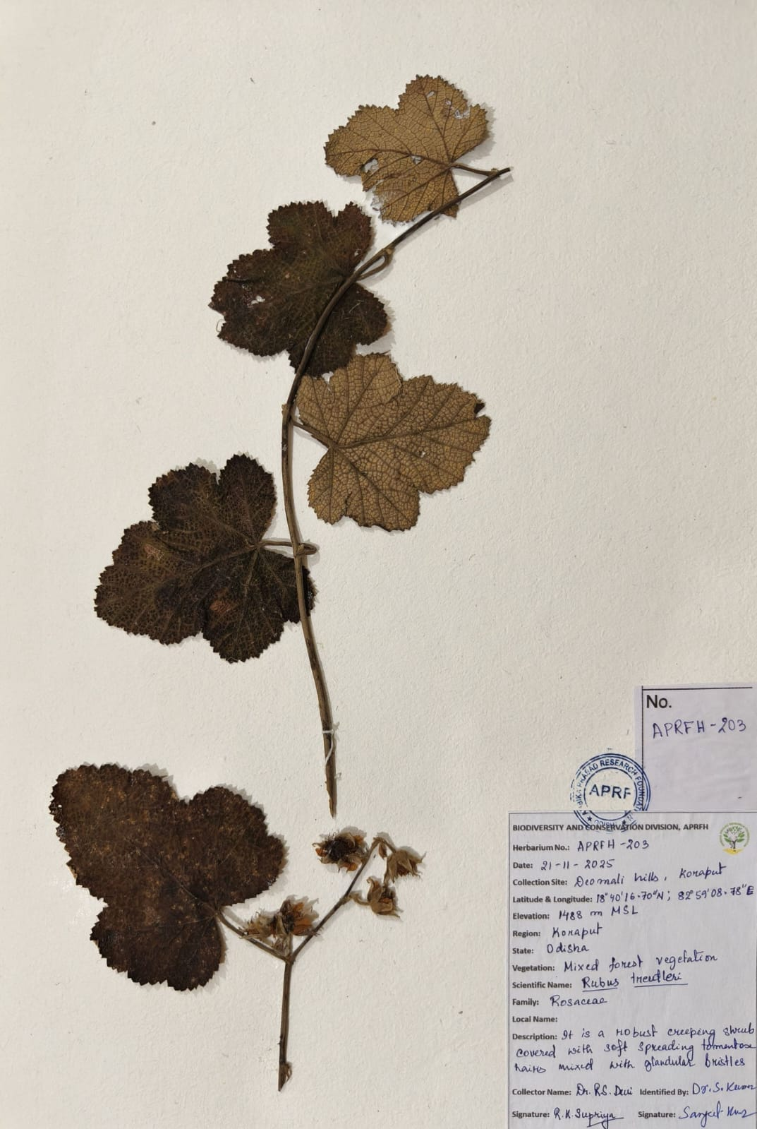
Figure 1: Herbarium specimen of Rubus treutleri Hook.f.
Conclusion
The present study documents Rubus treutleri Hook.f. for the first time from the Eastern Ghats, marking a significant southward extension of its previously known Himalayan distribution and adding a new species record for the flora of Odisha. The confirmed occurrence of this temperate Himalayan taxon in the Deomali Hills not only enriches the regional Rubus diversity but also underscores the biogeographical connectivity between the Himalayan and Eastern Ghats montane systems. Detailed morphological assessment of freshly collected specimens supports its distinct identity, while its restricted presence in high-elevation mixed forest habitats highlights the ecological uniqueness and conservation importance of the Deomali landscape. These findings emphasize the need for continued floristic exploration in under-surveyed hill ecosystems of eastern India to better understand their biodiversity and biogeographical significance.
Acknowledgement
Authors are thankful to the Divisional Forest Officer, Koraput Forest Division, Odisha, Range Officer and other forest officials for extending their support during the survey.

Competing interests
Authors have declared that they have no known competing financial interests OR non-financial interests OR personal relationships that could have appeared to influence the work reported in this paper.
REFERENCES
- Adhikary P and Gajurel PR. (2023). Extended distribution of Rubus opulifolius Bertol. (Rosaceae) in Arunachal Pradesh (India) and its lectotypification. Pleione. 17(3): 329–332. https://doi.org/10.26679/Pleione.17.3.2023.329-332
- Gao XF, Xiong XH, Boufford DE, Gao YD, Xu B and Zhang C. (2023). Phylogeny of the Diploid Species of Rubus (Rosaceae). Genes. 14(6):1152. https://doi.org/10.3390/genes14061152
- Hooker JD. (1879). The Flora of British India, Vol. 2. Reeve & Co., London.
- Hummer KE. (1996). Rubus diversity. HortScience 31(2):182–183. https://doi.org/10.21273/HORTSCI.31.2.182
- Lamichhane A, Lamichhane G and Devkota HP. (2023). Yellow Himalayan Raspberry (Rubus ellipticus Sm.): Ethnomedicinal, Nutraceutical, and Pharmacological Aspects. Molecules. 28(16): 6071. https://doi.org/10.3390/molecules28166071
- Meng Q, Manghwar H and Hu W. (2022). Study on Supergenus Rubus L.: Edible, Medicinal, and Phylogenetic Characterization. Plants. 11(9):1211. https://doi.org/10.3390/plants11091211.
- POWO. (2025). Plants of the World Online. Royal Botanic Gardens, Kew. https://powo.science.kew.org/
- Rawat DS, Chandra S and Chaturvedi P. (2022). Threatened flora of Uttarakhand: an update. Journal of Threatened Taxa. 14(12): 22309–22328. https://doi.org/10.11609/jott.6330.14.12.22309-22328.
- Saxena HO and Brahmam M. (1995). The Flora of Orissa Vol. II. Rosaceae to Martyniaceae. Regional Research Laboratory, Bhubaneswar, Orissa, India.
- Sofi SA, Islam T, Zargar SA, Malik AH, Mugal MA and Khuroo AA. (2024). Rubus idaeus subsp. strigosus (Michx.) Focke, a new distribution record to the flora of India from Kashmir Himalaya. Rheedea. 34(4): 107-112.
- Wang TT, Li MH, Kuang DY, Xia JL, Wang QP and Wang HC. (2025). Rubus semiplenus (Rosaceae), a new species with naturally occurring semi-double flowers from Hunan, China. PhytoKeys. 257: 79-93.

