Comprehensive Review of Ocular Manifestations Associated with Major Feline Viral Infections.

Abstract
Feline viral infections are a major but often under-recognized cause of eye disease, and the eye often provides early and sometimes definitive clues to systemic illness. This review combines current knowledge on the eye-related signs of the most important feline viral pathogens, focusing on feline herpesvirus-1, feline calicivirus, feline immunodeficiency virus, feline leukemia virus, feline coronavirus associated with infectious peritonitis, and feline panleukopenia virus. After describing key anatomical and functional features of the feline eye that affect how disease presents and is diagnosed, the article explains the range of viral-induced eye lesions, including conjunctivitis, keratitis, corneal sequestration, symblepharon, eosinophilic keratitis, anterior and posterior uveitis, chorioretinitis, retinal vasculitis and hemorrhage, retinal dysplasia, optic nerve involvement, and intraocular or orbital tumors. Special attention is given to clinical patterns most strongly linked with specific viruses, such as dendritic and geographic corneal ulcers in herpesvirus infection, conjunctivitis with oral ulcers in calicivirus infection, and granulomatous uveitis and retinal perivascular lesions in infectious peritonitis. The review also covers the challenges of diagnosis in cases of latent or persistent infections, frequent co-infections, and significant overlap between viral and non-viral causes of eye inflammation. Practical advice is provided on combining detailed eye exams, basic ancillary tests, and targeted viral tests into an effective diagnostic plan. Treatment options include managing environment and stress, supportive care, topical and systemic antiviral medications, anti-inflammatory treatments for uveitis, and surgery for advanced or neoplastic conditions, all tailored to the cat’s overall health and the owner’s ability to follow intensive protocols. Finally, the review identifies important knowledge gaps and future priorities, such as the need for better clinical trials of antiviral drugs, improved interpretation of point-of-care tests in vaccinated or co-infected cats, and the development of new drug delivery systems that improve eye bioavailability and reduce dosing frequency. By compiling current evidence and highlighting clinically relevant patterns, this article aims to help veterinarians identify, diagnose, and treat viral eye diseases more effectively, ultimately safeguarding sight and enhancing quality of life for affected cats.
- Introduction
The eye is often compared to a window into the body, and in feline practice, it is the only part of the central nervous system and associated vasculature that can be examined directly and non-invasively. Feline viral infections are an important and often under-recognized cause of ocular disease, and the eye truly serves as a window to systemic health in cats. Careful ophthalmic examination, therefore, offers clinicians an invaluable opportunity to detect not only primary ocular disease but also a wide range of systemic disorders at an early stage (La Croix, 2005; Beckwith-Cohen & Petersen-Jones, 2024). The fundus, in particular, allows direct visualization of neural tissue and blood vessels, so subtle changes in color, caliber, tortuosity or retinal thickness can signal underlying systemic pathology well before overt systemic signs appear (Beckwith-Cohen & Petersen-Jones, 2024). In this context, the feline eye functions as both a diagnostic window and a prognostic indicator for overall health.

Systemic feline diseases—including parasitic, bacterial, fungal, viral, neoplastic, metabolic, vascular and immune-mediated conditions—are frequently associated with ocular lesions (La Croix, 2005). These may present as conjunctivitis, keratitis, anterior or posterior uveitis, chorioretinitis, retinal hemorrhages or optic neuropathies, often in complex combinations. In some cats, ocular abnormalities are the first or only clinically apparent manifestation of a systemic infection, and failure to recognize their significance may delay life-saving diagnosis and treatment (La Croix, 2005; Wronski et al., 2023). Recent necropsy-based work has further emphasized how commonly systemic infectious agents produce clinically relevant ocular lesions, highlighting the risk of underdiagnosis when detailed ophthalmic examination is not incorporated into routine assessment (Wronski et al., 2023). Consequently, systematic ocular evaluation has become a cornerstone of comprehensive feline internal medicine.

Among systemic conditions, viral infections occupy a central and important position because of their high prevalence, tendency to establish latency or persistent infection, and capacity to cause both direct and immune-mediated ocular damage. Major feline viruses implicated in ocular disease include feline herpesvirus-1 (FHV-1), feline calicivirus (FCV), feline immunodeficiency virus (FIV), feline leukemia virus (FeLV) and feline coronavirus associated with feline infectious peritonitis (FIP), among others (Stiles, 2014). FHV-1 is a leading cause of infectious keratoconjunctivitis, corneal ulceration and chronic keratitis, whereas FCV is increasingly recognized as an important ocular surface pathogen. Retroviral infections such as FIV and FeLV contribute to uveitis, retinitis and opportunistic ocular infections through immunosuppression and virus-induced inflammation (Stiles, 2014; Wronski et al., 2023). Contemporary work on ocular microbiota further suggests that the bacterial community of the ocular surface may modulate the clinical course and treatment response in cats with FHV-1–associated disease, linking virology, microbiology and ocular immunology in a clinically relevant way (Mills et al., 2024).

These viral ocular diseases are not only vision-threatening and painful but also have major implications for feline welfare, particularly in high-density environments such as shelters and catteries. In addition, these diseases can negatively affect the psychological state of the infected animal. They can impair adoptability, prolong length of stay and increase management costs, while recurrent or chronic disease undermines quality of life for both cats and owners. Despite advances in diagnostics, antiviral therapy and vaccination, in interpreting test results in the context of latent or subclinical infections, and in tailoring treatment plans to individual patients. This review therefore aims to synthesize current knowledge on the anatomy and unique features of the feline eye, and to provide an integrated overview of the ocular manifestations, diagnostic approaches, therapeutic strategies and prognostic considerations associated with the principal feline viral infections. By bridging classical descriptions with recent evidence from clinical, pathological and microbiome-based studies, it seeks to support clinicians in achieving earlier diagnosis, more rational treatment and improved visual outcomes in affected cats (Beckwith-Cohen & Petersen-Jones, 2024; La Croix, 2005; Mills et al., 2024; Wronski et al., 2023; Stiles, 2014).
2.0 UNIQUE FEATURES OF CAT EYE
The feline eye possesses several distinctive anatomical and functional features that are closely linked to the cat’s crepuscular and nocturnal lifestyle. Compared with many other domestic species, cats have relatively large globes in proportion to the skull, with a broad, prominent cornea and a vertically slit pupil. This pupil shape allows very fine control of light entry, constricting to a narrow slit in bright conditions and dilating to a near circle in dim light, thereby supporting vision over a wide range of illumination (Mitchell, 2010). The anterior chamber is typically deep and the lens is positioned relatively posteriorly, contributing to wide-angle vision and facilitating examination of intraocular structures. The iris is often thin and lightly pigmented, with considerable variation in colour and stromal patterning among individuals (Mitchell, 2010; La Croix, 2005).

A key adaptation for low-light vision is the well-developed tapetum lucidum, a reflective layer within the choroid that returns unabsorbed photons back through the photoreceptor layer, effectively giving rods and cones a second chance to capture light and enhancing retinal sensitivity in dim environments (Mitchell, 2010). The feline retina is strongly rod-dominated, with a region of increased photoreceptor and ganglion cell density known as the area centralis providing enhanced spatial resolution analogous to, but anatomically distinct from, the primate macula (Mischi et al., 2022). Optical coherence tomography studies in cats and dogs have confirmed regional differences in outer retinal thickness and choriocapillaris visibility that correspond to these specialized visual regions and help explain the species’ excellent motion detection and scotopic vision (Mischi et al., 2022). The third eyelid (nictitating membrane) is supported by a T-shaped cartilage and contains both smooth and skeletal muscle, allowing dynamic movement across the corneal surface and playing an important role in tear film distribution and corneal protection; its elevation is therefore a sensitive, though non-specific, sign of ocular or systemic disease (La Croix, 2005; Mitchell, 2010).

The lacrimal system in cats produces a relatively modest basal tear volume, and tear film stability can be compromised by reduced blinking, illness or certain medications, predisposing to corneal surface desiccation and ulceration. Together, these structural and functional characteristics—large cornea, slit pupil, tapetum lucidum, rod-dominated retina with an area centralis, and a mobile third eyelid—define the unique optical and protective environment of the feline eye. Understanding these features is essential for accurate clinical examination, interpretation of diagnostic imaging, and recognition of how viral and other systemic diseases manifest within the feline ocular system (La Croix, 2005; Stiles, 2014).
  - VISION
- Cats have very efficient nocturnal vision. They achieve this with many adaptations including:
- A large cornea, which allows more light into the eye
- A slit pupil that can dilate 6mm more than a human pupil, allowing more light to enter in dark (scotopic) conditions. It also allows for profound miosis, which protects the rod-dominated retina from damage by bright light
- A tapetum lucidum, which is a cellular reflecting structure situated behind the retina that reflects 130 times more light than a human fundus (Mitchell, 2006).
Feline visual acuity has been estimated to be between 20/100 and 20/200 (Snellen fraction). The retina contains predominantly rod photoreceptors, which function well in scotopic conditions. Both feline and human cones are trichromatic, with functioning red, green and blue photoreceptors. However, behavioral studies suggest that feline colour vision is poor; their ability to distinguish between two coloured stimuli is limited unless they differ greatly in spectral content. Although cats have superior night-vision, they can only accommodate about four dioptres, compared to 14 dioptres in a human infant, or seven to eight dioptres in a 30-year-old adult. Instead of changing the shape of the lens, the cat is able to accommodate by actually moving the lens position (Mitchell, 2006).
- COMMON FELINE VIRAL DISEASES WITH OCULAR MANIFESTATIONS:
- Feline Herpes Virus (FHV) Infection
- Feline Calici Virus (FCV) Infection
- Feline Immunodeficiency Virus (FIV) Infection
- Feline Leukemia Virus (FeLv) Infection
- Feline Infectious Peritonitis (FIP)
- Feline Panleukopenia
3.1 Feline Herpes Virus
dsDNA virus that belongs to the subfamily Alphaherpesvirinae. Causative agent of feline viral rhinotracheitis. Trigeminal ganglion is a known site of latency for FHV-1, but the virus can persist in a quiescent form in ocular tissues, particularly the cornea (Townsend et al., 2004).
3.1.1 Pathogenesis of FHV-1 disease
- Transmission
FHV-1 is relatively unstable in the environment, persisting for up to 18 h in moist conditions and a shorter duration in dry conditions. It is susceptible to most disinfectants, antiseptics and detergents. The main source of transmission between cats are body fluids, in particular respiratory secretions, which are passed on via sneezing, contaminated fomites or unhygienic handling practices (Stiles, 2000).
- Primary infection
Primary infection occurs most frequently in kittens and adolescent cats, as maternal anti-bodies decline from around 8 weeks of age. However, even vaccinated cats remain at some risk because FHV-1 vaccines, both parenteral and intranasal, confer only partial immunity against clinical signs and no protection against reactivation/shedding (Stiles & townsend, 2007). FHV-1 preferentially infects muco-epithelial cells of the tonsils, conjunctiva and nasal mucosa (Gaskell & povey, 1979), but there is also significant infection of corneal epithelial cells (Nassie et.al., 1989). The resultant lytic infection is characterized by rapid replication and acute cellular damage leading to cytolysis. Clinical signs develop 2–6 days after infection. Ocular signs associated with this phase are acute conjunctivitis and epithelial keratitis characterized by the formation of punctate and dendritic epithelial ulcers that have been shown to persist for up to 24 days in experimental infections (Nassie et.al., 1989).
- Latency
The establishment of latency in the host tissue is a key characteristic of herpesviruses. During primary infection, FHV-1 virions invade sensory nerve endings of the trigeminal nerve within the host tissue and travel to the trigeminal ganglion, which is housed in a depression within the petrous temporal bone in the middle cranial fossa at the base of the skull. Here FHV-1 develops a latent state in which the genome persists in episomes within the cell nuclei of the trigeminal ganglia (Gaskell et.al., 1985).
- Recrudescent disease
Latent FHV-1 virus may be reactivated and cause recrudescent clinical disease. This has been recorded spontaneously as well as in association with various stressors including systemic corticosteroid administration, co-infection with other agents, change of housing, parturition and lactation (Gaskell & povey, 1977). The molecular mechanism behind viral recrudescence is poorly understood, but it results in viral replication and migration down the sensory axons to epithelial tissues. This may result in: Re-excretion of virus in the absence of clinical signs (subclinical shedding). Lytic infection, with clinical signs similar to, although usually less severe than, those of the primary infection. Development of immune-pathological disease (chronic stromal keratitis) as the host mounts an immune response against viral antigens within the cornea (Galle & Moore, 2007).
- Persistent infection
The advent of PCR technology has led to the identification of a previously unrecognized stage of herpes disease pathogenesis –that of persistent viral infection in non-neural cells. In an experimental murine model, herpes DNA was identified within the conjunctiva and eyelid in chronic inflammatory eyelid disease, raising the possibility that an equivalent mechanism may be involved in feline chronic ocular and periocular disease (Maggs et.al., 1998).

Picture 1- Phases of FHV-1 disease
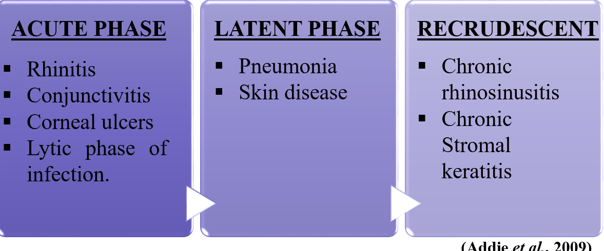3.1.2 OCULAR MANIFESTTIONS OF FHV-1
- Conjunctivitis
- Keratitis
- Symblepharon
- Corneal sequestration
- Eosinophilic-conjunctivitis
- Ophthalmia-neonatorum
- Keratoconjunctivitis sicca
- Calcific band keratopathy
- Anterior uveitis

3.1.2.1 Conjunctivitis
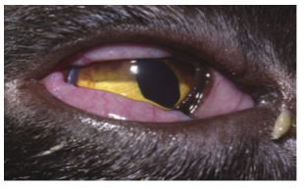
Fig 1. Conjunctivitis caused by FHV-1 with conjunctival hyperemia, chemosis and purulent ocular discharge(Stiles, 2014)
FHV-1 is a major cause of acute and chronic conjunctivitis. In primary infections, acute conjunctivitis occurs in conjunction with rhinotracheitis, following an incubation period of 2–6 days. The conjunctivitis is usually bilateral, with signs of hyperaemia, serous ocular discharge and a variable degree of chemosis. Areas of conjunctival ulceration may develop secondarily to viral-induced epithelial necrosis. In the majority of cases, the clinical signs resolve by 10–20 days post-infection. Recurrent acute conjunctivitis is a feature of viral recrudescence (Nassie et.al., 1989).
3.1.2.2 Keratitis
Inflammation of the cornea. It’s the second Most common ocular condition. It presents with or without corneal ulceration depending on the severity of infection (Nasisse et.al., 1989).

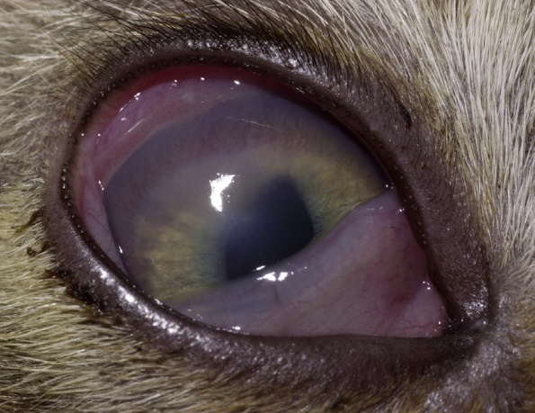
Fig 2. Keratitis without corneal ulceration caused by FHV-1 in a kitten with corneal vascularization and oedema. (Stiles, 2014)
- Dendritic Ulceration:
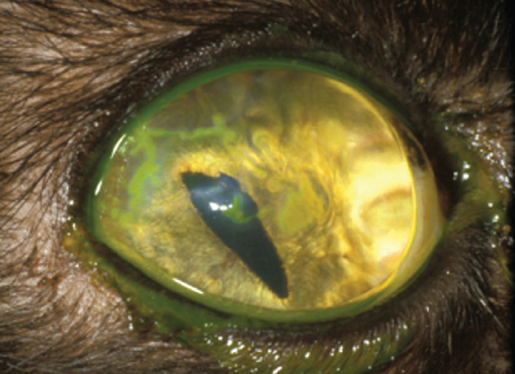
The presence of dendritic corneal ulcers is considered pathognomonic for FHV-infection. FHV-1 infection of the corneal epithelial cells in acute primary infection leads to corneal ulceration, which typically manifests as linear or branching epithelial defects. These can be very fine in appearance. Therefore, magnified examination under cobalt blue light, following application of topical fluorescein to the ocular surface, is recommended. Rose Bengal stain may also be used to aid identification of dendritic ulcers. However, it can be locally irritant so the ocular surface should be flushed thoroughly following its application (Nasisse et.al., 1989).

FIG 3. a & b: Dendritic corneal ulceration stained with topical fluorescein dye and rose Bengal dye (Stiles, 2014)

- Geographic Corneal Ulceration
Dendrites that coalesce to a map-like appearance are called geographic ulcers. Larger areas of geographic corneal ulceration may also develop as a result of primary infection. These may be single or multiple in appearance. In recrudescent infections, either dendritic or geographic corneal ulceration may be a clinical feature. Chronically, stromal oedema and vascularisation may occur (Nasisse et.al., 1989).
FIG 4. Geographic corneal ulceration stained with topical fluorescein dye and photographed under cobalt blue light. (Stiles, 2014)
- Chronic Stromal Keratitis
Stromal keratitis refers to infection and inflammation of the deeper corneal tissue. Result of an ineffective immune response to viral antigens sequestered within the cornea. It is considered to be a very significant form of disease. due to the potential for vision-threatening stromal opacification and scarring (Nasisse et.al., 1989).
FIG 5. Chronic stromal keratitis, characterised by stromal neovascularisation and progressive scarring (Stiles, 2014)
3.1.2.3 Eosinophilic conjunctivitis and keratitis
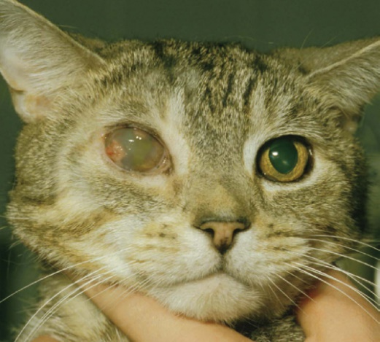
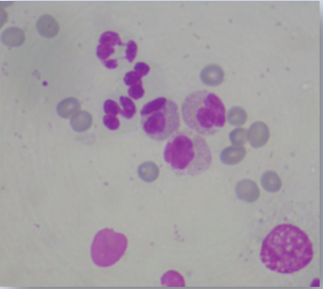
It is a progressive form of corneal disease that occurs in cats. Superficial, proliferative, irregular, white/pink vascularized infiltration of the conjunctiva and/or cornea. It may be unilateral or bilateral. Exfoliative cytology findings, reveal a mixed infiltrate of eosinophils, plasma cells, lymphocytes, mast cells and macrophages (Allgoewer et.al., 2001).
Fig 6. Eosinophilic keratitis (Stiles, 2014) Fig 7. Cytology of eosinophilic keratitis
FHV-1 has been isolated from eosinophilic keratitis specimens isolated by indirect immunofluorescence assay in 33.3% of samples from one laboratory, and in 76.3% of cases by PCR from another laboratory (Morgan et.al.,1996, Nasisse et.al., 1998).
The condition is also responsive to oral megestrol acetate at an initial dose of 0.5 mg/kg/day, tapering to every second day and then weekly administration until clinical resolution. Shows an improvement in clinical signs (Allgoewer et.al., 2001).
3.1.2.4 Symblepharon
Adhesion of the conjunctiva to itself or to the cornea. It can cause significant ocular problems including:
- Inability to blink,
- KCS Due to destruction of the lacrimal gland ductules
- Conjunctivoplasties of the cornea, leading to blindness (Stiles & townsend, 2007)

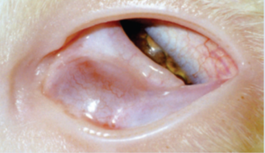
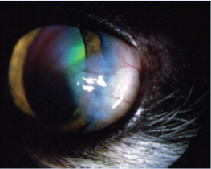
Fig. Symblepharon, Localised conjunctivalisation of the cornea in cat affected with FHV-1. (Stiles, 2014)
3.1.2.5 Corneal Sequestration
It is a common disease in cats. The term describes a focal area of corneal stromal degeneration associated with a brown/black discolouration. There is a breed predisposition in the Persian and Himalayan. In these breeds the condition may represent a primary stromal disease, but the majority of cases are associated with chronic corneal ulceration or chronic keratitis (Morgan, 1994). As such, FHV-1 has been strongly implicated in the aetiology of the condition.
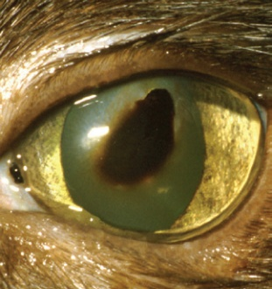
Topical corticosteroid use in cats experimentally infected with FHV-1 has been reported to induce corneal sequestrum formation. In two separate PCR studies on sequestra samples, FHV-1DNA was identified in 18% and 55% of cases (Nasisse et.al., 1998). Corneal sequestra are not responsive to medical treatment, and superficial keratectomy with or without grafting procedures (conjunctival pedicle graft or corneo-conjunctival transposition) is recommended (Gould, 2011).

Fig 8. Corneal sequestrum in cat affected with FHV-1(Stiles, 2014)
3.1.2.6 Ophthalmia neonatorum
Ocular FHV-1 infection in the neonatal period, before eyelid opening, can lead to a build-up of mucopurulent discharge behind the closed eyelids. This can cause extensive corneal damage and globe rupture in severe cases. Treatment consists of premature opening of the palpebral fissure and irrigation of the ocular surface (Bistner et.al., 1971).
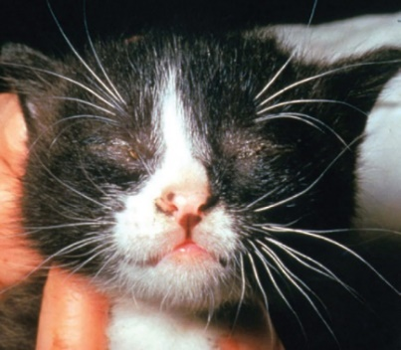
Fig.9 Ophthalmia neonatorum in a young kitten. (Stiles, 2014)

  - Feline Calici Virus
Feline calicivirus (FCV) is a single- stranded RNA virus with the ability to undergo rapid mutation, resulting in strain diversity and widely varying antigenicity. Infection with FCV appears to be especially common in young cats housed in shelter environments (Bannasch and Foley, 2005). Although FCV does not develop latency like FHV-1, cats might harbor FCV long term and be chronic or intermittent shedders (Wardley et al., 1974).
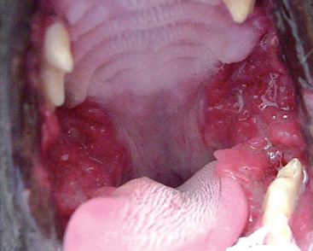
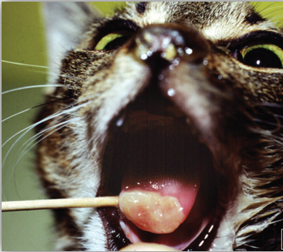
- CLINICAL SIGNS
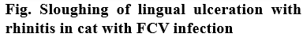
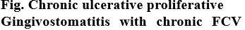
OCULAR SIGNS
Feline calicivirus causes URTD (Upper Respiratory Tract Disease) and oral mucosal ulceration, and can cause ocular surface disease, primarily conjunctivitis. In some outbreaks of virulent systemic FCV, large percentages of cats had died (Hurley et al., 2004; Coyne et al., 2006; Reynolds et al., 2009) Feline calicivirus had been cited as causing only mild conjunctivitis (Ramsey, 2000).
However, a recent study of 99 cats with URTD, as well as ocular surface disease, found that ocular samples analysed using PCR were positive for FCV alone in 11 (11.1%) cats; in 19 (19.2%) cats, FCV was present with other infectious agents, including FHV-1 (Gerriets et al., 2012).
Moderate to severe conjunctivitis with conjunctival epithelial erosions, as well as oral mucosal ulceration, were noted in FCV-positive cats. No corneal ulcers were noted in cats infected with only FCV. some cats with FCV infection have severe conjunctivitis that often precludes visualization of the cornea (Fig 9.). Different strains of FCV and the host immune response likely play roles in the severity of ocular surface disease.

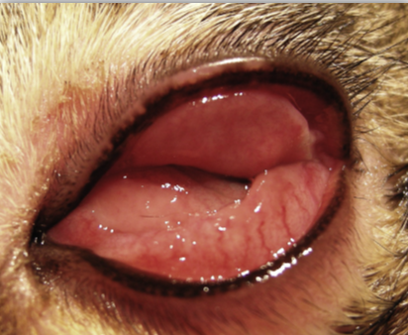
Fig 10. Severe conjunctivitis with marked conjunctival hyperaemia and chemosis that obscures the cornea ina cat affected with FCV.

  - Feline immunodeficiency Virus
FIV is a lentivirus with a worldwide distribution. Seven subtypes of FIV (A, B, C, D, E, F and U). Transmission of the virus occurs via saliva and blood (bite wounds), as well as in utero or post-partum via milk. (Addie et al., 2009)

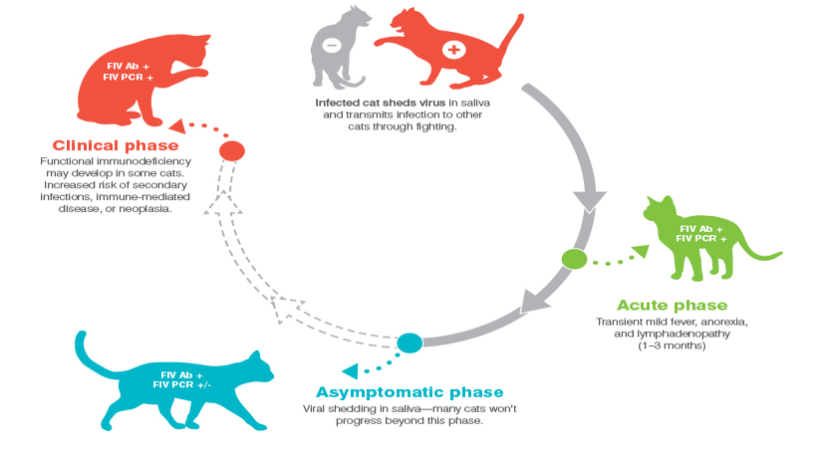
Fig 11. The three phases of FIV infection in cats, adapted from the 2020 American Association of Feline Practitioners (AAFP) feline retrovirus testing and management guidelines. Ab = antibodies, PCR = polymerase chain reaction, + = positive, = negative.
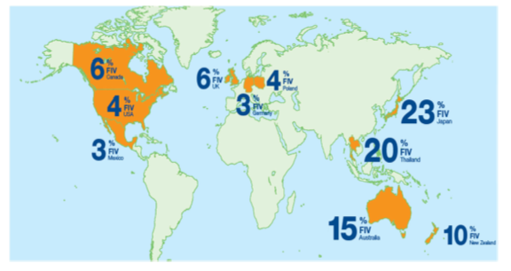
Fig 12. FIV prevalence worldwide. (Westman et al., 2019)

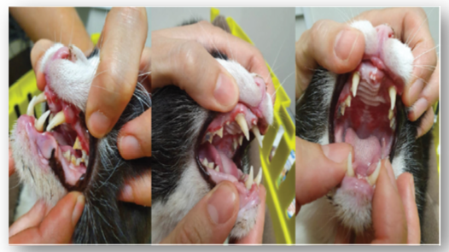
CLINICAL SIGNS
Fig 13. Gingivostomatitis is a common finding in FIV-infected cats

- OCULAR MANIFESTATIONS OF FIV

The ocular diseases associated with FIV are primarily chronic anterior uveitis and conjunctivitis. In one epidemiologic study, 35/318 (11%) FIV-positive cats had chronic conjunctivitis, although the relationship to FIV was not defined and other pathogens, such as FHV-1 or Chlamydia felis, might have played a role (Yamamoto et al., 1989). In 12 cats experimentally infected with FIV, the virus was recovered from the aqueous humor of three animals, and a perivascular lymphoplasmacytic uveitis was noted in all nine animals euthanised P4 weeks post-infection (Ryan et al., 2003). The magnitude and distribution of lesions in the eyes and brain did not correlate with viral loads. In a study of 15 naturally infected cats that had been euthanised, anterior uveitis was documented in 13 (Loesenbeck et al., 1996). The presence of extravascular IgG and complement component C3 suggested that immune complexes might play a role in anterior uveitis in FIV-positive cats. Nine cats with naturally occurring FIV had ocular lesions, including anterior uveitis, secondary glaucoma and inflammation of the pars plana of the ciliary body (English et al., 1990). In an experimental study on the effect of FIV on the central nervous system, neurologic abnormalities related to the visual system included anisocoria, delayed pupillary light reflex and delayed visual evoked potentials (Phillips et al., 1994). Infection with FIV is associated with lymphosarcoma in cats (Gabor et al., 2001; Magden et al., 2013), with the potential for ocular involvement (Fig 13.). Ocular lymphosarcoma can involve the uveal tract, conjunctiva or orbit. A recent case report also highlighted the diagnostic value of ocular findings in systemic retroviral infection, describing a cat with uveitis and neurological signs in which aqueous humor and cerebrospinal fluid testing confirmed coinfection with FIV, FeLV and feline coronavirus, emphasizing the importance of considering FIV and other retroviruses in cats presenting with unexplained uveitis and systemic illness (de Almeida et al., 2023).
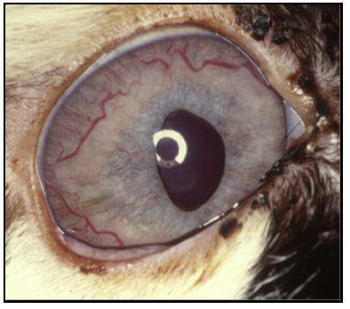
Fig 14. Uveal lymphosarcoma in a cat positive for FIV. (Stiles, 2014)
  - Feline Leukemia Virus
It is an RNA retrovirus, occurs worldwide. The incidence of FeLV infection has decreased in recent decades as a result of vaccination, quarantine and removal programs.

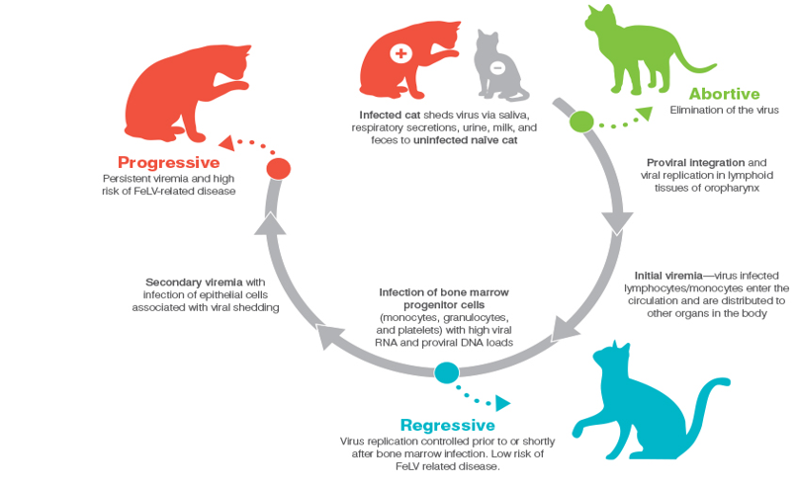
Fig 15. The three phases of FeLv infection in cats, adapted from the 2020 American Association of Feline Practitioners (AAFP) feline retrovirus testing and management guidelines. + = positive, = negative.
- OCULAR MANIFESTATIONS OF FeLV
- UVEAL LYMPHOSARCOMA:
Possible sites of ocular lymphosarcoma include the uveal tract, conjunctiva including the nictitating membrane and orbit. The early stages of uveal lymphosarcoma can be manifested as uveitis, although the iris and ciliary body become thickened and irregular as the disease progresses. With the overall reduction in the number of FeLV-infected cats, the number of FeLV-related lymphosarcoma cases has decreased. In one histopathologic study of 50 cases of lymphosarcoma, a high percentage of tumours still contained FeLV proviral DNA, suggesting that regressively infected cats (those that are infected but have become aviremic) might have proviral DNA that can cause generalized lymphosarcoma (Weiss et al.,2010).
- RETINAL HAEMORRHAGES:
Other ocular abnormalities associated with FeLV infection include retinal haemorrhages associated with severe anaemia and pupillary motility abnormalities (Brightman et al., 1991). On evaluation of corneal tissue by PCR and immunohistochemistry (IHC) in 17 naturally infected cats, 11 corneas were positive for FeLV by PCR and 8 were positive by IHC. This study concluded that corneal donor tissue should not be used without screening cats for FeLV. (Herring et al., 2001)
The role of FeLV, or the replication-defective feline sarcoma virus (FeSV), in spontaneously occurring ocular tumors in cats remains unclear. When FeLV was injected systemically or intravitreally into kittens, tumors of apparent retinal origin developed (Albert et al., 1977). When FeSV was injected into the anterior chamber of kittens, a pattern of iridal melanotic lesions occurred that progressed from distinct flat areas to raised infiltrative melanomas, very much like the naturally occurring anterior uveal melanomas of cats (Albert, 1980). In a study of 36 enucleated globes of cats with a diagnosis of diffuse anterior uveal melanoma, PCR identified three samples that were positive for FeLV–FeSV proviral DNA sequences (Stiles et al., 1999). In a subsequent study of 10 enucleated globes, FeLV–FeSV was not detected using IHC or PCR (Cullen et al., 2002).
  - Feline Infectious Peritonitis
Caused by a feline coronavirus (FCoV), an RNA virus. Hypotheses to explain viral pathogenesis include de novo FCoV mutation giving rise to virulence and distinct circulating avirulent and virulent strains. Young animals from multi-cat environments are the most likely group to develop FIP. (Brown, 2011)
- OCULAR MANIFESTATIONS OF FIP
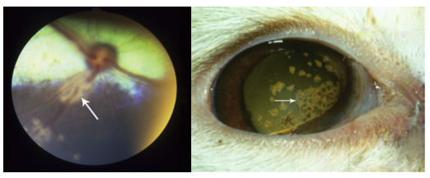
Fig 16. Anterior uveitis caused by FCoV Fig 17. Retinal vasculitis caused by FCoV(Stiles, 2014)

Since vasculitis is a feature of FIP, the eye is a common target organ. organ. Ocular manifestations include pyogranulomatous anterior uveitis, often with fibrin in the anterior chamber and keratic precipitates (Fig 18.), choroiditis with retinal detachment and retinal
vasculitis, with perivascular cuffing by inflammatory cells (August, 1984). Ocular manifestations of FIP are more common in the non-effusive (dry) form of the disease than the effusive (wet) form. Cats can be presented initially with ocular lesions and no (or vague) systemic signs.
In a study of naturally infected barrier-reared cats and their offspring, recurring bouts of URTD (Upper Respiratory Tract Diseases) and conjunctivitis occurred at intervals of about 4 months, beginning at 4–5 weeks of age (Hok, 1993a). The cats were negative for FHV-1, FCV and FeLV on laboratory testing. FCoV antigen was detected in the conjunctiva of the nictitating membrane in 90% of cats and persisted throughout the investigation. Virus isolation was also positive from swabs of the nictitating membrane, suggesting that ocular exudates from these cats were potentially infectious. When kittens serologically negative for FCoV were placed in catteries with a history of FIP and observed for 100 days, there was 100% morbidity and 90% mortality, with affected kittens developing recurrent bouts of conjunctivitis, URTD and gastrointestinal signs (Hok, 1993b).
  - Feline Panleukopenia
Feline panleukopenia is caused by Feline Parvovirus (FPV), a single-stranded DNA virus. The virus can persist long term in the environment; thus, cats are easily exposed, mostly by 1 year of age. In utero transmission also occurs (Truyen et al., 2009).
- CLINICAL SIGNS
In most cats infected with feline panleukopenia virus (FPV), there are no apparent clinical signs and infection may remain subclinical. In those that do become clinically ill, the disease is typically characterized by an acute onset of fever, marked depression, vomiting and diarrhoea, often accompanied by severe dehydration and palpably thickened intestinal loops. A profound leukopenia is a hallmark laboratory finding and reflects the virus’s tropism for rapidly dividing cells in bone marrow and intestinal crypt epithelium (Greene, 2012).

- OCULAR MANIFESTATIONS OF FPV
It includes retinal dysplasia and degeneration in kittens infected in utero or in the neonatal period. Kittens born to infected queens might have cerebellar hypoplasia, with tremors and ataxia Conjunctivitis, along with URTD, has been reported in two experimentally infected kittens (Greene, 2012).
- RETINAL DYSPLASIA

Retinal dysplasia has different appearances on fundic examination, depending on whether the lesions are geographic or focal, and whether they are located within the tapetal or non-tapetal fundus. Within the tapetal fundus, areas that have altered reflectivity (hyper or hypo reflectivity) can be visualized. Microscopic findings of the retina into circular lesions appear as tiny grey round foci of varying numbers (Greene, 2012).

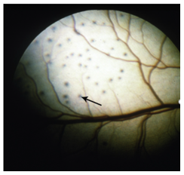
Fig 18. Retinal dysplasia in a kitten. (Stiles, 2014)

- PROGNOSIS
- Therapy for Feline Panleukopenia is supportive. There is no treatment for retinal dysplasia or degeneration.
- The prognosis for recovery from FPV depends on the severity of clinical signs and response to therapy.
- Visual deficits secondary to retinal dysplasia or degeneration are expected to remain static once the active infection has subsided (Greene, 2012).
- DIAGNOSIS
HISTORY
A thorough history is essential when evaluating cats with suspected viral ocular or upper respiratory disease. Key points include the animal’s vaccination status and any history of upper respiratory tract infection during kittenhood, as early infections can predispose to chronic ocular and respiratory problems. Recurrent episodes of conjunctivitis and/or keratitis should be carefully documented, as should any recent or recurrent stressful events (for example, introduction of new animals, boarding, surgery, or household changes) that might trigger reactivation of latent infections. It is also important to determine whether the cat has had close contact with clinically affected animals and whether it lives in a crowded or stressful environment, such as a multicat household, cattery or shelter. An outdoor lifestyle, especially with a history of fighting, increases the risk of exposure to viral pathogens and other infectious agents. Epidemiological studies confirm that factors such as living in multi-cat households and a history of upper respiratory signs are associated with higher prevalence of common respiratory pathogens in pet cats (Gould, 2011; Chan et al., 2023).

Table 1-DIAGNOSIS BASED ON CLINICAL SIGNS
DISEASE | PATHOGNOMIC CLINICAL SIGNS
Feline Herpesvirus-1 | Conjunctivitis, Keratitis, Corneal Ulcerations
Feline Calicivirus | Ulcerative or erosive stomatitis., conjunctivitis, Limb/joint swelling (limping syndrome)
Feline Immunodeficiency Virus | Chronic conjunctivitis, Uveitis
Feline Leukemia Virus | Ocular lymphoma, Secondary infections leading to conjunctivitis
Feline Infectious Peritonitis | Anterior Uveitis, Retinal Vasculitis
Feline Panleukopenia | Cerebellar hypoplasia, retinal dysplasia and degeneration in kittens
(Stiles,2014)
DIFFERENTIAL DIAGNOSIS
- Bacterial causes: Chlamydophila felis infection acute conjunctivitis in the absence of systemic signs. Bartonella spp. causes feline unilateral uveitis.
- Parasitic & Fungal causes: Chorioretinitis is the most common ocular manifestation of Toxoplasmosis, cryptococcosis and histoplasmosis.
- Neoplastic causes: Brain tumors can present a variety of ophthalmic signs including blindness, abnormal pupillary light reflexes, changes in vestibular ocular reflexes, and irregular ocular alignment.
- Metabolic causes: Kittens with hyperparathyroidism and secondary hypercalcemia may develop cataracts, Hyperthyroidism can cause systemic hypertension followed by secondary hypertensive retinopathy.
- Deficiencies: taurine deficiency can result in retinal atrophy (Gould, 2011).
OPHTHALMIC EXAMINATION
- Slit Lamp Examination:
  - Detailed examination of the anterior segment of the eye, including the cornea and anterior chamber. for evidence of conjunctivitis, corneal ulcers, and uveitis.
- Indirect Ophthalmoscopy:
  - Evaluation of the posterior segment, including the retina and optic nerve head. To detect retinal changes or inflammation.
- Tonometry:
  - Measure intraocular pressure, which can be elevated in conditions such as viral uveitis or glaucoma.
- Fluorescein Staining:
  - Useful for identifying corneal ulcers or erosions.

LABORATORY EVALUATION
- Hematology
- Serum biochemistry
- Analysis of abdominal or thoracic fluid samples: In case of FIP rise in serum FCoV titer.
- Histopathologic examination of tissues obtained through biopsy or necropsy. (Mitchell, 2010)
DIAGNOSTIC TESTS
- Polymerase Chain Reaction (PCR): Detection of viral DNA or RNA in ocular samples (conjunctival swabs, aqueous humor) to confirm the presence of viral infections. It has 100% specificity and extremely high sensitivity. conventional or real-time PCR standard test for FHV-1(Goldschmidt et.al., 2006).
- Virus isolation (VI): “Gold standard” for acute infection. In primary acute lytic disease, ocular swabs may be submitted in combination with pharyngeal swabs. A disadvantage of VI is the inevitable delay while awaiting viral culture results. This inconvenience, coupled with the fact that PCR testing is more sensitive than either VI or FAT (Storey et.al., 2002).
- Fluorescent antibody testing (FAT): Performed on conjunctival or corneal tissue. Most FAT use fluorescein-conjugated antibody to detect antigen within the submitted tissue, topical fluorescein should be avoided prior to collection. It has largely been superseded by virus isolation (VI) and PCR testing (Maggs et.al., 1999).
POINT OF- CARE (POC) KITS: Point-of-care (POC) kits now provide rapid and affordable in-clinic testing for FIV and FeLV, and are widely available under commercial names such as Anigen Rapid, Witness, and the SNAP Combo™ assay from IDEXX Laboratories. These kits detect antibodies and can help distinguish infected from non-infected cats, although they must be interpreted carefully in the context of vaccination history. The SNAP Combo™ test, for example, has been reported to have high diagnostic performance (sensitivity 100%, specificity 97%) but should never be used in any FIV-vaccinated cat, as vaccination-induced antibodies can lead to false-positive results (Westman et al., 2015). Whole blood, serum, plasma, or saliva can be used as test samples; blood is generally considered the gold standard, but saliva can be particularly useful for screening shelter cats in populations where FIV is prevalent. Blood for POC testing can be collected via minimally invasive techniques such as ear-tip or foot-pad bleeding, making these assays practical tools for both clinical practice and shelter medicine.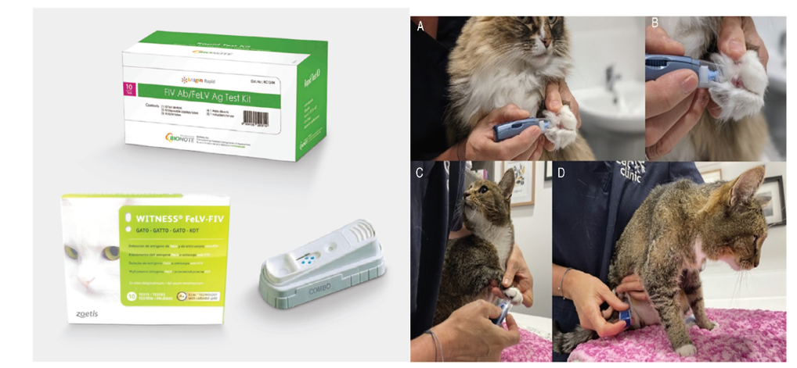
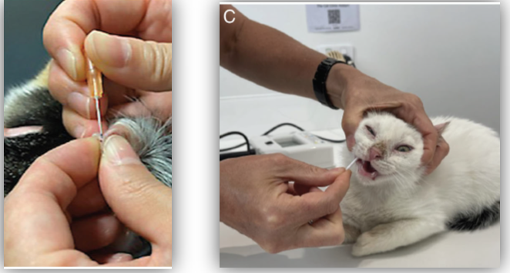
Fig19. Procedure for collection of samples for rapid test (Westman et.al., 2015)

Fig 20- Treatment procedures
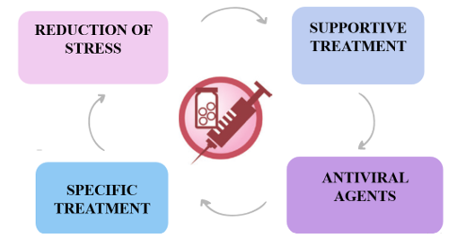

5. TREATMENT
Treatment of ocular disease in cats is often challenging, and selecting the most appropriate protocol usually requires a multifaceted approach that takes into account the stage and severity of infection, financial constraints, and owner and patient compliance. Management of ocular conditions caused by viral infections typically includes stress reduction, general supportive care, the use of antiviral agents in cases such as FHV and FCV, and specific therapies tailored to the particular ocular manifestations present (Stiles & Townsend, 2007).

- ANTIVIRAL AGENTS
- DNA analogues
The most effective group of anti-herpes virus drugs are the acyclic nucleoside analogues. These are virostatic, acting via competitive inhibition of DNA polymerase and triggering chain termination of replicating DNA. To become metabolically active, most acyclic nucleosides require phosphorylation by viral thymidine kinase (although some, such as cidofovir, rely only on host thymidine kinases for activation). Following viral thymidine kinase phosphorylation, additional phosphorylation steps occur; these are mediated by host cellular kinases. A large number of acyclic nucleoside analogue drugs exist, although commercial availability varies between countries (Galle, 2004).
Trifluorothymidine
Also known as trifluridine or 5FT, trifluoro -thymidine (TFT) shows the most effective in vitro efficacy against FHV-1. As such, disease theoretically the topical antiviral drug of choice. Unfortunately, however, no clinical trials of its use in cats have been reported.38,39A 1% topical solution should be used four to six times daily for up to 21 days. In the UK, TFT can only be obtained from eye hospital pharmacies, although in some countries it is available by prescription through a pharmacy. It is relatively expensive and can be irritant in some cats. The bottle should be kept refrigerated after opening (Galle, 2004).

Ganciclovir
Ganciclovir has recently become available in gel form from UK pharmacies (Virgan; Théa). In vitro studies indicate good efficacy against FHV1, so this drug is a promising treatment option although clinical trials in cats are currently lacking.
Cidofovir
Cidofovir is used to treat cytomegalovirus retinitis in humans but it also has a wide spectrum of activity against other viruses. Studies have shown it to be effective against FHV1, both in vitro and in vivo. Of particular interest is its apparent long-term antiviral action, the active metabolite of cidofovir possessing an intracellular half-life of 65h.This appears to be reflected in its therapeutic effects; twice daily application of 0.5% cidofovir significantly reduced viral shedding and severity of clinical signs in cats with experimentally induced FHV1 infection (Fontenelle et.al., 2008).
Famciclovir
Famciclovir is the prodrug of penciclovir, and is converted to the active drug following absorption across the gastrointestinal tract. The pharmacokinetics of penciclovir following oral administration of famciclovir in cats appear to be complex, with significant interindividual variability among cats.43 A recent study evaluated the effects of orally administered famciclovir in cats experimentally infected with FHV1. The study used high doses of famciclovir (90 mg/kg three times daily for 21 days) and showed that it reduced viral shedding and conjunctivitis scores compared with controls. As one of only two antivirals with proven clinical efficacy against FHV1 (the other being cidofovir, see above), famciclovir should be considered one of the drugs of choice in the treatment of FHV1 clinical disease. Although clinical efficacy of famciclovir has been proven only for doses of 90 mg/kg three times daily, anecdotal reports of efficacy at lower doses (62–125 mg per cat once to three times daily) have been reported (Thomasy et.al., 2011).

TABLE 2: SELECTED ACYCLIC NUCLEOSIDE ANALOGUE DRUGS
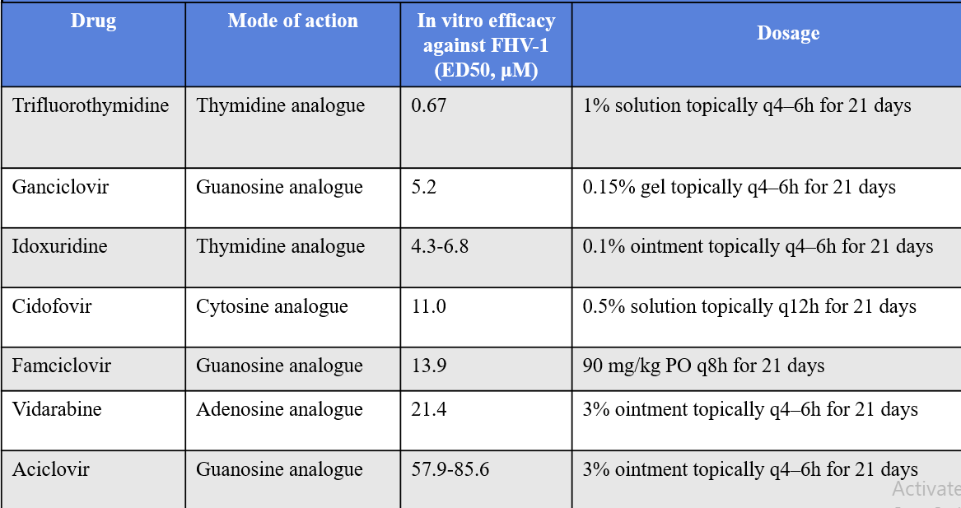
(Gould, 2011)

TREATMENT FOR UVEITIS
1) Mild Anterior Uveitis
Mild anterior uveitis can often be managed with topical non-steroidal anti-inflammatory drugs (NSAIDs). A commonly used option is 0.1% diclofenac, applied two to three times daily, with dosing adjusted according to clinical response and patient tolerance.

2) Moderate to Severe Anterior Uveitis
In cases of moderate to severe anterior uveitis, a more potent anti-inflammatory approach is required. Topical corticosteroids such as 1% prednisolone acetate or 0.1% dexamethasone are typically administered four times daily to control intraocular inflammation. Once the uveitis has improved and the intraocular inflammation is stabilized, it may be possible to transition to a topical NSAID for maintenance therapy in order to reduce the long-term risks associated with prolonged corticosteroid use.

3) Topical Atropine
Topical atropine is used to induce mydriasis and iridocycloplegia, thereby helping to prevent posterior synechiae and reduce ciliary spasm–associated pain. It is particularly helpful in cases with miosis and low intraocular pressure, where pupil dilation and cycloplegia improve comfort and help stabilize the anterior segment. In cats, the ointment formulation of atropine is preferred over the solution because the bitter-tasting solution tends to drain rapidly through the nasolacrimal duct onto the tongue, often causing hypersalivation and aversion (Holmberg & Maggs, 2004).
UVEAL LYMPHOSARCOMA
Management of uveal lymphosarcoma should include systemic chemotherapy to address the underlying neoplastic process, combined with topical corticosteroid therapy such as 1% prednisolone acetate to control intraocular inflammation. If glaucoma develops, topical medications such as dorzolamide and timolol can be added to reduce intraocular pressure. Enucleation is an appropriate consideration for blind, painful eyes with glaucoma that cannot be controlled medically. Orbital lymphosarcoma may be treated with systemic chemotherapy and/or external beam radiation therapy, depending on the extent of disease and overall patient status (Magden et al., 2013).

- CONCLUSIONS
The major pathogens reviewed here—FHV-1, FCV, FIV, FeLV, FCoV (FIP) and FPV—produce a wide spectrum of ocular lesions, ranging from conjunctivitis, keratitis and corneal sequestra to anterior uveitis, retinal vasculitis, retinal dysplasia and neoplastic infiltrates of the uveal tract. careful ophthalmic examination and systematic diagnostic work-up are essential with the help of Integrating slit-lamp biomicroscopy, indirect ophthalmoscopy, tonometry and fluorescein staining with targeted laboratory evaluation and specific viral testing allows the clinician to distinguish primary viral disease from secondary or immune-mediated complications and to identify cases where multiple pathogens may be acting concurrently.

- FUTURE PROSPECTS AND RECOMMENDATIONS
Future work in this field should focus on refining both diagnostics and therapeutics to enable earlier, more precise and less invasive management of viral ocular disease in cats. On the diagnostic side, there is considerable scope for developing standardized, point-of-care algorithms that combine clinical scoring systems with multiplex PCR panels and improved rapid tests, including assays validated specifically for ocular samples such as conjunctival swabs and aqueous humour. Better differentiation between active infection, latent carriage and immune-mediated sequelae will help clinicians to decide when antivirals, immunomodulators or primarily anti-inflammatory regimens are most appropriate. Longitudinal cohort studies in shelter, cattery and household populations could also clarify how housing density, vaccination strategies and stressors influence the incidence and recurrence of viral ocular disease.
Therapeutically, more feline-specific data on the safety, pharmacokinetics and efficacy of topical and systemic antivirals are urgently needed, particularly for drugs such as cidofovir, ganciclovir and famciclovir that show promise but remain under-studied in controlled clinical trials. Novel drug-delivery systems—including long-acting ocular gels, implants, nanoparticles and sustained-release inserts—may improve corneal penetration and reduce dosing frequency, thereby enhancing owner compliance and animal welfare. In parallel, advances in vaccine technology, such as improved mucosal vaccines for FHV-1 and FCV and optimized retroviral vaccination protocols, could reduce viral load in cat populations and indirectly decrease ocular complications. Finally, collaborative work between ophthalmologists, internists, virologists and epidemiologists, supported by digital image archives and potentially AI-assisted image analysis, may yield more robust diagnostic criteria and evidence-based treatment guidelines. Together, these developments have the potential to transform viral ocular disease in cats from a frustrating chronic problem into a more predictable, preventable and manageable group of conditions.

COMPETING INTERESTS DISCLAIMER:
Authors have declared that they have no known competing financial interests OR non-financial interests OR personal relationships that could have appeared to influence the work reported in this paper.

Disclaimer (Artificial intelligence)
Option 2:
Author(s) hereby declare that generative AI technologies such as Large Language Models, etc. have been used during the writing or editing of manuscripts. This explanation will include the name, version, model, and source of the generative AI technology and as well as all input prompts provided to the generative AI technology
Details of the AI usage are given below:
1. Generative AI (ChatGPT, GPT-5, OpenAI, accessed via chat.openai.com) was used in a limited capacity for language refinement, sentence restructuring, clarity improvement, and minor formatting (abstract and references). Input prompts included “Improve grammar and clarity without changing meaning” and “Simplify sentences for better readability.” All research design, data collection, analysis, interpretation, and conclusions were solely performed by the authors.

REFERENCES
- Addie, D., Belák, S., Boucraut-Baralon, C., Egberink, H., Frymus, T., Gruffydd-Jones, T., Hartmann, K., Hosie, M. J., Lloret, A., Lutz, H., Marsilio, F., Pennisi, M. G., Radford, A. D., Thiry, E., Truyen, U., & Horzinek, M. C. (2009). Feline infectious peritonitis. ABCD guidelines on prevention and management. Journal of Feline Medicine and Surgery, 11(7), 594–604. https://doi.org/10.1016/j.jfms.2009.05.008
- Albert, D. M. (1980). The role of viruses in the development of ocular tumors. Ophthalmology, 87(12), 1219–1225. https://doi.org/10.1016/s0161-6420(80)35104-x
- Albert, D. M., Lahav, M., Colby, E. D., Shadduck, J. A., & Sang, D. N. (1977). Retinal neoplasia and dysplasia. I. Induction by feline leukemia virus. Investigative Ophthalmology & Visual Science, 16(4), 325–337. https://iovs.arvojournals.org/article.aspx?volume=16&issue=4&page=325
- Allgoewer, I., Schäffer, E. H., Stockhaus, C., & Vögtlin, A. (2001). Feline eosinophilic conjunctivitis. Veterinary Ophthalmology, 4(1), 69–74. https://doi.org/10.1046/j.1463-5224.2001.00150.x
- Ammersbach, M., Little, S., & Bienzle, D. (2013). Preliminary evaluation of a quantitative polymerase chain reaction assay for diagnosis of feline immunodeficiency virus infection. Journal of Feline Medicine and Surgery, 15(8), 725-729. https://doi.org/10.1177/1098612X13475465
- August, J. R. (1984). Feline infectious peritonitis, an immune-mediated coronaviral vasculitis. Veterinary Clinics of North America: Small Animal Practice, 14(5), 971–984. https://doi.org/10.1016/s0195-5616(84)50102-8
- Bannasch, M. J., & Foley, J. E. (2005). Epidemiologic evaluation of multiple respiratory pathogens in cats in animal shelters. Journal of Feline Medicine and Surgery. https://doi.org/10.1016/j.jfms.2004.07.004
- Bistner, S. I., Carlson, J. H., Shively, J. N., & Scott, F. W. (1971). Ocular manifestations of feline herpesvirus infection. Journal of the American Veterinary Medical Association, 159(10), 1223–1237. https://pubmed.ncbi.nlm.nih.gov/4330456/
- Brightman, A. H., Ogilvie, G. K., & Tompkins, M. (1991). Ocular disease in FeLV-positive cats: 11 cases (1981–1986). Journal of the American Veterinary Medical Association, 198(6), 1049–1051. https://doi.org/10.2460/javma.1991.198.06.1049
- Brown, M. A. (2011). Genetic determinants of pathogenesis by feline infectious peritonitis virus. Veterinary Immunology and Immunopathology, 143(3-4), 265–268. https://doi.org/10.1016/j.vetimm.2011.06.021
- Coyne, K. P., Jones, B. R. D., Kipar, A., Chantrey, J., Porter, C. J., Barber, P. J., Dawson, S., Gaskell, R. M., & Radford, A. D. (2006). Lethal outbreak of disease associated with feline calicivirus infection in cats. Veterinary Record, 158, 544–550. https://doi.org/10.1136/vr.158.16.544
- Cullen, C. L., Haines, D. M., Jackson, M. L., & Grahn, B. H. (2002). Lack of detection of feline leukemia and feline sarcoma viruses in diffuse iris melanomas of cats by immunohistochemistry and polymerase chain reaction. Journal of Veterinary Diagnostic Investigation, 14(4), 340–343. https://doi.org/10.1177/104063870201400414
- English, R. V., Davidson, M. G., Nasisse, M. P., Jamieson, V. E., & Lappin, M. R. (1990). Intraocular disease associated with feline immunodeficiency virus infection in cats. Journal of the American Veterinary Medical Association, 196, 1116–1119. https://doi.org/10.2460/javma.196.7.1116
- Fontenelle, J. P., Powell, C. C., Veir, J. K., Radecki, S. V., & Lappin, M. R. (2008). Effect of topical ophthalmic application of cidofovir on experimentally induced primary ocular feline herpesvirus-1 infection in cats. American Journal of Veterinary Research, 69(2), 289–293. https://doi.org/10.2460/ajvr.69.2.289
- Gabor, L. J., Love, D. N., Malik, R., & Canfield, P. J. (2001). Feline immunodeficiency virus status of Australian cats with lymphosarcoma. Australian Veterinary Journal, 79(8), 540–545. https://doi.org/10.1111/j.1751-0813.2001.tb10742.x
- Galle LE, Moore CP. Clinical microbiology. In: Gelatt KN, ed. Veterinary ophthalmology. 4th edn. Iowa: Blackwell Publishing, (2007), 236–70.
- Galle, L. E. (2004). Antiviral therapy for ocular viral disease. Veterinary Clinics of North America: Small Animal Practice, 34(3), 639–653. https://doi.org/10.1016/j.cvsm.2003.12.008
- Gaskell, R. M., Dennis, P. E., Goddard, L. E., Cocker, F. M., & Wills, J. M. (1985). Isolation of felid herpesvirus I from the trigeminal ganglia of latently infected cats. Journal of General Virology, 66, 391–394. https://doi.org/10.1099/0022-1317-66-2-391
- Gaskell, R. M., & Povey, R. C. (1977). Experimental induction of feline viral rhinotracheitis (FVR) virus re-excretion in FVR-recovered cats. The Veterinary Record. https://doi.org/10.1136/vr.100.12.128
- Gaskell, R. M., & Povey, R. C. (1979). Feline viral rhinotracheitis: sites of virus replication and persistence in acutely and persistently infected cats. Research in Veterinary Science, 27(2), 167–174. https://pubmed.ncbi.nlm.nih.gov/230556/
- Gerriets, W., Joy, N., Huebner-Guthardt, J., & Eule, J.C. (2012). Feline calicivirus: A neglected cause of feline ocular surface infections?. Veterinary Ophthalmology, 15, 172–179. https://doi.org/10.1111/j.1463-5224.2011.00957.x
- Goldschmidt, P., Rostane, H., Saint-Jean, C., Batellier, L., Alouch, C., Zito, E., & Bourcier, T. (2006). Effects of topical anaesthetics and fluorescein on the real-time PCR used for the diagnosis of Herpesviruses and Acanthamoeba keratitis. British Journal of Ophthalmology, 90(11), 1354–1356. https://doi.org/10.1136/bjo.2006.098830
- Gould, D. (2011). Feline herpesvirus-1: ocular manifestations, diagnosis and treatment options. Journal of Feline Medicine and Surgery. https://doi.org/10.1016/j.jfms.2011.03.010
- Greene, C. E. (2012). Feline enteric viral infections. In C. E. Greene (Ed.), Infectious diseases of the dog and cat (4th ed., pp. 80–91). Elsevier. https://www.elsevier.com/books/infectious-diseases-of-the-dog-and-cat/greene/978-1-4377-0795-3
- Herring, E. S., Troy, G. C., Toth, T. E., Forrester, S. D., Weigt, L. A., & Herring, I. P. (2001). Detection of feline leukaemia virus in blood and bone marrow of cats with varying suspicion of latent infection. Journal of Feline Medicine and Surgery. https://doi.org/10.1053/jfms.2001.0132
- Herring, I. P., Troy, G. C., Toth, T. E., Champagne, E. S., Pickett, J. P., & Haines, D. M. (2001). Feline leukemia virus detection in corneal tissues of cats by polymerase chain reaction and immunohistochemistry. Veterinary Ophthalmology, 4(2), 119–126. https://doi.org/10.1046/j.1463-5224.2001.00187.x
- Hök, K. (1993). Development of clinical signs and occurrence of feline corona virus antigen in naturally infected barrier reared cats and their offspring. Acta Veterinaria Scandinavica, 34(4), 345–356. https://doi.org/10.1186/BF03548177
- Hök, K. (1993). Morbidity, mortality and coronavirus antigen in previously coronavirus free kittens placed in two catteries with feline infectious peritonitis. Acta Veterinaria Scandinavica, 34(2), 203–210. https://doi.org/10.1186/BF03548211
- Holmberg, B. J., & Maggs, D. J. (2004). The use of corticosteroids to treat ocular inflammation. Veterinary Clinics of North America: Small Animal Practice, 34(3), 693–705. https://doi.org/10.1016/j.cvsm.2003.12.007
- Hurley, K. E., Pesavento, P. A., Pedersen, N. C., Poland, A. M., Wilson, E., & Foley, J. E. (2004). An outbreak of virulent systemic feline calicivirus disease. Journal of the American Veterinary Medical Association, 224, 241–249. https://doi.org/10.2460/javma.2004.224.241
- La Croix, N. C. (2005). Ocular manifestations of systemic disease in cats. Clinical Techniques in Small Animal Practice, 20(2), 121-128. https://doi.org/10.1053/j.ctsap.2004.12.017
- Loesenbeck, G., Drommer, W., Egberink, H.F., & Heider, H.J. (1996). Immunohistochemical findings in eyes of cats serologically positive for feline immunodeficiency virus (FIV). Zentralblatt fur Veterinarmedizin. Reihe B, 43, 305–311. https://doi.org/10.1111/j.1439-0450.1996.tb00318.x
- Magden, E., Miller, C., MacMillan, M., Bielefeldt-Ohmann, H., Avery, A., Quackenbush, S. L., & Vandewoude, S. (2013). Acute virulent infection with feline immunodeficiency virus (FIV) results in lymphomagenesis via an indirect mechanism. Virology, 436, 284–294. https://doi.org/10.1016/j.virol.2012.12.003
- Maggs, D. J., Chang, E., Nasisse, M. P., & Mitchell, W. J. (1998). Persistence of herpes simplex virus type 1 DNA in chronic conjunctival and eyelid lesions of mice. Journal of Virology, 72(11), 9166–9172. https://doi.org/10.1128/JVI.72.11.9166-9172.1998
- Maggs, D. J., Lappin, M. R., & Nasisse, M. P. (1999). Detection of feline herpesvirus-specific antibodies and DNA in aqueous humor from cats with or without uveitis. American Journal of Veterinary Research, 60(8), 932–936. https://doi.org/10.2460/ajvr.1999.60.08.932
- Mitchell, N. (2006). Feline ophthalmology part I: Examination of the eye. Irish Veterinary Journal, 59, (3), 164.
- Morgan RV, Abrams KL, Kern TJ. Feline eosinophilic keratitis: a retrospective study of 54 cases (1989 –1994). Vet Comp Ophthalmol. (1996), 6, 131–34.
- Nasisse, M. P., Glover, T. L., Moore, C. P., & Weigler, B. J. (1998). Detection of feline herpesvirus 1 DNA in corneas of cats with eosinophilic keratitis or corneal sequestration. American Journal of Veterinary Research, 59(7), 856–858. https://doi.org/10.2460/ajvr.1998.59.07.856
- Nasisse, M. P., Guy, J. S., Davidson, M. G., Sussman, W. A., & Fairley, N. M. (1989). Experimental ocular herpesvirus infection in the cat. Sites of virus replication, clinical features and effects of corticosteroid administration. Investigative Ophthalmology & Visual Science, 30(8), 1758–1768. https://iovs.arvojournals.org/article.aspx?articleid=2170000
- Phillips, T. R., Prospero-Garcia, O., Puaoi, D. L., Lerner, D. L., Fox, H. S., Olmsted, R. A., Bloom, F. E., Henriksen, S. J., & Elder, J. H. (1994). Neurological abnormalities associated with feline immunodeficiency virus infection. Journal of General Virology, 75, 979–987. https://doi.org/10.1099/0022-1317-75-5-979
- Ramsey, D. T. (2000). Feline chlamydia and calicivirus infections. Veterinary Clinics of North America: Small Animal Practice, 30(5), 1015–1028. https://doi.org/10.1016/s0195-5616(00)05004-x
- Reynolds, B. S., Poulet, H., Pingret, J. L., Jas, D., Brunet, S., Lemeter, C., Etievant, M., & Boucraut-Baralon, C. (2009). A nosocomial outbreak of feline calicivirus associated virulent systemic disease in France. Journal of Feline Medicine and Surgery, 11, 633–644. https://doi.org/10.1016/j.jfms.2008.12.005
- Ryan, G., Klein, D., Knapp, E., Hosie, M. J., Grimes, T., Mabruk, M. J. E. M. F., Jarrett, O., & Callanan, J. J. (2003). Dynamics of viral and proviral loads of feline immunodeficiency virus within the feline central nervous system during the acute phase following intravenous infection. Journal of Virology, 77(13), 7477–7485. https://doi.org/10.1128/jvi.77.13.7477-7485.2003
- Stiles J, Townsend WM. Feline ophthalmology. In: Gelatt KN, ed. Veterinary ophthalmology, 4th edn. Iowa: Blackwell Publishing, 2007, 1095–164.
- Stiles, J. (2014). Ocular manifestations of feline viral diseases. The Veterinary Journal, 201(2), 166-173. https://doi.org/10.1016/j.tvjl.2013.11.018
- Stiles, J., & Pogranichniy, R. (2008). Detection of virulent feline herpesvirus-1 in the corneas of clinically normal cats. Journal of Feline Medicine and Surgery. https://doi.org/10.1016/j.jfms.2007.10.006
- Stiles, J., Bienzle, D., Render, J. A., Buyukmihci, N. C., & Johnson, E. C. (1999). Use of nested polymerase chain reaction (PCR) for detection of retroviruses from formalin-fixed, paraffin-embedded uveal melanomas in cats. Veterinary Ophthalmology, 2(2), 113–116. https://doi.org/10.1046/j.1463-5224.1999.00066.x
- Stiles, J. (2000). Feline herpesvirus. *Veterinary Clinics of North America: Small Animal Practice*, *30*(5), 1001–1014. https://doi.org/10.1016/s0195-5616(00)05003-8
- Storey, E. S., Gerding, P. A., Scherba, G., & Schaeffer, D. J. (2002). Survival of equine herpesvirus-4, feline herpesvirus-1, and feline calicivirus in multidose ophthalmic solutions. Veterinary Ophthalmology, 5, 263–267. https://doi.org/10.1046/j.1463-5224.2002.00234.x
- Thiry, E., Addie, D., Belák, S., Boucraut-Baralon, C., Egberink, H., Frymus, T., Gruffydd-Jones, T., Hartmann, K., Hosie, M. J., Lloret, A., Lutz, H., Marsilio, F., Pennisi, M. G., Radford, A. D., Truyen, U., & Horzinek, M. C. (2009). Feline herpesvirus infection. ABCD guidelines on prevention and management. Journal of Feline Medicine & Surgery, 11(7), 547-555. https://doi.org/10.1016/j.jfms.2009.05.003
- Thomasy, S. M., Lim, C. C., Reilly, C. M., Kass, P. H., Lappin, M. R., & Maggs, D. J. (2011). Evaluation of orally administered famciclovir in cats experimentally infected with feline herpesvirus type-1. American Journal of Veterinary Research, 72, 85–95. https://doi.org/10.2460/ajvr.72.1.85
- Townsend, W. T., Stiles, J., Guptill-Yoran, L., & Krohne, S. G. (2004). Development of a reverse transcriptase-polymerase chain reaction assay to detect feline herpesvirus-1 latency-associated transcripts in the trigeminal ganglia and corneas of cats that did not have clinical signs of ocular disease. American Journal of Veterinary Research, 65(3), 314–319. https://doi.org/10.2460/ajvr.2004.65.314
- Truyen, U., Addie, D., Belák, S., Boucraut-Baralon, C., Egberink, H., Frymus, T., Gruffydd-Jones, T., Hartmann, K., Hosie, M.J., Lloret, A., Lutz, H., Marsilio, F., Pennisi, M.G., Radford, A.D., Thiry, E., & Horzinek, M.C. (2009). Feline panleukopenia. ABCD guidelines on prevention and management. Journal of Feline Medicine and Surgery, 11(7), 538–546. https://doi.org/10.1016/j.jfms.2009.05.002
- Wardley, R. C., Gaskell, R. M., & Povey, R. C. (1974). Feline respiratory viruses--their prevalence in clinically healthy cats. Journal of Small Animal Practice, 15(9), 579–586. https://doi.org/10.1111/j.1748-5827.1974.tb06538.x
- Weiss, A. T., Klopfleisch, R., & Gruber, A. D. (2010). Prevalence of feline leukaemia provirus DNA in feline lymphomas. Journal of Feline Medicine and Surgery, 12, 929–935. https://doi.org/10.1016/j.jfms.2010.07.006
- Westman ME, Malik R, Hall E et al. Determining the feline immunodeficiency virus (FIV) status of FIV-vaccinated cats using point-of-care antibody kits. Comparative Immunology, Microbiology & Infectious Diseases (2015), 42, 43–52. https:// doi.org/ 10.1016/j.cimid.2015.07.004.
- Westman ME, Malik R, Norris JM. Diagnosing feline immunodeficiency virus (FIV) and feline leukaemia virus (FeLV) infection: An update for clinicians. Australian Veterinary Journal (2019), 97(3), 47–55. https://doi.org/10.1111/avj.12781.
- Yamamoto, J. K., Hansen, H., Ho, E. W., Morishita, T. Y., Okuda, T., Sawa, T. R., Nakamura, R. M., & Pedersen, N. C. (1989). Epidemiologic and clinical aspects of feline immunodeficiency virus infection in cats from the continental United States and Canada and possible mode of transmission. *Journal of the American Veterinary Medical Association*, *194*(2), 213–220. https://pubmed.ncbi.nlm.nih.gov/2537269/
- Beckwith-Cohen, B., & Petersen-Jones, S. M. (2024). Manifestations of systemic disease in the retina and fundus of cats and dogs. Frontiers in Veterinary Science, 11, 1337062. https://doi.org/10.3389/fvets.2024.1337062

- La Croix, N. C. (2005). Ocular manifestations of systemic disease in cats. Clinical Techniques in Small Animal Practice, 20(2), 121–128. https://doi.org/10.1053/j.ctsap.2004.12.017
- Mills, E. P., Liu, C.-C., Mironovich, M. A., Taylor, C. M., Luo, M., Emelogu, U., Scott, E. M., Leis, M. L., Carter, R. T., Camacho-Luna, P., & Lewin, A. C. (2024). Relationship between the bacterial ocular surface microbiota and outcomes for cats with feline herpesvirus type 1 ocular surface disease. Veterinary Ophthalmology, 27(4), 318–329. https://doi.org/10.1111/vop.13157
- Stiles, J. (2014). Ocular manifestations of feline viral diseases. The Veterinary Journal. https://doi.org/10.1016/j.tvjl.2013.11.018
- Wronski, J. G., de Cecco, B. S., Raiter, J., Henker, L. C., de Lorenzo, C., Bandinelli, M. B., Driemeier, D., Pavarini, S. P., & Sonne, L. (2023). Ophthalmic and immunopathological characterization of systemic infectious diseases in cats. Veterinary Pathology, 60(3), 352–359. https://doi.org/10.1177/03009858231158075
- Mischi, E., Soukup, P., Harman, C. D., Oikawa, K., Kowalska, M. E., Hartnack, S., McLellan, G. J., Komáromy, A. M., & Pot, S. A. (2022). Outer retinal thickness and visibility of the choriocapillaris in four distinct retinal regions imaged with spectral domain optical coherence tomography in dogs and cats. Veterinary Ophthalmology, 25(Suppl 1), 122–135. https://doi.org/10.1111/vop.12989
- Mitchell, N. (2010). Examination of the feline eye — functional anatomy. Veterinary Nursing Journal, 25(1), 17–18. https://doi.org/10.1111/j.2045-0648.2010.tb00004.x
- Chan, I., Dowsey, A., Lait, P. J. P., Tasker, S., Blackwell, E.-J., Helps, C. R., & Barker, E. N. (2023). Prevalence and risk factors for common respiratory pathogens within a cohort of pet cats in the UK. Journal of Small Animal Practice, 64(9), 552–560. https://doi.org/10.1111/jsap.13623
- de Almeida, J. C. N., de Carvalho, H. C. T., Gila, L. I., Martins, N. B., Szabó, M. P. J., & da Hora, A. S. (2023). Use of selected samples to diagnose a tricky feline viral disease in a cat with uveitis and neurological signs. Brazilian Journal of Veterinary Medicine, 45, e001223. https://doi.org/10.29374/2527-2179.bjvm001223

