Nutritive Value and Digestibility of Faidherbia albida Foliage in Arid and Semi-Arid Rangelands

.

ABSTRACT
In the arid and semi-arid rangelands of Tanzania, native grasses serve as the primary feed resource for herbivores. However, during the dry season, the nutritive value of these grasses declines significantly, posing challenges to the health, performance, and productivity of herbivores, especially livestock. This situation necessitates exploring alternative feed resources to sustain livestock during these critical periods. Faidherbia albida has emerged as a vital fodder tree due to its ability to maintain lush, nutritious foliage even in the dry season, thereby providing essential sustenance when other feed options are scarce. Therefore, the study aimed to evaluate the chemical composition, mineral profile, digestibility, ruminal degradability, and fermentation potential of F. albida foliage collected during the dry season to support evidence-based recommendations for its strategic use in livestock feeding. The foliage was randomly sampled from 20 mature F. albida trees (5 plots × 4 trees/plot), composited by plot (n = 5), dried, milled, and analyzed. Chemical composition was determined using proximate analysis, while in vitro dry matter (DM) and organic matter (OM) digestibility was determined using the Tilley and Terry technique. Cumulative gas production was recorded over 120 h, and the net 24 h gas production (Gp; mL per 200 mg DM) was combined with crude protein (CP) and ash to estimate OM digestibility and metabolisable energy. In sacco DM and OM degradability were assessed using nylon bags in rumen-fistulated cattle. Calcium (Ca) and phosphorus (P) were quantified by atomic absorption spectrophotometry and colorimetrically, respectively. Data were analyzed using descriptive statistics and linear mixed-effects models. On a DM basis, foliage contained 20.1% CP, 5.5% ash, 22.2% crude fibre, 74.0% neutral detergent fibre, 52.8% acid detergent fibre, and 28.0% acid detergent lignin. In vitro DM and OM digestibility were low (15.3% and 15.5%, respectively). Gas-based estimates indicated moderate fermentability, with net 24 h gas production (Gp) of ~22.9 mL per 200 mg DM, predicted OM digestibility of 47.9% and metabolisable energy of ~6.5 MJ kg⁻¹ DM. In sacco DM and OM degradability at 96–120 h were approximately 20%. The concentration of Ca and P was 0.45% and 0.26% DM, respectively (Ca:P 1.7:1). These findings indicate that F. albida foliage is protein- and mineral-rich in the dry season and, when offered to herbivores with longer rumen retention as a complementary supplement to low-quality roughages, might support animal performance.

Keywords: Dry-season Supplementation; Fodder Trees; Mineral Profile; Rumen Fermentation
.
1. INTRODUCTION
In arid and semi-arid rangelands, forage resources are constrained by low and variable rainfall, short growing seasons, and long dry periods characterized by senesced herbage (Muzzo et al., 2023). During the dry season, native grasses and crop residues typically contain less than about 80–100 g crude protein (CP) kg⁻¹ dry matter (DM), high fibre and inadequate mineral supply, which together limit intake, digestion and animal performance (Elseed et al., 2001; Belete et al., 2024). Herbivores grazing these systems must therefore cope with pronounced seasonal fluctuations in both the quantity and quality of available feed. In Tanzania's semi-arid rangelands, livestock production is largely based on extensive grazing, with cattle as the dominant herbivores and small ruminants having a complementary role. For much of the dry season, cattle diets are dominated by mature grasses and cereal residues that frequently fail to meet basic requirements for maintenance, growth, and reproduction (Marius et al., 2021). Under these low-input conditions, where access to commercial protein and mineral supplements is limited, pastoralists and agropastoralists increasingly rely on woody vegetation, including browse trees and shrubs, to buffer dry-season feed deficits and sustain herd performance (Muzzo et al., 2023).
Browse trees and shrubs, particularly leguminous species historically grouped within the Acacia sensu lato complex, are important components of arid and semi-arid rangeland systems and strategic dry-season supplements. Acacia sensu lato comprises pantropical pod-bearing woody legumes (Mimosoideae, Fabaceae) widely distributed across dry lands, whose leaves often contain tannins and which are valued for drought tolerance, nitrogen fixation, and multiple uses including fodder, shade, and live fencing (Alajmi et al., 2017; Van Auken and Bush, 2013; Aref et al., 2014). These browse species can provide green leaves, pods, and twigs when herbaceous forage has senesced and typically offer higher crude protein and mineral content than associated grasses; across the tropics, fodder tree and shrub leaves commonly contain 120–230 g CP kg⁻¹ DM with moderate fibre and relatively elevated macro- and micro-minerals, making them strategic supplements for bridging dry-season nutritional gaps (Rubanza et al., 2002, 2005; Cheema et al., 2010; Medjekal et al., 2020; Gupta et al., 1975; Aregheore et al., 2006; Lukhele and Van Ryssen, 2003; Mahieu et al., 2021; Belete et al., 2024; Okunade et al., 2014; Mekuriaw et al., 2023). Within East African rangelands, the role of browse resources is well recognized, and several leguminous taxa are commonly utilized as dry-season supplements. Key taxa include Vachellia tortilis, V. xanthophloea, V. drepanolobium, Senegalia senegal, and Faidherbia albida ("apple-ring acacia"), which is among the dominant browse species in Tanzanian and other African rangelands (Figure 1). Supplementation trials and meta-analyses rank F. albida among the more promising tropical browse legumes for protein content and feeding value, reporting improved intake, digestibility, and live-weight gain when foliage or pods accompany low-quality basal diets (Feyera et al., 2011; Mubi, 2009; Njidda et al., 2017; Mekuriaw et al., 2023). Reported mineral profiles are generally favourable (often high Ca, Mg, and K), although high Ca:P ratios and marginal phosphorus are sometimes observed (Rubanza et al., 2005, 2007; Elseed et al., 2001; Boufennara et al., 2012; Drechsel and Zech, 1991; Pedro et al., 2024).
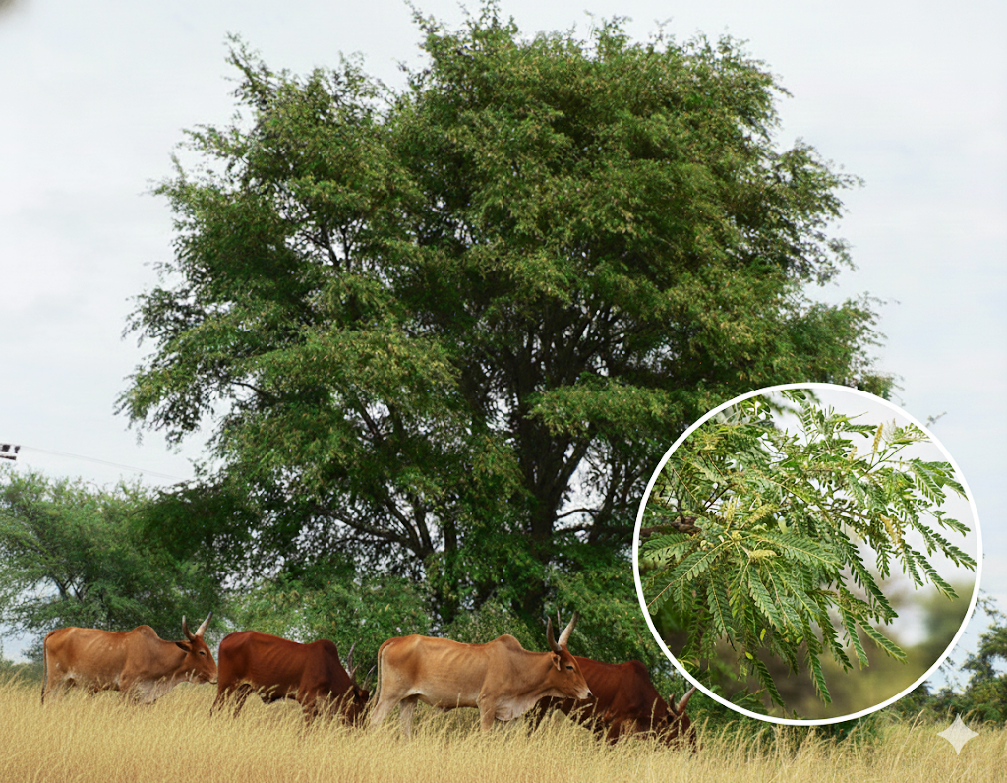
However, the nutritive value of individual browse species is highly variable and shaped by species identity, environment, phenological stage, and concentrations of secondary compounds such as tannins (Rubanza et al., 2002; Njidda et al., 2011; Belachew et al., 2018). When appropriately used, browse resources can nevertheless improve herbivore performance and productivity, but this requires robust, species-specific information under local conditions. Despite the apparent potential of Faidherbia albida, there is little integrated information on the nutritive value and ruminal digestibility of locally available foliage during the dry season, including coordinated analysis of proximate composition, fibre fractions, in vitro and in sacco degradability, gas production characteristics, and mineral content. This knowledge gap constrains the formulation of accurate rations and the development of evidence-based recommendations on the use of F. albida foliage as a complementary supplement to low-quality dry-season roughages for cattle and other herbivores, whether under free-grazing conditions or in confinement systems. Therefore, this study aimed to evaluate the chemical composition, mineral profile, digestibility, ruminal degradability, and fermentation potential of F. albida foliage collected during the dry season to support evidence-based recommendations for its strategic use as a complementary supplement to low-quality dry-season roughages.
Figure 1. Tanzania Shorthorn Zebu cattle browsing Faidherbia albida during the dry season in Dodoma, Tanzania (19 July 2025). The inset highlights foliage of F. albida targeted during browsing.

2. MATERIALS AND METHODS
2.1 Study area
Foliage samples of F.albida were collected at Magadu Farm, Sokoine University of Agriculture (SUA), Morogoro, Tanzania. The farm is located on the lower slopes of the Uluguru Mountains at an altitude of 500–600 m above sea level and is used for livestock production, training, and research. The area covers 134 ha, receives 800–900 mm of mean annual rainfall, and has a mean daily temperature of 25–30 °C, with relative humidity around 81 % during the rainy season ( July to October) (SUA Meteorological Centre, 2024). Sampling was conducted during the dry season, when F. albida was in whole-leaf form, and the surrounding herbaceous vegetation was largely senesced.

2.2 Sampling design, tree selection, and foliage collection
The Faidherbia albida stands surrounding Magadu Farm were mapped and subdivided into five plots, each approximately 100 × 100 m. Within each plot, all mature F. albida trees (≥10 per plot) were located, mapped, and assigned unique identification numbers. Trees were classified as mature based on the presence of a well-developed crown that could be safely accessed for foliage harvesting. Tree age was not directly determined because reliable planting records were unavailable and no age–size calibration was conducted; therefore, maturity was defined operationally using crown development and accessibility. In each plot, four trees were selected by simple random sampling without replacement using a random-number table applied to the list of tree IDs. Thus, every mature tree within a plot had an equal probability of selection, and no tree could be selected more than once. Figure 2 illustrates this "sampling individuals" procedure: open crowns represent all eligible mature trees within a plot, while the four numbered trees (1–4) indicate the randomly selected individuals. The connecting lines show the efficient walking route followed during field collection to minimize travel time. At each selected tree, total height and canopy height (CH) were measured using a graduated pole. Leafy twigs were harvested at approximately half of CH from each of the four cardinal directions (north, south, east, and west) using pruning shears. Subsamples from the four directions were pooled to form one composite foliage sample per tree. Each tree-level composite was placed into a labelled nylon bag (plot ID and tree ID), weighed fresh in the field, and transported to the Sokoine University of Agriculture Animal Nutrition Laboratory for drying and milling. To obtain plot-level replication consistent with the experimental design, the four tree-level composite samples within each plot were subsequently combined in equal proportions (on a dry matter basis) to produce one plot composite sample. Thus, a total of five plot composite samples (n = 5; one per plot) were generated and used for chemical composition, in vitro digestibility, in vitro gas production, in sacco degradability, and mineral analyses.

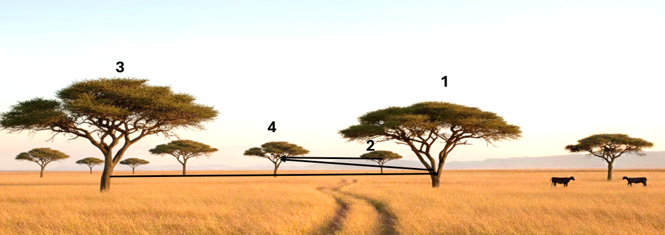
Figure 2. Illustration of the “sampling individuals” method used to select Faidherbia albida trees within each 100 × 100 m plot at Magadu Farm. All mature trees in a plot were mapped and numbered, and four trees (1–4) were selected by simple random sampling without replacement. The connecting lines indicate the efficient walking route followed in the field (3 → 1 → 4 → 2) rather than the numerical order of selection. Leafy twigs from each selected tree were harvested at half of canopy height from the four cardinal directions. Adapted from Wilson et al. (2012)

2.3 Sample preparation
Fresh foliage samples were weighed on arrival at the laboratory to determine fresh mass, then oven-dried at 60 °C to constant weight to obtain air-dry material for subsequent processing and to prevent heat damage to organic constituents. After drying, samples collected from the four selected trees in each plot were combined in equal proportions on a dry-matter basis to generate a single plot composite sample. Thus, five plot composite samples (n = 5; one per plot) were prepared for all laboratory analyses. Plot composites were mixed thoroughly and ground in a Wiley mill to pass through a 1-mm screen for chemical and mineral analyses and through a 2-mm screen for in vitro and in situ degradability determinations. Ground samples were stored in airtight, labelled bottles until analysis. All results were expressed on a DM basis.

2.4 Proximate composition
Proximate components were determined according to AOAC (1990, 2005) standard procedures. Dry matter (DM) was determined by oven-drying subsamples at 105 °C for 24 h (AOAC 934.01). Ash was obtained by incineration of dried samples in a muffle furnace at 550 °C for 3 h (AOAC 942.05), followed by cooling in a desiccator and weighing; if the residue was not carbon-free, samples were re-ignited for an additional 3 h (or until constant mass was achieved). Nitrogen (N) content was analysed by the Kjeldahl method using block digestion and steam distillation, and crude protein (CP) was calculated as N × 6.25 (AOAC 988.05). Ether extract (EE) was determined by Soxhlet extraction with petroleum ether (AOAC 920.39). Crude fibre (CF) was analysed using the ANKOM fibre analyser following AOAC 978.10. Nitrogen-free extract (NFE), representing soluble carbohydrates, was calculated by difference.

$${\text{NFE (g kg}}^{-1}\text{ DM)}=1000-(\text{Ash}+\text{CP}+\text{EE}+\text{CF}).$$
2.4.1 Fibre fractions (Van Soest system)
Cell wall fractions were determined according to the detergent system of Van Soest et al. (1991) using an ANKOM fibre analyser (ANKOM Technology, Macedon, NY, USA). Neutral detergent fibre (NDF) was analysed using neutral detergent solution containing sodium lauryl sulfate and EDTA, with sodium sulfite and heat-stable α-amylase added to aid the removal of starch and protein. Acid detergent fibre (ADF) was determined using acid detergent solution (cetyl trimethylammonium bromide in 1 N H₂SO₄). Acid detergent lignin (ADL) was measured by treating ADF residues with 72% H₂SO₄, then ashing at 550 °C. Hemicellulose and cellulose were calculated as:
$$\text{Hemicellulose}=\text{NDF}-\text{ADF},\text{Cellulose}=\text{ADF}-\text{ADL}.$$
2.5 In vitro dry matter and organic matter digestibility
In vitro dry matter digestibility (IVDMD) and organic matter digestibility (IVOMD) were determined using the two-stage technique of Tilley and Terry (1963). Approximately 0.5 g of 2-mm ground sample was weighed into 80-mL centrifuge tubes. Forty millilitres of pre-warmed McDougall's buffer (pH 6.8–7.0) and 10 mL of strained rumen fluid from a fistulated cow fed medium-quality hay plus mineral supplement were added to each tube under continuous CO₂ flushing to maintain anaerobic conditions. Tubes were sealed with rubber stoppers fitted with valves and incubated at 39 °C for 48 h in a shaking water bath, with periodic mixing to resuspend particles. After 48 h, the tubes were centrifuged (2000 × g, 25 min), and the supernatant was discarded. The residues were resuspended in 50 mL pepsin–HCl solution (2 g pepsin L⁻¹ in 0.1 N HCl) and incubated for a further 48 h at 39 °C. Final residues were filtered into pre-weighed crucibles, dried at 100 °C for 48 h, weighed, then ashed at 550 °C for 3 h. IVDMD and IVOMD were calculated as:

$$\text{IVDMD}=\frac{\text{Sample DM}-\text{Residue DM}}{\text{Sample DM}}×100, \\ \text{IVOMD}=\frac{\text{Sample OM}-\text{Residue OM}}{\text{Sample OM}}×100.$$

2.6 In vitro gas production and prediction of OMD and ME
In vitro gas production was determined using the calibrated glass syringe technique following the Hohenheim gas test described by Menke et al. (1979), and predicted organic matter digestibility (OMD) and metabolisable energy (ME) were estimated according to Menke and Steingass (1988). Approximately 200 mg of the 2-mm ground sample was weighed into pre-warmed 100-mL glass gas syringes. Rumen liquor was collected before morning feeding from rumen-fistulated cattle maintained on a basal hay diet, filtered through four layers of cheesecloth, kept at 39 °C, and continuously flushed with CO₂ to maintain anaerobic conditions. The incubation medium (buffer–mineral solution with a reducing agent and indicator) was prepared as described by Menke et al. (1979) and mixed with rumen fluid at a 2:1 (v/v) buffer: rumen fluid ratio. Each syringe was filled with the inoculum, gently shaken to disperse the substrate, and incubated upright at 39 °C in a thermostatically controlled water bath. Gas volume was recorded at 0, 3, 6, 12, 24, 48, 72, 96, and 120 h, and gas production was expressed as mL g⁻¹ DM. Net 24-h gas production (Gp; mL per 200 mg DM) was calculated as the 24-h reading minus the 0-h reading, and blank syringes containing only inoculum were used to blank-correct gas production. The 24-h net gas volume (Gp), together with crude protein (CP) and ash contents, was used to estimate predicted OMD (%) and ME (MJ kg⁻¹ DM) using the Menke and Steingass (1988) equations:
OMD (%) = 14.88 + 0.889·Gp + 0.45·CP + 0.651·Ash;
ME (MJ kg⁻¹ DM) = 2.20 + 0.136·Gp + 0.057·CP + 0.0029·EE².
For the prediction equations, CP, ash, and EE were expressed as % DM (g/100 g DM), and units were converted where necessary.
.2.7 In situ rumen degradability (nylon bag technique)
In situ degradability of DM and OM was estimated using the nylon bag technique in two rumen-fistulated cows adapted to a basal hay diet (Figure 3). Approximately 2 g of 2-mm ground sample per plot was weighed into nylon bags (10 × 5 cm; 38-µm pore size), which were then sealed and attached in sequence to a nylon string. For each cow, duplicate bags were prepared for each incubation time. Bags were incubated in the ventral sac of the rumen for 0 (washed only), 6, 12, 24, 48, 72, 96, and 120 h. After removal, bags were rinsed under running tap water until the effluent was clear, dried at 60 °C for 72 h, and weighed. Residues were ashed at 550 °C for 3 h to determine OM disappearance. Degradability at each time point was expressed as the proportion of DM or OM loss relative to the original sample. For each plot composite, the time-course of DM and OM degradability was fitted to the non-linear model of Ørskov and McDonald (1979):
$$p_{t}=a+b\left(1 − e^{-ct}\right)$$Where pₜ is the proportion degraded at time t, a is the rapidly soluble fraction, b is the potentially degradable fraction, and c is the fractional degradation rate (h⁻¹).
Effective degradability (ED) was calculated for each plot composite assuming a rumen passage rate (k) of 0.02 h⁻¹ using:
$$ED=a+\frac{b⋅c}{c+k}$$The parameters a, b, c, and ED were later summarised across plots as described in the statistical analysis.

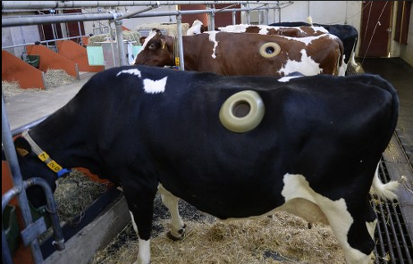
Figure 3: Fistulated animal at Sokoine university of Agriculture

2.8 Mineral analysis
Mineral content was determined on ash solutions prepared from ground foliage. Approximately 5 g of dried sample was ashed at 530 °C in a muffle furnace for 4 h (or until a carbon-free residue/constant mass was obtained), and the ash was moistened with 20 mL of warm 1:1 (v/v) HCl and left to stand overnight (~12 h). The digest was quantitatively transferred to a 100-mL volumetric flask and made up to volume with deionised water. Calcium (Ca) was measured by atomic absorption spectrophotometry (Model SP 191, Pye Unicam Ltd., Cambridge, UK) using appropriate hollow-cathode lamps and external calibration with Ca standard solutions; reagent blanks and check standards were included to verify calibration and analytical accuracy. A releasing agent (lanthanum or strontium chloride) was added to standards and samples to minimise chemical interference. Phosphorus (P) was determined colorimetrically by the molybdate–ascorbic acid method using a UV–visible spectrophotometer, and concentrations were calculated from standard curves and expressed as g kg⁻¹ DM.

2.9 Statistical analysis

The study used a plot-replicated sampling design in which the five plots served as independent replicates, and the plot composite sample was treated as the experimental unit (n = 5). Where laboratory determinations were performed in duplicate, technical replicates were averaged to obtain a single value per plot (and, where applicable, a single value per plot × time point) prior to analysis. Results are presented as plot values and as mean ± SD across plots. For in vitro gas production, gas volumes measured repeatedly over incubation time were analysed using a linear mixed model with incubation time as a fixed effect and plot as a random effect to account for between-plot variability.

$y_{ij}=μ+{Time}_{i}+b_{j}+ε_{ij}$,

where $y_{ij}$is gas production at incubation time $i$in plot $j$, ${Time}_{i}$is the fixed effect of incubation time, $b_{j}$is the random effect of plot $\left(b_{j}∼N(0,σ_{\text{plot}}^{2})\right)$, and $ε_{ij}$is the residual error.

For in situ incubations conducted in two fistulated cows, duplicate bags within each plot × cow × time were averaged before analysis, and cow was treated as a random blocking factor. Disappearance data across incubation times were analysed using a linear mixed model with time as a fixed effect and plot and cow as random effects.

$y_{ijk}=μ+{Time}_{i}+b_{j}+{Cow}_{k}+ε_{ijk}$,

where $y_{ijk}$is DM (or OM) disappearance for incubation time $i$in plot $j$and cow $k$, $b_{j}$is the random effect of plot $\left(b_{j}∼N(0,σ_{\text{plot}}^{2})\right)$, and ${Cow}_{k}$is the random effect of the cow $\left({Cow}_{k}∼N(0,σ_{\text{cow}}^{2})\right)$.

When the incubation time fixed effect was significant, differences among time-point means were assessed using Tukey-adjusted comparisons of model-based means. Degradability model fitting and calculation of effective degradability were conducted as described in Section 2.7, and the resulting fitted outputs were treated as plot-level outcomes and summarised similarly across plots. All analyses were performed in R (version 4.4.2; R Core Team, 2024), and statistical significance was declared at $P<0.05$.

- RESULTS AND DISCUSSION
F. albida foliage in this study had a high crude protein content, confirming its value as a high-protein browse feed for ruminant herbivores in semi-arid systems (Table 1). This CP level agrees with reports from East and North Africa, where F. albida leaf CP commonly ranges from 17 to 21% DM, depending on season, canopy stratum, and site conditions (Rubanza et al., 2005; Abdella and Akuma, 2019). Lower CP contents (14–17% DM) reported elsewhere (Wickens, 1969; Dagar et al., 2016) indicate that soil fertility, climate, tree age, and phenological stage strongly influence nitrogen accumulation in this forage. Similar variability is observed in other browse legume foliage: Acacia nilotica and Acacia seyal typically contain 13–19% CP, whereas Leucaena leucocephala can reach 22–26% CP on fertile sites (Mukangango, 2019). In this context, the CP content obtained in the present study lies at the upper end of the range for tropical browses and is adequate to correct the protein deficit of dry-season grass and cereal-residue diets and to meet maintenance and moderate production requirements of ruminants when energy supply and intake are not limiting.
The mineral profile of F. albida foliage was also favourable. Total ash (55 g kg⁻¹ DM; 5.5% DM) was moderate and slightly lower than values reported from Niger and Sudan (70–90 g kg⁻¹ DM) (Hassan et al., 2007; Bouazza et al., 2012), suggesting somewhat lower overall mineral content in the present environment. Calcium and phosphorus concentrations (4.5 g Ca kg⁻¹ DM [0.45% DM] and 2.6 g P kg⁻¹ DM [0.26% DM]) fall within the ranges reported for F. albida in West and East Africa (Ca 3–10 g kg⁻¹ DM; P 2–3 g kg⁻¹ DM) (Mokgolodi et al., 2011; Chinke et al., 2022), and the Ca:P ratio (1.7:1) is generally compatible with ruminant requirements. Compared with other fodder trees such as Calliandra calothyrsus and Gliricidia sepium, which often show slightly higher Ca but similar P contents (Osuga et al., 2006), F. albida is competitive as a macro-mineral source, particularly where basal grass diets are P-deficient, as in many tropical rangelands (Rubanza et al., 2007). However, the moderate ash content and known variability in trace-element supply in browses indicate that F. albida should be used as a complementary mineral source, not as the sole mineral source, consistent with findings for other semi-arid browse species (Mthi et al., 2021; Daneshvar et al., 2025). Therefore, the nutritional composition of F. albida foliage indicates that it is a strategic protein and macro-mineral supplement for low-quality grass and residue diets in semi-arid systems, particularly where access to commercial concentrates and mineral mixes is limited. Thus, conserving and integrating F. albida trees into pastoral and mixed crop–livestock systems can make a meaningful contribution to sustaining ruminant productivity during the dry season (Muzzo et al., 2023). Accordingly, when offered as a supplement to low-quality grasses and crop residues, F. albida foliage can improve dietary nitrogen and mineral supply and has been associated with improved intake and animal performance in supplementation studies (Feyera et al., 2011; Mubi, 2009; Njidda et al., 2017; Mekuriaw et al., 2023).
In contrast to the favourable protein and macro-mineral supply, the structural carbohydrate fractions showed that F. albida foliage was highly fibrous at the time of sampling (Table 1). Neutral detergent fibre, acid detergent fibre, and acid detergent lignin were high, indicating a large proportion of cell-wall material and extensive lignification (Table 1). These values are higher than those reported in several earlier studies on F. albida, where NDF often ranged between 40 and 55%, ADF was frequently <35% DM, and lignin was <15% DM (Niamey, 1992; Desta et al., 2024; Boufennara et al., 2013), but they fall within the upper range observed during the dry season or at advanced phenological stages (Simone et al., 2023). A plausible explanation is that foliage was collected at a late-maturity stage, when increased deposition of structural carbohydrates and lignin reduces cell-wall degradability and limits the energy-yielding potential of the forage. Similar seasonal increases in NDF and lignin, associated with lower digestibility, have been reported for Acacia tortilis and Acacia seyal in dry-season browse (Rubanza et al., 2005; Belete et al., 2024). The very low in vitro dry-matter and organic-matter digestibility values, therefore, reflect both the high cell-wall content and the probable influence of secondary compounds. Previous studies have reported in vitro DM digestibilities of about 60–80% for related acacia species under more favourable conditions or earlier leaf stages (Njidda et al., 2013; Alarape et al., 2023). The much lower values observed here are closer to those found for lignified browses sampled late in the dry season (Rubanza et al., 2005; Bouazza et al., 2012). In addition to structural limitations, F. albida foliage has been reported to contain condensed tannins and other phenolic compounds (Mudau et al., 2022; Boufennara et al., 2013), which can bind proteins and cell wall polysaccharides, reduce microbial access, and depress apparent digestibility. F. albida foliage has been reported to contain condensed tannins ( Wilson et al., 2024), which can form tannin–protein complexes in the rumen and thereby reduce ruminal proteolysis and deamination, shifting part of dietary nitrogen toward rumen-undegraded ('bypass') protein. This mechanism may improve nitrogen use efficiency when F. albida is used as a dry-season supplement; however, if tannin activity is high relative to protein supply, excessive binding could also limit rumen-available nitrogen needed for microbial fibre digestion of low-quality grasses. Although tannins were not quantified in the present work, the combination of high lignin content and low digestibility is consistent with constraints commonly observed in tannin-containing browse species. High lignin and phenolic contents reduce the potentially degradable fraction and the rate of ruminal degradation (Van Soest, 1994), which is consistent with the low in vitro digestibility measured in this study. Differences in donor rumen fluid, incubation conditions, and laboratory procedures among studies may also contribute to variation in absolute digestibility values and should be considered when making comparisons.
Table 1. Chemical composition, fibre fractions, and mineral profile of Faidherbia albida foliage (dry season)
Parameter | Plot 1 | Plot 2 | Plot 3 | Plot 4 | Plot 5 | Mean ± SD
Dry matter (DM) | 97 | 97.3 | 97.1 | 97.2 | 97.3 | 97.19 ± 0.13
Crude protein (CP) | 20 | 20.3 | 20.1 | 20 | 19.9 | 20.06 ± 0.15
Ash | 5.6 | 5.4 | 5.5 | 5.7 | 5.5 | 5.54 ± 0.11
Crude fibre (CF) | 22.3 | 22.1 | 22.4 | 22.2 | 22.2 | 22.24 ± 0.11
Neutral detergent fibre (NDF) | 73.8 | 74.2 | 74 | 73.9 | 74.1 | 74.00 ± 0.15
Acid detergent fibre (ADF) | 52.7 | 52.9 | 52.8 | 52.6 | 52.9 | 52.78 ± 0.11
Acid detergent lignin (ADL) | 27.9 | 28.1 | 28 | 27.8 | 28 | 27.96 ± 0.11
Hemicellulose (NDF−ADF) | 21.1 | 21.3 | 21.2 | 21.3 | 21.2 | 21.22 ± 0.09
Cellulose (ADF−ADL) | 24.8 | 24.8 | 24.8 | 24.8 | 24.9 | 24.84 ± 0.05
(DM = % as-fed; all other components = % of DM)

The in vitro gas production profile over 120 h further described the fermentation behaviour of F. albida foliage (Figure 4). Cumulative gas production increased rapidly during the first 24 h and then plateaued, indicating depletion of the more readily fermentable fractions and a large, slowly fermentable or undegradable component. Cumulative gas production at 24 h was 52 mL g⁻¹ DM, whereas the net 24-h gas volume used in the Menke prediction equations (Gp) was 22.9 mL per 200 mg DM. The 24-h gas response is within the range documented for tannin-containing browses (Bouazza et al., 2012; Mlambo et al., 2009). Lower gas production does not necessarily imply lower feeding value in protein- and tannin-containing feeds, because fermentation end-products and nitrogen transformations can influence measured gas output (Menke et al., 1979). However, interpreted together with the high NDF, ADF, and lignin contents and the very low IVDMD and IVOMD, the gas profile supports the conclusion that a substantial portion of the organic matter is slowly or poorly fermentable. Conversely, more digestible fodder trees such as Leucaena leucocephala and Gliricidia sepium typically show higher gas production and in vitro digestibility at similar incubation times, particularly when tannin activity is low or when polyethylene glycol is used to neutralise tannins (Edwards et al., 2024; Rashid et al., 2021). Using the Menke and Steingass approach, predicted OMD was 47.9% and predicted ME was about 6.5 MJ kg⁻¹ DM, indicating moderate fermentability but limited overall energy value relative to the high structural fibre fraction. The in situ (nylon bag) degradability results were consistent with the in vitro findings (Figure 5). Rumen disappearance of dry matter (DMD) and organic matter (OMD) increased rapidly during the first 24 h, after which values approached a plateau by 96–120 h, indicating that most of the degradable fraction was solubilised early, with a relatively large slowly degradable or undegradable fraction remaining. Any additional increase in rumen disappearance between 96 and 120 h indicates the presence of a very slowly degradable fraction that becomes available only under long rumen residence times. This late degradation is most likely to contribute nutritionally in large-bodied, bulk-feeding ruminants (e.g., cattle, buffalo, and other large bovids) and under dry-season/low-intake conditions that reduce passage rate and increase selective retention of coarse particles, whereas smaller ruminants (e.g., sheep and goats) with generally faster digesta turnover are less likely to realise this late degradability fully. Accordingly, effective degradability (ED) remains the more biologically realistic indicator in herviores (Kamal et al., 2025), of how much of this slowly degradable fraction is actually utilised in vivo. Effective degradability of DM and OM, estimated using the Ørskov and McDonald model, was low, consistent with a highly lignified substrate and restricted microbial access to cell-wall carbohydrates. Because incubations were conducted in two donor cows, some variability in disappearance patterns can also be expected due to differences in rumen microbial communities and host-related factors affecting utilisation of phenolic-rich feeds (Rira et al., 2022; Rubanza et al., 2005). Overall, the combination of high lignin and likely phenolic constraints implies a large potentially undegradable fraction in the rumen and a restricted contribution to fermentable energy.

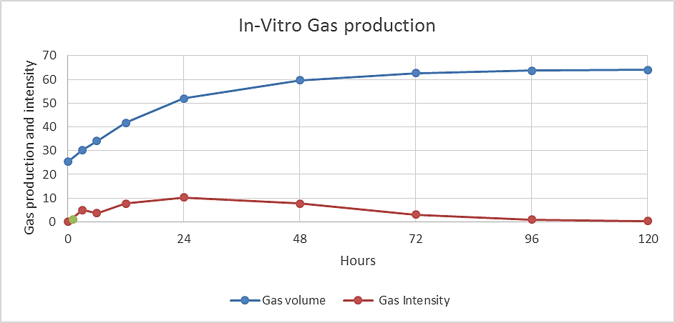
Figure 4. In vitro gas production of F. albida foliage over 120 h of incubation with buffered rumen fluid. The blue line shows cumulative gas volume, and the red line shows gas intensity at each incubation time, illustrating rapid fermentation during the first 24 h followed by a plateau and declining intensity, consistent with a large slowly fermentable or undegradable fraction of the foliage.

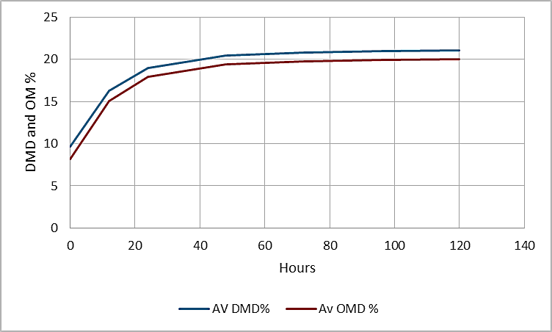
Figure 5. In situ (in sacco) rumen disappearance of dry matter (DMD) and organic matter (OMD) of Faidherbia albida foliage over 120 h of incubation in nylon bags. Lines represent mean percentage DMD (blue) and OMD (red) at each incubation time, showing rapid loss during the first 24 h followed by a plateau, consistent with a large slowly degradable or undegradable fraction of the foliage.
Overall, these results characterise F. albida foliage as a forage with high protein content and an adequate macro-mineral supply, but with limited energy value due to its large lignified cell-wall fraction and constraints on ruminal degradability, likely associated with phenolic compounds ( Figure 1). For ration formulation, this profile supports using F. albida as a source, as well as F. albida (apple-ring acacia), which is among the dominant browse species in Tanzanian and other African rangelands (Figure 1). In practice, supplementation with F. albida foliage, particularly when paired with an adequate fermentable energy source, can translate into improved animal performance under dry-season feeding conditions, as reported in previous feeding trials and syntheses (Feyera et al., 2011; Mubi, 2009; Njidda et al., 2017; Mekuriaw et al., 2023). The protein and mineral contents of F. albida foliage are adequate to correct major deficiencies in senesced grasses and cereal residues. Concurrently, the low digestibility and moderate fermentability indicate that it should be combined with more readily fermentable energy sources to optimise animal response. Consequently, when used strategically as a dry-season supplement to low-quality grasses and crop residues, F. albida foliage may improve herbivore performance and productivity by enhancing dietary nitrogen and mineral supply and supporting rumen function, while also potentially reducing environmental impacts through improved nitrogen use efficiency and lower nitrogen losses per unit of animal product. Studies with other tannin-containing browses show that mixing tree foliage with crop residues or improved forages, adjusting inclusion levels, and, where feasible, using tannin-binding agents such as polyethylene glycol can improve intake, digestion, and performance (Niderkorn and Jayanegara, 2021; Korir et al., 2022). Collectively, the in vitro and in situ measurements in the present study provide concordant evidence that a large proportion of F. albida foliage is slowly or poorly degradable in the rumen. Both techniques showed a rapid loss of the soluble and rapidly fermentable fraction within the first 24 h, followed by a plateau and low effective degradability at realistic passage rates. Although tannins were not measured directly, evidence from tannin-containing browses and purified extracts indicates that, at moderate inclusion levels, condensed tannins can confer functional benefits that partly offset their depressive effects on ruminal degradability by forming reversible complexes with dietary protein, increasing the flow of undegraded dietary protein to the small intestine, enhancing whole-body nitrogen retention, and reducing urinary nitrogen losses (Barry and McNabb, 1999; Muzzo, 2024). In tannin-supplemented grazing systems, Muzzo (2024) reported approximately 28% higher nitrogen retention in the treatment cattle group compared with the unsupplemented control group, illustrating how moderate tannin supply can improve nitrogen use efficiency in vivo. In addition, condensed tannins and associated phenolics in browse species have been linked to antiparasitic activity, improved antioxidant and immune status, and, in some cases, reduced enteric methane emissions (Rodríguez et al., 2023; Pandey et al., 2022). Thus, even though the high lignin content of F. albida limits its role as an energy source, the secondary metabolite profile reported for this species and similar browses suggests that, when inclusion level and dietary context are carefully managed, F. albida foliage can contribute not only to correction of protein and mineral deficits but also to improved nitrogen retention, animal health, and reduced environmental nitrogen losses in low-input ruminant production systems.

4. Conclusion
F.albida foliage is a protein- and mineral-rich but fibre- and lignin-constrained browse resource, with low degradability indicating a limited contribution to fermentable energy and rumen microbial growth. These characteristics support its use primarily as a strategic supplement to low-quality grass and crop-residue diets, helping to alleviate dry-season deficits in nitrogen and key minerals, rather than as the main basal roughage. Future research is recommended to define optimal inclusion levels for different ruminant classes and physiological stages, quantify seasonal and within-tree variation in chemical composition and tannin profiles, and evaluate animal performance responses under farm conditions. Moreover, further studies are suggested to clarify the role of F.albida in mixed tree-crop-livestock feeding systems across global arid and semi-arid regions, including its contribution to climate-resilient, resource-efficient livestock production.

COMPETING INTERESTS:
Authors have declared that they have no known competing financial interests, non-financial interests, OR personal relationships that could have appeared to influence the work reported in this paper.
Definitions, Acronyms, Abbreviations
Abbreviations used in this manuscript:
ADF: acid detergent fibre
ADL: acid detergent lignin
ANKOM: ANKOM Technology (fibre analyser; Macedon, NY, USA)
AOAC: Association of Official Analytical Chemists
Ca: calcium
CF: crude fibre
CH: canopy height
CO₂: carbon dioxide
CP: crude protein
Cu: copper
DM: dry matter
DMD: dry matter disappearance (in sacco)
ED: effective degradability
EDTA: ethylenediaminetetraacetic acid
EE: ether extract
Fe: iron
g: gram
Gp: net 24-h gas production
h: hour
ha: hectare
HCl: hydrochloric acid
H₂SO₄: sulfuric acid
ID: identification code (e.g., plot ID, tree ID)
IVDMD: in vitro dry matter digestibility
IVOMD: in vitro organic matter digestibility
K: potassium
kg: kilogram
LITA: Livestock Training Agency
ME: metabolisable energy
mg: milligram
Mg: magnesium
min: minute
MJ: megajoule
mL: millilitre
Mn: manganese
N: nitrogen; also normality when used for acid concentration
n: sample size/number of observations
Na: sodium
NDF: neutral detergent fibre
NFE: nitrogen-free extract
NY: New York
OM: organic matter
OMD: organic matter digestibility
P: phosphorus; also probability value when reporting statistical significance
pH: hydrogen ion concentration
R: R statistical computing environment
SUA: Sokoine University of Agriculture
UK: United Kingdom
USA: United States of America
UV: ultraviolet
v/v: volume/volume
Zn: zinc

Disclaimer (Artificial intelligence)
Author(s) hereby declare that NO generative AI technologies such as Large Language Models (ChatGPT, COPILOT, etc.) and text-to-image generators have been used during the writing or editing of this manuscript.

References
- Abdella, M., Nigatu, L., & Akuma, A. (2019). Impact of Parkland Faidherbia albida Delile A. Chev and Cordia africana Lam Trees on Selected Soil Properties and Sorghum Yield in Fedis District, East Hararghe Zone, Oromia, Ethiopia (Doctoral dissertation). Haramaya University. http://ir.haramaya.edu.et/handle/123456789/632
- Alarape, O. L., Migwi, P. K., & Ondiek, J. O. (2023). Nutritional evaluation and in vitro dry matter digestibility (IVDMD) of Moringa oleifera, Medicago sativa, Chloris gayana, and their combinations at different ratios. International Journal of Veterinary Science and Animal Husbandry, 8(4), 232–237. https://doi.org/10.22271/veterinary.2023.v8.i4d.602 Association of Official Analytical Chemists (AOAC). (1990). Official Methods of Analysis (15th ed.). Arlington, VA: AOAC.
- Association of Official Analytical Chemists (AOAC). (2005). Official Methods of Analysis (18th ed.). Gaithersburg, MD: AOAC International.
- Association of Official Analytical Chemists. (2005). Official Methods of Analysis (18th ed.). AOAC International. http://www.eoma.aoac.org/
- Aref, I. M., Khan, P. R., Al-Mefarrej, H., Al-Shahrani, T., Ismail, A., & Iqbal, M. (2014). Cambial periodicity and wood production in Acacia ehrenbergiana Hayne growing on dry sites of Saudi Arabia. Journal of Environmental Biology, 35(2), 301–310. https://www.jeb.co.in/previous-issues/2014-mar-35-2
- Aregheore, E. M., Steglar, T. A., & Ng'ambi, J. W. (2006). Nutrient characterisation and in vitro digestibility of grass and legume/browse species-based diets for beef cattle in Vanuatu. South Pacific Journal of Natural and Applied Sciences, 24(1), 20–27. https://doi.org/10.1071/SP06003
- Barnes, R. D., & Fagg, C. W. (2003). Faidherbia albida: Monograph and Annotated Bibliography. Oxford Forestry Institute, University of Oxford. https://ora.ox.ac.uk/objects/uuid:12345678-90ab-cdef-1234-567890abcdef/datastreams/CONTENT1
- Barry, T. N., & McNabb, W. C. (1999). The implications of condensed tannins on the nutritive value of temperate forages fed to ruminants. British Journal of Nutrition, 81(4), 263–272. https://doi.org/10.1017/S0007114599000501
- Belachew, Z., Yisehak, K., Taye, T., & Janssens, G. P. J. (2013). Chemical composition and in sacco ruminal degradation of tropical trees rich in condensed tannins. Czech Journal of Animal Science, 58(4), 176–192. https://doi.org/10.17221/6712-CJAS
- Belachew, Z., Yisehak, K., Taye, T., & Janssens, G. P. J. (2013). Chemical composition and in sacco ruminal degradation of tropical trees rich in condensed tannins. Czech Journal of Animal Science, 58(4), 176–192. https://doi.org/10.17221/6712-CJAS
- Bouazza, L., Bodas, R., Boufennara, S., Bousseboua, H., & López, S. (2012). Nutritive evaluation of foliage from fodder trees and shrubs characteristic of Algerian arid and semi-arid areas. Journal of Animal and Feed Sciences, 21(3), 521–536. https://doi.org/10.22358/jafs/66126/2012
- Belete, S., Tolera, A., Betsha, S., & Dickhöfer, U. (2024). Feeding values of indigenous browse species and forage legumes for the feeding of ruminants in Ethiopia: A meta-analysis. Agriculture, 14(9), 1475. https://doi.org/10.3390/agriculture14091475
- Boufennara, S., Bouazza, L., Bodas, R., Bousseboua, H., & López, S. (2013). Nutritive evaluation of foliage from some Acacia trees characteristic of Algerian arid and semi-arid areas. In H. Ben Salem & A. López-Francos (Eds.), Feeding and management strategies to improve livestock productivity, welfare and product quality under climate change (pp. 63-68). CIHEAM. http://om.ciheam.org/om/pdf/a107/00007012.pdf
- Cheema, U. B., Sultan, J. I., Javaid, A., Akhtar, P., & Shahid, M. (2011). Chemical composition, mineral profile and in situ digestion kinetics of fodder leaves of four native trees. *Pakistan Journal of Botany*, *43*(1), 397–404. http://www.pakbs.org/pjbot/pjhtmls/PJB43(1)2011.html
- Chinke, N. M., Hamzat, S., Oyinlola, E. Y., Idris, S., & Yusif, S. A. (2022). Assessment of nitrogen mineralization of Faidherbia albida and its effect on maize (Zea mays L.) growth on an Alfisol in Samaru, Northern Guinea Savanna of Nigeria. Journal of Agriculture and Environment, 18(1), 167–181. https://doi.org/10.4314/JAGRENV.V18I1

- Dagar, J. C., & Tewari, J. C. (Eds.). (2016). Agroforestry research developments. Nova Science Publishers. https://www.novapublishers.com/catalog/product_info.php?products_id=59690
- Drechsel, P., & Zech, W. (1991). Foliar nutrient levels of broad-leaved tropical trees: A tabular review. Plant and Soil, 131(1), 29–46. https://doi.org/10.1007/BF00010417
- Edwards, A., Mlambo, V., Mnisi, C. M., & Hughes, M. P. (2024). Mature fruits of Gliricidia sepium and Leucaena leucocephala plants have potential as inexpensive protein and mineral supplements for ruminants. Agroforestry Systems, 98(8), 2951–2960. https://doi.org/10.1007/s10457-024-01066-8
- Elseed, A. M. A. F., Amin, A. E., Abdel Ati, K. A., Sekine, J., Hishinuma, M., & Hamana, K. (2002). Nutritive Evaluation of Some Fodder Tree Species during the Dry Season in Central Sudan. Asian-Australasian Journal of Animal Sciences, 15(6), 844–850. https://doi.org/10.5713/ajas.2002.844
- Feyera, T., & Animut, G. (2011). Digestion, intake and live weight changes of Horro lambs fed vetch (Lathyrus sativus) haulm basal diet supplemented with sole wheat bran, Acacia albida leaf meal or their mixture. Pakistan Journal of Nutrition, 10(11), 1013–1021. https://doi.org/10.3923/pjn.2011.1013.1021
- Gohl, B. (1981). Tropical feeds: Feed information summaries and nutritive values. Rome: Food and Agriculture Organization of the United Nations. https://agris.fao.org/agris-search/search.do?recordID=XF1982000001
- Gupta, P. C., Singh, R., Sangwan, D. C., & Pradhan, K. (1975). Chemical composition and in vitro nutrient digestibility of some of the tree leaves. The Indian Forester, 101(11), 674–680.
- Hassan, L. G., Umar, K. J., & Yuguda, H. (2007). Nutritional evaluation of Faidherbia albida seeds and pulp as source of feeds for livestock. African Journal of Food, Agriculture, Nutrition and Development, 7(5). https://www.scispace.com/paper/10.13140/RG.2.1.4990.0880/nutritional-evaluation-of-faidherbia-albida-seeds-and-pulp-as-source-of-feeds-for-livestock-2007-L-G-Hassan-K-J-Umar-H-Yuguda
- Kamal, M., Aldhalmi, A. K., Abd El-Hack, M. E., Elsherbeni, A. I., Youssef, I. M., Hussein, S., Bai, B., Xu, Z., Hao, L., Mahrose, K. M., Taha, A., & Cheng, Y. (2025). ENHANCING THE FEED EFFICIENCY OF CROP RESIDUES IN RUMINANTS-A COMPREHENSIVE REVIEW. Anim. Sci, 25(2), 529–545. https://doi.org/10.2478/aoas-2024-0081
- Korir, D., Eckard, R., Goopy, J., Arndt, C., Merbold, L., & Marquardt, S. (2022). Effects of replacing Brachiaria hay with either Desmodium intortum or dairy concentrate on animal performance and enteric methane emissions of low-yielding dairy cows. Frontiers in Animal Science, 3, 963323. https://doi.org/10.3389/fanim.2022.963323
- Lorenzo, P., González, L., & Reigosa, M. J. (2010). The genus Acacia as invader: The characteristic case of Acacia dealbata Link in Europe. Annals of Forest Science, 67(1), 101. https://doi.org/10.1051/forest/2009082
- Lukhele, M. S., & Van Ryssen, J. B. J. (2003). The chemical composition and potential nutritive value of the foliage of four subtropical tree species in Southern Africa for ruminants. South African Journal of Animal Science, 33(2), 132–141. https://doi.org/10.4314/SAJAS.V33I2.3767
- Mahieu, S., Novak, S., Barre, P., Delagarde, R., Niderkorn, V., Gastal, F., & Emile, J.-C. (2021). Diversity in the chemical composition and digestibility of leaves from fifty woody species in temperate areas. Agroforestry Systems, 95, 1295–1308. https://doi.org/10.1007/s10457-021-00662-2
- McDougall, E. I. (1948). Studies on ruminant saliva. 1. The composition and output of sheep's saliva. Biochemical Journal, 43, 99–109. https://doi.org/10.1042/bj0430099
- Medjekal, S., Ghadbane, M., Boufennara, S., Bebderradji, L., Bodas, R., Bousseboua, H., & López, S. (2020). Chemical composition, in situ degradation, and fermentation kinetics of some browse plant species collected from Algerian arid and semi-arid areas. Journal of Rangeland Science, 10(2), 188–203. https://rangeland.borujerd.iau.ir/article_669014_35aab5483de7e3176fd79c4245df93fd.pdf
- Mekuriaw, S., Tsunekawa, A., Ichinohe, T., Tegegne, F., Haregeweyn, N., Kobayashi, N., Tassew, A., Mekuriaw, Y., Belete, M. W., Ali, S., Tsubo, M., Okuro, T., Meshesha, D., & Abebe, G. (2023). Selection and evaluation of promising indigenous fodder trees and shrubs as supplemental diets for ruminant animals across different agroecological environments. African Journal of Range and Forage Science, 41(1), 15–28. https://doi.org/10.2989/10220119.2023.2228840
- Menke, K. H., & Steingass, H. (1988). Estimation of the energetic feed value obtained from chemical analysis and in vitro gas production using rumen fluid. Animal Research and Development, 28, 7–55.
- Menke, K. H., Raab, L., Salewski, A., Steingass, H., Fritz, D., & Schneider, W. (1979). The estimation of the digestibility and metabolizable energy content of ruminant feedingstuffs from the gas production when they are incubated with rumen liquor in vitro. The Journal of Agricultural Science, 93(1), 217–222. https://doi.org/10.1017/S0021859600086305
- Mokgolodi, N. C., Setshogo, M., Shi, L., Liu, Y., & Ma, C. (2011). Achieving food and nutritional security through agroforestry: A case of Faidherbia albida in sub-Saharan Africa. Forestry Studies in China, 13(2), 123–131. https://doi.org/10.1007/s11632-011-0202-y
- Mubi, A. (2009). The effects of supplementing legume crop residue with Faidherbia albida pods for goat feeding in North East Nigeria. Journal of Agricultural Research and Development, 2(1), 25–31. https://doi.org/10.4314/JARD.V2I1.42196
- Mudau, H. S., Mokoboki, H. K., Ravhuhali, K. E., & Mkhize, Z. (2022). Effect of Soil Type: Qualitative and Quantitative Analysis of Phytochemicals in Some Browse Species Leaves Found in Savannah Biome of South Africa. Molecules 2022, Vol. 27, Page 1462, 27(5), 1462. https://doi.org/10.3390/MOLECULES27051462
- Mukangango, M. (2019). Potential of Acacia angustissima, Leucaena pallida and Mimosa scabrella in agroforestry systems on a Rwandan Ferralsol (Doctoral dissertation). Swedish University of Agricultural Sciences. https://res.slu.se/id/publ/100182
- Muzzo, B. I. (2023). A comparative assessment of propagation methods for Lannea schweinfurthii a critical threatened multipurpose tree species in Tanzanian Rangelands. International Journal of Agriculture and Plant Science, 5(1), 19–27. https://www.agriculturejournal.in
- Muzzo, B. I., Maleko, D. D., Thacker, E., & Provenza, F. D. (2023). Rangeland management in Tanzania: Opportunities, challenges, and prospects for sustainability. International Journal of Tropical Drylands, 7(2). DOI: 10.13057/tropdrylands/t070204
- Muzzo, B. I., Ramsey, R. D., & Villalba, J. J. (2024). Changes in climate and their implications for livestock nutrition and management. Climate, 13(1),1; https://doi.org/10.3390/cli13010001.
- Niderkorn, V., & Jayanegara, A. (2021). Opportunities offered by plant bioactive compounds to improve silage quality, animal health and product quality for sustainable ruminant production: A review. Agronomy, 11(1), 86. https://doi.org/10.3390/agronomy11010086
- Niderkorn, V., & Jayanegara, A. (2021). Opportunities offered by plant bioactive compounds to improve silage quality, animal health and product quality for sustainable ruminant production: A review. Agronomy, 11(1), 86. https://doi.org/10.3390/agronomy11010086
- Njidda, A. A. (2011). Chemical composition, fibre fraction and anti-nutritional substances of semi-arid browse forages of north-eastern Nigeria. Nigerian Journal of Basic and Applied Sciences https://doi.org/10.4314/NJBAS.V18I2.64308
- Njidda, A. A., Olafadehan, A. O., & Alkali, H. A. (2017). Potential nutritive value of selected leguminous browse forage species from Nigeria using in vitro gas production technique. Iranian Journal of Applied Animal Science. https://ijas.ir/article_61690.html
- Okunade, S. A., Isah, O. A., Aderinboye, R. Y., & Olafadehan, O. A. (2014). Assessment of chemical composition and in vitro degradation profile of some Guinea savannah browse plants of Nigeria. Tropical and Subtropical Agroecosystems, 17(3), 529–538. https://www.redalyc.org/pdf/939/93931067010.pdf
- Ørskov, E. R., & McDonald, I. (1979). The estimation of protein degradability in the rumen from incubation measurements weighted according to rate of passage. The Journal of Agricultural Science, 92, 499–503. https://doi.org/10.1017/S0021859600063048
- Osuga, I. M., Abdulrazak, S. A., Ichinohe, T., & Fujihara, T. (2005). Chemical composition, degradation characteristics and effect of tannin on digestibility of some browse species from Kenya harvested during the wet season. Asian-Australasian Journal of Animal Science. https://doi.org/10.5713/ajas.2005.54
- Pandey, A., Nayak, S., Khare, A., Sharma, R., Chourasiya, A., Reddy, B. V. V., & Risheen, G. D. (2022). Perspectives in the use of tannins in animal production & health: A review. Journal of Livestock Science, 13, 112-119. https://doi.org/10.33259/JLivestSci.2022.112-119
- Pedro, S. I., Gonçalves, J., Horta, C., Gonçalves, J. C., Gominho, J., Gallardo, E., & Anjos, O. (2024). A systematic analysis of nutritional and mineral composition and toxicity in Acacia species leaves. Applied Sciences, 14(20), 9437. https://doi.org/10.3390/app14209437
- Rashid, M. R. S., Hanafy, M. A., Youssef, M. S. H., Archimède, H., Sallam, S. M. A., Soltan, Y. A., & Ali Ghoneem, W. M. (2021). Chemical and in vitro evaluation of Leucaena (Leucaena leucocephala) Leaves as a Substitute of Alfalfa (Medicago sativa L.) with/without Rejected Green Banana Fruits (Musa paradisiaca). World's Veterinary Journal, 11(4), 685–697. https://doi.org/10.54203/scil.2021.wvj86
- Salama Rashid, M. R., Hanafy, M. A., Youssef, M. S. H., Archimède, H., Sallam, S. M. A., Soltan, Y. A., & Ali Ghoneem, W. M. (2021). Chemical and in vitro evaluation of Leucaena (Leucaena leucocephala) Leaves as a Substitute of Alfalfa (Medicago sativa L.) with/without Rejected Green Banana Fruits (Musa paradisiaca). World's Veterinary Journal, 11(4), 685–697. https://doi.org/10.54203/scil.2021.wvj86
- Rashid, M. R. S., Hanafy, M. A., Youssef, M. S. H., Archimède, H., Sallam, S. M. A., Soltan, Y. A., & Ghoneem, W. M. A. (2021). Chemical and in vitro evaluation of Leucaena (Leucaena leucocephala) Leaves as a Substitute of Alfalfa (Medicago sativa L.) with/without Rejected Green Banana Fruits (Musa paradisiaca). World's Veterinary Journal, 11(4), 685-697. https://doi.org/10.54203/scil.2021.wvj86
- Ravhuhali, K. E., Msiza, N. H., & Mudau, H. S. (2022). Seasonal dynamics on nutritive value, chemical estimates and in vitro dry matter degradability of some woody species found in rangelands of South Africa. Agroforestry Systems, 96(1), 23–33. https://doi.org/10.1007/s10457-021-00683-x
- Ravhuhali, K. E., Msiza, N. H., & Mudau, H. S. (2022). Seasonal dynamics on nutritive value, chemical estimates and in vitro dry matter degradability of some woody species found in rangelands of South Africa. Agroforestry Systems, 96(1), 23-33. https://doi.org/10.1007/s10457-021-00683-x
- Rira, M., Morgavi, D. P., Popova, M., Maxin, G., & Doreau, M. (2022). Microbial colonisation of tannin-rich tropical plants: Interplay between degradability, methane production and tannin disappearance in the rumen. Animal, 16(8), 100589. https://doi.org/10.1016/j.animal.2022.100589
- Rodríguez-Hernández, P., Reyes-Palomo, C., Sanz-Fernández, S., Rufino-Moya, P. J., Zafra, R., Martínez-Moreno, F. J., Rodríguez-Estévez, V., & Díaz-Gaona, C. (2023). Antiparasitic tannin-rich plants from the south of Europe for grazing livestock: A review. Animals, 13(2), 201. https://doi.org/10.3390/ani13020201
- Rubanza, C. D. K., Shem, M. N., Bakengesa, S. S., Ichinohe, T., & Fujihara, T. (2007). The content of protein, fibre and minerals of leaves of selected Acacia species indigenous to north-western Tanzania. Archives of Animal Nutrition, 61(2), 151–156. https://doi.org/10.1080/17450390701203907
- Rubanza, C. D. K., Shem, M. N., Ichinohe, T., & Fujihara, T. (2006). Polyphenolics and minerals composition of selected browse tree species leaves native to north-western Tanzania traditional fodder banks. Journal of Food, Agriculture and Environment, 4(1), 328–332. https://www.wflpublisher.com/Journal/JFAE/archive.html?year=2006&volume=4
- Rubanza, C. D. K., Shem, M. N., Otsyina, R., Ichinohe, T., and Fujihara, T. (2002). Nutritive evaluation of some browse tree legume foliages native to semi-arid areas in Western Tanzania. Asian-Australasian Journal of Animal Sciences, 16(10), 1429–1437. https://doi.org/10.5713/AJAS.2003.1429
- Simone, S. K., Urge, M., & Yeheyis, L. (2023). Effect of alfalfa (Medicago sativa L.) hay supplementation and urea molasses block on feed intake, digestibility, and body weight change of yearling local sheep fed grass hay as basal diet. Turkish Journal of Agriculture-Food Science and Technology, 11(6), 1067–1073. https://doi.org/10.24925/turjaf.v11i6.1067-1073.5989
- Tilley, J. M. A., & Terry, R. A. (1963). A two-stage technique for the in vitro digestion of forage crops. Journal of the British Grassland Society, 18, 104–111. https://doi.org/10.1111/j.1365-2494.1963.tb00335.x
- Van Auken, O. W., & Bush, J. K. (2013). Invasion of woody legumes. Springer. https://doi.org/10.1007/978-1-4614-7199-8
- Van Soest, P. J. (1994). Nutritional Ecology of the Ruminant (2nd ed.). Cornell University Press. https://doi.org/10.7591/9781501732355
- Van Soest, P. J., Robertson, J. B., & Lewis, B. A. (1991). Methods for dietary fiber, neutral detergent fiber, and nonstarch polysaccharides in relation to animal nutrition. Journal of Dairy Science, 74(10), 3583–3597. https://doi.org/10.3168/jds.S0022-0302(91)78551-2
- Van Soest, R. W. M., Zea, S., & Kielman, M. (1994). New species of Zyzzya, Cornulella, Damiria, and Acheliderma (Porifera: Poecilosclerida), with a review of fistular genera of Iophonidae. Bijdragen tot de Dierkunde, 64(3), 163-192. https://repository.naturalis.nl/document/549000
- Wickens, G. E. (1969). A study of Acacia albida Del. (Mimosoideae). Kew Bulletin, 23, 181–202. https://doi.org/10.2307/4108947
- Wickens, G. E. (1995). Role of Acacia species in the rural economy of dry Africa and the Near East (FAO Conservation Guide No. 27). Rome: FAO. http://www.fao.org/docrep/v5360e/v5360e00.htm

