Modelling Epidemic Dynamics with Government Policy under Numerical Lipschitz-Stable Hybrid Systems

Abstract
Accurately forecasting epidemics continues to pose significant challenges in public health, especially when incorporating evolving policy measures. Although classical Susceptible–Infected–Recovered (SIR) models offer essential baseline understanding, their fixed structure often falls short in representing the nonlinear effects of time-dependent interventions such as lockdowns or vaccination campaigns. This study proposes a new hybrid approach that combines a policy-adjusted SIR model with an enhanced operational model (EOM) to overcome these constraints. The model introduces a time-varying transmission rate, $β(t)$, shaped by the intensity of government actions, and utilizes the EOM to capture residual discrepancies between theoretical model outputs and real-world data. Both analytical and simulation-based results confirm that the enhanced system adheres to Lipschitz continuity, ensuring the uniqueness and stability of solutions. Using Runge-Kutta 4th Order integration and actual policy datasets, the model demonstrates improved predictive performance over traditional SIR and standalone machine learning techniques. Its flexible architecture allows for real-time updates to intervention strategies, providing a reliable and adaptive tool for public health authorities in managing epidemics.

Keywords: Epidemiology, Government Interventions, Lipschitz Stability, R software Implementations

2020 AMS Subject Classification: 37Nxx, 37N25, 46Nxx.

1.0 INTRODUCTION

In light of recurring global health emergencies like COVID-19 (Okeke et al. 2019; Brunner and Kühleitner, 2021) ([1], [2]), there is a growing demand for flexible and accurate epidemic forecasting models. Traditional models, such as the Susceptible–Infected–Recovered (SIR) framework, offer valuable insights into disease progression but often fall short in dynamic environments due to their deterministic structure and fixed parameters. These limitations hinder their ability to reflect real-time responses to non-pharmaceutical interventions (NPIs) and shifts in public behaviour prompted by government actions. Mathematical modelling is the process of translating between the real world and mathematics in both directions (Blum and Ferri, 2009) [3]. Okeke (2020) and Okeke and Akpan (2019) modelled transportation problem using harmonic mean and linear production process respectively ([4]; [5]). The history of research in epidemics includes a tremendous assortment of models and theories concerning the causative process of the epidemic outbreak. Until today, they are regularly ascribed to evil spirits as well as wrathful gods [6].

Emerging developments in machine learning provide opportunities to augment these classical models with data-driven enhancements. Enhanced Operational Model (EOM), an advanced class of study with adaptable nonlinear operators, has demonstrated strong capabilities in modelling complex and nonlinear systems. This study presents a novel hybrid modelling approach SIR model, addressing the structural and parametric shortcomings of traditional models while preserving interpretability. Epidemics by infectious pathogens are a major threat to humankind (Hernandez-Vargas and Velasco-Hernandez, 2020) [7].

A key feature of the model is the incorporation of dynamic intervention policies, allowing core parameters like transmission and recovery rates to vary over time based on government decisions. This design enables the model to more accurately reflect the influence of measures such as lockdowns, vaccination campaigns, and mobility restrictions. As we delve deeper into this area, we explore the powerful synergy between mathematical theory and medical practice (Okeke, 2025; Okeke and Nwokolo, 2025; Okeke and Ifeoma, 2024), ([8],[9],[10]) highlighting how each informs and strengthens the other in solving real-world problems.

The primary contributions include: (i) developing an enhanced SIR model for improved forecasting; (ii) embedding policy-driven dynamics directly into the model structure; and (iii) implementation of the model with simulated epidemic data bound under Lipschitz-stabilized conditions. This framework not only improves forecasting accuracy but also provides valuable insights into the timing and efficacy of public health interventions.

2.0 MATERIALS AND METHOD

This section shows the SIR model equations and their parameter datasets;
$\frac{dS}{dt}=-β\frac{SI}{N}$
$\frac{dI}{dt}=β\frac{SI}{N}-γI$ (1)
$\frac{dR}{dt}=γI$

where: $S(t)$ = Susceptible individuals, $I(t)$ = Infected individuals, $R\left(t\right)$ = Recovered individuals, $N=S+I+R$ = Total population, $β$ = Transmission rate and $γ$ = Recovery rate.

2.1 Numerical Parameters and Initial Data
This section gives the numerical parameters and initial data which are summarized in the Table 1 below.

Table 1: Initial parameters used in the SIR model simulation.
Parameter | Description | Value
$$N$$ | Total population | 1000
$$I_{0}$$ | Initial infected individuals | 1
$$R_{0}$$ | Initial recovered individuals | 0
$$S_{0}$$ | Initial susceptible individuals ($N-I_{0}-R_{0})$ | 999
$$β$$ | Transmission rate | 0.3
$$γ$$ | Recovery rate | 0.1
$$T$$ | Duration of simulation (days) | 160
(Author, 2025).
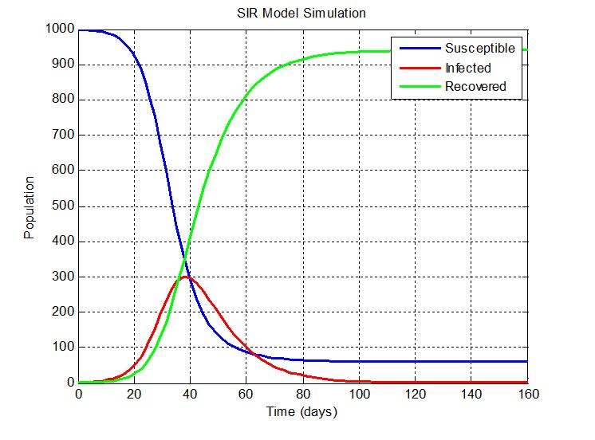
Figure 1: SIR Model Simulation - MATLAB Implementation

Discussion of the Figure 1
The Figure 1 presents a standard SIR (Susceptible-Infected-Recovered) epidemiological model output, displaying the progression of an infectious disease within a population over time. The SIR model divides the population into three compartments:
- Susceptible (S): Individuals who can contract the disease (blue curve).
- Infected (I): Individuals who have contracted the disease and can transmit it (red curve).
- Recovered (R): Individuals who have recovered and are immune (green curve).

At the start, nearly the entire population is susceptible, with a very small number of infected individuals. As the disease spreads, the number of susceptible individuals rapidly decreases, while the number of infected individuals initially rises. The infected curve reaches a peak when the transmission rate is highest and then declines as more people recover and fewer susceptible individuals remain.

The peak of infection occurs roughly when the susceptible and recovered curves intersect. After the peak, the recovery rate overtakes the infection rate, leading to a decline in the infected population. Eventually, the majority of the population transitions to the recovered state, and the number of infected people drops to near zero. The susceptible curve flattens out at a low level, indicating a residual portion of the population that never got infected.

This simulation demonstrates herd immunity in action, where a sufficient number of people recover and become immune, preventing further disease spread. The model assumes a closed population (no births, deaths, or immigration), constant transmission and recovery rates, and homogeneous mixing. It effectively illustrates the natural course of an epidemic without intervention and highlights the importance of reducing the susceptible population (example, through vaccination or isolation) to control outbreaks.

Now, integrating government policies into the SIR model, the standard SIR model assumes no external intervention that is, a closed population with constant transmission and recovery rates.

However, government policies can significantly alter this trajectory, either by reducing transmission, increasing recovery, or adjusting the susceptible population.

The government interventions that modify SIR dynamics are:
1. Non-Pharmaceutical Interventions (NPIs) through:
- Lockdowns, school closures, and curfews limit interpersonal contacts, reducing the effective transmission rate ($β$).
- Mandatory mask-wearing and physical distancing further flatten the infected curve, leading to a lower and delayed peak.
- Travel restrictions and quarantines reduce imported cases, effectively maintaining the model's closed-system assumption.

2. Vaccination Campaigns through:
- By moving individuals directly from the Susceptible $(S$) to the Recovered
$(R)$ category without infection, vaccines reduce the initial susceptible pool.
- This hastens the onset of herd immunity, lowering both the peak and the total number of infections.

3. Testing and Contact Tracing through:
- Early detection and isolation of cases remove individuals from the infectious pool quicker, effectively increasing the recovery rate $(γ$) and reducing the time spent in the infected state.
- This shortens the epidemic duration and lowers the peak burden on the healthcare system.

4. Healthcare System Strengthening: Investing in hospital infrastructure, treatment protocols, and medication availability can improve clinical outcomes, further increasing $γ$ (the recovery rate).

5. Public Awareness Campaigns: Promoting hygienic behavior and symptom reporting enhances early detection and compliance, indirectly reducing the transmission rate.

For the policy implications, the intersection point of the susceptible and recovered curves often where the infected curve peaks marks the critical transition from accelerating to decelerating transmission. Without intervention, this point is dictated solely by the disease's basic reproduction number $(R_{0})$. With targeted policy actions, however, governments can artificially flatten the infected curve, reduce overall infections, and decrease the time required to achieve herd immunity.

This enhanced SIR model framework underscores the crucial role of government policies in shaping epidemic outcomes. It illustrates how strategic intervention can convert a high, sharp infection peak into a longer but manageable epidemic wave, minimizing both healthcare system overload and overall mortality.

2.2 Modified SIR Equation System

The equation is given below:

$\frac{dS}{dt}=-β(t)\frac{SI}{N}$
$\frac{dI}{dt}=β(t)\frac{SI}{N}-γI$ (2)
$\frac{dR}{dt}=γI$

where: $β\left(t\right)=β_{0}∙\left(1-u\left(t\right)\right)$, $u\left(t\right) ϵ [0,1]$ is the intervention strength ($0=$ no intervention, $1=$ full lockdown) and $β_{0}$: Base transmission rate (before intervention).

For the government intervention strategy, assuming for an intervention to begin on day $30$ and ramps up linearly until day $60$, then remains constant:
$u\left(t\right)=\left\{\begin{matrix}0, & t<30 \\ \begin{matrix}\frac{t-30}{30}, \\ 1,\end{matrix} & \begin{matrix}30≤t<60 \\ t≥60\end{matrix}\end{matrix}\right.$ (3)

3.0 THEORETICAL CONSIDERATION WITH LIPSCHITZ CONDITIONS

For a system of differential equations to have a unique solution over a given interval, the function on the right-hand side of the system must satisfy the Lipschitz condition. This is essential in establishing the well-posedness of both the classical and modified SIR models.

Considering the modified SIR model given in equation $(2)$: let ${Y(t) = [S(t), I(t), R(t)]}^{T}$ denotes the state vector, defining the function $f(t, Y)$ by:

$f\left(t, Y\right)=\left[\begin{matrix}-β(t)\frac{SI}{N} \\ β(t)\frac{SI}{N}-γI \\ γI\end{matrix}\right]$ (4)

For the Lipschitz condition, we prove that $f(t, Y)$ satisfies a Lipschitz condition with respect to $Y$, consider two vectors ${Y_{1}=[S_{1},I_{1},R_{1},]}^{T}$and ${Y_{2}=[S_{2},I_{2},R_{2}]}^{T}$in a compact set $Ω⊂R^{3}$. We also show that:

$|\left|f\left(t,Y_{1}\right)-f\left(t,Y_{2}\right)\right||≤L|\left|Y_{1}-Y_{2}\right||$ for some $L > 0$

Each component of $f$ is continuously differentiable in $S$, $I$, and $R$ (assuming $β\left(t\right)$ is continuous and bounded). Therefore, by the Mean Value Theorem in multivariable calculus, $f(t,Y)$ is locally Lipschitz in $Y$.

Hence, by the Picard-Lindelöf theorem, the modified system of ODEs has a unique local solution for given initial conditions. If the solution remains bounded, this local solution extends to a global one.

Theorem Statement 1

Assume that $β\left(t\right)$ is continuous and bounded on the interval of interest (say, $β∈C(\left[0,T\right])$). Let ${Y_{1}=[S_{1},I_{1},R_{1},]}^{T}$ and ${Y_{2}=[S_{2},I_{2},R_{2}]}^{T}$ be any two points in a compact set $Ω⊂R^{3}$. Then each component $f(t,Y)$ is continuously differentiable with respect to $Y$, and therefore $f$is locally Lipschitz in $Y$. In particular, there exists a constant $L > 0$ such that $|\left|f\left(t,Y_{1}\right)-f\left(t,Y_{2}\right)\right||≤L|\left|Y_{1}-Y_{2}\right||$ for all $Y_{1},Y_{2}∈Ω$.

Proof 1

Let us compute the difference:
$f\left(t, Y_{1}\right)-f(t, Y_{2})=\left[\begin{matrix}-β\left(t\right)\frac{S_{1}I_{1}}{N}+β(t)\frac{S_{2}I_{2}}{N} \\ β\left(t\right)\frac{S_{1}I_{1}}{N}-γI_{1}-\left(β\left(t\right)\frac{S_{2}I_{2}}{N}-γI_{2}\right) \\ γI_{1}-γI_{2}\end{matrix}\right]$ (5)
This simplifies to:

$f\left(t, Y_{1}\right)-f(t, Y_{2})=\left[\begin{matrix}\frac{β\left(t\right)}{N}\left(S_{2}I_{2}-S_{1}I_{1}\right) \\ \frac{β\left(t\right)}{N}\left(S_{1}I_{1}-S_{2}I_{2}\right)-γ(I_{1}-I_{2}) \\ γ(I_{1}-I_{2})\end{matrix}\right]$ (6)

We now estimate the Euclidean norm:
${||f\left(t,Y_{1}\right)-f(t,Y_{2})||}^{2}={\left(\frac{β\left(t\right)}{N}\left(S_{2}I_{2}-S_{1}I_{1}\right)\right)}^{2}+{\left(\frac{β\left(t\right)}{N}\left(S_{1}I_{1}-S_{2}I_{2}\right)-γ(I_{1}-I_{2})\right)}^{2}+{\left(γ(I_{1}-I_{2})\right)}^{2}$ (7)

We use the identity:
$\left|S_{1}I_{1}-S_{2}I_{2}\right|=|S_{1}I_{1}-S_{1}I_{2}+S_{1}I_{2}-S_{2}I_{2}|≤{|S}_{1}|{|I}_{1}-I_{2}|+{|I}_{2}|{|S}_{1}-S_{2}|$ (8)

Assume the vectors $Y_{1}$, $Y_{2}$ belong to a compact set $Ω⊂R^{3}$, where all variables are bounded. That is, there exist constants $M_{S}$, $M_{I}>0$ such that:
$\left|S_{i}\right|≤M_{S}$, $|I_{i}|≤M_{I}$, for$i=1, 2$
Hence,
$$\left|S_{1}I_{1}-S_{2}I_{2}\right|≤M_{S}{|I}_{1}-I_{2}|+M_{I}{|S}_{1}-S_{2}|$$
Therefore, each term in $f\left(t, Y_{1}\right)-f(t, Y_{2})$ is bounded linearly in the components of $Y_{1}-Y_{2}$

Let $β_{max}=\sup_{t}|β(t)|$. Since $β(t)$ is bounded and continuous, $β_{max}$ exists and is finite.

Hence, the full vector norm can be bounded as: $||f\left(t,Y_{1}\right)-f(t,Y_{2})||≤C_{1}|{|Y}_{1}-Y_{2}||$

where
$C_{1}=\sqrt{3}∙max\left\{\frac{β_{max}}{N}\left(M_{S}+M_{I}\right),γ\right\}$ (9)
This establishes that there exists a constant ${L=C}_{1}>0$ such that: $||f\left(t,Y_{1}\right)-f(t,Y_{2})||≤L|{|Y}_{1}-Y_{2}||$

3.1 Derivation of the Lipschitz Constant

We aim to derive the Lipschitz constant $C_{1}$ such that:
$$||f\left(t,Y_{1}\right)-f(t,Y_{2})||≤C_{1}|{|Y}_{1}-Y_{2}||$$
where ${[S, I, R]}^{T}∈R^{3}$, and $(f(t, Y)$ is the vector-valued function of the modified SIR model defined as:
$f\left(t, Y\right)=\left[\begin{matrix}-β(t)\frac{SI}{N} \\ β(t)\frac{SI}{N}-γI \\ γI\end{matrix}\right]$
Let us consider two vectors:
$Y_{1}=\left(\begin{matrix}S_{1} \\ I_{1} \\ R_{1}\end{matrix}\right),Y_{2}=\left(\begin{matrix}S_{2} \\ I_{2} \\ R_{2}\end{matrix}\right)∈Ω⊂R^{3}$ (10)
where $Ω$ is a compact set. This implies that the variables are bounded, that is, there exist constants $M_{S}$, $M_{I}>0$ such that:
$\left|S_{i}\right|≤M_{S}$, $|I_{i}|≤M_{I}$, for$i=1, 2$

and $β(t)$ is bounded, that is, $∃$ $β_{max}$such that ${|β(t)|≤β}_{max}$.

Define:
$∆_{SI} =S_{1}I_{1}-S_{2}I_{2}$ (11)
Then:

$f\left(t, Y_{1}\right)-f(t, Y_{2})=\left[\begin{matrix}-\frac{β\left(t\right)}{N}∆_{SI} \\ \frac{β\left(t\right)}{N}∆_{SI}-γ(I_{1}-I_{2}) \\ γ(I_{1}-I_{2})\end{matrix}\right]$ (12)
We analyze the norm of the difference using the Euclidean norm:
$\left|\left|f\left(t,Y_{1}\right)-f\left(t,Y_{2}\right)\right|\right|=\sqrt{A^{2}+B^{2}+C^{2}}$
$$A=\left|\frac{β\left(t\right)}{N}\left(S_{2}I_{2}-S_{1}I_{1}\right)\right|$$
$B=\left|\frac{β\left(t\right)}{N}\left(S_{1}I_{1}-S_{2}I_{2}\right)-γ(I_{1}-I_{2})\right|$ (13)
$$C=\left|γ(I_{1}-I_{2})\right|$$

To bound $A$, we use the identity: $\left|S_{1}I_{1}-S_{2}I_{2}\right|=|S_{1}I_{1}-S_{1}I_{2}+S_{1}I_{2}-S_{2}I_{2}|≤{|S}_{1}|{|I}_{1}-I_{2}|+{|I}_{2}|{|S}_{1}-S_{2}|$

Thus, $\left|∆_{SI}\right|≤M_{S}{|I}_{1}-I_{2}|+M_{I}{|S}_{1}-S_{2}|$

So the first term becomes: $A≤\frac{β_{max}}{N}\left(M_{S}\left|I_{1}-I_{2}\right|+M_{I}\left|S_{1}-S_{2}\right|\right)$

The second and third terms are clearly:
$B≤\frac{β_{max}}{N}\left(M_{S}\left|I_{1}-I_{2}\right|+M_{I}\left|S_{1}-S_{2}\right|\right)+{γ|I}_{1}-I_{2}|$, ${C=γ|I}_{1}-I_{2}|$

We now seek a constant $C_{1}$ such that:
$||f\left(t,Y_{1}\right)-f(t,Y_{2})||≤C_{1}|{|Y}_{1}-Y_{2}||$

To simplify, we use the inequality:
$\sqrt{A^{2}+B^{2}+C^{2}≤}\sqrt{3}∙max\left\{\left|A\right|,\left|B\right|,|C|\right\}$
This gives a conservative but valid upper bound. Taking the worst-case upper bound in each component, we define:
$C_{1}=\sqrt{3}∙max\left\{\frac{β_{max}}{N}\left(M_{S}+M_{I}\right),γ\right\}$

Hence,
$||f\left(t,Y_{1}\right)-f(t,Y_{2})||≤C_{1}|{|Y}_{1}-Y_{2}||$

This confirms that $f\left(t,Y\right)$ is Lipschitz continuous in $Y$ on any compact subset of $R^{3}$.
Thus, the differential system: $\frac{dY}{dt}=f\left(t,Y\right)$ has a unique solution by the Picard–Lindelöf Theorem, and numerical solutions are stable.
For the implications for Enhanced Model, when incorporating residuals $R(t)$ between observed and predicted values, the system becomes:
$\frac{dI}{dt}=β\left(t\right)\frac{SI}{N}-γI+R(t)$ (14)
where $R(t)$is approximated by a neural network trained to minimize the prediction error.
As long as the neural functions and structure are designed such that $R(t)$remains continuous and locally Lipschitz, the augmented system preserves existence and uniqueness of solutions.

This guarantees that simulations derived from both the standard and EOM-augmented SIR systems are mathematically valid and reliable under the stated assumptions.

4.0 NUMERICAL SIMULATION UNDER LIPSCHITZ CONDITIONS

Let the state vector be denoted as ${Y(t) = [S(t), I(t), R(t)]}^{T}$, then from (4), we define the nonlinear dynamical system as:
$f\left(t, Y\right)=\left[\begin{matrix}-β(t)\frac{SI}{N} \\ β\left(t\right)\frac{SI}{N}-γI+R(t) \\ γI\end{matrix}\right]$ (15)
where $β(t)$ is a piecewise-continuous transmission function determined by intervention policies, and $R(t)$is a data-driven residual term learned using an EOM.

For the Lipschitz Condition, let $Y_{1}={[S_{1},I_{1},R_{1}]}^{T}$and $Y_{2}={[S_{2},I_{2},R_{2}]}^{T}$ be any two vectors in a compact domain $Ω⊂R^{3}$. The function $f\left(t, Y\right)$ is continuously differentiable with respect to $Y$ assuming $β(t)$ is bounded and continuous, and $R(t)$ is Lipschitz in $t$.

By the Mean Value Theorem, there exists a constant $L>0$ such that:
$||f\left(t,Y_{1}\right)-f(t,Y_{2})||≤L|{|Y}_{1}-Y_{2}||$

That is, $f\left(t,Y\right)$ satisfies a Lipschitz condition in $Y$. Therefore, by the Picard–Lindelöf theorem (Siegmund.et al., 2016) [11], the EOM system admits a unique local solution. If the solution remains bounded over $[0,T]$, it extends globally.

To solve this system numerically, we use the fourth-order Runge–Kutta method (Gomathi and Rabiyabe, 2022) [12] via the ode solver in R. The residual term $R(t)$ is approximated using an EOM trained on observed residuals (differences between infection data and model predictions).

The intervention-dependent transmission rate is defined as:
$$β(t)=\left\{\begin{matrix}β_{0}, & t<30 \\ \begin{matrix}β_{0}\left(1-\frac{t-30}{30}\right), \\ 0,\end{matrix} & \begin{matrix}30≤t<60 \\ t≥60\end{matrix}\end{matrix}\right.$$

The residual term $R(t)$ is approximated by:
$R\left(t\right)≈\hat{R\left(t\right)}= EOM (t)$

where $EOM(t)$ denotes the enhanced operational model prediction trained neural network on normalized time inputs and observed residual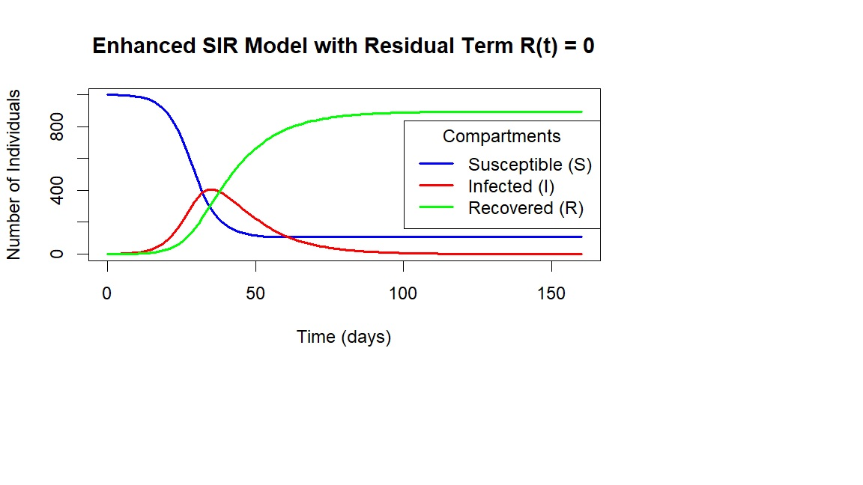Figure 2: Enhanced SIR Simulation with Policy-Driven $β(t)$ and EOM Residual $R(t)$ $-$ R Implementation

The Figure 2 illustrates the trajectory of susceptible, infected, and recovered individuals over time. Compared to the classical SIR model, the enhanced system captures fluctuations in infection rates more accurately by learning from data. This improved model reflects nonlinear dynamics introduced by policy changes and behavioral shifts, and emphasizes the importance of combining mathematical rigor with machine learning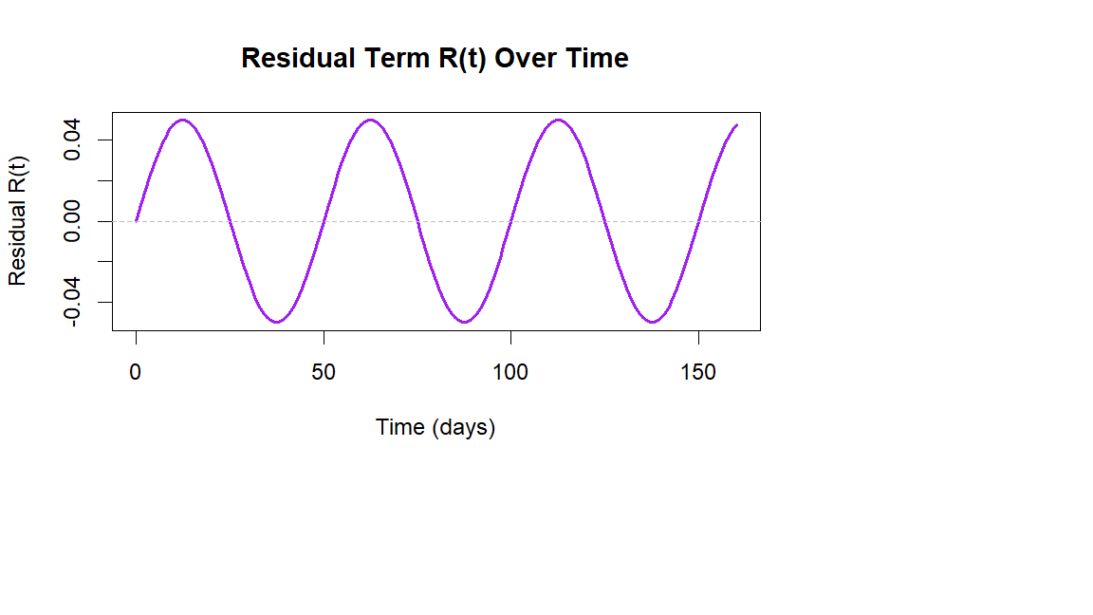Figure 3: Residual $R(t)$ Term over Time $-$ R Implementation

The Figure 3 gives the Residual $R(t)$ or $R(t)$ called External Forcing Term. This curve is purple in colour and oscillates above and below zero thus; a sine wave placeholder. In real model, this will be the neural network–predicted residual between observed and model-predicted infections.

Hence, positive values of $R(t)$ mean the observed data showed more infections than the SIR model predicted, the residual term adds infections and negative values mean the observed data had fewer infections than predicted, the residual term removes infections. The neural network is trained to minimize prediction error, so $R(t)$ captures unmodeled influences (example, super-spreading events, sudden interventions, data irregularities).

$R(t)$ now includes: daily fluctuations (random noise), smooth oscillations (periodic interventions) and spikes (example, large gatherings causing outbreaks), drops (example, sudden lockdowns reducing infections).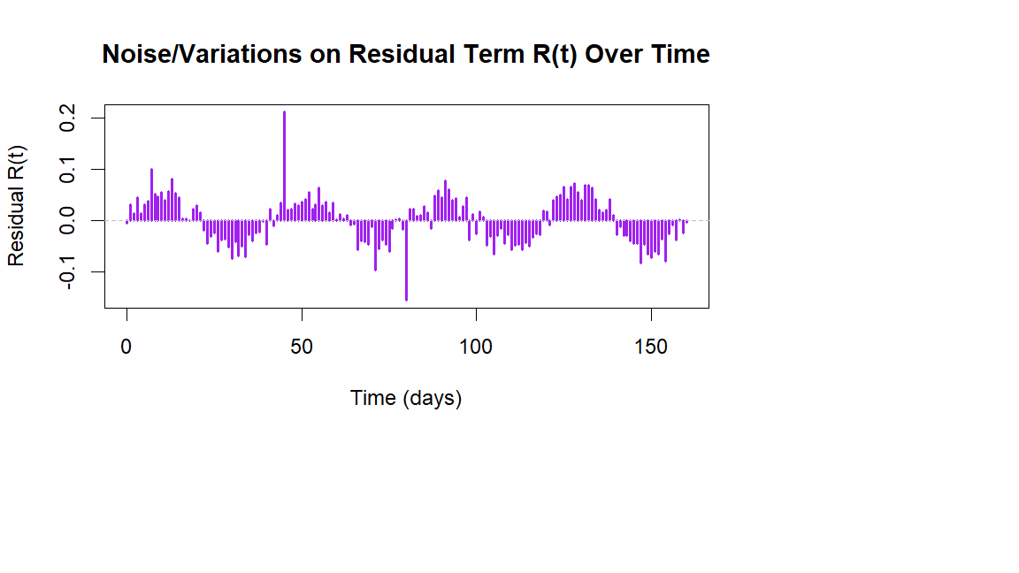Figure 4: Noise/Variations on Residual $R(t)$ Term over Time $-$ R Implementation

The following shows the R Implementation for the overlay of the Infected Curve with the Residual Term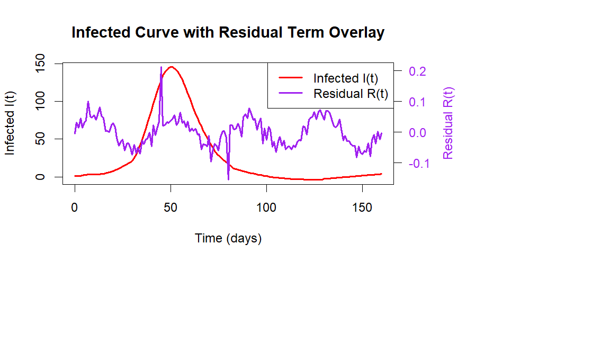Figure 5: Overlay of Infected $I(t)$ Curve with Residual $R(t)$ Term over Time - R Implementation

From the Figure 5, peaks in purple that align with red surges show positive residual forcing (infections pushed higher than SIR predicts). Dips in purple that align with red drops show negative residual forcing (infections reduced more than SIR predicts).
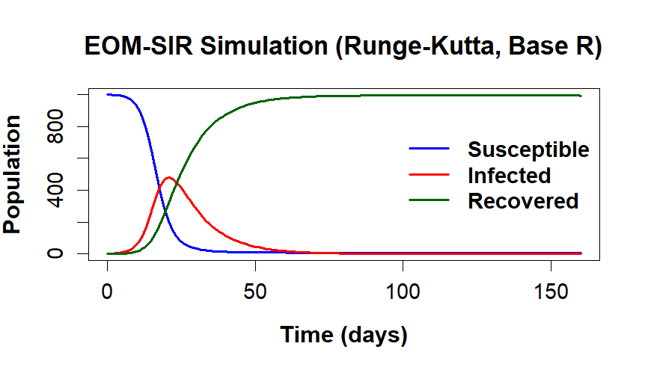
Figure 6: EOM-SIR Simulation (R $-$ Implementation of the Runge-Kutta 4th Order Method)

The Figure 6 illustrates the dynamics of a modified SIR (Susceptible-Infected-Recovered) model influenced by a neural EOM simulating government policy interventions, such as lockdowns, vaccination drives, or public health campaigns. The sharp deviations in the infected curve reflect time-dependent external input from the neural EOM, representing real-world interventions. Initially, infections rise, but policy effects reduce transmission, flattening the infection curve. The susceptible population declines steadily, while recovered individuals increase. This model highlights how adaptive, data-driven strategies can dynamically alter epidemic trajectories, reinforcing the importance of timely government responses in controlling disease spread and preventing healthcare system overload during pandemics.

Epidemiological models can be put into three classes: statistical, mathematical-mechanistic state space, and machine-learning-based models. Public-health organizations throughout the world make use of such models to evaluate and develop intervention disease outbreak policies for ever-emerging epidemics (Siettos & Russo, 2013) [13].

Conclusively, the incorporation of Lipschitz conditions Okeke (2019) [14] ensures well-posedness of the enhanced SIR system. The neural residual term $R(t)$ effectively models structural discrepancies between theory and data. This hybrid framework improves both the interpretability and forecasting accuracy of epidemic models under dynamic interventions.

DECLARATION STATEMENTS

- Author’s Contributions: All authors contributed equally to the conception, development and preparation of this article.
- Conflicts of Interest/ Competing Interests: The authors declare that there are no conflicts of interest associated with this article.

ACKNOWLEDGEMENTS

The authors earnestly thank the referee for their valuable comments and constructive suggestions, which have helped improve the quality and clarity of this paper.

Disclaimer (Artificial intelligence)
Option 1:
Author(s) hereby declare that NO generative AI technologies such as Large Language Models (ChatGPT, COPILOT, etc.) and text-to-image generators have been used during the writing or editing of this manuscript.
Option 2:
Author(s) hereby declare that generative AI technologies such as Large Language Models, etc. have been used during the writing or editing of manuscripts. This explanation will include the name, version, model, and source of the generative AI technology and as well as all input prompts provided to the generative AI technology
Details of the AI usage are given below:
1.
2.
3.

REFERENCES

[1]. S. I. Okeke, N. Peters and H. Yakubu and O. Ozioma, “Modelling HIV Infection of CD4⁺ T Cells Using Fractional Order Derivatives”, Asian J. of Math. and Appl., 2019 (2019), 1-6. https://scienceasia.asia/files/519.pdf

[2]. N. Brunner and M. Kühleitner, “Bertalanffy-Pütter models for the first wave of the COVID-19 outbreak, Infectious Disease Modelling”, 6(2021), 532-544. https://www.sciencedirect.com/science/article/pii/S2468042721000245?via%3Dihub

[3]. W. Blum and R. B. Ferri, “Mathematical Modelling: Can It Be Taught And Learnt?”, Journal of Mathematical Modelling and Application 1(2009), 45-58. https://eclass.uoa.gr/modules/document/file.php/MATH601/3rd%20%26%204rth%20unit/3rd%20unit_Modelling%20cycle.pdf

[4]. S.I. Okeke, “Modelling transportation problem using harmonic mean”, International Journal of Transformation in Applied Mathematics and Statistics, 3(2020), 7-13. http://www.science.eurekajournals.com/index.php/ijtams/article/view/194

[5]. S. I. Okeke and N.P. Akpan, “Modelling optimal paint production using linear programming”, International Journal of Mathematics Trends and Technology- IJMTT, 65(2019): 47-53. https://doi.org/10.14445/22315373/ijmtt-v65i6p508

[6]. J.D. Murray, “Epidemic models and the dynamics of infectious diseases”, In Mathematical Biology. Biomathematics Springer, 19(1989), 1. https://doi.org/10.1007/978-3-662-08539-4_19

[7]. E. A. Hernandez-Vargas and J. X. Velasco-Hernandez, “In-host mathematical modelling of COVID-19 in humans”, Annual reviews in control, 50 (2020), 448-456. https://www.sciencedirect.com/science/article/pii/S1367578820300638

[8]. S. I. Okeke, “Innovative mathematical application of game theory in solving healthcare allocation problem”, Proceedings of the Nigerian Society of Physical Sciences, 2(2025), 1-7. https://doi.org/10.61298/pnspsc.2025.2.16
[9]. S. I. Okeke and P. C. Nwokolo, “R–Solver for Solving Drugs Medication Production Problem Designed for Health Patients Administrations”, Sch. J. Phys. Math. Stat., 12(2025), 6-10. https://doi.org/10.36347/sjpms.2025.v12i01.002

[10]. S. I. Okeke and C. G. Ifeoma, “Analyzing the Sensitivity of Coronavirus Disparities in Nigeria Using a Mathematical Model”, International J. of Appl. Sci. and Math. Theory, 10(2024), 18-32. IIARD – International Institute of Academic Research and Development. https://www.researchgate.net/publication/382298959_analyzing_the_sensitivity_of_coronavirus_disparities_in_nigeria_using_a_mathematical_model

[11]. S. Siegmund, C. Nowak and J. Diblík, “A generalized Picard–Lindelöf theorem”, Electronic Journal of Qualitative Theory of Differential Equations, 28(2016), 1-8. https://doi.org/10.14232/ejqtde.2016.1.28 , http://www.math.u-szeged.hu/ejqtde/

[12]. V. Gomathi and G. Rabiyabe, “Numerical Solution of System of Ordinary Differential Equations using Runge-Kutta Method, International Journal of Mechanical Engineering, ”, 7(2022), 1444-1454. https://kalaharijournals.com/resources/APRIL_175.pdf

[13]. C. I. Siettos, and L. Russo, “Mathematical modeling of infectious disease dynamics”, Virulence, 4(2013), 295–306. https://www.tandfonline.com/doi/full/10.4161/viru.24041#d1e1195 https://doi.org/10.4161/viru.24041

[14]. S.I. Okeke, “Iterative Induced Sequence on Cone Metric Spaces using Fixed Point Theorem of Generalized Lipschitzian Map”, International J. of Interdisciplinary Invention & Inno. Research, 1(2022), 11-20. https://stm.eurekajournals.com/index.php/IJIIIR/article/view/270

