Rubus treutleri Hook.f.: A new distribution record and range extension to the Eastern Ghats, India

ABSTRACT
Rubus treutleri Hook.f. (Rosaceae) is a Himalayan bramble previously known from high-elevation regions of northern India and neighbouring countries. During recent floristic explorations in the Deomali Hills of the Koraput Forest Division, Odisha, Eastern Ghats, India, we documented a population of R. treutleri above 1300 m ASL. To our knowledge, this represents the first confirmed record of the species from Odisha and a notable southward range extension beyond its previously documented Himalayan distribution. Based on freshly collected material, we provide an updated taxonomic description, notes on diagnostic characters, habitat and phenology, and an illustration of the herbarium specimen. The occurrence of R. treutleri in the Deomali Hills highlights the biogeographical affinities between Himalayan and Eastern Ghats floras and underlines the importance of continued botanical surveys in under-explored montane ecosystems of eastern India.
Key words: Rubus treutleri, Deomali hills, Koraput, Eastern Ghats,
INTRODUCTION
The genus Rubus L. (Rosaceae) is predominantly distributed in temperate regions, especially across the Northern Hemisphere and the Himalayan ranges, with 1,555 species documented globally (POWO, 2025). Its remarkable diversity is reflected in the broad variation of growth forms from erect shrubs to trailing or climbing habits, as well as in leaf and stem morphology, the presence of prickles, and the wide range of fruit colours and sizes. The genus also shows extensive chromosomal variation. Members of this genus occur on six continents and occupy elevations from sea level to about 4,500 m (Hummer, 1996). Morphologically, Rubus species are creeping herbs or erect to sarmentose, usually prickle-bearing shrubs with alternate, simple or compound leaves. Flowers are arranged in terminal or axillary corymbose panicles, or may be solitary, and possess a broad calyx-tube with five persistent lobes, five petals, numerous stamens, and a disk lining the calyx-tube. The fruit is an aggregate of numerous one-seeded drupes borne on a dry or spongy, conical to cylindrical receptacle. Ripen fruits display colours ranging from white, yellow, orange to red, purple and black, with some forms bearing orange drupelets that darken to purple-black near the stylar end (Hooker, 1878; Hummer, 1996).
In India, Rubus is represented by 73 species (Sofi et al., 2024). Rubus treutleri occurs in temperate and high-altitude regions of the Himalaya, including China, Tibet, Bhutan and India (POWO, 2025). In India, it was earlier recorded from the Eastern Himalaya, notably Sikkim (Hooker, 1878). Several other Rubus species have been documented from Kashmir, Assam, Mizoram, Arunachal Pradesh, Meghalaya and Uttarakhand (Adhikary and Gajurel, 2023; Sofi et al., 2024; Rawat et al., 2022). Two species of Rubus have been reported from Odisha so far (Saxena & Brahmam, 1995).
Methodology
During a floristic survey conducted in the Deomali Hills of the Koraput Forest Division, Odisha, in November 2025, a creeping shrub belonging to the genus Rubus was encountered. Specimens were collected following standard herbarium procedures, and field notes on habitat, associated species and phenology were recorded in situ. To verify the novelty of this regional record, we compared our collections with relevant literature and examined material and/or digital images from major Indian herbaria, as well as online databases. Subsequent critical analysis of morphological characters, supplemented by comparison with taxonomic descriptions in standard flora books (Hooker, 1878) and verified e-herbarium resources (POWO, 2025), confirmed the identity of the specimen as Rubus treutleri Hook.f. Only after finding no previous records of Rubus treutleri from Odisha or the Eastern Ghats did we treat this as a new distributional record for the region.
Taxonomic treatment
Rubus treutleri Hook.f. Fl. Brit. India. 2: 331. 1878; Rubus moluccanus var. treutleri (Hook.f.) Kuntze. Revis. Gen. Pl. 1: 222. 1891; Rubus arcuatus Kuntze. Meth. Sp.-Beschr. Rubus: 66. 1879; Rubus calycinus var. tonglooensis (Kunth) Kuntze. Revis. Gen. Pl. 1: 220. 1891; Rubus moluccanus var. arcuatus (Kuntze) Kuntze. Revis. Gen. Pl. 1: 222. 1891; Rubus moluccanus var. rosulans (Kuntze) Kuntze. Revis. Gen. Pl. 1: 222. 1891; Rubus rosulans Kuntze. Meth. Sp.-Beschr. Rubus: 65. 1879; Rubus tonglooensis Kuntze. Meth. Sp.-Beschr. Rubus: 66. 1879.
A robust, leafy, shrub, variably covered with soft, spreading, flexuous tomentose hairs, frequently intermixed with slender glandular bristles; prickles slender, nearly straight, occasionally passing into bristles or slightly decurved; leaves orbicular-cordate, 5–7-lobed, the lobes shallow, rounded to acute, margins crenate with acute crenatures; lamina membranous, 5.1–10 cm in diameter, green and sparsely pilose above; petiole slender, short to elongate, sometimes reaching up to 7.5 cm; stipules leafy, pectinate to almost orbicular, concave, green, about 1.3 cm long; inflorescences consist of large, solitary flowers, sometimes clustered or borne in short corymbose panicles; flowers 1.3–2.3 cm in diameter, shortly pedicellate; bracts leafy and persistent, occasionally reduced to narrowly segmented forms; calyx-tube hemispheric, villous and often bristly; calyx-lobes large, frequently leafy, laciniate, or pectinately pinnatifid; petals nearly orbicular, smaller than the calyx, white or pink; stamens numerous; carpels very numerous, each pubescent; style filiform, stigma hairy; fruits an aggregate of drupelets (berry-like), many-seeded, red at maturity.
Diagnosis
Among Indian species of Rubus, our material of R. treutleri is most similar to R. moluccanus, but differs in several consistent characters. In the Indian flora, Rubus treutleri Hook.f. most closely resembles the widespread R. moluccanus L. in having scrambling or climbing shoots armed with prickles and leaves that are simple and shallowly 3–5-lobed. However, R. treutleri can be distinguished by its suborbicular leaves with a distinctly cordate base, relatively uniform shallow lobing, and blades that are pubescent above and softly pilose beneath. The petioles and branchlets bear dense soft hairs and conspicuous gland-tipped bristles with only scattered slender prickles, whereas R. moluccanus typically has stouter, more numerous prickles and non-glandular pubescence. A particularly useful character is the stipule morphology: in R. treutleri, the stipules are relatively long and divided almost to the base into several narrow, linear segments, while in R. moluccanus the stipules are smaller and usually entire or only shallowly lobed. The inflorescences of R. treutleri are short axillary racemes with few flowers, and the fruits are slightly larger, subglobose aggregates of red drupelets.
Specimen Examined
Rubus treutleri Hook.f.
India, Odisha, Koraput Forest Division, Deomali hills, 18º40ʹ16.70ʺ N, 82º59ʹ08.78ʺ E; 1488 m MSL elevation, 21st November, 2025, R.S Devi 203 (Herbarium of Ambika Prasad Research Foundation (Figure 1).
Ecology and Habitat: In the Deomali Hills, the species occurs above ca. 1300 m MSL in a montane hill ecosystem that is cooler and more humid than the surrounding lowlands. Populations were observed on mid- and upper slopes under mixed broad-leaved forest dominated by [e.g. Shorea spp., Quercus spp., etc.], with an understorey of [e.g. common shrubs/herbs]. Plants grow in semi-shaded positions on well-drained, moderately deep soils, typically along forest edges, gaps and gently disturbed slopes. In the present study, it was observed on the mid to upper slopes of the Deomali Hills, of Koraput Forest Division in Odisha, India, occurring within mixed forest vegetation.
Flowering: June - August
Fruiting: August - November
Distribution: Rubus treutleri is native to the Himalayan region and has been reported from Jammu & Kashmir, Himachal Pradesh, Uttarakhand, Sikkim and Arunachal Pradesh, as well as from Nepal and Bhutan. To our knowledge, the present collection from the Deomali Hills, Koraput Forest Division, represents a southward range extension from the Himalayan region to the Eastern Ghats of Odisha. A review of regional floras and checklists for Odisha and the Eastern Ghats (e.g. Saxena & Brahmam, 1995) and a search of online databases (e.g. POWO) revealed no previous records of R. treutleri from this area, supporting its status as the first documented record for the region.
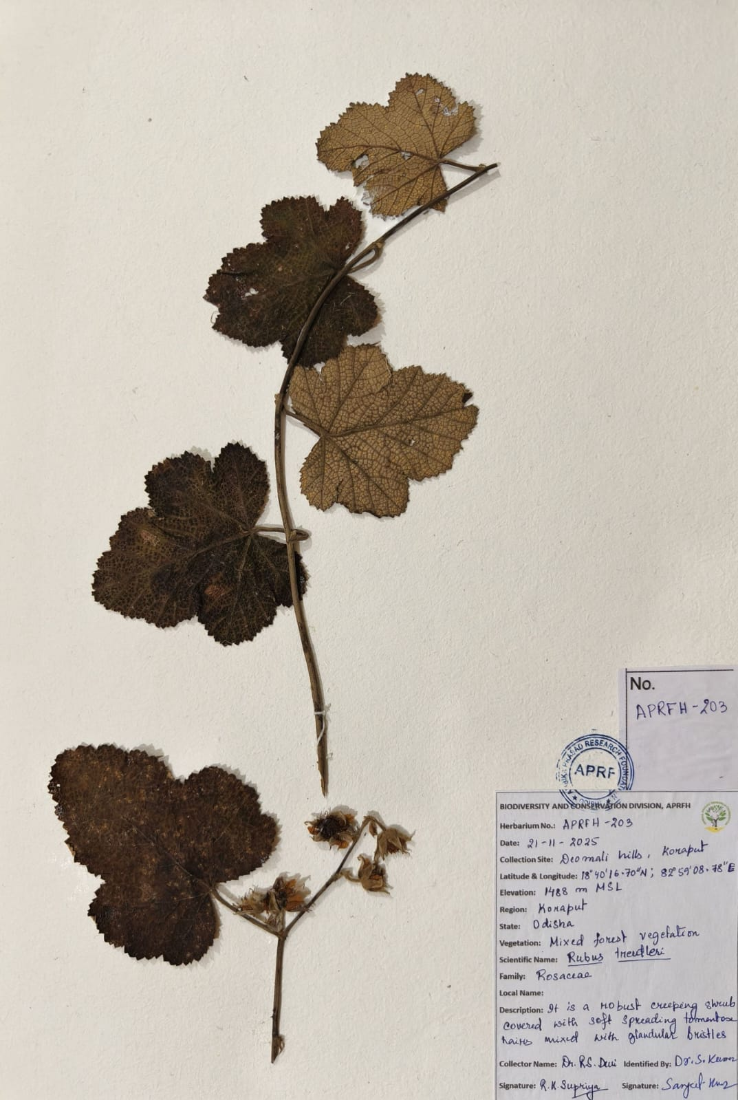
Figure 1: Herbarium specimen of Rubus treutleri Hook.f.

COMPETING INTERESTS DISCLAIMER:
Authors have declared that they have no known competing financial interests OR non-financial interests OR personal relationships that could have appeared to influence the work reported in this paper.

REFERENCES
Adhikary, P., & Gajurel, P. R. (2023). Extended distribution of Rubus opulifolius Bertol. (Rosaceae) in Arunachal Pradesh (India) and its lectotypification. Pleione, 17(3), 329–332. https://doi.org/10.26679/Pleione.17.3.2023.329-332.
Hooker, J. D. (1879). *The Flora of British India. Vol. 2*. Reeve & Co., London. https://www.biodiversitylibrary.org/item/13900#page/7/mode/1up.
Hummer, K. E. (1996). Rubus diversity. HortScience, 31(2), 182–183. https://doi.org/10.21273/HORTSCI.31.2.182
POWO. (2025). Plants of the World Online. Royal Botanic Gardens, Kew. https://powo.science.kew.org/
Rawat, D. S., Chandra, S., & Chaturvedi, P. (2022). Threatened flora of Uttarakhand: an update. Journal of Threatened Taxa, 14(12), 22309–22328. https://doi.org/10.11609/jott.6330.14.12.22309-22328.
Saxena HO and Brahmam M. (1995). The Flora of Orissa Vol. II. Rosaceae to Martyniaceae. Regional Research Laboratory, Bhubaneswar, Orissa, India.
Sofi, S. A., Islam, T., Zargar, S. A., Malik, A. H., Mugal, M. A., & Khuroo, A. A. (2025). Rubus idaeus subsp. strigosus (Michx.) Focke, a new distribution record to the flora of India from Kashmir Himalaya. *Rheedea*, *35*(2). https://doi.org/10.22244/rheedea.2025.35.02.09.

