Timber species of India and their medicinal uses

Abstract
The present investigation documented the medicinal uses of selected timber species distributed across three ecologically diverse regions of India (Himachal Pradesh, Odisha, Maharashtra, Uttar Pradesh and Rajasthan). A total of twenty-two species belonging to major families such as Fabaceae, Combretaceae, Meliaceae, Pinaceae and Lamiaceae were recorded. Field observations and ethnobotanical information revealed that these commonly exploited timber trees also possessed significant therapeutic properties, including treatments for skin diseases, diabetes, diarrhoea, menstrual disorders, respiratory ailments and inflammatory conditions. Species from Himachal Pradesh (e.g., Cedrus deodara, Pinus wallichiana) traditionally were used for respiratory and reproductive health issues, while those from Odisha exhibited rich medicinal diversity, particularly in dermatological, gastrointestinal and metabolic remedies. Timber species from Rajasthan (e.g., Tecomella undulata, Vachellia nilotica) traditionally served in managing diabetes and gastrointestinal complications. Overall, the study highlighted the dual significance of timber species as economically valuable resources and essential components of indigenous healthcare systems, thereby emphasizing the need for their conservation and sustainable utilization.
Keywords: Ethnomedicine; Medicinal uses; Timber species; Traditional knowledge
Introduction
Timber-yielding tree species play a crucial role in the ecological stability (Kumar et al., 2022) and rural economy of India, contributing significantly to construction, furniture, fuelwood and cultural practices (Chaudhary et al., 2016; Mansingh et al., 2025). Beyond their economic value, many of these species possess long-recognized medicinal properties that have been embedded in traditional healing systems such as Ayurveda, Siddha and various indigenous health traditions (Rizvi et al., 2022; Grygier et al., 2023). The diverse geographical and climatic zones of India from the Himalayan region to the Eastern Ghats and the arid landscapes of Rajasthan harbour a wide range of timber species with ethnomedicinal relevance, reflecting centuries of human plant interactions (Kumaran et al., 2014). Despite the cultural and therapeutic importance of these species, scientific documentation of their medicinal uses remains limited, scattered or focused only on non-timber medicinal flora (Lulesa et al., 2025). Timber species are often overlooked in ethnobotanical surveys because their primary use is associated with wood value, leading to an underestimation of their medicinal potential (Guzo et al., 2023). Understanding the medicinal applications of such species across different ecological regions is essential, as communities in these areas continue to depend heavily on local forest resources for primary healthcare. Documenting this knowledge is particularly relevant in regions such as Himachal Pradesh, Odisha, Maharashtra, Uttar Pradesh and Rajasthan, where traditional medicinal practices are strongly tied to local biodiversity. The present study therefore aimed to compile and analyse the medicinal uses of selected timber species occurring in these three states, representing distinct climatic and cultural zones of India. Comparing ethnomedicinal uses across the Himalayan, Eastern Ghats, and arid ecosystems, this research provides insights into regional variations in plant-based knowledge and highlights the dual economic and therapeutic roles of timber species. The findings highlighted the significance of conserving these valuable species, promoting sustainable utilization, and preserving traditional knowledge that may support future pharmacological investigations.
Methodology
The study was conducted using a combination of field surveys, ethnobotanical interviews across three regions of India (Himachal Pradesh, Odisha, Maharashtra, Uttar Pradesh and Rajasthan) representing distinct climatic zones and traditional knowledge systems during January 2024 to March 2025. Ethnobotanical information was collected from traditional healers, elderly community members, forest dwellers and local users using semi-structured interviews and informal discussions (Jena et al., 2025). Data were recorded on plant parts used, preparation methods and associated therapeutic applications. Botanical identification of each species was carried by authors. The methodology emphasized ethical considerations, including informed consent from participants and adherence to traditional knowledge documentation guidelines.
Results and discussion
A total of twenty-two timber species belonging to fourteen families were documented from the three study regions (Himachal Pradesh, Odisha, Maharashtra, Uttar Pradesh and Rajasthan). The family Fabaceae represented the highest number of species, followed by Combretaceae, Pinaceae and Meliaceae (Table 1). Each species was recorded with its specific medicinal use, plant part utilized and the locality of occurrence. Odisha contributed the largest number of species, while Himachal Pradesh and Rajasthan contributed fewer but ecologically distinctive timber species with notable ethnomedicinal relevance. Ethnobotanical observations revealed that multiple plant parts including bark, heartwood, leaves, roots, seeds and resin were used for medicinal purposes. Bark and heartwood were the most frequently used parts across species. The recorded medicinal applications ranged widely from treatments of skin infections, diarrhoea, diabetes, respiratory problems, menstrual disorders to inflammatory and gastrointestinal conditions. Several species, such as Terminalia arjuna, Pterocarpus marsupium and Dalbergia latifolia, were consistently reported for metabolic and cardiovascular conditions, while others like Azadirachta indica and Holoptelea integrifolia were predominantly used for skin-related ailments. Comparative analysis across the three states indicated regional variation in traditional use patterns. Timber species from Himachal Pradesh were primarily associated with respiratory and reproductive health remedies, reflecting the needs of cold-climate communities. Odisha displayed the highest diversity of medicinal applications, especially for gastrointestinal, dermatological and metabolic disorders, likely due to its rich forest cover and long-standing tribal knowledge systems. Rajasthan contributed species used mainly for gastrointestinal and diabetic treatments, aligning with traditional practices in arid and semi-arid zones. Overall, the results underscored the substantial medicinal value of timber species, often overlooked due to their commercial wood importance.

Table 1: Timber species of India and their medicinal uses
Name | Common name | Family | Medicinal uses | Location
Acacia auriculiformis A.Cunn. ex Benth. | Acacia | Fabaceae | Bark paste is useful in muscular inflammation and pain. | Odisha, Uttar Pradesh
Albizia lebbeck (L.) Benth. | Siris | Fabaceae | Flower juice is used to reduce the frequency and severity of asthmatic attacks. | Odisha
Artocarpus heterophyllus Lam. | Jackfruit | Moraceae | Leaves are useful in management of diabetic. | Odisha; Uttar Pradesh
Azadirachta indica A.Juss. | Neem | Meliaceae | Leaves paste is useful in skin infections. | Odisha; Maharashtra
Cedrus deodara (Roxb. ex D.Don) G.Don | Deodar | Pinaceae | Bark is useful in managing menstrual problems. | Himachal Pradesh
Dalbergia latifolia Roxb. | Indian rosewood | Fabaceae | Heartwood is used to treat urinary tract infections and kidney stones. | Odisha
Dalbergia sissoo Roxb. ex DC. | Sisam | Fabaceae | Powdered bark decoction is used to treat gonorrhoea and leprosy. | Odisha
Diospyros melanoxylon Roxb. | Kendu | Ebenaceae | Traditionally, seeds are used to treat mental disorders. | Odisha
Gmelina arborea Roxb. ex Sm. | Gamhar | Lamiaceae | Roots are used as rejuvenator. | Odisha
Holoptelea integrifolia (Roxb.) Planch. | Indian Elm | Ulmaceae | Paste of the leaves is applied to treat skin diseases. | Odisha; Rajasthan
Madhuca longifolia (L.) J.F.Macbr. | Mahua | Sapotaceae | Seed oil is useful in piles. | Odisha
Mangifera indica L. | Mango | Anacardiaceae | Bark decoction is used to treat diarrhoea. | Odisha; Himachal Pradesh
Pinus wallichiana A.B.Jacks. | Himalayan blue pine | Pinaceae | The wood is traditionally used for coughs. | Himachal Pradesh
Pterocarpus marsupium Roxb. | Indian Kino Tree | Fabaceae | The heartwood is used to treat diabetes. | Odisha
Shorea robusta C.F.Gaertn. | Sal | Dipterocarpaceae | Resin is used in the treatment of diarrhoea. | Odisha
Tecomella undulata (Sm.) Seem. | Marwar Teak | Bignoniaceae | The decoction of the heartwood is used to manage diabetes. | Rajasthan
Tectona grandis L.f. | Teak | Lamiaceae | In low amount, wood infusion is used to kill stomach worm. | Odisha
Terminalia anogeissiana Gere & Boatwr. | Axlewood | Combretaceae | The fruit, root, and leaves are used as an antiseptic and useful to treat wounds. | Odisha
Terminalia arjuna (Roxb. ex DC.) Wight & Arn. | Arjun | Combretaceae | Infusion of bark is used to reduce high cholesterol. | Odisha
Terminalia elliptica Willd. | Asan | Combretaceae | The bark is used as a remedy of diarrhoea. | Odisha
Toona ciliata M.Roem. | Red Cedar | Meliaceae | Infusion or decoction of flowers is used for excessive menstrual bleeding and other menstrual disorders. | Odisha
Vachellia nilotica (L.) P.J.H.Hurter & Mabb. | Babul | Fabaceae | The fruits are ground with seeds and taken with honey to treat stomach ulcers. | Odisha; Rajasthan

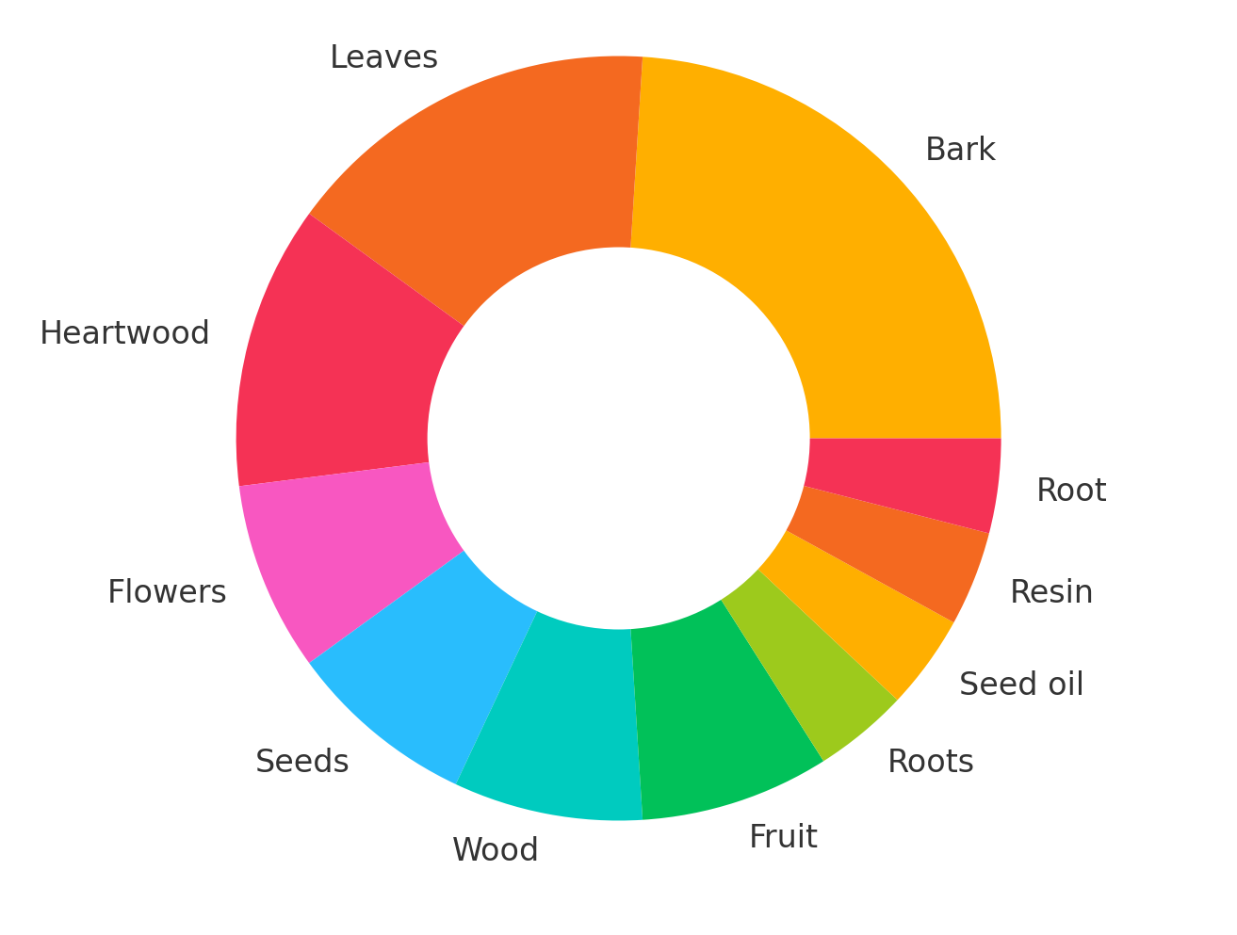
Figure 1: Donut chart showing the proportion of medicinal uses based on different plant parts of selected timber species recorded from Himachal Pradesh, Odisha and Rajasthan
The donut chart illustrated the proportion of plant parts used for medicinal purposes among the 22 documented timber species (Figure 1). The visual representation shows that bark is the most frequently used plant part, accounting for most medicinal applications. This aligns with traditional practices, as bark often contains a high concentration of bioactive compounds such as tannins, alkaloids, and polyphenols. Leaves form the second most utilized category, reflecting their accessibility and widespread use in remedies for skin diseases and metabolic disorders. Heartwood, flowers, seeds, wood, and fruit show moderate usage, each contributing to various therapeutic preparations, particularly in treatments of diabetes, gastrointestinal problems, and respiratory ailments. Less commonly used plant parts such as roots, resin and seed oil occupy smaller portions of the chart, indicating their more specialized or limited medicinal roles. Overall, the graph highlights a clear pattern in traditional medicinal practices: communities rely most heavily on bark and leaves, while other parts are employed more selectively depending on the species and the type of ailment being treated. This distribution also reflects sustainability considerations, as frequent use of bark and heartwood may impact tree survival, underscoring the importance of conservation-focused ethnobotanical studies.
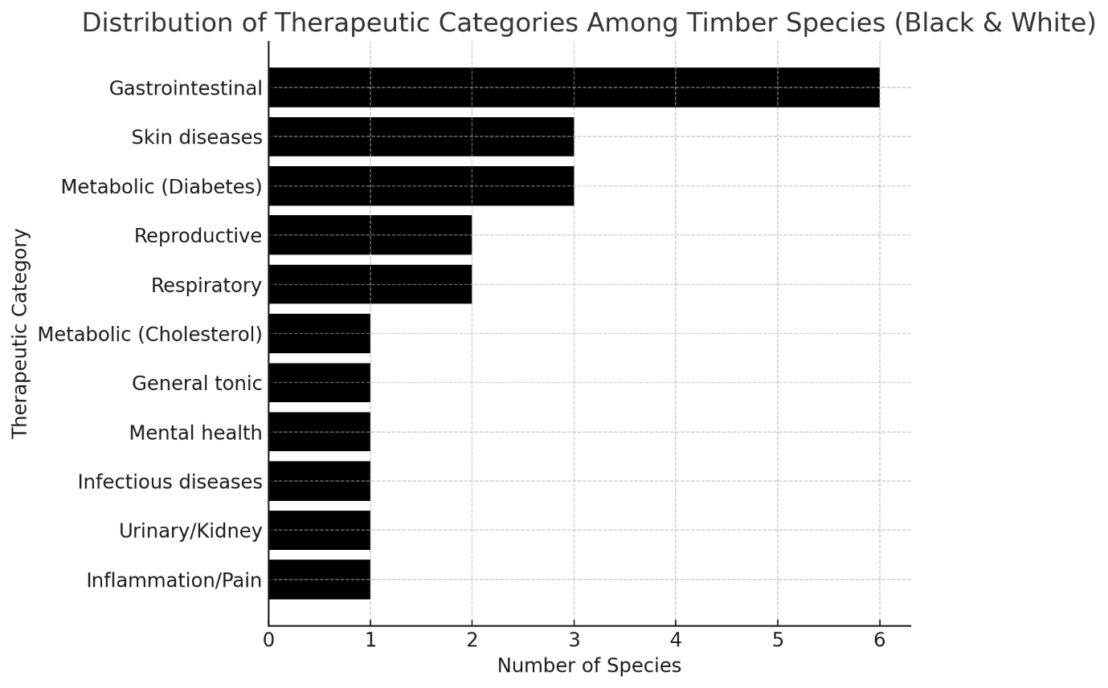
Figure 2: Distribution of therapeutic categories among the documented timber species from Himachal Pradesh, Odisha, and Rajasthan
The black-and-white horizontal bar graph illustrateed the distribution of medicinal applications across different therapeutic categories among the 22 documented timber species (Figure 2). The results show that gastrointestinal disorders were the most treated category, with six species traditionally used for managing conditions such as diarrhoea, stomach ulcers, and digestive discomfort. This suggests a strong reliance on locally available timber species for primary digestive healthcare needs in the studied regions. Skin diseases and metabolic disorders (especially diabetes) formed the next major categories, each represented by multiple species known for their effectiveness in treating infections, wounds, inflammation and blood sugar imbalance. Reproductive and respiratory ailments were also addressed using several timber species, reflecting their importance in traditional healing systems across varying climatic zones. Less frequently occurring categories such as inflammatory/pain conditions, urinary/kidney issues, infectious diseases, mental health disorders, general tonic uses and cholesterol management were represented by one or two species each. Although smaller in number, these categories highlight the broad therapeutic diversity of timber plants. Overall, the graph emphasizes that timber species serve not only structural and economic purposes but also play a vital role in traditional medicinal practices across different Indian regions.
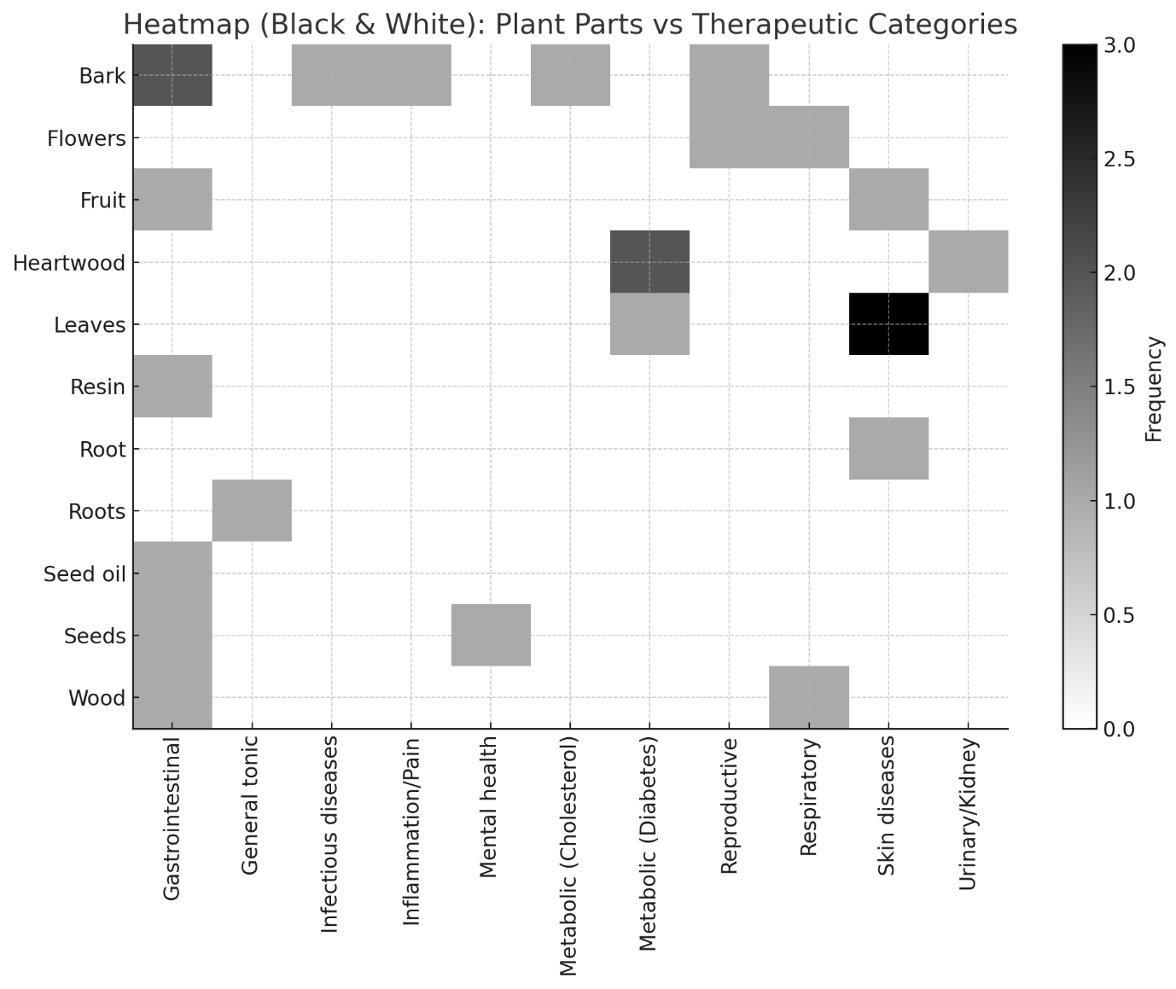
Figure 3: Black-and-white heatmap showing the relationship between plant parts and therapeutic categories among the documented timber species from Himachal Pradesh, Odisha and Rajasthan
The black-and-white heatmap illustrates the relationship between plant parts and therapeutic categories across documented timber species (Figure 3). Darker shades represent higher frequencies, helping to visually identify which plant parts are most associated with specific medicinal uses. The heatmap clearly shows that bark, leaves, and heartwood are the most versatile plant parts, appearing across multiple therapeutic categories. Bark is strongly linked to gastrointestinal, respiratory, and skin-related ailments, reflecting its broad traditional use and high concentration of bioactive compounds. Leaves also show high frequency in categories such as skin diseases and metabolic disorders, indicating their importance in topical applications and metabolic regulation. Heartwood is most prominently associated with metabolic (diabetes) and gastrointestinal disorders, supporting its traditional role in treating chronic conditions. In contrast, plant parts such as resin, roots, seed oil, and flowers appear less frequently and are confined to more specific therapeutic uses, suggesting specialized applications within indigenous healthcare systems. Overall, the heatmap highlights distinct patterns in ethnomedicinal practices, showing that communities rely heavily on woody plant parts like bark and heartwood for a wide range of ailments, while other parts are used more selectively. This visual analysis reinforces the multifunctional medicinal importance of timber species and supports the need for their phytochemical and pharmacological evaluation. The findings of the present study demonstrated that timber species, although primarily valued for their wood, also hold substantial ethnomedicinal importance across diverse ecological regions of India. The variation in medicinal applications observed among Himachal Pradesh, Odisha and Rajasthan reflected the influence of local health needs, cultural practices and availability of forest resources. The predominance of bark and heartwood in traditional remedies highlighted their phytochemical richness, supporting earlier reports on the therapeutic potential of secondary metabolites in woody species. The strong representation of Fabaceae and Combretaceae further emphasized the pharmacological relevance of these families in indigenous healthcare systems. Notably, species consistently cited for ailments such as diabetes, diarrhoea, skin infections and respiratory issues suggest a high potential for pharmacological validation and bioprospecting. The documentation of such traditional knowledge is vital, as it provides a baseline for conservation planning and sustainable use while bridging indigenous practices with modern therapeutic research.
Several researchers have contributed to documenting the medicinal, ecological, and pharmacological significance of tree species across India and beyond. Moghadamtousi et al. (2013) highlighted the diverse biological activities of Swietenia macrophylla, while Mogana et al. (2013) reported the traditional medicinal uses of Canarium patentinervium. Almubayedh and Ahmad (2020) further emphasized the therapeutic relevance of Cedrela serrata. Warrier et al. (2021) underscored the ethnomedicinal and ecological importance of Gmelina arborea, and Satapathy et al. (2021) provided an extensive account of medicinal tree species occurring in Bhubaneswar, Odisha. Pharmacological evaluations have also expanded, with Obakiro et al. (2021) documenting the bioactive and therapeutic potential of Erythrina abyssinica, and Asdaq et al. (2022) demonstrating the pharmacological properties of Tectona grandis. Additionally, Lama et al. (2022) characterized the bioactive compounds and antibacterial activities of Oroxylum indicum. Recent studies, such as those by Ramanan et al. (2024), have elaborated on the significance of Terminalia catappa, while Sahu et al. (2024) reported on the eco-social services provided by native Indian tree species. Collectively, these studies underscore the broad medicinal, ecological, and pharmacological value of tree species, reinforcing their importance in traditional knowledge systems and modern scientific research.
Future Works
Future research should focus on the phytochemical and pharmacological validation of the documented timber species to confirm their therapeutic efficacy and identify bioactive compounds responsible for their medicinal properties. Expanding ethnobotanical surveys across additional regions of India would help capture broader cultural variations and uncover lesser-known medicinal uses of timber species. Molecular approaches, such as DNA barcoding and metabolomic profiling, should be incorporated to support accurate species identification and assess chemical diversity. Long-term ecological studies are also needed to evaluate the impact of harvesting bark, heartwood, and roots on species survival, thereby promoting sustainable utilization practices. Finally, collaboration with local communities and traditional healers can strengthen community-based conservation strategies and facilitate the integration of indigenous knowledge into modern healthcare and conservation frameworks.
Conclusion
The present study highlighted the significant yet often overlooked medicinal value of timber species distributed across Himachal Pradesh, Odisha, Maharashtra, Uttar Pradesh, and Rajasthan. A total of twenty-two species were documented, revealing diverse therapeutic applications rooted in long-standing traditional practices. The findings demonstrated that timber trees serve not only as vital economic resources but also as important components of indigenous healthcare systems, addressing a range of ailments from metabolic and gastrointestinal disorders to skin diseases and respiratory conditions. The regional variations in medicinal use underscore the deep cultural connections between local communities and their forest environments. Overall, the study emphasizes the need for conservation of these species, sustainable harvesting practices and further scientific investigation to validate their pharmacological potential and support their continued use in traditional and modern healthcare.

COMPETING INTERESTS DISCLAIMER:
Authors have declared that they have no known competing financial interests OR non-financial interests OR personal relationships that could have appeared to influence the work reported in this paper.

References

Almubayedh, H., & Ahmad, R. (2020). Ethnopharmacology, phytochemistry, biological activities, and therapeutic applications of Cedrela serrata Royle: A mini review. Journal of Ethnopharmacology. https://doi.org/10.1016/j.jep.2019.112206

Asdaq, S. M. B., Nayeem, N., Abida, M., Alam, M. T., Alaqel, S. I., Imran, M., Hassan, E. E., & Rabbani, S. I. (2022). Tectona grandis L.f: A comprehensive review on its patents, chemical constituents, and biological activities. Saudi Journal of Biological Sciences, 29(3), 1456-1464. https://doi.org/10.1016/j.sjbs.2021.11.026

Chaudhary, A., Burivalova, Z., Koh, L. P., & Hellweg, S. (2016). Impact of Forest Management on Species Richness: Global Meta-Analysis and Economic Trade-Offs. Scientific Reports. https://doi.org/10.1038/srep23954

Grygier, A., Chakradhari, S., Ratusz, K., Rudzińska, M., Patel, K. S., Lazdiņa, D., Segliņa, D., & Górnaś, P. (2023). Evaluation of Selected Medicinal, Timber and Ornamental Legume Species' Seed Oils as Sources of Bioactive Lipophilic Compounds. Molecules, 28(10), 3994. https://doi.org/10.3390/molecules28103994

Guzo, S., Lulekal, E., & Nemomissa, S. (2023). Ethnobotanical study of underutilized wild edible plants and threats to their long-term existence in Midakegn District, West Shewa Zone, Central Ethiopia. J Ethnobiol Ethnomed, 19(1), 30. https://doi.org/10.1186/s13002-023-00601-8

Jena, N., Vimala, Singh, B., Patra, A., Sharma, B. P., Hossain, E., & Kumar, S. (2025). Methods for ethnobotanical data collection, phytochemistry, antioxidant, anthelmintic, and antimicrobial activities for pharmacological evaluation of medicinal plants. Journal of Biodiversity and Conservation, 9(2), 87-107. https://aprfjournal.in

Kumaran, N. K. P., Padmalal, D., Nair, M. K., Limaye, R. B., Guleria, J. S., Srivastava, R., & Shukla, A. (2014). Vegetation response and landscape dynamics of Indian Summer Monsoon variations during Holocene: an eco-geomorphological appraisal of tropical evergreen forest subfossil logs. PLoS One. https://doi.org/10.1371/journal.pone.0093596

Lama, R., Manjula, B. L., Kumbar, V., Panda, A., Singh, A., Kumar, S., & Marndi, S. (2022). Phytochemical Screening and Antibacterial Activities of Oroxylum indicum (Linn.): A Threatened Tree of India. Asian Pacific Journal of Health Sciences. https://doi.org/10.21276/apjhs.2022.9.4S.27

Lulesa, F., Alemu, S., Kassa, Z., & Awoke, A. (2025). Ethnobotanical investigation of medicinal plants utilized by indigenous communities in the Fofa and Toaba sub-districts of the Yem Zone, Central Ethiopian Region. Journal of Ethnobiology and Ethnomedicine, 21(1), 14. https://doi.org/10.1186/s13002-025-00768-2

Mansingh, A., Pradhan, A., Sahoo, S. R., Cherwa, S. S., Mishra, B. P., Rath, L. P., Ekka, N. J., & Panda, B. P. (2025). Tree diversity, population structure, biomass accumulation, and carbon stock dynamics in tropical dry deciduous forests of Eastern India. BMC Ecology and Evolution, 25(1), 48. https://doi.org/10.1186/s12862-025-02385-9

Mogana, R., Teng-Jin, K., & Wiart, C. (2013). The Medicinal Timber Canarium patentinervium Miq. (Burseraceae Kunth.) Is an Anti-Inflammatory Bioresource of Dual Inhibitors of Cyclooxygenase (COX) and 5-Lipoxygenase (5-LOX). ISRN Biotechnology. https://doi.org/10.5402/2013/986361

Moghadamtousi, S. Z., Goh, B. H., Chan, C. K., Shabab, T., & Kadir, H. A. (2013). Biological Activities and Phytochemicals of Swietenia macrophylla King. Molecules, 18(9), 10465-10483. https://doi.org/10.3390/molecules180910465

Obakiro, S. B., Kiprop, A., Kigondu, E., K'Owino, I., Odero, M. P., Manyim, S., Omara, T., Namukobe, J., Owor, R. O., Gavamukulya, Y., & Bunalema, L. (2021). Traditional Medicinal Uses, Phytoconstituents, Bioactivities, and Toxicities of Erythrina abyssinica Lam. ex DC. (Fabaceae): A Systematic Review. *Evidence-Based Complementary and Alternative Medicine*, *2021*, 5513484. https://doi.org/10.1155/2021/5513484

Ramanan S, S., Arunachalam, A., Singh, R., & Verdiya, A. (2024). Tropical almond (Terminalia catappa): A holistic review. Heliyon. https://doi.org/10.1016/j.heliyon.2024.e41115

Rizvi, S. A. A., Einstein, G. P., Tulp, O. L., Sainvil, F., & Branly, R. (2022). Introduction to Traditional Medicine and Their Role in Prevention and Treatment of Emerging and Re-Emerging Diseases. Biomolecules, 12(10), 1442. https://doi.org/10.3390/biom12101442

Sahu, L. M., Das, K., Sahu, J. K., Das, A., Behera, B., & Kumar, S. (2024). Eco-Social Services of Native Tree Species: A Conservation Approach. Indian Forester, 150(7), 630-634. https://doi.org/10.36808/if/2024/v150i7/170072

Satapathy S, Dimri R and Kumar S. (2021). Some important medicinal tree species of the temple city, Bhubaneswar, Odisha. Centurion Journal of Multidisciplinary Research. 11(2): 1-9.

Warrier, R. R., Priya, S. M., & Kalaiselvi, R. (2021). Gmelina arborea- an indigenous timber species of India with high medicinal value: A review on its pharmacology, pharmacognosy and phytochemistry. Journal of Ethnopharmacology. https://doi.org/10.1016/j.jep.2020.113593

Kumar, S. N., Kondaji, P., Mishra, S., Marndi, S., & Kumar, S. (2022). Identification of nesting trees and food plants of Indian Giant Squirrel in Bonai Forest Division, Odisha, India: a conservation perspective. Species, 23(71), 152-157. https://discoveryjournals.org/Species/current_issue/2022/71/A2.pdf

