EFFECTS OF DOUBLE-WALLED ADOBE STORAGE STRUCTURE ON MOISTURE AND DRY MATTER OF CASSAVA ROOTS

ABSTRACT
Millions of people in about 105 nations around the world including Nigeria rely on cassava as a major staple crop to supply their nutritional starch demands. Cassava roots are an important source of food and feed, as well as biofuel, biodegradable plastic manufacturing, and starch production. Fresh cassava roots are scarcely available despite their numerous uses. Because of a phenomenon known as Postharvest Physiological Deterioration (PPD), cassava roots have a short shelf life. The scope of this study is confined to the construction of a double-walled adobe structure suitable for storing cassava roots (TME 419), the determination of weight loss of stored samples, and the determination of dry matter and moisture content in sampled roots using the oven-drying method. A novel storage system is used in an effort to increase the shelf life of cassava roots by creating a microclimate in the structure. Two storage structures (AD1 and AD2) were erected for this experiment. Adobe bricks with a 0.15 m thickness and a 0.20 m wall separation make up the first building designated AD1. It is a cylindrical, double-wall construction. Straw that is sourced locally is used to construct the control, the second storage building. This study is aimed at evaluating the performance of a double-wall adobe structure for storage in a bid to prolong the shelf life of stored cassava roots. Over the course of 10 weeks, from November to February, samples were stored in each storage unit. Temperature, relative humidity, and sample mass were among the variables that were tracked throughout the storage period. The mass of individual samples were measured once per week over the 10 week storage period. The average dry matter and moisture content percentage for samples stored in AD1 was found to be 43.83% and 56.17% respectively. Likewise, the average dry matter and moisture content percentage for samples stored in AD2 47.88% and 52.12% respectively. The study showed that the double-wall adobe storage system demonstrated higher efficiency than the control, with an average mass loss of 25.64% as opposed to 42.95% over the storage period.
Keywords: Mass Loss, Water Loss, Dry Matter Content and Moisture Content
1. INTRODUCTION
Globally, cassava (Manihot esculenta) a starchy root crop, is a staple food for millions of people living in tropical and subtropical regions as their primary source of sustenance (Parmar et al., 2017; Anikwe and Ikenganyia, 2018). Cassava is particularly important in agriculture in developing countries, particularly in Sub-Saharan Africa, where it thrives in areas with poor soil and little rainfall (Onyenwoke and Simonyan, 2014). Its storage roots are a major source of food and feed, as well as biofuel and biodegradable plastic manufacturing and starch production (Marques et al., 2018; Srivastava et al., 2021). Given that Nigerians consume cassava and its derivatives in their daily meals, cassava is a prominent staple crop in that country (Parmar et al., 2017). Currently, cassava is transitioning from a purely subsistence crop produced on peasant fields to a commercial commodity farmed in plantations (Onyenwoke and Simonyan, 2014; Gengenbach et al., 2022; Beban and Gironde, 2023). Currently, cassava is produced in more than 100 countries and fulfills the daily caloric demands of millions of people living in tropical America, Africa, and Asia. Its importance as a food security crop is high in Western, Central and Eastern Africa due to its ability to produce reasonable yields (~10 t/ha) in poor soils and with minimal inputs (Parmar et al., 2017). Most of the world's population adopts a plant-based diet, and millions of people in roughly 105 nations around the world get their food energy from cassava, which is also thought to be the most affordable source of starch used in more than 300 industrial products (Zainuddin et al., 2017). After sugarcane, maize, rice, wheat, and potato, cassava is the sixth most main food crop in terms of global annual production. While a large number of crops are cultivated and harvested around the world, just four single crops accounted for half the global production of primary crops in 2020: sugar cane (20% of the total, with 1.9 billion tonnes), maize (12%, with 1.2 billion tonnes), rice and wheat (8%, with 0.8 billion tonnes each). Oil palm fruit and potatoes each accounted for an additional 4% of world crop production (FAO, 2022). According to FAO (2010), Cassava is the third largest source of calories in the tropics. It is a woody perennial plant with an edible root that thrives in tropical and subtropical climates. As a perennial crop, it can be harvested whenever necessary (Khojely et al., 2018). Cassava production is comparatively easier since it can withstand biotic and edaphic constraints that hinder the growth of many other crops. It is far more perishable than other key food crops despite their agronomic advantages. This is mostly due to the fact that crops are still living organisms after being harvested, and that losses that occur during storage are primarily caused by their physical (external features) and physiological (internal) state (Osunde and Fadeyibi, 2011). The primary causes of loss are infections, pests, physiological conditions (maturity, respiration, water loss, and sprouting), and mechanical harm (Osunde and Fadeyibi, 2011). Generally speaking, the shelf life of cassava is between 24 and 48 hours after harvest (Parmar et al., 2017; Silva et al., 2021).
Cassava roots have a limited shelf life because of postharvest physiological degradation (PPD), which occurs soon after harvest and is caused by a wound response (Sanchez et al., 2013). PPD decreases the quantity and quality of starch, making the cassava roots unsellable and unfit for human use (Tomlins et al., 2021). PPD is a sophisticated process that is connected to enzymatic stress reactions to injury and involves modifications to gene expression, protein synthesis, and the buildup of secondary metabolites, all of which are susceptible to environmental influences (Zainuddin et al., 2017). Due to PPD, the short shelf life of cassava roots has become a significant factor in the production of the crop, particularly with regard to its marketability.
Researchers have proposed several potential remedies for the perishability of cassava over the years, and these remedies can be divided into three categories:
- The use of improved storage techniques.
- Conventional breeding of varieties with roots having longer shelf-lives
- Use of genetic modification to bring about targeted changes in metabolism
Breeding and genetic modification are long-term strategies, whereas improved storage has a more immediate impact (Westby, 2002; Powlson et al., 2011; Yashveer et al., 2014; Muluneh, 2021). It is imperative for more efficient methods in terms of cost-effectiveness to be experimented on in order to encourage more farmers to explore the cultivation of cassava on a larger scale.
To prevent root perishability, traditional marketing and storage strategies have been modified. These adaptations include processing concentrated close to the production areas to maintain a daily supply of raw materials, processing into storable forms at the farm level (via sun drying, fermentation, etc.), and the customary practice of exchanging small amounts of roots (Weham, 1995; Westby, 2002; Costa and Delgado, 2019). The practice of leaving roots in the soil after the period of optimal root development until they may be consumed, processed, or sold is a typical method of preventing root losses caused by PPD (Onyenwoke and Simonyan, 2014). Cassava roots have a three-year shelf life in soil. The standing crop uses a lot of land, making it unavailable for extra agricultural production, which makes this method disadvantageous. Additionally, it is known that leaving cassava roots in the ground past their ideal harvesting window causes them to become woodier and more unpleasant, as well as more vulnerable to pathogen attack (Adiele, 2023). As of now, freezing has proven to be the most efficient approach for extending the shelf life of cassava roots, with some tests revealing an extension of up to three months (Wijesinghe and Sarananda, 2010). Freezing requires a constant energy source, making it expensive even at low levels. An increase in the shelf life of the root crop would result from exposing cassava roots to low enough temperatures, according to earlier studies that were able to prove this. Finding an affordable structure built of a material with the right thermal conductivity and heat retention qualities to enable this temperature drop is still the issue.
Adobe is a commonly aged building material, widely distributed in arid and semi-arid lands. Generally, adobe brick is of non-fired sun-dried mud mixed with organic material and may be stabilized with lime or cement (Revuelta et al., 2010). Before they warm up inside, adobe walls need to absorb a lot of heat from the sun and the surrounding air over a long period of time. The warm wall will keep transferring heat to the interior for several hours after the sun sets and the temperature decreases thanks to the thermal lag effect (Florescu and Bica, 2019). Marsh in 2010 outlined Thermal lag is the lag in how quickly heat moves through a substance. A material with a significant thermal lag will have a low conductivity and a high heat capacity. Influences on thermal lag periods include: differences in temperature between each face, exposure to wind flow, surface texture and coatings, thickness of the substance, conductivity of the substance.
Diurnal temperature changes are another way to describe thermal lag. In order to minimize internal/external temperature changes during daytime and nighttime temperature variations, external wall materials with a minimum time lag of 10 to 12 hours can be particularly beneficial
The ability of the adobe structure to dampen heat waves that are transmitted through it and moderate temperature swings inside the storage contribute to its recommended quality (Afek and Kays, 2010).
This study is aimed at evaluating the performance of a double-wall adobe structure for storage in a bid to prolong the shelf life of stored cassava roots. The following objectives were considered to achieve this aim:
- Determine the dry matter content percentage, moisture content percentage, and the percentage mass loss in the sampled cassava roots in each of the storage rooms.
- Determine the correlation relationship between mass loss and moisture content in cassava roots.

2. MATERIALS AND METHODS
2.1 Materials
The materials used for this research work include:
Fresh cassava roots (cultivated in Wukari farmlands), Adobe burnt bricks (from Ibi local government), Digital Hygrothermograph (HTC-2 10ºC to 70 ºC and 10% to 99%), basin, A scale or balance (Mettler-Toledo), Oven (Charcoal fired oven) and Measuring tape (Klien tools).
The Study Area
The study area is Wukari in Taraba state. It is situated at longitude 9°47`E and latitude 7°51`N. A savannah vegetation zone, riparian trees along the watercourse, and rocky outgrowths, which make up the majority of the landform, are what define the region. The two main seasons in the region are rainy and the Harmattan. In Wukari and its surroundings, agriculture is widely practiced. The main products available all year round include crops like rice, yams, maize, millets, cassava, sweet potatoes, etc. Depending on the season, the research region can encounter temperatures as low as 16˚C and as high as 40˚C. During the rainy season, relative humidity levels can increase by as much as 95%. A map of the study area is shown in Figure 1 below.
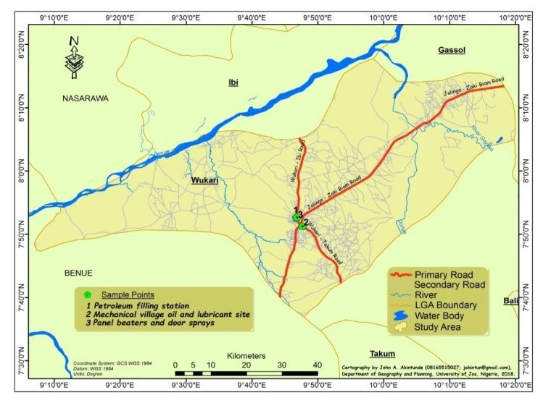
Figure 1: Map of the study area (source: Cartography Department of Taraba State Land and Survey, 2021).
2.2 Data Collection
Primary data was obtained from the indoor and outdoor parameters. The parameters were measured for the storage structures using a Hygrothermograph and a balance/scale. The instrument was used to measure the following parameters:
- Relative humidity inside the adobe storage room
- Ambient temperature outside the adobe storage room
- The temperature inside the adobe storage room
- Relative humidity outside the adobe storage room
- Weight of sampled cassava roots
2.3 Methods
The following are the methods employed to analysis and estimate the data.
Dry Matter Content Method
After cleaning the bark of the individual cassava roots with distilled water, it was then sliced into small sizes to facilitate oven drying at 70 - 100ºC. The following steps are employed to determine the dry matter:
- The oven dish was pre-weighed (W₁) and the scales zeroed.
- A quantity that comfortably fits in the oven dish was placed in the dish and weighed (W₂) whilst ensuring all sample were contained within the dish as any ‘overhang’ may fall off giving false MC.
- The sample was placed in the oven and time was set at 4 hours for slow drying.
- The sample was removed and weighed (W₃).
- Sample was dried for a further 30 minutes, removed and weighed, if the weight was the same as W₃ then the sample was dried (W₄). If it was lower, then it was dried further for 30 minutes and weighing repeated.
The moisture content percentage can be determined using the equation below:
(1)
The dry matter content DMC (%) can be obtained using the equation below:
DMC (%) = (100 - MC) % (2)

2.4 Experimental Procedure
Fifty (50) freshly harvested cassava roots were obtained from farmlands within Wukari Local Government Area, Taraba State and placed in two storage structures. Cassava roots were stored in the structure to determine how a controlled environment affects PPD rate. The roots were sorted into different size categories – small (0.20kg – 1.60kg) and large (1.65kg – 3.0kg) then placed at different positions in the storage structures. The temperatures and relative humidity levels of the two structures were monitored for five days (Monday, Tuesday, Thursday, Friday and Saturday) per week and three times a day (6 am, 12noon and 6 pm) for ten weeks. 20 out of the 50 roots were sampled in and each storage structure. All of the samples in the stores were weighed every week. The dry matter was obtained using the oven-drying method giving a two-week interval. The weekly average of all measured data was computed.
Description of Experimental Set-Up
Figure 2 below describes a sketch of the adobe storage room.
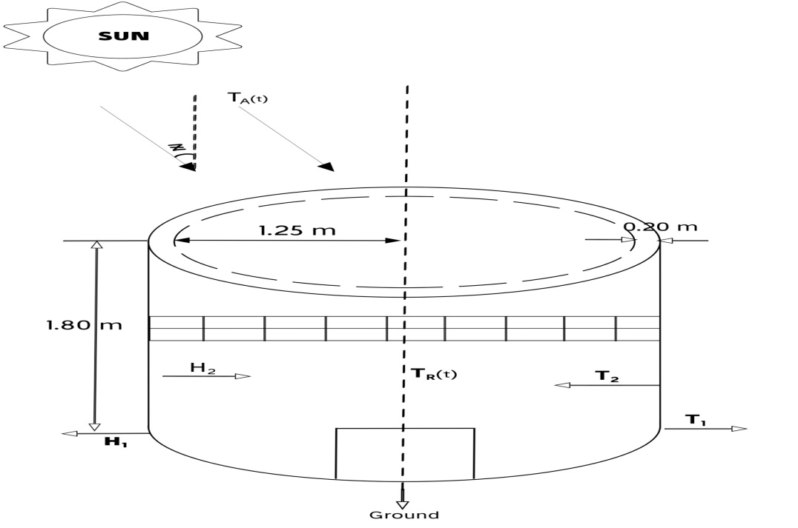
Figure 2: Sketch of Adobe Double Wall Storage Unit. (Source: Author’s Computation, 2023)
A cylindrical adobe storage unit was constructed with a thickness of 0.15m and a height of 1.80m, an inside diameter of 2.50m, air gap or wall separation of 0.20m and an external diameter of 3.10m. 42 slits with dimension 0.1m × 0.1m were constructed in the adobe structure, a door of 0.80m × 1.20m and roof width of 0.40m. The adobe structure has a volume of 8.84m³ and is capable of storing about 5,357kg of cassava roots with an average mass of 0.60kg
Location: Federal University Wukari, Taraba, Nigeria. Weather station, 670102.
Latitude: 7.8 N 7°50´40.64
Longitude: 9.77 E 9°46´38.83
2.5 Data Collection
Primary data was obtained from the indoor and outdoor parameters which was measured for the three storage rooms using a digital Hygrothermograph and a Balance/Scale. The readings from the instruments were for the following parameters:
- Average Mass Loss and Percentage Mass loss of cassava roots in the two storages.
Data Preparation
(Microsoft Excel 2016)
- Moisture content percentage of cassava roots in the two storages.
- Dry matter content percentage of cassava roots in the two storage structures.
3. Results and Discussion
3.1 Mass and Mass Loss
Table 1 shows the average weekly mass of stored samples in the two storage units. Figure 3 is a chart describing average masses of the samples in AD1 and AD2 storage units.

Table 1: Average Weekly Mass of Samples in Adobe Structure (AD1) and Control Structure (AD2)
Weeks | 1 | 2 | 3 | 4 | 5 | 6 | 7 | 8 | 9 | 10
AD1 | 0.88 | 0.88 | 0.83 | 0.78 | 0.72 | 0.68 | 0.60 | 0.53 | 0.41 | 0.28
AD2 | 0.71 | 0.71 | 0.54 | 0.53 | 0.45 | 0.35 | 0.23 | 0.20 | 0.19 | 0.17

Figure 3: Average Weekly Mass of Stored Samples in AD1 and AD2 Storage Units against Storage Period
Table 2 shows the average weekly mass loss of the stored samples in AD1 and AD2 storage units during the 10-week storage period. Figure 4 is a line chart of the results obtained.

Table 2: Average Weekly Mass Loss of Samples in AD1 and AD2
Weeks | 1 | 2 | 3 | 4 | 5 | 6 | 7 | 8 | 9 | 10 | Avg.
AD1 | 0.00 | 0.00 | 0.05 | 0.10 | 0.16 | 0.20 | 0.28 | 0.35 | 0.47 | 0.60 | 0.221
AD2 | 0.00 | 0.00 | 0.17 | 0.18 | 0.26 | 0.36 | 0.48 | 0.51 | 0.52 | 0.54 | 0.302

Figure 4: Average Mass Loss in AD1 and AD2 against Storage Period
Table 3 shows the average mass loss in percentage of samples stored in the two storage units. Figure 5 is a chart describing the percentage mass loss of samples in AD1 and AD2 within the period of 10 weeks
Table 3: Average Percentage Mass Loss of Samples in Adobe Structure (AD1) and Control Structure (AD2)
Weeks | 1 | 2 | 3 | 4 | 5 | 6 | 7 | 8 | 9 | 10 | Avg.
AD1 (%) | 0.00 | 0.00 | 6.82 | 11.36 | 19.32 | 23.86 | 32.39 | 40.45 | 53.41 | 68.75 | 25.64
AD2 (%) | 0.00 | 0.00 | 23.94 | 25.35 | 38.75 | 51.41 | 68.31 | 71.83 | 73.94 | 76.00 | 42.95

Figure 5: Percentage Mass Loss in AD1 and AD2 against Storage Period
3.2 Water Loss Analysis
Average water loss is determined from analysis of dry matter content obtained through the oven-drying method. Table 4 shows data collected from the above stated method and Figure 6 describes the percentage water loss in the two storage structures against the duration of study.

Table 4: Average Moisture and Dry Matter Content in Selected Samples from Oven Drying Method
Double Wall (AD1) |  |  |  |  |  | Control (AD2)
Duration of Storage (Weeks) | Sample ID | Initial Weight (kg) | Dry Weight (kg) | Moisture Content (%) | Dry Matter Content (%) | Initial Weight (kg) | Dry Weight (kg) | Moisture Content (%) | Dry Matter Content (%)
2 | DM1 | 1.40 | 0.45 | 67.86 | 32.14 | 1.20 | 0.40 | 66.67 | 33.33
4 | DM2 | 0.80 | 0.30 | 62.50 | 37.50 | 0.50 | 0.20 | 60.00 | 40.00
6 | DM3 | 0.80 | 0.32 | 60.00 | 40.00 | 0.30 | 0.13 | 56.67 | 43.33
8 | DM4 | 0.70 | 0.30 | 57.14 | 42.86 | 1.00 | 0.50 | 50.00 | 50.00
10 | DM5 | 0.30 | 0.20 | 33.33 | 66.67 | 0.55 | 0.40 | 27.27 | 72.73
Avg. |  | 0.80 | 0.31 | 56.17 | 43.83 | 0.71 | 0.33 | 52.12 | 47.88

Figure 6: Average Moisture Content against Storage Period

3.3 Correlation between Mass Loss and Moisture Content over Storage Period
The Pearson Correlations between Percentage Weight Loss and Moisture Content for structures AD1 and AD2 are presented in Tables 5 and 6. Figures 7 and 8 are scatter plots demonstrating the correlations.
Table 5: Pearson Correlation between Percentage Mass Loss and Moisture Content for Samples in AD1
Correlations for AD1
 |  | Percentage Weight loss (%) | Moisture Content (%)
Percentage Mass Loss  (%) | Pearson Correlation | 1 | -.952
Percentage Mass Loss  (%) | Sig. (2-tailed) |  | .013
Percentage Mass Loss  (%) | N | 5 | 5
Moisture Content (%) | Pearson Correlation | -.952* | 1
Moisture Content (%) | Sig. (2-tailed) | .013
Moisture Content (%) | N | 5 | 5
Correlation is significant at the 0.05 level (2-tailed).
From Table 5, it shows that the results presented have a strongly negative correlation since correlation coefficient r = -0.952. Again, the p-value of 0.013 is less than the 0.05 level. Hence, the relationship between percentage moisture content and percentage mass loss is significant.

Table 6: Pearson Correlation between Percentage Mass Loss and Moisture Content for Samples in AD2
Correlations for AD2
 |  | Percentage Weight Loss (%) | Moisture Content (%)
Percentage Weight Loss (%) | Pearson Correlation | 1 | -.826
Percentage Weight Loss (%) | Sig. (2-tailed) |  | .085
Percentage Weight Loss (%) | N | 5 | 5
Moisture Content (%) | Pearson Correlation | -.826 | 1
Moisture Content (%) | Sig. (2-tailed) | .085
Moisture Content (%) | N | 5 | 5
Correlation is significant at the 0.05 level (2-tailed).
From Table 6, it shows that the results presented have a strongly negative correlation since correlation coefficient r = -0.826. Hence, the relationship between percentage moisture content and percentage mass loss is significant.

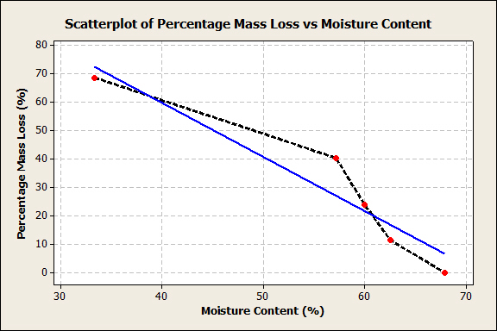
Figure 7: Scatterplot of Percentage Mass Loss against Moisture Content in AD1
The equation of the graph in Figure 8 is:
$β=\left(-1.915\right)α+136.429$ (3)
Where,
$β$is percentage mass loss (%)
$α$ is moisture content (%)
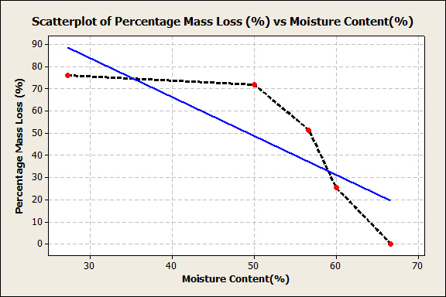
Figure 8: Scatterplot of Percentage Mass Loss against Moisture Content in AD2
The equation of the graph in Figure 8 above is:
$β=\left(-1.754\right)α+136.345$ (4)
4. Discussion of Results
Comparison of Percentage Mass Loss and Water Loss between Samples in Storage Structures (AD1 and AD2)
The average mass and percentage mass losses experienced in the two storage structures are presented in Tables 1 and 3 respectively. From results obtained, it can be seen that no significant weight loss was experienced in the first two weeks of storage in the storage structures AD1 and AD2. As the weeks proceed, the average percentage weight losses experienced in the two stores were still less pronounced. The average percentage mass loss in the AD1 and AD2 structures after the entire storage period of ten weeks was found to be 25.64% and 42.95% respectively. The AD1 store which is the double-walled unit is observed to have the lowest weight reduction rates. The chart in Figure 5 describes the average percentage weight loss plotted against the storage period.
The dry matter and moisture content percentages in selected samples stored in AD1 and AD2 is presented in Table 4. The average dry matter and moisture content percentage for samples stored in AD1 is found to be 43.83% and 56.17% respectively. Likewise, the average dry matter and moisture content percentage for samples stored in AD2 47.88% and 52.12% respectively. The average moisture in AD1 is higher when compared to the average recorded in AD2 which implies a lower loss rate. The moisture content obtained from the oven-drying method in the 2nd, 4th and 6th week in AD1 are 67.86%, 62.50% and 60.00% which is consistent with research conducted by Teye et al., (2011), also with Morgan and Choct (2016). In the 8th and 10th week, values 57.14% and 33.33% were obtained which corresponds to the weight-loss pattern observed. The moisture contents in AD2 for weeks 2 and 4 (66.67% and 60.00%) are also consistent with the above cited works. The Pearson correlation between percentage mass loss and moisture content in AD1 storage unit is presented in Table 5. The Pearson correlation coefficient -0.955 indicates a strong negative correlation between the variables. This implies a strong relationship between the weight and moisture content as the rate of weight loss is hinged on the rate of water loss. The Pearson correlation between percentage weight loss and moisture content in AD2 storage unit is presented in Table 6. The correlation coefficient -0.826 describes a strong negative relationship between the variables.
CONCLUSION
The research findings lead to the following conclusions: adobe bricks have low heat conductivity, which aids in thermal regulation. The weight loss in cassava roots caused by a decrease in moisture content decreased significantly in adobe storage, as indicated by the results of a correlation analysis between weight loss and moisture content. According to the findings of this study, the double wall construction AD1 is more effective than the control structure AD2 in extending the shelf-life of cassava roots.

REFERENCES
Adiele, J. G. (2023). improving the productivity of cocoyam for food security: a review. centennial, 256.
Afek, U., & Kays, S. J. (2004). Postharvest physiology and storage of widely used root and tuber crops. Horticultural Review, 30.
Anikwe, M. A., & Ikenganyia, E. E. (2018). Ecophysiology and production principles of cassava (Manihot species) in Southeastern Nigeria. Cassava. Sidney, Australian College of Business & Technology, 105-122.
Beban, A., & Gironde, C. (2023). Surviving cassava: Smallholder farmer strategies for coping with market volatility in Cambodia. Journal Of Land Use Science, 18(1), 109-127.
Costa, C., & Delgado, C. (2019). The cassava value chain in Mozambique. World Bank.
DOI: 10.5897/AJAR2013.8261.
Florescu, E. R., & Bica, S. M. (2010). Thermal properties of an adobe brick wall: adapting traditional techniques to contemporary living standards. 6th International Conference on Education, Social Sciences and Humanities. 1148-1160.
Food and Agriculture Organization (FAO) (2011)."FAOSTAT: Production, Crops, Cassava, 2010 data".
Food and Agriculture Organization (FAO) (2022)."FAOSTAT: Agricultural Production Statistics".
Gengenbach, H., Comé, A. A., & Nhabinde, J. B. (2022). Serving “the Uses of Life”: Gender, History, and Food Security in a Cassava Value Chain Scheme. African Studies Review, 65(1), 93-117.
Khojely, D. M., Ibrahim, S. E., Sapey, E., & Han, T. (2018). History, current status, and prospects of soybean production and research in sub-Saharan Africa. The Crop Journal, 6(3), 226-235.
Marques, S., Moreno, A. D., Ballesteros, M., & Gírio, F. (2018). Starch biomass for biofuels, biomaterials, and chemicals. Biomass and green chemistry: Building a renewable pathway, 69-94.
Marsh, P. D. (2010). Controlling the oral biofilm with antimicrobials. Journal of dentistry, 38, S11-S15.
Morgan, N. K., & Choct, M. (2016). Cassava: Nutrient composition and nutritive value in poultry diets. Animal Nutrition, 2(4), 253-261.
Muluneh, M. G. (2021). Impact of climate change on biodiversity and food security: a global perspective a review article. Agriculture & Food Security, 10(1), 1-25.
Onyenwoke, C. A., & Simonyan, K. J. (2014). Cassava post-harvest processing and storage in Nigeria: A review. African Journal of Agricultural Research, 9(53), 3853-3863.
Osunde, Z. D. Fadeyibi, A. (2012). Storage methods and some uses of cassava in Nigeria. Continental Journal of Agricultural Science, 5, 12-18.
Parmar, A., Sturm, B., & Hensel, O. (2017). Crops that feed the world: Production and improvement of cassava for food, feed, and industrial uses. Food Security, 9, 907-927.
Powlson, D. S., Gregory, P. J., Whalley, W. R., Quinton, J. N., Hopkins, D. W., Whitmore, A. P., & Goulding, K. W. (2011). Soil management in relation to sustainable agriculture and ecosystem services. Food policy, 36, S72-S87.
Revuelta-Acosta, J.D., Garcia- Diaz, A., Soto- Zarazua G.M. and Rico- Garcia, E. (2010). Adobe as a Sustainable Material: A Thermal Performance. Journal of Applied Sciences, 10: 2211-2216.
Sanchez, T., Dufour, D., Moreno, J. L., Pizarro, M., Aragón, I. J., Dominguez, M., & Ceballos, H. (2013). Changes in extended shelf life of cassava roots during storage in ambient conditions. Postharvest Biology and Technology, 86, 520-528.
Silva, O. A., Pellá, M. C. G., Friedrich, J. C., Pellá, M. G., Beneton, A. G., Faria, M. G., & Dragunski, D. C. (2021). Effects of a native cassava starch, chitosan, and gelatin-based edible coating over guavas (Psidium guajava L.). ACS Food Science & Technology, 1(7), 1247-1253.
Srivastava, R. K., Shetti, N. P., Reddy, K. R., Kwon, E. E., Nadagouda, M. N., & Aminabhavi, T. M. (2021). Biomass utilization and production of biofuels from carbon neutral materials. Environmental Pollution, 276, 116731.
Teye, E., Asare, A. P., Amoah, R. S., & Tetteh, J. P. (2011). Determination of the dry matter content of cassava (Manihot esculenta, Crantz) tubers using specific gravity method. journal of Agricultural and Biological Science, 6(11), 23-28
Tomlins, K., Parmar, A., Omohimi, C., Sanni, L., Adegoke, A., Adebowale, A. and Bennett, B. (2021). Enhancing the shelf-life of fresh cassava roots: a field evaluation of simple storage bags. doi:10.20944/preprints 202103.0312.v1.
Wenham, J.E., (1995). Post-harvest Deterioration of Cassava a Biotechnological Perspective. FAO, Rome.
Westby, A. (2002). Cassava utilization and small-scale processing. Cassava: Biology, Production and Utilization. 281-300.
Wijesinghe, W. and Sarananda, K. (2010). Utilization of cassava through freezing. Journal of Food and Agriculture 1(2): 17-29. DOI: 10.4038/jfa.v1i2.1796.
Yashveer, S., Singh, V., Kaswan, V., Kaushik, A., & Tokas, J. (2014). Green biotechnology, nanotechnology and bio-fortification: perspectives on novel environment-friendly crop improvement strategies. Biotechnology and Genetic Engineering Reviews, 30(2), 113-126.
Zainuddin, I. M., Fathoni, A., Sudarmonowatib, E., Beechingc, J. R., Gruissema, W., & Vanderschurena, H (2017). Cassava post-harvest physiological deterioration: From triggers to symptoms. Postharvest Biology and Technology, 142, 115–123

