The Secret to Myanmar’s EV Charging Station Business: How Solar Changes Everything

ABSTRACT
This study integrates PVGIS and FLEVY simulation tools to evaluate the economic performance of grid-connected and solar-based EV charging models in Myanmar, demonstrating that solar-BESS systems can provide long-term strategic benefits for rural electrification and sustainability. All are considered in same charging price and MOEP tariff rate and different location. Specifically, at present, approximately 99% of charging stations in Myanmar operate on AC grid power and are predominantly located in major cities, such as Yangon, Mandalay, and Naypyitaw. While this concentration benefits urban EV users, it creates a serious accessibility gap for non-EV drivers and potential EV adopters in rural and intercity areas. The absence of charging facilities along regional and countryside routes discourages internal combustion engine (ICE) car owners and express bus operators from considering EV replacements. This urban–rural disparity in charging access not only limits the diffusion of EV technology but also hinders the government’s objectives for energy diversification and fuel import reduction. As a result, the current development pattern risks creating a two-tier mobility system where urban populations benefit from clean transport, while rural populations continue to rely on fossil fuels. A major barrier to nationwide EVC deployment is the high capital cost of electrical infrastructure, particularly the installation of 33/11/0.4 kV distribution transformers with high MVA ratings. These transformers are often oversized relative to the actual EV demand, resulting in underutilized capacity and inefficient capital allocation. For most investors, these infrastructure costs represent the largest expenditure component and substantially influence the Internal Rate of Return (IRR), NPV and payback period of EVC projects. To examine these economic dynamics, this study evaluates three distinct charging business models over a 14-year financial period under the assumption of a 50% government bank loan with a 7% annual interest rate. Among the three cases, Case 1 (Conventional AC Model) represents the typical grid-connected EVC structure; Case 2 (Economical AC Model) focuses on cost-optimized charging design; and Case 3 (Off-grid Solar + Battery Energy Storage System) explores a renewable, stand-alone alternative for rural and remote regions. Based on financial analysis results, Case 2 and Case 3 demonstrate the most relevant and strategic value for Myanmar’s long-term transport electrification.
Keywords: AC grid, off-grid solar, RE, BESS, capital cost, IRR, NPV, Payback period, ICE, EV, EVC, MOEP, Myanmar.

1. INTRODUCTION
The transition toward electric mobility has emerged as a critical component of sustainable energy policy in many developing nations, and Myanmar is no exception. As the country faces growing fuel import costs and seeks to align with global climate goals, the development of public electric vehicle charging (EVC) infrastructure has become a strategic priority for both the Ministry of Electric Power (MOEP) and regional governments. However, Myanmar’s EVC development remains in its nascent stage, and the economic viability of various charging business models is still under evaluation. The success of this transition depends on a balanced combination of technical feasibility, economic sustainability, and public-private cooperation. Therefore, an economic analysis of EV charging business models is essential to inform decision-making for government agencies, private investors, and local communities.
Complementing this, the civil construction cost which includes site development, foundation work, and canopy installation forms the second-highest cost category. However, unlike electrical equipment, about 90% of steel and like cement materials used in civil works can be locally manufactured, and it shall be lower costs through eco-design and locally sourced construction materials.
The Economical AC EVC Model (Case 2) achieved the highest Internal Rate of Return (IRR) at 50.3% and the shortest payback period of 2.37 years. These results indicate a strong investment potential for small and medium private investors seeking rapid capital recovery. With reduced installation complexity and lower procurement costs, Case 2 is ideal for urban or township-based deployment, where moderate EV traffic ensures stable revenue flow. This model can also attract existing petrol station owners and local business groups to diversify into charging services, leveraging existing land and retail infrastructure.
Conversely, the Off-grid Solar EVC Model (Case 3)—although financially less attractive in the short term with an IRR of 18.6% and a payback period of 6.46 years—offers transformative potential for rural electrification and energy security. This model incorporates solar photovoltaic (PV) generation and battery energy storage (BESS) to provide 24-hour power supply without dependence on the national grid. While its capital cost is higher due to imported solar and battery components, it eliminates recurring fuel costs and reduces transmission losses in off-grid regions. Moreover, this model supports the government’s broader goals under the United Nations Sustainable Development Goals (SDGs).
From a strategic perspective, adopting the Solar+BESS model in off-grid or low-load rural areas could help the government reduce dependence on diesel generators and fuel imports for electricity generation. It also offers a viable pathway for existing solar generation companies in Myanmar to expand their business portfolios into the EV charging sector, thereby creating new investment opportunities and local employment. For non-EV drivers and ICE vehicle owners, such as countryside residents and express bus operators, the establishment of solar-based charging facilities would enhance travel confidence, reduce range anxiety, and encourage gradual EV adoption. In this way, the proposed model bridges the infrastructure gap between urban and rural regions while contributing to national energy transition and green development.
To conduct a detailed economic and technical evaluation, this research applies two analytical purchased software tools:
- PVGIS (Photovoltaic Geographical Information System): Used for assessing solar resource potential and annual irradiation at proposed station sites across Myanmar, ensuring accurate sizing of solar arrays and energy storage systems.
[ PVGIS tools, European Commission, 2024]

- FLEVY EV Charging Business Analysis Tool: Applied for financial modeling, including cash flow forecasting, NPV, IRR, and payback period analysis. This software provides scenario-based insights for both public and private investors, enabling informed decision-making in capital allocation and investment risk management. [ FLEVY tools]

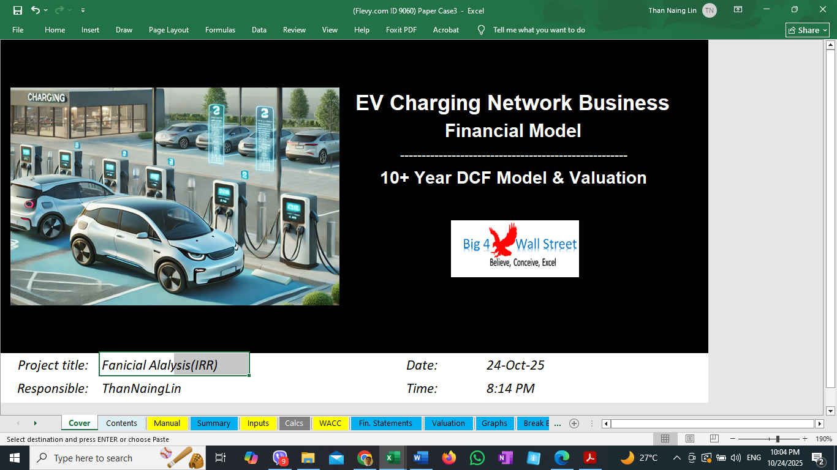
Fig.1. PVGIS tools [PVGIS 5.3] Fig. 2. EVC Financial Analysis Tools

The combined use of PVGIS and FLEVY tools allows for data-driven evaluation of technical feasibility and economic performance, producing results that are highly relevant for policy formulation and investment planning. By integrating these tools, the research demonstrates a practical methodology for regional governments, MOEP planners, and medium or small-scale investors to assess the cost-effectiveness of EVC projects under different financial and technical scenarios.
In summary, this paper addresses the economic and infrastructural challenges faced by Myanmar’s EV charging development and proposes cost-efficient and renewable-based solutions suitable for diverse regional contexts. Case 2 is positioned as the most financially feasible approach for near-term expansion in urban centers, while Case 3 represents a sustainable long-term solution for rural off-grid regions. Both models together provide a comprehensive roadmap to support the government’s energy transition strategy, facilitate private sector participation, and accelerate EV adoption across Myanmar. The outcomes of this research are expected to guide policy recommendations for the MOEP and provide practical reference for public and private investors in building a resilient, inclusive, and economically sustainable EV charging infrastructure network.

2. LITERATURE REVIEW
From a cost perspective, some previous studies have identified key factors influencing the financial viability of EV charging investments. Some emphasized that both capital expenditure and long-term operating expenses must be carefully managed to achieve sustainable business models [Theodore Narku Odonkor,Oghenekome Urefe, August 2024]. Almost Myanmar investor considered conventional charging station with much amount of budget for expected EV cars quantities. In the initial stage, the business should begin with an economical configuration model and adopt a charge point deployment method distributed along the road way, restaurant, universities and existing fuel- pump stations. However, not all areas in Myanmar are equipped with 11 kV high-voltage distribution lines, which presents a significant barrier to the development of electric vehicle (EV) charging infrastructure. Nevertheless, Myanmar possesses strong potential for solar photovoltaic (PV) energy generation due to its tropical climate and abundant solar irradiance throughout the year. The country comprises 15 administrative regions: Kachin, Kayin, Kayah, Chin, Mon, Rakhine, Shan, Sagging, Magway, Bago, Ayeyarwady, Mandalay, Tanintharyi, Yangon, and Naypyitaw. With the exception of the Chin and Yangon regions, most parts of the country offer favorable conditions for year-round solar energy production.
This is because it gets consistent sunlight most of the year and its seasons are more about wet and dry periods rather than drastic changes in sunlight. In this paper, PVGIS software is used to make design and optimize a PV-Utility grid electric vehicle (EV) charging station. Also, it needs to find out the annual deliverable solar output kwh by regions. While these CASE studies provide important insights into renewable energy public charging deployment, investor behavior, fixed pricing strategies is workable or not for solar used charging station, and AC grid connection materials cost, compare to significant research gaps remain and existing station cost. Before project investment, any charger investor has to consider as very few studies have incorporated detailed financial modeling that includes sensitivity analysis to evaluate how fluctuations in utilization rates, profit margins, energy costs, capital expenses, and operating expenses affect long-term investment sustainability. These gaps are especially important in emerging EV markets like Myanmar where investment uncertainty remains high and policy frameworks continue to evolve.
In this study, a fixed charging rate is considered across three business models. However, Myanmar’s existing grid system under the Ministry of Electric Power (MOEP) frequently experiences power shortages, and the tariff rate is expected to increase within the next five years due to rising global energy import prices and the actual resale rate to local distribution networks. Currently, the Myanmar government provides tariff subsidies in whole country. The primary analysis in this research focuses on the installation of EV chargers constrained by three business models, assessing whether their economic payback periods and internal rates of return are feasible. The integration of renewable energy sources and appropriately sized battery storage systems is evaluated for off-grid EV charging stations to be located along national highways at intervals of approximately 50 to 70 miles. To attract investors, various charging station models with optimal design configurations and viable implementation approaches are considered. The proposed solar-powered EV charging station model, being relatively new, demonstrates the potential for integration without requiring major upgrades to the existing power infrastructure.

2.1. SOLAR EXPORT TO GRID IN FUTURE
While no charging time interval, generated solar power can be connected to the national grid, with power distributed according to the Standard Operation Procedure (SOP) established by the Ministry of Electrical Power (MOEP). It can get some revenue and no waste solar generation for charging station owner side. In this research, there is no taken into account for that power export revenues. If consider that revenues, the RE CASE-3 model will be better benefit and short payback year.

2.2. ANNUAL IRRADITION
An off-grid EV charging station is a self-contained power plant that can charge one or more electric vehicles without a permanent connection to the utility grid. Solar panels capture energy, a charger controller conditions the power, batteries store it for later use, and an inverter supplies the alternating current required by most chargers. Station owners therefore bypass grid-connection delays, permitting processes and demand-charges, while motorists gain access to clean energy in places where the grid is weak or nonexistent [Pulse Energy,2025]. In this paper, it was considering the deliverable solar output (kWh) from each region by PVGIS tools. The minimum and maximum power output is acceptable range for small solar plant that can power resell to MOEP grid while no charging work but host purchase rate is one third of charging rate 0.17USD. The following data Table (1) and (2) can be used for future RE EV charging station design procedures.

Table 1. Deliverable Solar Power Annual Output in Regions
Month | Kachin | Kayar | Kayin | Chin | Mon | Rakhine | Shan | Sagging
Month | kWh/m | kWh/m | kWh/m | kWh/m | kWh/m | kWh/m | kWh/m | kWh/m
January | 18,988 | 19,752 | 18,888 | 19,600 | 20,662 | 21,977 | 21,309 | 20,339
February | 17,675 | 19,398 | 18,888 | 19,068 | 19,204 | 20,816 | 20,686 | 19,540
March | 19,354 | 20,545 | 19,724 | 21,006 | 20,147 | 22,207 | 22,108 | 20,916
April | 17,191 | 17,388 | 16,681 | 18,374 | 17,176 | 18,875 | 18,706 | 18,545
May | 14,519 | 14,200 | 12,127 | 15,969 | 12,468 | 14,886 | 15,820 | 16,390
June | 9,020 | 10,942 | 8,205 | 11,506 | 8,729 | 9,224 | 12,157 | 13,094
July | 8,639 | 10,364 | 7,384 | 11,073 | 7,891 | 8,775 | 11,330 | 12,704
August | 10,034 | 10,499 | 7,778 | 10,955 | 8,252 | 9,528 | 11,504 | 12,934
September | 11,735 | 12,671 | 10,441 | 11,817 | 10,905 | 12,144 | 13,359 | 14,288
October | 14,780 | 15,462 | 15,501 | 13,936 | 16,092 | 15,976 | 15,753 | 15,656
November | 17,150 | 16,994 | 18,043 | 16,596 | 18,622 | 18,805 | 17,639 | 17,393
December | 18,079 | 18,438 | 19,655 | 17,511 | 20,113 | 20,199 | 19,312 | 18,695
Table 2. Deliverable Solar Power Annual Output in Regions
Month | ManDY | Magway | NPW | Bago | Yangon | AyeYarWdy | TaNTherYi
Month | kWh/m | kWh/m | kWh/m | kWh/m | kWh/m | kWh/m | kWh/m
January | 20,598 | 21,299 | 21,266 | 20,450 | 20,838 | 20,961 | 20,545
February | 19,846 | 20,205 | 20,135 | 19,491 | 19,725 | 19,963 | 18,374
March | 21,140 | 21,463 | 21,475 | 20,756 | 21,019 | 21,245 | 19,267
April | 18,620 | 18,628 | 18,579 | 17,741 | 18,061 | 18,199 | 16,186
May | 15,932 | 15,926 | 15,296 | 13,215 | 13,536 | 13,859 | 12,086
June | 12,285 | 11,911 | 10,416 | 9,043 | 9,567 | 9,355 | 9,151
July | 11,750 | 11,691 | 9,591 | 8,531 | 9,013 | 9,079 | 8,295
August | 11,677 | 12,109 | 9,894 | 8,953 | 9,459 | 9,409 | 9,084
September | 13,114 | 13,674 | 12,448 | 11,298 | 11,558 | 11,204 | 10,245
October | 14,962 | 15,851 | 15,674 | 15,555 | 15,922 | 15,372 | 14,555
November | 17,349 | 18,220 | 18,243 | 18,108 | 18,471 | 18,310 | 17,889
December | 18,709 | 19,752 | 19,726 | 19,796 | 20,161 | 20,003 | 20,101

2.3. PROJECT INPUT OVERVIEW
This economic evaluation analyzes three investment models for public Electric Vehicle Charging (EVC) stations under a 14-year operational framework. Each project scenario assumes a 50% government bank loan with an annual interest rate of 7%, reflecting public–private partnership financing conditions suitable for Myanmar’s emerging EV market. Depreciation rate 5% & all expense, income tax 2%, Cost of equity capital 13%, After-tax cost of debt 6.9% included. The three project models are:
Case 1 – Conventional AC EVC Model: Grid-connected AC charging system using standard infrastructure.
Case 2 – Economical AC EVC Model: Cost-optimized AC charging system designed for urban and semi-urban deployment.
Case 3 – Off-grid Solar EVC Model: Stand-alone solar-based system with Battery Energy Storage System (BESS) for remote areas without access to the national AC grid.

2.4. ELECTRICITY PRICE IN 2024FY
Ministry of Electric Power (MOEP) set a reasonable tariff price upgrade since 2024, September has the following table (3). It has described unit 3 levels with different rates from MOEP and fixed rate to EV drivers.

Table 3. Tariff in Sept-2024FY for Level 3-DC Fast Charger
Power Consumption Unit(kwh) | MOEP Set Tariff for Level3  (50-200kW) DC Fast Charging Station  (kyat/kwh) / (USD/kwh) | Charging Station resell rate  Charging fixed price  (kyat/kwh) / (USD/kwh)
1-5000Unit | 250 / 0.057 | 750 / 0.17  for DC Fast Charger
5000-20000 Unit | 400 / 0.09 | 750 / 0.17  for DC Fast Charger
Above 20000 Unit | 500 / 0.11 | 750 / 0.17  for DC Fast Charger

2.5. PROJECT COST CONCEPT
A clear understanding of the project cost structure is essential for evaluating the financial feasibility and investment risk of EV charging infrastructure development in Myanmar. The total current project cost consists of several major components, including electrical infrastructure, civil and structural works, equipment procurement, and operational expenses. Among these, the electrical supply infrastructure cost represents the highest expenditure category, primarily due to the technical and market challenges associated with power system development in an emerging EV market.

2.6. HIGH COST OF ELECTRIC SUPPLY INFRASTRUCTURE
The electrical supply component accounts for the largest proportion of total project investment. This is attributed to the high cost of imported electrical equipment and the requirement for oversized transformer capacities relative to the current EV adoption rate in the country. As Myanmar’s current EV population ~6191 remains in the early development stage, [RTAD records EV registrations by Dec 2024] transformer installations are typically designed with large MVA capacities to accommodate future charging demand. However, this approach results in underutilized assets and a high initial capital burden during the early years of operation.
Furthermore, the importation of switchgear, metering outfit (MOF) and high-voltage cables is complicated by logistics, customs procedures, and currency exchange challenges. The absence of local manufacturing capability for these key electrical components further increases costs. Another high cost is local manufacturing transformer price that is double more than imported same products. Consequently, the electrical infrastructure cost per charging site is significantly higher compared to other project cost categories, particularly in rural or grid-extension areas.

2.7. CIVIL WORK AND STRUCTURAL COST CONSIDERATION
The main behavior of EV driver needs to top-up battery cheaply and easily where to access. In research seems, the second-highest cost category is the civil work and structural construction, primarily driven by site development, foundation work, and canopy installation. However, unlike electrical equipment, 90% of the required steel materials for civil construction can be sourced locally from Myanmar’s manufacturing sector. This presents an opportunity to adopt eco-design principles and cost-efficient structural solutions, reducing both material and transportation costs. Locally fabricated structures can also improve project sustainability by minimizing the embodied carbon footprint associated with imported materials. Therefore, optimizing the civil design process through modular structures and lightweight canopy systems can significantly improve the cost-effectiveness of EV charging station development.

- 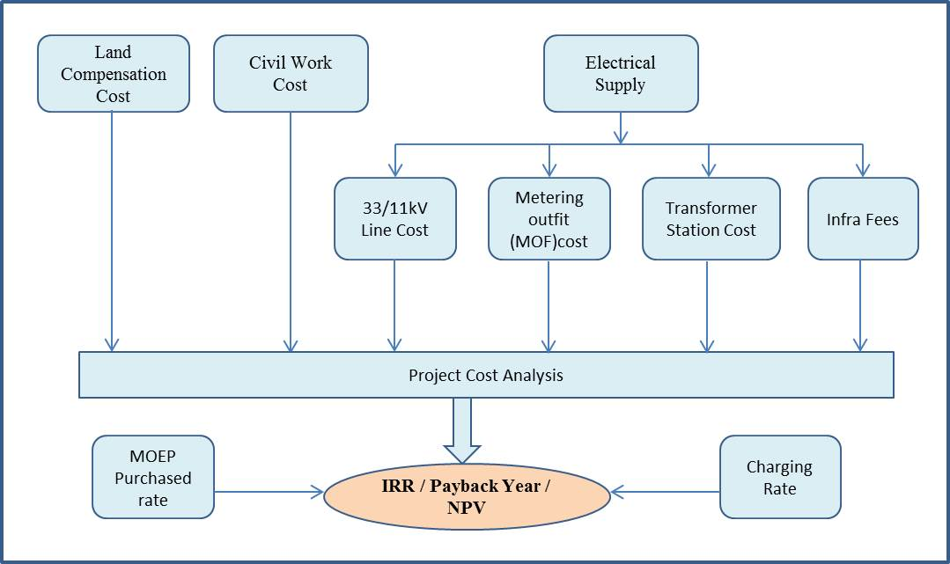
- Figure (3). Concept of Project Cost and IRR, NPV

2.8. WHY OFF-GRID SOLUTION ARE GAINING MOMENTUM
True sustainability means more than just installing either slow or fast chargers. A next-generation charging depot must be part of a larger, intelligent energy ecosystem. The best charging depots include: [Eleport,2025]
- On-site generation via solar rooftops or canopies
- Battery systems that buffer fluctuations and support grid stability
- Smart load management that prioritizes renewable inputs
- Demand-response integration for grid services
- Low-impact design and lifecycle planning
Rapid EV adoption in rural & peri-urban areas: AC grid expansion lags behind the growth of EV fleets in many emerging markets. Off-grid systems close that infrastructure gap at lower total cost.[ Pulse Energy, Sept, 2025]
Resilience for critical travels: By decoupling from utility outages, logistics hubs and public-safety agencies guarantee vehicle readiness during blackouts.
Government incentives: Government incentives for both solar generation and EV infrastructure frequently stack, improving project economics.
Technology convergence: Falling module prices, advanced lithium-ion BESS (including second-life EV packs), and suitable modular power-electronics enable bankable designs from 100kwh to 500kWh scale.

2.9. AC GRID AND OFF-GRID CHARGING POINT
EV charging involves supply of two power type, alternate current (AC) and direct current (DC) to the battery pack. As electricity distribution systems supply alternate current (AC) power, a converter is required to provide DC power to the battery. [Mapping India’s EV Charging Guidelines]. RE used chargers has Inverter, Solar, Battery and level2 and level3 fast charger. The following abbreviations and figure related to electric vehicle and charging system will be part of basic principles.

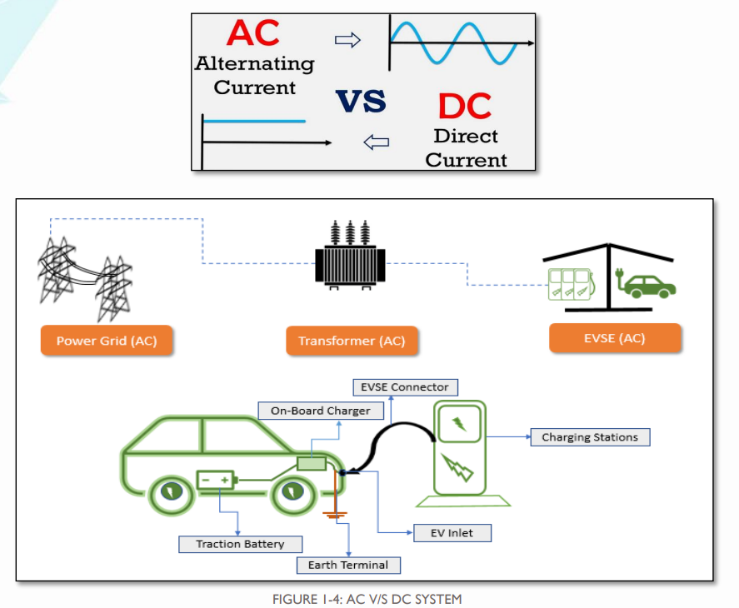
Fig.4. AC Grid Used Charging Station

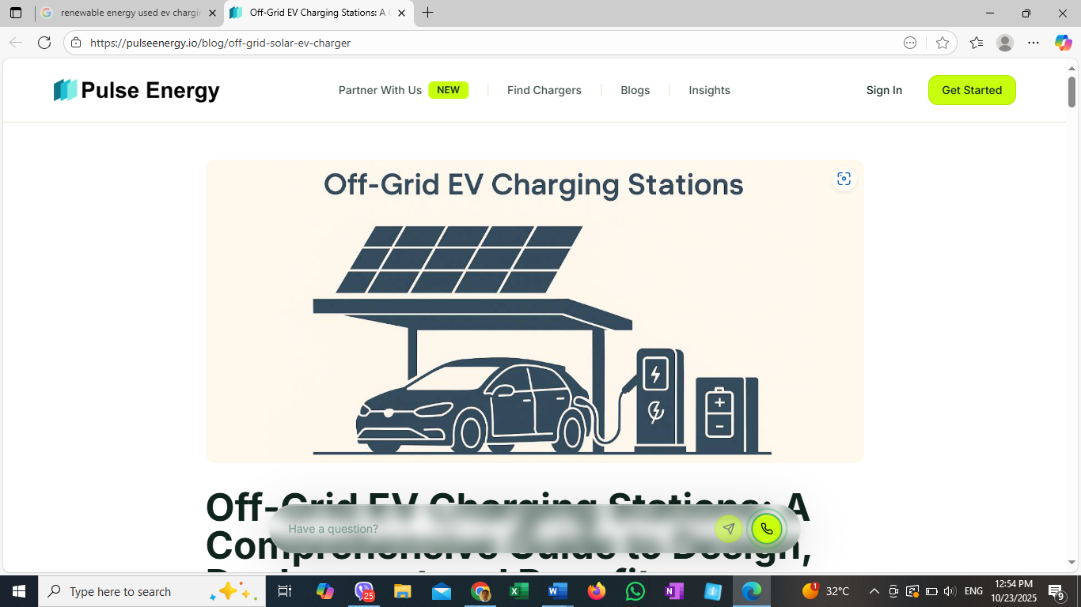
Fig. 5. Off-grid Solar and Battery System Used Charging Station

3. METHODOLOGY
This study aims to investigate the real-world demand for EV charging infrastructure in National highway and rural road. The objective is to assess charging behavior within an actual residential setting, reflecting the practical limitations and operational challenges associated with shared EV charging stations. By conducting the study within an existing residential environment, the findings provide a more accurate representation of the demand. [Pathom that Chiradeja, Appl. Sci. 2025, 15(17), 9716]
The research framework focuses on understanding charging station owner planning, analyzing energy consumption data, and identifying constraints related to retrofitting EV chargers in cities and rural area. Given the rapid adoption of electric vehicles in Myanmar, existing rural and countryside often lack adequate electrical capacity and regulatory provisions to support widespread charger installations. This study highlights these challenges while exploring practical solutions for optimizing EV charging accessibility in urban residential complexes. [Asiri Tayri, Xiandong Ma; Energies 2025]

3.1. INFRASTRUCTURE PLANNING
The design of charging infrastructure must be grounded in a comprehensive understanding of user diversity, power source capability, purchased tariff, geological condition, numbers of EV development in country, how to meet sustainable goal (SDG), economic issues analysis and behavioral patterns [Sihem Nasri, Nouha Mansouri, Aymen Mnassri, World Electr. Veh. J. 2025]. Individuals engage with electric vehicle charging in varied ways, influenced by their unique needs, perceptions, and emotional responses throughout the charging experience. The incorporation of user personas within this strategic framework has enabled stakeholders (government, EV driver, Land owner, ChargePoint owner), to analyze and empathize with a broad spectrum of user requirements. Adopting this user-centered methodology is essential for integrating customer-oriented perspectives into policy formulation and decision-making processes. Moreover, it serves as a critical base for the development of technical standards and the implementation of governmental support mechanisms and funding initiatives associated with this strategy. [ An Roinn Iompair,2022-2025]

3.2. FINANCIAL INPUT FACTOR VARIABLES
EV charging stations can be implemented either with or without loans, operating under a fixed tariff rate for 14 years. The analysis also considers the minimum charging time and daily plug utilization percentage. Table 4 presents the business model input variables used to analyze the cost implications for commercial electric vehicle charging stations in Myanmar.
Table 4. Input Factor Variables
Input Variables | Unit | CASE-1 | CASE-2 | CASE-3
Purchase Tariff rate to MOEP (avg) | USD/kwh | 0.087 | 0.087 | 0.087
Charging rate to EV car | USD/kwh | 0.17 | 0.17 | 0.17
1 Session charging capacity(kWh/charge) | kWh | 30 | 30 | 30
No. of Installed charging plug/station | plug | 10 | 4 | 2
Charging avg hour /day | hour | 16 | 16 | 16
Utilization % of installed plug /day | % | 50 | 50 | 50
Business period | years | 14 | 14 | 14
Inflation on Revenues | % | 2 | 2 | 2
Loan duration | years | 5 | 5 | 5
Loan amount over total investment | % | 50 | 50 | 50
Interest rate | % | 7 | 7 | 7
Depreciation Applied to New Capex | % | 5 | 5 | 5
Weighted Average Cost of Capital (WACC) | % | 10 | 10 | 10
Cost of Equity | % | 13 | 13 | 13
Income tax | % | 2 | 2 | 2
Yearly Direct labor cost | fixed | included | included | included
Yearly expenses for O&M cost | fixed | included | included | included

Result and discussion

3.3. CASE-1 SIMULATION [Existing AC grid Used Model]

In this paper, collected costs from MOEP data and it changed into USD in 2024FY exchange rate 1USD = 4400kyat. The existing model has mentioned about AC power grid facilities such as Transformers, metering outfit MOF, HV sectionizer switch and main charger devices and building works as the project cost Table (5). And simulated result Fig 6 and Fig 7.
- Table 5. CASE-1 Existing Myanmar standard Station Cost at Sept:2024FY
Sr. | Main Items | Local Market  Amount (USD)
1. | Charger [60kW (8set) + 200kW (2sets)] | 107500
2. | Electrical Power Supply and Facilities cost | 58023
 | (a) 11/0.4kV,1000kVA Infra+Deposit+EI fee | 3023
 | (b) 11/0.4kV, 1000kVA Installation cost | 34091
 | (c) 11kV Overhead line + Metering Outfit cost(MOF) | 20909
3. | Land prepares + Civil Work | 106818
 | One Charging Station total cost | 272,341
[Exh:4400k=1USD]


Fig. 6. CASE-1 Input and Output Result

- 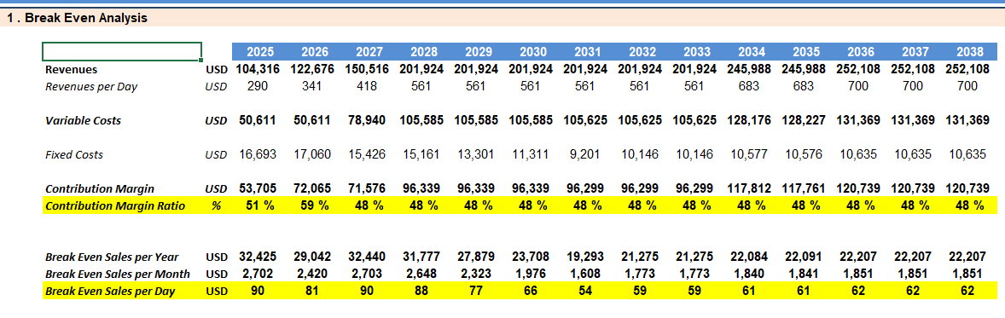
- Fig.7. CASE-1 Break-even Point Result
- 3.4. CASE-2 SIMULATION FOR ECO CHARGING STATION MODEL
Alternately, considered as CASE-2 with also AC grid used charging station model but reduced numbers of charger plug per station and it has to be placed spready every 50 to 70km apart along road. This model has proposed only 40kW two-gun plugs in one charger and 22kW x 2 plugs types chargers because limited AC transformer capacity 200kVA installed for eco design model. The owner may be hotels, restaurants, coffee-shop, schools and hospital etc. Also, may be National highway road between two townships. Project cost shown in Table (6) and simulated result shown in Fig 8 and Fig 9.

- Table 6. CASE-2 Tentative Eco EVC Project Cost at 2025FY
Sr. | Charging devices | Estimated 2024FY Cif Yangon Price (USD)
1. | 2x40kW DC Fast Charger 2plug Guns Type (1 set) | 3680
2. | Level2, 22kW Charger with 1plug (2sets) | 600
3. | Transformer 160kVA+CT meter and others fee | 9090
4. | Civil Work with Optimal design Cost | 4545
5. | Land preparation cost | 681
 | Total Cost for Optimal Design | 18596
- [Exh:4400k=1USD]

- 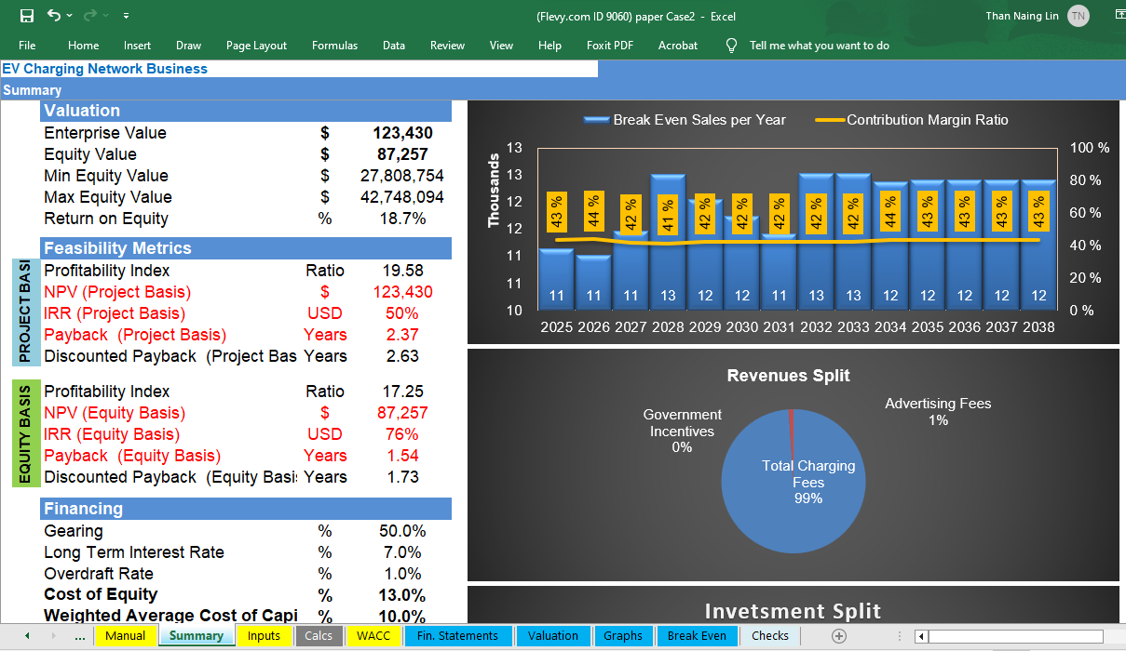
- Fig. 8. CASE-2 Input and Output Result

- 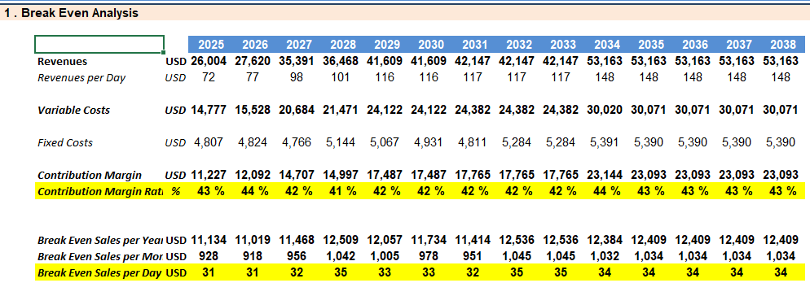
- Fig. 9. CASE-2 Break-even point Result
- 3.5. CASE-3 SIMULATION FOR FUTURE RE MODEL

Materials cost collected from China EVC facilities manufacturer in 2025FY. The future model has included battery energy storage system and solar power combination for enough charging devices. When AC grid outage, BESS can power into 60kW DC chargers 2 guns simultaneously. Most of the charging unit(kwh) may be 20~30kwh per session charge per car and the installed capacity 241kwh will be enough for 10 charging sessions at night. The observed the estimated cost shown in Table (7) simulated result described in Fig 10 and Fig 11.

- Table 7. CASE-3 Tentative RE-EVC Project Cost at 2025FY
Sr. | Charging devices | Estimated 2024FY Cif Yangon Price (USD)
1. | 2x40kW DC Fast Charger 2plug Guns Type (1 set) | 3680
2. | Solar Panel 120kWp+ 3phase Inverter 115kW | 27500
3. | Energy Storage Battery; BESS (241kWh) | 27000
4. | Civil Work with Optimal design Cost | 4545
5. | Land preparation cost | 681
 | Total Cost for Optimal Design | 63406
[Exh:4400k=1USD]

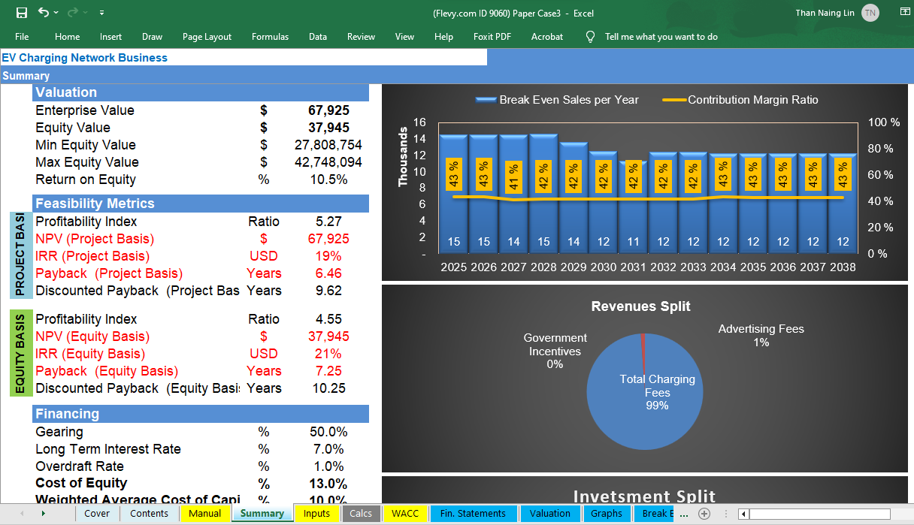
Fig.10. CASE-3 Input and Output Result

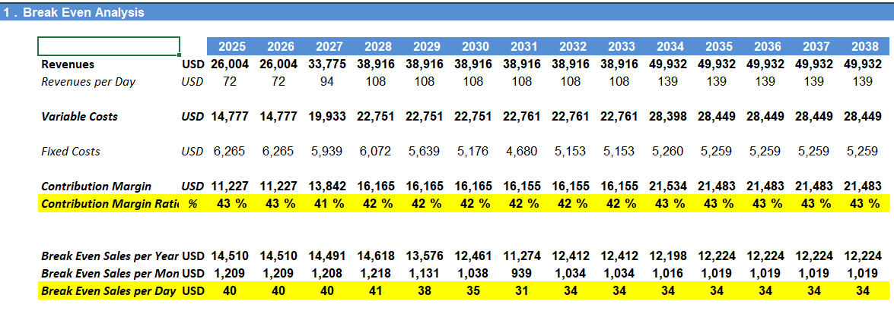
- Fig.11. CASE-3 Break-even point Result
- Table.8. Case Result Comparison
 | - 14 YEARS PERIOD  - CHECK POINT | - UNIT | - CASE-1  - Conventional AC EVC model | - CASE-2  - Economical AC EVC model | - CASE-3  - Off-grid Solar EVC model
- Project Basis | - Min Equity Value | - $ | - 27,808,754 | - 27,808,754 | - 27,808,754
- Project Basis | - Max Equity Value | - $ | - 42,748,094 | - 42,748,094 | - 42,748,094
- Project Basis | - Central | - $ | - 442,432 | - 87,257 | - 37,945
- Project Basis | - Profitability Index | - % | - 8.58 | - 19.58 | - 5.27
- Project Basis | - NPV (Project Basis) | - $ | - 661,508 | - 123,430 | - 67,925
- Project Basis | - IRR (Project Basis) | - % | - 28.3% | - 50.3% | - 18.6%
- Project Basis | - Payback (Project Basis) | - Years | - 4.1 | - 2.3 | - 6.4
- Project Basis | - Discounted Payback  - (Project Basis) | - Years | - 5.08 | - 2.63 | - 9.62
- Equity Basis | - Profitability Index | - % | - 7.52 | - 17.25 | - 4.55
- Equity Basis | - NPV (Equity Basis) | - $ | - 442,432 | - 87,257 | - 37,945
- Equity Basis | - IRR (Equity Basis) | - % | - 36.3% | - 75.9% | - 21.2%
- Equity Basis | - Payback (Equity Basis) | - Years | - 3.7 | - 1.5 | - 7.2
- Equity Basis | - Discounted Payback  - (Equity Basis) | - Years | - 4.59 | - 1.73 | - 10.25

- FINANCIAL PERFORMANCE DISCUSSION

4.1. CASE-1– COVENTIONAL AC EVC MODEL
The Conventional AC EVC model demonstrates strong economic feasibility with an IRR of 28.3% and a payback period of 4 years. The positive NPV ($661,508) and profitability index (5.58%) confirm that this model offers stable long-term profitability. It is most suitable for grid-connected urban zones and highway networks where energy infrastructure already exists, minimizing capital investment requirements.

4.2. CASE-2 – ECONOMICAL AC EVC MODEL
The Economical AC EVC model achieves the highest financial return with an IRR of 50.3% and a short payback period of 2.37 years. Lower equipment costs and reduced installation complexity make this model the most cost-effective option for rapid commercial deployment. It offers the best financial performance among all three models and is ideal for large-scale investment projects in city areas, where user demand is steadily increasing.

4.3. CASE-3 – OFF-GRID SOLAR EVC MODEL (with BESS)
The Off-grid Solar EVC model shows an IRR of 18.6% and a payback period of 6.4 years, indicating slower capital recovery compared to grid-connected options. This model involves high initial investment costs due to the integration of solar photovoltaic arrays, battery energy storage systems (BESS), and charge controllers, while accommodating only two charger plugs. To add more charging points, additional solar capacity and larger battery systems would be required, which would further increase capital costs. Despite being less economical in short-term financial terms, this model provides and ensuring the effective governance and sustainable management of our resource-based industries will be essential to sustaining Myanmar’s economic growth [Strategy 5.5, Myanmar Sustainable Development Plan (2018 – 2030)] strategic long-term value for the Myanmar government and the Ministry of Electric Power (MOEP) through several key benefits:
- Fuel Import Reduction: By supplying clean energy from local solar resources, this system reduces national dependency on imported diesel and heavy fuel oils used for AC power generation where government and IPP sectors.
- Grid Independence: Enables charging infrastructure in rural and remote areas where grid access is limited or non-existent.
- Environmental Benefits: Zero-emission operation supports Myanmar’s commitments to green energy transition and climate resilience.
- Alignment with Sustainable Development Goals (SDGs): [The Sustainable Development Goals in Myanmar,2025 United Nations in Myanmar]
  - SDG 7: Affordable and Clean Energy
  - SDG 8: Decent Work and Economic Growth
  - SDG 9: Industry, Innovation, and Infrastructure
  - SDG 11: Sustainable Cities and Communities

4.4. DIFFERENT BILLING APPROACHES
Different tariff rate structures should be considered because the MOEP grid system has experienced voltage rise issues during periods of low power demand, particularly between 1:00 AM and 5:00 AM since 2015. During this interval, charging station operators in Myanmar could implement attractive tariff rates to encourage off-peak charging. The possible billing approaches include:
- Time-based: Charges are determined by the duration of the charging session.
- Energy-based: Charges are calculated based on the amount of electricity consumed during the session.
- Fixed-rate: A set fee, such as a monthly subscription, regardless of usage.
- Hybrid pricing: A combination of time-based and energy-based methods.

4.5. FORECAST AND POLICY IMPLICATIONS FOR CASE-3
Although Case 3 currently presents a lower IRR (18.6%) and longer discounted payback period (9.62 years), it offers substantial public policy value. As Myanmar’s EV adoption rate grows and battery technology costs continue to decline, the cost-effectiveness of off-grid solar EVC systems is expected to improve significantly within the next decade. Government support through capital subsidies, soft loans, or tax incentives could further enhance project feasibility, reducing payback periods to less than 5 years. Also, solar output can send back resell into AC grid while no charging interval that will get some revenues in future and if can do this, the payback year will be shorter than 5 years. Moreover, the model contributes directly to national energy security, renewable capacity building, and decarbonization of the transport sector making it a valuable long-term investment in Myanmar’s sustainable development pathway.

  - PREPARATION FOR OFF-GRID PLANNER AND STAKEHOLDER
The build-out of charging in workplaces and publicly accessible areas and along National highway road will be key for increasing adoption among groups without access to home charging. Especially when considering a vehicle for long journeys. Charging services should also be easy to use everywhere, reliable and transparently priced. Further, ensuring interoperability is important when making investments in charging infrastructure and services, so that a wide customer base is able to benefit. [Global-EV-outlook-2024]
- Conduct rigorous needs assessment and planning to identify the need for renewable energy-based charging stations by assessing the local demand for electric vehicles and potential locations for charging infrastructure.
- Conduct feasibility studies to determine suitable sites for charging stations, considering factors like proximity to main roads, parking facilities, power grid connections, and availability of renewable energy sources.
- To be ready for off-grid projects employ technologies and methods similar to on-grid projects, but their objective is to generate reliable power and reduce the costs of developing and sustaining local economic activities. [ASEAN Energy Awards 2023: Best Practices in Renewable Energy Projects]
- Develop policies, regulations, and standards that support the installation, operation, and safety of renewable energy-based charging stations. This may constitute zoning laws, permitting processes, grid codes and building codes.
- Allocate budgets or secure funding for the planning, installation, and maintenance of charging infrastructure. Identify funding sources such as grants, incentives, public-private partnerships, or budget allocations in regional government.
- Promote awareness among the community, businesses, and potential users about the availability and benefits of renewable energy-based charging stations through outreach programs, workshops, and marketing campaigns for restaurants, hotels, condo owners, ICE owners and existing petrol fuel station owner to replace change to EVs and EVC.
- Develop technical specifications of RE based EV charging stations in specific areas and local geographical contexts. [ Harshal D. Kaushik, Member, IEEE,2025]

5. CONCLUSION
In conclusion, public chargers have tended to be installed in urban areas, where utilization rates are likely to be higher. Looking forward, however, chargers must also be installed outside of urban areas to enable continued adoption beyond cities and suburbs [Global-EV-outlook-2024]. As in simulated 3 business model, under a 50% government bank loan at 7% interest and 14-year evaluation period, all three EV charging station models show positive investment returns and potential for scaling. The Economical AC EVC Model (Case 2) is the most financially attractive for private investors, while the Off-grid Solar EVC Model (Case 3) though less profitable in the short term provides significant national-level environmental, social, and energy benefits. Therefore, the integration of Case 3 in Myanmar’s rural development plan is strongly recommended as part of the Ministry of Electric Power’s long-term green infrastructure strategy and EVs development plan.

Disclaimer (Artificial intelligence)
Option 1:
Author(s) hereby declare that NO generative AI technologies such as Large Language Models (ChatGPT, COPILOT, etc.) and text-to-image generators have been used during the writing or editing of this manuscript.
Option 2:
Author(s) hereby declare that generative AI technologies such as Large Language Models, etc. have been used during the writing or editing of manuscripts. This explanation will include the name, version, model, and source of the generative AI technology and as well as all input prompts provided to the generative AI technology
Details of the AI usage are given below:
1.
2.
3.

- REFERENCES
An Roinn Iompair, Electric Vehicle Charging Infrastructure Strategy 2022-2025
ASEAN Energy Awards 2023: Best Practices in Renewable Energy Projects
Asiri Tayri , Xiandong Ma; Energies 2025, Grid Impacts of Electric Vehicle Charging: A Review of Challenges and Mitigation Strategies
Eleport, How Eleport Ensures 100% Renewable Energy for EV Charging Published on October 1, 2025[https://eleport.com/renewable-energy-for-ev-charging/#: ~:text=Solar%20Energy%20%E2%80%93%20Harvested%20from%20photovoltaic, that%20power%20homes%20and%20businesses]
EV Charging Network Business Financial Model tools (Excel XLSX) [https://flevy.com/browse/marketplace/ev-charging-network-business-financial-model-9060?srsltid=AfmBOoqDen6UHKNp22dCTXbXmhUaGsi6L JbSM2W2Gi0toqtNh1BswsQv]
Global-EV-outlook-2024 [https://www.iea.org/reports/global-ev-outlook-2024/outlook-for-electric-vehicle-charging-infrastructure]
Harshal D. Kaushik, Member, IEEE,2025, Electric Vehicle Charger Infrastructure Planning: Demand Estimation, Coverage Optimization Over an Integrated Power Grid [https://arxiv.org/html/2509.23699v1#:~:text= A%20common %20approach% 0in%20the, makes%20them%20difficult%20to%20scale.]
Mapping India’s EV Charging Guidelines, https://www.evsahihai.com/ev-blog/mapping-india-ev-charging-guidelines]
Pathomthat Chiradeja, Analysis of Investment Feasibility for EV Charging Stations in Residential Buildings, Appl. Sci. 2025, 15, 9716
Pathomthat Chiradeja, Appl. Sci. 2025, 15(17), 9716; [https://doi.org/10.3390/ app15179716]
Pulse Energy, 2025 [https://pulseenergy.io/blog/off-grid-solar-ev-charger]
PVGIS tools [https://pvgis.com/en]
RTAD records EV registrations by Dec 2024, Global New Light Of Myanmar,[ https://www.gnlm.com.mm/rtad-records-17600-ev-registrations-by-dec-2024/]
Sihem Nasri ,Nouha Mansouri, Aymen Mnassri, World Electr. Veh. J. 2025, [Global Analysis of Electric Vehicle Charging Infrastructure and Sustainable Energy Sources Solutions]
Strategy 5.5, Myanmar Sustainable Development Plan (2018 – 2030)
The Sustainable Development Goals in Myanmar,2025 United Nations in Myanmar
Theodore Narku Odonkor, Oghenekome Urefe, Emmanuel Biney, & Shadrack Obeng,Volume 6, Issue 8, P.No. 1349-1374, August 2024, Comprehensive financial strategies for achieving sustainable growth in small businesses

Authors’ contributions

This work was carried out in collaboration among all authors. All authors read and approved the final
Manuscript

