Association of Cultural and Environmental Factors with the Newly Emerged Faba Bean Gall (Physoderma viciae) Disease Intensity in Tigary, Northern Ethiopia

ABSTRACT
Faba bean is a multipurpose crop which plays a vital role, in human nutrition and animal feed, and helpful for improving soil fertility. However, currently its production and productivity has been treated by biotic and abiotic factors. One of the main challenges for faba bean production in Tigray is the faba bean gall a new disease caused by (Physoderma viciae). A total crop loss may occur under favorable season for the disease development. The objectives of this study were to map the distribution and quantify the prevalence and severity of faba bean gall disease in major faba bean growing districts of Tigary highlands; to determine the association of factors that contribute to disease severity. Assessment of the disease were done in five districts of south east and east Tigray highlands namely Atsbi, D/tembien, G/afeshum, K/awlaelo and S/tsedaemba in the main cropping season between 15 August to 5 September in 2015. A total of 74 Global Positioning System (GPS) based ground data/ fields were collected and inspected. Survey results shown that, faba bean gall was found widely distributed in all faba bean growing districts. Altitudes, planting times, agronomic practices, soil drainage conditions, and crop growth stage and soil types affected the distribution and intensity of the disease. Highest faba bean gall disease prevalence was observed at Deuatembien (100%), at Atsbi (93.75%) and at G/afeshum (60%) compared to other surveyed districts. Varied level of faba bean gall distribution and severity were found at different faba bean growing districts. Severity with values of 53.33% and 46 % were high in D/tembien and Atsbi distrcts compared to severity of value of 14.83% and 26.1% in S/tsemba and G/afeshum districts, respectively. High faba bean gall disease severity was associated with June planted and at D/tembien district. Therefore, further independent research on effect of planting time is needed to verify and use the cultural practices as an integral component of faba bean gall management in study area and elsewhere with similar agro-ecological settings. Information obtained on the distribution, severity, prevalence, association of cultural and environmental factors with disease intensity is paramount to give clue to develop effective management strategies in the study area and elsewhere with similar agro-ecological settings. It also serves as a baseline information to conduct further detail investigation on faba bean gall disease across the region.
Key words: Disease epidemics; Faba bean gall; Physoderma viciae; Prevalence, Severity

- INTRODUCTION
Faba bean (Vicia faba L.) is a cool season legume crop cultivated throughout out world and due to high protein content highly valuable for human consumption and animal feed [1]. In addition, faba bean plays a critical role in soil fertility restoration and yields improvement following cereal crops [2].
Ethiopia is one of the major faba bean growing countries in the world but with a low average national yield (≤ 2 t ha-1) compared to yield levels in other countries [3]. Major constraints for faba bean production in Ethiopia are the cultivation of low-yielding cultivars, improper agronomic practices, weather shocks, shortage of improved seeds, fertilizers, and losses due to diseases and pests [4]. How ever the most yield limiting factors for faba bean production in Ethiopia are biological factors. Among the biological factors foliar diseases namely chocolate spot (Botrytis fabae), faba bean rust (Uromycesviciae-fabae) and ascochyta blight (Ascochyta fabae) as well as soil born disease black rot (Fusarium sp.) are the most important diseases of faba bean in Ethiopian [5]; [6]. But, recently faba bean production highly treated by newly introduced disease known as faba bean gall caused by (Physoderma viciae). Since pest survey and surveillance is very weak and the pest regulatory issue is addressed by pest check list which was not updated and spanned for several decades in Ethiopia [7] so that the pathogen means of introduction and the time was not known, but it was first recognized in Ethiopia a sample brought to the laboratory of Holeta Agricultural Research Center by farmers from Selale highlands [8]. It has an explosive character like that of late blight in potato and wipes-out fields without any tolerance. The disease was first report in Japan as new species in 1912 and called as blister disease in faba bean. Shunsuke Kusano 1936 confirmed that the small galls on faba bean in Japan are caused by Olpidium viciae. [9] but currently the morphological and molecular studies confirmed that Physoderma viciae, and not Olpidium viciae, to be the causative agent of the devastating Faba bean gall disease of faba bean (Vicia faba) in Ethiopia and also highlighted its ability to cross-infect with other host genera such as Pisum and Trifolium [9]. The disease also reported in China before several years as the most yield limiting factor for broad bean crops [10].

The present day the disease widely distribution in areas around in all faba bean growing high land of Ethiopia at an altitude of range is 2400-3000 m. a. s. l [8]; [12]; [13]; [14]. The disease also reported in faba bean growing area of Tigray with high prevalence and an epidemic level and farmers are forced stop growing this crop [11]. The pathogen over winter in resting zoosporangia for up to 2 years on crop debris of diseased plants in soil in the absence of the host plant, which is the main inoculum source for early infection [15]. [16] also discussed that high humidity; high rain falls and the temperature at level of from 10 to 25ºC, early growth stage of the crop and at high altitude give conducive environment for the disease development. Faba bean is one of the widely growing crops in Tigray regional state from 1900 to 300 m.a.s.l where the environmental conditions most favorable for growth and productivity of the crop. Previous study by [12] information on association of faba bean disease intensity with biophysical factors was done in high rain fall area but did not include dry land faba bean growing conditions of in Tigray which is characterized by extreme weather variable, limited rain fall and short growth period of the crops. Therefore, the study was initiated with following objectives
To assess the intensity of faba bean gall disease in major faba bean growing districts of Tigray
To determine the association of cultural and environmental factors with faba gall disease epidemics in Tigray

2. METHODOLOGY
2.1 Description of the Survey Areas
The assessment was conducted by collecting ground-based data, inspecting faba bean growing fields and interviewing growers in the selected districts of G/afeshum, S/tseadaemba, K/awlaelo, Atsbi and D/tembien (Figure:1). These selected districts were selected based on their accessibility and area of faba bean production potential. These selected districts were geographically found 13.46⁰ – 14.39⁰ N latitudes and 39.00⁰ – 39.88⁰ E longitudes with elevation value of ranges from 855m to 3216m m.a.s.l. with mean elevation of 2264m. The long-term annual rainfall of the selected districts were ranges from 550mm to 894mm with mean annual rainfall of 628mm, and long-term average temperature ranges from 13.05⁰c to 24.04⁰c with mean of 17.8⁰c (source: www.worldclim.org and own processing).
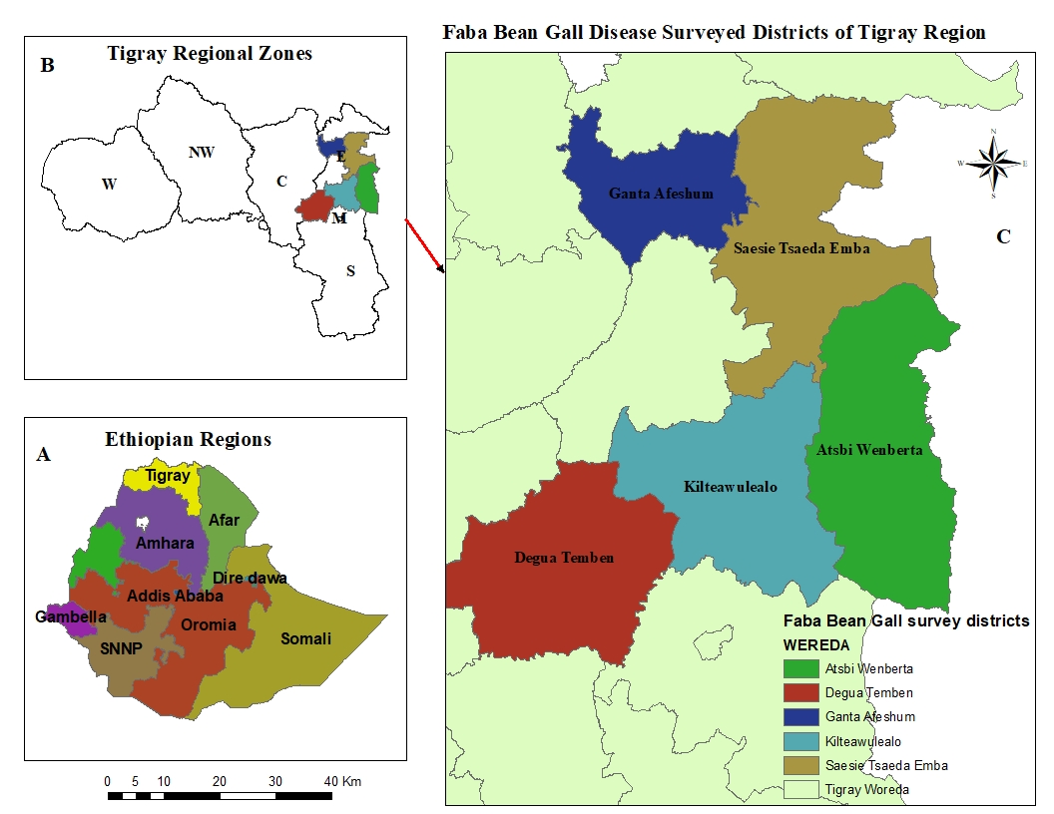
Figure1. Map of Ethiopian Regions (A), Tigray regional state zones (B) and Faba bean gall disease surveyed districts (C): Source: own processing using ArcGIS environment

2.2 Disease Assessment and Sampling procedures
Major faba bean growing areas of east and south east Tigray, were purposely selected; The survey was conducted by inspecting faba bean fields and interviewing growers in the districts. Fields was selected by random sampling techniques from each of the selected districts. Field data was collected starting from 15 August 2015 to 5 September 2015. In each sample field data was collected at each 5 m interval and the quadrants (1 m×1 m) was thrown following diagonal pattern, and in the field at a minimum distance of 5-10 km between fields. During the field survey 74 ground control points collected.
The plants in each quadrant were taken as the sample unit. The plant population in each quadrant was counted and the mean plant population density was considered from the plant population in the three quadrants. Following each throw, the number of healthy and faba bean gall -infected plants in the sampling area was recorded. Faba bean gall was rated as mean percentage of diseased plant within the quadrant. Severity was rated on leaves, stem and pods from 12 representative plants in each quadrant, using a 0–9 scale [17] where 0 indicates no visible symptom and 9 represents disease scoring more than 80% of diseased crop, heavy defoliation, and plant stem darkened, collapsing and dead. Disease severity scores were converted into percentage severity index [18] and disease incidence and prevalence were calculated [19].
Disease severity and prevalence were calculated using following formulas

(1). Disease prevalence = $\frac{Number of infected fields}{ Total number f fields assesed}x100$

(2). Disease incidence = $\frac{Number of diseased plants in the quadrant}{ Total number of plants assesed in the quadrant}x100$

(3). Percentage severity index =

During the survey time faba bean growers were asked on cultural practices, such as: previous crop in the field, source of seed, variety, cropping systems, planting date, ploughing frequency, fertilizer usage, and farmers’ disease management practice were recorded. Other data like altitude, soil drainage condition, soil type, weeding condition, cropping pattern plant growth stage also recorded.
The geographic coordinates of sampled areas were recorded using a hand held Global Positioning System (GPS) for mapping of the faba bean gall disease distribution in the major faba bean growing areas of the districts.

2.3 Data Analysis

Descriptive analysis was performed on all data collected from each field. Moreover, data analysis was conducted to quantify the severity, prevalence and association of faba bean gall in relation to the independent variables. Where significant difference for disease severity existed, the mean disease difference were separated using least significant difference (LSD) at (P<0.05).

Disease severity (the response variable) was classified into a distinct class of bivariate qualitative data using the statistical analysis for science procedure[20] of the univariate procedure of disease severity as variables. The selected class boundaries were 0, 0.1-25% and >25 % using un ordinal scale referring to no disease symptom, mild and highest symptoms [17]. Table of independent and variable classes for disease severity were constructed to represent the bivariate distribution of the fields. The value corresponding to each independent variable represents the frequency of fields falling. The association of faba bean gall (responsible variable) with the independent variables and variables class were analyzed using a logistic regression model which was explained by [21] with the SAS procedure of the general linear model procedure [20]. The model has been used to study the effect of different independent variable on incidence or severity on different crops [22]; [23]; [24]; [14] Logistic regression calculates the probability of a given binary outcome (response variable) as a function of the independent variables [25]. The general linear model procedure estimates the parameters of the model numerically through an iterative fitting process. Generalized linear model fits to the data by maximum likelihood estimation of the parameter. The logistic regression model allows evaluating the importance of multiple independent variables that affect the responsible variable. The logit link function was used in this binomially distributed data to determine the effects of the independent variable to the response variable (disease severity).
The importance of the independent variables were evaluated in three ways for their effect on the severity of faba bean gall. First, all the independent variables were tested in single variable model (Type 1 analysis). A Type 1 analysis consists of fitting a sequence of models, beginning with a simple model with only an intercept term, and continuing through a model of specified complexity, fitting one additional effect on each step. From this analysis all the parameter estimates were analysed and the likelihood ratio statistics were tested, and the deviance and the Chi-square value were analysed for the significance effect of the independent variables and variable classes on disease severity. The likelihood ratio statistics was used to examine the importance of variables and was tested against a Chi-square. Second, the association of an independent variables with disease severity were tested when entered last into the model with all other independent variables. Third, variables with high association to disease severity when entered first and last into a model were added to a reduced multiple variable model. A complete analysis of deviance table was generated for the final reduced multiple variable models, where deviance change was calculated for each variable as it was added to the reduced model. The deviance (−2×log likelihood) was used to compare single and multiple variable models. The difference between the two models, known as a likelihood ratio test (LRT), was used to examine the importance of the variable and was tested against a χ² value [25]. The parameter estimates and their standard error were analysed using the general linear model procedure both in single and multiple models. The odds ratio was obtained by exponentiation the parameter estimates for comparing the effect based on a reference point. Analysis of deviation was performed for the independent variable in a reduced model. The deviation was used to compare the different models.

3. RESULTS AND DISCUSSION

3.1 Distribution, Prevalence, incidence and Severity of the Disease
Varied level of faba bean gall disease had distributed various agro ecologies of five districts (Fig2 and Table 1); mainly differ in altitude, weather condition, soil types and agricultural practices (ploughing frequency, cropping system, utilization of agricultural inputs (fertilizers and seeds), weed and pest management practices, planting times and methods). Research findings by [14] indicated that disease intensity of faba bean gall varied among districts, cropping systems, sowing dates, growth stages and altitudes and other biophysical factors. Similar study by [26] also indicated that factors such as differences in podding and maturity stages, mono-cropping, altitude over 2,400 meters, high weed density, and fields not treated with fungicide seed dressing or spraying were highly associated with the faba bean disease intensities.
.
During the field survey 74 ground control points collected to identify the prevalence and distribution of the disease. Of the total field points 29 field points were collected in Deguatembien, 15 field points from G/afeshum , 15 field points from Atsbi , 10 field points from S/tsaemba and 5 field points in K/awlaelo districts and they were found with varied level of faba bean gall disease intensity
.
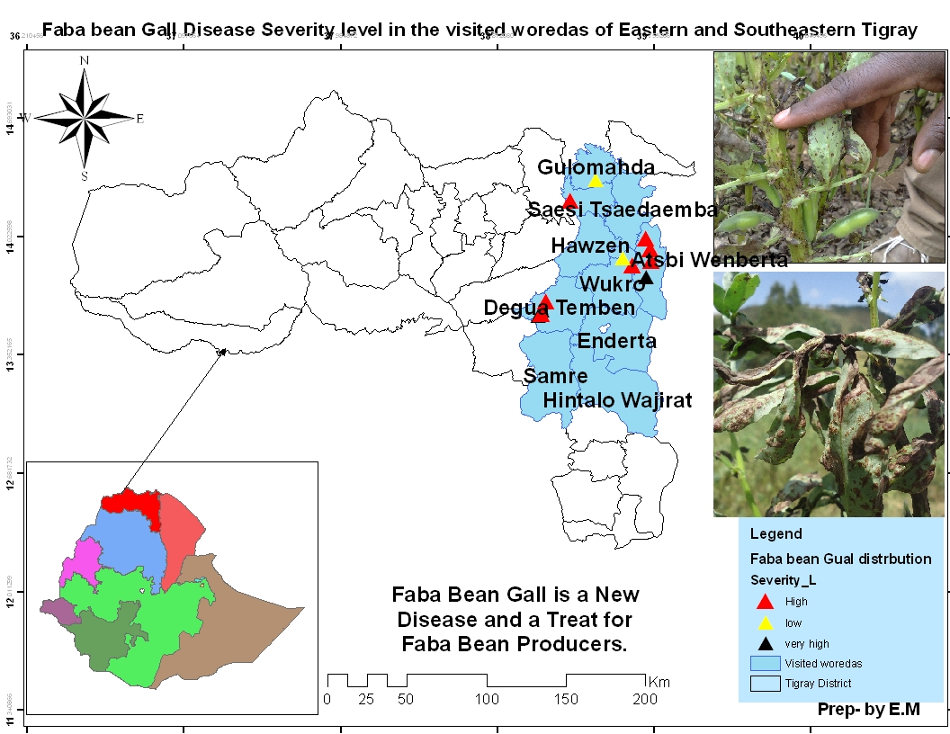
Figure 2. Distributions of faba bean gall in five districts of South east and East Tigray highlands, Ethiopia

The highest disease prevalence and incidence were observed in D/tembien (100 %) and Atsbi (93.75%) followed by G/afeshum (60 %). Lowest disease prevalence and incidence of were noticed in K/awlaelo (45%) and S/tsemba (50%). In the surveyed districts the gall disease severity ranges from 10 to 53.33%. The mean disease severity of faba bean gall at surveyed districts were, 53.33% at D/tembein, 14.83 % at S/tsaemba, 10 % at K/awlaelo, 26.1 % at G/afeshum and 46 % at Atsbi (Table 1). Highest faba bean gall disease severity was recorded in D/tembein (53.33 %) and Atsbi (46 %) followed by G/afeshum (26.1%) among the surveyed districts. Lowest disease severity was recorded in K/awlaelo and S/tsaemba districts (Table 1). Wide occurrence with heavy damage of the disease was reported across faba bean growing high lands of Ethiopia [13]; [12] and [14]. [27] similarly stated that anew foliar disease faba bean gall caused by plant deberis and soil born pathogen is rapidly spreading and caused high yield lost in Ethiopia. Relatively, highest disease severity was recorded in weed infested fields compared to weed free fields (Table 1). Different level of faba bean disease severity were scored from vegetative (48.13%), flowering (47.69%) and pod setting (32.2%) fields (Table 1). Other study on faba bean gall disease assessment conducted in northwest Ethiopia also indicated high disease intensity was reflected in vegetative and flowering growth stage of the crop compared to pod setting growth stage the crop [14].
Fab bean fields planted in June (41.66%) shown highest disease severity compared fields planted in May (39.26%). Highest disease prevalence (68.92%) and severity (31.3%) were recorded from altitude ranged >2500 m. a. s. l. compared to fields at <2500 m.a.s.l. Comparatively less populated fields shown less faba bean gall disease pressure compared to densely planted fields (Table 1). During the field survey we observed that short faba bean plants fields severely damaged by the disease than long faba bean plants.
As regards cropping pattern, broad casted planted fields had highest disease severity than row planted fields (Table 1). Suppressed disease severity was noted from fields ploughed highest frequency (41.07%) than less frequently ploughed fields (27.43%). With reference to cropping history the disease prevalence and severity were highest on fields previously planted by cereal crops (29.46%) than fallowing fields (15%). Regarding fertilizer application fertilized fields had less disease severity pressure (26.27%) than unfertilized fields (46.79%). Severely infected fields were observed at water logged than good drainage fields (Table 1). During field the assessment heavy damage by the faba bean gall disease was observed at clay soil fields than silt soil fields (Table1).

Table 1. Mean percentage prevalence, disease incidence and disease severity of faba bean gall for variables and variable class in Tigray, northern Ethiopia
Variable | Variable class | DI% | DP% | PSI% | Variable |  | Variable class | DI % | DP% | PSI%
District | D/tembien | 100 | 100 | 53.33 |  | Crop growth stage | Vegetative | 100 | 100 | 48.13
 |  |  |  |  |  |  | Flowering | 86.66 | 86.66 | 47.68
 |  |  |  |  |  |  | Pod setting | 86.49 | 86.49 | 32.2
District | S/tsedaemba | 100 | 100 | 14.83 | Crop density (0.8m²₎ |  | <20 | 84.62 | 84.62 | 28.46
 |  |  |  |  |  |  | >20 | 68.85 | 68.85 | 29.85
District | K/awlaelo | 60 | 60 | 10 | Planting date |  | May | 86.36 | 86.36 | 39.31
 |  |  |  |  |  |  | June | 94.23 | 94.23 | 41.66
District | G/afeshum | 60 | 60 | 26.1 | Weeding condition |  | Weeded | 66.67 | 66.67 | 28.98
 |  |  |  |  |  |  | Non weeded | 100 | 100 | 36.82
District | Atsbi | 93.75 | 93.75 | 46.25 | Ploughing frequency |  | >3 times | 67.21 | 67.21 | 27.43
 |  |  |  |  |  |  | <3 times | 92.86 | 92.86 | 41.07
Altitude | >2500 m.a.s.l | 73.23 | 73.23 | 31.3 | Cropping pattern |  | Broad cast planted | 100 | 100 | 37.5
 |  |  |  |  |  |  | Row planted | 69.39 | 69.39 | 29
Altitude | <2500 m.a.s.l | 50 | 50 | 10 | Soil type |  | Clay | 88.89 | 88.89 | 31.5
 |  |  |  |  |  |  | Silt | 55.26 | 55.26 | 28.21
Cropping history | Cereal | 70.83 | 70.83 | 29.46 | Fertilizer application |  | Fertilized | 65 | 65 | 26.27
 |  |  |  |  |  |  | Non fertilized | 100 | 100 | 46.79
Cropping history | Fallow fields | 100 | 100 | 55 | Drainage |  | Water logged | 75 | 75 | 30.25
 |  |  |  |  |  |  | Good drainage | 37.5 | 37.5 | 29.38
DI, Disease incidence, DP, Disease Prevalence, PSI, Disease severity index

3.2 Association of Faba bean Gall disease with Different Cultural and Environmental Factors
Association of faba bean gall disease severity their association with cultural and environmental with all independent variables at time of the independent variable entered as single variable and all independent variable are entered last in the logistic regression model is presented in (Table 2). The independent variables such as altitude, district, planting time, weed condition; soil type and fertilizer used, ploughing frequency and soil drainage condition were significantly associated with faba bean gall disease severity when entered into the logistic regression model as a single variable.
Table 2. Independent variables used in logistic regression model of faba bean gall and likelihood ratio statistics for ten variables entered first and last into a model
Independent variable | Estimation of faba bean gall severity using LRT
Independent variable | ªType I analysis |  |  | ^{b}Type III analysis
Independent variable | DF | DC | PR>X² | DF | DC | PR>X²
District | 4 | 20.878 | .000 | 4 | 21.294 | .000
Altitude | 1 | .000 | 0.04 | 1 | .000 | 1.000
Previous crop | 1 | .000 | 1.000 | 1 | .000 | 1.000
Planting time | 2 | 24.390 | .000 | 2 | 30.067 | .000
Weed condition | 2 | .000 | .04 | 2 | .000 | 1.000
Ploughing frequency | 2 | 5.176 | .030 | 2 | 5.259 | .072
Cropping pattern | 2 | .000 | 1.000 | 1 | .000 | 1.000
Soil type | 1 | 6.623 | .036 | 2 | 6.623 | .105
Fertilizer used | 2 | .000 | 0.04 | 2 | .000 | 1.000
Drainage | 2 | 2.231 | .04 | 2 | 2.231 | .328
DF, Degrees of freedom; DC, deviance change (Change in -2 Log Likelihood); PR, probability of a χ² value exceeding the deviance; LRT, likelihood ratio test.ªType I analysis = variable entered first in to the model. ^{b}Type III analysis = variable entered last in to the model
However, when all independent variables entered last into the regression model, only district and planting time remained significant in their association with faba bean gall disease severity. Among the independent variables both district and planting time were the most important independent variables in their association with disease when entered first and last in to the model. Altitude, weed condition, soil type, fertilizer, soil drainage condition and ploughing frequency lost their importance when entered into reduced variable model.
The independent variables such as district and planting time were tested in reduced multiple variable models. The results for analysis of deviation for variable and variable class are presented in (Table 3). The deviation analysis of these variables in a reduced multiple variable models showed the importance of their association with disease severity. The result from this reduced model showed that the importance of the variables and variable classes in their association with faba bean gall disease severity. The parameter estimates, standard error and odds ratio are presented in (Table 3). The probability of lowest faba bean gall disease severity was highly associated in May planted and under K/awlaelo and S/tsemba districts. High faba bean gall disease severity had high probability of association with higher with June plant, and D/tembien,Atsbi and G/afeshum district (Table 3). Other researchers also reported that the independent variables such as altitude >2800, planting of fab bean in May and June, growth stages (vegetative and flowering), cropping systems and weed management had significant associated with faba bean gall disease intensity [14,26].
Table 3. Analysis of deviance, natural logarithms of odds ratio and standard error of the selected independent variables in a reduced model analyzing faba bean gall severity
¹Independent Variable | DF | Residual deviance^{b} | Faba bean gall disease Severity  LRS^{c} |  | Variable Class | Estimate^{d} | SE^{e} | Odds  ratio^{f}
Intercept | 0 | 93.253 | DC | X² |  | 0.734 | 0.248 | 2.083
Date of Planting | 2 | -22.667 | 21.739 |  | May | 20.450 | 0.579 | 1.00
 |  |  |  | 0.000 | June | -20.363 | 0.740 | 0.00
Districts | 5 | -30.385 | 37.176 | 0.000 | D/tembien | -3.923 | 0.696 | .020
 |  |  |  |  | Atsbi | -40.813 | 0.994 | .000
 |  |  |  |  | G/afeshum | -22.699 | 0.062 | .000
DF, Degrees of freedom; DC, deviance change (Change in -2 Log Likelihood); PR, probability of a χ² value exceeding the deviance; SE, Standard Error

4. CONCLUSIONS AND RECOMMENDATIONS

Currently faba bean gall is one of devastating fungal disease that check for faba bean production and productivity in Ethiopia in general and Tigray regional state in particular. Information obtained on the distribution, severity, prevalence, association of cultural and environmental factors with disease intensity is paramount to give clue to develop effect management and control strategies to important disease in the study area and elsewhere with similar agro-ecological settings. Therefore, disease assessment was conducted to develop distribution map, quantify the severity and prevalence, and to determine factors that contributed for the disease development. Varied level of faba bean gall distribution and severity value was found at different faba bean growing districts and planting time. High faba bean gall severity was associated with June planted and at D/tembien districts and Atsbi districts. Severity was reduced in (May) planted faba bean fields. Therefore, further independent research on effect of planting time is needed to verify and use the cultural practices as an integral component of faba bean gall management in study area and elsewhere with similar agro-ecological settings. Information obtained on the distribution, severity, prevalence, association of cultural and environmental factors with disease intensity is paramount to give clue to develop effective management strategies in the study area and elsewhere with similar agro-ecological settings. It also serves as a baseline information to conduct further detail investigation on faba bean gall disease across the region.

Disclaimer (Artificial intelligence)
Option 1:
Author(s) hereby declare that NO generative AI technologies such as Large Language Models (ChatGPT, COPILOT, etc.) and text-to-image generators have been used during the writing or editing of this manuscript.

Reference

1. Zhum M, QinqingL, Yan Z,Jiahong C, Zhipeng S,ChunHR,Zijun Z, Xiao C, Yafeng H. Nutritive Value of faba bean (Vicia faba L.) as food stuff resources in livestock nutrition: Areiew Food SciNutri. 2021;9;5244-5262.
2. Amira A, Michaël A, Wassila RA, Sylvie N, Caroline D, Marthe AV, Isabelle TG. Introduction of faba bean in crop rotation: Impacts on soil chemical and biological characteristics. Applied Soil Ecology. 2017.V. 120, P219-228.
3. WondafrashM, Kindie T, Mezegebu G, SeidA, Amsalu N and Fasil M. Quantifying Yield Potential and Yield Gaps of Faba Bean in Ethiopia. Ethiop. J. Agric. Sci.2019. 29 (3)105-120.
4. Tadesse Getachew. Pulse Crops Production Opportunities, Challenges and Its Value Chain in Ethiopia: A Review Article. Journal of Environment and Earth Science www.iiste.org Vol.9, No.1, 2019
5. Nigussie T, Seid A, Derje G, Tesfaye B, Chemeda F, Adane A, Abiy T, Fekede A, Kiros M. Review of research on diseases food legumes. In: Abraham T (ed) Increasing crop production through improved plant protection-volume 1. Plant Protection Society of Journal of Plant Diseases and Protection 1 3 Ethiopia (PPSE), 19–22 December 2006. PPSE and EIAR, Addis Ababa, Ethiopia, 2008. pp 85–124.
6. Dereje G, Tesfaye B. Review of faba bean disease research in Ethiopia. In: Proceedings of the first national review workshop on cool-season food legumes. 16–18 December 1993, IAR. Addis Ababa, Ethiopia, pp 328–345
7. Ministry of Agriculture and Natural resources and FAO. Pest Management Support Services Strategy for Ethiopia Nov18,2015 Addis Ababa, Ethiopia.
8. Dereje G, Tesfaye B. Review of faba bean disease research in Ethiopia. In: Proceedings of the first national review workshop on cool-season food legumes. 16–18 December 1993, IAR. Addis Ababa, Ethiopia, pp 328–345.
9. Kusano S. On the life-history and cytology of a new Olpidium with special reference to the copulation of motile isogametes. J College Agric Implement Univ Tokyo.1912 4:141–199

10. Ming PY, Beyene BE, Seid AK, Martin JB. Faba Bean Gall Pathogen Physoderma viciae: New Primers Reveal Its Puzzling Association with the Field Pea Ascochyta Complex.Plant disease.2022. Volume106, number 9. https://doi.org/10.1094/PDIS-11-21-2576-RE
11. Xin Z, Xiong C, ZhangY. A preliminary study of blister disease of broad-bean (Olpidium viciae Kusano) and its control. Acta. Phytopathologica Sinica 1984. 14 (3):165–173. doi: https:// doi. org/ 10.13926/j. cnki. apps.
12. Hailu E, Getaneh G, Sefera T, Tadesse N, Bitew B, Anteneh B, Daniel K, TameneT. Faba bean gall; a new threat for faba bean (Vicia faba) production in Ethiopia. Adv Crop Sci Tech .2014.2:144. https://doi.org/10.4172/2329-8863.1000144
13. Abebe T, Birhane T, Nega Y, Workineh A. Study on occurrence and importance of faba bean diseases with special consideration to the newly emerging “faba bean gall” in Tigray. Ethiopia Afr J Agric Res.2014. 9 (50):3627–3631. https://doi.org/10.5897/2013.8370.
14. GetnetY, Chemeda F, HabtamuT, Agegnehu S. Distribution and association of faba bean gall (Olpidium viciae) disease with agro ecological factors in northwestern Ethiopia. Journal of Plant Diseases and Protection.2021 https://doi.org/10.1007/s41348-021-00497-0.
15. Li-Juan L, Zhao-hai Y, Zhow-jie Z, Ming-shiX, Han-qing Y. Faba bean in China: state of the art review, special study report. International Center for Agricultural Research in the Dry Areas (ICARDA), Aleppo, Syria, 1993. pp 127–129
16. Ji-ming Y and Hua-zhiY. Study on blister disease of broad bean caused by Olpidium viciae Kusano. PhD thesis (Abstract). 2012. Sichuan Agricultural University
17. ICARDA. Screening techniques for disease resistance in faba bean. International Center for Agricultural Research in the Dry Areas, Aleppo, Syria. 1986. pp. 59
18. Wheeler JB. An introduction to plant diseases. Wiley, London, 1969.pp 347.
19. Agrios GN. Plant pathology, 5th edn. Elsevier Academic Press, London.2005
20. SAS Institute. SAS Institute Inc,Guide for Personal Computers. Cary, NC. 2003
21. Hosmer and Lemshow. Applied Logistic Regression, Wiley, New York.1987. 307pp
22. Chemeda,F, and Yuen J. Association of maize rust and leaf blight epidemics with cropping systems in Hararghe highlands, Eastern Ethiopia. Journal of Crop Protection 2001. 20:669–678
23. Tamire Z, Chemeda F, Parshotum K, Sakhuja PK and Ahmed S. Association of white rot (Sclerotium cepivorum) of garlic with environmental factors and cultural practices in the North Shewa highlands of Ethiopia. Journal of Crop Protection.2007. 26:1566-1573
24. Siyoum Z and Yesuf M. Survey on Distribution and Significance of Garlic White Rot (Sclerotium cepivorum Berk) in East and Southeast Tigray Highlands, Northern Ethiopia. Ethiopian Journal of Applied Science and Technology.2012. 3(1), 43-56.
25. McCullagh and Nelder. Generalized Linear Models 2nded, Chapman & Hall, London 1989.511pp
26. Tekalign Z, Bereket A, Asenakech T, Gudisa H, Barbetti MJ, Alemayehu A, Tajudin A, Alemu A, Abadi K, BelachewT and Fekadu. Occurrence of Faba Bean Diseases and Determinants of Faba Bean Gall (Physoderma sp.) Epidemics in Ethiopia. Plant Pathol. J. 2023. 39 (4): 335-350.2023
27. Birhanu KM and Hailay MG. Fab bean gall (Olpidium viciae K.) as Priority Bio-security Threat for Producing faba bean in Ethiopia: Curent statust and future Perspectives. International Journal of Agronomy.2020. Article ID 4629230,12 pages. https://doi.org/10.1155/2020/4629230.

