Original Research Article

Euler Cordial Graphs

ABSTRACT

Let $η≥3$ be an odd integer. For a simple connected graph $G$ of order $n$, a bijective function $f:V\left(G\right)→\{1,2,…,n\}$ is called Euler cordial labeling modulo $η$ if the induced function $f_{η}^{*}:E\left(G\right)→\left\{0,1\right\}$, defined by $f_{η}^{*}\left(uv\right)=0$ whenever $\frac{{\left[f\left(a\right)+f\left(b\right)\right]}^{ϕ\left(η\right)}-1}{η}$ is even or $f\left(a\right)+f\left(b\right)$ and $η$ are not relatively prime, and $f_{η}^{*}\left(uv\right)=1$ whenever $\frac{{\left[f\left(a\right)+f\left(b\right)\right]}^{ϕ\left(η\right)}-1}{η}$ is odd, satisfies the condition $\left|e_{f_{η}^{*}}\left(0\right)-e_{f_{η}^{*}}\left(1\right)\right|≤1$ where $e_{f_{η}^{*}}\left(i\right)$ is the number of edges with label $i$ $\left(i=0,1\right)$. This study explores the Euler cordial labeling of path graphs, star graphs, complete bipartite graphs, bistar graphs, alternate cycle snake graphs, $m$-tuple star graphs, and book graphs. The path graphs $P_{η}$ and $P_{2η}$, the alternate cycle snake graph $A_{m}\left(C_{η}\right)$ (if $\gcd\left(\left(η+3\right)/2,η\right)=1$), and the book graph $P_{η,2q}$ (if $\gcd\left(\left(η+5\right)/2,η\right)=1$) were determined to admit Euler cordial labeling modulo $η$, where $η$ is an odd integer with $η≥3$. Moreover, the star graphs $S_{p}$ and $S_{2p-1}$, the complete bipartite graph $K_{q\left(p-1\right),q}$, the bistar graph $B_{p,p}$, and the $m$-tuple star graph $S_{m,p}$ admit Euler cordial labeling modulo $p$, where $p$ is an odd prime.

Keywords: odd integer, graph, Euler cordial labeling

1. INTRODUCTION

A simple graph $G=\left(V,E\right)$ consists of a vertex set $V=V\left(G\right)$ and an edge set $E=E\left(G\right)$, where $E$ is the set of unordered pairs of distinct elements of $V$. The elements of $V$ and $E$ are called vertices and edges, respectively. If $\left|V\right|=n$ and $\left|E\right|=m$, then $G$ is said to have order $n$ and size $m$. Graph labeling is an assignment of numbers or labels to the vertices and/or edges of a graph under certain conditions. Among the various types of graph labeling, cordial labeling, introduced by Cahit (1987), is a binary vertex labeling in which each vertex is assigned a label 0 or 1, and each edge receives a label determined by the labels of its endpoints; moreover, the numbers of vertices and edges labeled $0$ and $1$ differ by at most one. This concept led to the formulation of different types of graph labeling, such as integer cordial labeling (Nicolas & Maya, 2016), divisor cordial labeling (Sharma & Parthiban, 2022), and Tribonacci cordial labeling (Gudin & Pedrano, 2025).

The Legendre cordial labeling (Andoyo & Rulete, 2025), a recent variant of cordial labeling, is notable for being the first to explicitly use modulo an integer (in this case, an odd prime) in its labeling function, which is defined under the Legendre symbol. Inspired by this idea, the concept of Euler cordial labeling is introduced as a new variant of cordial labeling. In this notion, the labeling function operates under modulo an odd integer $η$, $η≥3$, and is defined based on the parity of the expression $\frac{a^{ϕ\left(η\right)}-1}{η}$ , which is an integer according to Euler's theorem if $\gcd\left(a,η\right)=1$.

The Euler cordial labeling is distinct from other variants of cordial labeling because it is the first to be constructed based on a modular arithmetic result, specifically Euler’s Theorem. Unlike other variants that rely primarily on additive or parity conditions, this labeling incorporates modular exponentiation and coprimality through the expression $\frac{{\left(f\left(a\right)+ f\left(b\right)\right)}^{φ\left(η\right)}- 1}{η}$. Its definition establishes a clear connection between graph labeling and modular arithmetic, forming a hybrid of combinatorial and arithmetic structures. This uniqueness highlights its significance in bridging number theory and graph theory, offering a new perspective for developing modular-based cordial labeling.

2. Basic concepts

Definition 2.1. A path graph $P_{n}$ of order $n$ is a graph with vertex set $V\left(P_{n}\right)=\left\{v_{1},v_{2},…,v_{n}\right\}$ and edge set $E\left(P_{n}\right)=\left\{v_{1}v_{2},v_{2}v_{3},…,v_{n-1}v_{n}\right\}$.
Definition 2.2. A cycle graph $C_{n}$ of order $n$, $n≥3$, is a graph with vertex set $V\left(C_{n}\right)=\left\{v_{1},v_{2},…,v_{n}\right\}$ and edge set $E\left(C_{n}\right)=E\left(P_{n}\right)∪\left\{v_{1}v_{n}\right\}$, for $n≥3$.
Definition 2.3. A star graph $S_{n}$ of order $n$, $n≥2$, is a graph with vertex set $V\left(S_{n}\right)=\left\{v_{1},v_{2},…,v_{n-1}\right\}∪\left\{x_{0}\right\}$ and edge set $E\left(S_{n}\right)=\left\{v_{i}x_{0}:i=1,2,…,n-1\right\}$, where $x_{0}$ is called the central vertex.
Definition 2.4. A complete bipartite graph $K_{n,m}$ of order $n+m$ is a graph where the vertex set $V\left(K_{n,m}\right)$ can be partitioned into two nonempty subsets $V_{1}$ and $V_{2}$, with $\left|V_{1}\right|=n$ and $\left|V_{2}\right|=m$, such that every vertex in $V_{1}$ is adjacent to every vertex in $V_{2}$, and no two vertices within the same subset are adjacent.
Definition 2.5. A bistar graph $B_{n,m}$ of order $n+m$ is created from two star graphs $S_{n}$ and $S_{m}$ such that the central vertex of $S_{n}$ is adjacent to the central vertex of $S_{m}$.
Definition 2.6. An alternate cycle snake graph $A_{n}\left(C_{m}\right)$ of order $nm$ is composed of cycle graphs $C_{m}^{1},C_{m}^{2},…,C_{m}^{n}$, with $V\left(C_{m}^{j}\right)=\left\{v_{1}^{j},v_{2}^{j},…,v_{m}^{j}\right\}$ for $j=1,2,…,n$, such that $v_{1}^{j}$ is adjacent to $v_{m}^{j+1}$ for $j=1,2,…,n-1$.
Definition 2.7. An $m$-tuple star graph $S_{m,n}$ is created from $m$ star graphs with order $n$ such that the central vertices of these star graphs are adjacent to a new vertex $z_{0}$.
Definition 2.8. A book graph $B_{n,m}$ of order $nm+2$ is obtained from path graphs $P_{n}^{1},P_{n}^{2},…,P_{n}^{m}$, with $V\left(P_{n}^{j}\right)=\left\{v_{1}^{j},v_{2}^{j},…,v_{n}^{j}\right\}$ for $j=1,2,…,m$, and path graph $P_{2}$, with $V\left(P_{2}\right)=\left\{u_{1},u_{2}\right\}$, such that $v_{1}^{j}u_{1},v_{n}^{j}u_{2}∈E\left(B_{m,n}\right)$ for $j=1,2,…,m$.
Theorem 2.9. (Binomial Theorem) For any real number $x$ and $y$, if $n$ is a positive integer, then ${\left(x+y\right)}^{n}=\sum_{i=0}^{n}{\left({n \atop i}\right)x^{i}y^{n-i}}$.
The following concepts are obtained from the book entitled Elementary Number Theory and its Application, 6th ed (Rosen, 2013).
Definition 2.10. The Euler phi function $ϕ(η)$ is the number of positive integers not exceeding $η$ that is relatively prime to $η$.
Theorem 2.11. If $η$ is an integer with $η≥3$, then $ϕ\left(η\right)$ is even.
Theorem 2.12. (Euler's Theorem) Let $η$ be a positive integer and $a$ be an integer with $\gcd\left(a,η\right)=1$. Then $a^{ϕ\left(η\right)}≡1(mod η)$.
By Euler's Theorem, $\frac{a^{ϕ\left(η\right)}-1}{η}$ is an integer whenever $\gcd\left(a,η\right)=1$. This motivates the creation of the following definition as a variant of cordial labeling based on the parity of $\frac{a^{ϕ\left(η\right)}-1}{η}$.
Definition 2.13. Let $η$ be odd with $η≥3$. For a simple connected graph $G$ of order $n$, a bijective function $f:V\left(G\right)→\left\{1,2,…,n\right\}$ is called Euler cordial labeling modulo $η$ if the induced function $f_{η}^{*}:E\left(G\right)→\left\{0,1\right\}$, defined by
$$f_{η}^{*}\left(ab\right)=\left\{\begin{aligned}0 if \frac{{\left[f\left(a\right)+f\left(b\right)\right]}^{ϕ\left(η\right)}-1}{η}≡0\left(mod 2\right) or\gcd\left(f\left(a\right)+f\left(b\right),η\right)≠1 \\ 1 if \frac{{\left[f\left(a\right)+f\left(b\right)\right]}^{ϕ\left(η\right)}-1}{η}≡1\left(mod 2\right), \end{aligned}\right.$$
satisfies the condition $\left|e_{f_{η}^{*}}\left(0\right)-e_{f_{η}^{*}}\left(1\right)\right|≤1$ where $e_{f_{η}^{*}}\left(i\right)$ is the number of edges with label $i$ ($i=0,1$). A graph that admits this labeling is called Euler cordial graph modulo $η$.
3. preliminary results

Remark 3.1. If $n$ is a positive integer, then $\sum_{i=1}^{n-1}{\left({n \atop i}\right)}≡0\left(mod 2\right)$.
Proof. By Theorem 2.9,
$${\left(1+1\right)}^{n}=\sum_{i=0}^{n}{\left({n \atop i}\right)} \\ 2^{n}=\left({n \atop 0}\right)+\sum_{i=1}^{n-1}{\left({n \atop i}\right)}+\left({n \atop n}\right) \\ \sum_{i=1}^{n-1}{\left({n \atop i}\right)}=2^{n}-2.$$
Therefore, $\sum_{i=1}^{n-1}{\left({n \atop i}\right)}≡0\left(mod 2\right)$. $∎$
Lemma 3.2. Let $η$ be odd with $η≥3$. Suppose that $ζ\left(a,η\right)=\frac{a^{ϕ\left(η\right)}-1}{η}$ for any integer $a$ with $\gcd\left(a,η\right)=1$.
- If $\gcd\left(a,η\right)=\gcd\left(b,η\right)$, then $ζ\left(a,η\right)$ and $ζ\left(b,η\right)$ have opposite parities if and only if $b-a$ is odd. Equivalently, $ζ\left(a,η\right)$ and $ζ\left(b,η\right)$ have the same parity if and only if $b-a$ is even.
- If $ζ\left(a,η\right)≡k\left(mod 2\right)$, then
$$ζ\left(a+mη,η\right)≡\left\{\begin{aligned}k\left(mod 2\right) if m≡0(mod 2) \\ \left(1-k\right)\left(mod 2\right) if m≡1(mod 2)\end{aligned}\right.$$
where $k∈\left\{0,1\right\}$.
- Suppose that $φ\left(η\right)=\left\{ξ:\gcd\left(ξ,η\right)=1, 0<ξ<η\right\}$. For $a∈φ\left(η\right)$ and $m≥0$, define
$$A_{m}=\left\{a+mη:ζ\left(a+mη,η\right)≡1\left(mod 2\right)\right\},$$
$$B_{m}=\left\{a+mη:ζ\left(a+mη,η\right)≡0\left(mod 2\right)\right\}.$$
Then $\left|A_{m}\right|=\left|B_{m}\right|=\frac{ϕ\left(η\right)}{2}$ for all $m≥0$.
- $ζ\left(η+1+mη,η\right)$ and $ζ\left(η+2+mη,η\right)$ have opposite parities for all $m≥0$.
Proof. Because $η$ is odd, $η≡1\left(mod 2\right)$. In addition, we need the following facts: For every integer $a$, $a^{m}≡a\left(mod 2\right)$ where $m$ is a positive integer; The integers $a$ and $b$ have opposite parities if and only if $b-a≡1\left(mod 2\right)$; If $\gcd\left(a,η\right)=1$, then $\gcd\left(a+mη,η\right)=1$ for all $m$.
(i): ($⟹$) Observe the following,
$$ζ\left(b,η\right)-ζ\left(a,η\right)=\frac{b^{ϕ\left(η\right)}-1}{η}-\frac{a^{ϕ\left(η\right)}-1}{η}=\frac{b^{ϕ\left(η\right)}-a^{ϕ\left(η\right)}}{η}.$$
Since $ζ\left(a,η\right)$ and $ζ\left(b,η\right)$ have opposite parities, we have
$$\frac{b^{ϕ\left(η\right)}-a^{ϕ\left(η\right)}}{η}≡1\left(mod 2\right) \\ b^{ϕ\left(η\right)}-a^{ϕ\left(η\right)}≡η\left(mod 2\right) \\ b-a≡1\left(mod 2\right).$$
Hence, $b-a$ is odd.
($⟸$) Suppose $b-a$ is odd, that is, $b-a≡1\left(mod 2\right)$. Thus, by Theorem 2.9,
$${\left(b-a\right)}^{ϕ\left(η\right)}≡1\left(mod 2\right) \\ \sum_{i=0}^{ϕ\left(η\right)}{\left({ϕ\left(η\right) \atop i}\right)b^{i}{\left(-a\right)}^{ϕ\left(η\right)-i}}≡1\left(mod 2\right) \\ {\left(-a\right)}^{ϕ\left(η\right)}+\sum_{i=1}^{ϕ\left(η\right)-1}{\left({ϕ\left(η\right) \atop i}\right)b^{i}{\left(-a\right)}^{ϕ\left(η\right)-i}}+b^{ϕ\left(η\right)}≡1\left(mod 2\right).$$
Since $ϕ\left(η\right)$ is even by Theorem 2.11, ${\left(-a\right)}^{ϕ\left(η\right)}=a^{ϕ\left(η\right)}$. Using Remark 3.1, we have
$$a^{ϕ\left(η\right)}-\sum_{i=1}^{ϕ\left(η\right)-1}{\left({ϕ\left(η\right) \atop i}\right)ba}+b^{ϕ\left(η\right)}≡1\left(mod 2\right) \\ a^{ϕ\left(η\right)}+b^{ϕ\left(η\right)}≡1\left(mod 2\right) \\ -2a^{ϕ\left(η\right)}+a^{ϕ\left(η\right)}+1+b^{ϕ\left(η\right)}-1≡1\left(mod 2\right) \\ \left(b^{ϕ\left(η\right)}-1\right)-\left(a^{ϕ\left(η\right)}-1\right)≡1\left(mod 2\right)$$
Since $ηζ\left(a,η\right)=a^{ϕ\left(η\right)}-1$ and $ηζ\left(b,η\right)=b^{ϕ\left(η\right)}-1$,
$$ηζ\left(b,η\right)-ηζ\left(a,η\right)≡1\left(mod 2\right) \\ ζ\left(b,η\right)-ζ\left(a,η\right)≡1\left(mod 2\right).$$
Consequently, $ζ\left(a,η\right)$ and $ζ\left(b,η\right)$ have opposite parities.
(ii): Observe that $a+mη-a=mη$. If $m≡0\left(mod 2\right)$, then $mη$ is even and by (i), $ζ\left(a+mη,η\right)≡k\left(mod 2\right)$. Similarly, if $m≡1\left(mod 2\right)$, then $mη$ is odd and so, $ζ\left(a+mη,η\right)≡\left(1-k\right)\left(mod 2\right)$ according to (i).
(iii): Consider the number $η-a$. Since $0<a<η$, we have $0<η-a<η$. If $d=\gcd\left(η-a,η\right)$, then $d$ divides the difference $η-\left(η-a\right)=a$. Given that $\gcd\left(a,η\right)=1$, it follows that $d=1$. Thus, $η-a∈φ\left(η\right)$. Also, it is clear that $η-a≠a$. Next, by (i), $ζ\left(η-a+mη,η\right)$ and $ζ\left(a+mη,η\right)$ have opposite parities since $η-a+mη-\left(a+mη\right)=η-2a$ is odd. Without loss of generality, suppose that $a+mη∈A_{m}$ and $η-a+mη∈B_{m}$. Let $F:A_{m}→B_{m}$ be a function defined by
$$F\left(a+mη\right)=η-a+mη.$$
This is a well-defined function since $ζ\left(a+mη,η\right)$ is odd if and only if $ζ\left(η-a+mη,η\right)$ is even. This function can be written in the form $F\left(x\right)=x+c$ where $x=a+mη$ and $c=η-2a$. Obviously, $F$ is a bijective function. Thus, $\left|A_{m}\right|=\left|B_{m}\right|$. Because $A_{m}$ and $B_{m}$ form a partition of the set $\left\{ζ\left(a+mη,η\right):a∈φ\left(η\right)\right\}$ which has cardinality $ϕ\left(η\right)$, we have $\left|A_{m}\right|=\left|B_{m}\right|=\frac{ϕ\left(η\right)}{2}$ for all $m≥0$.
(iv): Immediately follows (i).
4. Main results

In the following results, we assume that $η$ is an odd integer with $η≥3$ and let $p$ be an odd prime. Note that $ϕ\left(p\right)=p-1$. In addition, suppose that $ζ\left(a,η\right)=\frac{a^{ϕ \left(η\right)}-1}{η}$ for any integer $a$ relatively prime to $η$. Lastly, we always use the fact that if $\gcd\left(a,η\right)=1$, then $\gcd\left(a+mη,η\right)=1$ for all integer $m$.
Theorem 4.1. The path graphs $P_{η}$ and $P_{2η }$ are Euler cordial graphs modulo $η$.
Proof. Let $V\left(P_{η}\right)=\left\{v_{1},v_{2},…,v_{η}\right\}$. Suppose $f:V\left(P_{η}\right)→\left\{1,2,…,η\right\}$ is a function defined by
$$f\left(v_{i}\right)=\left\{\begin{aligned}\frac{i+1}{2} for i=1,3,…,η \\ η-\frac{i-2}{2} for i=2,4,…,η-1.\end{aligned}\right.$$
Thus, $f$ is a bijective function.
For the edges of $P_{η}$,
$$f\left(v_{i}\right)+f\left(v_{i+1}\right)=\left\{\begin{aligned}η+1 for i=1,3,…,η-2 \\ η+2 for i=2,4,…,η-1.\end{aligned}\right.$$
By Lemma 3.2 (iv), $ζ\left(η+1,η\right)$ and $ζ\left(η+2,η\right)$ have opposite parities. Therefore, $e_{f_{η}^{*}}\left(0\right)=e_{f_{η}^{*}}\left(1\right)=\frac{η-1}{2}$ and it follows that $\left|e_{f_{η}^{*}}\left(0\right)-e_{f_{η}^{*}}\left(1\right)\right|=0$. Consequently, $P_{η}$ is an Euler cordial graph modulo $η$.
For $P_{2η}$, assume that $V\left(P_{2η}\right)=\left\{v_{1},v_{2},…,v_{2η}\right\}$ and define the function $f:V\left(P_{2η}\right)→\left\{1,2,…,2η\right\}$ by
$$f\left(v_{i+η\left(j-1\right)}\right)=\left\{\begin{aligned}\frac{i+1}{2}+η\left(j-1\right) for i=1,3,…,η \\ η-\frac{i-2}{2}+η\left(j-1\right) for i=2,4,…,η-1\end{aligned}\right.$$
for $j=1,2$. Clearly, $f$ is a bijective function.
For the edges of $P_{2η}$,
$$f\left(v_{i+η\left(j-1\right)}\right)+f\left(v_{i+1+η\left(j-1\right)}\right)=\left\{\begin{aligned}η+1+2η\left(j-1\right) for i=1,3,…,η-2 \\ η+2+2η\left(j-1\right) for i=2,4,…,η-1\end{aligned}\right.$$
for $j=1,2$ and $f\left(v_{η}\right)+f\left(v_{η+1}\right)=\frac{η+1}{2}+1+2η$. Since $ζ\left(η+1+2η\left(j-1\right)\right)$ and $ζ\left(η+1+2η\left(j-1\right)\right)$ have opposite parities according to Lemma 3.2 (iv), for $j=1,2$, we have
$$e_{f_{η}^{*}}\left(0\right)=\left\{\begin{aligned}η if f_{η}^{*}\left(v_{η}v_{η+1}\right)=0 \\ η-1 if f_{η}^{*}\left(v_{η}v_{η+1}\right)=1,\end{aligned}\right.$$
$$e_{f_{η}^{*}}\left(1\right)=\left\{\begin{aligned}η-1 if f_{η}^{*}\left(v_{η}v_{η+1}\right)=0 \\ η if f_{η}^{*}\left(v_{η}v_{η+1}\right)=1.\end{aligned}\right.$$
Therefore, $\left|e_{f_{η}^{*}}\left(0\right)-e_{f_{η}^{*}}\left(1\right)\right|=1$. Thus, $P_{2η}$ is an Euler cordial graph modulo $η$. $∎$
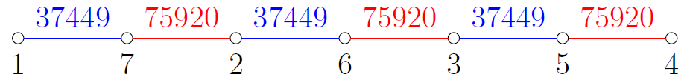
Figure 1. Euler cordial labeling modulo $7$ of $P_{7}$
Figure 2. Euler cordial labeling modulo 5 of $P_{10}$
Theorem 4.2. The star graph $S_{2p-1}$ are Euler cordial graphs modulo $p$.
Proof. Suppose that $V\left(S_{2p-1}\right)=\left\{v_{1},v_{2},…,v_{2p-1}\right\}$ and let $v_{p}$ be the central vertex. Let $f:V\left(S_{2p-1}\right)→\left\{1,2,…,2p-1\right\}$ be a function defined by $f\left(v_{i}\right)=i$ for $i=1,2,…,2p-1$. Hence, $f$ is a bijective function.
For the edges of $S_{2p-1}$, $f\left(v_{i}\right)+f\left(v_{p}\right)=i+p$ for $i=1,2,…,2p-1$, $i≠p$. Suppose that
$$β=\left\{f\left(v_{i}\right)+f\left(v_{p}\right):i=1,2,…,p-1\right\},$$
$$γ=\left\{f\left(v_{i}\right)+f\left(v_{p}\right):i=p+1,p+2,…,2p-1\right\}.$$
As a result,
$$β=\left\{1+p,2+p,…,p-1+p\right\},$$
$$γ=\left\{1+2p,2+2p,…,p-1+2p\right\}$$
Therefore, using Lemma 3.2 (iii), $e_{f_{p}^{*}}\left(0\right)=e_{f_{p}^{*}}\left(1\right)=2\left(\frac{p-1}{2}\right)=p-1$. Thus, $\left|e_{f_{p}^{*}}\left(0\right)-e_{f_{p}^{*}}\left(1\right)\right|=0$. Consequently, $S_{2p-1}$ is an Euler cordial graph modulo $p$. $∎$
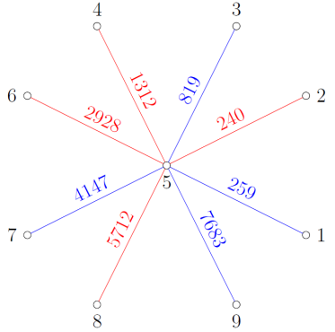
Figure 3. Euler cordial labeling modulo 5 of $S_{9}$
Theorem 4.3. The complete bipartite graph $K_{q\left(p-1\right),q}$ is an Euler cordial graph modulo $p$ for $q≥1$.
Proof. Let $V_{1}$ and $V_{2}$ be partite sets of $K_{q\left(p-1\right),q}$ with $V_{1}=V^{1}∪V^{2}∪⋯∪V^{q}$, where $V^{j}=\left\{v_{1}^{j},v_{2}^{j},…,v_{p-1}^{j}\right\}$ for $j=1,2,…,q$, and $V_{2}=\left\{v_{p}^{1},v_{p}^{2},…,v_{p}^{q}\right\}$. Assume that $f:V\left(K_{q\left(p-1\right),q}\right)→\left\{1,2,…,qp\right\}$ is a function defined by $f\left(v_{i}^{j}\right)=i+p\left(j-1\right)$ for $i=1,2,…,p$ and $j=1,2,…,q$. Clearly, $f$ is a bijective function.
Note that all vertices in $V^{j}$ are adjacent to $v_{p}^{k}$ for $j,k=1,2,…,q$. Hence,
$$f\left(v_{i}^{j}\right)+f\left(v_{p}^{k}\right)=i+p\left(j-1\right)+p+p\left(k-1\right)=i+p\left(j+k-1\right)$$
for $j,k=1,2,…,q$. In view of this labeling, define
$$α_{j,k}=\left\{f\left(v_{i}^{j}\right)+f\left(v_{p}^{k}\right):i=1,2,…,p-1\right\}$$
and so
$$α_{j,k}=\left\{1+p\left(j+k-1\right),2+p\left(j+k-1\right),…,p-1+p\left(j+k-1\right)\right\}$$
for $j,k=1,2,…,q$. By Lemma 3.2 (iii), $e_{f_{p}^{*}}\left(0\right)=e_{f_{p}^{*}}\left(1\right)=q\left(\frac{p-1}{2}\right)$. Hence, $\left|e_{f_{p}^{*}}\left(0\right)-e_{f_{p}^{*}}\left(1\right)\right|=0$ and it follows that $K_{q\left(p-1\right),q}$ is an Euler cordial graph modulo $p$. $∎$
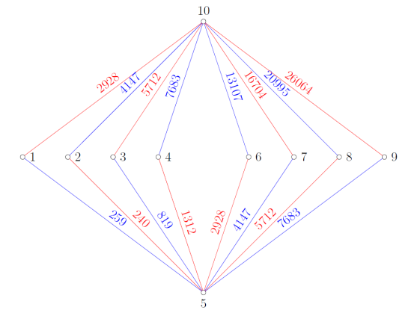
Figure 4. Euler cordial labeling modulo 5 of $K_{8,2}$
Theorem 4.4. The bistar graph $B_{p,p}$ is an Euler cordial graph modulo $p$.
Proof. Suppose that $S_{p}^{1}$ and $S_{p}^{2}$ are star graphs of $B_{p,p}$ with $V\left(S_{p}^{j}\right)=\left\{v_{1}^{j},v_{2}^{j},…,v_{p}^{j}\right\}$ where $v_{p}^{j}$ is the central vertex, for $j=1,2$. Define the function $f:V\left(B_{p,p}\right)$ by $f\left(v_{i}^{j}\right)=i+p\left(j-1\right)$ for $i=1,2,…,p$ and $j=1,2$. Hence, $f$ is a bijective function.
For the edges of $B_{p,p}$,
$f\left(v_{i}^{j}\right)+f\left(v_{p}^{j}\right)=i+p\left(2j-1\right)$ for $i=1,2,…,p-1$,
for $j=1,2$, and $f\left(v_{p}^{1}\right)+f\left(v_{p}^{2}\right)=3p$. Suppose that
$$α_{j}=\left\{f\left(v_{i}^{j}\right)+f\left(v_{p}^{j}\right):i=1,2,…,p-1\right\}$$
for $j=1,2$. Thus,
$$α_{j}=\left\{1+p\left(2j-1\right),2+p\left(2j-1\right),…,p-1+p\left(2j-1\right)\right\}$$
for $j=1,2$. By Lemma 3.2 (iii), together with the fact that $f_{p}^{*}\left(v_{p}^{1}v_{p}^{2}\right)=0$ (since $\gcd\left(3p,p\right)≠1$), we obtain $e_{f_{p}^{*}}\left(0\right)=2\left(\frac{p-1}{2}\right)+1=p$ and $e_{f_{p}^{*}}\left(1\right)=2\left(\frac{p-1}{2}\right)=p-1$. Hence, $\left|e_{f_{p}^{*}}\left(0\right)-e_{f_{p}^{*}}\left(1\right)\right|=1$ and so $B_{p,p}$ is an Euler cordial graph modulo $p$. $∎$
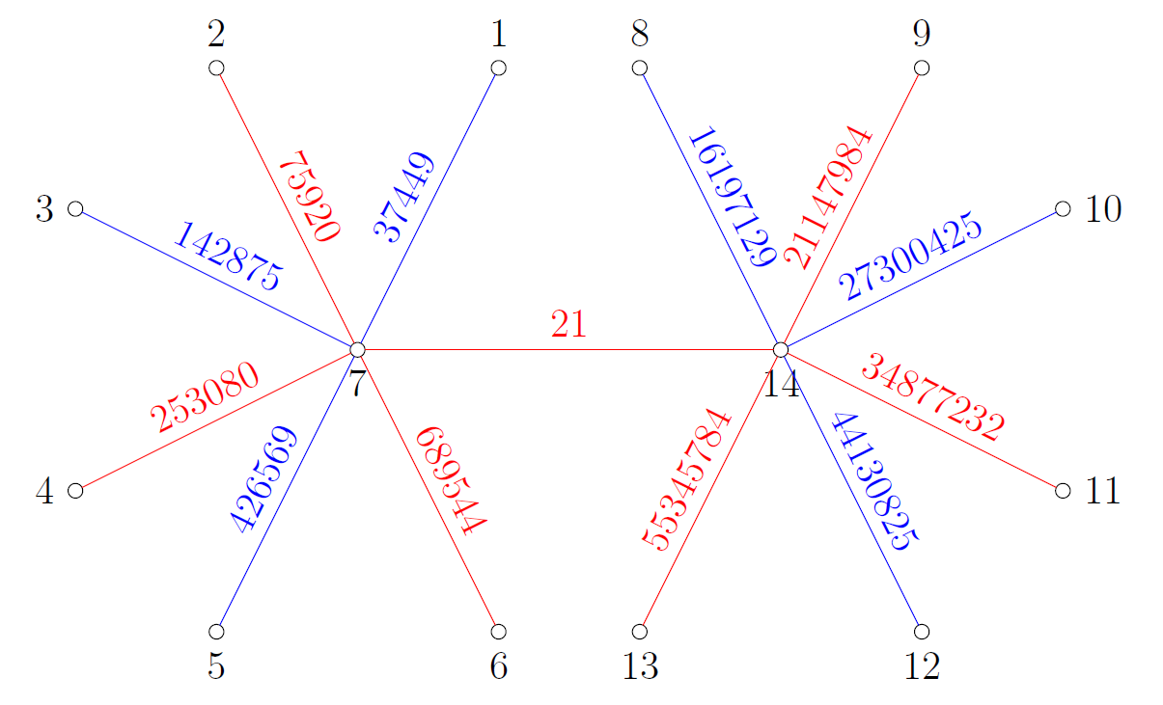
Figure 5. Euler cordial labeling modulo $7$ of $B_{7,7}$
Theorem 4.5. The alternate cycle snake graph $A_{m}\left(C_{η}\right)$ is an Euler cordial graph modulo $η$ if $\gcd\left(\frac{η+3}{2},η\right)=1$, for $m≥2$.
Proof. Suppose that $C_{η}^{1},C_{η}^{2},…,C_{η}^{m}$ are cycles of $A_{m}\left(C_{η}\right)$ with $V\left(C_{η}^{j}\right)=\left\{v_{1}^{j},v_{2}^{j},…,v_{η}^{j}\right\}$ for $j=1,2,…,m$. Assume that $f:V\left(A_{m}\left(C_η\right)\right)→\left\{1,2,…,mη\right\}$ is a function defined by
$$f\left(v_{i}^{j}\right)=\left\{\begin{aligned}\frac{i+1}{2}+η\left(j-1\right) for i=1,3,…,η \\ η-\frac{i-2}{2}+η\left(j-1\right) for i=2,4,…,η-1\end{aligned}\right.$$
For $j=1,2,…,m$. Clearly, $f$ is a bijective function.
For the edges of $A_{m}\left(C_{η}\right)$,
$$f\left(v_{i}^{j}\right)+f\left(v_{i+1}^{j}\right)=\left\{\begin{aligned}η+1+2η\left(j-1\right) for i=1,3,…,η-2 \\ η+2+2η\left(j-1\right) for i=2,4,…,η-1,\end{aligned}\right.$$
$$f\left(v_{1}^{j}\right)+f\left(v_{η}^{j}\right)=\frac{η+3}{2}+2ηj-2η,$$
for $j=1,2,…,m$, and
$$f\left(v_{1}^{j}\right)+f\left(v_{η}^{j+1}\right)=\frac{η+3}{2}+2ηj-η$$
for $j=1,2,…,m-1$.
According to Lemma (ii), $ζ\left(\frac{η+3}{2}+2ηj-2η,η\right)$ and $ζ\left(\frac{η+3}{2}+2ηj-η,η\right)$ have opposite parities, for $j=1,2,…,m-1$. Also, by Lemma (iv), $ζ\left(η+1+2η\left(j-1\right),η\right)$ and $ζ\left(η+2+2η\left(j-1\right),η\right)$ have opposite parities, for $j=1,2,…,m$. Therefore,
$$e_{f_{η}^{*}}\left(0\right)=\left\{\begin{aligned}m\left(\frac{η-1}{2}\right)+m if f_{η}^{*}\left(v_{1}^{m}v_{η}^{m}\right)=0 \\ m\left(\frac{η-1}{2}\right)+m-1 if f_{η}^{*}\left(v_{1}^{m}v_{η}^{m}\right)=1,\end{aligned}\right.$$
$$e_{f_{η}^{*}}\left(1\right)=\left\{\begin{aligned}m\left(\frac{η-1}{2}\right)+m-1 if f_{η}^{*}\left(v_{1}^{m}v_{η}^{m}\right)=0 \\ m\left(\frac{η-1}{2}\right)+m if f_{η}^{*}\left(v_{1}^{m}v_{η}^{m}\right)=1.\end{aligned}\right.$$
It follows that $\left|e_{f_{η}^{*}}\left(0\right)-e_{f_{η}^{*}}\left(1\right)\right|=1$. Consequently, $A_{m}\left(C_{η}\right)$ is an Euler cordial graph modulo $η$.
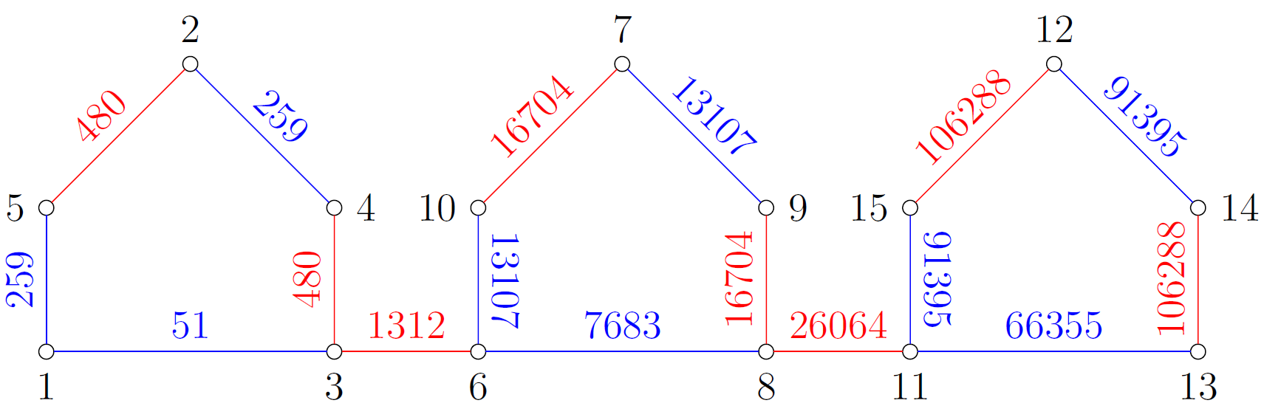
Figure 6. Euler cordial labeling modulo $5$ of $A_{3}\left(C_{5}\right)$
Theorem 4.6. The $m$-tuple star graph $S_{m,p}$ is an Euler cordial graph modulo $p$ for $m≥2$.
Proof. Let $S_{p}^{1},S_{p}^{2},…,S_{p}^{m}$ be star graphs of $S_{m,p}$ with $V\left(S_{p}^{j}\right)=\left\{v_{1}^{j},v_{2}^{j},…,v_{p}^{j}\right\}$ where $v_{p}^{j}$ is the central vertex, for $j=1,2,…,m$. Suppose that $x_{0}$ is a vertex of $S_{m,p}$ such that $v_{p}^{j}x_{0}∈E\left(S_{m,p}\right)$ for $j=1,2,…,m$. Let $f:V\left(S_{m,p}\right)→\left\{1,2,…,mp+1\right\}$ be a function defined by
$f\left(v_{i}^{j}\right)=i+p\left(j-1\right)$ for $i=1,2,…,p$ and $j=1,2,…,m$,
$$f\left(x_{0}\right)=mp+1.$$
Evidently, $f$ is a bijective function.
For the edges of $S_{p}^{j}$,
$f\left(v_{i}^{j}\right)+f\left(v_{p}^{j}\right)=i+p\left(2j-1\right)$ for $i=1,2,…,p-1$,
for $j=1,2,…,m$. Define the set
$$α_{j}=\left\{f\left(v_{i}^{j}\right)+f\left(v_{p}^{j}\right):i=1,2,…,p-1\right\}$$
and so
$$α_{j}=\left\{1+p\left(2j-1\right),2+p\left(2j-1\right),…,p-1+p\left(2j-1\right)\right\}$$
for $j=1,2,…,m$. By Lemma 3.2 (iii), for each $j=1,2,…,m$, there are $\frac{p-1}{2}$ edges of $S_{p}^{j}$ with label $0$ and $\frac{p-1}{2}$ edges with label $1$, under $f_{p}^{*}$.
For the remaining edges,
$$f\left(v_{p}^{j}\right)+f\left(x_{0}\right)=1+p\left(j+m\right)$$
for $j=1,2,…,m$. By Lemma 3.2 (ii), $ζ\left(1+p\left(k+m\right),p\right)$ and $ζ\left(1+p\left(k+1+m\right),p\right)$ have opposite parities, for $k=1,3,…,m-ε$, where
$$ε=\left\{\begin{aligned}1 if m≡0\left(mod 2\right) \\ 2 if m≡1\left(mod 2\right).\end{aligned}\right.$$
Combining all the arguments above, if $m≡0\left(mod 2\right)$,
$$e_{f_{p}^{*}}\left(0\right)=e_{f_{p}^{*}}\left(1\right)=m\left(\frac{p-1}{2}\right)+\frac{m}{2}.$$
Also, if $m≡1\left(mod 2\right)$,
$$e_{f_{p}^{*}}\left(0\right)=\left\{\begin{aligned}m\left(\frac{p-1}{2}\right)+\frac{m-1}{2}+1 if f_{p}^{*}\left(v_{p}^{m}x_{0}\right)=0 \\ m\left(\frac{p-1}{2}\right)+\frac{m-1}{2} if f_{p}^{*}\left(v_{p}^{m}x_{0}\right)=1,\end{aligned}\right.$$
$$e_{f_{p}^{*}}\left(1\right)=\left\{\begin{aligned}m\left(\frac{p-1}{2}\right)+\frac{m-1}{2} if f_{p}^{*}\left(v_{p}^{m}x_{0}\right)=0 \\ m\left(\frac{p-1}{2}\right)+\frac{m-1}{2}+1 if f_{p}^{*}\left(v_{p}^{m}x_{0}\right)=1.\end{aligned}\right.$$
In either case, $\left|e_{f_{p}^{*}}\left(0\right)-e_{f_{p}^{*}}\left(1\right)\right|≤1$. Therefore, $S_{m,p}$ is an Euler cordial graph modulo $p$. $∎$
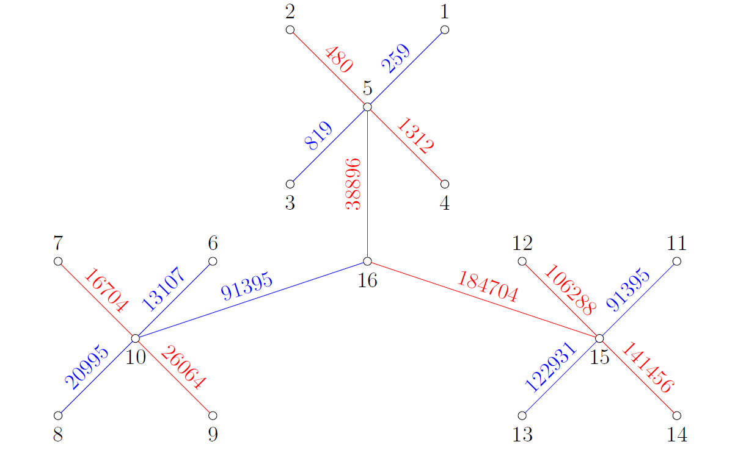
Figure 7. Euler cordial labeling modulo $5$ of $S_{3,5}$
Theorem 4.7. The book graph $B_{η,2q}$ is an Euler cordial graph modulo $η$ if $\gcd\left(\frac{η+5}{2},η\right)=1$, for $q≥1$.
Proof. Let $P_{η}^{1},P_{η}^{2},…,P_{η}^{2q}$ be path graphs of $B_{η,2q}$ with $V\left(P_{η}^{j}\right)=\left\{v_{1}^{j},v_{2}^{j},…,v_{η}^{j}\right\}$ for $j=1,2,…,2q$. Suppose that $P_{2}$ is a path graph of $B_{η,2q}$ with $V\left(P_{2}\right)=\left\{u_{1},u_{2}\right\}$. Define the function $f:V\left(B_{η,2q}\right)→\left\{1,2,…,2qη+2\right\}$ by
$$f\left(v_{i}^{j}\right)=\left\{\begin{aligned}\frac{i+1}{2}+η\left(j-1\right) for i=1,3,…,η \\ η-\frac{i-2}{2}+η\left(j-1\right) for i=2,4,…,η-1\end{aligned}\right. for j=1,2,…,2q,$$
$$f\left(u_{i}\right)=2qη+i for i=1,2.$$
Obviously, $f$ is a bijective function.
For the edges of $B_{η,2q}$,
$$f\left(v_{i}^{j}\right)+f\left(v_{i+1}^{j}\right)=\left\{\begin{aligned}η+1+2η\left(j-1\right) for i=1,3,…,η-2 \\ η+2+2η\left(j-1\right) for i=2,4,…,η-1,\end{aligned}\right.$$
$$f\left(v_{1}^{j}\right)+f\left(u_{1}\right)=2+η[2q+j-1],$$
$$f\left(v_{η}^{j}\right)+f\left(u_{2}\right)=\frac{η+5}{2}+η\left[2q+j-1\right],$$
for $j=1,2,…,2q$, and $f\left(u_{1}\right)+f\left(u_{2}\right)=4qη+3$.
Using Lemma 3.2 (ii), $ζ\left(2+η\left[2q+k-1\right],η\right)$ and $ζ\left(2+η\left[2q+k\right],η\right)$ have opposite parities, for $k=1,3,…,2q-1$. Similarly, for each $k=1,3,…,2q-1$, $ζ\left(\frac{η+5}{2}+η\left[2q+k-1\right],η\right)$ and $ζ\left(\frac{η+5}{2}+η\left[2q+k\right],η\right)$ have opposite parities by Lemma 3.2 (ii). Also, $ζ\left(η+1+2η\left(j-1\right),η\right)$ and $ζ\left(η+2+2η\left(j-1\right),η\right)$ have opposite parities, for $j=1,2,…,2q$, in accordance with Lemma 3.2 (iv). Thus,
$$e_{f_{η}^{*}}\left(0\right)=\left\{\begin{aligned}2q+q\left(η-1\right)+1 if f_{η}^{*}\left(u_{1}u_{2}\right)=0 \\ 2q+q\left(η-1\right) if f_{η}^{*}\left(u_{1}u_{2}\right)=1,\end{aligned}\right.$$
$$e_{f_{η}^{*}}\left(1\right)=\left\{\begin{aligned}2q+q\left(η-1\right) if f_{η}^{*}\left(u_{1}u_{2}\right)=0 \\ 2q+q\left(η-1\right)+1 if f_{η}^{*}\left(u_{1}u_{2}\right)=1.\end{aligned}\right.$$
Hence, $\left|e_{f_{η}^{*}}\left(0\right)-e_{f_{η}^{*}}\left(1\right)\right|=1$. Therefore, $B_{η,2q}$ is an Euler cordial graph modulo $η$.
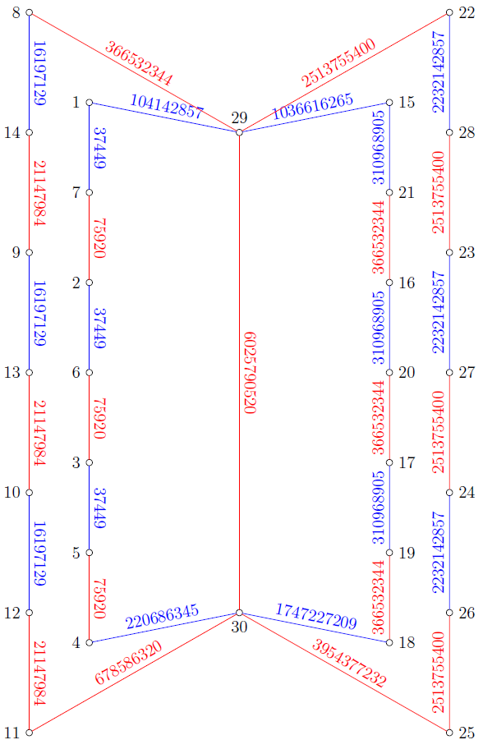
Figure 8. Euler cordial labeling modulo $7$ of $B_{7,4}$

5. Conclusion

This paper introduced the concept of Euler cordial labeling. Using this notion, several classes of graphs were shown to admit this labeling modulo an odd integer. In particular, the path graphs $P_{η}$ and $P_{2η}$, the alternate cycle snake graph $A_{m}\left(C_{η}\right)$ (if $\gcd\left(\left(η+3\right)/2,η\right)=1$), and the book graph $P_{η,2q}$ (if $\gcd\left(\left(η+5\right)/2,η\right)=1$) were determined to be Euler cordial graphs modulo $η$, where $η$ is an odd integer with $η≥3$. Additionally, the star graphs $S_{p}$ and $S_{2p-1}$, the complete bipartite graph $K_{q\left(p-1\right),q}$, the bistar graph $B_{p,p}$, and the $m$-tuple star graph $S_{m,p}$ admit Euler cordial labeling modulo $p$, where $p$ is an odd prime.
The results obtained indicate that Euler cordial labeling exhibits strong dependence on the relationship between graph structure and modular arithmetic properties. The conditions involving greatest common divisors suggest that certain symmetries and divisibility relations play a significant role in determining the existence of Euler cordial labeling. However, the complete characterization of graphs that admit Euler cordial labeling remains an open problem, as does identifying the necessary and sufficient conditions for general classes of graphs.
Future researchers are encouraged to investigate other classes of graphs under Euler cordial labeling to further explore its applicability and structural characteristics. They may also develop new types of cordial labeling inspired by well-known modular arithmetic results such as Freshman’s Dream Theorem, Chinese Remainder Theorem, and Wilson’s Theorem. These could lead to new variants of cordial labeling that apply modular congruence relations in distinct ways, opening new avenues for exploring the intersection of number theory and graph labeling.
DISCLAIMER (Artificial intelligence)

Author(s) hereby declare that NO generative AI technologies such as Large Language Models (ChatGPT, COPILOT, etc.) and text-to-image generators have been used during the writing or editing of this manuscript.

References

Cahit, I. (1987). Cordial graphs: a weaker version of graceful and harmonious graphs. Ars Combinatoria, 23, 201-207.
https://www.researchgate.net/publication/233792958_Cordial_Graphs_A_Weaker_Version_of_Graceful_and_Harmonious_Graphs

Nicholas, T., & Maya, P. (2016). Some results on integer cordial graph. Journal of Progressive research in Mathematics (JPRM), 8(1), 1183-1194.
https://scitecresearch.com/journals/index.php/jprm/article/view/786

Sharma, V., & Parthiban, A. (2022). On Divisor Cordial Labeling of Certain Classes of Planar Graphs. Journal of Algebraic Statistics, 13(2), 1421-1425.
https://publishoa.com/index.php/journal/article/view/304

Gudin, M.V., & Pedrano, A. (2025). Tribonacci Cordial Labeling of Some Snake Graphs. Annals of Communication in Mathematics. 8(3), 393-405.
https://www.technoskypub.com/journals/acm-2025-080306/

Andoyo, J.D., & Rulete, R.F. (2025). On Legendre cordial labeling of some graphs. European Journal of Mathematics and Statistics, 6(5), 1-7.
https://www.ej-math.org/index.php/ejmath/article/view/409

Rosen K.H. (2013). Elementary Number Theory and its applications (6th ed.). Pearson.
https://www.pearson.com/en-gb/subject-catalog/p/elementary-number-theory-pearson-new-international-edition/P200000005328/9781292055145

