DETERMINATION OF PATHLOSS EXPONENT 4G LTE SIGNAL IN URBAN AND RURAL ENVIRONMENT OF SOUTHERN NIGERIA (ASABA IN DELTA STATE AND ONITSHA IN ANAMBRA STATE)

ABSTRACT
We investigated the radio frequency channel behavior based on extensive measurements of signal strength and other propagation parameters up to 1200 m from the base stations, adopting single sector verification technique in wet and dry season in urban and rural environments of Delta and Anambra States in Nigeria. The measurements were carried out at 800 MHz bands using Sony Ericson Test Mobile System (TEMS) phones and global positioning system connected to a laptop equipped with TEMS software and cell refs of the base stations in the studied areas. The estimated pathloss values were compared with four commonly used propagation models namely: Erceg, Cost-231, Ericson, and Standard University Interim (SUI). SUI model presented a better agreement with the measured pathloss based on root mean square error (RMSE) metrics analysis in all the considered environments in both seasons. Modification of the SUI model was carried out by including the pathloss exponent which performed better in predicting the pathloss compared with commonly used SUI propagation models. Climatological parameters such as pressure, temperature and relative humidity at ground surface over all the monitored environments were obtained between 2022 and 2023. These data were used to compute the refractivity gradient, effective earth radius (k-factor), and geoclimatic factor for the studied area. Results show that using the standard value of 1.33 for k-factor in the investigated environments, the required height of antenna for line-of-sight communication link setup may not be achieved. This may result in overestimation or underestimation of the required link budget needed for urban and rural environments in southern Nigeria environment.
Keyword: pathloss: Test Mobile System; k-factor; geoclimatic factor
- Introduction
The rapidly growing wireless network channels, especially the Global System of Mobile communication (GSM) at 1800 MHz and 3500 MHz frequency bands 4G data service, has made it possible for rural, suburban and urban dwellers to access many wireless services e.g. mobile cell phones services, internet services etc. [1]. However, this developmental growth came with several inherent challenges, among which are poor signal reception in different climatic conditions, network congestion and power and signal outages. GSM network operators in Nigeria have been trying, over the years, to proffer solutions to these inherent problems. Some of these challenges are peculiar to specific environment and region in a particular climatic condition, where as, some others are general to all the environments and regions in all climatic conditions. For instance, the vegetation cover in the environment where these wireless networks are deployed could pose specific challenge to the signal propagation. Therefore, solutions peculiar to the environment need to be sought for each particular climatic environment [1].
Nigeria has a varied vegetation ranging from thick vegetation in the southern parts to the semi-desert regions in the north and extreme northern parts. The southern part of Nigeria experiences wet season every year between April and October (four to seven months) and dry season between November and March (five months). These variations in season impose obvious changes in the environment. The increase in moisture content during the period of wet season gives rise to increased ground conductivity and foliage. GSM signal strength is likely to be affected by this condition among other factors. Therefore, for more proper planning and precise design coverage link of any wireless channels, strength of signals should be properly taken into account and the effects of ground conductivity and increase foliage on cellular network received signal strength (RSS) has to be established, particularly in the region where such networks are being deployed [1].
In this study, two different environments in Delta and Anambra States in the southern region of Nigeria were selected. The effects of seasonal variation on the RSS of GSM 4G propagating signal were investigated using extensive drive test measurement values from the studied environments in the two basic seasons (rainy and dry seasons).
Our aim is to analyze the measured RSS in order to deduce seasonal propagation parameter such as good pathloss exponent in order to improved propagation models for LTE pathloss prediction in selected urban and rural environments of southern Nigeria. The specific objectives of this study are to: assess outdoor drive tests measurements in wet and dry seasons for three radial routes in urban and rural environments of some selected environments in Delta and Anambra States, estimate pathloss values from the measured RSS, estimate propagation parameters for each environment considered and compare the measured pathloss values with existing pathloss models and modify the most suited model with the measured value.
The description of the study areas is as follows
- Asaba in the Oshimili South Local Government Area, of Delta State, Nigeria. It is located at the western bank of the Niger River. the Oshimili South Local Government Area had a population of 150,032 as at the 2006 census [2]. Asaba lies $\sim 6° N$ north of the equator and $\sim 6° E$ of the meridian.
- Onitsha is located on latitude $6.1°N$ and longitude $6.8°E$ in the Anambra North Senatorial Zone of Anambra State. Onitsha had an estimated city proper population of about 250,000 [2]. As of early 2022, Onitsha has a rising estimated population at 3,553,000 [3].
- Methodology
GSM radio measurements at L-band frequencies employing the MTN 4G LTE cellular network in urban and rural environments of Delta and Anambra states of Nigeria and rainy and dry season were investigated. The various steps taken in the course of this research are as follow:
- Categorization of the investigated environments into urban, suburban and rural scenario.
- Signal strength measurements at various periods of wet and dry season.
- Evaluation, analysis and comparison of data using the plots for wet and dry season period.
- Investigation of suitable empirical model for the environments by comparing the various empirical models.
- Adjustment of the suitable empirical model with the measured data to include extra losses due to seasonal variations in the studied environments.
- Determination of effective earth radius factor ($k$ factor) and geoclimatic factor ($G$).
For the purpose of this study, a total of eight base stations were monitored: four base stations for analysis and the other four base stations for validation. The urban environments are typified with blocks of densely constructed buildings, building height between 3-17 meters, market places, hills, mountains and scanty trees of average height. Typically, more than 70% of the environment is occupied by structures constructed with concrete, blocks and tiles. The rural terrain is irregular, these sites reflect a typical rural environment consisting of sparsely constructed buildings, thick vegetation of tall trees and open areas. They are also characterized by some sequence of houses built with muds and planks with less than 45% of houses made of concrete. Some of the terrains are flat, it was observed that some of the bushes were burnt during the dry season.
Table 1. Details of the Base Stations and Characteristics of Each of the Sites Obtain from MTN Base Station
Parameters |  | Values
Frequency |  | 800 MHz
Transmitter power |  | 46 dBm
Transmitter antenna type and height | Anwia | Sectorial and 34 m
Transmitter antenna type and height | Asaba | Sectorial and 36 m
Transmitter antenna type and height | Nkwelle | Sectorial and 34 m
Transmitter antenna type and height | Onitsha | Sectorial and 36 m
Shadowing factor | Urban/Rural | 10.6/8.2 dB
Distance | Between 50 to 1200 m
Receiver’s height | - m
Measurement instrumentation include –
- Laptop furnished with Sony Eriksson TEMS 11.0 drive test software which provides a test platform for the radio-air-interface with USB port/serial port through which connections of scanners and Global Positioning Satellite (GPS) terminals are made.
- TEMS handset with data cable to stimulate communication of terminal users so that the probe can record test data.
- GPS- For acquiring the position and elevation of the points during a test.
- The network provider cell refs which contains all the base stations in the states considered.
A site verification exercise was done using testing tools. The measurement tools include; Sony Eriksson test phone handset in the Net monitor mode, which is a specialized equipment used by many network providers in Nigeria for monitoring wireless signals. It is also able to measure RSS in decibel milliwatts (dBm), has a sensitivity of -110 dBm, a digital GPS (MAP766CSX) and a laptop. The base station (BTS) antenna is a tri-sector vertical dipole directional antenna mounted at some heights above the ground and transmitting at frequencies of 800 MHz, the transmitted power is +46 dBm.
The first measurements of RSS level during the wet season were taken between the months of May and June, 2022. This period indicates the early stages of rainy season and the second measurement campaign in wet season was carried out between the months of July and September, 2022, indicating the peak of the rainy season. These periods were chosen for the wet season measurements because it was observed as the period when foliage cover, humidity and the earth’s moisture content would be at the peak. The first phase of dry season measurements was carried out between the months of December and January, 2023, indicating the peak stages of air dryness. This was to give considerable time for the earth’s moisture content and the foliage cover to reduce significantly. The second measurement campaign was carried out from February to March, 2023, indicating the late stages of the dry season months.
2.1 Data Collection and Processing
Intensive drive test was carried out along all identified paths in all the proposed environments. The drive test process was conducted by initiating calls at the beginning of each experiment using a data gathering investigation device TEMS at a height of 1.5 m. The reports acquisition of radio signal level and several other GSM signal parameters were acquired using a highly sensitive Sony Ericsson signal measurement phone linked to a laptop with an installed TEMS software and uploaded cell refs of the network provider. The positioning information, elevation and distances between the transmitter and the receiver were gathered through the GPS antenna that communicates directly with GPS satellite. The measuring system takes up to 100 points in one minute. To avoid measuring signal strength from other sectors and base stations from interfering with our measurement, a Single Sector Verification was adopted in this work.
The measured RSS values for each microcell was recorded in log files. These log files were transferred for more extraction process of the required data to a processing/analytical software known as ACTIX. ACTIX is a drive test software used for further processing of drive test results. It supports troubleshooting and optimization of GSM networks. This tool can automatically troubleshoot for problems in GSM and WCDMA RF systems. This tool was applied to convert the acquired log files into excel worksheet format for further analysis.
2.2 Pathloss Calculation
The pathloss, $P_{L},$ (dB) was estimated from the measured RSS values by the expression [4,5]:
$P_{L}=EIRP-{RSS}_{m}$ (1)
where $EIRP$is the total power density from the transmitter and it is expressed as [5]:
$EIRP=P_{T}+G_{T}+G_{R}-L_{T}-L_{R}$ (2)
Using equation (2) in equation (1) gives the expression for the propagation pathloss in decibel [6]:
$P_{L}=P_{T}+G_{T}+G_{R}-L_{T}-L_{R}-{RSS}_{m}$ (3)
where $P_{T}$ is base station transmitted power; $G_{R}$and $G_{T}$ are gain of mobile receiver and base station transmitter respectively; $L_{R}$ and $L_{T}$ are mobile receiver and transmitter cable loses in dB and ${RSS}_{m}$ is the mean received signal strength. The pathloss exponent which shows the lossy nature of a particular propagation environment was computed from the measurement data for each of the areas considered. [7] presents an approach to finding the pathloss exponent as
$n_{i}=\frac{\sum_{i=1}^{m}{\left\{P_{L}\left(d_{i}\right)- P_{L}\left(d_{0}\right)\right\}}}{\sum_{i=1}^{m}{10\log\left(\frac{d_{i}}{d_{0}}\right)}}$ (4)
Where $d_{0}$is the close-in reference distance of the antenna from the transmitting base station, $d_{i}$is the distance from the reference point and $n$ represents the value of the pathloss exponent.
2.3 Estimation of Effective Earth Radius ($k$) and Geoclimatic Factor ($G$)
“Due to the great demand and the wide applications of wireless network communications. It is imperative to consider closely those properties that contribute to loss of signal, as compared to signal propagating when the air condition is clear. Several atmospheric factors contribute to signal losses on the propagation link” [8, 9]. “In the loss-of-signal link of terrestrial propagation, multipath fading is one of the most regular fading phenomena in tropospheric propagation” [10]. “The most important factors used in the determination of multipath fade depth in radio communication link are geoclimatic factor, radio refractivity, refractivity gradient and effective radius factor. All these factors can be calculated, primarily, from the meteorological parameters measured at lower atmosphere” [11]. “The meteorological parameters used are mostly pressure, temperature, vapour pressure and relative humidity. These parameters affect the transmission of signals of microwave at reduced atmospheric heights (at lower atmosphere). To deduce the effects of atmospheric parameters, the radio refractive index is used as defined in equation (5), it is related to the radio refractivity (N) and hence, radio refractivity gradient (dN₁), $k$ as well as $G$ which are used in estimating fade depth in radio communication link” [11]. $k$ and $G$ were obtained using data obtained from the Nigeria Meteorology (NIMET) Agency in urban and rural environments of the investigated environment. The data contains temperature ($T$), atmospheric pressure ($P$) and relative humidity ($H$) monthly data obtained at 1000 and 950 hPa with equivalent height based on pressure level of 111 m and 540 m for the two years period of field investigation of this research work. The refractivity is computed in accordance with the [12] model as:
$N=N_{dry}+N_{wet}=\frac{77.6}{T}\left[P+\frac{4810e}{T}\right]$ (5)
$N_{dry}$ is dry season refractivity given as: $N_{dry}=\frac{77.6P}{T}$ [12] , and the wet season refractivity is $N_{wet}={3.725×10}^{5}\left(\frac{e}{T^{2}}\right)$, is expressed as [12],$P$ is in hectopascal (hPa), the water vapour pressure is denoted by $e$ in (hPa), $T$ is in Kelvin (K). The relative humidity and water vapour pressure are connected by the expression according to [13] as: $e=\frac{He_{s}}{100};$with $e_{s}$ given as in [12] model: $e_{s}=a\exp\left(\frac{bt}{t+c}\right), H$ is in (%), $t$ represents the temperature in Celsius (°C), the coefficients $a, b$ and $c$ have values as in [12];$a = 6.1121, b = 17.502 and c = 240.97.$
The refractivity gradient is calculated as a function of altitude according to the recommended model [12]:
$\frac{dN}{dh}= \frac{N_{2}-N_{1}}{h_{2}-h_{1}}$ (6)
where $N_{2}$ and $N_{1}$ represent the refractivity at height $h_{2}$ and $h_{1}$ respectively. The refractivity gradient in the troposphere around the lower 111 m is an essential parameter to deduce propagation effects like ducting, sub refraction, super refraction, surface refraction, effective earth radius factor and multipath fading on any communication loss-of-signal link.
In most literatures, the refractivity gradient is estimated at 65 m above the ground level [12, 14]. In this research work, the refractivity gradient is estimated using the expression [15, 14]:
$dN1=\frac{dN}{dh}=\frac{N_{s}-N_{1}}{h_{s}-h_{1}}$ (7)
$N_{s}$ is the surface refractivity at 111 m, $N_{1}$ is the upper atmospheric refractivity at 540 m. The $k$ factor is also obtained from the refractivity gradient as [11]:
$k={\left[1+\frac{1}{157}\frac{dN}{dh}\right]}^{-1}$ (8)
The $G$ factor is obtained according to the recommended [16] procedure which is given as [11] as
$G={10}^{(-4.2-0,0029dN1)}$ (9)
where $dN1$ is the refractivity gradient.
2.4 Performance Evaluation of Pathloss Model
The performance of the various pathloss models is evaluated by error analysis. The two major error metrics used in this research to select the best model are; Mean Error (ME) and Root Mean Square Error (RMSE). The lower the RMSE and mean error, the better the performance of the pathloss propagation mode. A RMSE value between 6 to 10 dB indicates a better fit [17]. The ME, which describes the difference between the observed pathloss ${PL}_{i}$ at $T_{x}-R_{x}$ (distance away from base station) separation of i and the empirical model estimated value of pathloss denoted by ${PR}_{i}$ is expressed as:
$ME=\frac{1}{n}\sum_{i=1}^{n}{({PL}_{i}-{PR}_{i})}$ (10)
The root mean square error is expressed as:
$RMSE=\sqrt{\frac{1}{n}\sum_{i=1}^{n}{({{PL}_{i}-{PR}_{i})}^{2}}}$ (11)
- Result and Discussion
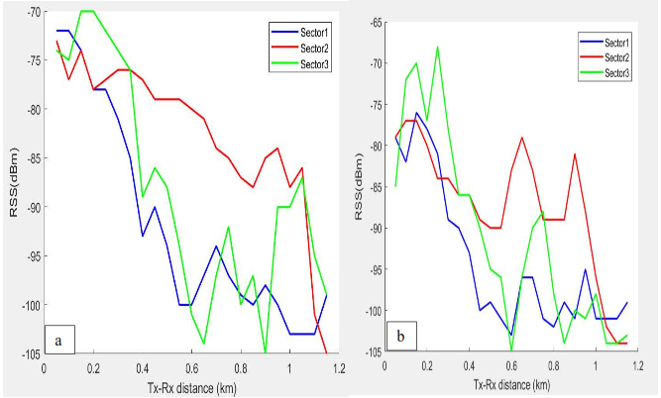
3.1 Sectorial Received Signal Strength Variation with Distance
Figure 1. RSS seasonal variations with propagation distance for rural environment of Delta State (a) rainy (b) dry

The RSS variations with propagation distance for all the three sectors for some base stations considered in rural environments (Awai) in rainy and dry season of Delta States investigated are depicted in figures 1a and 1b. Sector 2 presented a lower decrease in RSS when compared to
Sectors 1 and 2 both in rainy and dry seasons. Closer to the base station, up to 0.4 km, sector 3 exhibited lower RSS when compared to the other sectors in both seasons. Figures 2a and 2b
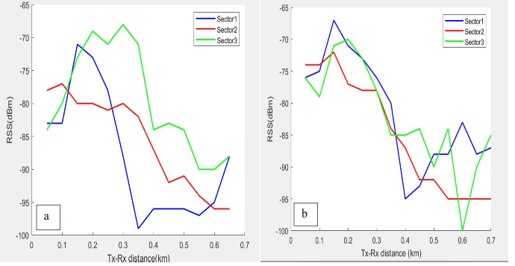
Figure 2. RSS seasonal variations with propagation distance for urban environment of Delta State (a) rainy (b) dry
presented the RSS variations with distance for Asaba urban environment of Delta State both in rainy and dry season. Sectors 1and 2 exhibited a lower RSS variation in dry season when compared to the variations in rainy season at all propagation distances. Sector 3 presented a lower RSS between 0.2 and 0.5 km when compared to the other sectors in rainy season while sector 2 presented the lowest RSS between 0.15 to 0.38 km in dry season.
The sectoral RSS variations with propagation distance in Nkwelle rural environment of Anambra State both in rainy and dry season are depicted in figures 3a and 3b. In all propagation distances, the RSS variations with distance are lower than the RSS variations in rainy season. Similarly, in Figures 4a and 4b, the RSS variations are depicted for Onitsha urban environment of Anambra State with various attenuation as the signals propagate from transmitter to receiver. In all the sectors investigated, the RSS decreases as distance away from the Base station is increased. Deviations from this trend, however, occurred on a few occasions. Higher RSS at distances near and far away from the transmitter may be as a result of high density of obstructions in the signal path, hilly topography, degradation of electromagnetic wave with distance and the nonexistence of line of sight in the environments.
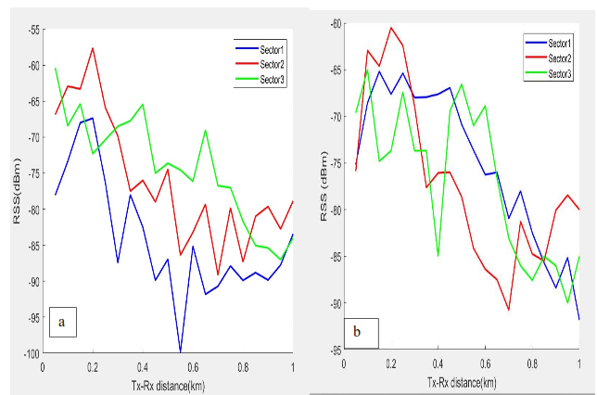
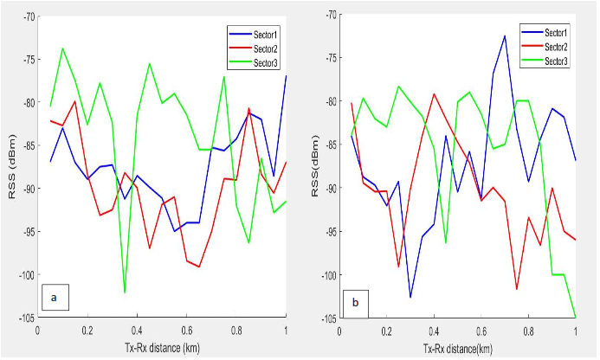
Figure 3. RSS seasonal variations with propagation distance for rural environment of Anambra State (a) rainy (b) dry

Figure 4. RSS seasonal variations with propagation distance for urban environment of Anambra State (a) rainy (b) dry

3.2. Comparative Analysis of Different Pathloss Models with Measured pathloss Values
A comparison of four conventional empirical pathloss models with the measured pathloss values for all the base stations monitored at 800 MHz during the dry and wet seasons in urban and rural environments were carried out in this section. Among numerous propagation models: Cost-231, Ericsson, SUI and Erceg [18] models used in this research, are the most common propagation pathloss models used to predict attenuation between transmitter and receiver over irregular and different terrains by applying desired correction factors [19]. Other propagation models not listed here are far from fitting the measured pathloss values.
Figures 5a and 5b depict the comparison for Anwai base stations representing urban environments at 800 MHz and 34 m antenna height for dry and wet season measurements. At all distances to the transmitter, Ericsson, Erceg and Cost-231 model under predicted the measured pathloss value with about 30 dB for wet and dry season measurement showing a less agreement with the measured pathloss values. SUI model has a better agreement with the measured pathloss values when compared with other pathloss models.
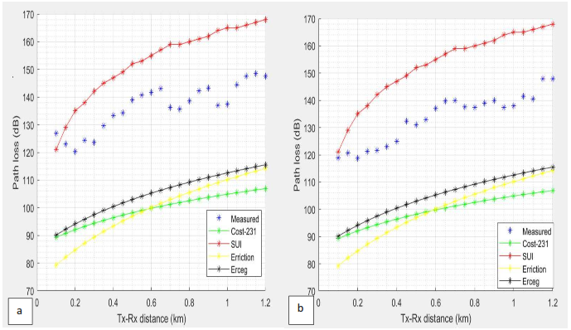
Figure 5. Comparison of various models with seasonal measured values for Anwai base station: (a) rainy (b) dry
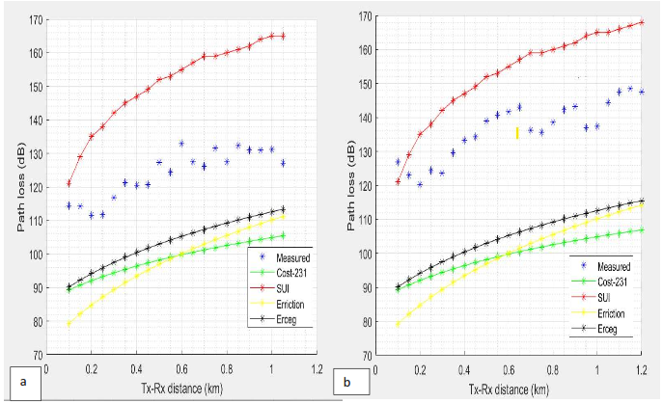
Figure 6. Comparison of various models with seasonal measured values for Asaba base station: (a) rainy (b) dry
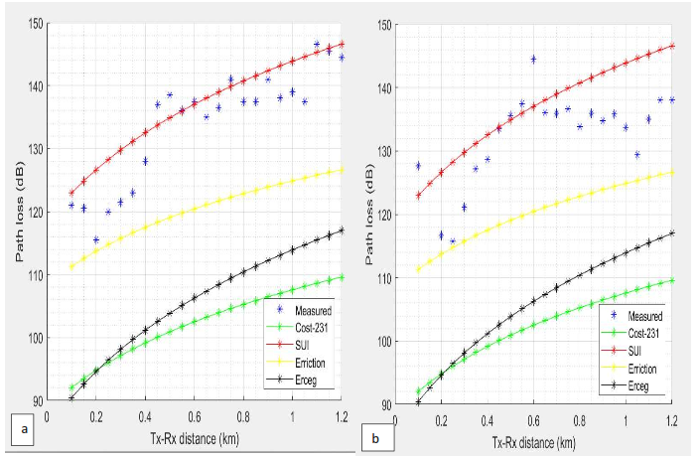
Figures 6a and 6b represent the comparison of Asaba base station, representing urban environments of the investigated states in rainy and dry season. At almost all distances to the transmitter, SUI depicted a closer agreement with the measured pathloss values followed by Ericsson pathloss model. Erceg and Cost-231 under predicted the observed pathloss at all distances to the transmitter.
Figure 7. Comparison of various models with seasonal measured values for Nkwelle base station: (a) rainy (b) dry

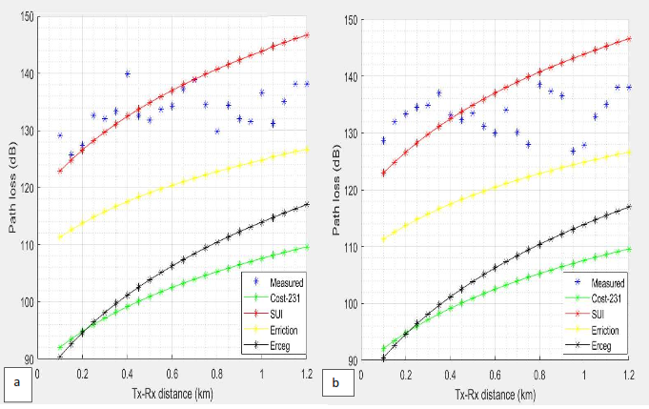
Figures 7a and 7b represent the comparison of Nkwelle base station, representing rural environments of the investigated Anambra State in rainy and dry season. At almost all distances to the transmitter, SUI and Erceg pathloss models depicted a closer prediction of the measured values, while Erricson and Cost-231 under predicted the observed pathloss at all distances to the transmitter.
Figure 8. Comparison of various models with seasonal measured values for Onitsha base station: (a) rainy (b) dry

In Figures 8a and 8b, represents the comparison of Onitsha base station, representing urban environments of the investigated states in rainy and dry season. At distances closer to the transmitter, the SUI model demonstrated a good prediction of the observed pathloss but over predicted at the observed values at 0.8 km onwards in both seasons. Ericsson pathloss model depicted a closer agreement with the measured data at all distances in both season when compared with Erceg and Cost-231 with wider margin of pathloss value. Generally, in all the environments investigated, the SUI prediction model shows a better agreement with the measured pathloss values when compared to the other prediction models. Similar trends were observed by [7] in urban and suburban environments of Ghana.

3.3 Error Analysis of the Prediction Models
Based on the comparisons of figures 5 to 8, the prediction errors of the models from the observed values were deduced. The root mean square error of Cost-231, Ericsson, Erceg, and SUI with respect to the observed values have been deduced as a function of distance for all the base stations considered in urban and rural environments both in wet and dry seasons. The results are shown in Tables 2. Estimated root means square error for each base station data points beginning from 50 m onwards were utilized. As depicted in Table 2 for urban environments, the SUI model predicted the lowest root mean square error in all the base stations considered both in dry and wet season. The SUI model also presents the lowest RMSE values in rural environments investigated. This model is therefore showing a closer agreement with the measured data in Urban and rural areas [7]. The SUI model is further modified and improved for more accurate predictions.
3.4 Pathloss Exponent
The pathloss exponent which shows the lossy nature of a particular propagation environment was computed from the measurement data for each of the areas considered. Table 2 presents the variations of pathloss exponents for the investigated environments in wet and dry seasons. In all investigated environments, the wet season exhibited higher pathloss exponents when compared to the dry season. This shows that pathloss exponent is not only environmental dependent as reported by most literatures [20, 21, 22] but also seasonal dependent. This can be observed in all the environments investigated in the two major seasons considered. Similar results were observed by [19].
Environment | Rainy Season RMSE |  |  |  | Dry Season RMSE
Environment | Cost-231 | SUI | Ericson | Erceg | Cost-231 | SUI | Ericson | Erceg
Asaba | 29.97 | 4.86 | 13.33 | 26.66 | 28.80 | 6.89 | 12.21 | 25.78
Onitsha | 31.40 | 6.33 | 13.73 | 28.18 | 31.29 | 8.06 | 13.84 | 28.23
Anwai | 34.96 | 16.94 | 35.48 | 30.04 | 31.80 | 19.42 | 32.20 | 26.80
Nkwelle | 26.10 | 18.05 | 26.59 | 20.15 | 23.97 | 17.28 | 23.50 | 18.60
Table 2 Root-Mean-Square-Error (RMSE) value for the prediction models

Table 3. Seasonal Variation of Pathloss Exponent
Environment | Season | Pathloss Exponent
Asaba (urban) | Rainy | 2.62 | $${PL}_{SUI}=123+26.6\log\left(\frac{d_{i}}{d_{0}}\right)+RMSE$$
Asaba (urban) | Dry | 2.27 | $${PL}_{SUI}=123+22.7\log\left(\frac{d_{i}}{d_{0}}\right)+RMSE$$
Onitsha (urban) | Rainy | 2.18 | $${PL}_{SUI}=123+21.8\log\left(\frac{d_{i}}{d_{0}}\right)+RMSE$$
Onitsha (urban) | Dry | 2.13 | $${PL}_{SUI}=123+21.3\log\left(\frac{d_{i}}{d_{0}}\right)+RMSE$$
Anwai (rural) | Rainy | 2.52 | $${PL}_{SUI}=121+25.2\log\left(\frac{d_{i}}{d_{0}}\right)+RMSE$$
Anwai (rural) | Dry | 2.26 | ${PL}_{SUI}=121+22.6\log\left(\frac{d_{i}}{d_{0}}\right)+RMSE$
Nkwelle (rural) | Rainy | 1.89 | $${PL}_{SUI}=121+19\log\left(\frac{d_{i}}{d_{0}}\right)+RMSE$$
Nkwelle (rural) | Dry | 1.62 | ${PL}_{SUI}=121+16.2\log\left(\frac{d_{i}}{d_{0}}\right)+RMSE$
3.5. Modification of Ericson Model
The SUI model which best fit measurement value in the urban and rural environments at 800 MHz frequency band was chosen and modified to fit the measured data. To modify and further improve the model, the mean square error between the urban and environments and the SUI model alongside the pathloss exponent values was added to the standardized SUI pathloss equation shown in equation 12.
${PL}_{SUI}=A+10γ\log\left(\frac{d_{i}}{d_{0}}\right)+X_{hr}+s±RMSE$ (12)
Terrain $A, B$ and $C,$ depicting urban area, suburban area and rural area respectively, the value of $X_{hr}=-10.8\log_{10}\left(\frac{h_{r}}{2000}\right)$ [12], $γ$ is the pathloss exponent given in Table 3, and $s$ is the shadowing effect given as 10.6 dB for urban and 8.6 dB for rural environments. Modified SUI pathloss model for various environment understudy is shown in Table 3

3.6 Validation of Modified SUI Pathloss Model
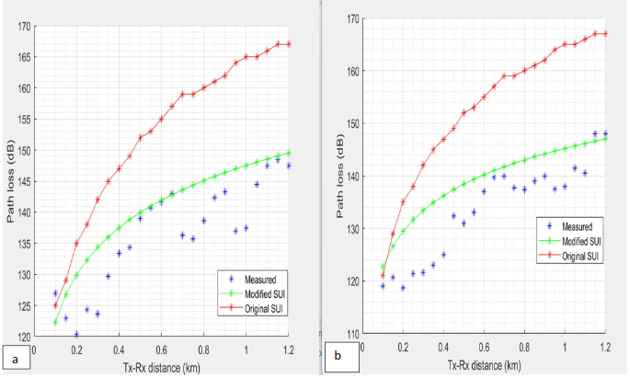
To validate the modified SUI propagation model, the model is applied at different base stations in urban and rural environments of the states respectively where measurements have been conducted as presented in figures 9 to 12. Comparison has also been performed in terms of root mean square error (RMSE), and mean prediction error between the original SUI model and the modified SUI model in all the considered environments.
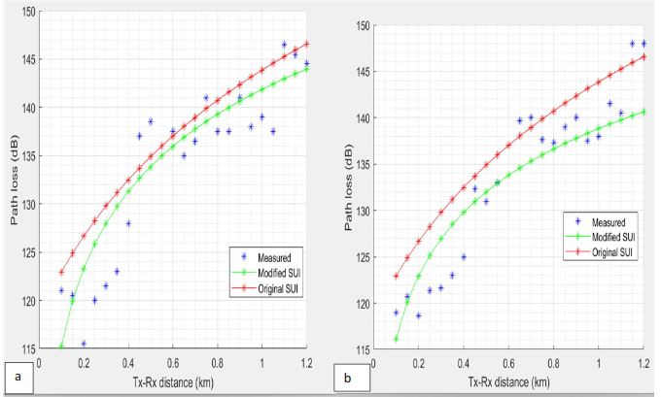
Figure 9. Comparison of original and modified SUI propagation model with measured pathloss values in rainy and dry season for Anwai base stations. (a) rainy (b) dry
Figure 10. Comparison of original and modified SUI propagation model with measured pathloss values in rainy and dry season for Asaba base stations. (a) rainy (b) dry
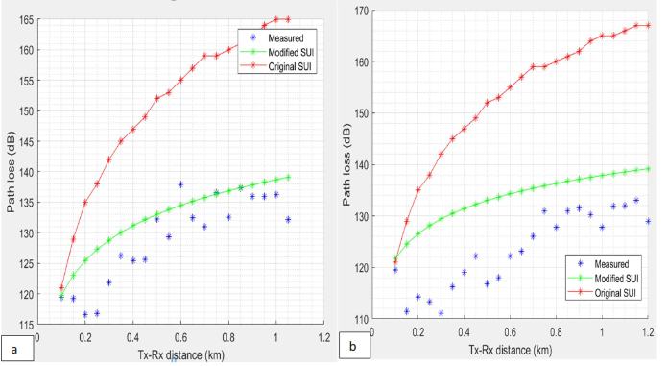
Tables 3 shows root mean square error (RMSE) of the original and modified SUI models. The modified SUI model showed better agreement with the measured values in the different environments since the RMSE is around the acceptable value [21].

Figure 11. Comparison of original and modified SUI propagation model with measured pathloss values in rainy and dry season for Nkwelle base stations. (a) rainy (b) dry
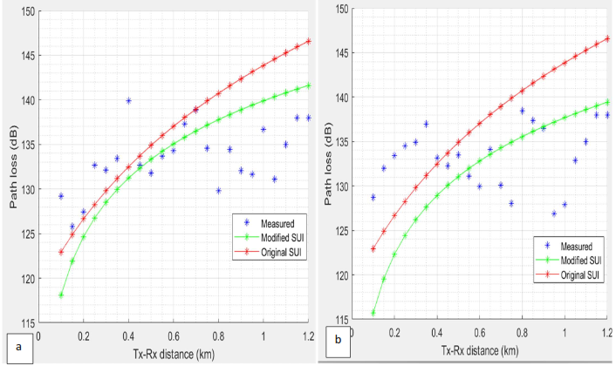
Figure 12. Comparison of original and modified SUI propagation model with measured pathloss values in rainy and dry season for Onitsha base stations. (a) rainy (b)

Table 4 Comparison of RMSE in dB of the original and modified SUI model for investigated environments in rainy and dry season
Environment | Rainy season  Root mean square error (dB) |  | Dry season  Root mean square error (dB)
Environment | Original SUI | Modified SUI | Original SUI | Modified SUI
Asaba | 4.86 | 2.16 | 6.89 | 3.56
Onitsha | 6.33 | 3.03 | 8.06 | 5.16
Anwai | 16.9 | 7.04 | 19.42 | 7.42
Nkwelle | 18.05 | 6.05 | 17.28 | 9.21

3.7 Result of the Atmospheric Parameters Analysis
The results of the estimated monthly effective earth radius factor, k, and geoclimatic factor $G$, for the period of field investigation are presented in this section. The monthly variations of point refractivity gradient (dN₁) for the period of field investigation have also been estimated. Results indicate that values of refractivity gradient raging between - 41 N-units/km and - 86 N-units/km were obtained in urban environment, and - 43 N-units/km to - 67 N-units/km in rural environment of Delta State with the worst cases falling in the wet season within the months of May, June, July, August and September with values between – 58 N-units/km and around -88 N-units/km.
“In Anambra State, the values of refractivity gradient in urban environment of Onitsha are between – 39 N-units/km and -74.23 N-units/km, and in rural environment, the refractivity gradient values are between – 40 N-units/km and – 66.46 N-units/km. The wet season (May, June, July, August, September and post wet season period (October) showed the worst cases of refractivity gradient values between – 49 N-units/km and about – 74 N-units/km” [11].
From the estimated values of refractivity gradient, it is noticed that most of the months in the investigated environments are predominated by super-refraction. The result implies that the ITU recommended value of – 60.20 N/km value of refractivity gradient is not a good assumption, because it does not put into consideration the monthly variation of the refractivity gradient and the worse months situation. These results are in conformity with the work of [11].
Tables 5 present the geoclimatic factor $G$ and effective earth radius ($k$-factor) monthly variables for investigated urban and rural environments of Delta and Anambra states respectively, estimated based on the monthly refractivity gradient calculated from the acquired atmospheric parameters.
Table 5. Geoclimatic and effective earth radius factor for different months in investigated environments of Delta and Anambra State.
Month | Urban (Asaba)  Environment |  | Rural (Anwai)  Environment |  | Urban (Onitsha) Environment |  | Rural (Nkwelle) Environment
Month | $k$ factor | $G$ Factor | $k$  factor | $G$ Factor | $k$ factor | $G$ Factor | $k$ factor | $G$ Factor
January | 1.35 | 8.34 × 10⁻⁵ | 1.52 | 8.53 × 10⁻⁵ | 1.33 | 8.70 × 10⁻⁵ | 1.34 | 8.31 × 10⁻⁵
February | 1.33 | 7.80 × 10⁻⁵ | 1.48 | 8.62 × 10⁻⁵ | 1.25 | 7.90 × 10⁻⁵ | 1.36 | 8.42 × 10⁻⁵
March | 1.41 | 8.62 × 10⁻⁵ | 1.41 | 8.92 × 10⁻⁵ | 1.40 | 8.61 × 10⁻⁵ | 1.47 | 9.13 × 10⁻⁵
April | 1.43 | 8.71 × 10⁻⁵ | 1.38 | 8.93 × 10⁻⁵ | 1.42 | 8.71 × 10⁻⁵ | 1.44 | 8.82 × 10⁻⁵
May | 1.46 | 9.40 × 10⁻⁵ | 1.51 | 9.12 × 10⁻⁵ | 1.47 | 8.60 × 10⁻⁴ | 1.45 | 8.86 × 10⁻⁵
June | 1.51 | 1.00 × 10⁻⁴ | 1.58 | 1.12 × 10⁻⁴ | 1.53 | 1.20 × 10⁻⁴ | 1.44 | 8.77 × 10⁻⁴
July | 1.53 | 1.30 × 10⁻⁴ | 1.56 | 9.33 × 10⁻⁵ | 1.57 | 1.33 × 10⁻⁴ | 1.41 | 8.64 × 10⁻⁵
August | 1.61 | 1.80 × 10⁻⁴ | 1.54 | 9.20 × 10⁻⁵ | 1.60 | 1.35 × 10⁻⁴ | 1.47 | 8.93 × 10⁻⁵
September | 1.55 | 1.50 × 10⁻⁴ | 1.63 | 1.40 × 10⁻⁴ | 1.55 | 1.58 × 10⁻⁴ | 1.62 | 1.20 × 10⁻⁴
October | 1.49 | 9.00 × 10⁻⁵ | 1.52 | 9.13 × 10⁻⁵ | 1.50 | 9.95 × 10⁻⁵ | 1.46 | 9.08 × 10⁻⁵
November | 1.43 | 8.73 × 10⁻⁵ | 1.48 | 8.98 × 10⁻⁵ | 1.42 | 8.51 × 10⁻⁵ | 1.39 | 8.58 × 10⁻⁵
December | 1.36 | 8.41 × 10⁻⁵ | 1.41 | 8.70 × 10⁻⁵ | 1.36 | 8.32 × 10⁻⁵ | 1.32 | 7.98 × 10⁻⁵

Figure 13 present the variation of effective earth radius (k factor) and geoclimatic factor with months for the different environments of the considered states. The results indicate that the worst cases of k-factor and geoclimatic factor falls in the rainy months (June, July, August and September). “The highest value of the k-factor is 1.63 in rural environment of Delta in the month of September. While the highest value of geoclimatic factor is 8.77 × 10⁻⁴ in rural environment of Anambra State in the month of June. The effect is that during the rainy months, the refractivity gradient refracts more of the mean bending angle of the transmitted signals along the line-of-sight links depending on the level of the atmospheric turbulence. This could lead to seasonal fluctuations of the transmitted signal at the receiving end” [11]. However, from the effective earth radius factor presented in figure 13, shows that using the standard value of 1.33 for k-factor in the investigated environments, the required height of antenna for loss of signal communication link set up will not be achieved. This may result in overestimation or underestimation of the required link budget needed for South Southern urban and rural environments. Similar variations were also observed in urban and rural environments considered in Anambra State.
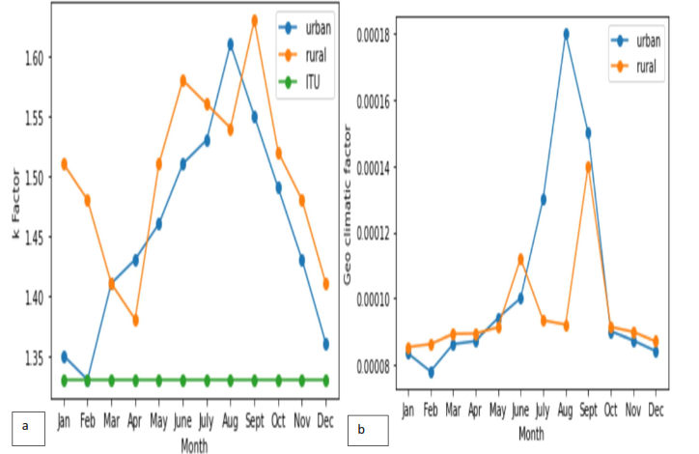
Figure 13. Variation of $k and G$ with months for the investigated urban and rural environments of Delta State
- Conclusion
In summary, signal strength of 4G LTE wireless network are randomly affected by changes in season and GSM signal strengths in the investigated environments suffer more distortion from around 200 m and above from the base station. The effects of losses as a result of seasonal changes are more severe in rural environment than in urban. This could be as a result of more trees and green leaves in rural environments which absorb GSM signals in environments. The theoretical pathloss models available in literature either over predicted or under-predicted pathloss characteristics of the studied outdoor propagation environments in southern region. The pathloss exponent is not only environmental dependent but also season dependent [19, 23].
The $G$ factor which caters for geographical and climatic conditions in multipath fading distribution varies with month and season with the worse months occurring in wet season. Using the recommended value of 1.33 for k-factor, will not give the required antenna height for loss-of-signal link set up in the studied locations. This may lead to an underestimation or overestimation of the link budget needed for these environments [24, 25, 26, 27].
In conclusion, this study was focused on developing improved versions of industry-standard propagation models suited for LTE pathloss prediction in the Delta-Anambra rural and urban environments. Pathloss of four propagation models namely: Cost 234, Ericson, Erceg and SUI models were compared with pathloss of propagation measurements taken from several 4G LTE 800 MHz base stations located in the urban and rural areas of Delta and Anambra State. Results confirmed the initial assumption of the study that propagation models’ prediction is far from the real measurement values. The SUI model showed satisfactory performance in the urban and rural environments at 800 MHz using statistical evaluations. The SUI models however were further improved and modified for a more accurate prediction of 4G LTE pathloss in urban and rural environments of the investigated states at 800 MHz

Authors’ contributions: This work was carried out in collaboration among all the authors. All authors read and approved the final manuscript

References
- Sharma, P.K., Dinesh, S., Singh R.K., (2014). Development of propagation model by considering different climatic conditions. Magnt Research Report, 2(6): 389-401.Teletopax (2012). Requirement for interference and carrier to interference ratio in GSM. Telecom Techniques Guide. December 19.
- Nigeria Bureau of Statistics Bulletin (2006)
- Onitsha Population, (2023). World Population Review. https://worldpopulationreview.com/world-cities/onitsha-population
- Perez, F.F., Marino, P., E., (2008). Modelling the Wireless Propagation Channel a simulation approach with matlab. A John Willey and Sons Publication Ltd, University of
- Akinyemi, P. (2016). Optimization of Path Loss Model for Macro-Cellular Network
- Abiodun, C.I. Azi, S.O., Ojo, J.S., Akinyemi, P., (2017). Assessment of pathloss prediction models for wireless propagation channels at L-band frequency over different micro-cellular environments of Ekiti state, Southwestern Nigeria. World Academy of Science, Engineering and Technology. International Journal of Electronics and Communication Engineering, 11 (10): pp. 1103-1109.
- James, D., Gadze, K. A., Agyekum, S. J., Nuagah E.A., (2019). Improved propagation models for lte path loss prediction in urban & suburban
Ghana. International Journal of Wireless & Mobile Networks (IJWMN) Vol. 11, No. 6,
- Mason, P. S., (2010). Atmospheric effects on radio frequency wave propagation in a humid near-surface environment. Nava Postgraduate School Monterey CA.
- Zubar, M., (2011). Atmospheric influences on satellite communications. Przglad Elektrotechnczny, 87 (5): 261-264.
Application in Selected State in Nigeria. Ph.D thesis, Department of Physics, University of Benin, Benin City Edo State Nigeria. Chapter 3, pp. 97-100.
- Ononiwu, G., Simon, O., Constance, K., (2015). Determination of the dominant fading and the effective fading for the rain zones. European Journal of Mathematics and Computer Science, Vol.22.
- Ojo, O.L., Ajewole, M., Adediji, A., Ojo, J.S., (2012). Estimation of clear-air fades depth due to Radio Climatological parameters for microwave link applications in Akure Nigeria. International Journal of Engineering, 7 (3): 1-8.
- International Telecommunications Union (2003). The radio refractive index, its formular and refractive data. International Telecommunications Union, Recommendation of ITU-4539.
- International Telecommunications Union (2000). The radio refractive index, its formular and refractive data. International Telecommunications Union, Geneva, Recommendation of ITU-453-8.
- Agbo, G.A., Okoro, O.N., Amechi, A.O., (2013). Atmospheric refractivity over Abuja. Nigeria International Research Journal of Pure and Applied Physics, pp. 37-45.
- Abu-Almal, A., Al-Ansari, K., (2010). Calculation of effective earth radius and point refractivity gradient in UAE. International Journal of Antenna and Propagation.
- International Telecommunications Union (2012). Propagation data and prediction methods required for the design of terrestrial LOS systems. International Telecommunication Union Recommendation ITU- P.530-14.
- Nasir, F., Adeseko, A. A., Yunusa, A. A., (2013). On the study of empirical pathloss models for accurate prediction of TV signal for secondary users. Progress in Electromagnetic Research B, Vol. 49, pp. 155-176.
- Erceg, V., Tjandra, S.Y., Parkoff, S.R., Gupta, A., Kulie B., Julius A.A. and Bianchi, R., (1999). An empirically based path loss model for wireless channels in suburban environment. IEEE Journal in Selected Areas in Communications, 17 (7): pp. 1205-1210.
- Abiodun, I.C., Idogho, J., (2021). Variations of GSM path loss exponent with Propagation distance at L-band frequencies in different microcellular environment of southwestern Nigeria. African Journal of Electrical and Electronics Research. Volume 4, Issue 1, 2021 (pp. 1-9)
- Fanimokun, A., Frolic, J., (2003). Effects of natural propagation environments on wireless sensor network coverage area. Proceedings of the 30th Southern Symposium on System Theory, pp. 16-20.
- Turkka, J. and Ranfor M. (2008). Path loss measurements for a non-line-of-sight mobile-mobile environment. Proceedings of the International Conference on Intelligent Transport System Telecommunications. Phuket, Thailand, October, 22-24.
- Bruce, L.C., (2006). Prediction of seasonal trends in cellular dropped call probability. IEEE Proceedings of International Conference on Electro/Information Technology. pp. 613-618.
- Bultitude R.J.C., Bedal, G.K., (1989). Propagation characteristics on microcellular urban mobile radio channel at 910 MHz. IEEE Journal on Selected Areas in Communications. pp.31-39.
- Jalel, C., Ali, K.L., Rafiqul, M.D., (2013). Comparison between measured and predicted pathloss for mobile communication in malaysia. World Applied Science Journal 21 (Mathematical Application in Engineering), pp. 123-128.
- Joshi, G.G., (2005). Near ground channel measurement over line of sight and forested paths. IEEE Proceedings on Microwaves, Antenna and Propagation, pp. 589-596
- Julio, C. C., (2008). Analysis and optimization of empirical path loss models and shadowing effects for Tampa Bay area in the 2.6 GHz band. M.Sc. Thesis, Department of Electrical Engineering, University of South Florida. Chapter 3 and 4, pp 12-27.
- Kanagalu, R. M., (1999). Coverage estimation for mobile cellular networks from signal
strength measurement. Ph.D Dissertation in Electrical Engineering, University of Texas Dalas.

