IDENTIFICATION OF SINGLE NUCLEOTIDE POLYMORPHISM (SNP) AND PATHWAY ANAYLSIS OF THYROID STIMULATING HORMONE BETA (TSHβ) GENE RELATED TO GROWTH TRAIT IN TWO CHICKEN BREEDS

ABSTRACT
Genetic variation drives phenotypic diversity in poultry and form the basis for improvement programs for better performance traits while TSHβ gene regulates growth through the HPT axis. This study investigated SNPs within the TSHβ gene in two chicken breeds and its involvement in HPT axis and neuroactive ligand receptor interaction pathway. 200 chicks (100 per breed) were reared under intensive management. At 8 weeks, liver samples from 32 birds (16 per breed) were collected for RNA molecular analyses. Total RNA was extracted, reverse transcribed to cDNA and TSHβ expression quantified by real-time PCR. Sequencing identified four SNPs, three in the 5′UTR and one synonymous variant in the coding region with haplotype analysis showing four haplotypes confined to Ross308. Variant effect predictor (VEP) indicated that SNP4 may exert dual regulatory roles, as it is positioned within the 3′ untranslated region (UTR) and simultaneously downstream of the gene. Pathway analysis confirmed TSHβ involvement in HPT axis and neuroactive ligand receptor interaction pathway. These findings affirms TSHβ as a functional candidate gene for growth regulation and provides valuable marker for molecular breeding and genetic improvement.
Keywords: TSHβ gene, SNPs, Ross 308 chicken, FUNAAB Alpha chicken, genetic diversity.

INTRODUCTION
Growth traits are economic indicators in poultry production, as they influence productivity and profitability. They are complex, shaped by genetics, nutrition, environment and endocrine control. Genetic variation provides the foundation for phenotypic diversity and enables selective breeding aimed at improving performance and adaptability. Identifying genetic markers, especially SNPs is vital for marker assisted selection in poultry, since they can alter gene expression or protein function (Deng et al., 2017; Ramírez-Bello and Jiménez-Morales, 2017). In chickens, SNPs within growth related genes such as GHR, IGF1 and TSHR have been associated with growth rate, body composition and feed conversion efficiency (Oh et al., 2021; Li et al., 2022).
The thyroid stimulating hormone beta (TSHβ) gene encodes the β-subunit of thyroid stimulating hormone (TSH), a pituitary glycoprotein that regulates thyroid hormone synthesis and secretion through the hypothalamic pituitary thyroid (HPT) axis (Klein, 2019; Pirahanchi et al., 2023). Thyroid hormones, triiodothyronine (T3) and thyroxine (T4) play important roles in metabolism, thermogenesis and skeletal development, influencing overall growth and feed efficiency in poultry (Mullur et al., 2014; Bernal, 2022; Shahid et al., 2023). Polymorphisms within TSHβ may alter transcriptional efficiency and gene expression, leading to phenotypic variation in growth traits (Oh et al., 2021). Studies in commercial and native chicken breeds have reported associations between TSHβ SNPs and body weight/carcass characteristics highlighting its potential as a candidate gene for growth improvement.
In Nigeria, poultry production relies on both exotic and improved indigenous breeds (Bassey et al., 2022). The Ross 308 broiler, developed in the United Kingdom (UK) by Aviagen, is known for rapid growth and high feed efficiency (Ogunnupebi et al., 2023). The FUNAAB Alpha broiler, developed by the Federal University of Agriculture, Abeokuta, is valued for adaptability and meat quality (Ojoawa et al., 2021). Despite their importance, limited information exists on TSHβ polymorphisms and it relationship with growth traits in these breeds. This study explored TSHβ gene variation in Ross 308 and FUNAAB Alpha chickens to identify functional SNPs linked to growth performance. By combining SNP and pathway analyses, it aimed to reveal molecular mechanisms and gene networks involved in growth regulation, providing valuable insights for marker assisted selection and sustainable poultry breeding programs in Nigeria.

MATERIALS AND METHODS
Experimental site
The study was conducted at the Poultry Breeding Unit of the Teaching and Research Farm, University of Uyo, Akwa Ibom State, Nigeria, a region characterized by tropical climatic conditions with moderate rainfall, high humidity and mean temperature of 28℃.
Experimental animals and management
A total of 200 day old chicks (100 FUNAAB Alpha and 100 Ross 308 respectively) were sourced from the Federal University of Agriculture, Abeokuta, Ogun state and a reputable farm in Ibadan, Oyo state. Chicks were reared intensively in partitioned pens under standard brooding, vaccination and biosecurity practices. Anti-stress supplements were given at arrival, starter diet (22.40% CP, 2967 kcal/kg ME) was fed from 0 - 4 weeks and a finisher diet (17.41% CP, 3139.96 kcal/kg ME) from 4 - 8 weeks, with water provided ad libitum.
Tissue Collection and RNA Extraction
At 8 weeks, 32 birds (16 per breed) were randomly selected for liver tissue harvesting. A smaller piece of the liver was collected using disposable surgical scalpel and immediately dropped into a welled labeled Eppendorf tube containing RNA/DNA shield. The collected samples were stored in an ice box and taken to the subunit of the Inqaba biotecTM at Ibadan for RNA extraction and qPCR amplification. Total RNA was extracted using the Zymo Quick-RNA Mini Prep Plus Kit, following homogenization, lysis, DNA removal, DNase treatment and purification steps. RNA concentration and purity were determined using a Nano Drop spectrophotometer, with quality assessed by 260/280 and 260/230 absorbance ratios.
cDNA synthesis and primer design
First-strand complementary DNA (cDNA) was synthesized from purified RNA using the LunaScript RT SuperMix Kit. Primers specific to the TSHβ gene and the housekeeping GAPDH gene were used for amplification.
PCR amplification and sequencing
The TSHβ gene fragment spanning 271 base pairs was amplified using specific primers. PCR products were trimmed and filtered for quality control before identification of single nucleotide polymorphism.
Bioinformatic Analysis
The TSHβ sequences were viewed in Bioedit and BLAST against GenBank in National Centre for Biotechnology Information, U.S. Reference sequence of TSHβ was downloaded and aligned against TSHβ sequences from this study to identify single nucleotide polymorphism presence among the sequences. The sequences were submitted to Genbank and accession numbers were given as; PV126564, PV126565, PV126566, PV126567, PV126568, PV126569, PV126570, PV126571, PV126572, PV126573, PV126574, PV126575, PV126576, PV126577, PV126578, PV126579.
The frequency and distribution of the identified single nucleotide polymorphisms were estimated using DNAsp software. Genetic diversity indices of the sequences were estimated using R software. The single nucleotide polymorphisms identified were used in variant prediction effect using ENSEMBL. Pathway analysis was done using KEGG pathway database.
Ethical Statement
This research project was conducted in accordance with ethical guidelines governing the use of animals and genetic materials in scientific research as stipulated by the Ethical Committee of Animal Science, University of Uyo.

RESULTS
4.1 Identification of Single Nucleotide Polymorphism (SNP) in the Thyroid Stimulating Hormone Beta (TSHβ) mRNA
Sequencing of the thyroid stimulating hormone beta (TSHβ) gene in 16 chickens produced a fragment consisting of 271 nucleotide bases. Analysis of this sequence revealed four single nucleotide polymorphisms (SNPs) at positions 1, 2, 9 and 67. The first three SNPs were found at the 5’ untranslated region (5' UTR) of TSHβ while the fourth SNP is in the translated region of TSHβ. Transition mutation was observed at position 1 (T → C) and 2 (C → T), while transversion occurred at position 9 (C → A) and 67 (C → A). The fourth SNP in the translated region of TSHβ did not alter the amino acid sequence, indicating it is a synonymous mutation.

Table 1: Detected SNPs in TSHβ gene fragment of Ross 308 and FUNAAB Alpha broiler chickens
SNP code | Postision | Reference base | Variant base | Mutation type
SNP 1 | 1 | T | C | Transition
SNP 2 | 2 | C | T | Transition
SNP 3 | 9 | C | A | Transversion
SNP 4 | 67 | C | A | Transversion
SNP: Single nucleotide polymorphism; T: Thymine; C: Cytosine; A: Adenine.

4.2 Frequency Distribution of SNPs in the TSHβ mRNA between the Two Chicken Breeds (Ross 308 and FUNAAB Alpha)
The haplotype distribution of thyroid stimulating hormone beta (TSHβ) mRNA sequences in Ross 308 and FUNAAB Alpha broiler chickens based on identified single nucleotide polymorphisms (SNPs) revealed four distinct haplotypes (Hap_1, Hap_2, Hap_3 and Hap_4). This distinct haplotype pattern suggests genetic differentiation between Ross 308 and FUNAAB Alpha chickens at the thyroid stimulating hormone beta (TSHβ) locus. Hap_1, Hap_2 and Hap_3 were observed in 2 samples each and Hap_4 had the highest frequency, occurring in 8 samples. Each haplotype corresponds to specific IDs (PV126564 - PV126571); representing individual chickens carrying that particular haplotype. The presence of three different haplotypes (Hap_1, Hap_2 and Hap_3) in Ross 308 suggests a higher degree of genetic variability in this breed for the TSHβ gene. Hap_4 is exclusive to only Ross 308 chickens, possibly indicating breed specific variation.

Table 2: Haplotype distributions of TSHB mRNA sequences based on identified single nucleotide polymorphism in Ross 308 and FUNAAB Alpha broiler chickens
Haplotype | Frequency | Distribution | Breed with the haplotype
Hap_1 | 2 | PV126565, PV126569 | Ross 308 chickens
Hap_2 | 2 | PV126565, PV126569 | Ross 308 chickens
Hap_3 | 2 | PV126566, PV126570 | Ross 308 chickens
Hap_4 | 8 | PV126564, PV126565, PV126566, PV126567, PV126568, PV126569, PV126570, PV126571 | Ross 308 chickens
Hap_1: Haplotype 1; Hap_2: Haplotype 2; Hap_3: Haplotype 3; Hap_4: Haplotype 4.

4.3 Genetic Diversity Indices for TSHβ mRNA Sequences in Ross 308 and FUNAAB Alpha Chicken
The genetic diversity indices include; allelic frequency, genotypic frequency, polymorphic informative content, hardy-weinberg equilibrium, heterozygosity and the effective number of alleles. The allelic frequency, genotypic frequency, polymorphic informative content (PIC) and hardy-weinberg equilibrium (HWE) values for all the SNPs were the same except for SNP 4. Heterozygosity and effective number of alleles were the same across the SNPs. Polymorphic informative content (PIC) measured the informativeness of the SNPs and the higher PIC values in the study indicated greater genetic diversity. The very low p-values suggested deviations from HWE, possibly due to selection or small sample size. The differences between SNP1 - SNP3 values and SNP4 values under heterozygosity indicated different levels of genetic variation.

Table 3: Genetic diversity indices for TSHB mRNA sequences in Ross 308 and FUNAAB Alpha broiler chickens
SNPs | Allelic frequency |  | Genotypic frequency |  |  | PIC |  | HWE |  | Heterozygosity | Effective no. of alleles
SNP1  (T>C) | T | C | TT | TC | CC
 | 0.875 | 0.125 | 0.875 | 0.00 | 0.125 | 0.22 | 2.17E-10 |  |  | 0.22 | 1.28
SNP2  (C>T) | C | T | CC | TC | CC
 | 0.875 | 0.125 | 0.875 | 0.00 | 0.125 | 0.22 | 2.17E-10 |  |  | 0.22 | 1.28
SNP3  (C>A) | C | A | CC | CA | AA
 | 0.875 | 0.125 | 0.875 | 0.00 | 0.125 | 0.22 | 2.17E-10 |  |  | 0.22 | 1.28
SNP4  (C>A) | C | A | CC | CA | AA
 | 0.500 | 0.500 | 0.500 | 0.00 | 0.500 | 0.50 | 2.06E-09 |  |  | 0.22 | 1.28
SNPs: Single Nucleotide Polymorphisms; T: Thymine; C: Cytosine; A: Adenine; PIC: Polymorphic Information Content; HWE: Hardy-Weinberg equilibrium; no: number.

4.4 Effects of Genetic Variants on Genes, Transcriptional and Regulatory Regions
The results from Ensembl's Variant Effect Predictor (VEP) showed one analyzed variant (SNP4). Variant filtered out was zero, no novel variant, two overlapped genes and transcripts, and no regulatory features. The predicted effects of the variant are categorized into two main consequences, each contributing 50% to the overall annotation. The first half showed the processed variant at 3' untranslated region (UTR) of the gene, a region that plays a role in mRNA stability, localization and translation regulation. The second half revealed the variant’s location downstream of the gene, meaning it does not directly affect the coding sequence but might influenced gene regulation or enhancer elements.
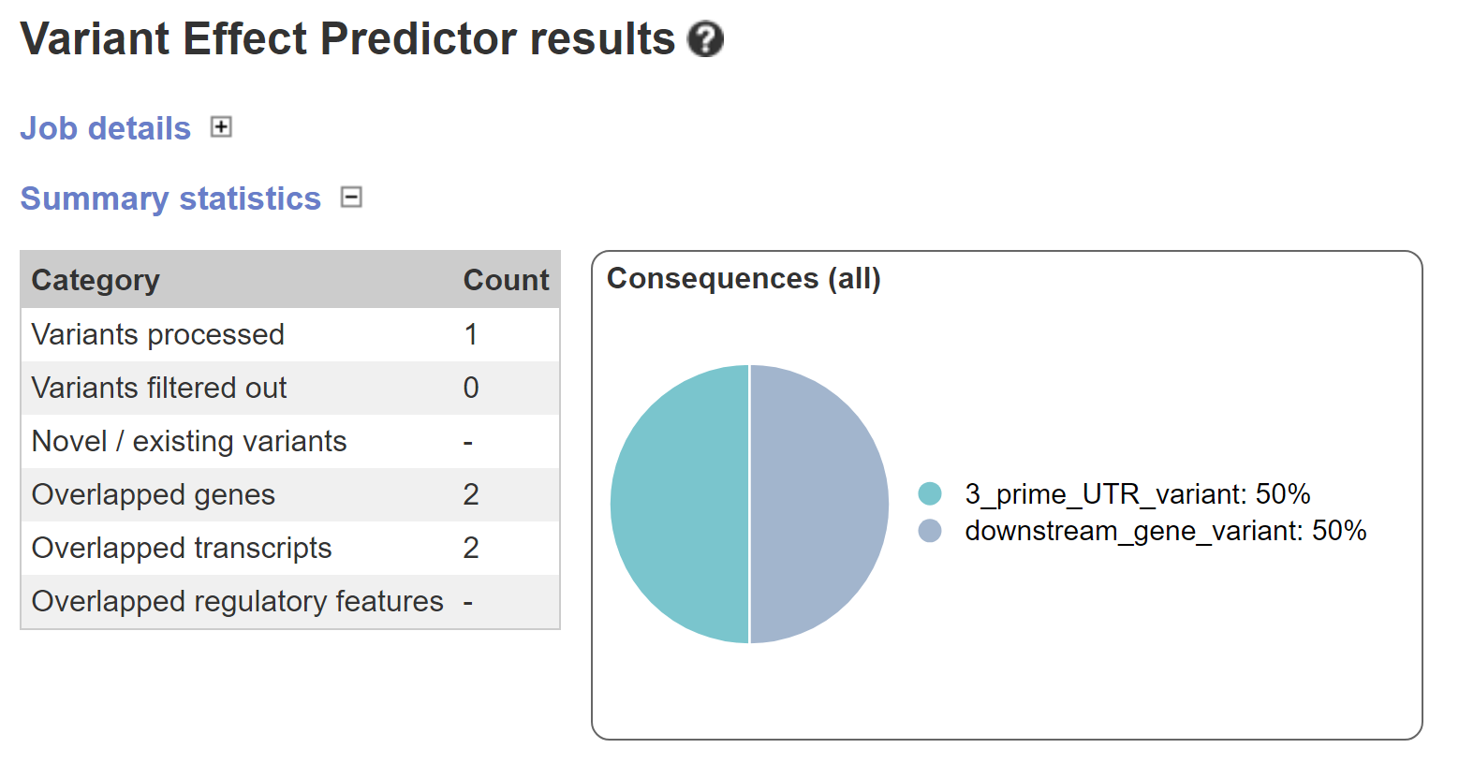Figure 1: Effects of genetic variants on TSHβ genes, transcripts, and regulatory regions.

4.5 Thyroid Stimulating Hormone Beta (TSHβ) Protein in Hormone Signaling
The hormone signaling pathway in figure 2 illustrates the sequential interaction of hormones and receptors across multiple organs and tissues. The pathway started from the brain, to the anterior pituitary gland, down to the glands including thyroid gland, and then to other organs and tissues of the body such as liver, kidney, muscle, blood plasma, heart etc. The activities involved in this pathway includes; secreting and inhibiting hormones, binding of secreted hormones to their respective receptors, activation of Gq-protein-coupled signaling, adenylate cyclase (AC), phospholipase C (PLC), etc., production of hormones in the glands and transportation of these hormones out of the gland to other organs and tissues for physiological control.
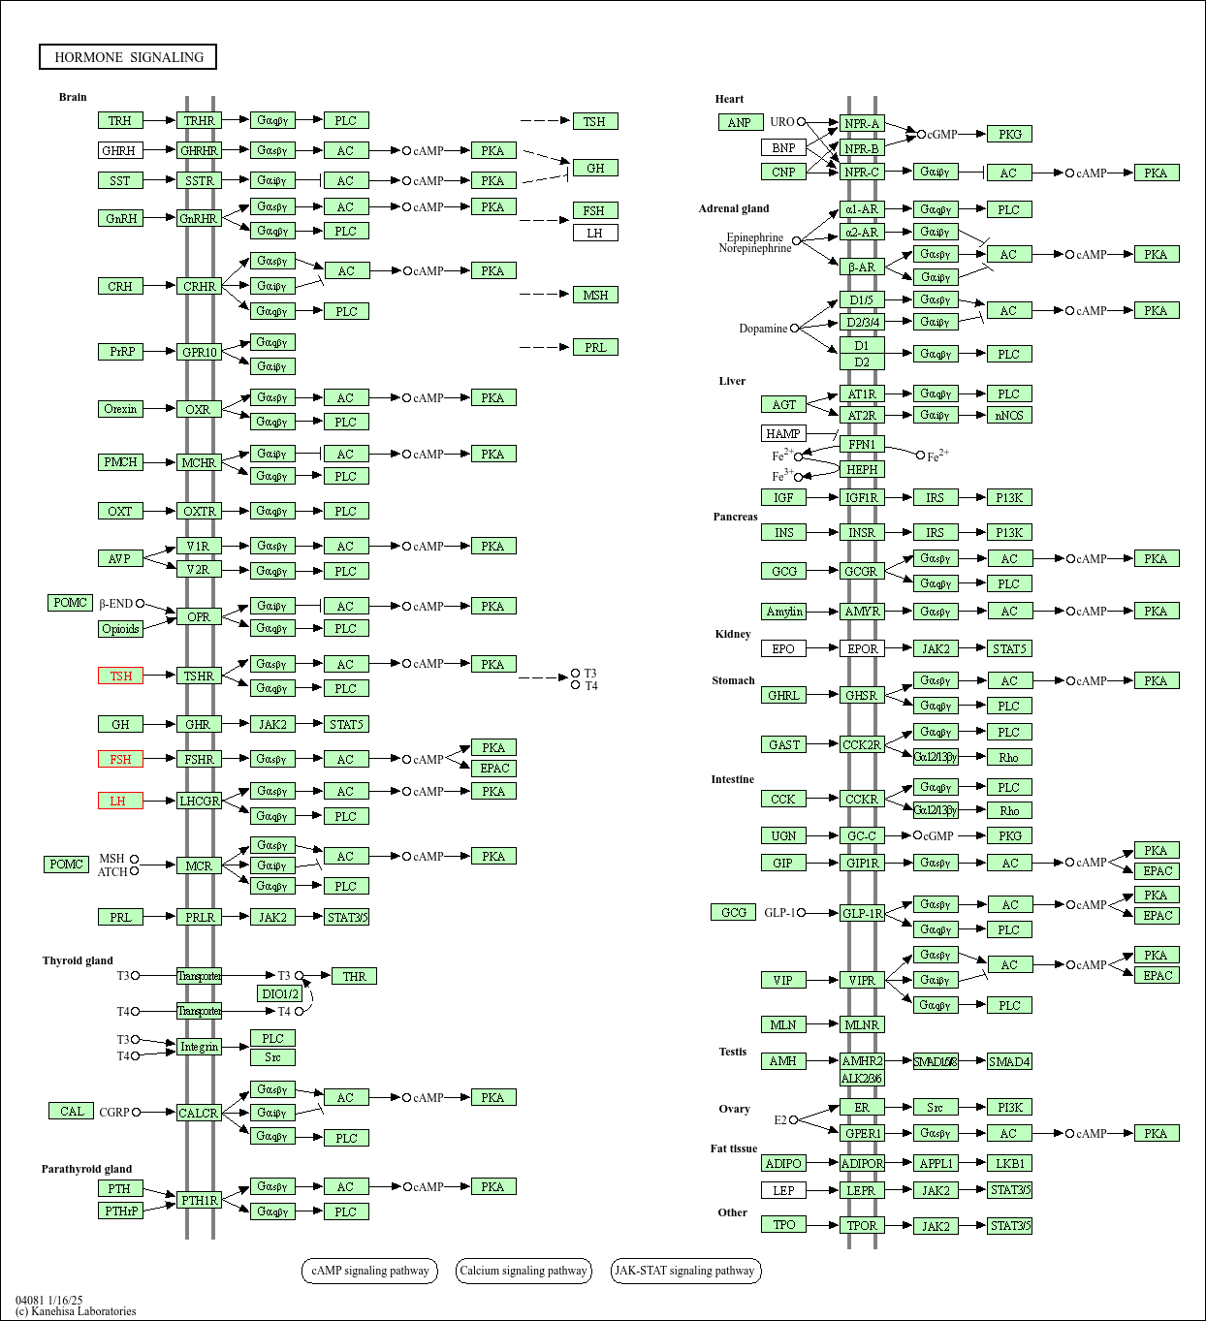
Figure 2: Thyroid stimulating hormone beta protein in hormone signaling.
4.6 Thyroid Stimulating Hormone Beta (TSHβ) Protein in Neuroactive Ligand Receptor Interaction
Neuroactive ligand receptor interaction pathway represented in figure 3 shows how various ligands (hormones, neurotransmitters and peptides) interact with their respective receptors in different signaling pathways. The receptors which are primarily GPCRs (G-protein-coupled receptors) on the pathway map are grouped into different classes. The green highlighted genes are those identified in the analysis and the red highlighted genes (Follicle stimulating hormone -FSH, Luteinizing hormone subunits beta -LHβ, Thyroid stimulating hormone -TSH) indicate genes of particular interest, possibly associated with neurological, hormonal and immune functions, impacting processes such as growth, reproduction, stress response and behaviour. The hormone of interest (thyroid hormones) and their receptors were identified in the analysis and are seen at the hormone protein signaling pathway where the thyroid stimulating hormone (TSH) binds to it receptor, the thyroid stimulating hormone receptor (TSHR); at the thyrotropin releasing hormones group of signaling pathway where the thyrotropin releasing hormones (TRH) binds to it receptor, the thyrotropin releasing hormone receptor (TRHR); and at the channels/other receptors where both triiodothyronine (T3) and thyroxine (T4) binds to their receptor, the thyroid hormone receptor (THR), forming an integrated network that governs endocrine and neurophysiological regulation.
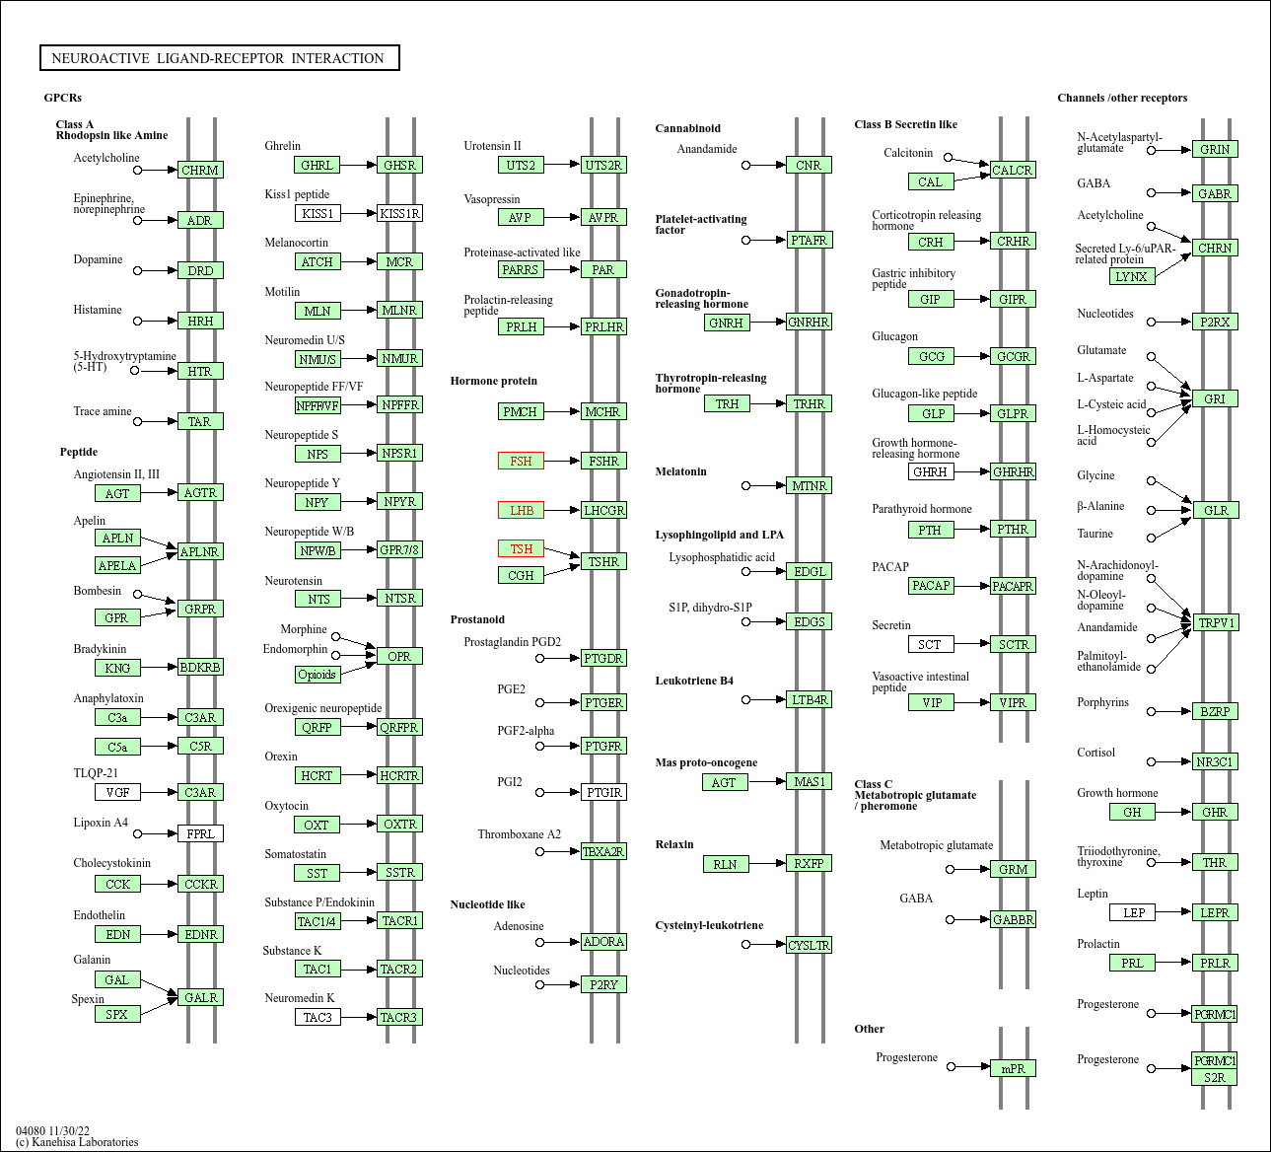
Figure 3: Thyroid stimulating hormone beta protein in Neuroactive ligand-receptor interaction

DISCUSSION
Identification of Single Nucleotide Polymorphism (SNP) in the TSHβ mRNA
The detection of four single nucleotide polymorphisms (SNPs) in the thyroid stimulating hormone beta (TSHβ) gene in this study shows gene’s variability in chicken breeds. Although non-coding, 5′UTR variants can influence mRNA stability, transcription initiation and translational efficiency (Barrett et al., 2012). The synonymous SNP at position 67, while not altering the amino acid sequence, may affect mRNA folding and translation kinetics as reported by Hunt et al. (2014) and Li et al. (2020). These variations could translate into phenotypic differences between the breeds, especially in growth traits, since TSHβ regulates metabolism and skeletal growth through the hypothalamic pituitary thyroid axis.

Frequency Distribution of SNPs in the TSHβ mRNA between the Two Chicken Breeds
Frequency distribution of identified SNPs in TSHβ gene revealed four haplotypes, all of which were observed exclusively in Ross 308 chickens. The presence of multiple haplotypes in Ross 308 chicken may be due to greater allelic recombination or introgressive hybridization. Hap_4 had the highest frequency (n=8), which means that it might be a dominant or selectively favoured haplotype in this breed. The absence of these haplotypes in FUNAAB Alpha chicken may be due to the fact that the TSHβ gene in FUNAAB Alpha chicken is more conserved, because of it more stable or less genetically diverse background. This finding agrees with the reports by Sha et al. (2020) and Tan et al. (2022) who observed that indigenous and improved indigenous chicken lines often show lower SNP density in several genes when compared to commercial breeds.

Genetic Diversity of TSHβ mRNA Gene in the Two Breeds of Chicken
The genetic diversity analysis shows the varying levels of polymorphism and genetic variability across the four SNP loci examined (SNP1 to SNP4). According to researches like that of Botstein et al. (1980), Serrote et al. (2020) and Canales et al. (2023), markers with PIC values <0.25 are considered low polymorphic, while values between 0.25 and 0.50 are moderately polymorphic. Therefore SNP1, SNP2 and SNP3 showed low polymorphic informative content (PIC = 0.22), while SNP4 was moderately informative (PIC = 0.50). Observed heterozygosity was also low for SNP1 - SNP3, but higher for SNP4, consistent with the effective number of alleles (Ne = 2.0) at that locus. All SNP loci showed highly significant deviation from Hardy Weinberg equilibrium (HWE), likely reflecting selection pressure in Ross 308 chickens.

Effects of Genetic Variants on Genes, Transcriptional and Regulatory Regions
Ensembl's variant effect predictor (VEP) identified SNP 4 within the 3' untranslated region (3' UTR). The results also categorized the SNP as a downstream gene variant. Each of these predicted effects contributed 50% to the overall annotation, meaning that SNP4 may have dual regulatory implications. Variants in the 3' UTR are known to alter mRNA stability, microRNA binding and protein interactions (Mayr, 2019; Romo et al., 2024), while downstream variants may influence transcriptional termination and regulatory elements (Barrett et al., 2012). The result in this study agrees with Steri et al. (2018) who report on 3′UTR location at the downstream of the coding sequence and its involvement in regulatory processes, including RNA stability, mRNA translation and localization. The presence of such a regulatory SNP in the TSHβ gene reflects breed specific selection for optimized growth and metabolic profiles in Ross 308 chicken. Thus, the identification of SNP4 as having both 3’ UTR and downstream effects confirms it potential regulatory role rather than a direct effect on the amino acid sequence.

Potential Candidate Genes and Regulatory Elements that Interact with TSHβ Gene to Influence Growth Traits in Chickens
The hormone signaling pathway involves a hierarchical control of hormone release and activity, primarily managed by the brain particularly the hypothalamus which integrates signals from various organs to maintain feedback loops and dynamic interactions among hormone secreting tissues. Thyroid stimulating hormone beta (TSHβ) plays a role in the hypothalamic pituitary thyroid (HPT) axis. In response to low circulating levels of thyroid hormones (T3 and T4), the hypothalamus secretes thyrotropin releasing hormone (TRH). TRH is transported via the hypophyseal portal circulation to the anterior pituitary, where it targets thyrotroph cells. TRH binds to thyrotropin releasing hormone receptors (TRHRs) a class of Gq protein-coupled receptors (GPCRs) on thyrotrophs, initiating a cascade via phospholipase C (PLC) activation, inositol triphosphate (IP3) generation and Ca²⁺ mobilization, which ultimately stimulate TSH synthesis and release (Ortiga-Carvalho et al., 2016; Bill and Vines, 2020). The beta subunit of TSH (TSHβ) confers biological specificity and is essential for TSH receptor (TSHR) binding. TSH then stimulates thyroid follicular cells via the TSHR a Gs-protein-coupled receptor activating the adenylate cyclase cAMP PKA pathway, which promotes the synthesis and release of T3 (triiodothyronine) and T4 (thyroxine) (Pirahanchi et al., 2023). Thyroid hormones, especially T4, circulate through the bloodstream and reach virtually every tissue, including the liver, kidneys, heart, skeletal muscle and the central nervous system. Within these tissues, T4 is often converted to the more active T3 (Shahid et al., 2023). Thyroid hormones also regulate pituitary function; they stimulate growth hormone (GH) production and release, while inhibiting prolactin secretion. Additionally, they elevate basal metabolic rate, heat production and oxygen consumption. T3 is important for fetal development, including linear bone growth, endochondral ossification and epiphyseal maturation. It also enhances nervous system function, increasing wakefulness, alertness and responsiveness to external stimuli (Armstrong et al., 2023). Elevated levels of T3 and T4 exert negative feedback at both the hypothalamus and pituitary, inhibiting TRH and TSH secretion and ensuring hormonal homeostasis (Shahid et al., 2023). The TSHβ protein, as a core component of this signaling cascade, is not only vital for thyroid hormone regulation but is also embedded within a neuroendocrine framework involving multiple feedback loops and interacting signaling pathways.
The neuroactive ligand receptor interaction pathway, as mapped by the Kyoto encyclopedia of genes and genomes (KEGG) database, is a complex signaling network that involves the interaction of hormones, neurotransmitters and neuropeptides with their specific receptors primarily G protein coupled receptors (GPCRs). This pathway plays a pivotal role in mediating endocrine and neuroendocrine functions in animals, including poultry. Studies by Li et al. (2018) and Naulé et al. (2021) have linked neuroactive ligand receptor interactions to key physiological processes such as feed intake, weight gain, stress response and sexual maturation in chickens and other animals. In KEGG pathway maps, genes such as TSH, FSH and LHB are highlighted in red, indicating their importance as central endocrine regulators. Their expression and receptor interaction confirmed a strong genetic influence on multiple physiological traits. The green highlighted genes in the dataset, including TSH, were detected in the present study, confirming active expression of the TSHβ gene in the analyzed chicken breeds. The thyroid stimulating hormone beta subunit (TSHβ) gene encodes the β-subunit of TSH, which binds to the TSH receptor (TSHR) on thyroid follicular cells to stimulate the production of thyroid hormones (T3 and T4). These hormones are crucial regulators of growth, metabolism, thermoregulation and neurodevelopment in birds (Shahid et al., 2023). TSHβ and its associated receptor system, particularly the thyroid stimulating hormone receptor (TSHR), belong to the Class A rhodopsin-like subfamily of G protein-coupled receptors (GPCRs). This family includes receptors for amines (e.g., dopamine (DRD), trace amines (TAAR), histamine (HRH), acetylcholine (CHRM)), peptides (e.g., neuropeptide Y receptor (NPYR), oxytocin receptor (OXTR)) and hormones (e.g., thyrotropin releasing hormone receptor (TRHR), gonadotropin releasing hormone receptor (GNRHR)). These receptors are involved in key physiological functions such as mood regulation, appetite, social behavior, reproduction and homeostasis (Baribeau and Anagnostou, 2015; Pei et al., 2016; Gasmi et al., 2023; Khalil et al., 2024). In addition, other signaling components, such as ionotropic receptors including GABA receptors (GABRA/B), glutamate receptors (GRIN, GRM) and nicotinic acetylcholine receptors (CHRN) mediate fast synaptic transmission (Sallard et al., 2021; Viscardi et al., 2021; Rivera-Perez et al., 2021; Soares et al., 2024). Although these are not GPCRs, they are part of the broader neuroactive ligand receptor interaction pathway. Receptors such as TRPV1 (a transient receptor potential channel) and P2RX (a purinergic ion channel) also contribute to neuronal communication and pain sensation. The thyroid hormone receptor (THR), on the other hand, is a nuclear receptor that modulates gene transcription in response to T3/T4 hormones (Puchałowicz et al., 2014; González-Ramírez et al., 2017; Fiveable, 2024). The interaction of TSHβ with its receptor and downstream signaling networks shows its regulatory importance in metabolism, growth, reproduction and stress adaptation. This supports the pleiotropic effects of TSHβ beyond thyroid hormone regulation, as it influences multiple physiological systems.

Conclusion and Future Perspectives
This study identified four SNPs in the TSHβ gene of chickens, including three in the 5′UTR and one synonymous coding variant. Among these, SNP4 in the 3′UTR/downstream region emerged as the most functionally relevant, showing breed specific fixation. The presence of multiple haplotypes in Ross 308 but not in FUNAAB Alpha shows stronger selection and genetic diversity in the commercial line. Pathway analysis confirmed TSHβ involvement in HPT axis and neuroactive ligand receptor interaction pathway. Collectively, these findings support the reports that TSHβ is a pleiotropic candidate gene for growth regulation in chickens, making it a viable target for genetic improvement programs.
Incorporating the identified SNPs into breeding programs could enhance growth performance, feed efficiency and economic returns, particularly for improving indigenous breeds. The improvement of these breeds will increase local breed competitiveness, reduce import dependency and contribute to food security and rural livelihood development. Future research should validate these associations in diverse breeds, explore the functional mechanisms of SNP4 and incorporate these findings into genomic selection strategies for improving indigenous breeds. Genome wide association studies (GWAS) including TSHβ and other candidate genes should also be conducted to uncover additional loci influencing growth and development in chickens.

References
Armstrong, M., Asuka, E. and Fingeret, A. (2023). Physiology, Thyroid Function. In: StatPearls. Treasure Island (FL): StatPearls. Available online at https://www.ncbi.nlm.nih.gov/books/NBK537039/
Baribeau, D. A. and Anagnostou, E. (2015). Oxytocin and vasopressin: linking pituitary neuropeptides and their receptors to social neurocircuits. Frontiers in neuroscience. 9: 335. Available online at https://doi.org/10.3389/fnins.2015.00335
Barrett, L. W., Fletcher, S. and Wilton, S. D. (2012). Regulation of eukaryotic gene expression by the untranslated gene regions and other non-coding elements. Cellular and molecular life sciences: CMLS. 69(21): 3613–3634. Available online at https://doi.org/10.1007/s00018-012-0990-9
Bassey, O., Akpan, U., Ikeobi, C., Adebambo, O., Idowu, O. and Ilori, O. (2022). Performance of Nigerian indigenous chicken genotypes and their crosses with marshal breed. Anchor University Journal of Science and Technology (AUJST). 2(2): 70-77. In AJOL: https://www.ajol.info/index.php/aujst
Bernal, J. (2022). Thyroid Hormones in Brain Development and Function. In: Feingold KR, Ahmed SF, Anawalt B, et al., editors. Endotext. South Dartmouth (MA): MDText.com, Inc.; 2000-. Retrieved from: https://www.ncbi.nlm.nih.gov/books/NBK285549/
Bill, C. A. and Vines, C. M. (2020). Phospholipase C. Advances in experimental medicine and biology.1131: 215–242. Available online at https://doi.org/10.1007/978-3-030-12457-1_9
Botstein, D., White, R. L., Skolnick, M. and Davis, R. W. (1980). Construction of a genetic linkage map in man using restriction fragment length polymorphisms. American journal of human genetics. 32(3): 314–331. PMCID: PMC1686077, PMID: 6247908
Canales, A. M., Camacho, M. E., Beltrán, A. H., Delgado, J. V., Landi, V. and Martínez, A. M. (2023). Genetic diversity in 10 populations of domestic Turkeys by using microsatellites markers. Poultry science. 102(1): 102311. https://doi.org/10.1016/j.psj.2022.102311
Deng, N., Zhou, H., Fan, H. and Yuan, Y. (2017). Single nucleotide polymorphisms and cancer susceptibility. Oncotarget. 8(66):110635-110649. doi: 10.18632/oncotarget.22372. PMID: 29299175; PMCID: PMC5746410.
Fiveable (2024). Thyroid Hormone Receptor. Anatomy and Physiology I. Review. Available online at https://library.fiveable.me/key-terms/anatomy-physiology/thyroid-hormone-receptor.
Gasmi, A., Nasreen, A., Menzel, A., Gasmi Benahmed, A., Pivina, L., Noor, S., Peana, M., Chirumbolo, S. and Bjørklund, G. (2023). Neurotransmitters Regulation and Food Intake: The Role of Dietary Sources in Neurotransmission. Molecules. 28(1): 210. Available online at https://doi.org/10.3390/molecules28010210.m
González-Ramírez, R., Chen, Y., Liedtke, W. B. and Morales-Lázaro, S. L. (2017). TRP Channels and Pain. In: Emir TLR, editor. Neurobiology of TRP Channels. Boca Raton (FL): CRC Press/Taylor & Francis; 2017. Chapter 8. Available online at https://www.ncbi.nlm.nih.gov/books/NBK476120/ doi: 10.4324/9781315152837-8
Hunt, R. C., Simhadri, V. L., Iandoli, M., Sauna, Z. E. and Kimchi-Sarfaty, C. (2014). Exposing synonymous mutations. Trends in Genetics. 30(7):308-21. doi: 10.1016/j.tig.2014.04.006.
Khalil, B., Miller, E. J. and Lappin, S. L. (2024) Physiology, Cellular Receptors. In: StatPearls. Treasure Island (FL): StatPearls Available online at https://www.ncbi.nlm.nih.gov/books/NBK554403/
Klein J. R. (2019). Novel Splicing of Immune System Thyroid Stimulating Hormone β-Subunit-Genetic Regulation and Biological Importance. Frontiers in endocrinology, 10, 44. https://doi.org/10.3389/fendo.2019.00044
Li, H., Wang, Z., Xu, L., Li, Q., Gao, H., Ma, H., Cai, W., Chen, Y., Gao, X., Zhang, L., Gao, H., Zhu, B., Xu, L. and Li, J. (2022). Genomic prediction of carcass traits using different haplotype block partitioning methods in beef cattle. Evolutionary applications. 15(12): 2028–2042. Available online at https://doi.org/10.1111/eva.13491.
Li, Y., Jin, W., Wang, Y., Zhang, J., Meng, C., Wang, H., Qian, Y., Li, Q. and Cao, S. (2020). Three Complete Linkage SNPs of GDF9 Gene Affect the Litter Size Probably Mediated by OCT1 in Hu Sheep. DNA and cell biology. 39(4): 563–571. Available online at https://doi.org/10.1089/dna.2019.4984
Li, Z., Liu, X., Zhang, P., Han, R., Sun, G., Jiang, R., Wang, Y., Liu, X., Li, W., Kang, X. and Tian, Y. (2018). Comparative transcriptome analysis of hypothalamus-regulated feed intake induced by exogenous visfatin in chicks. BMC Genomics. 19(1). DOI:10.1186/s12864-018-4644-7
Mayr, C. (2019). What Are 3' UTRs Doing? Cold Spring Harbor perspectives in biology. 11(10): a034728. Available online at https://doi.org/10.1101/cshperspect.a034728
Mullur, R., Liu, Y. Y. and Brent, G. A. (2014). Thyroid hormone regulation of metabolism. Physiological reviews. 94(2): 355 - 382. Available online at https://doi.org/10.1152/physrev.00030.2013
Naulé, L., Maione, L. and Kaiser, U. B. (2021). Puberty, a sensitive window of hypothalamic development and plasticity. Endocrinology.162(1).
Ogunnupebi, J., Igwe, R., Olorunleke, S., Nwakpu, P. and Osakwe, I. (2023). Meat yield and sensory evaluation of two commercial hybrid strains of broiler chicken reared in Abaliki, Ebonyi State, Nigeria. Nigerian Journal of Animal Production. 49(5), 103–111.
Oh, D., Ha, J., Yi, J., Kim, D., Oh, S, Kim, S., Han, K. and Park, Y. (2021). Investigation of single nucleotide polymorphism in <i>TSH-&beta;</i> and <i>CaSR</i> associated with body weight in Korean native chickens (Gray Brown). Journal of Animal Reproduction and Biotechnology. 36:129-136. Retrieved from https://doi.org/10.12750/JARB.36.3.129
Ojoawo, H. T., Ogunpaimo, O. J., Ilori, B. M., Wheto, M., Durosaro, S., Adebambo, A. O. and Adebambo O. A. (2021). Comparative evaluation of carcass composition of FUNAAB Alpha broiler with two exotic broiler breeds. Nigerian Journal of Animal Science. 23 (3): 1-8. Available online at https://doi.org/10.51791/njap.vi.4277
Ortiga-Carvalho, T. M., Chiamolera, M. I., Pazos-Moura, C. C. and Wondisford, F. E. (2016). Hypothalamus-Pituitary-Thyroid Axis. Comprehensive Physiology. 6(3): 1387–1428. Available online at https://doi.org/10.1002/cphy.c150027
Pei, Y., Asif-Malik, A. and Canales, J. J. (2016). Trace Amines and the Trace Amine-Associated Receptor 1: Pharmacology, Neurochemistry, and Clinical Implications. Frontier in Neuroscience. 10: 148. doi: 10.3389/fnins.2016.00148
Pirahanchi, Y., Toro, F. and Jialal, I. (2023). Physiology, Thyroid Stimulating Hormone. In: StatPearls. Treasure Island (FL): StatPearls. Available online at https://www.ncbi.nlm.nih.gov/books/NBK499850/
Puchałowicz, K., Tarnowski, M., Baranowska-Bosiacka, I., Chlubek, D. and Dziedziejko, V. (2014). P2X and P2Y receptors—role in the pathophysiology of the nervous system. International Journal of Molecular Sciences. 15(12): 23672–23704. Available online at https://doi.org/10.3390/ijms151223672.
Ramírez-Bello, J., and Jiménez-Morales, M. (2017). Functional implications of single nucleotide polymorphisms (SNPs) in protein-coding and non-coding RNA genes in multifactorial diseases. Medical Gazette of Mexico. 153(2): 238 - 250.
Rivera-Perez, L. M., Kwapiszewski, J. T. and Roberts, M. T. (2021). α3β4∗ Nicotinic Acetylcholine Receptors Strongly Modulate the Excitability of VIP Neurons in the Mouse Inferior Colliculus. Frontier in Neural Circuits. 15: 709387. doi: 10.3389/fncir.2021.709387
Romo, L., Findlay, S. D., and Burge, C. B. (2024). Regulatory features aid interpretation of 3'UTR variants. American Journal of Human Genetics. 111(2): 350–363. Available online at https://doi.org/10.1016/j.ajhg.2023.12.017
Sallard, E., Letourneur, D. and Legendre, P. (2021). Electrophysiology of ionotropic GABA receptors. Cellular and molecular life sciences: CMLS. 78(13): 5341–5370. Available online at https://doi.org/10.1007/s00018-021-03846-2
Serrote, C. M. L., Reiniger, L. R. S., Silva, K. B., Dos Santos Rabaiolli, S. M. and Stefanel, C. M. (2020). Determining the polymorphism information content of a molecular marker. Gene. 726. doi: 10.1016/j.gene.2019.144175.
Sha, Y., Gao, C., Liu, M. and Zhao, S. (2020). Evaluation of the genetic diversity of six Chinese indigenous chickens. Asian-Australas Journal of Animal Science. 33(10): 1566-1572. doi: 10.5713/ajas.19.0606. Epub 2019 Nov 12. PMID: 32054196; PMCID: PMC7463083.
Shahid, M. A., Ashraf, M. A. and Sharma, S. (2023). Physiology, Thyroid Hormone. In: StatPearls. Treasure Island (FL): StatPearls. Available online at https://www.ncbi.nlm.nih.gov/books/NBK500006.
Soares, É. N., Costa, A. C. d. S., Ferrolho, G. d. J., Ureshino, R. P., Getachew, B., Costa, S. L., da Silva, V. D. A. and Tizabi, Y. (2024). Nicotinic Acetylcholine Receptors in Glial Cells as Molecular Target for Parkinson’s Disease. Cells. 13(6): 474. Available online at https://doi.org/10.3390/cells13060474
Steri, M., Idda, M. L., Whalen, M. B. and Orrù, V. (2018). Genetic variants in mRNA untranslated regions. Wiley interdisciplinary reviews. RNA. 9(4): e1474. Available online at https://doi.org/10.1002/wrna.1474
Tan, X., Liu, R., Li, W., Zheng, M., Zhu, D., Liu, D., Feng, F., Li, Q., Liu, L., Wen, J. and Zhao, G. (2022). Assessment the effect of genomic selection and detection of selective signature in broilers. Poultry science. 101(6): 101856. Available online at https://doi.org/10.1016/j.psj.2022.101856
Viscardi, L. H., Imparato, D. O., Bortolini, M. C. and Dalmolin, R. J. S. (2021). Ionotropic Receptors as a Driving Force behind Human Synapse Establishment. Molecular biology and evolution. 38(3): 735–744. Available online at https://doi.org/10.1093/molbev/msaa252

