Review Article

From Aggression to Anxiety: A Review on Behavioural Disorders in Dogs

Abstract
In a survey conducted in Finland with 4,114 dogs, equal representation was observed for both male and female canines. The role of dogs in human lives has shifted from work to companionship, mirroring societal changes. Understanding and managing their behavior is crucial for a harmonious relationship. Unwanted behaviors, like aggression or excessive barking, can impact both the dog and the owner's quality of life. The aim of the study is to review the causes, characteristics, and management of behavioural disorders in dogs, focusing on aggression and anxiety, to improve understanding and welfare. Understanding the intricacies of dog behavior necessitates a focus on the brain and the nervous system. The development of the brain in all vertebrates, including dogs, originates from the neural tube during the embryonic stage. The limbic system, a primitive part of the dog's brain, operates as a closed circuit dedicated to processing emotions. The modal action pattern (MAP) engages the central nervous system (CNS) initially, but once triggered, it operates independently of the CNS. Hormones play a significant role in shaping the feeding and reproductive behavior of dogs, with specific sets of hormones jointly determining particular behaviors. To explore behavioral problems related to aggression in dogs, it is essential to initially comprehend how dogs’ express aggression. This behavior manifests in situations that instill fear in a dog. The causes include insufficient socialization, traumatic experiences, and a lack of training. Understanding the intricate structures of a dog's brain, particularly the smaller neocortex and the primitive limbic system and endocrinal status, is pivotal in comprehending their emotional processing and behavior.

1.0 INTRODUCTION
The role of dogs in human lives has shifted from work to companionship, mirroring societal changes. Understanding and managing their behavior is crucial for a harmonious relationship. Unwanted behaviors, like aggression or excessive barking, can impact both the dog and the owner's quality of life. Shockingly, over 30% of abandoned dogs end up in shelters due to behavioral problems. This highlights the need for education and support to address issues proactively, fostering healthier relationships and reducing abandonment (Wells and Hepper, 2000).
  - PREVALENCE STUDY
In a survey conducted in Finland with 4,114 dogs, equal representation was observed for both male and female canines. Strikingly, the findings revealed that a significant 85% of these dogs were grappling with serious behavioral problems, shedding light on the prevalence of such issues within the canine population (Dinwoodie et al., 2019).
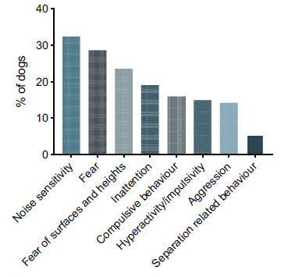
A comprehensive study conducted in America involving 13,700 dogs revealed that a substantial 73% exhibited some form of highly problematic behavior, shedding light on the prevalence of behavioral issues within the canine population. Notably, 32% of the dogs exhibited noise phobia, emphasizing a widespread sensitivity to auditory stimuli among the surveyed dogs. The study further unveiled gender-specific trends, with male dogs displaying aggression at a rate of 15%, while female dogs exhibited a higher prevalence of fearful behavioral problems (Salonen et al., 2020).
Fig 1- Types of behavioral disorder wise incidence
In a recent study on breed-specific behavioral problems, mixed breeds were identified as highly susceptible to disorders, surpassing other breeds. Cocker Spaniels exhibited a significant 14% incidence, followed closely by German Shepherds at 13%. English Springer Spaniels, Doberman Pinchers, and Golden Retrievers showed moderate rates of 9%, while Dachshunds displayed a 5% incidence. These findings highlight the varying predispositions of different breeds to behavioral challenges, emphasizing the importance of targeted interventions based on breed characteristics (Wright, 1987).
  - When behavior of dogs is undesirable???
When assessing undesirable behavior in dogs, it is essential to consider three distinct levels. Firstly, behaviors falling within the normal range for the species, age, and breed may not align with the owner's preferences. Secondly, behaviors that fall within or just beyond the normal range, while not abnormal, can be particularly intense or challenging for the owner to manage effectively. Lastly, at the third level, behaviors deemed abnormal or pathologic may arise due to underlying emotional disorders or mental health issues in the canine. Recognizing these levels of consideration is crucial for a comprehensive understanding and management of undesirable behaviors in our canine companions (Denenberg and Sagi, 2021).
2.0 NEUROLOGY OF BEHAVIOR
2.1 The Brain and The Nervous System
Understanding the intricacies of dog behavior necessitates a focus on the brain and the nervous system. The development of the brain in all vertebrates, including dogs, originates from the neural tube during the embryonic stage. As the process unfolds, the brain undergoes differentiation, forming three distinct parts: the forebrain, midbrain, and hindbrain. This early development sets the foundation for the neurological complexities that influence various aspects of canine behavior. Delving into the structure and functions of these brain components provides valuable insights into the mechanisms that drive and regulate behavior in dogs (Alcock, 2001).
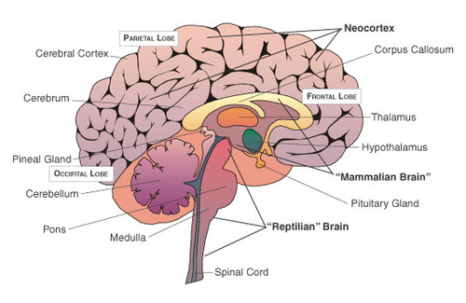
The cerebral cortex encompasses a crucial component known as the Neocortex, serving as the hub for integrating sensory stimuli, social behavior, and decision-making—a feature exclusive to mammals. Among mammals, humans possess the most advanced cerebral cortex, with the neocortex constituting approximately 80% of it. In contrast, the neocortex in dogs forms a relatively smaller proportion of their brain. This distinction in neocortical size highlights variations in cognitive capabilities and suggests that the degree of cortical development contributes to the differences in sensory processing, social interactions, and decision-making abilities between humans and dogs (Hecht et al., 2021).
Fig 2 Different Parts of Brain
2.2 Limbic System
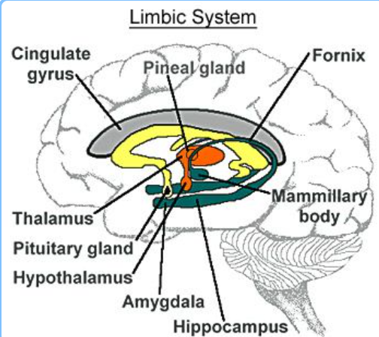
The limbic system, a primitive part of the dog's brain, operates as a closed circuit dedicated to processing emotions. The cingulate gyrus functions as the receptive field for emotional experiences and connects to sensory areas in the neocortex, facilitating the association of emotions and feelings. Components of the limbic system include the Amygdala, responsible for generating fear and aggression, the Hippocampus, which plays a role in memory, and the Hypothalamus, triggering hormone release and influencing behavior. Together, these elements form a crucial network in the canine brain involved in emotional processing, memory, and behavioral responses (Roxo et al., 2011).
Fig 3-. Parts of Limbic System
2.3 Modal Action Patterns (MAP)
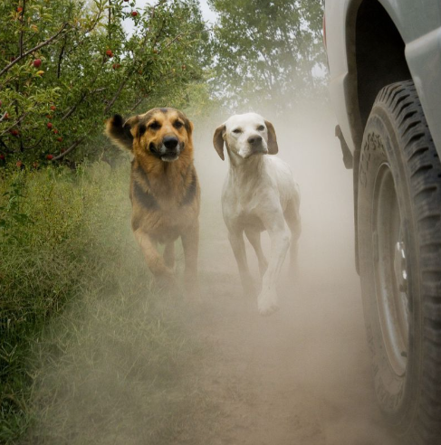

The modal action pattern (MAP) engages the central nervous system (CNS) initially, but once triggered, it operates independently of the CNS. Once released, the MAP continues until completion in the absence of additional stimuli. This characteristic of MAP contributes to simplifying dog training, making it more straightforward to teach new tricks or tasks, as the pattern persists through its course without the need for continuous CNS involvement (Maes et al., 2008).
Picture 1- Modal Action Patterns (MAP)
Around ten thousand years ago, early humans domesticated dogs for hunting purposes, using them alongside arrows to injure prey from a distance. Dogs were relied upon to track and chase the wounded animal until it fell. This historical hunting behavior has left a lasting modal action pattern in the dog's brain. Even today, dogs, particularly those with a high prey drive, may perceive vehicles as moving prey due to similarities in speed and sound. This can trigger a chase response in dogs, showcasing the persistence of ancient hunting instincts in their behavior (Maes et al., 2008).
3.0 ENDOCRINOLOGY OF BEHAVIOR
Hormones play a significant role in shaping the feeding and reproductive behavior of dogs, with specific sets of hormones jointly determining particular behaviors. Notably, hormones like ACTH, cortisol, vasopressin, and adrenaline are released during both acute and chronic stress situations. Stress hormones, particularly cortisol, are responsible for triggering the fight or flight response in dogs. Prolonged exposure to chronic stress can result in adverse psychological effects such as anxiety, panic, phobias, and depression, underscoring the profound impact of hormonal influences on canine behavior (Kozlovsky et al., 2008).
Table 1- Hormonal Effects on Behavior and Physiology in Dogs and Humans
HORMONES | EFFECTS
Oxytocin and Vasopressin | Reproductive behavior and calming on dog.
Prolactin | Infant-parent bonding
Testosterone | Sexual responsiveness and aggression.
Hypothyroidism | Lethargy, cold intolerance, exercise intolerance, and decreased libido.
(Snowdon and Ziegler, 2015)

4.0 BEHAVIORAL GENETICS
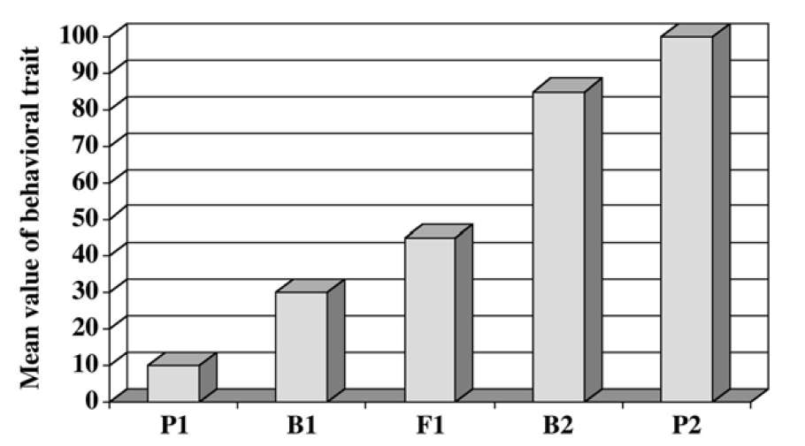
Genes serve as carriers of genetic information, containing codes for RNA and protein products that influence individual performance. The impact of genes on dog behaviors was distinctly illustrated through breeding experiments, highlighting the pivotal role genetic factors play in shaping the behavioral traits of dogs.
Graph 1- Mean value of behavioural trait
In an experiment conducted to investigate genetic influences on behavior, two distinct parental populations (P1 and P2) with different behaviors were studied. The offspring (F1) resulting from the crossbreeding of P1 and P2 exhibited behavior intermediate to that of the parents. Further back-crossing of the F1 generation to either P1 or P2, producing B1 and B2 respectively, continued to yield offspring with behaviors intermediary to their respective parental populations. This series of experiments strongly supports the conclusion that behavior is under genetic control, as the traits consistently exhibited an intermediary pattern across generations (Mackenzie et al., 1986).
Table 2-MEDICAL CAUSES OF BEHAVIORAL PROBLEMS

Metabolic/Endocrine | Types of Behavioral Problems
Pain | Decreased activity, restlessness, vocalization, house soiling, aggression.
Gastrointestinal | Licking, polyphagia, coprophagia, house soiling, tongue rolling.
Ovarian and testicular tumors | Males- Aggression, marking, mounting  Females- Nesting or possessive aggression of objects
Hepatic or renal encephalopathy | Epilepsy, anxiety, aggression, house soiling, restlessness, increased sleep.
Dermatologic | Psychogenic alopecia, acral lick dermatitis, Nail biting, hyperesthesia.
(Camps et al., 2019)

5.0 BEHAVIORAL DISORDERS
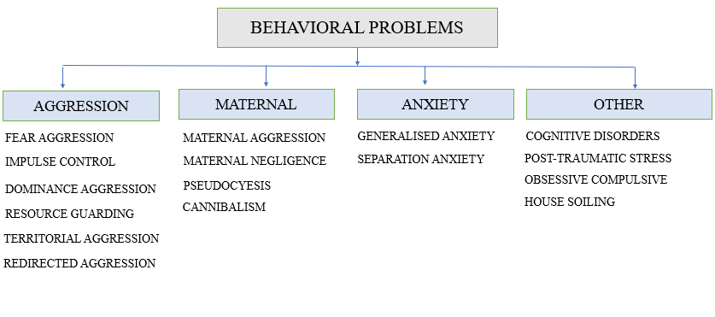
Picture 2- BEHAVIORAL DISORDERS
5.1 Aggression Related Behavior Problems
Most encountered behavioral problems are aggression related. They are of five types like Fear Aggression, Impulse Control Aggression, Dominance Aggression, Territorial Aggression, Redirected Aggression, Resource Guarding.
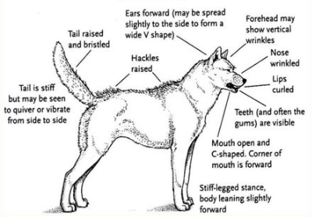
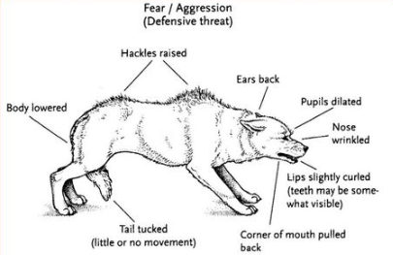
To explore behavioral problems related to aggression in dogs, it is essential to initially comprehend how dogs’ express aggression. Aggression in dogs manifests through two primary types of body postures: 1) Defensive Aggressive Posture and 2) Offensive Aggressive Posture.

Picture 4-Offensive Aggressive Posture

Picture 3-Defensive Aggressive Posture
Defensive aggressive posture: - Dog's attempt to escape from a perceived threat. This posture is marked by a tucked tail, visible teeth, ears pulled backward, slightly curled lips, a lowered body stance, and dilated pupils. In this defensive stance, the dog exhibits a combination of physical cues that signal its discomfort and intention to retreat from the potential danger (Radosta, 2023).
Offensive aggressive posture: - In this situation, a dog attempts to retaliate against a perceived threat. This aggressive posture is characterized by a raised and stiff tail, curled lips, forward ears, visible teeth and gums, a forward-leaning body, and stiff legs. The dog, in this defensive stance, exhibits a combination of physical indicators signaling its readiness to confront and respond aggressively to the perceived challenge or danger (Radosta, 2023).
5.1.1 Fear aggression
This behavior manifests in situations that instill fear in a dog. The causes include insufficient socialization, traumatic experiences, and a lack of training. Initially, fearful dogs attempt to avoid the perceived threat, but aggression may arise when escape is not possible. An offensive posture becomes predominant in such instances. Additionally, when animals learn that aggression is effective in eliminating threats, they may display aggressive behavior even when there is no immediate threat (Diverio et al., 2008).
.


Fig 4. Dog Showing Fear Aggression

5.1.2 Impulse control aggression
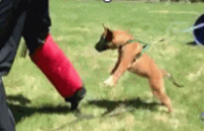
This behavior stands in stark contrast to fearful aggression. Fearful dogs tend to increase the distance between themselves and a perceived threat, whereas dogs exhibiting impulse control aggression decrease the distance. They approach the threat and retaliate, with an offensive posture being predominant. This behavior contributes to an escalation of their anxiety levels (Sueda and Malamed, 2014).

Fig5-. Dog Showing Impulse Control Aggression

5.1.3 Dominance Aggression
This type of aggression is directed towards family members, whether they be people or other dogs. In this scenario, the dog engages in conflict to establish a higher hierarchical position within the family. An offensive aggression posture typically prevails. The root cause is often attributed to inadequate socialization and training. Management strategies involve implementing proper training techniques and, in some cases, utilizing medications from the Azapirone group to address the behavioral issues effectively (Landsberg et al., 1998).
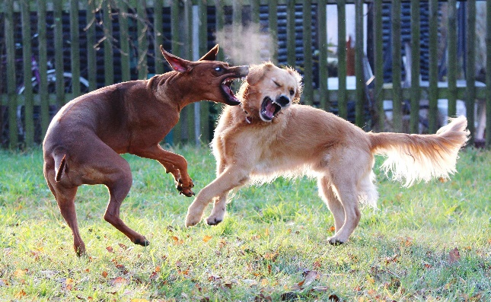

Fig6- Dog Showing Dominance Aggression
5.1.4 Redirected Aggression
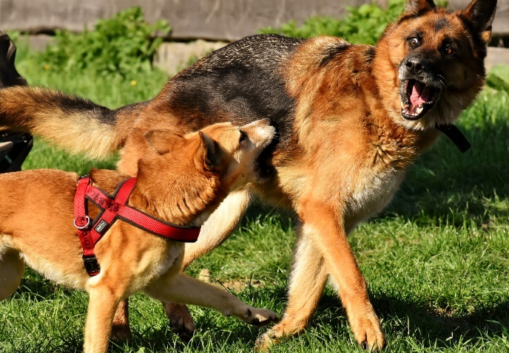
This behavior occurs when a dog experiences excessive arousal, stemming from excitement, frustration, or stress. Unable to direct its energy towards the intended target, the dog may instead attack a third party, with the victim being the closest available target, whether it be a dog or a human. Treatment for this issue involves avoiding over-arousal situations, implementing proper house training, and, in some cases, utilizing Benzodiazepines as part of the intervention strategy (Lynn and Malamed, 2014).

Fig 7-. Dog Showing Redirected Aggression

5.1.5 Territorial aggression
Territorial aggression is directed towards the same species and typically involves the owner's house, yard, and possibly the space in and around a vehicle or crate. Defensive body postures predominate in such instances, and the behavior may include actions such as chasing, growling, barking, or biting (Lynn and Malamed, 2014).
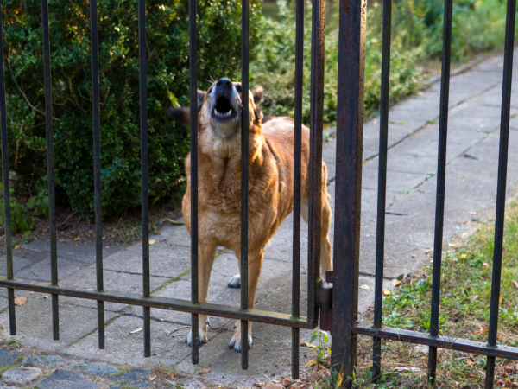

Fig 8. Dog Showing Territorial Aggression

5.1.6 Resource Guarding
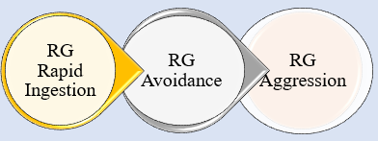
Certain dogs exhibit possessiveness towards resources, including a food bowl, bone, favorite person, toy, or resting area. Causes of this behavior may stem from past unfavorable experiences or unfulfillment of basic needs. Three distinct patterns of this possessive behavior seem to exist. Effective management strategies involve desensitization techniques to address and modify this possessive behavior in dogs.

Picture 5- Resource Guarding
Resource guarding in dogs manifests in three distinct patterns. The first is RG Rapid Ingestion, where the dog quickly consumes its favourite food items to prevent them from being consumed by other dogs. The second pattern is RG Avoidance, where the dog strategically positions its head or body to maintain control over the resource. Resource guarding aggression in dogs shows aggressive behaviors aimed to protect valuable possessions such as food, toys, or resting areas (Jacobs et al., 2018).

5.2 Maternal Behavior Problems
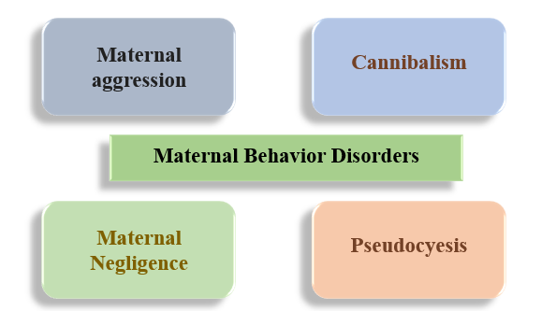
Maternal behavior problems can be classified into four types: the first being Maternal aggression, the second involving cannibalism, the third identified as Maternal Negligence, and the fourth recognized as pseudocyesis (Lezama et at., 2019).
Picture 6- Maternal Behavior Problems

5.2.1 Maternal Aggression
Immediately after whelping, a dog may exhibit aggression directed towards anyone approaching the nest, the puppies, or objects perceived as puppies. Various causes contribute to this behavior, including pain, as observed in conditions like Mastitis and Metritis, anxious or immature dams (primiparous), an unstable social environment, a low level of oxytocin, stress, and fear. This aggressive tendency tends to diminish gradually as the puppies grow up and become less dependent on the dam (Lezama et at., 2019).
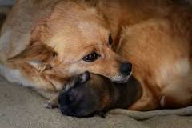

Fig 9-. Dog Showing Maternal Aggression
5.2.2 Cannibalism
This behavior, where the dam consumes her offspring after killing them, may occur inadvertently, especially during the process of cutting the umbilical cord. Several contributing factors to this disturbing behavior include pain associated with conditions like mastitis and eclampsia, the strain of having a large litter, heightened stress levels, the presence of defective offspring, and the impact of a suboptimal environment. Cannibalism in dams is notably influenced by physiological factors, such as a low level of blood cholesterol (<120 mg/dl) and oxytocin (<5.5 ng/ml). These imbalances in biological markers can further exacerbate the tendency for the dam to engage in cannibalistic behavior (Lezama et at., 2019).
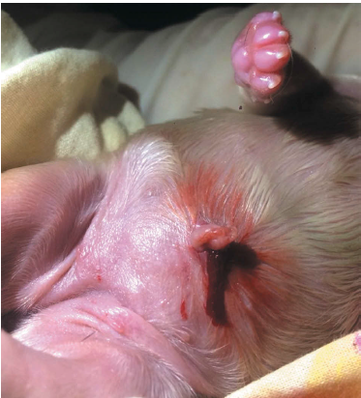

Fig 10. Primiparous dam pulls too much the umbilical cord this may cause evisceration or inclusive cannibalism.

5.2.3 Maternal Negligence
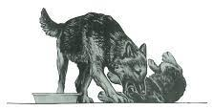
Primiparous dogs are often considered less proficient as mothers. The causes of this phenomenon include factors such as anxious dams giving birth to premature litters, puppies born through a cesarean section, and an unfavorable environment. Morbidities such as Mastitis, Metritis, Eclampsia, and stressing factors like overcrowding and large litters also contribute to

Fig 11. Dog Showing Maternal Negligence

their challenges. Additionally, a low level of oxytocin is identified as a factor in their maternal difficulties. It is noteworthy that many of these dams tend to become more adept mothers with subsequent litters (Lezama et at., 2019).
5.2.4 Pseudocyesis
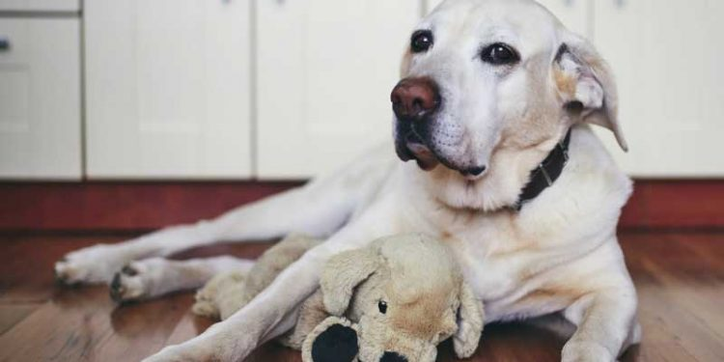
Non-pregnant dogs undergo similar hormonal changes as pregnant ones. At the end of diestrus, progesterone levels decline, and prolactin levels rise. The causes of these hormonal fluctuations include medical conditions such as pyometra, ovarian cysts, and endometritis. Symptoms of these hormonal changes in non-pregnant dogs may include mammary development, milk production, nest construction, aggression, and the adoption of inanimate objects as if they

Fig 12. Dog Showing Pseudocyesis

were their puppies. Treatment options involve administering Tab. Cabergoline at a dosage of 0.5 mcg/kg/day or pursuing surgical intervention through ovariohysterectomy (Lezama et at., 2019).
5.3 Anxiety Related Behavior Problems
Anxiety-related behavior disorders include separation anxiety disorder and generalized anxiety disorder.
5.3.1 Separation Anxiety
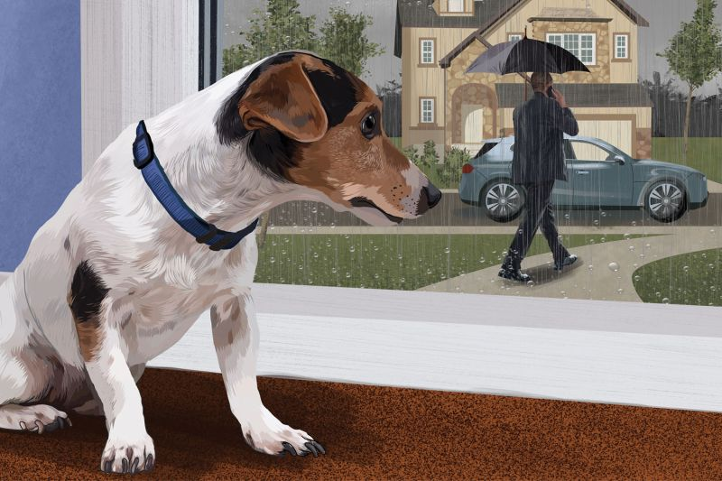
Separation anxiety in a dog occurs when it is separated from its owners or confined to interactions solely with other dogs. Various causes contribute to this condition, including being left alone at home, a change of ownership, the loss of a family member, and alterations in the family routine. The symptoms of separation anxiety include a strong inclination to follow the owner throughout the entire house, excessive vocalization, destructive behavior, restlessness, inappropriate defecation, urination, and attempts to escape (Schlehahn, 2008).

Fig 13. Dog Showing Separation Anxiety

5.3.2 Generalized Anxiety Disorders
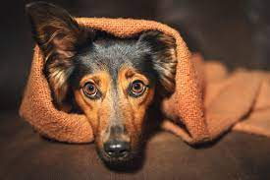

Dogs exhibiting constant signs of anxiety and worry, irrespective of the situation, may be experiencing Generalized Anxiety Disorder (GAD). The causes of GAD include genetic predisposition, environmental factors, and early life experiences such as poor socialization, low-quality nursing care, and negative encounters during puppyhood. Symptoms of GAD manifest as 2 to 3 months of chronic anxiety, characterized by trembling, vocalizing, urinating, defecating, salivating, hiding, and destructiveness. Treatment for GAD often involves the use of Azapirone, selective serotonin reuptake inhibitors, coupled with behavior modification techniques (Haq et al., 2017)

Fig 14. Dog Showing Anxiety

Fig 15. Dog Showing Anxiety

5.4 Other Common Behavior Problems
Other common behavior problems in dogs encompass Post-Traumatic Stress Disorder (PTSD), Obsessive-Compulsive Disorder (OCD), Canine Cognitive Disorders, Noise phobia, and Destructive behaviors.
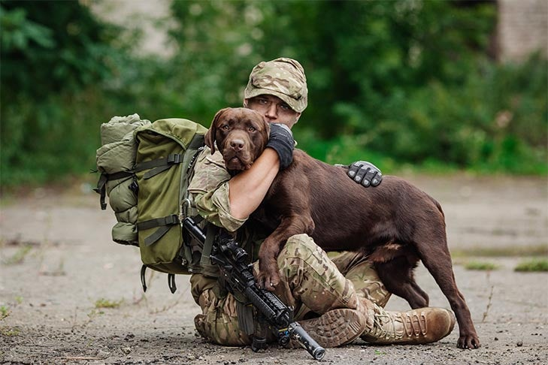
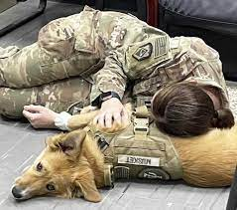
5.4.1 Post-Traumatic Stress Disorder (PTSD)
Military dogs, by nature of their exposure to intense and often traumatic events, are prone to developing Post-Traumatic Stress Disorder (PTSD). This can result from personal attacks, natural or man-made calamities, tragedies, or the rigors of military combat. Recognizable symptoms of PTSD in these dogs include chronic anxiety, hypervigilance, avoidance of specific
Picture 8- Military dogs Post-Traumatic Stress Disorder (PTSD)
people, places, or situations, sleep disturbances, fear of being alone, diminished interest in once-favored activities, and, in some cases, displays of aggression (Haq et al., 2017).
It's noteworthy that military canines, once exposed to combat, may exhibit a refusal to engage in work. To manage PTSD in these heroic animals, a combination of Benzodiazepines and behavior modification techniques is often employed (Haq et al., 2017).
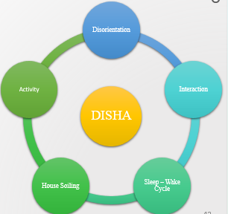

Picture 9- DISHA and Associated Behavioral/Functional Areas

5.4.2 Obsessive Compulsive Disorder (OCD)
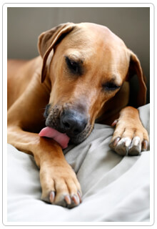
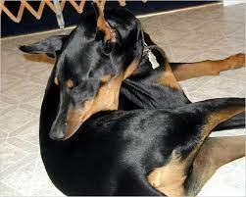
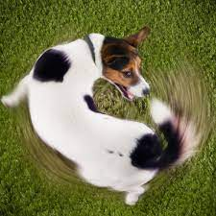
Obsessive-Compulsive Disorder (OCD) in dogs is characterized by the intense engagement in unusual activities, preventing the display of natural behaviors. The involvement of Chromosome 7 in the brain's hippocampus is identified as a key factor contributing to OCD in dogs. Effective management of this disorder entails employing behavioral modification strategies and implementing environmental enrichment practices. These approaches aim to address the root causes and provide a more balanced and fulfilling environment for the dog. implementing environmental enrichment practices. These approaches aim to address the root causes and provide a more balanced and fulfilling environment for the dog (Haq et al., 2017).
5.4.3 Canine Cognitive Disorders
Age-related changes in cognitive ability occur, marked by the presence of ß-amyloid plaque deposits in the brains of older dogs. This phenomenon affects crucial brain regions such as the hippocampus, cerebral cortex, and limbic system, leading to neuronal loss and cortical atrophy.
Picture 10- Canine Cognitive Disorders
The severity of Canine Cognitive Dysfunction (CCD) is directly linked to the amount of ß-amyloid present. Various factors contribute to the development of CCD, including ventricular dilation, thickening of meninges, vascular changes, decrease in cerebral volume, and an increase in oxidative stress.
Addressing these issues, the suggested treatment involves the use of Acetylcholinesterase inhibitors, specifically Rivastigmine, administered at a dosage of 6mg per dog per day. Additionally, L-serine, recognized as a neuroprotective agent, plays a role in managing and mitigating the effects of CCD. These interventions aim to enhance cognitive function and alleviate the impact of age-related cognitive decline in older dogs.
Canine Cognitive Dysfunction (CCD) in dogs manifests through five distinct types, conveniently encapsulated by the acronym DISHA:
- Disorientation:
  - Getting lost within the confines of the house or yard.
  - Standing at the wrong door or an incorrect part of the door when attempting to go out.
- Impairment in Social Interaction:
  - Decline in greeting owners.
  - A noticeable change, be it an increase or decrease, in following owners around the house.
- Sleep-Wake Cycle:
  - Regularly waking the owner at night through pacing or vocalizing.
  - Sleeping less during nighttime hours.
- House Soiling:
  - Initiation of urinating or defecating within the house.
- Activity:
  - Fluctuations in activity levels, either an increase or decrease.
  - Engaging in aimless wandering.
(Mihev and Majdic, 2019)
5.4.4 Noise Phobia
Causes of anxiety in pets encompass a range of stimuli, including the noise of gunshots, firecrackers, thunderstorms, and even the sounds of birds. Additionally, changes in barometric pressure, lightning, electrostatic disturbances, and the scents associated with storms can contribute to these issues. The diverse array of triggers highlights the complexity of factors influencing anxiety in animals.
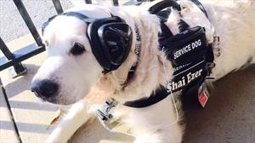
The symptoms exhibited by pets experiencing anxiety include panting, shaking, urination, defecation, salivation, hiding, escape attempts, and attention-seeking behaviors. These signs collectively underscore the diverse ways in which anxiety can manifest in pets.
Picture 11- Noise Phobia
To address and manage anxiety in pets, various strategies can be employed. These include desensitization techniques, sound masking, and the administration of Tab. Clomipramine at a dosage of 3 mg/kg/day until the signs of anxiety resolve. This multi-faceted approach aims to alleviate the impact of anxiety triggers and enhance the overall well-being of the affected animals (Michelazzi et al., 2015).
5.4.5 Destructive behaviors
Many of the destructive behaviors, including chewing, stealing, garbage raiding, and digging, are normal exploratory behaviors that arise when the dog is unsupervised and not otherwise engaged in more desirable activities. these behaviors do not arise when the owners are home. Some dogs engage in destructive behaviors because of anxiety (eg, separation anxiety, confinement, noise phobias (Lindell et al., 1997).


5.5 Elimination Behavioral Problems

Fig 16. Dog Showing Destructive Behavior

5.5.1 Housesoiling:

Dogs may soil in inappropriate locations because of inadequate or insufficient training, as a marking behavior, or cognitive dysfunction. This requires the owner to accompany the dog to its elimination area (eg, outdoors), and return the dog to its elimination site at appropriate intervals. When the owner is not able to supervise, a combination of scheduling (ensuring that the dog eliminates before departure and having someone return to take the dog to its elimination area) (Yeon et al., 2017).

Fig 17. Dog Showing House Soiling

5.5.2 Marking Behavior:
Although marking is most often seen in intact males as a form of social and olfactory communication, it is also seen in females (especially when in heat) and in neutered males and females, some dogs will mark when they visit unfamiliar (McGuire and Bemis, 2017).
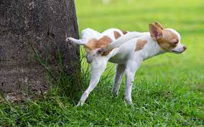
Households, especially when another dog’s odor is present. Neutering intact males will reduce the behavior, and good supervision can prevent or inhibit most marking.
Picture 12- Marking Behavior
5.5.3 Excitement, Submission, and Conflict-related Elimination:
Dogs may eliminate when they are overly excited, such as when greeting people. Some dogs will urinate when showing submissive postures (eg, crouching to the ground or turning over to expose the belly) or when highly aroused (Luescher, 2014).
6.0 DIAGNOSIS
6.1 History: -
A comprehensive and detailed history, encompassing both medical and behavioral aspects, serves as the primary diagnostic tool in behavior cases. This history should include crucial information such as the sex, breed, and age of the animal, considering that certain problems may exhibit breed predispositions. Additionally, key details such as the age at onset of the condition or complaint, the duration of the condition or complaint, the frequency of the behavior (whether it occurs hourly, daily, weekly, or monthly), any observed changes in the intensity of the behavior, and a thorough 24-hour schedule of both the animal and the owner are essential components for accurately diagnosing behavioral disorders. This meticulous approach to gathering information ensures a comprehensive understanding of the case and aids in formulating an effective diagnostic and treatment plan (Stelow et al., 2018).
6.2 Canine Behavioral Assessment and Research Questionnaire (C-BARQ)
The C-BARQ, an online tool developed by the University of Pennsylvania, serves as an effective means for evaluating behavioral problems in dogs. The current version comprises 100 items, categorized into 14 sub-scales, designed to assess various aspects of a dog's behavioral responses. Owners are required to rate their dogs' behaviors on a series of 5-point frequency scales, ranging from 0 (indicating "never") to 4 (indicating "always"), or in terms of intensity, with 0 representing "no sign of the behavior" and 4 indicating a "severe form of the behavior.
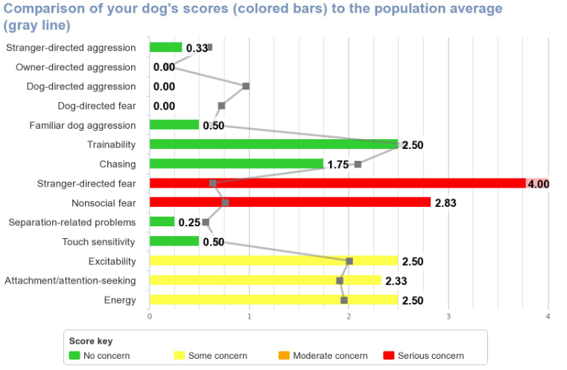
picture 13- Behavioral Profile Assessment Summary
Upon collecting these ratings, the tool generates a bar diagram featuring a control line, represented by a gray line. Diagnosis is then determined based on the population mean, and in instances where the red bars surpass the control line, it suggests that the dog is exhibiting stranger-directed aggression. This visual representation facilitates a clear understanding of the behavioral patterns and aids in identifying potential issues for further evaluation and intervention (Broseghini et al. 2023).
6.3 Safety Assessment for Evaluating Rehoming (Safer)
The SAFER (Safety Assessment for Evaluating Rehoming) test is a behavioral assessment commonly used in animal shelters to evaluate the behavior of dogs. This test aims to assess a dog's temperament, reactions, and behavior in various situations to determine its suitability for adoption
and identify any potential behavior challenges. Here's an overview of the components typically included in a SAFER test for dogs:
picture 14-
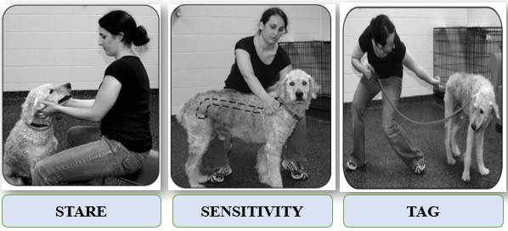
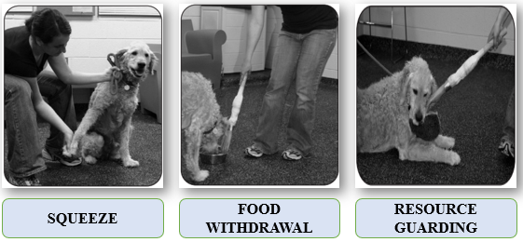
- Stare: This assesses the dog's reaction when gently restrained and subjected to soft, direct eye contact from a stranger.
- Sensitivity: This evaluates the dog's responsiveness to touch, determining its level of touch sensitivity.
- Tag: This examines the dog's reaction to stimuli involving movement and sounds.
- Squeeze: This evaluates the dog's sensitivity response, assessing bite inhibition and its acceptance of being touched in a mildly controlled and potentially unpleasant manner.
- Food Withdrawal: This is employed to identify any signs of food aggression in the dog.
- Resource Guarding: This component of the assessment aims to evaluate the dog's behavior concerning food, toys, or other resources. (Patronek et al., 2019)
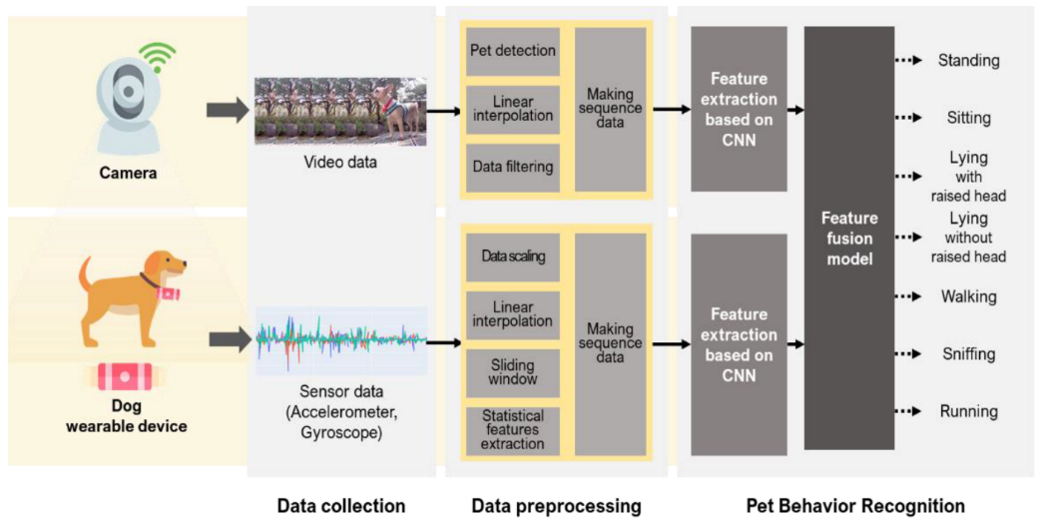
6.4 Technology Integration
Picture 15- Multimodal Pet Behavior Recognition System using Video and Sensor Data
Modern advancements in technology have introduced valuable diagnostic tools for understanding and addressing behavioral issues in dogs. Among these tools are video cam recorders and innovative dog wearables like smart collars and harnesses. These devices provide a more in-depth and comprehensive approach to behavioral assessments (Kim et al., 2022).
  - Biomarkers
Cortisol Level: Elevated levels of cortisol, indicative of a response to chronic stress, are associated with anxiety in dogs (Ryan et al., 2023)
Serotonin: Dogs exhibiting impulse control aggression often show a decrease in the cerebrospinal fluid (CSF) concentration of the serotonin metabolite 5-hydroxyindoleacetic acid (5-HIAA) (Riggio, 2021).
Oxytocin and Vasopressin: The presence of behavioral problems such as separation anxiety or socialization issues is associated with fluctuations in oxytocin and vasopressin levels (MacLean, 2017).
7.0 TREATMENT
The primary objective of treating any behavioral disorder is to modify the problematic behavior effectively. In cases where behavior problems are addressed through behavior modification alone, it is essential to consider the comprehensive approach that involves treating any concurrent diseases and potential surgical interventions like castration or neutering. However, it is crucial to note that successful intervention goes beyond these measures. Environmental management, coupled with appropriate behavior modification strategies, should always be integrated with any medication-based approaches. This comprehensive approach ensures a more holistic and effective treatment for behavioral disorders, addressing not only the immediate behavioral issues but also considering the broader context of the individual's well-being (Keerthana et al., 2022).
7.1 Pharmacological Intervention
7.1.1 Selective Serotonin Reuptake Inhibitors
Addressing anxiety, aggression, and compulsive disorders in dogs is crucial for ensuring their well-being. Notably, these behavioral challenges can be effectively managed with certain medications (Ogata et al., 2019).
Fluoxetine, prescribed at a dosage of 1–2 mg/kg orally once daily, has gained approval from the Food and Drug Administration (FDA) for its efficacy in treating separation anxiety specifically.
Paroxetine, administered at 1 mg/kg orally once daily, and

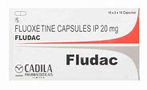
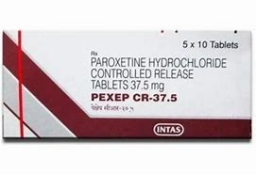
Sertraline, recommended at 2–4 mg/kg orally once daily or divided into two doses, are also recognized for their effectiveness in addressing these behavioral issues.
Picture 16- Pharmacological Intervention
7.1.2 Tricyclic Antidepressants
Employed in the treatment of anxiety, aggression, and compulsive disorders in dogs,
Amitriptyline is administered at a dosage of 1–2 mg/kg orally every 12 hours.
Clomipramine, recognized and FDA-approved for addressing separation anxiety in dogs, is prescribed at a dosage of 3 mg/kg every 12 hours.
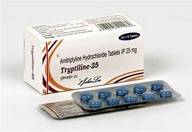

These medications, with their specified dosages, play a vital role in managing canine behavioral issues effectively (Crowell and Murray, 2006).
Picture 17- Tricyclic Antidepressants
7.1.3 Azapirones
Buspirone @ 1 mg/kg PO q8 – 24h (mild anxiety); 10 – 15 mg per dog PO (severe anxiety, thunderstorm phobia) (Dantas and Radosta, 2023).
7.1.4 Monoamine Oxidase Inhibitor
Selegiline is prescribed at a dosage of 1 mg/kg orally once daily.
Clinical reevaluation is recommended over the next two months, and if there is no observable improvement, the dosage may be escalated to 2 mg/kg once daily. It is crucial to note that Selegiline should not be combined with serotonin reuptake inhibitors or tricyclic drugs due to the potential for adverse drug interactions (Dantas and Crowell, 2019).
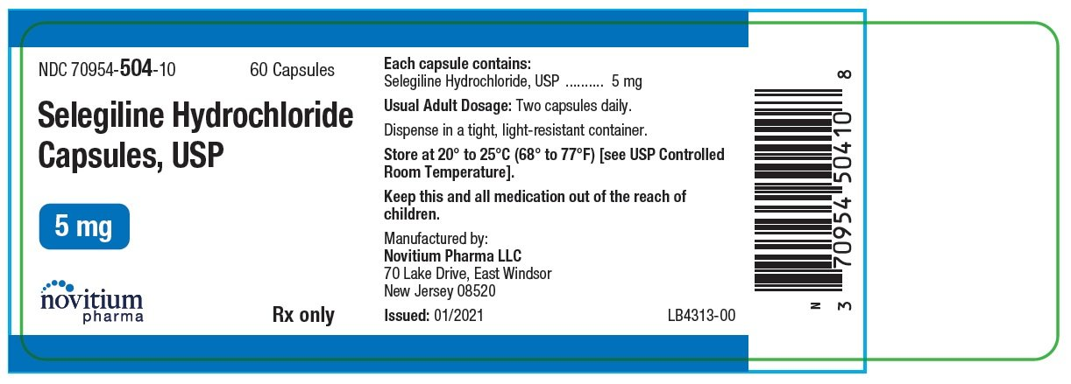

Picture 17- Monoamine Oxidase Inhibitor
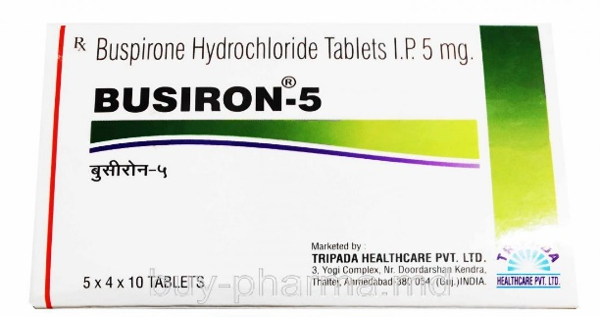
Picture 18- BUSIRON-5 Medication Information
7.1.5 Benzodiazepines
Alprazolam and Diazepam are utilized in the management of specific canine behavioral issues (Overall, 2019).
Alprazolam is employed to address thunderstorm and noise phobia, as well as general anxiety, with a recommended dosage of 0.01–0.1 mg/kg orally as needed for panic, ensuring not to exceed 4 mg per dog per day.

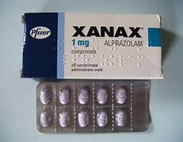
Diazepam is prescribed for separation anxiety and noise phobia, with a dosage range of 0.5–2.2 mg/kg orally as needed.
Picture 19 Benzodiazepines
7.2 Endocrine Management
Spaying dogs experiencing pseudopregnancy is a common practice, and in cases where this condition arises,
Cabergoline is employed to terminate the pseudopregnancy.
The resolution of hypothyroidism is achieved by either correcting the thyroid level or administering levothyroxine as part of the treatment.
Diabetes-related changes necessitate insulin supplementation to manage the condition effectively. In instances of maternal behavior problems, the hormone Oxytocin is utilized as an intervention (Beach, 1975).
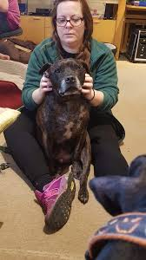
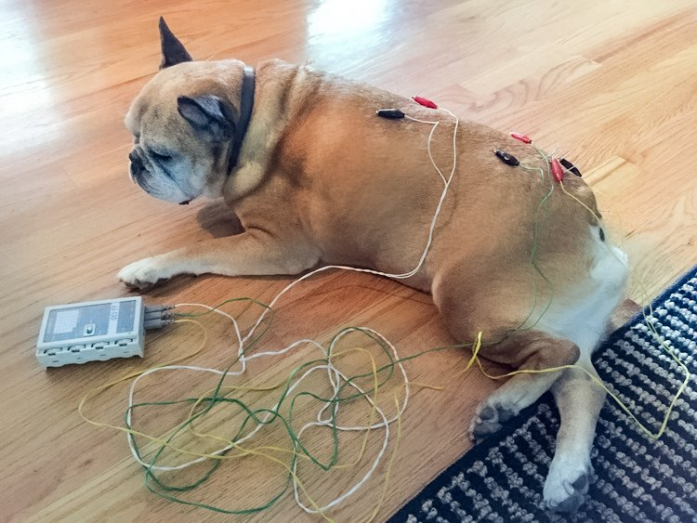
7.3 Pain management: - Pain management plays a crucial role in addressing behavioral disorders in dogs, with one-third of cases attributed to pain-related issues. Various causes contribute to such discomfort, including hip dysplasia, arthritis, intervertebral disc disease, and chronic otitis. The introduction of nonsteroidal anti-inflammatory drugs (NSAIDs) and opioids has significantly enhanced the potential for reducing pain in affected dogs. Additionally, alternative therapies such as acupuncture, magnetic therapy, physiotherapy, and the Tellington-Touch method offer additional avenues for managing pain and promoting overall well-being in canine patients
Fig 18. Acupuncture for Pain Management
Fig 19. Tellignton Touch

(Mills et al., 2020).
Analgesics are vital in managing pain in dogs, and various medications are employed for this purpose.
Butorphanol, administered at a dosage of 0.4 mg/kg three times a day subcutaneously, serves as an effective pain-relieving option.
Fentanyl, provided at a rate of 25 µg/h intravenously, offers another avenue for pain management.
Prednisolone, prescribed at a dosage of 0.2 mg/kg twice a day orally, addresses pain and inflammation.
Nonsteroidal anti-inflammatory drugs (NSAIDs) such as Carprofen, Ketoprofen, and Meloxicam further contribute to pain relief through their anti-inflammatory properties (Epstein et al., 2015).
Picture 20- nonsteroidal anti-inflammatory drugs (NSAIDs) and opioids
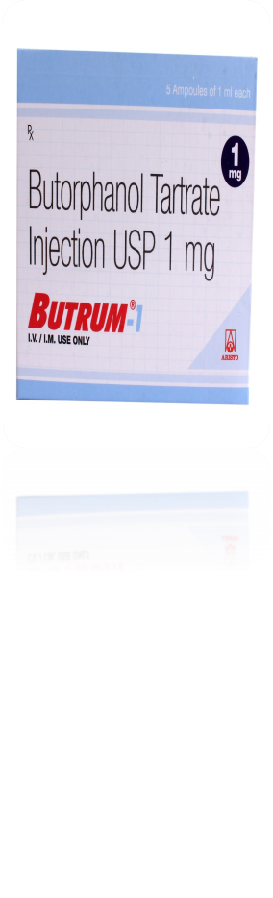
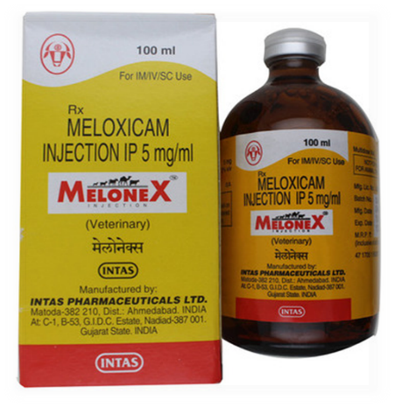
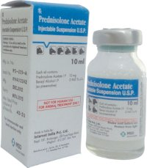

7.4 Dietary management
Amino acids play a crucial role as precursors in the synthesis of neurotransmitters and hormones. For instance, Tryptophan serves as a precursor for serotonin, a neurotransmitter associated with mood regulation. Changes in the levels of amino acids such as tryptophan and tyrosine are likely to exert an influence on behavior due to their role in neurotransmitter production. Diet rich in high protein and fat, particularly with elevated levels of tryptophan found in sources like soybeans, is essential for promoting behavioral wellness. This underscores the significance of dietary components in shaping the availability of specific amino acids, thereby impacting the neurochemical processes influencing behavior (Tynes and Landsberg, 2021).
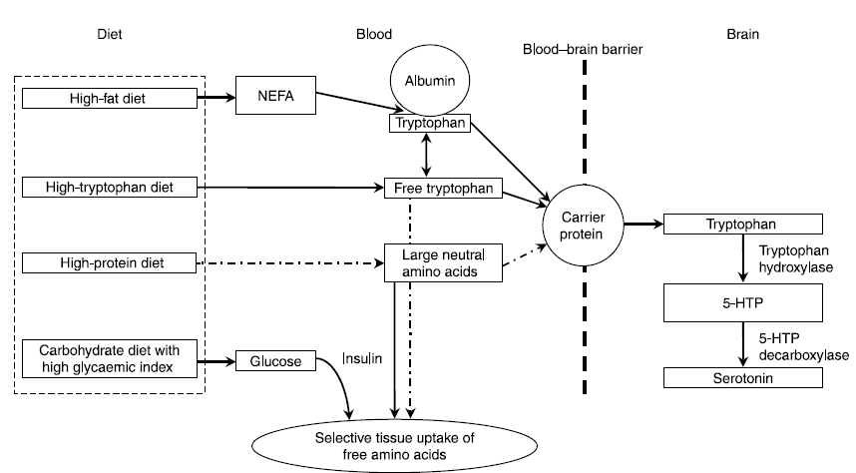
Picture 21- Dietary Regulation of Tryptophan Availability and Serotonin Synthesis in the Brain
7.5 Operant Conditioning
Operant conditioning is a type of learning process in which behavior is strengthened or weakened by the consequences that follow it. In the context of dog behavior, operant conditioning plays a significant role in training and modifying their actions. This approach, developed by B.F. Skinner, involves manipulating the consequences of a behavior to increase or decrease the likelihood of its recurrence. The process involves the following key elements:
- Reinforcement:
  - Positive Reinforcement: Involves adding something desirable to reinforce a behavior. For example, giving a dog a treat when it sits on command.
  - Negative Reinforcement: Involves removing something unpleasant to reinforce a behavior. For instance, stopping an annoying noise when the dog follows a command.
- Punishment:
  - Positive Punishment: Involves adding something unpleasant to decrease a behavior. An example could be a verbal reprimand when the dog engages in undesirable behavior.
  - Negative Punishment: Involves removing something desirable to decrease a behavior. For instance, taking away a toy when the dog exhibits unwanted behavior. (Jezierski et al., 2010)
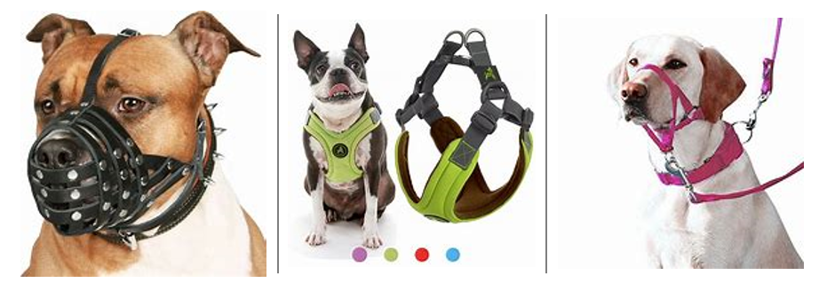
7.6 Physical aids/equipment
Fig 20. MUZZLE

Fig 21. HARNESS

Fig 22. HEAD COLLAR

Muzzles prevent biting, acral licks or ingestion of undesirable material (e.g. coprophagia).
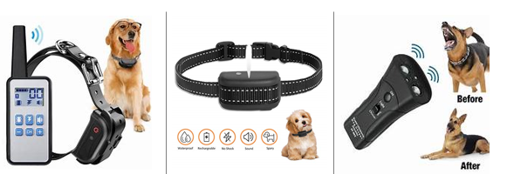
Headcollars provides a greater degree of physical control over the direction and movement of the dog’s body and harness does the same (Martin and Pear, 2019).
Fig 24. Citronella Collar

Fig 25. Us Antibark Device

Fig 23. Electric Shock Collar

7.7 Electronic training aids
Electric shock collars deliver a painful stimulus when a dog engages in inappropriate behavior, such as chasing farm livestock. On the other hand, a citronella collar sprays gas from a cylinder mounted under the dog's collar when it barks or chases a vehicle. Lastly, ultrasonic anti-bark devices operate on the principle that dogs can hear ultrasound waves, emitting a sound to discourage barking. Each of these devices serves as a tool for modifying canine behavior, employing distinct mechanisms to discourage unwanted actions through aversive stimuli or deterrents (Martin and Pear, 2019).
7.8 Dog Appeasing Pheromone
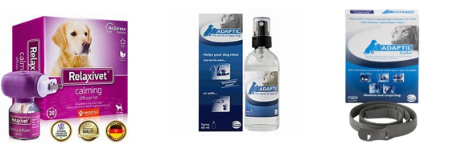
A synthetic analogue of the sebaceous secretions found in lactating female dogs, which has been shown to reduce anxiety and fear states in adult dogs, is referred to as the 'dog appeasing pheromone' (DAP). This product is accessible in the market in three distinct forms. DAP diffusers, akin to how we use mosquito repellents at home, are designed for indoor use. Additionally, DAP sprays and DAP-coated collars are also available for outdoor applications (Tod et al., 2005).
Fig 27. DAP SPRAY

Fig 26. DAP DIFFUSER

Fig 28. DAP COLLAR

8.0 CONCLUSIONS
The transformation of dogs as companions highlights a significant shift in human-canine bonds. Unwanted behavior deeply affects the well-being of both dogs and owners, often resulting in abandonment and euthanasia.
Understanding the intricate structures of a dog's brain, particularly the smaller neocortex and the primitive limbic system and endocrinal status, is pivotal in comprehending their emotional processing and behavior.
Hormones like thyroxin, oxytocin, vasopressin, testosterone and the medical causes like pain, gastrointestinal abnormality, hepatic encephalopathy and dermatologic conditions also causes behavior problems.
Commonly documented dog behavioral problems include aggression-based like redirected behaviors, impulse control deficiencies, and dominance/territorial aggression. Maternal behavior problems encompass cannibalism, puppy rejection, and pseudocyesis.
In-depth history taking, C-BARQ, the SAFER exam, biomarkers, technological integration (e.g., video recorders, smart collars), genomic analysis, laboratory results from blood and CSF analysis, and the other comorbidities are all used in the diagnosis of behavioral problems.
Pharmacological interventions such as selective serotonin reuptake inhibitors, tricyclic antidepressants, benzodiazepines, and tranquilizers, as well as behavioral modification techniques like operant conditioning, environmental enrichment, and the use of physical equipment and aids, are helpful to manage behavioral problems.
9.0 FUTURE PROSPECTS
Implementation of artificial intelligence (AI) and machine learning algorithms for analyzing behavior data and predicting patterns indicative of potential issues.
Utilizing advanced genetic testing to identify specific behavioral markers, leading to more targeted interventions.
Collaborations between veterinary behaviorists, ethologists, geneticists, and technology experts to advance understanding and treatment of behavioral problems.

COMPETING INTERESTS DISCLAIMER:
Authors have declared that they have no known competing financial interests OR non-financial interests OR personal relationships that could have appeared to influence the work reported in this paper.

References
Alcock, J. (2003). A textbook history of animal behaviour. 3-10.
Beach, F. A. (1975). Behavioral endocrinology: An emerging discipline: How hormones affect—and are affected by—behavior is a subject of increasing interest to students of human and animal behavior. American Scientist, 63(2), 178-187.
Broseghini, A., Guerineau, C., Looke, M., Mariti, C., Serpell, J., Marinelli, L., & Mongillo, P. (2023). Canine Behavioral Assessment and Research Questionnaire (C-BARQ): Validation of the Italian Translation. Animals, 13(7), 1254.
Camps, T., Amat, M., & Manteca, X. (2019). A review of medical conditions and behavioral problems in dogs and cats. Animals, 9(12), 1133.
Crowell-Davis, S. L., & Murray, T. (2006). Tricyclic antidepressants. Veterinary psychopharmacology, 179-206.
Dantas, L. M., & Radosta, L. (2023). Pharmacologic intervention in behavioral therapy. Behavior Problems of the Dog and Cat-E-Book, 193, 183.
de Souza Dantas, L. M., & Crowell-Davis, S. L. (2019). Monoamine oxidase inhibitors. Veterinary Psychopharmacology, 185-199.
Denenberg, S., Machin, K. L., & Landsberg, G. M. (2024). Behavior and Cognition of the Senior Cat and Its Interaction with Physical Disease. Veterinary Clinics: Small Animal Practice, 54(1), 153-168.
Dinwoodie, I. R., Dwyer, B., Zottola, V., Gleason, D., & Dodman, N. H. (2019). Demographics and comorbidity of behavior problems in dogs. Journal of Veterinary Behavior, 32, 62-71.
Diverio, S., Tami, G., & Barone, A. (2008). Prevalence of aggression and fear-related behavioral problems in a sample of Argentine Dogos in Italy. Journal of Veterinary Behavior, 3(2), 74-86.
Epstein, M. E., Rodan, I., Griffenhagen, G., Kadrlik, J., Petty, M. C., Robertson, S. A., & Simpson, W. (2015). 2015 AAHA/AAFP pain management guidelines for dogs and cats. Journal of Feline Medicine and Surgery, 17(3), 251-272.
Haq, A. U. (2017). Canine psychiatry: Addressing animal psycho-pathologies. behaviour, 6(7).
Hecht, E. E., Kukekova, A. V., Gutman, D. A., Acland, G. M., Preuss, T. M., & Trut, L. N. (2021). Neuromorphological changes following selection for tameness and aggression in the Russian farm-fox experiment. Journal of Neuroscience, 41(28), 6144-6156.
Jacobs, J. A., Coe, J. B., Pearl, D. L., Widowski, T. M., & Niel, L. (2018). Factors associated with canine resource guarding behaviour in the presence of people: A cross-sectional survey of dog owners. Preventive Veterinary Medicine, 161, 143-153.
Jensen, P. (2007). Mechanisms and function in dog behaviour. The Behavioural Biology of Dogs, 61-75.
Jezierski, T., Gorecka-Bruzda, A., Walczak, M., Swiergiel, A. H., Chruszczewski, M. H., & Pearson, B. L. (2010). Operant conditioning of dogs (Canis familiaris) for identification of humans using scent lineup. Animal Science Papers and Reports, 28(1), 81-93.
Keerthana, A., Srinivasan, G., Sunilchandra, U., Shridhar, N. B., Kumar, M. V., & Ravikumar, C. (2022). An overview of behavioral disorders and its therapeutic management in Dogs and Cats. Indian Journal of Veterinary and Animal Sciences Research, 51(1), 1-11.
Kim, J., & Moon, N. (2022). Dog behavior recognition based on multimodal data from a camera and wearable device. Applied sciences, 12(6), 3199.
Kozlovsky, N., Kaplan, Z., Zohar, J., Matar, M. A., Shimon, H., & Cohen, H. (2008). Protein synthesis inhibition before or after stress exposure results in divergent endocrine and BDNF responses disassociated from behavioral responses. Depression and Anxiety, 25(5), 24-34.
Landsberg, G., Hunthausen, W., & Ackerman, L. (2011). Behavior problems of the dog and cat. Elsevier Health Sciences.
Lezama-García, K., Mariti, C., Mota-Rojas, D., Martínez-Burnes, J., Barrios-García, H., & Gazzano, A. (2019). Maternal behaviour in domestic dogs. International Journal of Veterinary Science and Medicine, 7(1), 20-30.
Lindell, E. M. (1997). Diagnosis and treatment of destructive behavior in dogs. Veterinary Clinics of North America: Small Animal Practice, 27(3), 533-547.
Luescher, A. U. (2014). Canine behavior and development. Canine and Feline Behavior for Veterinary Technicians and Nurses, 30-50.
Mackenzie, S. A., Oltenacu, E. A. B., & Houpt, K. A. (1986). Canine behavioral genetics—a review. Applied Animal Behaviour Science, 15(4), 365-393.
MacLean, E. L., Gesquiere, L. R., Gee, N. R., Levy, K., Martin, W. L., & Carter, C. S. (2017). Effects of affiliative human–animal interaction on dog salivary and plasma oxytocin and vasopressin. Frontiers in psychology, 1606.
Martin, G., & Pear, J. J. (2019). Behavior modification: What it is and how to do it. Routledge.
McGuire, B., & Bemis, K. E. (2017). Scent marking in shelter dogs: effects of body size. Applied Animal Behaviour Science, 186, 49-55.
McMillan, F. D., Vanderstichel, R., Stryhn, H., Yu, J., & Serpell, J. A. (2016). Behavioural characteristics of dogs removed from hoarding situations. Applied Animal Behaviour Science, 178, 69-79.
Michelazzi, M., Berteselli, G. V., Talamonti, Z., Cannas, S., Scaglia, E., Minero, M., & Palestrini, C. (2015). Efficacy of L-Theanine in the treatment of noise phobias in dogs: preliminary results. Veterinaria Anno, 29(2), 53-59.
Mills, D. S., Demontigny-Bédard, I., Gruen, M., Klinck, M. P., McPeake, K. J., Barcelos, A. M., & Levine, E. (2020). Pain and problem behavior in cats and dogs. Animals, 10(2), 318.
Ogata, N., de Souza Dantas, L. M., & Crowell-Davis, S. L. (2019). Selective serotonin reuptake inhibitors. Veterinary psychopharmacology, 103-128.
Overall, K. L. (2019). Behavioral pharmacotherapeutics. Pharmacotherapeutics for veterinary dispensing, 377-401.
Overall, K. L., & Dunham, A. E. (2002). Clinical features and outcome in dogs and cats with obsessive-compulsive disorder: 126 cases (1989–2000). Journal of the American Veterinary Medical Association, 221(10), 1445-1452.
Patronek, G. J., Bradley, J., & Arps, E. (2019). What is the evidence for reliability and validity of behavior evaluations for shelter dogs? A prequel to “No better than flipping a coin”. Journal of Veterinary Behavior, 31, 43-58.
Prpar Mihevc, S., & Majdič, G. (2019). Canine cognitive dysfunction and Alzheimer’s disease–two facets of the same disease. Frontiers in neuroscience, 604.
Radosta, L. (2023). Canine behavior and development. Canine and Feline Behavior for Veterinary Technicians and Nurses, 34-58.
Riggio, G., Mariti, C., Sergi, V., Diverio, S., & Gazzano, A. (2020). Serotonin and tryptophan serum concentrations in shelter dogs showing different behavioural responses to a potentially stressful procedure. Veterinary Sciences, 8(1), 1.
Roxo, M. R., Franceschini, P. R., Zubaran, C., Kleber, F. D., & Sander, J. W. (2011). The limbic system conception and its historical evolution. The Scientific World Journal, 11, 2427-2440.
Ryan, E. P., & Oquendo, M. A. (2020). Suicide risk assessment and prevention: challenges and opportunities. Focus, 18(2), 88-99.
Salonen, M., Sulkama, S., Mikkola, S., Puurunen, J., Hakanen, E., Tiira, K., & Lohi, H. (2020). Prevalence, comorbidity, and breed differences in canine anxiety in 13,700 Finnish pet dogs. Scientific reports, 10(1), 2962.
Schlehahn, D. R. (2018). Separation Anxiety in Canines and Potential Mitigation Options. USURJ: University of Saskatchewan Undergraduate Research Journal, 4(2).
Seibert, L. M., & Landsberg, G. M. (2008). Diagnosis and management of patients presenting with behavior problems. Veterinary Clinics of North America: Small Animal Practice, 38(5), 937-950.
Snowdon, C. T., & Ziegler, T. E. (2015). Variation in prolactin is related to variation in sexual behavior and contact affiliation. PLoS One, 10(3), 0120650.
Stelow, E. (2018). Diagnosing behavior problems: a guide for practitioners. Veterinary Clinics: Small Animal Practice, 48(3), 339-350.
Sueda, K. L. C., & Malamed, R. (2014). Canine aggression toward people: a guide for practitioners. Veterinary Clinics: Small Animal Practice, 44(3), 599-628.
Sueda, K. L. C., & Malamed, R. (2014). Canine aggression toward people: a guide for practitioners. Veterinary Clinics: Small Animal Practice, 44(3), 599-628.
Tod, E., Brander, D., & Waran, N. (2005). Efficacy of dog appeasing pheromone in reducing stress and fear related behaviour in shelter dogs. Applied Animal Behaviour Science, 93(3-4), 295-308.
Tynes, V. V., & Landsberg, G. M. (2021). Nutritional management of behavior and brain disorders in dogs and cats. Veterinary Clinics: Small Animal Practice, 51(3), 711-727.
Wells, Deborah L., and Peter G. Hepper (2000). "The influence of environmental change on the behaviour of sheltered dogs." Applied animal behaviour science, 68(2), 151-162.
Wright, J. C., & Nesselrote, M. S. (1987). Classification of behavior problems in dogs: distributions of age, breed, sex and reproductive status. Applied Animal Behaviour Science, 19(1-2), 169-178.
Yeon, S. C., Erb, H. N., & Houpt, K. A. (1999). A retrospective study of canine house soiling: diagnosis and treatment. Journal of the American Animal Hospital Association, 35(2), 101-106.

