Effects of selected physical soil moisture conservation techniques for degraded mountainous lands rehabilitation in soil erosion-prone highland areas of Sidama Region, Ethiopia

Abstract

The rehabilitation of degraded lands can be successful and sustainable when localized evidence on the performance and effect of different soil moisture techniques is investigated. Even though national and regional conservation efforts in soil and water conservation continue, the degradation of mountainous lands continues, partly due to the lack of localized evidence on the effect and performance of different soil moisture conserving techniques. This experiment was conducted in Hulla District of Sidama Region by considering four physical moisture conserving structures (outward bench terrace, fanyajuu, stone-faced soil bund, and soil bund with three replications for three years. The study findings showed that the four experimental physical structures improved soil moisture, soil properties, and vegetation growth. Comparably highest soil moisture content of 18.04 and 13.95 % was recorded on the fields treated with outward bench terrace and stone-faced soil bund, respectively. However, the lowest percentage soil moisture content of 10.76 and 12.76 % was recorded on the field treated with soil bund and fanyajuu, respectively. Correspondingly, the highest improvement of organic carbon, organic matter, and total nitrogen percent was observed on the outward bench terrace, followed by stone faced soil bund. Furthermore, the highest tree height was observed on the Gravilia Robusta tree planted on the field treated by the outward bench terrace. But there was no significant difference among treatments with respect to the collar diameter of the tree. Farmers perceive that the outward bench terrace and stone-faced soil bund better rehabilitate the degraded land, even though the construction of the outward bench terrace requires more labor and effort than other treatments. Thus, the study strongly recommends the outward bench terrace and stone-faced soil bunds as the best techniques for degraded mountainous land rehabilitation.

Keywords: Fanyajuu bund, Land degradation, Land rehabilitation, Mountainous areas rehabilitation, Outward bench terrace, Soil bund, Soil erosion, Soil moisture conserving physical structures, Stone-faced soil bund, Tree growth, and Vegetation growth
- Introduction
  - Background and Justification

Land degradation due to soil erosion remains a major environmental, social, and economic issue in the highland areas of Ethiopia (Taddese, 2001). The parts of the Sidama region are known for their rugged topography or mountainous terrain and intensive land use, highly susceptible to soil erosion due to the nature of steep slopes, deforestation, and inappropriate agricultural activities (Bedadi et al., 2023). These issues have led to the loss of fertile topsoil, reduced land productivity, declining water availability, reduced agricultural productivity, and increased food insecurity among rural communities of the region.

Over the past years, different physical soil moisture conservation measures have been introduced and implemented in different parts of Ethiopia, including the Sidama region, to address land degradation impact and promote sustainable land use practices (Mekuriaw et al., 2018). These practices aimed to control surface runoff, trap sediments, improve soil infiltration rate, and enhance soil moisture by contributing to degraded mountainous lands rehabilitation (Sharma et al., 2023). However, the effectiveness of those practices varies significantly depending on local environmental conditions, slope characteristics, and maintenance habits (Kelbore & Nigussie, 2023).

Despite national and regional conservation efforts, the degradation of the mountainous lands of Sidama Region continues, partly due to the lack of localized evidence on the performance of different soil moisture techniques (Bayle & Muluye, 2023). Moreover, the adoption and sustainable use of these practices by farmers is often limited, which raises concerns about the long-term success of land restoration programs (Zemede & Tesfatsion, 2023). This is broadly because many soil and water conservation interventions are implemented without adequately considering local farmers’ perception, preferences, and local knowledge (Amado & Assefa, 2024). Without localized evidence, many conservation efforts risk being either insufficient or unsustainable, wasting valuable resources and labor.

To ensure successful and sustainable rehabilitation of degraded mountainous lands, it is essential to evaluate the performance of selected physical soil moisture conservation practices under real field conditions and understand how farmers perceive these practices in terms of their effectiveness, labor demand, and long-term benefits (Amare et al., 2024).

Therefore, this study is designed to evaluate and compare the effectiveness of the selected physical soil moisture conservation methods in soil erosion control and improving soil moisture condition in degraded mountainous lands; to identify the most suitable method based on its effectiveness, assess farmers' perception and acceptance of these methods, and provide insights into factors influencing adoption and long-term sustainability.

By linking scientific assessment with local farmers’ perspectives, this study will provide evidence-based recommendations for effective mountainous land restoration in erosion-prone areas of Sidama Region (Hameso et al., 2018). The findings will help policymakers, local communities, government bodies, development practitioners, and local communities in designing and implementing technically sound, socially acceptable, and context-specific soil and water conservation(SWC) interventions.

- Research Methodology

  - Description of the study area.
The experiment was conducted on degraded mountains in the highlands of Hulla District, Sidama Region. The specific name of the experimental site is named as Gatema kebele, as shown in Figure 1. The district covers 160.95km². The total population of the Hulla district is 106,110, of whom 53,086 are male and 53,023 are female (CSA, 2021). Hulla district is geographically located at a latitude of 6.415-6.555 and a longitude of 38.448-38.648 with an altitude of 2058 to 2884m above sea level. It is located 90 km far in southeast of the regional capital city of Hawassa and 370km far in south of Addis Ababa, the capital city of Ethiopia. The study area map was sketched using Arc GIS 10.8 using shape files from the Ethiopian Mapping Agency (ema.gov.et). Based on the data obtained from the National Meteorological Agency (NMA), the mean annual rainfall (mm) was 1441.9 mm. The mean annual temperature of the district was 13.7 °C. The area has Dystric Nitisol soil types. A crop production system is mainly a rain-fed and subsistence system. The main annual crops cultivated in the area are wheat, barley, potato, faba bean, maize (Zea mays), and haricot bean.
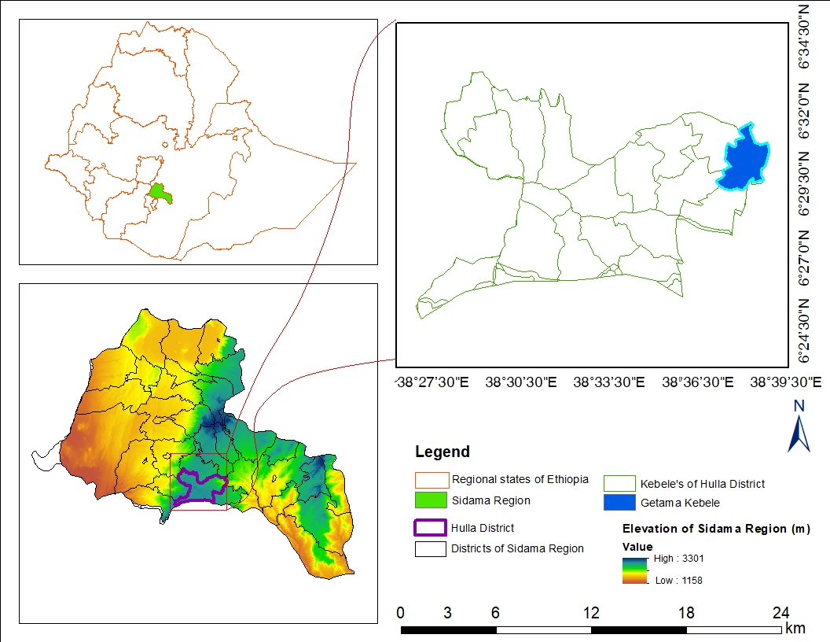
Figure1. Geographic map of the study area
  - Experimental method
The trial was conducted over three years. First year, the following tasks, like degraded mountainous site selection, soil samples collection before the trial for the soil physicochemical properties analysis, physical structures construction, Gravelia Robusta tree seedlings collection, and planting were performed. Soil moisture and bulk density data were collected at each 3-month interval using a core sampler starting from the construction of the structures till the end of the experiment. The data, including tree height, collar diameter, newly emerged plant species, soil samples after the trial, laboratory analysis, newly emerged species identification, and farmer’s perception data collection tasks, were performed in the second and third years.

  - Experimental Design
The trial evaluated four treatments as shown in Table 1. Each treatment was replicated three times using RCBD (Randomized Complete Block Design). The Gravilia Robusta test tree was planted below the excavated ditch and embankment of Fanyajuu, soil bund, and stone-faced soil bund. But, in the case of the outward bench terrace, the seedlings were planted on the prepared table. The vertical interval between the structures was determined based on the slope of the site. The length of each structure was excavated in each ten meters.
Table 1. Treatments of the experiment and their description
No. | Treatments | Description
1. | Outward bench terrace | A flat, gently sloping platform (bench) constructed on hillside or steep slope lands, which extends outward from the main slope or structure, forming a terrace-like surface.
2. | Fanayajuu | An embankment or bund is constructed along the contour lines of a slope. The soil excavated from the channel downslope and thrown uphill (juu) to form a raised bund or terrace.
3. | Stone-faced soil bund | Soil embankment is built along the contour lines of a slope, with stone placed on the outer side to protect the embankment from collapse.
4. | Soil bund | Soil embankment is built along the contour lines of a slope. The soil excavated from the channel was thrown to the downside.

  - Soil moisture, selected soil properties, tree height, collar diameter, and farmer’s perception.
The soil samples were collected at each 3-month interval using a core sampler to evaluate and compare the soil moisture content of the treatments. The weight of the wet sample was measured in the field using a sensitive balance. Then, the dry weight of the collected soil sample was oven-dried for 24 hours at 105°C. Soil moisture content was calculated using the formula developed by Reynolds (1970).
To evaluate and compare the effect of experimental physical moisture conservation techniques on selected soil physical and chemical properties, composite soil samples from representative points were collected before and after the establishment of the experiment, based on the standard soil sampling procedure. Each composite soil sample was subjected to physicochemical analysis. The United States Geological Survey (USGS) textural classification was used to classify soil texture.
The height and collar diameter (CD) of each planted Gravelia Robusta tree were measured at each two-month interval using a tape and caliper, respectively. The newly emerged plant species, due to the construction of physical moisture conservation structures on the experimental sites, were identified based on the field data. Newly emerged plants were collected from the field and identified at the national herbarium of Ethiopia.
Finally, farmers’ perception data were collected to assess their attitude toward the constructed structures. To collect this data, selected farmers residing near the experimental sites were visited in the experimental field frequently and interviewed to collect their perceptions.
  - Statistical Analysis
Analysis of Variance (ANOVA) was employed to analyze the variation of soil physical and chemical properties, soil moisture, and height and collar diameter of the tree between the treatments. The data set was checked for normality and the homogeneity of variance test before analysis of variance (ANOVA). Post-hoc tests for multiple comparisons using the Least Significant Differences test (LSD test, P < 0.05) were made on each measured parameter. R software was used to conduct ANOVA analyses and an LSD test. The level of significance was defined at P < 0.05 for all statistical analyses.
- Result and Discussion
  - Soil moisture, Woody test tree height, and Collar Diameter (CD)
    - Soil moisture content
The soil moisture data of the treatments were analyzed for each separate year. The physical moisture-conserving experimental structures, including outward bench terrace, stone-faced soil bund, fanayajuu bund, and soil bund, improved the soil moisture available before the construction of the structures. But the percent of conserved moisture varies among treatments. Comparatively, statistically significant variation of SMC (%) was observed between treatments at p < 0.05 in each of the three years, as shown in Table 2. This study is in line with (Kelbore & Gebreyes, 2022), which says physical soil moisture conservation structures improved soil moisture than the traditional way of tree planting. First year, the highest percentage of soil moisture content values of 18.04 and 13.95 were recorded on the fields treated with outward bench terrace and stone-faced soil bund, respectively. This is because there was excellent infiltration and retention of water on the flat or table-like parts of the outward bench terrace, and the stones in the sides of stone stone-faced soil bund reinforced the embankment of the structure, resulting in better soil stability and reduced runoff than the fanyajuu and soil bund. However, the lowest percentage soil moisture content was recorded on the field treated with fanyajuu and soil bund. The moisture content on the fields treated with soil bund and fanayajuu was 10.76 and 12.76 % respectively. This implies there was no significant difference in soil moisture content due to the implementation of fanayajuu and soil bund. Similarly, in the second and third years, the highest percentage of soil moisture content was observed on the fields treated with outward bench terrace and stone-faced soil bund. While significantly lower values were observed in the soil bund and fanyajuu bund, as shown in Table 2.
Table 2. Soil moisture content between treatments
Treatments | Soil moisture in content (%)
Treatments | Year one | Year two | Year three
Outward bench terrace | 18.04a | 23.58a | 42.73a
Fanayajuu | 12.01b | 12.77b | 30.33bc
Stone-faced soil bund | 13.95ab | 18.98ab | 38.22ab
Soil bund | 10.76b | 13.03b | 28.17c
CV (%) | 16.81 | 23.88 | 14.39
Note: The values indicated by the same letter are not significantly different at p<0.05. CV implies coefficient of variation.
    - Height and Collar Diameter (CD) of Woody tree (Gravilia Robusta)
Statistically significant variation was observed among treatments with respect to plant height in the three experimental years. But, there was no significant difference among treatments with respect to the collar diameter of the Gravilia Robusta tree. This study is in line with (Kelbore & Gebreyes, 2022), which confirms that physical soil moisture conservation structures assisted in faster tree growth than the traditional way of tree planting. In the three years, the highest tree height was observed on a tree planted on the field treated by the outward bench terrace. First year, significantly the highest tree height (cm) of 47.58 and 32.79 cm were recorded in the outward bench terrace and stone-faced soil bund, respectively. This is because the tree planting zone on the outward bench terrace was level or table-like structured, which is excellent for tree growth, and the embankment of stone-faced soil bund was enforced by the stone than other structures. But, the lowest tree height (cm) values of 29.44 and 29.85cm were recorded on trees planted on the soil bund and fanayajuu bunds, respectively. In the second year, the tree height (cm) was significantly higher in trees planted on the field treated with outward bench terrace (having 135.47cm), followed by fanayajuu(having 101.20cm).
Table 3. Gravilia Robusta height and collar diameter data for each year.
Treatments | Tree height (cm) |  |  | Tree collar diameter (cm)
Treatments | Year one | Year two | Year three | Year one | Year two | Year three
Outward bench terrace | 47.58a | 135.47a | 287.00a | 4.78a | 8.60a | 10.47a
Fanayajuu | 29.85b | 101.20ab | 144.33b | 3.50a | 7.33a | 9.17a
Stone-faced soil bund | 32.79ab | 88.28b | 122.00b | 3.57a | 6.03a | 8.93a
Soil bund | 29.44b | 95.87ab | 115.33b | 3.80a | 6.37a | 8.93a
CV (%) | 25.63 | 22.36 | 25.69 | 37.16 | 43.12 | 22.31
Note: The values indicated by the same letter are not significantly different at p<0.05. CV implies coefficient of variation.
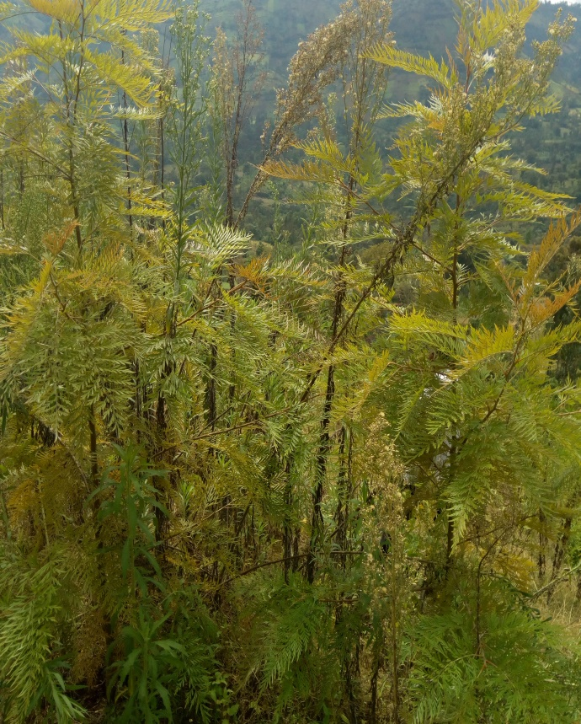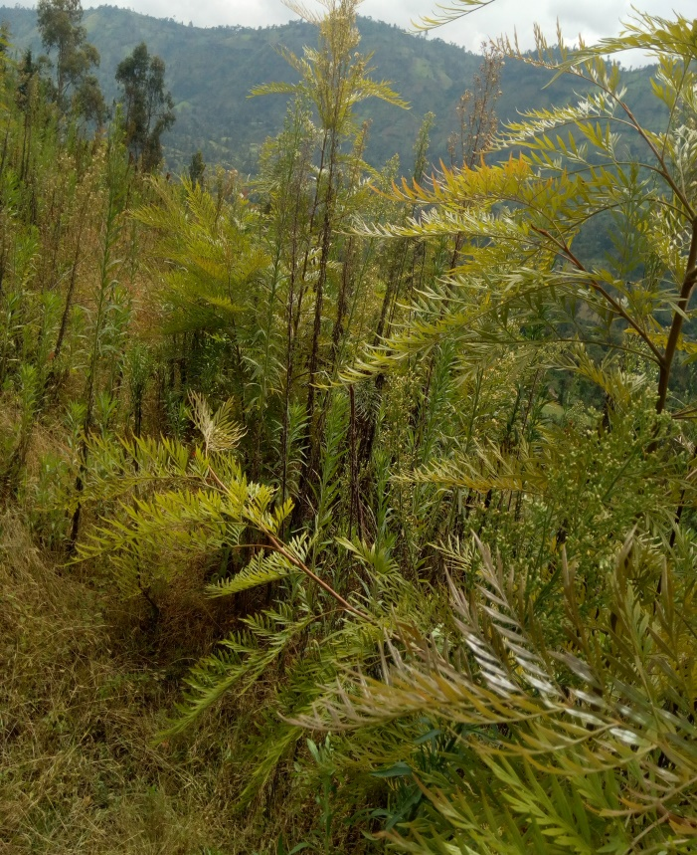
Figure2. Field picture of a planted Gravilia rubusta tree on the physical soil and water conservation structures at the study area
  - Selected Soil Properties Before and After the Experiment.
Implemented outward bench terrace, fanyajuu, stone-faced soil bund, and soil bund improved soil properties of the study area. The soil properties like pH (1:2.5), OC (%), OM (%), TN (%), clay(%), silt(%), sand(%), and soil textural class were analyzed before and after the experiment. The construction of the physical structures positively influenced OC (%), OM (%), and TN (%). But, pH and soil texture didn’t show any improvement due to the implementation of the physical structures, as shown in the Table. 4. This study is similar to (Kelbore & Gebreyes, 2022), which reflects that physical soil moisture conservation structures contributed to improving soil properties, especially total nitrogen, phosphorus, organic matter, and organic carbon of the soil, except soil pH and soil texture.
Table 4. Selected soil properties data collected before and after the implementation of physical moisture-conserving structures.
Treatments | pH (1:2.5) in H2O |  | OC (%) |  | OM (%) |  | TN (%) |  | Clay (%) |  | Silt (%) |  | Sand (%) |  | Textural class
Treatments | Before | After | Before | After | Before | After | Before | After | Before | After | Before | After | Before | After
Outward bench terrace | 5.6 | 5.68 | 2 | 3 | 3.45 | 5.18 | 0.15 | 0.26 | 30 | 30 | 10 | 10 | 60 | 60 | Sandy clay loam
Fanayajuu | 5.78 | 5.8 | 1.35 | 1.88 | 2.33 | 3.24 | 0.089 | 0.16 | 20 | 20 | 18 | 18 | 62 | 62 | Sandy clay loam
Stone-faced soil bund | 5.4 | 5.45 | 1.55 | 2.25 | 2.67 | 3.9 | 0.09 | 0.19 | 0.09 | 0.09 | 20 | 20 | 79.91 | 79.91 | Sandy clay loam
Soil bund | 5.86 | 5.85 | 1.65 | 2.25 | 2.84 | 3.9 | 0.1 | 0.19 | 0.1 | 0.1 | 20 | 20 | 79.9 | 79.9 | Sandy clay loam

The highest improvement (% change) in organic carbon (OC), organic matter (OM), and total nitrogen (TN) was observed in the fields treated by outward bench terrace, followed by stone-faced soil bund and soil bund. But the lowest change was observed on the field treated with Fanyajuu, as shown in Figure 3.
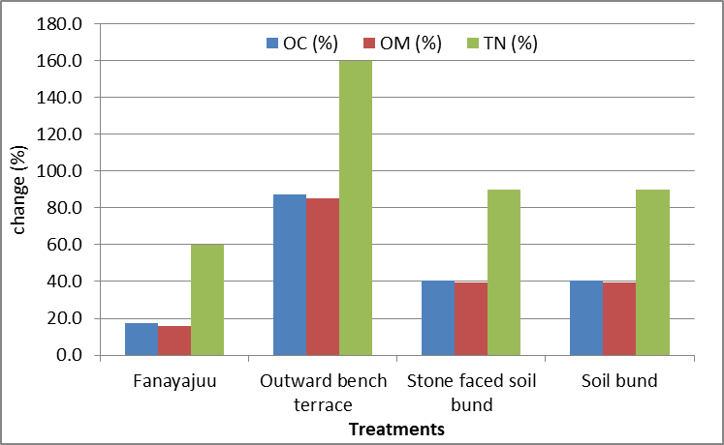
Figure 3: Percent of change (improvement) in selected soil properties from the beginning of the experiment to the end of the experiment
  - Newly emerged plant species and the farmers' perception
The experimental area degraded, and many plant species died in the area due to land degradation caused due to soil erosion over the past years. Some of the died out plant species previously emerged due to the implementation of the outward bench terrace, fanyajuu, stone-faced soil bund, and soil bund (physical moisture conserving structures), and Gravilia Robusta tree planting at the study area. The newly emerged plant species data were collected, and their botanical name was identified at the national herbarium of Ethiopia, as shown in Table 5.
Farmers participating in the study perceived that the experimental site is rehabilitated well, with no runoff on the site, the excavated structures harvested water well, and dead plant species appeared on the site. But comparably, the highest vegetation growth and tree heights were seen on the field treated by outward bench terrace and stone-faced soil bund. The outward bench terrace and stone-faced soil bund better rehabilitated the degraded land, even though the construction of the outward bench terrace requires more labor and effort than other treatments.
Farmers who took part in the study thought the experimental site was well-rehabilitated, that there was no runoff there, and that the excavated structures collected water well. Comparatively speaking, however, the area treated by the stone-faced soil bund and outer bench terrace had the highest tree heights and vegetation growth. Even though building an outward bench terrace takes more work and effort than other treatments, the stone-faced soil bund and outward bench terrace rehabilitated the degraded lands well.
Table 5. Newly emerged plant species in the study area
No. | Botanical name | Family Name
1. | Clerodendrum myricoides (Hochst.) Vatke | Lamiaceae
2. | Lippia adoensis Hochst. ex Walp. | Verbenaceae
3. | Laggera tomentosa (Sch. Bip. ex A. Rich.) Olivo & Hiern | Asteraceae

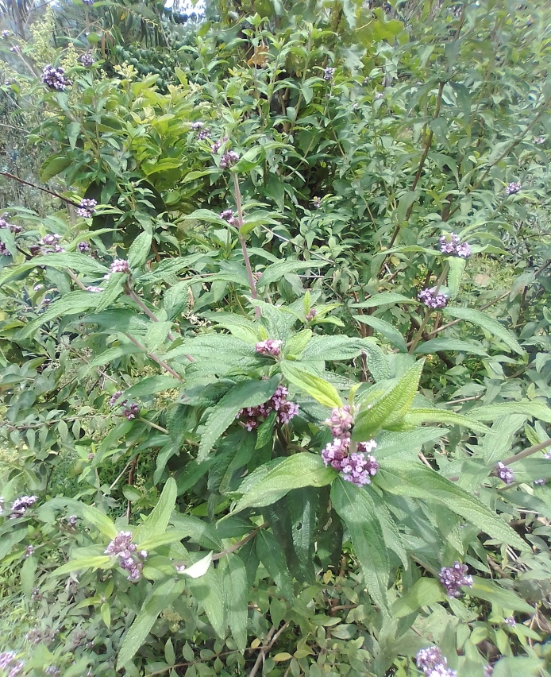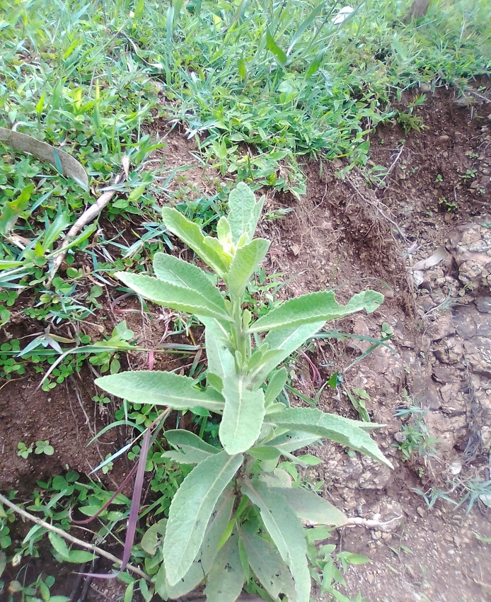
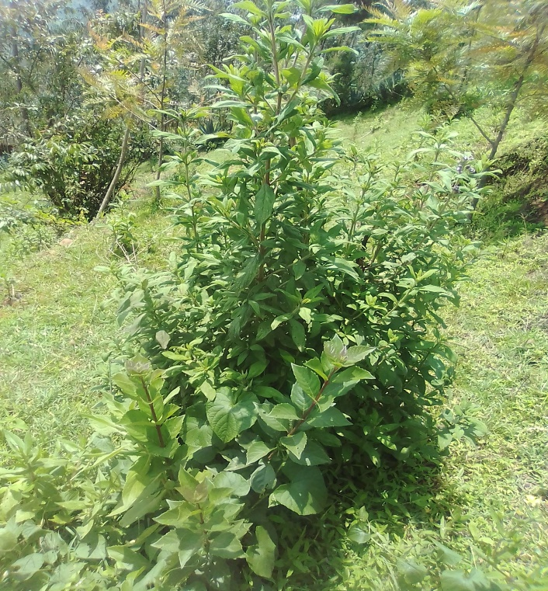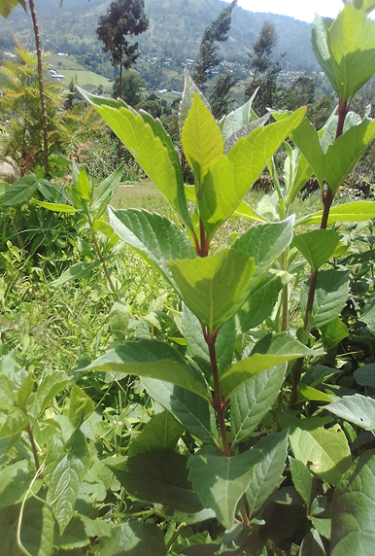
Figure 4. Pictures of newly emerged plant species in the study area.

- Conclusion and Recommendation
Land degradation due to soil erosion remains a critical environmental, social, and economic problem in highland areas of Ethiopia. Over the past years, different physical soil moisture conservation practices have been introduced and implemented in different parts of Ethiopia, including the Sidama region, to restore degraded lands and support sustainable land use practices. The restoration of degraded lands can be successful when localized evidence on the performance and effect of different soil and water conservation measures is studied. Even though national and regional conservation efforts in soil and water conservation continue, the degradation of mountainous lands continues, partly due to the lack of localized evidence on the effect and performance of different soil moisture conserving measures. So, this study is designed to evaluate and compare the effectiveness of the selected physical soil moisture conservation methods in soil erosion control and improving soil moisture condition in degraded mountainous lands; to identify the most suitable method based on its effectiveness, assess farmers' perception and acceptance of these methods, and provide insights into factors influencing adoption and long-term sustainability. The study was conducted in Hulla District of Sidama Region by considering four physical moisture conserving structures (outward bench terrace, fanyajuu, stone-faced soil bund, and soil bund with three replications for three years. The study findings showed that the four experimental physical structures improved soil moisture, soil properties, and vegetation growth. Comparably highest soil moisture content of 18.04 and 13.95 % was recorded on the fields treated with outward bench terrace and stone-faced soil bund, respectively. However, the lowest percentage soil moisture content of 10.76 and 12.76 % was recorded on the field treated with soil bund and fanyajuu, respectively. Correspondingly, the highest improvement of organic carbon, organic matter, and total nitrogen percent was observed on the outward bench terrace, followed by stone faced soil bund. Furthermore, the highest tree height was observed on the Gravilia Robusta tree planted on the field treated by the outward bench terrace. But there was no significant difference among treatments with respect to the collar diameter of the tree. Farmers perceive that the outward bench terrace and stone-faced soil bund better rehabilitate the degraded land, even though the construction of the outward bench terrace requires more labor and effort than other treatments. Thus, the study strongly recommends the outward bench terrace and stone-faced soil bunds as the best techniques for degraded mountainous lands rehabilitation.

Data availability statement
Data used are available from the corresponding author upon reasonable request.

Abbreviations
CD Collar Diameter
CSA Central Statistical Agency
EMA Ethiopian Mapping Agency
NMA National Meteorological Agency
SWC Soil and Water Conservation
USGS United States Geological Survey

- References
- Amado, Z., & Assefa, E. (2024). Status of Implemented Traditional and Improved Soil Conservation Practices in Selected Districts of Sidama, Gedio and Halaba Zones. International Journal of Research in Environmental Science, 10(1), 14-27.
- Amare Tadesse Muche, Yohannes Smeneh Ketsela & Belete Meketaw Ali (2024). Assessing the effectiveness of integrated watershed management practices and suggesting innovative strategies in southern Ethiopia, Heliyon, Volume 10, Issue 19, e38619, ISSN 2405-8440, https://doi.org/10.1016/j.heliyon.2024.e38619.
- Bayle, D., & Muluye, K. (2023). Review on successful soil conservation methods in Ethiopia. Cogent Food & Agriculture, 9(2), 2274171.
- Bedadi, B., Beyene, S., Erkossa, T., & Fekadu, E. (2023). Soil management. In The soils of Ethiopia (pp. 193-234). Cham: Springer International Publishing.
- Hameso, S. (2015). Perceptions, vulnerability and adaptation to climate change in Ethiopia: The case of smallholder farmers in Sidama (Doctoral dissertation, University of East London).
- Kelbore, Z. A., & Gebreyes, E. A. (2022). Evaluation of different soil moisture conservation structures in selected moisture stressed dry lands areas of Halaba, Southern Ethiopia. J Earth Sci Clim Change, 13(612), 2.
- Kelbore, Z. A., & Nigussie, T. A. (2023). Effects of Changes in Land Use and Land Cover on Soil Erosion Risk in the Halaba-Bilate Watershed of the Central Rift Valley, Ethiopia. Journal of Chinese Soil and Water Conservation, 54(3), 216-227.
- Mekuriaw, A., Heinimann, A., Zeleke, G., & Hurni, H. (2018). Factors influencing the adoption of physical soil and water conservation practices in the Ethiopian highlands. International soil and water conservation research, 6(1), 23-30.
- Reynolds, S. G. (1970). The gravimetric method of soil moisture determination Part IA study of equipment, and methodological problems. Journal of Hydrology, 11(3), 258-273.
- Sharma, S., Bala, N., Sharma, P., Singh, J., Bahel, S., & Katnoria, J. K. (2023). Integrated remedial and management strategies for sustaining mountainous soil. In Understanding Soils of Mountainous Landscapes (pp. 43-57). Elsevier.
- Taddese, G. (2001). Land degradation: a challenge to Ethiopia. Environmental management, 27(6), 815-824.
- Zemede Amado Kelbore & Tesfatsion Tadele Wote (2023) Fanyaaju stabilization and productivity of Pennisetum Pedicellatum in response to planting position and spacing at Hawassa Lake watershed, Southern Ethiopia, Cogent Food & Agriculture, 9:2, 2275401, DOI: 10.1080/23311932.2023.2275401

