Minireview Article
Zika, an emerging zoonosis, vector-borne and sexual transmission disease, a threat to the next generation

Abstract
Zika, is considerd as an zoonotic, emerging vector-borne and sexual trasmission disease, a threat to the next generation . The objective is to collect all the current infromations about zika for providing aguideline for disease control.An intensive search of scientific literature was done in “PubMed”, “Web of Knowledge”, “Scopus”, “Google Scholar”, “SID”, etc. Result showed that this vector-borne disease also transmitted by sexual transmission and mainly affect on the forthcoming generation. Due to novel method of transmission of disease to human, global collaboration about disease control is required.
Keywords: Zika, Aedes, sexual transmission, control

Introduction:
Zika diseases is a Zoonotic disease. The vector is Aedes (family: culicidae). transmission by female Aedes mosquito between sunrise and sunset, lays eggs on surface of the stagnant water, the eggs can abide in unfavorable conditions for long time (months). Several species of mosquitoes belonging to the subgenus Stegomyia and Dicerimyia of Aedes are probably enzootic vectors in Asia and Africa. Ae.albopictus & Ae.aegypti are the main vectors (Fig.1). Stegomyia, black and white pattern, tiger Mosquito, tropical and subtropical areas, feeds the blood meal during the day, prefer to live close to human habitations. The breeding place of larvea are: pottery jugs, water storage tanks, empty pots, broken bottles. Aedes aegypti has high vectorial capacity, feeds frequently on human, bite multiple human in a single meal, has an imperceptible bite, lives in nearby humans habitation community, It has been the main vector of American ZIKV outbreak. Aedes albopictus was founded in Asia at the first, a suitable vector for 22 arboviruses, despite the short flight it has spread well, spread throughout tropical and subtropical areas by commercial trades and can exist in more temperate areas than Ae.aegypti.

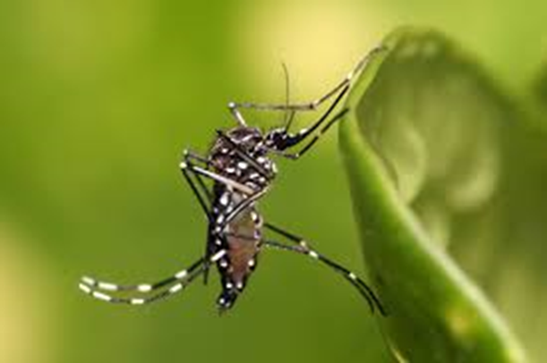
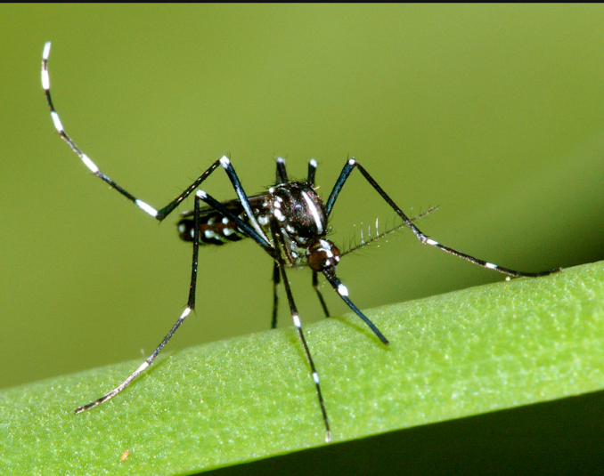
Fig.1. Vectors of Zika: Aedes aegypti, Ae. albopictus
Life cycle of zika in mosquito:
Mosquitos bite the infected patient, an then take the combination of Zika virus , pass through the epithelial midgut cell, settlement in the salivary gland, incubation is 5-10 days, find in the saliva, and then can infect the human. Zika transmission routes is presented in fig. 2.
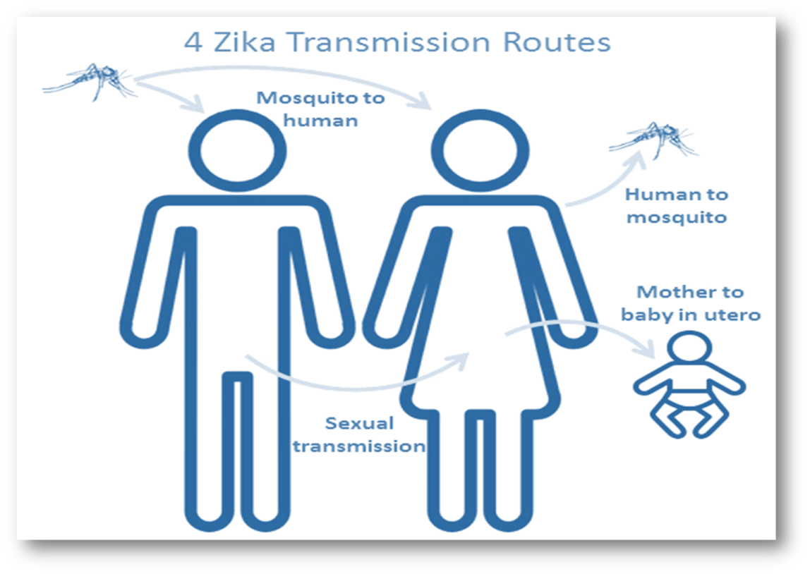
Fig.2. Zika transmission routes

The disease has sylvatic cycle which is Monkey-mosquito-monkey by
Aedes mosquito. Urban cycle is human-mosquito-human by Ae.aegypti
Ae.albopictus, Ae.hensilii (Fig.3).
Life cycle of virus in human:
Feeding blood by infected mosquito and then Inject the zika to skin, effect of derma and epidermal cell, pass through the lymphatic, get to blood stream and finally infect the organs and tissue

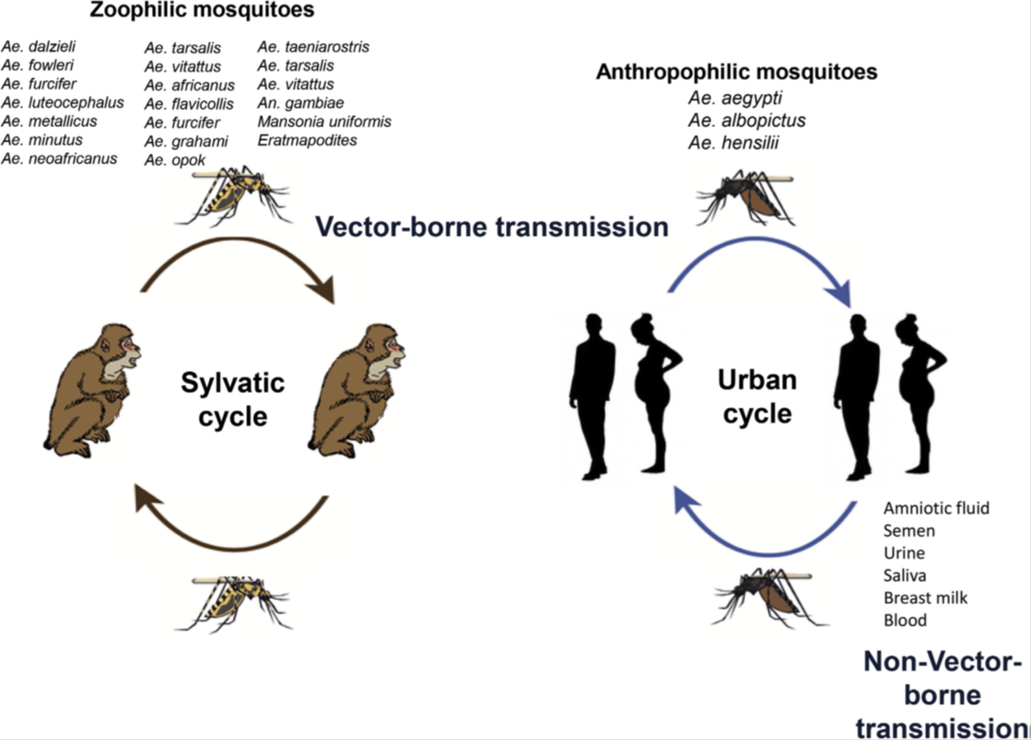
Fig.3. Zika disease cycle

The Agent is Flavivirus (family:flaviviridae). Flavivirus closely related to other flaviviruses, Dengue, Yellow fever, Japanese encephalitis. It is first detected was in 1947 in the zika forest(Uganda). The zika virus was isolated on several occasions from Ae.africanus in 1948 . By 2000 only 12 cases of human disease had been reported, which fortunately were declared safe.
Symptoms of Zika
20% of patients show the clinical symptoms, similar to other arboviruses (as Dengue or Chikungunya), it has low grade fever, rash, arthralgia, myalgia, conjunctivitis. Its can be effect on adult, fetus and children.Clinical symptoms are: fever, rash, myalgia. Clinical symptom in18% of patients have been observed. First endemic transmission in Brazil 240000-1300000 suspected cases. Microcephaly (Figs.4,5) .It could be infected the monkeys and others mammalian.

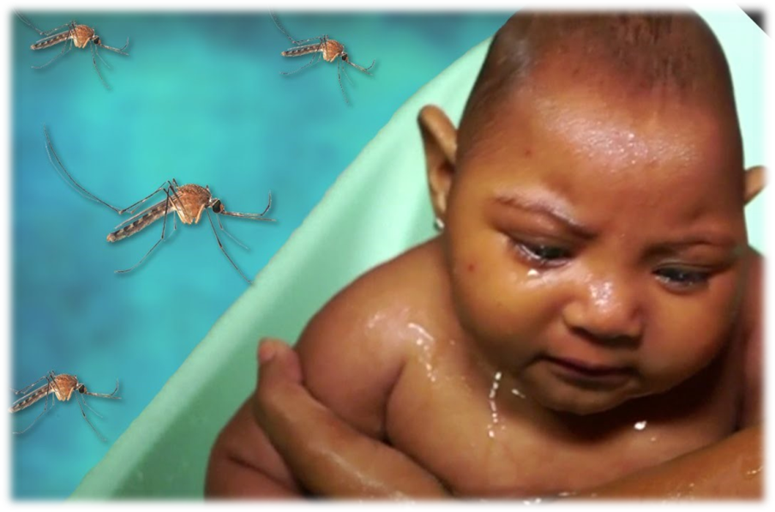
Fig.4. Symptoms of Zika

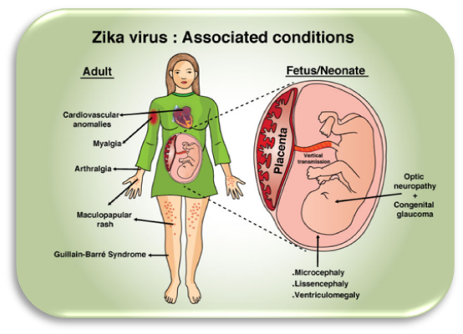 Fig.5. Symptoms of Zik
Global distribution of Zika
Global distribution of Zika is shown in Fig.6.
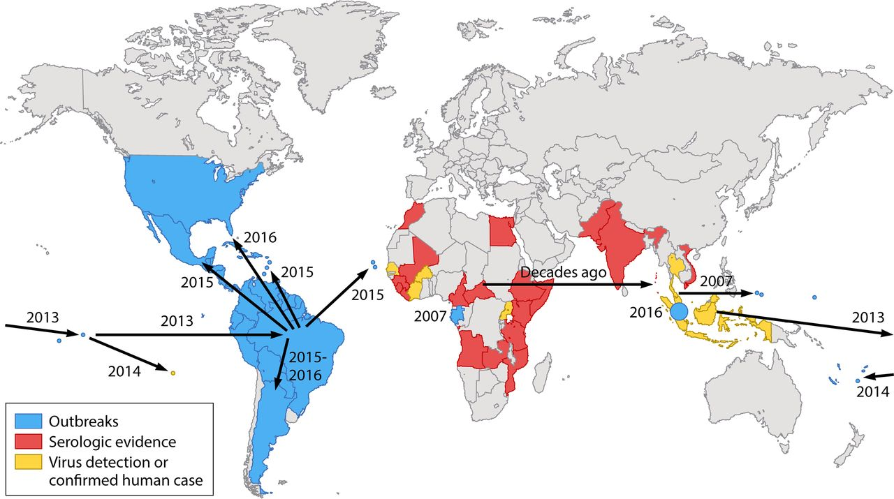
Fig.6. Global distribution of Zika

The strategy of treatment
There is no Zika virus vaccine so far. Vaccine candidates could be: nucleic acid vaccines live attenuated vaccines, inactivated whole virus vaccines and using antivirus drugs.
Personal protection
Avoidance mosquito bite, using impregnated bednets, using permethrin insecticide for clothes, using insect repellents, and using screens on windows and doors.
Discussion and conclusion:
Global strategy for disease control:
Rapid suppression of new populations, expansion and amplification of monitoring of these mosquitoes, establishment of quarantine system, regular and more accurate inspection of entry from native of such disease (1-10).
References:
1 Díaz-Menéndez M (2017). Zika Virus Infection Risk of Spreading in Europe. Spriger.
2 Boyer S, Calvez E, Chouin-Carneiro T, Diallo D, Failloux AB (2018) An overview of mosquito vectors of Zika virus. Microb Infect 1: 20(11-12):646-60.
3 Higuera A, Ramírez JD (2019) Molecular epidemiology of dengue, yellow fever, Zika and Chikungunya arboviruses: an update. Acta Tropica 1:190:99-111.
4 Singh RK, Dhama K, Malik YS, Ramakrishnan MA, Karthik K, Tiwari R, Saurabh S, Sachan S, Joshi SK(2016) Zika virus–emergence, evolution, pathology, diagnosis, and control: current global scenario and future perspectives–a comprehensive review. Vet Q 36(3):150-75.
5 Hilgenfeld R, Vasudevan SG (2018) editors. Dengue and Zika: Control and Antiviral Treatment Strategies. Springer May 29.
6 Pattnaik A, Sahoo BR, Pattnaik AK (2020) Current Status of Zika Virus Vaccines: Successes and Challenges. Vaccines 8(2):266.
7 Nejati J, Bueno-Marí R, Collantes F, Hanafi-Bojd AA, Vatandoost H, Charrahy Z, Tabatabaei SM, Yaghoobi-Ershadi MR, Hasanzehi A, Shirzadi MR, Moosa-Kazemi SH (2017) Potential risk areas of Aedes albopictus in south-eastern Iran: a vector of dengue fever, zika, and chikungunya. Front Microbiol 5(8):1660.
8 Song BH, Yun SI, Woolley M, Lee YM (2017) Zika virus: history, epidemiology, transmission, and clinical presentation. J Neuroimmunol 15:308:50-64.
9 Weaver SC (2017) Emergence of epidemic Zika virus transmission and congenital Zika syndrome: Are recently evolved traits to blame?. M Bio. 8;8(1).
10 World Health Organization (2016) Zika situation report. World Health Organization, Geneva, Switzerland. http://www.who.int/emergencies/zika-virus/situation-report/6-october-2016/en/ .

