Ethnomedicinal and phytochemical studies on sacred plants of Eastern and Northern India

Abstract
Sacred groves in India represent a unique convergence of cultural heritage, ecological sustainability, and traditional healthcare practices. These community-managed forest patches safeguard plant species of both religious and therapeutic significance, but are increasingly threatened by anthropogenic pressures. The present study highlights their ethnomedicinal value through documentation, phytochemical profiling, and quantitative estimation of total phenols and flavonoids. Sacred groves from Odisha, Jharkhand, Madhya Pradesh, Uttarakhand, and Bihar were surveyed between 2023–2025, documenting 12 sacred medicinal plants from 11 families. Qualitative phytochemical analysis revealed the presence of bioactive secondary metabolites such as alkaloids, flavonoids, phenols, saponins, tannins, and terpenoids. Quantitative assays indicated that Emblica officinalis exhibited the highest total phenolic content (4.86 mg/100 g), while Ocimum sanctum showed the highest flavonoid concentration (2.18 mg/100 g). These findings emphasize the dual ecological and pharmacological importance of sacred plants, underscoring the need for sustainable conservation and integration of traditional knowledge with modern healthcare systems.
Keywords: Sacred groves, ethnomedicine, biodiversity, cultural heritage, therapeutic uses, conservation

Introduction
“India is globally recognized for its rich cultural, spiritual, and ecological heritage, where humans have coexisted with nature for millennia” (Finn et al., 2017; Inbadas, 2017; Sharma et al., 2022). “Sacred groves which are community-protected forest patches often associated with temples or religious rituals” (Das et al., 2022). “These groves conserve a wide diversity of plant species that hold deep cultural, religious, and therapeutic significance” (Suthari et al., 2016). “Despite their importance, increasing urbanization, deforestation, and unsustainable resource extraction threaten these unique ecosystems” (Roba, 2021). “Studying sacred plants is therefore crucial not only to preserve biodiversity but also to document traditional knowledge that may otherwise be lost” (Khosravi and Escobedo, 2025). “Such documentation provides a foundation for integrating community-led conservation with scientific research” (Singh et al., 2014).
“The medicinal relevance of sacred plants has long been recognized in traditional healthcare systems such as Ayurveda, Siddha, and Unani” (Pandey et al., 2013). “Many species found in sacred groves like Aegle marmelos, Azadirachta indica, Ficus religiosa, and Ocimum sanctum have been used for centuries to treat gastrointestinal disorders, respiratory ailments, skin diseases, and inflammatory conditions” (Das et al., 2020). “Scientific investigation of these plants has revealed the presence of bioactive secondary metabolites including alkaloids, flavonoids, phenols, saponins, tannins, and terpenoids. These compounds have significant pharmacological potential” (Mendonce et al., 2025), providing a rationale for exploring sacred plants as sources of new therapeutic agents. Investigating their phytochemical composition and bioactivity can help bridge traditional knowledge with modern drug discovery. In addition to their medicinal value, sacred plants contribute substantially to ecosystem stability and ecological services (Jana et al., 2017; Dar et al., 2019).
“These species support soil fertility, prevent erosion, regulate microclimates, and maintain water cycles” (Asokan et al., 2015). “Trees like Ficus religiosa release oxygen continuously and provide habitats for diverse fauna, while other species stabilize sand dunes, prevent runoff, and maintain forest structure. By conserving sacred groves, local communities inadvertently protect ecosystem functions that sustain both human livelihoods and biodiversity” (Chaturvedi et al., 2025). “Understanding these ecological services highlights the multidimensional importance of sacred plants, beyond their cultural and therapeutic roles. Given their combined cultural, medicinal, and ecological significance, sacred plants are invaluable resources for sustainable development” (Ray et al., 2022). “Documenting and analysing their ethnomedicinal uses, phytochemical composition, and bioactive potential can guide the sustainable utilization of these species while promoting conservation. Such studies also highlight opportunities for novel drug development and the creation of eco-friendly management strategies” (Mariappan et al., 2022). By integrating traditional knowledge with modern science, research on sacred plants can ensure the preservation of both biodiversity and cultural heritage for future generations.
Aim of the present study
The aim of study to highlights the importance of sacred groves and their medicinal plants through documentation of ethnomedicinal uses, mythological importance and screening & quantification of bioactive compounds in different aspects of life and biodiversity conservation.
Materials and methods
Ethnomedicinal survey: A systematic field survey was conducted (2023–2025) across sacred groves, temple premises, and community-protected forests in Odisha, Jharkhand, Madhya Pradesh, Uttarakhand, and Bihar. Data were collected through field observations, semi-structured interviews with local priests, healers, and community elders (Kumar et al., 2021; Jena et al., 2025. Kumar, 2025). Species identification was carried out using standard floras and regional checklists by authors (Kumar et al., 2021).
Collection of plant parts, extraction, and phytochemical screening (Qualitative and Quantitative): Plant parts of enumerated sacred medicinal plant species were collected from Cuttack, Odisha. Collected plants parts were air dried and using mechanical powder was made for experimental works. Soxhlet apparatus was used for extraction using distilled water (Jena et al., 2025). Phytochemical screening was performed on aqueous extracts of selected plant parts to detect alkaloids, phenols, flavonoids, saponins, tannins, terpenoids, and other metabolites. Quantification of total phenolic and flavonoid content was carried out using spectrophotometric methods (Jena et al., 2025).
Test for saponin: 1 ml of the filtrate of plant extracts were taken and mixed with 1ml of distilled water and shaken vigorously. Presence of saponin is known by the persistent froth formation after shaking.
Test for tannin: 1 ml of the filtrate of the plant extracts were taken and to it few drops of 0.1% solution of lead acetate were added. The formation of creamy gelatinous precipitate shows the presence of tannin.
Test for flavonoids: 1 ml of the filtrate of the plant extracts were taken and 1ml of 2% NaOH solution, 2 -3 drops of dilute HCl were then added. The presence of flavonoids is shown by the intense yellow color with the addition of NaOH, which disappears to be colorless.
Test for terpenoids: 1 ml of the filtrate of the plant extracts were taken and 4-5 drops of chloroform was added. It was then placed at water bath for few minutes. 4-5 drops of H₂SO₄ were then added. The reddish-brown interface shows the presence of terpenoids.
Test for reducing sugar: 1 ml of the filtrate of plant extracts were taken and 2 drops of Fehling’s solution A and Fehling’s solution B were added and it was placed in a water bath for 10-15 mins. The presence of red orange precipitate confirms the positive result for the presence of reducing sugar.
Test for phenolic compounds: 1 ml of the filtrate of plant extracts were taken and few drops of 5% ferric chloride were added. The presence of phenolic compounds is shown by dark bluish black color.
Test for steroids: 1 ml of the plant extracts were taken and it was added 1ml of the chloroform and 1ml of concentrated H₂SO₄. The presence of steroids is indicted by the transition of upper red and lower yellow with green fluorescence color.
Test for alkaloids: 1 ml of the filtrate of plant extracts were taken and 3-4 drops of Dragendorff’s reagent were added and placed in water bath for about 15-20 mins. The presence of alkaloids is shown by the formation of reddish-brown precipitate.
Test of glycosides: 1 ml of the filtrate was treated with 1 % ferric chloride solution and was put into water bath for 5 minutes at 100 °C. The mixture was cooled and equal volume of benzene was added. The benzene layer was separated and 5 mL of ammonia solution was added. Formation of rose-pink colour indicated the presence of glycosides.
Estimation of total phenol: Triplicate samples (0.5 g each) were extracted with 60% methanol, then centrifuged five times at 5000 rpm for 20 minutes. Seven test tubes (including a blank and duplicates for each replicate) were prepared with 0.1 or 0.2 ml of extract, adjusted to 1 ml with 60% methanol. Each tube received 1 ml of 0.1 N HCl, followed by 1 ml of sodium nitrite–molybdate mixture, shaken, and diluted with 5 ml distilled water. Finally, 2 ml of 1 N NaOH was added, and tubes were left for 20 minutes. Absorbance was measured at 515 nm, and phenol content was estimated using a standard curve (Swain and Hillis, 1959). Triplets are maintained and mean along with standard deviation is presented.
Estimation of flavonoids: A sample of 100 μl of the extract is mixed with 100 μl of 5 % sodium nitrate (Sodium Nitrate ACS, 44618, CAS: 7631-99-4, SRL) and allowed to stand for 5 minutes. Next, 100 μl of aluminium trichloride (Aluminium chloride anhydrous, CAS: 7446-70-0, LOBA CHEMIE PVT. LTD.) is added and incubated for 6 minutes, followed by addition of 1 ml of 1 M sodium hydroxide. Total volume of the mixture was made up to 5 ml with distilled water and incubated for 15 minutes at room temperature in dark for taking absorbance at 510 nm. The amount of flavonoid present in the sample is calculated from the standard graph. The standard graph was prepared for quercetin (Quercetin dihydrate, CAS: 6151-25-3, HI MEDIA) (Chang et al., 2002). Triplets are maintained and mean along with standard deviation is presented.
Results and discussion
The survey undertaken for present study in selected ecologically important sacred groves of above-mentioned states revealed 12 prevalent plant species belonging to 11 families with therapeutic values (Table 1; Plate 1). It was noticed that Aegle marmelos offered to Lord Shiva is used for the treatment of gastric problems Bark of Saraca asoca is responsible for the treatment in skin diseases. S. asoca is also considered a sacred plant under which mother Sita sat in the famous ancient epic The Ramayana. During the field survey it was observed that Azardirachta indica or the neem leaves is offered to Lord Jagannath. Again, the divine idol of the Lord Jagannath in Puri Temple is made from neem wood with specific pattern. Phyllanthus emblica tree is worshipped as Lord Vishnu on the 11th day of waxing moon in the lunar calendar. Cardiospermum halicacabum is used for the treatment of arthritis. Leaves of Ficus religiosa or Ashvath is used for the treatment of cough, asthma, and gastric problems. In details, along with name, family, vernacular name, religious purposes and medicinal uses of enumerated plants are discussed below.
- Aegle marmelos (Linn.) Corr.
Family: Rutaceae; Vernacular name: Bael
Religious purpose: The leaves are an essential element in all types of worship in each & every temple, particularly in the Shiva temple.
Medicinal uses: Roots are one of the ingredients in dasamularishta and are used against dysentery, diarrhoea, fever, and vomiting. Three leaves given once a day for 15 days against constipation and indigestion. Tender leaves juice mixed with 2-3 drops of honey is given twice daily on an empty stomach to reduce blood pressure. A twig with fruit intact is hung on the southern wall of the home after delivery to keep evil eye spirits away.

- Azadirachta indica A. Juss.
Family: Meliaceae; Vernacular name: Neem
Religious purpose: It is the sacred plant conserved in the temples of Goddess Parvati. The leaves of the plant are hung on the doors to eradicate the evil spirits during the chicken pox and smallpox period.
Medicinal uses: The tree is considered a good purifier of air. Decoction of leaves is an antiseptic and is used to clean ulcers and wounds. Green twigs are used as a brush. Oil extracted from the seeds is effective in the treatment of skin diseases. The tree trunk, which was embraced seven times, is used for scorpion poison treatment.
- Cardiospermum halicacabum Linn.
Family: Sapindaceae; Vernacular name: Sakralata
Religious purpose: It is one of the members of dasapushpa and is used to worship Goddess Laxmi.
Medicinal uses: The roots are used for chronic rheumatism and, fever, and arthritis. The leaf extract is taken to treat menstrual disorders and an irritable uterus. The seeds are tonic and diaphoretic and are good for arthritis and fever.
- Saraca asoca (Roxb.) de Wilde
Family: Caesalpiniaceae; Vernacular name: Ashoka
Religious purpose: The name is given to the plant as Ashoka, which eliminates the shoka or sadness. It is a sacred plant in temples.
Medicinal uses: The stem bark decoction is taken to regulate menstrual disorders and haemorrhoids of the uterus. The paste of flowers is used for skin diseases. The extract of the flower mixed with cow milk is used to treat stomach pain during the menstrual period.
- Cassia fistula Linn.
Family: Fabaceae; Vernacular name: Sunari
Religious purpose: The flowers are made into a garland for Sri Krishna. So, it is sacred in Srikrishna temples. During the time of Vishnukani, Malayalees used the flowers for pooja.
Medicinal uses: The roots are astringent, cooling, purgative, febrifuge, and are useful in skin diseases, syphilis, and burning sensations. The bark is laxative, diuretic, and is useful in boils, leprosy, ringworm, and diabetes.
- Clitoria ternatea Linn.
Family: Fabaceae; Vernacular name: Aparajita
Religious purpose: The flowers are used for worshiping Lord Shiva and Vishnu.
Medicinal uses: The root paste is used against burning sensations.
- Crateva religiosa G. Forst.
Family: Capparaceae; Vernacular name: Varuna
Religious purpose: It is a sacred tree, and the name religiosa indicates its growth near the places of worship.
Medicinal uses: The bark is used for various kinds of urinary disorders, as an antiemetic, an antidote in snakebite, and to improve digestion (Present study).
- Eclipta prostrata (L.) Linn.
Family: Asteraceae; Vernacular name: Bhringraj
Religious purpose: It is one of the members of dasapushpa.
Medicinal uses: It is very effective for blackening and strengthening hair. The roots are used in snakebite and scorpion sting. The plant is used in the treatment of skin diseases, and jaundice (Present study).
- Emblica officinalis Gaertn
Family: Euphorbiaceae; Vernacular name: Aonla
Religious purpose: The whole plant is worshipped on ‘Aonla Navami’ day in November.
Medicinal uses: The fruit is used as a cardiac and liver tonic (Present study).
- Emilia sonchifolia (Linn.) DC.
Family: Asteraceae; Vernacular name: Binj-kudo
Religious purpose: It is one of the members of dasapushpa.
Medicinal uses: The plant paste is used to reduce joint pain (Present study).
- Ficus religiosa Linn.
Family: Moraceae; Vernacular name: Ashvath
Religious purpose: It is a sacred tree worshipped on ‘Savitribrata’ in May.
Medicinal uses: Traditionally, the leaf juice has been used to help alleviate cough, asthma, and gastric problems (Present study).
- Ocimum sanctum Linn.
Family: Lamiaceae; Vernacular name: Tulasi
Religious purpose: The leaves of the plant are used to worship the God Vishnu.
Medicinal uses: A mixture of leaf extract with cloves and jaggery is used for cough. The juice of the leaf is used as a stimulant and as a remedy for bronchitis. The leaf extract is used to cure an ear infection. Leaf juice is mixed with cow milk and used to relieve pain after delivery (Present study).
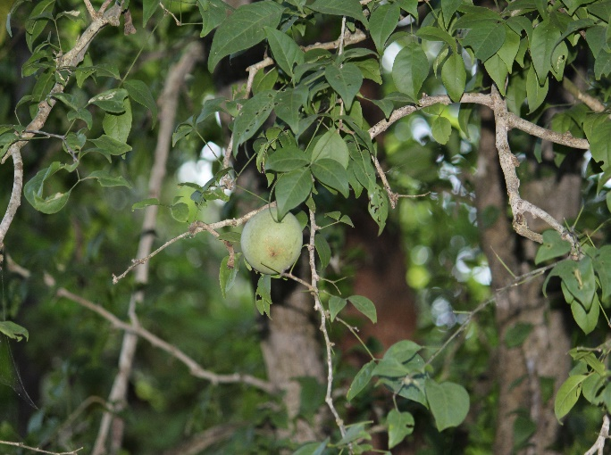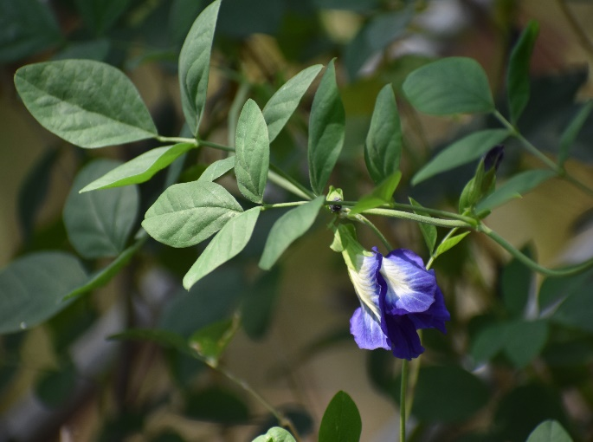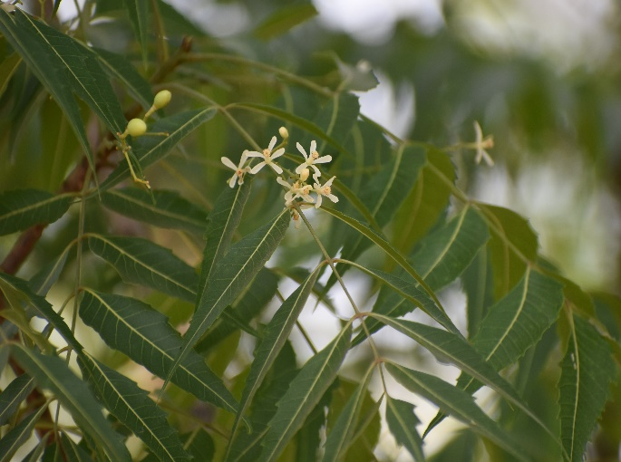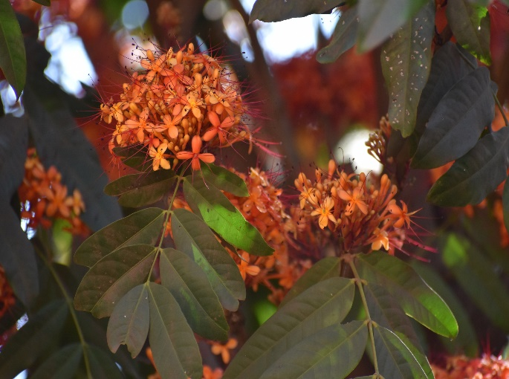
a
b
c
d
Plate 1: Important medicinal plants of sacred groves of India; (a) Aegle marmelos, (b) Clitoria ternatea, (c) Azadirachta indica, and (d) Saraca asoca.
The above ethnomedicinal uses revealed that these plant parts have diverse secondary metabolites. Therefore, phytochemical screening was carried out. The phytochemical screening of twelve sacred medicinal plants (Table 1) revealed the widespread presence of bioactive compounds, particularly alkaloids, flavonoids, phenols, saponins, tannins, terpenoids, and steroids. These metabolites are known to play significant roles in plant defense and pharmacological activity. Notably, Eclipta prostrata exhibited the broadest phytochemical spectrum, containing almost all tested classes of compounds, which justifies its extensive use in traditional medicine for hair growth, liver protection, and skin disorders (Table 1). Similarly, Cassia fistula bark and Clitoria ternatea roots were found to be rich in flavonoids and tannins, supporting their ethnomedicinal applications in wound healing and anti-inflammatory remedies. The presence of diverse phytoconstituents across species indicates that sacred groves act as reservoirs of phytochemically rich plants with strong therapeutic potential. Quantitative analysis (Table 2) showed significant variations in total phenolic content among the studied plants. Emblica officinalis fruits exhibited the highest phenolic concentration (4.86 mg/100 g), consistent with its reputation in Ayurveda as a potent rejuvenator and antioxidant. High phenolic levels are associated with free radical scavenging, hepatoprotective, and anti-aging properties, explaining its inclusion in formulations like Chyawanprash. On the other hand, Emilia sonchifolia showed negligible phenolic content, reflecting its relatively limited role as a phenolic-rich therapeutic agent. These variations suggest that phenolic accumulation is plant- and organ-specific, and fruits and barks tend to store higher amounts compared to leaves. Flavonoid content also varied substantially among the studied species. Ocimum sanctum exhibited the highest flavonoid concentration (2.18 mg/100 g), followed closely by Eclipta prostrata (1.94 mg/100 g) and Ficus religiosa (1.36 mg/100 g). Flavonoids are well-documented for their antioxidant, antimicrobial, and anti-inflammatory roles, and their abundance in Tulsi validates its long-standing use as an immunity booster and adaptogen in traditional medicine. Interestingly, Clitoria ternatea roots showed very low flavonoid content despite being valued in traditional practices, suggesting that other bioactive classes (such as alkaloids and tannins) may be responsible for its therapeutic efficacy. Taken together, the combined results of qualitative and quantitative analyses confirm that the religiously significant plants of sacred groves are not only culturally symbolic but also scientifically validated sources of pharmacologically active compounds. Plants such as Emblica officinalis and Ocimum sanctum stand out as particularly rich in phenolics and flavonoids, while metabolically diverse species like Eclipta prostrata provide broad-spectrum therapeutic potential. These findings strengthen the argument for conserving sacred groves as hotspots of both cultural heritage and pharmacological resources, while also pointing toward their relevance in modern drug development.
Table 1: Phytochemical analysis of sacred plants parts
Scientific name | Plant part(s) used | Extract | Detected secondary metabolites
Aegle marmelos (Linn.) Corr. | Leaves | Aqueous | Alkaloids, flavonoids, saponins, steroids, tannins, and carbohydrates
Azadirachta indica A. Juss. | Leaves | Aqueous | Alkaloids and flavonoids
Cardiospermum halicacabum Linn. | Leaves | Aqueous | Alkaloids, carbohydrates, saponins, amino acids, and steroids
Saraca asoca (Roxb.) de Wilde | Stem | Aqueous | Flavonoids, saponins, phenols, steroids, and terpenoids
Cassia fistula Linn. | Bark | Aqueous | Alkaloids, flavonoids, phenols, carbohydrates, saponins, tannins, and terpenoids
Clitoria ternatea Linn. | Roots | Aqueous | Alkaloids, phenols, flavonoids, and tannins
Crateva religiosa G. Forst. | Bark | Aqueous | Alkaloids, flavonoids, and saponins
Eclipta prostrata (L.) Linn. | Whole plant | Aqueous | Tannins, phenols, terpenoids, steroids, saponins, alkaloids, flavonoids, carbohydrates, and amino acids
Emblica officinalis Gaertn | Fruits | Aqueous | Tannins, saponins, steroids, terpenoids, alkaloids, and phenols
Emilia sonchifolia (Linn.) DC. | Whole plant | Aqueous | Alkaloids, terpenoids, flavonoids, steroids, saponins, phenols, tannins, and carbohydrates
Ficus religiosa Linn. | Leaves | Aqueous | Phenols, alkaloids, flavonoids, steroids, reducing sugar, and terpenoids
Ocimum sanctum Linn. | Leaves | Aqueous | Phenols, flavonoids, saponins, carbohydrates, and tannins

Table 2: Quantification of total phenol and flavonoids (Mean ± SD)
Scientific name | Plant part(s) used | Total Phenol (mg/100 g) | Flavonoids (mg/100 g)
Aegle marmelos (Linn.) Corr. | Leaves | 0.23 ± 0.06 | 0.09 ± 0.02
Azadirachta indica A. Juss. | Leaves | 0.71 ± 0.05 | 1.19 ± 0.23
Cardiospermum halicacabum Linn. | Leaves | 0.27 ± 0.07 | 0.22 ± 0.05
Saraca asoca (Roxb.) de Wilde | Stem | 0.26 ± 0.06 | 0.46 ± 0.03
Cassia fistula Linn. | Bark | 0.86 ± 0.41 | 0.16 ± 0.15
Clitoria ternatea Linn. | Roots | 0.83 ± 0.14 | 0.025 ± 0.06
Crateva religiosa G. Forst. | Bark | 1.04 ± 0.15 | 1.2 ± 0.42
Eclipta prostrata (L.) Linn. | Whole plant | 0.15 ± 0.08 | 1.94 ± 0.75
Emblica officinalis Gaertn | Fruits | 4.86 ± 0.05 | 1.42 ± 0.62
Emilia sonchifolia (Linn.) DC. | Whole plant | 0.001 ± 0.003 | 0.09 ± 0.02
Ficus religiosa Linn. | Leaves | 0.63 ± 0.28 | 1.36 ± 1.23
Ocimum sanctum Linn. | Leaves | 0.88 ± 0.56 | 2.18 ± 0.46
(SD: Standard Deviation)
Future works on sustainable utilization and conservation
The present study highlights the cultural and pharmacological importance of sacred medicinal plants; however, long-term sustainability requires integrated strategies. Future research should focus on comprehensive ethnobotanical documentation that captures not only medicinal applications but also local beliefs, rituals, and seasonal patterns of plant use. Many tribal and rural communities still possess orally transmitted knowledge that is at risk of being lost (Reyes-García et al., 2013). Digitizing and archiving such traditional knowledge, while respecting intellectual property rights, will create a robust resource for both scientific validation and cultural preservation. Establishing ex-situ conservation measures, such as herbal gardens, seed banks, and tissue culture repositories, would ensure the availability of these plants even if their natural habitats face degradation. Overharvesting of bark, roots, or whole plants often threatens wild populations. Awareness programs should encourage practices like selective pruning, rotational harvesting, and use of leaf/fruit parts instead of destructive methods. Training local healers and temple committees in non-destructive collection methods can balance medicinal use with conservation (Onyekwelu et al., 2024). In addition, value-addition through herbal formulations, nutraceuticals, and plant-based products can provide livelihood opportunities, incentivizing local people to conserve rather than exploit these resources. Another future pathway lies in policy integration and legal protection. Sacred groves should be recognized as Community Conserved Areas (CCAs) under existing biodiversity frameworks. Collaborative models involving forest departments, research institutions, NGOs, and village councils can help safeguard these groves.
Conclusion
Sacred groves in India represent a remarkable convergence of cultural heritage, ecological stability, and traditional medicinal knowledge. Present study highlights the significance of Sacred Groves and their medicinal plants by documenting twelve culturally and therapeutically important plant species across Eastern and Northern India. The ethnomedicinal uses recorded reveal a rich tapestry of traditional practices. Phytochemical profiling of sacred plants highlighted the presence of diverse bioactive compounds. These secondary metabolites validate the traditional therapeutic claims. Quantitative analysis revealed notable variations in total phenolic and flavonoid contents, with Emblica officinalis fruits showing the highest phenolic concentration and Ocimum sanctum leaves exhibiting the maximum flavonoid content. These findings emphasize the potential of sacred grove species as reservoirs of pharmacologically active compounds, highlighting opportunities for modern drug discovery and nutraceutical development. By preserving plant diversity, these groves maintain ecosystem services such as soil stabilization, air purification, and microclimate regulation. Sacred groves thus serve as living laboratories where culture, ecology, and medicine intersect, offering valuable lessons for biodiversity conservation, sustainable development, and future pharmaceutical innovations. Preserving and valorising these unique landscapes is not merely an act of cultural preservation, it is a necessary strategy to safeguard ecological balance, medicinal heritage, and the well-being of future generations.

Disclaimer (Artificial Intelligence)
Author(s) hereby declares that no generative AI technologies are used for direct text writing. META A1 & ChatGPT5 are used for grammar corrections during editing this manuscript. All photographs are original and taken by the authors from field survey.
Acknowledgement
The authors are grateful to the rural and tribal communities of study areas for their support and assistance in obtaining plant photographs and information of sacred plants of sacred groves.
References

Asokan A, Chouhan S and SinghV. (2015). Sacred Grove—A Nature’s Gift—as a Remedy for Human Ailments, a Biodiversity Reservoir for Restoring Indigenous Traits for Endangered Listed Plants—A Review. Open Access Library Journal. 2:1-13.

Chang CC, Yang MH, Wen HM and Chern JC. (2002). Estimation of total flavonoid content in propolis by two complementary colorimetric methods. Journal of Food and Drug Analysis. 10(3): 3-5.

Chaturvedi SK, Singh S and Devi P. (2025). Use of Ficus religiosa and Ficus benghalensis as habitat and food resources by peri-urban forest dwelling fauna in Chitrakoot. International Journal of Zoology Studies. 10(3): 72-76.

Chokotho L and van Hasselt E. (2005). The use of tannins in the local treatment of burn wounds - a pilot study. Malawi Medical Journal. 17(1): 19-20.

Dar JA, Subashree K, Raha D, Kumar A, Khare PK and Khan ML. (2019). Tree diversity, biomass and carbon storage in sacred groves of Central India. Environmental Science and Pollution Research International. 26(36): 37212-37227.

Das L, Mishra S, Das A, Dimri R and Kumar S. (2022). Some common flora of temple city of Odisha, India: source for ethno-medico-cultural values. Indian Forester, 148(2): 207-212.

Das MK, Das PK, Kumar S and Singh NR. (2020). Flora of Khandagiri & Udayagiri, an urban heritage of Odisha. Indian Forester, 146(6): 509-518.

Finn S, Herne M and Castille D. (2017). The Value of Traditional Ecological Knowledge for the Environmental Health Sciences and Biomedical Research. Environ Health Perspect. 125(8): 085006. doi: 10.1289/EHP858.

Inbadas H. (2017). Indian philosophical foundations of spirituality at the end of life. Mortality. 23(4): 320-333.

Jana P, Dasgupta S and Todaria NP. (2017). Impact and ecosystem service of forest and sacred grove as saviour of water quantity and quality in Garhwal Himalaya, India. Environ Monit Assess.189(9): 477. doi: 10.1007/s10661-017-6173-2.

Jena N, Vimala, Singh B, Patra A, Sharma BP, Hossain E and Kumar S. (2025). Methods for ethnobotanical data collection, phytochemistry, antioxidant, anthelmintic, and antimicrobial activities for pharmacological evaluation of medicinal plants. Journal of Biodiversity and Conservation, 9(2): 87-107.

Khosravi MA and Escobedo F. (2025). The role of traditional ecological knowledge and ecosystem quality in managing ecosystem services. Scientific Reports. 15: 31510. https://doi.org/10.1038/s41598-025-17611-z

Khosravi MA and Escobedo F. (2025). The role of traditional ecological knowledge and ecosystem quality in managing ecosystem services. Scientific Reports. 15(1):31510. doi: 10.1038/s41598-025-17611-z

Kumar N and Goel N. (2019). Phenolic acids: Natural versatile molecules with promising therapeutic applications. Biotechnology Reports. 24: e00370. doi: 10.1016/j.btre.2019.e00370

Kumar S and Pandey AK. (2013). Chemistry and biological activities of flavonoids: an overview. Scientific World Journal. 2013:162750. doi: 10.1155/2013/162750

Kumar S. (2025). Data collection from literature for biological sciences, medicinal plants research, ethnobotany, and pharmacology: a methodological overview. Journal of Biodiversity and Conservation, 9(2): 167-169.

Kumar SN, Mishra S and Kumar S. (2021). Documentation of Indigenous Traditional Knowledge (ITK) on Commonly Available Plants in Koira Range, Bonai Forest Division, Sundargarh, Odisha, India. Asian Plant Research Journal, 8(4): 83-95.

Mariappan P, Kiran KR, Swathy PS, Kaniyassery A, Thorat SA, Bhagyashree P, Thiruvengadam M and Muthusamy A. (2022). Sacred groves and nakshatravan trees - A comparative analysis for their medicinal properties and volatile compounds for human health. South African Journal of Botany. 151: 623-638.

Mendonce KC, Palani N, Rajadesingu S, Radhakrishnan K, Ayyar M and Priya LS. (2025). Pharmacological potential of bioactive compounds in Catharanthus roseus extract: A comprehensive review. Toxicology Reports. 14: 101998. doi: 10.1016/j.toxrep.2025.101998.

Michalak M, Pierzak M, Kręcisz B and Suliga E. (2021). Bioactive Compounds for Skin Health: A Review. Nutrients. 13(1): 203. doi: 10.3390/nu13010203.

Onyekwelu JC, Agbelade AD, Stimm B and Mosandl R. (2024). Role of sacred groves in southwestern Nigeria in biodiversity conservation, biomass and carbon storage. Environ Monit Assess. 196(3):269. doi: 10.1007/s10661-024-12407-6

Pandey MM, Rastogi S and Rawat AK. (2013). Indian traditional ayurvedic system of medicine and nutritional supplementation. Evidence-Based Complementary and Alternative Medicine. 2013: 376327.

Ray P, Dnyanoba KR, Rajesh PP, Dattatray KA and Kumar S. (2022). Importance of sacred groves in conservation of medicinal plants. In: Medico Biowealth of India, Volume 5. Ambika Prasad Research Foundation, Odisha, India.

Reyes-García V, Guèze M, Luz AC, Paneque-Gálvez J, Macía MJ, Orta-Martínez M, Pino J and Rubio-Campillo X. (2013). Evidence of traditional knowledge loss among a contemporary indigenous society. Evol Hum Behav. 34(4): 249–257.

Riaz M, Khalid R, Afzal M, Anjum F, Fatima H, Zia S, Rasool G, Egbuna C, Mtewa AG, Uche CZ and Aslam MA. (2023). Phytobioactive compounds as therapeutic agents for human diseases: A review. Food Science and Nutrition. 11(6): 2500-2529.

Roba GO. (2021). Anthropogenic menace on sacred natural sites: the case of Me'ee Bokko and Daraartu sacred shrines in Guji Oromo, Southern Ethiopia. Heliyon. 7(3): e06460. doi: 10.1016/j.heliyon.2021.e06460

Sharma PK, Singh A and Sharma NK. (2022). A socio-ecological critique on India's local health traditions amidst rising incidence of global pandemics. Journal of Herbal Medicine. 34: 100578. doi: 10.1016/j.hermed.2022.100578.

Singh H, Husain T, Agnihotri P, Pande PC and Khatoon S. (2014). An ethnobotanical study of medicinal plants used in sacred groves of Kumaon Himalaya, Uttarakhand, India. Journal of Ethnopharmacology. 154(1): 98-108.

Suthari S, Kandagalta R, Ragan A and Raju VS. (2016). Plant wealth of a sacred grove: Mallur Gutta, Telangana state, India. International Journal of General Medicine. 9: 369-381.

Swain T and Hillis WE. (1959). The phenolic constituents of Prunus domestica. I.-the quantitative analysis of phenolic constituents. Journal of the Science of Food and Agriculture. 10: 63-68.

