Opinion Article
The economy of Sal tree: From traditional handcrafts to the health and construction sectors
Abstract
Shorea robusta C.F. Gaertn. (Sal tree) is a keystone tree species of tropical deciduous forests in India, valued for its ecological, medicinal, cultural, and economic importance. Keeping the importance of this tree and climate change scenario, an attempt has been made to document the utility of plant parts of Sal. Through extensive literature survey and field survey for collection plant parts, results are presented in this paper. Results revealed that leaves are traditionally stitched into eco-friendly plates and bowls, providing sustainable livelihoods for rural and tribal women. Twigs are widely used as natural toothbrushes (Datun), offering antimicrobial benefits and supporting traditional oral care. The Sal flower plays a central role in the Santal Baha Bonga festival, symbolizing fertility and renewal. Sal resin (Jhuna) is employed in Ayurveda for its antiseptic and wound-healing properties and is commercially important in incense and varnish production. Rugda mushroom (Astraeus hygrometricus), associated with Sal forests, provides nutritional and economic value. Ecologically, Sal forests regulate water, conserve soil, enhance fertility via ectomycorrhiza, and aid carbon sequestration. Thus, S. robusta integrates culture, health, economy, and ecology, for sustainable forest-based livelihoods and biodiversity conservation. Present study highlights the importance of this tree and draw attention towards there is a need of study such tree species.
Keywords: Bioactive compounds, conservation, sustainability, trees, tribals
Introduction
Shorea robusta, commonly known as Sal (Figure 1), is a dominant forest tree native to the Indian subcontinent and some adjoining regions in Southeast Asia. It belongs to the family Dipterocarpaceae and often reaches 35-40 meters in height with a robust trunk (Soni et al., 2013). Sal forests occupy a significant area in South Asia, stretching from the Shivaliks and plains of northern India to southern Nepal, Bhutan, Bangladesh, and extending into parts of Myanmar and Thailand. Within India, S. robusta is widely found in Jharkhand, Chhattisgarh, Odisha, Madhya Pradesh, Uttarakhand, West Bengal, Sikkim, Assam, Meghalaya, Haryana, Himachal Pradesh, Uttar Pradesh, Maharashtra, Bihar, Andhra Pradesh, and Tripura. Sal forests are adapted to tropical and subtropical moist deciduous environments and typically thrive in deep, well-drained alluvial soils, but the species is also tolerant to sandy, loamy, clay, and variously acidic or alkaline soils. The estimated coverage of Sal forests is approximately 11 million hectares across India, Nepal, and Bangladesh, with Odisha, Jharkhand, and Chhattisgarh holding the largest contiguous Sal forests (Kumar and Abbas, 2012; Lal and Singh, 2012; Kumar et al., 2013; Kora, 2019; Kumar and Saikia, 2020). S. robusta is a tree that is highly utilized for its multiple uses, including as a main source of timber for construction and furniture, and is highly regarded for its strength and durability (Kumar and Abbas, 2012). Sal forests are a rich source of livelihood for local inhabitants. During the past decades, there was massive deforestation of Sal to use the wood as railway sleepers, ship-building; non-timber forest products including fodder, seed for oil, tannin, and gum from bark and for building highways through the forest. In addition to commercial purposes Jhuna or Resin of S. robusta and the leaf is well documented in traditional Siddha literatures especially for conditions such as menorrhagia, leucorrhoea, and all types of wounds including burns and scalds (Mukherjee et al., 2013; Adlakha et al., 2014). The distribution, multifaceted utilization, and critical ecological services of the Sal tree make it a cornerstone of forest ecosystems and rural livelihoods (Islam et al., 2015; Chatterjee and Ganguly, 2019). Phytochemical screening states the presence of flavonoids, saponins, steroids, tannins, phenols, etc. mainly tri-terpenoids which plays the prominent role for their therapeutic potential in the drug (Chatterjee and Ganguly, 2019). Sal leaves (Figure 3) are widely collected and shaped into eco-friendly plates and bowls. Additionally, Sal wood is used as fuel, while its bark and seed oil have applications in indigenous medicine, ranging from skin treatments to anti-inflammatory remedies (Adlakha et al., 2014). Rural communities rely on Sal forests for fodder, animal bedding, compost material, and numerous subsistence resources for their livelihood purposes. Sal forests provide a suite of vital ecological services and play an irreplaceable role in biodiversity conservation. Sal-dominated forests act as carbon sinks, helping to mitigate climate change through carbon sequestration (Banik et al., 2018). They stabilize soils and regulate local microclimates, promoting water retention and reducing erosion, especially along riverbanks and foothill regions. Sal forests serve as critical habitat for a wide range of faunal species, including elephant, tiger, deer, and avifaunal species (Das et al., 2022; Vinayaka et al., 2024). The structure and functioning of these ecosystems underpin ecosystem processes essential for landscape resilience in the face of climate variability. Sal forests also contribute tangibly to maintaining hydrological cycles and preserving genetic resources, which are indispensable for both ecological balance and future forestry improvements (Das et al., 2022). Its wide distribution, versatile utilization, and profound ecological services make it a backbone of rural economies, biodiversity, and ecosystem health. In the face of pressures like over-exploitation, habitat fragmentation, and climate change, conserving and sustainably managing Sal forests is important for environmental stability and traditional livelihoods.
Methodological framework
Present communication is a result of extensive literature survey. Field photographs are taken through field survey under different floristic works in Jharkhand and Odisha state. Literature data was gathered from Scopus, Web of Science, Springer, PubMed, Chem Spider, Elsevier, BioMed Central Google Scholar, MDPI, Science Direct, SciFinder, Scirus, and Scientific Electronic Library Online using the search terms “Shorea robusta”, “Economic uses of Shorea robusa”, “Sal leaf” and “Resin of Sal” (SciELO) from 2022-2025 (Kumar, 2025).
Economic and ecological services
In India, Shorea robusta (Sal) leaves are widely used to make traditional leaf plates and bowls, serving as an eco-friendly alternative to plastic and paper tableware (Figure 4). These plates, known locally as Patravali, Tapari, Khali or Pattal, are especially common in eastern and central states such as Odisha, Jharkhand, Chhattisgarh, West Bengal, and Assam, where Sal trees thrive in tropical moist and dry forests (Kora, 2019).
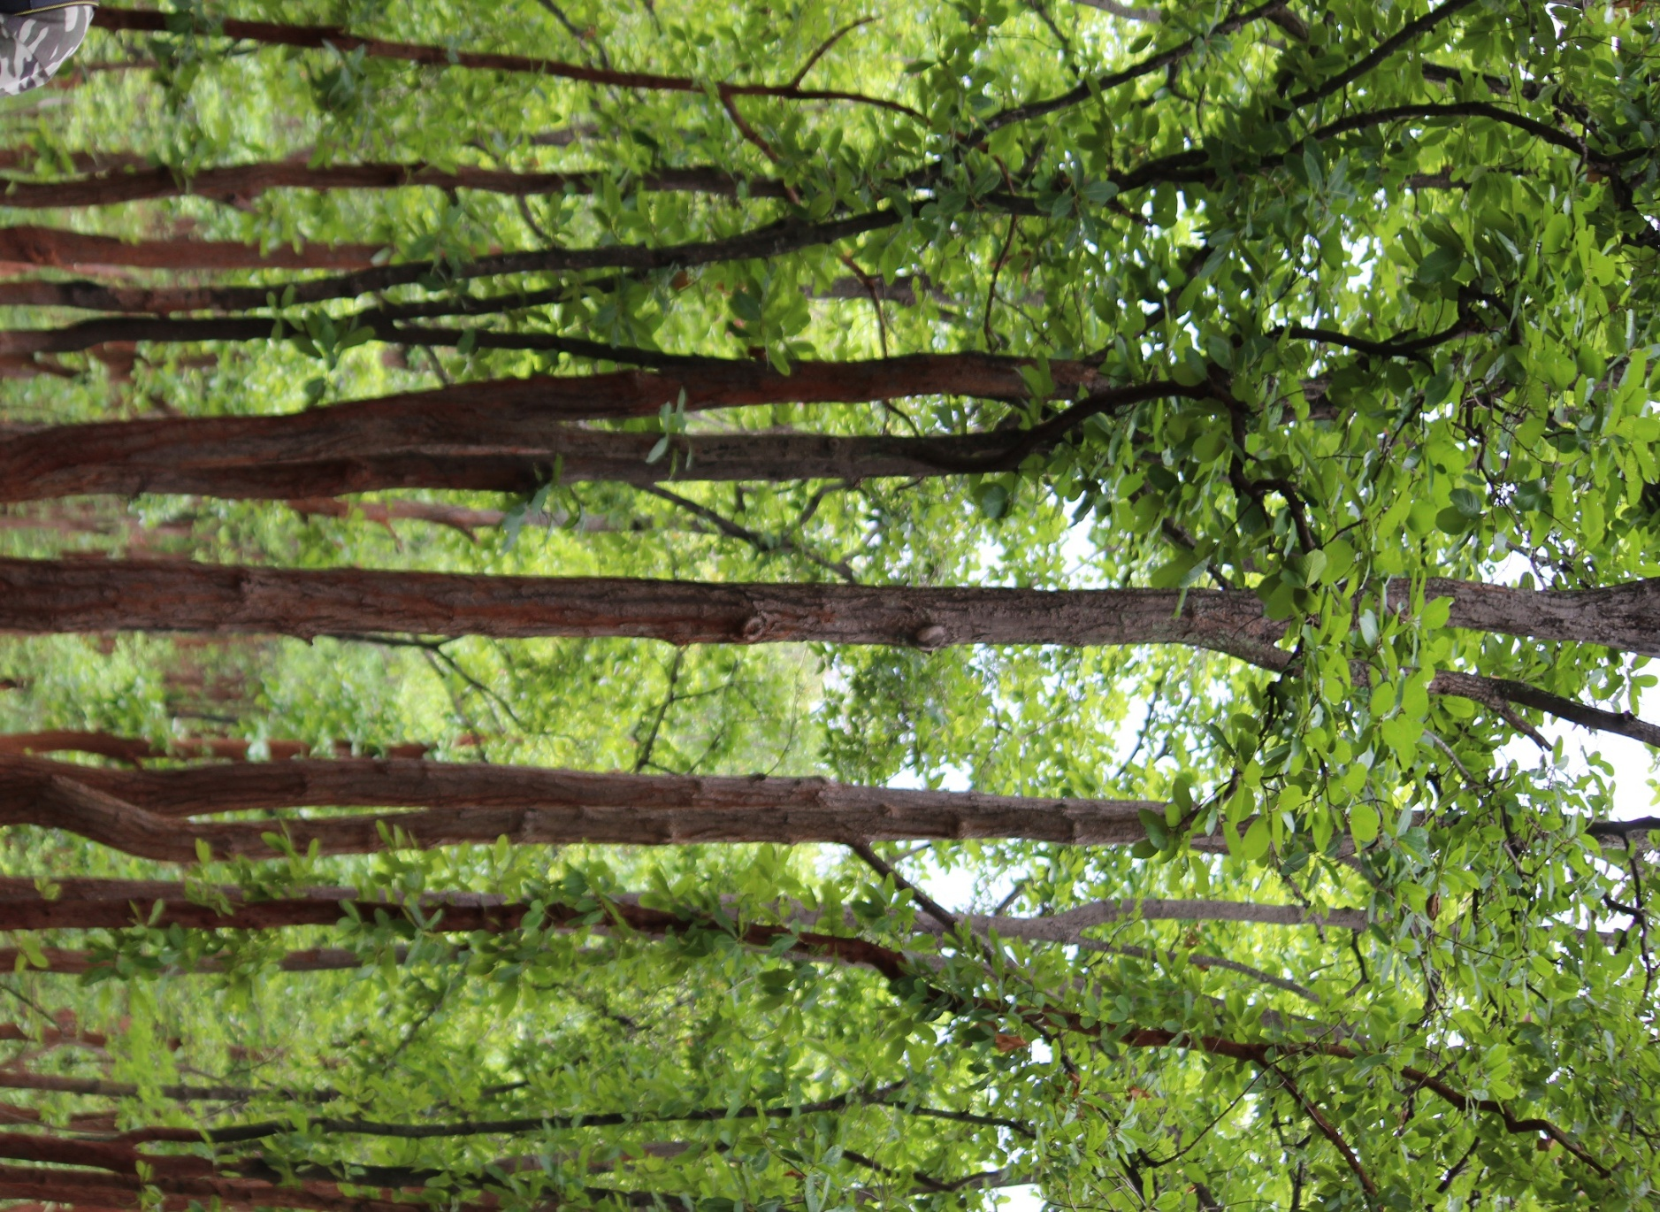
Figure 1: Sal trees in natural habitat
The process involves gathering Sal leaves, which are then cleaned and stitched together using thin twigs, forming durable and biodegradable plates that are ideal for serving food during community feasts, religious ceremonies, and festivals (Singh and Quli, 2011). The widespread use of Sal leaf plates reflects a deep cultural heritage, notably among tribal and rural communities, and provides sustainable income for those engaged in leaf collection and plate-making (Singh and Quli, 2011; Islam et al., 2015). Economically, the trade in Sal leaf plates forms a vital source of livelihood for millions, especially tribal women, who collect, stitch, and sell plates in local markets or to traders. Families can earn a modest yet vital income by producing and trading these plates. Seasonal leaf collection and plate making which helps rural populations diversify income, avoid starvation during lean months, and empower women economically (Islam et al., 2015). Use of these plates helps to reduce single-use plastic waste and promotes environmental conservation, making S. robusta leaves a symbol of tradition, sustainability, and livelihood in India (Kora, 2019). In traditional Indian practices, twigs from the S. robusta are also commonly used as natural toothbrushes, known locally as Datun or Karkat in some tribal communities (Hazarika et al., 2018; Nayak et al., 2023). The tender stems or small branches of the Sal tree are cut into manageable pieces, and one end of the stick is chewed until it forms bristles that can gently clean and massage the teeth and gums (Mohanty et al., 2020). This natural tooth-cleaning method is preferred because the twigs often contain medicinal properties that help prevent gum diseases, toothaches, and bad breath (Kumar et al., 2022; Deshmukh et al., 2024). The use of Sal twigs as toothbrushes is especially prevalent among rural and tribal populations in states like Jharkhand, Odisha, and West Bengal, where the Sal tree is abundant. Besides their cleaning effect, these twigs are known for antimicrobial properties that contribute to oral health and serve as an effective traditional dental care practice that is sustainable and chemical-free (Shrestha et al., 2022). Local communities also collect resin and used to sell in local markets (Figure 5). Resin or Jhuna in Odisha is used to perform different rituals and worship.
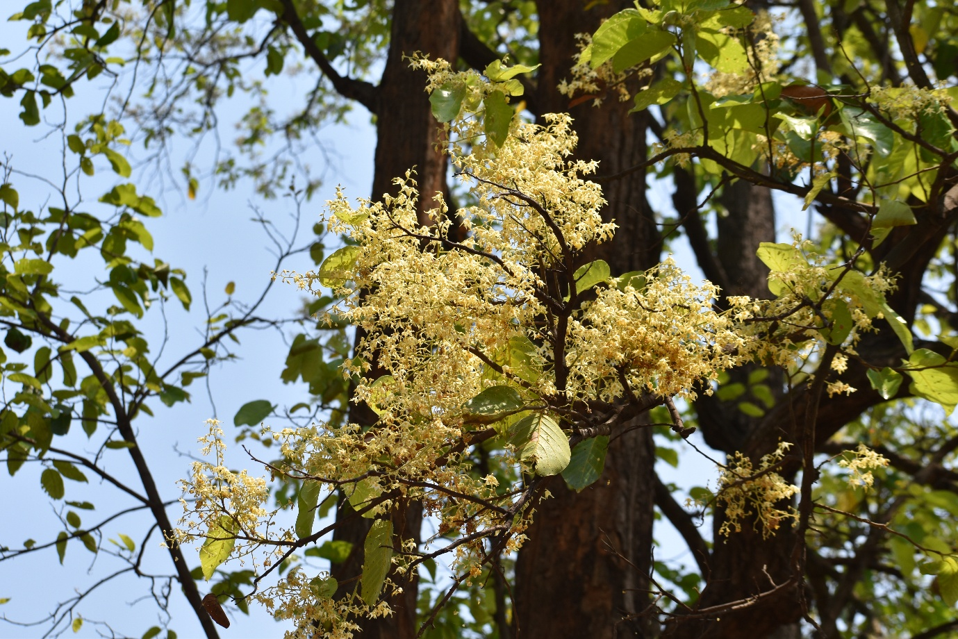
Figure 2: Flowers of Sal tree
S. robusta holds immense ecological importance in the Indian subcontinent's tropical deciduous forests. Sal forests serve as vital habitats supporting rich biodiversity, including a variety of flora and fauna (Sharma, 2022). These forests regulate local climate conditions, conserve water resources by protecting watersheds, and prevent soil erosion through their extensive root networks (Sharma et al., 2025). Sal trees form ectomycorrhizal associations with fungi, which enhance nutrient uptake and soil fertility, contributing to healthy forest regeneration and ecosystem productivity (Adhikari et al., 2017; Sharma et al., 2025). Additionally, Sal forests play a crucial role in carbon sequestration, helping reduce greenhouse gases and mitigate climate change (Banik et al., 2018). The natural regeneration of Sal is essential for maintaining forest stability and resilience, though it faces challenges due to anthropogenic pressures such as deforestation, overgrazing, and habitat fragmentation (Tomar et al., 2021). Sustainable management and conservation of Sal forests ensure the preservation of these ecosystem services, which also support the livelihoods of many forest-dependent communities. Sal trees are a cornerstone of tropical forest ecology, balancing environmental health and biodiversity while underpinning human well-being (Tripathi and Shankar, 2014).
Cultural importance
The flower (Figure 2) of the Sal plays a central role in the Baha Bonga festival, an important cultural and spiritual event celebrated by the Santhal tribal community in India, especially in the regions of Jharkhand, Odisha, and West Bengal (Manjula and Marndi, 2021). The festival, also known as the Flower Festival, marks the arrival of spring and the blooming of Sal and Mahua trees, symbolizing fertility, renewal, and harmony with nature. During Baha Bonga, the first flowers of the Sal tree are offered to deities as thanksgiving for nature’s bounty and the promise of a prosperous agricultural season (Schulte-Droesch, 2014; Soren, 2025). The festival involves rituals led by the village priest (Naik), who conducts prayers and sacrifices in the sacred Sal groves (Jaher Than), which the Santhals consider their spiritual abode (Kumar, 2015; Sen et al., 2020). Women and men come together to sing traditional songs, dance, and reinforce their deep bond with the environment. The Sal flower signifies life and fertility and is also believed to carry protective powers against diseases and evil spirits. According to Santhal belief, the festival nurtures nature and respects its cycles; thus, no flowers or leaves are plucked before the festival concludes. Baha Bonga reflects the indigenous community’s reverence for the Sal tree as a sacred symbol intertwined with their cultural identity and agricultural livelihood (Manjula and Marndi, 2021; Soren, 2025). S. robusta gum, locally known as Jhuna, is a resinous substance obtained from the Sal tree that holds significant traditional, medicinal, cultural, and economic importance in India (Singh et al., 2015). Medicinally, Jhuna is used in Ayurveda and other traditional Indian medicine systems for its astringent, antiseptic, and anti-inflammatory properties. It is applied to treat wounds, respiratory ailments, digestive disorders, and bleeding conditions (Wani et al., 2012; Bhalekar et al., 2020). Culturally, Jhuna plays a vital role in religious rituals and ceremonies across many Indian communities (Soni et al., 2013). The gum is often burned as incense during pujas and festivals to purify the surroundings and create a sacred ambiance. Among tribal groups, the Sal tree and its resin are deeply revered, symbolizing life, growth, and protection. Economically, it is a valuable non-timber forest product that supports the livelihoods of millions of rural and forest-dependent people in India (Sheetal et al., 2024; Das et al., 2022). The resin is harvested and traded widely, used in the incense (Agarbati) industry, varnishes, adhesives, and traditional medicines. Its collection provides employment opportunities, especially for forest dwellers and tribal communities, contributing significantly to rural incomes (Das et al., 2022). The global demand for natural resins like Jhuna also presents opportunities for income generation and sustainable forest management. Thus, Jhuna represents a vital link between cultural heritage, traditional medicine, and economic sustenance for many communities in India. Rugda mushroom (Astraeus hygrometricus), which grows on the burnt forest floor of Sal forests, holds significant economic importance for tribal and rural communities in India, particularly in Jharkhand, Odisha, West Bengal, and Bihar (Vinayaka et al., 2024). As a highly prized seasonal delicacy often referred to as the vegetarian mutton, Rugda commands a good market price, ranging from Rs. 20 to Rs. 2000 per kilogram, depending on quality and demand (Kumar et al., 2022a; Kumar et al., 2022b). Tribal collectors, especially women, harvest these mushrooms during monsoon seasons and sell them in local markets and weekly markets, providing a crucial source of income and helping reduce rural poverty (Manna et al., 2014; Kumar et al., 2022b).
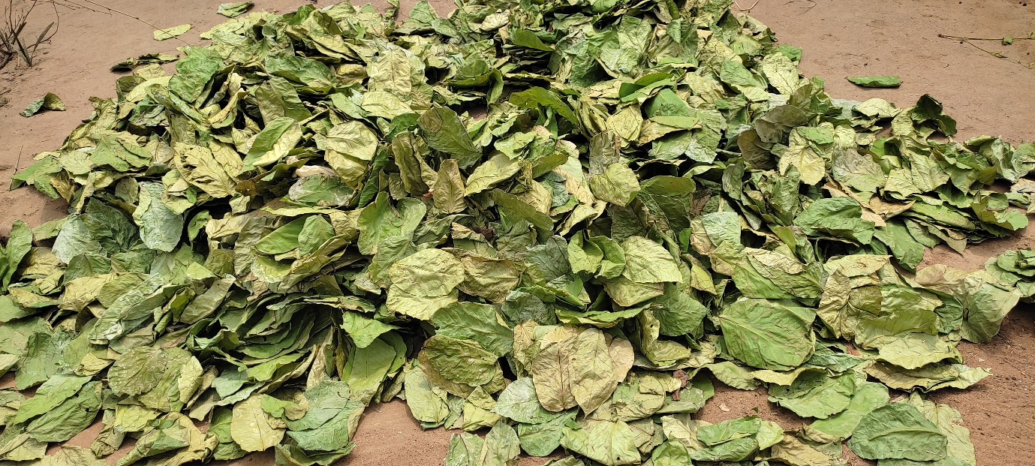
Figure 3: Dried leaves of Sal tree
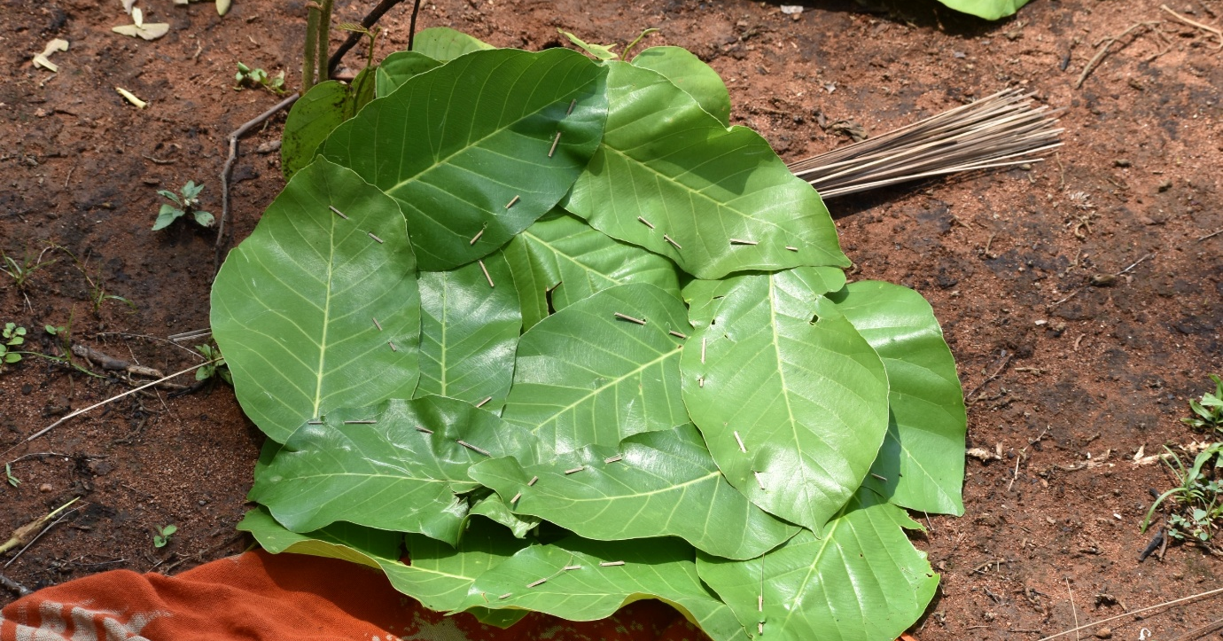
Figure 4: Sal leaf plate making for local market
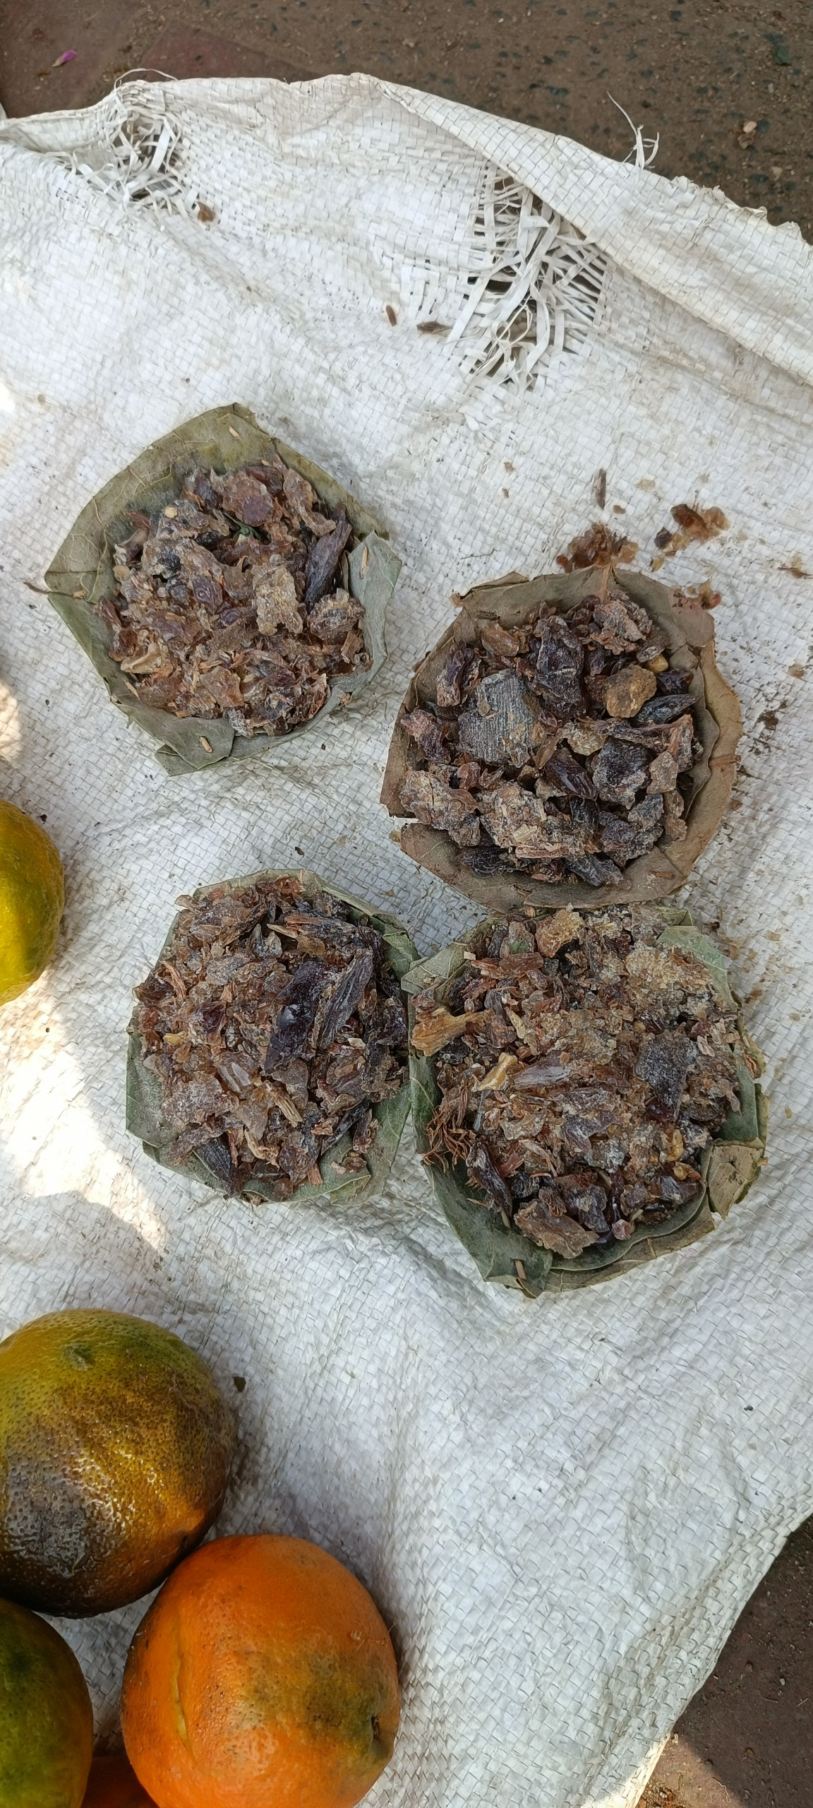
Figure 5: Resin of Sal in local market of Odisha, India
The edible mushroom is rich in proteins, vitamins, and minerals, making it a valuable nutritional supplement to the local diet. Despite its high market value, Rugda remains an unprocessed product due to its high perishability and challenges in artificial cultivation, limiting its availability to the monsoon months (Vinayaka et al., 2024; Rai et al., 2025). Efforts to improve shelf life, processing, and marketing could enhance its commercial potential further. Conserving Sal forests is vital not only for biodiversity but also for sustaining this unique and valuable non-timber forest product, which plays a key role in rural livelihoods and indigenous food culture (Pavithra et al., 2016).
Medicinal values
S. robusta has a wide range of medicinal uses in traditional Indian medicine, including Ayurveda, Unani, and tribal healing systems (Mukherjee et al., 2013). The resin is highly valued for its astringent, antiseptic, anti-inflammatory, analgesic, and wound-healing properties. It is traditionally used to stop bleeding, treat piles, dysentery, diarrhea, and skin diseases, as well as for pain relief and healing of cuts and burns (Mukherjee et al., 2013; Adlakha et al., 2014). The resin is also burned as incense for its medicinal properties during religious rituals and as a disinfectant in sickrooms. The leaves are used as anthelmintics and to treat ulcers, leprosy, cough, earache, and headache (Satyanarayan et al., 2019). The bark is applied externally to stop bleeding, promote wound healing, and treat ulcers (Adlakha et al., 2014; Bainsal et al., 2020). In Ayurveda, the resin and bark are used to help manage menorrhagia, spleen enlargement, and various inflammatory conditions. Pharmacological studies have confirmed the analgesic, anti-inflammatory, anti-microbial, anti-ulcer, and immunomodulatory effects of S. robusta extracts, supporting its traditional uses for managing chronic pain, inflammation, infections, and wound healing (Wani et al., 2012; Musa et al., 2023). Medicinal properties of Sal tree make it a valuable natural resource for healthcare in rural and tribal communities (Khan et al., 2016). The above all aspects show its significance and services (Figure 6). Resin has also economic values (Figure 5). Resin is mixed with honey and used to make pills. Pills are used to cure diarrhoea and dysentery by Kandha tribal community of Odisha state (Authors have observed during field works).

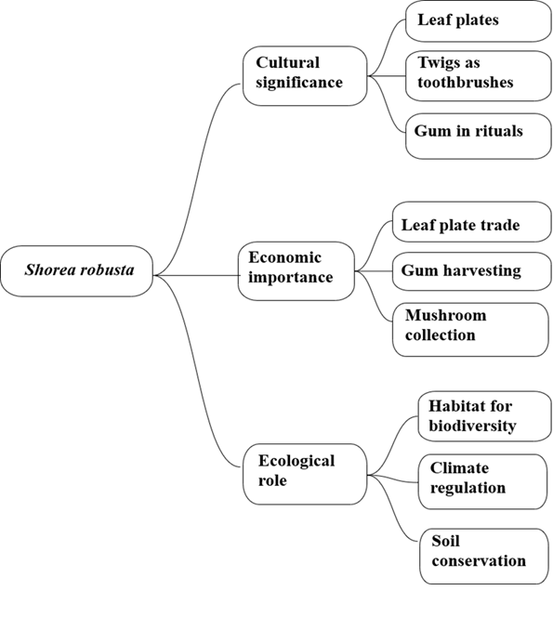
Figure 6: Socio-cultural and ecological services of Sal tree
Threats and challenges
Despite its diverse uses, the Sal tree faces multiple anthropogenic and climatic threats. Deforestation for timber and mining, unsustainable resin tapping, and overharvesting of leaves have severely affected regeneration and forest structure. Increasing temperature, irregular monsoon, and forest fires further stress the Sal ecosystem. Pest infestations, particularly by the Sal heartwood borer, and inadequate forest management practices worsen the scenario. Socio-economic inequities and declining traditional ecological knowledge among younger generations also threaten sustainable utilization. Addressing these challenges requires integrated forest management, community participation, and sustainable policy interventions.
Conclusion
Documentation and sustainable utilization of natural products are most important aspects in the climate change scenario. In this aspect, present study highlights the importance of Sal trees. Various uses are presented to draw attention towards sustainable organic utilization which can lead to value addition of its plant parts. It is a keystone species linking forest ecology, culture, economy, and community well-being across tropical India. Its diverse roles, from providing durable timber and bioactive resin to supporting livelihoods through leaf plate industries and medicinal uses, make it indispensable to both nature and people. However, increasing deforestation, unregulated extraction, and changing climate patterns threaten its sustainability. Recognizing the Sal tree not merely as a forest resource but as an ecological and socio-economic pillar is essential for ensuring its continued contribution to rural development and environmental resilience. Strengthening community-based forest management, promoting sustainable harvesting, and revitalizing traditional ecological knowledge can collectively secure the future of Sal forests. Thus, the economy of the Sal tree exemplifies how conserving a single species can nurture livelihoods, preserve biodiversity, and sustain cultural heritage in a rapidly changing world.
Disclaimer (Artificial Intelligence)
Author(s) hereby declares that no generative AI technologies are used for direct text writing. META A1 is used for grammar corrections during editing this manuscript.
Acknowledgement
The authors are grateful to the tribal communities of Odisha for their support and assistance in obtaining plant photographs.
References
Adhikari B., Kapkoti B., Lodhiyal N. and Lodhiyal L.S. (2017). Structure and Regeneration of Sal (Shorea robusta Gaertn. f.) Forests in Shiwalik Region of Kumaun Himalaya, India. Indian Journal of Forestry. 40(1): 1-8.
Adlakha MK, Bhargava AK, Kapoor R, Sharma LN and Singh C. (2014). Ayurvedic medicinal plant - Shala (Shorea robusta) (a bird’s eye view). Innovare Journal of Ayurvedic Sciences. 2(4): 18–21.
Bainsal N, Goyal P and Singh J. (2020). Shorea robusta Gaertn. F: a multi-therapeutic potential indigenous drug. Plant Archives. 20(2): 3313-3322.
Banik B, Deb D, Deb S and Datta BK. (2018). Assessment of biomass and carbon stock in Sal (Shorea robusta) forests under two management regimes in Tripura, Northeast India. J. For. Environ. Sci. 34: 209–222.
Bhalekar O, Dhamal K, Pawar P, Padhake P and Dharmadhikari K. (2020). Ayurvedic medicative plant: Shorea robusta. International Journal of Research in Pharmacy and Pharmaceutical Sciences. 5(6): 64-65.
Chatterjee K and Ganguly C. (2019). Significance of Shorea robusta (Sal Tree) and prospects of its assisted natural regeneration (ANR) for empowering the local inhabitants of the lateritic region of West Bengal, India. http://dx.doi.org/10.2139/ssrn.4212821
Das SR, Devi R and Kumar S. (2022). Ecological, cultural and medicinal values of sal (Shorea robusta): a multifaceted native tree of India. In: Ethnopharmacology Volume I. Ambika Prasad Research Foundation, Odisha, India.
Deshmukh N, Ikhar A and Paul P. (2024). Traditional practices of oral health care among tribals of India: A scoping review. MRIMS Journal of Health Sciences. 12(1): 1-7.
Hazarika P, Hazarika P and Dutta D. (2018). Traditional knowledge for using plant resources as tooth brushing stick (datun) by the indigenous communities of Assam, India. International Journal of Herbal Medicine. 6(6): 22-34.
Islam MA, Quli SMS, Rai R and Singh PK. (2015). Livelihood promotion through value addition to household traditional Sal (Shorea robusta Gaertn.) leaf plate making in Jharkhand, India. Indian Journal of Natural Products and Resources. 6 (4): 320-325.
Khan YM, Ali SA and Pundarikakshudu K. (2016). Wound healing activity of extracts derived from Shorea robusta resin. Pharmaceutical Biology. 54(3):542-548.
Kora AJ. (2019). Leaves as dining plates, food wraps, and food packing material: Importance of renewable resources in Indian culture. Bulletin of the National Research Centre. 43: 205. https://doi.org/10.1186/s42269-019-0231-6.
Kumar A, Prasad S and Singh S. (2013). Climbers and lianas distribution in Jharkhand Forests. Indian Forester. 139(12):1121–1125.
Kumar G, Dash P, Suresan V, Singh A, Verma RK and Patnaik J. (2022). Assessment of Oral Health-Related Quality of Life among Kutia Kandha Tribes of Odisha. Journal of Pharmacy and Bioallied Sciences 14(Suppl 1): S621-S625.
Kumar K and Abbas SG. (2012). Ethnomedicinal composition depends on floristic composition: a case studied in sal forests of Jharkhand. International Journal of Pharmaceutical and Life Sciences. 3(5): 1710–1719.
Kumar R and Saikia P. (2020). Floristic analysis and dominance pattern of sal (Shorea robusta) forests in Ranchi, Jharkhand, eastern India. Journal For. Res. 31(2): 415–427.
Kumar S, Mishra AK, Kumar SN and Mishra S. (2022b). Economically Important Wild Edible Mushrooms of Bonai Forest Division, Odisha, India. Asian Journal of Biology. 16 (1): 31–40.
Kumar S, Mishra AK, Mishra S and Marndi S. (2022a). Economic Importance of Wild Mushrooms in Mayurbhanj District, Odisha, India. Asian Journal of Biology. 15 (4): 20–25.
Kumar S. (2015). Life support plant species among aboriginals of Similipal Biosphere Reserve Forest, Odisha: Diversity and Conservation. International Journal of Biological Sciences and Engineering. 6(2): 80-86.
Kumar S. (2025). Data collection from literature for biological sciences, medicinal plants research, ethnobotany, and pharmacology: a methodological overview. Journal of Biodiversity and Conservation. 9(2): 167-169.
Lal HS and Singh S. (2012) Study of plant biodiversity of Hazaribag district Jharkhand India and its medicinal uses. Journal of Bioscience Discovery. 3(1): 91–96.
Manjula BL and Marndi S. (2021). Baha bonga and flower of Shorea robusta (Sal) a cultural significance of conservation. Journal Of Biodiversity and Conservation. 5 (3): S7-S10.
Manna S, Ray D and Roy A. (2014). Tribal Relation to Spatio-Temporal Variation of Wild Mushrooms in Eastern Lateritic Part of India. Ethnobotany Research and Applications. 12: 15–24.
Mohanty B, Mohanty S and Panigrahi A. (2020). Oral Hygiene Practice and Oral Health Status among Tribal Children of Odisha, India. Indian Journal of Forensic Medicine & Toxicology, 14 (4): 9179-9182.
Mukherjee H, Ojha D, Bharitkar YP, Ghosh S, Mondal S, Kaity S, Dutta S, Samanta A, Chatterjee TK, Chakrabarti S, Mondal NB and Chattopadhyay D. (2013). Evaluation of the wound healing activity of Shorea robusta, an Indian ethnomedicine, and its isolated constituent(s) in topical formulation. Journal of Ethnopharmacology. 149(1): 335-343.
Musa A, Aminah NS, Kristanti AN, Fathoni I, Amalia RT, Thant TM, Rajasulochana P and Takaya Y. (2023). Phytochemical and pharmacological profile of genus Shorea: A review of the recent literature. Heliyon. 10(2): e23649.
Nayak J, Pattanayak J and Panda D. (2023). Plant resources used for tooth brushing and dental care by the Paraja and the Gadaba tribes of Koraput district, Odisha, India. Science and Culture. 89 (9–10): 357-363
Pavithra M, Sridhar KR, Greeshma AA and Tomita-Yokotani K. (2016). Bioactive potential of the wild mushroom Astraeus hygrometricus in South-west India. Mycology. 7(4): 191–202.
Rai N, Gupta N and Kumar A. (2025). Qualitative and Molecular Characterization of Rugda Mushroom: A Comprehensive Analysis. Uttar Pradesh Journal of Zoology. 46 (15): 285–294.
Satyanarayan P, Sahu S, Singh AKM. (2019). Medicinal Properties of Shorea robusta Gaertn. F. - A Review. International Journal of Advanced Research and Publications. 3(6): 219- 222.
Schulte-Droesch Lea. (2014). Fertility or Indigeneity? Two Versions of the Santal Flower Festival. Asian Ethnology. 73: 155-180.
Sen UK, Bhakat RK and Kumar S. (2020). Sacred groves: sustainable conservation values in future? Journal of Biodiversity and Conservation. 4(3): 391-396.
Sharma A, Bhardwaj DR, Thakur CL, Katoch N, Sharma JP. (2025). Floristic diversity and dominance patterns of Sal (Shorea robusta Gaertn. f.) forests in North Western Himalayas: implications for conservation and sustainable management. Frontiers in Forests and Global Change. Frontiers in Forests and Global Change. https://doi.org/10.3389/ffgc.2025.1524808.
Sharma M. (2022). Shorea robusta Gaertn.f: A review on its importance, entomological problems and management in the Indian sub-continent. Indian Forester. 148(6): 606–614.
Sheetal, Singh DV, Johar V and Dhyani A. (2024). A review on importance of sal tree (Shorea robusta) as an interminable wood. Asian Journal of Microbiology, Biotechnology & Environmental Sciences. 26: 153-156.
Shrestha BK, Dhungana B, Shakya J, Shrestha R and Chauhan S. (2022). Phytochemical and Antimicrobial Screening of Bark Extract of Shorea robusta (Sal). Nepal Journal of Biotechnology. 10(1). https://doi.org/10.54796/njb.v10i1.227.
Singh H, Baske PK, Saravanan R and Dhole P. (2015). Traditional uses and marketing of crude oleoresin (Jhuna) of Shorea robusta (Dipterocarpaceae) by tribes in Odisha. ENVIS Newsletter. 20(1): 5.
Singh PK and Quli SMS. (2011). Economic valuation of non-timber forest product’s contribution in tribal livelihood in West Singhbhum district of Jharkhand. Indian Forester. 137(11): 1258-1264.
Soni RK, Dixit V, Irchhaiya R and Singh H. (2013). A review update on Shorea robusta Gaertn f. (Sal). Journal of Drug Delivery and Therapeutics. 3(6). http://jddtonline.info/index.php/jddt/article/view/653.
Soren K. (2025). Individual to Community OR Community to Individual? A Question of Sociological Significance of ‘Baha Bonga’ of Santal Tribe of Odisha. International Journal of Research and Scientific Innovation. 324-329. https://doi.org/10.51244/IJRSI.2025.120700031.
Tomar JMS, Prasad S, Jayaprakash J, Kumar R, Sankar M, Kaushal R and Chaturvedi OP. (2021). The Response of Sal (Shorea robusta Gaertn.) Forests Under Disturbance Regimes in Uttarakhand – India. Journal of Global Agriculture and Ecology. 11(1): 8–22.
Tripathi AK and Shankar U. (2014). Patterns of species dominance, diversity, and dispersion in ‘Khasi hill sal’ forest ecosystem in northeast India. Forest Ecosystems. 1: 23 https://doi.org/10.1186/s40663-014-0023-2.
Vinayaka K.S., Mahendru N., Lal S., Mishra S. and Kumar S. (2024). Rugda (Astraeus hygrometricus): a livelihood of Tribal community. In Book: Edible and Medicinal Mushrooms of India, Volume 1. Ambika Prasad Research Foundation, Odisha, India.
Wani TA, Chandrashekara HH, Kumar D, Prasad R, Gopal A, Sardar KK, Tandan SK and Kumar D. (2012). Wound healing activity of ethanolic extract of Shorea robusta Gaertn. f. resin. Indian Journal of Experimental Biology. 50(4): 277-281.

