Nutrient Fluxes and Their Effects on Food Web Stability in Aquatic Systems
Abstract
Nutrient dynamics are essential in determining the structure, functionality, and long-term stability of food chains and food webs within ecosystems. Through major biogeochemical cycles, such as those of nitrogen, phosphorus, carbon, and sulphur; nutrients are continually cycled and exchanged between living organisms and their physical environment. These cycles govern the availability of critical nutrients necessary for primary producers, thereby shaping the foundational levels of trophic systems and driving the flow of energy through successive trophic levels. Changes in nutrient supply influence species diversity, trophic relationships, and the overall productivity of biomass. While balanced nutrient inputs support biodiversity and promote ecosystem stability, excessive nutrient loading can disrupt food web dynamics, triggering problems such as eutrophication, loss of species, and imbalances across trophic levels; commonly referred to as the "paradox of enrichment." Additionally, nutrient recycling through detritus-based processes and consumer activities creates feedback mechanisms that can either buffer or amplify ecological fluctuations depending on prevailing environmental factors. Overall, the interactions between nutrient cycles and trophic dynamics underscore the critical need to manage nutrient inputs carefully to preserve ecological health across both aquatic and terrestrial ecosystems.
Keywords
Nutrient dynamics, Biogeochemical cycles, Primary production, Nutrient enrichment, Detritus pathway, Ecosystem resilience
Introduction
“Nutrients, in their broadest sense, refer to all chemical elements essential for biological processes such as growth, survival, and reproduction” (DeAngelis et al., 1989). Organisms require macronutrients including carbon (C), hydrogen (H), nitrogen (N), phosphorus (P), potassium (K), sulfur (S), and calcium (Ca) in substantial amounts to carry out fundamental physiological functions. Additionally, elements like silicon (Si) play specialized roles in cellular and structural processes. Micronutrients, such as copper (Cu) and zinc (Zn), though needed in much smaller quantities, are equally critical for enzymatic and metabolic activities (Smith and Smith, 1998). In natural environments, the limitation of certain nutrients can constrain the primary productivity of ecosystems depending on spatial and temporal conditions. Notably, in aquatic systems, the availability, chemical form, and stoichiometric ratios of nitrogen (N) and phosphorus (P) are primary factors regulating productivity (Officer and Ryther, 1980). The term nutrient dynamics broadly encompasses the mechanisms by which nutrients are absorbed, stored, transformed, and recycled within an ecosystem over time and space. Understanding these nutrient pathways is fundamental to maintaining ecological balance, enhancing ecosystem productivity, and promoting long-term sustainability in terrestrial, aquatic, and agro-ecological systems.
Nutrient dynamics
Nutrient dynamics refer to the processes by which nutrients are absorbed, stored, transported, and recycled within ecosystems across both spatial and temporal scales (Hauer and Lamberti, 2006; Allan and Castillo, 2007). These processes are fundamental to comprehending the ecological equilibrium, biological productivity, and long-term sustainability of terrestrial, aquatic, and agricultural environments.
Aquatic Ecosystems
Nutrient Dynamics in Aquatic Ecosystems
In aquatic systems, nutrient dynamics govern the availability of essential elements to phytoplankton, which form the foundation of food webs. Phytoplankton productivity directly influences higher trophic levels, including herbivorous zooplankton, invertebrates, and fish, ultimately shaping the structure and stability of aquatic communities. Nutrient cycling regulates primary production and determines the energy available for consumers, while also influencing species composition and biodiversity. The processes governing nutrient dynamics in aquatic ecosystems are complex and interlinked. Nutrients enter these systems through natural sources such as rock weathering, atmospheric deposition, and biological nitrogen fixation, as well as anthropogenic sources including agricultural runoff, industrial effluents, and municipal wastewater. Once introduced, nutrients undergo transformation processes. Nitrogen, for example, cycles through fixation, nitrification, ammonification, and denitrification, while phosphorus undergoes mineralization, sorption-desorption, and precipitation. Carbon and sulfur cycles involve photosynthesis, respiration, decomposition, and oxidation-reduction reactions. These transformation processes determine nutrient bioavailability and regulate the growth of primary producers, which in turn control energy flow through the food web.
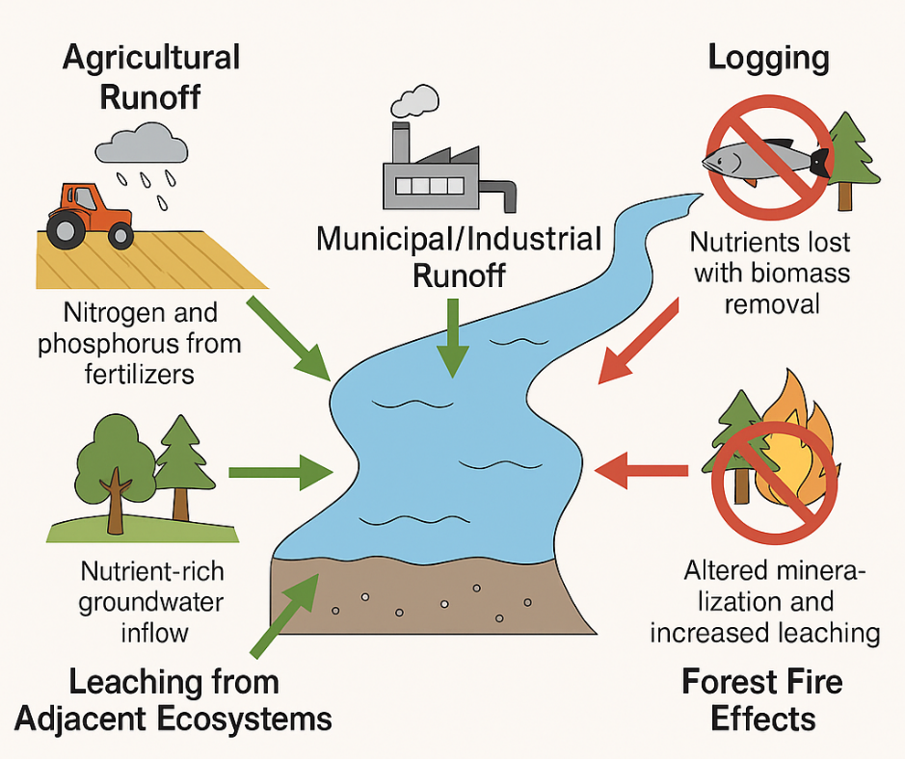
Fig.1 Import of Nutrients into Aquatic Ecosystems
Processes in Nutrient Dynamics:
- Input Sources: Natural (weathering, atmospheric deposition) and anthropogenic (agricultural runoff, wastewater discharge).
- Transformation:
  - Nitrogen: Fixation, nitrification, denitrification.
  - Phosphorus: Sorption-desorption, mineralization, precipitation.
- Transport: Through surface runoff, groundwater flow, and sediment transport.
- Loss Pathways: Volatilization (for nitrogen), leaching, sedimentation.
Nutrient cycle
The nutrient cycle, or biogeochemical cycle, describes the ongoing circulation and recycling of nutrients within Earth's ecosystems, involving both biotic (living) and abiotic (non-living) components. These cycles are vital for sustaining life, as they control the supply of essential elements required for various biological functions. Nutrients are transformed, transported, and reused through a series of chemical, biological, and geological processes, including weathering, decomposition, and assimilation.
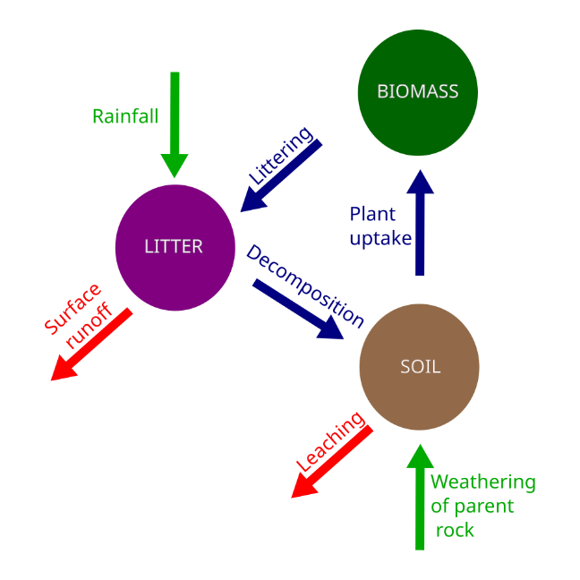
Fig.2 Nutrient cycle
Nutrient Cycling and Resource Availability
- The process of nutrient cycling enhances the supply of essential, often limiting, nutrients for primary producers by reusing mineral elements, thereby establishing a vital connection between all trophic levels and the foundational energy sources within food webs.
- In ecosystems where nutrients are scarce, this recycling mechanism can account for over half of the total nutrient input, significantly supporting the survival and continuity of species.

Influence of Nutrient Cycles on Food Chains and Webs
Nutrient cycling directly affects the structure, diversity, and stability of food chains and webs. By regulating the availability of essential nutrients, recycling processes influence primary productivity and energy flow, which in turn support herbivores, carnivores, and detritivores. In ecosystems with limited nutrients, recycling enhances the survival of species across trophic levels and maintains food web stability. Conversely, in nutrient-rich systems, excessive nutrient availability may lead to overproduction of basal resources such as phytoplankton, triggering population oscillations, increased competition, and higher risks of species loss—a process referred to as the paradox of enrichment (Abrams, 1993; Loreau, 2010; Binzer et al., 2011).
Food web stability can be assessed using metrics such as resilience, resistance, and temporal variability. Resilience refers to the ability of an ecosystem to return to equilibrium after a disturbance, whereas resistance measures the degree to which populations withstand change under environmental stress. Temporal variability indicates the fluctuations of population densities over time (McCann, 2000). Nutrient cycling can influence all these aspects by providing a continuous supply of limiting nutrients and generating feedback loops through detritus and consumer excretion, which regulate biomass distribution and energy flow across trophic levels.
Impact of Nutrient Cycling on Food Web Stability via Various Mechanisms
“Recycled nutrients supplement external mineral nutrient inputs, potentially causing an enrichment effect within ecosystems” (Loreau, 2010). “By enhancing nutrient availability, nutrient cycling promotes primary production” (Loreau, 2010), which in turn increases energy flow to consumer organisms. This boost in energy transfer can support the survival of more species and help maintain higher trophic levels (Abrams, 1993; Binzer et al., 2011). However, nutrient cycling can also have destabilizing consequences for food web dynamics by elevating the availability of basal resources. When resource levels rise excessively, it may amplify population fluctuations, thereby raising the likelihood of species extinctions. In ecosystems where nutrients are limited, nutrient cycling typically enhances food web stability by promoting species survival and supporting upper trophic levels. Conversely, in nutrient-rich environments, this process may disrupt stability. Additionally, nutrient cycling introduces direct feedback mechanisms from all trophic levels back to the base of the food web. These feedback loops, beyond merely increasing nutrient levels, may significantly influence biomass fluctuations across the ecosystem.
Allometric Food Web Models and Nutrient Cycling
Allometric food web models are widely used to study complex ecosystems because they integrate species interactions, nutrient cycling, and energy flow within a stoichiometric framework. These models consider multiple species of producers and consumers, alongside non-living compartments such as mineral nutrients and detritus. Organisms contribute to nutrient recycling either directly, through excretion of mineral nutrients, or indirectly, by producing decomposable detritus. The flow between carbon-based biological components and nutrient-based compartments follows stoichiometric constraints, which regulate nutrient conversion and balance.
Simplified models, such as a three-species food chain consisting of a primary producer, an herbivore, and a carnivore, demonstrate how nutrient cycling links population dynamics with ecosystem processes. Incorporating nutrient recycling into these models allows for predictions of how species populations respond to changes in nutrient availability, and how these responses affect overall ecosystem functioning. Modern approaches also integrate allometric relationships, where species metabolic rates, body sizes, and consumption rates influence nutrient and energy flow, providing a more realistic representation of ecosystem dynamics.

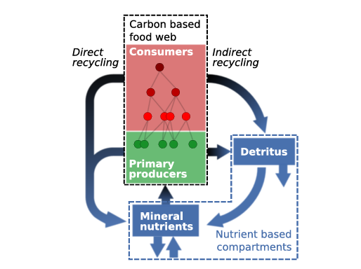
Fig.3 Schematic diagram of the modelled food web
Nutrient Cycling and Enrichment Effects
- The influence of nutrient cycling on food web stability is primarily driven by how it alters nutrient availability within ecosystems.
- This process creates an enrichment effect that supports species survival under low nutrient conditions but may disrupt ecosystem stability when nutrient levels are high.
- In nutrient-rich environments, excessive primary production can occur, often resulting in species loss and a decline in the overall complexity of the food web.

Detrital Food Chains and Nutrient Recycling
Detritus plays a central role in nutrient recycling and the maintenance of food web stability. Organic matter from dead plants, algae, and animals is decomposed and mineralized through a two-step process. Fragmenters, including microfauna such as earthworms, amphipods, and millipedes, break down large organic particles into smaller pieces, increasing surface area for microbial decomposition. Decomposers, such as bacteria and fungi, further process these fragments into simpler inorganic forms like ammonium, nitrate, and phosphate, which are then available for uptake by primary producers.
In aquatic ecosystems, detrital decomposition is influenced by environmental factors such as temperature, oxygen availability, and water stratification. Seasonal changes, particularly in temperate lakes, can alter water column mixing and oxygen distribution, affecting decomposition rates and nutrient redistribution. The detritus-based (brown) food chain complements the grazing-based (green) food chain, ensuring that nutrients are retained within the ecosystem and energy is efficiently transferred across trophic levels (Moore et al., 2004).
Decomposition in Aquatic Environments:
In aquatic systems, decomposition is influenced by environmental factors. Photosynthesis occurs primarily at the surface, while organic detritus sinks to the benthic zone. In this lower zone, reduced oxygen levels and cooler temperatures slow decomposition. Seasonal changes affect water movement stratification typically occurs in summer, creating distinct layers, while mixing happens during fall/autumn turnovers, redistributing nutrients and oxygen throughout the water column.
Conclusion
Nutrient dynamics are fundamental to the productivity, stability, and resilience of aquatic food chains and webs. Recycling of essential nutrients supports primary production and species survival in nutrient-limited environments, whereas excessive nutrient enrichment can destabilize ecosystems, reduce biodiversity, and alter trophic interactions. Detritus serves as a crucial nutrient reservoir, facilitating recycling through the brown food web. Understanding the interactions between nutrient cycles, food web dynamics, and anthropogenic pressures is vital for effective management and conservation of aquatic ecosystems. Future research should focus on comparing ecosystems with contrasting nutrient cycling rates to better understand the role of nutrient dynamics in ecological stability and resilience.
Disclaimer (Artificial intelligence)
Option 1:
Author(s) hereby declare that NO generative AI technologies such as Large Language Models (ChatGPT, COPILOT, etc.) and text-to-image generators have been used during the writing or editing of this manuscript.
Option 2:
Author(s) hereby declare that generative AI technologies such as Large Language Models, etc. have been used during the writing or editing of manuscripts. This explanation will include the name, version, model, and source of the generative AI technology and as well as all input prompts provided to the generative AI technology
Details of the AI usage are given below:
1.
2.
3.
Reference
Abrams, P. A. (1993). Does increased productivity increase the risk of population cycles? Ecology, 74(3), 2010–2020.
Allan, J. D., Castillo, M. M., & Capps, K. A. (2021). Stream ecology: Structure and function of running waters. Springer Nature.
Binzer, A., Guill, C., Brose, U., & Rall, B. C. (2011). Interactive effects of warming, eutrophication and size structure: Impacts on biodiversity and food-web structure. Global Change Biology, 17(4), 1455–1466.
DeAngelis, D. L., Mulholland, P. J., Palumbo, A. V., Steinman, A. D., Huston, M. A., & Elwood, J. W. (1989). Nutrient dynamics and food-web stability. Annual review of Ecology and Systematics, 71-95.
Harrison, M.D. (2016). Nutrient Dynamics. In: Kennish, M.J. (eds) Encyclopedia of Estuaries. Encyclopedia of Earth Sciences Series. Springer, Dordrecht. https://doi.org/10.1007/978-94-017-8801-4_75
Hauer, F. R., & Lamberti, G. (2017). Methods in stream ecology: Volume 1: Ecosystem structure. Academic Press.
Loreau, M. (2010). From populations to ecosystems: Theoretical foundations for a new ecological synthesis. Princeton University Press.
McCann, K. (2000). The diversity–stability debate. Nature, 405, 228–233.
Moore, J. C., Berlow, E. L., Coleman, D. C., de Ruiter, P. C., Dong, Q., Hastings, A., … & Wall, D. H. (2004). Detritus, trophic dynamics and biodiversity. Ecology Letters, 7(7), 584–600.
Officer, C. B., & Ryther, J. H. (1980). The possible importance of silicon in marine eutrophication. Marine Ecology Progress Series, 3(1), 83-91.
Smith, R. L., & Smith, T. M. (1998). Elements of ecology (4th ed.). Benjamin Cummings.
Smith, R. L., Smith, R. L., Hickman, G. C., & Hickman, S. M. (1998). Elements of ecology.

