Short Research Article
Comparison of the radiopacity of zinc oxide-eugenol cements using different radiographic methods

.
ABSTRACT

Aims: To evaluate whether there is a difference in the radiopacity of four endodontic sealers, using two imaging techniques.
Study design: Experimental study, with a quantitative approach.
Place and Duration of Study: Research Laboratory - Dentistry Course at the University of Fortaleza (UNIFOR), between June 2024 and May 2025.
Methodology: Four endodontic sealers (Endofill, Ciment-Fill, Pulp Fill, and Fill Canal) were prepared according to the manufacturer's instructions and inserted into 10 mm diameter x 1 mm high rings, with three samples per group (n = 3), totaling n = 12. After complete setting, the samples were positioned on radiographic occlusal films, next to an aluminum penetrometer and exposed to X-rays (60 kV, 10 mA, 0.3 s, at 30 cm), using a digital sensor and analog method. Radiopacity was analyzed in the Photopea program, converting the radiographic density into millimeters of aluminum.
Results: Digital radiography showed greater sensitivity in detecting radiopacity, with a statistically significant difference compared to the analog technique (P < 0.05). Endofill showed the highest radiopacity in both methods, significantly surpassing Pulp Fill and Fill Canal. Ciment-Fill presented intermediate values, similar to Pulp Fill, with no statistical difference between them (P > 0.05). Fill Canal presented the lowest radiopacity, significantly lower than the others (P < 0.05), which may compromise its clinical visibility.
Conclusion: The materials tested are within the values ​​proposed by the American Dental Association (2000), specification no. 57 and no. 6876 of the International Organization for Standardization (ISO). In addition to evaluating the radiopacity density, the digital radiographic technique presented superior results to the analog, both revealing positive results.

Keywords: Endodontics; Root Canal Restorative Materials; Zinc Oxide-Eugenol Cement; Radiography, Dental.

1. INTRODUCTION

Endodontic therapy aims to eliminate the microorganisms responsible for the inflammatory and infectious response of the pulp through three stages of endodontic treatment: cleaning, shaping, and obturation of the root canals, after removal of the causative agent through chemomechanical preparation; disinfection of the root canal system; its adequate sealing; and sealing of the coronal portion (Burkovski; Karl, 2019; Zuckerman et al., 2007; Alghazaly; Habib, 2023).
Therefore, after chemomechanical preparation, it is necessary to obturate the root canals. This requires a smaller amount of sealing cement and a larger amount of gutta-percha due to its dimensional stability, non-adherence to dentin, non-discoloration, radiopacity, and easy removal. Thus, root canal sealers are seen as the "fragile" component of the system. However, despite their fragility, root canal sealers are not dispensable due to their potential for flow into the branches of the canal system, in addition to providing regularization of the dentin/root canal sealer interface, lubricating action, serving as a cementing agent during the obturation phase, and possessing radiopaque properties that aid in assessing the quality of the obturation (de Deus et al., 2002; Komabayashi et al., 2020; Fernandes, 2021).
Furthermore, during endodontic treatment, various radiographic examinations are performed to confirm the intervention phase. Therefore, knowledge of good radiographic techniques and the properties of the root canal sealer used is essential. During root canal obturation, the root canal sealer must possess good radiopacity, a physical property that is extremely important in the obturation evaluation process. Therefore, dental radiography is responsible for differentiating dentin and bone structure, the presence of interruptions in the continuity of the sealer, and adequate root canal filling. This helps visualize the presence of bubbles in the sealing material, overfilling, and underfilling, facilitating the operator's identification of defects during the filling phase. Therefore, ideal radiopacity in a sealing material must enable clarity and homogeneity in radiographic images. Thus, the American Dental Association and the International Organization for Standardization (ISO) are responsible for promoting specifications 57 and 6876, which provide standardization regarding the radiopacity of endodontic sealers, which must present radiopaque properties greater than or equal to 3 mm of aluminum (Carvalho Filho et al., 2008; Carvalho Filho, 2009).
From this perspective, sealing sealers contain radiopacifying agents in their composition, responsible for radiopacity, a physical property of the sealing material. Radiopacifiers are extremely important during endodontic treatment, especially during the filling phase, as they allow the operator to visualize the quality of the canal filling, including any gaps, bubbles, or material flow (overfilled and underfilled) which can be visualized during radiographs (do Nascimento et al., 2022).
It is important to list the different types of endodontic sealers, which can be classified according to their composition and setting reaction: zinc oxide-eugenol-based sealers, calcium hydroxide-based sealers, plastic resin-based sealers, and bioceramic sealers. Zinc oxide-eugenol (ZOE) sealers are classified according to their composition, which is presented in powder-liquid form. The powder contains zinc oxide, and the liquid contains eugenol, an essential oil obtained from cloves. (Komabayashi et al., 2020). Furthermore, ZOE-based sealers are widely used in endodontics due to their good performance when used long-term. Their characteristics include high antibacterial activity, impermeability, efficient flow, radiopaqueness, easy handling, and good dentin adhesion. According to Fernandes (2021), the inflammatory response is reduced, and they present good biocompatibility with periradicular tissues. However, some formulas contain silver powder, which is seen as an advantage, as it increases radiopacity; but a disadvantage, as it can cause darkening of the dental crown, and eugenol has some cytotoxic potential. (Komabayashi et al., 2020).
In this context, there is currently a diversity among the different types of filling materials and differences in their ideal characteristics. Therefore, the objective of the present study was to evaluate the existence of differences in the radiopacity of four endodontic sealers based on zinc oxide and eugenol (Endofill, Ciment-Fill, Pulp Fill and Fill Canal – Fig. 1. A, B, C and D).

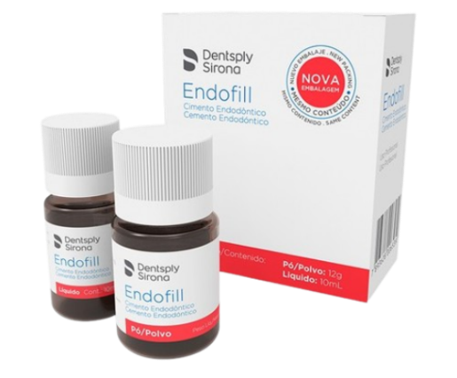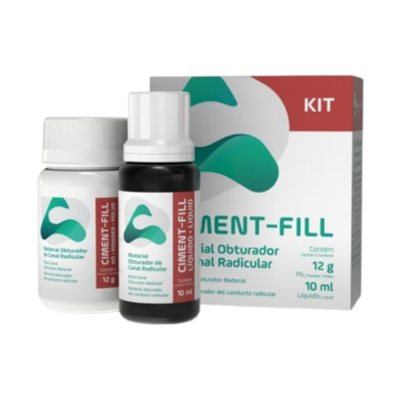
- (B)

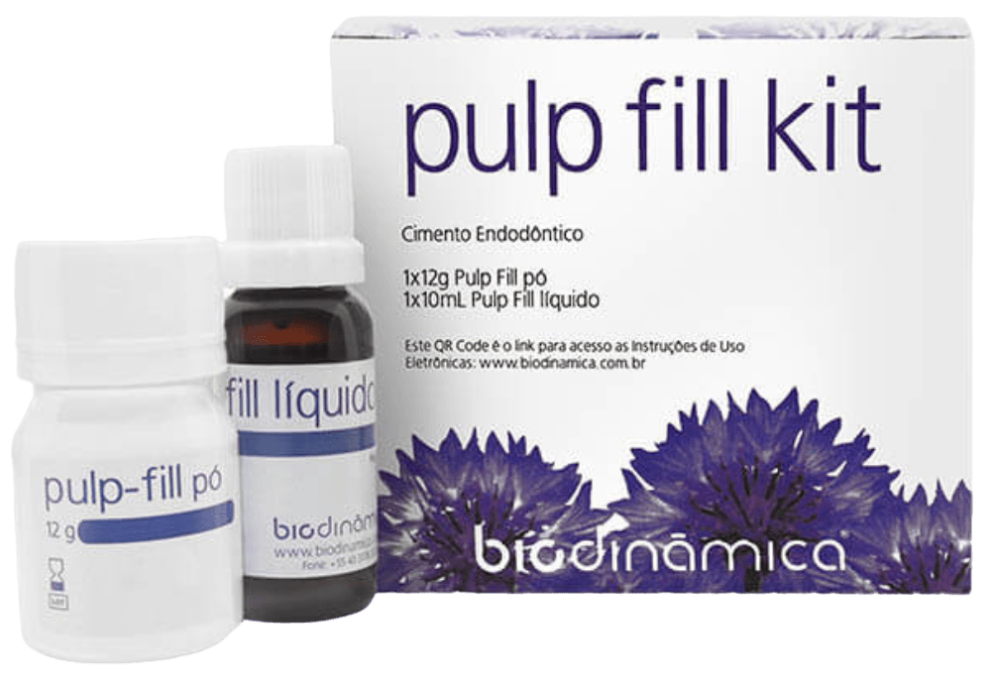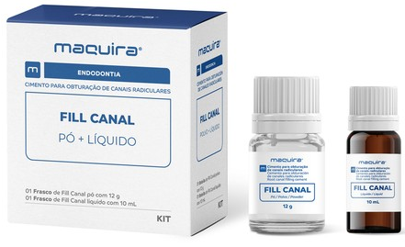

(C) (D)

Fig. 1. (A) Endofill - (B) Ciment-Fill - (C) Pulp Fill - (D) Fill Canal
Source: https://www.dentalcremer.com.br/

2. material and methods

This experimental study, with a quantitative approach, was conducted in the Research Laboratory of the Dentistry program at the University of Fortaleza (UNIFOR). This included the cement handling and radiographic stages.
Initially, it was necessary to understand the radiopacity tests. The specifications used were those of the American Dental Association 57 and the International Organization for Standardization (ISO) 6876/2012, which specify the methods and requirements for conducting the tests in a standardized manner.
In this context, the four ZOE-based sealers chosen for the test were: Endofill, Fill Canal, Pulp Fill, and Ciment-Fill. They were handled as instructed by the manufacturers and arranged in rings measuring 10 mm in diameter and 1 mm in height (n = 3) on a flat, smooth glass plate. The recommendations of ISO 6876/2012 were followed. The set was stored in an oven and waited for the filling material to set, requiring three times the setting time determined by the manufacturer. Then, to assess radiopacity, analog and digital radiographic methods were used. Following the methodology proposed by Duarte et al. (2009), the rings were positioned along with an aluminum penetrometer (Odeme Dental Research – Fig. 2) (increasing from 2 to 16 mm of Al), on an occlusal radiographic film (Kodak Comp, Rochester, NY, USA – Fig. 3). Afterward, regarding the cement setting, the glass plates were removed from the oven and their thickness checked with a digital caliper. Once the cement rings were approved and within the proposed measurements, the samples were placed on an occlusal film next to the aluminum rings (used as a reference) and sensitized with a 60kV, 10mA X-ray device (Gnatus XR 6010; Gnatus, Ribeirão Preto, SP, Brazil – Fig. 4) and a digital sensor (VistaScan Mini View; Dürr Dental AG, Bietigheim-Bissingen, Germany – Fig. 5), with an exposure time of 0.3 seconds and a distance of 30 cm from the film to the focus of the device.
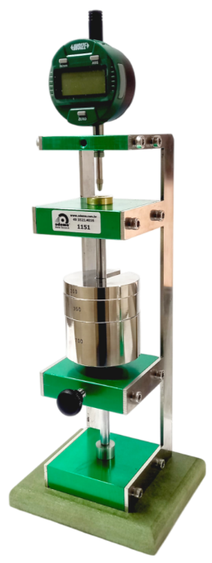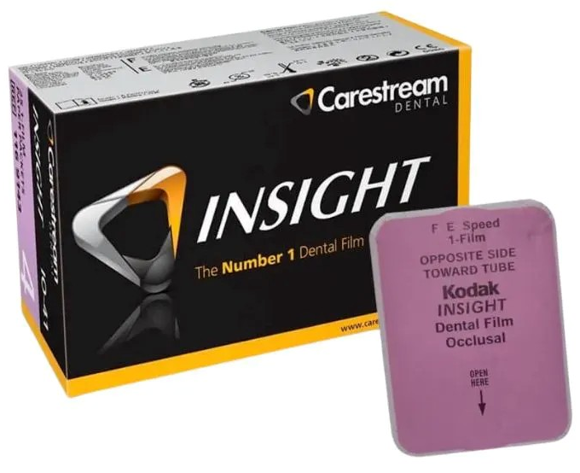
Fig. 3. Occlusal Radiographic Film
Source:https://images.tcdn.com.br/img/img_prod/585327/filme_oclusal_io_41_kodak_carestream_2755_1_20231026173749.jpg

Fig. 2. Aluminum Penetrometer
Source: https://www.odeme.com.br/?lang=pt

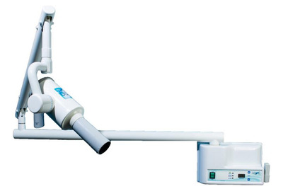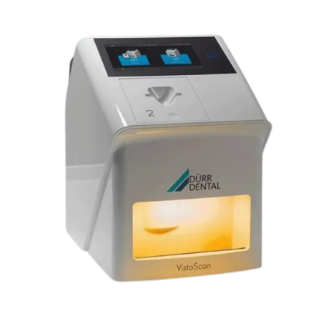
Fig. 5. Digital Sensor
Source:https://www.medicalexpo.com/pt/prod/duerr-dental/product-72550-604915.html

Fig. 4. X-ray
Source:https://http2.mlstatic.com/D_903099-MLB79652135110_102024-C.jpg

Following this, the conventional radiographs were developed in the order of two minutes in the developer, five seconds in water, four minutes in the fixative, five minutes in water, and then placed in the dryer for complete drying. The images were scanned using photographs and placed on a grayscale. The radiopacity of the digital radiographs was then analyzed using digital imaging software, Photopea (Photopea, Prague, Czech Republic). The comparative value of radiopacity was determined according to the radiographic density, which was converted into millimeters of aluminum (mm Al) using the formula presented by Duarte et al (2009):

A 2/B + mm/AL
A = Radiographic Density of the material (DRm) – Radiographic Density of aluminum below DRm
B = Radiographic Density of aluminum above DRm – Radiographic Density of aluminum below DRm
2 = 2mm increment between aluminum and other material steps

The cements used were: ZOE-based filling cements from different companies: Endofill (Dentsply Sirona, Charlotte, NC, USA), Fill Canal (Maquira Dental Group, Maringá, PR, Brazil), Ciment-Fill (AAF do Brasil, Londrina, PR, Brazil), and Pulp Fill (Biodinâmica, Ibiporã, PR, Brazil). Regarding the sample size, 12 samples were used: three samples per brand of filling material and one control sample, for comparison, such as an aluminum plate.
The exclusion criteria used were: filling cements that were not zinc oxide and eugenol-based; difficulty in purchasing them in specialized dental supply stores; and samples that presented bubbles, cracks, or thicknesses outside the parameters during the experiment. After the experiments were completed, the data were placed in tables and analyzed in relation to their parametric or non-parametric nature, subject to analysis of variance and individual comparative tests, ANOVA with Tukey's test (P < 0.05) with a significance level of 5%.

3. results

Table 1 presents the results of the radiopacity tests, which identify the cements used, with radiographs obtained through analog and digital methods. It presents data such as the mean for each method, material, and standard deviation using the ANOVA test.

Table 1. Mean and standard deviation presented by the cements for the radiopacity property.
 | RADIOPACITY | DIGITAL | RADIOPACITY | ANALOG
 | MÉDIA | DP | MÉDIA | DP
PULP FILL | 204.92 ^{b, A} | 4.07 | 159.17 ^{b, B} | 1.31
ENDOFILL | 213.11 ^{a, A} | 2.71 | 162.27 ^{a, B} | 1.39
CIMENT-FILL | 210.61 ^{ab, A} | 3.74 | 159.81 ^{ab, B} | 3.27
FILL CANAL | 199.52 ^{c, A} | 3.87 | 154.16 ^{c, B} | 1.90
a,b Different superscript lowercase letters indicate statistically significant difference between groups using the same method and different uppercase letters indicate significant difference within groups using the same method according to the ANOVA test with Tukey's test (P < 0.05).
Source: author's own.

When performing the analysis, we obtained the average radiopacity of each cement. Comparing the two imaging techniques, we found that digital radiography presented a higher average radiopacity than analog radiography in all groups tested. Thus, the difference between the methods was statistically significant (P < 0.05), demonstrating that the digital technique offers greater sensitivity in detecting material density.
Endofill presented greater radiopacity in both digital (213.11 ± 2.71) and analog (162.27 ± 1.39) images, with a significant difference compared to Pulp Fill and Canal Fill (P < 0.05). This positioned it as the cement with the best radiographic visibility. Ciment-Fill presented intermediate values ​​(210.61 ± 3.74 digital and 159.81 ± 3.27 analog), with no statistically significant difference in relation to Pulp Fill (204.92 ± 4.07 digital and 159.17 ± 1.31 analog), which indicates similar behavior between these two cements in both methods (P > 0.05). And Fill Canal presented the lowest radiopacity in both methods (199.52 ± 3.87 digital and 154.16 ± 1.90 analog), with a significant difference in relation to the other cements (P < 0.05). Characterizing it as the material with the worst radiographic performance, which may compromise its clinical identification in radiographs.
From this perspective, when analyzing the analog and digital radiographic technique, it is possible to place them in decreasing order in relation to the radiopacity density of the cements, classifying them as: Endofill > Ciment-Fill > Pulp Fill > Fill Canal.

4. DISCUSSION

Radiopacity is one of the physicochemical properties of root canal sealers, which are used in the final stage of endodontic treatment. Therefore, it plays an important role in the root canal filling phase, as radiography allows for the analysis of filling, quality, and drainage in the root canal system. This helps differentiate adjacent tissues from root canal filling material, aiding in the diagnosis and follow-up process. Therefore, the methodology proposed by Duarte et al. was used. (2009) to perform the radiopacity analysis (Werlang et al., 2015; (Lemos Dupont et al., 2024).
In this perspective, during data collection, the composition of the root canal sealers was verified, and their package inserts showed that the four groups contain the same radiopacifying agents: bismuth subcarbonate and barium sulfate. According to Almeida et al. (2011), when materials contain a combination of radiopacifying agents in their composition, the difference in proportion can alter the extrinsic and intrinsic properties, such as radiopacity. Therefore, it is suggested that there is a difference in the proportion of the components presented, as a statistically significant difference (P < 0.05) was analyzed between Fill Canal sealer, which presented the worst result, and the other sealers: Endofill, Ciment-Fill, and Pulp Fill. Thus, we can suggest that Fill Canal has a lower proportion. of radiopacifier compared to the other cements analyzed.
In this context, when collecting data on radiopaque density in both radiographic methods, a statistically significant difference (P < 0.05) was observed when comparing the analog with the digital method. The radiopacity obtained by digital flow showed superior results in relation to the radiopacity density of the cement groups tested, when compared to the analog method, in contrast to the literature presented by Ochoa-Rodríguez et al. (2020), as the article states that endodontic materials present a variation of 7 to 20% less radiopacity in Photosensitive Phosphor Plate (PSP) images. Despite the difference in average radiopacity density between the digital and analog radiographic methods, the cements presented the same ranking when analyzed statistically.
From this perspective, according to the American Dental Association (2000) specification No. 57 and No. 6876 of the International Organization for Standardization (ISO), which determines that filling materials must have a minimum radiopacity of 3 mm of aluminum (Al). Analyzing the data obtained in this study, the endodontic sealers Endofill, Ciment-Fill, Fill Canal, and Pulp Fill, using the analog radiographic method, presented an average radiopacity ranging from 6 to 10 mm of Al, and using the digital method, they presented an average radiopacity ranging from 8 to 10 mm of Al. Therefore, they presented values ​​greater than 3 mm of Al during radiopacity density analysis of radiographs, both using the analog and digital radiographic methods (Sydney et al., 2008; Do Nascimento et al., 2022).
Although the four root canal sealers evaluated had the same radiopacifying agents in their composition, Fill Canal sealer presented a lower radiopacity density when compared to the other sealers evaluated. Therefore, it is suggested that there is a difference in the proportion of the components of each root canal sealer.
The limitations presented were the lack of a more precise quantitative analysis of the sealer composition. obturators, which could confirm the hypothesis raised regarding the influence of the proportion of radiopacifying agents on the alteration of radiopaque density. From this perspective, it is necessary to invest in additional research employing more rigorous analytical techniques, such as scanning electron microscopy coupled with energy dispersive spectroscopy (SEM/EDS), which would allow the morphological and elemental characterization of the components, as well as X-ray diffraction (XRD), capable of identifying the crystalline phases present in the sealers. These methods could provide complementary and more detailed data, enriching the understanding of the radiopacity of zinc oxide and eugenol-based obturator sealers. Such approaches would contribute significantly to expanding and consolidating the scientific literature on the subject.
Clinically, the proposed theme reinforces the importance of choosing the obturator sealer, as radiopacity is used to assess root canal filling, in addition to radiographic monitoring of endodontic treatment, which contributes to proservation, treatment longevity, and diagnosis (Aznar, 2010).

4. Conclusion

The materials tested met the values ​​proposed by the American Dental Association (2000), specification no. 57, and no. 6876 of the International Organization for Standardization (ISO). In addition to assessing radiopacity density, the digital radiographic technique yielded superior results compared to the analog technique, both revealing positive results. Endofill presented the highest radiopacity, positioning it as the cement with the best radiographic visibility. And Fill Canal presented the lowest radiopacity, characterizing it as the material with the worst radiographic performance, which may compromise its clinical identification on radiographs.

DISCLAIMER (ARTIFICIAL INTELLIGENCE)

Authors hereby declare that no generative AI technologies such as Large Language Models (ChatGPT, COPILOT, etc.) and text-to-image generators have been used during the writing or editing of this manuscript.

CONSENT AND ETHICAL APPROVAL

It is not applicable.

COMPETING INTERESTS DISCLAIMER:
Authors have declared that they have no known competing financial interests OR non-financial interests OR personal relationships that could have appeared to influence the work reported in this paper.

References

- Alghazaly, A., Al Habib, L., & Alghazaly Sr, A. (2023). Management of endodontic flare-up in the presence of periapical radiolucency: Case report and overview. Cureus, 15(11).
- Aznar, F. D. D. C., Bueno, C. E. D. S., Nishiyama, C. K., & Martin, A. S. D. (2010). Radiopacity of seven endodontic sealers evaluated using digitized radiograph. RGO. Revista Gaúcha de Odontologia (Online), 58(2), 181-184.
- Burkovski, A., & Karl, M. (2019). Lack of evidence for the necessity of root canal obturation. Quintessence International, 50(1).
- Carvalho Filho, I. B., Pontual, M. L. A., Khoury, H. J., Pontual, A. A., Devito, K. L., & Silveira, M. M. F. (2009). Radiopacity of endodontic sealers with varying exposure time and films. Rev. bras. sci. health, 15-22.
- Carvalho Filho, I., Pontual, M., Khoury, H., Pontual, A., Devito, K., & Silveira, M. (2008). Influence of exposure time and kVp on the radiopacity of endodontic sealers. Journal of the School of Dentistry-UPF, 13(2).
- de Almeida, M. S., Castro-Silva, I. L., Bittencourt, R. C., de ALMEIDA, P. B. A., & Granjeiro, J. M. (2011). Radiopacity of new biomaterials used in endodontic surgery. Brazilian Research in Pediatric Dentistry and Integrated Clinic, 11(4), 465-469.
- de Deus, G., Gurgel Filho, E. D., Ferreira, C. M., & Coutinho Filho, T. (2002). Intratubular penetration of root canal sealers. Brazilian Dental Research, 16, 332-336.
- do Nascimento, J. V. M., de Almeida Gomes, F., de Morais Vitoriano, M., de Vasconcelos, B. C., Aguiar, B. A., Gurgel Filho, E. D., ... & Braga, D. D. M. (2022). Evaluation of the insertion of radiopacifiers in intracanal medication in different proportions associated with calcium hydroxide. Brazilian Journal of Health, 5(4), 13852-13863.
- do Nascimento, L. R., Mota, M. T., de Araújo, Y. C., de Almeida Gomes, F., de Morais Vitoriano, M., & Viana, L. C. T. M. C. (2022). Evaluation of setting time and radiopacity of different endodontic cements. Brazilian Journal of Development, 8(4), 26105-26212.
- Duarte, M. A. H., D'arc de Oliveira El, G., Vivan, R. R., Tanomaru, J. M. G., Tanomaru Filho, M., & de Moraes, I. G. (2009). Radiopacity of Portland cement associated with different radiopacifying agents. Journal of Endodontology, 35(5), 737-740.
- Endodontics, A. R. (2013). Endodontics colleagues for excellence. Chicago, Illinois: American Association of Endodontists, 1-8.
- Fernandes, O. C., Mendes, J. M. F., de Oliveira, A. F., de Souza, E. M., Goes, S. F., & João, M. M. B. P. (2021). The evolution of endodontic cements: literature review. Brazilian Journal of Development, 7(12), 117583-117595.
- International Organization for Standardization ISO 6876: Dental Root Canal Sealing Materials, International Organization for Standardization, Geneva, Switzeerland (2012).
- Komabayashi, T., Colmenar, D., Cvach, N., Bhat, A., Primus, C., & Imai, Y. (2020). Comprehensive review of current endodontic sealants. Journal of Dental Materials, 39(5), 703-720.
- Lemos Dupont, L., de Sà, L. D. V., de Vasconcelos, L. E. R., Santos, J. P. D. A., Neves, J. R. A., Mota, C. C. B. D. O., … & Maciel, W. V. (2024). Analysis of the radiopacity of bioceramic cements used in endodontics. Brazilian Journal of Surgery & Clinical Research, 48(2).
- Ochoa-RodrÍguez, V. M., Wilches-Visbal, J. H., Roma, B., Coaguila-Llerena, H., Tanomaru-Filho, M., GonÇalves, A., … & Faria, G. (2020). Radiopacity of endodontic materials using two models for conversion to millimeters of aluminum. Pesquisa Oral Brasileira, 34, e080.
- Sydney, G. B., Ferreira, M., Leonardi, D. P., Deonizio, M. D. A., & Batista, A. (2008). Analysis of the radiopacity of endodontic sealers using digital radiography. Revista Odonto Ciencia, 23(4).
- Werlang, A.C., Slongo, P., Mezzomo, V.C., & Fornari, V.J. (2015). Evaluation of the radiopacity of four endodontic sealers. Jornal de Investigações Orais, 4(2), 11-17.
- Zuckerman, O., Metzger, Z., Sela, G., & Lin, S. (2007). "Flare-up" during endodontic treatment--etiology and management. Refu'at Ha-peh Veha-shinayim (1993), 24(2), 19-26.

